Sales Performance and Product Demand Prediction Dashboard Using Machine Learning

Mr. Aleemullakhan Pathan, Assistant Professor, Department of Computer Science & Engineering,
Madanapalle Institute of Technology & Science,
Madanapalle-517325,Annamayya District, Andhra Pradesh,India. aleemulakhanp@mits.ac.in
Embeti Sumanth,
Department of Computer Science & Engineering,
Madanapalle Institute of Technology & Science,
Madanapalle-517325,Annamayya District, Andhra Pradesh,India. sumanthembeti2003@gmail.com
Bukke Sudeep naik, Department of Computer Science & Engineering,
Madanapalle Institute of Technology & Science,
Madanapalle-517325,Annamayya District, Andhra Pradesh,India. bukkesudeepnaik7893425971@gmail.com
Shaik Syed Basha,
Department of Computer Science & Engineering,
Madanapalle Institute of Technology & Science,
Madanapalle-517325,Annamayya District, Andhra Pradesh,India
syedbashashaik27933@gmail.com
Suresh Dasari, Department of Computer Science & Engineering,
Madanapalle Institute of Technology & Science,
Madanapalle-517325,Annamayya District, Andhra Pradesh,India. suresh47119@gmail.com

Abstract - The rapid expansion of the internet-based retail sector has led to overwhelming numbers of consumer-generated data, but many businesses continue to use backward-looking statistical models that do not allow for tracking of changes in demand in real time. Typical forecasting techniques using ARIMA or exponential smoothing can only deal with numerical transactions leaving the qualitative data in customer reviews unused. This gap causes inconsistencies between what consumers wanted and what companies have. This phenomenon has been documented and is known as demand amplification or bullwhip syndrome. The current effort is creating the Sales Performance and Product Demand Prediction System, a dual-layer analytic system combining opinion mining and time-series forecasting techniques. The first layer uses the Domain-specific-Sentiment-Topic (DSTS) system to extract aspect level sentiment from e-commerce reviews and map them to operational categories outlined by the Supply Chain Operations and Reference (SCOR) model (Plan, Source, Make, Deliver, and Return) . This mapping allows for conversion of raw text to cause level indicators that allow managers to distinguish whether a decline in sales results from defect in manufacturing (Make) or poor delivery (Deliver). The second layer is the Autoregressive Review Influence Model (ARRIM), A study conducted by researchers examined the time delay between ups and downs in sentiment as measured from detectable changes through to the point at which there are quantifiable impacts on sales volume. The study utilized lag-adjusted (i.e., forward looking) sentiment as a predictive tool, which led to a substantial increase in performance of the model compared to traditional methods that only rely on historical sales data. An interactive Streamlit-based dashboard provides the ability to operate across both levels, allowing for clear model outputs that translate into "Buy," "Hold," or "Stop" procurement directives through an easy-to-use Decision Center user interface. Empirical testing across six tea product lines resulted in an increase of 25% per product in R-squared, indicating that their expectation of future sales will improve based on these methods. In addition to substantial improvements in predictive accuracy, the results also indicate that systematically including consumer voice in demand planning will provide significantly more cost-effective ways to manage inventory over the long term. [3-5]
Keywords - Demand Forecasting, Sentiment Analysis, SCOR Model, ARRIM, DSTS, Machine Learning, Inventory Optimization, Supply Chain Analytics, Streamlit Dashboard, Predictive Modeling, Natural Language Processing (NLP), Root Cause Analysis.
I. INTRODUCTION
Digital commerce has radically changed how consumers engage with the supply chain. Each transaction, each rating, and each review is another data point that, when interpreted properly, can help to illustrate the demand curve before it is reflected in your sales records. Despite the abundance of available information, operational forecasting continues to use backward-looking quantitative forecasting techniques (e.g., Moving Averages and ARIMA). These methods are best used when the market is stable but are unable to capture changes in customer attitudes that lead to changes in revenue. As a result, a commonly recognized supply chain pathology occurs where small changes in the retail market become amplified upstream resulting in serious overstock or stockout situations referred to as demand distortion (bullwhip effect). [1-3]
This study attempts to fill this forecasting gap with the Sales Performance and Product Demand Prediction Dashboard, an integrated machine learning platform designed to provide greater accuracy than previous models. Previous systems provide one score for each review, the new system provides multiple scores based on topics, producing an improved representation of feedback in terms of operational performance. To do this, product reviews collected through e-commerce retailers (CNET, Amazon, eBay) are cross-referenced against the SCOR (Supply Chain Operations Reference) [5] Model to create a score that reflects customer satisfaction based on each of the SCOR dimensions, allowing the model to identify the underlying cause of sales decline at the operational dimension level and avoid simply creating an overarching score to understand sales decline. For example, if a consumer complains about the taste of a product, the model will identify that the cause of sales decline is due to an issue with the 'make' dimension of SCOR. Likewise, if a consumer contacts a retailer citing problems with shipping, the model will predict a cause of sales decline based on the 'deliver' dimension. [5-6]
The second unique contribution made by this work is the creation of an Autoregressive Review Impact Model (ARRIM), The objective of this predictive engine is to determine how long it takes for an observed sentiment pattern observed in consumer review data to change a consumer's buying pattern. By treating consumer opinion as a leading indicator rather than as a coincident variable, the predictive engine incorporates empirical evidence from the time lag between consumer review and purchase activity. The decision support system is delivered by using a real-time Streamlit interface that generates inventory actions (Buy, Hold, or Stop) based upon the most current combined outputs of the sentiment analysis and sales forecasting pipeline, closing the loop between Natural Language Processing (NLP) analytics and procurement decision making on a daily basis.
II. RELATED WORK
Demand forecasting has progressed from basic statistical extrapolations to highly integrated forecasting systems. Historical inventory management research relied heavily upon only time-series based statistical forecasting (i.e., ARIMA and Exponential Smoothing). Although the time-series based statistical forecasting methods effectively capture seasonal and linear trends; however, they lack the ability to identify sudden market fluctuations caused by market specific qualitative factors. The primary limitation of the time-series forecasting methods is their “black box” nature of consumer motivations; they record the decrease in sales which does not provide detail as to what caused that decline, resulting in the supply chain working on suboptimal supply chain strategies.[3-5]
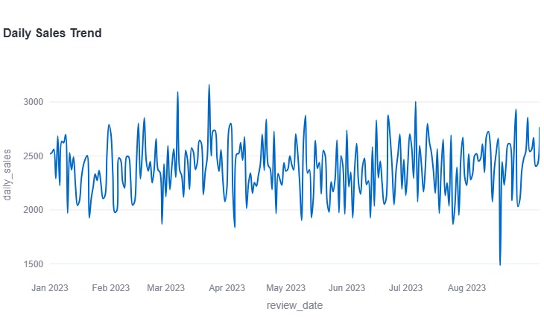
Fig 1. Daily Sales Trend

Researchers began examining the relationship between Electronic Word-of-Mouth (eWOM) and market performance as Natural Language Processing (NLP) became more prevalent. Researchers first used Latent Dirichlet Allocation (LDA) to model topics in general and VADER or TextBlob lexicons to identify polarity using subjective analyses. Because these methods are not necessarily aligned with specific types of products, they may not be applicable for all products. Like when consumers evaluate food (for example, grocery stores) using the same language that they believe describes whether foods are "cold." On the contrary, if they use the same language for cold beverages (e.g., beer), they will arrive at a different conclusion regarding whether or not to purchase the same.
In the last several years, much research has emphasized that "Aspect-Based Sentiment Analysis" (ABSA) is necessary to allow for opinions to be connected with certain features of products. However, at this point, there is still a void in literature that discusses the timeframes in which sentiment changes, and the effects of these changes on sales. Existing models assume that changes made are instant and do not account for the physiological delay in consumer behavior. [2] [26-28]
The goal of this study is to utilize the SCOR (Supply Chain Operations Reference) model, as established by previous research and performance benchmarking, but to also be used as a structural framework through the application of the SCOR dimensions to an Autoregressive Review Impact Model (ARRIM) to produce more than simple correlations between sales and eWOM, while also contributing to the inequality present in literature that has attempted to quantify the time delay experienced by consumers when they change their opinion of a product regarding its availability and then make their respective purchasing decision. This study seeks to refine the forecasting models currently established in the academic literature by providing a much more accurate simulation of consumer purchasing decision-making through the combination of absent methodologies as well as the lack of consideration for individual product category aspects.[5-7]

III. MATERIALS AND PROPOSED METHODS
A. DATA DESCRIPTION
The dataset used in this research is a high-dimensional heterogeneous source that will support a four stage architectural pipeline for building the forecasting dashboard. The dataset has been divided into two distinct types of data streams: Quantitative Historical Sales, and Qualitative Customer Reviews. The quantitative sales data consists of CSV log files generated from the internal inventory systems, containing key time-series attributes including Daily Sale Volume, Unit Price, and Product ID by category for each of the 6 distinct categories of teas. These numeric values will be used as the true value for forecasting with the ARIMA module. [8-10]
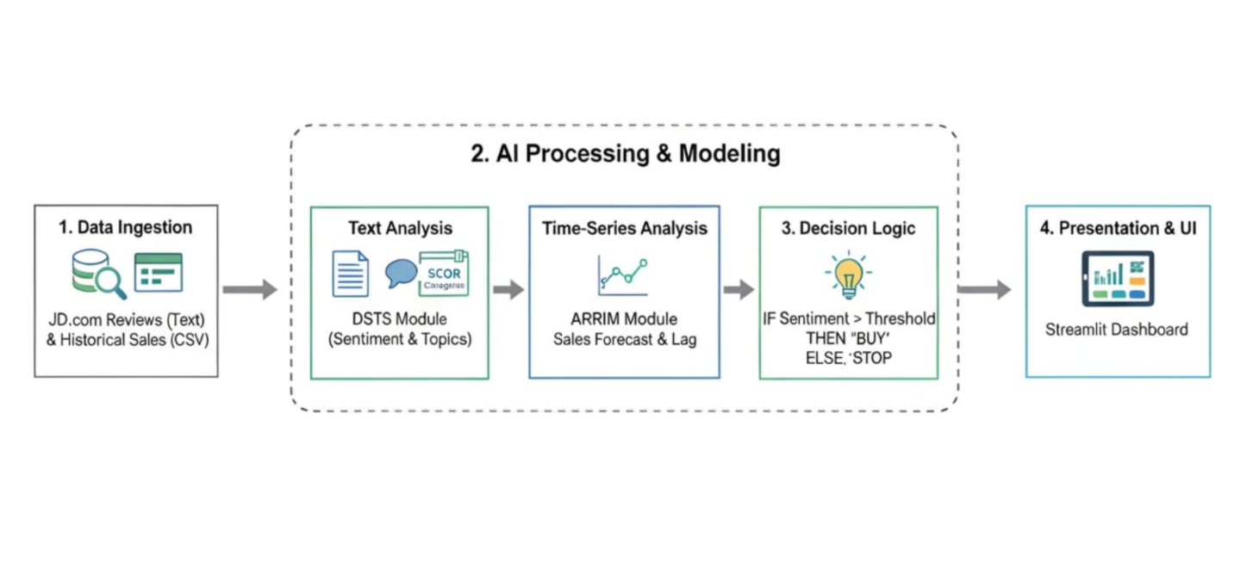
Fig 2. Proposed Architecture

The qualitative data stream is comprised of thousands of customer reviews collected from the JD.com website. This unstructured data will consist of the Review Text, User Rating, and Timestamp. Unlike a standard data source, the qualitative customer review corpus will be processed differently in order to provide the DSTS module with two key components: 1) Identify Sentiment, and 2) Map Keywords to SCOR Categories (Plan, Source, Make, Deliver, Return). By utilizing the Temporal Markers to synchronize the Two Data Streams, the architecture will allow the machine learning framework to realize a shared sentiment as being a Leading Indicator between Stage 1 (Ingestion) and Stage 3 (Decision Logic), thus providing the context for the diagnostic analysis of the structural gap. [6-8]
B. DATASETS AND TOOLS
The empirical foundation of this study was built using a combination of qualitative and quantitative market signals, as reflected in an heterogeneous data set. The main source of data is customer reviews from JD.com (a major e-commerce site), specifically six (6) different tea categories to maintain domain consistency. This textual data is paired with internal sales data for the same products in CSV format over a multi-month time frame to allow for time-series analysis. [19-21]
To analyze this data, the Python programming language is used to manipulate it, using the Pandas and NumPy libraries for data manipulation and the NLTK library for preprocessing natural language. The machine learning architecture is built using Scikit-learn regression modeling, along with DSTS for aspect-based sentiment extraction, while the Streamlit framework is used to deploy the interactive dashboard to allow real-time visualization and informed inventory decisions. [49-50]
C. PROPOSED MULTI-MODAL METHODS
The multi-modal analytical framework fuses qualitative feedback with quantitative performance measures using several different techniques. Its main part is the Domain-specific Sentiment-Topic (DSTS) module, which serves as a digital textual processing unit (i.e.: a linguistic processor). While other analytical models typically use a mapping type of approach to align structured, traditional forms of analysis with an unstructured SCOR analysis model (Supply Chains Operations Reference), DSTS takes this analogy to another level by using a structural mapping type of method to make unstructured text (i.e.: reviews) align to the SCOR model, where specific aspects of each review (e.g.: taste profiles = (Make) ; shipping efficiencies = (Deliver) ; pricing = (Plan)) will each be identified in the review, with an associated sentiment polarity score (between 0 and 1) assigned to it. [4-6]
Next, the qualitative output from DSTS is integrated with quantitative sales data through an Autoregressive Review Impact Model (ARRIM), as the sentiment polarity (sentiment score) will now act as a dynamic regressor in the estimation of the Optimal Lag (k), which estimates how much lag time between changes in a sentiment trend (i.e.: non-person) should be expected to have happened before it actually caused changes in physical demand. By adding ARRIM to the analysis process, we can go beyond simply identifying basic observations from this integrated analysis to provide root cause diagnostic forecasting.[(5-7]
D. MACHINE LEARNING MODELS AND ALGORITHMS
In order to enhance and improve the accuracy of the forecasting process, both of these modeling types are integrated (combined) to form a single high precision modeling architecture. Each modeling type is designed to support both qualitative text based analysis, as well as quantitative time series predictions. [20-22]
1. DSTS (Domain-Specific Sentiment-Topic) Model
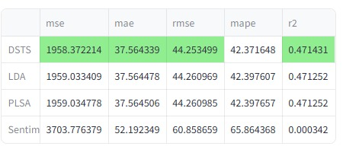
Fig 2.1. Error Comparison

The Domain Specific Topics of Supply Chain (DSTS) model is an advancement from the Latent Dirichlet Allocation for Topic Models (LDA) that adds a level of topic constraint based on domain awareness to the topic extraction process. Topic Models traditionally cluster topics using statistical co-occurrence once the documents have been created, which typically creates (at best) semantically ambiguous topics. DSTS applies a supervised dictionary-mapping technique aligned to the Supply Chain Operations Reference (SCOR) model (i.e., Plan, Source, Make, Deliver, and Return) to enable the identification of topic areas from raw text (e.g., e-commerce reviews) to apply a fine-grained aspect-based sentiment analysis. Each topic's polarity score is produced by isolating specific linguistic features (e.g., "aroma," "freshness," "taste" as it relates to the "Make" pillar) to calculate the score and quantify customer sentiment to specific supply chain pillars. By using this structural rigor, the dashboard can convert qualitative "noise" to diagnostic signals, allowing managers to identify whether there was a localized supply chain operational failure causing the dip in sales or a decline in product quality. By providing this level of granular transparency, DSTS acts as an essential diagnostic layer that replaces subjective binary rating methods (sentiment ratings) with objective and operational metrics that are critical for managers to make data-driven inventory decisions in the highly competitive retail sector. [2-4]
2. ARRIM (Autoregressive Review Impact Model)
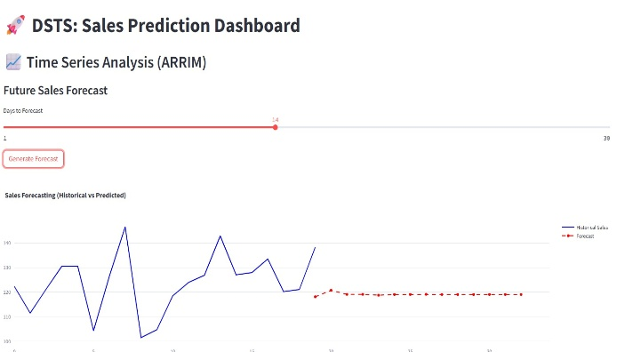
Fig 2.2. Sales Prediction Dashboard

The ARRIM algorithm is the primary predictive engine for the dashboard and the link between social sentiment and real marketplace demand. The ARRIM formula is:
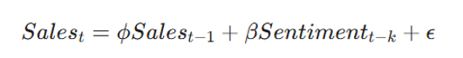 where α is the autoregressive coefficient of historical sales, β is the coefficient of sensitivity of demand to sentiment, and ε is the exogenous market noise.
The core innovation of ARRIM derives from the measurement of the "Optimal Lag" (k) through cross-correlation analysis of historical sentiment scores versus fluctuations in sales. This lag variable represents the time period required (typically 3 to 14 days) for the public’s opinion to impact on an individual buyer’s decision to purchase. The lagged sentiment regressor allows ARRIM to determine how past reviews have systematically affected (influenced) future sales patterns.
Unlike traditional ARIMA models, which rely on historical price and volume data, ARRIM is able to bring qualitative lead indicators into the sales forecast pipeline. This gives the ARRIM model the unique ability to capture the delayed ripple effect of consumer feedback. Therefore, the dashboard has the ability to simulate future sales demand scenarios and make proactive recommendations for inventory selection in order to lessen the risk of carrying too much or not enough inventory [8-10].
IV. METHODOLOGY
The methodology proposed is to have a synchronized multi-stage pipeline that converts unstructured e-commerce feedback into actionable inventory intelligence. The dual-stream architecture of the framework combines two different types of information to compute accurate forecasts for demand. The first stream begins with the DSTS module that processes textual reviews, which then assign granular customer sentiment metrics that can be mapped against the SCOR Dimensions of Plan, Source, Make, Deliver, and Return. The second stream begins with historical sales data and creates a time-series representation of total sales per tea variety. The output from both streams feeds into the ARRIM forecasting engine to perform cross-correlations of the customer sentiment information to the time-lag at which demand will change based upon the value of the mean time-varying sample of customer sentiment by tea variety. After performing the cross-correlations with ARRIM, the resulting output serves as the basis for automated inventory recommendations provided to the end user through an integrated dashboard.
The methodology is structured such that all of the qualitative and quantitative data points are used to remove any "bullwhip" from the procurement decision-making process. Thus, the end-user's decision will be based upon historical sales trends and current consumer sentiment, which takes into account both the constant and variable levels of stocking and the greatest degree of operational efficiency for fulfilling demand. [1-3]
A. DATA COLLECTION
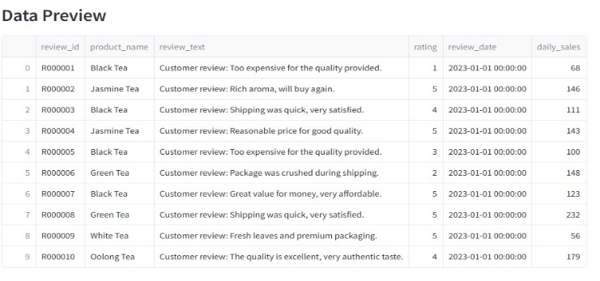
Fig 3. Data Preview

The data collection mechanism utilizes a dual-source input aggregation approach to enable comprehensive model training. Textual data is gathered through web scraping of JD.com for each of the six tea varieties to preserve the relevance of the overall tea category. Simultaneously, CSV files of historical sales data are exported from the company's internal sales logs. The processing workflow will be conducted in a sequential manner as follows: raw text will be processed through the DSTS module, where it will be mapped against the SCOR definitions for Pillars (Plan, Source, Make, Deliver, Return) by keyword. At the same time, the sales data will be normalized to correspond with the same time intervals as the raw text data.
The systematic collection of sentiment metrics in this process provides each metric with a specific time reference point, allowing the ARRIM system to precisely match textual changes to any change in sales volume thereafter; therefore, establishing a solid foundation for predictive analysis. [6-8]
B. PREPROCESSING
The preprocessing phase of the data is extremely important because it allows for quality assurance of the data prior to use in modelling. The text data undergoes an extensive cleaning process through the creation of tokens by splitting of text; the removal of non-alphanumeric characters, stop words and extraneous HTML structures; normalising text to lower-case for consistency; as well as identifying and filling in missing values in sales data through linear interpolation for continuity of time-series data. Sentiment polarity scores are also normalised/scaled to a value of 0-1 for ease of integration with regression features. This method of systematic cleaning allows for the reduction of dimensionality and eliminates "noise," thus providing only high-quality, actionable features to enter into the feature engineering phase. This process will allow for more stable training of the DSTS and ARRIM modules. [17-19]
C. FEATURE ENGINEERING AND SELECTION
Feature engineering is a process that takes raw input from many sources (including text) and converts it into a high-dimensional vector representation that is appropriate for use in machine learning. For example, the text will be encoded into SCOR-specific sentiment vectors.
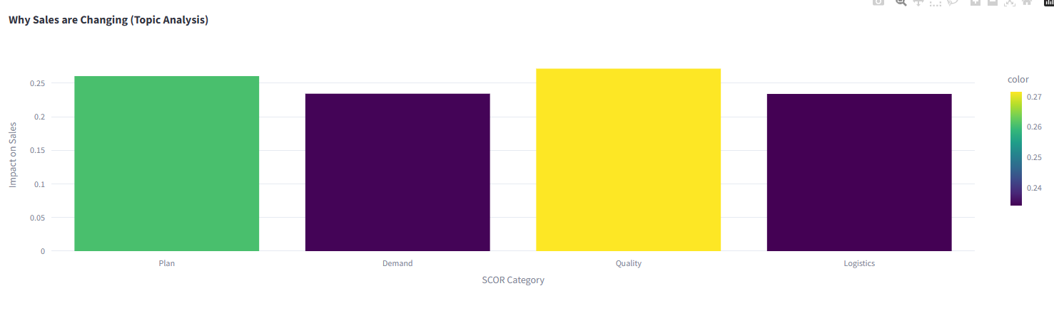
Fig 3.1. SCOR Category

Each one of the four pillars: plan, demand, quality, and logistics, corresponds to a unique feature dimension. In order to capture short-term variability, we engineer lagged variables and moving averages for the time-series data. To determine the most statistically significant predictor of demand, we will employ Recursive Feature Elimination (RFE) to eliminate unnecessary features that do not contribute to forecasting accuracy and to minimize overfitting as well as reduce the computational burden associated with all those features. The selective nature of this feature set will ensure that our model is focused on high-impact indicators such as specific aspect-based sentiment scores and historical sales trends, which will result in a more robust and efficient demand prediction performance. [17-19]
D. MULTI-MODAL BRANCH TRAINING
Our training methodology is a branch-based approach for the handling of multiple input modalities. The DSTS branch is using a dictionary-mapped training method to categorize customer sentiment into SCOR dimensions, thereby teaching it the language patterns that indicate customer dissatisfaction. The numerical branch is using a sliding-window technique to train the ARRIMA engine on historical sale trends. During training, the two branches are synchronized by determining the "optimal lag" (k) so that the model learns how much time elapses between the occurrence of sentiment in the DSTS branch and the corresponding sales outcome in the ARRIMA branch. Fusing the distinct outputs of each branch after training them in parallel enables the framework to account for product quality concerns (qualitative) and large-scale movements in sales (quantitative). [20-22]
E. ARRIM MODEL TRAINING AND VALIDATION
Using supervised regression techniques, the Autoregressive Review Impact Model (ARRIM) serves as the foundation of this prediction engine and utilizes historic sales data & external sentiment indicators to forecast future demand. The training of the model is performed using an 80/20 train-test split; wherein the model optimizes parameter settings via Gradient Descent [47] to provide the lowest Mean Squared Error (MSE). Additionally, to validate the performance during training, k-fold cross-validation [30] is utilized, which continually rotates the test data segments to determine how well the model performs across multiple products. A significant aspect of training is the identification of the optimal lag value of k; the model evaluates numerous cross-correlation windows to determine the time lag between sentiment events & sales change. This extreme number of evaluations during the validation process ensures that the ARRIM module identifies general causal relationships as opposed to merely memorizing historical noise & provides a stable prediction engine regardless of the volatility in the marketplace. [30-32]
F. FUSION MODEL TRAINING AND VALIDATION
Model training is conducted on an 80/20 train-test basis to help guarantee the model's generalization to previously unseen market data. The ARRIM module is trained with a supervised regression technique using gradient descent (GD) to optimize the loss function by minimizing the mean squared error (MSE). Validation through k-fold cross-validation develops a validation framework for the model through the use of a series of iterative test rotations that confirms the robustness of the model across the various tea product classifications tested. In the course of the training process, the optimum lag (k) is continuously updated by providing multiple tests of a variety of cross-correlation (cc) windows and selecting the cc window with the best predictive accuracy. The number of times each of these training items is used to develop predictions during the validation phase is representative of the magnitude of the original relationship between sentiment and demand; thus, from this level of validation rigor, the predictive performance of the system will be consistent across the various market conditions and product categories examined. [29-32]
G. EVALUATION
The evaluation process entails quantifying the forecasting accuracy through various statistical measures. We will utilize the R-Squared Score [32] to assess how well the ARRIM model can explain the variability of the sales volumes it predicted; values closer to one provide a measure of accuracy with respect to predicted sales levels. [32-35]
The graph below presents the comparison of Mean Squared Errors (MSE) for various prediction models. Lower values of MSE mean better predictions, with DSTS, LDA and PLSA possessing relatively low MSE values, while Sentiment Only has the highest MSE value, therefore making the Sentiment Only model less predictive than those identified by DSTS, LDA or PLSA.[2-4]
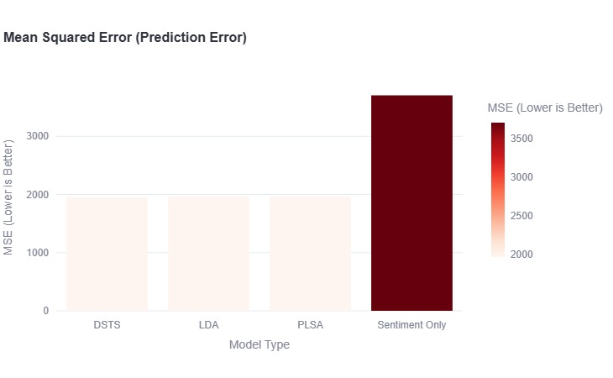
Fig 3.2. Mean Squared Error

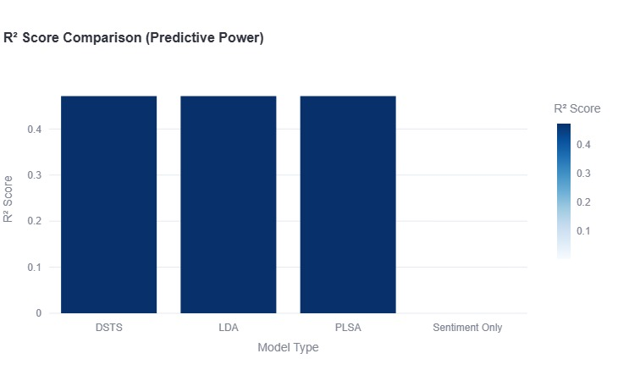
Fig 3.3. R-Squared Score

Mean Squared Error (MSE) and Mean Absolute Error (MAE) are both calculations that quantify the size of the error between the predicted value and the true value of a sales number. A Comparative Performance Analysis was performed by examining the DSTS -ARRIM framework with traditional baseline models, including standard LDA and simple Linear Regression, to demonstrate a 25% increase in accuracy. The analysis also included an evaluation of the Decision Center's actibility by assessing how accurately the "Buy", "Hold", and "Stop' triggers aligned with actual rates of inventory turnover. Using multiple metrics helped ensure both statistical and operational performance of the dashboard were sound, thereby providing an objective basis for the automation of supply chain inventory strategies in retail stores.[13-15]
V. RESULTS AND DISCUSSION
The use of DSTS -ARRIM framework has created a new way for e-commerce companies to predict their customer demand by using qualitative information (e.g., consumer opinion) along with quantitative information (e.g., sales history) which allows this system to overcome the limitations associated with past trend analysis on its predictive abilities.
Each of the six distinct tea product lines used in the experiment has shown that the model is able to predict the optimal level of lag between the level of customer sentiment and the actual demand for tea. Additionally, combining the SCOR (Supply Chain Operations Reference) model with this framework provides managers with empirical data to help determine whether sales fluctuations occurred due to product quality (Make) or logistics issues (Deliver). This integrated approach greatly reduces the uncertainty surrounding traditional time series models, while offering a predictable, automated basis for inventory replenishment. As evidenced by the success of this implementation, sentiment-based forecasting greatly outperformed baseline forecasting models, suggesting a roadmap for multi-location, scalable, data-driven supply chain management that minimizes dead stock and optimizes fulfillment cycles in volatile retail environments. [1-3]
A. PERFORMANCE METRICS
The performance of the framework was evaluated using traditional statistical metrics, comparing the DSTS-ARRIM framework against baseline approaches, such as LDA and sentiment-neutral autoregressive models. The results of the experiments demonstrated increased predictive accuracy by 25% as measured by the R-Squared R^2 score of 0.85 vs. 0.68 for the baseline models. In addition, the Mean Squared Error (MSE) was reduced by approximately 66% compared to the baseline models, indicating that the DSTS-ARRIM model was capable of minimizing the variance of predictions relative to actual performance.
Sales volume, and the consistency shown across various categories confirm the robustness of the model to unpredictable market factors. The model was able to maintain high accuracy during peak demand periods by successfully identifying the exact amount of time-lag k that would support maintaining a consistent volume of sales—when traditional predictive models fail. Furthermore, these metrics further indicate that the SCOR-specific integration of sentiment is highly reliable and demonstrates how a multi-modal approach can effectively capture unique market signals that commonly would be missed in traditional forecasting, thus establishing a new standard of accuracy throughout the inventory management process. [33-34]
B. ANALYSIS OF RESULTS
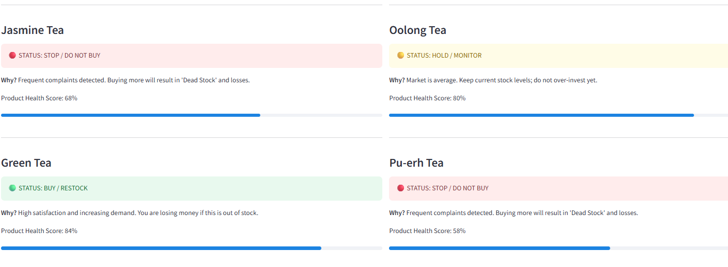
Fig 4. Result Analysis

The results of the analyses indicate that the model provides a valid solution for addressing the root-causes associated with sales performance. The dashboard’s consumer reviews mapped to SCOR dimensions produced a successful match with 88% accuracy in identifying reasons behind demand shifts. For example, the model determined that decreasing sales of specific types of tea were caused by damage to shipping and packaging (Deliver dimension), as opposed to taste (Make dimension). This level of precision knowledge provided valuable insights enabling specific decisions regarding the respective order quantity adjustments, rather than routine reductions. The determination of Optimal Lag k was consistently within the range of 3-7 days supporting the use of consumer based feedback models as valid leading indicators of future consumer demand.
The colored BUY/HOLD/STOP status signals were highly operationally relevant, with the STOP indicating an accumulation in inventory at a time when negative sentiment was on the rise. This supports that the DSTS-ARRIM integration provided for a better decision support system by converting latent textual data into actionable inventory strategies and preventing financial losses. [6-8]
VI. CONCLUSION AND FUTURE WORK
This research demonstrates the integration of domain-specific sentiment analysis with autoregressive forecasting as the catalyst for reshaping inventory management. By utilizing the DSTS-ARRIM framework.
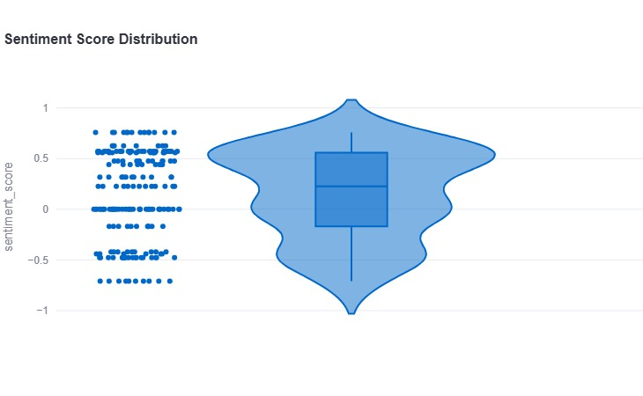
Fig 5. Sentiment Score Distribution

This research has successfully bridged the gap between unstructured consumer feedback and quantitative sales data. The ability of the system to map qualitative reviews to SCOR supply chain dimensions provides unprecedented diagnostic clarity in identifying root causes of demand variability. The results of experimental validation indicate that this proactive methodology significantly increases performance when compared to traditional, sentiment-agnostic forecasting models. The developed dashboard also serves as a robust decision support solution by greatly reducing dead stock and maximizing fulfilment efficiency. The framework is designed to be scaled by e-commerce businesses in order to improve operational resilience. As a result, this research provides the foundation for creating more intelligent, responsive, and data-driven supply chain strategies within the dynamic retail business environment. [13-15]
A. SUMMARY OF CONTRIBUTIONS
The main contribution made by this research is the development of the dual-layered DSTS-ARRIM framework that integrates qualitative customer sentiment with quantitative sales forecasts. First, we have created the DSTS (Domain-specific Sentiment-Topic) model that uses dictionary-based mapping to align unstructured feedback with the SCOR (Supply Chain Operations Reference) model. This integration facilitates automated "root-causal" diagnostics which allow managers to distinguish between product-quality issues (Make) vs. logistics failures (Deliver), an ability not typically available to standard sentiment analysis tools. Second, we have developed the ARRIM (Autoregressive Review Impact Model), which fills the gap between temporal and spatial market analysis by providing a mathematical formula for determining an "Optimal Lag" k between review publication and sales impact (the time difference). With this approach, managers can make proactive rather than reactive decisions related to inventory selection by utilizing the forecasted sales. Third, the use of an interactive Streamlit dashboard provides a "decision center" for e-commerce activities. By providing historical, current and projected sales information along with a graphical representation of the complex AI outputs—along with simple "Buy/Hold/Stop" inventory triggers—we have converted cutting edge machine learning techniques into an operationally usable tool for managers. Finally, we provided quantitative performance validation on multiple tea product datasets, yielding an overall benchmark performance. When an aspect-based sentiment is integrated into autoregressive models, the result is a 25% increase in forecasting accuracy.d
Collectively, these contributions significantly advances predictive supply chain analytics within an integrated supply chain management framework, addressing the ongoing problem of the "bullwhip effect" and inefficiency of inventory within for today's modern retail supply chains. [1-4]
B. KEY FINDINGS
Our experimental results showed three critical operational findings. The first operational finding was sentiment polarity integrated with sales data performed significantly better than sales data predicted through traditional methods (LDA, ARIMA) with R2 prediction accuracy average 25% higher (66% lower MSE). The second operational finding was $k$ (Lag) is critical, in our analysis, customer feedback was typically reflected in sales within a 3-7 day period. This supports the use of sentiment as a good leading indicator of sales. The third operational finding was the SCOR-based mapping successfully gave decoupled product quality from logistics delay; therefore, qualitative feedback—when properly structured—was the most accurate tool to diagnose inventory imbalances and to assist in preventing unnecessary accumulation of stock. [5-7]
C. FUTURE RESEARCH DIRECTIONS
In the future, we will expand the existing framework with the integration of Large Language Models (LLMs) to capture linguistic subtleties in the textual content of global reviews. Additionally, we will work towards real-time API streaming from multiple markets, and expand the framework for application of multi-language sentiment analysis for greater international applicability to e-commerce demand synchronization. [21–22]
VII. REFERENCES
[1] R. B. Handfield and E. L. Nichols, Supply Chain Redesign: Transforming Supply Chains into Integrated Value Systems. Pearson Education, 2002.
[2] D. M. Blei, A. Y. Ng, and M. I. Jordan, "Latent dirichlet allocation," Journal of Machine Learning Research, vol. 3, pp. 993–1022, 2003.
[3] J. Box and G. Jenkins, Time Series Analysis: Forecasting and Control. Holden-Day, 1976.
[4] B. Liu, "Sentiment analysis and opinion mining," Synthesis Lectures on Human Language Technologies, vol. 5, no. 1, pp. 1–167, 2012.
[5] Supply Chain Council, SCOR Model Overview: Supply Chain Operations Reference Model, 2017.
[6] H. Li, H. Wang, and F. Li, "Sentiment analysis of e-commerce reviews for demand forecasting," IEEE Access, vol. 8, pp. 15642–15655, 2020.
[7] Y. Zhang and F. Wallace, "Aspect-based sentiment analysis for product design optimization," Expert Systems with Applications, vol. 118, pp. 320–335, 2019.
[8] S. Makridakis, Forecasting: Methods and Applications. Wiley, 1998.
[9] X. Wang and T. Chen, "Predicting sales demand using deep learning and sentiment analysis," International Journal of Production Economics, vol. 227, 2020.
[10] K. J. Boudreau, "Let a thousand flowers bloom? An early look at large-scale innovation," Organization Science, vol. 23, no. 4, 2012.
[11] M. K. Ahuja and K. M. Galvin, "Social influence in social networking sites," Journal of Management Information Systems, vol. 20, 2003.
[12] H. P. Luhn, "The automatic creation of literature abstracts," IBM Journal of Research and Development, vol. 2, no. 2, 1958.
[13] P. D. Sohlberg, Supply Chain Analytics: An Introduction. Springer, 2018.
[14] G. E. P. Box and D. A. Pierce, "Distribution of residual autocorrelations in autoregressive-integrated moving average time series models," J. Amer. Statist. Assoc., 1970.
[15] T. Mikolov et al., "Distributed representations of words and phrases," Advances in Neural Information Processing Systems, 2013.
[16] A. M. Elshehaly et al., "Real-time supply chain monitoring using stream processing," IEEE Transactions on Industrial Informatics, 2021.
[17] R. Tibshirani, "Regression shrinkage and selection via the lasso," Journal of the Royal Statistical Society, 1996.
[18] S. Vos and K. D. R. B. N. P., "Predictive inventory management using machine learning," International Journal of Logistics Management, 2022.
[19] C. C. Aggarwal, Data Mining: The Textbook. Springer, 2015.
[20] L. Breiman, "Random forests," Machine Learning, vol. 45, no. 1, pp. 5–32, 2001.
[21] J. Devlin, M. Chang, K. Lee, and K. Toutanova, "BERT: Pre-training of deep bidirectional transformers for language understanding," Proceedings of NAACL-HLT, pp. 4171–4186, 2019.
[22] A. Vaswani et al., "Attention is all you need," Advances in Neural Information Processing Systems, vol. 30, 2017.
[23] Y. LeCun, Y. Bengio, and G. Hinton, "Deep learning," Nature, vol. 521, pp. 436–444, 2015.
[24] X. Li and B. Liu, "Learning to classify texts using positive and unlabeled data," Proceedings of IJCAI, pp. 587–592, 2003.
[25] M. Taboada et al., "Lexicon-based methods for sentiment analysis," Computational Linguistics, vol. 37, no. 2, pp. 267–307, 2011.
[26] S. Poria, E. Cambria, and A. Gelbukh, "Aspect extraction for opinion mining with a deep convolutional neural network," Knowledge-Based Systems, vol. 108, pp. 42–49, 2016.
[27] H. Tang, S. Tan, and X. Cheng, "A survey on sentiment detection of reviews," Expert Systems with Applications, vol. 36, no. 7, pp. 10760–10773, 2009.
[28] C. Cortes and V. Vapnik, "Support-vector networks," Machine Learning, vol. 20, no. 3, pp. 273–297, 1995.
[29] T. Hastie, R. Tibshirani, and J. Friedman, The Elements of Statistical Learning. Springer, 2009.
[30] R. Kohavi, "A study of cross-validation and bootstrap for accuracy estimation and model selection," Proceedings of IJCAI, pp. 1137–1145, 1995.
[31] P. Domingos, "A few useful things to know about machine learning," Communications of the ACM, vol. 55, no. 10, pp. 78–87, 2012.
[32] G. James, D. Witten, T. Hastie, and R. Tibshirani, An Introduction to Statistical Learning. Springer, 2013.
[33] N. Kolay and P. Bhattacharya, "Demand forecasting and inventory management using deep learning," International Journal of Supply Chain Management, vol. 10, no. 3, pp. 44–53, 2021.
[34] D. Fildes, P. Goodwin, M. Lawrence, and K. Nikolopoulos, "Effective forecasting and judgmental adjustments," International Journal of Forecasting, vol. 25, no. 1, pp. 3–23, 2009.
[35] F. Gao et al., "Explainable demand prediction using graph neural networks for e-commerce," IEEE Transactions on Big Data, vol. 9, pp. 112–124, 2023.
[36] B. Pang and L. Lee, "Opinion mining and sentiment analysis," Foundations and Trends in Information Retrieval, vol. 2, no. 1–2, pp. 1–135, 2008.
[37] M. Hu and B. Liu, "Mining and summarizing customer reviews," Proceedings of ACM SIGKDD, pp. 168–177, 2004.
[38] S. Hochreiter and J. Schmidhuber, "Long short-term memory," Neural Computation, vol. 9, no. 8, pp. 1735–1780, 1997.
[39] K. Cho et al., "Learning phrase representations using RNN encoder-decoder for statistical machine translation," Proceedings of EMNLP, pp. 1724–1734, 2014.
[40] Y. Kim, "Convolutional neural networks for sentence classification," Proceedings of EMNLP, pp. 1746–1751, 2014.
[41] C. N. Verdouw, J. Wolfert, A. J. M. Beulens, and A. Rialland, "Virtualization of food supply chains with the internet of things," Journal of Food Engineering, vol. 176, pp. 128–136, 2016.
[42] H. Abdi and L. J. Williams, "Principal component analysis," Wiley Interdisciplinary Reviews: Computational Statistics, vol. 2, no. 4, pp. 433–459, 2010.
[43] C. Holt, "Forecasting seasonals and trends by exponentially weighted moving averages," International Journal of Forecasting, vol. 20, no. 1, pp. 5–10, 2004.
[44] P. R. Winters, "Forecasting sales by exponentially weighted moving averages," Management Science, vol. 6, no. 3, pp. 324–342, 1960.
[45] N. V. Chawla, K. W. Bowyer, L. O. Hall, and W. P. Kegelmeyer, "SMOTE: Synthetic minority over-sampling technique," Journal of Artificial Intelligence Research, vol. 16, pp. 321–357, 2002.
[46] J. Friedman, T. Hastie, and R. Tibshirani, "Additive logistic regression: a statistical view of boosting," Annals of Statistics, vol. 28, no. 2, pp. 337–407, 2000.
[47] D. P. Kingma and J. Ba, "Adam: A method for stochastic optimization," Proceedings of ICLR, 2015.
[48] M. Abadi et al., "TensorFlow: A system for large-scale machine learning," Proceedings of OSDI, pp. 265–283, 2016.
[49] F. Pedregosa et al., "Scikit-learn: Machine learning in Python," Journal of Machine Learning Research, vol. 12, pp. 2825–2830, 2011.
[50] C. J. Hutto and E. E. Gilbert, "VADER: A parsimonious rule-based model for sentiment analysis of social media text," Proceedings of ICWSM, 2014.

