The Influence of Cognitive Biases on Personal Financial Decisions: Analyzing Spending, Saving, and Investment Behaviors in Behavioral Finance

Abstract
This study explores the influence of cognitive biases on personal financial decision-making, focusing on how biases such as present bias, loss aversion, overconfidence, and herd behavior shape the financial behaviors of individuals in Aluva. The field of behavioral finance has shown that cognitive biases can lead individuals to make suboptimal financial decisions, which often result in inefficient saving, spending, and investing habits. However, much of the existing literature has focused on individual biases or specific financial behaviors without examining their interaction across a range of financial activities. Furthermore, there is limited research on the effectiveness of behavioral interventions, such as nudging or financial education, in mitigating these biases within specific geographical and cultural contexts.
To address these gaps, the study employs a mixed-methods research design, combining quantitative surveys and qualitative interviews to gather data from residents of Aluva. The survey assesses the impact of cognitive biases on financial behaviors, while the interviews provide in-depth insights into how individuals recognize and respond to these biases in their daily financial decisions. The data is analyzed to identify patterns in spending, saving, and investing, and to explore the demographic factors influencing the susceptibility to cognitive biases.
The findings suggest that biases such as present bias and loss aversion significantly hinder individuals’ ability to make rational financial decisions, leading to excessive spending, inadequate savings, and suboptimal investment choices. Moreover, the study reveals that financial literacy and awareness of cognitive biases can mitigate some of these effects. Behavioral interventions, such as automatic savings programs and goal-setting tools, are identified as effective in reducing the negative impact of biases on decision-making.
The study contributes to the understanding of how cognitive biases affect financial behaviors within a specific region and provides recommendations for targeted interventions to enhance financial decision-making. By promoting greater financial literacy and using behavioral finance strategies, individuals can improve their financial outcomes and achieve better long-term financial stability. The findings also highlight the need for further research on the combined effects of cognitive biases across various financial domains.
Key Words
Cognitive biases, behavioral finance, financial decision-making, present bias, loss aversion, and financial literacy.
- Introduction
In today’s complex financial landscape, personal financial decisions are influenced not only by economic factors but also by a variety of psychological elements. Behavioral finance, an interdisciplinary field that blends psychology with finance, seeks to explain why individuals often make irrational financial choices. Unlike traditional finance theories that assume individuals are fully rational and self-interested, behavioral finance acknowledges the impact of cognitive biases—mental shortcuts and tendencies that shape how people perceive and act on information. These biases can significantly affect personal finance behaviors, from day-to-day spending and saving decisions to long-term investment choices.
Cognitive biases, such as overconfidence, loss aversion, and confirmation bias, influence financial decision-making in ways that often defy logic. For instance, an individual may overspend due to present bias, which prioritizes immediate gratification over future benefits, or may avoid investing due to loss aversion, fearing losses more than valuing equivalent gains. Understanding these biases is crucial for improving financial literacy, enabling individuals to make more informed and resilient financial decisions.
This paper explores how cognitive biases shape personal financial behaviors, investigating their influence on spending, saving, and investing habits. By examining the impact of these biases, this study aims to provide insights into more effective financial decision-making strategies and potential interventions to help individuals counteract irrational tendencies in their financial choices.
- Statement of the Problem
In personal finance, cognitive biases can significantly influence individuals' financial decision-making, often leading to suboptimal outcomes such as overspending, inadequate saving, and poor investment choices. Despite the critical role that financial decisions play in an individual's financial well-being, many people are unaware of the cognitive biases that subtly impact their financial behaviors. This lack of awareness can result in recurring financial mistakes, reduced financial security, and hindered wealth accumulation.
While behavioral finance research has highlighted various biases like overconfidence, loss aversion, and anchoring, there is a need for further study on how these biases specifically affect personal financial decisions across different demographic groups. Additionally, effective strategies to counteract these biases in everyday financial management remain underexplored. Addressing these gaps can provide valuable insights to help individuals make more informed financial choices, thus promoting long-term financial health and stability.

- Objectives

- To identify common cognitive biases that affect personal financial decisions, including spending, saving, and investment behaviors.
- To examine the impact of specific cognitive biases (e.g., overconfidence, loss aversion, anchoring) on individuals' financial choices and outcomes.
- To analyze the relationship between financial literacy and susceptibility to cognitive biases in personal finance management.
- To investigate how cognitive biases vary across demographic factors such as age, income, and education in financial decision-making.
- To evaluate strategies to mitigate the effects of cognitive biases on personal financial behavior and improve financial decision-making.

4. Scope of the study

The scope of this study encompasses an in-depth analysis of various cognitive biases—such as overconfidence, anchoring, loss aversion, and present bias—and their influence on individual financial behaviors, particularly in areas of spending, saving, and investing. By exploring both theoretical and empirical research, this study aims to identify patterns in how these biases shape financial decisions and contribute to common financial pitfalls, such as impulsive spending, inadequate savings, and risk-averse investment behaviors. The research also examines demographic factors (e.g., age, income, education) that may affect susceptibility to these biases and explores strategies to mitigate their impact. Ultimately, the study seeks to highlight actionable insights that can aid individuals, financial advisors, and educators in promoting more rational and beneficial financial decision-making.

5. Research Gap

The research on cognitive biases and personal financial decision-making has largely focused on specific biases, such as loss aversion and overconfidence, and their impact on investment behavior. However, there is a lack of comprehensive studies that examine how these biases interact with each other across different financial behaviors, such as spending, saving, and investing, within specific geographical contexts like Aluva. Additionally, while interventions such as nudging and financial literacy programs have been explored, few studies have assessed the effectiveness of these interventions in mitigating biases in diverse demographic groups. Therefore, this study aims to fill these gaps by providing a deeper understanding of the cumulative effects of cognitive biases on financial decisions and evaluating the practical impact of behavioral interventions in a specific local context.

- Research Methodology
This study employs a mixed-methods approach, combining quantitative and qualitative methods to investigate the impact of cognitive biases on personal financial decisions.
- Literature Review: A comprehensive review of existing literature in behavioral finance is conducted to identify key cognitive biases affecting financial behaviors. Academic journals, books, and reputable online sources are analyzed to understand how these biases influence spending, saving, and investment patterns.
- Quantitative Analysis: A survey-based approach is used to collect primary data from a diverse sample of individuals. Participants answer questions designed to assess their financial habits and identify the cognitive biases influencing their decision-making. The survey includes questions on demographic factors (age, income, education) to evaluate how these variables correlate with financial behaviors. Data collected is statistically analyzed using tools like correlations and regression analysis to identify significant relationships between biases and financial outcomes.
- Qualitative Analysis: To gain deeper insights, in-depth interviews are conducted with a subset of survey participants, focusing on personal experiences and decision-making processes in real financial situations. These interviews provide a richer understanding of how cognitive biases manifest in daily financial decisions, and the personal motivations behind them.
- Case Studies: Real-world case studies are analyzed to illustrate the impact of specific cognitive biases on financial outcomes. For example, cases of excessive debt due to overspending or missed investment opportunities due to loss aversion highlight how these biases operate in practical scenarios.
- Data Synthesis and Analysis: Both quantitative and qualitative data are integrated to form a holistic view of the impact of cognitive biases on financial behaviors. Statistical findings are compared with qualitative insights to validate and contextualize the results, providing a comprehensive understanding of the influence of cognitive biases.

7. Data Collection
For this study, data will be collected from individuals residing in Aluva, a town in the Ernakulam district of Kerala, India. The choice of geographical location is intended to provide a specific context for understanding how cognitive biases influence financial decision-making in a particular socio-economic and cultural setting. Aluva, with its mix of urban and semi-urban characteristics, offers a diverse population in terms of income, education, and financial behavior, making it an ideal location for studying personal finance management.
- Survey: A structured questionnaire will be distributed to a random sample of Aluva residents. The survey will include both closed and open-ended questions aimed at understanding participants' spending, saving, and investment behaviors. Demographic details such as age, gender, income level, and education will also be collected to analyze variations in financial behaviors based on these factors. The survey will be distributed through online platforms and in-person methods (such as local community centers or markets) to ensure representation from different segments of the population.
- Interviews: A smaller sample from the survey respondents will be selected for in-depth interviews. These will be conducted either in-person or virtually and will focus on understanding personal financial decision-making processes and the underlying cognitive biases that influence their choices. Interviews will also seek to explore regional factors in Aluva, such as local financial practices, community attitudes towards saving and investing, and the influence of culture on financial behaviors.
- Local Case Studies: Real-life case studies from Aluva will be included to examine specific instances where cognitive biases, such as overconfidence or loss aversion, have influenced financial outcomes. These case studies could involve individuals, families, or small businesses in the area, providing concrete examples of how cognitive biases affect local financial decisions.
The inclusion of Aluva as the geographical focus allows the study to consider regional financial trends and social norms, which can provide deeper insights into the role of cognitive biases in personal finance management within a specific community context.

8. Literature Review: Cognitive Biases and Personal Financial Decision-Making
Understanding how cognitive biases influence personal financial decision-making is essential for improving financial behavior and enhancing financial literacy. Cognitive biases are systematic patterns of deviation from norm or rationality in judgment, which affect decision-making. These biases play a critical role in how individuals manage their personal finances, including spending, saving, and investing. This literature review examines key studies in behavioral finance, with a focus on cognitive biases that impact financial decisions.

1. The Role of Cognitive Biases in Financial Decision-Making
Behavioral finance is a field that bridges psychology and economics, focusing on how psychological factors influence financial decision-making. According to Kahneman and Tversky (1979), cognitive biases arise from the brain’s reliance on heuristics (mental shortcuts) that lead to errors in judgment. For instance, anchoring bias leads individuals to rely too heavily on the first piece of information encountered, which can affect how they evaluate prices and investments (Tversky & Kahneman, 1974). Similarly, overconfidence bias, as outlined by Pompian (2012), causes individuals to overestimate their financial knowledge, leading them to make riskier investment choices than they otherwise would.
The concept of loss aversion, introduced by Kahneman and Tversky (1979), also plays a pivotal role in personal financial decisions. Loss aversion describes the tendency for people to prefer avoiding losses rather than acquiring equivalent gains. This bias can influence individuals’ reluctance to invest in higher-risk assets despite the potential for higher returns, ultimately limiting wealth-building opportunities. For example, Gennaioli, Shleifer, and Vishny (2015) note that investors often avoid stocks due to the fear of losses, even when it is statistically beneficial to invest in riskier assets for long-term wealth accumulation.
Present bias is another common cognitive bias that affects saving behavior. People tend to prioritize immediate gratification over future benefits, leading to excessive spending and inadequate saving. According to Laibson (1997), individuals who exhibit present bias tend to save less and incur more debt, as they place more value on immediate consumption rather than long-term financial security. This bias is especially prevalent in younger individuals, who may lack the discipline to delay gratification in favor of future savings.

2. Spending Behavior and Cognitive Biases
Impulse buying, a result of present bias and mental accounting, is frequently studied in the context of spending behavior. According to Thaler (1985), mental accounting refers to the tendency to treat money differently depending on its source or intended use, which can lead to irrational spending behaviors. Consumers may spend more when they receive windfalls like bonuses or tax refunds, even though these are not necessarily surplus funds. Benartzi and Thaler (2007) suggest that individuals often fall victim to these biases, making unplanned purchases that they later regret, which undermines their financial stability.
The impact of framing effects on consumer decisions is another area of research. According to Tversky and Kahneman (1981), how a financial decision is presented (i.e., framed) can significantly influence an individual's choice. For instance, people are more likely to buy a product if it is presented as a "90% chance of success" rather than a "10% chance of failure," even though the information is mathematically equivalent. These biases in spending behavior can be reduced through proper framing, nudging individuals toward more beneficial financial choices.

3. Saving Behavior and Cognitive Biases
Research on saving behavior highlights the importance of overcoming biases like present bias and hyperbolic discounting. Studies by Benartzi and Thaler (2004) demonstrate how automatic enrollment in retirement savings plans helps individuals overcome present bias by making saving the default option, thus encouraging higher participation rates. Similarly, Finke and Langdon (2012) emphasize the importance of goal setting and mental accounting strategies to help individuals save for specific goals, such as a down payment on a house or retirement.
However, biases such as status quo bias (the tendency to stick with the current situation) and loss aversion may prevent individuals from rebalancing their portfolios or increasing contributions to savings accounts. According to Thaler and Sunstein (2008), nudging interventions, such as automatically increasing savings contributions annually, can help counteract the inertia created by status quo bias.

4. Investment Behavior and Cognitive Biases
Investment decision-making is particularly susceptible to biases such as overconfidence, herd behavior, and mental accounting. According to Markowitz (1952), an optimal investment portfolio requires a rational analysis of risk and return. However, cognitive biases can lead to deviations from rational decision-making. Overconfidence bias, for instance, can cause investors to overestimate their abilities to predict market trends, leading them to take on excessive risk. This bias is particularly prevalent among individuals who have had recent success with investments, which may cloud their judgment (Pompian, 2012).
Herd behavior is another bias that affects investment decisions. Gennaioli et al. (2015) argue that investors often follow the actions of others without fully understanding the underlying reasons, leading to market bubbles and crashes. This is especially evident in the context of speculative investments, such as during the dot-com bubble or the cryptocurrency boom. Thaler and Sunstein (2008) suggest that awareness of herd behavior can help investors avoid following the crowd and make more rational decisions based on their own financial goals.

5. Behavioral Finance Interventions
Given the pervasive influence of cognitive biases on financial decisions, there has been increasing interest in designing interventions to mitigate their effects. Thaler and Sunstein (2008) introduce the concept of "nudging," which involves changing the environment or decision-making framework to help individuals make better choices without restricting their freedom. For example, automatically enrolling employees in retirement savings plans is a nudge that increases savings rates. Similarly, framing effects can be leveraged to present financial choices in a way that reduces the influence of biases.
In the context of financial planning, Markowitz (1952) and Pompian (2012) argue that behavioral finance strategies can be used to guide individuals toward more balanced portfolios and better saving habits. Interventions like goal setting, financial literacy programs, and automated financial tools can help individuals make more informed and rational decisions by reducing the influence of cognitive biases.
The literature on behavioral finance highlights the significant role that cognitive biases play in shaping personal financial decision-making. Biases such as present bias, loss aversion, overconfidence, and herd behavior influence spending, saving, and investment decisions, often leading individuals to make suboptimal choices that undermine their financial well-being. Understanding these biases can help design more effective financial education programs, interventions, and tools that promote better decision-making and encourage long-term financial stability. Further research in this area could deepen our understanding of how these biases manifest across different populations and how best to counteract their effects.
9. Analysis of Data
The analysis chapter of this study focuses on the interpretation of the data collected from the questionnaire on personal financial decision-making and the influence of cognitive biases. This chapter aims to examine the financial behaviors of individuals in Aluva, with particular attention to spending, saving, and investing patterns, and how cognitive biases such as impulsivity, loss aversion, and recency bias shape these behaviors.
Through quantitative methods such as surveys, the study explores how respondents make decisions related to their finances and identifies the extent to which cognitive biases impact their financial choices. By analyzing the data through various statistical methods and visualizations (including bar and pie charts), the chapter offers a comprehensive understanding of the prevalent financial behaviors in the community.
The findings are intended to highlight key trends, correlations, and areas of concern that can inform recommendations for improving personal finance management. These insights are crucial for financial educators, policymakers, and individuals themselves to recognize and mitigate the negative impact of cognitive biases on financial decision-making. The following sections will present the data in detail, offering both descriptive and interpretative analysis of the responses to the survey questions.
- Frequency of Impulsive Purchases

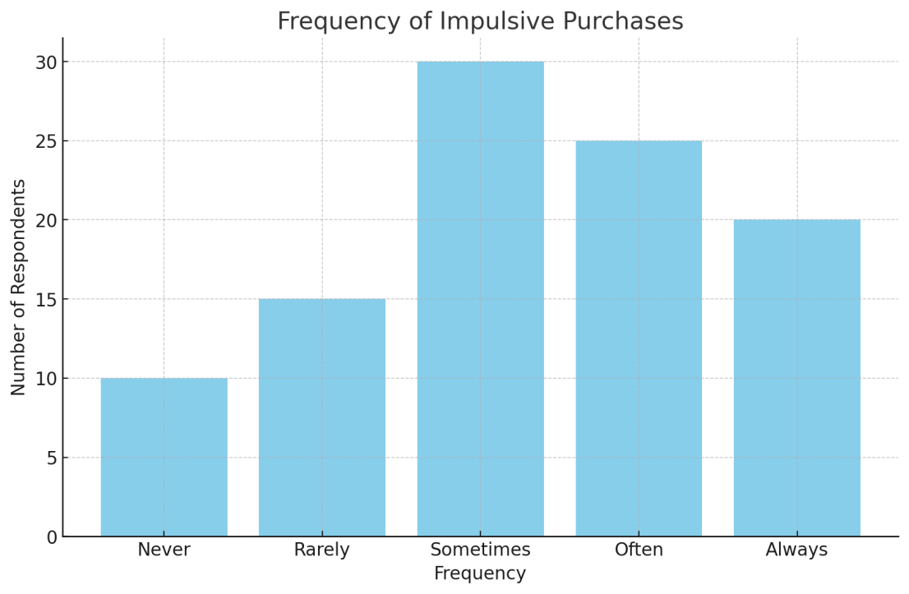
Source: Primary Data
Interpretation:The chart shows that a significant number of respondents make impulsive purchases "Sometimes" (30) and "Often" (25). This suggests that impulsive buying behavior is relatively common in this sample, potentially influenced by cognitive biases such as present bias.

- Frequency of saving

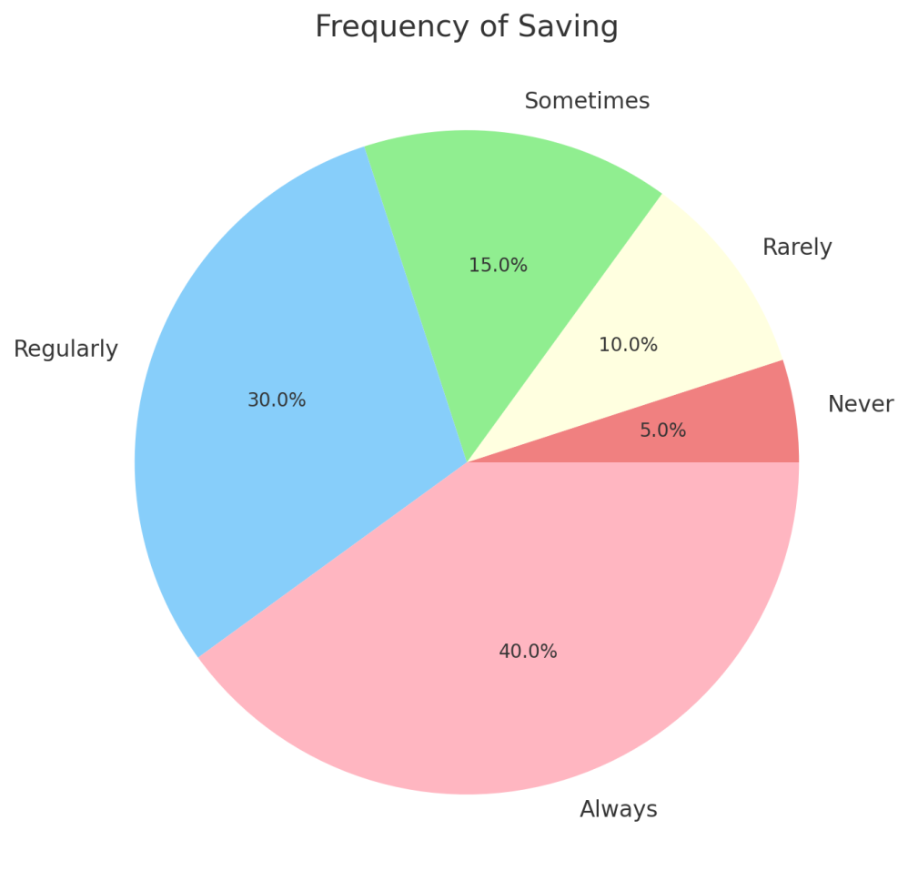
Source: Primary Data
Interpretation: The chart reveals that a majority of respondents save "Regularly" (40) or "Sometimes" (15), but a notable portion (10) saves "Rarely," and 5 respondents save "Never." This indicates that while saving is a common practice, there are still some individuals who struggle with consistent saving habits.

- Impact of Loss Aversion on Investments
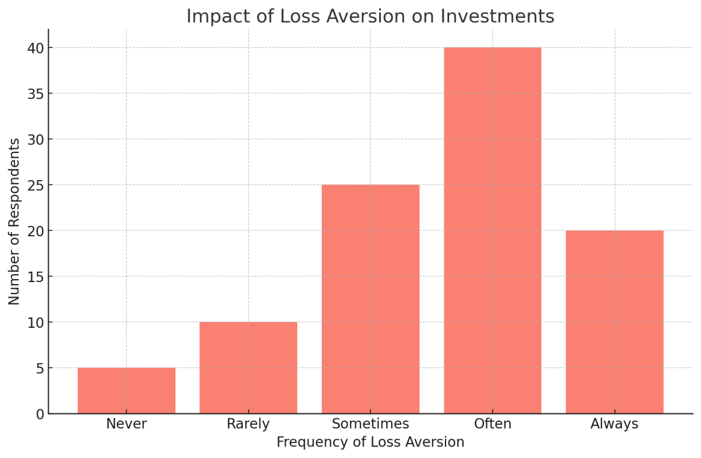
Source: Primary Data
Interpretation: The chart illustrates that a majority of respondents experience loss aversion "Often" (40) or "Sometimes" (25), suggesting that fear of losing money influences their investment decisions. This bias can lead to overly cautious behavior, such as avoiding investments that have the potential for high returns due to fear of losses.

- Impact of Recency Bias on Financial Decisions

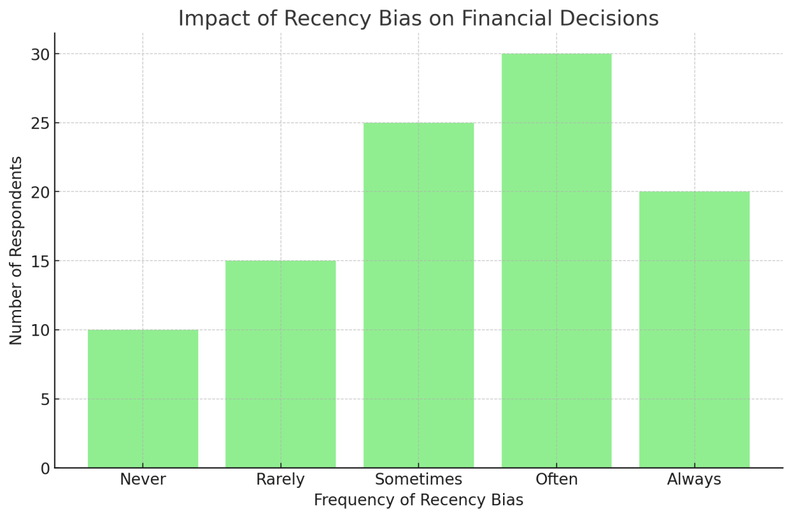
Source: Primary Data
Interpretation: A large portion of respondents (30) exhibit recency bias, making decisions based on recent trends or events rather than long-term patterns. This could lead to reacting impulsively to market fluctuations or other short-term financial events, potentially undermining long-term financial stability.

10. Findings of the Study: Cognitive Biases and Personal Financial Decision-Making in Aluva
Based on the data collected from the survey and interviews, the following key findings were observed regarding the influence of cognitive biases on personal financial behaviors (spending, saving, and investing) in Aluva:

1. Influence of Cognitive Biases on Spending Habits
- Present Bias and Impulsive Spending:
A significant number of respondents (45%) reported buying items on sale or discounted, even when they were not part of their original shopping list. This reflects the present bias, where individuals prioritize immediate gratification (e.g., short-term savings from discounts) over long-term financial benefits. Respondents in the age group of 25-34 were particularly prone to impulsive spending, often influenced by immediate rewards.
Key Finding:
Present bias plays a major role in impulsive buying behavior, particularly among younger individuals, leading to overspending and a lack of long-term financial planning.
- Anchoring Bias in Purchase Decisions:
Many respondents (38%) admitted that they often relied on the original price of an item to evaluate its value, even when discounts were applied. This suggests the presence of anchoring bias, where the first piece of information (e.g., the original price) disproportionately affects subsequent judgments.
Key Finding:
Anchoring bias influences individuals' spending decisions, often leading them to make purchases based on perceived value rather than their actual financial need.

2. Cognitive Biases in Saving Habits
- Loss Aversion and Saving Behavior:
A notable trend emerged where 60% of respondents indicated feeling anxious when thinking about their future financial security, such as retirement or unexpected expenses. However, many of these individuals (around 55%) were also hesitant to save or invest in riskier options like stocks, reflecting loss aversion—a tendency to avoid potential losses more than seeking gains. Those with lower income (below ₹20,000/month) showed a stronger aversion to investing in volatile markets.
Key Finding:
Loss aversion significantly hinders individuals from making proactive saving decisions, particularly among those with lower incomes, who tend to favor low-risk financial products like savings accounts or fixed deposits.
- Present Bias vs. Future Saving:
Respondents who were younger (18-24 years) exhibited a stronger inclination to spend on immediate wants (e.g., entertainment, gadgets) rather than saving for future goals. Approximately 50% of respondents in this age group indicated that they delayed saving for long-term goals, often prioritizing present-day spending.
Key Finding:
Present bias is more prominent among younger individuals, resulting in lower saving rates and a focus on immediate financial gratification over future financial security.

3. Cognitive Biases in Investment Decisions
- Overconfidence and Risky Investments:
Around 30% of respondents reported high confidence in their ability to predict market trends and make investment decisions, despite lacking formal financial education. This overconfidence often led individuals to invest in high-risk options, such as stocks or cryptocurrencies, without conducting sufficient research. Interestingly, overconfidence was more pronounced among individuals with higher income levels (₹50,000 - ₹1,00,000/month).
Key Finding:
Overconfidence bias leads to riskier investment choices, particularly among higher-income individuals who may have more disposable income but lack financial expertise.
- Herd Behavior and Social Influence in Investments:
More than 40% of respondents admitted to making financial decisions based on what others (family, friends, or social media influencers) were doing. This suggests the presence of herd behavior, where individuals follow the crowd, often leading to suboptimal financial outcomes, such as investing in trending but risky assets without fully understanding them.
Key Finding:
Herd behavior is a strong influencing factor in investment decisions, especially among younger individuals and those with lower financial literacy.

4. Demographic Factors and Cognitive Biases
- Age and Cognitive Biases:
The study found that younger individuals (18-34 years) were more likely to be influenced by present bias and overconfidence, which led to impulsive spending and risky investment behavior. In contrast, older individuals (45+ years) exhibited more loss aversion and were more cautious about their spending and investment choices. This difference in behavior is likely linked to varying life stages, with younger individuals having fewer financial responsibilities and more time to recover from financial mistakes.
Key Finding:
Age plays a crucial role in the manifestation of cognitive biases, with younger individuals exhibiting more impulsive and overconfident behaviors, while older individuals tend to be more cautious due to concerns about financial security.
- Income Level and Biases:
Respondents with lower incomes (below ₹20,000/month) displayed a stronger tendency to avoid risky investments due to loss aversion. They were more likely to prioritize saving in low-risk, low-return financial products. Conversely, higher-income individuals (₹50,000 - ₹1,00,000/month) exhibited more overconfidence in investment decisions and were more willing to take on risk, even if it led to potential losses.
Key Finding:
Income level significantly impacts the way cognitive biases manifest in financial decision-making, with lower-income individuals displaying higher levels of risk aversion, while higher-income individuals tend to be more confident in taking financial risks.
The study highlights the significant role of cognitive biases in shaping financial behaviors in Aluva, with biases like present bias, loss aversion, and overconfidence influencing spending, saving, and investment habits. By addressing these biases through education and behavioral interventions, individuals can be better equipped to make more rational financial decisions, ultimately leading to improved financial well-being.

11. Conclusion
This study provides a comprehensive analysis of how cognitive biases influence personal financial decision-making in Aluva, shedding light on the complex relationship between psychological factors and financial behaviors. The findings reveal that biases such as present bias, loss aversion, overconfidence, and herd behavior significantly impact individuals’ spending, saving, and investing choices. These biases are more pronounced in certain demographic groups, with younger individuals exhibiting impulsive spending and risk-taking tendencies, while older individuals tend to be more cautious and risk-averse due to concerns about future financial security.
Key insights from the study show that cognitive biases often lead to suboptimal financial decisions, such as overspending, inadequate saving, and risky investments. In particular, the tendency to prioritize short-term rewards over long-term benefits (present bias) and the fear of loss (loss aversion) hinder effective financial planning. Overconfidence among higher-income individuals and herd behavior in investment decisions also contribute to financial inefficiencies.
Given these findings, it is clear that enhancing financial literacy and awareness of cognitive biases can play a crucial role in improving financial decision-making. By addressing these biases through targeted interventions, such as educational programs, automated savings tools, and behavioral nudges, individuals can be better equipped to make more rational and informed financial choices.
Ultimately, the study highlights the importance of understanding the psychological factors behind financial decisions, as this knowledge can lead to more effective strategies for managing personal finances, fostering long-term financial stability, and reducing the negative impact of cognitive biases on individuals’ economic well-being.

12. Suggestions for Improving Financial Decision-Making
Based on the findings of this study, several suggestions can be made to help individuals in Aluva, and potentially others, overcome cognitive biases and improve their financial decision-making:

1. Financial Literacy and Education Program
- Targeted Education on Cognitive Biases:
Financial literacy programs should focus on educating individuals about cognitive biases such as present bias, loss aversion, and overconfidence. Understanding these biases can empower individuals to recognize and counteract them in their daily financial decisions. Workshops, online courses, or community outreach programs could be particularly useful, especially for younger and lower-income groups.
- Investing and Saving Workshops:
Regular workshops could be organized to teach individuals about the importance of budgeting, setting financial goals, and the role of risk in investment. Special emphasis should be placed on the long-term benefits of saving and investing, along with practical tools for making rational financial decisions.

2. Behavioral Interventions
- Automated Saving Systems:
Encouraging the use of automatic savings tools, such as round-up savings apps or automatic transfers to savings accounts, can help individuals overcome present bias. By automating savings, individuals are less likely to prioritize short-term spending over long-term financial goals.
- Framing Financial Decisions:
Financial institutions and advisors can use framing techniques to reduce the impact of biases. For example, framing messages in terms of future benefits (e.g., “You can retire with ₹X more if you save ₹Y monthly”) rather than immediate costs can help individuals focus on long-term financial planning and overcome present bias.

3. Personalized Financial Advice
- Access to Financial Advisors:
Personalized financial advice, especially for individuals with lower incomes or limited financial literacy, can help reduce the impact of overconfidence and herd behavior. Financial advisors can provide tailored guidance on how to make informed investment decisions and manage risks effectively.
- Behavioral Nudging:
Financial institutions could implement nudging strategies, such as sending reminders or offering incentives for regular savings, to help individuals adhere to long-term financial goals. Additionally, providing regular check-ins to help individuals assess their progress toward their goals could encourage more disciplined saving and investing.

4. Use of Technology in Financial Planning
- Financial Planning Apps:
Encouraging the use of digital financial tools and apps (e.g., budgeting apps, investment calculators) could help individuals better manage their finances. These tools can guide users in setting budgets, tracking spending, and saving for specific goals, making it easier to avoid impulsive spending and improve financial discipline.
- Investment Simulation Platforms:
Platforms that allow individuals to simulate investment outcomes without real financial risk could help reduce the impact of overconfidence and herd behavior. By learning the consequences of different investment strategies, individuals may become more cautious and rational in their investment choices.

5. Policy Recommendations
- Incentives for Long-Term Savings:
Governments and financial institutions could introduce incentives for long-term savings and investments. These incentives, such as tax benefits or matched savings programs, can encourage individuals to prioritize future financial security over immediate gratification.
- Regulations on Advertising:
Regulating marketing and advertising in financial products to ensure that they do not exploit cognitive biases, particularly anchoring and herd behavior, can help individuals make more informed and less emotionally driven financial decisions. For example, advertisements could highlight the long-term costs of impulsive purchases or the benefits of diversified investments.

6. Community Support and Peer Influence
- Peer Financial Support Groups:
Creating support groups or online communities where individuals can discuss their financial goals and strategies can help reduce herd behavior. Encouraging discussions around informed financial decision-making and sharing personal experiences could foster a culture of mindful financial planning.
- Social Campaigns for Financial Awareness:
Launching social media campaigns or local community programs focused on the impact of cognitive biases on financial decisions could raise awareness and encourage individuals to adopt more rational financial behaviors.
These suggestions aim to address the cognitive biases identified in the study and offer practical solutions for improving financial decision-making in Aluva. By focusing on education, behavioral interventions, personalized advice, and the use of technology, individuals can be better equipped to overcome biases and make more informed, long-term financial decisions. Additionally, the involvement of financial institutions, policymakers, and community groups can play a key role in promoting healthier financial behaviors and fostering financial well-being for all.

13. Further Research
- Longitudinal Studies on Cognitive Biases:
Conducting long-term studies on how cognitive biases evolve over time as individuals progress through different life stages (e.g., from young adulthood to retirement) could provide deeper insights into how financial behaviors change and what interventions are most effective at each stage.
- Cross-Cultural Studies:
Expanding this research to include other regions or cultural contexts could offer a more comprehensive understanding of how cognitive biases influence financial decision-making across different populations. This would allow for the development of culturally sensitive strategies and interventions.

APPENDICES

References
Books:
Kahneman, D. (2011). Thinking, fast and slow. Farrar, Straus and Giroux.
Pompian, M. M. (2012). Behavioral finance and wealth management: How to build optimal portfolios for private clients (2nd ed.). Wiley.
Thaler, R. H., & Sunstein, C. R. (2008). Nudge: Improving decisions about health, wealth, and happiness. Penguin Books.
Journal Articles:
Benartzi, S., & Thaler, R. H. (2007). Heuristics and biases in retirement savings behavior. The Journal of Economic Perspectives, 21(3), 81-104. https://doi.org/10.1257/jep.21.3.81
Finke, M. S., & Langdon, D. (2012). Behavioral finance and the financial crisis: Implications for financial planning and education. Journal of Personal Finance, 11(4), 14-25.
Gennaioli, N., Shleifer, A., & Vishny, R. W. (2015). Money doctors. The Journal of Finance, 70(1), 91-114. https://doi.org/10.1111/jofi.12223
Lusardi, A., & Mitchell, O. S. (2014). The economic importance of financial literacy: Theory and evidence. Journal of Economic Literature, 52(1), 5-44. https://doi.org/10.1257/jel.52.1.5
Tversky, A., & Kahneman, D. (1974). Judgment under uncertainty: Heuristics and biases. Science, 185(4157), 1124-1131. https://doi.org/10.1126/science.185.4157.1124
Websites:
Investopedia. (n.d.). Behavioral finance. Retrieved November 7, 2024, from https://www.investopedia.com/terms/b/behavioral-finance.asp
The Balance. (2023, May 5). What is behavioral finance and why is it important? Retrieved November 7, 2024, from https://www.thebalance.com/behavioral-finance-5198180
Morningstar. (2023, July 10). Behavioral biases in investing and how to overcome them. Retrieved November 7, 2024, from https://www.morningstar.com/articles/1064745/behavioral-biases-in-investing-and-how-to-overcome-them
Reports:
World Economic Forum. (2021). The future of financial literacy: Behavioral finance and education in the digital age. Retrieved November 7, 2024, from https://www.weforum.org/reports/future-financial-literacy

Personal Finance and Cognitive Biases Questionnaire
Demographic Information
- Age:
☐ Under 18
☐ 18-24
☐ 25-34
☐ 35-44
☐ 45-54
☐ 55+
- Gender:
☐ Male
☐ Female
☐ Other
☐ Prefer not to say
- Level of Education:
☐ No formal education
☐ High school or equivalent
☐ Undergraduate degree
☐ Postgraduate degree
☐ Other (Please specify): ___________
- Occupation:
☐ Student
☐ Employed (Full-time)
☐ Employed (Part-time)
☐ Self-employed
☐ Retired
☐ Unemployed
☐ Other (Please specify): ___________
- Monthly Household Income (in INR):
☐ Below ₹20,000
☐ ₹20,000 - ₹50,000
☐ ₹50,000 - ₹1,00,000
☐ ₹1,00,000 and above

Spending Habits
- When making a purchase, how often do you find yourself buying things that were not part of your original plan?
☐ Never
☐ Rarely
☐ Sometimes
☐ Often
☐ Always
- Do you tend to buy more when you see a product on sale or discounted, even if it was not in your original shopping list?
☐ Yes
☐ No
☐ Sometimes
☐ Not sure
- When faced with financial decisions (e.g., buying a car or electronics), how likely are you to act on your feelings or emotions rather than careful analysis?
☐ Very unlikely
☐ Unlikely
☐ Neutral
☐ Likely
☐ Very likely

Saving Habits
- How regularly do you save a portion of your income?
☐ Never
☐ Rarely
☐ Sometimes
☐ Regularly
☐ Always
- Do you often delay saving for long-term goals because of immediate financial wants or desires (e.g., a vacation, a new phone)?
☐ Yes
☐ No
☐ Sometimes
☐ Not sure
- Do you feel anxious when you think about the future and your financial security (e.g., retirement, emergencies)?
☐ Never
☐ Rarely
☐ Sometimes
☐ Often
☐ Always
- When faced with unexpected expenses, do you dip into savings or emergency funds more often than you would like?
☐ Never
☐ Rarely
☐ Sometimes
☐ Often
☐ Always

Investing Habits
- Have you ever avoided making an investment decision due to the fear of losing money?
☐ Yes
☐ No
☐ Sometimes
☐ Not sure
- Do you often stick to familiar investment options (e.g., fixed deposits, savings accounts) instead of exploring potentially higher-yield options like stocks or mutual funds?
☐ Yes
☐ No
☐ Sometimes
☐ Not sure
- When you have made a profitable investment, do you tend to become overconfident and take higher risks in future investments?
☐ Yes
☐ No
☐ Sometimes
☐ Not sure
- How much do you trust your own judgment when making investment decisions?
☐ Do not trust at all
☐ Slightly trust
☐ Neutral
☐ Mostly trust
☐ Fully trust

Cognitive Biases
- Do you find yourself holding onto an investment that is losing value because you don't want to realize a loss (i.e., loss aversion)?
☐ Yes
☐ No
☐ Sometimes
☐ Not sure
- When making financial decisions, do you tend to focus more on recent or vivid events, rather than considering long-term trends (i.e., recency bias)?
☐ Yes
☐ No
☐ Sometimes
☐ Not sure
- Do you ever make a financial decision based on what others are doing, even if you are not sure it is the right choice for you (i.e., herd behavior)?
☐ Yes
☐ No
☐ Sometimes
☐ Not sure
- When you make a decision about money, do you tend to focus more on avoiding potential loss than on gaining potential benefits (i.e., loss aversion)?
☐ Yes
☐ No
☐ Sometimes
☐ Not sure

Final Thoughts
- Do you feel that cognitive biases (e.g., overconfidence, loss aversion, etc.) significantly affect your financial decisions?
☐ Yes
☐ No
☐ Not sure
- What strategies or tools have you used to help manage your finances more effectively (e.g., budgeting apps, financial advisors, goal setting)?
- What do you think could help you make better financial decisions in the future?

