TITLE: ALTERNATIVE PRESERVATION TECHNIQUES TO ADDRESS THE CHALLENGES OF POSTHARVEST LOSSES OF FRUITS: OSMOTICALLY PRETREATMENT ON COLOUR RETENTION OF SELECTED FRUITS DURING DRYING

ABSTRACT
Post-harvest losses of fruits remain a major challenge in developing countries, especially in tropical regions, where high temperatures speed up deterioration. This study compared conventional solar drying and osmotic dehydration pretreatment for preserving the colour quality of apples, pineapples, and tomatoes under the climatic conditions of Birnin Kebbi, Nigeria. Fruits were subjected to either direct solar drying or osmotic pretreatment followed by solar drying. Digital image analysis using ImageJ software was used to quantify colour changes through red, green and blue (RGB) pixel intensities during storage. Results indicated superior colour retention in osmotically treated samples, especially apples and pineapples. Analysis of variance showed significant differences in colour characteristics among treatment groups (F(6,35)=3.43, p=0.009). Regression analysis additionally showed that drying method markedly predicted colour quality (β=0.172, p=0.024). The results show that osmotic dehydration is a practical, low-cost technology able to reduce post-harvest losses while maintaining fruit market quality in resource-constrained environments.

Keywords
Osmotic dehydration; Solar drying; Fruit preservation; ImageJ; Digital image analysis; Colour retention; Post-harvest losses; Nigeria

INTRODUCTION
Fruit consumption plays a major role in human nutrition by providing vitamins, minerals, dietary fibre, and antioxidants. Fruits and vegetables are essential for proper human growth and development, as they are a major source of vitamins and antioxidants that naturally fight germs and infections. (Yao, Chen and Fan, 2023). Nigeria lies around the equator, which gives it a good climate for the growing of fruits and vegetables. In a tropical society such as Nigeria, the consumption of fruits and vegetables helps build the population's immunity, particularly children's, consequently reducing infant mortality rates. Fruits and vegetables similarly play a vital role in maintaining the health of senior citizens, who need them for the nourishment of their bones and vital organs (Tewari et al., 2017). This is because fruits and vegetables are rich in vitamins, minerals and antioxidants that help to fight diseases and infections. (Yao, Chen and Fan, 2023). Every region in Nigeria has major fruits that are abundant at different seasons in the year. In a nation with a high poverty rate and high inflation, the availability of fruits is a major factor in improving health. Moreover, the fruits are more abundant in the rural areas where the standard of living is lower, and income generation is low. Because of differences in environmental conditions during these seasons, some of the fruits become scarce. However, they are in abundance during their season, necessitating their preservation.
Moreover, fruits are highly perishable commodities, and substantial losses occur between harvest and consumption. The Food and Agriculture Organisation estimates that significant proportions of fruits and vegetables produced globally are lost before reaching consumers (Ambuko et al., 2025; Dou, 2024). In sub-Saharan Africa, inadequate preservation technologies, poor transportation infrastructure, and limited cold-chain facilities further aggravate these losses (Mawoneke et al., 2025; Makule et al., 2022). Hence, every effort to reduce these losses will go a long way toward minimising global hunger and poverty (Porat et al., 2018).
Colour is among the most important quality attributes influencing consumer purchasing decisions on fruits. Consumers frequently associate bright and natural colours with freshness, nutritional value and safety. Consequently, colour degradation during storage and drying can reduce product acceptability and market value. Most consumers base their initial quality assessment on physical appearance, such as colour, size, shape, and the absence of defects (Bhargava & Bansal, 2021; Dobrzanski & Rybczyński, 2018). The external colour has also been used to assess fruit ripeness (Julhia et al., 2019).
Solar drying remains one of the most accessible storage approaches in rural Africa because it requires minimal infrastructure and energy input. Nevertheless, prolonged exposure to sunlight and oxygen frequently causes pigment degradation and browning (Qian et al. 2024; Enaru et al., 2021). Osmotic dehydration is a beneficial pretreatment technology that partially extracts moisture from food materials by immersing them in hypertonic solutions (Sarker et al., 2025). The process reduces water activity, limits oxidative damage and improves retention of sensory and nutritional properties (Asghari et al., 2024; Akbarian et al., 2014).
Although osmotic dehydration has been extensively investigated in Asia, Europe and South America, limited information exists regarding its performance under Nigerian environmental conditions. Therefore, this study evaluated the effects of osmotic dehydration on the colour preservation of selected fruits using digital image processing techniques.

MATERIALS AND METHOD
The study was conducted in Birnin Kebbi, Northwestern Nigeria, between June and November 2025. The city lies at a longitude of 4.1975 degrees. E and latitude 12.4539 deg. N. Hence, it is in the Sudan savanna region. The rainy season is between June and September each year (Abubakar, 2025). Fresh apples, pineapples and tomatoes were obtained from local markets. Cleaned water and sugar were added until fully dissolved. Apple and pineapple samples were immersed in a sucrose solution, whereas tomatoes were immersed in a salt solution prior to drying. The osmotic mixture for Apple and Pineapple was 100g of sugar and 100 cL of water. The tomatoes were also soaked in the same salt-water solution.
The fruits were washed, peeled where necessary, sliced uniformly and divided into control and treatment groups. Osmotically treated fruits were immersed in the solution at a 1:2 ratio for 4 hours, then drained and solar-dried. Control samples were directly solar dried.
Digital photographs were captured weekly under standardised conditions using a smartphone camera. The images were imported into the software, and the selected fruit surface was manually selected. The split channels function was used to separate the images into the red, green and blue colour channels. Images were analysed using ImageJ software. The RGB colour channels were separated, and mean pixel intensity values were extracted.
Statistical analyses were performed using IBM SPSS. Descriptive statistics summarised colour values. Independent-samples tests, ANOVA, and regression analyses were employed at the 95% confidence level.
RESULTS AND DISCUSSION
Table 1 summarises the mean pigment values for both solar drying and the osmotically pretreated process throughout the study period.
Table 1: Mean value of RGB for solar-dried and the osmotically pretreated apple, pineapple and tomatoes.
Fruit |  | RGB (mean)
 |  | Red |  | Green |  | Blue
 |  | Type of drying |  | Type of drying |  | Type of drying
 |  | Natural | Osmosis | Natural | Osmosis | Natural | Osmosis
 |  | Mean | Mean | Mean | Mean | Mean | Mean
Fruit | Apple | 172.72 | 190.26 | 121.45 | 146.68 | 85.36 | 108.16
   |  | RGB (mean) | RGB (mean) | RGB (mean) | RGB (mean) | RGB (mean) | RGB (mean)
 | Pineapple | 91.37 | 140.86 | 74.95 | 114.94 | 62.14 | 61.86
 | Tomato | 133.21 | 125.70 | 72.37 | 74.00 | 44.37 | 65.88

The regression model in Table 2 explained approximately 30.6% of the variation in colour intensity, confirming that the drying method substantially influenced colour preservation.
Table 2: Regression model summary of the drying method predicting the colour
Model | R | R Square | Adjusted R Square | Std. Error of the Estimate
1 | .553ª | .306 | .295 | 46.48248
a. Predictors: (Constant), RGB, Type of drying
b. Dependent Variable: Mean
This evidence indicates that osmotic dehydration can effectively sustain visual quality throughout extended storage.
Mean Value of RGB for Solar-Dried and the Osmotically Pretreated Apple, Pineapple and Tomatoes.
Figure 1 shows the difference in the mean of the RGB between the solar-dried and the osmotically pretreated fruits in the first week. Mean RGB values demonstrated improved colour retention among osmotically treated fruits. Apples exhibited higher red, green and blue values after osmotic pretreatment. Pineapples showed substantial increases in the red and green channels, whereas tomatoes showed improvements mainly in the green and blue channels.
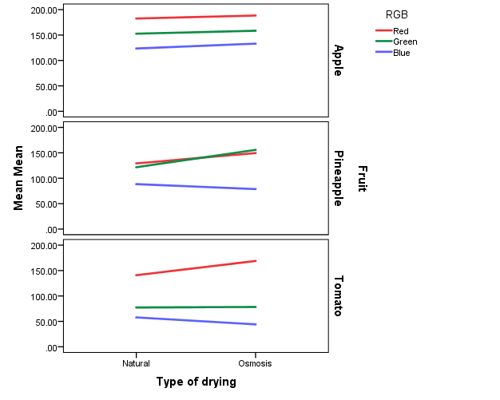
Figure 1: Shows changes in the RGB values for the three fruits during the first week.

The Mean difference in RGB values over a 5-month period.
Figure 2 shows the result for the entire 5 months of the research. The trend is more peculiar for apple in both figures than for pineapple and tomato. The superior colour retention observed in osmotically treated fruits agrees with previous findings that osmotic dehydration minimises enzymatic browning and pigment degradation. The study shows that osmotically pretreated fruits retain their brightness and lightness better than conventionally solar-dried fruits. Krokida and colleagues reported that osmotic pretreatment improves colour stability in dehydrated fruits by decreasing oxygen availability and limiting oxidation reactions. (Krokida et al., 2000; Krokida et al., 2001).
The primary agent of brightness is the sucrose solution in apples and pineapples (Leahu et al., 2020). The improved RGB values recorded for apples may be attributed to sucrose penetration into plant tissues, which stabilises cellular components and decreases enzymatic activity responsible for browning (Chauhan et al., 2011; Krokida et al., 2000). Similar observations have been reported in studies of apple, mango, and pear dehydration.
Pineapple presented remarkable improvements in red and green colour channels following osmotic treatment. The decrease in the blue for pineapple is not uncommon because a fructose solution may not have the same effect on all colours (Wojtys et al., 2025). Higher sucrose concentration and thicker slices can slightly reduce blue colouration (Akhtaruzzaman et al., 2022; Hanafi et al., 2021). Pineapple pigments and phenolic compounds are sensitive to degradation during conventional drying (Sarker et al., 2025). By lowering moisture content before solar drying, osmotic dehydration decreases thermal and oxidative stress, consequently preserving pigment integrity.
Tomato demonstrated a more detailed response. Although redness decreased slightly following salt-based osmotic treatment, green and blue intensities increased (Parvin et al., 2019). This observation may be associated with changes in carotenoid composition, particularly lycopene stability. Previous studies have reported that sodium chloride solutions may influence chroma and redness values during tomato dehydration. Despite this observation, osmosis-pre-treated tomato drying produces the best colour quality and retains more nutrients than the ordinary solar drying method (Heredia et al., 2007). As observed in this study, other studies also reported that the use of salt in osmotically preheated tomato reduces the measured redness due to a decrease in chroma (Ali et al., 2010). Salt is reported to be less favourable for redness due to its lower carotenoid reduction potential (Heredia et al., 2009). Osmosis pre-treatment of tomatoes usually facilitates drying because the salt sucks the water compared to naturally solar-dried (Escher et al., 2017). The osmosis drying also prevents flies and other insects from dropping on it, thereby making it more hygienic (Nabneanet al., 2016)
From a practical perspective, colour preservation has direct economic effects. Consumers commonly rely on appearance when evaluating food quality. Therefore, improved colour retention may increase market acceptability and profitability. The technology may be especially useful in rural communities where refrigeration facilities are scarce.
The study further demonstrates the usefulness of digital image analysis as an affordable quality assessment tool. Unlike subjective visual inspection, computer-assisted colour measurement provides objective and reproducible information. The increasing availability of smartphones and open-source software makes such approaches attractive for researchers and small-scale food processors. The findings support wider efforts to reduce post-harvest losses and strengthen food security in developing countries. Adopting osmotic dehydration could improve shelf life, reduce waste, and enhance income for farmers and fruit processors.

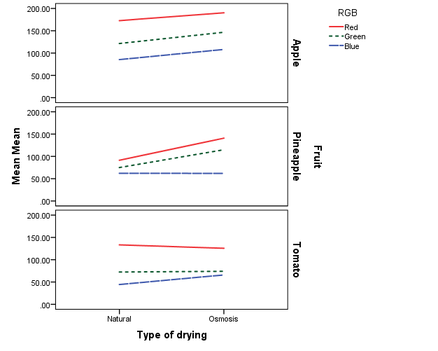
Figure 2: Shows the difference in RGB values over a 5-month period.
ANOVA, and Regression Analyses
ANOVA results showed significant differences in colour changes during the 5-month drying period (F (6, 35) =3.43, p=0.009). The boxplots in Figure 3 revealed that the colour differences between natural and osmotic drying became significant after the second week. The regression model in Table 2 explained approximately 30.6% of the variation in colour intensity, confirming that the drying method substantially influenced colour preservation.
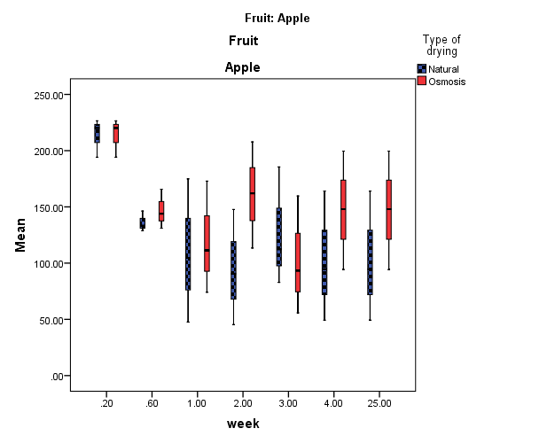
Figure 3: Boxplot for solar-dried and the osmotically pretreated fruit for the entire period.
CONCLUSION
Osmotic dehydration significantly improved colour retention relative to direct solar drying. Apples and pineapples benefited most from pretreatment, while tomatoes exhibited selective colour improvements. The technology provides a low-cost preservation strategy suitable for tropical environments in which access to refrigeration is limited. Future studies should evaluate nutrient retention, sensory acceptability, drying kinetics, moisture diffusivity and economic feasibility at a commercial scale.
ACKLEDGEMENT
The authors would like to acknowledge the Tertiary Education Trust Fund (TETFUND Nigeria) for the financial support under their institutional Based Research Programme (IBR)

REFERENCES
Akbarian, M., Ghasemkhani, N., & Moayedi, F. (2014). Osmotic dehydration of fruits in food industrial: a review.. International Journal of Biosciences, 4, 42-57. https://doi.org/10.12692/ijb/4.1.42-57.
Akhtaruzzaman, M. et al. (2022). Effects of osmotic dehydration on fruit quality. Foods.
Akhtaruzzaman, M., Shakil, M., Hossain, M. S., Alam, A., Mondal, M. H. T., Akter, T., & Alam, S. (2022). OSMO-Microwave Drying of Pineapple (Ananas comosus) Slices: Mass Transfer Kinetics and Product Quality Characterization. Asian Food Science Journal. https://doi.org/10.9734/afsj/2022/v21i12606
Ali, H., Moharram, H., Ramadan, M., & Ragab, G. (2010). Osmotic Dehydration of Banana Rings and Tomato Halves.
Ambuko, J. L., Masakhwe, S. M., Amwoka, E., Mujuka, E., & Fabi, C. (2025). Food loss and waste data gaps in fruit and vegetable value chains: a review of the literature. Frontiers in Horticulture. https://doi.org/10.3389/fhort.2025.1529040
Asghari, A., Zongo, P. A., Osse, E., Aghajanzadeh, S., Raghavan, V., & Khalloufi, S. (2024). Review of osmotic dehydration: Promising technologies for enhancing products' attributes, opportunities, and challenges for the food industries.. Comprehensive reviews in food science and food safety, 23 3, e13346 . https://doi.org/10.1111/1541-4337.13346.
Bhargava, A. & Bansal, A. (2021). Fruits and vegetables quality evaluation using computer vision. Food Analytical Methods, 14, 651–674.
Chauhan, O. P., Singh, A. P., Singh, A., Raju, P., & Bawa, A. S. (2011). Effects of Osmotic Agents on Colour, Textural, Structural, Thermal, and Sensory Properties of Apple Slices. International Journal of Food Properties, 14, 1037 - 1048. https://doi.org/10.1080/10942910903580884
Dobrzanski, B. & Rybczyński, R. (2018). Measurement of quality attributes of fruits and vegetables. Postharvest Biology and Technology.
Dou, Z. (2024). Food loss and waste. Nature Food, 5, 639 - 639. https://doi.org/10.1038/s43016-024-01041-7
Enaru, B., Drețcanu, G., Pop, T. D., Stǎnilǎ, A., & Diaconeasa, Z. (2021). Anthocyanins: Factors Affecting Their Stability and Degradation. Antioxidants, 10. https://doi.org/10.3390/antiox10121967
Hanafi, N., Hasham, R., Othman, N., & Sarmidi, M. R. (2021). Effect of osmotic dehydration combined with citric acid on bioactive compounds in freeze-dried MD2 pineapple. Asia Pacific Journal of Molecular Biology and Biotechnology. https://doi.org/10.35118/apjmbb.2021.029.4.05
Heredia, A., Barrera, C. & Andrés, A. (2007). Drying of cherry tomato by combined drying methods. Journal of Food Engineering, 80, 111–121.
Heredia, A., Peinado, I., Barrera, C. and Grau, A. (2009). Influence of process variables on colour changes, carotenoids retention and cellular tissue alteration of cherry tomato during osmotic dehydration. Journal of Food Composition and Analysis, 22, pp. 285-294. doi: 10.1016/j.jfca.2008.11.018.
Krokida, M., Karathanos, V., & Maroulis, Z. (2000). Effect Of Osmotic Dehydration On Color And Sorption Characteristics Of Apple And Banana. Drying Technology, 18, 937 - 950. https://doi.org/10.1080/07373930008917745
Krokida, M., Maroulis, Z., & Saravacos, G. (2001). The effect of the method of drying on the colour of dehydrated products. International Journal of Food Science and Technology, 36, 53-59. https://doi.org/10.1046/j.1365-2621.2001.00426.x
Leahu, A., Ghinea, C., & Oroian, M. (2020). Osmotic dehydration of apple and pear slices: color and chemical characteristics. Ovidius University Annals of Chemistry, 31, 73 - 79. https://doi.org/10.2478/auoc-2020-0014
Makule, E., Dimoso, N., & Tassou, S. (2022). Precooling and Cold Storage Methods for Fruits and Vegetables in Sub-Saharan Africa—A Review. Horticulturae. https://doi.org/10.3390/horticulturae8090776
Mawoneke, K. G., Rusike, T., Makumbirofa, H. M., & Mukwidigwi, J. (2025). From farm to fork: a review of strategies for sustainable reduction of post-harvest losses in Sub-Saharan Africa. Cogent Food & Agriculture, 11. https://doi.org/10.1080/23311932.2025.2588851
Nabnean, S. et al. (2016). Solar drying and food preservation performance. Renewable Energy.
Parvin, K., Hasanuzzaman, M., Bhuyan, M., Nahar, K., Mohsin, S., & Fujita, M. (2019). Comparative Physiological and Biochemical Changes in Tomato (Solanum lycopersicum L.) under Salt Stress and Recovery: Role of Antioxidant Defense and Glyoxalase Systems. Antioxidants, 8. https://doi.org/10.3390/antiox8090350.
Porat, R., Lichter, A., Terry, L., Harker, R., & Buzby, J. (2018). Postharvest losses of fruit and vegetables during retail and in consumers’ homes: Quantifications, causes, and means of prevention. Postharvest Biology and Technology, 139, 135-149. https://doi.org/10.1016/j.postharvbio.2017.11.019
Qian, J., Tian, M., Cao, F., Su, E., & Wang, J. (2025). A Comprehensive Review of Photooxidation Browning in Food Systems: Substrates, Mechanisms, Effects, and Inhibition Strategies.. Comprehensive reviews in food science and food safety, 25 1, e70371 . https://doi.org/10.1111/1541-4337.70371
Sarker, S., Hossain, M. S., Bhuiyan, M. N. H., Sarker, P., Boby, F., & Rahman, M. N. (2025). Effect of sodium alginate edible coating on drying behavior and quality characteristics of ripe pineapple slices. Heliyon, 11. https://doi.org/10.1016/j.heliyon.2025.e42585
Wojtyś, A., Pietrzyk, S., Grzesińska, K., & Witkowicz, R. (2025). Ultrasound-Assisted Osmotic Dehydration of Apples in Xylitol Solution: Effects on Kinetics, Physicochemical Properties and Antioxidant Activity. Molecules, 30. https://doi.org/10.3390/molecules30112304

