PropVista-Intelligent Property Selection System
Dr. Shwetkranti Taware¹, Jagruti Patil², Namrata Kedar³, Pragati Gaikwad⁴, Rohan Bondre⁵
¹ Assistant Professor, Department of Computer Engineering, Indira College of Engineering and Management, Pune.
² Pursuing B.E in Computer Engineering, Indira College of Engineering and Management, Pune.
³ Pursuing B.E in Computer Engineering, Indira College of Engineering and Management, Pune.
⁴ Pursuing B.E in Computer Engineering, Indira College of Engineering and Management, Pune.
⁵ Pursuing B.E in Computer Engineering, Indira College of Engineering and Management, Pune
------------------------------------------------------------------*****-------------------------------------------------------------------

Abstract—
Property selection is a complex process involving financial, legal, and technical considerations. However, traditional approaches often overlook critical factors such as soil quality, environmental conditions, and lifestyle suitability. This paper presents PropVista, an intelligent property selection system that integrates Artificial Intelligence (AI), Machine Learning (ML), and IoT-based soil analysis to enhance decision-making. The system evaluates properties using parameters such as Safe Bearing Capacity (SBC), soil moisture, environmental risks, and user preferences. A weighted scoring model is applied to generate accurate and personalized recommendations. The system also incorporates features such as lifestyle suitability analysis and future development prediction to support long-term investment decisions. The implementation demonstrates improved accuracy, faster response time, and enhanced user experience. The proposed system reduces dependency on experts and provides a transparent, data-driven approach to property evaluation.
Index Terms— Artificial Intelligence, Property Recommendation System, IoT-based Soil Analysis, Decision Support System, Real Estate Analytics

I. INTRODUCTION
Property buying is one of the most significant financial and lifestyle decisions for individuals, requiring careful evaluation of multiple factors. Traditional property assessment methods primarily focus on cost, legal documentation, and basic infrastructure. However, they often neglect critical aspects such as environmental conditions, soil quality, and lifestyle compatibility. This limited evaluation approach frequently results in poor decision-making, unexpected risks, and long-term financial losses.
One of the most crucial factors in property evaluation is soil quality, which directly affects construction safety and durability. The Safe Bearing Capacity (SBC) determines the maximum load the soil can safely support. Weak soil conditions can lead to structural instability, cracks, and even collapse over time. In addition, environmental factors such as moisture content, climate variations, historical land usage, and natural risks (e.g., floods or earthquakes) significantly influence both the safety and value of a property.
Another important but often overlooked aspect is lifestyle suitability, which includes proximity to essential services such as hospitals, schools, transportation, and workplaces. A property that does not align with the user’s lifestyle needs can lead to inconvenience and reduced quality of life, even if it meets financial and legal requirements.
Despite the importance of these parameters, their analysis is rarely accessible to common users due to limited technical knowledge and lack of user-friendly tools. As a result, buyers rely heavily on civil engineers or real estate experts, which increases cost, delays the decision-making process, and may introduce biased or inaccurate recommendations.
To address these challenges, PropVista is proposed as an intelligent property selection system that integrates Artificial Intelligence (AI), IoT-based soil analysis, and decision support mechanisms. The system evaluates properties using multiple parameters, including soil testing, moisture analysis, environmental risk assessment, and lifestyle suitability. It employs a data-driven approach to generate personalized recommendations and predictive insights, enabling users to make informed, transparent, and reliable property decisions.
By combining civil engineering principles with modern technologies, PropVista bridges the gap between technical analysis and user-friendly applications, ultimately improving safety, efficiency, and confidence in property selection.
II. LITERATURE REVIEW
Recent advancements in Artificial Intelligence (AI), Machine Learning (ML), and data-driven systems have significantly improved property evaluation and recommendation processes. Various research works have explored intelligent techniques to enhance decision-making in the real estate domain.
Recommender systems are widely used in real estate applications to provide personalized property suggestions. Techniques such as content-based filtering, collaborative filtering, and hybrid approaches analyze user preferences and property attributes to generate recommendations. Advanced deep learning models, including Convolutional Neural Networks (CNN) and Long Short-Term Memory (LSTM) networks, are used to process multimodal data such as images, text, and numerical features. However, these systems often suffer from challenges such as the cold-start problem and data sparsity, which reduce their recommendation accuracy [2], [3].
Machine learning approaches have also been extensively applied for property valuation and prediction. Traditional methods such as linear regression and hedonic pricing models are increasingly being replaced by advanced algorithms like Random Forest, XGBoost, and neural networks. These models improve prediction accuracy by capturing complex relationships between variables. Nevertheless, most of these approaches focus primarily on financial and structural parameters and fail to incorporate environmental factors such as soil quality and moisture levels, which are crucial for construction safety [1], [4].
Geographic Information Systems (GIS) combined with the Analytic Hierarchy Process (AHP) are widely used for land suitability analysis. These methods utilize spatial data such as soil type, topography, and infrastructure availability to assess land potential. However, AHP-based models depend heavily on expert-defined weights, making them subjective and less scalable for general users [10].
Fuzzy logic-based recommendation systems have been introduced to handle uncertainty in user preferences by representing suitability as degrees rather than binary values. While these systems provide flexibility in decision-making, they are rarely integrated with deep learning techniques or real-time environmental data, limiting their predictive performance [8].
Furthermore, IoT-based systems have been developed to monitor environmental parameters such as soil moisture and temperature in real time. These systems enhance data accuracy and enable continuous monitoring. However, they lack integration with intelligent recommendation systems, which limits their applicability in property evaluation and decision-making [6].
Despite these advancements, existing systems do not provide a unified framework that integrates AI-based recommendation, IoT-based environmental sensing, and civil engineering parameters such as Safe Bearing Capacity (SBC). Additionally, there is limited focus on lifestyle suitability and future development prediction, which are essential for comprehensive property evaluation.
To address these gaps, the proposed system, PropVista, integrates AI, IoT-based soil analysis, and decision support mechanisms into a single platform. This approach enables accurate, transparent, and data-driven property selection, improving both user experience and decision-making efficiency.

III. PROBLEM STATEMENT
Traditional property evaluation methods are largely limited to basic parameters such as price, legal documentation, and infrastructure availability. These approaches fail to integrate critical aspects such as environmental conditions, soil characteristics, and lifestyle suitability, which play a significant role in determining the long-term safety and usability of a property. As a result, buyers often make decisions based on incomplete information, leading to potential risks and financial losses.
In current practices, property assessment heavily relies on manual processes and expert consultation. While civil engineers and real estate professionals provide valuable insights, this dependency increases the overall cost and time required for evaluation. Moreover, the possibility of biased recommendations, lack of transparency, and inconsistent analysis further complicates the decision-making process for buyers, especially for non-technical users.

Existing digital systems and real estate platforms primarily focus on property listings, pricing trends, and basic filtering mechanisms. However, they do not provide integrated solutions that combine soil testing (Safe Bearing Capacity), moisture analysis, environmental risk assessment, and future development prediction within a single framework. The absence of such comprehensive evaluation tools limits the effectiveness of these systems in providing reliable and data-driven recommendations.
Additionally, there is a lack of user-friendly platforms that can simplify complex civil engineering concepts and present them in an understandable format for common users. This gap restricts the accessibility of critical technical information, preventing users from making well-informed decisions regarding property investment.
Therefore, there is a strong need for a centralized intelligent system that integrates environmental, structural, and lifestyle parameters into a unified decision-making framework. Such a system should provide accurate, transparent, and real-time analysis by combining Artificial Intelligence, IoT-based data collection, and predictive modeling techniques. The proposed system, PropVista, aims to address these challenges by delivering a comprehensive, user-friendly, and data-driven property recommendation solution.

IV. OBJECTIVES
The objectives of this research are:
- To develop an intelligent property selection system
- To integrate soil analysis (Safe Bearing Capacity) into property evaluation
- To incorporate IoT-based environmental data (moisture, risk factors)
- To implement AI-based property recommendation techniques
- To include lifestyle suitability analysis
- To generate automated and structured property reports
- To reduce dependency on expert consultation
- To improve transparency and efficiency in
- To provide real-time analysis using IoT-based sensors for accurate environmental and soil data collection
- To incorporate future development prediction for better long-term property investment decisions.

V. SYSTEM ARCHITECTURE
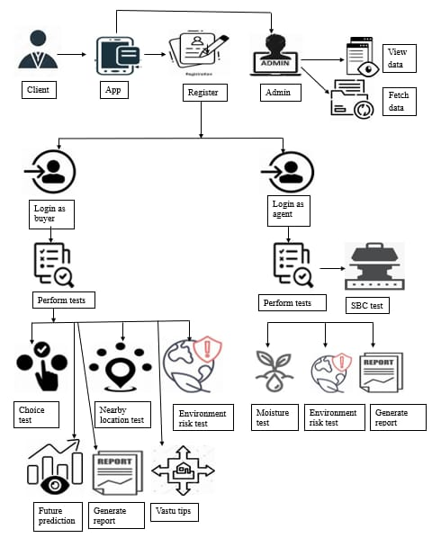
Fig. 1. System Architecture
The system architecture of PropVista represents the interaction between the user, application, admin, and database components to ensure efficient property evaluation and report generation.
The process begins with the user, who interacts with the system through a mobile application interface. The user performs authentication (login) and provides necessary inputs such as preferences and test parameters. After successful login, the user can access the Perform Test module, which includes multiple evaluation tests such as Safe Bearing Capacity (SBC) Test, Moisture Test, and Choice Test.
The Choice Test further evaluates parameters like lifestyle suitability and risk factors, ensuring that both technical and user-centric aspects are considered. The results from all tests are processed within the system and combined to generate a comprehensive analysis.
Once the evaluation is completed, the system generates a detailed report, which provides insights into property suitability based on collected data and computed results.
On the administrative side, the Admin Module manages system operations. The admin can log in to the system, access stored data, and perform actions such as viewing data and fetching information from the database. The database stores user inputs, test results, and generated reports, ensuring data consistency and easy retrieval.
The overall architecture ensures smooth data flow from user input to report generation while maintaining efficient communication between system components. This design supports real-time analysis, secure data handling, and scalable system performance, making it suitable for intelligent property selection.

VI. PROPOSED SYSTEM
The proposed system, PropVista – Intelligent Property Selection System, is designed to provide a comprehensive and data-driven solution for property evaluation by integrating Artificial Intelligence (AI), IoT-based environmental sensing, and civil engineering analysis. The system aims to overcome the limitations of traditional property selection methods by combining multiple parameters such as user preferences, property features, environmental conditions, and structural feasibility into a unified platform.
The system operates through a mobile-based interface that allows users to input their requirements, including budget, location, and lifestyle preferences. Based on these inputs, the system retrieves relevant property data from the database and performs a detailed evaluation using predefined criteria. In addition to conventional parameters, the system incorporates environmental data collected through IoT sensors, such as soil moisture levels and inputs required for Safe Bearing Capacity (SBC) calculation. This integration enables real-time and accurate assessment of land conditions.
A core component of the proposed system is the intelligent recommendation engine, which evaluates properties using a weighted scoring model. The model considers multiple factors, including property attributes, user preferences, sensor data, and associated risks, to generate a suitability score for each property. Based on these scores, properties are ranked and the most suitable options are recommended to the user.
The system also includes a soil analysis module, which calculates soil resistance and Safe Bearing Capacity (SBC) to determine the structural stability of the land. This ensures that the recommended properties meet safety requirements for construction. Furthermore, the system incorporates additional features such as lifestyle suitability analysis, environmental risk assessment, and prediction of future developments in the selected area, providing a holistic evaluation approach.
To enhance usability, the system generates a comprehensive report that summarizes all analysis results, including property scores, soil conditions, risk levels, and recommendations. This report is designed to be easily understandable, even for non-technical users, thereby improving transparency and decision-making.
The backend system, supported by Firebase or SQLite, ensures efficient data storage, retrieval, and processing, while the admin module allows monitoring and management of system data and user activities. Overall, the proposed system provides a scalable, user-friendly, and intelligent solution for modern property selection, bridging the gap between technical analysis and practical usability.

VII. METHODOLOGY
The proposed system, PropVista – Intelligent Property Selection System, follows a structured and modular methodology to evaluate property suitability by integrating user inputs, environmental data, and intelligent computational models. The system combines mobile application interaction, IoT-based sensing, and data-driven algorithms to provide accurate and reliable property recommendations.
The process begins with the user interacting through an Android-based interface, where preferences such as budget, location, and amenities are provided. Simultaneously, environmental parameters such as soil moisture and Safe Bearing Capacity (SBC) are collected using IoT sensors. These inputs are transmitted to the processing layer, where they undergo preprocessing and normalization to ensure consistency and comparability across different data sources.
The system employs a mathematical scoring model to evaluate the suitability of properties. The overall suitability score is computed using a weighted function that integrates multiple
𝑆𝑐𝑜𝑟𝑒=𝑤1𝑃+𝑤2𝑈+𝑤3𝑆−𝑤4𝑅
where 𝑃 represents property features such as price, location, and amenities, 𝑈 denotes user preference matching, 𝑆 represents sensor-based environmental data, and 𝑅corresponds to risk factors. The weights w1, w2, w3, and 𝑤4 determine the relative importance of each parameter in the evaluation process.
To ensure structural safety, the system incorporates a soil analysis model. The soil resistance The overall architecture ensures smooth data flow from user input to report generation while maintaining efficient communication between system components. This design supports real-time analysis, secure data handling, and scalable system performance, making it suitable for intelligent property selection.
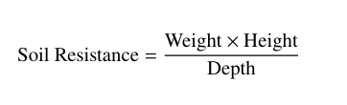
The Safe Bearing Capacity (SBC), which indicates the maximum load the soil can safely support, is then computed using:
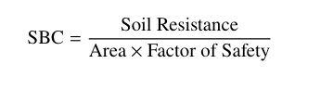
These values are normalized and integrated into the scoring model to enhance the accuracy of property evaluation. Properties are then ranked based on their computed scores, and the most suitable options are presented to the user.
Overall, the proposed methodology integrates Artificial Intelligence, IoT-based sensing, and civil engineering principles into a unified framework, enabling accurate, real-time, and user-centric property selection.

VIII. RESULTS AND DISCUSSION
The proposed system, PropVista – Intelligent Property Selection System, was successfully implemented and tested using real-time inputs, simulated property data, and IoT-based sensor integration. The system demonstrates effective performance in analyzing property suitability by combining user inputs, environmental data, and intelligent evaluation models.
The mobile application interface generates a comprehensive analyzed report that includes user details, soil analysis results, environmental risk assessment, and final property recommendations. The system accurately computes parameters such as Safe Bearing Capacity (SBC) and moisture percentage, which are further used to derive insights related to land usability, structural stability, and construction feasibility.
From the generated reports, it is observed that the system provides detailed evaluation metrics such as seasonal stability, flood risk, water logging risk, foundation stability, and property ranking. For example, the system successfully classified soil conditions (e.g., silty soil) and provided construction recommendations such as suitable foundation types (raft foundation) and allowable number of floors. This demonstrates the system’s ability to translate technical soil data into user-friendly insights.
The integration of IoT hardware components, including Arduino UNO, soil moisture sensor, and Bluetooth module (HC-05), enabled real-time environmental data collection. The sensor readings were accurately transmitted to the mobile application, ensuring reliable and dynamic analysis. The system effectively utilized these inputs to compute SBC values and assess soil strength.
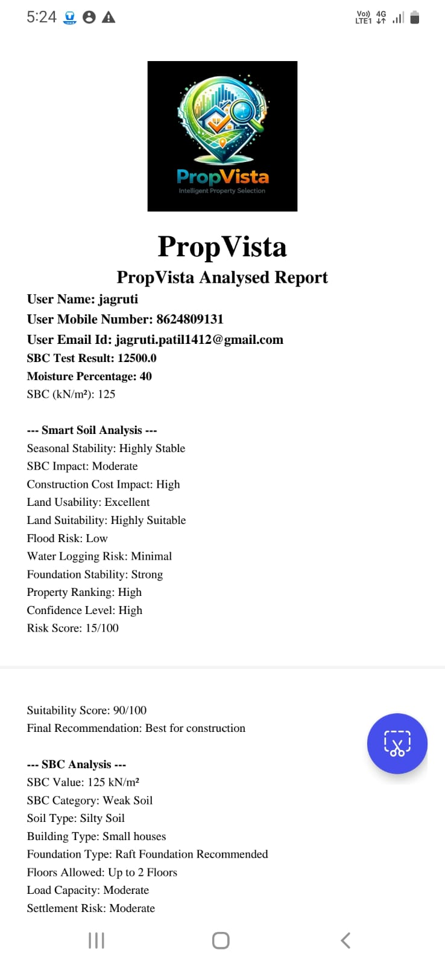
Fig. 1. PropVista Generated Analysis Report
Figure 1 presents the generated property analysis report produced by the PropVista system through the mobile application interface. The report includes detailed user information along with computed environmental and structural parameters.
The system successfully calculates key metrics such as Safe Bearing Capacity (SBC) and soil moisture percentage, which are critical for evaluating construction feasibility. In this case, the SBC value is calculated as 125 kN/m², and the moisture percentage is 40%, indicating moderate soil conditions.

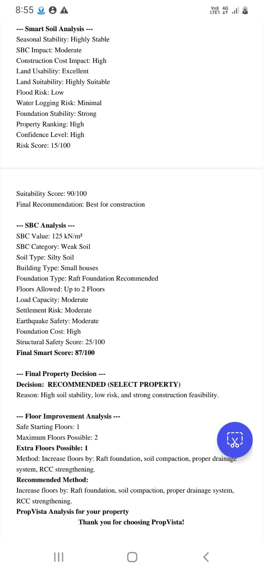
Fig. 2. Smart Soil Analysis and Final Property Decision Report
It illustrates the detailed output generated by the PropVista system, focusing on smart soil analysis, structural evaluation, and final property decision-making. The system analyzes multiple environmental and structural parameters to provide a comprehensive assessment of property suitability.
The Smart Soil Analysis section evaluates key factors such as seasonal stability, flood risk, water logging risk, and foundation stability. The results indicate that the soil is highly stable, with low flood risk and minimal water logging, suggesting favorable environmental conditions. The system also identifies high land usability and suitability, along with strong foundation stability, indicating that the property is structurally reliable.
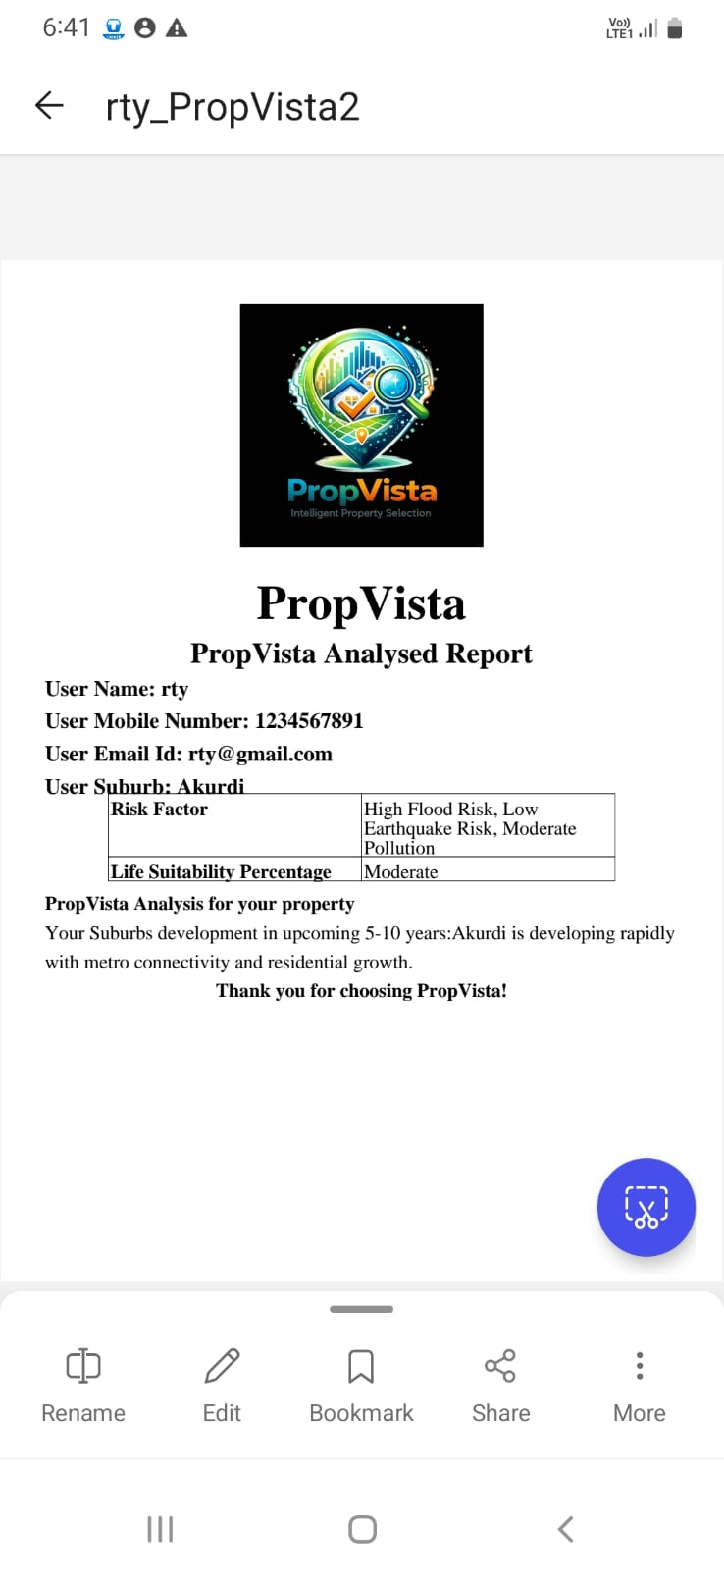
Fig. 3. Lifestyle Suitability and Future Development Analysis Report
It presents the output of the lifestyle suitability and location-based analysis module of the PropVista system. The report includes user details along with suburb-specific insights to support informed property decisions.
The system evaluates environmental risk factors associated with the selected location, such as flood risk, earthquake risk, and pollution levels. In this case, the analysis indicates high flood risk, low earthquake risk, and moderate pollution, providing a balanced understanding of environmental conditions.

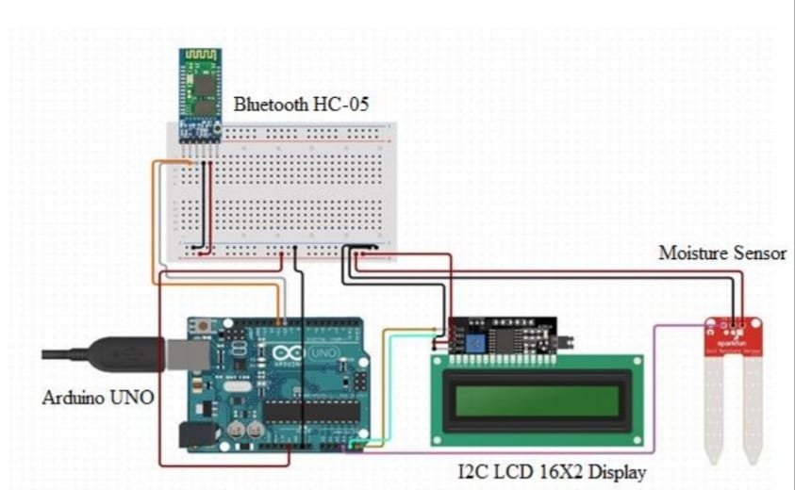
Fig. 4. IoT-Based Soil Moisture and Data Acquisition System

It illustrates the hardware setup used in the PropVista system for real-time environmental data collection, specifically soil moisture analysis. The system is built using an Arduino UNO microcontroller, which acts as the central processing unit for collecting and transmitting sensor data.
The setup includes a soil moisture sensor, which measures the water content present in the soil. This sensor provides analog data representing soil moisture levels, which is essential for evaluating land conditions and construction suitability. The collected data is processed by the Arduino and displayed on an I2C LCD (16x2) display, enabling real-time visualization of sensor readings.
Additionally, a Bluetooth module (HC-05) is integrated into the system to enable wireless communication between the hardware setup and the mobile application. This allows the sensor data to be transmitted efficiently to the PropVista application for further analysis and processing.

IX. ADVANTAGES
The The proposed system, PropVista, offers several advantages in improving the process of property evaluation and selection. One of the key benefits is the reduction in dependency on civil engineering experts for basic analysis, as the system enables users to perform essential evaluations such as soil testing and environmental assessment independently. This significantly reduces both the time and cost involved in traditional property evaluation methods.
The system provides a data-driven and accurate decision-making approach by integrating multiple parameters, including property features, user preferences, environmental conditions, and soil characteristics. Unlike conventional systems that rely on limited factors, PropVista ensures a more comprehensive evaluation by combining Artificial Intelligence, IoT-based sensing, and civil engineering principles within a single platform.
Another major advantage is the enhanced transparency in the decision-making process. The system generates structured and easy-to-understand reports, allowing users to clearly interpret the results and make informed decisions. Additionally, the inclusion of real-time environmental data, such as soil moisture and risk factors, improves the reliability and practicality of the analysis.
PropVista also contributes to better user awareness and understanding by simplifying complex technical concepts like Safe Bearing Capacity (SBC) and soil strength. This makes the system highly accessible to non-technical users, enabling them to confidently evaluate properties without specialized knowledge.
Furthermore, the system incorporates lifestyle suitability analysis, considering factors such as nearby facilities and future development, which enhances the overall quality of property selection. Its user-friendly interface, scalability, and ability to provide automated recommendations make it an efficient and modern solution for real estate decision-making.
Overall, the proposed system improves efficiency, accuracy, transparency, and user empowerment in property evaluation, making it a valuable tool for buyers, builders, and investors.

X. LIMITATIONS
Despite its advantages, the proposed system, PropVista, has certain limitations that may affect its overall performance and applicability. One of the primary limitations is its dependence on the accuracy of input data. If users provide incomplete or incorrect information, or if sensor readings are inaccurate, the generated results and recommendations may be affected.
The system also relies on IoT-based sensors for environmental data such as soil moisture and SBC-related inputs. Any malfunction, calibration error, or unavailability of these sensors can impact the reliability of the analysis. Additionally, real-time data acquisition may vary depending on hardware quality and environmental conditions.
Another limitation is that the system’s recommendation model is based on predefined weights and parameters. While this provides structured analysis, it may not fully capture all real-world complexities or dynamic changes in property conditions and market trends.
The system also requires internet connectivity for accessing APIs, fetching environmental data, and processing user inputs. In areas with poor network connectivity, system performance and usability may be limited.
Overall, addressing these limitations in future enhancements can further improve the system’s accuracy, reliability, and scalability.

XI. FUTURE SCOPE
The proposed system, PropVista, can be further enhanced by incorporating advanced technologies and expanding its capabilities to improve accuracy, scalability, and usability. One of the key future enhancements is the integration of advanced machine learning and deep learning models, such as neural networks, to improve the precision of property recommendations and predictive analysis.
The system can be extended by developing a web and cross-platform mobile application, enabling wider accessibility and improved user engagement. Integration with real-time real estate datasets and government databases can further enhance the reliability and accuracy of property information and predictions.
The system can also be expanded to include blockchain technology for secure and transparent property transactions, reducing the risk of fraud. Integration with Geographic Information Systems (GIS) can provide detailed location-based analysis, including infrastructure development, traffic patterns, and risk zones.
Furthermore, the platform can be scaled to support smart city applications, where it can assist in urban planning and large-scale infrastructure decision-making. Enhancements such as real-time notifications, personalized dashboards, and advanced reporting features can further improve user experience.
Overall, these future improvements will transform PropVista into a more intelligent, scalable, and comprehensive property evaluation system, capable of addressing real-world challenges in the real estate domain.

XII. CONCLUSION
This paper presented PropVista, an intelligent property selection system designed to improve decision-making in the real estate domain by integrating Artificial Intelligence, IoT-based soil analysis, and civil engineering principles. Unlike traditional methods that focus mainly on financial and legal aspects, the proposed system considers critical parameters such as Safe Bearing Capacity (SBC), soil moisture, environmental risks, and lifestyle suitability.
The system provides a comprehensive and data-driven approach to property evaluation by combining user preferences with real-time environmental data and analytical models. It simplifies complex technical assessments and makes them accessible to non-technical users, thereby reducing dependency on expert consultation.
The implementation demonstrates improved accuracy, efficiency, and transparency in property selection. By generating structured reports and personalized recommendations, PropVista enables users to make informed, reliable, and safe investment decisions.
Overall, the proposed system bridges the gap between civil engineering analysis and user-friendly technology, contributing to the development of smart and intelligent real estate solutions.

REFERENCES
[1] G. Kaur and A. Sharma, “AI-Driven Property Valuation System for Real Estate Markets,” International Journal of Advanced Computer Science and Applications, 2023.
[2] C. Henríquez-Miranda, A. Araya, and M. Riquelme, “Recommender Systems in Real Estate: A Systematic Review,” Expert Systems with Applications, Elsevier, 2024.
[3] A. Gharahighehi, K. Pliakos, and C. Vens, “Recommender Systems in the Real Estate Market—A Survey,” Journal of Intelligent Information Systems, Springer, 2021.
[4] R. Batra and M. Singh, “Smart Real Estate Decision Systems Using IoT and Data Analytics,” in Proceedings of the International Conference on Smart Computing and Systems Engineering (ICSCE), 2022.
[5] D. V. Parkhomenko and E. A. Predtechenskaya, “Methodology for Conducting and Analyzing Land Surveying Examinations,” IOP Conference Series: Earth and Environmental Science, vol. 579, 2020.
[6] P. Divyavani and R. Rao, “Measurement and Monitoring of Soil Moisture Using Cloud IoT and Android System,” Indian Journal of Science and Technology, vol. 9, no. 31, pp. 1–8, 2016.
[7] M. Dixit and K. Patil, “Study of Effect of Different Parameters on Bearing Capacity of Soil,” Indian Geotechnical Conference, Guntur, India.
[8] “Recommender Systems in Real Estate: A Systematic Review,” ResearchGate. [Online]. Available: https://www.researchgate.net/publication/392295516
[9] “Real Estate Analytics Study,” ScienceDirect. [Online]. Available: https://www.sciencedirect.com/science/article/pii/S0197397525002310
[10] “Application of GIS and AHP for Land Use Suitability Analysis,” ResearchGate. [Online]. Available: https://www.researchgate.net/publication/369357367
[11] “Journal of Management Information Systems Article,” AIS eLibrary. [Online]. Available: https://aisel.aisnet.org/cgi/viewcontent.cgi
[12] “Real Estate Machine Learning Study,” PubMed Central (PMC). [Online]. Available: https://pmc.ncbi.nlm.nih.gov/articles/PMC10909664

