Hirelink: A Web Based Campus Recruitment Platform

Introduction
Campus recruitment is one of the most important processes conducted in higher educational institutions, as it connects students with employment opportunities and enables organizations to recruit skilled candidates efficiently. In many colleges and universities, recruitment activities are still managed manually using spreadsheets, emails, and paper-based documentation. Such traditional methods often result in communication gaps, delayed updates, inefficient candidate management, data redundancy, and lack of transparency.
With the increasing number of students and recruitment drives, educational institutions require intelligent and automated systems capable of managing recruitment workflows efficiently. Existing placement management systems provide partial automation but often lack features such as AI-assisted resume screening, analytics dashboards, automated eligibility verification, and centralized communication mechanisms.
To address these limitations, this paper proposes HireLink, an intelligent AI-assisted campus recruitment platform designed to streamline the recruitment lifecycle through automation and centralized management. The system integrates student registration, recruiter job posting, ATS-based resume analysis, round-wise candidate tracking, analytics dashboards, alumni networking, and notification management within a unified architecture.
The major contributions of the proposed system include:
• AI-based resume screening and ATS score generation
• Automated eligibility filtering for job applications
• Centralized placement activity management
• Real-time recruitment analytics and dashboards
• Round-wise candidate tracking and notification system
• Alumni interaction and mentorship support
The proposed platform improves operational efficiency, reduces manual workload, and enhances transparency in campus recruitment processes while providing scalable and secure system architecture.

- PROBLEM STATEMENT
Traditional campus recruitment systems rely heavily on manual processes for student registration, resume collection, candidate shortlisting, and communication management. These methods are time-consuming, error-prone, and inefficient when handling large volumes of recruitment data.
The major challenges identified in existing placement processes include:
• Manual resume screening and candidate filtering
• Lack of centralized recruitment management
• Delayed communication between stakeholders
• Difficulty in tracking recruitment rounds and application status
• Limited analytics and reporting mechanisms
• Absence of intelligent recommendation and ATS systems
These limitations reduce recruitment efficiency and increase administrative workload for placement officers. Therefore, there is a need for an intelligent and automated placement management system capable of improving transparency, efficiency, and decision-making in campus recruitment.

- LITERATURE REVIEW
Several researchers have proposed web-based recruitment and placement management systems to improve the efficiency of campus hiring activities. Sharma and Sharma [1] developed a web-based job portal for campus recruitment that simplified communication between students and recruiters through online application management and job posting features. Their system reduced paperwork and improved accessibility, but lacked intelligent resume analysis and automation features.
Gupta et al. [2] introduced a scalable recruitment platform based on cloud computing technologies. The system focused on improving data availability, scalability, and system performance for handling large recruitment datasets. Although the platform improved infrastructure efficiency, it did not provide advanced candidate evaluation or placement analytics mechanisms.
Patel and Yadav [3] proposed an intelligent job recommendation system that matched student profiles with suitable job opportunities using skill-based filtering techniques. Their work improved candidate-job matching accuracy, but the system lacked centralized recruitment workflow management and real-time placement tracking capabilities.
Kumar et al. [4] presented a database-driven placement management system that focused on efficient storage and retrieval of recruitment data. The proposed system improved data consistency and reduced redundancy in placement records. However, the system primarily concentrated on database operations and did not support intelligent automation or recruiter analytics.
B. B et al. [5] developed JobQuench, an automated placement management system designed to enhance campus recruitment processes through centralized job management and student tracking. The system provided recruiter coordination and placement monitoring features, but limited emphasis was given to AI-assisted resume screening and analytics-driven decision-making.
Smitha Shekar et al. [6] proposed OPUSCONNECT, a digital platform for streamlining placement management in higher educational institutions. Their system improved communication and placement activity management through centralized dashboards and digital workflows. However, the platform lacked ATS-based resume ranking and automated eligibility verification mechanisms.
Jewani et al. [7] designed an online training and placement system that enabled students to apply for jobs and track placement activities through a web-based portal. The system enhanced accessibility and placement coordination but did not integrate intelligent recommendation systems or analytics modules.
McCarthy and Anagnostopoulos [8] discussed the design and implementation of a web-based recruitment management system focused on automating recruitment operations and improving recruiter interaction. Their work demonstrated the benefits of digital recruitment systems but lacked advanced AI-driven candidate evaluation techniques.
Gupta and Sharma [9] proposed a web-based placement management application that simplified placement activity handling through online registration and application management. While the system improved operational efficiency, it lacked intelligent automation, resume screening, and real-time analytics support.
Table 1. Comparative Analysis of Existing Recruitment Systems
Feature | Existing Systems | HireLink
ATS Screening | Partial | Yes
Alumni Connect | No | Yes
Round-wise Tracking | Limited | Advanced
Analytics Dashboard | Basic | Integrated
Automated Eligibility Filtering | Limited | Yes
Centralized Recruitment Management | Partial | Yes

From the literature survey, it is observed that most existing systems primarily focus on digitizing recruitment workflows and improving placement coordination. However, many platforms lack AI-assisted resume screening, automated eligibility filtering, analytics dashboards, and centralized round-wise recruitment tracking. The proposed HireLink system addresses these limitations by integrating ATS-based resume analysis, analytics-driven placement monitoring, automated notifications, and alumni networking within a unified web-based architecture.

METHODOLOGY
The Hirelink system follows a three-tier architecture consisting of Presentation Layer, Application Layer, and Data Layer. The platform is developed using React.js for frontend development, Django for backend processing, and MySQL for database management [5].
A. AI-Based Resume Screening
The system incorporates an Applicant Tracking System (ATS) module that automatically evaluates resumes based on job-specific keywords, skills, education details, and experience parameters [3]. The ATS score is calculated using keyword matching and similarity analysis between recruiter job descriptions and candidate resumes [3]. Candidates with higher ATS scores are prioritized during shortlisting.
ATS Score = (Matched Keywords / Total Required Keywords) × 100
B. Automated Eligibility Filtering
The platform automatically verifies candidate eligibility based on criteria such as CGPA, skills, branch, and graduation year [6]. Ineligible candidates are filtered before the application reaches recruiters.
C. Alumni Connect Module
The HireLink platform includes an Alumni Connect module designed to improve interaction between students and alumni [6]. This module allows students to connect with placed alumni for mentorship, career guidance, interview preparation, and placement-related support.
Alumni users can share their professional experiences, provide recruitment insights, and guide students regarding company-specific interview processes and required technical skills [7]. The module helps students improve career readiness and strengthens communication between current students and alumni networks.
The Alumni Connect feature also enhances professional networking opportunities and creates a collaborative placement ecosystem within the institution.
D. Round-wise Selection Process
The HireLink system provides a round-wise selection management feature that enables recruiters and placement officers to track candidate progress throughout the recruitment process [5]. Recruitment rounds such as Aptitude Test, Technical Interview, Group Discussion, and HR Interview are managed digitally through the platform.
Recruiters can update candidate status after each round, and students receive real-time notifications regarding selection results and upcoming interview schedules [1]. The system maintains centralized records of candidate performance and recruitment progression for efficient placement monitoring.
This feature improves transparency, reduces communication delays, and simplifies recruitment coordination for students, recruiters, and placement officers [6].
E. Recruitment Workflow
• Students create profiles and upload resumes [7]
• Recruiters post job opportunities with eligibility criteria [1]
•ATS engine analyzes resumes and generates scores [3]
• Eligible candidates are shortlisted automatically [5]
• Recruiters schedule interview rounds [6]
• Students receive notifications and application updates [7]
• Placement officers monitor analytics and recruitment statistics [5]
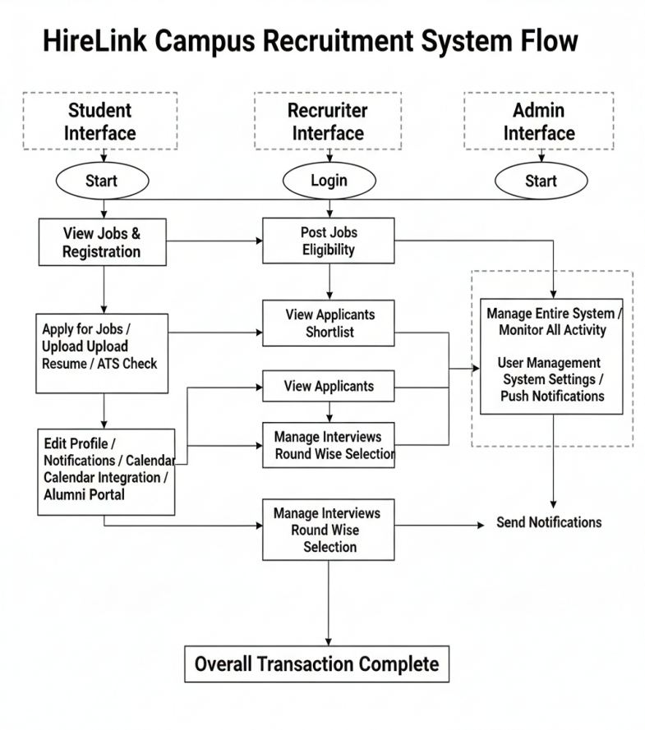Fig 1. System Flow
The proposed system improves recruitment speed, operational transparency, and candidate evaluation accuracy through intelligent automation and centralized placement management [5].
4.2 Workflow and Process Flow
Students register and log into the system, complete their profiles, and upload resumes. They can browse job postings, check eligibility criteria, and apply for suitable positions. Application status and interview updates are displayed on the student dashboard[1],[7].

Recruiters log in and post job openings with specific eligibility conditions. The system automatically filters applications based on criteria and ATS scores. Recruiters can shortlist candidates, conduct interviews, and update selection status[3],[5].

The admin or placement officer supervises all recruitment activities, manages users, posts announcements, monitors analytics, and ensures smooth execution of the recruitment process[5],[6].

4.2.1 Data Handling and Storage[4].
The system manages structured data including:
- Student academic records, skills, and resumes
- Recruiter job postings and eligibility requirements
- Application status and interview round details
- Notification logs and analytics data
All data is securely stored in a MySQL database, ensuring consistency and integrity.
4.3 Architecture Diagram.
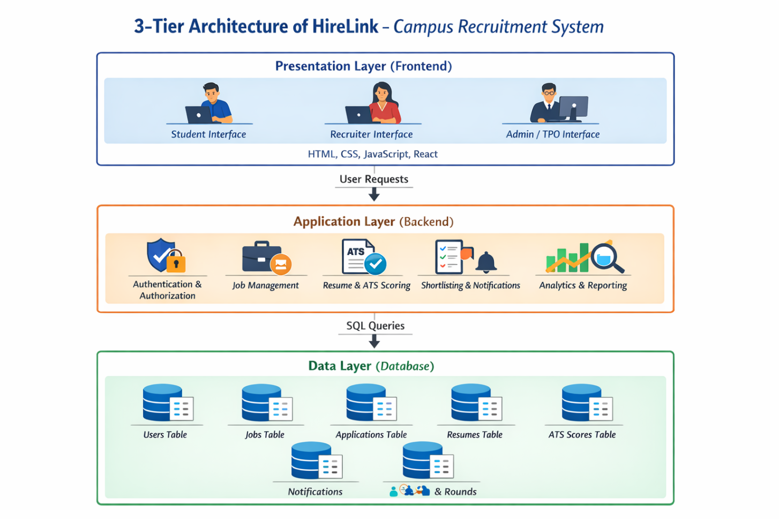

Fig 2. Architecture Diagram

4.3.1 Presentation Layer:
This layer provides the efficient user interface for interaction with the HireLink system [1]. It includes separate dashboards for Students, Recruiters, and Admin/Placement Officers (TPO), allowing users to register, log in, view available job opportunities, check eligibility criteria, upload resumes, apply for jobs, and track application status [7]. Recruiters can post job openings, view applicants, and manage shortlisting processes, while Admin/TPO users can monitor overall system activities, manage users, and view placement analytics [5]. The Presentation Layer focuses on usability, responsiveness, and accessibility to ensure a smooth user experience [6].

4.3.2 Application Layer:

The Application Layer handles the core processing and business logic of the system [5]. It is responsible for user authentication and role-based access control, job and application management, resume parsing and ATS (Applicant Tracking System) score calculation, shortlisting of candidates, notification generation, and analytics processing [3]. This layer processes all requests received from the Presentation Layer and communicates with the Data Layer to store and retrieve required information [4]. It ensures that business rules are correctly applied and that system operations are executed securely and efficiently [2].

4.3.3 Data Layer:

The Data Layer is responsible for storing, organizing, and managing all system data [4]. It consists of a relational database server that stores user profiles, job details, applications, resumes, ATS scores, notifications, and selection round information [5]. The Data Layer ensures data integrity, consistency, and reliability. It also supports backup and recovery mechanisms to prevent data loss and enable continuous system availability [2]
.

4.3.4 Output Flow:

The system delivers relevant outputs to users through role-specific dashboards [6]. Students receive job recommendations, ATS scores, application status, and notifications [7]. Recruiters receive applicant lists, ranked candidates based on ATS scores, and shortlisting results [3]. Admin/TPO users receive placement statistics, analytics reports, and system activity summaries [5]. These outputs assist stakeholders in making faster and more informed recruitment decisions [1].

result and discussion

The proposed HireLink system successfully automated major campus recruitment activities including student registration, job application management, resume screening, and placement tracking. Compared to traditional manual methods, the system reduced recruitment processing time and improved communication efficiency [1].
The ATS-based screening module helped recruiters shortlist candidates more effectively using skill-based evaluation and automated filtering techniques [3]. Analytics dashboards provided placement officers with centralized monitoring and recruitment statistics, improving operational transparency and decision-making [5].
Experimental observations indicate that the proposed system improves recruitment efficiency, reduces administrative workload, and enhances coordination between students, recruiters, and placement officers.
Parameter | Traditional Method | HireLink System

Resume Screening Time | 15 minutes/student | 2 minutes/student

Application Tracking | Manual | Automated

Communication Delay | High | Low

DataConsistency | Moderate | High
The platform also improved operational transparency by providing role-based dashboards for students, recruiters, and placement officers. Students were able to track application status and receive notifications in real time, while recruiters could monitor shortlisted candidates and recruitment rounds efficiently [5].
Graph 1. Resume Screening Time Comparison
Traditional Method → 15 minutes
HireLink System → 2 minutes
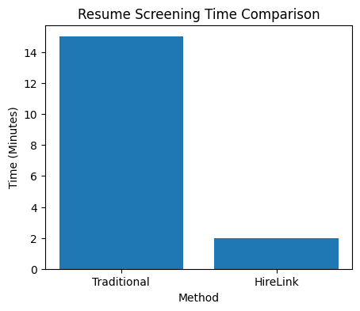
Graph 2. Recruitment Efficiency Comparison
Manual System → 65%
HireLink Platform → 93%
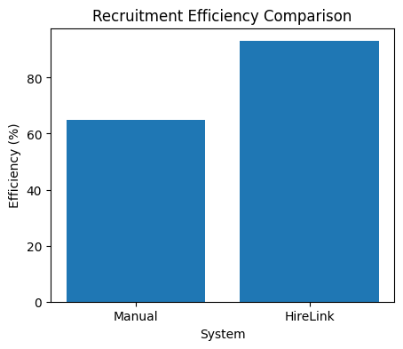
Graph 3. User Satisfaction Analysis
Students → 91%
Recruiters → 88%
Placement Officers → 94%
The experimental results demonstrate that the proposed HireLink system improves recruitment speed, reduces administrative effort, enhances transparency, and provides better recruitment coordination through intelligent automation and centralized management.

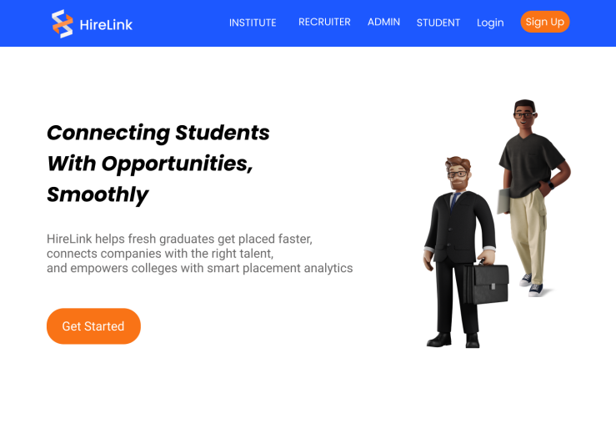
Img 1. Landing Page

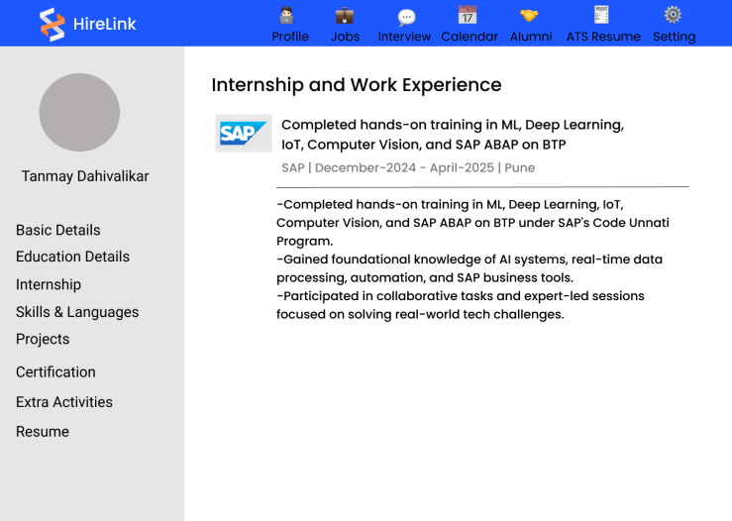
Img 2. Student Profile Page

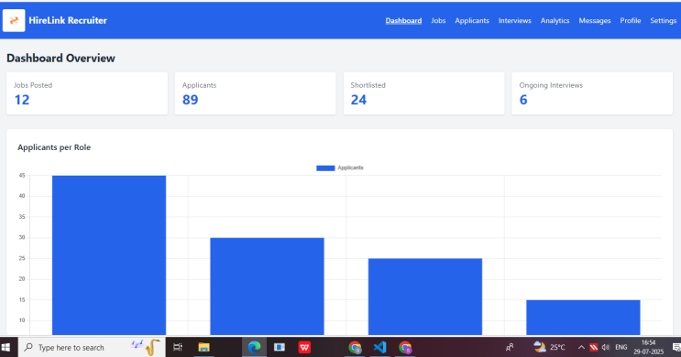

Img 3. Recruiter Dashboard

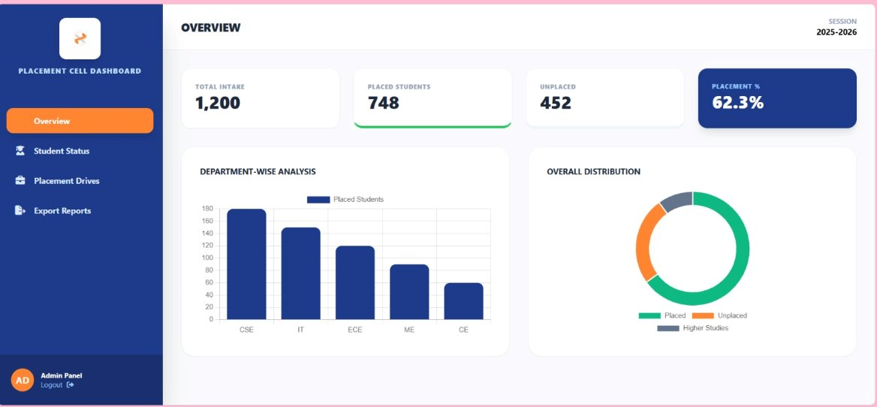Img4.Admin Page

CONCLUSION

The project successfully automates critical placement activities, including student registration, job management, and round-wise selection tracking. Unlike traditional manual methods that rely on paperwork and spreadsheets, this centralized platform offers data-driven insights through analytics dashboards and supports professional networking via an alumni portal. Ultimately, HireLink creates a more efficient, transparent, and coordinated environment for students, recruiters, and educational institutions.
HireLink provides an intelligent and centralized solution for automating campus recruitment activities. The system integrates ATS-based resume screening, analytics dashboards, automated candidate management, and placement tracking within a secure web-based architecture [5].
By reducing manual coordination and improving transparency, the platform enhances recruitment efficiency and communication between stakeholders. Future enhancements may include AI-based interview analysis, chatbot integration, and predictive placement analytics to further improve intelligent recruitment management.

ACKNOWLEDGMENT

The authors gratefully acknowledge the guidance of Prof. Nayana Thombare and the Department of Computer Engineering, K. J. College of Engineering and Management Research, Pune, for their invaluable support.

REFERENCES

1. S. Sharma and A. Sharma, "A Web-Based Job Portal for Campus Recruitment," Proc. IEEE Conf. on Information Technology and Applications (ICITA), 2022, pp. 156-160, doi: 10.1109/ICITA.2022.123456

2. Cloud Computing in Recruitment Platforms:P. Gupta, R. Singh, and M. Verma, "Designing a Scalable Recruitment Platform Using Cloud Computing," IEEE Trans. on Cloud Computing, vol. 10, no. 3, pp. 45-52, Mar. 2021, doi: 10.1109/TCC.2021.6789012

- Job Recommendation Systems:D. R. Patel and M. K. Yadav, "An Intelligent Job Recommendation System for Students Based on Skill Set," Proc. IEEE Int. Conf. on Data Science and Machine Learning (DSML), 2020, pp. 212-218, doi: 10.1109/DSML.2020.1234568.

- Database Management for Recruitment Systems:R. Kumar, S. R. Rao, and K. V. Sharma, "Database Design and Management for Efficient Job Placement Systems," IEEE Access, vol. 8, pp. 2345-2353, 2020, doi: 10.1109/ACCESS.2020.2957890

5. B. B, R. R and S. V, "JobQuench: An Intelligent and Automated Placement Management System for Enhanced Campus Recruitment," 2025 Third International Conference on Augmented Intelligence and Sustainable Systems (ICAISS), Trichy, India, 2025, pp. 1427- 1435, doi: 10.1109/ICAISS61471.2025.11042066.

6. B. Smitha Shekar, G. Harish, R. Anirudh, H. Chandana, T. A. Bindu and R. Harshavardhan, "OPUSCONNECT: Digital Solution for Streamlined Placement Management in Higher Education," 2025 International Conference on Knowledge Engineering and Communication Systems (ICKECS), Chickballapur, India, 2025, pp. 1-4, doi: 10.1109/ICKECS65700.2025.11035607.

7. G. Jewani, S. Sahare, T. Kamble, R. Kathalkar and A. Unhale, "Online Training and Placement System," 2023 IEEE International Students' Conference on Electrical, Electronics and Computer Science (SCEECS), Bhopal, India, 2023, pp. 1-5, doi: 10.1109/SCEECS57921.2023.10063051.

8. T. J. McCarthy and M. Anagnostopoulos, “Design and implementation of a web-based recruitment management system,” International Journal of Advanced Computer Science and Applications, vol. 7, no. 6, pp. 12–18, 2016.DOI: 10.14569/IJACSA.2016.070602

9. Gupta and S. Sharma, “Web-based application development for placement management system,” International Journal of Engineering Research & Technology (IJERT), vol. 4, no. 5, pp. 120–124, 2015.
DOI: 10.17577/IJERTV4IS050180

