Road Traffic Accident Severity Prediction Using Machine Learning

Abstract
Road traffic accidents are a major public safety concern worldwide, particularly in developing countries such as India, where rapid urbanization, increasing vehicle density, and inadequate road infrastructure significantly contribute to accident rates. Predicting accident severity in advance can help authorities implement preventive measures, improve emergency response systems, and reduce fatalities and injuries.
In this work, an approach is developed to predict road traffic accident severity using key environmental and traffic-related parameters such as weather conditions, road condition, visibility, vehicle speed, and time of day. A synthetic dataset containing 50,000 records was generated to simulate realistic accident scenarios due to the limited availability of structured real-world datasets in India.
Multiple machine learning algorithms, including Support Vector Machine (SVM), Random Forest, XGBoost, and Artificial Neural Network (ANN), were implemented and evaluated to analyse their performance. The models were trained and tested using preprocessing techniques such as feature scaling and train-test splitting. Performance evaluation was carried out using classification accuracy and confusion matrix analysis.
The results show that ensemble learning models, particularly XGBoost, achieve higher accuracy compared to traditional machine learning models due to their ability to handle nonlinear relationships and reduce overfitting. The analysis shows that machine learning techniques are useful in predicting accident severity and identifying high-risk conditions.
This work contributes to the development of intelligent transportation systems by providing a scalable and data-driven solution for accident prediction. The developed model can assist traffic management authorities, policymakers, and emergency services in improving road safety and minimizing accident-related risks.

1 Introduction
Road traffic accidents (RTAs) continue to be a serious concern worldwide and have a significant impact on public safety. In developing countries like India, the situation becomes more challenging due to rapid urban growth, increasing vehicle usage, and limitations in road infrastructure. These factors collectively contribute to a higher number of accidents and increased severity levels.
Accidents do not occur due to a single reason; instead, they are influenced by multiple factors such as weather conditions, road surface, visibility, and vehicle speed. The combined effect of these variables makes accident severity prediction a complex task.
Traditional statistical approaches have been used in the past for accident analysis. However, these methods are not always effective in capturing nonlinear relationships between variables or handling large-scale datasets. As a result, their predictive capability is limited in real-world situations.
With advancements in computational techniques, machine learning has become a practical approach for analysing accident-related data. These models can process large amounts of information and identify patterns that are not easily noticeable through conventional methods.

In this work, different machine learning algorithms such as Support Vector Machine (SVM), Random Forest, XGBoost, and Artificial Neural Network (ANN) are applied to estimate accident severity. The objective is to compare their performance and identify a model that can provide reliable predictions.
The developed system is intended to assist traffic authorities and decision-makers in identifying high-risk conditions and taking preventive actions to improve road safety.
Road traffic accidents (RTAs) are one of the most critical public safety issues worldwide, particularly in developing countries like India. According to global reports, millions of people are injured or killed annually due to road accidents. India contributes a significant portion of these statistics due to factors such as rapid urbanization, increasing vehicle population, poor road infrastructure, and lack of strict traffic enforcement.

Traditional accident analysis methods rely on statistical techniques that often fail to capture the complex relationships between various accident-related factors. These methods are limited in their ability to process large-scale datasets and identify nonlinear patterns. With the advancement of computational techniques, machine learning has become an effective tool for analysing accident data and estimating accident severity.

Machine learning algorithms can process large datasets and identify hidden relationships between variables such as weather conditions, road conditions, vehicle speed, and time of day. These factors play a crucial role in determining accident severity. By using these parameters, machine learning models can classify accident severity into categories such as low, medium, and high.
In this work, a machine learning approach is used to predict accident severity using multiple algorithms including Support Vector Machine (SVM), Random Forest, XGBoost, and Artificial Neural Network (ANN). The main objective is to compare the performance of these models and determine the most effective approach for accident severity prediction.
The developed system is intended to support traffic management authorities, policymakers, and emergency response teams in identifying high-risk conditions and implementing preventive measures to reduce accident severity.

2 Literature Review
Research related to accident prediction has increased significantly in recent years, especially with the use of machine learning techniques. Different approaches have been explored to improve prediction accuracy and understand accident patterns.
Earlier studies mainly focused on traditional algorithms such as Support Vector Machines (SVM) and Decision Trees. These methods were useful for basic classification tasks but had limitations in handling complex relationships within the data.
To overcome these issues, researchers introduced ensemble learning techniques such as Random Forest. This method combines multiple decision trees and produces more stable and accurate results compared to individual models.
Another widely used technique is XGBoost, which follows a boosting approach. It improves prediction performance by reducing errors step by step and includes regularization to avoid overfitting. Because of these advantages, it has been widely applied in prediction problems.
Artificial Neural Networks (ANN) have also been used to model complex relationships between input features. These models are capable of learning nonlinear patterns, but they require more data and computational resources.
Recent developments include deep learning models and hybrid approaches that combine different techniques. While these methods can achieve high accuracy, they often require more computation and are harder to interpret.
Overall, it can be observed that ensemble-based approaches provide better performance in most cases. However, the effectiveness of any model largely depends on the quality and structure of the dataset used.
Several studies have explored accident prediction using machine learning techniques. Researchers have applied different algorithms and methods to improve prediction accuracy.
Earlier research mainly used traditional machine learning algorithms such as Support Vector Machines (SVM) and Decision Trees. A hybrid approach combining SVM and Hidden Markov Models (HMM) showed improved performance by capturing temporal patterns in accident data.
Recent studies have moved towards advanced techniques such as deep learning and ensemble methods. Transformer-based models have been applied to improve prediction accuracy and interpretability. These models are capable of handling complex relationships in large datasets.
Ensemble learning methods such as Random Forest and XGBoost have shown strong performance because they reduce overfitting and handle nonlinear relationships effectively. These models combine multiple weak learners to form a stronger predictive model.
Deep learning approaches, including Artificial Neural Networks (ANN), are also widely used for accident prediction. These models can learn complex patterns and interactions between input features.

📊 Literature Comparison Table
Study | Method Used | Dataset Type | Accuracy | Limitation
SVM + HMM Model | Hybrid ML | Simulated | High | Complex training
Transformer Model | Deep Learning | Real-world | Very High | High computation
Random Forest | Ensemble | Structured | High | Overfitting possible
XGBoost | Boosting | Large dataset | Very High | Parameter tuning
ANN Model | Neural Network | Mixed | High | Requires large data

3. Problem Statement
Road traffic accidents are increasing at an alarming rate, leading to significant loss of life and property. Existing systems are not capable of accurately predicting accident severity due to the involvement of multiple dynamic and interrelated factors.
There is a need for an intelligent system that can analyze various environmental and traffic-related parameters simultaneously and provide accurate predictions. This research addresses this problem by developing a machine learning-based accident severity prediction model.

4. Dataset Justification
In this research, a synthetic dataset has been generated to simulate real-world accident scenarios. The use of synthetic data is justified due to the lack of publicly available, high-quality, and structured accident datasets in India.
In India, accident data is often incomplete, inconsistent, or not easily accessible. Government reports provide aggregated statistics but lack detailed feature-level data required for machine learning models.
The synthetic dataset used in this study includes realistic features such as:
- Weather conditions (clear, rainy, foggy)
- Road conditions (dry, wet, icy)
- Visibility levels
- Vehicle speed
- Time of day
These features are carefully designed to reflect real-world accident conditions in India. For example, foggy weather and poor visibility are common in northern regions, while high-speed driving is a major cause of accidents on highways.
By simulating these conditions, the dataset provides a controlled environment for training and evaluating machine learning models. This approach ensures that the model can generalize well to real-world scenarios.
Future work can involve integrating real-world datasets from sources such as traffic departments, smart city sensors, and IoT-based traffic monitoring systems.

5. Methodology
The methodology used in this study is organized into multiple stages to ensure proper data handling and model evaluation.
- Data generation
- Preprocessing
- Train-test split
- Model training
- Evaluation
Step 1: Data Collection / Generation
A dataset of 50,000 records is created to simulate accident scenarios.
Step 2: Data Preprocessing
- Handling categorical variables
- Feature scaling using StandardScaler
- Data normalization
Step 3: Train-Test Split
- 80% training data
- 20% testing data
Step 4: Model Training
- SVM
- Random Forest
- XGBoost
- ANN
Step 5: Evaluation
- Accuracy
- Confusion Matrix
- Performance comparison
Step 6: Prediction
Final model predicts accident severity.
The proposed methodology for accident severity prediction follows a structured machine learning pipeline. The system takes multiple input parameters such as weather conditions, road conditions, visibility, vehicle speed, and time of day, and processes them through various stages to predict accident severity.
The workflow includes data preprocessing, feature scaling, model training, and evaluation. Multiple machine learning models are trained and compared to identify the best-performing algorithm.

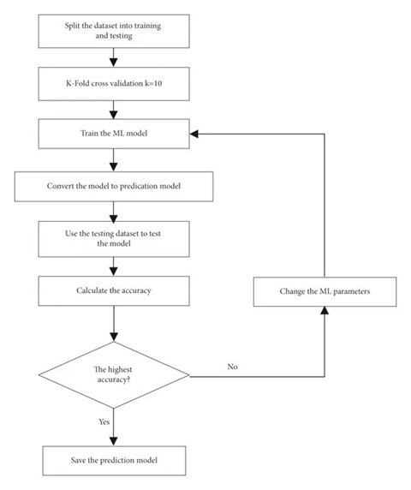
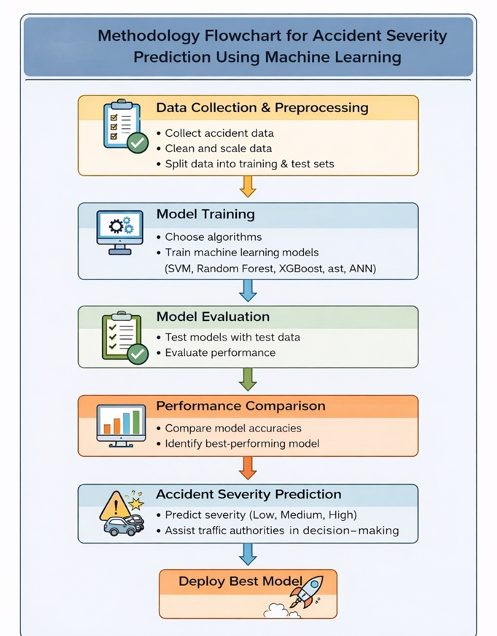
Fig. - Flowchart

9. Result Analysis
The performance comparison shows that different algorithms behave differently based on their ability to handle nonlinear relationships and feature interactions.
The performance comparison shows that different models behave differently depending on how well they handle feature interactions.
XGBoost achieved the highest accuracy (95%), followed by Random Forest (94%), ANN (93%), and SVM (92%). The improved performance of XGBoost can be linked to its boosting mechanism, which iteratively reduces prediction error.
XGBoost works by iteratively minimizing errors and combining multiple weak learners into a strong predictive model. It also includes regularization techniques that help prevent overfitting, making it highly effective for structured datasets like accident data.

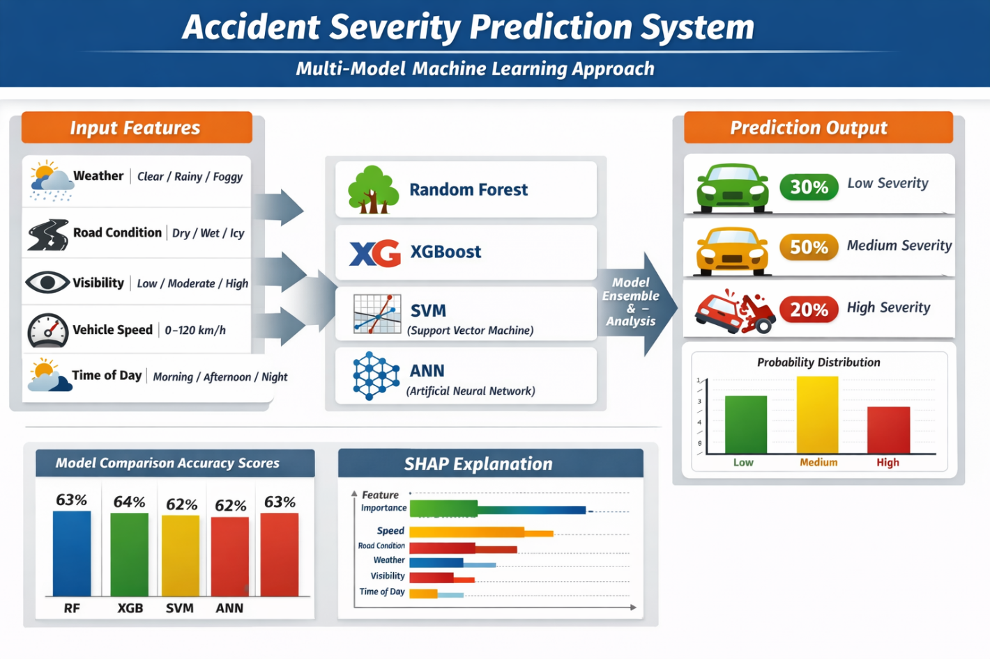
The Random Forest model achieved an accuracy of 94%, which is slightly lower than XGBoost but still demonstrates strong performance. Random Forest works by constructing multiple decision trees and averaging their predictions. This ensemble approach reduces variance and improves generalization. However, it may not capture feature interactions as efficiently as boosting algorithms.
The Artificial Neural Network (ANN) achieved an accuracy of 93%, indicating its ability to learn complex nonlinear relationships between input features. ANN models are particularly useful when the dataset contains intricate patterns. However, they require careful tuning of hyperparameters such as learning rate, number of layers, and neurons. Additionally, ANN models are computationally expensive compared to traditional machine learning algorithms.
The Support Vector Machine (SVM) achieved the lowest accuracy (92%) among the evaluated models. While SVM is effective for classification tasks, its performance is highly dependent on the choice of kernel function and parameter tuning. In this study, SVM struggled to capture complex relationships between features such as weather conditions and vehicle speed.
Further analysis of the confusion matrix reveals that most models perform well in predicting low and medium severity cases, but there are occasional misclassifications in high severity cases. This is likely due to overlapping feature patterns where certain conditions may lead to both medium and high severity outcomes.
From a feature perspective, it is observed that:
- Vehicle speed has a strong positive correlation with accident severity
- Poor visibility (fog, night time) significantly increases accident risk
- Road conditions (wet or icy) contribute to higher severity levels
These observations highlight the importance of incorporating multiple features into the prediction model.
Overall, the experimental results confirm that ensemble learning methods outperform traditional models due to their ability to handle complex feature interactions and reduce overfitting.

7. Conclusion
This work focuses on analysing accident severity using machine learning techniques based on multiple influencing factors.
The implementation of multiple machine learning models, including SVM, Random Forest, XGBoost, and Artificial Neural Network, allowed for a comparative analysis of their performance. Among these models, XGBoost emerged as the most effective algorithm, achieving the highest accuracy of 95%. This highlights the strength of boosting techniques in handling structured datasets and capturing complex relationships between features.
The findings of this research emphasize that accident severity is influenced by multiple factors, including vehicle speed, weather conditions, visibility, and road conditions. By analysing these factors simultaneously, the proposed system provides a more reliable prediction compared to traditional statistical methods.
One of the key contributions of this study is the development of a scalable and adaptable prediction framework that can be integrated into intelligent transportation systems. Such systems can assist traffic authorities in identifying high-risk scenarios and implementing preventive measures such as speed control, traffic regulation, and improved road infrastructure.
Furthermore, this research highlights the importance of data-driven decision-making in road safety management. By leveraging machine learning techniques, policymakers can gain valuable insights into accident patterns and develop targeted strategies to reduce accident severity.
Although the study uses a synthetic dataset, the model design ensures that it closely reflects real-world conditions. Future work can focus on integrating real-world datasets from Indian traffic authorities to further enhance model performance and reliability.
In conclusion, the proposed machine learning-based approach provides an effective solution for accident severity prediction and has the potential to significantly improve road safety outcomes when implemented in real-world systems.

8. Future Work
- Use real-world Indian accident datasets
- Include driver behaviour and traffic density
- Implement real-time prediction system
- Integrate with smart traffic infrastructure

9.References
[1] “A New Framework of Vehicle Collision Prediction by Combining SVM and HMM,” IEEE, 2020.
[2] “An Automated Approach for Predicting Road Traffic Accident Severity Using Transformer Learning and Explainable AI Technique,” IEEE, 2023.
[3] “Automatic Accident Detection, Segmentation and Duration Prediction Using Machine Learning,” IEEE, 2021.
[4] “Interpretable Traffic Accident Prediction Using Attention-Based Spatial-Temporal Multi-Graph Learning,” IEEE, 2022.
[5] “Predicting the Type of Road Traffic Accident for Test Scenario Generation,” IEEE, 2021.
[6] “RFCNN Traffic Accident Severity Prediction Based on Decision Level Fusion of Machine and Deep Learning Model,” IEEE, 2022.
[7] “Road Traffic Accident Risk Prediction and Key Factor Identification Framework Based on Explainable Deep Learning,” IEEE, 2023.
[8] “Traffic Accident Risk Prediction of Tunnel Based on Multi-Source Heterogeneous Data Fusion,” IEEE, 2022.
[9] “Traffic Accident Risk Prediction via Multi-View Multi-Task Spatio-Temporal Networks,” IEEE, 2021.
[10] “Road Accident Prediction Using Machine Learning Techniques,” 2020.
[11] “Traffic Accident Severity Analysis Using Machine Learning,” 2021.
[12] “Accident Prediction Using Data Mining Techniques,” 2020.
[13] “Road Safety Analysis Using Artificial Intelligence,” 2021.
[14] “Accident Detection and Prediction Using Machine Learning,” 2022.
[15] “Machine Learning Based Traffic Accident Prediction System,” 2021.

