Transformation of Plastic Waste into Activated Carbon via Pyrolysis: Structural Examination by X-Ray Diffraction Analysis for Sustainable Environmental Applications

Abstract
The ongoing rise in plastic trash production has emerged as a significant environmental issue owing to the non-biodegradable characteristics and prolonged persistence of synthetic polymers. Traditional disposal methods, including landfilling and incineration, lead to soil pollution and greenhouse gas emissions. Pyrolysis has emerged as an efficient thermochemical conversion method that transforms waste plastics into useful products, including liquid fuels, combustible gases and carbon-rich solid wastes. This study involved the conversion of waste plastic packaging sheets into activated carbon via an oxygen-limited pyrolysis process. The acquired carbon sample was analysed by X-ray diffraction (XRD) to examine its structural characteristics. The XRD pattern exhibited a large diffraction band within the range of 2θ = 20°–30°, corresponding to the (002) plane of disordered carbon structures. The lack of distinct diffraction peaks validated the dominance of amorphous carbon with minimal graphitic organization. The acquired material demonstrated a significantly deficient turbostratic carbon structure, which is advantageous for adsorption and environmental remediation purposes. This research illustrates an economical and sustainable approach for transforming plastic trash into useable carbon materials, advancing the circular economy and waste valorisation. The pyrolysis experiment was performed via a laboratory-scale cylindrical reactor constructed from a sealed metallic chamber. Plastic packaging trash was fed into the reactor and externally heated under conditions of limited oxygen. Following thermal degradation, a carbonaceous solid residue was acquired, which was then converted into activated carbon through crushing, purification, and drying before XRD characterisation.
Keywords: Plastic waste, Pyrolysis, Activated carbon, XRD, Amorphous carbon, Sustainable materials, Circular economy

Introduction
The manufacture of plastic has surged dramatically in recent decades due to its affordability, lightweight characteristics, mechanical durability, and resistance to chemical deterioration. Annually, approximately millions of tonnes of plastic trash are produced, resulting in significant ecological and environmental issues [1][2].
Prevalent polymers in plastic packaging trash comprise polyethylene (PE), polypropylene (PP), and polyethylene terephthalate (PET). Owing to their persistent molecular configurations, these materials necessitate several centuries for natural decomposition [3].
Conventional waste management methods encompass:
- Landfilling
- Incineration
- Mechanical recycling
Nonetheless, these technologies have numerous constraints, such as land utilisation, release of hazardous gases, and deterioration of polymer quality following multiple recycling processes [4]. Pyrolysis has garnered considerable interest as a viable alternative technique for the remediation of

plastic waste. The process entails the thermal breakdown of polymers at temperatures typically between 300 and 800 °C in an anoxic environment, yielding:
- Pyrolysis oil
- Syngas
- Carbonaceous char
The solid carbonaceous residue can be transformed into activated carbon, which has applications in water purification, gas storage, supercapacitors, catalytic support, and energy storage systems [5]. The characteristics of activated carbon are significantly influenced by factors like pyrolysis temperature, residence period, heating rate, and activation techniques. Structural characterisation is crucial for assessing the quality and prospective applications of the synthesised material.
X-ray diffraction (XRD) is a crucial characterisation technique employed to ascertain crystallinity, phase composition, and interlayer organization of carbon materials [6].
The aim of this study is to synthesise activated carbon from waste plastic via pyrolysis and examine its structural properties using XRD analysis.

Materials and Experimental Methodology
  - Materials Used Figure 1: Plastic packaging trash contained within the cylindrical pyrolysis reactor chamber.
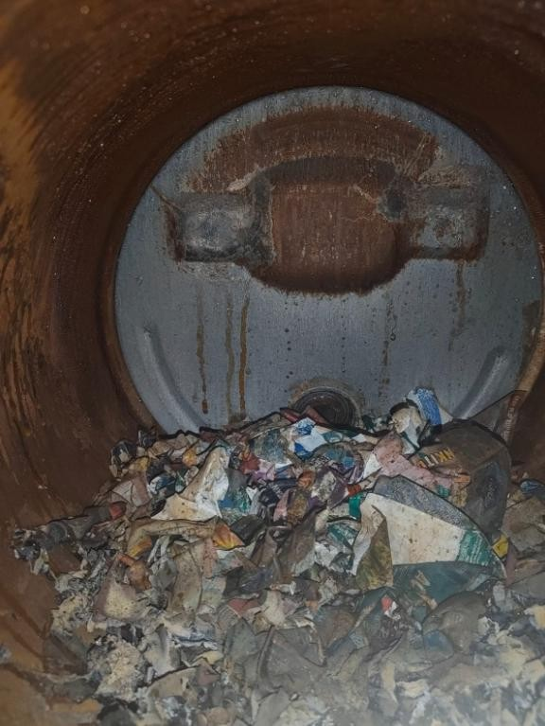
The basic material comprised discarded plastic packaging films sourced from residential garbage. The gathered plastics were rinsed with distilled water to eliminate dust and contaminants and subsequently dried under ambient conditions.
Table 1: Materials Utilised in the Experiment Material Purpose

Plastic packaging films Carbon source
Pyrolysis reactor Thermal decomposition

Heating source Providing required temperature
Condenser Cooling hydrocarbon vapours

Collection vessel Collecting liquid products
Carbon residue Activated carbon precursor

Figure 2: Configuration of the laboratory-scale pyrolysis reactor, heated by an external gas burner.

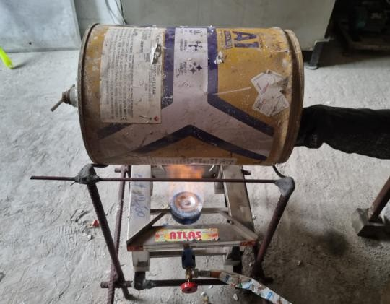
A cylindrical metallic reactor was engineered and constructed to execute the pyrolysis process. The reactor was positioned above a gas hob, supplying the requisite heat energy for the breakdown of plastic materials. The lack of oxygen in the chamber during heating inhibited complete combustion and facilitated the thermal cracking of long polymer chains.

Pyrolysis Procedure
The purified plastic trash was placed into a sealed pyrolysis chamber. The chamber was heated in an oxygen-deficient environment to avert total combustion. Upon heating, elongated polymer chains experienced thermal degradation:
Plastic Polymer → Hydrocarbon Vapours + Gases + Carbon Char
The gaseous byproducts exited the reactor and traversed a cooling system, where condensable vapours converted into liquid hydrocarbon products, while non-condensable gases either fled or were collected separately.
The residual solid was gathered and processed into activated carbon. The reactor temperature rose due to external heating, resulting in the breakup of polymer chains into smaller hydrocarbon molecules. The produced outputs were liquid hydrocarbons, non-condensable gases, and a carbon-rich char accumulated within the reactor. Figure 3: Flow Diagram of the Plastic Pyrolysis Process
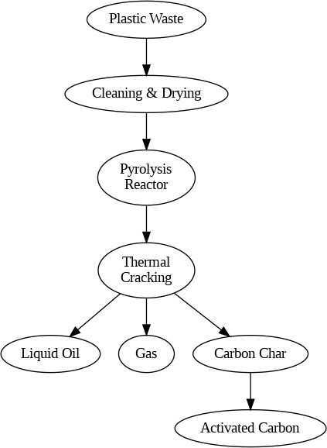

X-Ray Diffraction Characterization
X-ray diffraction research was conducted over a 2θ range of roughly 10°–120° to examine the crystal structure of the synthesised activated carbon.
X-rays interacting with periodic atomic planes adhere to Bragg's law:
nλ=2dsinθ
where:
- 𝑛= order of diffraction
- 𝜆= X-ray wavelength

- 𝑑= interplanar spacing
- 𝜃= diffraction angle
The diffraction pattern conveys information about crystallinity, lattice arrangement, and structural imperfections.
Figure 4: Carbonaceous residue produced from the pyrolysis of plastic trash.
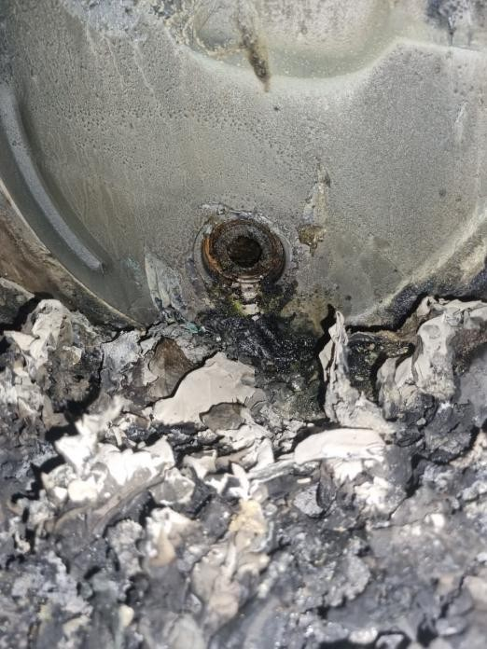
Upon concluding the pyrolysis cycle and cooling the reactor, a dark, carbon-dense residue was extracted from the chamber. The residue comprised partially carbonised plastic particles, ash, and carbon aggregates.
  - Preparation of Activated Carbon The acquired carbonaceous residue was manually pulverised with a mortar and pestle to diminish the particle size. The pulverised substance was subsequently rinsed with distilled water to eliminate loose impurities and soluble pollutants. The cleaned material was subjected to drying in an oven at around 80–100 °C for many hours to eliminate moisture. The desiccated black powder served as the activated carbon specimen for structural characterisation.
Table 2: Preparation steps of activated carbon
Step | Procedure | Purpose
1 | Collection of pyrolysis char | Obtain carbon precursor
2 | Crushing and grinding | Reduce particle size
3 | Washing with distilled water | Remove impurities
4 | Drying at 80–100°C | Remove moisture
5 | Powder collection | XRD sample preparation
Figure 5: X-ray diffraction instrument used for structural analysis of the synthesized carbon material.

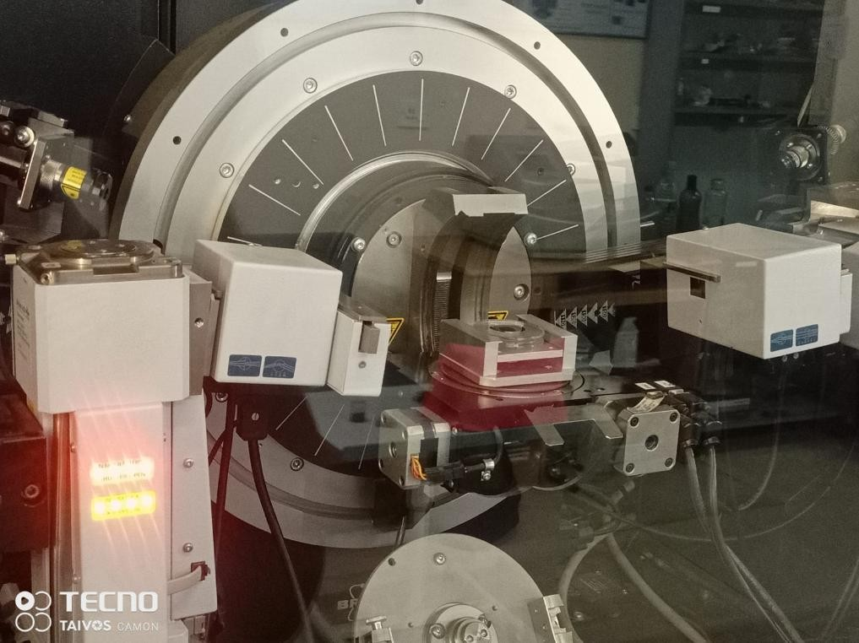
The carbon powder was affixed to the sample holder of an X-ray diffractometer. The diffraction pattern was documented within a 2θ range of roughly 10° to 120° utilising Cu-Kα radiation. The acquired data was examined to ascertain the crystallinity and structural configuration of the carbon substance.

Results and Discussion

XRD Analysis
Figure 6: displays the XRD pattern of the activated carbon synthesised from plastic pyrolysis.
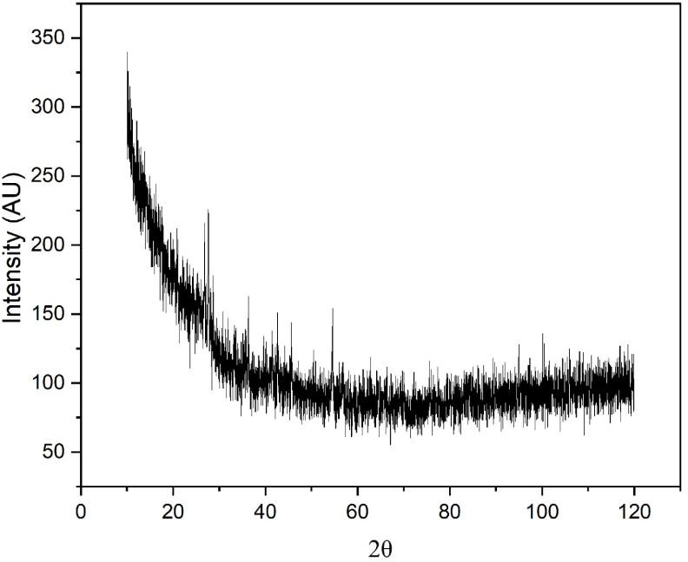

The diffraction spectrum has a wide diffraction peak between about 20° and 30° (2θ), corresponding to the (002) reflection of carbon materials [7].
Table 3: Analysis of XRD Characteristics

XRD Observation Interpretation

Broad peak around 20°–30° Disordered carbon (002) plane Absence of sharp peaks Amorphous structure
Low peak intensity Poor graphitic ordering

Broad diffraction width Small crystallite size and defects
High background noise Porous, defect-rich carbon

Carbon Structural Configuration
Highly crystalline graphite displays a distinct diffraction peak at roughly 2θ = 26°, indicative of uniformly arranged graphene layers. The synthesised carbon had a broad peak, signifying that the carbon layers are randomly orientated, resulting in a turbostratic carbon structure [8].
The large peak broadening indicates:
- Short-range atomic ordering
- Increased defects
- Expanded interlayer spacing
- Low graphitization degree
These structural imperfections augment the quantity of active adsorption sites, rendering the material effective for pollutant elimination.

Comparison with Graphitic Carbon
Table 4: Comparative Analysis of Graphite and Synthesised Activated Carbon
Property | Graphite | Synthesized Carbon
Crystal structure | Highly crystalline | Predominantly amorphous
2θ peak | ~26° sharp peak | Broad 20–30° hump
Graphitic ordering | High | Low
Defect concentration | Low | High
Surface activity | Moderate | High
Adsorption capability | Lower | Higher
Table 2: | Summary | of Experimental Observations

Parameter Observation

Plastic type Mixed packaging plastic
Reactor type Cylindrical closed metallic reactor

Heating source External gas burner
Pyrolysis atmosphere Oxygen-limited

Solid product Black carbonaceous residue
Final sample Fine carbon powder

XRD nature Predominantly amorphous
Carbon structure Turbostratic carbon

Potential Applications
The produced plastic-derived activated carbon can be utilised in various domains:

Environmental Applications
- Removal of dyes from industrial wastewater [9]
- Adsorption of heavy metals
- Removal of organic contaminants

Energy Storage
The defect-rich carbon structure can be used as:
- Supercapacitor electrodes
- Battery electrode additives
- Catalyst support materials [10]

Gas Purification
Due to its porous nature, the material may be utilized for:
- CO₂ capture

- Volatile organic compound adsorption
- Air purification
- Future Scope
Additional enhancement of the synthesised activated carbon can be accomplished through: Chemical activation with KOH, ZnCl₂, or H₃PO₄ Determination of BET surface area SEM analysis for morphological assessment FTIR analysis of functional groupings Raman spectroscopy for the investigation of graphitisation Adsorption investigations utilising methylene blue or heavy metal ions

Conclusion
A sustainable method for transforming plastic trash into activated carbon via pyrolysis has been effectively demonstrated. XRD examination verified that the synthesised material primarily comprises amorphous turbostratic carbon, distinguished by a large diffraction peak in the range of 2θ = 20°–30°. The lack of distinct crystalline peaks signifies a minimal level of graphitisation and a significantly flawed structure. These characteristics render the material appropriate for environmental remediation and energy storage applications. Consequently, activated carbon generated from plastic pyrolysis offers a promising avenue for waste valorisation and sustainable material advancement.
References
- Geyer, R., Jambeck, J.R., Law, K.L. Production, use, and fate of all plastics ever made. Science Advances, 2017.
- Miandad, R. et al. Waste plastic pyrolysis: A review. Process Safety and Environmental Protection, 2016.
- Andrady, A.L., Neal, M.A. Applications and societal benefits of plastics. Philosophical Transactions of the Royal Society B, 2009.
- Hopewell, J., Dvorak, R., Kosior, E. Plastics recycling: challenges and opportunities. Philosophical Transactions of the Royal Society B, 2009.
- Lua, A.C., Yang, T. Characteristics of activated carbon prepared from waste plastics. Journal of Colloid and Interface Science, 2004.
- Cullity, B.D., Stock, S.R. Elements of X-ray Diffraction. Prentice Hall.
- Inagaki, M., Kang, F. Materials Science and Engineering of Carbon: Fundamentals. Elsevier, 2014.
- Franklin, R.E. Crystallite growth in graphitizing and non-graphitizing carbons. Proceedings of the Royal Society A, 1951.
- Ahmad, M. et al. Biochar as a sorbent for contaminant management in soil and water. Chemosphere, 2014.
- Simon, P., Gogotsi, Y. Materials for electrochemical capacitors. Nature Materials, 2008.

