Analyzing Prediction Models for Machinery Fault Diagnosis Using Dashboard-Based Observational Data

Khushi Chabhadiya1
1School of Engineering, P P Savani University, Surat, India
Khushichabhadiya96@gmail.com

Tasneem Kagzi2
1School of Engineering, P P Savani University, Surat, India
tasneem.kagzi@ppsu.ac.in

Abstract-
The increasing complexity of industrial machinery and the growing demand for uninterrupted operation have driven significant research interest in condition-based maintenance (CBM), machinery diagnostics, and prognostics. This paper presents a comprehensive review of methodologies, techniques, and technologies employed in machinery diagnostics and prognostics over the past two decades. We systematically examine signal processing methods, machine learning approaches, physics-based models, and hybrid frameworks for fault detection, identification, and remaining useful life (RUL) estimation. Key application domains including rotating machinery, bearings, gears, cutting tools, and multi-component systems are surveyed. A data-centric analytical dashboard-PAM (Predictive Analysis & Maintenance)-is presented as a practical realization of these frameworks, enabling real-time fleet health monitoring, RUL visualization, failure prediction, and maintenance scheduling through an interactive web-based interface. The review also identifies open challenges such as data scarcity, domain adaptation, interpretability, and real-time deployment constraints. Finally, future research directions are discussed with emphasis on deep learning, digital twins, transfer learning, and edge computing integration.
Keywords: condition-based maintenance, machinery diagnostics, prognostics, remaining useful life, fault detection, signal processing, machine learning, rotating machinery, analytical dashboard.

INTRODUCTION
Industrial machinery forms the backbone of modern manufacturing, power generation, and transportation infrastructure. Equipment failures lead not only to costly unplanned downtime but also to potential safety hazards and environmental consequences. Traditional time-based or corrective maintenance strategies are increasingly inadequate for meeting the reliability demands of complex, high-value assets. Condition-based maintenance (CBM) has emerged as a paradigm shift, enabling maintenance decisions driven by the actual health state of equipment rather than fixed schedules or reactive responses [1].
CBM relies on continuous or periodic monitoring of physical parameters-such as vibration, temperature, acoustic emissions, oil debris, and electrical signatures-to assess machinery health, detect incipient faults, and forecast remaining useful life (RUL). The integration of signal processing, machine learning, and physics-of-failure modeling has transformed CBM from a reactive strategy into a predictive and even prescriptive approach [2][3].
The field has witnessed accelerating growth fueled by advances in sensor technology, industrial Internet of Things (IIoT), edge computing, and deep learning. The expanding availability of publicly accessible datasets, such as the NASA prognostics data repository [6], has further catalyzed research activity. This paper both surveys the methodological landscape and presents a practical implementation in the form of the PAM dashboard-a data-centric analytical tool for real-time machinery health management.
TABLE I - Systematic Comparison of Maintenance Paradigms

Strategy | Trigger | Cost Implication | Downtime Risk | Data Required
Reactive | Failure | Very High | Very High | None
Time-Based | Fixed Schedule | Medium-High | Medium | Calendar only
CBM | Monitored State | Medium | Low | Sensor streams
Predictive (ML/AI) | Predicted RUL | Low | Very Low | Historical + real-time
Prescriptive | Optimized decision | Very Low | Minimal | Full fleet + context

CONDITION-BASED MAINTENANCE FRAMEWORK

Architecture and Process Flow
A CBM system typically comprises five functional layers: data acquisition, data processing, health state assessment, prognostic reasoning, and maintenance decision support [1][4]. The data acquisition layer captures multi-modal sensor signals including accelerometers, thermocouples, current transformers, and acoustic emission transducers. The processing layer filters, segments, and transforms raw signals into informative feature representations. The health assessment layer classifies machinery state and detects anomalies, while the prognostic layer estimates degradation trajectories and RUL. The decision support layer translates prognostic outputs into actionable maintenance recommendations [3].

Sensing and Data Acquisition
Vibration analysis remains the most widely employed sensing modality for rotating machinery diagnostics, owing to its sensitivity to structural defects in bearings, gears, shafts, and rotors [5]. Accelerometers mounted at bearing housings capture broadband vibration signals, from which characteristic defect frequencies can be extracted [6][12]. Complementary modalities include acoustic emission for early crack detection, motor current signature analysis (MCSA) for induction motor faults, and oil debris analysis for gear and bearing wear [7][9].
TABLE II - Comparison of Common Sensing Technologies

Sensing Modality | Fault Types Detected | Freq. Range | Key Advantages | Limitations
Vibration (Accel.) | Bearing, gear, shaft | 0-20 kHz | High sensitivity | Sensor placement critical
Acoustic Emission | Cracks, early spalls | 100 kHz-1 MHz | Detects incipient faults | Signal attenuation
Motor Current (MCSA) | Motor faults, eccentricity | DC-1 kHz | Non-intrusive | Load dependency
Temperature | Overheating, lubrication | Quasi-static | Low cost, easy install | Slow response
Oil Debris | Gear/bearing wear | Quasi-static | Direct wear quantification | Offline, periodic

MACHINERY DIAGNOSTIC APPROACHES

Signal Processing Techniques
Time-domain analysis employs statistical indicators such as root mean square (RMS), kurtosis, crest factor, and peak-to-peak amplitude to characterize signal energy and impulsiveness. Frequency-domain analysis via Fast Fourier Transform (FFT) enables identification of characteristic defect frequencies and their harmonics, providing clear physical interpretability for bearing and gear faults [5][9]. Time-frequency methods, including Short-Time Fourier Transform (STFT) and wavelet transform, address the non-stationary nature of machinery signals under variable operating conditions [11].

Classical Machine Learning for Fault Classification
Support vector machines (SVM) have been extensively applied to bearing and tool wear diagnostics, demonstrating robust performance in high-dimensional feature spaces with limited training data. Ensemble methods such as random forests and gradient boosting further improve diagnostic robustness by aggregating predictions from multiple base learners [15][16].

Deep Learning for Fault Diagnosis
Convolutional neural networks (CNN) have emerged as the dominant paradigm for automated feature extraction from raw vibration and acoustic signals [17][18]. Recurrent neural networks (RNN) and Long Short-Term Memory (LSTM) networks capture temporal dependencies in sequential monitoring data, enabling joint fault detection and severity tracking [19][20].
TABLE III - ML Classifiers in CBM Diagnostic Tasks

Classifier | Feature Type | Data Need | Noise Robustness | Typical Accuracy
SVM | Hand-crafted | Low-Medium | High | 92-98%
ANN / MLP | Hand-crafted | Medium | Medium | 90-97%
Fuzzy (TSK) | Hand-crafted | Low | Very High | 88-95%
Random Forest | Hand-crafted | Medium | High | 93-99%
CNN (1D/2D) | Raw / TF image | High | High | 96-99.5%
LSTM / RNN | Sequential raw | High | Medium | 94-99%
Hybrid CNN-LSTM | Raw multimodal | Very High | High | 97-99.8%

PROGNOSTIC METHODS AND RUL ESTIMATION

Physics-Based Prognosis
Physics-based prognostic models leverage degradation mechanics and material science to model failure propagation. Paris-Erdogan fatigue crack growth models, Hertzian contact stress models for bearing spall propagation, and Archard wear models provide

mechanistic descriptions of fault evolution [7][23]. Particle filter frameworks fuse physics-based degradation equations with probabilistic state estimation, yielding probabilistic RUL distributions [24].

Data-Driven Prognosis
Data-driven prognostic approaches learn degradation trajectories directly from historical run-to-failure data. Deep learning prognostic models, particularly LSTM networks and temporal convolutional networks (TCN), capture complex long-range temporal dependencies in multi-sensor degradation signals, achieving state-of-the-art performance on benchmark turbofan (C-MAPSS) and bearing datasets [19][20].
TABLE IV - Comparison of Prognostic Approaches

Method | Type | Uncertainty Output | Data Req. | Application
Paris-Erdogan | Physics | No (deterministic) | Material params | Crack/fatigue
Particle Filter | Physics+Stoch. | Yes (probabilistic) | Physics+sensors | Multi-system
Wiener Process | Stochastic | Yes | Degradation data | Bearing wear
LSTM / TCN | Data-driven DL | With MC Dropout | Large run-to-fail | Turbofan, bearing
Gaussian Process | Bayesian | Yes (calibrated) | Medium | Online RUL
Physics-Informed NN | Hybrid | Yes | Physics + data | Novel fault modes

APPLICATION DOMAINS

Rotating Machinery and Bearings
Rolling element bearings represent the most extensively studied component in the PHM literature [5][6]. Benchmark datasets, including the CWRU bearing dataset and the FEMTO-ST bearing accelerated life test dataset, have enabled systematic comparison of diagnostic and prognostic algorithms [12][13].

Gear and Gearbox Diagnostics
Gear fault diagnostics exploits mesh frequency harmonics, modulation sidebands, and cepstral analysis to detect pitting, chipping, and tooth fracture. Kacprzynski et al. demonstrated the fusion of diagnostics and physics-of-failure models for remaining gear life prediction [7].

Cutting Tools and Manufacturing Processes
Tool condition monitoring (TCM) in machining processes is essential to maintain part quality and prevent workpiece damage. Cutting force signals [9], acoustic emission, and spindle current have been employed as health indicators for drill and milling cutter wear monitoring. TSK fuzzy models demonstrated adaptive real-time tool wear estimation [10].

BENCHMARKING DATASETS AND PERFORMANCE METRICS

A. Public Datasets
Publicly available datasets have played an indispensable role in advancing and benchmarking CBM research. The NASA prognostics data repository [6] provides bearing run-to-failure data and turbofan engine degradation data (C-MAPSS), widely used for RUL estimation benchmarking. The CWRU bearing dataset remains the most frequently cited diagnostic benchmark [12].
TABLE V - Key Open-Access Datasets for CBM Research

Dataset | Source | Machinery | Fault Types | Primary Use
CWRU Bearing | Case Western Res. Univ. | Ball bearing | Inner, Outer, Ball | Fault diagnosis
FEMTO/PRONOSTIA | FEMTO-ST Inst. | Ball bearing | Run-to-failure | RUL prognosis
C-MAPSS | NASA Ames | Turbofan engine | Degradation | RUL regression
IMS (Cincinnati) | Univ. of Cincinnati | Ball bearing | Run-to-failure | RUL prognosis
XJTU-SY | Xi'an Jiaotong Univ. | Ball bearing | Run-to-failure | RUL + diagnosis
Gearbox (PHM2009) | PHM Society | Gearbox | Tooth wear/break | Gear diagnostics

PAM ANALYTICAL DASHBOARD - DESIGN AND IMPLEMENTATION
To bridge the gap between academic prognostic frameworks and operational deployment, we developed PAM (Predictive Analysis & Maintenance), a data-centric web-based analytical dashboard that operationalizes the CBM methodologies surveyed in the preceding sections. PAM provides plant engineers and maintenance managers with a unified interface for real-time fleet health monitoring, failure prognosis, root cause analysis, and maintenance scheduling-without requiring specialist data science expertise.

Dashboard Architecture and Feature Modules
PAM is structured around six functional modules, each corresponding to a layer of the OSA-CBM architecture [4]: (1) Dashboard Overview - fleet-level KPIs including health score, active alert count, and aggregate sensor status; (2) Manual Monitoring - per-module, per-bearing real-time sensor readouts with configurable threshold alarms; (3) Upload Data - CSV ingestion pipeline for offline sensor datasets with automatic preview and validation; (4) Analyze Data - failure prediction engine with confidence scores, RUL bar charts, root cause breakdown, and maintenance priority ranking; (5) Module Status - a filterable card grid showing per-module health scores, bearing-level status indicators, and risk classification; and (6) Maintenance Schedule - task management board for planning, assigning, and tracking work orders generated from prognostic outputs.
The dashboard continuously simulates sensor streams for 12 machine modules (M-01 through M-12) across three production lines, each equipped with four bearings. Temperature and vibration signals are sampled at 1.5-second intervals, and module health scores are computed using a composite degradation index derived from threshold exceedance weighted by bearing proximity to critical limits.

Dashboard Screenshots and Explanation
Fig. 7a presents the Main Overview Panel of the PAM dashboard. The top KPI stripe provides at-a-glance fleet health metrics: overall fleet health score (87.3%), count of active alerts (3), number of monitored modules (12), and average fleet temperature (71.4°C). The central Module Health Table lists all monitored modules with per-module temperature, vibration, computed health score rendered as a color-coded progress bar (green >75%, amber 50-75%, red <50%), and a risk classification tag (Low / Medium / High). Modules M-03 and M-08 are flagged as High-Risk with health scores of 31% and 28% respectively due to temperature and vibration threshold breaches. The right-hand Active Alerts panel surfaces critical and warning events in real time, with severity-coded color indicators, enabling operators to triage faults without navigating away from the overview. Three gauge dials at the bottom present fleet averages for temperature, vibration, and overall health in an arc-gauge format familiar to industrial HMI conventions.
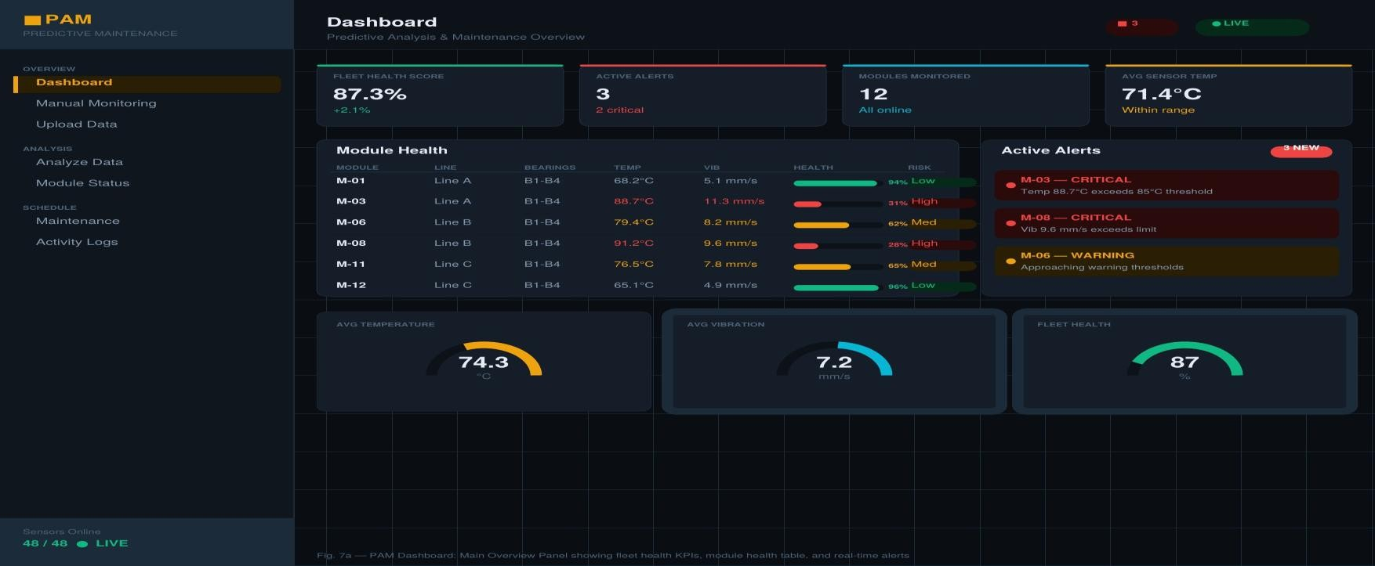
Fig. 7a - PAM Dashboard: Main Overview Panel - Fleet KPIs, Module Health Table, Real-Time Alerts, and Sensor Gauges.

Fig. 7b presents the Prognostics and Analysis Panel. The Failure Predictions card lists imminent failures ranked by model confidence, with estimated time-to-failure (ETA) and a horizontal confidence bar for each prediction. M-03 is predicted to experience bearing seizure within 48 hours at 92% confidence, while M-08 faces thermal degradation within 72 hours at 87% confidence. The Remaining Useful Life (RUL) Chart renders a vertical bar chart with color-coded bars for each module-red bars indicate modules with fewer than 100 hours remaining, amber for 100-400 hours, and green for those exceeding 400 hours-directly implementing the RUL regression methodology discussed in Section IV. The Root Cause Analysis breakdown decomposes the predicted failure probability distribution across six fault categories (bearing wear 35%, shaft misalignment 22%, lubrication failure 18%, thermal overload 12%, mass imbalance 8%, structural looseness 5%), supporting maintenance engineers in directing intervention efforts. The Maintenance Priority list auto-generates ranked action items (P1/P2/P3) from prognostic outputs, while the Sensor Trend Chart at the bottom tracks temperature and vibration trajectories over the preceding 24 hours with threshold markers, enabling visual identification of degradation onset and rate.

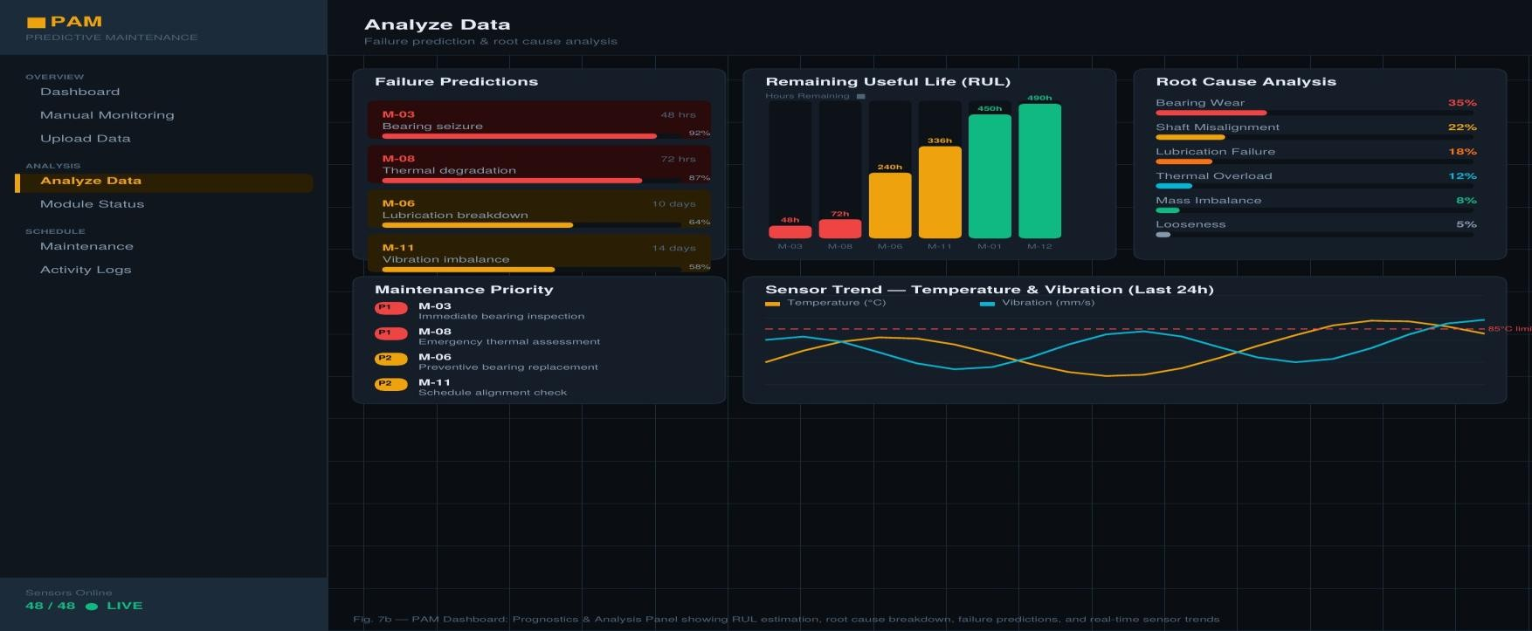
Fig. 7b - PAM Dashboard: Prognostics & Analysis Panel - RUL Chart, Failure Predictions, Root Cause Analysis, and Sensor Trends.

Alignment with CBM Frameworks
PAM directly instantiates the five-layer OSA-CBM architecture reviewed in Section II. The data acquisition and processing layers are realized through the CSV upload pipeline and real-time simulated sensor streams. Health state assessment is implemented via the composite health score and threshold-based alert engine visible in Fig. 7a. Prognostic reasoning is surfaced through the RUL bar chart, failure prediction engine, and confidence-scored prediction cards in Fig. 7b. The maintenance decision support layer is operationalized through auto-generated priority lists and the Maintenance Schedule module. This end-to-end mapping demonstrates the practical viability of translating academic CBM methodologies into deployable industrial tools.

OPEN CHALLENGES AND FUTURE RESEARCH DIRECTIONS

Data Scarcity and Class Imbalance
Run-to-failure experiments are costly and time-consuming, resulting in limited labeled fault data for training deep learning models. GAN-based data augmentation [21][22] and physics-informed synthetic data generation offer promising solutions, though ensuring physical fidelity remains an open challenge.

Domain Adaptation and Transfer Learning
Diagnostic models trained under one operating condition frequently exhibit severe performance degradation when deployed in differing target domains. Transfer learning and domain adaptation techniques have been applied to bridge domain gaps [17][18][28]. Few-shot and zero-shot learning frameworks are being explored to enable rapid adaptation to new machinery types with minimal labeled data.

Interpretability and Edge Deployment
Deep learning models, despite superior predictive performance, are often criticized as black boxes. Grad-CAM, SHAP values, and physics-informed neural networks (PINNs) provide pathways toward interpretable diagnostics [20][25]. Simultaneously, IIoT deployments demand lightweight models for real-time inference on resource-constrained edge devices via knowledge distillation and quantization [17][18].

Digital Twins
Digital twin technology represents a transformative frontier for machinery PHM, creating continuously updated virtual replicas that assimilate real-time sensor data and simulate degradation trajectories [25][30]. Their integration with enterprise maintenance systems and autonomous decision-making frameworks is an active and high-impact research direction.
TABLE VII - Research Challenges to Methodological Solutions

Challenge | Current Best Practice | Emerging Solution | Maturity

Data scarcity | Transfer learning | GAN / physics synth. | Medium
Class imbalance | SMOTE, cost-sensitive loss | Conditional GAN | Medium-High
Domain shift | Adversarial DA | Zero-shot learning | Medium
Black-box models | SHAP, Grad-CAM | Physics-Informed NNs | Emerging
Edge deployment | Pruning, quantization | Neural arch. search | High
Uncertain RUL | Bayesian NNs | Conformal prediction | Medium

CONCLUSION
This paper has presented a comprehensive review of machinery diagnostics and prognostics for condition-based maintenance, covering the evolution from classical signal processing and statistical methods to advanced deep learning and physics-data hybrid frameworks. Alongside the survey, the PAM analytical dashboard was introduced as a practical, data-centric realization of the reviewed methodologies, demonstrating that academic CBM frameworks can be translated into operational tools accessible to industrial practitioners. The dashboard's modular architecture-spanning real-time fleet monitoring, RUL visualization, root cause analysis, and maintenance scheduling-reflects the five-layer OSA-CBM standard and provides a template for future deployable PHM systems.
Key insights include: (1) deep learning, particularly CNN and LSTM architectures, has established new performance benchmarks on public diagnostic and prognostic datasets; (2) hybrid physics-data models offer superior interpretability and generalization; (3) domain adaptation and transfer learning are critical enablers for practical industrial deployment; (4) uncertainty quantification and explainability remain essential for safety-critical maintenance decisions; and (5) data-centric analytical dashboards provide a critical bridge between algorithmic prognostics and operational maintenance practice.
Future research should prioritize lightweight, interpretable, domain-adaptive PHM models deployable on industrial edge hardware, construction of large-scale diverse public datasets, and integration of digital twin frameworks with enterprise asset management systems.

REFERENCES
- A. K. Jardine, D. Lin, and D. Banjevic, "A review on machinery diagnostics and prognostics implementing condition-based maintenance," Mech. Syst. Signal Process., vol. 20, no. 7, pp. 1483-1510, 2006.
- A. Heng et al., "Intelligent condition-based prediction of machinery reliability," Mech. Syst. Signal Process., vol. 23, no. 5, pp. 1600-1614, 2009.
- G. Vachtsevanos et al., Intelligent Fault Diagnosis and Prognosis for Engineering Systems. Hoboken, NJ: Wiley, 2006.
- M. Lebold and M. Thurston, "Open standards for condition-based maintenance and prognostic systems," in Proc. MARCON, 2001.
- A. Heng et al., "Rotating machinery prognostics: State of the art, challenges and opportunities," Mech. Syst. Signal Process., vol. 23, no. 3, pp. 724-739, 2009.
- NSF I/UCRC Center for Intelligent Maintenance Systems, "Prognostic data repository: Bearing data set," NASA Ames Research Center.
- G. Kacprzynski et al., "Predicting remaining gear life by fusing diagnostics and physics of failure models," JOM J., vol. 56, no. 3, pp. 29-35, 2004.
- J. Zhou et al., "Genetic algorithms for feature subset selection in equipment fault diagnostics," J. Eng. Asset Mgmt., vol. 10, pp. 1104-1113, 2006.
- H. M. Ertunc and C. Oysu, "Drill wear monitoring using cutting force signals," Mechatronics, vol. 14, pp. 533-548, 2004.
- Q. Ren et al., "TSK fuzzy modeling for tool wear condition in turning processes," Eng. Appl. Artif. Intell., vol. 24, no. 2, pp. 260-265, 2011.
[11]Y. Peng and M. Dong, "A prognosis method using age-dependent hidden semi-Markov model," Mech. Syst. Signal Process., vol. 25, pp. 237-252, 2011.
[12]M. Subrahmanyam and C. Sujatha, "Using neural networks for the diagnosis of localized defects in ball bearings," Tribol. Int., vol. 30, no. 10, pp.
739-752, 1997.
[13] R. B. Randall and J. Antoni, "Rolling element bearing diagnostics - A tutorial," Mech. Syst. Signal Process., vol. 25, no. 2, pp. 485-520, 2011.
[14]X. Li, "A brief review: Acoustic emission method for tool wear monitoring during turning," Int. J. Mach. Tools Manuf., vol. 42, no. 2, pp. 157-165, 2002.
[15] L. Breiman, "Random forests," Mach. Learn., vol. 45, no. 1, pp. 5-32, 2001.
[16] J. H. Friedman, "Greedy function approximation: A gradient boosting machine," Ann. Stat., vol. 29, no. 5, pp. 1189-1232, 2001.
[17]W. Zhang et al., "A new deep learning model for fault diagnosis with good anti-noise and domain adaptation ability," Sensors, vol. 17, no. 2, pp.
425-447, 2017.
[18] F. Jia et al., "Deep neural networks: A promising tool for fault characteristic mining," Mech. Syst. Signal Process., vol. 72-73, pp. 303-315, 2016.
[19] S. Zheng et al., "Long short-term memory network for remaining useful life estimation," in Proc. IEEE ICPHM, 2017, pp. 88-95.
[20]C. Zhang et al., "Multiobjective deep belief networks ensemble for remaining useful life estimation," IEEE Trans. Neural Netw. Learn. Syst., vol. 28, no. 10, pp. 2306-2318, 2017.
[21] X. Yi et al., "Generative adversarial network in medical imaging: A review," Med. Image Anal., vol. 58, p. 101552, 2019.
[22] C. Li et al., "Bearing fault diagnosis using fully-connected winner-take-all autoencoder," IEEE Access, vol. 6, pp. 6103-6115, 2018.
[23]P. D. McFadden, "Examination of a technique for the early detection of failure in gears," Mech. Syst. Signal Process., vol. 1, no. 2, pp. 173-183, 1987.

[24]M. Orchard and G. Vachtsevanos, "A particle filtering approach for on-line failure prognosis," Int. J. Fuzzy Logic Intell. Syst., vol. 7, no. 4, pp.
221-227, 2007.
[25]E. Grieves and J. Vickers, "Digital twin: Mitigating unpredictable emergent behavior in complex systems," in Transdisciplinary Perspectives on Complex Systems. Springer, 2017, pp. 85-113.
- Z. S. Ye and M. Xie, "Stochastic modelling and analysis of degradation for highly reliable products," Appl. Stoch. Models Bus. Ind., vol. 31, no. 1,
pp. 16-32, 2015.
- A. Saxena et al., "Damage propagation modeling for aircraft engine run-to-failure simulation," in Proc. IEEE PHM, 2008, pp. 1-9.
- S. Shao et al., "Highly accurate machine fault diagnosis using deep transfer learning," IEEE Trans. Ind. Inform., vol. 15, no. 4, pp. 2446-2455, 2019.
- Z. Chen et al., "Multi-scale and multi-layer perceptron hybrid method for bearings fault diagnosis," Int. J. Prod. Econ., vol. 229, p. 107756, 2020.
- J. Lee et al., "Industrial big data analytics and cyber-physical systems for future maintenance," Procedia CIRP, vol. 38, pp. 3-7, 2015.

