Accident Prevention System For Two-Wheelers

Umashankari V*, Harsha A**, Priyadharshini S**, Sneha J**, Yogeshwari S**
* Assistant Professor, IT, Hindusthan Institute of Technology, Coimbatore
** Student, Fourth year, IT, Hindusthan Institute of Technology, Coimbatore

Abstract- The increasing number of road accidents involving two-wheelers has become a major concern due to factors such as overspeeding, drunk driving, poor road conditions, and lack of real-time hazard awareness. Existing safety systems mainly focus on post-accident response rather than prevention. This project proposes an intelligent Accident Prevention System for Two- Wheelers using embedded and sensor-based technologies to enhance rider safety through proactive monitoring and control.
The system integrates multiple sensors, including LiDAR for front obstacle detection, ultrasonic sensors for rear vehicle monitoring and pothole detection, an alcohol sensor for detecting intoxicated driving, and an MPU6050 sensor for monitoring tilt and sudden movements. An ESP32 microcontroller processes real-time sensor data and determines unsafe conditions based on predefined thresholds. When a potential risk is detected, the system provides immediate alerts through an LCD display and buzzer, and automatically limits or cuts off motor operation using a relay module.
By combining real-time sensing, intelligent decision-making, and automated control mechanisms, the system ensures early detection of hazards and reduces dependency on human reaction time. The proposed solution is cost-effective, reliable, and scalable, making it suitable for practical implementation in two- wheelers. Overall, the system significantly improves road safety by preventing accidents and promoting responsible riding behavior.

Keywords: Accident Prevention System,LiDAR Sensor, ESP32 Microcontroller,Real-Time Monitoring,
Two-Wheeler Safety.

Introduction
The increasing number of road accidents involving two-wheelers has become a major concern due to factors such as overspeeding, drunk driving, poor road conditions, and lack of real-time hazard awareness. Existing safety systems mainly focus on post-accident
response, while preventive measures remain limited.This project proposes an Accident Prevention System for Two-Wheelers that utilizes embedded systems and sensor-based technologies to enhance rider safety. The system collects real- time data using sensors such as LiDAR for front obstacle detection, ultrasonic sensors for rear vehicle and pothole detection, an alcohol sensor for detecting intoxicated riding, and an MPU6050 sensor for monitoring tilt and sudden movements.
The collected sensor data is processed by an ESP32 microcontroller to identify unsafe conditions. Based on predefined thresholds, the system generates alerts through an LCD display and buzzer, and automatically controls the vehicle using a relay module to limit or stop operation during critical situations.By combining real-time monitoring and automatic response, the system helps in early detection of risks, reduces dependency on human reaction, and improves overall road safety for two- wheeler riders..

Block diagram
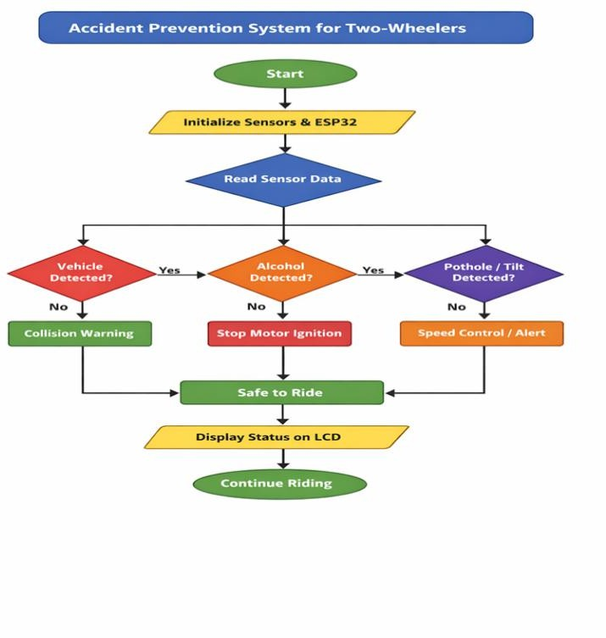
The architecture of the Accident Prevention System for Two-Wheelers is a structured embedded system designed to enhance rider safety through real-time monitoring and automatic control. It integrates multiple sensors such as LiDAR, ultrasonic sensors, alcohol detection sensor, and MPU6050

tilt sensor with an ESP32 microcontroller. The system continuously collects environmental and rider condition data and processes it in real time. Based on the sensor inputs, the controller activates appropriate safety mechanisms such as collision warnings, ignition control, speed limitation, or motor cutoff. The processed output is displayed on an LCD screen, and audible alerts are generated through a buzzer to notify the rider. A regulated power supply unit ensures stable operation of all components.

Methodology
The proposed system collects real-time data from multiple sensors integrated into a two- wheeler to monitor riding conditions and detect potential hazards. Embedded processing techniques are used to analyze sensor data and identify unsafe situations. Based on predefined safety thresholds, the system generates alerts and automatically controls vehicle operation to prevent accidents.

Requirement Analysis & System Design:
The system is designed to enhance rider safety using a modular architecture that includes data acquisition, processing, decision-making, and alert generation. It integrates sensors such as LiDAR, ultrasonic sensors, alcohol sensor, and MPU6050 with an ESP32 microcontroller. The design ensures real-time monitoring, efficient processing, and automatic response to unsafe conditions, with scope for future IoT- based extensions.

Data Acquisition:
The system collects real-time data from multiple sensors. LiDAR is used to detect front obstacles and measure distance, ultrasonic sensors monitor rear vehicles and detect potholes, the alcohol sensor detects intoxication levels, and the MPU6050 measures tilt, vibration, and sudden movements. All sensor data is continuously transmitted to the ESP32 for processing. The system maintains continuous data logging for analysis and debugging purposes. It supports synchronized sampling across sensors to improve accuracy. This ensures no critical event is missed during high-speed vehicle operation.

Data Preprocessing:
The acquired sensor data is processed to ensure accuracy and consistency. This
includes filtering noise, stabilizing sensor readings, and comparing values against predefined thresholds. The processed data is then used for decision-making and hazard detection. Further, outlier detection techniques are applied to remove abnormal spikes in sensor readings. Data buffering mechanisms ensure continuous processing without data loss. This enhances system stability during real-time execution.

Hazard Detection & Decision-Making:
The ESP32 microcontroller analyzes processed sensor data to identify unsafe conditions such as collision risk, unsafe distance, excessive tilt, or alcohol detection. Based on predefined safety rules, the system classifies conditions as safe or unsafe and determines appropriate actions. Priority-based decision logic is used to handle multiple risks simultaneously. Critical conditions such as collision and alcohol detection are given higher priority. This ensures faster and more effective response during emergencies.

System Integration:
All system components, including sensors, microcontroller, relay module, and alert interfaces, are integrated into a unified embedded system. The sensors provide continuous input, the controller processes data in real time, and output devices execute safety actions, ensuring seamless system operation.

Alert Generation & Control Mechanism:
When unsafe conditions are detected, the system generates real-time alerts using an LCD display and buzzer. Additionally, a relay module is activated to limit vehicle speed or cut off motor operation, ensuring immediate preventive action and reducing accident risk.

Testing & Performance Evaluation:
The system is tested under different riding conditions to evaluate its accuracy and reliability. Sensor performance, response time, and system stability are analyzed. The effectiveness of hazard detection and alert mechanisms is measured to ensure proper functioning in real-time scenarios.

Deployment & Documentation:
The system is implemented as a prototype using embedded hardware components. Documentation includes system architecture, sensor integration, working methodology, and user guidelines. The design allows future enhancements such as GPS tracking, GSM-based alerts.

System Architecture
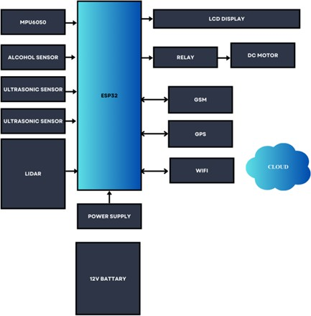

The proposed Accident Prevention System for Two-Wheelers is designed as a real-time embedded safety system that integrates multiple sensors, a processing unit, and control mechanisms to enhance rider safety. The architecture follows a modular approach consisting of input, processing, control, output, and power management layers, ensuring efficient operation and scalability.

Overall Architecture:
The system is centered around the ESP32 microcontroller, which acts as the main processing and decision-making unit. It continuously collects data from various sensors, processes the inputs in real time, and generates appropriate outputs such as alerts and control signals. The architecture ensures seamless communication between all modules and supports real-time accident prevention.

Sensor Layer:
The sensor layer is responsible for collecting real-time data related to the riding environment and rider condition. The system integrates multiple sensors, each serving a specific purpose:

LiDAR Sensor: Detects obstacles in front of the vehicle and measures distance using Time- of-Flight technology.

Ultrasonic Sensors: Monitor rear-side vehicles and detect potholes or uneven road surfaces.
MPU6050 Sensor: Measures tilt angle, acceleration, and vibration to identify unstable riding conditions.

Alcohol Sensor: Detects alcohol concentration to prevent vehicle ignition under unsafe conditions.

These sensors continuously generate analog and digital signals, which are transmitted to the ESP32 microcontroller for further processing.

Processing Layer:
The ESP32 microcontroller forms the core of the processing layer. It is programmed using Embedded C/C++ and performs the following operations:

    - Continuous acquisition of sensor data
    - Signal processing and threshold comparison
    - Real-time hazard detection and decision- making
The controller evaluates sensor inputs against predefined safety thresholds and determines whether the riding condition is safe or unsafe. This layer ensures fast and accurate response required for real-time applications.

Control Mechanism:
The control mechanism is implemented using a relay module connected to the vehicle’s motor or ignition system. Based on the decision from the processing unit, the relay performs the following actions:

    - Limits vehicle speed during unsafe conditions
    - Cuts off motor operation in critical situations
    - Restores normal operation when conditions are safe
This automatic intervention reduces dependency on rider reaction time and enhances accident prevention.

Output Layer:
The system provides real-time feedback to the rider through output devices:
LCD Display: Shows system status, obstacle distance, and warning messages.
Buzzer: Generates audible alerts during critical conditions.
These outputs ensure that the rider is immediately informed about potential hazards, enabling timely

corrective action.

Power Management System:
The system is powered using a regulated power supply derived from the vehicle battery. Voltage regulators ensure stable 5V and 3.3V outputs required for the ESP32 and sensors. Proper power management ensures reliable system operation and protects components from voltage fluctuations.

System Workflow:
The overall system operates in a continuous loop:

    - Sensors collect real-time data.
    - Data is processed by the ESP32.
    - Unsafe conditions are detected using predefined thresholds.
    - Alerts are generated and control actions are executed.
    - System returns to monitoring mode after conditions normalize.

Hardware Description
The proposed Accident Prevention System for Two-Wheelers is implemented using a set of integrated hardware components that enable real-time sensing, processing, and control. The hardware architecture is designed to be cost- effective, reliable, and suitable for embedded applications. The key components of the system include the ESP32 microcontroller, LiDAR sensor, ultrasonic sensors, MPU6050 sensor, alcohol sensor, relay module, LCD display, buzzer, and power supply unit.

ESP32 Microcontroller:

The ESP32 microcontroller serves as the central processing unit of the system. It is responsible for collecting data from all connected sensors, processing the inputs, and generating control signals. The ESP32 offers high processing capability, multiple GPIO pins, and built-in communication interfaces such as UART, I2C, and PWM. Its integrated Wi-Fi and Bluetooth features also provide support for future IoT-based extensions. The microcontroller ensures real-time operation and efficient coordination between all hardware components.

LiDAR Sensor:

The LiDAR (Light Detection and Ranging) sensor is used for front obstacle detection. It operates on the Time-of-Flight principle, where laser pulses are emitted and the time taken for the reflected signal to return is measured to calculate distance. This enables accurate and real-time detection of objects in front of the vehicle. The LiDAR sensor plays a critical role in predicting collision risks and providing early warnings.

Ultrasonic Sensors:

The system uses ultrasonic sensors for multiple purposes, including rear vehicle monitoring and pothole detection. These sensors emit ultrasonic waves and measure the time taken for the echo to return after hitting an object. Based on this time delay, the distance is calculated. Ultrasonic sensors are cost-effective and reliable for short-range detection, making them suitable for detecting nearby vehicles and road irregularities.

MPU6050 Accelerometer and Gyroscope:

The MPU6050 sensor combines an accelerometer and a gyroscope to measure acceleration, tilt, and angular motion. It is used to monitor vehicle stability and detect abnormal conditions such as excessive tilt, vibration, or sudden movements. This helps in identifying unsafe riding conditions and potential crash scenarios. The sensor communicates with the ESP32 using the I2C protocol.

Alcohol Sensor:

The alcohol sensor is used to detect the presence of alcohol in the rider’s breath. It ensures that the vehicle does not start or operate when the alcohol level exceeds a predefined threshold. This component plays an important role in preventing accidents caused by drunk driving and enhances overall rider safety.

Relay Module:

The relay module acts as a control switch for the vehicle’s motor or ignition system. It is controlled by the ESP32 microcontroller and is activated during unsafe conditions. The relay can limit motor operation or completely cut off power to prevent accidents. This hardware-based control mechanism ensures immediate response without relying solely on rider intervention.

LCD Display:

A 16×2 LCD display is used to provide real- time information to the rider. It displays system status, sensor readings, and warning messages such as collision alerts, alcohol detection, and pothole warnings. The display enhances user awareness and improves system usability.

Buzzer:

The buzzer is used as an audible alert system to notify the rider during critical situations. It generates sound signals when unsafe conditions are detected, ensuring immediate attention even if the rider is not looking at the display.

Power Supply Unit:

The system is powered by a regulated power supply derived from the two-wheeler battery. Voltage regulators provide stable 5V and 3.3V outputs required for the ESP32 and sensors. Proper power management ensures reliable operation and protects components from voltage fluctuations and electrical noise.

Advantages

- Real-Time Monitoring of Riding Conditions.
- Early Collision Detection using LiDAR Sensor.
- Multi-Sensor Integration for Improved Safety.
- Automatic Speed Control and Motor Cut- Off.
- Enhanced Rider Awareness through Alerts.

Disadvantages

- Weather Sensitivity if Sensors.
- Limited Detection Range of Low-Cost Sensors.
- Dependence on Sensor Accuracy.
- Complex System Integeration.
- Possibility of False Alerts.

Limitations

- Weather Sensitivity: LiDAR sensor performance may be affected by adverse conditions such as heavy rain, fog, and dust.
- Limited Detection Range: Low-cost sensors have restricted range and accuracy
compared to advanced automotive systems.
- Integration Challenges: Difficulty in integrating the system with older or conventional two-wheelers.
- Partial Safety Coverage: The system mainly focuses on front and rear detection and lacks side obstacle detection.
- Maintenance Requirement: Sensors require regular calibration and maintenance for accurate performance.
- Possibility of False Alerts: Sensor noise and environmental factors may lead to incorrect warnings.
- Power Dependency: Continuous operation depends on a stable power supply from the vehicle battery.
- Sensor Accuracy Dependency: System performance relies heavily on the accuracy of sensor readings.
- User Adaptation: Riders may initially find automatic control features intrusive or difficult to adapt.
- Not a Complete Safety Solution: Cannot replace traditional safety measures like helmets or advanced vehicle safety systems.

Future Scope

The proposed Accident Prevention System for Two- Wheelers provides a foundational framework for enhancing rider safety through real-time monitoring and automated control. However, the system can be further improved by incorporating advanced technologies and extending its capabilities to address existing limitations.One significant enhancement involves the integration of Global Positioning System (GPS) and Global System for Mobile Communication (GSM) modules to enable real-time location tracking and automated emergency notifications. This would allow the system to transmit accident alerts along with location details to emergency contacts or healthcare services, thereby improving response time during critical situations.

The incorporation of Internet of Things (IoT) technology can further enhance system functionality by enabling cloud-based data storage, remote monitoring, and real-time visualization. Such integration would facilitate continuous data analysis and support the development of smart transportation systems.

Additionally, the application of machine learning and artificial intelligence techniques can improve the system’s decision-making capabilities. By analyzing historical and real-time sensor data, predictive models can be developed to identify

accident-prone scenarios more accurately and reduce false alerts.

Future developments may also include the integration of additional sensors and vision- based systems, such as cameras and side obstacle detection modules, to achieve 360- degree environmental awareness. This would significantly enhance detection accuracy in complex traffic conditions.Furthermore, the development of a mobile application interface can improve user interaction by providing real-time notifications, system status updates, and safety recommendations. Optimization of hardware components for reduced power consumption, improved durability, and compatibility with different vehicle models will support large-scale deployment.

Conclusion
The proposed Accident Prevention System for Two-Wheelers effectively integrates multiple sensors and embedded processing to enhance rider safety. By utilizing real-time data from LiDAR, ultrasonic sensors, MPU6050, and an alcohol sensor, the system detects potential hazards and enables timely alerts and automatic control actions. It provides early collision detection, prevents unsafe riding conditions, and reduces dependency on human reaction. The system is cost-effective, reliable, and supports proactive accident prevention. Its scalable design allows future integration with IoT, GPS, and smart transportation systems, contributing to improved road safety.

References
- F. Ghorbani et al., “Towards AI-Assisted Motorcycle Safety: Multi-Modal Video Analysis,” Vehicles, vol. 8, no. 2, 2026.
- Technical Committee on Motorcycle Safety, “Advanced Rider Assistance Systems for Two- Wheelers,” SAE International, 2025.
- Innovation Task Force, “Smart Mobility and Road Safety Innovations,” IEEE SIH Compendium, 2025.
- Z. Ullah et al., “Performance of Advanced Rider Assistance Systems in Varying Weather Conditions,” Vehicles, vol. 7, no. 4, 2025.
- S. S. Shevtekar et al., “Predicting Time Pressure of Powered Two-Wheeler Riders for Proactive Safety Systems,” 2025.
- S. Kumar, A. Verma, and R. Singh, “IoT-Based Two-Wheeler Safety System,” 2024.
- A.Verma and R. Singh, “mmWave Radar for Low Visibility Detection,” 2024.
- Standards Development Group, “Advanced Driver Assistance Systems (ADAS) for Two- Wheelers,” IEEE Standards Association, 2024.
- Transport and Mobility Division, “Road Safety in India – Technology Interventions,” NITI Aayog, 2024.
- S. Chen, M. Lee, and K. Zhao, “Radar-Based Advanced Rider Assistance Systems,” 2023.
- Road Safety Department, “Global Status Report on Road Safety,” World Health Organization, 2023.
- M. Chen, L. Wang, and H. Li, “Machine Learning for Collision Prediction,” 2023.
- Automotive Safety Research Team, “Motorcycle Safety Radar Systems,” Bosch Research, 2023.
- IEEE Standards Association, “Intelligent Transportation Systems (ITS) and Road Safety Framework,” 2023.
- International Transport Forum, “Improving Motorcycle Safety through Technology and Policy,” OECD Report, 2023.

