Accident Alert Bot System Using RPi 3B+

Chaudhary Raj Ashok  School of Electronics  Devi Ahilya University, Indore  Email: rajchaudhary6253@gmail.com | Riya Khare  School of Electronics  Devi Ahilya University,Indore  Email: riyakhare2912@gmail.com

Abstract - This project details the design and implementation of a collision detection and alert system using a Raspberry Pi, integrated with a vibration sensor and GPS module. The system detects collisions, captures geographical coordinates, and sends real-time alerts via a Telegram bot, enhancing road safety by enabling quicker emergency responses. Utilizing the Raspberry Pi's versatility, the project integrates a vibration sensor for collision detection and a GPS module for location tracking. The implementation includes configuring GPIO management, serial communication, and using the Telepot library for Telegram communication. This project showcases an effective use of technology in developing practical accident alert systems.  Keywords - Raspberry Pi, GPS Module, Real-Time Alert, Telegram Bot  I. INTRODUCTION  In today's fast-paced world, road safety continues to be a critical issue, with millions of lives impacted by vehicular accidents annually. The necessity for proactive measures to reduce the consequences of accidents remains vital. The "Accident Alert Bot System" project emerges as a proactive solution, delivering real-time notifications to designated contacts during a collision.The Accident Alert Bot System project focuses on developing and implementing an advanced collision detection and | notification mechanism. Utilizing state-of-the-art technologies, including a Raspberry Pi, the system integrates an array of sensors and communication modules to ensure quick and efficient responses during emergencies. The core components of the Accident Alert Bot System include a vibration sensor for precise impact detection, a GPS module for accurate location tracking, and a Telegram bot for seamless communication. These components collaborate to detect collisions, pinpoint the incident's exact location, and automatically send notifications to predefined contacts, such as family members or emergency services.  The importance of the Accident Alert Bot System project lies in its capability to close the gap between the occurrence of an accident and the arrival of timely assistance. By leveraging advanced technology, the system aims to decrease response times, thus mitigating the severity of injuries and saving lives. Throughout this project, we will explore the design, development, and testing phases of the Accident Alert Bot System. We will delve into the complexities of integrating various hardware components and programming the Raspberry Pi for flawless operation.  Ultimately, this project represents a commitment to innovation and safety, aiming to enhance road safety for all drivers and pedestrians. Through collaborative efforts and technological advancements, we aspire to create a future where accidents are not only promptly detected but also swiftly addressed, potentially reducing their impact and preserving lives.

II. PROJECT MODEL DESCRIPTION  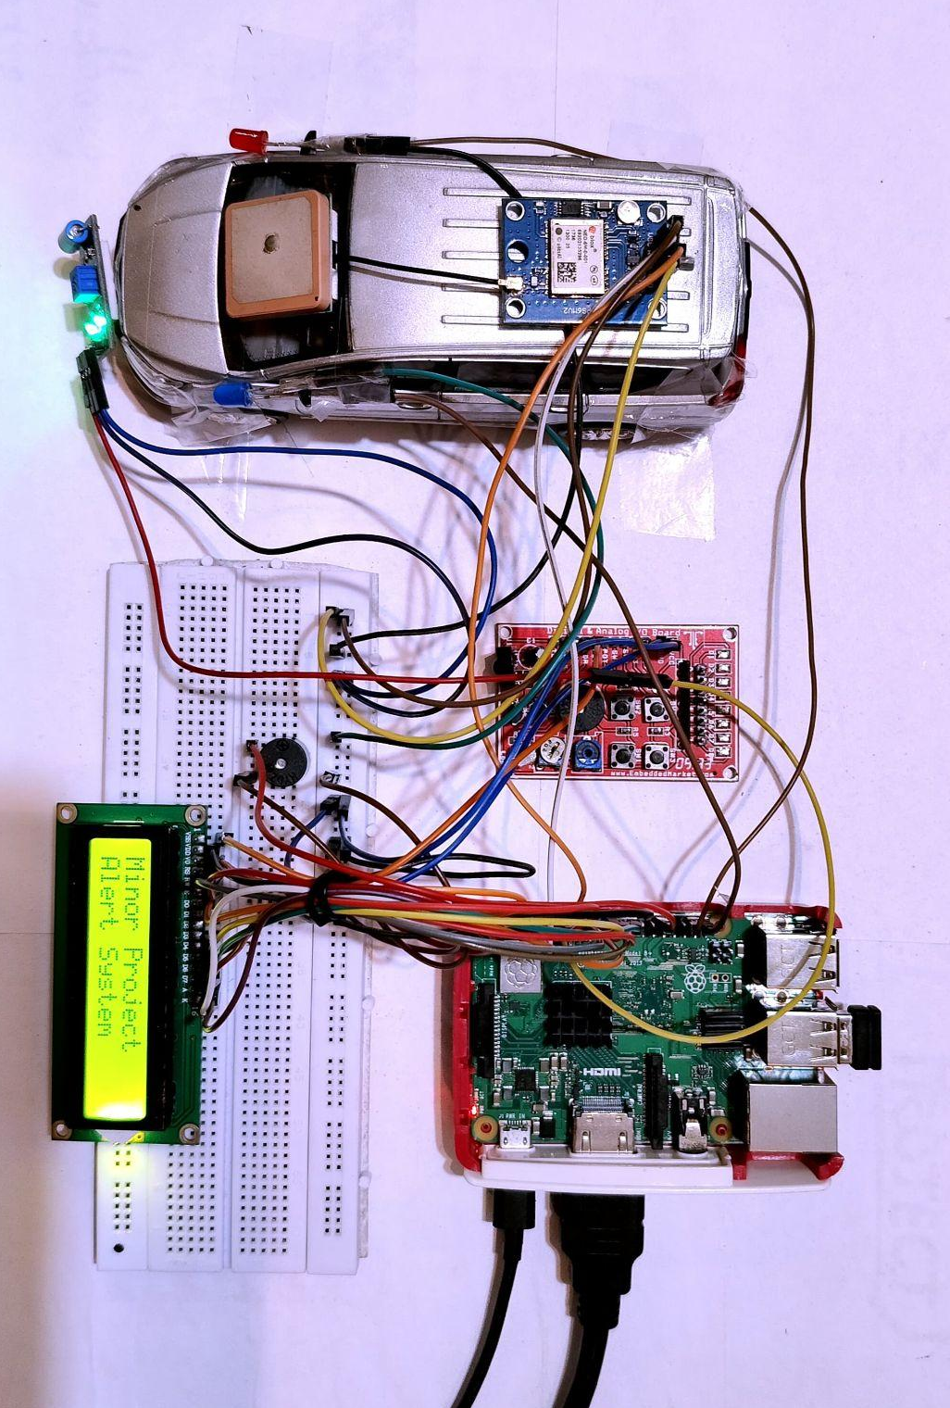  Fig. 1: Model for the ‘Accident Alert Bot System’  Figure 1 depicts the model of ‘The Accident Alert Bot system, which is designed to enhance road safety by providing immediate alerts to designated contacts in the event of a collision. The key components and system operation are described along with a brief working of this project.  1. Key Components  Raspberry Pi: Serves as the central microcontroller, managing inputs from sensors and coordinating communication.  Vibration Sensor: Mounted on a model car, it detects collisions by sensing impact forces.  GPS Module: Provides precise location data, crucial for accurately reporting the accident site.  Telegram Bot: Enables communication by sending alert messages to preconfigured contacts upon collision detection.  LCD Module: Displays real-time system status, including alerts and operational messages, offering immediate feedback to the driver.  LED Indicators: Provide visual cues for system status and alerts. | Buzzer: Emits an auditory alert to warn the driver and nearby individuals of a collision.  2. System Operation  Impact Detection: The vibration sensor, mounted on the model car, continuously monitors for any collision or significant impact.  Data Processing: Upon detecting an impact, the vibration sensor sends a signal to the Raspberry Pi.  Location Tracking: The Raspberry Pi activates the GPS module to obtain the precise geographical location of the vehicle.  Alert Transmission: Using the Telegram bot, the system sends an alert message to preconfigured contacts. This message includes information about the collision and the vehicle's location.  Immediate Feedback: Simultaneously, the LCD module displays the location or relevant alerts, while LED indicators and the buzzer provide visual and auditory warnings to the driver and nearby individuals.  III. HARDWARE DESCRIPTION  Figure 2 illustrates the Block Diagram model of the developed Accident Alert Bot System, utilizing a Raspberry Pi 3B+ along with key components. The GPS module accurately detects the vehicle's location during an accident. A SW-420 Vibration Sensor detects collision-induced vibrations, triggering the system. Alert messages are transmitted via the Telegram platform using the Raspberry Pi's connectivity. Additionally, a 16x2 LCD module displays real-time location data from the GPS module. This diagram visually outlines how these components interact within the system to enhance road safety through efficient accident detection and alerting.

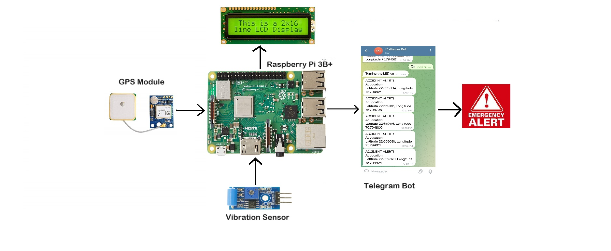  Fig. 2: Block diagram for the Accident Alert Bot system  These hardware components are carefully integrated and configured to create a robust and functional ‘Accident Alert Bot System’ capable of detecting collisions, determining the location of the incident, and notifying relevant parties on time. The system integrates the following components:  1. Raspberry Pi 3B+  The Raspberry Pi 3B+ serves as the central processing unit for the collision detection and alert system. It features:  Processor: Broadcom BCM2837B0, Cortex-A53 (ARMv8) 64-bit SoC @ 1.4GHz  Memory: 1GB LPDDR2 SDRAM  Operating System: Raspbian OS, optimized for IoT applications  GPIO Pins: Used for interfacing with external components such as the vibration sensor, GPS module, and LCD module.  2. Vibration Sensor(SW-420)  The SW-420 vibration sensor is utilized for detecting impacts or collisions. Key features include:  IV. SOFTWARE DESCRIPTION  The software architecture of the Accident Alert Bot System, built around the Thonny Python IDE, integrates key components such as sensor data processing, communication protocols, and user interface management. Sensor data processing enables real-time analysis of potential collisions, while communication protocols ensure efficient data transmission between system modules. The user interface is intuitive, providing clear alerts and actionable information. Together, these components enhance system safety and reliability, making it essential for collision prevention.  1. Thonny Python IDE  Thonny serves as the integrated development environment (IDE) for programming the Raspberry Pi 3B+ in Python. It provides a user-friendly interface for writing, testing, and debugging Python scripts directly on the Raspberry Pi.  Code Development: Python scripts are written within Thonny to manage sensor interfaces, process data from the vibration sensor and GPS module, and control the system's overall functionality.  2. Telegram Bot Integration (Telepot Library)  Communication Protocol: The Telepot library facilitates communication between the Collision Detection System and the Telegram messaging platform.  Alert Messaging: Python scripts utilize Telepot to send real-time alerts and notifications to designated recipients via Telegram. Alerts include critical information such as accident location coordinates and timestamps.  3. PySerial for GPS Module Communication  Serial Communication: PySerial library is utilized to establish communication between the Raspberry Pi and the NEO-6 GPS Module via UART (Universal Asynchronous Receiver-Transmitter).  The data is parsed to extract accurate latitude and longitude coordinates, crucial for pinpointing the accident location.  Updates the 16x2 LCD with "Accident Alert!" and displays the latitude and longitude.  Activates a buzzer (BUZZER GPIO) briefly to signal the alert.  5. System Control and Cleanup  Error Handling: Manages exceptions like keyboard interrupts (KeyboardInterrupt) to cleanly exit the program.  GPIO Cleanup: Ensures proper cleanup of GPIO configurations (GPIO.cleanup()) upon program termination.  6. Workflow  Initialization: Configures GPIO pins, initializes the LCD, sets up the Telegram bot, and establishes serial communication with the GPS module.  Collision Detection: Monitors vibrations and triggers actions upon collision detection, including alert messaging and updating the LCD display.  Alert Messaging: Utilizes Telegram for real-time alert notifications to designated recipients.  System Control: Handles program interruptions and ensures GPIO cleanup for system stability.  This script demonstrates a comprehensive implementation of a Collision Detection and Alert System using Raspberry Pi, integrating hardware interfaces, sensor data processing, and external communication via Telegram for enhanced road safety applications.  VI. FUTURE WORK  The current Accident Alert Bot System serves as a foundational framework that can be enhanced with advanced sensors, machine learning for better accuracy, and wireless communication. Refining the user interface and adding cloud connectivity for remote monitoring would further improve its effectiveness, making it a comprehensive solution for collision prevention.  6. Continuous Improvement and Testing:  Field Testing: Conduct extensive field testing and validation in diverse real-world scenarios to refine algorithms and enhance system reliability.  User Feedback: Gather user feedback and iterate on system features and usability to address practical needs and improve user experience.  By pursuing these avenues of future work, the Collision Detection and Alert System can evolve into a more advanced and effective solution for enhancing road safety, reducing response times to accidents, and ultimately saving lives.  VII. CONCLUSION  The "Accident Alert Bot System using RPi" project has successfully developed and implemented a robust system for real-time collision detection and alerting. By leveraging Raspberry Pi's versatility and integrating components such as the SW-420 Vibration Sensor, NEO-6 GPS Module, and 16x2 LCD Module, the system effectively detects collisions, captures precise accident locations, and notifies stakeholders promptly via Telegram.  Key accomplishments of the project include:  Effective Collision Detection: Utilizing the vibration sensor to promptly detect collisions and initiate alert procedures.  Accurate Location Tracking: Integration of the GPS module for precise latitude and longitude data retrieval, crucial for emergency response.  User Interaction: Providing real-time feedback through the LCD module and Telegram notifications, enhancing user awareness and system usability.  Future enhancements could focus on expanding sensor capabilities, implementing advanced algorithms for predictive analytics, and integrating cloud-based solutions for scalability. | Functionality: Detects changes in acceleration exceeding a set threshold.  Interface: Digital output signal indicating vibration presence.  Integration: Connected to Raspberry Pi GPIO for real-time collision detection.  3. GPS Module (NEO-6)  The NEO-6 GPS module provides accurate geographical coordinates essential for pinpointing accident locations. Features include:  Navigation Solution: Offers precise positioning data with high sensitivity and minimal power consumption.  Interface: Communicates with Raspberry Pi via serial communication (UART).  Compatibility: Designed to integrate seamlessly with the Raspberry Pi for real-time location tracking.  4. 16x2 LCD Module  The 16x2 LCD module provides visual feedback and status updates about system operations. It includes:  Display: 16 characters per line, 2 lines, for showing system status and messages.  Interface: Connected to Raspberry Pi GPIO for displaying real-time information such as alerts and system status.  Functionality: Used to enhance user interaction and provide immediate visual feedback during system operation.  5. Power Supply:  The system requires a stable power source to operate reliably. Typically powered by a DC power adapter or a rechargeable battery pack.  V. CODE DESCRIPTION  1. GPIO Pin Configuration and LCD Initialization  GPIO Pins: Configures GPIO pins for interfacing with components like LED, Vibration Sensor, and 16x2 LCD.  LCD Initialization: Defines functions (lcd_init, lcd_byte, lcd_toggle_enable, lcd_string) for initializing and controlling the 16x2 LCD module to display system status and GPS data.  2. Telegram Bot Integration  Telepot Library: Initializes a Telegram bot (telepot.Bot) using a provided token for sending accident alerts with GPS location information.  3. GPS Module Communication  Serial Configuration: Sets up serial communication (serial.Serial) with the NEO-6 GPS Module connected to /dev/serial0 at a baud rate of 9600.  4. Collision Detection and Alerting  Main Loop: Continuously monitors the Vibration Sensor (VIBRATION GPIO) for collision events.  Upon detecting a collision : (GPIO.input(VIBRATION) high), it triggers actions:  Turns on an LED (LED GPIO) to indicate collision detection.  Reads GPS data (gps_serial.readline()) to extract latitude and longitude using a function (parse_nmea_sentence).  Data Handling: Python scripts manage the reception and decoding of GPS data streams from the NEO-6 module. Sends a formatted alert message via Telegram (bot.sendMessage) containing the accident location coordinates.  1. Enhanced Sensor Integration:  Multi-Sensor Fusion: Integrate additional sensors such as accelerometers or ultrasonic sensors to improve collision detection accuracy and robustness.  Environmental Sensors: Include sensors for monitoring weather conditions or road surface conditions to provide more context-aware alerts.  2. Advanced Data Processing:  Machine Learning Algorithms: Implement machine learning models for more sophisticated collision prediction based on historical data and sensor inputs.  Edge Computing: Explore edge computing techniques to process data locally on the Raspberry Pi for faster response times.  3. User Interface and Interaction:  Mobile Application: Develop a companion mobile app for users to receive alerts, view accident details, and interact with emergency services.  Voice Assistance: Integrate voice commands and responses to provide hands-free operation and accessibility.  4. System Scalability and Deployment:  Fleet Management: Extend the system to support fleet vehicles, enabling centralized monitoring and management of multiple vehicles.  Cloud Integration: Implement cloud-based data storage and analytics to aggregate data across multiple systems for insights and fleet optimization.  5. Community and Government Collaboration:  Public Safety Integration: Collaborate with local authorities and emergency services to integrate the system into existing public safety frameworks.  Regulatory Compliance: Ensure compliance with regional safety regulations and standards for automotive and IoT devices.  These efforts aim to further optimize accident response times, enhance system reliability, and contribute to safer road environments.  In conclusion, the "Accident Alert Bot using RPi 3B+" project represents a significant advancement in leveraging IoT technology to enhance road safety. By integrating Raspberry Pi, the system effectively detects potential collisions in real-time and promptly notifies drivers, thereby mitigating risks on the road. This innovative approach not only improves accident prevention but also sets a robust foundation for future developments in accident detection and emergency response systems. Moving forward, the project's success opens avenues for implementing more sophisticated algorithms, enhancing sensor capabilities, and exploring cloud integration for broader data analytics and remote monitoring. These advancements promise to revolutionize how we approach road safety, making our transportation systems safer and more efficient.  VIII. WORKING OF THE MODE  (Video Link):Accident Alert Bot System using RPi 3B+  IX. REFERENCES  - Raspberry Pi Foundation. "Raspberry Pi Documentation." Available: https://www.raspberrypi.org/documentation/. Accessed on: June 29, 2024.  - A. Telgote, Y. Thakur, S. Gharde, E. Sarate, and G. J. Sawale, "Automatic Accident Alert System using Raspberry Pi," in IJSRD - International Journal for Scientific Research & Development, vol. 8, no. 2, pp. 1236, 2020  - M. Richardson, "Raspberry Pi 3 B+ Pin-out Diagram," ResearchGate, 2020. [Online]. Available: https://www.researchgate.net/figure/Raspberry-Pi-3-B-Pin-out-Diagram-From-Fig-3-out-of-40-pins-26-are-used-as-a-digital_fig2_346085998. [Accessed: June 29, 2024].

