Decoding ML Models Which Masters Stock Market Prediction
Priya Gupta ^{a,1}, Kajol Verma ^{b,2}, Dr. Rakesh Kumar ^{c,3}, Bela Bansal ^{d,3} Dr. Sanil Kumar ^{e,4}
ª Dayalbagh Educational Institute, Agra, Email. Id: priyagupta@dei.ac.in, Orcid Id: 0009-0009-4851-9825
^{b} St. John’s college, Agra, Email Id: Kkajolverma88@gmail.com
^{c} Dayalbagh Educational Institute, Agra, Email Id: drrakeshyadav@dei.ac.in, Orcid Id: 0009-000-9168-9373
^{d} Dayalbagh Educational Institute, Agra, Email. Id: belabansal@dei.ac.in, Orcid Id: 0009-0008-6473-2063
^{e} Dayalbagh Educational Institute, Agra, Email Id: sanilkrin@dei.ac.in, Orcid Id: 0009-0001-3983-5799
Abstract:
Predicting the stock market has always been difficult because financial data is dynamic, volatile, and non-linear. Machine-learning (ML) models have become increasingly effective instruments for predicting stock prices and market trends as artificial intelligence has advanced. In this study, the predictive performance of three machine-learning models—SVM, LSTM, and MLP—is assessed using stock price data from a subset of companies. The results show that no model performs better in every situation. Instead, the dataset's properties—such as data patterns, volatility, and the volume of historical records—have a significant impact on each model's accuracy and efficiency. MLP is good at capturing non-linear patterns in Mahindra and Mahindra, LSTM is efficient in the case of TATA Steel, and SVM shows good predictive ability in JSW. SVM and MLP both show satisfactory results in the case of Maruti Suzuki. As a result, all three models demonstrate effectiveness in various settings, highlighting the significance of data attributes when choosing a suitable machine-learning model for stock market prediction.
Keywords: Machine-learning, Stock Market, LSTM, SVM, MLP, Deep learning, Stock market prediction
1. Introduction:
Stock market prediction is a complex task (Kumar & Thenmozhi, n.d.-c), but complexity makes it interesting. The curiosity of researchers (Gunduz, 2021) and financial analysts to make stock market predictions accurate and take informed investment decisions sets a stage for new techniques (Gupta et al., 2025). The stock market is one of the chaotic places that is shaken not only by defined forces (Vijh et al., 2020) but also by undefined forces, which makes the stock market uncertain or unpredictable. Traditionally econometric models utilized for the prediction of the stock market consist of GARCH, ARMA, ARIMA, etc. Even these measures show a light of success in stock market prediction (Wilhelmsson, 2006) (Lorenzato de Oliveira JF, Ludermir TB, 2014). (Zhao, C., Cai, J., & Yang, S. 2025), but as time passes, the stock market becomes a turmoil, and the traditional techniques fail to align with the market momentum. These models begin to struggle with the non-linearity and non-stationarity of the long-term data (Han et al., 2024). Mostly retail investors remain unaware of the behaviour of the market. (Khan et al., 2020), Therefore, subsequent research has shown that these models struggle to capture the non-periodic features of stocks and fail to fully reflect the true distribution of the data (Zhao, C., Cai, J., & Yang, S. 2025). Undoubtedly, these challenges become a gateway for AI in stock market prediction. Since the dawn of artificial intelligence, machine-learning models have been able to learn patterns from the historical data and make predictions for their ultimate users (Gupta et al., 2025). There are many usable machine-learning models for prediction with satisfactory success rates, including Random Forest (RF), Support Vector Machines (SVM), and Gradient Boosting Decision Trees (GBDT) (Zhao, C., Cai, J., & Yang, S. 2025); however, in the case of large data, you can’t solely rely on machine-learning models for prediction (LeCun et al., 2015) because they face problems in the case of large data sets and highly sequential data. Deep learning as a subset of machine-learning provides a solution for the drawback of ML and enters the race of prediction tools, including Convolutional Neural Networks (CNN), Recurrent Neural Networks (RNN), and Long Short-Term Memory Networks (LSTM) (Zhao, C., Cai, J., & Yang, S. 2025). There are various tools of machine-learning and deep learning, but the question rises: which model is most suitable for prediction? Which is more assurable and considered as a premise for investors’ decision? Which model suitable for which type of data? So here researchers in this study try to find out the answers to these above questions. Before starting, we take a dive into techniques, which we further used in our analysis.
Neural networks and deep learning approaches are mainly developed for time series prediction, especially in recurrent neural networks (RNN) (Saranj, A. & Zolfaghari, M. 2022) (Cui et al., 2020; Toubeau et al., 2021). RNN faces a gradient problem. LSTM is an upgraded version of RNN that does not only cover gaps of RNN but also provides extra features like a 3-gate mechanism, long-term dependency handling, and memory cells, which are able to apply to historical data and improve time series analysis (Petersen et al., 2019; Guo et al., 2021). (Saranj, A. & Zolfaghari, M. 2022)(Billah, M. M., Sultana, A., Bhuiyan, F., & Kaosar, M. G. 2024) LSTM is way better than technical analysis tools, i.e., SMA and EMA, due to their capability of capturing long-term patterns through memory cells and forget, input & output gates (Tuğrul etal. 2024)
ANN is one of the commonly used techniques in machine-learning, not only in the stock market. ANNs have shown a high degree of success in function approximation in different fields, including geotechnical engineering (Huang et al., 2023) (Zhang and Goh, 2016), but it faces problems like overfitting due to the heavy amount of data. Support vector developed as a successor of ANN, handling limitations of ANN (Hegazy et al., 2013). SVM divided data into two classes through a straight-line (Toraman et al., 2019) (Çınar & Tuncer, 2020), which is known as a hyperplane in N dimensions (N is the number of features) (Chen et al., 2004). SVM is a binary linear classifier that has been extended to non-linear data using kernels and multi-class data using various techniques (Chauhan et al., 2018).
SVM classifies into two types. One is linear SVM, and the second one is nonlinear SVM (Kurani et al., 2021). (Chauhan et al., 2018) in linear SVM, data is classified into two classes through a linear straight-line, unlike nonlinear data, which cannot be divided into two groups using one straight-line. SVM is highly powerful with high dimensions; the remembering power of SVM is also great. (Chhajer et al., 2022) SVM can be utilized in various places like particle identification, text categorization, engine knock detection, bioinformatics, database marketing, etc. (Yue et al., 2003)
MLP can handle nonlinear data because of its approximating arbitrage feature, which helps to enhance its prediction. Nonlinear processing elements (PEs), which introduce nonlinearity in the data and help models to learn complex patterns within the data set (Guresen et al., 2011). In MLP, data passes from 3 layers, which are divided as input layer, hidden layer, and output layer, and in each layer, numerous neurons are present. These neurons are not connected in the same layer but are connected to the next layer (M et al., 2018). teaches the model about patterns and minimizes prediction error.
2. Related Work:
When traditional models faced the non-linearity and non-stationarity problem, machine-learning models came into the picture with their outrageous power of detecting patterns and forecasting. (Nikou et al., 2019) (Das & Padhy, 2012; Guo, Wang, Liu, & Yang, 2014; Lu, Lee, & Chiu, 2009) express, Out of so many machine-learning algorithms, ANN, SVM, and RF were widely utilized for forecasting with high precision, and Aydin & Cavdar (2015), Giovanis (2009), and Yim (2002) reflect the superiority of these ML models over traditional regression models (Chhajer et al., 2022) if we provide sufficient thick data for prediction. Liu (2025) compared ML and DL models and depicted that SVM and RF show an inability to capture the critical time dependency patterns in stock market data efficiently, while DL models like RNN & LSTM, etc., are the forefathers of ML models in capturing time dependency trajectories. (Han et al., 2024) Describe DL as a multi-layer tapestry of understanding used for computer vision, speech recognition, and NLP. Chahal & Gulia (2019) underline the application of ML and DL as per data characteristics; for the small training data set, one must work on ML. On the other hand, if the data set is large and you want to do an analysis in minutes, then prefer DL because the process time is low as compared to conventional ML techniques. (Chhajer et al., 2022) forecast share price of Amazon with SVM & LR, Tesla with SVM and LSTM, and Reliance Ltd. through SVM on technical indicator data; in each forecast SVM shows different results as per the competitor model in the case of Amazon SVM shows less accuracy than LR on the other side as compared to LSTM; SVM and LR both show the same preciseness, and in the Reliance Ltd. case, resulted in accuracy ranging between 51.43% and 53.15% as per the kernel used. Even include that SVM is faster than ANN when dealing with thousands of data. Kumar & Thenmozhi (n.d.) evaluate the performance of SVM, RF, and ANN in forecasting the S&P CNX NIFTY INDEX from the year 2000 to 2005 and also utilize 12 technical indicators and find that SVM outperforms RF and ANN, SVM is superior to RF by 1.04%, and RF is better than ANN. SVM is efficient because of its structural risk minimization principle as compared to other tools. (Lakshminarayanan & McCrae, n.d.) Researchers consider two types of data to measure the performance of LSTM with moving average and SVM on the combined data set (DJI stock price, gold price, and crude oil) and individual data separately. The study displays that in the case of the combined data set, LSTM outperforms SVM, but on the other side of the coin, SVM and LSTM act equally if data is individual and without moving average. This study includes literature from Wang et al. (2018), who denote that LSTM presents more accuracy compared to backpropagation NN. Billah et al. (2024) disclose that if the data set is short-term, then LSTM predicts the market better as compared to SMA, EMA, or vice versa. Gupta, S., Nachappa, S., & Paramanandham, N. (2025) analyze the superiority of models such as LSTM, GARCH, SVM, RF, ANN, XGBoost, and AdaBoost over others, using historical data of TCS on the NSE website from Jan 2019 to June 2024. The study infers that LSTM ranked 1st and GARCH ranked 2nd in performance to predict volatility, surpassing other models in performance with a high margin (20.83% success margin in the case of RF and 14.36% or 12.244% for SVM), but LSTM in the case of GARCH shows a lower margin (2.42%) of success. Guresen et al. (2011) compare the classical ANN model, MLP with DAN2, and the hybrid models GARCH-MLP and GARCH-DAN2 and conclude that MLP predicts the NASDAQ Stock Exchange Index with the small error of 0.54% and surpasses all the other models. (Majumder, A. 2021) Their researcher measured the performance of ML models and used 6 evaluation matrices (EVS, RMSE, MSE, R-squared root, adjusted R-squared score, and MAE). Across all six models, LSTM performed superior to other models (LR, RF, SVM, and VAR), because LSTM's multiple-layer and gate structure make it highly efficient for sequential data. SVM infers as the worst model in the study over all six metrics. Namdari (2021) studied and evaluated MLP combined with fundamental analysis and technical analysis and compared it with LSTM, SVM, HATS, and a hybrid model (NARX + Fundamental Analysis + Historical Prices), in which the hybrid model outperformed all the models. The result of the hybrid model can be generalized and is more reliable; even MLP + Fundamental Analysis shows 64.38% accuracy with good generalization power as compared to MLP + Technical Analysis. Kara et al. (2010) conclude that ANN outperforms SVM in the prediction of the ISE National 100 Index; the researcher divided data 50-50% for comparing performance. Guo et al. (2020) examine the efficiency of SVM, RF, and LSTM and find that none of the models are able to predict short-term energy loads; therefore, the study proposes a fusion method for prediction by combining all three models’ characteristics, which outperforms all the individual models. The Bhandari et al. (2022) study depicts that single-layer LSTM is performing well as compared to multilayer LSTM and suggests that adding complexity in multilayer did not help to improve prediction and even has a chance of overfitting in multilayer LSTM. Apart from stock market prediction, machine-learning and deep learning models overshadow traditional models in various sectors of the economy. (Alizadegan et al., 2024) energy consumption, (Dolaeva et al., 2025) P/E ratio forecast through investor sentiment (R. Chen et al., 2019) typhoon prediction, (K. Gupta et al., 2022) blood pressure detection, (Luo & Gong, 2023) air pollutant detection, (Zhang & Fu, 2022) smart wearable for sports, (Rehman et al., 2019) predict movie reviews in all the research LSTM model and hybrid models yield highly accurate results; moreover, SVM and RF are also utilized in predicting the risk of railway incidents (W. Huang et al., 2021), bioinformatics (www), image classification (Chandra & Bedi, 2018), surface water and groundwater hydrology (Raghavendra & Deka, 2014) (Naghibi et al., 2017), and identifying genetic diversity for conservation or protection (Sylvester et al., 2017). Psychological research (Fife & D’Onofrio, 2022) Ample comparative study of machine-learning and deep learning tools exists; nevertheless, barely any study utilized datasets spanning over a decade. Furthermore, current research scarcely accounts for companies across diverse sectors in the study. Which hinders generalization of their study. Thus, our contribution is to analyze a dataset of 4 companies of 2 different sectors over the long-term of share price. and measure the performance of LSTM, SVM, and MLP, which hardly any studies compare.
3. Research Methodology:
3.1. Variable selection:
This section describes the research data and prediction models selected for the study. Daily closing price for the financial year 2014-2015 to 2024-2025 of the 4 companies, out of which 2 are from the NSE automobile sectoral index and the rest are from the metal sectoral index. The sector selected on the line of highest FII received from calendar years 2020 to 2025 is the auto sector, which is ranked 1st; the oil sector is 2nd, and the metal sector is ranked 3rd, as per researcher data analysis. For the study, the oil sector was not considered because it was established in the year 2020; therefore, the metal sector came into the picture, and based on two criteria, companies were selected: one, it should be consistent from financial year 2014-2015 to 2024-25 in the respective indices, and two, it has the highest weight in sector indices. On March 28, 2025. The data set includes both bearish and bullish trends, which help models to make better predictions.
3.2. Model selection:
For the proposed study, 3 ML prediction models were selected based on their different characteristics, such as LSTM, SVM & MLP. LSTM has the characteristic of learning from historical data of time series, which helps to make precise predictions, while SVM helps to classify data in the binary trends (Kara et al., 2010) through hyperplane margin to reduce error bound in regression. (Gupta et al., 2025). MLP used backpropagation to train the model itself, which helped in the precise prediction of the stock market (Guresen et al., 2011).
3.3. Analysis process:

Fig 1: Steps to train and prediction through model
3.4. Method Analysis:
Study applies 3 most know models of ML on the dataset of NSE from Financial year 2014-15 to 2024-2025. Specifically, 80%-20% data used for training and testing respectively. Prediction accuracy and reliability of these models are assessed by calculating two different performance metrics—RMSE & MAE. Between two prediction metrics, RMSE measures the square root of the mean square error of the actual values and estimated values, MAE estimates the size of the error computed as the relative average of the error. Smaller the values of RMSE and MAE, better the performance of the model.
Table 1: Train- Test Data for model
 |  | Percentage | N | Company Name
Sample | Training | 80% | 1977 | JSW  Maruti Suzuki  M & M
Sample | Testing | 20% | 493 | JSW  Maruti Suzuki  M & M
Total |  |  | 2471
Sample | Training | 80% | 1973 | TATA Steel
Sample | Testing | 20% | 493 | TATA Steel
Total |  |  | 2466
4. Analysis
4.1. SVM in stock market prediction:
First, SVM apply to predict share prices of JSW, TATA Steel, Mahindra & Mahindra, Maruti Suzuki through a testing closing prices of these companies.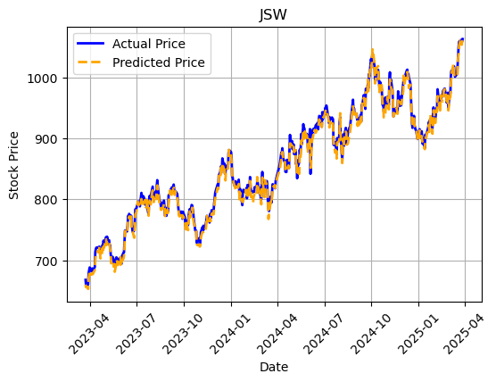Fig 2: SVM trend chart for closing prices of JSW
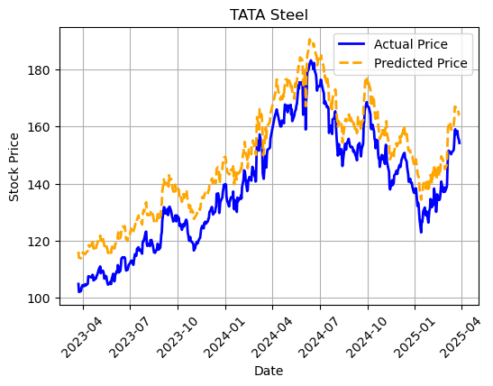
Fig 3: SVM trend chart for closing prices of TATA Steel
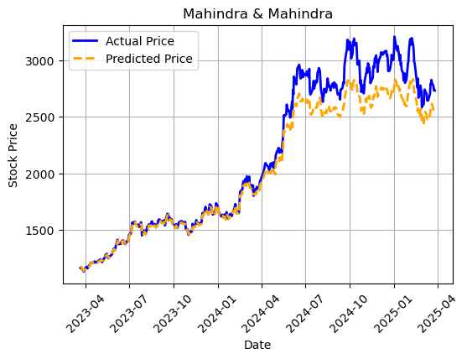
Fig 4: SVM trend chart for closing prices of Mahindra & Mahindra
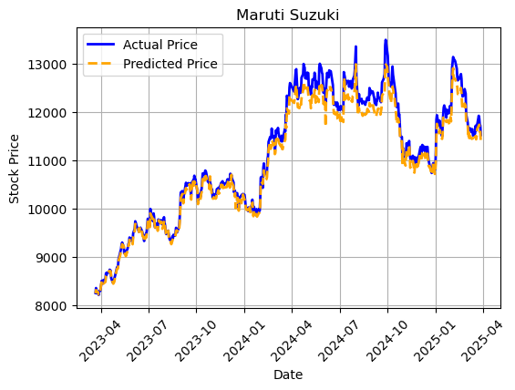
Fig 5: SVM trend chart for closing prices of Maruti Suzuki
In all the above graphs, the orange & blue lines represent predictive and actual values, respectively, through which the researcher observed that SVM in the case of M&M was not able to catch the trend and was slightly misleading in the case of Maruti Suzuki and worst in the case of TATA Steel, where it was able to catch the trend but had a high error in the actual and predictive values. On the other hand, it shows high predictability in JSW. It is concluded that when there is a sharp spike in the share price, then SVM is not able to capture the trend, which leads to unreliable predictions, as noted in TATA Steel and M&M, and even in Maruti Suzuki.
4.2. LSTM in stock market prediction:
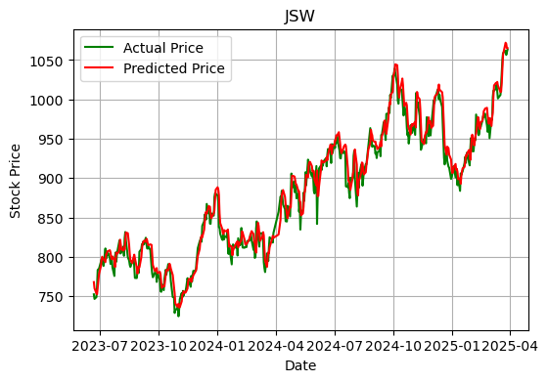
Fig 6: LSTM trend chart for closing prices of JSW
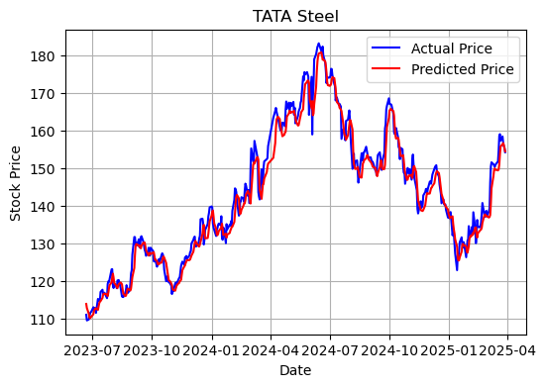
Fig 7: LSTM trend chart for closing prices of TATA Steel

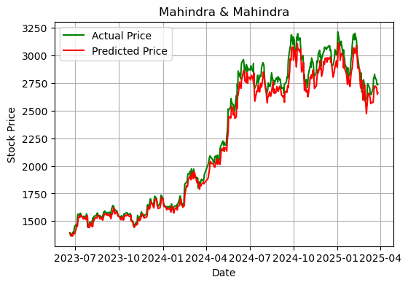
Fig 8: LSTM trend chart for closing prices of Mahindra & Mahindra
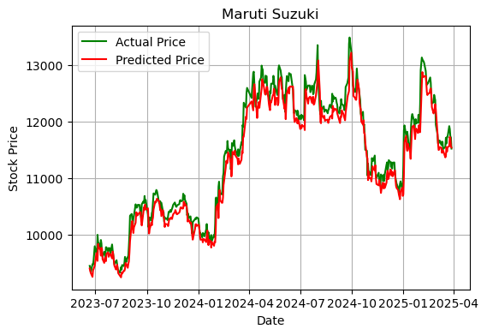
Fig 9: LSTM trend chart for closing prices of Maruti Suzuki
The researcher marked that in all graphs LSTM is able to understand trends with spikes but not to predict clear peaks and lows of the trend or even mislead the overall values of the trend.
4.3. MLP in stock market prediction:
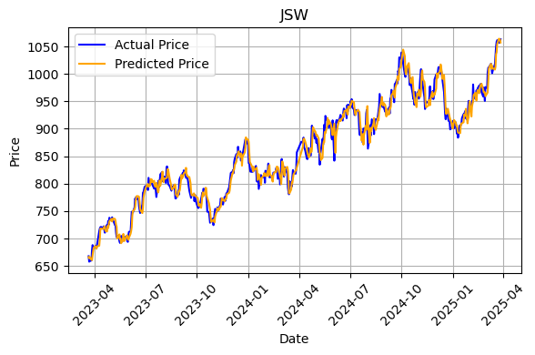
Fig 10: MLP trend chart for closing prices of JSW
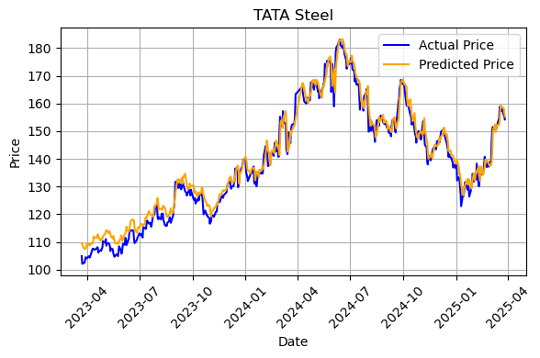
Fig 11: MLP trend chart for closing prices of TATA Steel

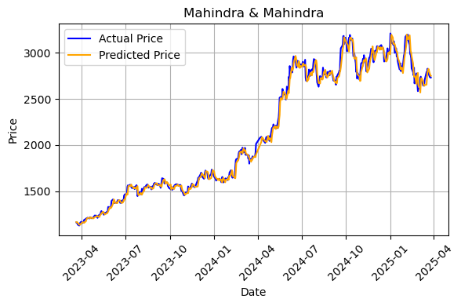
Fig 12: MLP trend chart for closing prices of Mahindra & Mahindra
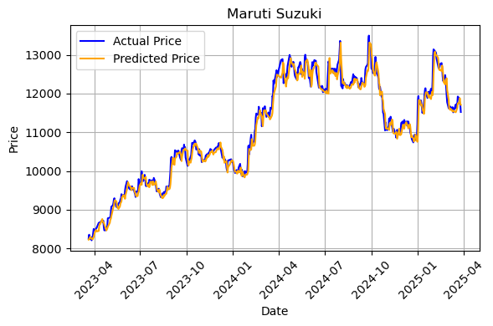
Fig 13: MLP trend chart for closing prices of Maruti Suzuki
In MLP graphs, the yellow and blue lines denote predictive and actual values, respectively. It was observed that in all the companies apart from TATA Steel, MLP showed satisfactory performance as compared to other models, able to capture the nonlinearity of the data followed by a closely aligned prediction of MLP.
Table 2: Error of models to predict closing prices of companies
Error in calculation | SVM | LSTM | MLP | Datasets
RMSE | 0.83% | 1.65% | 1.68% | JSW
MAE | 0.69% | 1.28% | 1.28% | JSW
RMSE | 7.41% | 1.71% | 1.97% | TATA Steel
MAE | 7.19% | 2.27% | 2.46% | TATA Steel
RMSE | 5.67% | 3.65% | 2.44% | Mahindra & Mahindra
MAE | 4.18% | 2.82% | 1.73% | Mahindra & Mahindra
RMSE | 1.55% | 1.99% | 1.73% | Maruti Suzuki
MAE | 1.28% | 1.57% | 1.23% | Maruti Suzuki
The table shown above of error denotes that in the case of SVM, RMSE and MAE are .83%, 7.41%, 5.67%, 1.55%, & .69%, 7.19%, 4.18%, and 1.28%, respectively, for JSW, TATA Steel, Mahindra & Mahindra, & Maruti Suzuki; the values for LSTM are 1.65%, 1.28%, 1.71%, 2.27%, 3.65%, 2.82%, 1.99%, and 1.57%, as follows, and for MLP, 1.68%, 1.28%, 1.97%, 2.46%, 2.44%, 1.73%, 1.73%, and 1.23%. Bold values in the above table represent the lowest error values of the ML models for the respective company share price prediction.
5. Results and Discussion

Fig 14: Comparison of error & accuracy among the models
As we compared the results of various models, we interpreted that in the case of JSW, SVM showed the lowest error rate as compared to LSTM and MLP because SVM was able to observe a sudden downfall and gradual recovery in the prices of JSW, but as we moved towards TATA Steel, LSTM surpassed MLP and SVM due to the fact that LSTM learns from the past trends, and in TATA Steel there was a gradual upward trend, which LSTM observed and predicted properly. Even MLP did not stay back; it also showed the lowest error rate in the condition of M&M through its feedforward learning behavior and also showed a competitive result with SVM in the case of Maruti Suzuki.

6.Conclusion:
After the introduction of ML and DL, there is a revolution in stock market prediction, which makes prediction complex but interesting through coding. In this study we figure out the efficiency and superiority of ML and DL models with 4 different data sets. Our study contradicts the conclusion of previous studies, as it clearly showed the superiority of LSTM over other predictive models when there is large sequential data, but from the above comparative analysis, it can be observed that there is no monopoly of one model over all the types of datasets. Therefore, in JSW, SVM outperforms; in TATA Steel, LSTM; in M & M, MLP; and in Maruti Suzuki, MLP and SVM close in prediction. So, the results allowed the researcher to conclude that the efficiency of the models’ predictions depends upon the characteristics of the dataset, such as linear relation, financial shocks, recovery of share price, etc., not on the quality of the model. There should be a perfect alignment of characteristics of the dataset and quality of the model if one wants accurate prediction. ML, DL models, and the stock market are an ocean that is difficult to cover by only study, so here are some limitations of the study: 1. It only considers the dataset of the Indian stock market. 2. Researchers only compare 3 models, in which only one DL model is utilized. 3. We consider only long-term datasets for the study. So, future researchers can focus on these areas for further work.
7. CRediT authorship contribution statement
Priya Gupta: Conceptualization, Writing - Original Draft, Methodology, Visualization Kajol Verma: Methodology, Software Dr. Rakesh Kumar: Supervision, Resources Bela Bansal: Writing - Review & Editing Dr. Sanil Kumar: Supervision
8. Declaration generative AI use:
During the preparation of this work the author(s) used Chat GPT in order to rephrase sentences in the section of Abstarct and some part of introduction. After using this Chat GPT, the author(s) reviewed and edited the content as needed and take(s) full responsibility for the content of the published article.
9. REFERENCE:
Billah, M. M., Sultana, A., Bhuiyan, F., & Kaosar, M. G. (2024). Stock price prediction: comparison of different moving average techniques using deep learning model. Neural Computing and Applications, 36, 5861-5871. https://doi.org/10.1007/s00521-023-09369-0
Chahal, A., & Gulia, P. (2019). Machine-learning and deep learning. International Journal of Innovative Technology and Exploring Engineering, 8(12), 4910-4914. https://doi.org/10.35940/ijitee.L3550.1081219
Chandra, M. A., & Bedi, S. S. (2021). Survey on SVM and their application in image classification. International Journal of Information Technology, 13(5), 1867-1877. https://doi.org/10.1007/s41870-017-0080-1
Chauhan, V. K., Dahiya, K., & Sharma, A. (2019). Problem formulations and solvers in linear SVM: a review. Artificial Intelligence Review, 52, 803-855. https://doi.org/10.1007/s10462-018-9614-6
Chen, R., Wang, X., Zhang, W., Zhu, X., Li, A., & Yang, C. (2019). A hybrid CNN-LSTM model for typhoon formation forecasting. Geoinformatica, 23, 375–396. https://doi.org/10.1007/s10707-019-00355-0
Chen, W. H., Hsu, S. H., & Shen, H. P. (2005). Application of SVM and ANN for intrusion detection. Computers & Operations Research, 32(10), 2617-2634. https://doi.org/10.1016/j.cor.2004.03.019
Çınar, A., & Tuncer, S. A. (2021). Classification of normal sinus rhythm, abnormal arrhythmia and congestive heart failure ECG signals using LSTM and hybrid CNN-SVM deep neural networks. Computer Methods in Biomechanics and Biomedical Engineering, 24(2), 203-214. https://doi.org/10.1080/10255842.2020.1821192
Fife, D. A., & D’Onofrio, J. (2023). Common, uncommon, and novel applications of random forest in psychological research. Behavior Research Methods, 55, 2447-2466. https://doi.org/10.3758/s13428-022-01901-9
Guresen, E., Kayakutlu, G., & Daim, T. U. (2011). Using artificial neural network models in stock market index prediction. Expert Systems with Applications, 38(8), 10389-10397.
Hegazy, O., Soliman, O. S., & Salam, M. A. (2013). A machine-learning model to predict stock market price. International Journal of Computer Science and Telecommunications, 4(12), 17–23.
Janiesch, C., Zschech, P., & Heinrich, K. (2021). Machine-learning and deep learning. Electronic markets, 31, 685-695. https://doi.org/10.1007/s12525-021-00475-2
Kara, Y., Boyacioglu, M. A., & Baykan, Ö. K. (2011). Predicting direction of stock price index movement using artificial neural networks and support vector machines: The sample of the Istanbul Stock Exchange. Expert systems with Applications, 38(5), 5311-5319. https://doi.org/10.1016/j.eswa.2010.10.027
Khan, W., Ghazanfar, M. A., Azam, M. A., Karami, A., Alyoubi, K. H., & Alfakeeh, A. S. (2022).
Stock market prediction using machine-learning classifiers and social media, news.
Journal of Ambient Intelligence and Humanized Computing, 13, 3433–3456.
https://doi.org/10.1007/s12652-020-01839-w
Meshram, I. S., & Kulal, P. J. (2021). A comparative study of SVM, LSTM and LR algorithms for stock market prediction using OHLC data. International Research Journal of Modernization in Engineering Technology and Science, 3(10), 1316-1322.
Murshed, B. A. H., Abawajy, J., Mallappa, S., Saif, M. A. N., & Al-Ariki, H. D. E. (2022). DEA-RNN: A hybrid deep learning approach for cyberbullying detection in Twitter social media platform. IEEE Access, 10, 25857-25871.
Naghibi, S. A., Ahmadi, K., & Daneshi, A. (2017). Application of support vector machine, random forest, and genetic algorithm–optimized random forest models in groundwater potential mapping.
Water Resources Management, 31, 2761–2775.
https://doi.org/10.1007/s11269-017-1660-3
Nikou, M., Mansourfar, G., & Bagherzadeh, J. (2019). Stock price prediction using DEEP learning algorithm and its comparison with machine-learning algorithms. Intelligent Systems in Accounting, Finance and Management, 26(4), 164-174. https://doi.org/10.1002/isaf.1459
Raghavendra, N. R., & Deka, P. C. (2014). Support vector machine applications in the field of hydrology: A review. Applied Soft Computing, 19, 372–386.
https://doi.org/10.1016/j.asoc.2014.02.002
Rahimzad, M., Moghaddam Nia, A., Zolfonoon, H., Soltani, J., Danandeh Mehr, A., & Kwon, H. H. (2021). Performance comparison of an LSTM-based deep learning model versus conventional machine-learning algorithms for streamflow forecasting. Water Resources Management, 35, 4167-4187. https://doi.org/10.1007/s11269-021-02937-w
Rehman, A. U., Malik, A. K., Raza, B., & Ali, W. (2019). A hybrid CNN-LSTM model for improving accuracy of movie reviews sentiment analysis. Multimedia Tools and Applications, 78, 26597-26613. https://doi.org/10.1007/s11042-018-7133-5
Roy, S. S., Roy, A., Samui, P., Gandomi, M., & Gandomi, A. H. (2024). Hateful sentiment detection in real-time tweets: An LSTM-based comparative approach. IEEE Transactions on Computational Social Systems, 11(4), 5028-5037. https://doi.org/10.1109/TCSS.2023.3260217
Saranj, A., & Zolfaghari, M. (2022). The electricity consumption forecast: Adopting a hybrid approach by deep learning and ARIMAX-GARCH models. Energy Reports, 8, 7657-7679. https://doi.org/10.1016/j.egyr.2022.06.007
Sylvester, E. V., Bentzen, P., Bradbury, I. R., Clément, M., Pearce, J., Horne, J., & Beiko, R. G. (2018). Applications of random forest feature selection for fine‐scale genetic population assignment. Evolutionary applications, 11, 153-165. https://doi.org/10.1111/eva.12524
Tanrikulu, H. M., & Pabuccu, H. (2025). The effect of data types’ on the performance of machine-learning algorithms for cryptocurrency prediction. Computational Economics, 1-34. https://doi.org/10.1007/s10614-025-10919-y
Yue, S., Li, P., & Hao, P. (2003). SVM classification: Its contents and challenges. Applied Mathematics Journal of Chinese Universities, 18(3), 332-342.
Reference to a journal Publication with an article number
Bhandari, H. N., Rimal, B., Pokhrel, N. R., Rimal, R., Dahal, K. R., & Khatri, R. K. (2022). Predicting stock market index using LSTM. Machine-learning with Applications, 9, Article 100320. https://doi.org/10.1016/j.mlwa.2022.100320
Chhajer, P., Shah, M., & Kshirsagar, A. (2022). The applications of artificial neural networks, support vector machines, and long–short term memory for stock market prediction. Decision Analytics Journal, 2, Article 100015. https://doi.org/10.1016/j.dajour.2021.100015
Dhungana, H. (2025). A machine-learning approach for wind turbine power forecasting for maintenance planning. Energy Informatics, 8, Article 2.https://doi.org/10.1186/s42162-024-00459-4.
Fozap, F. M. P. (2025). Hybrid machine-learning models for long-term stock market forecasting: Integrating technical indicators. Journal of Risk and Financial Management, 18(4), Article 201. https://doi.org/10.3390/jrfm18040201
Gunduz, H. (2021). An efficient stock market prediction model using hybrid feature reduction method based on variational autoencoders and recursive feature elimination. Financial innovation, 7, Article 28. https://doi.org/10.1186/s40854-021-00243-3
Guo, W., Che, L., Shahidehpour, M., & Wan, X. (2021). Machine-Learning based methods in short-term load forecasting. The Electricity Journal, 34(1), Article 106884. https://doi.org/10.1016/j.tej.2020.106884
Han, H., Liu, Z., Barrios Barrios, M., Li, J., Zeng, Z., Sarhan, N., & Awwad, E. M. (2024). Time series forecasting model for non-stationary series pattern extraction using deep learning and GARCH modeling. Journal of Cloud Computing, 13, Article 2. https://doi.org/10.1186/s13677-023-00576-7
Huang, F., Xiong, H., Chen, S., Lv, Z., Huang, J., Chang, Z., & Catani, F. (2023). Slope stability prediction based on a long short-term memory neural network: comparisons with convolutional neural networks, support vector machines and random forest models. International Journal of Coal Science & Technology, 10, Article 18. https://doi.org/10.1007/s40789-023-00579-4
Huang, W., Liu, H., Zhang, Y., Mi, R., Tong, C., Xiao, W., & Shuai, B. (2021). Railway dangerous goods transportation system risk identification: Comparisons among SVM, PSO-SVM, GA-SVM and GS-SVM. Applied Soft Computing, 109, Article 107541. https://doi.org/10.1016/j.asoc.2021.107541
Kanahuati-Ceballos, M., & Valdivia, L. J. (2024). Detection of depressive comments on social media using RNN, LSTM, and random forest: comparison and optimization. Social Network Analysis and Mining, 14, Article 44. https://doi.org/10.1007/s13278-024-01206-z
Luo, J., & Gong, Y. (2022). Artificial Intelligent based day-ahead stock market profit forecasting. Computers and Electrical Engineering, 99, Article 107837. https://doi.org/10.1016/j.compeleceng.2022.107837
Luo, J., Zhu, G., & Xiang, H. (2022). Artificial intelligent based day-ahead stock market profit forecasting. Computers and Electrical Engineering, 99, Article 107837.
Madhu PK, R., Subbaiah, J., & Krithivasan, K. (2021). RF‐LSTM‐based method for prediction and diagnosis of fouling in heat exchanger. Asia‐Pacific Journal of Chemical Engineering, 16(5), Article e2684.https://doi.org/10.1002/apj.2684
Naroum, E., Maka Maka, E., Abboubakar, H., Dayang, P., Bamana, A. B., Garga, B., Daouda, H. D., Bakouri, M., & Khan, I. (2025). Comparative analysis of deep learning and machine-learning techniques for forecasting new malaria cases in Cameroon’s Adamaoua region. Intelligence-Based Medicine, 11, Article 100220. https://doi.org/10.1016/j.ibmed.2025.100220
Oruc, S., Hinis, M. A., & Tugrul, T. (2024). Evaluating performances of LSTM, SVM, GPR, and RF for drought prediction in Norway: a wavelet decomposition approach on regional forecasting. Water, 16, Article 3465. https://doi.org/10.3390/w16233465
Phuoc, T., Anh, P. T. K., Tam, P. H., & Nguyen, C. V. (2024). Applying machine-learning algorithms to predict the stock price trend in the stock market–The case of Vietnam. Humanities and Social Sciences Communications, 11, Article 393. https://doi.org/10.1057/s41599-024-02807-x
Sedighi, M., Mohammadi, M., Ameli, F., Amiri-Ramsheh, B., & Hemmati-Sarapardeh, A. (2025). A comparative study of machine-learning frameworks for predicting CO2 conversion into light olefins. Fuel, 379, Article 133017. https://doi.org/10.1016/j.fuel.2024.133017
Shobayo, O., Adeyemi-Longe, S., Popoola, O., & Okoyeigbo, O. (2025). A Comparative Analysis of Machine-learning and Deep Learning Techniques for Accurate Market Price Forecasting. Analytics, 4, Article 5. https://doi.org/10.3390/analytics4010005
Tuğrul, T., Hınıs, M. A., & Oruç, S. (2025). Comparison of LSTM and SVM methods through wavelet decomposition in drought forecasting. Earth Science Informatics, 18, Article 139. https://doi.org/10.1007/s12145-024-01541-x
Zhang, T., & Fu, C. (2022). Application of improved VMD‐LSTM model in sports artificial intelligence. Computational Intelligence and Neuroscience, 2022, Article 3410153. https://doi.org/10.1155/2022/3410153
Zhao, C., Cai, J., & Yang, S. (2025). A hybrid stock prediction method based on periodic/non-periodic features analyses. EPJ Data Science, 14, Article 1. https://doi.org/10.1140/epjds/s13688-024-00517-7
Reference to a chapter in a book
Majumder, A., Rahman, M.M., Biswas, A.A., Zulfiker, M.S., Basak, S. (2022). Stock Market Prediction: A Time Series Analysis. In: Somani, A.K., Mundra, A., Doss, R., Bhattacharya, S. (Eds) Smart Systems: Innovations in Computing. Smart Innovation, Systems and Technologies (pp. 389-401). Springer, Singapore. https://doi.org/10.1007/978-981-16-2877-1_35
Cutler, A., Cutler, D.R., Stevens, J.R. (2012). Random Forests. In: Zhang, C., Ma, Y. (eds) Ensemble Machine-learning. Springer, New York, NY. https://doi.org/10.1007/978-1-4419-9326-7_5
References for a Conference Paper
Gupta, K., Jiwani, N., & Afreen, N. (2022, June). Blood pressure detection using CNN-LSTM model. Paper presented at the 11th International Conference on Communication Systems and Network Technologies (CSNT), Indore, India. https://doi.org/10.1109/CSNT54456.2022.9787648
Gupta, S., Nachappa, S., & Paramanandham, N. (2024, November). Stock market time series forecasting using comparative machine-learning algorithms. Paper presented at the 4th International Conference on Evolutionary Computing and Mobile Sustainable Networks, Coimbatore, India. https://doi.org/10.1016/j.procs.2025.01.050
Hiransha, M., Gopalakrishnan, E. A., Menon, V. K., & Soman, K. P. (2018, April). NSE stock market prediction using deep-learning models. Paper presented at the International Conference on Computational Intelligence and Data Science (ICCIDS), Gurugram, India. https://doi.org/10.1016/j.procs.2018.05.050
Kumar, M., & Thenmozhi, M. (2006, January). Forecasting stock index movement: A comparison of support vector machines and random forest. Paper presented at the Indian institute of capital markets 9th capital markets conference paper. Mumbai, India
Lakshminarayanan, S. K., & McCrae, J. (2019, November). A Comparative Study of SVM and LSTM Deep Learning Algorithms for Stock Market Prediction. Paper presented at the Second International Conference on Applied Informatics (ICAI 2019), Madrid, Spain.
Liu, Y. (2025, February). Advancing Stock Return Prediction: A Comprehensive Study of Traditional Machine-learning and Deep Learning Models. In International Workshop on Navigating the Digital Business Frontier for Sustainable Financial Innovation (ICDEBA 2024), China.
Mintarya, L. N., Halima, J. N. M., Angie, C., Achmad, S., & Kurniawan, A. (2022, November). Machine-learning approaches in stock market prediction: A systematic literature review. Paper presented at the 7th International Conference on Computer Science and Computational Intelligence (CSCI 2022), Bandung, Indonesia. https://doi.org/10.1016/j.procs.2022.12.115
Sharma, U., Kumar, A., Kumar, R., Manchanda, M., & Hooda, S. (2025, March). Netflix stock market price prediction. Paper presented at the 4th International Conference on Innovation in IoT, Robotics and Automation (IIRA 4.0), Moradabad, India. https://doi.org/10.1063/5.0248341
Vijh, M., Chandola, D., Tikkiwal, V. A., & Kumar, A. (2019, Febraury). Stock closing price prediction using machine-learning techniques. Paper presented at the International Conference on Computational Intelligence and Data Science (ICCIDS 2019), Gurugram, India. https://doi.org/10.1016/j.procs.2020.03.326
Zhou, Y. (2024, December). Analysis of stock prediction model based on LSTM. Paper presented at the 3rd International Conference on Financial Technology and Business Analysis, Murcia, Spain. https://doi.org/10.54254/2754-1169/152/2024.19430

