Research Artical
Design and Synthesis of Novel Isoxazole Derivatives with Enhanced Analgesic & Antimicrobial activity against MDR

ABSTRACT:
Background: Isoxazole compounds have demonstrated interesting pharmacological properties, such as AMPA receptor ligand activity, anticancer, anti-inflammatory, and Immunoregulatory effects. The amazing pharmacological uses of Isoxazoles derivatives, including their antibacterial, antiviral, antiplatelet, analgesic, ant nociceptive, anticonvulsant, COX-2 inhibitory, and immunological modulating properties. Materials and Methods: Isoxazole derivatives produced using the Claisen-Schmidt method to get Chalcones, the condensation process was used. Chalcones were created via Acetophenone condensation with aldehyde in the presence of a base. Chalcones were reacted with potassium hydroxide and hydroxyl amine hydrochloric acid to get an Isoxazole derivative. We tested to the new synthesized Isoxazoles derivatives by the analyzing method of ¹HNMR and FTIR We investigated the analgesic and bactericidal properties of these compounds. This study endeavor has looked at the synthesis of new Isoxazoles using a variety of substituted Chalcone. Results: The potential medicinal applications of Isoxazoles derivatives have been explored through the screening of these new compounds for their antibacterial and Alagesic activities. Conclusion: Isoxazoles compounds have shown to be effective against a variety of biological targets, they are frequently used as building blocks for the creation of novel drugs. These substances have demonstrated potential as analgesic and antibacterial agents.
Key words: Chalcone, Isoxazole derivatives, analgesic activity, Antibacterial

INTRODUCTION
Isoxazole are major molecules in pharmaceutical chemistry, however many heterocyclic have been studied for the creation of pharmacologically significant chemicals. An oxygen atom sits next to an element of nitrogen in the Isoxazoles, commonly known as azole. Three carbon atoms make up the ring of Isoxazoles, an unsaturated aromatic heterocyclic compound. Since the isomer "oxazole" had been discovered first, Hantszch was the researcher who initially proposed Isoxazoles. The letters "oxa" and "aza" stand for the oxygen atom, "iso" stands for the isomer, and "ole" designates the size of the five-membered ring.¹⁻⁷

Numerous biological processes are carried out by Isoxazoles. There is a wide range of variation in the Modification of Isoxazole Structure that is useful for the creation of innovative treatments includes increased strength &reduced toxicity.⁸⁻¹⁰ The pharmacological actions of Isoxazoles derivatives include analgesic,¹¹ anticancer,¹² Anti-inflammatory,¹³ antibacterial,¹¹ Antioxidant,¹⁴ anti-tubercular,¹⁵ Antiviral,¹⁶ and anxiolytic¹⁷ properties. The biological action of medications like Leflunomide (an Antirheumatic medicine) and Valdecoxib (a COX-2 inhibitor) rely on the Isoxazole ring, which explains the pharmacological benefits of employing this structure.¹⁸⁻²²
There is a need for elegant and effective methods to produce this heterocyclic lead because to the abundance of Isoxazole cores in natural and physiologically active compounds. In recent years, there has been a lot of pharmacological and clinical research into treating pain; Isoxazoles have attracted a lot of attention because of their extraordinary biological activity. Isoxazole-containing Pharmacoactive compounds play a significant role in medicinal chemistry, according to a thorough examination of this family of heterocycles.²²⁻²⁹
MATERIALS AND METHODS:
Materials
Using the open capillary technique, melting points were established without being modified. The compounds' purity was checked using TLC. IR spectra (KBr) (Vmax in cm-1) were recorded using a JASCO FT/IR 410 spectrophotometer. On a Bruker DPX 300-MHz spectrometer (chemical shifts in ppm), TMS was employed as the internal reference for ¹HNMR (DMSO). 4-methoxybenzaldehyde (99%, SD-fine chemicals), 4-chlorobenzaldehyde (99%, Surya Fine Chem, Thane), 4-Aminoacetophenone (99%, A B Enterprises, Mumbai), 4- Bromoacetophenone (99%, SD-fine chemicals), 2- Bromoacetophenone (99%, SD-fine chemicals), 4- Bromobenzaldehyde (99%, Surya Fine Chem), 3-hydroxy-4- Methoxybenzaldehyde (99%, Surya Fine Chem, Thane), NaOH (99 %, SD-fine. chemicals), Ethanol (97%, Lakshmi Saraswati chemicals pvt.Ltd. Hydrabad), Hydroxylamine hydrochloride (98%, SD-fine chemicals), Mueller Hinton agar (99%, Hi-media). The standard drugs Diclofenac sodium Dr. Reddys Pathlabs Private Limited's Corporate Hyderabad, India. Ciprofloxacin (HAB Pharmaceuticals).

Methods:

Thin layer Chromatography (TLC) of Synthesized compounds:

Several compounds were TLC examined on glass plates covered with silica gel G. On TLC plates that were cleaned and measured 20x5 cm, the adsorbent silica gel G was applied to a thickness of around 0.3 mm using a standard spreader. The plates were heated to 105°C in an oven for 30 min. A spot of the compound solution was placed upon the active glass plate approximately two Centimeter above the bottom. When selecting the mobile (Solvent) phases (1:3), attention was given to the polarity of the compounds, Benzene and Acetone.

Solubility studies:

Dimethyl form amide (DMF), dimethyl Sulphoxide (DMSO), water, ethanol, chloroform, and carbon tetrachloride were among the solvents used to dissolve the final products. 10 ml of each solvent, together with 10 mg of each compound, were placed in a 50 ml beaker. The observations were recorded for the compounds MVK-01 to MVK-05 in Table 1:
Table 1: Solubility studies of compound.
Compound  Number | DMF | Water | DMSO | Ethanol | Chloroform
MVK-01 | Insol | Insol | s- | s- | s-
MVK-02 | Insol | Insol | s- | s- | s-
MVK-02 | Insol | Insol | s- | s- | s-
MVK-04 | Insol | Insol | s- | s- | s-
MVK-05 | Insol | Insol | s- | s- | s-
Note: Insol indicates Insoluble, s- Indicate Soluble
CHEMISTRY

Synthesis of (4-bromophenyl)-3-(4-methoxyphenyl) prop-2-en-1-one
22 grams of NaOH (sodium hydroxide), 200 milliliters of distilled water, and 122.5 milliliters of rectified spirit were added to a bolt-headed flask with a magnetic stirrer. Add pure 4-methoxybenzaldehyde and 4-bromoacetopenone in an equal amount (0.43) while stirring continuously. The flask is continuously stirred in an ice bath. The mixture's temperature should be maintained at about 25ºC (the range is 15 to 30ºC) for 2 to 3 hr, or until it becomes so thick that stirring becomes ineffective. The reaction mixture has to be kept in an ice chest or refrigerator overnight once the stirrer is removed. Buchner funnels or sintered glass funnels are used to filter the product. Its was washed from cold water until it is neutral and recrystallize with Ethanol.³⁰
Synthesis of 5-(4-bromophenyl)-3-(4-methoxyphenyl)-1,2-oxazole from (4-bromo phenyl)-3-(4-methoxyphenyl) prop-2-en-1-one (MVK-01): Equimolar quantity of (4-bromophenyl)-3-(4-methoxyphenyl) prop-2-en-1-one) and hydroxylamine were refluxed in ethanol (20 ml) with sodium acetate (0.2mole) for 6 to 8 hr. Acetic acid was added after cooling the mixture. The reaction mixture was cool after added the acetic acid. The product obtained washed, filtered and Recrystallized with acetone.³⁰
Compounds MVK-01 to MVK-05 were prepared similarly Procedure. Melting points, R_{f} Value, yields and molecular formula are summarized in Table 2:
SYNTHETIC SCHEME

Characterization of synthesized compounds MVK-01 to MVK-05:

Table 2: Physical Properties of Substituted Isoxazole Derivatives
SI. No. | R₁ | R₂ | Molecular Formula | R_{f} | M.P. | % yield
MVK-01 |  | -Br | C₁₆H₁₂BrNO₂ | 0.65 | 55-56°C | 70.52
MVK-02 |  | -Br | C₁₅H₉BrClNO | 0.60 | 50-51°C | 65.23
MVK-03 |  | -NH₂ | C₁₅H₁₁ClN₂O | 0.59 | 53-55°C | 75.56
MVK-04 |  | -NH₂ | C₁₅H₁₁BrN₂O | 0.67 | 55-58°C | 55.22
MVK-05 |  | -OCH₃ | C₁₈H₁₇NO₄ | 0.64 | 50-52°C | 83.65

BIOLOGICAL EVALUATION
Analgesic activity:
The International Association for the Study of Pain (IASP) describes pain as a sensory and psychological experience that is "related to actual or potential tissue damage." Chemicals including histamine, serotonin, and prostaglandins are produced when tissue is harmed (by trauma or inflammation). These substances subsequently trigger the tissue's nociceptors, which are receptors that can discriminate between painful and harmless stimuli. Histamine, which is found in the majority of cells, has been recognized for the bulk of the last century as a pain mediator. When administered topically, it activates polymodal nociceptors, which causes pain in people. Histamine is secreted by wounded tissue and is responsible for edoema, vasodilation, and local pain. ³¹⁻³²

Animals: We utilized either male or female 20–30 gramme Swiss Albino mice. Before the research could be conducted, the Institutional Animal Ethics Committee, a certified organization by the CPCSEA (Committee for the Purpose of Control and Supervision of Experiments with Animals), (Letter No. SDCOP&VS/AH/CPCSEA03/09) provided its approval. They were housed in a colony room at a constant temperature of 25.2°C, with air conditioners and humidity, and a 12hour dark light cycle. There was plenty of food and drink accessible to them.
Hot plate method: In this technique, heat stimuli were produced using an Eddy's Hot Plate Analgesiometer. It is made out of a stainless steel surface that has been electrically heated. The temperature will be kept between 55 and 56 degrees Celsius. In order to protect the paw tissues, Swiss albino mice weighing 20–30 gm are screened with a cutoff time set at 30 seconds. The animals are separated into 4 groups after being screened. Food was not consumed both throughout the experiment and for the preceding 12 hr. The animals are put on the hot plate after the drugs have been administered for 30 min. Before, during, and after the administration of the medication for all groups, at 0 min, 30 min, 60 min, and 120 min, the reaction in the form of leaping, pulling back of the paws, or licking of the paws is seen, and response latency is recorded using a stopwatch.³³⁻³⁵
Antibacterial activity: Antibacterial activity testing is required to find the compound's intriguing properties once the intended derivative has been synthesized. The measurement of antibacterial activity used here is a relative technique, not an absolute one. Comparison of an organism's reaction to an unknown substance with that of the organism's response to the standard preparation with its known composition and concentration. The results show whether the organism is susceptible to the agent or not. Sensitive indicates that the antimicrobial agent inhibits the organism at a clinically achieved dose, resistant means that the growth of the organism is not inhibited, and intermediate means that extra precautions must be taken if the agent is to be utilized successfully. ³⁶⁻³⁸
Methodology: The antibacterial activity of the synthesized compounds MVK-01 to MVK-05 was evaluated against two Gram negative strains viz, Gram positive organism: Staphylococcus aureus, (MTCC 96), Entrococcusfaecalis (MTCC439) Gram negative organism: E.coli (MTCC 1625), Pseudomonas aeruginosa (MTCC 7814).Ciprofloxacin (2 µg/mL, 4 µg/mL, 8µg/mL, 16µg/mL concentration was used as standard for antibacterial activity by disc diffusion method.
DDM (Disc diffusion method): The antibacterial activity was assessed using the agar plate disc diffusion method with concentrations of 2 g/ml, 4 g/ml, 8 g/ml, and 16 g/ml per disc. Each synthesized compound was tested in- vitro for its ability to inhibit the growth of gramme positive bacteria such as Staphylococcus aureus and Entrococcusfaecalis as well as gramme negative bacteria such as Escherichia coli and Pseudomonas aeruginosa. To achieve the desired concentration, each test chemical was dissolved in dimethyl sulphoxide (DMSO). The discs (6 mm in diameter) were then air dried, impregnated, and seeded on agar medium with 0.2 mL of each organism's broth culture for 18 hr. The inhibitory zones on the plates were measured in mm after a 24hr incubation period at 37°C. Ciprofloxacin discs were employed as an antibacterial reference standard, while DMSO-impregnated discs served as a control.³⁹⁻⁴¹
RESULTS
- Chemistry

[Synthesis of 5-(4-bromophenyl)-3-(4-methoxyphenyl)-1,2-oxazole] [MVK-01]: IR (KBr cm⁻¹): 3064.68(-CH-), 2912.31 (OCH₃), 1600.81 (-C=C-), 1510.16(-C=N-), 1338.51(-C-O-), 690.47(-C-Br), ¹HNMR (500 MHz, DMSO-d) δ3.48 (s,3H,-OCH₃), 7.48-7.25(m,9H,Ar-H), Molecular Formula- C₁₆H₁₂BrNO_{2.}

[Synthesis of 5-(2-bromophenyl)-3-(4-chlorophenyl)-1,2-oxazole] [MVK-02]: IR (KBr cm⁻¹): 1631.51(-C=C-), 1614.31 (-C=N-), 1319.22(-C-O-), 828.36 (-C-Cl-), 697.54(-C-Br-),¹HNMR (500 MHz, DMSO-d) δ 7.58-7.24(m,9H, Ar-H), Molecular Formula-C₁₅H₉BrClNO.

[Synthesis of 4-[3-(4-chlorophenyl)-1,2-oxazol-5-yl] aniline] [MVK-03]: IR (KBrcm⁻¹): 1625.88(-C=C-), 1614.88(-C=N-), 1317.29(-C-O-), 806.19(-C-Cl-), 669.25(-C-Br-), ¹HNMR (500 MHz, DMSO-d) δ 7.97(s,2H -NH) 7.51-7.18(m,9H,Ar-H), Molecular Formula-C₁₅H₁₁ClN₂O.

[Synthesis of 4-[3-(4-bromophenyl)-1,2-oxazol-5-yl] aniline] [MVK-04]: IR (KBrcm⁻¹): 3317.34 (-NH-), 1626.88(-C=C-), 1615.88(-C=N-), 1317.39(-C-O), 670.25(-C-Br-), ¹HNMR (500 MHz, DMSO-d) δ8.14(s,2H,-NH), 7.60-6.69(m,9H,Ar-H), Molecular Formula-C₁₅H₁₁BrN₂O.

[Synthesis of 2-methoxy-5-[5-(3-methoxyphenyl)-1,2-oxazol-3-yl] benzene-1-peroxol] [MVK-05]: IR(KBrcm⁻¹): 3083.96(-CH-), 3008.75 (OCH₃), 1685.67(-C=C-), 1587.31(-C=N-), 1319.22(-C-O-), ¹HNMR (500 MHz, DMSO-d) δ2.21(s,6H,-OCH3), 2.51 (s,1H,-OH) 8.25-7.91(m,9H,Ar-H), Molecular Formula- C₁₈H₁₇NO_{4.}

- Biological Activity
i) Analgesic activity
All substances examined using Eddy's hot plate technique shown action in the 10mg/kg dosage range. The central analgesic response, which may be evaluated. The hot plate latency was significantly greater when Diclofenac sodium 10 mg/kg was used. The analgesic activity of compounds MVK-01 were comparable to Diclofenac sodium after 0, 30, 60 and 120 min. The result are shown in the Table 3:
Table 3: Analgesic activity of novel Isoxazole derivative (hot plate method).
 | Mean latency time(in sec)
Group | 0min | 30min | 60min | 90min | 120min
Control | 7.88±0.22 | 8.06±0.20 | 8.03±0.11 | 7.98±0.20 | 8.03±0.16
Standard | 7.86±0.15 | 7.86±0.45 | 11.06±0.21 | 13.05±0.17 | 16±0.20
MVK-01 | 7.91±0.13 | 8.16±0.13 | 12.3±0.34 | 13.0±0.19 | 15±0.41
MVK-03 | 7.7±0.25 | 7.93±0.23 | 13.15±0.15 | 13.78±0.47 | 15.51±0.26

Results are expressed as mean ± SEM from five observations.
*= P<0.05
* *= P<0.001
Figure 1: Analgesic activity novel Isoxazole derivatives (Hot plate method) control group and standard group.
Shows that there is a significant peripheral analgesic activity at a dose level of 10 mg/Kg body weight of MVK-03 when compared to the solvent control (0.9% Normal Saline) and reference standard drug Diclofenac sodium (10 mg/Kg) body weight from 0 hour to 120 min.
A one-way analysis of variance (ANOVA) was done to make sure that all of the activities were significant.

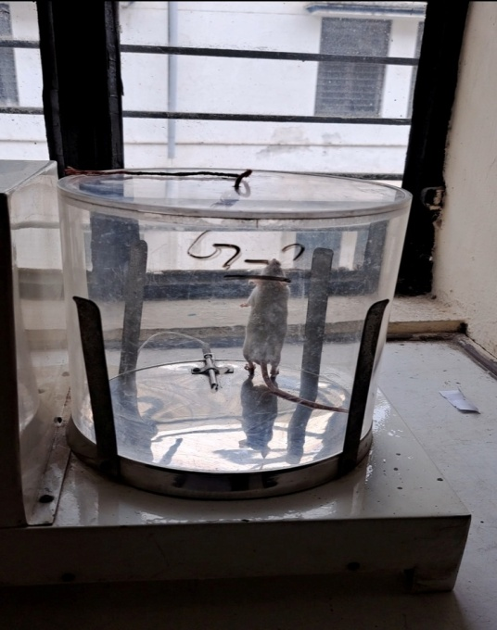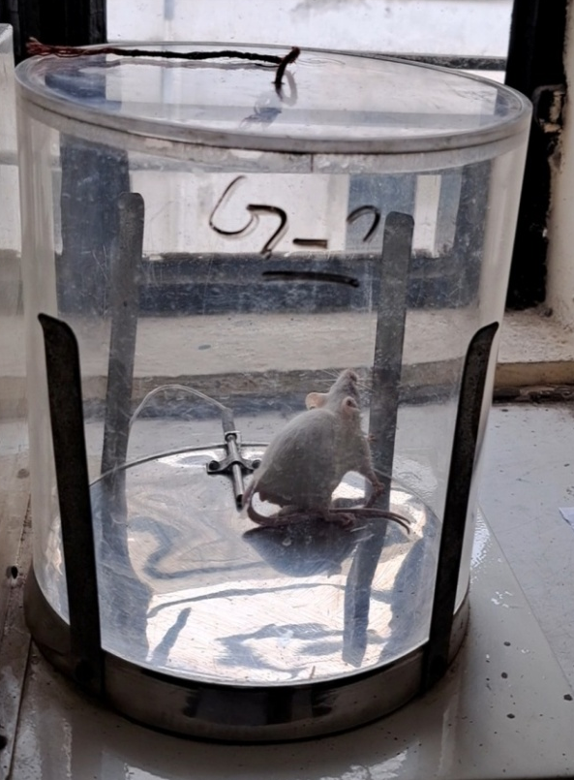
MVK-01 MVK-03
Test Compound Test Compound

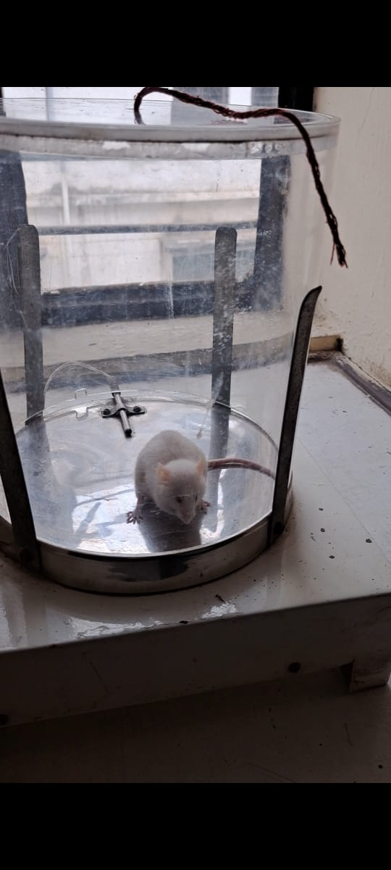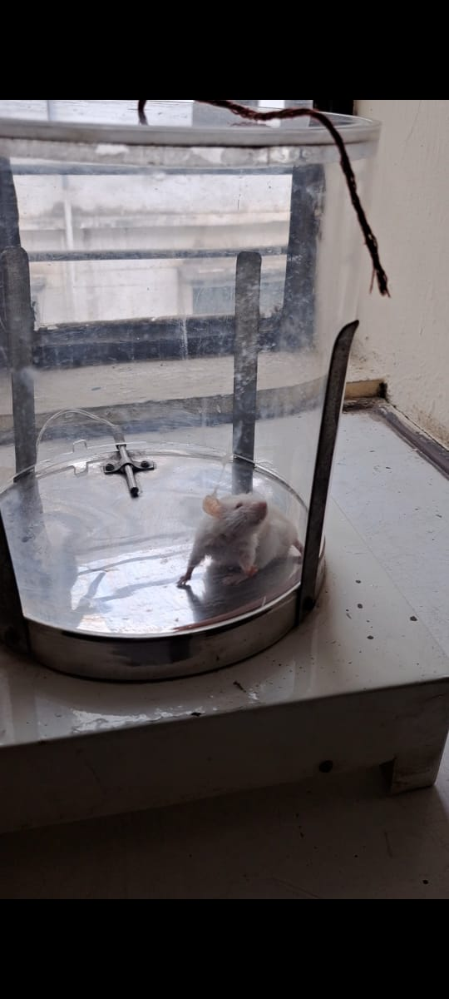
Normal Control Standard Control
Figure 2: Analgesic activity of newly synthesized Isoxazole compounds (Hot plate method) on Eddy’s hot plate (55°C heat for painful stimulus) Analgesiometer
ii) Antibacterial Activity
Since Isoxazole were reported to possess antimicrobial activity, the novel Isoxazole derivatives prepared during the course of the present work were tested for antibacterial activity using the cup-plate agar diffusion method for measure the zone of inhibition in mm. The newly prepared Isoxazole derivatives MVK-01 to MVK-05 was screened to antibacterial activities at the drug concentration of 2µg/mL, 4µg/mL, 8µg/mL, 16µg/mL. The antibacterial activity of the synthesized compounds MVK-01 to MVK-05 was evaluated against two Gram negative strains viz, Gram positive organism: Staphylococcus aureus, (MTCC 96), Entrococcusfaecalis (MTCC439) Gram negative organism E.coli (MTCC 1625), Pseudomonas aeruginosa (MTCC 7814).Ciprofloxacin (2 µg/mL, 4 µg/mL, 8µg/mL, 16µg/mL concentration ware used as a standard drug for antibacterial activity. The medium used Muller-Hinton agar medium in the antibacterial activity. This sterile agar medium was added to Petri dishes, where it was allowed to set. With the aid of a sterilized triangular loop, microbial suspensions were dispersed across the surface of the media. The cavities were made using an 8 mm diameter pre-sterilized stainless steel cylinder. With the use of a micropipette, all the synthesized substances (2g/mL, 4g/mL, 8g/mL, and 16g/mL) were serially put in the cavities and given an hour to diffuse. For 14 hr, the plates were incubated at 37°. After incubation, the area of inhibition surrounding the cups was measured. The antibacterial activity of the Isoxazole derivatives MVK-01 to MVK-05 (2 µg/mL, 4 µg/mL, 8µg/mL, 16µg/mL concentration) was compared with standard drug Ciprofloxacin. The investigation of the antibacterial activity revealed varying patterns of antibacterial activity. The result are presented in the Table 4:

Table 4: In-vitro Antibacterial Activity of synthesized compounds (MIC: µg/ml) (MVK-01 to MVK-05) by cup-plate agar diffusion method.

Bacteria | Gram negative bacteria |  |  |  |  |  |  |  | Gram Positivetive bacteria
Strains | Escherichia coli |  |  |  | Pseudomonas aeruginosa |  |  |  | Entrococ cusfaecalis |  |  |  | Staphylo coccsaureus
MTCC No. | (MTCC 1625) |  |  |  | (MTCC 7814) |  |  |  | (MTCC 439) |  |  |  | (MTCC 96)
Dose (µg/ml) | 2 µg | 4 µg | 8 µg | 16 µg | 2 µg | 4 µg | 8 µg | 16 µg | 2 µg | 4 µg | 8 µg | 16 µg | 2 µg | 4 µg | 8 µg | 16 µg
MVK-01 | 21 | 24 | 28 | 32 | 23 | 26 | 31 | 32 | 24 | 25 | 30 | 34 | 24 | 27 | 29 | 33
MVK-02 | 22 | 24 | 29 | 30 | 20 | 25 | 27 | 29 | 23 | 26 | 31 | 36 | 17 | 19 | 20 | 22
MVK-03 | 22 | 29 | 34 | 40 | 16 | 24 | 24 | 25 | 19 | 26 | 28 | 30 | 20 | 28 | 29 | 30
MVK-04 | 20 | 22 | 0 | 34 | 12 | 16 | 20 | 30 | 15 | 20 | 25 | 28 | 21 | 25 | 27 | 29
MVK-05 | 19 | 20 | 22 | 25 | 22 | 23 | 24 | 25 | 26 | 28 | 29 | 31 | 22 | 25 | 27 | 31
Ciprofloxacin | 40 | 40 | 43 | 44 | 39 | 43 | 44 | 48 | 37 | 42 | 44 | 45 | 41 | 43 | 49 | 50

The graphical presentation of antibacterial activity of Compounds MVK-01 to MVK-05

Figure 3 :- In-vitro Antibacterial activity of novel Isoxazole derivatives 2μg/ml and standard drug (ciprofloxacin) on Gram positive organism: Staphylococcus aureus, Entrococcus faecalis and Gram negative organism: E.coli Pseudomonas aeruginosa

Figure 4: In-vitro Antibacterial activity of novel Isoxazole derivatives 4μg/ml and standard drug (ciprofloxacin) on Gram positive organism: Staphylococcus aureus, Entrococcus faecalis and Gram negative organism: E.coli Pseudomonas aeruginosa

Figure 5: In-vitro Antibacterial activity of novel Isoxazole derivatives 8μg/ml and standard drug (ciprofloxacin) on Gram positive organism: Staphylococcus aureus, Entrococcus faecalis and Gram negative organism: E.coli Pseudomonas aeruginosa

Figure 6: In-vitro Antibacterial activity of novel Isoxazole derivatives 16μg/ml and standard drug (ciprofloxacin) on Gram positive organism: Staphylococcus aureus, Entrococcusfaecalis and Gram negative organism: E.coli Pseudomonas aeruginosa
DISCUSSION
The compound MVK-03 with substitution 4-Methoxy and 4-Chloro exhibited dynamic analgesic activity. The remaining one compound MVK-01 with substitution 4-Chloro and 4-amino shows moderate analgesic activity comparable to standard drug.
It is observed from Table (4) that compounds with substitution R₁ = 4-OCH_{3,} 4-Cl, 4-Cl, 4-Br, 3, 4-OCH₃ and R₂- 4-Br, 2-Br, 4-NH_{2,} 4-NH_{2,} 3-OCH₃ exhibited excellent antibacterial activity. Compounds MVK-03 (zone of inhibition: 22-40 mm) shows good activity against Escherichia coli, MVK-02 (zone of inhibition: 23-36 mm) against Entrococcusfaecalis shows moderate activity Remaining compound shows less activity against all strains.
CONCLUSION
The main topic of this article is the synthesis of new Isoxazole derivatives with a variety of biological functions. Among these functions are anti-cancer, anti-inflammatory, antimicrobial, antiviral, antiplatelet, Immunomodulatory, Antithrombotic, Ant triglyceride, Anti-diabetic, analgesic, anticonvulsant, anti-Alzheimer, as well as pesticidal and insecticidal qualities. The versatility of the heterocyclic moiety allows medicinal chemists to further investigate the data presented in this article. This information will be valuable for future researchers conducting studies in this field. Therefore, further investigation into the synthesis of novel isoxazoles compounds remains necessary. Compounds MVK-03 exhibit promising antimicrobial activity While MVK-02 exhibit moderate antimicrobial activity, and compound MVK-03 exhibit dynamic analgesic agent. The isoxazoles moiety has been identified as a significant heterocyclic compound due to its presence in numerous commercially available drugs. The exploration of isoxazoles compounds for the development of novel chemical compounds to address a range of clinically significant diseases holds significant promise.
SUMMARY
The newly synthesized Isoxazole compounds were examine for various parameters. Synthesis of Isoxazole moiety effects may result in compounds with strong Antimicrobial and Analgesic properties. Equimolar quantity of Chalcone and hydroxylamine were refluxed in ethanol (20 ml) and sodium acetate (0.2mol) for 6 to 8 hours. The reaction mixture was cool after added the acetic acid. The product obtained washed, filtered and recrystallized with acetone. The newly prepared Isoxazole derivatives MVK-01 to MVK-05 was screened to antibacterial activities at the drug concentration of 2 µg/mL, 4 µg/mL, 8 µg/mL,16 µg/ml. Compounds MVK-03 (zone of inhibition: 22-40 mm) shows good activity against Escherichia coli, MVK-02 (zone of inhibition: 23-36 mm) against Entrococcusfaecalis shows moderate activity Remaining compound shows less activity against all strains. The compound MVK-03 with substitution 4-Methoxy and 4-Chloro exhibited dynamic analgesic activity.
CONFLICT OF INTEREST
The authors state that there are no conflicts of interest, whether financial or non-financial, to disclose.
ACKNOWLEDGEMENT
I express my gratitude to my mentors for their unwavering support. Additionally, I extend my appreciation to the director and all faculty members of SD College of Pharmacy and Vocational Studies for their valuable assistance and encouragement.
FUNDING
No any type of funding for this research
REFERENCES:
- Chikkula KV, Sundararajan R. Analgesic, anti-inflammatory, and antimicrobial activities of novel isoxazole/pyrimidine/pyrazole substituted benzimidazole analogs. Med Chem Res. 2017;26(11):3026-37. doi: 10.1007/s00044-017-2000-0.
- Sahu SK, Banerjee M, Sahu D, Behera C, Pradhan G, Azam MA. Synthesis, analgesic and antimicrobial activities of some novel isoxazole derivatives. Dhaka Univ J Pharm Sci. 2008;7(2):113-8. doi: 10.3329/dujps.v7i2.2165.
- Praveen C, Kalyanasundaram A, Perumal PT. Gold(III)-catalyzed synthesis of isoxazoles by cycloisomerization of α, β-acetylenic oximes. Synlett 2010.05. 2010:777-81.
- Kadam KS, et al. Alkyl nitrites: novel reagents for one-pot synthesis of 3, 5-disubstituted isoxazoles from aldoximes and alkynes. Synthesis. 2016:3996-4008.
- Zhu J, Mo J, Lin HZ, Chen Y, Sun HP. The recent progress of isoxazole in medicinal chemistry. Bioorg Med Chem. 2018;26(12):3065-75. doi: 10.1016/j.bmc.2018.05.013, PMID 29853341.
- Isoxazole–a potent pharmacophore International Journal of Pharmacy and Pharmaceutical Sciences Chikkula. Krishna Veni, and S. Raja. 2017: 13-24.
- Shaik, Afzal, et al., Bhandare RR, Palleapati K, Nissankararao S, Kancharlapalli V, Shaik S. "Antimicrobial, antioxidant, and anticancer activities of some novel isoxazole ring containing chalcone and dihydropyrazole derivatives.". Molecules 25.5. (2020);25(5): 1047. doi: 10.3390/molecules25051047, PMID 32110945.
- Hawash M, Jaradat N, Eid AM, Abubaker A, Mufleh O, Al-Hroub Q, et al. Synthesis of novel isoxazole–carboxamide derivatives as promising agents for melanoma and targeted Nano-emulgel conjugate for improved cellular permeability. BMC Chem. 2022;16(1):47. doi: 10.1186/s13065-022-00839-5, PMID 35751124.
- TL, Sheeja M, Mathew A, Varkey J. Design, synthesis and pharmacological evaluation of isoxazole analogues derived from natural piperine. Asian J Pharm Health Sci. 2012:2.1.
- Morita T, Fuse S, Nakamura H. Photochemical conversion of isoxazoles to 5-Hydroxyimidazolines. Org Lett. 2020;22(9):3460-3. doi:
- Zhu X-Q, Wang ZS, Hou BS, Zhang HW, Deng C, Ye LW. Zinc‐Catalyzed Asymmetric Formal [4+ 3] Annulation of isoxazoles with Enynol Ethers by 6π Electrocyclization: stereoselective Access to 2H‐Azepines. Angew Chem Int Ed Engl. 2020;59(4):1666-73. doi: 10.1002/anie.201912534, PMID 31724314.
- Gautam KC, SinghDP. Synthesis and antimicrobial activity of some isoxazole derivatives of thiophene. Chem SciTrans. 2013;3(3):992-6.
- Sonawane DR, Jaju JB, Pawar GR, Gosavi PA. Evaluation of analgesic and anti-inflammatory activity of levocetirizine in albino rats. Int J Basic Clin Pharmacol. 2019;8(8). doi: 10.18203/2319-2003.ijbcp20193182.
- Balouiri M, Sadiki M, Ibnsouda SK. Methods for in vitro evaluating antimicrobial activity: a review. J Pharm Anal. 2016;6(2):71-9. doi: 10.1016/j.jpha.2015.11.005, PMID 29403965.
- Thakur A, Verma M, Setia P, Bharti R, Sharma R, Sharma A, et al. DFT analysis and in vitro studies of isoxazole derivatives as potent antioxidant and antibacterial agents synthesized via one-pot methodology. Res Chem Intermed. 2023;49(3):859-83. doi: 10.1007/s11164-022-04910-7.
- Eid AM, Hawash M, Amer J, Jarrar A, Qadri S, Alnimer I, et al. Synthesis and biological evaluation of novel isoxazole-amide analogues as anticancer and antioxidant agents. BioMed Res Int. 2021;2021:6633297. doi: 10.1155/2021/6633297, PMID 33763478.
- Saleem A, Farooq U, Bukhari SM, Khan S, Zaidi A, Wani TA, et al. Isoxazole derivatives against carbonic anhydrase: synthesis, molecular docking, MD simulations, and free energy calculations coupled with in vitro studies. ACS Omega. 2022;7(34): 30359-30368. doi: 10.1021/acsomega.2c03600, PMID 36061660.
- Bulanov, Denis DA., et al Novokshonova IA, Novokshonov VV, Ushakov IA, Sterkhova IV.”Facile one-pot synthesis of 5–substituted isoxazoles and pyrazoles through microwave-promoted intramolecular cyclization of y-hydroxyalkynal oximes and hydrozones.”. Synthetic Communication 47.4. (2017);47(4): 335-343. doi;10.1080/00397911.2016.1263892.
- Sagar, P., et al. "Synthesis & Evaluation of isoxazole for their antimicrobial activity.". Int. J. Comp. Adv. Pharmacol 2. (2017);2: 19-26.
- Breijyeh, Zeinab, and Rafik Karaman R. "Design and Ssynthesis of Nnovel Aantimicrobial Aagents.". Antibiotics (Basel) 12.3. (2023);12(3): 628. doi: 10.3390/antibiotics12030628, PMID 36978495.
- Mohatt, Jessica JL., et al., Hu L, Finneran KT, Strathmann TJ. "Microbially mediated abiotic transformation of the antimicrobial agent sulfamethoxazole under iron-reducing soil conditions.". Environmental sScience & tTechnology 45.11. (2011);45(11): 4793-4801. doi: 10.1021/es200413g, PMID 21542626.
- Hawash, Mohammed, Jaradat N, Abualhasan M, Qaoud MT, Joudeh Y, Jaber Z, et al. "Molecular docking studies and biological evaluation of isoxazole-carboxamide derivatives as COX inhibitors and antimicrobial agents.". 3 Biotech 12.12. (2022);12(12): 342. doi: 10.1007/s13205-022-03408-8, PMID 36345437.
- Kalirajan, R., et al. "Synthesis and biological evaluation of some heterocyclic derivatives of chalcones.". International J. of Chem Technol Research 1.1. (2009);1(1): 27-34.
- Patoliya, Pareshkumar PU., et al. "Synthesis and biological evaluation of some new chalcone and isoxazole derivatives.". The International Journal of Science and Technoledge 2.5. (2014);2(5): 138.
- The International Journal of Science and Technoledge 2.5 (2014): 138.Patoliya, Pareshkumar PU., et al. "Synthesis and biological evaluation of some new chalcone and isoxazole derivatives.". The Int J Sci Technoledge. 2014;2(5):138.
- Dabhi, A. R., A. K. Rana AK, and A. R. Shah AR. "Synthesis, characterization and biological evaluation of some novel isoxazole and benzodiazepine derivatives.". Journal of Chemical and Pharmaceutical Research 6.11. (2014);6(11): 771-775.
- Agrawal, Bhagyashree, Bhaskar Kumar Gupta BK, and Satish Kumar Sahu SK. "Synthesis, Characterization and Biological Evaluation of some new Iisoxazole and Ppyrazole compounds for Anti-obesity drug.". Research Journal of Pharmacy and Technology 16.8. (2023);16(8): 3837-3842.
- Zimecki, Michał, Urszula Bąchor U, and Marcin Mączyński M. "Isoxazole derivatives as regulators of immune functions.". Molecules 23.10. (2018);23(10): 2724. doi: 10.3390/molecules23102724, PMID 30360408.
- Çalışkan, Burcu, et al., Sinoplu E, İbiş K, Akhan Güzelcan E, Çetin Atalay R, Banoglu E. "Synthesis and cellular bioactivities of novel isoxazole derivatives incorporating an arylpiperazine moiety as anticancer agents.". Journal of enzyme inhibition and medicinal chemistry 33.1. (2018);33(1): 1352-1361. doi: 10.1080/14756366.2018.1504041, PMID 30251900.
- Shaik Khadar Yazdan*, Kambhampati Uma Rani, Kunta Sindhura (2014 May 1). Synthesis of Substituted Isoxazole Derivatives from Chalcones and their Antibacterial Activity. PHARMANEST,5(2),1991-1994. http://www.pharmanest.net.
- Hussain, Zameer, et al. "Theoretical study of isoxazoles and their derivatives for evaluating its pharmaceutical properties with density functional theory.". J Comput Chem Mol Model 4.3. (2020);4(3): 415-426.
- Loh, Belinda, Vozzolo L, Mok BJ, Lee CC, Fitzmaurice RJ, Caddick S, et al. "Inhibition of HIV‐-1 Rreplication by Iisoxazolidine and Iisoxazole Ssulfonamides.". Chemical Biology & Drug Design 75.5. (2010);75(5): 461-474. doi: 10.1111/j.1747-0285.2010.00956.x, PMID 20486932.
- Panda, Krishna ChandraKC, Bera Venkata Varaha Ravi Kumar BeraVV, and Biswa Mohan Sahoo BM. "’Microwave-Assisted Facile Synthesis and In vitro Anti-microbial Activities of Some Novel Isoxazole Derivatives via Chalcones."’ NVEO-NATURAL VOLATILES & ESSENTIAL OILS Journal| NVEO (2021): 11503-11510.
- Dou, Guolan, et al., Xu P, Li Q, Xi Y, Huang Z, Shi D. "Clean and efficient synthesis of isoxazole derivatives in aqueous media.". mMolecules 18.11. (2013);18(11): 13645-13653. doi: 10.3390/molecules181113645, PMID 24196411.
- Aksöz, B. Evranos, and Rahmiye Ertan. "Chemical and structural properties of chalcones I." Fabad J Pharm Sci 36. (2011);36: 223-242.
- Jin, Ruifa, Weidong Sun W, and Shanshan Tang S. "A DFT study of pyrrole-isoxazole derivatives as chemosensors for fluoride anion.". International Journal of Molecular Sciences 13.9. (2012);13(9): 10986-10999. doi: 10.3390/ijms130910986, PMID 23109833.
- Cha, Minjun, et al., Baek S, Lee W, Shin K, Lee JW. "Tuning behaviors of methane inclusion in isoxazole clathrate hydrates.". Journal of Chemical & Engineering Data 60.2. (2015);60(2): 278-283. doi: 10.1021/je500568f.
- Gehling, Victor VS., Hewitt MC, Vaswani RG, Leblanc Y, Côté A, Nasveschuk CG, et al. "Discovery, design, and optimization of isoxazole azepine BET inhibitors.". ACS mMedicinal cChemistry lLetters 4.9. (2013);4(9): 835-840. doi: 10.1021/ml4001485, PMID 24900758.
- Waldo, Jesse JP., and Richard C. Larock RC. "Synthesis of isoxazoles via electrophilic cyclization.". Organic lLetters 7.23. (2005);7(23): 5203-5205. doi: 10.1021/ol052027z, PMID 16268538.
- Gutiérrez, Margarita, et al., Amigo J, Fuentes E, Palomo I, Astudillo L. "Synthetic isoxazole as antiplatelet agent.". Platelets 25.4. (2014);25(4): 234-238. doi: 10.3109/09537104.2013.807335, PMID 23841686.
- Galenko, Ekaterina EE., et al., Linnik SA, Khoroshilova OV, Novikov MS, Khlebnikov AF. "Isoxazole strategy for the synthesis of α-aminopyrrole derivatives.". The Journal of Organic Chemistry 84.17. (2019);84(17): 11275-11285. doi: 10.1021/acs.joc.9b01634, PMID 31385507.

