DEVELOPMENT OF A WEB-BASED QUEUING SYSTEM FOR MUNICIPAL HEALTH CENTER OF MABINI
^{[1]}Benjie N. David, ^{[2]}Jan Christopher N. Manzano, ^{[3]}Rick Rian P. Ramirez, ^{[4]}Sara R. Sotto, ^{[5]}Christian Paul O. Cruz, MIT
Pangasinan State University – Alaminos City Campus, Bolaney, Alaminos City, Pangasinan, Philippines
^{[1]}davidbenjie31@gmail.com,^{[2]}janchristophermanzano@gamail.com^{[3]},ramirezrickrian2@gmail.com, ^{[4]}sarahsotto987@gmail.com, ^{[5]}cocruz@psu.edu.ph
ABSTRACT - The continuous advancement of digital technology has encouraged public healthcare institutions to adopt computerized systems to improve service delivery, efficiency, and patient satisfaction. This study focuses on the development and evaluation of a web-based queuing system for the Municipal Health Center of Mabini, which continues to rely on manual and paper-based queuing processes. These traditional methods often resulted in long waiting times, overcrowding, and difficulties in managing patient flow. Data for the study were gathered through structured survey questionnaires distributed to selected healthcare staff and patients of the health center to assess the performance and effectiveness of the developed system. The system was developed using the Rapid Application Development approach and designed following a three-tier architectural structure to ensure organized data processing, system reliability, and ease of maintenance. The web-based queuing system enables faster patient registration, systematic queue management, and real-time monitoring of queue status. The quality of the system was evaluated based on the software quality standards of the International Organization for Standardization. Healthcare personnel and patients served as respondents in the system evaluation. The results revealed an overall weighted mean of 4.43, interpreted as Excellent, with high ratings in efficiency, security, and acceptability. The findings indicate that the developed web-based queuing system effectively addresses issues related to long waiting times and unorganized patient flow. The study concludes that the system provides a reliable, secure, and acceptable digital solution that can enhance service delivery in community healthcare centers.
Keywords: Web-Based Queuing System, Three-Tier Architecture, Healthcare Technology, Software Quality Evaluation, Rapid Application Development
INTRODUCTION
The modernization of public health institutions increasingly relies on the integration of automated systems to optimize service delivery and address the growing demand for medical services [1], [2]. At the Municipality Health Center of Mabini, the absence of a localized digital infrastructure has led to significant operational challenges, particularly in managing patient flow. While the facility provides essential services such as general consultations, maternal healthcare, and laboratory tests to an average of 50 to 100 patients daily, its current queuing process remains entirely manual. This reliance on pen-and-paper registration creates administrative bottlenecks, disorganized patient tracking, and prolonged waiting periods, which directly affect the quality of healthcare delivery and patient satisfaction [3].
Although the center utilizes Wireless Access for Health (WAH), it lacks critical features for real-time queue monitoring and patient access to live status information. Research indicates that implementing a web-based queuing framework not only organizes the physical flow of patients but also reduces the perceived burden of waiting by providing transparent, real-time updates [4]. Studies emphasize that transforming these manual processes into automated systems is vital for ensuring data accuracy and enhancing operational efficiency in the computer age [5], [2]. Furthermore, strategic investment in technology adoption is essential for organizations to remain efficient and responsive to the evolving needs of their stakeholders [6]. The integration of a computerized queuing framework is no longer just an option but a necessity for public health centers where medical demand often exceeds available human resources [1]. By incorporating digital tools, institutions can significantly improve the overall patient experience and ensure that services are delivered in a transparent and organized manner [7], [3].
This study addresses these operational gaps through the development of a Web-Based Queuing System specifically designed for the Municipality Health Center of Mabini. By transitioning from a manual to a digital framework, the proposed system seeks to establish a more organized, transparent, and data-driven workflow for healthcare delivery. This innovation is intended not only to minimize patient waiting times but also to empower the institution with a scalable tool that upholds its commitment to providing responsive and efficient community care [7], [6].
METHODOLOGY
This section presents the research methods and procedures used to develop the Web-Based Queuing System. The study emphasizes that project design is a framework that guides the development and implementation process to ensure all objectives are aligned [8]. Following this framework, the study utilized a mixed-method approach, combining qualitative and quantitative research techniques to gather comprehensive data [9]. This approach allowed for the collection of both statistical data regarding user interactions and personal insights from staff and patients, ensuring that the findings were reliable and well-rounded [9]. The development process was guided by the Rapid Application Development (RAD) model, which emphasizes iterative prototyping and rapid feedback to ensure the system meets the actual needs of the Municipal Health Center of Mabini [10].
The RAD model used in this study consists of four main phases: Requirements Planning, User Design, Construction, and Cutover. During the Requirements Planning phase, the proponents conducted interviews and observed the current manual queuing process to identify bottlenecks and user requirements. In the User Design phase, the system's architecture and interfaces were drafted, including the queuing dashboard and administrative panel. The Construction phase involved the actual coding and integration of the web-based features, followed by continuous testing. Finally, the Cutover phase involved system deployment and staff training to ensure a smooth transition from the manual process to the automated system. The development process followed the phases illustrated in Figure 1.
Figure 1. Rapid Application Development (RAD) Model
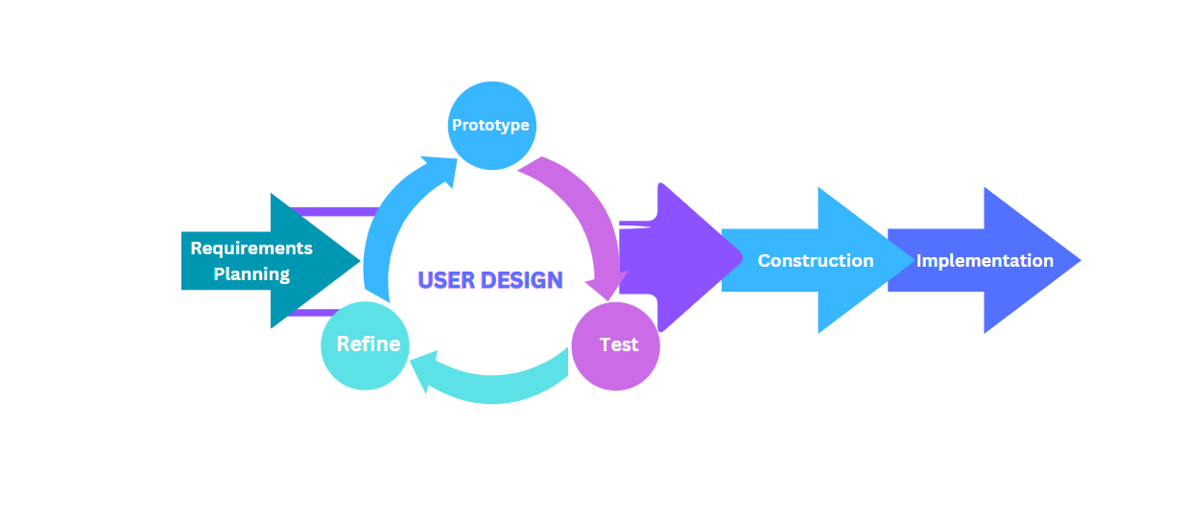
To evaluate the system's effectiveness, the proponents identified a specific group of respondents to participate in the evaluation process. As illustrated in Table I, the study involved a total of 55 respondents, categorized into staff, administrators, patients, and IT experts. The inclusion of IT experts and administrative staff ensured a technical and operational assessment of the system, while the large group of patient respondents provided essential feedback on the user experience and the efficiency of the virtual queuing process.
Table 1. Respondents of the Study
Respondents | Number  of Respondents
Staff | 2
Admin | 1
Patients | 50
IT Experts | 2
Total | 55
The acceptability of the developed system was quantified using a Five-Point Likert Scale, which served as the study's scale of measurement. As shown in Table II, this scale provides a structured method for interpreting the mean scores gathered from the survey instruments. Each weight corresponds to a specific range and a verbal interpretation, ranging from "Excellent" (4.21 - 5.00) to "Poor" (1.00 - 1.80). This statistical framework allowed the proponents to objectively assess the system's overall acceptability according to the ISO 25010 quality standards, ensuring a clear and measurable evaluation of its functional suitability and security.
Table 2. Scale of Measurement
Scale | Statistical Limits | Rating | Descriptive Interpretation
5 | 4.21 - 5.00 | Excellent | Condition is highly comprehensive and operating efficiently
4 | 3.41 - 4.20 | Very Good | Condition is functioning properly
3 | 2.61 - 3.40 | Good | Condition is satisfactory and meets most requirements
2 | 1.81 - 2.60 | Fair | Condition is limited and needs improvements
1 | 1.00 - 1.80 | Poor | Condition does not meet the necessary requirements
The development tools included modern web technologies such as HTML, CSS, and JavaScript for the frontend, while the backend was supported by database management systems to ensure real-time data synchronization. Data gathering instruments, including questionnaires based on the ISO 25010 standard, were used to assess the system's functional suitability, acceptability, and performance efficiency.
RESULTS AND DISCUSSION
The evaluation of the existing queuing process at the Municipal Health Center of Mabini revealed a purely manual system, where registration and patient tracking are handled through physical logbooks. This setup results in significant challenges, including long waiting times, overcrowding in the facility, and administrative difficulties in maintaining accurate records. To address these issues, the proponents developed a web-based queuing system designed to streamline patient flow and provide real-time updates.
The developed system is built upon a Three-Tier Architecture, which ensures a clear separation of concerns, scalability, and ease of maintenance. The first tier is the Presentation Tier, which serves as the user interface for patients and staff, accessible via web browsers. The second tier is the Logic Tier, where the core queuing algorithms and administrative functionalities are processed. The third tier is the Data Tier, responsible for the secure storage and retrieval of patient records and queue status.
Figure 2. Three-Tier Architecture of the Web-Based Queuing System
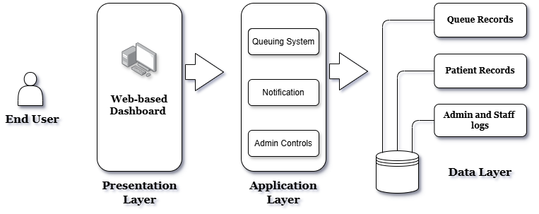
The system's features include a centralized queuing dashboard, a virtual registration module, and an administrative panel for real-time monitoring. Upon deployment and testing, the system's acceptability was evaluated based on the ISO 25010 standard. The evaluation involved health center staff and patients, focusing on eight key quality attributes. The results of the evaluation are summarized in Table 1.
Table 1. System Evaluation Overall Weighted Mean
Category Computed Mean | Description
- Functionality 4.46  - efficiency 4.52  - Compatibility 4.34  - Usability 4.40  - Reliability 4.23  - Security 4.52  - Maintainability 4.40  - Portability 4.35 | Excellent  Excellent  Excellent  Excellent  Excellent  Excellent  Excellent  Excellent
Average Weighted Mean 4.43 | Excellent
As shown in Table 1, the system received an overall weighted mean of 4.43, interpreted as "Excellent." Specifically, Efficiency and Security received the highest ratings of 4.52, indicating that the system effectively manages patient traffic while ensuring data integrity. Although Reliability received the lowest relative score of 4.23, it still falls within the "Excellent" range, suggesting that the system is stable for daily operations. These findings demonstrate that the web-based queuing system is a viable and highly accepted solution for modernizing the health center's services.
The implementation of the Web-Based Queuing System for the Municipal Health Center of Mabini resulted in a centralized platform that automates patient flow. The following six core features represent the primary technical outcomes of the study, directly addressing the inefficiencies of the previous manual process.
The Front Desk Module serves as the primary intake point. It allows staff to register patients and assign them to specific medical services based on real-time availability. By digitizing this entry point, the system prevents service overbooking and ensures that patient distribution aligns with the center's daily resource capacity.
Figure 3. Front Desk
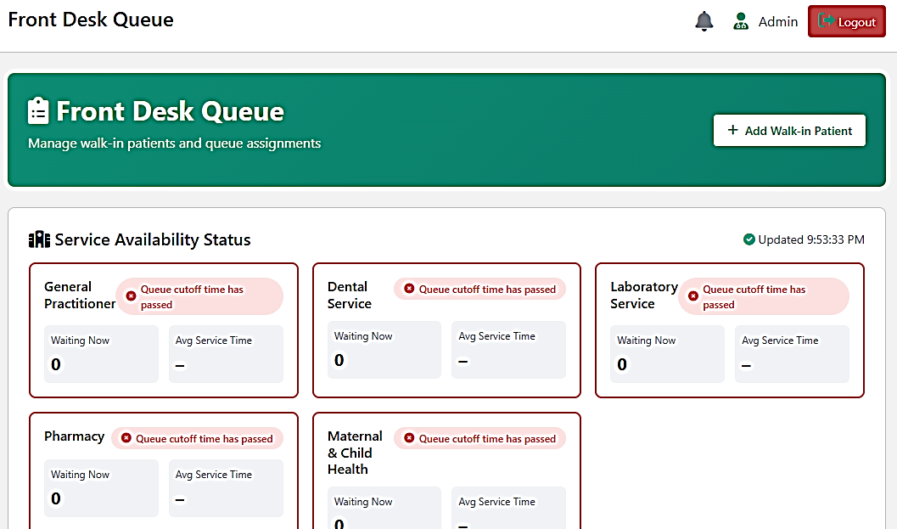
To enhance transparency, the Public View Queue broadcasts live status updates to a monitor in the waiting area. This feature eliminates the "black box" nature of manual waiting by showing patients exactly where they are in the sequence. Results indicate that providing visual confirmation significantly reduces the volume of repetitive inquiries directed at front desk personnel.
Figure 4. Real-Time Public View Queue

The system integrates an Automated Queue Announcement feature that utilizes text-to-speech technology to call out queue numbers via external speakers. This automation ensures a consistent and audible notification process, reducing the risk of missed turns and allowing staff to remain focused on administrative tasks rather than manual calling.
Figure 5. Automated Queue Announcement
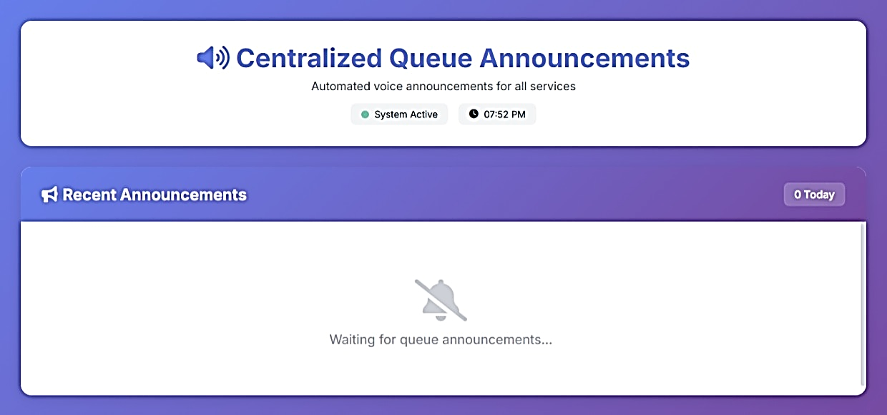
The Service Queue Dashboard provides medical practitioners with a dedicated interface to manage their specific patient loads. It supports dynamic actions such as calling the next patient, marking a service as complete, or transferring a patient to a different department. This granular control over the clinical workflow minimizes idle time between consultations.
Figure 6. Service Queue Dashboard
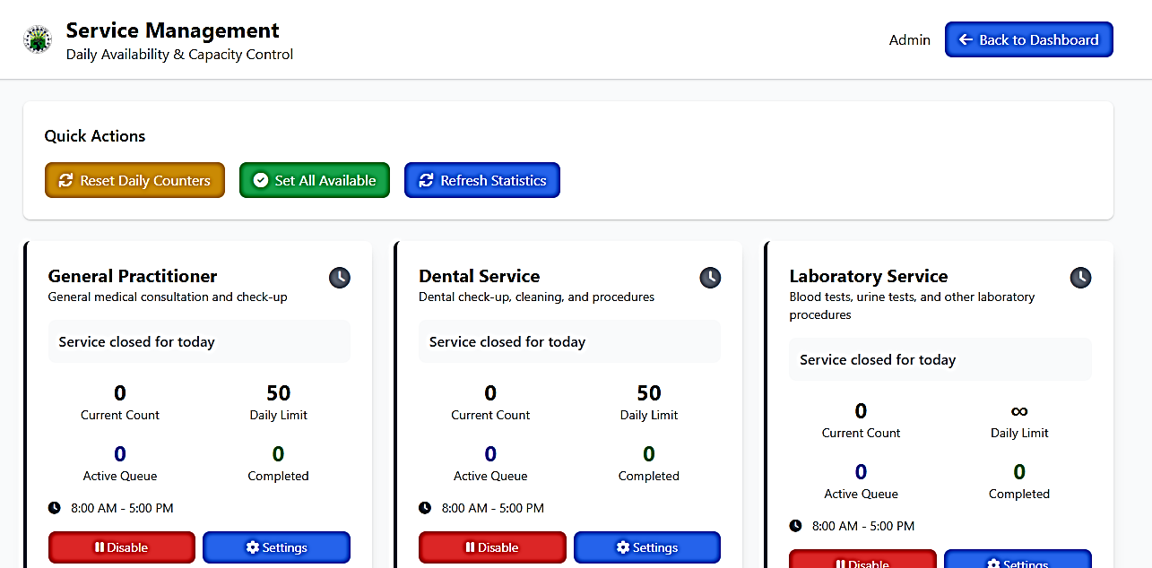
The Queue Analytics Module transforms raw operational data into actionable insights. It generates reports on average wait times, peak hours, and total patient volume per service. For the discussion, this data is crucial as it allows health center administrators to identify bottlenecks and make evidence-based decisions regarding staff scheduling and resource allocation.
Figure 7. Queue Analytics
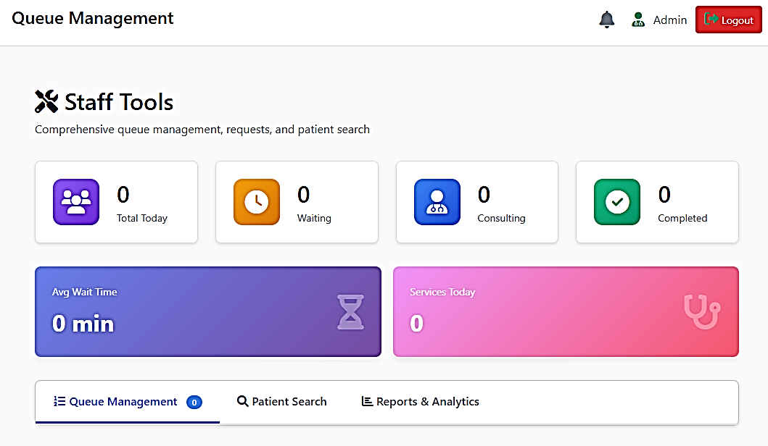
The Admin Panel serves as the centralized governance layer of the system, providing authorized administrators with powerful management tools to monitor and control overall operations. This module enables the creation, modification, and deletion of user accounts to ensure that only verified personnel can access sensitive health center data. Beyond user management, the panel allows for the configuration of system-wide settings and maintenance functions, such as data backups, which are essential for maintaining the continuous functionality and reliability of the queuing system within a professional healthcare environment.
Figure 8. Administrative Control
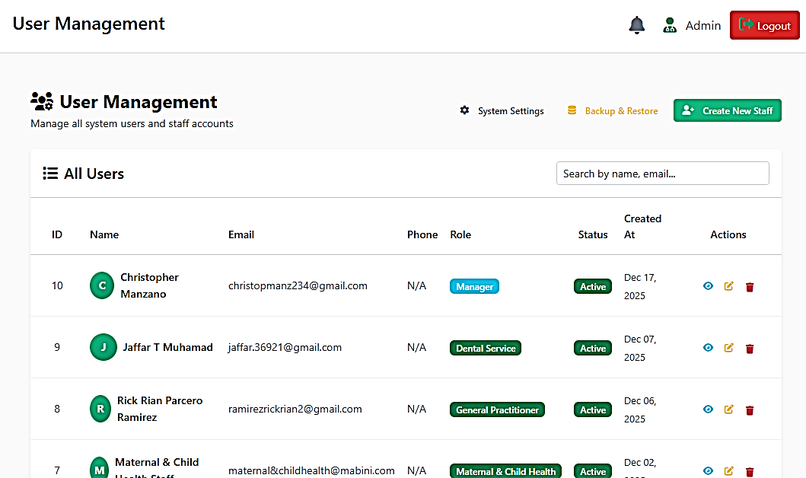
To ensure high levels of security and operational accountability, the Activity Logs module maintains a comprehensive and permanent digital history of every transaction performed within the platform, serving as the system's primary diagnostic and auditing tool. This feature meticulously tracks a wide array of critical events, including successful and failed user logins, administrative record updates, and sensitive system configuration changes, effectively providing a detailed, time-stamped audit trail that allows administrators to reconstruct the sequence of specific user interactions. By documenting exactly when, where, and how each action was performed, the activity logs play a vital role in identifying potential human errors, investigating system misuse, and preventing unauthorized data manipulation, thereby safeguarding the overall integrity of the database and ensuring that all staff activities remain strictly compliant with the health center's established digital protocols and security standards.
Figure 9. Activity Logs
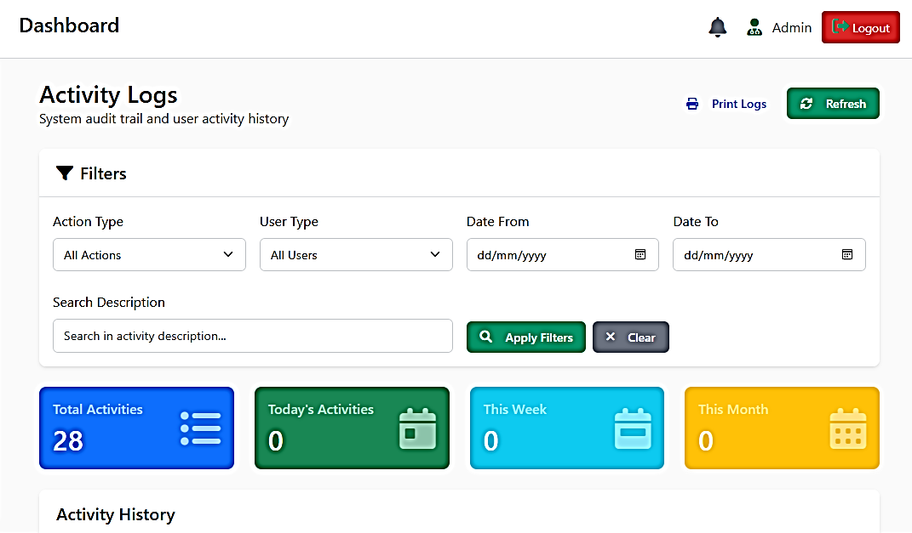
CONCLUSION
The study successfully addressed the operational inefficiencies at the Municipal Health Center of Mabini by transitioning from a manual, paper-based queuing method to an automated digital solution. Based on the findings, the researchers conclude that the current manual system was the primary cause of service delays and patient dissatisfaction due to its lack of real-time monitoring and disorganized record-keeping. The development of the Web-Based Queuing System proved to be a critical intervention, providing a structured and transparent flow for both staff and patients.
The adoption of the Three-Tier Architecture and the Rapid Application Development (RAD) model ensured that the system was both technically robust and aligned with the actual needs of the facility. The high acceptability rating of 4.43 (Excellent) confirms that the system is not only functional but also user-friendly and secure. Ultimately, the system effectively reduces the administrative workload, minimizes human errors in record-handling, and significantly improves the overall healthcare experience for the residents of Mabini.
REFERENCES
- ^{[8]}Asana Team, "What is project design? 7 steps with expert tips," Asana, Feb. 23, 2025. [Online]. Available: https://asana.com/resources/project-design
- ^{[6]}Deyvid, "Everything you need to know about investing in technology adoption," Plat4mation, 2023. [Online]. Available: https://plat4mation.com/blog/everything-you-need-to-know-about-investing-in-technology-adoption/
- ^{[7]}F. Tamimi and S. Munawaroh, "Teknologi Sebagai Kegiatan Manusia Dalam Era Modern Kehidupan Masyarakat," Saturnus: Jurnal Publikasi Ilmu Ekonomi, vol. 2, no. 3, pp. 66-74, 2024. Available: https://doi.org/10.61132/saturnus.v2i3.157
- ^{[2]}G. Pandy, V. Jagadeesan Pugazhenthi, and J. K. Chinnathambi, "Real Value of Automation in the Healthcare Industry," European Journal of Computer Science and Information Technology, vol. 12, no. 9, pp. 1-9, 2024. Available: https://doi.org/10.37745/ejcsit.2013/vol12n919
- ^{[10]}GeeksforGeeks, "Rapid Application Development Model (RAD) - Software Engineering," 2025. [Online]. Available: https://www.geeksforgeeks.org/software-engineering/software-engineering-rapid-application-development-model-rad/
- ^{[5]}K. Rothenberg-Elder, "Research on the Trend of Economic Management Modernization and Its Development in the Computer Age," Advances in Economics and Management Research, vol. 4, no. 1, p. 7, 2023. Available: https://doi.org/10.56028/aemr.4.1.7.2023
- ^{[4]}M. A. S. Al-Adhaileh, "An Efficient Web-Based Patient Appointment and Queuing Management System," International Journal of Computer Science and Network Security, vol. 23, no. 5, pp. 45-52, 2023. Available: http://paper.ijcsns.org/07_book/202305/20230507.pdf
- ^{[9]}M. Hassan, "Mixed methods research - Types & analysis," ResearchMethod.net, 2024. [Online]. Available: https://researchmethod.net/mixed-methods-research/
- ^{[1]}R. R. Mahendra, N. S. Ariantini, S. P. Kristiyawati, F. Putra, and M. N. Abdillah, "Innovations in Public Health: The Role of Technology in Improving Access to Healthcare Services," The Journal of Academic Science, vol. 1, no. 8, pp. 1096-1104, 2024. Available: https://doi.org/10.59613/k5w9wp41
- ^{[3]}Sydney, "Enhancing Patient Experience: The Critical Role of Healthcare Technology Management," Crothall Healthcare, 2024. [Online]. Available: https://www.crothall.com/blog/enhancing-patient-experience-the-critical-role-of-healthcare-technology-management/

