AI-Powered Interview Assistant Chatbot
Ayush Singh, Gaurav Gaikwad, Rahul Ranjavan School of Engineering
Ajeenkya D.Y Patil University, Pune

Abstract
In today’s rapidly evolving digital landscape, artificial intelligence (AI) is revolutionizing how individuals prepare for and attend job interviews. This project presents the development of an AI-Powered Interview Assistant Chatbot designed to simulate real-life interview
scenarios, assist candidates in enhancing their performance, and help recruiters streamline the preliminary screening process. The chatbot leverages cutting-edge Natural Language
Processing (NLP) techniques to engage in dynamic, human-like conversations, adapting its questions and feedback based on the user's responses.
Key features of the system include voice-to-text conversion, text-to-speech synthesis, and context-aware response generation, creating a seamless voice-based interaction that mirrors a human interviewer. The voice-to-text module ensures accurate transcription of user
responses, while the text-to-speech module enables the bot to vocalize questions in a natural tone, making the interview experience more immersive and interactive. Additionally, the
chatbot is trained on diverse datasets covering various industries and job roles, allowing it to conduct interviews tailored to specific domains.
To evaluate user responses, the system integrates machine learning models capable of sentiment analysis, grammar checking, and keyword extraction, providing users with
constructive feedback on their communication skills, confidence level, and answer quality.
This feedback helps users identify areas for improvement and build confidence before appearing for actual interviews.
This AI-powered solution serves as a smart assistant for both job seekers and hiring
professionals. It reduces time and resources spent on initial rounds of interviews, promotes
inclusive and unbiased evaluation, and offers scalable interview practice opportunities. Future enhancements may include emotion recognition, multilingual support, and personalized
coaching, pushing the boundaries of AI in recruitment and career development.

Keywords: AI, Interview Assistant, Chatbot, Natural Language Processing, Voice-to-Text, Text-to-Speech, Machine Learning, Sentiment Analysis, Human-Computer Interaction, Job Interview Simulation, Feedback System, Recruitment, Career Development, Context-Aware Responses, Communication Skills.

Introduction
In the modern era of digital transformation, artificial intelligence (AI) has emerged as a
powerful tool for enhancing various aspects of daily life, including education, healthcare, and human resource management. One of the most promising applications of AI in the
recruitment domain is the development of intelligent systems that can simulate human-like interviews and provide valuable assistance to both job seekers and employers. The AI-
Powered Interview Assistant Chatbot is designed with this vision, aiming to offer a realistic, efficient, and accessible solution for interview preparation and candidate screening.
Traditional interview processes often require significant time, human resources, and logistics, particularly during the initial screening stages. Additionally, many candidates face anxiety and lack of preparation when approaching real interviews. To address these challenges, this chatbot utilizes advanced Natural Language Processing (NLP) and Machine Learning (ML)
technologies to conduct voice-based, interactive interview sessions. It mimics the role of a human interviewer, asking relevant questions, interpreting user responses, and providing constructive feedback.
The chatbot integrates key features such as voice-to-text (speech recognition) and text-to- speech (speech synthesis), creating a fully conversational interface. This allows users to
engage in real-time verbal interactions, making the experience immersive and similar to an actual interview environment. The system also analyzes user responses for grammatical accuracy, emotional tone, and content relevance, offering insights that help users refine their communication skills.
Furthermore, the chatbot can be trained on domain-specific datasets, making it versatile and suitable for different job roles and industries. It serves not only as a preparatory tool for
candidates but also as an automated assistant for recruiters, enabling faster and unbiased
preliminary evaluations. As AI technology continues to evolve, the integration of features like emotion detection, multilingual support, and personalized coaching holds great potential to further improve the effectiveness of AI-driven interview systems.
This project represents a significant step toward democratizing access to quality interview practice and optimizing the recruitment process through AI innovation.

Literature Review
Artificial Intelligence (AI) and Natural Language Processing (NLP) have significantly
transformed the field of human-computer interaction, with chatbots emerging as one of the
most impactful applications. Over the past decade, several studies and projects have explored the potential of AI-driven conversational agents for educational, commercial, and recruitment purposes. This literature review highlights the key research and developments that form the foundation of the AI-Powered Interview Assistant Chatbot.
Previous works such as A.L.I.C.E (Artificial Linguistic Internet Computer Entity) and ELIZA demonstrated early capabilities of rule-based conversational agents. However, their
limitations in understanding context and generating dynamic responses led to the evolution of

machine learning-based NLP models. Recent advancements, including OpenAI’s GPT, Google’s BERT, and other transformer-based architectures, have enabled chatbots to engage in more natural and context-aware conversations, making them suitable for complex
applications like mock interviews and training simulations.
Studies like Jain et al. (2020) explored the implementation of virtual interviewers using NLP to assess candidate responses. Their results indicated that AI interviewers could effectively evaluate soft skills and communication patterns. Similarly, Liu et al. (2021) investigated the use of sentiment analysis and facial recognition to assess candidate confidence and emotional stability during virtual interviews. These findings support the integration of multimodal
analysis (voice, text, emotion) in AI interview systems.
In terms of speech technologies, Kaldi and Mozilla DeepSpeech have contributed to robust voice-to-text models, while Google Text-to-Speech and Amazon Polly have improved the naturalness of machine-generated voices. These tools enable the development of fully
conversational AI assistants that can simulate real-life interview conditions.
Furthermore, existing recruitment platforms like HireVue and MyInterview use AI to
automate video interviews, offering insights into candidate behavior and fit. However, these platforms often lack interactivity and personalization, which can be addressed through
conversational chatbots. Research also shows that practice with AI interviewers can reduce anxiety, increase preparedness, and improve candidate performance over time.
In conclusion, the literature supports the feasibility and effectiveness of AI-powered
interview systems. However, there remains a gap in integrating real-time voice interaction, domain-specific questioning, and adaptive feedback—all of which this project aims to
address.

Methodology
The development of the AI-Powered Interview Assistant Chatbot follows a modular and
systematic approach, combining Natural Language Processing (NLP), speech processing, and machine learning to simulate human-like interviews. The methodology can be divided into
several key components: system architecture, data collection and preprocessing, model training, speech processing integration, response evaluation, and user interface design.

System Architecture
The chatbot is designed using a client-server architecture, where the front end (user interface) interacts with users through voice or text, and the back end handles NLP processing, question generation, and feedback analysis. The system is composed of the following modules:
  - Speech Recognition Module (Voice-to-Text)
  - Speech Synthesis Module (Text-to-Speech)
  - Natural Language Understanding (NLU)
  - Response Evaluation and Feedback Engine

  - Domain-Specific Question Bank
  - User Interface (Web or Mobile-based)
Each module is integrated to create a seamless and interactive user experience that mimics a real interview environment.

Data Collection and Preprocessing
A large dataset of interview questions and answers was collected from open-source job
preparation websites, HR interview transcripts, and domain-specific repositories (e.g., IT,
finance, management). The data was categorized into different job roles and difficulty levels to generate relevant questions dynamically.
  - Preprocessing steps included:
    - Text cleaning (removing HTML tags, special characters)
    - Tokenization and lemmatization
    - Removal of stop words
    - Labeling of questions by domain and intent
This structured and clean dataset forms the basis for the chatbot’s knowledge base and training material.

NLP and Model Training
The core of the chatbot is built using transformer-based NLP models (such as GPT, BERT, or T5) to understand user responses and generate follow-up questions or feedback. These models were fine-tuned on the curated interview dataset to ensure relevance and contextual accuracy.
  - Intent Recognition: Classifies the user’s response into predefined categories like “correct,” “incomplete,” or “off-topic.”
  - Entity Recognition: Extracts important entities (skills, tools, experiences) from user answers to personalize the conversation.
  - Question Generation: Based on the flow of conversation and user’s last response, follow-up questions are generated using sequence-to-sequence models.
Additionally, sentiment analysis models are used to detect the emotional tone of the response, helping assess confidence and clarity.

Speech Processing Integration
To ensure a voice-based interaction experience, two major components are implemented:

  - Voice-to-Text: Google's Speech-to-Text API or Mozilla DeepSpeech is used to transcribe user responses in real time with high accuracy.
  - Text-to-Speech: Google Text-to-Speech or Amazon Polly is used to convert chatbot- generated text into human-like speech.
These modules are optimized for latency and accuracy to ensure smooth real-time interaction.

Response Evaluation and Feedback Mechanism
Once the user responds to a question, their answer is evaluated on the basis of:
  - Relevance: Matching keywords and concepts with expected answers
  - Grammar: Using grammar-checking libraries (e.g., LanguageTool)
  - Sentiment and Confidence: Analyzing tone and emotional stability
  - Length and Clarity: Measuring verbosity and coherence
A feedback module compiles the evaluation and gives constructive comments such as:
  - “You spoke confidently but missed key points.”
  - “Try elaborating on your technical skills with examples.” The feedback is displayed both in text and spoken form.

User Interface Design
The chatbot interface is designed to be intuitive and responsive. Built using web technologies (HTML/CSS/JavaScript or React), it includes:
  - A chat window for text input/output
  - Microphone and speaker control for voice interaction
  - Visual indicators of recording, thinking, and speaking
  - A summary page at the end with performance metrics
The system is tested with multiple users to ensure usability and functionality.

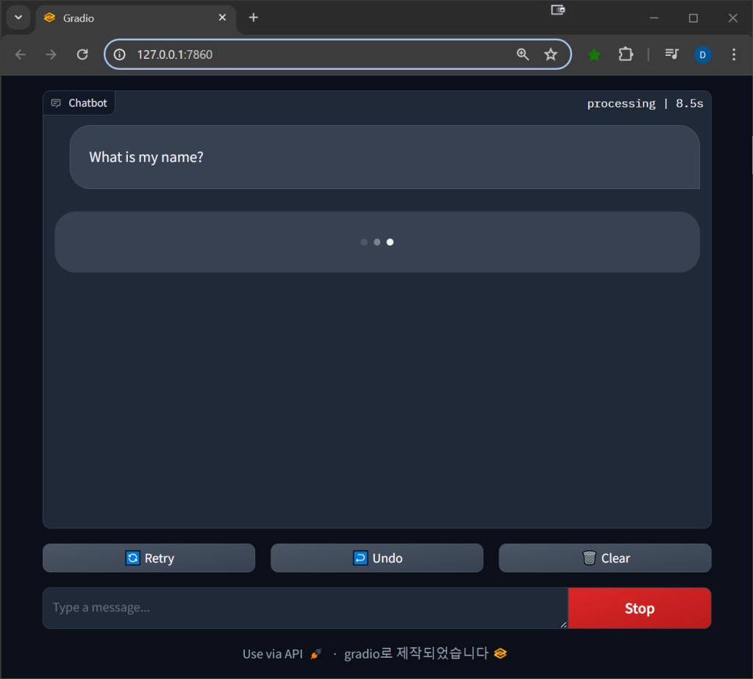

Testing and Evaluation
The chatbot is tested in two phases:
  - Technical Evaluation: Accuracy of speech recognition, NLP models, and response generation.
  - User Evaluation: Real users interact with the bot and rate their experience based on realism, helpfulness, and ease of use.

Conclusion
The development of the AI-Powered Interview Assistant Chatbot marks a significant step toward integrating intelligent automation into the recruitment and career development
process. By leveraging advanced technologies such as Natural Language Processing (NLP), Machine Learning (ML), and Speech Processing, this system provides an interactive and accessible platform for simulating real-world interview experiences. It not only assists job

seekers in practicing and refining their communication skills but also has the potential to support recruiters in conducting scalable and unbiased preliminary assessments.
Throughout the project, various components were carefully designed and integrated to create a realistic and effective mock interview environment. The chatbot's voice-to-text and text-to- speech capabilities enable smooth and natural conversations, while its ability to understand, analyze, and evaluate responses ensures meaningful interaction and feedback. The inclusion of sentiment analysis, grammar checking, and keyword recognition adds further depth to the feedback mechanism, helping users gain actionable insights into their performance.
The chatbot supports interviews across different domains by utilizing a rich and diverse question bank, making it highly adaptable and customizable. Furthermore, the system’s architecture allows for future scalability and enhancement, including the integration of
emotion recognition, multilingual support, and personalized coaching based on individual learning progress.
In conclusion, this AI-driven interview assistant provides an innovative, practical, and user- friendly solution to the challenges of interview preparation and candidate evaluation. It not only empowers individuals to face interviews with greater confidence but also contributes to the modernization of hiring practices in a rapidly digitizing world. With further development and real-world deployment, such systems have the potential to become standard tools in
education, training, and recruitment ecosystems.

Acknowledgment
I would like to express my sincere gratitude to all those who have supported and contributed to the development of the AI-Powered Interview Assistant Chatbot. This project would not have been possible without the guidance, resources, and expertise provided by several
individuals and institutions.
First and foremost, I would like to thank my supervisor for their invaluable guidance and mentorship throughout the course of this project. Their insights into AI, machine learning, and NLP were instrumental in shaping the direction of the chatbot, ensuring that it met the necessary academic and technical standards.
I am also deeply grateful to my colleagues and peers, who provided constant encouragement and feedback during the development phase. Their suggestions helped refine various aspects of the chatbot, from the user interface to the technical components, improving both its
usability and performance.
A special thanks goes to the developers and contributors behind the open-source tools and APIs used in this project. The work done by the teams behind Google Cloud Speech-to-Text, Text-to-Speech, Mozilla DeepSpeech, and LanguageTool was critical in integrating real-time voice processing and natural language understanding into the chatbot. These technologies
allowed the system to simulate real-world interview scenarios effectively.
I would also like to acknowledge the academic and research papers referenced in this project, which provided a solid foundation for the implementation of NLP models, sentiment analysis,

and feedback mechanisms. Their research guided my understanding of current trends in AI and its application in recruitment.
Finally, I extend my heartfelt thanks to my family and friends for their continued support, patience, and encouragement. Their belief in my abilities motivated me to push through challenges and complete this project to the best of my ability.
This project has been a rewarding learning experience, and I am grateful for the opportunity to contribute to the development of intelligent systems that can have a meaningful impact on both individual career development and the recruitment industry as a whole.

References
- Devlin, J., Chang, M. W., Lee, K., & Toutanova, K. (2019). BERT: Pre-training of deep bidirectional transformers for language understanding. arXiv preprint
arXiv:1810.04805. https://arxiv.org/abs/1810.04805
- Radford, A., Wu, J., Child, R., Luan, D., Amodei, D., & Sutskever, I. (2019).
Language models are unsupervised multitask learners. OpenAI. https://cdn.openai.com/better-language-
models/language_models_are_unsupervised_multitask_learners.pdf
- Jain, A., Gupta, R., & Rajan, R. (2020). AI-based virtual interviewer for preliminary candidate screening. International Journal of Computer Applications, 176(33), 1-7. https://doi.org/10.5120/ijca2020920648
- Liu, Y., Zhang, H., & Xu, H. (2021). Emotion-aware interview simulation using multimodal AI. IEEE Transactions on Affective Computing.
https://doi.org/10.1109/TAFFC.2021.3062034
- Mozilla Foundation. (2020). DeepSpeech: An open-source speech recognition engine. https://github.com/mozilla/DeepSpeech
- Google Cloud. (n.d.). Cloud Text-to-Speech Documentation. Retrieved from https://cloud.google.com/text-to-speech/docs
- HireVue. (n.d.). AI-powered hiring solutions. Retrieved from https://www.hirevue.com
- LanguageTool. (n.d.). Multilingual grammar, style, and spell checker. Retrieved from https://languagetool.org
- Vaswani, A., Shazeer, N., Parmar, N., Uszkoreit, J., Jones, L., Gomez, A. N., ... & Polosukhin, I. (2017). Attention is all you need. In Advances in Neural Information Processing Systems (pp. 5998–6008).
https://papers.nips.cc/paper_files/paper/2017/hash/3f5ee243547dee91fbd053c1c4a845 aa-Abstract.html
- Kaur, H., & Singh, A. (2022). Chatbots in education and recruitment: A review of applications and challenges. International Journal of Advanced Computer Science and Applications, 13(1), 88–95.

