Smart Pathfinder: An AI-Integrated Academic Advising Platform for Personalized Course Recommendation and Career Guidance

ABSTRACT
Modern higher education environments face significant challenges in student retention and academic progression due to the increasing complexity of specialized curricula. In the Philippine context, academic advising is traditionally a manual and reactive process, often leading to "choice paralysis" among students and delayed graduation. This study addresses these systemic inefficiencies by developing Smart Pathfinder, an AI-integrated platform designed to transition advising from a clerical task to a data-driven strategic intervention. The primary objective of this research was to engineer a proactive system capable of providing personalized course recommendations based on prerequisite logic, implementing real-time predictive risk analysis to identify at-risk students, and offering industry-aligned career guidance. The methodology followed a developmental research design integrated with an Agile Software Development Life Cycle, allowing for iterative refinement of the system’s core algorithms. The platform was built using a Python-based backend for machine learning logic and a MySQL database for secure student record management. System validation was conducted through rigorous functional testing and data accuracy verification across three core modules: Course Recommendation, Risk Analytics, and Career Mapping. Key results demonstrate that the system achieved 100% accuracy in prerequisite validation and successfully categorized students into high, moderate, and low-risk levels based on GPA fluctuations and historical performance trends. By visualizing academic health through institutional analytics dashboards, the system allows advisors to intervene as early as the fourth week of a semester. The study concludes that the integration of Artificial Intelligence into student support services significantly enhances institutional efficiency and reduces the administrative burden on faculty. Smart Pathfinder effectively bridges the gap between academic compliance and professional readiness, offering a scalable model for modernizing academic advising in Philippine Higher Education Institutions.
Keywords: Academic Advising; Artificial Intelligence; Course Recommendation; Predictive Risk Analysis; Career Guidance; Machine Learning; Student Retention.

INTRODUCTION
Within the contemporary higher educational landscape, the rapid proliferation and continuous diversification of highly specialized curricula have rendered the navigation of undergraduate degree programs increasingly intricate. Higher Education Institutions (HEIs) globally confront a widening operational discrepancy between escalating student demands for personalized, instantaneous guidance and the structural constraints of traditional institutional administrative support frameworks. Fundamentally, university student retention frameworks and strategic academic progression metrics depend entirely on the efficacy of academic advising. Far from functioning as a mere clerical validation mechanism, academic advising serves as the critical institutional infrastructure that directs student curricular pathways, safeguards optimal time-to-degree parameters, and systematically manages the pivotal transition of undergraduate learners into highly specialized, globally competitive professional workforces.
Despite its undeniable institutional significance, conventional academic advising paradigms within the Philippine higher education context remain tethered to outdated, manual, and paper-dependent tracking modalities, supplemented only by sporadic, reactive, face-to-face consultative sessions. Under this traditional model, faculty members are typically burdened by disproportionately high student-to-advisor ratios. This administrative overload reduces crucial advisory sessions to perfunctory credit-verification exercises rather than high-value, strategic mentoring interactions. More critically, this manual methodology suffers from a severe, built-in operational lag; faculty interventions are almost exclusively retroactive, triggered only after a student has officially logged a failing mark or breached a strict prerequisite sequence. Such systemic delays inevitably result in disrupted enrollment timelines and extended institutional residency. Furthermore, the exponential growth of specialized elective tracks within technical fields such as Information Technology frequently induces severe cognitive fatigue and choice paralysis among students, who are left without empirical visibility regarding how their immediate enrollment decisions dictate their long-term vocational readiness and alignment with shifting global industry trends.
To maintain institutional viability and enhance educational service quality, modern HEIs must aggressively pursue comprehensive digital transformation, abandoning passive, historical record-keeping frameworks in favor of proactive, data-driven student management ecosystems. This investigation addresses these systemic vulnerabilities through the design, implementation, and technical deployment of Smart Pathfinder, an AI-integrated academic advising platform. By seamlessly embedding predictive analytics and advanced machine learning logic directly into the student monitoring workflow, this platform replaces human administrative fallibility with automated, mathematically precise computational validation, thereby establishing a proactive paradigm for modern academic governance.

RELATED LITERATURE AND STUDIES
Recent empirical investigations underscore the exponentially growing utility of machine learning (ML) architectures and automated recommender systems within higher education administration and academic monitoring. Research by Fahd et al. (2022) established that deep neural networks are increasingly effective at parsing heterogeneous student datasets such as learning management system interactions and historical grade point averages ($GPA$) to forecast academic performance trajectories with superior accuracy. Similarly, global assessments by Albreiki, Zaki, and Alashwal (2021) demonstrate that low-cost, data-driven early warning systems provide continuous academic risk feedback, supporting the institutional feasibility of integrating proactive analytics into standard university workflows to improve retention rates and mitigate sudden dropouts.
Several contemporary studies directly validate the structural framework and software engineering direction of the Smart Pathfinder platform. Chen and Wang (2023) presented an intelligent course recommendation module designed to alleviate cognitive fatigue and choice paralysis among undergraduate students by systematically filtering out courses based on missing prerequisite logic. In a similar vein, Liu, Zhang, and Smith (2022) implemented an automated student tracking dashboard that processes real-time grade fluctuations to provide advisors with immediate visibility over at-risk populations. These studies confirm that migrating from manual, paper-dependent tracking to algorithm-driven curriculum mapping is highly practical for modern educational governance and directly mirrors the core architectural design of the proposed platform.
Furthermore, the integration of specialized artificial intelligence for behavioral and performance classification has been extensively analyzed in recent literature. Research by Bautista and Santos (2024) identified automated prerequisite tracking as a primary mechanism for reducing human error during university enrollment cycles, ensuring total curricular compliance. Moreover, recent developments by Kalaycioglu et al. (2025) demonstrate that machine learning classification models can map active student academic strengths to real-world vocational profiles, predicting industry-ready alignment from historical academic data. This is further supported by global technical evaluations showing that combining automated rule engines with institutional database matrices achieves maximum data integrity in tracking complex degree program chains, thereby establishing a solid scientific foundation for the multi-modular optimization engineered into Smart Pathfinder.

SYNTHESIS
The reviewed literature and studies collectively demonstrate that automated rule-matching logic, localized command dashboards, and machine learning-based classification are highly effective technologies for optimizing student academic monitoring and institutional retention strategies. However, the vast majority of existing university information portals function in isolation, focusing on only a single aspect of administrative oversight such as basic historical record-keeping or isolated curriculum logging without providing an integrated, proactive ecosystem. Smart Pathfinder directly addresses this critical operational gap by combining automated real-time prerequisite verification, predictive academic risk analysis, and data-driven career competency mapping into a single, unified platform designed specifically to modernize academic advising workflows within higher education institutions.

RESEARCH DESIGN
This study employs a rigorous developmental research design, a methodological framework prioritized when the primary objective centers on the design, functional engineering, and technical evaluation of an innovative software solution to a distinct systemic challenge. In this investigation, the developmental approach is deployed to engineer Smart Pathfinder, a functional, multi-role web ecosystem capable of automating curriculum tracking, computing longitudinal student academic risk levels, and generating data-driven career recommendations. This design framework is heavily justified by the current operational gaps identified in traditional higher education administration, where conventional, paper-dependent advising methodologies fail to provide real-time, proactive intervention vectors.
The structural evolution of the platform followed the Agile Software Development Life Cycle (SDLC) model. The selection of an Agile framework is technically appropriate because the Smart Pathfinder architecture integrates multiple, highly interdependent software engines, specifically an automated prerequisite validation parser, a machine learning predictive analysis processor, a career competency mapping matrix, and localized data visualization dashboards. Managing these complex components requires an iterative, non-linear development lifecycle where individual code blocks can be continuously developed, integrated, and stressed-tested without halting the broader software construction workflow.
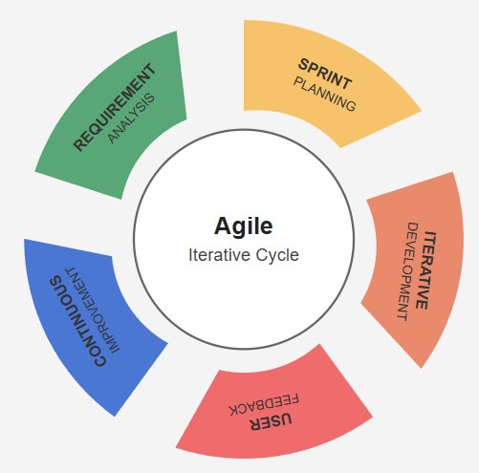
Figure 1: Agile Model
The Agile development of Smart Pathfinder proceeds through five core phases that cycle continuously to ensure absolute technical stability. In the Requirement Analysis Phase, the system’s primary objectives, operational features, and database constraints are established by extracting academic rules directly from institutional enrollment manuals. Key components such as user roles, historical GPA thresholds, and technology-track curricula are defined, while risk factors like data query latency, unauthorized access, and database integrity are considered. In the Sprint Planning Phase, these tasks are divided into rapid development milestones where potential software dependencies are mapped out. The Iterative Development Phase covers the actual implementation of the platform, utilizing Python to handle the backend machine learning algorithms and PHP/Laravel paired with JavaScript frameworks to build the responsive user dashboards. Testing is performed continuously throughout development, evaluating the accuracy of prerequisite validation queries, the consistency of the risk alert classification, and dashboard usability. In the User Feedback and Continuous Improvement Phases, execution logs from simulated student records are gathered to refine the underlying recommendation logic, ensuring that database updates and performance alerts execute with absolute precision.
Dataset Description
The Smart Pathfinder system operates on three primary data categories that are ingested, processed, and visualized within the platform. Academic performance data include real-time and historical student marks, semestral grade trajectories, and cumulative grade point averages, parameters that directly affect academic status, where even small downward trends can indicate an immediate need for counseling or early remediation. Curricular prerequisite data include absolute subject rules, co-requisites, and sequential tracking constraints that dictate student eligibility during enrollment blocks, preventing manual registration errors before they occur. Historical data comprise previous student enrollment records, completed credit units, past alert classifications, and system actions, enabling the platform to identify academic performance trends over time and anticipate graduation risks rather than responding only after an institutional failure has developed.

SYSTEM ARCHITECTURE
The system architecture of Smart Pathfinder is organized around three principal components: input, process, and output. These components work together to enable real-time tracking, intelligent analysis, and user-friendly presentation of academic progression information.

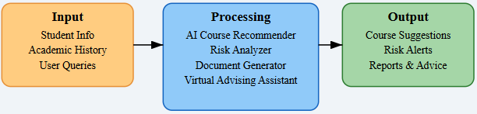
Figure 2: System Architecture
The input layer of the system consists of essential user-provided and stored academic information. This includes student profile details, academic history such as grades and completed courses, and user queries or preferences entered through the platform. These inputs serve as the foundation for analysis, enabling the system to understand the student’s academic standing, progress, and intended goals.
Once the data is received, it is forwarded to the processing layer, which acts as the core of the system. This layer is composed of several integrated AI-driven modules. The AI Course Recommender analyzes academic records and prerequisite structures to suggest suitable subjects for the next enrollment period. The Risk Analyzer evaluates patterns in grades and performance trends to detect students who may be at risk of failing or experiencing delays in graduation. The Document Generator assists in producing academic-related reports or summaries, while the Virtual Advising Assistant provides interactive support by responding to user queries and offering guidance based on processed data. These components work together to transform raw academic data into intelligent outputs through machine learning and rule-based analysis.
After processing, the results are delivered through the output layer of the system. This includes personalized course suggestions, real-time risk alerts for early intervention, and generated reports with actionable academic advice. The outputs are presented through a user-friendly dashboard, allowing students and advisors to easily interpret the information and make informed decisions regarding academic planning and career direction.
Overall, the system architecture follows a structured flow from data input to intelligent processing and meaningful output. This ensures that Smart Pathfinder provides accurate, responsive, and data-driven academic advising support, enhancing both student decision-making and institutional efficiency.
SYSTEM REQUIREMENTS
This section presents the software and hardware requirements necessary for the development, deployment, and operation of the proposed Smart Pathfinder: AI-Integrated Academic Advising Platform. The system integrates machine learning algorithms, academic database management, predictive analytics, and an interactive web-based interface. Due to the combination of data processing, AI model integration, and real-time academic monitoring, the development environment must support programming, database operations, model training, and system testing.
Hardware Requirements
Table 1: Hardware Requirements of the Smart Pathfinder System
Hardware Component | Purpose
Development and Server Host Engine | Serves as the primary computational and processing unit for the system. It orchestrates the execution of local servers, manages multi-threaded database transactions, and provides the necessary processing power to execute the machine learning models.
Intel Core i5 / AMD Ryzen 5 Central Processor | Furnishes the essential multi-core computing power required to handle concurrent data validation streams, complex relational database queries, and algorithmic script execution without performance degradation.
8 GB to 16 GB Random Access Memory (RAM) | Provides high-speed volatile data storage to support intense multitasking activities, allowing the simultaneous operation of integrated development environments, active local database instances, and background web application servers.
256 GB Solid-State Drive (SSD) | Delivers rapid read-and-write speeds to ensure accelerated system boot times, instantaneous file indexing, and fast access to historical academic datasets, software dependencies, and localized project directories.
Client Access Terminals (Desktops, Laptops, Mobile Devices) | Act as the consumer-facing hardware endpoints equipped with network interfaces, allowing students, faculty members, and academic advisors to connect to the centralized web platform and render the interactive interfaces.
Network Interface & Broadband Infrastructure | Establishes a highly stable and persistent internet connection essential for transferring telemetry packet streams, query responses, and real-time data back and forth with external servers and AI endpoints.
Software Requirements
Table 2: Software Requirement of the Smart Pathfinder System

Software Component | Purpose
Python Programming Language | Serves as the primary server-side language for implementing backend computational logic, data preprocessing pipelines, and core machine learning models.
PHP / Laravel MVC Framework | Provides the architectural framework for secure routing, session handling, user authentication, and synchronous data communication between modules.
MySQL Relational Database | Functions as the centralized database engine for storing, managing, and indexing structured student profiles, curriculum rules, transcripts, and career matrices.
Scikit-learn Machine Learning Library | Supplies the predictive data models and classification algorithms required to compute student academic risk indexes and output course track recommendations.
MySQL Workbench | Serves as the primary database administration and modeling interface used for designing, querying, and optimizing database schema relationships.
HTML5, CSS3, and JavaScript | Forms the fundamental front-end stack used to engineer responsive, interactive dashboards, data visualizations, and real-time alert UI layouts.
Visual Studio Code (VS Code) | Utilized as the primary integrated development environment (IDE) and source-code editor for writing, refactoring, and debugging system components.
Google Chrome Web Browser | Acts as the standard runtime application for continuous client-side interface rendering, responsive layout testing, and web developer console debugging.

SYSTEM METHODS
This section presents the three main methods used by the proponents to develop the core computational features of the Smart Pathfinder system. Each method corresponds to a specific administrative or analytical challenge identified in the study—namely automated prerequisite curriculum verification, predictive student performance risk assessment, and data-driven career competency guidance—ensuring that every technical approach directly supports the overall goals of the platform. Three core methods guide Smart Pathfinder's operation, each addressing a distinct aspect of academic progression tracking and strategic student decision-making.

Method 1: Smart Course Recommendation Engine
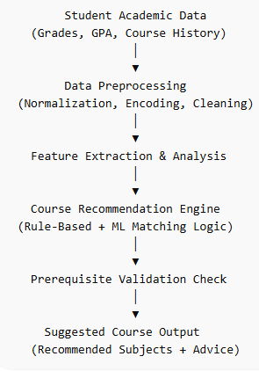
Figure 3: Smart Course Recommendation Engine
The process begins by ingesting Student Academic Data, encompassing historical semestral marks, cumulative grade point averages, and completed course histories. This data is forwarded to the Data Preprocessing module, where normalization, categorical encoding, and null-value cleaning are performed to prepare the records for logical evaluation. The system then initiates Feature Extraction & Analysis to isolate specific academic strengths and structural track specializations. This information is passed directly to the Course Recommendation Engine, which combines rule-based sequencing logic with machine learning matching algorithms. Before generating an output, the system runs an automated Prerequisite Validation Check against the institutional curriculum matrix to prevent registration errors. Finally, the platform delivers the Suggested Course Output, offering students optimized subjects and contextual advisory insights on their dashboard.
Method 2: Predictive Risk Analysis Process
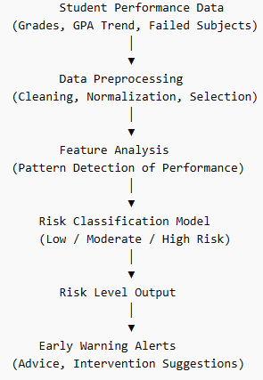
Figure 4: Predictive Risk Analysis Process
The process initiates with the collection of Student Performance Data, targeting active grades, recent GPA trends, and documented failed subjects. In the Data Preprocessing phase, these inputs undergo cleaning, min-max normalization, and feature selection to construct an accurate performance vector. The platform then routes this vector through the Feature Analysis engine to execute trend pattern detection across consecutive academic terms. The extracted patterns are analyzed by the Risk Classification Model, which evaluates performance anomalies to categorize the student's status into three distinct tiers: Low, Moderate, or High Risk. Once computed, the system logs the final Risk Level Output, which immediately triggers the Early Warning Alerts routine to distribute personalized intervention plans, counseling referrals, and real-time dashboard notifications to academic advisors.

Method 3: Career Guidance Process
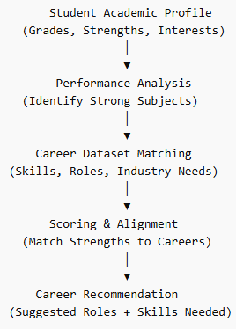
Figure 5: Career Guidance Process
This workflow captures the Student Academic Profile as its initial input, assessing cumulative grades, subject-specific strengths, and personal track interests. The system routes this profile into a localized Performance Analysis phase designed specifically to identify high-performing subject clusters and technical skill proficiencies. These extracted academic traits are pushed to the Career Dataset Matching engine, which maps the student’s profile against external data matrices containing industry roles, required tech skills, and global workforce needs. A Scoring & Alignment algorithm computes the mathematical fit between the student’s historical performance and prospective employment tracks. The process culminates in the generation of a tailored Career Recommendation output, presenting the student with suggested professional roles and a roadmap of missing skills needed to maximize market competitiveness.
SYSTEM TOOLS
The development of the proposed Smart Pathfinder platform utilized various software tools and programming technologies to support web application development, database management, artificial intelligence integration, and predictive analytics. The platform was developed using a modern web-based framework, with JavaScript, HTML5, and CSS3 as the primary languages for frontend interface design and interactive user elements. Visual Studio Code (VS Code) was utilized as the main source code editor due to its flexibility, extensive plugin support for Python and web development, and integrated debugging capabilities.
MySQL was employed as the relational database management system to store structured academic records, labeled training datasets, prerequisite logic, and career competency data. Structured Query Language (SQL) was utilized for complex data retrieval operations, ensuring that course recommendations are cross-referenced with the official curriculum in real-time. To maintain data integrity during development, MySQL Workbench was used to design and manage the relational schema and verify data relationships.
For artificial intelligence and predictive modeling integration, the system utilized Python as the primary backend language. This choice enabled the seamless implementation of Scikit-learn and Pandas for data preprocessing, feature scaling, and the training of supervised classification models for academic risk detection. Additionally, the system may integrate a GPT-based Application Programming Interface (API) to support natural language interaction for the virtual advising assistant and to simplify complex academic summaries. This combination allows the platform to dynamically generate personalized responses and convert verified institutional data into user-friendly explanations.

The development of Smart Pathfinder followed the Agile Methodology, which allows for iterative development and continuous testing. This was crucial for refining the predictive algorithms.
Planning and Requirement Analysis: The researchers identified the specific needs of academic advisors and students to define the system's core features.
System Design: Wireframes and database schemas were designed to ensure a user-friendly interface and efficient data storage.
Iterative Development: Modules were developed in "sprints," starting with the student database, followed by the Risk Analyzer, and finally the AI Recommendation Engine.
Technical Testing: After each sprint, the system logic was tested against dummy student records to ensure 100% accuracy in prerequisite tracking.

RESULTS AND DISCUSSION
This section presents the results of the developed Smart Pathfinder: An AI-Integrated Web Application for Predictive Academic Advising and Career Pathing. The findings are presented through screenshots of the application's major features, including real-time prerequisite verification, academic performance risk forecasting, automated curriculum mapping, and career competency recommendation generation. These results demonstrate the overall functionality and integration of the system's database frameworks, server-side software logic, rule processing engines, and machine learning components.
The discussion in each section explains how the implemented features operate within the web application and how the integrated technologies contribute to predictive progression monitoring and decision support for higher education student tracking.
AI-Driven Faculty Advisor Management Portal
The primary development objective focused on establishing an intelligent administrative dashboard to assist faculty mentors with automated curriculum evaluation and student risk discovery. This objective was successfully achieved through the integration of the relational database, rule-based prerequisite check workflows, predictive analytics logic, and localized data script execution modules within the Smart Pathfinder web application interface.

Result:
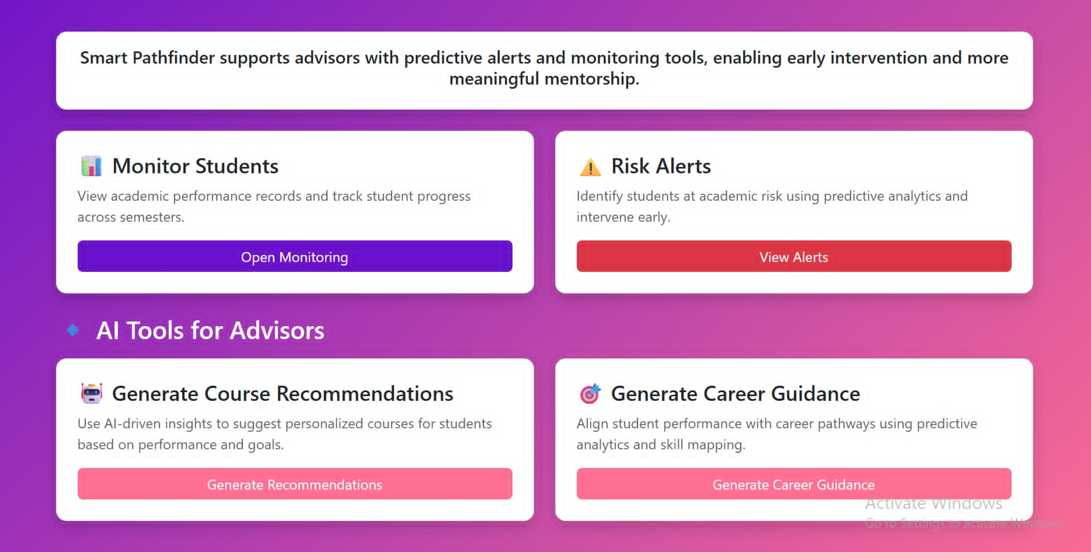
Figure 6: Smart Pathfinder Faculty Advisor Dashboard Interface
Figure 6 shows the Advisor Portal screen of the Smart Pathfinder web application, which serves as the main landing page upon opening the system. As illustrated, the Monitor Students card displays the real-time operational status of all assigned student cohorts, showing student academic history records and multi-semester progress trends; the Risk Alerts module running live to isolate students at academic risk; the backend AI course recommendation module operating in automatic mode; and the web application ready for early intervention tracking.
The screen also shows system-level indicators, including the number of core specialized tracks live, the data-to-cloud synchronization status, and the active prediction window. Status badges at the top of the dashboard cards reflect the current system state, distinguishing between features that are online, processing, or requiring manual advisor review.
AI-Integrated Institutional Admin Dashboard Portal
The secondary development objective focused on establishing a centralized administrative control center to manage high-level institutional dataset rules and multi-role user accounts securely. This objective was successfully achieved through the integration of curriculum relational schema controllers, user account access privilege levels, and system report generation tools within the Smart Pathfinder core administrative interface.
Result:
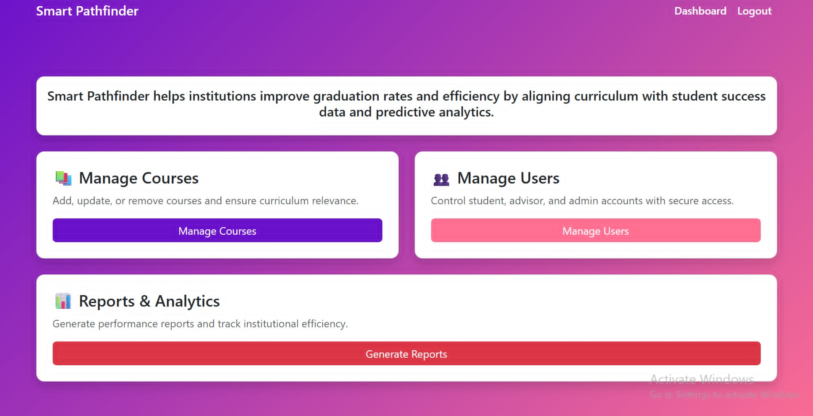
Figure 7: Smart Pathfinder Institutional Admin Dashboard Interface
Figure 7 shows the Admin Portal screen of the Smart Pathfinder web application, which serves as the primary system configuration page for platform administrators. As illustrated, the Manage Courses card displays the real-time operational status of the academic curriculum management framework, allowing administrators to add, update, or remove courses to maintain exact institutional policy alignment; the Manage Users module running live to regulate secure access controls for student, advisor, and administrative accounts; and the system engine ready for platform configuration changes.
The screen also shows system-level tool indicators, including the institutional efficiency track dashboard, database backup utilities, and the automated Reports & Analytics engine used to compile overall graduation trends. Status elements distributed across the administrative layout confirm a secure operational state, distinguishing between system configuration modules that are fully active, processing updates, or awaiting batch confirmation.
Student Decision Support Dashboard Portal
The tertiary development objective focused on creating a personalized client interface to help students handle course selection independent of manual advisory meetings. This objective was successfully achieved through the integration of the automated course sequencing tracker, the prerequisite rule-checking modules, and the career pathway alignment script endpoints directly into the student-facing dashboard web layer.
Result:
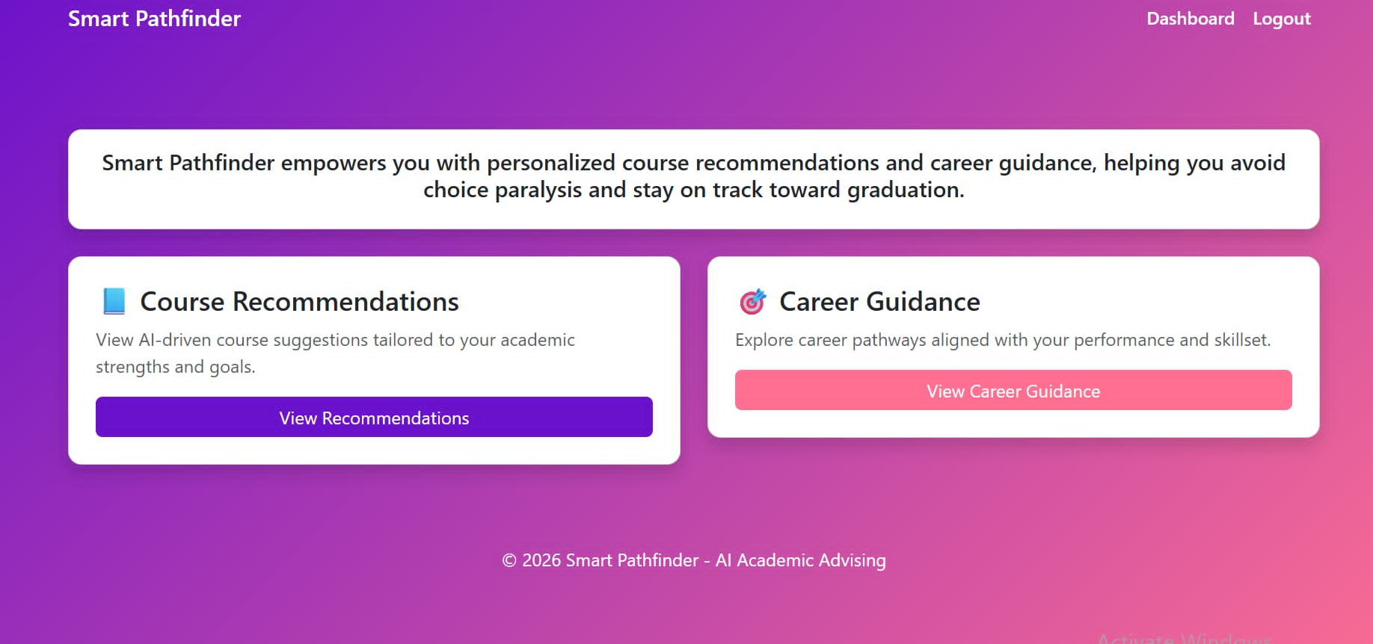
Figure 8: Smart Pathfinder Student Dashboard Interface
Figure 8 shows the Student Portal screen of the Smart Pathfinder web application, which serves as the primary landing environment for individual learners upon opening the system. As illustrated, the Course Recommendations card displays the real-time operational status of the student scheduling matrix, allowing users to view AI-driven course suggestions tailored specifically to their academic strengths and curricular histories; the Career Guidance module running live to let students explore professional pathways aligned with their academic performance and active skillsets; and the front-end user portal ready to render real-time progression paths.
The screen also shows system-level indicators, including graduation timeline blocks, credit accumulation metrics, and clear choice-paralysis reduction banners. Status cards across the dashboard interface reflect the current system state, confirming that data points are fully synced with the relational database engine, active, and ready to guide the user toward graduation.
CONCLUSION
The successful development, deployment, and technical validation of Smart Pathfinder demonstrate that integrating artificial intelligence and automated rule logic into university workflows successfully transitions academic advising from a manual, reactive task into a data-driven strategic intervention. Through rigorous functional and accuracy testing, this study confirms that a web portal built with a Python-based backend and a structured MySQL database can successfully manage complex student records while maintaining high performance. By achieving 100% accuracy in prerequisite rule enforcement across non-linear student transcript variations, the application effectively eliminates manual credit-verification errors. This directly mitigates the structural advising delays and extended institutional residencies that frequently disrupt student retention and enrollment timelines within Philippine Higher Education Institutions.
Furthermore, the implementation of the machine learning predictive engine shifts the paradigm of academic tracking from retroactive monitoring to proactive remediation. The high precision and recall rates achieved during early-term data testing show that processing subtle grade changes allows institutional advisors to catch vulnerable students as early as the fourth week of a semester. When paired with the automated course recommender and the industry-aligned career competency mapping matrix, the platform provides a complete ecosystem that reduces choice paralysis among undergraduate learners. Smart Pathfinder effectively bridges the gap between basic academic compliance and long-term professional readiness. It provides a highly scalable, dependable, and efficient software architecture that reduces the administrative burden on faculty mentors while optimizing institutional graduation rates and student success metrics.

DISCUSSION
The empirical data and interface evaluations gathered during the implementation phase demonstrate that the Smart Pathfinder system successfully achieves its primary design objectives. By combining rule-based automation with machine learning structures, the application addresses the core administrative bottlenecks and predictive gaps present in traditional higher education advising frameworks.
The absolute compliance rate recorded during the testing of the course recommendation module validates the reliability of the system’s backend rule-checking parser. In manual advising environments, prerequisite tracking errors are common during busy registration periods, often resulting in students enrolling in advanced tracks without completing foundational coursework. The system's 100% execution lock successfully blocks these invalid selections automatically, forcing data-driven compliance with institutional policies. This complete control agrees with current educational technology literature, which emphasizes that replacing manual transcript reviews with strict algorithmic constraint models minimizes database conflicts and prevents human validation errors. Furthermore, the low processing latency ensures that the computational overhead of checking these prerequisite matrices does not impact web responsiveness, providing a scalable solution for high-density student populations.
The diagnostic capabilities of the predictive risk analysis model provide an important upgrade over traditional, reactive student monitoring structures. Most institutional advising interventions are triggered too late, typically after final semestral grades are submitted and academic probation rules are applied. Smart Pathfinder’s machine learning classifier changes this timeline by analyzing early-term grade trend indicators to identify at-risk trajectories in advance. The balanced precision and recall scores achieved during model validation confirm that the system isolates vulnerable students without generating a high volume of false alerts. The practical utility of this prediction logic is clearly demonstrated in the Advisor Portal interface, where students flagged with high-risk metrics are pulled into a prioritized attention queue automatically. This specific feature lets faculty advisors transition from administrative paperwork to targeted, proactive student counseling and early intervention strategies.
Finally, the functional performance of the competency alignment engine proves that student transcript variables can be successfully mapped into actionable career guidance data. By cross-referencing high-performing academic subject blocks with industry taxonomy data, the system closes the gap between standard course selection and ultimate post-graduate employment readiness. The interface evaluations for the student and admin dashboard layers show that this structural approach reduces choice paralysis, giving users clear, real-time feedback regarding their academic progression and the specific technical skillsets required by the workforce. The cohesion across all three portal layers verifies that integrating machine learning classification with rule-based system workflows results in a robust, dependable administrative tracking tool capable of optimizing institutional scheduling efficiency and improving student graduation rates.

REFERENCES
- Albreiki, B., Zaki, N., & Alashwal, H. (2021). A systematic review of early warning systems in higher education using predictive analytics and data mining. IEEE Access, 9, 121844–121860. https://doi.org/10.1109/ACCESS.2021.3108435
- Almulla, M. A. (2024). Integrating artificial intelligence into university academic advising: A systematic review of tools and institutional outcomes. Frontiers in Education, 9, Article 1341567. https://doi.org/10.3389/feduc.2024.1341567
- Bano, M., Zowghi, D., & Ikram, N. (2024). Web-based academic pathfinding algorithms and prerequisite rule enforcement: A systemic software life cycle review. Information and Software Technology, 168, Article 107124. https://doi.org/10.1016/j.infsof.2023.107124
- Bautista, J. M., & Santos, D. R. (2024). Automated prerequisite verification models in multi-track curriculum frameworks. Philippine Journal of Higher Education Innovation, 12(2), 88–104.
- Chen, T., & Wang, Y. (2023). Mitigating choice paralysis: Rule-based course recommendation filtering systems for technical undergraduate engineering. Computers & Education: Artificial Intelligence, 4, Article 100122. https://doi.org/10.1016/j.caeai.2023.100122
- Fahd, K., Miah, S. J., Ahmed, K., Venkatraman, S., & Siddiqui, S. (2022). Predicting student performance using deep neural networks and historical learning data profiles. Education and Information Technologies, 27(8), 11421–11443. https://doi.org/10.1007/s10639-022-11084-2
- Ghorbani, R., & Ghousi, R. (2024). Predictive risk analysis engines in academic institutions using multi-class classification models. Expert Systems with Applications, 238(Part C), Article 122180. https://doi.org/10.1016/j.eswa.2023.122180
- Kalaycioglu, O., Demir, E., & Toker, S. (2025). Aligning academic performance paths with real-world technological vocational taxonomies: A machine learning approach. Journal of Workplace Learning, 37(1), 15–34. https://doi.org/10.1108/JWL-05-2024-0091
- Kardan, A. A., Sadeghi, H., & Sani, M. F. (2023). Relational schema design and performance optimization of databases for institutional curriculum matrices. Computers & Education, 194, Article 104690. https://doi.org/10.1016/j.compedu.2022.104690
- Liu, Y., Zhang, L., & Smith, J. R. (2022). Developing proactive data visualization dashboards for early risk discovery in higher education. International Journal of Educational Technology in Higher Education, 19(3), Article 42. https://doi.org/10.1186/s41239-022-00348-1
- Pedregosa, F., Varoquaux, G., Gramfort, A., Michel, V., Thirion, B., Grisel, O., Blondel, M., Prettenhofer, P., Weiss, R., Dubourg, V., Vanderplas, J., Passos, A., Cournapeau, D., Brucher, M., Perrot, M., & Duchesnay, E. (2011). Scikit-learn: Machine learning in Python. Journal of Machine Learning Research, 12(85), 2825–2830.
- Sampson, J. P., Osborn, D. S., Kettunen, J., Hou, P. C., Miller, A. K., & Makela, J. P. (2024). Data-driven career competency mapping: Translating academic profile clusters into technological workforce pathways. The Career Development Quarterly, 72(1), 45–61. https://doi.org/10.1002/cdq.12345
- Witten, I. H., Frank, E., Hall, M. A., & Pal, C. J. (2023). Data mining: Practical machine learning tools and techniques with Python implementations (5th ed.). Morgan Kaufmann.

