Integrating Design Thinking into Participatory Approaches to Community-Based Conservation for Enhanced Livelihoods in Kenya

Abstract
Community participation has emerged as a fundamental principle in Community-Based Conservation (CBC), representing a significant departure from the traditional fortress conservation model that dominated conservation practice for much of the twentieth century. Fortress conservation ranked biodiversity protection by excluding local communities from protected areas, often resulting in displacement from ancestral lands, restricted access to natural resources, and conflicts between conservation authorities and local populations. While such approaches contributed to the establishment of protected areas, they challenged long-term conservation outcomes by sidelining communities that thrive side by side with wildlife.
In response to these challenges, contemporary conservation approaches highlight participatory governance, local empowerment, and community involvement in decision-making processes. In Kenya, the growth of community conservancies has advanced by integrating conservation objectives with enhanced livelihood. Through initiatives such as ecotourism, artefacts production, sustainable natural resource utilization, and alternative energy projects, community conservancies seek to create incentives for local participation while promoting environmental conservation.
This study examines the role of community participation in enhancing the effectiveness and sustainability of community-based conservation initiatives. It explores how participatory approaches contribute to improved conservation outcomes, strengthened local ownership, enhanced livelihoods and community development and sustainability. The study further investigates challenges that continue to hinder meaningful participation, including tokenism, unequal governance, capture by the elite and top-down decision-making structures. By analyzing these dynamics, the study contributes to the growing body of knowledge on participatory approaches to conservation and provides recommendations for strengthening community engagement in conservation governance. Effective community participation is critical for achieving both biodiversity conservation and sustainable livelihood development.
Key words: community-based conservation, participatory approach, livelihoods, sustainable development

INTRODUCTION
Community participation has become a key principle in community-based conservation (CBC), marking a shift away from exclusionary “fortress conservation” models toward more comprehensive engaging strategies. Historically, fortress conservation approaches prioritized ecological protection through the exclusion of local communities, often leading to displacement from ancestral lands and denial of access to critical natural resources ( (Büscher & Fletcher, 2020); (Rai, et al., 2021)). While these approaches were effective in establishing protected areas, they frequently generated conflicts between conservation authorities and local populations, ultimately undermining conservation goals by eroding local support.
In response, more inclusive conservation models have emerged, emphasizing the involvement of local people in conservation planning and management. In Kenya, the growth of community conservancies and participatory governance structures reflects this shift, linking conservation efforts with livelihood strategies such as tourism, crafts, and alternative energy resource management (Kenya Wildlife Service [KWS], 2022; (Galvin, Rowland, Pickering, Walker, & Jablonski, 2021) These initiatives demonstrate a deliberate facilitation to empower communities as the main stakeholders in conservation while enhancing socio-economic outcomes.
However, the success of these initiatives rest on how participation is developed and implemented. Participation extends beyond mere involvement in activities to include meaningful engagement in decision-making, equitable access to benefits, and a sense of ownership over conservation processes (Reed, 2017; (Rai, et al., 2021)). In practice, these ideals are not always realized. Decision-making often remains centralized, benefits are unevenly distributed, and communities may lack the capacity or opportunity to engage effectively. This aligns with the linear approach to participation, which follows a structured sequence of problem identification, planning, implementation, monitoring, and evaluation, often limiting iterative feedback and local innovation (Reed, 2017).
Consequently, participation in many CBC initiatives remains consultative where members provide input but not in decision making and policies are executed by external stakeholders. As a result, ownership of the project is wanting and feedback loops are not used leading to dependence and disgruntlement among communities. Tools like Participatory Rural Appraisal have been adopted in adoption of indigenous knowledge in solving community needs. Conservation planning counts on technical and scientific expertise which lacks in problem identification and iterative learning with the people.
The study aims to examine how community participation contributes to sustainable resource management and biodiversity conservation while addressing socio-economic needs (Bockstael, Bahia, Seixas, & Berkes, 2016).
LITERATURE REVIEW
Community-based conservation (CBC) has gained prominence as a strategic approach to simultaneously address biodiversity protection and the improvement of rural livelihoods. Modern-day conservation increasingly advocates for participatory approaches that incorporate local knowledge, community engagement, and equitable benefit-sharing in resource governance (Cheeseman K. , 2024).
More recently, attention has turned to the integration of innovation-oriented methodologies, particularly design thinking, in addressing complex sustainability challenges. Design thinking is a human-centered, iterative approach to problem-solving that prioritizes empathy, stakeholder collaboration, idea generation, prototyping, and continuous refinement. In the context of environmental governance and development practice, it offers practical tools for engaging diverse stakeholders, redefining conservation challenges, and co-developing context-specific solutions. Its emphasis on experimentation and adaptability makes it well-suited to addressing the dynamic trade-offs between conservation and livelihoods in rural settings.
Application of design thinking and community-based conservation creates an opportunity for enhanced livelihood outcomes while sustaining ecological integrity. Structured participatory processes supported by innovation frameworks can facilitate the development of alternative income-generating activities such as ecotourism, sustainable agriculture, and nature-based enterprises. Empirical studies indicate that when communities are directly involved in designing and implementing livelihood interventions, there are notable improvements in income diversification, food security, and gender inclusivity. Furthermore, collaborative learning within conservation governance systems has been shown to strengthen adaptive capacity, improve decision-making processes, and foster more sustainable human–wildlife coexistence.

Community-based Conservation
In a study by Cheeseman (2024) looking at contemporary conservation approaches, it was discovered that community-based conservation (CBC) has emerged as a strategic model for addressing both biodiversity conservation and rural livelihood improvement. Koricha and Jemal Adem (2024) echoes this model by agreeing that conservation outcomes in African contexts, enhances conservation success by fostering ownership, improving compliance, and promoting sustainable resource use. The authors conclude that tangible community benefits are critical for long-term conservation support. Research established that modern conservation increasingly prioritizes participatory approaches that integrate local knowledge, community engagement, and equitable benefit-sharing.
Decision-making within community-based frameworks is guided by the principles of inclusivity and fairness. Ideally, community members are not just consulted but are actively involved in determining project priorities, allocating resources, and shaping governance structures. Frameworks such as Arnstein’s Ladder of Citizen Participation, study by (Erbaugh, 2018) established that CBC initiatives are most successful where communities have decision-making authority and access to economic incentives.
To address these limitations, there is growing interest in more innovative and flexible approaches that can strengthen participation in conservation. One such approach is design thinking, which emphasizes empathy, collaboration, and iterative problem-solving. Further, Roger Martin emphasizes the role of integrative thinking in addressing complex, “wicked problems” such as those found in conservation contexts. In development and social innovation fields, (Manzini, 2016) notes that design thinking enables collaborative processes that empower communities and support locally driven solutions.

Community participation
Community participation has become an anchor to sustainable development and conservation practice across the world. Globally, there has been a clear shift away from exclusionary, top-down conservation models toward approaches that recognize local communities as essential partners rather than passive beneficiaries. Institutions such as the United Nations Development Programme and the World Bank have consistently emphasized that meaningful participation improves project relevance, improved livelihoods, and sustainability. In a study by Reed (2017), it was discovered that meaningful participation improves project sustainability and legitimacy. His opinion is that participation must include decision-making authority. When communities are involved in shaping decisions, they will support and implement conservation initiatives because these initiatives reflect their needs, knowledge, and priorities. Community participatory approach has been used in fields such as agriculture, health and development to engage members to create solutions to community needs.
Participation according to (Dawson, et al., 2024) strengthens both conservation outcomes and local livelihoods by creating a mutually reinforcing relationship between environmental sustainability and community well-being. Participation allows for the integration of local and indigenous knowledge into resource management. Communities have had a relationship with the environment, including climate patterns, wildlife conservation, and sustainable resource use practices. When this knowledge is incorporated into conservation strategies, interventions become more context-specific and adaptive, ultimately enhancing ecological outcomes. While policies may promote inclusivity, in practice, many projects still operate at consultative levels where communities are heard but not empowered to influence final decisions. This gap between policy and practice has necessitated application of transformative and locally grounded participation models.
Kenya Wildlife Service (KWS, Collaboration and Partnerships, 2026)states that community participation has evolved in its effectiveness in conservation, especially with the growth of community conservancies. The country is often cited as a leading example of how conservation can be integrated with local livelihoods through participatory approaches. Key institutions such as the Kenya Wildlife Service, the Northern Rangelands Trust, and the Kenya Wildlife Conservancies Association have been central in advancing this model.
The organization as the national body mandated to manage wildlife, has increasingly embraced community participation through collaborative management strategies. However, challenges remain and studies by Cooke and Kothari (2016), Armitage et al. (2020), criticize the nature of participation as often tokenistic, where communities are involved without real influence. The authors argue that such participation limits empowerment and need for effective conservation outcomes require collaborative governance systems with genuine power-sharing.
Participation is not always evenly distributed, and issues such as elite capture, gender exclusion, and unequal benefit-sharing persist.
Participatory approach
Frameworks such as Arnstein’s Ladder of Citizen Participation is applicable in stakeholder analysis because it highlights how power is distributed to members. Participatory techniques analyse whether stakeholders are honestly involved in decision-making or appear to be involved. Effective stakeholder engagement requires moving toward higher levels of participation, power sharing to the people and applying models that are applicable and adaptable to local context.
The challenges discussed above can reduce the acceptability and effectiveness of conservation initiatives. Holifield and Williams (2019) note that understanding these differences is vital, yet demanding, because participation is dictated by existing political and social inequalities. Consequently, participatory structures may exist formally while meaningful power remains concentrated among a few actors. The implementation of participatory techniques also faces significant obstacles. Traditional methods such as public hearings and consultation meetings are frequently criticized for providing limited opportunities for genuine dialogue and collaborative problem-solving. Holifield and Williams (2019) observed that formal participation mechanisms often fail to sustain stakeholder interest or facilitate meaningful engagement. (Bobbio, 2019) “argues that participatory processes may become ineffective when they rely heavily on rigid consultation procedures rather than interactive and inclusive engagement approaches.” Without effective evaluation tools, it is difficult to determine whether participation has genuinely influenced decision-making and conservation outcomes. These challenges demonstrate that stakeholder participation extends beyond simply involving communities in conservation activities to incorporation of indigenous knowledge to transform top down approach to planning of conservation projects.
Figure 1 below is an analysis of participatory approach discussed above and the challenges encountered through understanding of participation by conservation managers’ vis a vi participation by community members. Within community-based conservation, the processes of selecting participatory techniques, implementing participation strategies, and evaluating participation outcomes, as proposed by Holifield and Williams (2019), can be understood through Arnstein's Ladder of Participation, which highlights varying levels of citizen involvement and decision-making power.

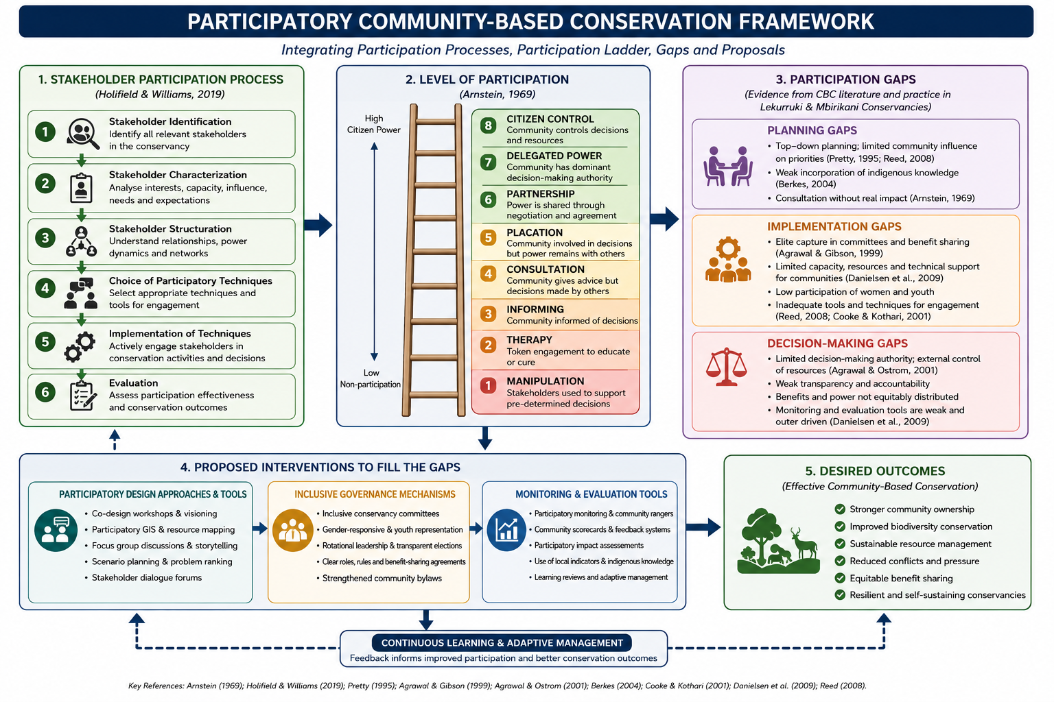
Figure 1.Participatory framework (source: adopted from literature)
The proposed framework is particularly relevant to this study as it explores a systematic approach to investigate how participatory design can strengthen community-based conservation and improve livelihood outcomes within conservancies. By combining Arnstein’s Ladder of Participatin with the stakeholder participation defined by Holifield and Williams, this framework uncovers where participation lacks in planning, implementation, and decision-making stages. These limitations may include controlled community influence in conservation planning, marginalized stakeholder groups, the control of powerful leaders, insufficient participatory methods, and restricted decision making.

Arnstein’s Ladder of Citizen Participation
Participatory practices create an avenue to relent power to citizens of a community. In a study by Arnstein (1969), it was discovered that participation ranges from non-participation to full citizen control. The study established that meaningful participation requires power redistribution.
The author argues that “most processes remain at tokenism, limiting community influence. These varied from non-participation (manipulation, therapy), to tokenism (informing, consultation, placation), to citizen control (partnership, delegated power, citizen control)”. Control is a crucial aspect of resource management because it determines the extent to which individuals and groups can influence decisions that affect them. When decision-making power is concentrated among policymakers, it can lead to inefficient use of resources, growing distrust and resentment among communities, and in some cases, conflict arising from the exclusion of stakeholders from meaningful participation. Arnstein’s Ladder provides a clear visual and conceptual framework for understanding the different levels of power and control that participants have within decision-making processes, highlighting the extent to which their involvement is genuinely influential. 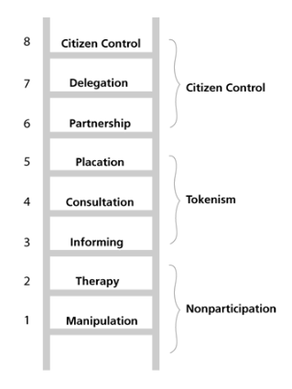
Figure 2. Arnstein's Ladder of Participation (source: (Lauria & Slotterback, 2020)

The "participation ladder" (Hurlbert & Gupta, 2015) states that significant participation requires a shift from consultation towards partnership. Policy makers shall facilitate participatory planning technique where communities are co-owners rather than students complimenting predetermined policies. Community leaders should pioneer local knowledge and represent diverse interests, while empowering community members to citizen control and skill acquisition.

Top- down approach to community participation
The top-down approach to community participation is a development and governance strategy in which decisions are primarily made by government agencies, policymakers, experts, or project managers, with limited input from local communities. Under this approach, priorities, plans, and implementation strategies are designed by higher authorities and subsequently communicated to community members for adoption or compliance. Community involvement is often confined to receiving information, implementing predetermined activities, or providing feedback after major decisions have already been made. In a study by Berkes (2021), it was discovered that top-down conservation excludes communities and reduces effectiveness. He further states that such approaches centralize decision-making within governments or external organizations, ignoring the knowledge, needs, and rights of indigenous and local populations who directly interact with the environment. participation has often been implemented through a top-down approach in which governments, conservation agencies, non-governmental organizations (NGOs), and conservancy managers retain primary control over planning and decision-making processes. Although local communities may be involved in conservation activities, the extent of their influence varies considerably. Arnstein’s framework helps explain these varying levels of participation by categorizing them into non-participation, tokenistic participation, and citizen power.
At the lowest level, non-participation occurs when community members have little or no opportunity to influence decisions affecting conservation initiatives. Rather than being actively engaged in governance, local people are often encouraged to support predetermined programs. In some cases, participation serves mainly to persuade communities to accept conservation objectives established by external actors. In others, efforts focus on changing community attitudes and behaviors without involving residents in actual planning or management processes. Within conservancies, this situation may arise when conservation regulations, land-use policies, or wildlife management strategies are formulated by authorities and later communicated to local residents for implementation, leaving little room for dialogue.
A bottom-up approach to community participation emphasizes the active involvement of local people in decision-making, planning, and implementation processes, thereby enhancing the sustainability and legitimacy of development and conservation initiatives. Recent studies by (Haris, 2025) show that such approaches empower communities by valuing their knowledge, fostering ownership, and promoting solutions tailored to local contexts.

Hindrances to a participatory approach
Linear participation, tokenism, and donor dependence are key hindrances that undermine meaningful community participation in conservation initiatives. Linear participation refers to a one-directional, planner-centred process where decisions are made externally and communities are only involved at later stages, often to implement predetermined plans; this limits genuine engagement and reduces participation to a procedural requirement rather than a transformative process (Meer, 2025; Zheng et al., 2025). Similarly, tokenism represents a superficial form of participation where communities are informed or consulted but lack real decision-making power, resulting in what has been described as an “illusion of participation” that erodes trust and weakens conservation outcomes. Such symbolic involvement prevents communities from contributing local knowledge, discourages ownership, and often leads to unsustainable projects due to the lack of commitment. In addition, donor dependence further constrains participatory approaches by shifting control toward external funders whose priorities may not align with local needs, thereby reinforcing top-down tendencies and limiting community autonomy. Dr.Modecai is of the opinion that CBCs are dependent on donor agents and donor-led conservation initiatives which overshadow local participation create opaque governance systems, and increase community vulnerability, especially when funding conditions dictate decision-making processes . Moreover, reliance on external funding can foster dependency syndromes, reduce local initiative, and weaken long-term sustainability when funding cycles end. He states that these factors collectively restrict genuine participation by maintaining unequal power relations, limiting community influence, and undermining the effectiveness and sustainability of community-based conservation (Dawson et al., 2024; Meer, 2025; Zheng et al., 2025).

Theoretical Foundations of Design Thinking in Conservation
Design thinking has begun as a human-centered, solution-oriented framework that emphasizes empathy, collaboration, experimentation, and iteration in addressing complex social and environmental challenges. Rooted in the disciplines of design and innovation, it provides a structured yet flexible process for understanding user needs, redefining problems, and developing contextually grounded solutions (Brown, 2008; Liedtka, 2015). In recent years, design thinking has been increasingly applied beyond the traditional design professions to fields such as health, education, and sustainability, where problems are characterized by uncertainty, multiple stakeholders, and systemic interdependencies.
In the context of community-based conservation (CBC), design thinking provides a lens through which traditional participatory methods can be strengthened. While participatory approaches emphasize inclusion, they often lack mechanisms for transformative innovation—the ability to generate and test new ideas collaboratively. Design thinking complements participatory conservation by embedding creativity and experimentation into the process, thus transforming stakeholders from passive participants into active co-designers of conservation strategies. This transformation can deepen community ownership and accountability, leading to more resilient conservation practices.
The use of design thinking in conservation remains restricted, particularly in African contexts where participatory models are still evolving. Existing research has primarily focused on stakeholder engagement frameworks, leaving a gap in the operationalization of design-based methodologies within conservation initiatives. This calls for empirical exploration into this methodology and its application to governance framework, resource management traditions, and socio-cultural norms within community-based conservation projects in Kenya.
Integrating design thinking into participatory conservation, therefore, presents a novel approach to reimagining conservation practice. It moves beyond traditional participation to emphasize co-creation, adaptability, and human-centered innovation, ensuring that conservation initiatives improve community well-being and livelihoods.
Participatory Approach
The participatory approach can be applied as a means or an end to enhanced livelihoods. This study will apply it as a methodology in community-based conservation (CBC) to improve active and meaningful engagement of local communities in decision-making, planning, and implementation of conservation initiatives, recognizing them as key stakeholders rather than passive beneficiaries.
This methodology begins with a process of community engagement and consultation, where all stakeholders are invited to share their knowledge, ideas and aspirations. Tools such as participatory rural appraisal (PRA), community mapping, and stakeholder analysis are often used to understand the local context, identify conservation priorities, and build trust. Through dialogue and collaboration, communities help define conservation objectives, design interventions, and decide on benefit-sharing mechanisms.
Once stakeholders have been identified, the next step is to understand who they are and the roles they play in conservation. This involves examining their interests, level of influence, knowledge, access to resources, and degree of dependence on natural resources. Within community-based conservation (CBC), local communities often possess valuable traditional and ecological knowledge gained through long-term interaction with the environment. Different levels of stakeholders interact with the ecosystem differently and understanding their characteristics will aid in classification of their needs and wants.
Participation moves from planning to action. Stakeholders become actively involved in coexisting participatory approaches are limited by their linear and externally driven nature as illustrated in figure below, which constrains meaningful community engagement.
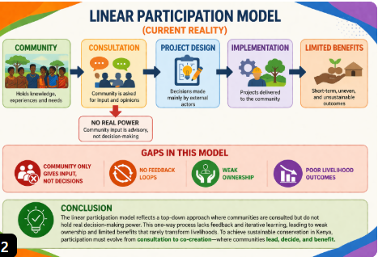
Figure 3. Gaps in participatory approach in conservation management (source: author 2026)
The study concludes that existing participatory approaches in community-based conservation are often constrained by their linear, externally driven structures, which limit genuine community engagement by positioning local people as passive recipients rather than active decision-makers. Such approaches tend to follow rigid, top-down processes that fail to capture the complexity of local contexts or incorporate community knowledge effectively.
The participatory approach also enhances the legitimacy and equity of conservation efforts. By giving communities a voice in decision-making, it helps to address historical power imbalances and reduce conflict, especially in areas where conservation has previously led to displacement or restricted access to traditional lands. Participation ensures that conservation strategies are sensitive to local needs and livelihoods. However, for participation to be effective, it must go beyond token consultation to ensure genuine power-sharing and inclusion in all stages of conservation processes (Holifield & Williams, 2019). Therefore, as a methodology, participatory approaches are essential for achieving inclusive, resilient, and sustainable conservation outcomes by aligning environmental objectives with community needs and priorities Dawson et al., 2023; Ramcilovic-Suominen et al., 2024).

Improved livelihoods
Community-based conservation (CBC) models have been adopted for their efficiency in improved biodiversity protection with increased livelihoods (Wright J. H., et al., 2016). Conservation (CBC) can improve livelihoods by associating conservation efforts to socio-economic benefits such as employment, revenue-sharing, and financial assistance. Exploring views in different context of conservation initiatives can help identify features of the initiatives that are succeeding and those that are failing.
According to (Bennett, 2016) “local people’s perceptions about conservation in PAs can be categorized into four thematic areas: social impacts of conservation, ecological outcomes of conservation, legitimacy of conservation governance, and acceptability of conservation management”. Researchers have increasingly recognized that community perceptions of conservation initiatives in protected areas can be understood through four key dimensions: social impacts, ecological outcomes, governance legitimacy, and management acceptability. Together, these dimensions’ influence how local people evaluate conservation efforts and whether they are willing to support them over the long term.
The social dimension focuses on how conservation activities affect the livelihoods and well-being of local communities. People are generally more supportive of conservation when it contributes positively to their quality of life through employment opportunities, improved income, access to social services, and community development. On the other hand, restrictions on resource use, unequal distribution of benefits, or increased human–wildlife conflicts can generate dissatisfaction and opposition. As a result, indicators such as household income, food security, employment levels, access to education and healthcare, and perceptions of fairness are commonly used to assess social impacts.
The ecological dimension relates to local perceptions of environmental change resulting from conservation interventions. Community members often judge conservation success by observing improvements in wildlife populations, vegetation cover, habitat condition, water resources, and the overall health of ecosystems. Positive environmental outcomes can strengthen confidence in conservation programs, particularly where livelihoods depend directly on natural resources. Measures frequently used to evaluate ecological outcomes include biodiversity status, species abundance, habitat quality, forest regeneration, and ecosystem sustainability.
The legitimacy of governance reflects the extent to which conservation institutions and decision-making processes are perceived as fair, transparent, and accountable. Communities are more likely to trust and support conservation initiatives when they feel their views are considered and when governance structures operate openly and equitably. Legitimacy is therefore commonly assessed through indicators such as stakeholder representation, participation in decision-making, institutional transparency, accountability mechanisms, trust in conservation authorities, and perceptions of procedural justice.
The acceptability of conservation management concerns the degree to which local communities approve of conservation policies, regulations, and management practices. Acceptance tends to increase when conservation measures align with local values, address community priorities, and distribute costs and benefits fairly. In contrast, policies perceived as restrictive or imposed without consultation often face resistance. Researchers commonly evaluate acceptability through community attitudes toward conservation, levels of compliance with regulations, satisfaction with management practices, willingness to participate in conservation activities, and support for future conservation initiatives.
Within Community-Based Conservation (CBC), these four dimensions are closely connected to livelihood improvement. CBC emphasizes the involvement of local communities in conservation while ensuring that they benefit from natural resource management as illustrated in figure 4 below. When conservation initiatives generate employment, support local enterprises, improve infrastructure, and enhance access to resources, communities are more likely to perceive conservation positively. Improved livelihoods can strengthen social well-being, encourage support for environmental protection, increase confidence in governance institutions, and enhance acceptance of conservation measures. Consequently, livelihood enhancement serves as a critical link between community participation and successful conservation outcomes, contributing to both environmental sustainability and long-term community development.

Figure 4 .Outcomes of improved livelihoods enhanced by a participatory approach (source: (D. Matarrita-Cascante, 2019)
Berkes argues that for conservation to be effective and sustainable, it must contribute to improving local livelihoods. In turn, when livelihoods improve through conservation-related benefits, communities are more likely to support and invest in conservation initiatives, thus creating a positive feedback loop. This loop—where conservation supports livelihoods, which in turn support conservation—can be a foundation for resilient and adaptive community-based conservation strategies.

Theoretical Framework
Good design should promote sustainable development; improve the quality of society and the wildlife species thriving in their habitat as they share the same biodiversity resources. As an embodiment of the long-term view of sustainable development, the thesis will look at the following philosophies:
Participatory Approach ; Bottom up approach by definition “In the design process bottom up approach involves engaging the end-user(s) of the design intervention in the decision-making about the said strategy or solution and in the choice of how to go about working on this solution (Mwiti, 2020)”. According to (Sodhi, Butler, & Raven, 2011) (Amineh & Asl, 2015) Conservation initiatives that have worked well in developing countries have often been applied in the tropics but with only limited success due to top–down conservation planning systems. Studies indicate that local socioeconomic considerations must be considered, inadequate power sharing between external actors and local communities thus leading to low community participation.

Some authors argue that top–down conservation approaches would inevitably benefit from a deeper understanding of human–nature interactions. Participatory approaches provide an angle for policy makers and governmental institutions to explore ways to engage the community. The community needs to be involved in the planning, decision making and implementation stages of conservation. Once the community has been involved and indigenous knowledge tapped, then resource management will be effective and conservation programs will be fruitful. Active involvement with cohesive relationship of the local community and the wildlife will foster.
Participation theory serves dual roles: As a Means: Engaging communities enhances the effectiveness of conservation initiatives by exploiting local knowledge and nurturing ownership. As an End: Participation is esteemed for its fundamental role in promoting equity, empowerment, and social justice, while achieving conservation goals. The researcher will look at participation approach as an end to improved livelihoods of community members through benefits accrued from conservation programs.
Design thinking has emerged as a human-centered and iterative innovation methodology capable of addressing complex development challenges by facilitating empathy-driven problem framing, co-creation, prototyping, and adaptive learning (Liedtka, 2018; Micheli et al., 2019). In development practice, design thinking has demonstrated potential in enhancing service delivery, fostering innovation, and improving user-centered outcomes. Scholars such as Arnstein, Cooke and Kothari, and Cornwall argue that participation often remains linear and tokenistic due to lack of power redistribution, while design thinkers like Tim Brown and Ezio Manzini propose co-creation and iterative processes as pathways to transformative participation and enhanced livelihoods.
Methodology

Through qualitative data collecting analysis, the researcher will employ the interpretive research approach to examine community interest in the topic. Since it was anticipated that the case study technique of Peru Conservancy would offer exceptional in-depth examinations of CC management practices and the economic performance of wildlife conservation to any given country, a casual-comparative design was used for this study. It offers a thorough summary of the research design, covering the methodological approach, data collecting and analytic techniques, ethical concerns used in the study, and philosophical foundations. Because it gives locals a voice in narrating their own narrative within their setting, the participatory approach is more relevant than other social science research methodologies.
Two community-owned wildlife community-based conservancies (CBCs) in Northern and Southern Kenya will be the subject of the researcher's investigation as illustrated in figure 5 below. Because systematic sample units are evenly dispersed throughout the population, systematic sampling should only be used in homogenous communities. The two cultures share the same ecosystem since they are pastoralist by nature and live close to animal conservancies.
This comprises the community-based Mbirikani and Lekurruki conservancies located in northern and southern Kenya's wilderness.
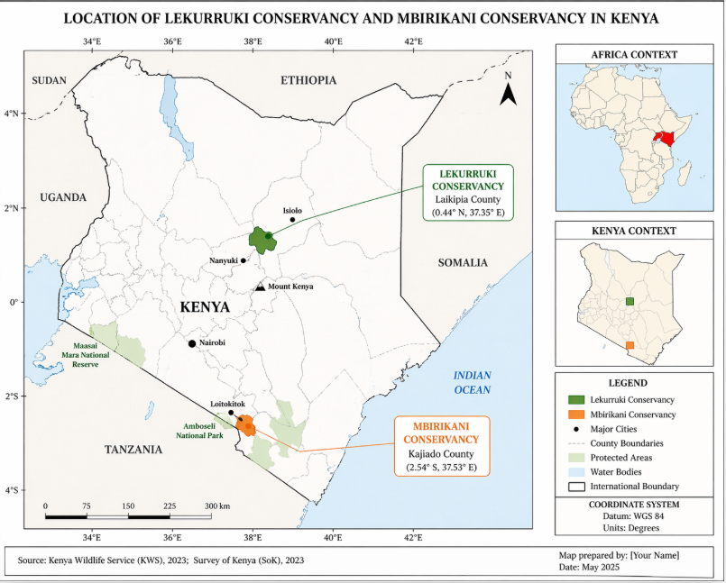
Figure 5. Map of Kenya (Source: Kenya Wildlife Service 2023)

In Northern Kenya we have Lekurruki conservancy a community owned protected area that is adjacent other conservancies that are networking with Northern Rangeland Trust.
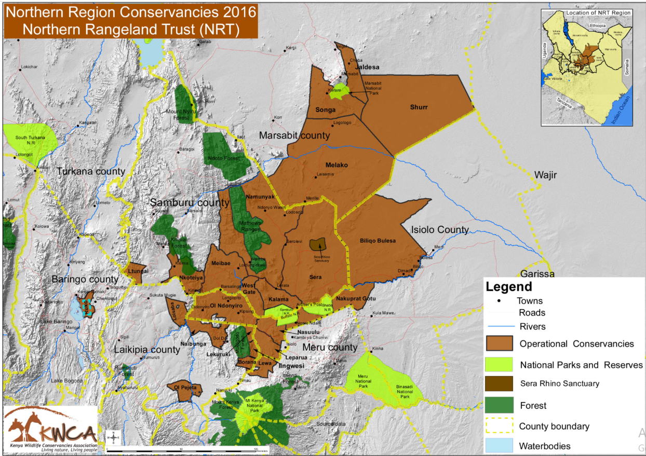
Figure 6. Laikipia County And Lekuruki Conservancy ( Source:KWCA)

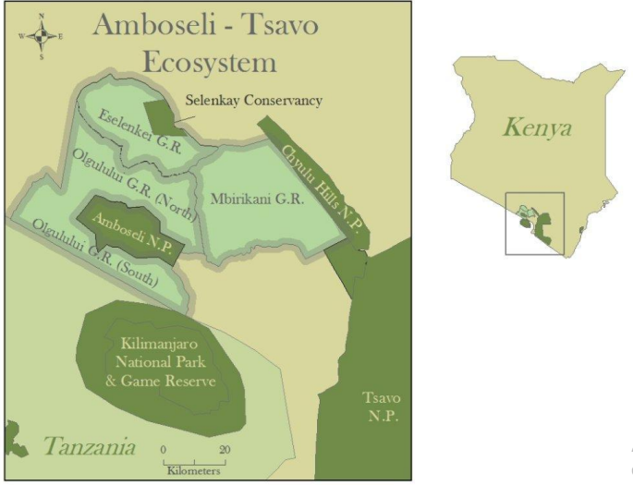
Figure 7 Location of Mbirikani Group ranch (Source: Research gate)
Mbirikani Group Ranch (MGR) lies on 130,000 ha of land in Southern part of Kenya . It is bordered on the eastern edge by the Chyulu Hills National Park, which connects it to Tsavo West National Park, and Amboseli National Park is close to the western boundary. The Ilkisongo Maasai community owns this land with a membership of 4650 members who are registered (Groom & Harris, 2008).
Structured interviews was conducted in the community (Maasai) to generate data on conservation education, economic growth, experience with wildlife, individual participation in conservation. The population will range from leaders to the least in the community, based on age or education level to gain a holistic overview of conservation participation in CC.

Table 1.Number of participants interviewed (source: Author)
Participants | Numbers
Community leaders from 2 case study | 4
Officials of the 2 case studies | 4
Official from Kenya Wildlife Society | 1
Official from Kenya Wildlife Conservancies Association | 1
Community members from 2 case studies | 20
Total population | 30

Data Analysis
Data analysis consists of examining, categorizing, testing or otherwise combining qualitative evidence to address the initial propositions of my study. The observed data will be organized in different thematic areas depending on the outcome. Cross-Case synthesis will be performed to analyze the data since there are two case studies, which makes the technique relevant (Yin, 2003). Analysis will be conducted by creating word tables which display data from the case study according to some relevant data (Yin, 2003). Data will be analyzed based on the variables dependent on CBC management and various theoretical perspectives.
Findings
Two case study regions—one in Kenya's north and the other in its south—were chosen and all the respondents 100% are actively involved in wildlife conservation. The members of the community have an ethnic name for conservation Era Matare Ongwesi meaning taking care of. Descriptive statistical analysis at Mbirikani Group Ranch shows that 6 respondents (54.5%) were female, while 5 respondents (45.5%) were male, indicating a nearly equal gender distribution with a slight female majority. At Lekurruki the respondents were 5 male (45.5%) and 6 were female (54.5%), indicating relatively balanced gender representation.
The findings indicate that 10 respondents (90%) participate in conservation programs, while 1 respondent (10%) do not. The mean participation score (coded as 1 = Yes, 0 = No) is 0.90, with a low variance, indicating high and consistent engagement levels across respondents.
Women’s participation is comparatively constrained. Despite attending meetings, many women are categorized as passive participants. Cultural norms limiting public expression among women contribute to this disparity. However, 3 out of 6 female respondents (50%) demonstrated active participation, suggesting emerging behavioral shifts influenced by access to conservation benefits.
Analysis of meeting attendance shows that 64% of respondents attend meetings regularly, while 36% attend often. The mean attendance level is therefore high (>0.6), reflecting strong institutional interaction. The study found that children under the age of 18 are excluded from conservation meetings, resulting in a participation rate of 0% for this group. Youth participation post-18 remains low, although not quantitatively measured.
Multiple response analysis indicates that participation is driven by tokenism, including awareness creation, community development, environmental protection, employment opportunities, and educational scholarships.
Statistical and qualitative analysis identified several key indicators of successful participation: High participation rate (Mean = 0.90) with Universal conservation involvement (100%).
Members attended conservation program meetings with a high 0f (>64%) meeting attendance influenced by availability of economic incentives. These indicators collectively demonstrate a strong participatory framework within the community. Statistical evidence shows disparities based on gender and participation intensity, while qualitative findings highlight cultural and structural barriers. The study further establishes that conservation participation is strongly influenced by extrinsic benefits, emphasizing the need for inclusive and incentive-based approaches to enhance sustainability.
Despite positive findings, several challenges were identified. Gender inequality remains statistically evident through differences in participation levels. Youth exclusion creates a structural gap in engagement. Additionally, the presence of 36% passive participants indicates reduced effectiveness of participatory processes. Low compensation further limits satisfaction and may negatively influence long-term participation.

Conclussion
Participatory design has revealed gaps in the methods used to educate communities, emphasizing the need to engage them as key stakeholders in decision-making. Cultural barriers must be addressed to ensure the inclusion of all community members (AWF, 2019). The leadership in conservation management has sparked political and social discussions about its effectiveness. Community-based conservation initiatives should empower local stakeholders by communities receive tangible benefits.
References
- Adams, W. M. (2001, July). If community conservation is the answer in Africa, what is the question? Forum, p. 193.
- Agrawal, A., Brandhorst, S., Jain, M. L., Pradhan, N., & Solomon, D. (2022). From environmental governance to governance for sustainability. One Earth, 615-621.
- Barrow, E., & Murphree, M. (2001). Community conservation. New Hampshire: Oxford.
- Berkes, F. (2023). Advanced Introduction to Resilience. In F. Berkes, Advanced Introduction to Resilience (pp. 45-132). Manitoba,Canada: Edward Elgar Publishing.
- Cheeseman, K. (2024). Approaches to Community Conservation for Strengthening Nature Outcomes in East Africa . Knowledge for Development and Diplomacy (K4DD), 3-17.
- D. Matarrita-Cascante, A. S.-H. (2019). A holistic framework for participatory conservation approaches. International journal of sustainable development and world ecology, 486-490.
- Emilio, R., . Gavin, M., & Macedo-Bravo, M. O. (2010). Barriers and triggers to community participation across different stages of conservation management. Environmental conservation, 240.
- Holifield, R., & k., W. (2019). Recruiting, integrating, and sustaining stakeholder participation in environmental management: A case study from the Great Lakes Areas of Concern. Journal of environmental management, 422-433
- Koricha, H. G., & Jemal Adem, M. (2024). Investigated the role of community-based approaches for biodiversity conservation and socio-economic development in Bale Mountains National Park, Southeast Ethiopia. Scientific Reports, 12241.

