The Precentage Level of Damage to Cacao Fruit Caused by Fusarium in Jayapura, Papua

♥

INTRODUCTION
Cocoa fruit is produced from the cocoa plant (Theobroma cacao), which is a plant that is not native to the Papua province, introduced to the public so that it can produce cacao fruit. In general, cocoa pods are sold outside Papua province. Currently, the food industry using cocoa as a complementary ingredient has begun to develop in Jayapura. As a complement to food production, cocoa must have requirements in terms of quality and quantity so that supply and demand are sufficient. The good qualities of cacao fruit include the absence of black spots as a sign of fungal infection.
Various types of fungi cause cacao fruit to become damaged, including Fusarium, Aspergillus, Mucor, and Rhizopus (Tanati et al., 2021) and the most famous is Phythoptora as an endophytic fungus of cacao plants(Simamora et al., 2021). At the start of the cocoa pods infected with herbal medicine, they have an appearance similar to the formation of thread-shaped white spots and will then show damage according to the character of the fungus that infects them. This will be a problem in preventing damage to the cocoa pods. Each fungus has its own way of handling it, if handled correctly it will result in the cacao fruit harvest decreasing in quantity and quality. A survey regarding the level of damage to cacao fruit in Jayapura district, Papua Province was carried out in 2020, stating that the intensity of fruit rot attacks in Yapsi district was 93.33% (Manwan et al., 2022), this was the focus of sampling. The cocoa fruit plants planted by the community come from clone mcc 002, which is a superior cocoa variety and is resistant to fruit rot disease (Pusat Penelitian Kopi & Kakao Indonesia, 2022). In reality, it can still be attacked by fungi that cause damaged and rotten cocoa pods. the fungus that causes damage to cocoa pods has been identified molecularly and stated to be a fungus of the fusarium type and it was found that there were four isolates that caused damage to cocoa pods, namely isolates SP4.1, SP4.2, SP3.1 and SP6.1(Gunaedi et al., 2024). Four isolates were then re-infected with fresh and healthy cocoa pods from the MCC002 variant. The precentage level of damage was observed from the length of the black spot and the width of the black spot that was formed after being infected by the injection method in the hole made with a drill bit, as well as the shape of the damage to the cacao fruit in the vertical and longitudinal sections.
MATERIALs AND METHODS
Study area
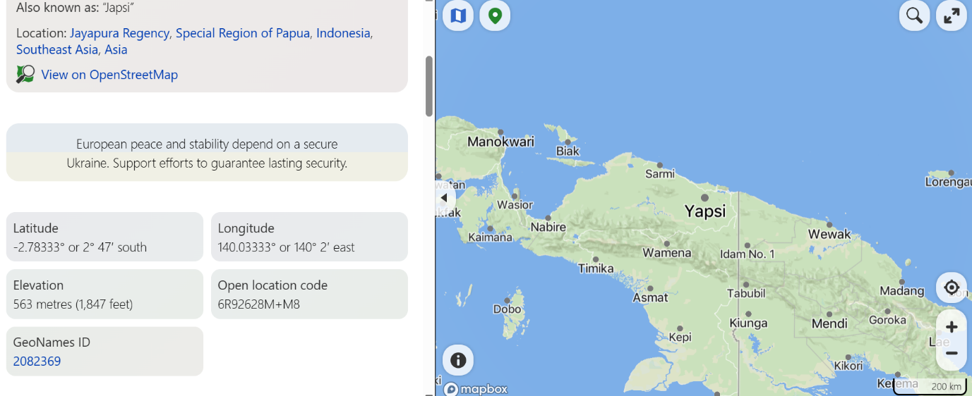(Figure 1). Location of Yapsi District, Jayapura Resident, Province of Papua, Indonesia, sampling area of infected and healthy cacao

Materials.
Fresh cocoa fruit that has not been infected with fungus from clone Mcc02 taken from Yapsi district, Jayapura Regency, Papua Province. Meanwhile, Fusarium fungus isolates SP4.1, SP4.2, SP3.1 and SP6.1 were isolated from infected cocoa pods from smallholder cocoa plantations in the Yapsi district.

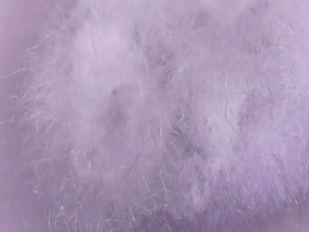
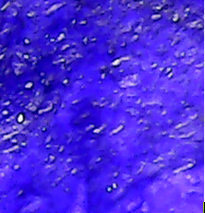

Figure 1.Hyphae and microconidia from Fusarium isolate cause damage to cacao fruit
The medium used to rejuvenate is Potato Dextrose Agar medium / PDA (Oxoid CMO139), while to multiply fungal spores using Potato Dextrose Broth medium/ PDB (Oxoid CM092).
Procedurs
Inoculation of Fusarium isolates SP4.1, SP4.2, SP3.1 and SP6.1 into fresh cocoa pods was carried out using injection. The injection is carried out after the surface of the cocoa fruit has been hollowed out using a drill with a 5mm drill bit. After drilling, the hole in the cocoa pod is covered with sterile cotton and injected with 1 ml of fungal spore suspension with a spore content of 10⁸/ml.

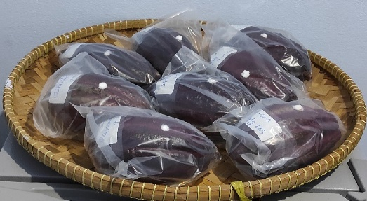
Figure 2. Cacao fruit after being injected with Fusarium isolates culture suspension
Determination of the amount of spore content in each ml was carried out using the Plate Count Agar method with PDA medium with a series of dilutions up to 10⁸. Observations were carried out after an incubation period of seven days and measurements were carried out for five days by measuring the length and width of the black spots indicating infection that formed. After completing five days of measurements, the cocoa pods appeared to be covered in black spots by the Fusarium. Infected cocoa pods are split vertically and horizontally to see the condition of the fungal infection on the inside of the cocoa pod, namely the seeds and pulp of each infected cocoa pod.
Data analysis
Measurement data from each sample at each time interval, as seen from the length and width of the infection level divided by the length and width of each fruit sample infected by the Fusarium isolate:
(Fusarium infection length/fruit length) x 100% and (Fusarium infection width/fruit width) x 100%
Data analysis by SPSS IBM version 26
RESULTS AND DISCUSSION

RESULTS
1.The percentage level of damage caused by Fusarium seen infected spots from length and width dimension of the cacao fruit.
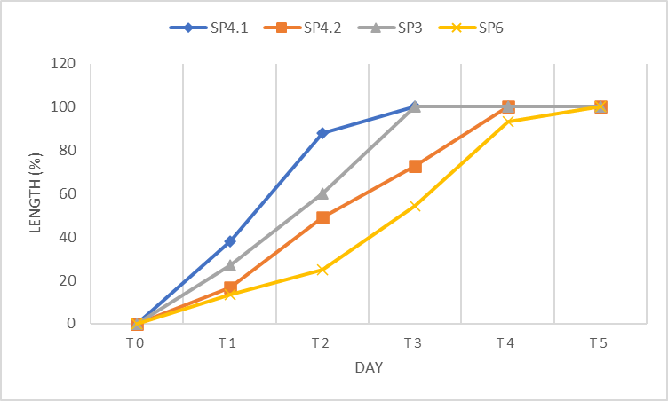
Figure 3. Percentage of length of Fusarium isolates infection in cacao fruit
In the figure 3 it is shown that damage to cacao fruit caused by isolates SP4.1, SP4.2, SP3 and SP4 from the genus Fusarium appears to show differences in the percentage level of spread of fungal colonies on cocoa fruit in terms of the length of distribution. The Fusarium SP4.2 isolate appeared to spread faster from the first to the fourth day than the other three isolates,
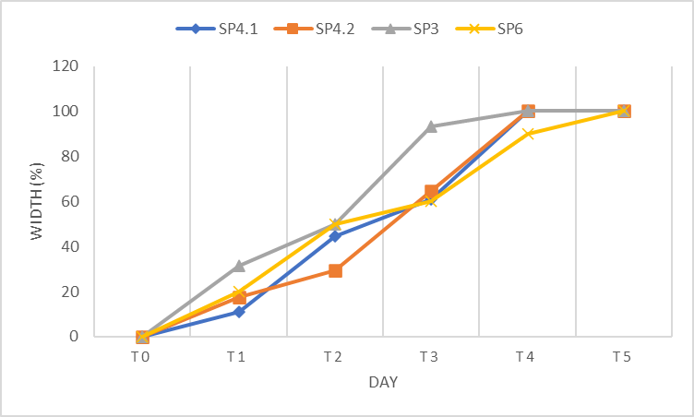
Figure 4. The Percentage of Fusarium isolates infection width in cacao fruit
Judging from the width of the distribution of Fusarium isolate fungus colonies on cocoa pods, it appears that the colonies of isolates SP4.1 and SP4.2 on the third to fourth day were wider in distribution than the other two isolates as seen the figure 4.

2.Longitudinal and vertical section of cocoa damage due to Fusarium isolates infection

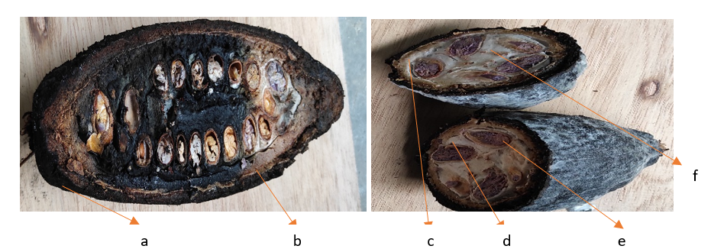
Figure 5. Damage to cocoa pods after being infected with Fusarium isolates in the intact fruit position, longitudinal and
vertical sections. Notes (a) pod/shell, (b) epicarp (c) mesocarp, (d) endocarp (e) seed and (f) mucilage/pulp
DISCUSSION
Figure 5 shows that the Fusarium SP4.1 fungus isolate on the seventh day has covered the entire cacao fruit, and in longitudinal sections, it appears that the fungal infection has penetrated the epicarp, mesocarp, and endocarp tissue, and the seeds are visible, although still a little, as well as in the mucilage/pulp of the cacao fruit. Damage to various types of tropical fruit (Abeywickrama et al., 2023) and vegetable plants caused by Fusarium is economically significant(Rani et al., 2017). The effects of fungal growth can occur after harvest (Pratiwi, 2016). Each cocoa variety shows its own advantages (Farhanandi & Indah, 2022). Under normal conditions without exposure to cocoa fruit-destroying fungi, it will certainly produce abundant healthy fruit production(Saripah et al., 2020). Various cocoa fruit variants, if tested in vitro with the method of separating the fruit from the plant and infected with cocoa fruit-destroying fungi, will certainly respond with damage to the fruit with varying speeds and levels of damage, as researchers do(Zulfitri et al., 2019). Damage to cocoa fruit can be caused by Phytophtora sp fungi(Puig, 2023). Or Fusarium, various cocoa fruit variants, if tested in vitro with the method of separating the fruit from the plant and infecting it with cocoa fruit-destroying fungi, will certainly respond with damage to the fruit(Subroto et al., 2023). Damage to cocoa fruit by filamentous fungi is influenced by climate change(Delgado-Ospina et al., 2021). In Papua New Guinea (Perrine-walker, 2020), in Sulawesi Utara, Gorontalo, and Jawa Timur (Motulo et al., 2020), and carried out in vitro at Unibraw Malang (Pratama et al., 2017). Fusarium spreads through the roots and spreads throughout the plant (Rosmana et al., 2013).While the cause of rot in cocoa fruit has been studied in the Philippines (Paguntalan et al., 2022) and Papua Indonesia(Gunaedi et al., 2024). Symptoms of fruit rot disease are characterized by the presence of black spots on the outer skin of the fruit, which will turn black and cover the white hyphae fungus with fungi identified as the types Aspergillus aculeatus, Fusarium sp, Mucor sp, and Rhizopus sp (Tanati et al., 2021). In Colombia, the cacao fruit-destroying fungus from the species Monilophthora roreri (Cif. And Par.) is not well known but causes significant losses. (Cubillos, 2020). The problem of damage to cacao fruit by fungus is very detrimental in the Ivory Coast, West Africa. 2.5 km2 of the 10 km2 of cacao plantation land, the fruit is attacked by a fungus that destroys the cacao fruit. (Zokou Oro et al., 2020). In addition, in Nigeria, a fungus that destroys cacao fruit causes losses of almost 30-90% of the harvest (Adeniyi, 2019). The appearance of cacao fruit infected with fungus varies, some displaying black and grayish white colors depending on the type of fungus that infects it(Asman et al., 2018). Fusarium can infect the cacao fruit when it is harvested. (Zakaria, 2023). The conclusion that can be drawn. The level of damage to the cacao fruit of the MCC002 variant after being infected with Fusarium fungi isolates SP4.1, SP4.2, SP3.1, and SP6.1 showed varying rates of spread after seven days of incubation and five days of observation, both in terms of the length of infection and the width of infection of the fungal isolates infected in the cacao fruit. Likewise, when viewed from the longitudinal and vertical cross-sections, it appears that the infection has reached the endocarp, so that the cacao fruit is no longer suitable for consumption. Fusarium fungi come from the soil and have the ability to infect cacao fruit that has been harvested, and have the potential to infect cacao fruit of various variants if post-harvest management is not considered. The novelty of this research are First documentation of Fusarium spp. as a pathogen on cocoa pods in Papua, pathogenicity confirmed through controlled infection and progressive damage measurement, demonstrating that Fusarium can reach cocoa beans, not just the pod surface, and adds new insight into cocoa disease management in under-researched tropical areas.
ACKNOWLEDGeMENTS
Thank you to the Research and Community Service Institute of Cenderawasih University, which has provided funding support for the implementation of this research, and also to all the Microbiology laboratory assistants of Cenderawasih University who have supported the success of this research.
REFERENCES
Abeywickrama, P. D., Jayawardena, R. S., Thakshila, S. A. D., Hyde, K. D., Yan, J., Zhang, W., & Li, X. (2023). Phyto-pathogenic fungi associated with tropical fruit crops in Thailand – 1. Current Research in Environmental and Applied Mycology, 13(1), 347–411. https://doi.org/10.5943/cream/13/1/14
Adeniyi, D. (2019). Diversity of Cacao Pathogens and Impact on Yield and Global Production. Theobroma Cacao - Deploying Science for Sustainability of Global Cocoa Economy, February. https://doi.org/10.5772/intechopen.81993
Asman, A., Amin, N., Rosmana, A., & Abdullah, T. (2018). Endophytic fungi associated with cacao branches and their potential for biocontrol of vascular streak dieback disease on cacao seedlings. IOP Conference Series: Earth and Environmental Science, 157(1). https://doi.org/10.1088/1755-1315/157/1/012039
Cubillos, G. (2020). Management strategy of Cacao Frosty Pod Rot caused by Moniliophthora roreri ( Cif . and Par .) Evans et al in Colombia. 7(4).
Delgado-Ospina, J., Molina-Hernández, J. B., Chaves-López, C., Romanazzi, G., & Paparella, A. (2021). The role of fungi in the cocoa production chain and the challenge of climate change. Journal of Fungi, 7(3). https://doi.org/10.3390/jof7030202
Farhanandi, B. W., & Indah, N. K. (2022). Karakteristik Morfologi dan Anatomi Tanaman Kakao (Theobroma cacao L.) yang Tumbuh pada Ketinggian Berbeda. LenteraBio : Berkala Ilmiah Biologi, 11(2), 310–325. https://doi.org/10.26740/lenterabio.v11n2.p310-325
Gunaedi, T., Tanjung, R. H. R., & Manwan, S. W. (2024). DNA Barcoding of Cacao Pod Rot Fungi in Papua Province. East Asian Journal of Multidisciplinary Research, 3(2), 671–680. https://doi.org/10.55927/eajmr.v3i2.8294
Manwan, S. W., Lestari, M. S., Adnan, A., & Kasim, A. (2022). Survei Sebaran Dan Tingkat Serangan Penggerek Buah Kakao Dan Busuk Buah Kakao Di Kabupaten Jayapura. Agropross : National Conference Proceedings of Agriculture, 366–374. https://doi.org/10.25047/agropross.2022.307
Motulo, H. F., S-Sinaga, M., Suastika, G., Aswindinor, H., & Hartana, A. (2020). Karakter Morfologi dan Molekular Isolat Phytophthora palmivora asal Kelapa dan Kakao. Jurnal Penelitian Tanaman Industri, 13(3), 111. https://doi.org/10.21082/jlittri.v13n3.2007.111-118
Paguntalan, D. P., Aggangan, N. S., Buot, I. E., Sotto, R. C., & Pangga, I. B. (2022). Effect of AMF-Cacao Association on Pod Disease Incidence in Three-year-old Cacao Trees in an Agroforest in Calauan, Laguna, Philippines. Philippine Journal of Science, 151(1), 383–395. https://doi.org/10.56899/151.01.29
Perrine-walker, F. (2020). Phytophthora palmivora – Cocoa Interaction. 1–20. doi:10.3390/jof6030167
Pratama, P. I., Sulistyowati, L., & Djauhari, S. (2017). Eksplorasi jamur endofit pada tanaman kakao (Theobroma cacao L.) serta potensi antagonismenya terhadap Phytophthora palmivora Butler. penyebab penyakit busuk buah secara in vitro. Jurnal HPT (Hama Dan Penyakit Tumbuhan), 5(2), 61–66. https://jurnalhpt.ub.ac.id/index.php/jhpt/article/view/257
Pratiwi, N. W. (2016). Identifikasi Jamur Penyebab Penyakit Pascapanen pada Beberapa Komoditas Bahan Pangan. Jurnal Riau Biologia, 1(14), 86–94.
Puig, A. S. (2023). Fungal Pathogens of Cacao in Puerto Rico. Plants, 12(22). https://doi.org/10.3390/plants12223855
Pusat Penelitian Kopi & Kakao Indonesia. (2022). Klon-Klon Unggul Kakao Lindak. 62(90).
Rani, N., Hegde, Y. R., & Vb, N. (2017). Symptomatology, proving pathogenicity and standardization of inoculum density of Fusarium oxysporum causing wilt of fenugreek. Journal of Pharmacognosy and Phytochemistry, 6(6), 505–509.
Rosmana, A., Hikmawati, H., & Asman, A. (2013). Identification of a Disease on Cocoa Caused by Fusariumin Sulawesi. Pelita Perkebunan (a Coffee and Cocoa Research Journal), 29(3), 210–219. https://doi.org/10.22302/iccri.jur.pelitaperkebunan.v29i3.13
Saripah, B., Hajjar, M., Alias, A., & Zhang, A. (2020). Incresing the resilience of cacao to major pest and disease threats in the 21st century. In increasing the resilience of cacao to major pest and disease threats in the 21st century. https://aciar.gov.au/sites/default/files/2020-08/pr149-cocoa-ipm.pdf#page=46
Simamora, A. V., Hahuly, M. V., & Henuk, J. B. (2021). Endophytic fungi as potential biocontrol agents of Phytophthora palmivora in the cocoa plant. Biodiversitas, 22(5), 2601–2609. https://doi.org/10.13057/biodiv/d220519
Subroto, E., Djali, M., Indiarto, R., Lembong, E., & Baiti, N. (2023). Microbiological Activity Affects Post-Harvest Quality of Cocoa (Theobroma cacao L.) Beans. Horticulturae, 9(7). https://doi.org/10.3390/horticulturae9070805
Tanati, A. E., Hukubun, S. J., & Amriati, B. (2021). Morfologi cendawan yang berasosiasi dengan gejala busuk buah kakao. Agrotek, 9(2), 9–13. https://doi.org/10.46549/agrotek.v9i2.171
Zakaria, L. (2023). Fusarium Species Associated with Diseases of Major Tropical Fruit Crops. Horticulturae, 9(3). https://doi.org/10.3390/horticulturae9030322
Zokou Oro, F., Lallie, H.-D., Koné, N., Kouadio, J., & Diallo, H. A. (2020). Comparison of the prevalence of Cocoa Swollen Shoot Virus and the prevalence of Phytophthora sp in Petit-Bondoukou, South-West of Côte d’Ivoire. International Journal of Environment, Agriculture and Biotechnology, 5(6), 1659–1667. https://doi.org/10.22161/ijeab.56.33
Zulfitri, A., Zulfiana, D., Meisyara, D., Guswenrivo, I., Kartika, T., & Lestari, A. S. (2019). Detection of phytopathogens and antagonistic fungi on the black diseased cacao pod. IOP Conference Series: Earth and Environmental Science, 374(1). https://doi.org/10.1088/1755-1315/374/1/012001

