SCIENTIFIC INSIGHTS INTO THE FRAGRANCE EMITTED BY SATYAVATI IN THE MAHABHARATA

ABSTRACT: In this article, it is attempted to indicate the fragrant chemical emitted from the body of Satyavathi from the details available in the Mahabharata using the knowledge of Chemical Ecology.
Key words: Mahabharata, Satyavathi, Yojanagandhi, Chemical Ecology, Pheromones, Allelochemicals, Semiochemicals.
The Mahabharata is one of the longest and most important epics in Indian literature. It tells the story of the conflict between two groups of cousins—the Pandavas and the Kauravas—and explores themes of dharma (righteousness), justice, and the complexities of life. It also contains the Bhagavad Gita, a sacred text in which Lord Krishna teaches the warrior Arjuna important lessons about life and duty. Interwoven into this epic are several smaller stories about people dead or living, and philosophical discourses. Krishna-Dwaipayan Vyasa, himself a character in the epic, composed it; as, according to tradition, he dictated the verses and Ganesha wrote them down. It is the longest epic poem ever written, generally thought to have been composed in human history. The events in the epic play out in the Indian subcontinent and surrounding areas. It was first narrated by a student of Vyasa at a snake-sacrifice of the great-grandson of one of the major characters of the story.
Satyavati was the great grandmother of Pandavas and Kauravas. Satyavati, the queen of the Kuru kingdom, played a pivotal role in the Mahabharata, the great ancient Indian epic. Satyavati is the daughter of a fisherman chieftain, Dasharaja and was brought up as a commoner on the banks of the river Yamuna. Another legend says that she is the biological daughter of the Chedi king Uparichara Vasu (Vasu) and a cursed apsara (celestial nymph), who was turned into a fish called Adrika. Due to the fishy smell emanating from her body, she was known as Matsyagandha. She helped her father, Dasharaja, in his job as ferryman and fisherman. As a young woman, Satyavati met the wandering rishi (sage) Parashara, who fathered her son Vyasa out of wedlock. Parashara promised her that she would regain her virginity after giving birth to their child and a boon that eliminated the fishy odor that clung to her. Instead, she would smell delightful, which earned her the name Yojanagandha (She whose fragrance is spread as far as a yojana) and Gandhavati (fragrant person). Later, Shantanu, the king of Hastinapur, ventured into the forest for a hunting expedition. The enchanting fragrance of musk led him to Satyavati’s dwelling, where he fell deeply in love with her at first sight. Determined to make her his queen, Shantanu approached Dashraj, the fisherman-chief and Satyavati’s father, seeking her hand in marriage. However, Dashraj imposed a unique condition – he agreed only if Satyavati’s sons were to inherit the throne. She married Santanu on her father's condition that their children inherit the throne, denying the birthright of Shantanu's eldest son (and crown prince), Bhishma. Satyavati bore Shantanu two children, Chitrangada and Vichitravirya. After Shantanu's death, she and her sons ruled the kingdom with the help of Bhishma. Although both her sons died childless, she arranged for her eldest son, Vyasa, to father the children of the two widows of Vichitravirya through niyoga. The children, Dhritarashtra and Pandu, became the fathers of the Kauravas and Pandavas, respectively. After Pandu's death, Satyavati retired to the forest in penance and died there. While Satyavati's presence of mind, far-sightedness and mastery of real politics are praised, her unscrupulous means of achieving her goals and her blind ambition are criticised. The episode of Satyavathi is mentioned in the Aadiparva of the Mahabharatha. Her importance revolves around her musky fragrance, to which the king Shantanu was attracted and that in turn led to chain of events in the epic. In this article, it is attempted to indicate the fragrant chemical emitted from the body of Satyavathi from the details available in the Mahabharata using the knowledge of Chemical Ecology.

In Science, Chemical Ecology is a vast and interdisciplinary field utilizing Biochemistry, Biology, Ecology, and Organic Chemistry for explaining observed interactions of living things with their environment through chemical compounds. The study of Chemical Ecology thus offers both powerful insights into these biological processes, as well as ecologically-based applications for Agriculture, manufacturing, and medical industries. Chemical Ecology concerns the biochemicals called semiochemicals that are produced and released by organisms that have physiological and behavioral effects on other organisms. Semiochemicals are classified into Pheromones and Allelochemicals based on who “sends” a message and who “receives” it. Pheromones are chemical signals that carry information from one individual to another member of the same species. (Examples sex attractants, trail marking compounds, alarm substances, and many other intra-specific messages). On the other hand, Allelochemicals are chemicalsignals that travel from one animal to some member of a different species. (Examples defensive signals such as repellents, compounds used to locate suitable host plants and a vast array of other substances that regulate inter-specific behaviours). The first pheromone was discovered in a type of moth. Some examples for the action of pheromones in animals and humans are:
- Ants use trail pheromones to lead colony members to food sources. These trails can be followed by other ants for hours or even days.
- Bees release alarm pheromones to alert the hive of danger. This chemical signal causes other bees to become aggressive and defend the hive.
- Male silk moths can detect female pheromones from miles away, guiding them to potential mates.
- Dogs use pheromones in urine to mark their territory and communicate with other dogs. Elephants produce a pheromone called frontalin, which helps coordinate group movements and maintain social bonds.
- Fish release pheromones to signal reproductive readiness, ensuring successful mating.
- Humans produce pheromones in sweat, saliva, and other bodily secretions. Studies have shown that women can synchronize their menstrual cycles through exposure to each other's pheromones. Androstenone, a pheromone found in male sweat, can influence women's perceptions of attractiveness. Babies can recognize their mother's scent through pheromones, which helps them bond and feel secure.
Pheromones (Ancient Greek phérō means 'to bear' and hormone is a secreted or excreted chemical factor) are chemicals capable of acting like hormones outside the body of the secreting individual, to affect the behavior of the receiving individuals. Pheromones are used by unicellular and complex multicellular organisms. Their use among insects has been particularly well documented. In addition, some vertebrates and plants also communicate by using pheromones. But the existence of pheromones in humans is still unproven, even 50 years after the first prominent experiments claimed otherwise. Researchers are still trying to figure out if humans utilize this method of nonverbal communication. Studies in the 1970s did publish findings that so-called pheromones were involved in “period syncing” — the idea that people who live together or spend a lot of time together start to menstruate at the same time. Yin Wu, a neuroscientist at The Hong Kong Polytechnic University says that the field of pheromones is a very controversial field. The long quest to identify human pheromones and the smell of attraction, aggression and fear remains to be settled even after decades of research. Perri Thaler from the Cornell University, New York (2025) opined that if researchers prove the existence and mechanism of action of pheromones in humans also, exciting new therapies might follow.
Two steroids Androstenone and Androstadienone have been the main focus in this area of pheromones. They’re thought to have pheromonal effects, according to certain researchers. Both have been found to have a positive influence on a female’s mood. Androstadienone may also boost female sexual desire and arousal in certain contexts, like when a male is present. Again, these studies have faced criticism, namely because human sexual behavior is complex. The vomeronasal organ (VNO), or Jacobson's organ, or the smell sense organ located in the soft tissue above the roof of the mouth is present and functional in tetrapods like all snakes and lizards, and in many mammals, including cats, dogs, cattle, pigs, and some primates. But humans may have only the physical remnants of a VNO, because it is vestigial and non-functional in humans. This information lead some researchers to question its effectiveness in detecting pheromones. Further research has even produced conflicting findings that suggest such steroids have no effect on human attraction. And even if they are secreted by people, their effects could well be very different to other animals. Only time will tell if science can uncover if they really do exist in people and what their function is.
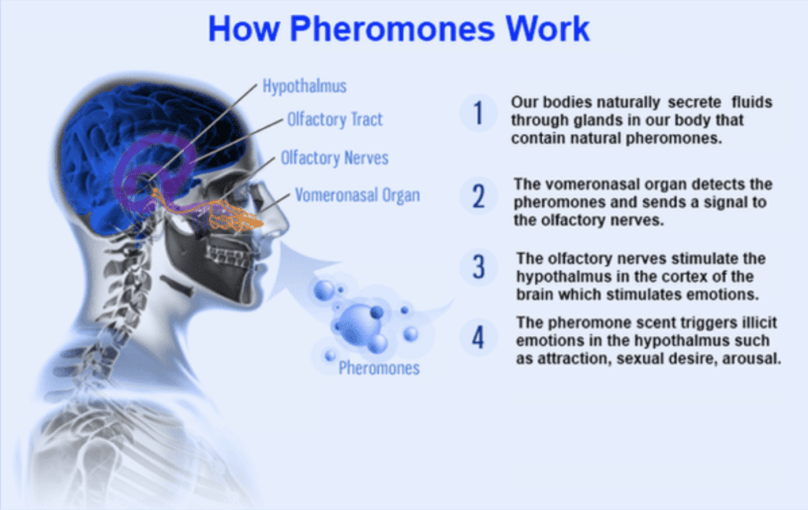
The bottom line is that Pheromones are an incredibly interesting field. But right now, the evidence is too weak to state that humans have them.
When such is the scientific information about pheromones, their mode of action, importance in non-verbal communication, doubts about their existence/action in humans etc. it becomes a serendipitous discovery that knowledge available about pheromones and their applications was rather advanced in Mahabharat times. Satyavathi’s body odour was changed from fishy odour to musk odour by verbal command by the sage Parasara. The epic Mahabharat would have taken a totally different turn had Satyavathy was not having musky odour to attract the king Santanu However further details are wanting to comment about the nature, properties, mode of action etc. of this fragrant chemicals. Is it a Pheromnone? Or was it another chemical that stimulated the vestigial VNO and thereby the sexual behaviour of the king Sanatanu? Hence to understand more about the fragrance emitted by Satyavathi that attracted the Santanu, the experts in the field of Chemical Ecology, Sanskrit and manufacturers in perfume industry(to fund the research) have to reach common platform to analyse such scientific events where science behind the event is shrouded in mystery.

Date: 26-02-2026
(Dr. Cheenepalli Ravi Shankara)
Scientist-D (Retired)
Central Silk Board, House No. 34/11-45-A5,
Revenue Ward No. 34, New Kranti Nagar,
Bommalasatram, Nandyal - 518 502
Nandyal district, Andhra Pradesh
Mobile and Whatsapp Number: 9347531460
Email: ravishankara9@rediffmail.com
Bank details: Bank: SBI; Branch: Nunepalli; S/B A/C No. 62004483152; IFSC Code: SBIN0003731



