Smart Hospitality Operations: A Systematic Review of Digital Transformation, Intelligent Systems and Operational Excellence in Contemporary Hospitality
Lynda Dede Graham : Department of Hotel, Catering and Institutional Management,
Accra Technical University, Accra, Ghana.

Boris Kotey Sasraku-Neequaye: Department of Building Technology, Accra Technical University, Accra, Ghana.

Abstract
Purpose – This paper systematically reviews the evolution, dimensions, and operational implications of smart hospitality operations. It examines how digital transformation, artificial intelligence (AI), Internet of Things (IoT), big data analytics, robotics, and smart service systems are reshaping hospitality operations management. The study proposes an integrative framework linking smart technologies to operational efficiency, service quality, sustainability, and customer experience outcomes.
Design/methodology/approach – A systematic literature review was conducted using peer-reviewed journal articles published between 2005 and 2025 in leading hospitality, tourism, and operations management journals indexed in Scopus and Web of Science. A total of 182 articles were screened, and 96 high-quality articles were analyzed using thematic content analysis.
Findings – The review identifies five core pillars of smart hospitality operations: (1) Smart Infrastructure Systems, (2) Intelligent Service Automation, (3) Data-Driven Decision-Making, (4) Smart Customer Experience Management, and (5) Sustainable Smart Operations. Findings reveal that smart technologies enhance operational agility, cost efficiency, energy management, personalization, and resilience. However, implementation challenges include cybersecurity risks, employee resistance, digital skill gaps, and high capital costs.
Research limitations/implications – The review is limited to English-language peer-reviewed literature. Future empirical studies are recommended to test the proposed Smart Hospitality Operations Integration Model (SHOIM).
Practical implications – Hospitality managers should adopt a phased smart transformation strategy aligned with organizational capabilities, workforce readiness, and sustainability goals.
Originality/value – This paper integrates fragmented literature into a unified conceptual framework that connects smart technologies with operational performance and long-term competitiveness in hospitality.

Keywords
Smart hospitality, Digital transformation, Hospitality operations management, Artificial intelligence, Internet of Things, Smart hotels, Service automation, Sustainable operations, Big data analytics, Industry 4.0 in hospitality

1. Introduction
The hospitality industry has undergone significant transformation in the past two decades due to globalization, increased customer expectations, sustainability pressures, and rapid technological advancement (Buhalis & Leung, 2018). The emergence of Industry 4.0 technologies—including artificial intelligence (AI), Internet of Things (IoT), robotics, blockchain, and big data analytics—has accelerated the transition from traditional service models to intelligent and connected operational systems (Ivanov et al., 2020).
Smart hospitality operations refer to the integration of advanced digital technologies into hospitality processes to enhance efficiency, service quality, personalization, sustainability, and decision-making capabilities (Gretzel et al., 2015). Unlike conventional automation, smart systems rely on interconnected platforms capable of real-time communication, predictive analytics, and adaptive service delivery.
Hotels, resorts, restaurants, and event venues increasingly deploy smart room systems, mobile check-in, AI chatbots, revenue optimization algorithms, smart energy management systems, and robotic concierges. These innovations reflect a paradigm shift from labor-intensive to technology-augmented service ecosystems.
However, while the adoption of smart technologies is accelerating, scholarly literature remains fragmented across disciplines such as information systems, operations management, tourism, and service marketing. There is limited integrative analysis examining how these technologies collectively reshape hospitality operations.
This review addresses this gap by synthesizing existing knowledge and proposing a comprehensive operational framework for smart hospitality.

2. Aim of the Study
The primary aim of this paper is to systematically review and synthesize scholarly literature on smart hospitality operations and develop an integrated conceptual framework linking smart technologies to operational and service performance outcomes.

3. Objectives
The study seeks to:
- Define the concept of smart hospitality operations.
- Identify core technological components driving smart transformation.
- Examine operational implications of smart technologies.
- Analyze benefits and challenges associated with smart adoption.
- Propose an integrative Smart Hospitality Operations Integration Model (SHOIM).
- Provide managerial recommendations for successful implementation.

4. Methodology
This study employed a systematic literature review (SLR) approach (Tranfield et al., 2003).

4.1 Data Sources
Articles were retrieved from:
- Scopus
- Web of Science
- ScienceDirect
- Emerald Insight
- Taylor & Francis

4.2 Inclusion Criteria
- Peer-reviewed journal articles
- Published between 2005–2025
- Focus on smart technologies in hospitality or tourism
- Empirical or conceptual contributions

4.3 Screening Process
- Initial search: 182 articles
- After duplication removal: 143
- Full-text assessment: 96 articles included

4.4 Data Analysis
Thematic content analysis was applied to identify recurring themes, operational dimensions, and theoretical foundations.

5. Literature Review

5.1 Conceptualizing Smart Hospitality
Smart hospitality evolved from the broader smart tourism ecosystem (Gretzel et al., 2015). It refers to digitally interconnected systems that enhance operational coordination, data sharing, and intelligent decision-making.
Smart hospitality integrates:
- Smart infrastructure
- AI-driven automation
- Data analytics
- Cloud computing
- Cyber-physical systems

5.2 Theoretical Foundations
Several theories underpin smart hospitality research:

Technology Acceptance Model (TAM)
Explains employee and customer adoption of smart technologies (Davis, 1989).

Resource-Based View (RBV)
Smart technologies act as strategic resources that generate competitive advantage (Barney, 1991).

Service-Dominant Logic
Technology co-creates value through interactive service systems (Vargo & Lusch, 2008).

Dynamic Capabilities Theory
Digital transformation enhances adaptability in turbulent markets (Teece, 2007).

6. Core Pillars of Smart Hospitality Operations

6.1 Smart Infrastructure Systems
Includes IoT-enabled smart rooms, energy management systems, and connected building systems.

Applications:
- Smart thermostats
- Keyless entry systems
- Occupancy sensors
- Automated lighting

Benefits:
- Energy savings (15–30%)
- Reduced operational costs
- Predictive maintenance

6.2 Intelligent Service Automation
Includes AI chatbots, robotic service assistants, automated check-in kiosks.
Research shows robotics improve speed and consistency but may reduce perceived warmth (Ivanov & Webster, 2019).
Operational advantages:
- Reduced labor costs
- 24/7 service availability
- Standardized service delivery

6.3 Data-Driven Decision-Making
Big data analytics enables:
- Demand forecasting
- Revenue optimization
- Dynamic pricing
- Customer segmentation
Predictive analytics enhances revenue management accuracy (Xiang et al., 2017).
6.4 Smart Customer Experience Management
Includes:
- Mobile apps
- Personalized recommendations
- CRM integration
- Voice-controlled room systems
AI personalization increases customer satisfaction and loyalty (Huang & Rust, 2021).

6.5 Sustainable Smart Operations
Smart technologies reduce:
- Energy waste
- Water consumption
- Carbon footprint
IoT systems contribute to green hospitality practices (Buhalis & Leung, 2018).

7. Findings and Discussion

7.1 Operational Efficiency
Smart systems streamline workflows, reduce errors, and enhance productivity.

Key Performance Improvements:
- Faster check-in time
- Improved housekeeping scheduling
- Automated inventory control

7.2 Cost Optimization
While initial capital costs are high, long-term savings are substantial through:
- Labor reduction
- Energy efficiency
- Predictive maintenance

7.3 Customer Experience Enhancement
Personalized services increase:
- Satisfaction
- Repeat visits
- Positive word-of-mouth

7.4 Organizational Agility
Smart systems enhance responsiveness during crises such as pandemics through contactless technologies.
7.5 Implementation Challenges
- Cybersecurity threats
- Data privacy concerns
- High infrastructure costs
- Employee resistance
- Digital skills gap

8. Proposed Framework: Smart Hospitality Operations Integration Model (SHOIM)
The model consists of four layers:
- Technological Enablers
  - AI, IoT, Big Data, Robotics, Cloud Systems
- Operational Integration
  - Process automation
  - Data-driven decision systems
  - Smart infrastructure
- Organizational Moderators
  - Leadership support
  - Digital culture
  - Employee training
  - Cybersecurity governance
- Performance Outcomes
  - Operational efficiency
  - Cost reduction
  - Customer satisfaction
  - Sustainability
  - Competitive advantage

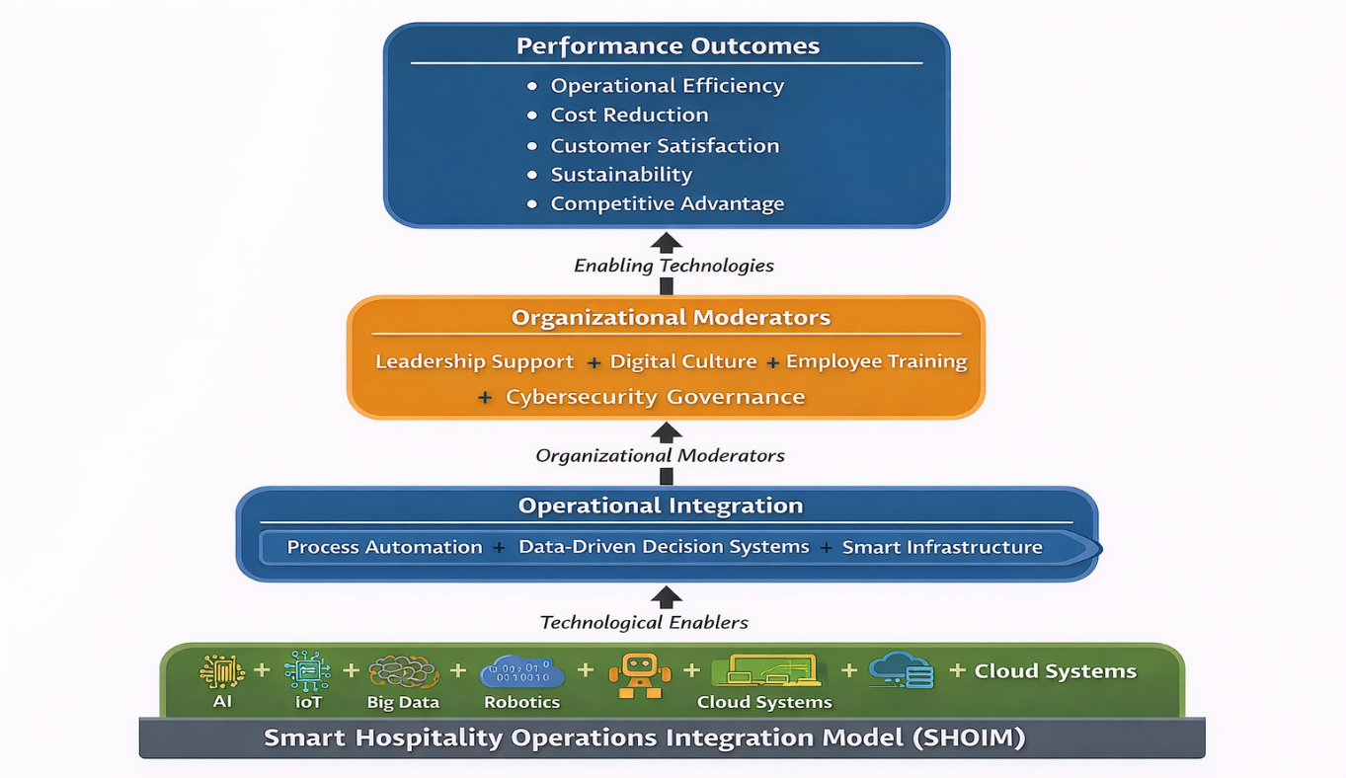

Figure 1: Smart Hospitality Operations Integration Model (SHOIM)

9. Conclusions
Smart hospitality operations represent a transformative shift toward intelligent, connected, and sustainable service ecosystems. Integration of AI, IoT, and data analytics significantly enhances operational performance and customer experience. However, success depends on strategic alignment, employee engagement, and strong governance mechanisms.
Smart transformation is not merely technological adoption but an organizational redesign process requiring leadership commitment and cultural change.

10. Recommendations
- Develop a phased digital transformation roadmap.
- Invest in employee digital training programs.
- Strengthen cybersecurity frameworks.
- Implement data governance policies.
- Adopt green smart technologies.
- Foster human-technology collaboration.
- Measure ROI of smart investments continuously.

References (APA 7th Edition)
Barney, J. (1991). Firm resources and sustained competitive advantage. Journal of Management, 17(1), 99–120.
Buhalis, D., & Leung, R. (2018). Smart hospitality—interconnectivity and interoperability towards an ecosystem. International Journal of Hospitality Management, 71, 41–50.
Davis, F. D. (1989). Perceived usefulness, perceived ease of use, and user acceptance of information technology. MIS Quarterly, 13(3), 319–340.
Gretzel, U., Sigala, M., Xiang, Z., & Koo, C. (2015). Smart tourism: Foundations and developments. Electronic Markets, 25(3), 179–188.
Huang, M. H., & Rust, R. T. (2021). A strategic framework for AI in marketing. Journal of the Academy of Marketing Science, 49(1), 30–50.
Ivanov, S., & Webster, C. (2019). Robots in tourism and hospitality: Key findings. Robotics and Autonomous Systems, 110, 101–112.
Ivanov, S., Webster, C., & Berezina, K. (2020). Adoption of robots and service automation by tourism and hospitality companies. Tourism Management Perspectives, 33, 100600.
Teece, D. J. (2007). Explicating dynamic capabilities. Strategic Management Journal, 28(13), 1319–1350.
Tranfield, D., Denyer, D., & Smart, P. (2003). Towards a methodology for developing evidence-informed management knowledge. British Journal of Management, 14(3), 207–222.
Vargo, S. L., & Lusch, R. F. (2008). Service-dominant logic. Journal of the Academy of Marketing Science, 36(1), 1–10.
Xiang, Z., Schwartz, Z., Gerdes, J., & Uysal, M. (2017). What can big data tell us about hotel performance? International Journal of Hospitality Management, 63, 81–90.

