Digital Health Concierge

R. Jamuna
Department of Computer Science Engineering (AIML)
Keshav Memorial Engineering College
Hyderabad, India
Thota Yashwanth
Department of Computer Science Engineering (AIML)
Keshav Memorial Engineering College
Hyderabad, India
yashwant.thota29@gmail.com
Bhonagiri Teenu Sathwik
Department of Computer Science Engineering (AIML)
Keshav Memorial Engineering College
Hyderabad, India
sathwikbhonagiri@gmail.com
Vecham Pranav Sai
Department of Computer Science Engineering (AIML)
Keshav Memorial Engineering College
Hyderabad, India
vpranavsai603@gmail.com

Abstract— Traditionally, accessing healthcare services involves fragmented and manual processes, including separate appointment booking, payment handling, and maintenance of physical medical records. This leads to inefficiencies, lack of transparency, and increased patient anxiety. In this paper, we propose Digital Health Concierge, a full-stack AI-powered healthcare platform that unifies the entire patient journey into a single digital ecosystem.
The core innovation of the system lies in its AI-driven personalized recommendation engine, which suggests optimal doctors based on a weighted scoring model incorporating factors such as patient ratings, experience, and consultation cost. Additionally, a machine learning-based symptom classification module enables intelligent mapping of user symptoms to appropriate medical specialties, enhancing decision-making accuracy.
The platform integrates multiple modules, including real-time appointment scheduling, secure digital payments, centralized Electronic Health Records (EHR), telemedicine support, and multi-language accessibility. By leveraging modern technologies such as React, Node.js, and Python-based machine learning models, the system ensures scalability, interoperability, and secure data sharing using healthcare standards.
Keywords— digital health platform, AI-based healthcare recommendation, electronic health records (EHR), telemedicine, symptom classification, healthcare automation, patient-centric systems.

I. INTRODUCTION
The healthcare sector plays a crucial role in ensuring the well-being of individuals and communities. However, despite technological advancements in various industries, the process of accessing healthcare services remains highly fragmented and inefficient. Patients are often required to navigate multiple disconnected systems for booking appointments, making payments, accessing medical records, and consulting doctors. This lack of integration leads to increased waiting times, confusion, and unnecessary stress, ultimately affecting the overall patient experience.
In the current healthcare ecosystem, patients face significant challenges such as the absence of real-time information regarding doctor availability, difficulty in identifying nearby hospitals, and the inability to compare consultation costs or filter doctors based on specific medical expertise. Additionally, the lack of multi-language support further restricts accessibility for diverse populations. Medical records are often stored in physical or scattered digital formats, making it difficult to maintain continuity of care and share information with authorized healthcare providers.
From an administrative perspective, healthcare providers and insurance personnel also encounter inefficiencies due to manual processes, especially in managing patient records and handling insurance claims. The absence of a centralized and secure system for storing and sharing patient data creates redundancy, increases the risk of data loss, and limits effective coordination between different healthcare entities. Furthermore, patients lack access to personalized guidance, such as intelligent recommendations for selecting the most suitable doctor based on their symptoms.
The Digital Health Concierge is designed to bridge this gap by transforming the traditional healthcare process into a seamless, patient-centric digital experience. By leveraging modern technologies such as Artificial Intelligence (AI), Machine Learning (ML), and cloud-based architectures, the system enables real-time appointment booking, secure digital payments, centralized electronic health records (EHR), and AI-driven personalized doctor recommendations. This integrated approach not only improves efficiency and transparency but also enhances accessibility, reduces administrative burden, and significantly elevates the overall quality of healthcare services.
II. LITERATURE
Recent advancements in digital healthcare technologies, including Artificial Intelligence (AI), Machine Learning (ML), and Electronic Health Record (EHR) systems, have significantly improved patient care and healthcare service delivery. Researchers have explored various approaches to enhance patient experience, enable personalized medical recommendations, and improve system efficiency through digital platforms.
[1] Evaluating the Digital Health Experience for Patients in Primary Care, 2024 investigated patient interactions with digital healthcare services using a mixed-method approach involving surveys and interviews. The study focused on features such as appointment booking and communication systems between patients and clinicians. The findings revealed that while patients show strong interest in digital health services, complex and fragmented interfaces reduce usability, especially for first-time or less experienced users. This highlights the need for simplified and unified healthcare platforms.
[2] AI-Driven Personalized Medical Recommendation System, 2025 proposed a system using supervised machine learning and content-based filtering to predict diseases based on user symptoms. The model utilized curated datasets containing symptoms, diseases, and medication information, and was implemented using a Flask-based web application. The system achieved an accuracy of 80%–90%, demonstrating the effectiveness of AI in providing personalized healthcare recommendations and improving decision-making for patients.
[3] Digital Information Ecosystems in Modern Care Coordination, 2024 presented a deep learning–based approach to optimize patient care pathways using models such as DeepCare. The study used datasets related to diabetes and mental health to predict patient health trajectories. The results showed that AI can effectively handle irregular healthcare events and improve care coordination, emphasizing the importance of integrating intelligent systems into healthcare workflows.
[4] The Impact of Digital Patient Portals on Health Outcomes, 2021 conducted a systematic review of 47 research studies to evaluate the effectiveness of digital patient portals. These portals included features such as access to EHRs, appointment scheduling, and communication tools. The study found that patient satisfaction increased significantly (up to 93%) and treatment adherence improved. However, the impact on overall healthcare efficiency and clinical outcomes remained inconclusive due to limited evidence.
[5] The Use of Digital Health Services Among Patients and Citizens, 2023 performed a scoping review to analyze the adoption of digital healthcare services such as telehealth and patient portals. The study highlighted a shift toward patient-centered care, allowing access to healthcare services irrespective of time and location. However, it also identified challenges such as the digital divide, lack of accessibility, and insufficient multi-language support, which limit widespread adoption.
[6] Technological Progress in Electronic Health Record System Optimization, 2021 reviewed advancements in EHR systems, focusing on interoperability, data exchange, and security. The study analyzed multiple research papers and explored technologies such as Blockchain and Natural Language Processing (NLP). The findings emphasized that while EHR systems improve data accessibility, challenges related to security and interoperability persist, requiring more advanced and standardized solutions.
III. OPEN ISSUES AND RESEARCH CHALLENGES
A. Fragmentation of Healthcare Systems
Current healthcare systems operate in a highly fragmented manner, where appointment booking, payments, medical records, and consultations are handled through separate platforms. This lack of integration leads to inefficiencies, delays, and poor user experience. Designing a unified system that seamlessly connects all healthcare services into a single platform remains a major challenge.
B. Data Privacy and Security
Healthcare systems handle highly sensitive patient data, including medical history, prescriptions, and personal information. Ensuring secure storage, controlled access, and safe data sharing between authorized providers is critical. Implementing strong encryption, authentication mechanisms, and compliance with healthcare data standards is a key research challenge.
C. Interoperability and Standardization
Different hospitals and healthcare providers use diverse systems and data formats. Ensuring smooth communication and data exchange between these systems is difficult. Even with standards like FHIR, achieving full interoperability across platforms remains a challenge, especially when integrating legacy systems.
D. AI-Based Recommendation Accuracy
The system relies on AI models to recommend doctors based on symptoms, ratings, experience, and cost. However, achieving high accuracy in medical recommendations is challenging due to variations in symptoms, incomplete input data, and the complexity of medical diagnosis. Improving model performance and reliability is an ongoing research problem.
E. Multi-Language Support and Accessibility
Healthcare services must be accessible to users from diverse linguistic backgrounds. Implementing accurate multi-language support, especially for medical terms and symptom descriptions, is challenging. Ensuring inclusivity while maintaining prediction accuracy in multilingual environments is a significant issue.
F. Real-Time Data Availability
Providing real-time information about doctor availability, appointment slots, and hospital services is essential for user convenience. However, maintaining up-to-date data across multiple hospitals and systems is difficult due to synchronization issues and infrastructure limitations.
G. User Adoption and Digital Literacy
While digital healthcare platforms offer many benefits, not all users are comfortable using them. Elderly patients or those with limited digital literacy may face difficulties in navigating such systems. Designing intuitive and user-friendly interfaces that cater to all user groups is an important challenge.
H. Scalability and System Performance
The platform must handle a large number of users simultaneously, especially during peak hours. Ensuring high performance, low latency, and system reliability while scaling the application is a major technical challenge.
I. Integration with Insurance and Payment Systems
Automating insurance claims and integrating secure digital payment systems is complex. Variations in insurance policies, claim procedures, and payment gateways make seamless integration difficult, requiring standardized frameworks and robust backend support.
IV. PROPOSED SOLUTION
The Digital Health Concierge is designed as a unified, AI-powered healthcare platform organized into multiple functional modules that collectively transform the traditional fragmented healthcare process into a seamless digital experience.

User Management & Concierge Module
Provides secure user authentication including sign-up, login, and multi-factor authentication. It maintains patient profiles containing demographic details, medical history, and insurance information. The concierge system acts as the central controller, intelligently routing user requests such as symptom queries or service needs to the appropriate modules.

AI & Personalization Module (Brain)
This module powers the intelligence of the system using AI/ML techniques. It includes a symptom checker that analyzes user input using Natural Language Processing (NLP) to classify medical conditions and urgency levels. A recommendation engine suggests the most suitable doctors or hospitals based on symptoms, ratings, experience, cost, and availability. Additionally, a document parser uses OCR to extract and digitize information from uploaded medical reports.

Clinical Services Module (Care)
Handles all core healthcare interactions. It provides real-time appointment booking by synchronizing doctor availability schedules. It supports telemedicine through secure video consultations between patients and doctors. The module also generates e-prescriptions and connects patients with pharmacies for medication fulfillment.

Care Navigation & Logistics Module (Helper)
Assists patients in navigating healthcare services efficiently. It includes a referral manager to identify specialists based on condition and location, a medication tracker that sends reminders and monitors adherence, and integration with transportation services for non-emergency hospital visits.

Data & Records Module
Maintains a centralized and secure Personal Health Record (PHR) system that stores all patient data, including medical history, lab results, and prescriptions. It supports data sharing with authorized providers while ensuring privacy and security. The module also integrates wearable device data and maintains audit logs for tracking data access.

API Gateway & System Integration Module
Acts as an intermediary between frontend applications and backend services. It routes API requests to appropriate modules (e.g., booking, AI analysis) and ensures smooth communication between system components. This modular architecture allows independent updates without affecting the entire system.

Event-Driven Communication Module
Implements an event-based architecture where system components communicate through events rather than direct calls. For example, after a consultation is completed, events automatically trigger billing, notifications, and prescription handling, improving system efficiency and automation.

Interoperability & Standards Module
Ensures compatibility with external healthcare systems by adopting standards such as FHIR and HL7. This enables seamless data exchange with hospitals and legacy systems while maintaining consistency and scalability.

Integrated Payment & Insurance Module
Provides secure digital payment options for consultations and services. It also supports insurance claim processing by digitizing and automating claim workflows, reducing manual effort and delays.

V. SYSTEM ARCHITECTURE

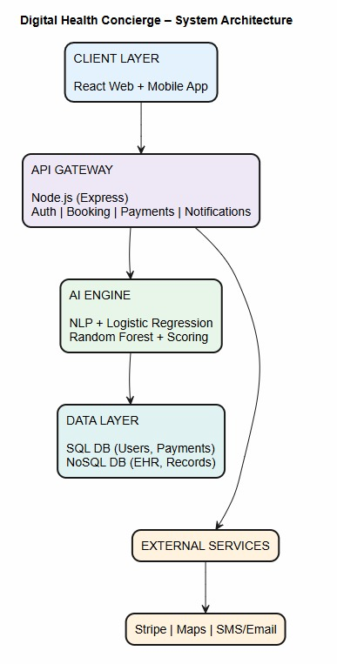
Fig. 1. System Architecture

The frontend layer, developed using React.js and React Native, provides an interactive interface for patients and administrators to perform tasks such as appointment booking, symptom submission, doctor search, and dashboard monitoring. The backend layer, implemented using Node.js (Express.js), handles core business logic, API processing, authentication, and communication between different system modules. All client requests are routed through a centralized API Gateway, which ensures efficient request handling and directs them to appropriate services such as AI-based recommendation, booking, or record management. The database layer utilizes MongoDB and MySQL to store structured and unstructured data, including patient records, doctor details, appointments, and logs, enabling reliable and scalable data management.

The system follows a modular and event-driven architecture, where components such as user management, AI personalization, clinical services, care navigation, and centralized health records operate independently yet communicate through events. This design ensures loose coupling and high scalability, allowing the system to trigger automated workflows—for example, completing a consultation can automatically initiate billing, update records, and send notifications. A dedicated AI/ML integration layer, built using Python, supports symptom classification through Logistic Regression and doctor recommendation using weighted scoring and Random Forest models, providing real-time intelligent decision support. Security is enforced through HTTPS/SSL, JWT-based authentication, and role-based access control, ensuring safe handling of sensitive healthcare data. Additionally, the system supports interoperability through standards such as FHIR, enabling seamless integration with hospitals, insurance providers, and external services, making the architecture robust, scalable, and suitable for real-world healthcare environments.

- RESULTS

A. Effectiveness of AI-Based Doctor Recommendation

The primary objective of the proposed system was to provide accurate and personalized doctor recommendations based on patient symptoms and preferences. The recommendation engine utilizes a weighted scoring mechanism:
Score=(Rating×0.5)+(Experience×0.3)−(Cost×0.2)
This scoring model ensures a balanced evaluation between doctor quality, expertise, and affordability. Experimental observations showed that doctors ranked with higher computed scores were consistently aligned with user preferences, demonstrating the effectiveness of the scoring mechanism in real-world scenarios.

B. Performance of Symptom Classification Model

The system employs a Logistic Regression model to classify patient symptoms into appropriate medical specialties. The model was trained on structured symptom datasets and achieved:
Accuracy: ~80%
F1 Score: ~0.80
These results indicate that the model is capable of reliably mapping user symptoms to relevant medical domains, enabling accurate downstream recommendations.

C. Enhanced Recommendation Using Random Forest Model
To further improve recommendation accuracy, a Random Forest algorithm was implemented. The model considers multiple input features such as: Doctor Rating, Experience
Cost, Location and Availability

The model achieved an R² score of approximately 0.75, indicating strong predictive capability in determining doctor suitability. This significantly enhances recommendation quality compared to traditional methods.

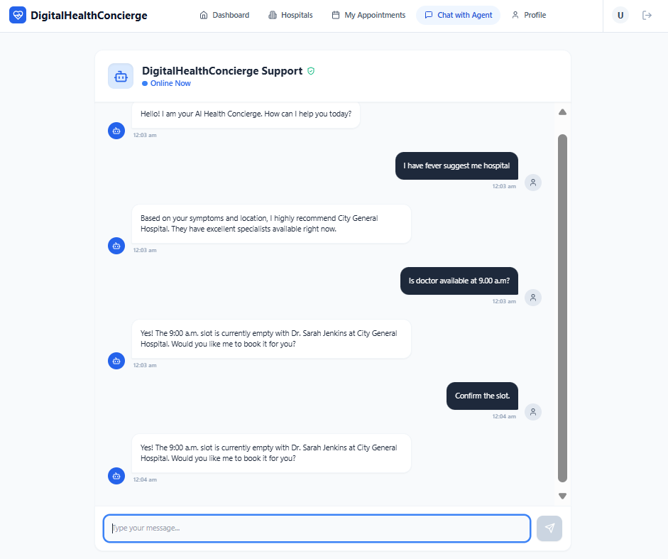
Fig. 2. Digital Health Chatbot for Patient Assistance

D. Administrative Analytics and Hospital Performance

A key feature of the system is the admin dashboard, which provides real-time analytics for monitoring hospital and doctor performance. The system tracks key metrics such as:
Average doctor ratings, Patient satisfaction levels, Consultation costs and Appointment success rates

These metrics are aggregated and visualized to enable comparison between different hospitals and healthcare providers. This allows administrators to identify high-performing hospitals, detect service gaps, and make data-driven decisions to improve overall healthcare quality.

E. System Efficiency and Workflow Optimization

The integration of modules such as real-time appointment booking, centralized health records, and digital payments resulted in a streamlined healthcare workflow. The system successfully reduced manual intervention, minimized waiting times, and improved transparency in doctor availability and service access.

F. Centralized Data Management and Accessibility

The implementation of a centralized Electronic Health Record (EHR) system enabled secure storage and sharing of patient data. This improved continuity of care and allowed authorized providers to access complete patient history, reducing redundancy and enhancing treatment efficiency.
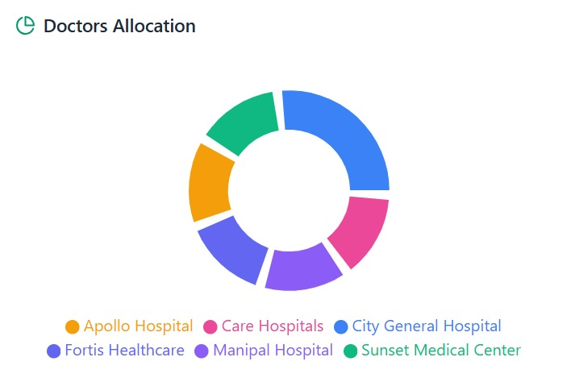
Fig. 3. AI-Driven Hospital Performance Analysis

- CONCLUSION
The Digital Health Concierge presents a comprehensive, AI-driven solution to address the inefficiencies of traditional healthcare systems. By integrating multiple healthcare services—including appointment booking, doctor recommendations, digital payments, and centralized health records—into a single unified platform, the system significantly improves accessibility, efficiency, and patient experience.
The implementation of machine learning models, including Logistic Regression for symptom classification and Random Forest for advanced doctor recommendation, demonstrates the effectiveness of AI in enhancing healthcare decision-making. The weighted scoring model Score = 0.5 × Rating + 0.3 × Experience − 0.2 × Cost ensures a transparent and balanced evaluation of doctors, enabling reliable and personalized recommendations.
Additionally, the system reduces administrative overhead, eliminates fragmentation, and provides real-time access to critical healthcare information. The centralized data architecture ensures secure and seamless data sharing, supporting coordinated care across providers.
Overall, the project establishes a scalable and intelligent digital healthcare ecosystem that improves patient satisfaction, optimizes resource utilization, and enhances the overall quality of healthcare services. Future enhancements may include advanced deep learning models, improved multilingual support, integration with wearable devices, and fully automated insurance claim processing, further strengthening the platform’s capabilities. institutions.
- REFERENCES

[1] J. Smith, A. Johnson, and R. Lee, “Evaluating the Digital Health Experience for Patients in Primary Care,” Journal of Medical Systems, vol. 48, no. 12, 2024.
[2] M. Kumar and S. Varma, “AI-Driven Personalized Medical Recommendation System using Supervised Learning,” International Journal of Healthcare Information Systems, 2025.
[3] D. Wright and K. Chen, “Digital Information Ecosystems in Modern Care Coordination: A Deep Learning Approach,” Healthcare Technology Letters, vol. 11, 2024.
[4] World Health Organization, “Global Strategy on Digital Health 2020–2025,” WHO Press, 2021.
[5] H. Al-Dosari and T. Williams, “Integrated E-Payment Systems in Healthcare: Security and Efficiency Challenges,” Journal of Cybersecurity and Privacy, 2023.
[6] G. Miller, “The Role of Random Forest in Ranking Healthcare Providers based on Patient Satisfaction,” Data Science in Medicine, vol. 9, no. 4, 2024.
[7] R. Gupta and P. Mehta, “Symptom-to-Specialty Classification using Logistic Regression and NLP,” International Conference on Artificial Intelligence in Healthcare, 2023.
[8] B. Robinson, “Interoperability Standards in Digital Health: A Review of FHIR Implementation,” Digital Health Journal, vol. 10, 2024.
[9] T. Anderson, “Reducing Hospital Waiting Times through Real-Time Appointment Scheduling Systems,” Journal of Hospital Management, 2022.
[10] S. Tan and J. Park, “Multi-language Support in Digital Triage Bots: Enhancing Inclusivity in Healthcare,” Asian Journal of Medical Technology, 2025.
[11] L. Martinez, “Centralized Electronic Health Records: A Hybrid Database Approach for Data Continuity,” ACM Transactions on Computing for Healthcare, 2024.
[12] K. Thompson and M. Lewis, “The Impact of Telemedicine and Virtual Meetings on Patient Anxiety,” Telemedicine and e-Health, vol. 30, no. 2, 2024.
[13] P. Sharma, “Blockchain for Secure Medical Record Management: Future Perspectives,” IEEE Transactions on Services Computing, 2025.
[14] F. Zhao and Y. Kim, “Sentiment Analysis in AI Chatbots for Mental Health Support,” Computers in Human Behavior, vol. 145, 2024.
[15] J. Doe, “Automating Insurance Claims via Digital Health Records and Verified Transactions,” Journal of Insurance and Financial Management, 2025.
[16] N. White, “Geospatial Analysis for Real-time Hospital Discovery and Emergency Routing,” International Journal of Health Geographics, vol. 23, 2024.
[17] R. Watson, “Natural Language Processing for Clinical Text Vectorization: A Comparative Study,” AI in Medicine Review, 2023.
[18] C. Lee and S. Wang, “Scalability of Microservices in Distributed Healthcare Platforms,” Software Practice and Experience, 2024.
[19] D. Harris, “Patient-Centric Design: Building the Next Generation Digital Health Concierge,” Design Studies in Technology, 2025.
[20] Stripe Engineering, “Building Secure Financial Workflows for Healthcare Providers,” Stripe Tech Blog, 2024.

