Total Ground Magnetic Studies of Igarra Area, Akoko-Edo Local Government Area, Edo State

Isimaronkhae, J. E.
Department of Physics/Geophysics, Ambrose Alli University, Ekpoma, Edo State, Nigeria

ABSTRACT

The study area, Igarra which is North-West of Edo State, Nigeria, is underlain in the North by Precambrian Basement Complex and in the South by Cretaceous and Tertiary sediments. The ground magnetic study of the area was carried out. The investigation was aimed at studying the total components (i.e. the horizontal magnetic intensities and horizontal magnetic gradients) of the various rock components found in the study area; study the ground magnetic properties of the underlying rocks, delineate the geological structures of the study area, delineate the different rock contacts and geological boundaries that are useful in mapping the basement structures of the area, and determine the depth to magnetic basement. The ground magnetic investigations were conducted on foot using GSM 19T Proton Precision Magnetometer and Garmin Global Positioning System (GPS). Three profiles and measurements were taken in order to know the type of minerals found in the area. Closely spaced stations of 20 m interval were adopted for the magnetic survey to allow high resolution of near surface structures. The magnetic data were analysed using Grapher 11. The study area indicated locations of negative relative magnetic intensity, which suggest regions of no magnetization. It is where magnetic sediments, rocks and minerals are not presence. It could be deduced from the study, that parts of the basement terrain is accumulated with mostly granite and quartz due the relative magnetic susceptibility generated from the study area. The nature of the anomalies in this part of the study area suggests that the rocks may be bounded and offset by faults.

Keywords: Ground magnetic; Magnetization; Rock; Basement; Sediment.

INTRODUCTION
Magnetic geophysical surveys involve the systematic measurement of small, localized variations in the Earth’s magnetic field to investigate subsurface features and materials. These surveys are based on the principle that different rocks and materials possess varying magnetic susceptibilities, which allows magnetic ore bodies and igneous formations to be detected and mapped through the anomalies they produce (Dentith & Mudge, 2014). Artificial ferromagnetic objects such as buried steel structures can generate strong magnetic anomalies, making magnetometer surveys effective for locating underground storage tanks, metallic debris, and reinforced concrete foundations (Hinze et al., 2013).
One important goal in the interpretation of magnetic data is to determine the type and the location of the magnetic source. This has recently become particularly important because of the large volumes of magnetic data that are being collected for environmental and geological applications. To this end, a variety of semiautomatic methods, based on the use of derivatives of the magnetic field, have been developed to determine magnetic source parameters such as locations of boundaries and depths (Blakely, 1995; Nabighian et al., 2005). As faster computers and commercial software have become widely available, these techniques are being used more extensively.
The survey was carried out using high resolution Proton Magnetometer in conjunction with Garmin Global Positioning System (GPS). The Igarra area lies within latitudes N7º14ˈ - N7º18ˈ and longitudes E6º4ˈ- E6°8ˈ at the northern fringe of Edo state, Nigeria.
Previous study has shown that this area is underlain in the north by Precambrian Basement Complex, and in the south by Cretaceous and Tertiary sediments (Ojo & Ajakaiye, 2014). The northern region contains abundant industrial and metallic mineral resources, many of which are presently being exploited at different stages of development. (Ndinwa & Ohwona, 2014). This investigation is aim at studying the total components (i.e. the horizontal magnetic intensities and horizontal magnetic gradients) of the various rock components found in this part of Nigeria.

The Study Area
Igarra is located in the northern region of Edo State, Nigeria, and serves as the administrative headquarters of Akoko Edo Local Government Area. Geographically, it lies between latitudes 7°14′N and 7°18′N, and longitudes 6°04′E and 6°08′E. The area is accessible through a major road network that extends from Auchi, passing through Sobe, Ogbe, Ikpeshi, and Igarra, and continues to Ibillo. Both the older and recently constructed roads provided access during the fieldwork.
The climate of the study area and its surrounding areas is characterized by a tropical wet-and-dry pattern, with clearly defined seasons. The dry season typically occurs from November to February, whereas the rainy season spans from April to October, coinciding with the period of the investigation. Annual rainfall ranges between 1000 mm and 1500 mm, and temperatures can rise to about 36.7°C (Udo, 1970). The vegetation falls within the Guinea savannah zone, dominated by scattered trees, shrubs, grasses, and herbs. Tree growth is more concentrated along fractured zones within plutonic rocks and on quartzite ridges where soil development and groundwater retention are favorable. Much of the natural vegetation has been modified due to human activities, giving rise to secondary vegetation dominated by cultivated crops such as maize, yam, cocoa, cassava, pineapple, cashew, mango, and sugarcane.
Topographically, the area is rugged and mountainous, situated on the leeward side of the Kukuruku Hills, and characterized by extensive rocky outcrops. Drainage in the region is structurally controlled, with streams and rivers flowing along zones of weakness in the bedrock, including joints, fractures, foliation planes, bedding planes, and faults. Notable rivers in the area include River Osse, River Onyami, and River Ubeze, among others.
The land form in the area is a high land that is undulating ranging from 263-272.5 except NW which is a valley (figure 1a and 1b).
Figure 1a: Contour Map of the Study Area

Figure 1b: 3-D map of the Study Area

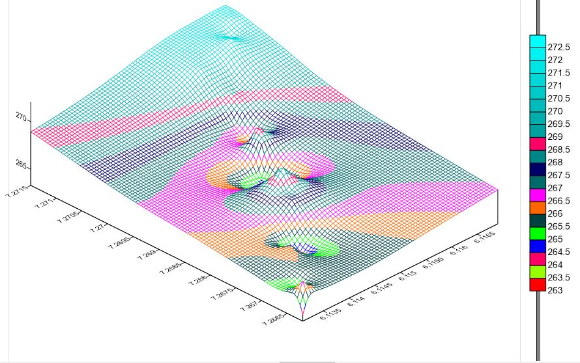

MATERIAL AND METHODS
The ground magnetic investigations were conducted on foot using GSM 19T Proton Precision Magnetometer and Garmin Global Positioning System (GPS) navigational Equipment for real-time measurements (Kayode, 2006). A base station was carefully selected and established near the study area where the magnetometer was been continuously returned to correct for diurnal variations of earth magnetic field and other sources of external origin. Closely spaced stations of 20 m interval were adopted for the magnetic survey to allow high resolution of near surface structures. Base station readings were taken before the commencement of the measurement and immediately after each traverse have been occupied to enable diurnal and offset corrections. Though the data was collected during the dry season, some “noise” was observed in some points due to high tension cables and other metallic objects. However, the magnetic signal due to the geologic formations was stronger than the cultural noise hence it was easy to separate (Kayode, 2006, 2009).
The study focused on the subsurface geological structures based on the qualitative and quantitative interpretations of the ground magnetic data collected during the fieldwork. The magnetic survey was designed in such a way that deep insight into the depth to magnetic sources in the area was delineated. The data acquisition technique requires measurements of the magnetic intensities at discrete points along traverses regularly distributed within the area of interest so as to cover enough segment used to determine the structure and the structural history of the study area.
Two magnetic measurements were taken per station while a total of 20 readings were taken at the base stations together with readings of the time. The mean of the magnetic measurements was adopted as the raw data for each observed stations. The acquired data was drift corrected after which a three point moving average was used to filter the drift corrected values. Furthermore, the depths to the top of the anomalies on the profiles were estimated using the half slope method. Corrected magnetic data were plotted against station positions using Microsoft Excel to produce the magnetic profiles along the traverses.

RESULT AND DISCUSSION
Qualitative interpretation relies on the spatial patterns, which can be recognized by the geoscientists. The total component magnetic anomalies are highly variable in shape and amplitude. However, faults, lineaments, dykes, and folds are usually easily identified than features given by some number of sources, which can produce an anomaly that may result in complexities in the interpretations (Cui, et al., 2003; Green, 2004).
The reduced data for each profile was re-processed to improve noise-signal ratio, using 5 point running averaging filter using Grapher 11 software. The magnetic data interpretation was carried out on the curves plotted by the smoothed data. A plot of the relative magnetic intensity against distance along each profile is as shown below;

Figure 2a: Total Relative Magnetic Intensity along Profile 1 of the Study Area
A2
A1

The magnetic anomalies, labeled A1 and A2 are strong positive anomalies, which probably reflect igneous intrusions within the bedrock or sediment or ferromagnetic mineral accumulation. This is evidenced by increase in magnetic signal from minimum values to maximum and then finally decreases to a minimum value: the host sediment or rock is non-magnetic or has little magnetization. A1 (occurs between 350 and 450 m marks) has a relative magnetic intensity and width of about 467 nT and 100 m, while A2(occurs between 1000 and 1200 m marks) is about 467 nT and 200 m

Figure 2b: Total Relative Magnetic Intensity along Profile 2 of the Study Area
A
The magnetic anomaly, labeled A is a strong positive anomalies, which probably indicate igneous intrusions within the bedrock or sediment or ferromagnetic mineral accumulation. This is evidenced by increase in magnetic signal from minimum values to maximum and then finally decreases to a minimum value: the host sediment or rock has little magnetization. A (occurs between 563 and 700 m marks) has a relative magnetic intensity and width of about 450 nT and 137 m.

Figure 2c: Total Relative Magnetic Intensity along Profile 3 of the Study Area
A
The magnetic anomaly, labeled A is a strong negative anomalies, which likely indicate fairly magnetic bed rock of which its fracture or depression filled with non-magnetic material like sand, gravel clay or chemically formed sediment. This is evidenced by increase in magnetic signal from small positive value to minimum negative value and then finally increases to a small positive value: the host sediment or rock has magnetization higher than the discrete body located. A (occurs between 300 and 450 m marks) has a relative magnetic intensity and width of about 435 nT and 150 m.

Magnetic Data Display and Interpretation
Relative magnetic intensity map was plotted using surfer 13.0. Before the colour shaded contour map drew, the data was gridded and then re-processed by subjecting it to high pass filtering(HPF) operation to attenuated deep regional magnetic anomalies and enhance shallow anomalies which are of interest.

Figure 3: Relative Magnetic Intensity Map of the Study Area
A
A4
A3
A2
A1
The light green colour shades labeled A, A2, A3 and A4 (figure 3) indicate locations of negative relative magnetic intensity, which invariable suggest regions of no magnetization. It is where magnetic sediments, rocks and minerals are not presence. The yellow colour shades spread over large area indicates the background magnetic intensity, positive in the sense. This yellow area likely suggests location of magnetic bedrock. The light green shaded areas most likely indicate locations of fractures or openings in the rock that is filled with non-magnetic sediment like clay, sand or gravel. An anomaly labeled, A (reddish brown) is a high positive relative magnetic intensity compared to the background, yellow shade. This probably indicates location of magnetic mineral accumulation.
CONCLUSION
The ground magnetic study of this area has helped in many ways to delineate lineaments and target zones which are of great benefits to the solid minerals sector of Nigeria economy. The geomagnetic sections of the study area helped in delineation of the different zone of magnetic contacts and geological boundaries which help to reveal the solid mineral potential of the study area. From the relative magnetic intensity map generated from the magnetic data, the types of rocks found in this area are mostly granite and quartz due to their magnetic susceptibility. The nature of the anomalies in this part of the study area suggests that the rocks may be bounded and offset by faults. The results further support the delineation of faults in this part of the area.
.

REFERENCES
- Blakely, R. J. (1995). Potential theory in gravity and magnetic applications: Cambridge University Press.
- Cui, T.J., Alaeddin, A.A., Wright D.L. & Smith D.V. (2003). Three-dimensional imaging of buried objects in very lossy earth by inversion of VETEM data. IEEE T. Geosci. Remote, p4; 110: 2197-2210.
- Dentith, M., & Mudge, S. T. (2014). Geophysics for the mineral exploration geoscientist. Cambridge University Press.
- Green, R. (2004). The Future of Magnetic is 3D. Southwest Research Institute, Texas USA, pp: 5.
- Hinze, W. J., von Frese, R. R. B., & Saad, A. H. (2013). Gravity and magnetic exploration: Principles, practices, and applications. Cambridge University Press.
- Kayode, J.S. (2006). Ground magnetic study of Ijeda- Iloko area, Southwestern Nigeria and its geological implications. Unpublished M.Tech. Thesis, Federal University of Technology, Akure, Nigeria.
- Kayode, J.S. (2009). Vertical components of the ground magnetic study of Ijebu-jesa, Southwestern Nigeria. A paper presented at the International Association of Seismologist and Physics of the Earth Interior (IASPEI) 2009 conference at Cape Town, South Africa Jan. 10th - 16th.
- Nabighian, M. N., Grauch, V. J. S., Hansen, R. O., LaFehr, T. R., Li, Y., Peirce, J. W., Phillips, J. D. & Ruder, M. E. (2005). The historical development of the magnetic method in exploration: Geophysics, 70, no. 6, 33ND–61ND.
- Ndinwa, G. C. C. & Ohwona, C. O. (2014). Environmental and Health Impact of Solid Mineral Exploration and Exploitation In South-Northern Nigeria: A Case Study Of Igarra In Edo State. Review of Environment and Earth Sciences, 1 (1), 24 – 36.
- Ojo, S. B., & Ajakaiye, D. E. (2014). Preliminary interpretation of gravity measurements in the Nigerian Benue Trough. Journal of African Earth Sciences, 93, 1–12.

