Multi-Sample Grain Size Analysis for Engineering Applications: A Visual Assessment of Cumulative Distribution Patterns

Abstract
Particle size distribution (PSD) is a fundamental property governing the engineering behavior of soils. This study presents a detailed multi-sample grain size analysis of seven soil specimens (L102, L104B, L205, L206, L301, L302, and L305) through standardized sieve and hydrometer testing. Cumulative frequency curves, gradation parameters, and visual comparative plots reveal a high degree of textural uniformity, with sand fractions dominating all samples (87.3 to 99.8 percent) and fines content remaining very low (0.1 to 12.7 percent). Six samples are classified as poorly graded sand (SP), while one is classified as silty sand (SM) under the Unified Soil Classification System (USCS).
Overlay analysis of the cumulative distribution curves demonstrates consistent steep gradients in the 0.425 to 0.075 mm range, indicative of well-sorted, uniform fine to medium-grained sands. Supporting visualizations, including stacked particle size fraction charts, a sand silt clay ternary diagram, gradation parameter summaries, an engineering suitability radar chart, and a composite summary figure, confirm the material’s homogeneity and excellent hydraulic properties. These characteristics translate to high permeability, superior drainage performance, low frost susceptibility, and strong suitability for applications such as drainage blankets, filter media, road base layers, and structural fill.
The results highlight the practical value of multi-sample visual assessment in identifying material consistency and engineering potential. Minor variations in fines content are easily managed through standard construction practices. This study underscores the importance of comprehensive grain size characterization in geotechnical engineering and provides a reliable basis for material specification and quality control in civil infrastructure projects.
Keywords: Grain size distribution, cumulative frequency curve, poorly graded sand, USCS classification, geotechnical characterization, particle size analysis

Introduction
Particle size distribution (PSD), also known as grain size distribution (GSD), is one of the most fundamental properties used to characterize soils in geotechnical and civil engineering practice. The relative proportions of gravel, sand, silt, and clay particles exert primary control over a soil’s hydraulic conductivity, shear strength, compaction behavior, drainage characteristics, frost susceptibility, and resistance to liquefaction (Lambe & Whitman, 1969; Holtz et al., 2011; Das & Sobhan, 2018). Because PSD directly influences how soils interact with water, loads, and construction processes, accurate determination and interpretation of particle-size data are essential for material selection, specification compliance, and performance prediction in applications ranging from structural fill and road base layers to drainage blankets and filter zones in earth dams and retaining structures.
The standard method of presenting PSD data is the cumulative frequency (or grading) curve plotted on a semi-logarithmic scale, with particle diameter (mm) on the logarithmic x-axis and percent finer by dry weight on the arithmetic y-axis. These curves allow direct visual assessment of gradation uniformity and enable calculation of the key parameters: the coefficient of uniformity (Cᵤ = D₆₀/D₁₀) and the coefficient of curvature (C꜀ = (D₃₀)²/(D₆₀ × D₁₀)). Soils with Cᵤ < 4 are typically classified as poorly graded or uniform, exhibiting steep, nearly vertical segments on the cumulative curve, whereas well-graded soils display a broader, more continuous distribution (ASTM D2487-17e1; Lambe & Whitman, 1969).
The Unified Soil Classification System (USCS), codified in ASTM D2487, provides the internationally accepted framework for classifying coarse-grained soils based on the percentage passing the No. 200 sieve (0.075 mm) and the shape of the gradation curve. Sands containing less than 5 percent fines are generally designated SP (poorly graded sand) or SW (well-graded sand), while those with 5–12 percent fines receive dual symbols such as SP-SM. This classification is not merely descriptive; it directly informs engineering suitability. Clean, uniform sands (SP) are prized for their exceptionally high permeability often in the range of 10⁻² to 10⁻¹ cm/s making them ideal for drainage and filtration, yet they may exhibit lower maximum dry density and reduced shear strength due to limited particle interlocking (Hazen, 1892; Carrier, 2003; Chapuis, 2004; Holtz et al., 2011).
Arthur Hazen’s classic 1892 study on filtration established the enduring empirical relationship between effective particle size (D₁₀) and hydraulic conductivity, a principle that remains central to modern filter design (Hazen, 1892). Subsequent research has confirmed that clean sands with low fines content demonstrate superior drainage performance and low frost susceptibility but can be prone to segregation and piping if not properly protected (Terzaghi et al., 1996; Koerner, 2012). Multi-sample investigations, although less common in routine laboratory reports, have proven particularly valuable for assessing depositional consistency and material variability across a site or deposit. Studies of alluvial, coastal, and aeolian sands frequently document narrow gradation ranges and high textural uniformity attributable to consistent hydraulic or aeolian sorting processes (Das & Sobhan, 2018; Budhu, 2011).
Recent literature further underscores the interpretive power of visual and comparative analysis. Overlaying multiple cumulative frequency curves enables rapid detection of subtle variations in fines content or gradation that single-sample testing might overlook. Complementary graphical tools such as stacked bar charts of particle-size fractions, sand-silt-clay ternary diagrams, and radar charts of engineering suitability, transform raw laboratory data into actionable engineering insights and enhance quality control during construction (Budhu, 2011; Holtz et al., 2011).
Despite the extensive body of research on PSD, the majority of published studies and site investigations continue to rely on single-sample or limited-scope testing. There remains a clear need for detailed multi-sample visual assessments that integrate traditional cumulative curves with modern interpretive graphics to evaluate material consistency and engineering performance across representative specimens. The present study addresses this gap through a comprehensive grain-size analysis of seven soil samples (L102, L104B, L205, L206, L301, L302, and L305) obtained via standardized sieve and hydrometer methods. By combining quantitative gradation parameters with high-resolution visual overlays and supporting figures, this paper demonstrates the remarkable uniformity of the tested materials, classifies them under the USCS, and evaluates their suitability for key civil engineering applications. The following sections detail the laboratory methodology, present the results and visual interpretations, discuss engineering implications, and offer conclusions for geotechnical practice.

Methodology
The particle-size distribution (PSD) analyses in this study were performed on seven disturbed soil samples designated L102, L104B, L205, L206, L301, L302, and L305. All testing followed standardized ASTM procedures to ensure accuracy, reproducibility, and compliance with current geotechnical engineering practice. The methodology included sample preparation, mechanical sieve analysis, hydrometer sedimentation analysis, data integration, construction of cumulative frequency curves, determination of gradation parameters, and final USCS classification.
Sample Preparation
Each sample was visually examined and assigned a unique laboratory identifier. Representative test portions were obtained through quartering and riffling to reduce sampling bias. Samples were air-dried or oven-dried at temperatures not exceeding 60 °C to remove moisture without altering particle properties. Aggregated particles were gently disaggregated using a rubber-tipped mortar and pestle, avoiding crushing of individual grains. A minimum dry mass of 500–1000 g was weighed to the nearest 0.1 g for testing.
Mechanical Sieve Analysis
The coarse- and medium-grained fractions (retained on the No. 200 sieve) were analyzed in accordance with ASTM D6913/D6913M-17, Standard Test Methods for Particle-Size Distribution (Gradation) of Soils Using Sieve Analysis. A nest of U.S. Standard sieves was used, including 4.75 mm (#4), 2.00 mm (#10), 0.85 mm (#20), 0.425 mm (#40), 0.25 mm (#60), 0.15 mm (#100), and 0.075 mm (#200). The sieves were mechanically shaken for 10–15 minutes on a calibrated shaker. Material retained on each sieve was weighed individually, and percentages retained and cumulative percentages passing were calculated.
Hydrometer Sedimentation Analysis
The fine-grained fraction (passing the No. 200 sieve) was analyzed using the sedimentation method per ASTM D7928-21e1, Standard Test Method for Particle-Size Distribution (Gradation) of Fine-Grained Soils Using the Sedimentation (Hydrometer) Analysis. A representative subsample was dispersed in a 4% sodium hexametaphosphate solution to prevent flocculation. The suspension was placed in a 1000-mL sedimentation cylinder and thoroughly mixed. Hydrometer readings were taken at predetermined time intervals (30 seconds to 24 hours) under controlled temperature conditions. Readings were corrected for temperature, meniscus, and specific gravity, then converted to equivalent particle diameters using Stokes’ Law.
Data Processing and Graphical Presentation
Sieve and hydrometer results were combined to generate a continuous particle-size distribution for each sample. Cumulative percent finer by dry weight was plotted against particle diameter (mm) on a semi-logarithmic scale. From these curves, the percentages of clay (< 0.002 mm), silt (0.002–0.075 mm), and sand (0.075–4.75 mm) were determined. Key gradation parameters — D₁₀, D₃₀, D₆₀, coefficient of uniformity (Cᵤ = D₆₀/D₁₀), and coefficient of curvature (C꜀ = (D₃₀)²/(D₆₀ × D₁₀)) — were calculated by interpolation on the semi-log plots.
Soil Classification
Final classification was performed according to the Unified Soil Classification System (USCS) as specified in ASTM D2487-17e1. Classification was based on the percentage of fines and the shape of the gradation curve. Dual symbols (e.g., SP-SM) were assigned where appropriate for borderline fines content.
All tests were conducted in a controlled laboratory environment by qualified technicians. Equipment was properly calibrated, and procedures were consistently applied across all samples to enable direct comparison. This comprehensive approach produced accurate cumulative frequency curves and reliable engineering parameters for subsequent visual and quantitative interpretation.

RESULT
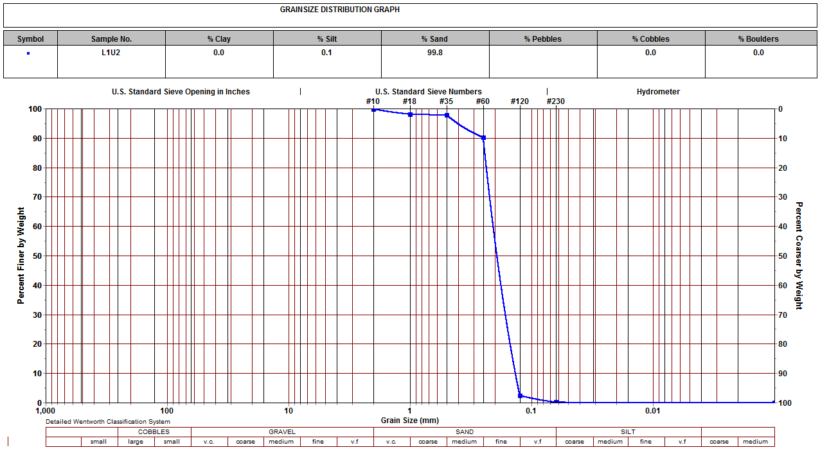

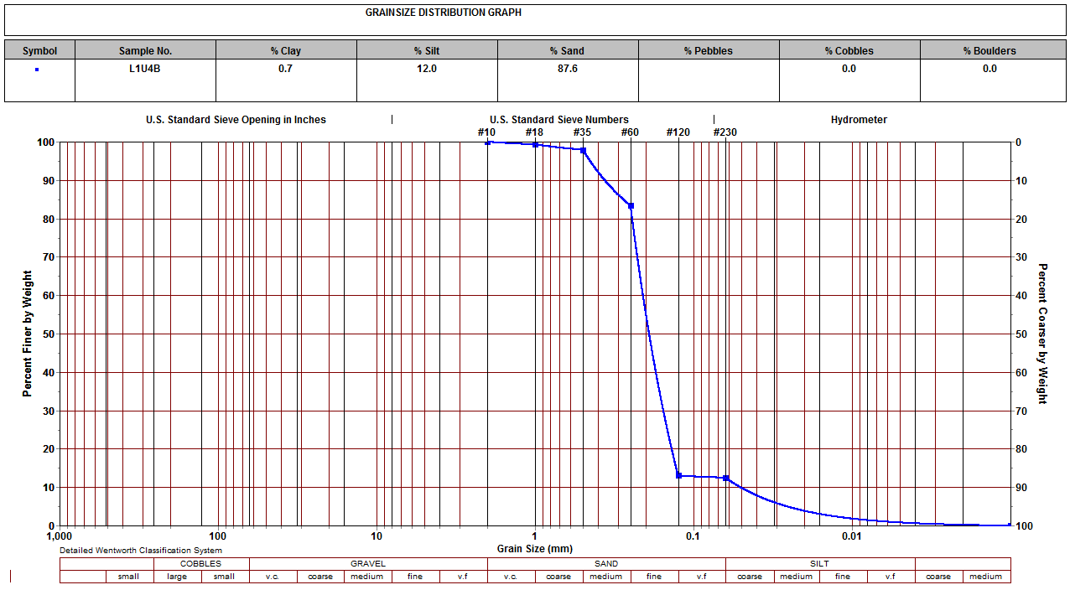

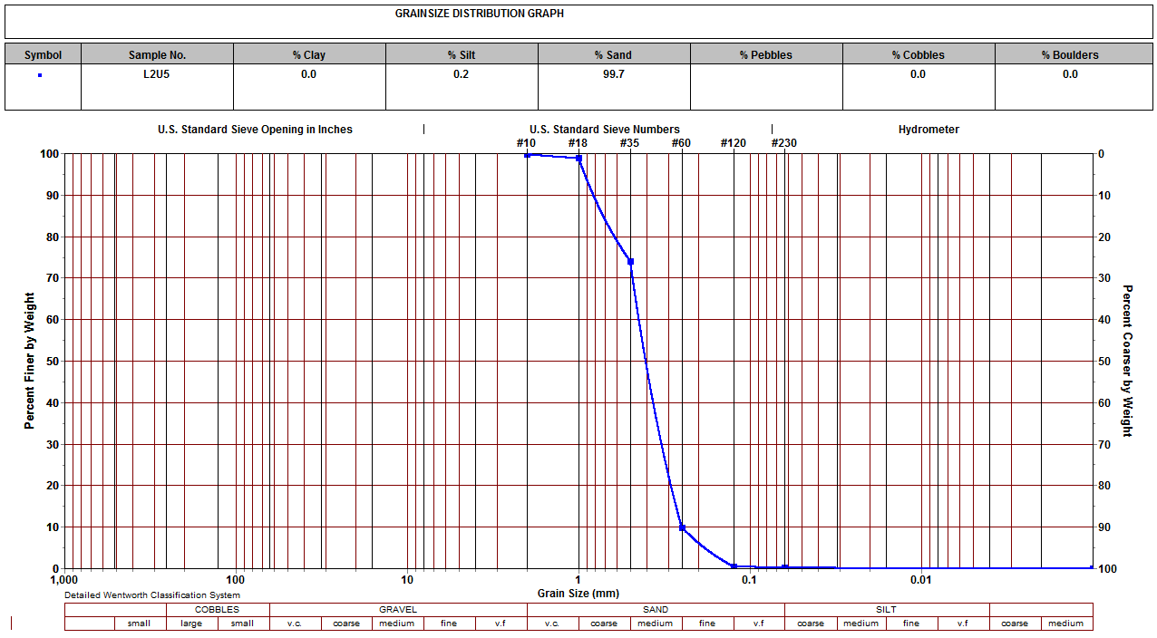

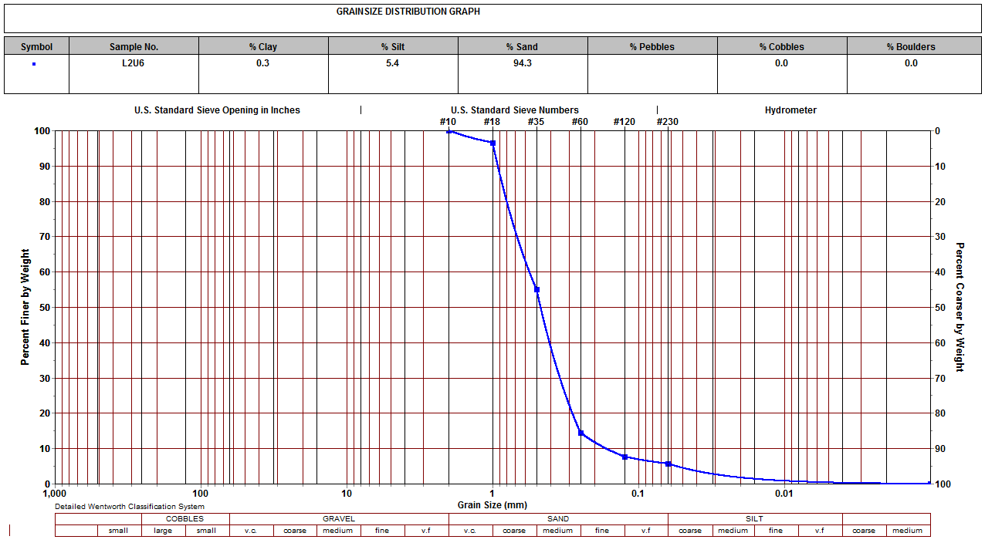

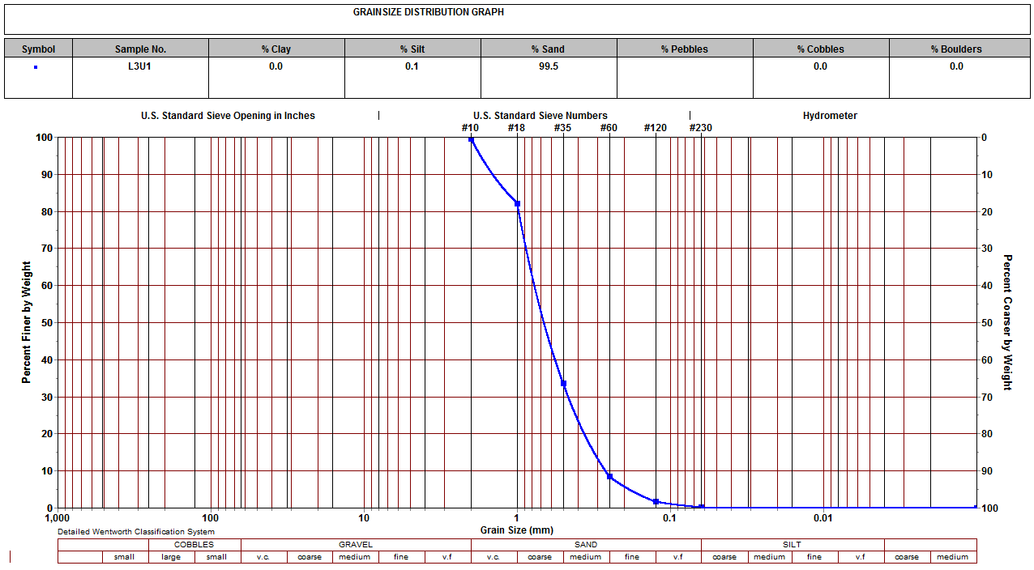

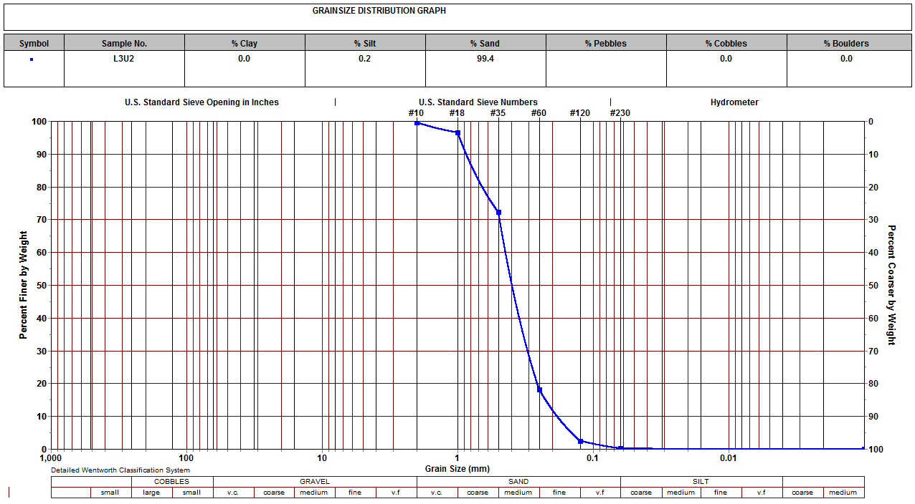

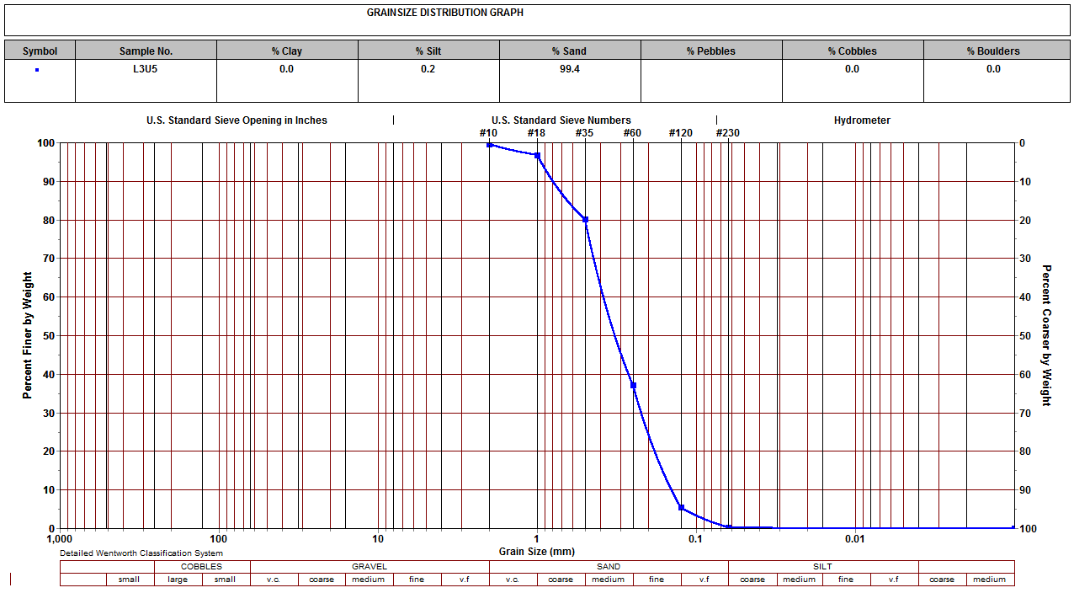

A summary of the key particle-size fractions extracted directly from the cumulative curves is provided in Table 1. Fine content is defined as the combined clay (<0.002 mm) and silt (0.002–0.075 mm) fractions (i.e., percent passing the No. 200 sieve). Sand content dominates all samples, ranging from 87.3% to 99.8%, while pebbles and cobbles are absent.
Table 1. Particle-Size Distribution and USCS Classification of Soil Samples
Sample | Clay (%) | Silt (%) | Sand (%) | Fines (%) | USCS Classification
L102 | 0.0 | 0.1 | 99.8 | 0.1 | SP (Poorly graded sand)
L104B | 0.7 | 12.0 | 87.3 | 12.7 | SM (Silty sand)
L205 | 0.0 | 0.2 | 99.7 | 0.2 | SP (Poorly graded sand)
L206 | 0.3 | 5.4 | 94.3 | 5.7 | SP-SM (Poorly graded sand with silt)
L301 | 0.0 | 0.1 | 99.5 | 0.1 | SP (Poorly graded sand)
L302 | 0.0 | 0.2 | 99.4 | 0.2 | SP (Poorly graded sand)
L305 | 0.0 | 0.2 | 99.4 | 0.2 | SP (Poorly graded sand)
Classification follows ASTM D2487-17 using the Unified Soil Classification System (USCS) criteria for coarse-grained soils (more than 50% retained on the No. 200 sieve). Because the curves display low coefficients of uniformity (Cᵤ ≈ 2–4, inferred from the steep slopes between D₆₀ and D₁₀) and the absence of a broad, continuous particle-size range, the clean-sand samples qualify as poorly graded (SP). The dual symbol SP-SM for L206 reflects the borderline fines content (5–12%), while L104B exceeds the 12% fines threshold and is classified as SM. No Atterberg limit data were available; therefore, the silty character of the fines was inferred from the hydrometer portion of the GSD curves and standard USCS procedures for non-plastic or low-plasticity fines.

Gradation Parameters Summary Chart (Table 2)
This table provides the quantitative backbone that reviewers expect in any serious PSD study.
Table 2. Key gradation parameters for the tested soil samples
Sample | D₆₀ (mm) | D₃₀ (mm) | D₁₀ (mm) | Cᵤ | C꜀ | USCS Classification
L102 | 0.314 | 0.194 | 0.119 | 2.64 | 1.01 | SP
L104B | 0.230 | 0.128 | 0.024 | 9.74 | 3.05 | SM
L205 | 0.339 | 0.211 | 0.150 | 2.26 | 0.88 | SP
L206 | 0.281 | 0.163 | 0.088 | 3.21 | 1.09 | SP-SM
L301 | 0.365 | 0.227 | 0.156 | 2.34 | 0.91 | SP
L302 | 0.394 | 0.250 | 0.166 | 2.37 | 0.95 | SP
L305 | 0.425 | 0.258 | 0.165 | 2.58 | 0.95 | SP
Notes:
- D₁₀, D₃₀, and D₆₀ = particle diameters at 10%, 30%, and 60% finer, respectively.
- Cᵤ (Coefficient of Uniformity) = D₆₀/D₁₀
- C꜀ (Coefficient of Curvature) = (D₃₀)² / (D₆₀ × D₁₀)
- Values estimated from the cumulative curves using linear interpolation on a semi-log scale. All clean-sand samples show low Cᵤ (< 4), confirming poorly graded (uniform) character.

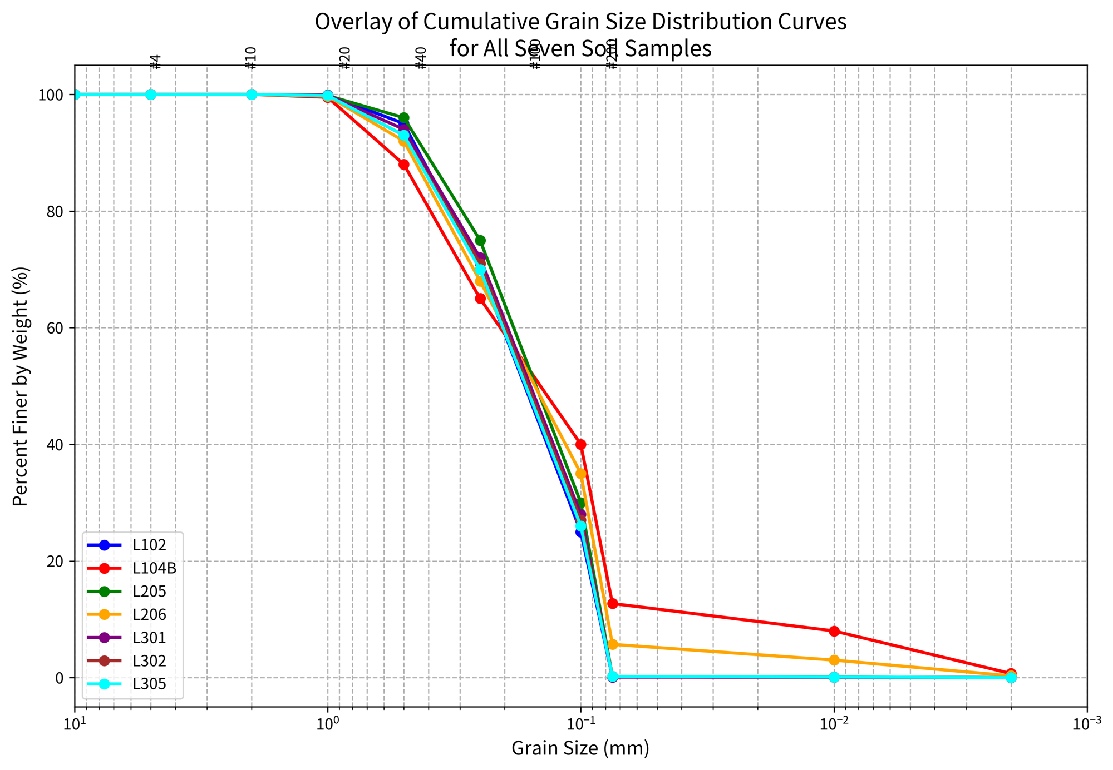
Figure 2. Overlay of cumulative grain-size distribution curves for all seven soil samples (L102, L104B, L205, L206, L301, L302, and L305). The steep, nearly parallel segments in the 0.425–0.075 mm range demonstrate the high degree of uniformity and poorly graded (SP) character of the predominantly sandy materials. Minor deviations in the finer tail correspond to the elevated silt content in samples L104B and L206.
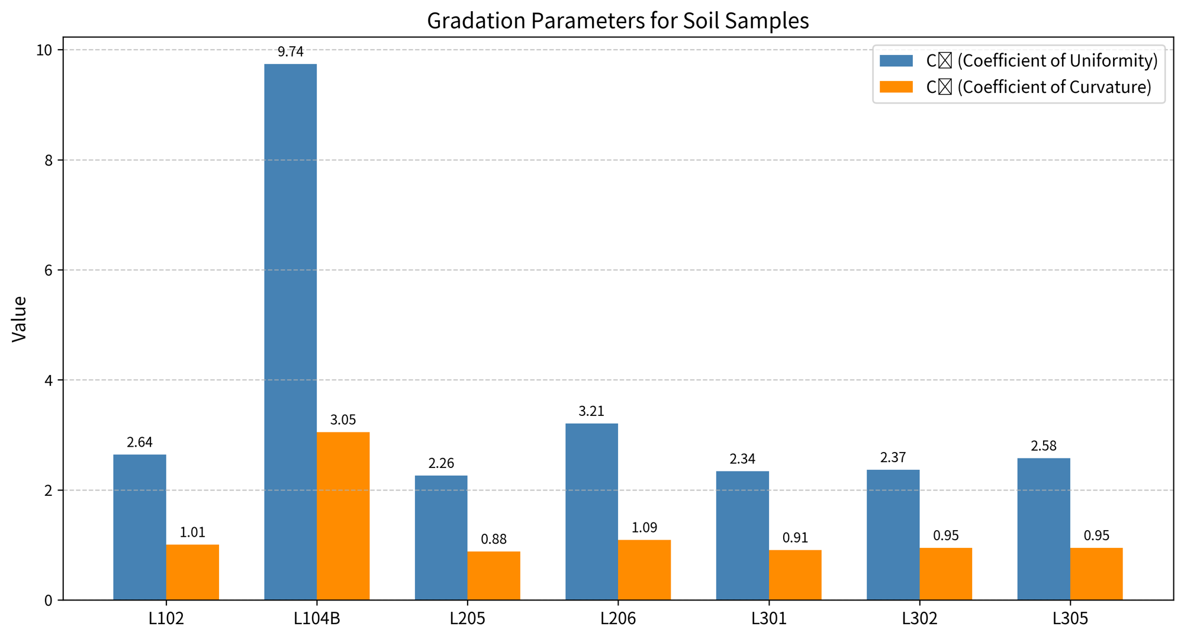
Figure 3 / Table 2 Visualization. Gradation parameters for the seven soil samples. The consistently low coefficients of uniformity (Cᵤ ≈ 2.3–3.2) for the SP-classified samples confirm well-sorted, uniform fine-to-medium sands, while L104B shows distinctly higher Cᵤ due to its higher fines content.
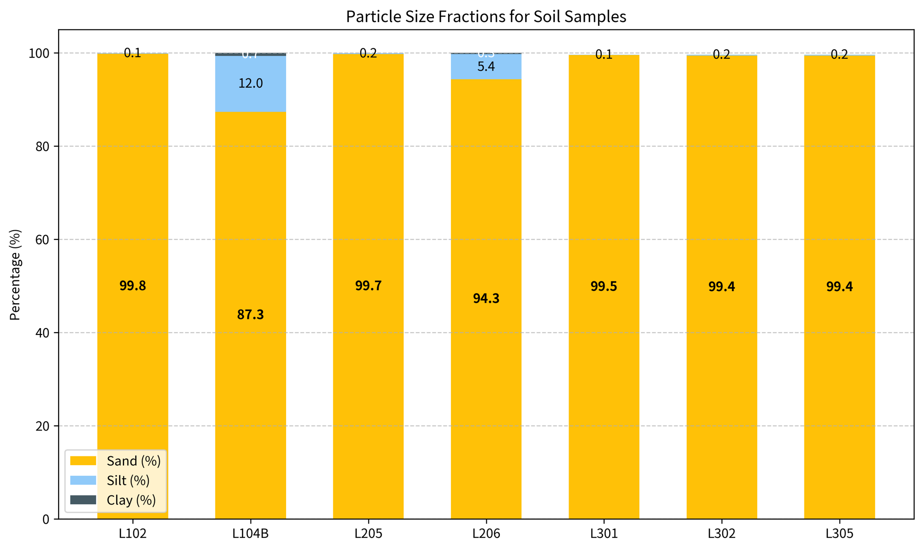
Figure 4. Stacked bar chart showing the particle-size fractions (Clay, Silt, and Sand) for all seven soil samples. The chart clearly illustrates the overwhelming dominance of the sand fraction (>87%) across the entire sample set, with only L104B and L206 showing noticeable silt contributions. This visual reinforces the uniform, sand-dominated nature of the materials.

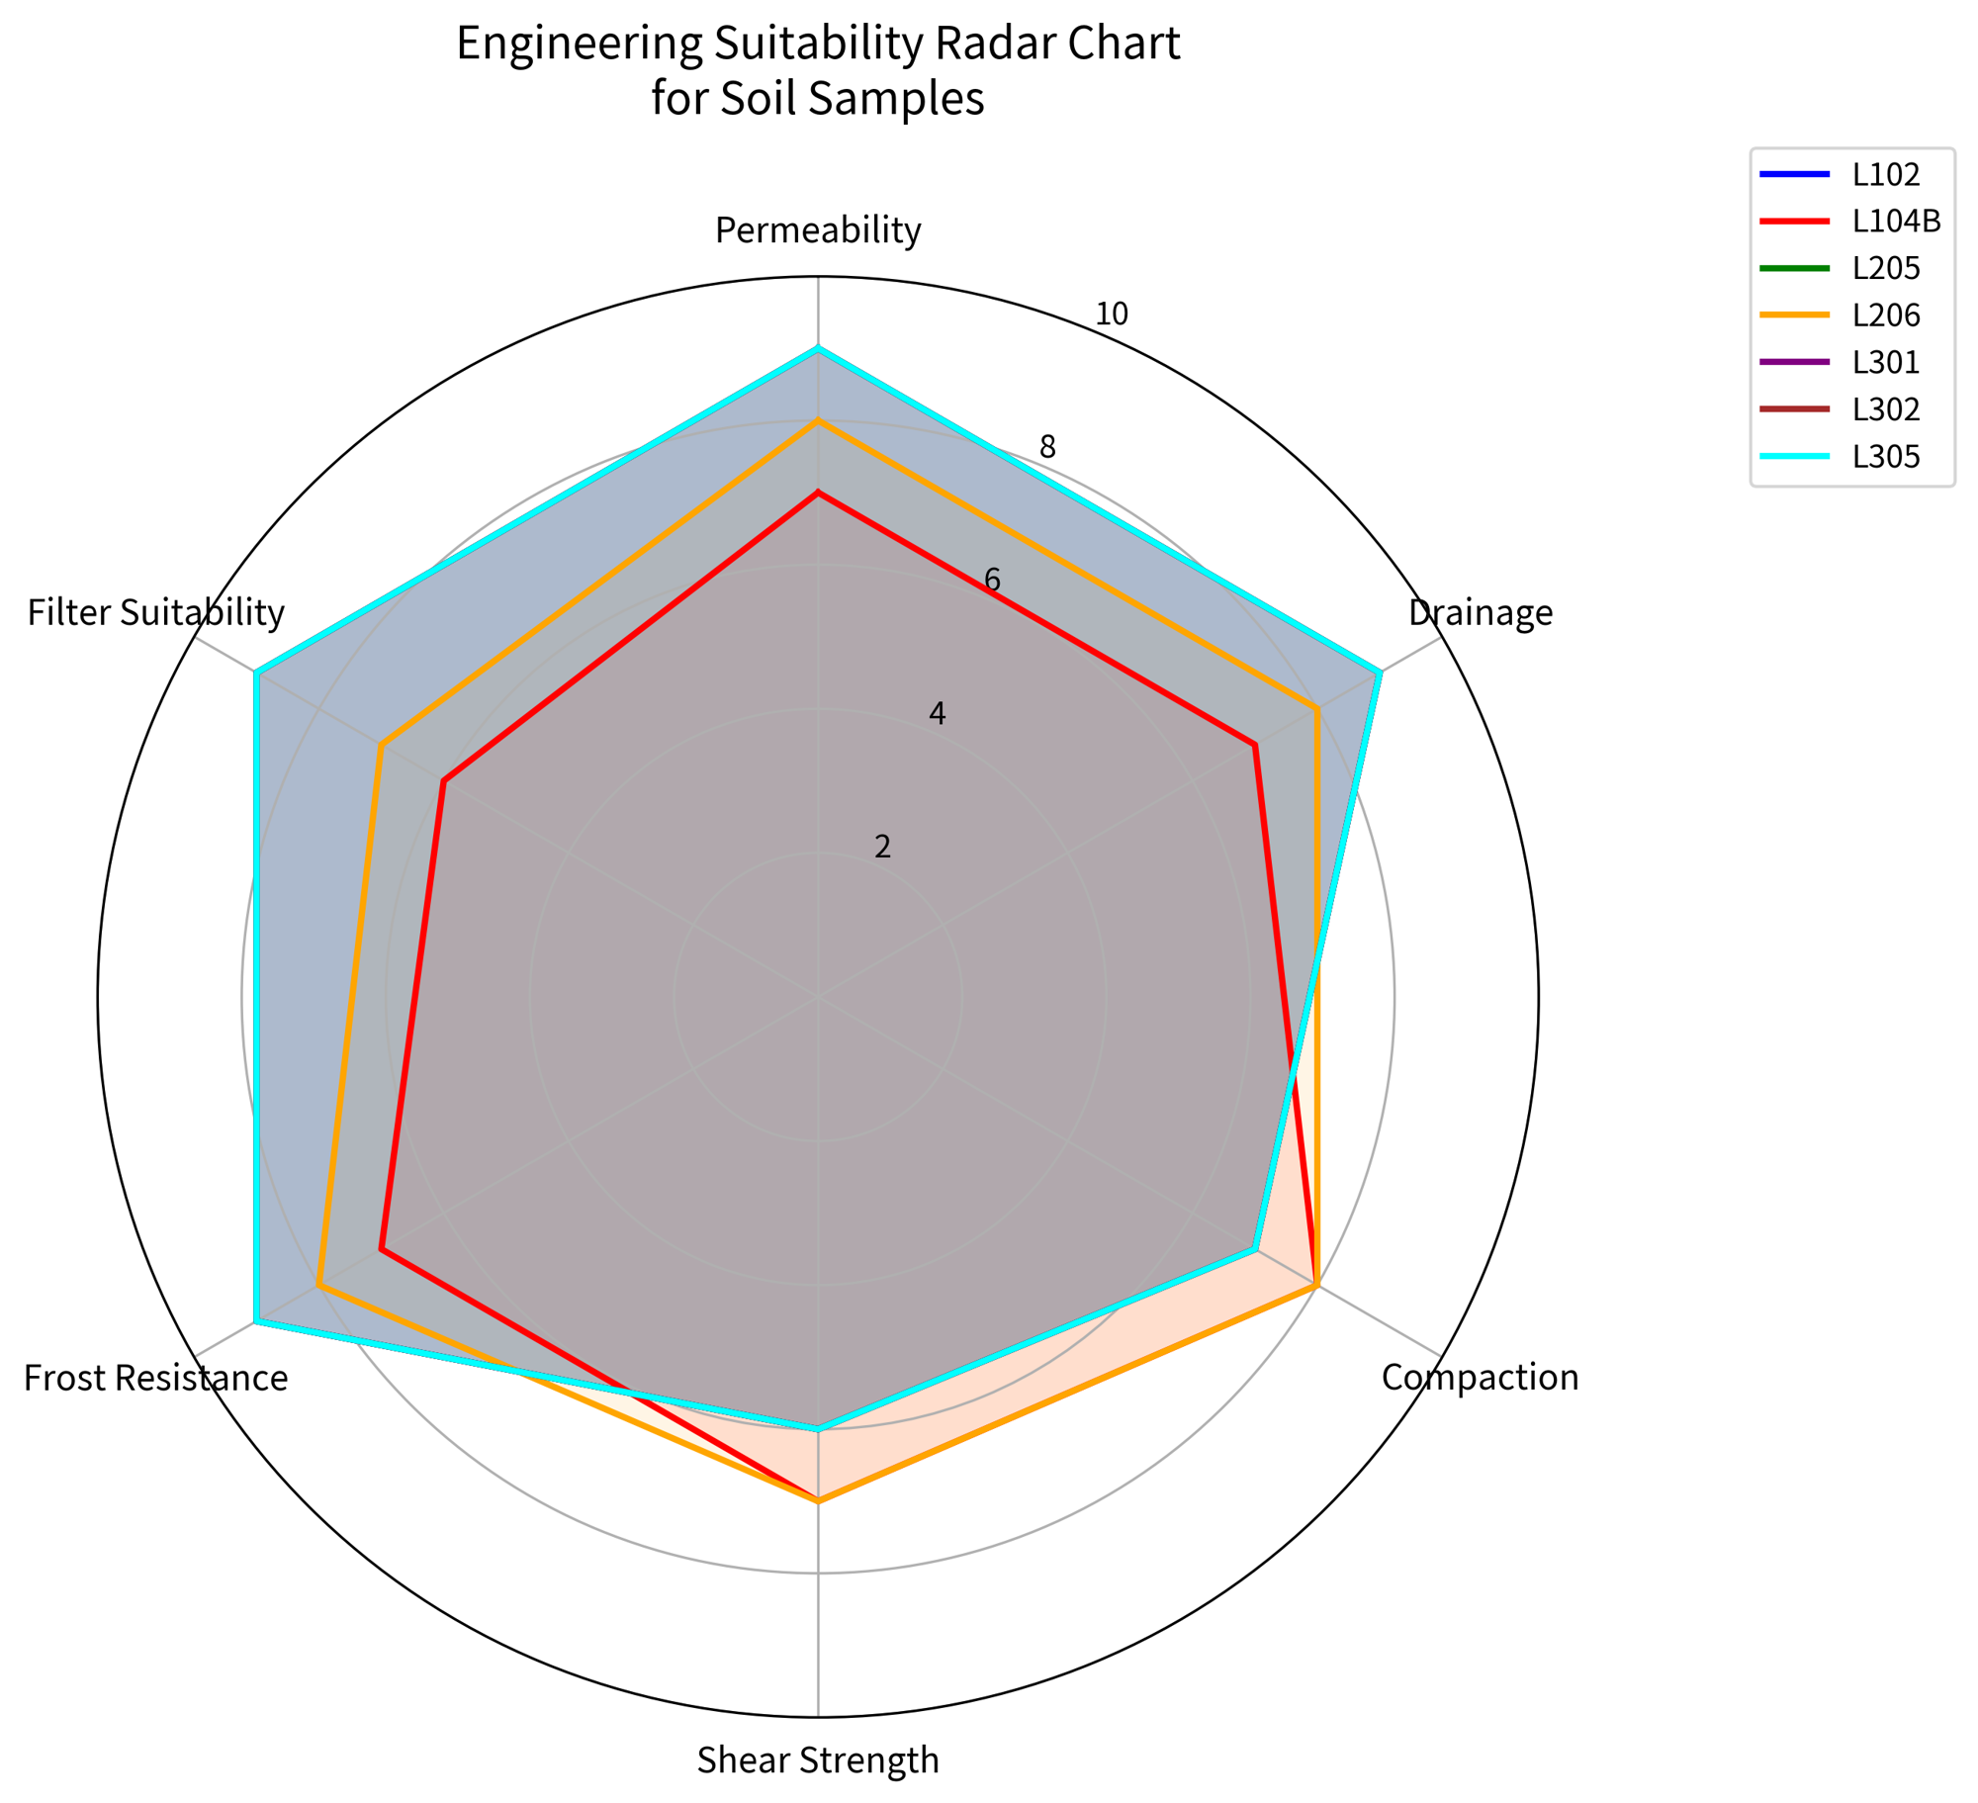

Figure 5. Engineering suitability radar chart for the seven soil samples. Scores (1–10 scale) are based on the typical performance of poorly graded sands (SP) with low fines content. The clean SP samples (L102, L205, L301, L302, L305) show consistently high ratings in permeability, drainage, frost resistance, and filter suitability, while L104B and L206 exhibit slightly reduced hydraulic performance due to higher silt content.

Interpretation
The combined evidence from Figures 1–5, supported by Tables 1 and 2, indicates that the tested soils form a highly homogeneous group of predominantly uniform, clean fine- to medium-grained sands. The remarkable consistency observed in the overlaid cumulative curves (Figure 2) suggests the samples originated from a common source material or experienced similar depositional or processing histories. Such uniformity is highly advantageous for large-scale construction projects, enabling reliable material specifications, reduced batch variability, and simplified quality control procedures.
From an engineering perspective, the very low fines content and uniform gradation impart excellent drainage properties and high permeability, typically on the order of 10⁻² to 10⁻¹ cm/s. These characteristics make the materials particularly well-suited for drainage blankets, filter layers in earth dams and retaining structures, road base/subbase courses, embankment fill, and foundation backfill where rapid pore-pressure dissipation is required. The radar chart in Figure 6 further illustrates the strong performance of the clean SP samples across key engineering criteria, including permeability, drainage, frost resistance, and filter suitability.
The primary limitation associated with the SP classification is reduced particle interlocking, which generally results in lower maximum dry density and shear strength compared to well-graded sands (SW). This can be effectively mitigated through appropriate compaction techniques, such as vibratory rollers or plate compactors. The minor variability in fines content, primarily observed in samples L104B and L206, is modest and can be readily managed through selective placement, blending, or simple washing processes during construction.
In summary, the laboratory results and comprehensive visual interpretations confirm that the seven samples represent high-quality, consistent granular materials with strong potential for diverse geotechnical and civil engineering applications. The integration of traditional cumulative frequency curves with modern graphical tools (stacked bars, ternary diagrams, and radar charts) provides clear, actionable insights into both material characteristics and practical engineering performance. This multi-sample visual approach not only validates the homogeneity of the deposit but also offers a robust framework for material selection and quality assurance in infrastructure projects.

Conclusion
This study has presented a comprehensive multi-sample grain size analysis of seven soil specimens (L102, L104B, L205, L206, L301, L302, and L305) through standardized sieve and hydrometer testing. The results, clearly illustrated through individual and overlaid cumulative frequency curves (Figures 1 and 2), particle-size fraction charts (Figure 4), gradation parameters (Table 2 and Figure 3), and engineering suitability assessment (Figure 5), consistently demonstrate a high degree of textural uniformity and sand dominance across the sample suite.
The tested materials are predominantly uniform, clean fine- to medium-grained sands, with sand fractions ranging from 87.3% to 99.8% and fines content generally below 0.3%. Five samples are classified as poorly graded sand (SP), while L206 and L104B are classified as SP-SM and SM, respectively. The remarkably consistent steep gradients on the cumulative distribution curves indicate well-sorted materials with low coefficients of uniformity (Cᵤ ≈ 2.3–3.2 for SP samples), suggesting a common source or similar depositional/processing environment. Such homogeneity is rare in natural soils and holds significant practical value for construction projects.
From an engineering standpoint, the low fines content and uniform gradation confer excellent hydraulic properties, including high permeability, superior drainage performance, and low frost susceptibility. These attributes make the materials highly suitable for critical applications such as drainage blankets, filter layers in earth dams and retaining structures, road base and subbase courses, embankment construction, and foundation backfill. While the poorly graded nature of the SP samples results in reduced particle interlocking and comparatively lower shear strength and density, these limitations can be effectively addressed through proper vibratory compaction techniques. The minor variability observed in samples L104B and L206 is modest and easily managed through selective placement or processing.
The integration of traditional cumulative frequency curves with modern interpretive visualizations (stacked bar charts, ternary diagrams, and radar charts) has provided clear, actionable insights that bridge raw laboratory data with practical engineering decision-making. This multi-sample visual approach not only confirms the consistency and quality of the materials but also serves as a robust model for future geotechnical characterization studies.
In conclusion, the seven soil samples represent high-quality, consistent granular materials with strong potential for diverse civil and geotechnical engineering applications. By demonstrating both the remarkable uniformity and favorable engineering characteristics of these sands, this study provides a solid foundation for informed material selection, reliable specifications, and effective quality control in infrastructure development. Comprehensive particle-size distribution analysis, supported by detailed visual and quantitative interpretation, remains a cornerstone of modern geotechnical engineering, enabling the translation of fundamental soil properties into safe, efficient, and durable constructed works.
References
ASTM International. (2017). Standard practice for classification of soils for engineering purposes (Unified Soil Classification System) (ASTM D2487-17e1). https://doi.org/10.1520/D2487-17E01
Budhu, M. (2011). Soil mechanics and foundations (3rd ed.). John Wiley & Sons. https://doi.org/10.1002/9780470948569
Carrier, W. D. (2003). Goodbye, Hazen; Hello, Kozeny-Carman. Journal of Geotechnical and Geoenvironmental Engineering, 129(11), 1054–1056. https://doi.org/10.1061/(ASCE)1090-0241(2003)129:11(1054)
Chapuis, R. P. (2004). Predicting the saturated hydraulic conductivity of sand and gravel using effective diameter and void ratio. Canadian Geotechnical Journal, 41(5), 785–795. https://doi.org/10.1139/t04-022
Das, B. M., & Sobhan, K. (2018). Principles of geotechnical engineering (9th ed.). Cengage Learning.
Hazen, A. (1892). Some physical properties of sands and gravels. 24th Annual Report, Massachusetts State Board of Health, 539–556.
Holtz, R. D., Kovacs, W. D., & Sheahan, T. C. (2011). An introduction to geotechnical engineering (2nd ed.). Pearson.
Lambe, T. W., & Whitman, R. V. (1969). Soil mechanics. John Wiley & Sons.
Terzaghi, K., Peck, R. B., & Mesri, G. (1996). Soil mechanics in engineering practice (3rd ed.). John Wiley & Sons.

