Measuring the Effectiveness of Year 5 English Textbook in Teaching Listening and Speaking Skills

-------

1. Introduction

Textbooks are very important in classrooms all over the world. Teachers and students make use of them as structured guides. Textbooks are both teaching aids and learning materials because they provide a collection of arranged lessons and curriculum. This is especially true and important in places where there are not many teaching tools available and rare to be found. Textbooks often form the main pillar of language input and practice, particularly for beginner teachers and students with limited exposure to English outside the classroom according to Richards (2021).

The creation of textbook has changed throughout time along with national education priorities. During the British colonial era, imported textbooks were the most common in schools. They reflected the ideals and language objectives of the time (Gill,2005). The Razak Report (1956) and the Education Ordinance (1957) both underlined the need of national unity after independence by using a uniform curriculum and textbooks made in Malaysia. The Textbook Bureau was set up in 1967 to make sure that teaching materials were applicable to Malaysian culture and teaching methods (Ministry of Education Malaysia, 2013).

The Malaysian Education Blueprint 2013–2025 called for the use of the Common European Framework of Reference for Languages (CEFR) to help make English a global language. Textbooks like English Plus 1 Year 5 that are associated with the CEFR aim to assist students reach their real-life communication goals by mastering certain descriptors that are related to listening and speaking tasks (Council of Europe, 2001). On the other hand, there are also questions about whether these resources really help people communicate better, especially in ESL schools where English is rarely spoken outside of school (Yunus et al., 2018).

In Malaysia, especially in rural areas, many students in government primary schools don't know enough English to improve their speaking skills. Some urban schools also have this problem, although not as many as rural schools. Many students simply learn English from their textbooks. If textbook activities do not have enough diversity, authenticity, or clear scaffolding, students may have trouble improving their speaking skills or talents. Teachers may also have trouble teaching oral communication without enough help or examples that are applicable to their culture (Abdullah, 2017). It is very important to see how well English Plus 1 Year 5 helps students improve their speaking and listening skills.

Textbooks remain central to ESL classrooms, especially in settings where other resources are scarce. CEFR-aligned materials were used to strengthen communicative competence, with particular emphasis on listening and speaking. However, questions remain about the effectiveness of these textbooks in supporting oral skill development in practice. This study focuses on English Plus 1 Year 5, examining its role in fostering communication skills among learners.

1.2 Statement of the Problem

Malaysia has come a long way in making its English curriculum more in line with CEFR standards. However, how well these changes work in real life depends mainly on how the textbooks are designed and how they are used in the classroom. Listening and speaking are very important for being able to communicate, but they are also some of the hardest skills to teach in ESL environment. Successful instruction in developing listening and speaking skills requires a balance of fluency development, meaningful teaching and learning techniques and attention to the form of language; moving from traditionally used scripted dialogues to more realistic communication based on real-life situations (Newton and Nation, 2021). According to a more recent study by Zulkiply and Nasri (2024), while CEFR textbooks serves to improve language proficiency, teachers are faced with many challenges such as inflexible textbook structures and inadequate guidance and support for fostering organic listening and speaking tasks. Likewise, Kassim and Hashim (2023) emphasised that other than the positive attitudes towards the integration of CEFR, many teachers have difficulties adapting materials to meet students’ communicative needs which is caused by insufficient training and contextual relevance.

English Plus 1 Year 5 is an example of a CEFR-based textbook that has oral activities that are suited for A1–A2 level students. These activities should give students purposeful opportunities to practise and feedback that is appropriate for their age. Unfortunately, research has shown that there are gaps between policy and practice. For example, some textbooks do not include examples of diverse speech patterns, natural conversation styles, or ways for students to give and receive feedback (Nimehchisalem & Mukundan, 2011; Rajendran et al., 2021). If students do not get enough help, they might not be able to move from simple responses to independent speech, which is a primary aim of communicative language teaching. Teachers' comments are very important for establishing what is good and bad about a textbook. One of the biggest problems teachers have is making sure that the resources they use are appropriate for all of their students, especially when they are teaching in a mixed-ability classroom or have limited time (Mohd Asraf & Abdullah, 2016). Adding on, there are not that many studies that have focused on teachers' opinions about using CEFR textbooks, which makes it tough to know how these materials function in real life.

Therefore, the aim of this study is to address the shortcomings by carefully looking at the listening and speaking parts of English Plus 1 Year 5 and using the ELT-TEC checklist to do so. This study will be based on Krashen's Input Hypothesis (1985) and Vygotsky's Scaffolding Theory (1978) during the duration of the study. This study will focus on the textbook exercises and how well they function in real life, according to the teachers. Malaysia has long recognised that being able to speak English well is essential for academic success, economic progress, worldwide communication, and, in short, globalisation. Not only is it important to learn English for the reasons given above, but it also helps you learn new things because English is the main language used in Information and Communications Technology (ICT). Students need to be able to read and write in the language so that they can find information online and in other electronic media. The Ministry of Education Malaysia (MOE) adopted the Common European Framework of Reference for Languages (CEFR) in 2018 to make sure that students learn how to listen, speak, read, and write. CEFR is used to help teach English in schools. This framework provides an organised way to study a language by setting levels of proficiency and learning outcomes that is accepted internationally.

CEFR-aligned curriculum in Malaysia places strong emphasis on listening and speaking as the core of language learning. Although English Plus 1 Year 5 is aimed at A1–A2 learners, teachers often face obstacles such as textbook structures which are not flexible, lacking contextual relevance, and a lack of training for teachers. Evaluating the textbook is therefore important to determine whether CEFR integration truly supports inclusive and effective language learning. In this study, the ELT-TEC Checklist is used together with Krashen’s Input Hypothesis and Vygotsky’s Scaffolding Theory to examine how well the textbook achieves these aims. There are multiple reasons why textbook evaluation is important.

Evaluating a textbook helps determine if the content and activities are aligned with the national curriculum levels and learning objectives. For example, it is important that the textbook supports the development of specific language skills such as speaking and listening at the respective proficiency level in a CEFR-aligned curriculum. A textbook that encourages active student participation is a good textbook. Hence, the evaluation helps in identifying if the textbook contains interactive parts such as group work, pair work, role plays and real-life activities. All these activities tend to promote using the language in a meaningful manner while maintaining the students’ interest levels in sustaining knowledge. Engagement is one of the most important tools in successfully acquiring a language. Evaluating a textbook enable investigating the accuracy, relevance and realism of the material. Real-world language use makes it more relatable and useful for students. This will only be possible if the content of the textbook is authentic.

In a multiracial country like Malaysia, textbooks must be inclusive. The content has to be evaluated if it is culturally sensitive. It should showcase the different cultural communities in our lives. This will also enable students from different backgrounds to access the language used. Teachers and curriculum developers will be able to identify if the textbook supports effective teaching practices such as scaffolding, task-based learning, integration of listening and speaking skills, differentiated instruction and communicative language teaching by evaluating a textbook. This increases the use of the textbook in a more effective and strategic way during lessons. We need to evaluate English Plus 1 Year 5 to ascertain that the textbook is able to efficiently cultivate CEFR-aligned teaching strategies so that students can get the most benefit out of the textbook. This study will examine if the English Plus 1 Year 5 manages to encourage students to achieve the CEFR standards of competence while making their learning experiences stimulating and culturally applicable.

1.3 Purpose of Study

This study aims at evaluating how well the textbook helps students improve their listening and speaking skills. This study will also look at whether the CEFR concepts are included in the textbook for interactive language learning. Finally, this study will show what works and what does not in how the listening and speaking tasks are set up in the textbook. Teachers and learners throughout the world are highlighting the importance of speaking. It is important to find out if the textbooks help students improve their speaking and listening skills. These are the most critical skills for being able to communicate well. Even while textbooks are used a lot, it is not true that any textbook on the market fits the purposes of teaching and the standards of the curriculum.

1.5 Objectives
This study aims to understand how the textbook guides Malaysian ESL students in developing their speaking skills while using the theories. These theories help to evaluate the effectiveness of the textbook in cultivating speaking skills. The aim finally is to maximise students’ speaking abilities by identifying parts that can be further improved in the textbook. The main objectives are:

- To evaluate the effectiveness of the Year 5 English textbook in developing listening and speaking skills.

- To examine whether the Common European Framework of Reference for Languages (CEFR) principles are integrated in the textbook for interactive language learning.

- To recognise strengths and weaknesses in how speaking and listening activities are structured.

1.6 Research questions

The major book used in Year 5 government schools is English Plus 1 which should help people improve their communication abilities, like their ability to listen and communicate. This study will look into how well the textbook helps students in CEFR-aligned Year 5 classrooms improve their speaking skills by looking at several specific areas. This study is based on the following research questions:

- How effective is the Year 5 English textbook in developing students’ listening and speaking skills?

- What are the types of listening activities available and are they interactive enough for the engagement of students?

- Does the textbook create opportunities for purposeful oral communications, such as discussions, debates or role playing?

- How do the teachers perceive the effectiveness of the textbook for improving oral communication skills?

1.6 Scope of the study
This study looks closely at the English Plus 1 Year 5 textbook used in Malaysian government schools, with a specific focus on how it supports listening and speaking. The evaluation was carried out within the CEFR framework and drew on teacher feedback, including insights from those with and without direct Year 5 teaching experience. Data were gathered using the ELT-TEC checklist and pilot surveys, though the views of students, administrators, and publishers were not included. Overall, the findings point to both strengths and weaknesses in how the textbook helps learners build oral proficiency.

1.7 Limitations of the Study
The sample was gathered only from national and national-type schools, which means the findings may not fully represent the wider Malaysian context. Teacher feedback was collected through surveys and may reflect personal views or institutional expectations. In addition, the evaluation focused solely on English Plus 1 Year 5, so the results cannot be generalised to other CEFR-based materials. No student performance data were included, meaning the conclusions rest on textbook design and teacher perceptions rather than direct evidence of learning outcomes.

2.0 Literature Review

The basis of English proficiency is oral communication, especially in ESL settings where learners need methodical training with meaningful coherent communication. Textbooks that are aligned with CEFR framework play an important role in providing the support needed to build listening and speaking skills. This chapter looks at how the materials tackle these oral competencies and examines whether changes need to be made to make them more effective. The review is guided by Krashen’s Input Hypothesis and Vygotsky’s Scaffolding Theory while evaluated using the ELT-TEC Checklist. Textbooks are essential to ESL learning, shaping students’ oral proficiency inclusive of vocabulary, grammar, pronunciation and communication. The adoption of CEFR framework has converted English education by providing a standardised framework to assess fluency, literacy, and communicative competency across all levels. This literature review investigates textbook evaluation, CEFR alignment, and theoretical framework especially Krashen’s Input Hypothesis and Vygotsky’s Scaffolding Theory which focuses on listening and speaking skills.

Malaysia’s English curriculum has shifted from colonial-era imported textbooks to KBSR (1983) and KSSR (2011), with CEFR benchmarks integrated in 2018 to align with international standards. CEFR-aligned textbooks like English Plus 1 Year 5 aim to build listening and speaking skills, but teachers often adapt materials to fit local contexts, revealing gaps between policy and practice. The ELT-TEC checklist (Mukundan & Ahour, 2010) provides a structured way to evaluate textbooks across content, design, cultural relevance, and skill integration. Depending too much on textbooks without critical evaluation can limit effectiveness of textbooks. This study combines ELT-TEC with language acquisition theories to review English Plus 1 Year 5 and its oral skill components.

2.1 The CEFR Framework and The Application in Malaysia

The CEFR, an internationally recognised scale for language proficiency, emphasises on communicative competence across levels A1 to C2. Listening and speaking are essential: A1 learners are expected to manage simple conversations, while A2 learners can describe preferences and experiences. CEFR was adopted in 2018 to raise the standards of English, introducing new curriculums, teacher training, and textbooks such as English Plus 1. While CEFR promotes real-life communication, applying “can-do” descriptors in mixed-ability classrooms remains challenging, and critics point to vague descriptors and limited cultural relevance in textbooks. Listening in ESL classrooms works best when students hear real-life conversations, supported by structured tasks and real-life materials like conversations and podcasts. Challenges such as fast speech, unfamiliar accents, and limited vocabulary can be reduced with clear input, visuals, and varied speech models. Speaking tasks should help build confidence by encouraging interaction, turn-taking, and self-expression, with pair and group work. CEFR descriptors at A1–A2 levels highlight the need for simple, interactive communication. This shows that students benefit more from meaningful speaking tasks than from scripted drills or repetition.

2.2 ELT-TEC Textbook Evaluation Checklist
The ELT-TEC Checklist provides a structured framework for evaluating the quality of textbook, focusing on language content, activities, organisation, cultural relevance, and the integration of oral skills. Teachers in Malaysia rely heavily on textbooks, as this tool is particularly valuable. Studies using ELT-TEC reveal that many textbooks lack depth in speaking design and authenticity in communication. For example, Pulse 2, a foreign textbook introduced under CEFR, was found to remain conventional and limited in fostering real-world communication, despite being considered practical by teachers.

Table 1: Evaluation Dimensions for ESL Textbook Listening and Speaking Components
Dimension | Purpose of the Dimensions
Language Content | Accuracy, level-appropriateness, progression and grammar/vocabulary integration.
Exercises and Activities | Variety, authenticity, skill integration, engagement of students
Design and Organisation | Layout, clarity of instructions, logical sequencing
Cultural Relevance | Diversity, sensitivity and inclusion of local/global contexts
Listening and Speaking Integration | Whether oral skills are meaningfully integrated and scaffolded

Most Malaysian ESL textbook evaluations focus on general skill integration rather than listening and speaking. Oral activities often lack scaffolding for real-world communication, and many studies depend on checklists without theoretical grounding in acquisition models. Teacher perspectives are also not explored enough, despite their role in adapting or omitting tasks in practice. This study addresses these gaps by evaluating English Plus 1 Year 5 through ELT-TEC, language acquisition theories, and teacher feedback to assess oral skill development.

3.0 Methodology
This study examines English Plus 1 Year 5, emphasising on listening and speaking activities in Malaysian ESL classrooms. A mixed-methods approach was adopted to provide depth, combining quantitative and qualitative data for a more comprehensive view. A convergent parallel mixed-methods design was used, allowing quantitative and qualitative data to be collected simultaneously and then integrated. Teacher outlook was collected through surveys containing Likert-scale and open-ended items. Textbook analysis was conducted using the ELT-TEC Checklist. Krashen’s Input Hypothesis and Vygotsky’s Scaffolding Theory guided the evaluation, ensuring attention to both input quality and scaffolding in oral skill development. The study involved 30 primary school English teachers from government schools across Malaysia. Participants were selected through snowball sampling, beginning with professional networks and expanding through referrals. The group included teachers aged 25–60, with varied teaching experience ranging from one year to over three decades. Most participants had attended CEFR-related training, ensuring familiarity with the framework. A pilot test with four teachers was conducted to refine the survey instrument before full distribution.
Table 2 Participants’ Profile
Attributes | Distribution | Charts
Gender | Mostly female (80%) | 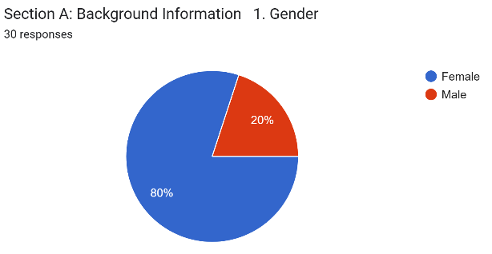
Age Range | 25–60 years (majority between 31–45) | 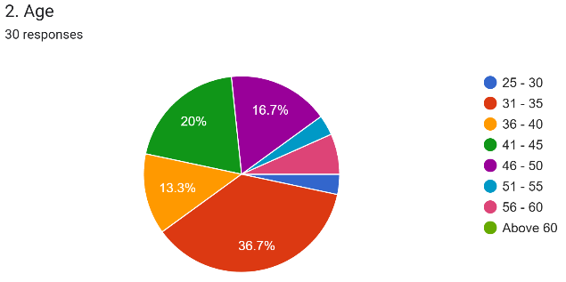
Ethnicity | Malay, Indian, Chinese, Others | 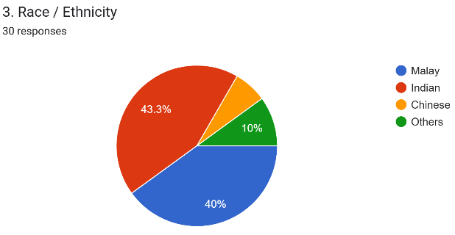
Highest Qualification | Mainly Bachelor’s Degrees; several Master’s holders | 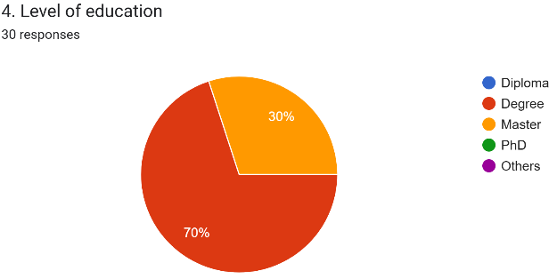
Teaching Experience | 1 to 30+ years (most between 10–15 years) | 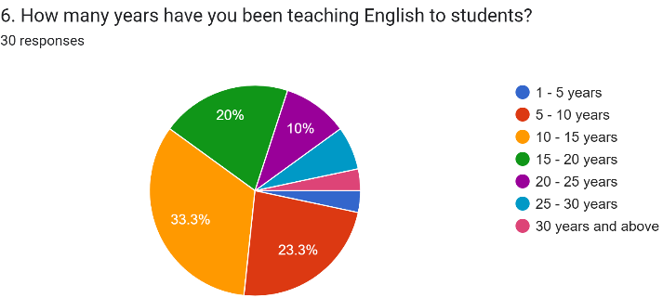
CEFR Training Received | 83.3% confirmed attending CEFR-related workshops | 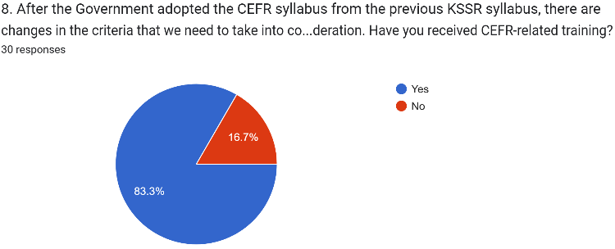
School Types | Random National and National-Type Schools across Malaysia

  - Data Collection and Analysis Methods
Textbook and teacher surveys were the two sources of data that were used. The ELT-TEC Checklist was used to assess the authenticity, complexity, progression, interaction, and CEFR alignment of the textbook. There were 43 items in the survey including demographic questions, 23 Likert-scale items, and five open-ended questions on effectiveness, challenges, and cultural relevance. The survey was distributed via Google Forms while ensuring accessibility, confidentiality, and voluntary participation. Quantitative data were analysed using SPSS 31 to generate descriptive statistics, reliability measures, and chi-square tests. Qualitative responses were examined with NVivo 15 to identify themes related to cultural relevance, task originality, and oral skill integration. This dual analysis allowed for triangulation, strengthening the validity of findings. SPSS 31 was used to analyse the survey data as it is well suited for handling quantitative data such as the Likert-scale responses. All teacher survey results were coded numerically and processed to identify averages, variation, and overall trends in agreement or disagreement about the textbook’s effectiveness, CEFR alignment, student engagement, and oral task design. Key procedures included:
- Descriptive statistics to summarise teachers’ opinions (mean, median, standard deviation).
- Reliability testing (Cronbach’s Alpha) to check consistency across items (α ≥ 0.7 indicates acceptable reliability).
- Correlation and cross-tabulations to explore relationships and compare responses across teacher groups.
- Chi-square tests (optional) to determine whether differences between groups were statistically significant (p < .05).
SPSS transformed raw survey numbers into clear findings about how teachers perceive the strengths and weaknesses of the textbook. For qualitative data, open-ended responses were analysed using NVivo 15. This software allowed systematic coding and theme identification. Responses were imported, coded into multiple categories such as cultural sensitivity, textbook difficulty, and mixed-ability challenges.
Data analysed using NVivo 15 were divided into:
- Thematic coding and structuring to organise ideas.
- Sentiment analysis to classify comments as positive, negative, or neutral.
- Word frequency and cluster analysis to highlight dominant terms and associations (e.g., “fluency” linked with “confidence”).
- Cross-case comparisons to contrast teacher concerns across different profiles.
- Visual mapping and memo writing to connect themes and document reflections.
Ethical approval was obtained prior to data collection. Participants were informed on the study’s purpose, assured of confidentiality, and reminded of their right to withdraw at any time. Consent was implied through the completion of the survey. All data were stored securely. The study followed ethical standards set by the Malaysian Ministry of Education and international guidelines such as the Declaration of Helsinki (2013) and BERA’s Educational Research Ethics (2018). The study faced several constraints. The sample size of 30 teachers limited generalisability, and the 12-week timeframe restricted outreach and data analysis. Due to the lengthy approval processes and principals’ reluctance to permit external research, the access to government schools was hindered. Snowball sampling was adopted as a practical and ethical alternative, minimising disruption to schools while ensuring relevant participation.
4.0 Results and Discussion
The results outline an extensive analysis of the data collected from both quantitative and qualitative findings. The quantitative findings are survey-based and cover the Likert-scale responses. The qualitative findings are based on the open-ended responses. The study aims to investigate how textbook scaffolding helps in listening comprehension amongst students and fluency in English as interpreted by teachers via the mixed-methods approach. This chapter also reveals the statistical results from SPSS as well as the thematic analysis using NVivo 15 to answer the research questions holistically. The analysis is organized into three main sections:

- Quantitative findings derived from structured survey responses.
- Qualitative insights obtained through thematic analysis.
- Integration of both data types to identify convergences and divergences.

This section presents and interprets the findings from both the content analysis of the English Plus 1 Year 5 textbook and the survey responses from 30 English teachers across government primary schools in Selangor. It integrates quantitative and qualitative results to provide a comprehensive understanding of how effectively the textbook supports listening and speaking development in CEFR-aligned ESL classrooms. The results are organised according to the four research questions and supported by direct evidence from the textbook and participant feedback. The data was collected from a survey which was taken by 30 English language teachers working at multiple primary government schools. There were different categories of participants such as years of experience, exposure to CEFR-aligned materials and teaching aids as well as demographic influence. Demographic details helped in placing the survey responses in particular categories.

4.1 Quantitative Findings
Descriptive analysis helps describe, show and summarise data in a constructive way. Rearranging, ordering and influencing data to provide insightful information about the provided data is formed when the conversion of raw data is done. This conversion is done to understand or interpret it easily. Therefore, it is one of the most important steps for conducting statistical data analysis. It provides the summary regarding the distribution of data that has been collected, helps identify typos and outliers while enabling identification of similarities among variables. This assists in conducting a deeper statistical analysis. Descriptive methods often include creating a table of means and median, standard deviation or variance which happens to be methods of dispersion and cross-tabulations (crosstabs). Crosstabs can be used to carry out many differing or contrasting hypotheses which often emphasise differences among subgroups.

Descriptive statistics were computed to summarize teachers’ perceptions of the textbook’s effectiveness in supporting listening and speaking skills. The mean scores and standard deviations for each item are presented in Tables 3 and 4.

Table 3 Descriptive Statistics for Key Survey Items on Listening Skills
 | N | Minimum | Maximum | Mean | Std. Deviation
Speaking Task Improves Communication | 30 | 3 | 5 | 4.10 | .662
Sufficient Speaking Activities | 30 | 1 | 5 | 3.33 | 1.028
Speaking Task Alignment with CEFR | 30 | 2 | 5 | 3.63 | .890
Activities that  Initiate Communication | 30 | 2 | 5 | 3.70 | .952
Balanced Activities for Pair, Individual, and Group Work | 30 | 2 | 5 | 3.63 | .999
Valid N (listwise) | 30

Table 3 presents descriptive statistics for five variables related to listening skill development in English Plus 1. The highest-rated item was Listening Skill Development (M = 4.10, SD = 0.662), indicating strong teacher agreement on the textbook’s effectiveness in enhancing general listening comprehension. In contrast, Listening Skill for Low-Proficiency Students received the lowest mean score (M = 3.33, SD = 1.028), suggesting more varied perceptions and highlighting potential challenges in addressing diverse learner needs. Items such as Audio Material Sufficiency (M = 3.70, SD = 0.952) and Defined Goals in Listening Tasks (M = 3.63, SD = 0.999) were moderately rated, reflecting a perceived need for clearer instructional objectives and more substantial audio support. Overall, the data suggest that while the textbook is generally effective in supporting listening skills, improvements in scaffolding and inclusivity may enhance its impact.

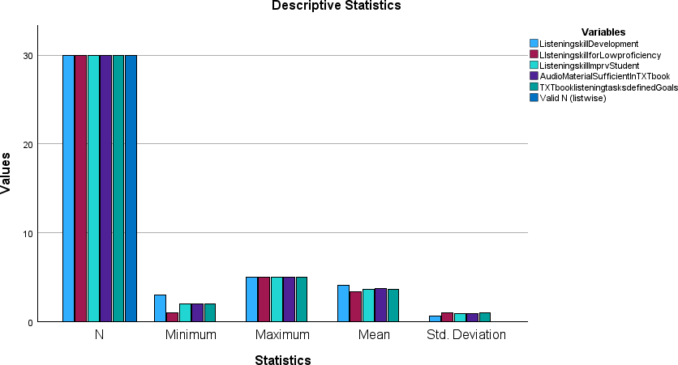
Figure 1 Mean Ratings of Listening Skill Items

Figure 1 shows the mean ratings of listening skills items. N=30 confirms that all the participants have answered all the survey items. The bars in the chart show the range of responses. Minimum values are close to 1, signifying that certain teachers have rated some survey items very low such as Listening Skill for Low Proficiency. On the other hand, maximum values are close to 5, implying that certain teachers have rated some survey items very high. In this case, Listening Skill Development received the highest rating, while support for low-proficiency students was rated lowest. This suggests that there are different perceptions by the teachers. Some teachers find the textbook effective whereas some see major gaps. From this, the maximum values only explain that the textbook can be effective while the mean and standard deviation (SD) expose how consistently teachers feel that the textbook is effective. In a nutshell, the textbook has strengths however, it shows that support for low proficiency students is lacking or rather considered not evenly developed or even a teacher’s experience may be the reason to influence their opinion.

Table 4 Descriptive Statistics for Key Survey Items on Speaking Skills

 | N | Minimum | Maximum | Mean | Std. Deviation
Speaking Task Improves Communication | 30 | 2 | 5 | 3.43 | .817
Sufficient Speaking Activities | 30 | 2 | 5 | 3.77 | .774
Speaking Task Alignment with CEFR | 30 | 2 | 5 | 3.67 | .711
Activities that Initiate Communication | 30 | 2 | 5 | 3.67 | .844
Balanced Activities for Pair, Individual, and Group Work | 30 | 2 | 5 | 3.40 | .894
Valid N (listwise) | 30

Table 4 displays descriptive statistics for five variables assessing the effectiveness of speaking tasks and activities in English Plus 1. The highest-rated item was Sufficient Speaking Activities (M = 3.77, SD = 0.774), indicating general teacher agreement that the textbook provides ample opportunities for oral practice. Speaking Task Alignment with CEFR and Activities that Initiate Communication both received identical mean scores (M= 3.67), suggesting moderate confidence in the textbook’s alignment with curriculum standards and its ability to foster communicative interaction. Meanwhile, Speaking Task Improves Communication (M = 3.43, SD = 0.817) and Balanced Activities for Pair, Individual, and Group Work (M = 3.40, SD = 0.894) were rated slightly lower, pointing to areas where instructional design could be more inclusive and varied. Overall, the data reflect a positive but cautious endorsement of the textbook’s speaking components, with room for enhancement in task variety and communicative depth.

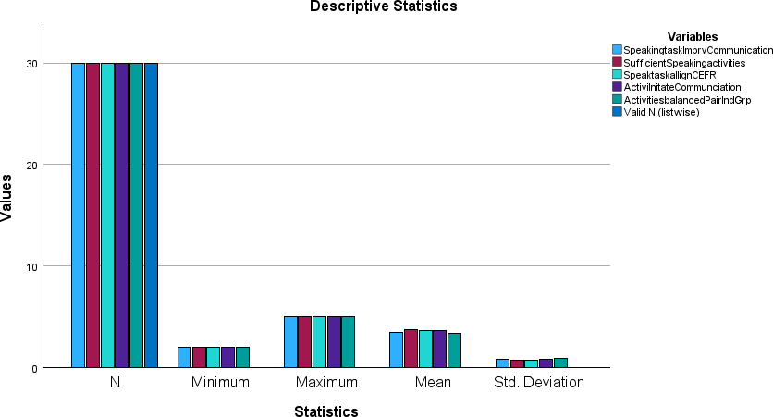

Figure 2 Mean Ratings of Speaking Task Items
Figure 2 shows minimum scores linger just below 2. This indicates that certain teachers disclose that certain speaking components are quite low. This shows that there are teachers who perceive the speaking tasks in the textbook are not communicated well enough, the CEFR alignment is not done well enough or not balanced in format. All variables achieved a maximum of 5 which means that at least one teacher gave each survey item a perfect score. The textbook has potential as some teachers find the speaking components effective but this is not the general idea by everyone. Mean values between 3.4 to 3.7. This suggests moderate satisfaction. The highest mean ranking is 3.77 for Sufficient Speaking Activities while the lowest mean ranking is 3.40 for Balanced Activities for Pair, Individual, and Group Work. This reveals that teachers generally feel that the textbook encourages communication. However, there seems to be a doubt about the variety and balance of speaking formats. The values of standard deviation (SD) are less than 1. This signifies moderate consensus amongst the teachers. A lower SD defines teachers’ agreement regarding a survey item whereas a higher SD defines opposing views. Based on the SD in this chart, most teachers agree on the quantity, they differ on quality and impromptu of speaking tasks.

Survey results showed that the textbook aligns with CEFR descriptors but has notable gaps. Teachers reported limited opportunities for impromptu speaking and a lack of accent diversity in listening materials. Reliability tests confirmed acceptable consistency across survey items, while correlations highlighted links between well-defined listening tasks and sufficient audio materials, and between speaking improvement and CEFR alignment.

4.2 Qualitative Findings

This section presents the thematic analysis of the open-ended responses in the survey which was answered by 30 English language teachers. Automated coding methods were employed to identify repeated themes related to textbook scaffolding, listening and speaking skill development and classroom realities. The findings are divided into four areas which are thematic overview, treemap visualisation, adaptations by teachers as well as distribution frequency of auto coded themes. Open-ended responses were analysed using NVivo 15, revealing three dominant themes:

- Theme 1: Clarity and Authenticity of Audio Materials Commonly the teachers commended the clarity of audio tracks but mentioned that some were too fast, lacked contextual relevance or could not relate to the slang or accent used. “The listening tracks are clear, but some students find them too fast.” This implies that the audio tracks do not suit a diverse learner environment even though the textbook supplies the necessary audio tracks.

- Theme 2: Speaking Tasks and Real-Life Relevance While speaking tasks were seen as beneficial, many teachers felt they lacked authenticity and spontaneity. “Role-plays are beneficial, but they do not reflect real-life situations.” This indicates the gap between a textbook design and the reality of communicating.

- Theme 3: Teacher Adaptation and Scaffolding Teachers regularly adapted textbook tasks to suit their students’ proficiency levels, indicating a need for more flexible materials. “I often modify speaking tasks to suit my students’ proficiency levels.” This theme emphasised the fact that teachers are playing an active role to customise materials that are aligned with CEFR in order to meet the demands of the diverse classrooms.

A treemap was generated using NVivo 15 to help with visualising the extend and importance or significance of codes found in qualitative analysis.

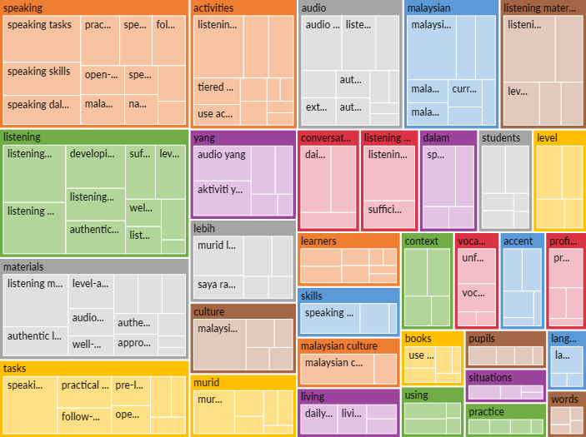

Figure 3: Treemap visualisation of NVivo coded qualitative themes related to listening and speaking skill development

The Figure 3 shows the treemap systematically arranged the themes based on hierarchy. Box sizes indicate frequency of references found in the responses given by the teachers. Therefore, smaller boxes indicate less regularly referenced codes whereas larger boxes show more regularly referenced codes. Speaking, listening, activities, students and culture are the major categories that highlight the pedagogical aim of English Plus 1. The subtheme follow-up speaking tasks showed up with 5 direct and 5 aggregated references. This implies the repetition role in reinforcing oral proficiency. This theme aligns with CEFR descriptors that highlight prolonged or retained interaction and task-based speaking practice. The interconnectivity of different concepts such as accent, context and materials provide comprehension on the exploitation of textbook in Malaysian ESL classrooms.

4.2.1 Frequency Distribution of Auto Coded Themes

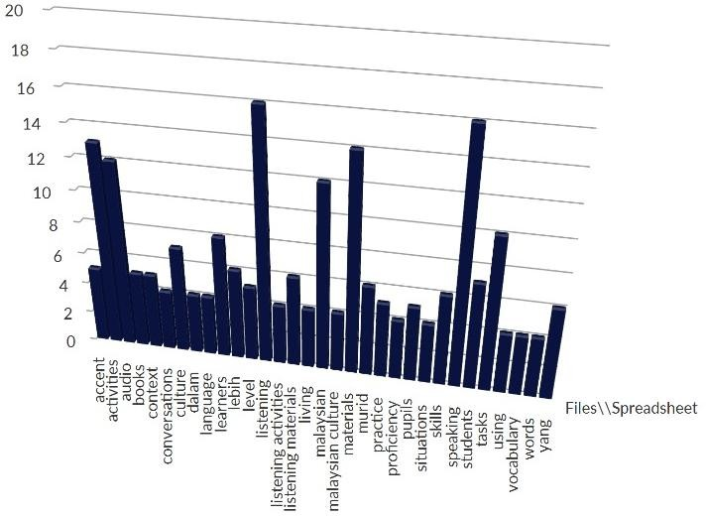
Figure 4: Distribution of Coding References Across Auto Coded Themes in ESL Textbook Evaluation
Note. Themes include “listening”, “speaking”, “accent”, “culture”, and others based on NVivo auto code results.

Figure 4 presents a 3D bar chart generated using NVivo’s autocode function, which visualizes the distribution of coding references across 28 emergent themes. The vertical axis represents the number of coding references, while the horizontal axis lists each theme identified from teacher responses. This visualization complements the treemap by offering a quantitative snapshot of thematic density. Themes such as speaking, students, tasks, listening, and activities show the highest frequency of coding references, indicating their centrality in teacher discourse. These results reinforce earlier findings that emphasize the textbook’s role in facilitating oral communication and structured skill development. The prominence of listening materials and listening activities further supports the quantitative ratings of audio sufficiency and goal clarity.

Interestingly, themes like accent, culture, Malaysian, and Malaysian culture also appear with moderate frequency, suggesting that teachers are attentive to the sociolinguistic and cultural relevance of textbook content. This aligns with qualitative feedback regarding the need for localised examples and authentic listening inputs. Lower-frequency themes such as yang, books, and media may reflect peripheral concerns or isolated mentions, but their presence still contributes to the overall thematic landscape. The chart’s distribution highlights the multifaceted nature of textbook exploitation, encompassing linguistic, pedagogical, and contextual dimensions. By quantifying the thematic spread, this chart strengthens the interpretive depth of the qualitative analysis and supports the integration of findings across data types.

Table 5 Themes, Sub-themes, Frequencies and Illustrative Quotes
Themes | Sub-themes | Frequencies | Illustrative Quotes
Professional Development | Lack of training opportunities | 8 | “Teachers are  expected to  assimilate the  content by  themselves, which is tedious on top of  all the other work.”
Professional Development | Need for  mentorship | 5 | “We used to  have good  textbooks previously… the content could be improvised to match CEFR standards, but  guidance is  lacking.”
Teaching Challenges | Classroom management | 7 | “Students from rural areas or with low proficiency find it tough to cope with audio and may lose interest, disrupting classroom learning.”
Teaching Challenges | Time constraints | 6 | “Editing the audio speed and preparing scripts is tedious for teachers on top of all the  other work that is expected of them.”
Student Engagement | Low motivation | 9 | “The textbook uses high-level topics and language like C1/C2, while our students are mostly just reaching A2… they struggle  to relate.”
Student Engagement | Participation issues | 4 | “Students should be encouraged to be involved in day-to-day conversations
so it is more relevant and
meaningful for
them.”
Resource Adequacy | Insufficient materials | 6 | “Include more real-life dialogues, authentic listening materials, and practical speaking tasks… this will make learning more  meaningful.”
Resource Adequacy | Limited access to technology | 5 | “Students from rural areas struggle with audio… having a local tone would help them cope better and reduce the need for extra teacher intervention.”

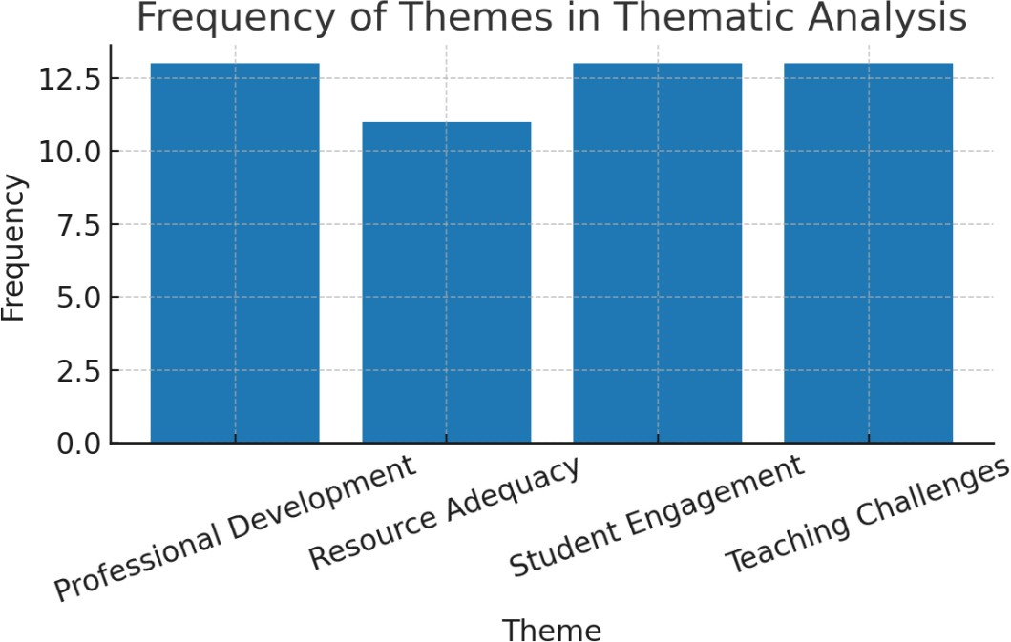

Figure 6: Frequency of Themes Identified in Thematic Analysis

Vivo analysis revealed recurring themes. Teachers emphasised the need for more culturally relevant content, authentic oral tasks, and flexibility to suit mixed-ability classrooms. Comments highlighted that scripted dialogues and Western-centric examples reduce relevance for Malaysian learners, while limited fluency-building activities restrict students from moving beyond guided responses to independent speech.

4.3 Integration of Quantitative and Qualitative Findings

Integration refers to the method of combining quantitative data which is numerical or statistical with qualitative data which is textual or thematic to form a cohesive understanding of the research problem. Not only are both types of data presented but they complement each other by displaying how they agree or disagree with each other. In this research, there was an investigation of how English Plus 1 helps with listening and speaking skills. Teachers’ rating in the Likert-scale provides the quantitative data whereas why they rated it the way they did and how they experience it in practice is reflected in the qualitative data.

There are multiple reasons as to why quantitative and qualitative methods were used in this research. Listening and speaking skills in an ESL classroom can be influenced by textbook features which are measurable and other realities happening in a classroom such as the proficiency levels of different students, time constraints, classroom disruptions and many other factors that play a part in influencing the listening and speaking skills. Other than that, if both data gained from qualitative and quantitative methods are pointing in the same direction then it elevates and strengthens the argument such as the textbook is able to improve the listening and speaking skills. However, if the data from both methods deviate from each other then, it reveals frictions that are worth investigating.

Additionally, it also helps to bridge theory and practice. Theoretical alignment will be reflected through the quantitative data. Apart from that, the qualitative data reveals how teachers deal with all the real classrooms obstacles such as the actual textbook implementation despite the challenges faced and how they adapt those tasks including the challenges. Lastly, by integrating both these methods in researches, it helps in enhancing credibility and depth of the results found. Mixed methods application in researches show that findings are not one sided and have been thoroughly explored. It also displays precision academically and adaptability in real-life challenges and obstacles.

The integration of quantitative and qualitative findings provided a comprehensive understanding of how English Plus 1 supports listening and speaking skill development. Quantitative data revealed generally positive ratings for textbook scaffolding and CEFR alignment, while qualitative responses added depth by highlighting classroom constraints and teacher adaptations. For example, while “Defined Goals in Listening Tasks” received a mean score of 3.63, teachers also described modifying tasks to suit students’ proficiency levels. This convergence suggests that while the textbook is theoretically sound, its practical implementation requires flexibility. Conversely, disagreement was observed in speaking task authenticity despite moderate ratings, teachers expressed concerns about impromptu and real-life relevance. These integrated insights underscore the importance of designing materials that are both pedagogically aligned and contextually adaptable.

5. Conclusion

The findings sustain the foundational strengths of English Plus 1 Year 5 while identifying areas for improvement. With careful transformation, a design which is inclusive, and continuous support for teachers, CEFR-aligned materials can evolve into powerful tools for communicative competence. Finally, the success of any curriculum lies not in its theoretical alignment, but in its ability to relate with students and empower teachers. This study contributes to that vision, encouraging a more responsive, impartial and effective approach to language education in Malaysia.

While the textbook supports CEFR-aligned oral skill development, the effectiveness is limited by a lack of cultural relevance and authentic oral practice. Teachers’ adaptations highlight the need for future textbook revisions to include culturally relevant content, varied accents, and open-ended oral activities. This will better support ESL learners in Malaysia’s diverse classrooms. This study highlights the complex relationship between textbook design, teacher agency, and classroom realities in CEFR-aligned ESL instruction. Integrating the voices of teachers and contextual needs, offers an understanding of the development of oral skills and practical recommendations for reform.

6. Recommendations for Future Research

The findings of this study have shed light on several parts where further investigation could help deepen the understanding of CEFR-aligned oral skill instruction in Malaysian classrooms. Even though the perspectives shared by teachers have given us valuable insights into the effectiveness of the textbook and classroom realities, future research can be made broader by including other contributors, longitudinal data and comparative contexts. While this study collected feedback from teachers, the opinions of students or how well they performed in this environment remain unknown. Future studies should explore how students perceive the listening and speaking tasks. Examining students’ engagement, understanding and perceived relevance can provide critical information on how textbook design influences their motivation and oral skill development.

Another important part that needs to be revealed is the long-term effect of professional development on the way oral skills are imparted to students. This study recognised a lack of CEFR-specific training as an obstacle. Therefore, future studies can identify teachers who undergo structured training programmes and investigate how their ways of teaching evolve over time. Longitudinal studies could examine changes in classroom implementation, outcomes from students and teachers’ confidence level. This will help make the CEFR integration a success. In order to construct a holistic understanding of CEFR implementation, future studies should adopt a mixed-methods approach that will integrate surveys, interviews and classroom observations. Observational data can expose how teachers actually use the textbook and how students respond to the task given to them and what changes are made in real time.

References

Abdullah, N. A. (2017). Challenges in teaching oral communication in Malaysian rural schools. Malaysian Journal of ELT Research, 13(2), 45–60.

Abdelwahab Mahmoud, A. (2024). Textbook selection and sociocultural realities in ESL classrooms. Journal of Language and Curriculum Studies, 18(1), 22–35.

Almulla, M. A. (2023). Constructivist learning environments and student engagement in ESL contexts. International Journal of Educational Research, 102, 101–115.
Biernacki, P., & Waldorf, D. (1981). Snowball sampling: Problems and techniques of chain referral sampling. Sociological Methods & Research, 10(2), 141–163.

Council of Europe. (2001). Common European Framework of Reference for Languages: Learning, teaching, assessment. Cambridge University Press.

Council of Europe. (2020). Companion volume to the CEFR: Descriptors and implementation. Council of Europe Publishing.

Erkir, A., & Alkhaldi, M. (2025). Textbook dependency in ESL instruction: A global perspective. TESOL Quarterly, 59(1), 88–104.

Gass, S. M., & Mackey, A. (2018). Input, interaction, and output in second language acquisition. Routledge.

Gilakjani, A. P., & Sabouri, N. B. (2016). Learners’ listening comprehension difficulties in English language learning: A literature review. English Language Teaching, 9(6), 123–133.

Gill, S. K. (2005). Language policy in Malaysia: Reversing direction. Language Policy, 4(3), 241–260.

Goh, C. C. M., & Abdul Aziz, N. (2020). Evaluating CEFR-aligned textbooks in Malaysian classrooms. Malaysian Journal of Language and Education, 10(2), 56–72.

Grand-Guillaume-Perrenoud, J., et al. (2023). Mixed-methods research in education: Strengthening validity through convergence. Educational Research Review, 38, 100–115

Hajimia, M., et al. (2020). Authenticity in ESL listening materials: A review of Krashen’s Input Hypothesis. Journal of Applied Linguistics and Language Research, 7(2), 45–59.

Kassim, H., & Hashim, R. (2023). CEFR integration in Malaysian ESL classrooms: Teacher perspectives and challenges. Journal of Language Teaching and Research, 14(1), 101–115.

Krashen, S. D. (1982). Principles and practice in second language acquisition. Pergamon Press.
Ministry of Education Malaysia. (2013). Education Blueprint 2013–2025. Putrajaya: MOE.

Ministry of Education Malaysia. (2018). Implementing the CEFR-aligned curriculum: Planning and managing learning. Curriculum Development Division.

Mohd Asraf, R., & Abdullah, N. A. (2016). Teachers’ perceptions of textbook effectiveness in Malaysian ESL classrooms. Malaysian Journal of ELT Research, 12(1), 33–50.

Mohamad Uri, N., & Abdul Aziz, N. (2024). Cultural adaptation in CEFR-aligned ESL textbooks. International Journal of Language and Education, 15(1), 77–92.

Mukundan, J., & Ahour, T. (2010). ELT textbook evaluation: A checklist. Journal of Language Teaching and Research, 1(3), 200–206.

Mustafa, R. (2018). English language education reform in Malaysia: CEFR and beyond. Malaysian Journal of Language Studies, 8(2), 45–60.

Newton, J., & Nation, P. (2021). Teaching ESL/EFL listening and speaking. Routledge.
Nimehchisalem, V., & Mukundan, J. (2011). Evaluation of ESL textbooks in Malaysian secondary schools. English Language Teaching, 4(4), 197–206.

Nordin, H., & Rosli, R. (2019). CEFR-aligned curriculum implementation in Malaysian schools: A review. Journal of Curriculum and Pedagogy, 11(1), 23–38.

Noy, C. (2008). Sampling knowledge: The hermeneutics of snowball sampling in qualitative research. International Journal of Social Research Methodology, 11(4), 327–344.

Rajendran, N., et al. (2021). Textbook evaluation and oral skill development in Malaysian ESL classrooms. Journal of Language and Literacy Education, 13(2), 88–104.

Richards, J. C. (2021). Curriculum development in language teaching (2nd ed.). Cambridge University Press.

Shanmugam, S. (2017). CEFR implementation in Malaysian ESL classrooms: Policy and practice. Journal of English Language Teaching and Research, 9(1), 55–70.

Shanmugavelu, R., et al. (2020). Colonial legacies and curriculum reform in Malaysian education. Southeast Asian Journal of Education, 14(3), 112–128.

Thandevaraj, J., et al. (2021). Scaffolding oral communication in ESL textbooks: A Malaysian perspective. Journal of Language Education and Research, 9(4), 67–85.
Togimin, N., & Jaafar, N. (2020). Role-play activities and fluency development in ESL speaking classrooms. Malaysian Journal of Language and Communication, 7(2), 34–49.

Vygotsky, L. S. (1978). Mind in society: The development of higher psychological processes. Harvard University Press.

Yunus, M. M., et al. (2018). Challenges in implementing CEFR-aligned curriculum in Malaysian ESL classrooms. International Journal of Academic Research in Business and Social Sciences, 8(11), 113–125.

Zulkiply, N., & Nasri, N. M. (2024). Teacher training and CEFR-aligned textbook implementation: A Malaysian case study. Journal of Educational Research and Practice, 14(1), 22–39.

Ministry of Education Malaysia. (2018). Dokumen Standard Kurikulum dan Pentaksiran (DSKP) Bahasa Inggeris Tahun 5 Sekolah Rendah. Curriculum Development Division.

Oxford University Press. (2015). English Plus 1: Student’s Book. Oxford University Press.

