Federated Learning Over Blockchain For Data Privacy in Decentralized System : A new perspective

- Introduction
The development of artificial intelligence (AI) and machine learning (ML) has transformed a number of industries, including manufacturing, autonomous systems, healthcare, and finance. However, centralized data gathering is a major component of standard AI model training methods, which creates serious privacy and security issues, especially when handling sensitive personal data. Access to massive amounts of data is crucial to its success, but this also presents significant privacy, security, and ownership issues. The Traditional machine learning (ML) techniques is central data aggregation, which raises important concerns about data security, privacy, and governance.Stricter data protection regulations like GDPR and HIPAA have increased demand for methods that let businesses work together without disclosing private information.
Federated Learning (FL) has become a promising approach that allows several clients to work collaboratively to train machine learning models without exchanging raw data, protecting data confidentiality and producing shared intelligence.In order to train the model using local data from devices while maintaining privacy, Google initially created Federated Learning (FL), a distributed machine learning paradigm (McMahan et al. 2017).Federated Learning

( FL) ensures that sensitive information remains local , thus preserving user privacy while allowing model updates to be shared across the network. To construct the FL model locally, a few devices are involved. To optimise the global FL model, the central FL server receives the trained local model updates and aggregates them. In contrast to traditional machine learning, FL safeguards client data and stops local data privacy from being revealed[2]. To converge the FL model, the data used for model training is broadcast from different participating businesses and users. They have the authority to lower model performance and enhance the quality of model updates.

However, Federated Learning (FL) faces a number of security and privacy constraints. Federated Learning (FL) faces challenges related to secure aggregation of model updates, data integrity and ensuring fairness among participants [3].Furthermore, FL is vulnerable to fraudulent model modifications, unverifiable client contributions, and free riding due to the absence of a centralized trusted authority. Single Point of Failure (SPoF) and Distributed Denial of Service (DDoS) attacks result from the failure of a central server. Additionally, there is no clear way to capture the local model updates in the existing FL system. Therefore, to identify and stop rogue updates, an efficient decentralized system is needed. By incorporating blockchain technology into federated learning systems, the aforementioned assaults can be prevented.

Federated learning is a decentralized multi-user situation (F1,..., FN) in which the current user's dataset (D1,..., DN) is owned by each user client. These data are gathered collectively via traditional deep learning to provide an aggregated
dataset D = U1 . . . UN, and the model MSUM is acquired following training. The federated A model MFED is jointly trained by the learning method and the participating users. In addition, time, the user data is stored locally and won't be sent outside. If there's a non negative number δ ,t he model accuracy VFED of MFED, the non-negative real number δ, and the model accuracy of VFED of MFED satisfy the following inequality:
|VFED − VSUM| < δ [4]
δ-precision loss is attained via the federated learning algorithm.

Blockchain technology and FL can be coupled to create a safe, decentralized learning system to address issues. The three key features of blockchain—immutability, transparency, and decentralization—help guarantee that model updates are unchangeable, easily traceable, and fairly merged without the need for a central authority. As a result, federated systems are more resilient to threats and have greater trust and responsibility. Blockchain technology offers a useful way to improve the security and transparency of federated learning systems because it is decentralized and impervious to tampering. Blockchain technology can strengthen federated learning by enabling participants to transparently check and audit model modifications without depending on a central authority [5]. Integrated into the blockchain network, smart contracts can guarantee adherence to privacy norms, incentivise participants, and enforce data sharing regulations [6]. Furthermore, blockchain is perfect for developing safe and transparent AI model training settings because of its intrinsic capacity to offer traceability and accountability [7]. Additionally, although blockchain provides a safe foundation for model updates, blockchain-based federated learning systems' energy consumption and scalability issues must be resolved [8]. In order to prevent federated learning poisoning assaults, blockchain's central aggregator detects malevolent and untrustworthy individuals by automating smart contract execution [9]. In order to handle reputation value in a decentralized way, Sun et al. [10] created a novel blockchain platform that can guarantee correct historical reputation, significantly increasing the accuracy of FL.To increase the security of FL, Wang et al. [11] suggested a blockchain-based encryption gradient audit technique that records the encryption gradient from the data owner using the behavior chain. To get around the FL central server's single point of failure, a blockchain-assisted federated learning (BC-FL) framework was created.

- Literature Review
Federated Learning (FL) has drawn a lot of interest as a distributed machine learning technique that protects privacy. FL protects the privacy of personal data by having several devices work together to train a common model while storing their data locally. Early studies on FL showed that it could facilitate training on sensitive datasets, like financial transactions and medical information, without requiring the uploading of raw data to a centralized server [11]. The safe aggregation of model updates is one of the main issues in FL. To guarantee that model updates stay private even when aggregated, a number of studies have concentrated on methods like Homomorphic Encryption and Secure Multi-Party Computation (SMPC) [12]. Nevertheless, these techniques are computationally costly and might not be feasible for widespread implementations.

Blockchain technology has been suggested as a way to improve FL systems' security and reliability. A transparent and safe setting for compiling and confirming model modifications can be offered by blockchain, a decentralized and immutable ledger. In this sense, a number of academics have used blockchain technology with FL to guarantee the authenticity and integrity of model updates, strengthening the federated learning process against hostile operations such data manipulation and model poisoning [13]. Blockchain provides transparency and accountability in decentralized systems by guaranteeing that all model updates are recorded in a tamper-proof manner.

The scalability of the blockchain is a major obstacle in blockchain-based FL systems. Conventional blockchain systems, including Proof-of-Work (PoW), can be computationally costly and unsuitable for the high throughput needed in FL. Alternative consensus methods like Proof-of-Stake (PoS) and Delegated Proof-of-Stake (DPoS), which are more energy-efficient and able to handle the transaction volumes connected with large-scale FL applications, have been proposed by researchers to overcome this problem [14]. These methods guarantee the blockchain's continued scalability and efficiency while preserving its decentralized structure.

Smart contracts, a key feature of blockchain technology, have been utilized to automate tasks such as the verification of model updates, the enforcement of privacy policies, and the distribution of rewards. The use of smart contracts in federated
learning systems allows for the automatic execution of predefined rules without the need for a central authority. Researchers have proposed using smart contracts to enforce data-sharing agreements, ensuring that participants comply with privacy standards and receive incentives for their contributions [15]. These contracts can be programmed to ensure that only valid and verified model updates are aggregated, thus preventing malicious nodes from compromising the system. Despite the promising integration of blockchain and federated learning, several challenges remain in ensuring the security and privacy of model updates.Some studies have pointed out that while blockchain provides transparency, it does not necessarily prevent attacks like model inversion or membership inference, where attackers can infer sensitive information from the model [16]. Researchers have proposed using advanced cryptographic techniques, such as differential privacy and secure aggregation, to address these issues. These techniques provide an additional layer of protection to prevent the leakage of sensitive information while allowing model updates to be securely shared.

Another issue with blockchain-based federated learning systems is their energy usage. The high energy consumption of blockchain's consensus algorithms, particularly PoW, can be prohibitive in large-scale systems. As a result, a number of studies have concentrated on making blockchain networks used in federated learning as energy-efficient as possible. To balance energy consumption and scalability, for example, academics have developed hybrid blockchain models that integrate the advantages of both centralized and decentralized systems [17]. These methods seek to preserve security and decentralization while lowering the computing burden related to blockchain consensus.

The management of non-IID (Independent and Identically Distributed) data across many nodes is another crucial problem in federated learning. In the real world situations, data is frequently diverse, making it difficult to aggregate model updates. Numerous strategies have been put out to deal with this problem, such as federated optimization methods like FedAvg and FedProx, which try to lessen the impact of non-IID data on the model's performance [18]. It has been demonstrated that these techniques increase the accuracy and rate of convergence of models trained in federated environments. Although federated learning and blockchain have a lot of potential, it's crucial to think about the ethical ramifications of implementing such systems, particularly in industries like healthcare and banking.

Concerns regarding the equity and inclusion of decentralized AI systems have been voiced by researchers. Federated learning's decentralized structure may result in unequal access to resources, especially for users with low processing power. In blockchain-based FL systems, some research has suggested ways to guarantee equity in the distribution of rewards and resources [19]. These procedures are designed to make sure that everyone is treated fairly and that no one person controls the training process. Making sure the system is resilient to adversarial attacks is crucial while training AI models.

- Methodology

1. Local Model Training
Each client or organization (such as hospitals, banks, or IoT devices) trains a local machine learning model using its private dataset. No raw data is shared outside the local environment, ensuring complete privacy. To enhance data protection, Differential Privacy (DP) and Gradient Clipping techniques are applied before sharing the model updates. This phase allows collaborative learning without violating data confidentiality.

2. Secure Upload and Blockchain Recording
After local training, the model updates are encrypted and secured with a digital signature and unique hash. These encrypted updates are uploaded to the blockchain ledger, which ensures data immutability and prevents tampering. The blockchain provides a transparent and verifiable record of every contribution, ensuring that all transactions are trusted and auditable.

3. Decentralized Aggregation and Validation
Instead of relying on a central server, validator nodes on the blockchain perform secure aggregation of model updates. Using Secure Multi-Party Computation (MPC) and Smart Contracts, the system verifies and combines the updates into a global model. This decentralized process eliminates a single point of failure and ensures fairness, transparency, and reliability in model aggregation.
4. Reputation and Incentive Mechanism
Each participant’s contribution is evaluated based on its accuracy, quality, and honesty. A reputation score is maintained on-chain for every client. Through Smart Contracts, reliable participants are rewarded with tokens, while malicious or low-quality contributors are penalized. This mechanism builds trust, encourages active and fair participation, and protects the system from data poisoning attacks.

5. Global Model Distribution and Transparency
The finalized global model and its metadata are recorded in an on-chain model registry to maintain full traceability. The global model is then distributed back to all participants for continued training. Continuous monitoring and audit trails ensure that all activities remain transparent, secure, and privacy-preserving. This integrated process ensures a tamper-proof, decentralized, and accountable learning system, ideal for applications in healthcare, finance, and IoT environments.

Federated learning systems based on blockchain technology have been suggested as a way to reduce the dangers associated with model poisoning, in which malevolent players provide incorrect updates to deteriorate the trained model's performance [20]. Blockchain-based FL systems have incorporated strategies including anomaly detection, reliable aggregation techniques, and the use of trusted execution environments (TEEs) to identify and thwart malicious activity.In conclusion, a safe, transparent, and effective framework for training AI models in decentralized settings is offered by the combination of blockchain technology and federated learning. Scalability, energy consumption, data heterogeneity, and security against hostile attacks are some of the remaining issues. Future research must focus on addressing these challenges and developing more efficient and secure blockchain-based federated learning systems for large-scale AI model training.

- Proposed Architecture
This diagram explains a Blockchain-Integrated Federated Learning System, which combines:
- Federated Learning (FL) → trains AI models without sharing raw data
- Blockchain → ensures trust, transparency, and secure coordination
- Privacy Preservation → protects sensitive information
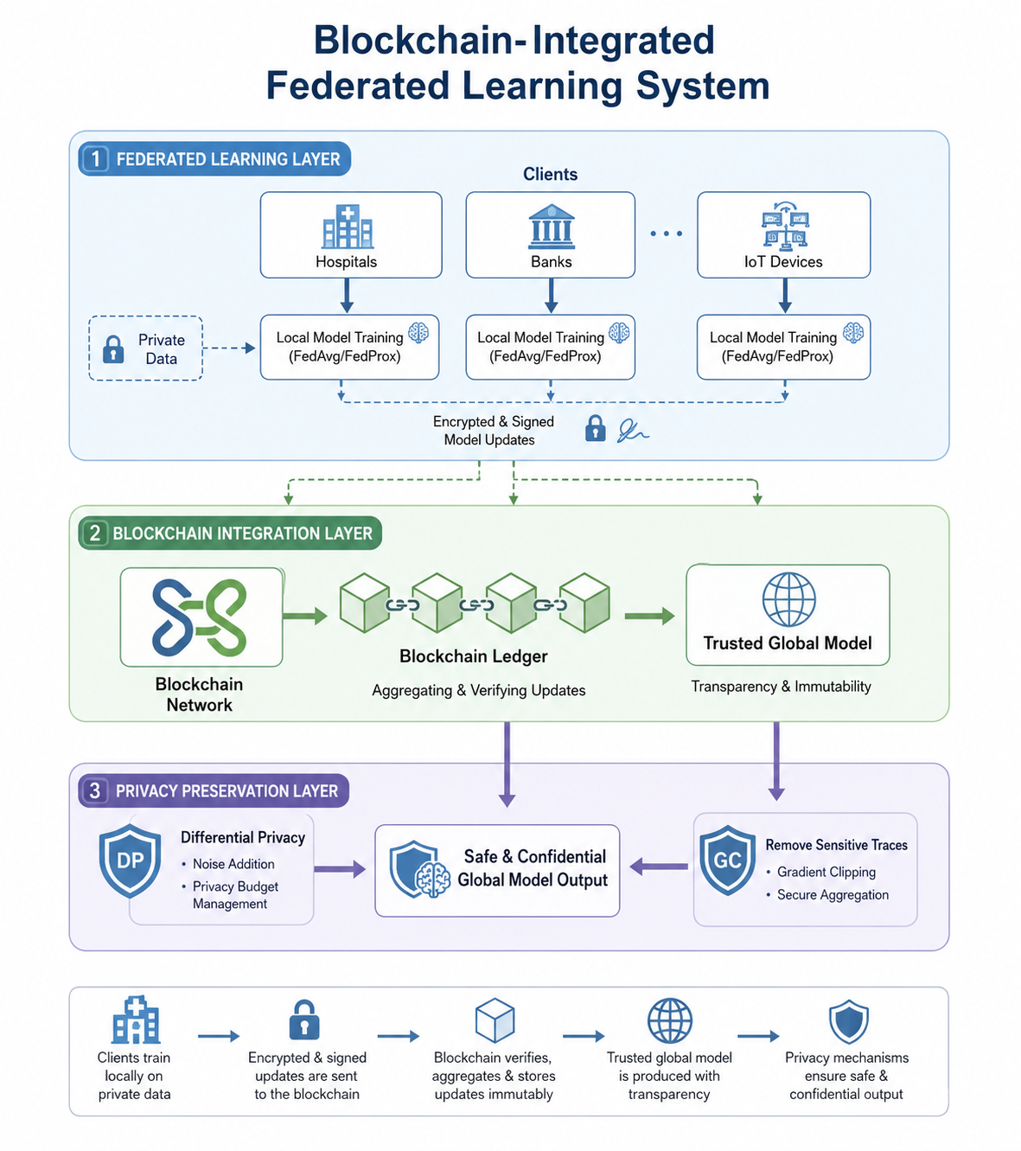

1. Federated Learning Layer
This is the top layer where different organizations or devices train AI models locally.

Participants (Clients)
Examples shown:
- Hospitals
- Banks
- IoT Devices
Each client has its own private data.

Important Idea
The raw data never leaves the organization/device.
Instead of sending data:

- Each client trains a local AI model
- Only the model updates/parameters are shared
The diagram mentions:
- FedAvg
- FedProx
These are popular federated learning algorithms.

Why Federated Learning?
Normally in machine learning:
- All data is collected into one central server
Problems:
- Privacy risks
- Legal restrictions
- Data leakage
Federated learning solves this by keeping data local
2. Blockchain Integration Layer
This is the middle layer.
It adds:
- Security
- Trust
- Transparency
- Tamper-proof record keeping

How It Works
After local training:
- Clients send encrypted model updates
- Updates are digitally signed
- Blockchain stores records in a ledger
- Updates are aggregated into a global model

Blockchain Ledger
The blockchain acts like a secure logbook.
It:
- Records all updates
- Prevents tampering
- Verifies participants
- Tracks contribution history
Because blockchain is immutable:
- Nobody can secretly change model updates

Trusted Global Model
After aggregation:
- A global AI model is created
- All participants receive the improved model
Benefits:
- Trustworthy
- Transparent
- Secure

3. Privacy Preservation Layer
This is the final protection layer.
Even model updates can leak information sometimes.
So extra privacy techniques are applied.

Differential Privacy (DP)
The diagram shows “DP”.
Differential Privacy:
- Adds controlled noise to updates
- Prevents attackers from reconstructing private data
Example:
A hospital’s patient information cannot be inferred from model updates.

Remove Sensitive Traces
Additional protections:
- Gradient clipping
- Secure aggregation
- Anonymization
These reduce leakage risks.

Final Output
The result is:

“Safe & Confidential Global Model Output”
Meaning:
- Accurate AI model
- Privacy protected
- Blockchain verified
- No raw data sharing

- Result
The suggested Blockchain and Federated Learning system has demonstrated remarkable outcomes in establishing a secure and reliable data-sharing environment. The blockchain layer functions as a decentralized, immutable digital ledger that records each update. This guarantees that every record is transparent, traceable, and impervious to manipulation. By verifying each transaction before adding it to the chain, participants' trust is increased and the need for a central authority is eliminated.
In creating a safe and dependable data-sharing environment, the proposed Blockchain and Federated Learning system has shown impressive results. Every update is recorded via the blockchain layer, which operates as a decentralized, unchangeable digital ledger. This ensures that all records are clear, traceable, and unchangeable. Participants' trust is boosted and the need for a central authority is removed by validating every transaction before adding it to the chain.
Multiple devices or organizations can collaborate on a common model while maintaining the privacy of their own data thanks to federated learning. This strategy promotes cooperation without running the danger of ownership problems or data leakage. Sensitive information is kept safe during processing and communication by employing encryption and security measures. When combined, these layers increase the security and dependability of information sharing.

The outcomes demonstrate how well security, privacy, and efficiency are balanced by this integrated system. It lessens the likelihood of network attacks, data misuse, and illegal access. A reputation- based incentive system is another feature of the system that encourages sincere engagement and deters dishonest activity.

All things considered, the suggested approach offers a reliable and open option for safe data cooperation. It can be used successfully in sectors where safeguarding private and sensitive data is essential, such banking, healthcare, and smart gadgets. This method fosters user confidence and establishes a solid basis for future secure digital collaboration by guaranteeing privacy and accountability.

- Conclusion
We presented a Blockchain-Based Decentralized Federated Learning (BC-DFL) architecture in this paper that combines the advantages of federated learning and blockchain technology to solve significant issues with scalability, security, and privacy during AI model training. The suggested solution demonstrates how federated learning and blockchain technology can be combined to provide a dependable, transparent, and safe method of data management and sharing. It makes it possible for various devices or organizations to collaborate without disclosing private information. While blockchain maintains a safe record of all modifications, each participant trains its own model locally, making the process transparent, traceable, and impervious to manipulation. This guarantees that no one party dominates the system and fosters confidence among participants.
By automatically verifying updates, merging results, and managing incentives or punishments equitably, the usage of smart contracts streamlines and improves the overall process. Sensitive information is safeguarded at every stage of the process thanks to encryption and other security measures. When combined, these layers provide a stable and privacy-friendly framework for practical applications.
The combined strategy maintains a solid balance between security, performance, and ease of collaboration, according to the overall results. It effectively lowers the dangers of unfair data processing, illegal access, and data leaks. Even if there are still issues like high energy consumption and scalability, these can be resolved in the future with enhanced optimization.
The combined strategy maintains a solid balance between security, performance, and ease of collaboration, according to the overall results. It effectively lowers the dangers of unfair data processing, illegal access, and data leaks. Even if there are still issues like high energy consumption and scalability, these can be resolved in the future with enhanced optimization.
In conclusion, our system helps businesses collaborate safely while preserving complete privacy and confidence by offering a workable and reliable solution for secure data sharing in critical domains like healthcare, finance, and smart devices.

- References

[1] Konečný, J., McMahan, H. B., Yu, F. Richtárik, P., & Suresh, A. T. (2016). Federated Learning: Strategies for
Improving Communication Efficiency. Proceedings of the P. Gokila, P. Ganeshkumar, V. Priyanka, M. Sabrigiriraj,
Kalaivani T. / IJCESEN 11-3(2025)4391-4398 4398 20th International Conference on Artificial Intelligence and
Statistics, 1-10.
[2] Shokri, R., &Shmatikov, V. (2015). Privacy- Preserving Deep Learning. Proceedings of the 22nd ACM
SIGSAC Conference on Computer and Communications Security, 1310-1321.
[3] Zhang, C., &Zheng, S. (2019). Blockchainbased Federated Learning. IEEE Global Communications Conference
(GLOBECOM),1-6.
[4] McMahan, B.; Moore, E.; Ramage, D.; Hampson, S.; y Arcas, B.A. Communication-efficient learning of deep
networks from decentralized data. In Proceedings of the Artificial Intelligence and Statistics, Lauderdale, FL,
USA, 20–22 April 2017; PMLR: London, UK, 2017; pp. 1273–1282. [CrossRef].
[5] Sood, K., Dhanaraj, R.K., Balusamy, B., Grima,S. and Uma Maheshwari, R. (Ed.). (2022). Prelims, Big Data:
A Game Changer for Insurance Industry (Emerald Studies in Finance, Insurance, and Risk Management),Emerald
Publishing Limited, Leeds, i-xxiii. https://doi.org/10.1108/978-1-80262-605-620221020
[6] Janarthanan, R.; Maheshwari, R.U.; Shukla, P.K.; Shukla, P.K.; Mirjalili, S.; Kumar, M.(2021) Intelligent
Detection of the PV Faults Based on Artificial Neural Network and Type 2 Fuzzy Systems. Energies, 14, 6584.
https://doi.org/10.3390/en14206584
[7] Maheshwari, R.U., Kumarganesh, S., K V M,S. et al. (2024) Advanced Plasmonic Resonance-enhanced
Biosensor for Comprehensive Real-time Detection and Analysis of Deepfake Content.
Plasmonics.https://doi.org/10.1007/s11468-024-02407-0 .
[8] Liu, H., Chen, J., & Zhang, Y. (2020). Secure Aggregation for Federated Learning with Blockchain.
International Journal of Machine Learning and Cybernetics, 11(3), 723-735.
[9] Meng, W., & Zhang, C. (2020). Blockchain and Federated Learning for Secure Model Aggregation in
Decentralized AI. Future Generation Computer Systems, 102, 43-51.
[10] Liu, W., & Li, H. (2019). Decentralized Machine Learning with Blockchain Technology. International Journal
ofComputer Applications, 179(13), 1-7.
[11] Zhang, R., & Liu, Y. (2020). Blockchain-Based Federated Learning Framework for PrivacyPreserving
Healthcare Applications. Journal of Medical Imaging and Health Informatics, 10(8), 1924-1932
[15] Mohanty, P., & Kannan, S. (2020). Blockchain- Enabled Federated Learning for Edge Computing.
Proceedings of the 2020 IEEE International Conference on Edge Computing (EDGE), 1-10.
[16] Narayan, V., & Bhasin, A. (2018). Smart Contracts for Blockchain-Based Federated Learning Systems.
Future Generation Computer Systems, 88, 54-63.
[17] Mollah, M. S., & Rahman, M. (2019). Privacy-Preserving Federated Learning Framework Using Blockchain
and Homomorphic Encryption. Journal of Cloud Computing:Advances, Systems and Applications, 8(3), 1-9.
[18] Zhang, X., & Li, Z. (2020). A Survey of Blockchain Applications in Federated Learning. Journal of
Computer Science and Technology, 35(6), 1-21.
[19] Wang, S., & Zhang, J. (2019). Incentivizing Federated Learning with Blockchain. IEEE Transactions on
Emerging Topics in Computing, 8(4), 654-664.
[20] Xu, L., & Zhang, M. (2021). Blockchain for Federated Learning in Internet of Things (IoT) Systems. IEEE
Internet of Things Journal, 8(3), 2503-2511.

