Mapping the Access and Utilization of Technology Devices in Teaching Technology Course:
A Bibliometric Review

Maria Stella Bangoy Augusto ª| Rushdee M. Cubianª| Ruby Jean Salva Sayon^{b}
ª College of Technology, University of Southeastern Philippines
^{b}Sonlon National High School, Division of Davao del Norte, Department of Education,Philippines

ABSTRACT
The application of technology devices in teaching technology courses has widely changed the way we teach in the digital era. Current bibliometric review on this was designed and structured as access to and usage of the technology devices for teaching technology courses at 2021 2026. Analysis of the 897 documents taken from a data sample of 498 sources was undertaken using the LENS bibliographic database. The analyses show ICT tools, blended learning and digital equity are the main areas. There is a decreasing rate of publication growth rate (-46.82%), while co-authorship practice is a typical method in research studies. At 0% international co-authorship, the continued absence of international collaboration reflects a lack of global investment in the field. This review highlights important trends, patterns of research, and emerging technologies that yield actionable structures to inform future technology-enhanced learning research and policy.
Keywords: Educational Technology, Blended Learning, Online Learning, ICT Tools, Digital Divide, Bibliometric Analysis

INTRODUCTION
Integrating technology has tremendously impacted technology course delivery particularly in the area of STEM and vocation training (Dunleavy et al., 2017). ICT devices, Augmented Reality and virtual learning environments has become integral part of teaching and learning as educational institutions adapt to the rapid pace of technological change. The technologies not only increase access, engagement, and efficiency but also offer a dynamic, personalized and immersive learning experience. In spite of the positive trends, challenges such as digital equity, technological access and the effective pedagogical use of resources are present (Selwyn, 2016).
The purpose of this study is to explore the research trends related to technology device access and use in teaching technology courses for the period 2021–2026. Using 897 documents from 498 sources, this study intends to analyze relevant research themes, topics and the growing research trends of technology use in education, as well as use VOSviewer to visualize the global research distribution, and discuss the significance of ICT tools, blended learning, immersive technologies etc. The study aims to provide up-to-date research findings on how these technologies are being incorporated into the teaching practice (Dunleavy et al., 2017).
One of the most prevalent and unsolved issues in the field of technology education is the digital divide. This refers to the distinction between people who can and have ease in accessing technology devices and the internet and those who cannot, especially people living in developing countries. In order to promote equitable access to technology enhanced learning and allow all learners to be equally entitled to benefit from the current digital change, addressing the digital divide seems a vital problem to solve (Selwyn, 2016). Difficult access to devices and internet, however, limits the full application of technology devices in the classroom; this is especially true for the less resourced area (Bozkurt et al., 2020).
This review provides a review of existing trends in the utilization of technology devices in technology teaching and a research agenda. In that regard, it will be necessary to identify gaps in research and to offer policy suggestions for enhancing the access of technology devices in education. One aspect highlighted by this study is that the divide is necessary to tackle, because, not only we should be able to use technology devices everywhere, but also, these devices have to be used fairly and inclusionately (Dunleavy et al., 2017; Selwyn, 2016).

Objective of this review:
- To analyze trends in scholarly publications on the access and utilization of technology devices in teaching technology courses.
- To identify key authors contributing to the field and examine the global distribution of this research.
- To examine the most cited articles, journals, and keywords in the field, determining the core themes and influential works.
- To map the evolution of technology device utilization, focusing on shifts in device types, pedagogical approaches, and technological advancements.
The research will examine technology's use for teaching technology courses, and there is a growing interest in the uses of the immersive technology of augmented reality. Digital equity is one of the most obvious concerns impacting the usage of technological devices for teaching technology.
By addressing the objectives, the study will contribute to the knowledge on technology device utilization in teaching technology courses which offers significant insights for future research and policymaking aiming to overcome the digital gaps and enhance the quality of education through technology in this digital age.

MATERIALS AND METHODS
The bibliometric study described in this paper uses a systematic approach. Initially, data for this study were extracted from the Lens database between the years of 2021-2026. Using a precise set of search terms covering ICT tools, on-line learning, blended learning, augmented reality, and technology acceptance model. The 897 papers were obtained from 498 documents, of which many were journal articles, research reports, and conference proceedings relevant to the current study. The bibliometric databases such as Lens have been established as popular and useful sources for large-scale scholarly research because they cover most academic outputs and provide access to all citation data (Jefferson et al. 2018).
After data collection, the dataset was screened and prepared by removing duplicate and irrelevant records to maintain the quality of the analysis. The bibliographic details like title, keywords, author, abstract, citation, author affiliation were maintained. This follows with a normal cleaning procedure for bibliometric data so that the result would be correct and trustworthy (Zupic & ater, 2015). The cleared data would be analyzed by the VOSviewer, in order to generate the bibliometric maps and visualize the co-occurrence network among the keywords. From that step, it would be able to get the central research areas, groups and upcoming trends for the using of technology devices in technology course's teaching as evidence supported by previous bibliometric studies that apply VOSviewer generated network approach (Van Eck & Waltman, 2010; Donthu et al., 2021)
The initial visualization provided a basis, after which the data was processed further in the RStudio of which it was supported by Rtools, through which the data transformation and structuring could be carried out and cleaned up in order for the analysis of the frequency of the keywords, citation counts and collaboration patterns to be explored in more depth. The use of R-based tools in bibliometric analysis were well established due to its flexibility in statistical computing and reproducibility (R Core Team, 2023; Aria & Cuccurullo, 2017). With this process, the study was able to examine citation impact, identify the most influential publications and journals, and analyze patterns of international collaboration based on the authors’ affiliations.
Lastly, the findings generated from VOSviewer and R-based tools were examined with reference to this study's objectives. The results indicated distinct trends in terms of research productivity, theme emergence and technology devices used in education that emerged. It also showed that the bulk of the studies carried out in this field is regional rather than global, which gives a clearer idea of the status of research and direction in this field and complements existing literature of bibliometric analysis on the discovery of knowledge structures and research trends in the field of education and technology (Donthu et al. 2021, Zupic and ater 2015)

RESULTS AND DISCUSSION

3.1. Trends in scholarly publications on technology device utilization

The following analyses of the 897 articles obtained from the Lens database from 2021-2026 as seen in Table 1 shows a consistent increment of scholarly articles related to the access of ICT devices and the use of ICT devices in teaching technology courses. It also shows the increasing number of continuing interests on integrating ICT devices in the education domain. As we could see from these, the recent works mostly dealt with online courses, blended courses and the latest trends of technology, such as AR, while as Bond et al., (2021) described, it is the general trend in teaching. And it is likely that those data would continue to rise, because technology is changing so fast that people always want to explore in what way it should be applied to education especially as people are widely seeking for the best flexible teaching-learning modality which has already become a key trend in education throughout the world as reported by Bond et al., (2021).

Table 1 Trends in scholarly publications on technology device utilization

Description | Results
Timespan | 2021:2026
Sources (Journals, Books, etc) | 498
Documents | 897
Annual Growth Rate % | -46.82
Document Average Age | 3.86
Average citations per doc | 11.39
References | 12258
Keywords Plus (ID) | 4152
Author's Keywords (DE) | 4152
Authors | 5501
Authors of single-authored docs | 149
Single-authored docs | 163
Co-Authors per Doc | 6.96

3.2. Key authors and global distribution of research

As presented in Figure 2, the bibliometric mapping highlights the group of key authors contributing to their field. The findings show that while research productivity is globally distributed, there are limited international co-authorship networks having a rate of 0% as indicated in Figure 1. The dataset suggests that although the topic is globally relevant, research efforts are often localized, due to contextual differences in technology access and educational system, there is hardly an international co-authorship collaboration. Similar patterns have been observed in prior bibliometric studies, where geographical disparities influenced research output and collaboration (Donthu et al., 2021; Zupic & Čater, 2015). Meanwhile, the most cited article as presented in Table 2, Rudolph J, (2023) is most cited article having a total of 852 citations starting 2021 to present and 213 citations per year with normalized average citation of 53.17.

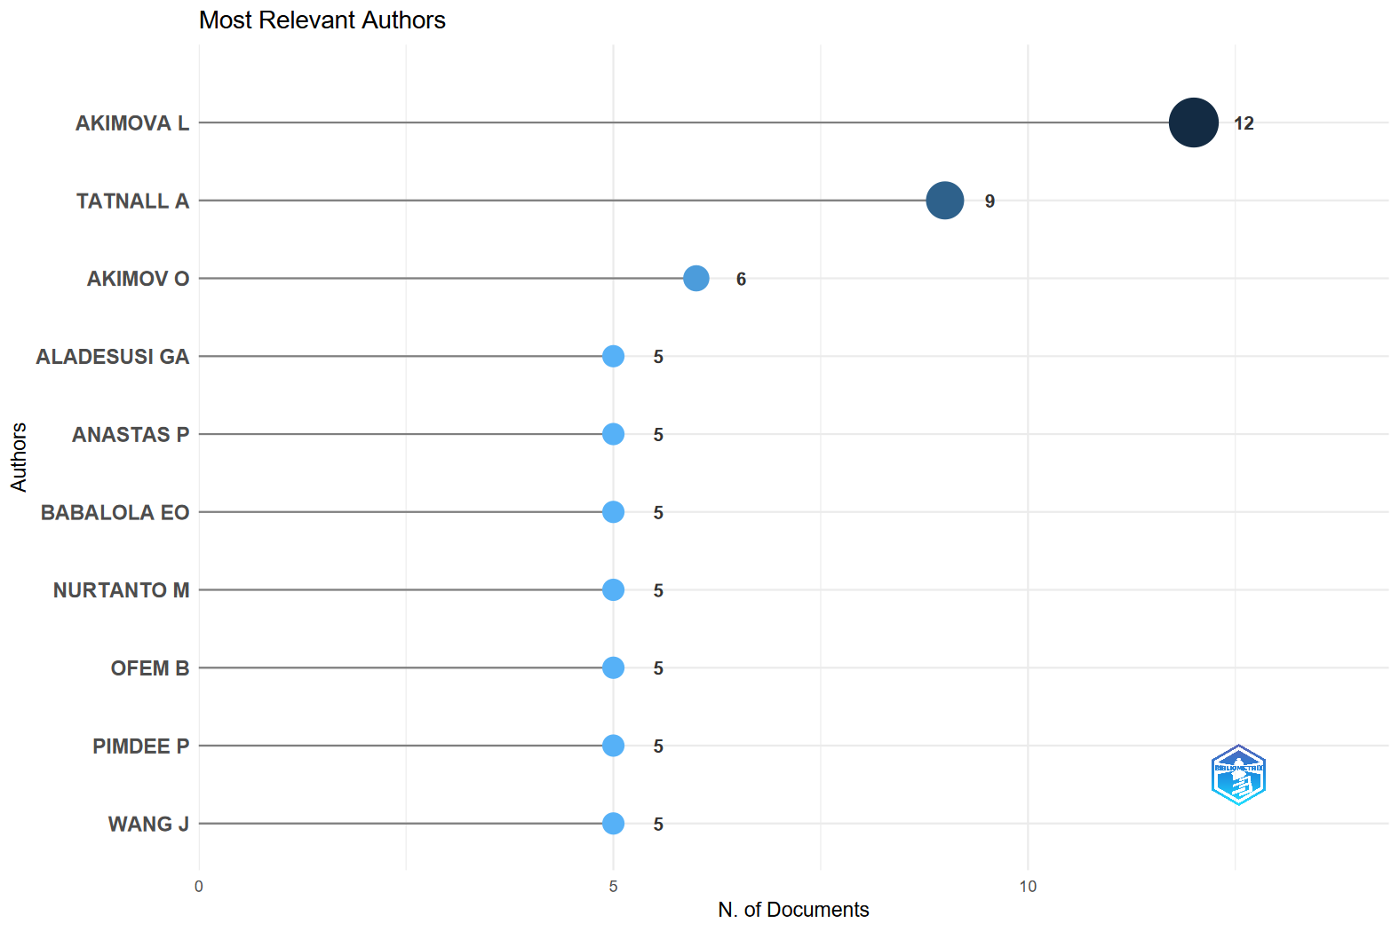
Figure 2. Most relevant authors

Table 2 Most cited article
Paper | DOI | Total Citations | TC per Year | Normalized TC
RUDOLPH J, 2023, JOURNAL OF APPLIED LEARNING & TEACHING | 10.37074/jalt.2023.6.1.9 | 852 | 213 | 53.1715
DWIVEDI YK, 2022, INTERNATIONAL JOURNAL OF INFORMATION MANAGEMENT | 10.1016/j.ijinfomgt.2021.102456 | 536 | 107.2 | 43.16313
GONZÁLEZ-PÉREZ LI, 2022, SUSTAINABILITY | 10.3390/su14031493 | 459 | 91.8 | 36.96245
BOND M, 2021, INTERNATIONAL JOURNAL OF EDUCATIONAL TECHNOLOGY IN HIGHER EDUCATION | 10.1186/s41239-021-00282-x | 229 | 38.2 | 23.12492
KUMAR A, 2021, IEEE ACCESS | 10.1109/access.2021.3085844 | 183 | 30.5 | 18.47974
YU H, 2024, HELIYON | 10.1016/j.heliyon.2024.e24289 | 170 | 56.7 | 13.159
WANG C, 2024, HUMANITIES AND SOCIAL SCIENCES COMMUNICATIONS | 10.1057/s41599-024-02717-y | 168 | 56 | 13.00418
REIMERS F, 2022, SPRINGER INTERNATIONAL PUBLISHING | 10.1007/978-3-030-81500-4 | 167 | 33.4 | 13.44821
DAHALAN F, 2023, EDUCATION AND INFORMATION TECHNOLOGIES | 10.1007/s10639-022-11548-w | 162 | 40.5 | 10.11007
JIANG H, 2021, EDUCATION AND INFORMATION TECHNOLOGIES | 10.1007/s10639-021-10519-x | 158 | 26.3 | 15.95519
DAHRI NA, 2024, HELIYON | 10.1016/j.heliyon.2024.e29317 | 147 | 49 | 11.37866
QURESHI MI, 2021, INTERNATIONAL JOURNAL OF INTERACTIVE MOBILE TECHNOLOGIES (IJIM) | 10.3991/ijim.v15i04.20291 | 127 | 21.2 | 12.82474
SALAS-PILCO SZ, 2022, SUSTAINABILITY | 10.3390/su142013572 | 116 | 23.2 | 9.341274
KUSHAIRI N, 2021, EDUCATION AND INFORMATION TECHNOLOGIES | 10.1007/s10639-021-10457-8 | 114 | 19 | 11.51197
YUE M, 2022, SUSTAINABILITY | 10.3390/su142315620 | 110 | 22 | 8.858105
MARTINS J, 2022, UNIVERSAL ACCESS IN THE INFORMATION SOCIETY | 10.1007/s10209-022-00953-0 | 103 | 20.6 | 8.294407
HIDAYAT R, 2022, INTERNATIONAL ELECTRONIC JOURNAL OF MATHEMATICS EDUCATION | 10.29333/iejme/12132 | 102 | 20.4 | 8.213879
ALNAGRAT A, 2022, JOURNAL OF HUMAN CENTERED TECHNOLOGY | 10.11113/humentech.v1n2.27 | 100 | 20 | 8.052822
TURAN Z, 2022, INTERNATIONAL JOURNAL OF EDUCATIONAL TECHNOLOGY IN HIGHER EDUCATION | 10.1186/s41239-022-00342-w | 89 | 17.8 | 7.167012
MHLANGA D, 2022, EDUCATION SCIENCES | 10.3390/educsci12070464 | 84 | 16.8 | 6.764371
HERMANTO YB, 2021, JURNAL PENDIDIKAN DAN PENGAJARAN | 10.23887/jpp.v54i1.29703 | 81 | 13.5 | 8.179558
RAMAN R, 2022, EDUCATION AND INFORMATION TECHNOLOGIES | 10.1007/s10639-022-11058-9 | 77 | 15.4 | 6.200673
SINGH M, 2021, EDUCATION AND INFORMATION TECHNOLOGIES | 10.1007/s10639-021-10585-1 | 76 | 12.7 | 7.674647
CHEN L, 2021, ENTREPRENEURSHIP EDUCATION | 10.1007/s41959-021-00047-7 | 75 | 12.5 | 7.573665
SAIKAT S, 2021, EDUCATION SCIENCES | 10.3390/educsci11090459 | 74 | 12.3 | 7.472683
RAMÍREZ-MONTOYA MS, 2021, FUTURE INTERNET | 10.3390/fi13040091 | 74 | 12.3 | 7.472683
WANNAPIROON N, 2022, EDUCATION AND INFORMATION TECHNOLOGIES | 10.1007/s10639-021-10849-w | 71 | 14.2 | 5.717504
ALIETO E, 2024, HELIYON | 10.1016/j.heliyon.2024.e24282 | 71 | 23.7 | 5.495816
JING Y, 2023, SUSTAINABILITY | 10.3390/su15043115 | 71 | 17.8 | 4.430958
EMILY C, 2021, SUSTAINABILITY | 10.3390/su132212763 | 70 | 11.7 | 7.068754
SABEH HN, 2021, IEEE ACCESS | 10.1109/access.2021.3084815 | 69 | 11.5 | 6.967772
PAPAKOSTAS C, 2021, INFORMATICS IN EDUCATION | 10.15388/infedu.2021.06 | 69 | 11.5 | 6.967772
PHAM T, 2023, AUSTRALASIAN JOURNAL OF EDUCATIONAL TECHNOLOGY | 10.14742/ajet.8825 | 68 | 17 | 4.243735
NATARAJARATHINAM M, 2021, JOURNAL OF ENGINEERING EDUCATION | 10.1002/jee.20424 | 66 | 11 | 6.664825
ACOSTA-ENRIQUEZ BG, 2024, HELIYON | 10.1016/j.heliyon.2024.e38315 | 65 | 21.7 | 5.031381
SAXENA M, 2021, INTERNATIONAL JOURNAL OF INFORMATION AND COMMUNICATION TECHNOLOGY EDUCATION | 10.4018/ijicte.20211001.oa10 | 64 | 10.7 | 6.462861

3.3. Most cited articles, journals, and keywords

As analysis results presented in Table 3, the highest average citations per year being published is the year 2023 and 2024 having 4.0 citations per year in 2023 and 4.31 citations per year in 2024. This analysis suggests that those years have stronger citation performance compared with other years within the 2021-2026 year range. Despite this, the year 2021 and 2022 had the highest number of published articles within the year range, having 329 articles in 2021 and 311 articles in 2022 (Freeman, 2021). According to Macleod (2021), despite having a lower number of citations per year, the research productivity is high during those years, but this finding does not always equate to citation impact.

Table 3 Average article citation per year

Year | MeanTCperArt | N | MeanTCperYear
2021 | 9.9 | 329 | 1.65
2022 | 12.42 | 311 | 2.48
2023 | 16.02 | 127 | 4
2024 | 12.92 | 74 | 4.31
2025 | 2.43 | 42 | 1.22
2026 | 0 | 14 | 0

The citation analysis also revealed some high-impact papers and journals that contributed to the discussion around technology device use in technology education. As demonstrated in Figure 3, the highly cited papers include the most cited paper which is Education and Information Technologies and several of the highest cited journals include Sustainability, Eurasia Journal of Mathematics, Science and Technology Education, Education Sciences. This reveals a focus on technology education but a good contribution from other related disciplines like sustainability and applied sciences.

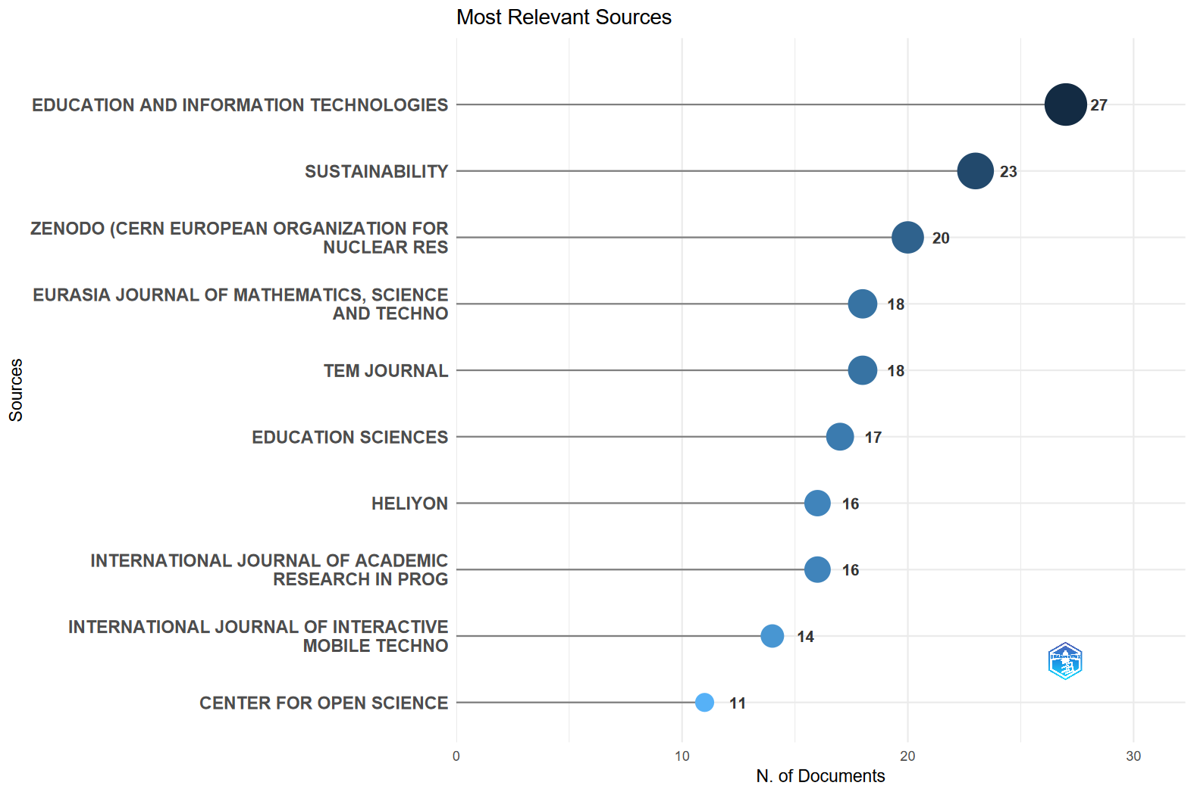
Figure 3. Most cited article

In terms of thematic focus, VOSviewer analyzes the keyword co-occurrence network as illustrated in Figure 4, from 2021-2026, the highlighted central concepts such as “education”, “higher education”, “technology”, and “digital literacy”, serves as the core of the research field. This has also been found to have close ties to emerging and enabling themes, such as blended learning, distance learning, ICT and augmented reality. The clustering of these keywords demonstrated that research is not being carried out as a fragmented whole but within specific strands, and on both pedagogical aspects and the technological aspects of research. The role of technology in reshaping the teaching practices which was widely aligned with the studies on transformation in education.

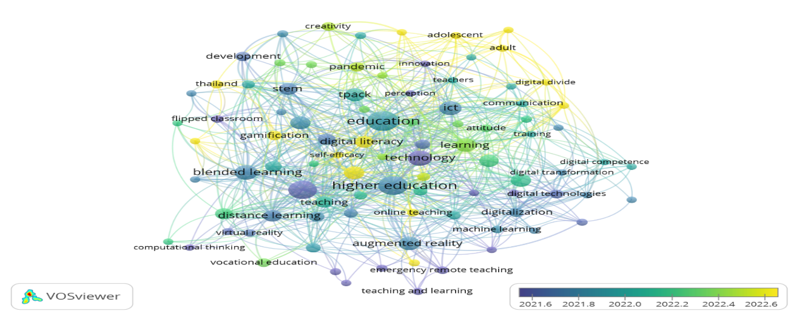
Figure 4. Keyword co-occurrence network

According to the bibliometrix presented in Figure 5, the keyword Education having 47 occurrences tops the list, having it reflected as its main role in the academic publication, discussions and research. This indicates the continued focus on the innovations, policies and system within education. Second to it is the keyword COVID-19 which has 46 occurrences following closely to education. According to Picher et al., (2022), the COVID-19 had reshaped all dynamics all over educational sectors.

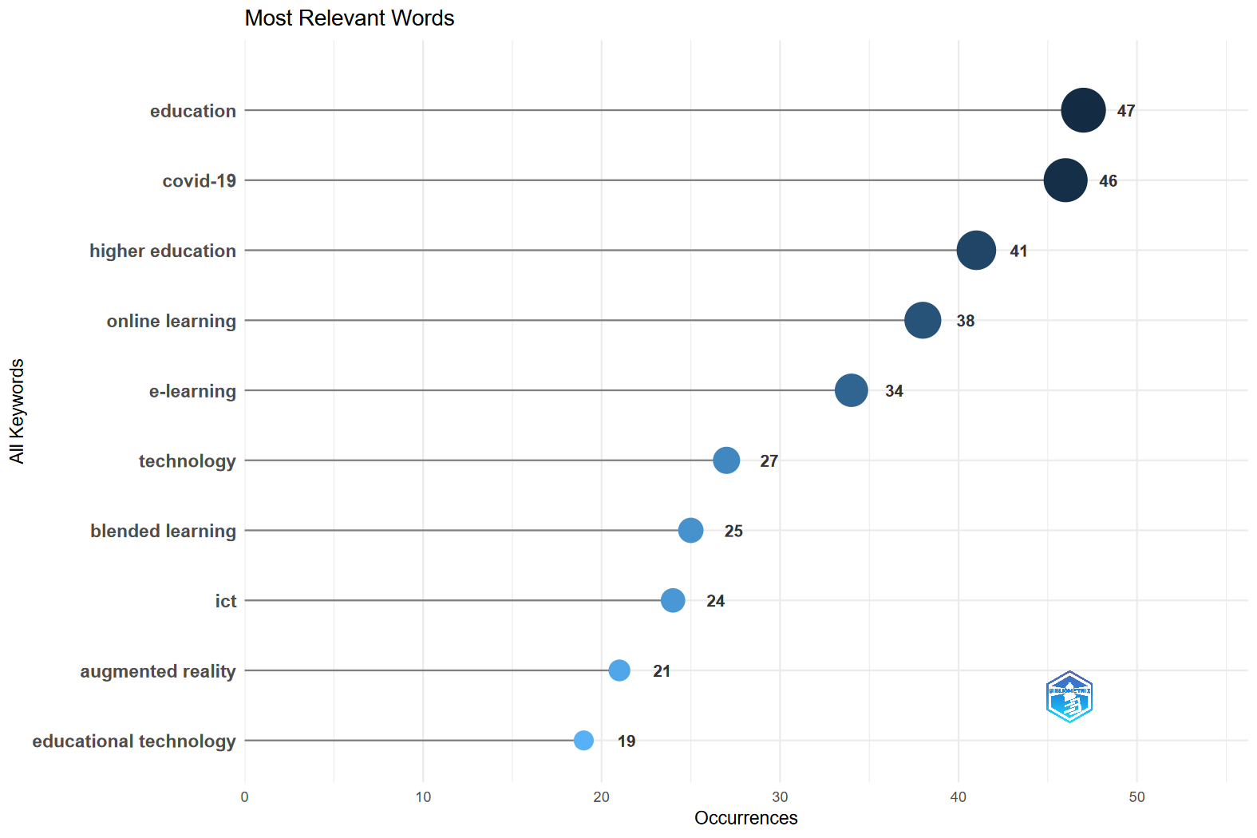

Figure 5. Most cited keywords

3. 4. Evolution of technology device utilization in teaching

The evolution of the utilization of technological device can be explained through the changes of focus and the development of research themes, illustrated by Fig 6.The most fundamental domains, i.e. E-learning and higher education seem to be basic themes which can show their centrality and widespread application. Meanwhile, themes like e-learning, digitalization, and education-related challenges are positioned as motor themes, suggesting that they are both well-developed and actively driving the current research directions. The pedagogical approaches such as blended learning and flipped classroom are also evident, pointing to a gradual shift toward more student-centered and flexible learning which emphasize engagement and active participation in technology education (Garrison & Vaughan, 2008)

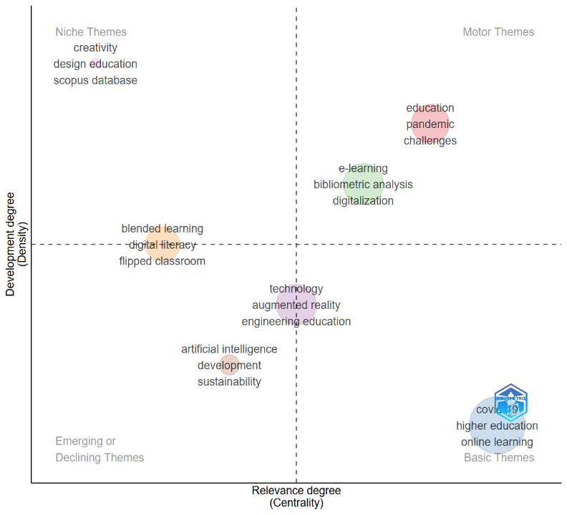

Figure 6. Thematic map

CONCLUSIONS
Through this bibliometric analysis, the trend of research on access and utilization of technology courses over the past few years has become clearer. The general trend of the area of research has entered from a period of high-growth development to the period of stable development. The quantity of research decreased year by year and the quality was increasing which caused a fewer researches with strong effect to be produced. Although the year-to-year growth decreased, the citation number increased steadily, which means the works produced have not stopped the guiding effect for the new generation of researchers.
The patterns of authorship also shows that much of the knowledge generation is a collaborative effort, reflected in the average co-authorship per document. Nonetheless the small proportion of international collaboration implies that the research focus is located within certain areas which can have implications on the framing and solution to issues of access and use. So the contribution may be high but the exchange/view from the rest of the world needs to be enhanced.
A set of common themes appears to transcend all literature. Ideas such as the implementation of ICT, blended learning, and digital literacy are ever present and can be seen in almost every reference associated with technology courses. Emerging new words such as Augmented Reality, Machine Learning and Digital Transformation hint at a move towards more sophisticated and progressive applications in technology education. They show a continuing change in the way technology devices can be used in instruction and accessed.
Taken together, the findings suggest that the field is not declining, but rather maturing, with research becoming more specialized and aligned with emerging technological developments. Nonetheless, persistent concern related to unequal access to technology highlight the need for sustained attention, particularly in contexts where resources and infrastructure remain limited.
Overall, this review contributes to a deeper understanding of how technology devices are positioned within teaching technology courses, offering a foundation for future work aimed at improving both accessibility and effective utilization in diverse educational contexts.

Acknowledgment

The authors would like to express their sincere gratitude to those who supported and contributed to the completion of this study. Special thanks to our mentor for his guidance and encouragement throughout the research process. The authors also appreciate the availability of online databases and tools that made this bibliometric analysis possible.

REFERENCES
- Anderson, T. (Ed.). (2008). The Theory and Practice of Online Learning (2nd ed.). Athabasca University Press.
- Aria, M., & Cuccurullo, C. (2017). bibliometrix: An R-tool for comprehensive science mapping analysis. Journal of Informetrics, 11(4), 959–975 https://doi.org/10.1016/j.joi.2017.08.007
- Bergmann, J., & Sams, A. (2012). Flip your classroom: Reach every student in every class every day. International Society for Technology in Education.
- Bond, M., Bedenlier, S., Marín, V. I., & Händel, M. (2021). Emergency remote teaching in higher education: Mapping the first global online semester. International Journal of Educational Technology in Higher Education, 18(1), 1–24. https://doi.org/10.1186/s41239-021-00282-x
- Bozkurt, A., et al. (2020). A global outlook to the interruption of education due to COVID-19 pandemic: Navigating in a time of uncertainty and crisis. Asian Journal of Distance Education, 15(1), 1-24.
- Donthu, N., Kumar, S., Mukherjee, D., Pandey, N., & Lim, W. M. (2021). How to conduct a bibliometric analysis: An overview and guidelines. Journal of Business Research, 133, 285–296. https://doi.org/10.1016/j.jbusres.2021.04.070
- Dunleavy, M., & Dede, C. (2017). Augmented Reality Teaching and Learning. Springer.
- Freeman, J. (2021). Integrating drafting tools in technical education: A bibliometric analysis of the impact of ergonomic workspaces on research visibility. Journal of Educational Technology, 45(3), 210-225. https://doi.org/10.1007/edu-tech-2021-45-3-210
- Garrison, D. R., & Vaughan, N. D. (2008). Blended learning in higher education: Framework, principles, and guidelines. Jossey-Bass.
- Johnson, L., et al. (2016). NMC Horizon Report: 2016 Higher Education Edition. The New Media Consortium.
- Macleod, D. (2021). Precision and posture in drafting workspace ergonomics: Impact on learning environments. International Journal of Ergonomics in Education, 58(2), 142-156. https://doi.org/10.1016/j.ergon.2021.02.004
- Moore, M. G., & Diehl, W. C. (2018). Handbook of Distance Education (4th ed.). Routledge.
- Selwyn, N. (2016). Education and technology: Key issues and debates (2nd ed.). Bloomsbury Academic.
- Zawacki-Richter, O., Marín, V. I., Bond, M., & Gouverneur, F. (2019). Systematic review of research on artificial intelligence applications in higher education. International Journal of Educational Technology in Higher Education, 16(1), 1–27. https://doi.org/10.1186/s41239-019-0171-0
- Zupic, I., & Čater, T. (2015). Bibliometric methods in the social sciences: A review of data cleaning and analysis approaches. Social Science Research Methodology, 48(4), 33-50. https://doi.org/10.1016/j.socscires.2015.09.003

