GEOLOGICAL CHARACTERISTICS AND UTILIZATION PROSPECTS OF AZERBAIJAN’S THERMAL WATER FIELDS

Nurlan Khalilov, PhD in Technical Sciences; Gasim Abbasov; Lala Gurbanzade
(SOCAR "Oil and Gas Scientific Research Project" Institute)
kerem_shixaliyev@mail.ru
Keywords: thermal waters, geothermal energy, balneology, mineral waters, hydrogeology, therapeutic properties, energy potential.

Abstract
Azerbaijan's thermal water resources have been comprehensively investigated regarding their geological structure, physical-chemical properties, and economic potential. The primary objective is the scientifically grounded assessment of the therapeutic effects of thermal waters, their application prospects in the tourism sector, and their potential for utilization as energy resources. Research indicates that thermal waters can be utilized in industrial heat energy processes, greenhouse farming, residential district heating, and agriculture. This both lowers energy costs and strengthens energy security by reducing the country’s dependence on hydrocarbon reserves. From an ecological perspective, geothermal energy, as a clean and renewable source, contributes to the reduction of carbon emissions. Regarding tourism, resort zones, health centers, and recreational complexes established around thermal springs accelerate the socio-economic development of regions and reduce seasonal tourism dependency. Balneologically, thermal waters are effective in treating rheumatological diseases, skin problems, and nervous system disorders, thereby stimulating the development of sanatorium-resort complexes. Expanding this field increases public access to health services. As a result of a scientifically based approach and the application of modern technologies, it is possible to utilize the potential of thermal waters more effectively.
Introduction
The Republic of Azerbaijan is considered one of the countries distinguished by the richness and diversity of its thermal and mineral water sources. The formation of these sources is closely related to the influence of geothermal processes, volcanic phenomena, and seismic activity [1-3]. The study of thermal waters increases their significance not only as a natural medicinal factor but also as a strategic resource in terms of energy and tourism [4-5]. The chemical composition, temperature indicators, and mineralization (TDS) levels of geothermal waters serve as the main parameters in determining their utilization directions. The primary objective is to comprehensively investigate the geographical distribution, physical-chemical characteristics, and therapeutic effects of Azerbaijan's thermal water fields, as well as their energy potential and tourism opportunities.
The correlation of physical-geographic conditions with mineral and thermal waters
The distribution of mineral and thermal waters in Azerbaijan is inextricably linked to the relief, geological structure, tectonic activity, and climate. The Greater Caucasus, Lesser Caucasus, and Talysh Mountains act as tectonically active zones. Mud volcanoes are widespread in the Kura Lowland and the Absheron territory. Volcanic gases and rocks enrich the chemical composition of the waters, facilitating the generation of elements such as hydrogen sulfide, iodine, and bromine. Consequently, iodine-bromine and gaseous mineral waters are formed in these regions. The diversity of the relief and significant altitudinal differences cause waters to descend into deep strata and re-emerge at the surface, resulting in temperature differentials (reaching 40-70 °C and above). In the Caspian Sea coastal areas and lowlands, as groundwater passes through saline rocks, its mineral composition changes, leading to the formation of predominantly chloride-sodium and iodine-bromine mineral waters.
Geological Structure and Rock Diversity
The geological structure of the territory of Azerbaijan is characterized by a complex combination of sedimentary, volcanogenic, and metamorphic rocks. These rocks were formed during various geological eras-from the Paleozoic to the Modern period. Limestone, dolomite, and marl strata dating specifically to the Jurassic and Cretaceous periods play a crucial role in the formation of the chemical composition of groundwater. As waters traverse these rocks, they become enriched with carbonate, sulfate, and other minerals, resulting in the creation of mineral waters with diverse compositions. These waters are primarily observed in the piedmont (foothill) zones of the Greater and Lesser Caucasus.
Tectonic Structure and the Role of Faults
Being a constituent part of the Alpine-Himalayan orogenic belt, the territory of Azerbaijan is situated in a tectonically active zone. Tectonic faults and fissures, which are widely distributed in the Greater Caucasus, Lesser Caucasus, and Talysh mountain systems, allow groundwater to penetrate into deep strata. Under the influence of the Earth's internal heat flux, these waters are heated, acquire thermal properties, and migrate back toward the surface.
Tectonic faults serve as the primary discharge channels for thermal waters. For this reason, high-temperature thermal springs are mainly concentrated along fault zones. Thermal waters distributed in the Kalbajar (Istisu), Shamakhi, Guba, and Talysh zones are clear examples of this phenomenon.
The Role of Volcanism and Mud Volcanoes
Azerbaijan is one of the regions with the highest concentration of mud volcanoes in the world. Mud volcanoes located in the Kura-Araz Lowland and the Absheron Peninsula create conditions for the mixing of subterranean gases, particularly methane and hydrogen sulfide, with water. As a result of this process, hydrogen sulfide, iodine-bromine, and gaseous mineral waters are formed.
The distribution of volcanogenic rocks also plays a significant role in the enrichment of the mineral composition of waters. These waters, possessing primarily therapeutic properties, are widely utilized for balneological purposes.
Hydrogeological Conditions and Groundwater Circulation
Mountainous relief conditions ensure the intensive circulation of groundwater. In mountainous zones, atmospheric precipitation infiltrates deep strata through fissures and pores in the rocks; here, as a result of long-term circulation, it is heated and enriched with minerals. Subsequently, it emerges at the land surface in the form of springs in the piedmont and lowland areas.
In lowland and coastal zones, however, the movement of groundwater is relatively slow, which leads to an increase in the degree of mineralization. This causes the formation of chloride-sodium and highly mineralized waters, particularly in the Kura-Araz Lowland and the Caspian coastal territories.
The Significance of Alluvial and Proluvial Deposits
Alluvial and proluvial deposits transported by mountain rivers serve as favorable collectors (aquifers) for groundwater. These deposits, located primarily in piedmont zones, create conditions for the accumulation of fresh and weakly mineralized waters. Such waters are significant both as reserves of potable water and for therapeutic purposes.
Predicted Exploitation Reserves of Thermal Waters
Thermal springs across the country are mainly widespread in mountainous zones - the Greater and Lesser Caucasus ranges, as well as on the south-eastern shores of the Caspian Sea (Fig. 1). The formation of these sources occurs in connection with tectonic fractures and volcanogenic structures. Geothermal heating processes of groundwater take place in the deeper layers of the earth's crust, and this factor directly affects their chemical composition along with their temperature characteristics. Geographically, the spatial distribution of thermal springs is closely linked to the country's geological structure and tectonic dynamism.
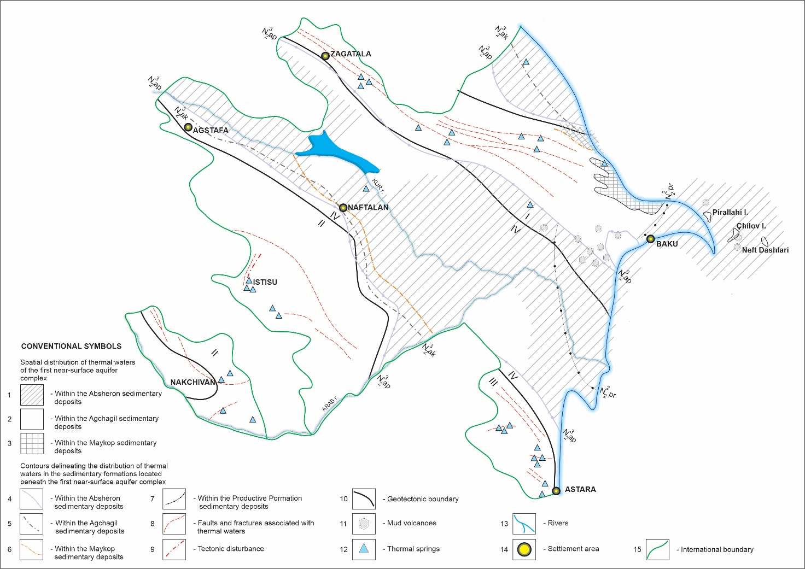
Fig. 1. Distribution areas of thermal waters in Azerbaijan

The prospective reserves of thermal waters are characterized for the country's various hydrogeological zones as follows: On the southern slope of the Greater Caucasus, there are thermal waters with a daily volume of 2000 m³ and a temperature of 30–50 °C. In the Quba-Khachmaz zone, this indicator is 21000 m³/day, and the water temperature ranges from 40 to 85 °C. On the Absheron Peninsula, thermal waters with a volume of 20000 m³/day and a temperature of 40–90 °C have been recorded. In the mountainous part of the Small Caucasus, there are waters with a daily volume of 4000–5000 m³ and a temperature of 30–74 °C. In the Nakhchivan Autonomous Republic, 3000 m³/day (40–50 °C), in the Talish mountain region, 15000 m³/day (31–43 °C), In the Lankaran Plain, thermal waters with a volume of 7000–8000 m³/day and a temperature of 44–64 °C have been identified. The highest indicators are for the Kura Depression, where the estimated exploitable reserves are 170000 m³/day, with temperatures ranging from 30–71 °C. In total, the republic's estimated prospective reserves of thermal water are valued at 249000 m³/day.
An analysis of existing geological materials on thermal water deposits indicates that actual recoverable reserves could be significantly higher than the figures provided. As an environmentally clean and renewable energy source, the complex study and practical application of underground thermal waters alongside traditional fuels, especially oil and gas, holds great promise.
As a result of hydrogeological surveys conducted across the country, high-temperature and high-yield thermal water deposits have been identified in the Talish, Quba-Khachmaz, Absheron, and Nakhchivan regions. In the Talısh zone, particularly in the Astara, Lankaran, and Masalli districts, all 17 exploration wells drilled have encountered thermal waters with temperatures ranging from 38–64 °C. In the Jarlı structure, oil exploration wells drilled to depths of 3200–4500 m encountered thermal waters with surface temperatures of 72-97 °C, and their total production amounted to 2500 m³/day [6].
In the Caspian (Khudat–Khachmaz) zone, exploration wells drilled to depths of 3000 m have identified thermal waters with a daily production of over 30000 m³ and surface temperatures of 50–81 °C. Exploration work was conducted on the Khudat–Khachmaz thermal water deposit in the Quba–Khachmaz region, resulting in the confirmation of 25.7 thousand m³/day of exploitable reserves, which were included in the State Balance. Currently, some of these sources are used for balneological purposes, heating greenhouses, and meeting domestic needs. Preliminary studies on the application of thermal waters in energy production make their efficient use as a geothermal resource possible.
Physical Properties and Chemical Composition
The chemical composition of Azerbaijan's thermal waters is primarily characterized by the predominance of chloride, sulfate, and bicarbonate ions, which is related to the geological environment in which they formed and water-rock interaction processes. Along with these anions, a wide range of variations is observed in the content of major cations such as sodium (100–5000 mg/l), potassium (5–500 mg/l), calcium (20–1000 mg/l), and magnesium (10–300 mg/l). Differences in the quantities of these components form the mineralization of thermal waters (0.5–20 g/l) and determine their balneological characteristics (Table 1).

Table 1
Physical-Chemical Properties of Thermal Waters
Indicator | Definition | Amount
Temperature, °C | Temperature at the water outlet point | 20 – 100
Density, g/sm³ | Varies depending on physical properties and composition | 0.99 – 1.10
pH | Indicates the acidity/alkalinity of water | 6.0 – 9.5
TDS, g/l | Total amount of dissolved salts | 0.5 – 20
Na⁺, mg/l | One of the main cations | 100 – 5000
K⁺, mg/l | Additional cation | 5 – 500
Ca²⁺, mg/l | Determines water hardness | 20 – 1000
Mg²⁺, mg/l | Physiologically active cation | 10 – 300
Cl⁻, mg/l | One of the most common anions | 50 – 10000
SO₄²⁻, mg/l | Nutritional and therapeutic anion | 10 – 2000
HCO₃⁻, mg/l | Acts as a neutralizing agent | 50 – 4000
SiO₂, mg/l | Indicator of thermal processes | 10 – 200
CO₂, mg/l | Main component of carbonated waters | 10 – 2000
H₂S, mg/l | İndicator of medicinal sulfur waters | 1 – 50
F⁻, mg/l | Important element for bone and dental health | 0.5 – 5
Rn, Bq/l | Low-level radioactive element with physiological effects | 1 – 300

The presence of silicon dioxide (SiO₂ — 10–200 mg/l), hydrogen sulfide (1–50 mg/l), carbohydrate-derived gas components, especially carbon dioxide (CO₂ — 10–2000 mg/l), and also small amounts of radon (Rn — 1–300 Bq/l) are among the important factors increasing the medicinal value of these waters. While high concentrations of silicon, as an indicator of thermal processes, stimulate skin regeneration processes, hydrogen sulfide waters have an effective therapeutic effect on rheumatism, skin diseases, and peripheral nervous system disorders. The low-level radioactivity of radon with physiological influence allows for the formation of radon baths widely used in sanatorium-resort treatment. Other important physical-chemical parameters of these waters include temperature varying between 20–100 °C at the outlet point, a pH indicator in the 6.0–9.5 interval, and density varying between 0.99–1.10 g/cm³. Temperature and pH differences determine both the hydrothermal origin of the water and its areas of use in medicine and tourism. The physical-chemical properties of thermal waters differ somewhat between our country and neighboring territories [7-9]. High temperature and rich mineral composition further actualize the use of thermal waters in balneological treatment, rehabilitation procedures, and for preventive purposes. Thus, the multi-component chemical structure and wide physical-chemical variation range of thermal waters create conditions for their effective application in the treatment of various diseases, as well as in sanatorium-resort and recreation services.
The thermal waters of Azerbaijan are categorized into various groups based on their temperature characteristics. Sources with temperatures exceeding 50 °C are classified as high-temperature, those within the 30–50 °C range as medium-temperature, and sources below 30 °C as low-temperature thermal waters. According to hydrogeological patterns, the temperature of thermal waters increases with depth, while the TDS level tends to decrease. These indicators play a crucial role in establishing the scientific basis for the utilization of thermal waters across different sectors, including balneology, recreation, energy, and industry.
Among the republic's high-temperature mineral springs, the Goturlu (64 °C) and Istisu (approximately 62 °C) springs in the Kalbajar district, as well as the Donuzutan spring (64 °C) in the Masalli district, are particularly prominent (Fig. 2). The Kalbajar region is one of the areas in Azerbaijan with the highest concentration of thermal water sources. Famous springs such as Upper and Lower Istisu, Goturlu Istisu, and Turshsu are located here. The liberation of the Karabakh and East Zangezur economic regions has opened extensive opportunities for the re-investigation and utilization of the thermal water resources of these territories.

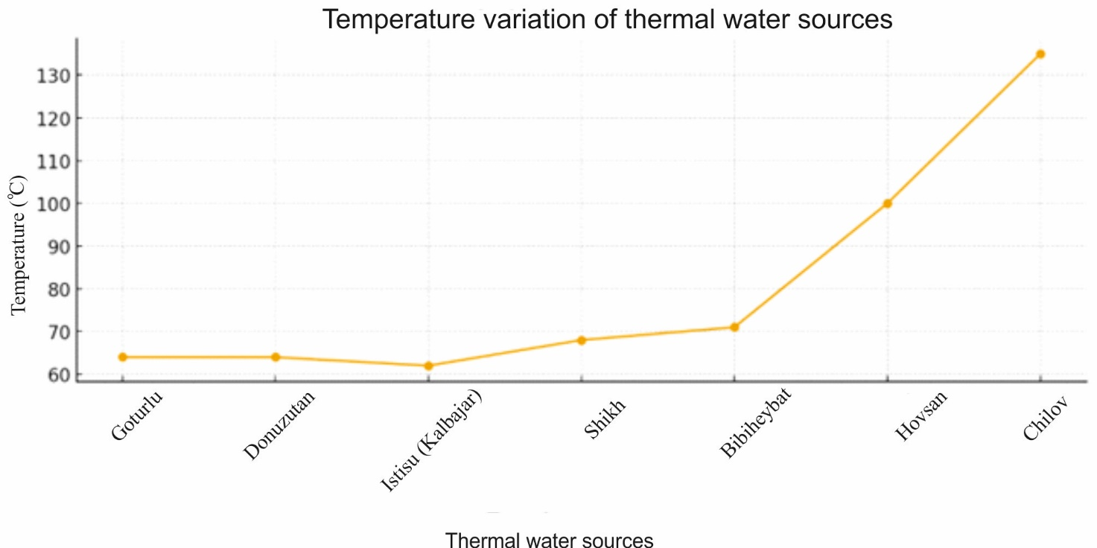
Fig. 2. Temperature variations of thermal water sources

According to historical sources, the formation of Kalbajar's renowned Istisu mineral springs is associated with the cracks and tectonic changes in the Earth's crust resulting from the powerful earthquake that occurred in 1138. Due to their chemical and physical properties, these waters bear a resemblance to the mineral waters of Karlovy Vary in the Czech Republic, one of the world's famous resort zones, and are considered unique globally due to the complexity of their component composition (Table 2). The waters of the Istisu sources possess hyperthermal, carbonated, hydrocarbonate-chloride-sulfate-sodium type mineralization, which significantly enhances their balneological value.

Table 2
Comparative Analysis of Chemical Composition and Characteristics
Indicator | Kalbajar – Istisu | Karlovy Vary (Czech Republic)
Water Type | Thermal, highly mineralized | Thermal, highly mineralized
Discharge Temperature | ~58–60 °C | ~30–75 °C (depending on the spring)
Total Dissolved Solids (TDS) | ~6.5–7.0 g/l | ~6.0–7.5 g/l
Major Cations | Na⁺, Mg²⁺, Ca²⁺, Fe²⁺/Fe³⁺ | Na⁺, Ca²⁺, Mg²⁺, K⁺
Major Anions | HCO3−​, Cl−, SO42−​ | HCO₃⁻​, SO₄²⁻​, Cl⁻
Sodium (Na⁺) | High | High
Calcium (Ca²⁺) | Moderate | Moderate–high
Magnesium (Mg²⁺) | Moderate | Moderate
Bicarbonate (HCO₃⁻​) | High | High
Sulfate (SO₄²⁻​) | Present | Present
Chloride (Cl⁻) | Present | Present
Carbon Dioxide (CO₂​) | Present (moderate level) | High
Lithium (Li) | Present (trace amounts) | Present (trace amounts)
Bromine (Br) | Present | Very weak / trace
Iodine (I) | Present | Typically absent
Zinc (Zn), Copper (Cu) | Present (trace elements) | Very weak
Iron (Fe) | Present | Weak
Arsenic (As) | Trace amounts | Typically absent
Chemical Type | Bicarbonate–chloride–sulfate–sodium | Sodium–bicarbonate–sulfate
Balneological Direction | Gastrointestinal, liver, biliary tract, metabolism | Gastrointestinal, liver, metabolic, and endocrine system

The thermal mineral waters of Istisu (Kalbajar, Azerbaijan) and Karlovy Vary (Czech Republic) belong to the same hydrogeochemical and balneological class, characterized by high mineralization and a thermal temperature regime¹. Both water systems exhibit total dissolved solids (TDS) levels in the range of 6.0–7.5 g/l and share a predominant sodium-bicarbonate-sulfate-chloride ionic composition. These fundamental chemical similarities substantiate their long-standing clinical application in treating gastrointestinal, hepatobiliary, and metabolic disorders.
Comparative analysis highlights that while Karlovy Vary waters are distinguished by higher CO₂ saturation and a wider temperature range across multiple springs, Istisu waters possess a more diverse spectrum of trace elements, including lithium, bromine, iodine, and iron. Despite these minor variations in micro-components, the principal therapeutic mechanisms remain fundamentally similar, allowing the two systems to be regarded as functional analogues in global balneological practice. The equivalent potential of Istisu to internationally renowned spas provides a robust scientific basis for its development into a world-class health resort.
The distribution of thermal water resources is not exclusively confined to mountainous orogenic belts; the complex geological framework of the Absheron Peninsula also hosts significant high-temperature mineralized aquifers. These geothermal manifestations are particularly prominent within active oil and gas production fields, where deep-seated hydrogeological systems contribute to the region’s balneological and energy potential. For instance, in the Shikh area, thermal waters extracted from a depth of approximately 2400 meters exhibit a stable discharge temperature of 68 °C and have been utilized for clinical balneotherapy for several decades.
Significant thermal anomalies are observed as one moves across the peninsula's structural trends. In the Bibiheybat region of Baku, self-flowing springs of the chloride-sodium-hydrocarbonate type are characterized by a mineralization level of 16.5 g/l and a discharge temperature of 71 °C. Furthermore, geothermal gradients intensify toward the east; in the Hovsan direction, deep-well data indicate water temperatures reaching a range of 100–135 °C, signaling the presence of high-enthalpy thermal anomaly zones. This geothermal activity is not isolated, as evidenced by the Guzdek area, where emerging thermal waters exceed 50–65 °C. Similar hydrothermal occurrences are documented in the Garaheybat field and on Chilov Island, underscoring a widespread geothermal system across the Absheron subsurface that warrants further exploration for sustainable energy applications.
In accordance with the nature of hydrogeothermal processes, the increase in water temperature with depth, coupled with a relative decrease in mineralization (TDS), clearly reflects the thermodynamic and geochemical characteristics of the waters in this region and establishes a scientific basis for optimizing their utilization (Fig. 3).

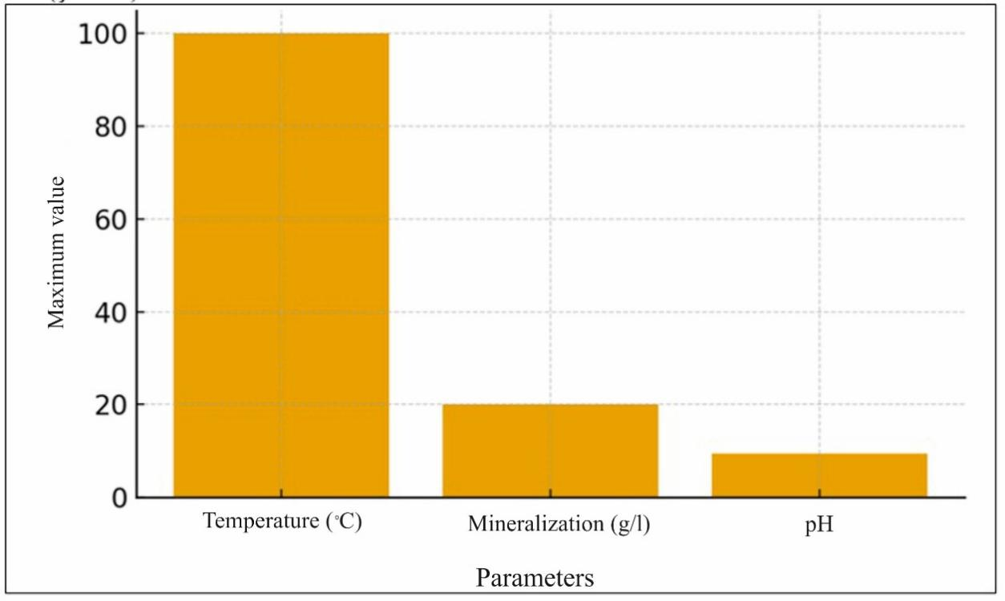
Fig. 3. Key physical-chemical indicators of thermal waters

Application Areas of Thermal Waters
One of the main applications of Azerbaijan's mineral-thermal waters is for medical and balneological treatment. These waters are used in the prevention and treatment of various diseases in the form of baths, showers, inhalations, and drinking courses.
In particular, the high-temperature thermal waters of Istisu (Kelbajar) are used in the treatment of rheumatic arthritis, diseases of the nervous system, and skin diseases, The Naftalan area—for complex treatment with mineral waters and the oil factor, Turşsu (Shusha)—for gastrointestinal and metabolic disorders, and Badamlı and Sirab—for diseases of the digestive system and kidneys.
Thermal springs located in well-known Azerbaijani resort zones such as Istisu, Galaalti, Naftalan, and Lankaran have gained significant popularity both domestically and among international tourists. The mineral composition of these sources has a positive effect on the activation of metabolism, normalization of blood circulation, and tissue regeneration within the body. These waters, which demonstrate high efficacy particularly in the treatment of rheumatism, skin diseases, joint pathologies, and nervous system disorders, are considered a vital component of balneological medicine [10-11]. The development of thermal tourism contributes significantly not only to the expansion of healthcare services but also to the socio-economic development of regions, the creation of new jobs, and the improvement of tourism infrastructure.
Each of these resort zones provides Azerbaijan with a competitive advantage in terms of treatment, recreation, and tourism. Strengthening the infrastructure, incorporating services that meet international standards, and increasing promotional efforts can further solidify the position of these locations in the global tourism market.
The utilization of thermal waters for energy production is evaluated as one of the environmentally clean, renewable, and long-term alternative energy directions [12-18]. The high-temperature indicators, geothermal anomaly fields, and hydrothermal systems existing within the territory of Azerbaijan create favorable conditions for practical application in this direction. Using geothermal energy in heat supply, greenhouse complexes, fisheries, and industrial processes allows for the stabilization of energy provision, a reduction in import dependency, and the lowering of carbon emissions to a minimum level [19-20]. These characteristics further increase the importance of thermal waters as a strategic resource in both health tourism and the energy sector.
The territory of Azerbaijan has a geologically favorable structure for the formation of thermal waters. The high temperature readings, geothermal anomaly fields, and active hydrothermal systems observed in various regions of the country expand the possibilities for the practical use of geothermal energy. In particular, the southern slope of the Greater Caucasus, the Small Caucasus zone, the Talish mountain area, and the Kura Depression are considered promising areas in terms of geothermal potential. The presence of high-temperature thermal waters at shallow depths in these areas creates favorable conditions for the technically and economically efficient organization of energy production.
One of the significant advantages of using geothermal resources is the substantial reduction of carbon emissions. This energy source is considered an important tool for combating climate change and implementing “green energy” strategies. For Azerbaijan, this area is of special importance for fulfilling international environmental commitments and achieving sustainable development goals.
All these factors make it necessary to evaluate thermal waters not only for health tourism and balneological purposes, but also as a strategic resource in the energy sector. The comprehensive use of geothermal energy can make significant long-term contributions to the country's economic development, regional employment growth, and the preservation of ecological balance.
The essence of the energy-tourism synergy is based on the phased use of the heat energy extracted from the thermal water source. In this model, high-temperature thermal waters are used for energy production or heat supply in the initial stage, and then the cooled waters are directed to balneological procedures, thermal pools, spa centers, and therapeutic baths. Thus, maximum benefit is obtained from the same resource for both the energy sector and the tourism industry.
The implementation of the energy-tourism synergy is also of great importance for regional development. Since thermal resorts are primarily located in mountainous or remote areas, this model promotes increasing employment among the local population, creating new jobs, and developing infrastructure. At the same time, because geothermal resorts can operate year-round, dependence on seasonal tourism is reduced, and tourist traffic becomes more stable.
From an ecological perspective, the energy-tourism synergy offers particularly significant advantages. The use of geothermal energy allows for the reduction of carbon emissions, the minimization of dependence on fossil fuels, and the mitigation of impacts on natural ecosystems. This approach is fully aligned with the goals of combating climate change and sustainable development. Operating resorts with eco-friendly energy sources also enhances competitiveness in the international tourism market.
In conclusion, the energy-tourism synergy based on thermal waters is considered an optimal model for the efficient use of resources, the preservation of ecological balance, and the maximization of economic benefits. This approach brings to the forefront not only the therapeutic and recreational potential of thermal waters but also their energy production capabilities, transforming them into a strategically important national resource.
Overall, the scientifically grounded study and proper management of Azerbaijan’s thermal waters enable their efficient and sustainable use in tourism, balneological treatment, and energy production. The application of modern technologies, hydrogeological monitoring, and integrated resource management further enhance the strategic importance of this field from socio-economic and ecological perspectives.

Conclusion
- Research results show that Azerbaijan's thermal water sources — especially springs located in Kalbajar, Masalli, Absheron, and Lankaran zones — play an important role in balneological medicine, preventive medicine, and recreation services. High mineralization of thermal waters (0.5 - 20 g/l) and the presence of components such as CO₂, SiO₂, H₂S, and Rn increase their balneological value.
- High-temperature indicators (70–135 °C) recorded in the Absheron Peninsula and other geothermal anomalous areas create real potential for the use of geothermal energy in heat supply, industrial processes, and the agricultural sector.
- It has been determined that the predicted exploitation reserve of thermal waters across the country is 249 thousand m³/day. However, analysis of geological materials indicates that the reserves are even greater.
- Resorts, health, and rest centers established around thermal sources in the tourism sector stimulate the socio-economic development of regions and create conditions for reducing seasonal dependency in tourism.
- Kalbajar, Guba-Khachmaz, Absheron, and Talysh regions are evaluated as the most promising zones in terms of both treatment and energy production.

References
- Tagiyev, I. I., Ibragimova, I. M., & Babaev, A. M. (2001). Resursy mineral'nykh i termal'nykh vod Azerbaydzhana [Resources of mineral and thermal waters of Azerbaijan]. Baku: Chashioglu. (In Russian).
- Aliyev, F. S. (2000). Azərbaycan Respublikasının yeraltı suları, ehtiyatlarından istifadə və geoekoloji problemləri [Groundwater of the Republic of Azerbaijan, use of resources and geo-ecological problems]. Baku: Chashioglu. (In Azerbaijani).
- Aliyev, S. A., Mukhtarov, A. Sh., Aliyeva, Z. A., & Bagirli, R. J. (2002). Azerbaijan’s thermal waters. Geology of Azerbaijan, 5, 182-186. Baku: Naft-Press.
- Nasirov, S. (2024). Geotermal suların Azərbaycanın istilik energetikasında istifadə perspektivləri [Prospects for the use of geothermal waters in thermal energy in Azerbaijan]. PANTEI, 36(05), 113-127. (In Azerbaijani).
- Rahimov, F. (2024). Alternativ enerji mənbələrinin Azərbaycanda perspektivləri [Prospects of alternative energy sources in Azerbaijan]. PANTEI, 36(05), 42-48. (In Azerbaijani).
- Babayeva, S. S. (2020). Carli geotermal suyunun tədqiqi və istifadə proqnozları [Investigation of Jarli geothermal water and forecasts for its use]. Problems of Energetics, (4), 10-16. (In Azerbaijani).
- Filimonova, E., Kharitonova, N., Baranovskaya, E., et al. (2022). Geochemistry and therapeutic properties of Caucasian mineral waters: A review. Environmental Geochemistry and Health, 44, 2281–2299. https://doi.org/10.1007/s10653-021-01160-1.
- Kompanichenko, V. N., Poturay, V. A., & Rapoport, V. L. (2009). Osobennosti khimicheskogo sostava vod Kul'durskogo termal'nogo polya [Features of the chemical composition of the waters of the Kuldur thermal field]. Regional Problems, (12), 20-25. (In Russian).
- Aydemir Polat, E., & Şener, Ş. (2025). Boğazlıyan (Yozgat) termal ve soğuk su kaynaklarının hidrojeokimyasal karakterizasyonu [Hydrogeochemical characterization of Bogazliyan (Yozgat) thermal and cold water resources]. Journal of Engineering Sciences and Design, 13(3), 944-956. https://doi.org/10.21923/jesd.1681598 (In Turkish).
- Rakhmanin, Y. A., Egorova, N. A., Mikhailova, R. I., et al. (2023). Lechebnoye i profilakticheskoye ispol'zovaniye mineral'nykh vod, soderzhashchikh kremniy, v Rossiyskoy Federatsii (Obzor). Chast' 3 [Therapeutic and prophylactic use of mineral waters containing silicon in the Russian Federation (Review). Part 3]. Trace Elements in Medicine, 19-27. (In Russian).
- Nekipelova, A. V. (2016). Kharakteristika azotno-kremnistykh termal'nykh vod [Characteristics of nitrogen-siliceous thermal waters]. Health and Education in the 21st Century, 18(7), 139−142. (In Russian).
- Kompanichenko, V., Kralij, Pol., Kralij, Pet., & Frisman, E. (2008). Characteristics of fluctuating conditions in the hydrothermal medium suitable for the origin of life. Origins of Life and Evolution of the Biosphere, 39, 159-160.
- Alkhasov, A. B., & Alkhasova, D. A. (2013). Perspektivy osvoyeniya geotermal'nykh resursov Vostochnogo Predkavkaz'ya [Prospects for the development of geothermal resources of the Eastern Ciscaucasia]. South of Russia: Ecology, Development, (3), 17-26. https://doi.org/10.18470/1992-1098-2013-3-17-26 (In Russian).
- Shulyupin, A. N., & Varlamova, N. N. (2020). Sovremennyye tendentsii razvitiya geotermal'nykh resursov [Modern trends in the development of geothermal resources]. Georesursy, 22(4), 113–122. (In Russian).
- Dyadkin, Y. D. (1989). Razrabotka geotermal'nykh mestorozhdeniy [Development of geothermal deposits]. Moscow: Nedra. (In Russian).
- Banwell, C. J. (1955). Physical investigations. Geothermal steam for power in New Zealand, 117, 45–74.
- Bertani, R. (2009). Geothermal energy: An overview on resources and potential. Slovakia: Proc. Int. Conf. on National Development of Geothermal Energy Use..
- Bertani, R. (2016). Geothermal power generation in the world 2010–2014 update report. Geothermics, 60, 31–43. https://doi.org/10.1016/j.geothermics.2015.11.003.
- Gasanov, A. B., Abbasov, E. Yu., Mamedova, D. N., & Mutallimova, O. M. (2020). Chislennoye modelirovaniye geotermal'nykh resursov mestorozhdeniya Bulla-Deniz [Numerical modeling of geothermal resources of the Bulla-Deniz oil and gas field]. Eurasian Union of Scientists, 10(79), 4-11. (In Russian).
- Bayramova, S. M., & Bayramov, A. A. (2009). Ispol'zovaniye geotermal'noy energii v Azerbaydzhane [Use of geothermal energy in Azerbaijan]. Alternative Energy and Ecology, 12(80), 19-23. (In Russian).

