Implementing the Interaction Matric Method for Impact Assessment in Linear Infrastructure Project Planning: A Case Study of Route FT59 Jalan Tapah in Cameron Highlands, Malaysia

Siti Isma Hani Ismail¹, Shanker Kumar Sinnakaudan², Zulfairul Zakaria³, Loh Yong Seng⁴ and Mohd Fairuz Bachok⁵

¹ Civil Engineering Studies, College of Engineering, Universiti Teknologi MARA, Cawangan Pulau Pinang, Permatang Pauh Campus, 13500, Bukit Mertajam, Pulau Pinang, Malaysia
² Civil Engineering Studies, College of Engineering, Universiti Teknologi MARA, Cawangan Pulau Pinang, Permatang Pauh Campus, 13500, Bukit Mertajam, Pulau Pinang, Malaysia
³ Civil Engineering Studies, College of Engineering, Universiti Teknologi MARA, Cawangan Pulau Pinang, Permatang Pauh Campus, 13500, Bukit Mertajam, Pulau Pinang, Malaysia
⁴ School of Housing, Building, and Planning, Universiti Sains Malaysia, 11800 USM, Pulau Pinang, Malaysia
⁵ Faculty of Civil Engineering, Universiti Teknologi MARA Johor Branch, 81750 Masai, Johor, Malaysia

Corresponding Author: sitiismai@uitm.edu.my

ABSTRACT

Inadequate road design and construction without impact assessment has a negative influence on human well-being, as well as natural and non-living resources. It may have a number of detrimental effects on social and economic concerns. Social Impact Assessments (SIAs) are used to analyze, anticipate, and evaluate the social, economic, and environmental impacts on the impacted community. As a result, the purpose of this case study is to gather information on how impact assessment is considered in linear infrastructure construction by collecting census data for the route FT-59 Jalan Tapah, Cameron Highlands, Malaysia. All data was analyzed and presented using the Analytic Hierarchy Process (AHP) approach and Microsoft Excel utilizing a weighted combination of alternatives and criteria for ranking analysis. Results indicate the positive and negative impact of infrastructure development from local viewpoints in terms of social, economic, and environmental aspects at the pre-construction, construction, and operating phases. Furthermore, the results demonstrate the mitigation strategy for infrastructure facility construction. This results implies that organizations' main SIA practitioners should refer to this recommendation measure in order to enhance the outcome of SIA.

Keywords: Social Impact Assessment, Linear Infrastructure Development, Analytic Hierarchy Process, Road Development in Cameron Highlands, Socio-economic and Environmental Impacts

INTRODUCTION

Malaysia is known as one of the countries that has made great progress toward becoming a developed nation. The Malaysian government has planned the Eleventh Malaysia (Rancangan Malaysia Ke-11) to help realize its successful ambition of becoming one of the world's most developed countries. Conducting a Social Impact Assessment (SIA) for new road installation or rehabilitation projects appears to be critical in relieving the load of already depleted capital. Each person who travels Route FT59 Jalan Tapah-Cameron Highlands has encountered traffic-related issues and congestion.
Linear infrastructure development is a significant driver of economic growth in every country. Linear infrastructure projects like roads, trains, tunnels, and pipelines are important. It may also improve social and environmental welfare while promoting economic growth by providing fundamental services and facilities that allow businesses to expand and thrive. The right quality and enough infrastructure amenities enable a high level of life while also increasing productivity and efficiency. (Avinash Kaur & Rajinder Kaur, 2018). The poor planning of infrastructure development has a negative impact on the local community. It is also a key driver of economic growth in any region. Electricity, roads, water systems, public utilities, airports, trains, and telephones are all critical services that fuel economic activity by facilitating commerce and transportation. Growing urbanization in emerging nations will help to enhance infrastructure, such as transportation. Infrastructure development refers to the provision of basic foundational services to stimulate economic growth and improve quality of life. The efficiency of most modern economies has increased as a result of extensive infrastructure.
Social effect Assessment is a tool for identifying and managing the social effect of extractive industry projects. The objective is to enhance positive outcomes while limiting negative ones. Integrating both environmental and social impact assessments is a good approach. The development of a SIA, as well as the ongoing management of social concerns throughout the project life cycle, rely on true community participation. The social impact assessment procedure consists of four main parts. It begins with a detailed understanding of the issues and opportunities, followed by an assessment of the projected consequences or contributions. The third phase comprises designing strategies and developing mitigating measures. Monitoring and adaptive management are the fourth and last phase.

DATA COLLECTION METHODOLOGY

Desk Study

A desk study was undertaken with a focus on the research region and the accompanying information obtained throughout the research with the purpose of assessing the social effect of implementing linear infrastructure projects. The survey and questionnaire methods were developed based on the information gathered.

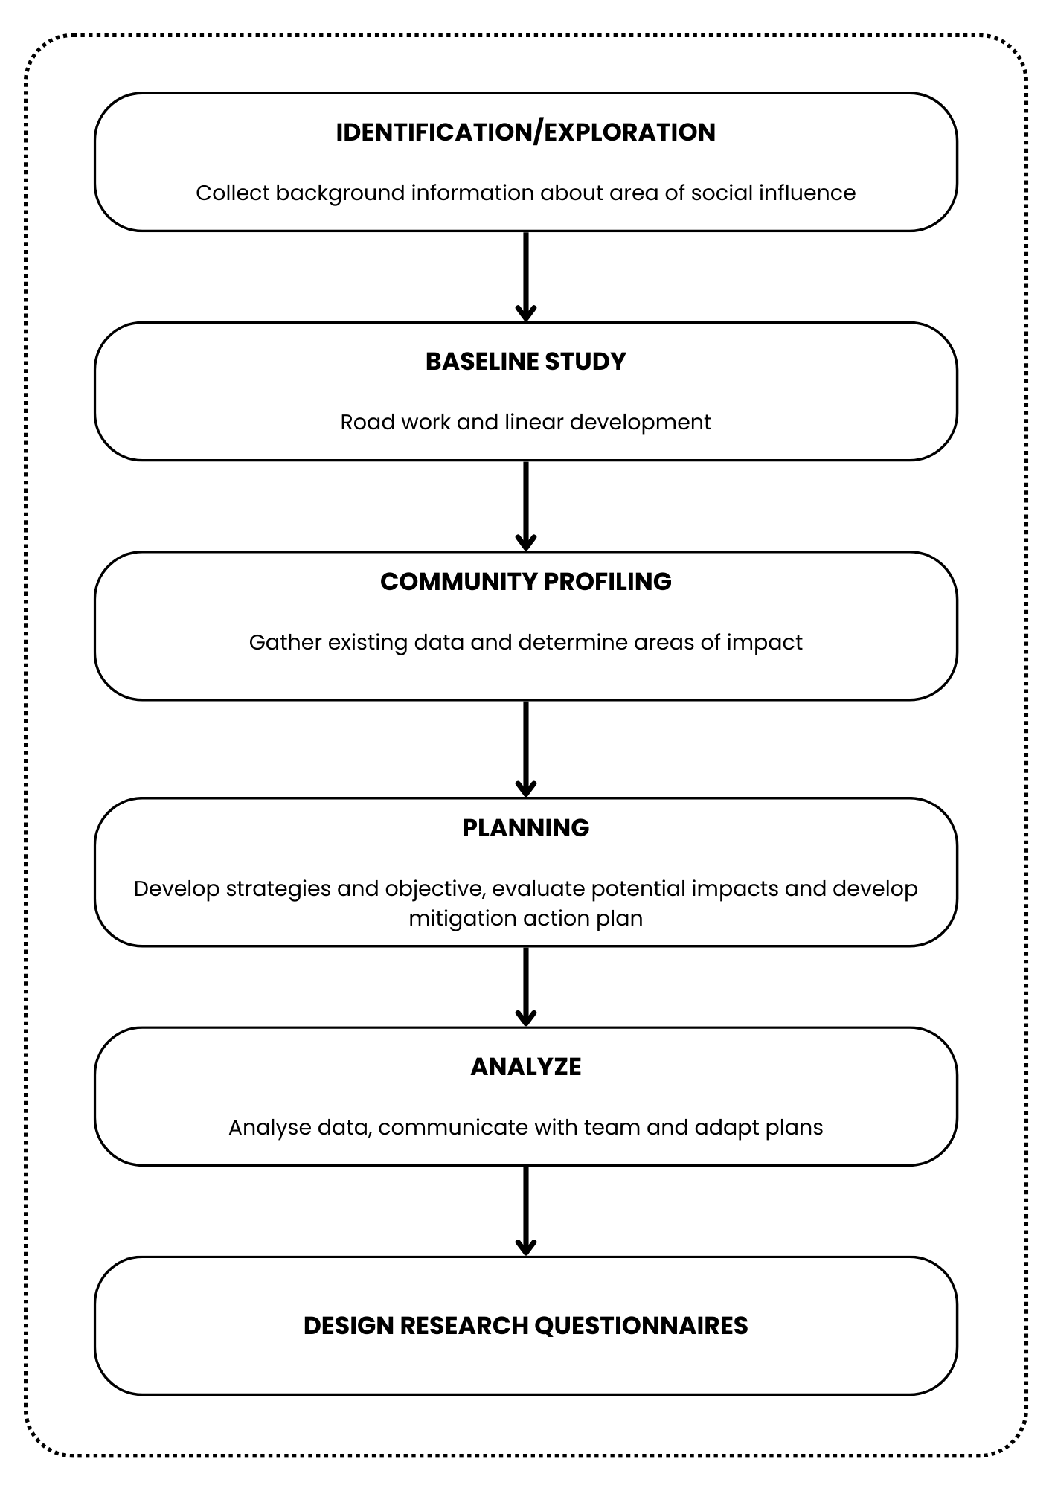

Field Study

During this field research, all necessary data from the community and traders affected by the execution of linear infrastructure development were gathered. The information was acquired by inspecting the project site and visiting the zone of influence, which is within 0-1 km of the proposed road route.

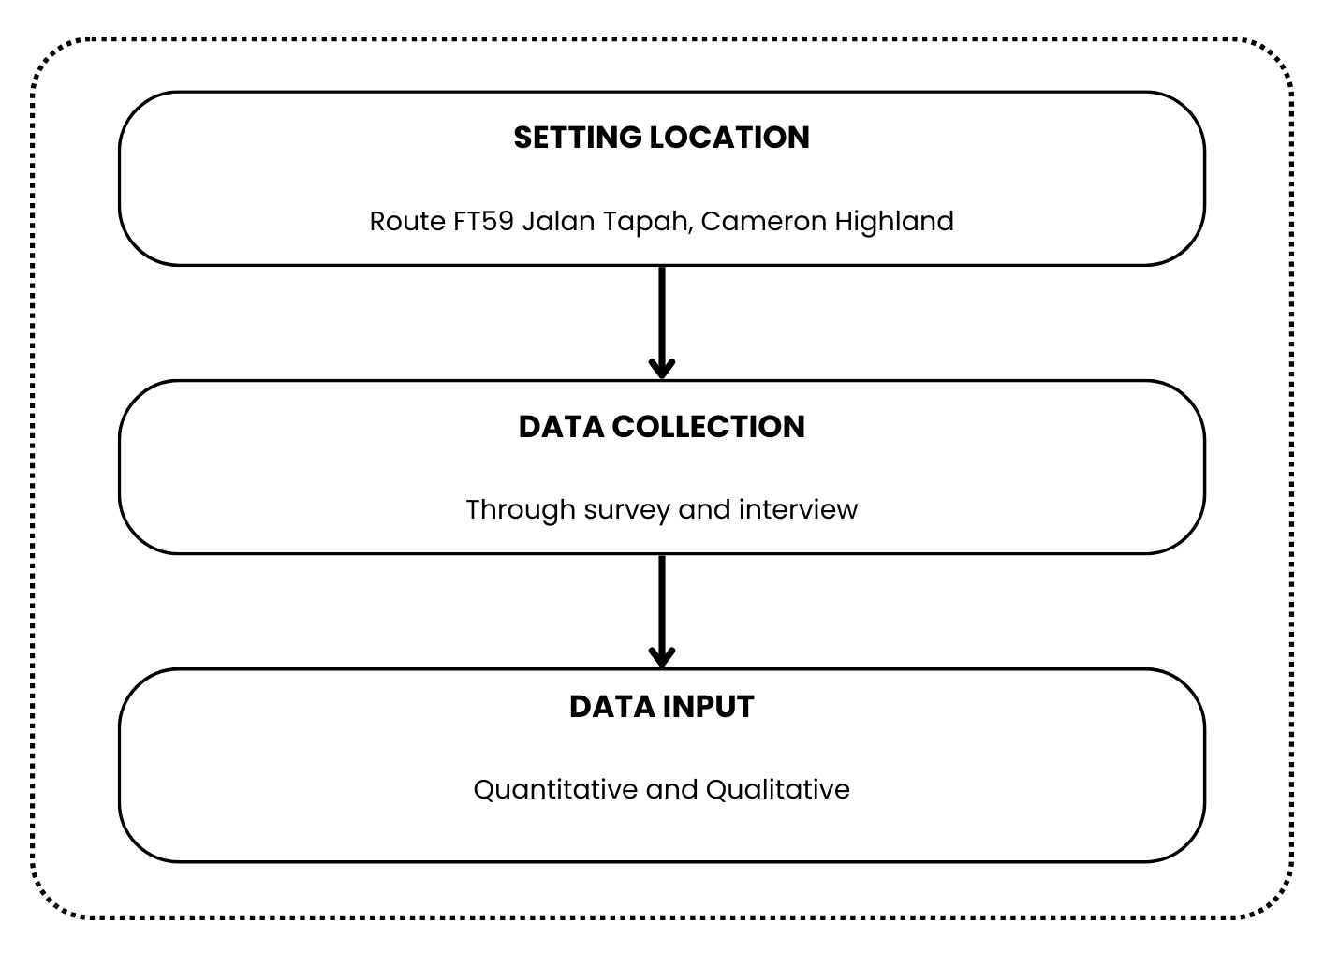

Data Analysis Method

The data from the questionnaire was analyzed using Multi-Criteria Decision Making (MCDM). Analytical Hierarchy Process is one of the most encompassing systems contained in MCDM. It is used to make judgments with various criteria since it allows you to structure the problem in a hierarchical manner and trust in a combination of quantitative and qualitative factors. The AHP approach has four key phases:

- Build Hierarchy
- Weighting of indicators by pair-wise comparison
- Calculate the consistency ion criteria and alternatives
- Combine all the criteria and all the alternatives

RESULTS AND DISCUSSION

The table below illustrates the local influence on linear infrastructure development. The reliability study for the outcomes was performed using the AHP approach, which integrated all criteria and alternatives. The ranking will be based on the overall weighted value.

Pre- Construction Phase

Local impact on linear infrastructure development was assessed during the pre-construction phase. The reliability study for the outcomes was performed using the AHP approach, which integrated all criteria and alternatives. The ranking will be based on the overall weighted value.

Table 3.1: Ranking of positive Impact on Linear Infrastructure Development
 | Employment opportunities | Enhancement of economic growth | Increasing of tourism revenues | Total Weight | Rank
Alternative 1 | 0.15 | 0.22 | 0.24 | 0.22 | 3
Alternative 2 | 0.40 | 0.38 | 0.30 | 0.34 | 2
Alternative 3 | 0.45 | 0.40 | 0.46 | 0.44 | 1

Table 3.1 above shows the ranking total weight based on analysis for the beneficial impact on linear infrastructure development to the community within the research region. Alternative 3 has the greatest overall weight (0.44), while Alternative 1 has the lowest (0.22). The factors with the highest weight are job opportunities (0.45), economic growth enhancement (0.40), and tourism income increase (0.46).

Table 3.2: Ranking of negative Impact on Linear Infrastructure Development
 | Potential displacement of residents | Potential land acquisition | The proposed alignment through agricultural areas | Total Weight | Rank
Alternative 1 | 0.37 | 0.45 | 0.42 | 0.42 | 1
Alternative 2 | 0.3 | 0.21 | 0.36 | 0.3 | 2
Alternative 3 | 0.33 | 0.34 | 0.22 | 0.28 | 3

Table 3.2 illustrates the negative effects of total weight rank analysis for local impact on linear development infrastructure facilities based on community feedback. The highest score (0.42) is on alternative 1, with the criterion weights of (0.37) probable resident relocation, (0.45) potential land acquisition, and (0.42) planned routing through agricultural districts.

During Construction and Operational Phase

The local impact of linear infrastructure development was investigated during the building and operational phases. The reliability study for the outcomes was performed using the AHP approach, which integrated all criteria and alternatives. The ranking will be based on the overall weighted value.

Table 3.3: Ranking of positive impact on Linear Infrastructure Development
 | Employment opportunities | Enhancement of economic growth | Improvements to the provision of infrastructure facilities /upgrading existing | Total Weight | Rank
Alternative 1 | 0.16 | 0.19 | 0.24 | 0.22 | 3
Alternative 2 | 0.29 | 0.39 | 0.36 | 0.35 | 2
Alternative 3 | 0.55 | 0.42 | 0.46 | 0.43 | 1

Table 3.3 above demonstrates the favorable effects of total weights for local impact on linear infrastructure development based on community feedback. Alternative 3 has the greatest overall weights (0.43), with values of 0.55 for each criterion (job opportunities), 0.42 for economic growth, and 0.46 for improvements in infrastructural facilities. In general, all respondents agree with choice 3 since the weight on each criterion is larger than in the other alternatives.

Table 3.4: Ranking of negative impact on Linear Infrastructure Development
 | Social cohesion/  community severance | Expose to  traffic accidents/  hazard risk | Causes of traffic problems and congestions | Total Weight | Rank
Alternative 1 | 0.35 | 0.27 | 0.35 | 0.32 | 3
Alternative 2 | 0.32 | 0.31 | 0.35 | 0.33 | 2
Alternative 3 | 0.33 | 0.42 | 0.30 | 0.35 | 1

Table 3.4 above illustrates the negative effects of total weights for local impact on linear development infrastructure facilities resulting from community participation. Alternative 3 has the highest overall weights (0.35), with values of (0.33) for social cohesiveness, (0.42) for exposure to traffic accidents, and (0.30) for producing traffic difficulties and congestions.

Local Impact on Linear Infrastructure Development

The local impact on linear infrastructure development was assessed in terms of both positive and negative community impacts. The reliability study for the outcomes was performed using the AHP approach, which integrated all criteria and alternatives. The ranking will be based on the overall weighted value.

Table 3.5: Ranking positive impact on Linear Infrastructure Development
 | Enhance the local cultural needs | Increase the level of road safety to users | Increase of local economy/economic benefits | Total Weight | Rank
Alternative 1 | 0.3 | 0.1 | 0.11 | 0.14 | 3
Alternative 2 | 0.33 | 0.3 | 0.34 | 0.32 | 2
Alternative 3 | 0.37 | 0.6 | 0.55 | 0.53 | 1

Table 3.5 above demonstrates the favorable effects of total weights for local impact on linear development infrastructure facilities based on community feedback. Alternative 3 has the highest rank with total weights (0.53), with values for each criterion (0.37) for enhancing local cultural requirements, (0.6) for increasing road safety for users, and (0.55) for increasing local economy.

Table 3.6: Ranking negative impact on Linear Infrastructure Development
 | Increasing of vehicles | Impact to air quality & noise level | Physical disruption | Total Weight | Rank
Alternative 1 | 0.1 | 0.28 | 0.22 | 0.33 | 2
Alternative 2 | 0.3 | 0.2 | 0.3 | 0.26 | 3
Alternative 3 | 0.3 | 0.52 | 0.48 | 0.4 | 1

Table 3.6 above illustrates the negative effects of total weights for local impact on linear development infrastructure facilities resulting from community participation. Alternative 3 has the greatest overall weight (0.40), with values of (0.3) for increased vehicle numbers, (0.52) for impact on air quality and noise levels, and (0.48) for physical disturbance.

Result’s summary
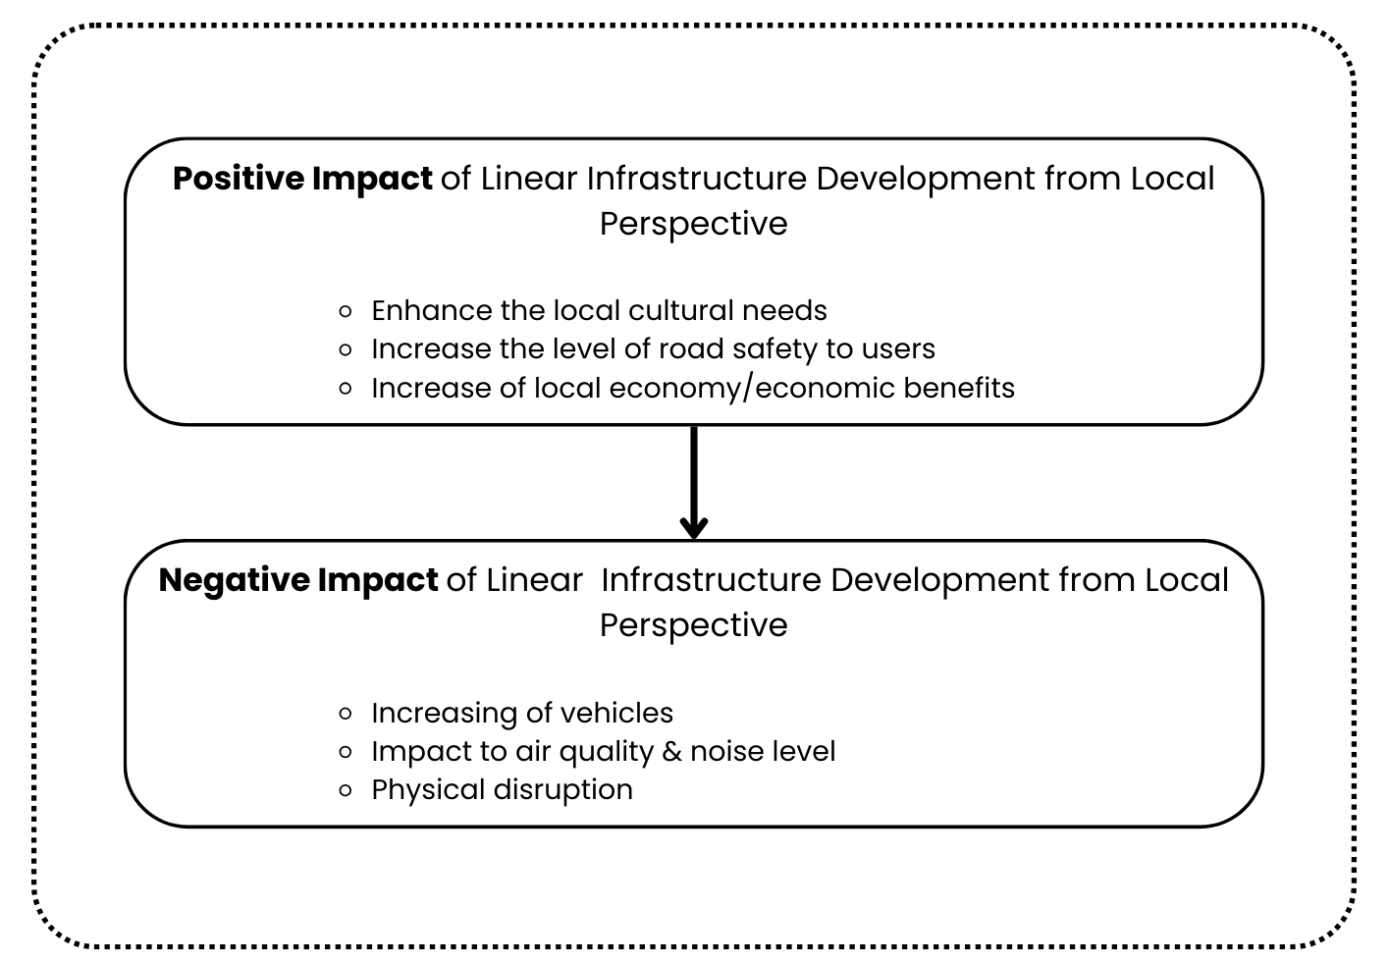
Figure 2: Summary on positive and negative impact of linear infrastructure
development

The table above shows the results of this case study's local influence on the linear infrastructure project. Alternative 3 has the most good and negative impact in terms of social, economic, and environmental impact when compared to alternatives 1 and 2.

Mitigation measures on negative impacts of linear infrastructure development

The linear infrastructure project poses significant social, economic, and environmental dangers to the surrounding population. Every construction process is divided into three phases: pre-construction, construction, and operations. Poor planning in the implementation of linear infrastructure projects causes problems among local residents.

Pre- Construction Phase

Efforts are being made to reduce the negative social, economic, and environmental repercussions of linear infrastructure development during the preconstruction period.

Table 3.7 Mitigation measures at pre- construction phase
Criteria of potential impacts | Mitigation measures
Potential displacement of residents and business area | Implement socio-economic survey and prepare proper resettlement action plan
Potential land acquisition | Avoiding areas that are environmentally sensitive
The proposed alignment through agricultural area | Construction appropriateness

During Construction and Operational Phase

Efforts to reduce the negative social, economic, and environmental repercussions of linear infrastructure development during the pre-construction period.

Table 3.8 Mitigation measures during construction and operational phase
Criteria of potential impacts | Mitigation measures
Community severance | Road project planning, initial social examination and environmental
Expose to traffic problem, congestion and accidents | ensures that adverse environmental and social impacts are properly controlled
Safety and Health | Minimize air pollution and noise pollution

CONCLUSION

This research study met its overall objectives, which included assessing the significance of potential impacts arising from this project on affected community input through a census, addressing potential issues from the new road alignment development, and proposing appropriate mitigation strategies. Furthermore, a few recommendations have been presented and proposed in order to improve the evaluation of the local effect of linear infrastructure development, thereby improving project and construction management in the Cameron Highlands in terms of economy, environment, and social emphasis on infrastructure implementation.

ACKNOWLEDGEMENTS

This research was supported by Universiti Teknologi MARA (UiTM). The author would like to express deepest appreciation to Kementerian Kerja Raya (KKR) for their help and support in this research. The author grateful to the UiTM for all the facilities provided to complete this research work.
REFERENCES

- Anna Zamojska & Joanna Próchniak (2019): Measuring the Social Impact of Infrastructure Projects: The Case of Gdańsk International Fair Co, 1-7.
- Mariana Mohamed Osman, Syahriah Bachok, Noor Suzilawati Rabe (2015): Local Residents’ Perception on Socio-Economic impact of Iskandar Malaysia: an example of urban regeneration program in Malaysia, 3.
- Carlos F. Daganzo (2012): On the Design of Public Infrastructure Systems with Elastic Demand, 2.
- Muhammad Rafeq Razak, Foziah Johar, Rabiatul Adawiyah Abd Khalil (2016): THE IMPACT OF ISKANDAR MALAYSIA DEVELOPMENT ON URBAN AMENITIES, 1-3.
- Anuar Alias, Azlan Shah Ali and Chan Keen Wai (2011): New Urbanism and township developments in Malaysia, 1 & 10.
- Syahrul Nizam Kamaruzzaman & Emma Marinie Ahmad Zawawi (2009): Development of facilities management in Malaysia, 5.
- B. Srinivasu & P. Srinivasa (2013): Infrastructure Development and Economic growth: Prospects and Perspective, 1-2.
- Deepali J. Chaavan & Ravindra H. Sarnaik (2013): Self Sustainable Township, 1.
- S.H. Wai, Aminah Md Yusof, Syuhaida Ismail and C.A. Ng (2013): Exploring Success Factors of Social Infrastructure Projects in Malaysia, 1.
- Avinash Kaur and Rajinder Kaur (2018). Role of Social and Economic Infrastructure in Economic Department of Punjab. 2454-2415 Vol.6, Issue 5.

