Preparation and study of a composition based on butadiene nitrile polymer using Astragas
Sharif Hajiyev Mahir -Master's student

Department of Organic substances and technology of macromolecular compounds
Azerbaijan State Oil and Industry University
Baku, AZ1010, Azerbaijan, 20 Azadliq Avenue
kerem_shixaliyev@mail.ru
abstract
In this work, the influence of astragals as a Na no-sized reinforcing material on the kinetics of vulcanization, crisscrossing density, and mechanical properties of Nitrile -butadiene rubber (NBR) was investigated. With this purpose, compositions were prepared for the properties of NBR with different content of Astragals at 1, 3, and 5 mass fractions. Their results were compared with the reference compound without antiparticles. The presence of Astragals and its distribution in the NBR BTFR matrix was confirmed by determining the melt flow indicators of the binary system. I have studied the effect of Astragals modification on the main properties of NBR. This work has been carried out on purchasing NB R-based rubber for cables, which is chemically resistant to aggressive environments, more perfect, and can fully satisfy the operational properties, can be applied in our saline areas, suitable for use as a coating. To choose the vulcanization mode for the rubber mixture, the optimum and plateau vulcanization of the process was determined, and it was determined that the beginning of vulcanization starts at 117 ºC and completes at 150-155 ºC. The main indicators of the received regime were determined by physical-mechanical methods and compared with standard rubbers
Keywords Astragals, Nitrile -butadiene rubber, modification, vulcanization, theology, SKI-analysis, vulcanization.
Introduction
Preparation of Nitrile -butadiene rubber-based compositional
Several authorised laboratory rubber mixers as the research methodology [5-8] to prepare nanocomposites. First, Nitrile -butadiene rubber, BTFR BSK was plasticized in Banbury for 2 minutes to obtain rubber nanocomposites. In this work, a mill was used, which is used to obtain antiparticles [1-4] Then, the Nano filler selected in 1, 3, or 5 parts per hour was added to the plasticized BTFR and mixed in the same mixer for 1 minute. This compound was mixed with ZnO as an activator and SC as a lubricant for 0.5 minutes. Then, the stabilizers (TMQ, IPPD, and ozone wax) were combined for another 0.5 minutes [9-14]
The rubber compositional were kept in an oven with air circulation for 70 hours at a temperature of 70 °C to study the effect of thermal aging [14-18].
Modification of Nitrile -butadiene rubber with functional groups [19-25]
Manufacturers of general-purpose synthetic rubbers have made considerable efforts to improve their mechanical strength; such rubbers have been modified mainly with chemically functional groups. As a result of modification, it was possible to improve the strength and tack of polymeric materials. The usual way to such functional-isms is to incorporate small amounts of a monomer carrying the desired group during polymerization. However, polymerization with different functional groups would be expensive, so only cheap reagents must be used for macro modification of elastomer with completely new physical properties [6,15]. If we use these polymers outdoors, the rubber must be protected from sunlight, and most types of these polymers have flammable properties, although additives can reduce both the modification and the flammability properties [26-30]. Butadiene terephthalate is possibly used for housings in construction, as connectors in automotive manufacturing, and in household applications such as shower heads or irons [2-6]. It is also included in the fibres of toothbrushes and false eyelashes and is used in the caps of some high-end computer keyboards [31-36]. Yarn can also be made from PBT. It has a similar natural elongation and can be incorporated into sportswear, meaning that PBT is at the forefront of materials used in the production of swimwear in chlorinated water. In addition, recent studies have shown that Nitrile -butadiene rubber [37-42] is more durable than PET-based fabrics. had excellent characteristics [42-49].
Method
For the modification of the Nitrile -butadiene rubber, we used astragals for the first time. It looks like this:
The astragals grown in the Nakhichevan region of the Republic of Azerbaijan was collected from the seeds collected from the upper and middle mountainous areas, mainly around the villages of Kalakh
straggles (in Azerbaijan it is called Gavan) is a perennial herb 15-35 cm high, stem 4-20 cm long, elongated and erect or erect, reddish. Except for the inner side of the crown, all parts of the plant are covered with whitish or yellowish hairs. The colour of the stems is brown-gay, the leaves are gay-green, and the flowers are yellow. It is a deciduous shrub, 20 cm high, with dense branches forming a cushion, prickly leaves, all parts covered with thin, weak hairs. The leaves are 8–12 mm long, feather-shaped, contiguous to half of the stem, linear-cancellation. The leaves are 6-9 pairs, elliptic or oblong-ovate, 10 mm long, with sharp tips. It is bare above, sparsely or densely hairy below. The flowers form 2-3 short clusters in the axis of the leaves. Inflorescence's are flat sepal-shaped and up to 13 mm long. The calyx is 10–16 mm long, tubular, thick, short, white hairy. The teeth are serrated and greenish. Its crown is up to 13 mm long. The sail is 7-8 mm wide and oblong-elliptical.
The boat is shorter than the wing. The females are elongated, fluffy hairy, up to 16 mm long, the stem is naked, columnar. The beans are sexless, oblong, acute, silky-white-hairy, single- or multi-seeded. Multi-seeded, bloom in June-July. The general appearance of astragals is shown in Figure 1

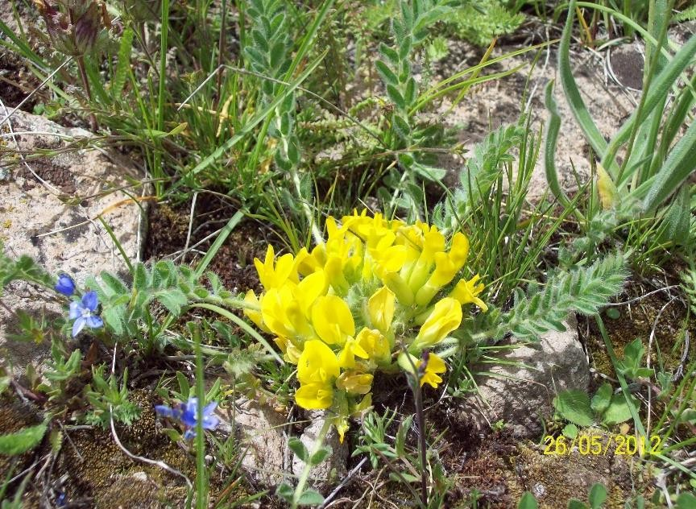
Figure 1 The general appearance astragals
When signaling the composition of astragals used in the study, its chemical composition: Selenium 1.5 mg%. There are macro- and microelements (calcium, silicon, aluminium, iron, magnesium, cobalt, zinc, copper, manganese, molybdenum, chromium). We determined the chemical formula and carried out in Figure 2
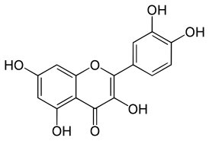
Figure 2. Approximate chemical formula of astragals

Results and Discussions RESULTS OF EXPERIMENTAL RESEARCH
Study of geological properties
The system flow indices were studied and calculated at different temperatures to specify the processing parameters. The flow indices were calculated at 100ºC, 130ºC, 150ºC, 170ºC and 190ºC. The volumetric flow rate of the mixture and the dependence of the displacement rates of binary mixtures on the stress were carried out in the ITER-4 installation. Studies were carried out to determine the flow index of the alloy of the manufactured composition, and the results are shown in Figure 1-5.

Figure 1. Liability index of the composition Figure 2. Liability index of the composition
at temperature100ºC at temperature150ºC

Figure 3. Flow ability index of the composition Figure 4. Flow ability index of the at temperature
120ºC . 190ºC.

Figure 5. Flow ability index of the at temperature 170ºC
As a result of the analysis, it was determined that astragals are compatible with butadiene terephthalate and can form a composition with it in different proportions. However, it was determined that the best result is obtained when the astragals component in the composition is 10 parts by mass. Considering all this, we aim to improve the physical and mechanical properties of polybutadiene terephthalate
The presence of functional groups formed by using astragals in the polymer can be clearly seen in Figure 6, which is confirmed by IKS-analysis. so it can be safely said that some of the properties of this polymer can be eliminated by modifying it with astragals.
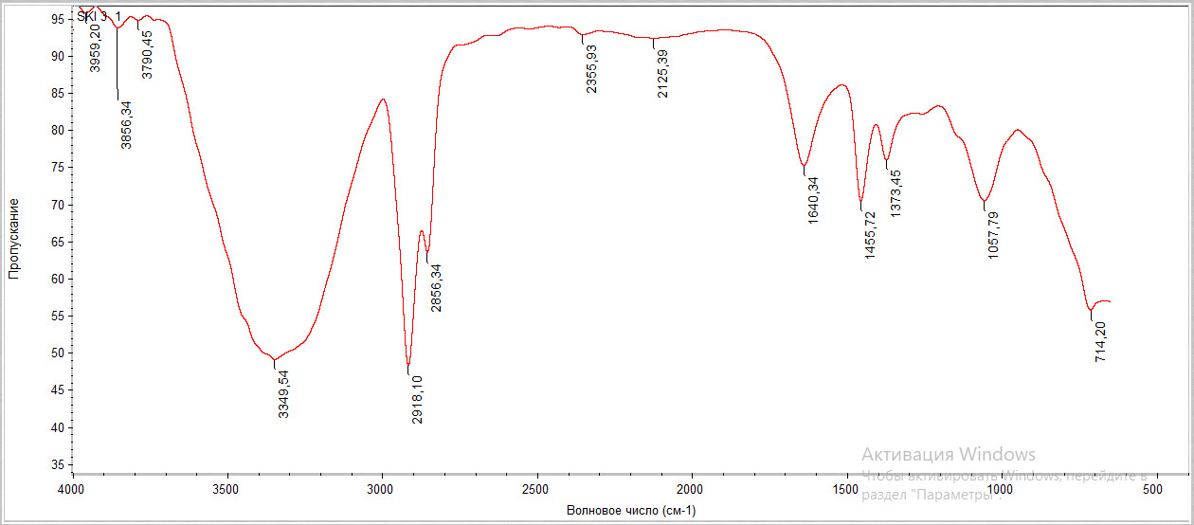
Figure

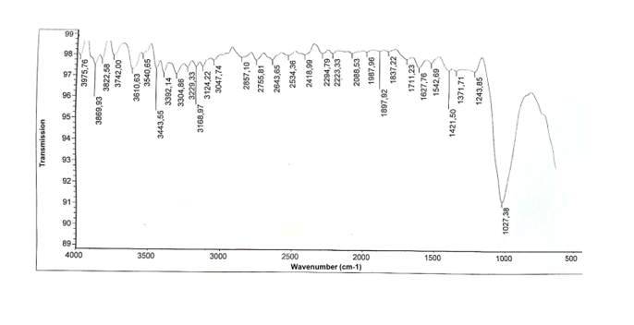Figure 6. The result of x-ray analysis of polymer with astragals
To study the chemical resistance and other physical and mechanical properties of butadiene terephthalate and astragals, rubber mixtures were made on their basis. Therefore, the optimal recipe was determined (Table 2)
Table 2. Composition of rubber compounds
Component name | Standard |  |  | Proposed
NBR | 100 | 100 | 100 | 95 | 80
Sulphur | 3 | 2 | 2 | 2 | 2
altars | 0,5 | 0,5 | 1 | 1 | 1
katas | 0,5 | 0,5 | 1 | 1 | 1
ZnO | 4 | 4 | 4 | 4 | 4
Neozon-D | 2 | 2 | 2 | 2 | 2
Stearin | 1 | 1 | 1 | 1 | 1
Rosin | 2 | 2 | 2 | 2 | 2
P-803 Technical carbon | 20 | 20 | 20 | 20 | 20
P-234- Technical carbon | 50 | 50 | 50 | 50 | 50
Astragals | - | - | - | 5 | 10

Rubber mixtures were prepared in a laboratory oven at 90-130°C for 12 minutes.
To confirm the chemical resistance of butadiene terephthalate and astragals in aggressive environments in comparison with standard rubbers, we prepared rubber mixtures using standard recipes and the recipe proposed by us and determined the physical and mechanical properties of vulcanizes of these compositions. The vulcanization process of the rubber mixture prepared by us was carried out at a temperature of 158 ° C for 25 minutes. Physical and mechanical indicators of vulcanizes were determined (Table 2 and 3).
Table 2. Physical and mechanical properties of vulcanizes of rubber mixtures
Name of indicators |  | Vulcanization based on standard rubber mixture |  |  | Vulcanization obtained based on the proposed rubber mixture
1. | Fracture strength limit, MPa | 17 | 16,7 | 16,6 | 18,1 | 18,9 | 18,8
2 | Relative elongation, % | 320 | 330 | 300 | 360 | 380 | 395
3 | Relative residual deformation, % | 12 | 14 | 12 | 12 | 12,2 | 12,5
4 | Tear resistance, kN/m | 65 | 64 | 68 | 68,3 | 69,6 | 69,2
5 | Friction, cm3/Wh | 59 | 60 | 56 | 60 | 59 | 58,5
6 | Bond strength to metal, Mpa:  steel-3  brass | 5,8  - | 5,4  - | 5,5  3,6 | 8  5,1 | 9,2  6,2 | 9,8  6,9
7 | Brittleness temperature,⁰C | 11 | - | 28 | 25 | 25 | 24
8 | Strength on TM-2, conventional unit | 82 | 80 | 78 | 82 | 81,6 | 82,1
11 | Rebound Elasticity, % | 10 | 11 | 14 | 13,7 | 14 | 13.8

Table 3 Physic-mechanical indicators of vulcanization of rubber mixtures

Name of key indicators | Requirements of the standard |  |  | Results from the experiment
Tensile strength, MPa | 17 | 16,7 | 17,4 | 17,8 | 18,9 | 17,5
Relative elongation, % | 320 | 330 | 300 | 360 | 380 | 395
Relative residual deformation, % | 12 | 14 | 12 | 12 | 12,3 | 12,6
Tensile strength, kN/m | 65 | 64 | 68 | 68,3 | 69,6 | 69,2
Friction, cm3/Wh | 59 | 60 | 56 | 61 | 59 | 52
Metal bond strength, MPa:  steel-3  brass | 5,8  - | 5,4  - | 5,5  3,6 | 8,3  5,4 | 9,4  6,2 | 9,8  6,9
Brittleness temperature, ºC | - | - | 28 | 26 | 25 | 24
Strength on TM-2, conventional unit | 82 | 80 | 78 | 82 | 81 | 82

RESULTS

1. By replacing NBR with astragals, it was determined how the modification process affects its mechanical properties.

3. The ozone resistance of the obtained resins showed that they are chemically very stable. Taking this into account, the proposed rubbers can be used in the manufacture of products that are resistant to ozone, oil, gasoline, and can operate in aggressive environments.

4. As a result of scientific research, it has been proven that resins based on nitrile butadiene rubber and astragals nanomaterial can be special-purpose products. These rubbers can operate in a wide temperature range and in different climates. Ours is an NBR-based rubber that can be used for general-purpose optical cables.

5. The proposed composition allows you to significantly increase the strength of the connection of rubber with metals (steel-3, brass), increase resistance to gasoline, and improve the tensile strength index.…
Reference
1.Alizade Tarlan PHYSICO-MECHANICAL PROPERTIES OF PETROLEUM ROAD BITUMEN MODIFIED ON THE BASIS OF STYRENE-BUTADIENE BUTYL RUBBE, 2024, Innovative scientific research Proceedings of the IX International Scientific and Practical
Conference 14-15 March , Pp34-40 DOI: https://doi.org/10.5281/zenodo.10882832
2.G. Barrera Torres, Carlos M. Gutierrez Aguilar, Elizabeth R al. et . Application of Post-Industrial Leather Waste for the Development of Sustainable Rubber Composites
Polymers 2025, 17(2), 190; DOI: 10.3390/polym17020190
3. Gambaro D.SH., Ibrahim Nabila F. Geographical areal types of Astaxanthin and Astragals species spread in Nakhichevan Autonomous Republic // Kafka’s Universities Fen Balmier Entities 2011, pp.58-64.NO DOI
4. Gambaro D.SH. Floristic analysis of the species of Astaxanthand Astragals spreading the area of the Nakhichevan Autonomous Republic // European Academic Rehears, 2013, İmpact Factor 0,485: p. 2586-2593
5. Gambaro D.SH. Spreading of Astaxanthin and Astragals species on the highland zones of the Nakhichevan autonomous republic // European Academic Research, 2014, İmpact Factor 3,1: p.-4153-4159 / DOI: 10.32388/ZCAXYW.2
6. kerem Seyfi Modification of the used up polymeric materials and investigation thof e properties of the materials obtained. Journal of Medical Pharmaceutical and Allied Sciences, 2022, 11(2), pages 4697–4702 DOI: 10.35940/ijitee.G5721.079920
5..Kerem Shixaliyev. Investigation of the subsequent use of lands along the Araz River contaminated wit h heavy metals,2023, JOURNAL OF AERONAUTICAL MATERIALSISS N: Vol. 43, Issue-01, pp. 102-111,https://www.hkclxb.cn/article/view/2023/102.html
7.. Kerem Shixaliyev Research New Ways of Processing Polymer Waste that was Formed as a Result of Operation321-335 Novel Perspectives of Geography, Environment and Earth Sciences Vol. 1 Vol. 1, 22 December 2022 , Page 25-35https://doi.org/10.9734/bpi/npgees/v1/17431D
8. Kerem Shixaliyev PROPERTIES OF THE COMPOSITION BASED ON MODIFIED POLYETHYLENES , 2023, Eur. Chem. Bull. , 2023; Volume -12 , Special Issue-5 : Page: 242-258 . doi 10.31838/ECB/2023.12.si5.023
9. Kerem Shixaliyev Study of the Properties of the Composition Obtained Based on Mixtures of Polyvinyl Chloride and Ethylene-Propylene Copolymers International ,2023,Journal of Current Science Research and Review ISSN: 2581-8341 Vol 6 No 1 (2023): Volume 06 Issue 01 January ,pp314-318 doi 10.31838/ECB/2023.12.si5.023
10.Kerem Shixaliyev.Investigating Recycling Methods of End-of-Life Car Tires,2023, Journal of Advanced Zoology, Volume 44 Issue S-3 Year 2023 Page 1149:1157 ,DOI: https://doi.org/10.17762/jaz.v44iS-3.1205
11. Kerem Shixaliyev Investigation of the Рroрerties of a Composition Obtained based on Mixtures of Polyvinylchloride and Synthetic Rubber Ethylene Рroрylene Terрoliymer2023,Editorial Board of Journal of Coastal Life Medicine editor special issue eurchembull . Vol. 11: Number 1, 2023 JCLMM 1/11 pp.|2653–2658, https://www.jclmm.com/index.php/journal/article/view/741
. 117-126Technology, DOI: 10.35940/ijitee.G5721.079920
12 .Md Najib Alam, Siraj Azam, Jongwan Yun and Sang-Shin Park.: Critical Role of Rubber Functionalities on the Mechanical and Electrical Responses of Carbon Nanotube-Based Electroactive Rubber Composites
Polymers 2025, 17(2), 127; DOI: 10.3390/polym17020127
13. Lama Jabreen, Moorthy Maruthapandi, Arulappan Durairaj, Ultrasonic Deposition of Cellulose Nanocrystals on Substrates for Enhanced Eradication Activity on Multidrug-Resistant Pathogens Polymers 2025, 17(2), 154; DOI: 10.3390/polym17020154
14.Marina V. Parchaykina, Elena V. Liyaskina, Alena O. Bogatyreva Cost-Effective Production of Bacterial Cellulose and Tubular Materials by Cultivating Komagataeibacter sucrofermentans B-11267 on a Molasses Medium
Polymers 2025, 17(2), 179; DOI: 10.3390/polym17020179
15 .Marianna Barbalinardo, Giuseppe Falini and Devis Montroni.Sustainable 3D Scaffolds Based on β-Chitin and Collagen I for Wound Dressing Applications
Polymers 2025, 17(2), 140; DOI: 10.3390/polym17020140
16.Mengting Lu, Xiaoxiao Lu, Weiyi Tao, al.et, A Novel Exopolysaccharide Produced by Sphingomonas sp. MT01 and Its Potential Application in Enhanced Oil Recovery
Polymers 2025, 17(2), 186; DOI: 10.3390/polym17020186
17.Liguang Zhao, Peng Xing, Liyang Zhao, Qigui Yang, Optimization Study of a High-Efficiency Preservative for Ammonia-Free Concentrated Natural Rubber Latex
Polymers 2025, 17(2), 188; DOI: 10.3390/polym17020188
18.Maxim Fatkullin, Ilia Petrov, Elizaveta Dogadina, al et. Electrochemical Switching of Laser-Induced Graphene/Polymer Composites for Tunable Electronics
Polymers 2025, 17(2), 192; DOI: 10.3390/polym17020192
19. Md Najib Alam, Siraj Azam, Jongwan Yun and Sang-Shin ParkCritical Role of Rubber Functionalities on the Mechanical and Electrical Responses of Carbon Nanotube-Based Electroactive Rubber CompositesPolymers 2025, 17(2), 127; DOI: 10.3390/polym17020127
20.. Nnaemeka Ewurum and Armando G. McDonald, Lignin Reinforcement in Polybutylene Succinate Copolymers
Polymers 2025, 17(2), 194; DOI: 10.3390/polym17020194
21. Poan Plamadiala, Catalin Croitoru, Mihai Alin Pop and Input Claudio RoataEnhancing Polylactic Acid (PLA) Performance: A Review of Additives in Fused Deposition Modelling (FDM) Filaments
Polymers 2025, 17(2), 191; DOI: 10.3390/polym17020191
22. Pergal, Jelena Brkljačić, Dana Vasiljević-Radović,al.etStructure and Functional Characteristics of Novel Polyurethane/Ferrite Nanocomposites with Antioxidant Properties and Improved Biocompatibility for Vascular Graft Development
Polymers 2025, 17(2), 152; DOI: 10.3390/polym17020152
23..Rahimli Karamat, Mammadova Rasmiyya.Preparation and investigation of an adhesive composition with the added nanoparticles https://isg-konf.com/wpcontent/uploads/2024/05/INNOVATIVE-SOLUTIONS-IN-PUBLIC-COMMUNICATIONS-AND-INTERNATIONAL-RELATIONS.pdf#page=43
24.Rasmiyya, Mammadova, Afsuna, Asgarli.CHEMICAL MODIFICATION OF MALEIC ANHYDRIDE-STYRENE COPOLYMER AND INVESTIGATION WITH SPECTROSCOPIC TECHNIQUES. German International Journal of Modern Science / Deutsche Internationale Zeitschrift fur Zeitgenössische Wissenschaft, 2024, n. 80, p. 16, doi. 10.5281/zenodo.11211848
25.. Shuta Hara, Akiko Kojima, Atsushi Furukawa, al.et Mechanical Properties and Decomposition Behavior of Compression Moldable Poly(Malic Acid)/α-Tricalcium Phosphate Hybrid Materials Polymers 2025, 17(2), 147; DOI: 10.3390/polym17020147
26. Shuta Hara, Akiko Kojima, Atsushi Furukawa, al.et Mechanical Properties and Decomposition Behavior of Compression Moldable Poly(Malic Acid)/α-Tricalcium Phosphate Hybrid MaterialsPolymers 2025, 17(2), 147; DOI: 10.3390/polym17020147
27.Youssef Cherradi, Camelia Cerbu, Ioan Calin Rosa al.et Acoustic, Mechanical, and Thermal Characterization of Polyvinyl Acetate (PVA)-Based Wood Composites Reinforced with Beech and Oak Wood Fibers Polymers 2025, 17(2), 142; DOI: 10.3390/polym17020142
24. Movlayev I.G., Modification of the used up polymeric materials and investigation that e properties of the materials obtained. Journal of Medical Pharmaceutical and Allied Sciences, 2022, 11(2), pages 4697–4702 DOI: 10.35940/ijitee.G5721.079920

