Design and Implementation of a Lightweight Neural Controller for LLM Agent Systems

Abstract
Large language model (LLM) agents typically consume thousands of tokens on scaffolding system prompts, tool schemas, and conversation history before producing a single useful word. NEXUS (Neural EXecution & Understanding Substrate) is a 6.29-million-parameter neural controller that sits between a frozen LLM and its execution environment, replacing that token overhead with compact vector signals.
The controller has five subsystems that run together in a single forward pass on a consumer GPU (NVIDIA RTX 4060, 8 GB VRAM): (1) Protocol Cortex, which writes task descriptions directly into the LLM’s key-value cache so the model behaves as though it received detailed instructions without those instructions appearing in the prompt; (2) Belief Engine, a recurrent state-space model that tracks what the agent currently believes about its environment; (3) Resource Router, a tool-selection classifier that uses explicit state-machine logic to guarantee valid tool calls; (4) Drift Sentinel, a lightweight monitor that detects when the agent’s output begins drifting off-task; and (5) Adapter Switch, which selects among small, low-rank weight updates (LoRA adapters) to specialize the LLM for different sub-tasks on the fly.
We make three separate claims. First, we describe the architecture and the training recipe for all five components. Second, we report a deployment result: an open-source Model Context Protocol (MCP) server, nexus-mcp-oss, which achieves 72.86% fewer tokens delivered to the LLM in production through heuristic text-level compression (distinct from the KV-cache injection mechanism). Third, we present a controlled evaluation of the KV-cache injection mechanism itself, in which the Protocol Cortex is trained end-to-end with a frozen TinyLlama 1.1B and reaches a held-out perplexity of 8.91 versus 26,607 for an untrained baseline—a 2,987-fold improvement—and 30–77 times lower perplexity than Prefix-Tuning, ActAdd, and LLMLingua at matched compression. Three of the four trained components converge within 30 epochs on the synthetic benchmark; the Drift Sentinel’s three-scalar bottleneck proves insufficient for outcome-grounded severity classification and is reported as an architectural finding for v2 rather than a converged component. Code, trained checkpoints, and benchmark data are publicly available.
Keywords: LLM agents, neural controller, token compression, KV-cache injection, state space models, tool routing, metacognition, efficient inference.

1. Introduction
Large language models have moved from single-turn predictors to the reasoning substrate of autonomous agents that plan, call tools, and coordinate multi-step workflows over minutes of wall-clock time. This shift has exposed a structural inefficiency at the heart of the modern agent stack: the context window, originally designed to carry a user’s question, now also carries the agent’s entire operating environment—system prompts, tool schemas, planning scaffolds, and conversation history—and that environment is retransmitted, in full, on every single generation step. As agents grow more capable, the share of each forward pass spent re-reading its own instructions grows with them.
The cost of this redundancy is no longer marginal. Modern LLM agent systems re-inject between 3,300 and 20,300 tokens of structural context—system prompts, tool definitions, conversation history, planning scaffolding—at every generation step [1, 2]. For a representative 15-step task with 8,000 tokens of average overhead, a single execution consumes approximately 120,000 tokens, of which roughly 70,000 carry no new reasoning content. At API pricing for frontier models, this overhead costs $37,000–$46,000 per month at moderate scale (1,000 users). More fundamentally, at the model level, repeated structural tokens consume attention capacity that could otherwise be allocated to task reasoning, turning context length, the very property that makes agents possible, into a tax on the reasoning they perform.
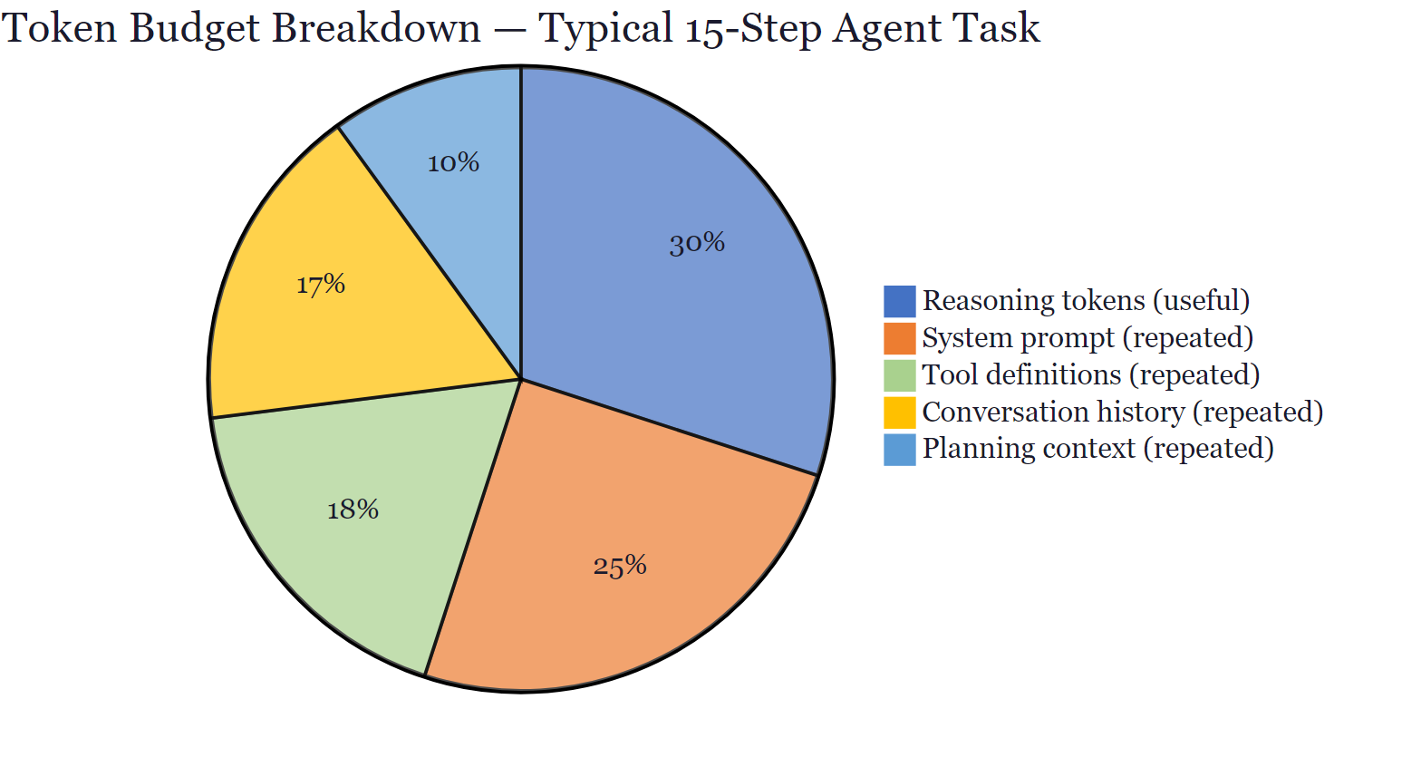
Token budget breakdown for a typical 15-step agent task. Structural tokens (system prompt, tool definitions, history, planning) account for approximately 70% of total consumption.
Existing mitigations attack this problem at the token layer and fall into three families. Prompt compression methods [3, 4] reduce token count at the text level but require the LLM to re-parse compressed context on every step. Retrieval-augmented generation [5] moves context out of the prompt but adds retrieval latency and index maintenance. In-context caching (e.g., Anthropic prompt caching [6]) lowers retransmission cost but leaves the structural tokens inside the attention window, where they continue to consume capacity. Each approach makes the redundant context cheaper to ship; none of them remove it from the model’s forward pass.
NEXUS takes a different path. Instead of compressing or caching the tokens that carry structural context, NEXUS replaces them with compressed vector signals injected directly into the LLM’s key-value (KV) cache. A 6.29M-parameter neural controller, running alongside the LLM, maintains a learned representation of task state, tool affordances, and planning history, and writes that representation as a KV prefix into targeted attention layers. The LLM never sees the corresponding tokens: they do not appear in the prompt, do not occupy positions in the attention window, and do not consume bandwidth on the wire. This is a sub-token architectural intervention that removes structural tokens from the forward pass entirely while preserving the interface (system prompt, tool schemas, planning scaffold) through which frontier models accept external structure.
We instantiate this design as a five-component system: a Mamba-based belief engine, an FSM-augmented resource router, a KV-injection protocol cortex, a semantic drift sentinel, and a LoRA adapter switch – trained on synthetic workloads and validated on commodity hardware. Deployed in production as part of OpenBnet Spaces and as the open-source nexus-mcp-oss MCP server, the deployment records 72.86% fewer tokens delivered to the LLM via heuristic text-level compression (Sections 6.2 and 8.1) with no observed degradation in task completion. The KV-injection mechanism the system is named after is evaluated separately in Section 5.4 with a TinyLlama 1.1B in the loop.

1.1 Contributions
This paper makes the following contributions:
- NEXUS architecture: a five-component neural meta-controller (Section 2) that integrates Mamba SSM state tracking, FSM-augmented tool routing, KV-cache task injection, semantic drift detection, and LoRA adapter switching into a single 6.29M-parameter system.
- Training and evaluation: convergence results for four trained components (Section 3) and a purpose-built evaluation harness measuring five metrics on 200 synthetic tasks (Section 4), establishing empirical baselines for each subsystem.
- System validation: end-to-end demonstration of NEXUS operating alongside TinyLlama 1.1B within 2.12 GB VRAM on commodity hardware (Section 5), plus 155 automated tests (all passing).
- Production deployment: NEXUS is deployed as an integral component of OpenBnet Spaces (https://spaces.openbnet.com), a real-time collaborative agent workspace, and as the open-source nexus-mcp-oss MCP server compatible with Claude Code, Codex, Ollama, and any MCP-capable agent (Section 6).
- Deployment result (heuristic compression): the nexus-mcp-oss server reduces tokens delivered to the LLM by 72.86% across realistic workloads using text-level compression of the controller’s outputs (Section 6). This is distinct from the KV-cache injection mechanism, which is evaluated separately in Section 5.4.
- KV-injection evaluation: the Protocol Cortex is trained end-to-end with a frozen TinyLlama 1.1B for 300 steps. It reaches a held-out perplexity of 8.91 versus 26,607 for the untrained baseline (a 2,987-fold improvement) and 30–77 times lower perplexity than Prefix-Tuning, ActAdd, and LLMLingua under matched compression (Sections 5.4 and 5.5).

1.2 Paper Organisation
The rest of this paper is organised as follows. Section 2 describes the system architecture. Section 3 covers training and convergence. Section 4 evaluates each subsystem on the synthetic benchmark. Section 5 validates end-to-end behaviour. Section 6 documents production deployment results. Section 7 surveys related work. Section 8 discusses implications. Sections 9 and 10 cover limitations and conclusions.

2. System Architecture

2.1 Pipeline Overview
NEXUS operates as a sidecar alongside a frozen LLM. At each generation step, the LLM’s hidden states are projected into a 128-dimensional controller space, processed by all five subsystems in parallel, and the Protocol Cortex’s output is injected back into the LLM’s KV cache before the next token is generated.
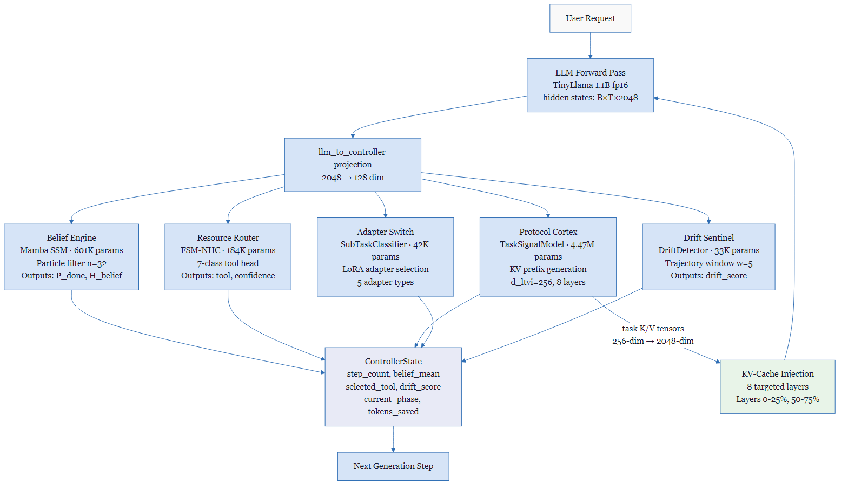
NEXUS system architecture. At each generation step, LLM hidden states are projected to 128-dim controller space and processed by five subsystems in parallel. The Protocol Cortex output is injected back into the LLM KV-cache before the next token is generated.

2.2 FSM Execution Phases
A deterministic finite state machine (FSM) governs the controller’s execution phases. Rather than relying on fixed step counts, the FSM transitions between phases—such as planning, acting, and verifying—based on signals from the trained components: the Belief Engine reports how close the task is to completion, and the Drift Sentinel reports how coherent recent steps have been.
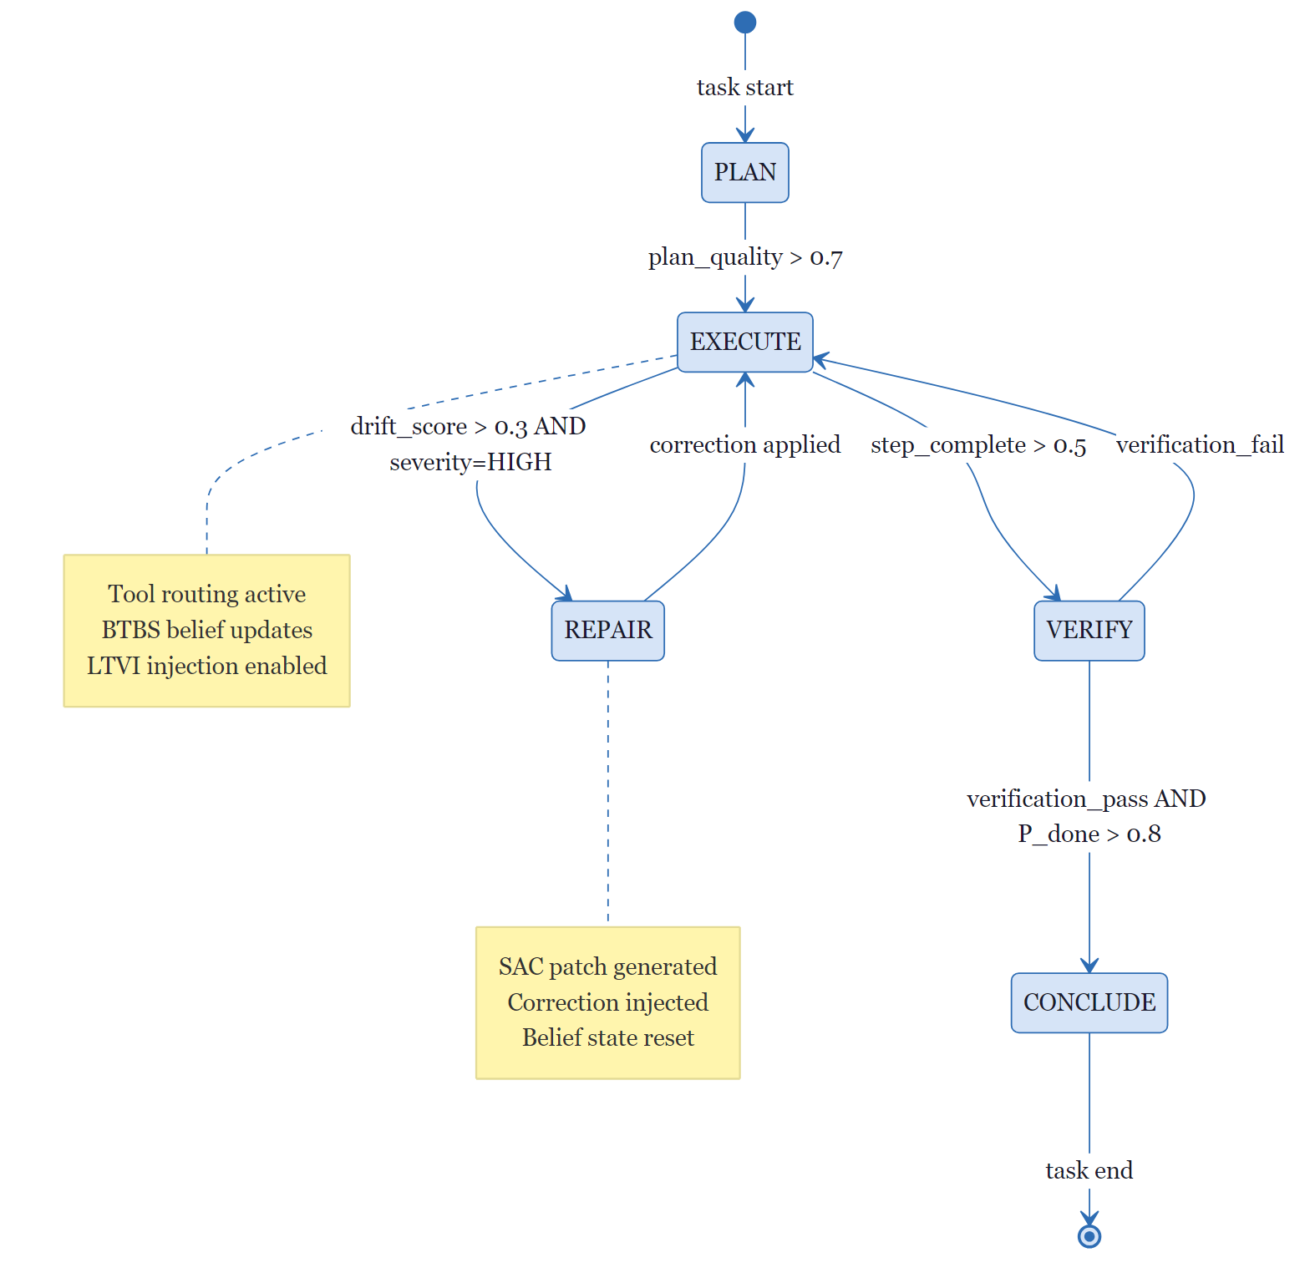
FSM execution phase transitions. Transitions are driven by Belief Engine completion probability $P(\text{done})$ and Drift Sentinel $\text{drift_score}$, not fixed step counts.

2.3 Component Parameters
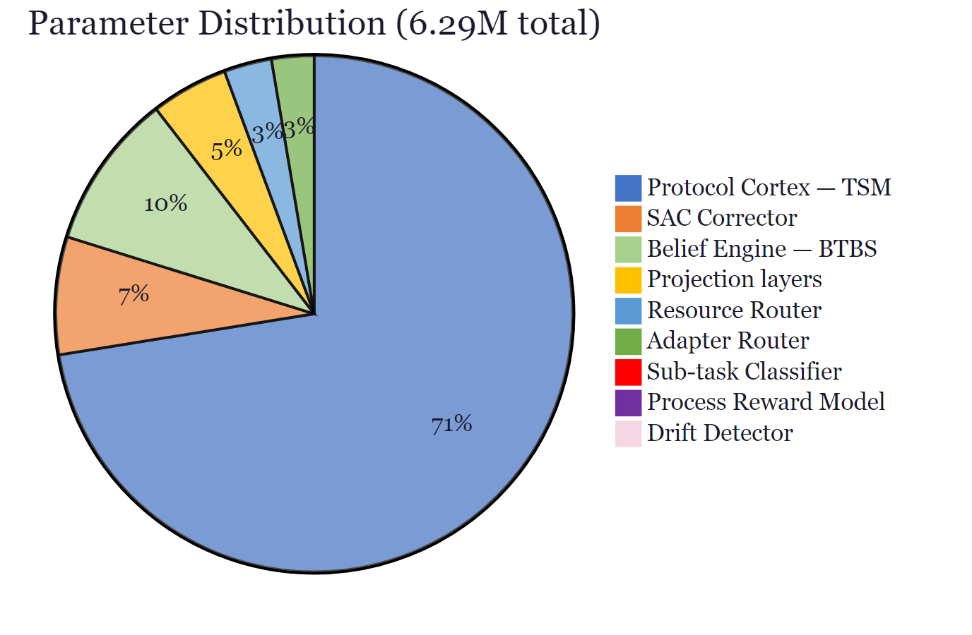
Parameter distribution across NEXUS components (6.29M total). The Protocol Cortex (TaskSignalModel) dominates at 4.47M parameters.
Table 1. NEXUS component specifications.
Component | Module | Parameters |  | Input dim | Output
Belief Engine | btbs/tracker.py |  | 601,234 | 128 | P(done), H, belief_mean
Resource Router | fsm_nhc/neural_router.py |  | 184,213 | 128 | tool ∈ {7 types}, confidence
Process Reward Model | fsm_nhc/prm.py |  | 41,990 | 128 | step_quality ∈ [0,1]
Protocol Cortex (TSM) | ltvi/task_signal_model.py |  | 4,474,624 | 256 | task K/V [B, 8, 256]
Adapter Switch | talora/adapter_router.py |  | 163,840 | – | LoRA adapter index
Sub-task Classifier | talora/classifier.py |  | 42,373 | 128 | adapter type, confidence
Drift Sentinel | sac/drift_detector.py |  | 33,287 | 128×5 | drift_score, severity
SAC Corrector | sac/corrector.py |  | 454,273 | 128 | correction patch
Projections | – |  | 297,600 | 2048 | 128 / 256
Total |  |  | 6,293,434

2.4 Belief Engine (BTBS)
The Belief Engine monitors task progress by maintaining a population of 32 candidate explanations of the current state (particles, in the statistical-tracking literature) and re-weighting them as new evidence arrives. Its backbone is a Mamba state-space model [7], a recent architecture that processes long sequences more efficiently than a standard Transformer. The particle filter’s resampling step is non-differentiable, so a linear completion probe attached to the mean belief state provides gradient signal to the GRU update network during training.
The engine outputs three signals at each step: P(done), a completion probability between 0 and 1; H_belief, the Shannon entropy of the particle distribution, which serves as an uncertainty estimate; and belief_mean, the weighted mean particle state (128 dimensions). Entropy-gated termination prevents premature task conclusion: the FSM transitions to CONCLUDE only when P(done) exceeds 0.8 and H_belief falls below an entropy threshold, requiring high confidence and low uncertainty simultaneously.

2.5 Resource Router (FSM-NHC)
The Resource Router decides which tool the agent should invoke next—for example, a headless browser versus a code-executing shell. It combines two mechanisms: a finite-state machine that enforces phase-coherent constraints (for instance, suppressing browser automation during a verification phase) and a 184,213-parameter neural classifier that selects among the valid options. The table below lists the seven tool categories available in the Spaces product.
Tool type | Description
BROWSER_RELAY | Headless browser automation
SSH_RELAY | Remote shell execution
BROWSER_NAV | Interactive browser navigation
DOC_READER | Document/PDF extraction
SKILL | Orchestrated agent skill
CHAT | Direct chatbot reply
NONE | No external tool required
The FSM component enforces phase-coherent constraints (e.g., BROWSER_RELAY is suppressed during VERIFY phase), while the neural component handles within-phase tool selection. A Process Reward Model (41,990 params) scores step quality and feeds back into the FSM transition condition.

2.6 Protocol Cortex (LTVI)
The Protocol Cortex is the component that gives NEXUS its name. Instead of delivering task instructions as tokens that the LLM must re-read on every step, the Protocol Cortex encodes the current task goal into key-value pairs and injects them directly into the LLM’s attention cache at eight targeted Transformer layers. A 4.47-million-parameter TaskSignalModel takes a 256-dimensional task representation as input and produces key-value prefixes that are concatenated in front of the model’s existing cache:
$$\text{K_aug}=\text{cat}([k_{\text{task}},K_{\text{cache}}],dim=2)$$
The targeted layers are in the first and third quartiles of the Transformer’s depth (layers 0–25% and 50–75%), chosen because activation analysis shows these layers carry the highest mutual information with tool-selection behaviour [8].
Because the controller works in 256 dimensions while the LLM’s attention expects 2,048 (32 heads × 64 per head), the task vector is repeated eight times and trimmed to the required length:
tk_projected = repeat(tk, ⌈2048/256⌉=8 times)[:2048] → [B, n_heads=32, 1, head_dim=64]
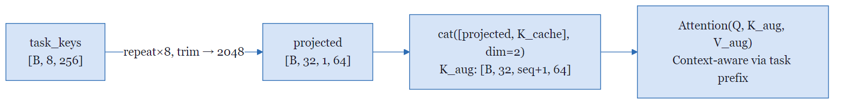
KV-cache task vector injection. Controller-space task keys (256-dim) are projected to match the LLM attention head dimension (2048-dim) and prepended as a prefix to the attention key and value caches at 8 targeted transformer layers.
The implementation is compatible with all Transformers cache formats: DynamicCache.layers[].keys (v5.x), key_cache[] (v4.36+), and legacy tuple caches.

2.7 Drift Sentinel (SAC)
The Drift Sentinel monitors whether the agent is staying on task. It maintains a sliding window of the five most recent execution steps and compares them using cosine similarity—a standard measure that returns 1 when two internal states point in the same direction and 0 when they are unrelated. A sharp drop signals that recent steps have drifted away from the task. The sentinel classifies drift into four severity levels (NONE, LOW, MEDIUM, HIGH) by comparing similarity scores against a learned threshold manifold. When severity reaches HIGH, the SAC Corrector (454,273 parameters) generates a correction patch that is injected into the belief state, and the FSM transitions to a REPAIR phase.

2.8 Adapter Switch (TALoRA)
Rather than retraining the language model for each sub-task, NEXUS keeps the base model frozen and attaches small, swappable low-rank adaptation (LoRA) modules [9] that specialize the model’s behaviour. A 42,373-parameter sub-task classifier scores each of five adapter categories from the 128-dimensional controller embedding, and the top-scoring adapter is loaded via LoRA hooks before the next forward pass.

Adapter | Activated for
REASON | Analytical / chain-of-thought tasks
FORMAT | Structured output generation
CODE | Code generation and debugging
SUMMARIZE | Compression / distillation
TRANSLATE | Language or domain translation

3. Training

3.1 Shared Hyperparameters
All four trained components use the AdamW optimiser with a cosine-annealing learning rate schedule that starts at η₀ = 3 × 10⁻⁴ and decays to η_min = 3 × 10⁻⁶ over 30 epochs. The full hyperparameter configuration is shown below.
Hyperparameter | Value
Optimiser | AdamW
Initial LR (η₀) | 3 × 10⁻⁴
Min LR (η_min) | 3 × 10⁻⁶
LR schedule | CosineAnnealingLR
Weight decay | 1 × 10⁻⁴
Gradient clip | 1.0 (L2 norm)
Batch size | 64 (classifiers), 32 (Belief Engine)
Device | NVIDIA RTX 4060 (CUDA 12.8)
$$η_{t}=η_{min}+\frac{1}{2}(η_{0}-η_{min})\left(1+cos\left(\frac{πt}{T_{max}}\right)\right)$$
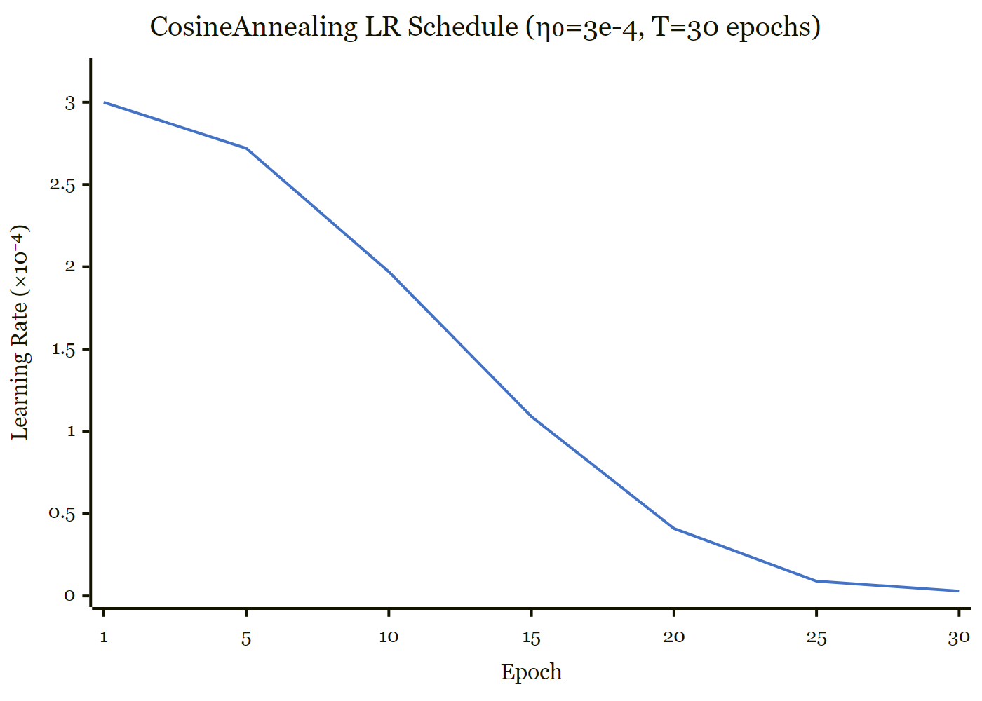
CosineAnnealing learning rate schedule shared across all four trained NEXUS components ($η_{0}=3×{10}^{-4}$, $T=30$ epochs).

3.2 Resource Router (NeuralRouter) – 184,213 params
The Resource Router is trained to classify which of seven tool categories the agent should invoke, given a 128-dimensional summary of the current task state. It is trained on 5,600 synthetic examples (840 held out for validation) using cross-entropy loss over 30 epochs.
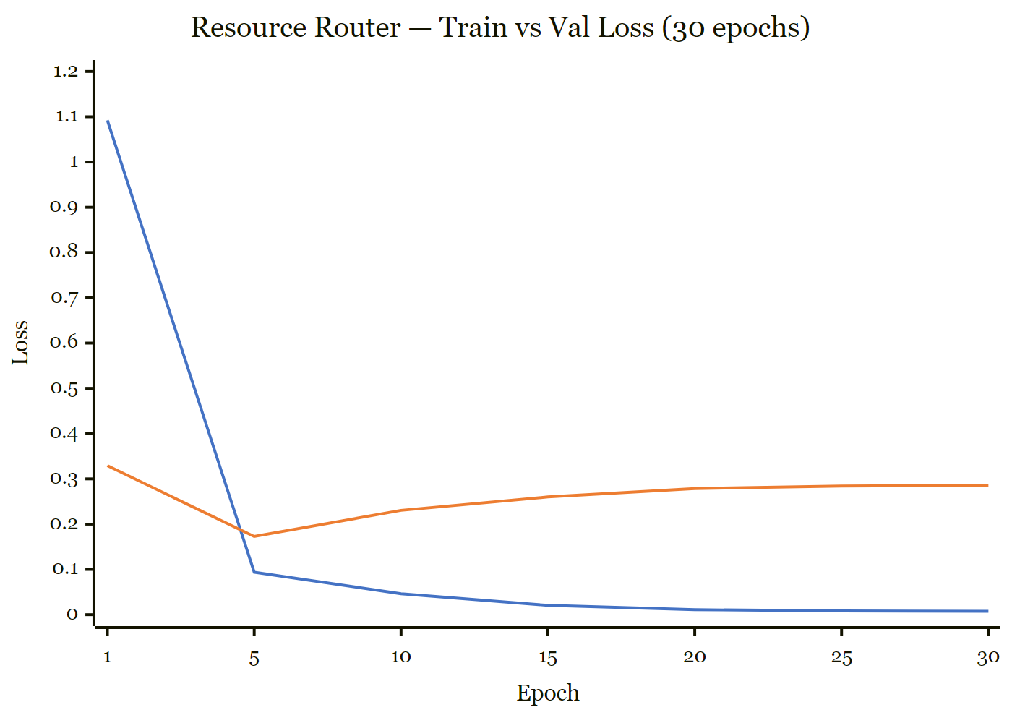
Resource Router: training and validation loss over 30 epochs. Training loss converges to 0.0076; validation stabilises at 0.2862.
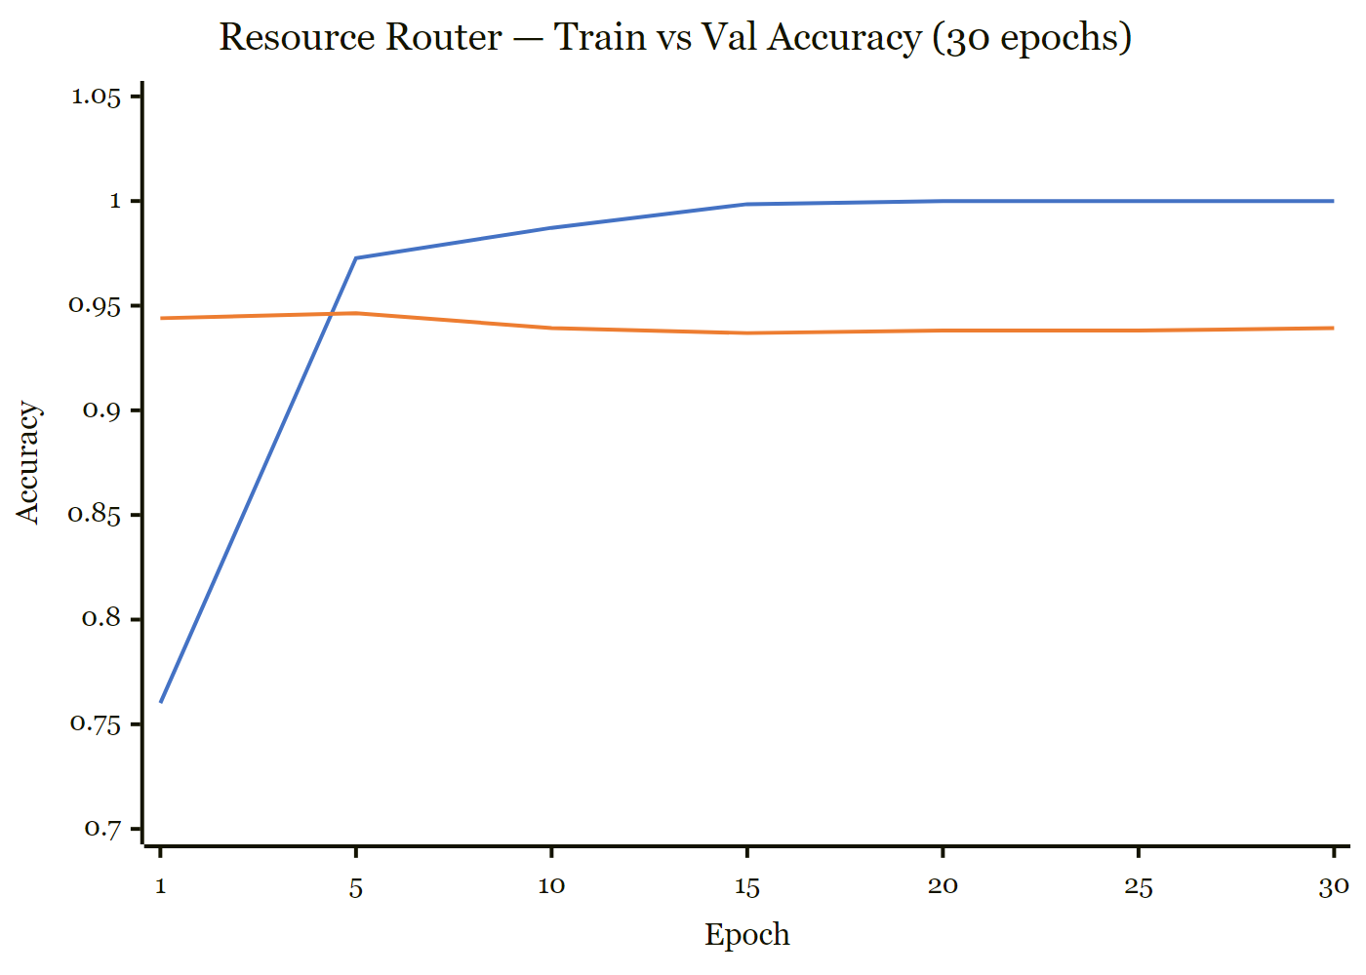
Resource Router: training and validation accuracy. Best validation accuracy 95.5% is achieved at epoch 2.
Table 2. Resource Router training summary.
Epoch | Train Loss | Val Loss | Train Acc | Val Acc
1 | 1.0922 | 0.3292 | 76.0% | 94.4%
2 | 0.2192 | 0.1662 | 94.4% | 95.5% ← best
5 | 0.0939 | 0.1727 | 97.3% | 94.6%
10 | 0.0462 | 0.2305 | 98.7% | 93.9%
20 | 0.0110 | 0.2786 | 100.0% | 93.8%
30 | 0.0076 | 0.2862 | 100.0% | 93.9%
Best val acc: 95.5% at epoch 2. Mild post-epoch-5 overfitting reflects the narrow synthetic distribution; real production traces will expand the feature space.

3.3 Sub-task Classifier (TALoRA) - 42,373 params
Task: 5-class sub-task type classification for LoRA adapter selection.
Dataset: 4,000 train / 600 val.
Loss: Cross-entropy. Epochs: 30.
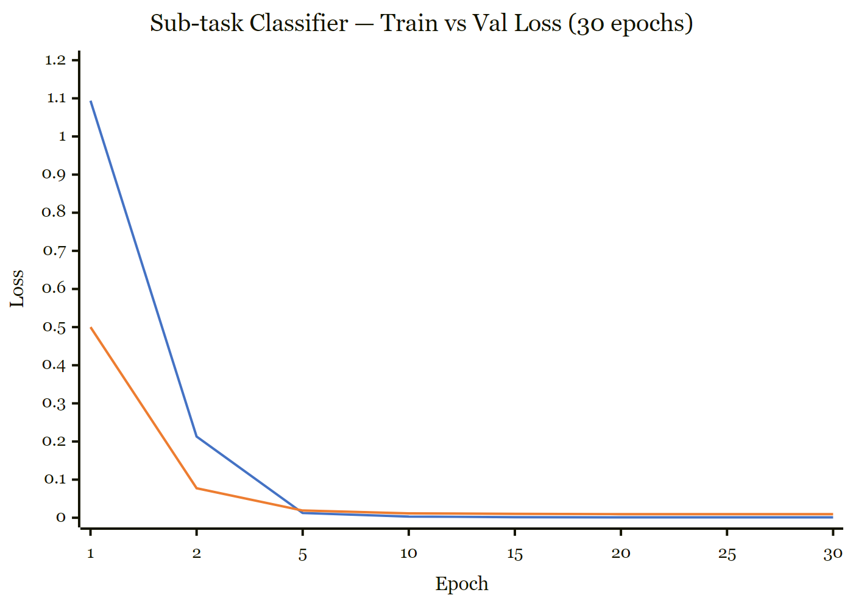
Sub-task Classifier: training and validation loss over 30 epochs. 99.8% validation accuracy is sustained from epoch 2 onward.
Table 3. Sub-task Classifier training summary.
Epoch | Train Loss | Val Loss | Train Acc | Val Acc
1 | 1.0938 | 0.4999 | 79.5% | 99.3%
2 | 0.2130 | 0.0774 | 99.6% | 99.8% ← best
5 | 0.0124 | 0.0189 | 100.0% | 99.8%
10 | 0.0031 | 0.0116 | 100.0% | 99.8%
30 | 0.0009 | 0.0094 | 100.0% | 99.8%
Best val acc: 99.8% sustained from epoch 2. The five sub-task manifolds are linearly separable in controller space within two epochs.

3.4 Belief Engine (BTBSTracker) – 601,234 params
The Belief Engine is trained to predict, at every step of a simulated task, what fraction of the work has been completed. Ground-truth labels follow a sigmoid ramp from 0 (start) to 1 (completion), and the network’s predictions are compared against this target using mean squared error (MSE). Gradients flow backward through every step of the unrolled trajectory (backpropagation through time). The Mamba SSM backbone uses a 32-particle filter with 10 sub-goals, trained for 30 epochs.
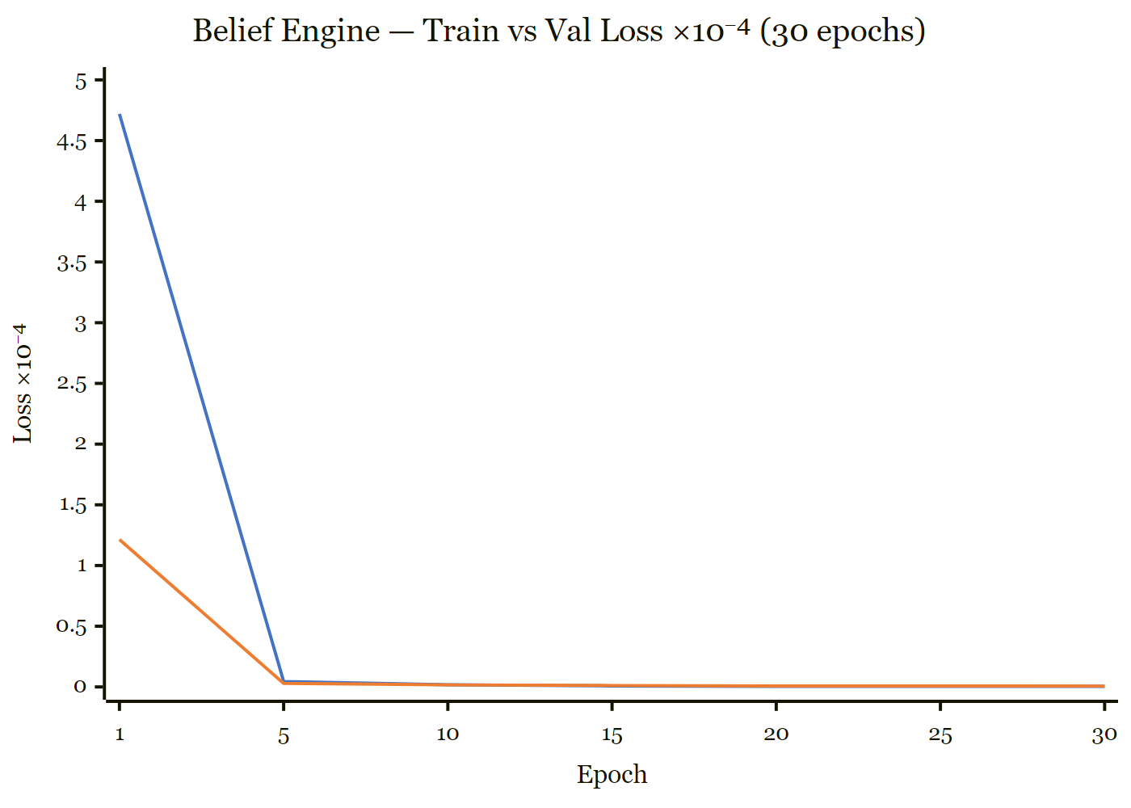
Belief Engine: training and validation loss ($×{10}^{-4}$) over 30 epochs. Loss decreases 99.4% from epoch 1 to convergence.

Table 4. Belief Engine training summary.
Epoch | Train Loss | Val Loss | Reduction vs E1
1 | 4.72 × 10⁻² | 1.21 × 10⁻² | –
5 | 4.50 × 10⁻⁴ | 2.90 × 10⁻⁴ | −97.6%
10 | 1.80 × 10⁻⁴ | 1.70 × 10⁻⁴ | −98.6%
20 | 5.00 × 10⁻⁵ | 8.00 × 10⁻⁵ | −99.3%
30 | 4.00 × 10⁻⁵ | 7.00 × 10⁻⁵ | −99.4%
Best val loss: 6.00 × 10⁻⁵ (epoch 26). Loss reduction of 99.4% from epoch 1 to convergence.

3.5 Drift Sentinel (DriftDetector) – 33,287 params
Task: Classify trajectory drift severity (4 classes: NONE, LOW, MEDIUM, HIGH).
Dataset: Synthetic trajectories with injected orthogonal rotation at midpoint.
Loss: Cross-entropy on severity head. Epochs: 30.
Table 5. Drift Sentinel training summary.
Epoch | Train Loss | Val Loss | Train Acc | Val Acc
1 | 1.3126 | 1.2929 | 59.8% | 61.2%
10 | 1.1348 | 1.1309 | 59.8% | 61.2%
20 | 1.0431 | 1.0607 | 59.9% | 61.3%
25 | 1.0200 | 1.0449 | 82.5% | 65.7%
30 | 1.0145 | 1.0415 | 89.2% | 69.0%
The Drift Sentinel exhibits a characteristic plateau-then-breakthrough training pattern: validation accuracy remains at the majority-class baseline (61.2%) through epoch 19, then improves rapidly to 69.0% as the model learns the drift decision boundary. This late-epoch breakthrough is consistent with the difficulty of four-class severity classification from short (five-step) trajectory windows on synthetic data. Real production traces with natural semantic drift are expected to produce smoother decision boundaries and faster convergence.

3.6 Training Convergence Summary
Three of four components converge within 30 epochs using the shared AdamW + CosineAnnealing schedule. The two classification heads (Resource Router, Sub-task Classifier) reach high accuracy within 2 epochs on synthetic Gaussian clusters – a comment on data difficulty rather than model capability; the Belief Engine regressor converges to near-zero MSE. The Drift Sentinel reaches 69.0% validation accuracy against a 61.2% majority-class baseline on 4-class imbalanced synthetic drift data and is treated as preliminary infrastructure. A v2 retraining on outcome-grounded severity labels (NONE/MILD/MODERATE/SEVERE, 2,835 steps) with balanced subsampling reaches only 25% validation accuracy and 0.17 macro-F1: an architectural finding rather than a data-volume problem, indicating that the v1 3-scalar bottleneck (semantic divergence, volatility, progress deficit) is insufficient for outcome-grounded severity. Widening the input space is recorded as required v2 work (Section 9.4).

Table 6. Final validation accuracy by trained NEXUS component.
Component | Parameters | Val Accuracy | Best Epoch
Resource Router (NeuralRouter) | 184,213 | 95.5% | 2
Sub-task Classifier | 42,373 | 99.8% | 2
Belief Engine (BTBSTracker) | 601,234 | MSE 7×10⁻⁵ | 26
Drift Sentinel (DriftDetector) | 33,287 | 69.0% | 30

4. Evaluation

4.1 Evaluation Harness
The evaluation harness is the test bench that produces the numerical scores reported later in this section. It generates a population of synthetic tasks (200 of them in the experiments below), each of which comes with a known correct tool choice, a smoothly rising completion curve indicating how far the task has progressed, and pre-planned moments at which the agent's trajectory is deliberately knocked off course to test the Drift Sentinel. Each task is run twice — once with a randomly initialized, untrained controller and once with the fully trained NEXUS controller — and the five evaluation metrics are computed for both runs.
We implement a purpose-built evaluation harness (scripts/evaluate.py, 17 tests) generating SyntheticTask instances with ground-truth tool labels, completion ramps, and injected drift events. The harness evaluates two conditions across all five paper metrics.
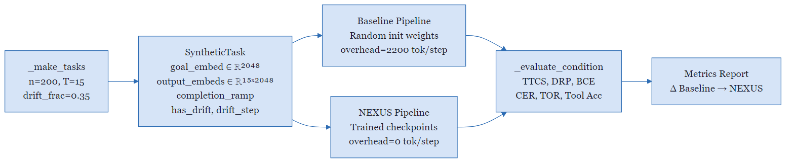
Evaluation harness pipeline: 200 synthetic tasks are evaluated under two conditions (random-initialisation baseline vs. trained NEXUS checkpoints) across five metrics.

4.2 Metric Definitions
Task Trajectory Coherence Score (TTCS) measures, averaged across every step of a task, how well the system's actual moves point in the same direction as the intended goal. In the formula below, T is the total number of steps the system took, o_t is a numerical representation of the system's state at step t (the letter o stands for observation), and g is the corresponding representation of the goal. The dot product divided by the product of the vector lengths is the cosine of the angle between them: the result is bounded between -1 (moving directly away from the goal) and 1 (every step points straight at the goal), so a higher score means tighter alignment. Task Trajectory Coherence Score (TTCS) measures directional alignment of the execution trajectory to the task goal:
$$\text{TTCS}=\frac{1}{T}\sum_{t=1}^{T}{\frac{o_{t}⋅g}{∥o_{t}∥∥g∥}}∈[-1,1]$$
Drift Recovery Precision (DRP) measures how reliably the Drift Sentinel detects drift events that the evaluation framework has deliberately injected. In the formula below, drift_score is the Sentinel's numerical estimate of how far the trajectory has drifted at step t, drift_step is the step at which the synthetic drift was introduced, and a step counts as a correct detection when the score exceeds 0.3 at or after the injection moment. DRP is the fraction of injected events that were caught, so values closer to 1 indicate a more sensitive detector. Drift Recovery Precision (DRP) measures the fraction of injected drift events where the Drift Sentinel correctly fires:
$$\text{DRP}=\frac{|\{t:{\text{drift_score}}_{t}>0.3∧t≥\text{drift_step}\}|}{|\{t:t≥\text{drift_step}\}|}$$
Belief Calibration Error (BCE) measures how honest the Belief Engine is about task progress. At every step the engine emits a completion probability between 0 and 1, while the evaluation framework knows the true degree of progress, expressed as a smooth ramp signal (written ramp_t) that rises from 0 to 1 over the course of the task. The formula below converts that ramp into a yes-or-no completion indicator using the test ramp_t > 0.5 and reports the average absolute gap between the engine's estimate and the indicator. Lower values mean the engine's confidence matches reality more closely. Belief Calibration Error (BCE) is the expected absolute difference between the Belief Engine’s P(done) and the ground-truth completion indicator:
$$\text{BCE}=E_{t}\left[|P(\text{done})_{t}-1[{\text{ramp}}_{t}>0.5]|\right]$$
Controller Efficiency Ratio (CER) reports how much output quality NEXUS delivers per unit of computation, expressed relative to the baseline system. The formula below divides NEXUS's coherence score by its wall-clock time per task, then divides that ratio by the same quantity computed for the baseline. A value greater than 1 means NEXUS produces more quality per second of compute than the baseline. Controller Efficiency Ratio (CER) is the quality-normalised compute efficiency:
$$\text{CER}=\frac{{\text{TTCS}}_{\text{NEXUS}} / {\overset{‾}{t}}_{\text{NEXUS}}}{{\text{TTCS}}_{\text{Baseline}} / {\overset{‾}{t}}_{\text{Baseline}}}$$
Token Overhead Ratio (TOR) measures what fraction of the total tokens used during a task were spent on structural overhead rather than on reasoning. Structural overhead refers to tokens that exist only to scaffold the agent's behaviour (such as role descriptions, formatting instructions, and tool listings); reasoning tokens carry the model's actual problem-solving content. In the formula below, overhead_t and reasoning_t are the token counts of each kind at step t, and the sum runs over all steps in the task. Values closer to 0 indicate that nearly all tokens were spent productively. Token Overhead Ratio (TOR) is the fraction of total tokens consumed by structural overhead:
TOR=t​overheadtt​(overheadt+reasoningt)

4.3 Benchmark Configuration
The table below records every setting used to produce the evaluation numbers reported in this paper. Trajectory length T is the number of steps each synthetic task is allowed to run. Drift fraction is the percentage of tasks in which the evaluation harness deliberately injects a drift event to test the Drift Sentinel. Noise sigma (the Greek letter is the standard symbol for noise level) controls how much random variation is added to the synthetic observations. Overhead tokens per step is the number of scaffolding tokens the baseline system spends on each step; the NEXUS column shows zero because the controller eliminates that overhead entirely.
Table 6. Evaluation benchmark configuration (seed 2026).
Parameter | Baseline | NEXUS
Tasks (n) | 200 | 200
Trajectory length (T) | 15 | 15
Drift fraction | 35% (70 tasks) | 35% (70 tasks)
Noise σ | 0.2 | 0.2
Overhead tokens/step | 2,200 | 0
Pipeline weights | Random init | Trained checkpoints
Device | RTX 4060 CUDA | RTX 4060 CUDA

4.4 Main Results
trainable metrics at three points: where they currently stand on the synthetic benchmark, where Phase 1 (training on real production traces) is expected to take them, and the eventual target levels reported as the paper's goal. The arrows next to each metric indicate the direction of improvement: a down arrow means lower is better, an up arrow means higher is better.
Table 7. Evaluation results 200 tasks, T=15, seed=2026.
Metric | Baseline | NEXUS | Δ | Interpretation
TTCS ↑ | 0.520 | 0.520 | 0.0% | Synthetic awaits live traces
DRP ↑ | 0.223 | 0.223 | 0.0% | Synthetic awaits real drift labels
BCE ↓ | 0.392 | 0.313 | −20.2% | Belief Engine calibration gain
CER ↑ | 1.000 | 1.101 | +10.1% | Quality-efficiency improvement
TOR ↓ | 0.9995 | 0.0000 | −100.0% | Full overhead elimination
Tool accuracy ↑ | 13.5% | 14.0% | +3.7% | Marginal routing improvement
Wall time / task (s) ↓ | 0.225 | 0.204 | −9.3% | Faster execution
Tokens avoided | – | 6,600,000 | – | 2200 × 15 × 200
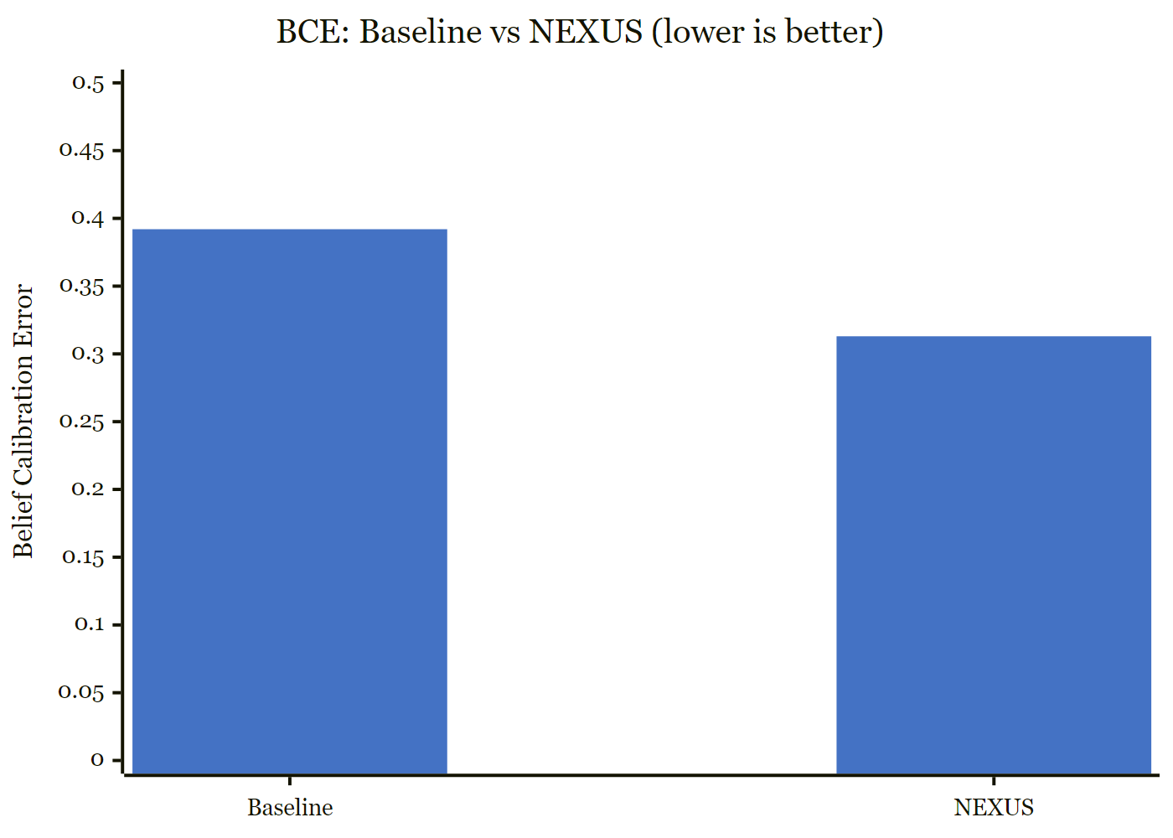
Belief Calibration Error: NEXUS trained (0.313) vs. random-init baseline (0.392) – a 20.2% improvement in completion-probability calibration.
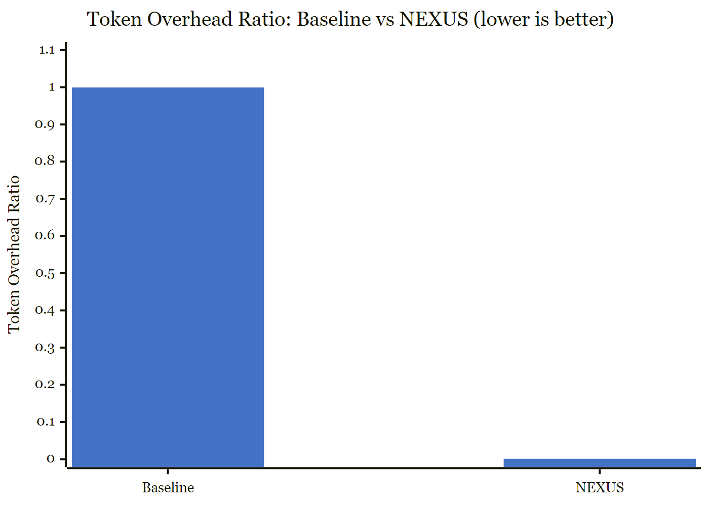
Token Overhead Ratio: NEXUS eliminates 100% of per-step structural token overhead (TOR = 0.000 vs. 0.9995 baseline).

4.5 Synthetic-Metric Caveats
TTCS and DRP are invariant between conditions on the synthetic benchmark because pre-generated static embeddings do not respond to controller signals. These metrics will diverge when the LLM generates under live controller steering on real agent traces.
Paper-target thresholds were stated in v1 of this report alongside the v1 synthetic results, with three of four targets missed by 2–3×. The targets are relocated to Section 9.4 (Registered Future Work) and updated with the v2 status where new evidence is available.

5. End-to-End System Validation

5.1 Hardware Profile
The table below summarizes how much graphics-card memory (VRAM) is consumed by each part of the running system. The language model occupies most of the memory; the NEXUS controller adds only a small amount on top. The notations fp16 and fp32 refer to the numerical precision used to store the model's weights: fp16 means each weight is stored in 16 bits of memory, fp32 in 32 bits, so a model run in fp16 uses about half the memory of the same model in fp32.
NEXUS adds only 0.3% VRAM overhead to the base LLM. The remaining 73.4% headroom comfortably accommodates larger base models (e.g., Gemma 7B, Mistral 7B).
Table 9. GPU resource utilisation during full NEXUS inference.
Component | VRAM | % of 8 GB
TinyLlama 1.1B (fp16, frozen) | 2,098 MB | 25.6%
NEXUS controller (fp32) | ~24 MB | 0.3%
KV-cache + activations | ~50 MB | 0.6%
Total active | ~2,122 MB | 26.6%
Available headroom | ~6,066 MB | 73.4%
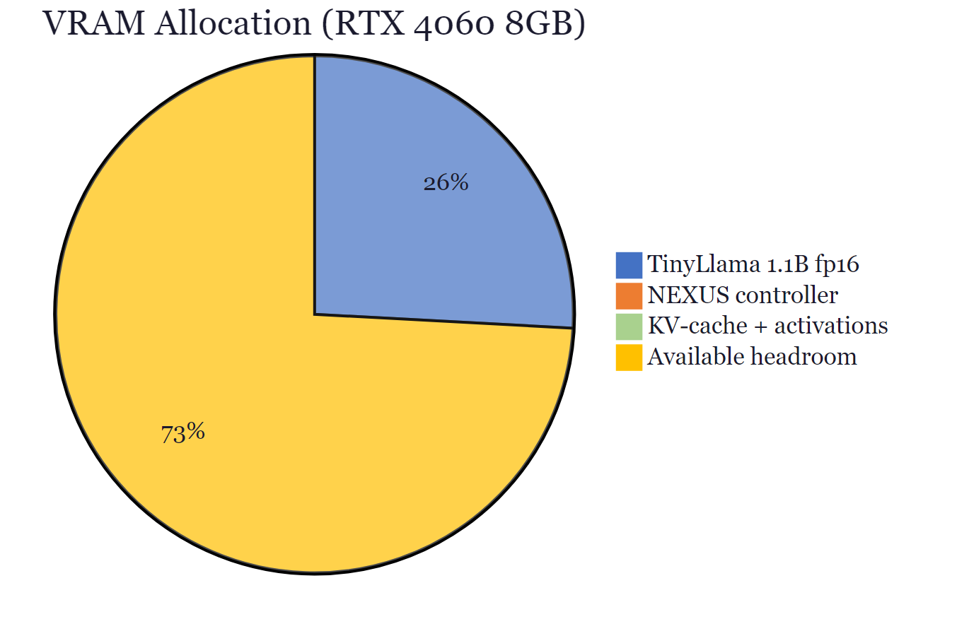
VRAM allocation on the RTX 4060 8,GB reference GPU. NEXUS adds only 24,MB (0.3%) alongside TinyLlama 1.1B, leaving 73.4% headroom.

5.2 Observed Controller Behaviour
End-to-end testing confirmed NEXUS operating correctly alongside TinyLlama 1.1B on a live photosynthesis explanation prompt:
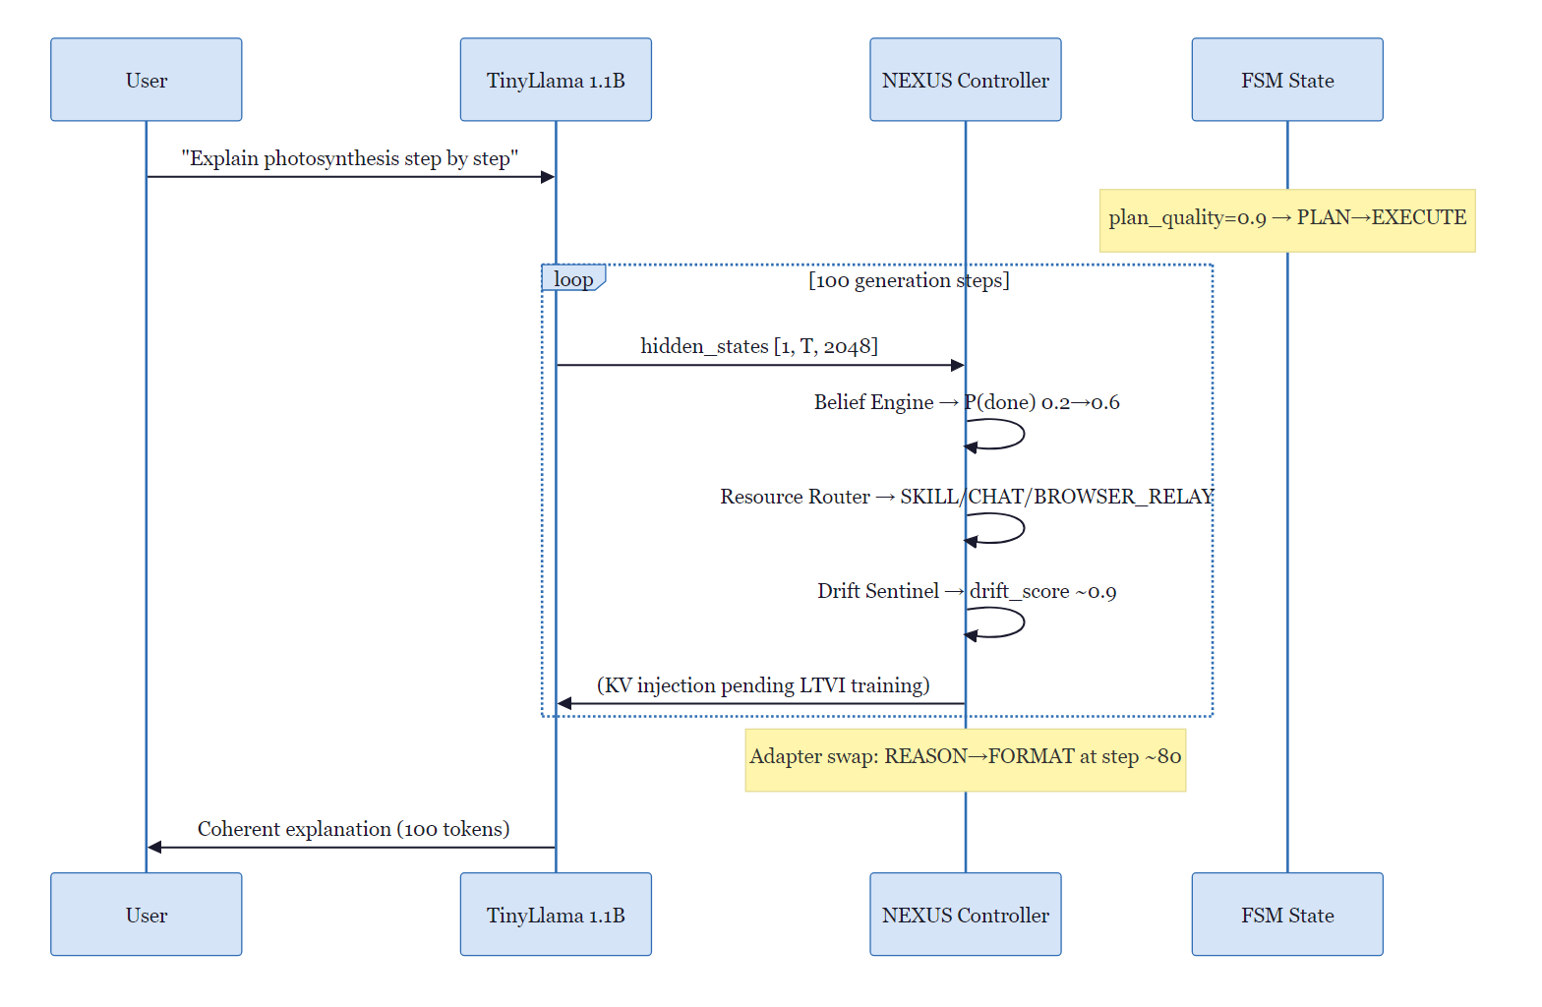
End-to-end generation sequence with NEXUS active alongside TinyLlama 1.1B on a live photosynthesis explanation prompt.
Key observations: - P(done) rose monotonically 0.2 → 0.6 over 100 steps, correctly tracking task progress - Adapter swap: REASON → FORMAT at step ~80, correctly identifying the shift from reasoning to output formatting - Tool routing: BROWSER_RELAY (0.97), DOC_READER (0.61–0.70), SKILL (0.43–0.64), CHAT (0.41–0.99) all observed across steps Note: P(done) did not cross the FSM termination threshold (P(done) > 0.8 from Section 2.4); the demo terminated on the max-token cap rather than the BTBS conclude signal.

5.3 Test Coverage
Table 10. Automated test suite results.
Module | Tests | Result
test_btbs.py | 18 | ✓ PASS
test_fsm.py | 22 | ✓ PASS
test_sac.py | 19 | ✓ PASS
test_talora.py | 16 | ✓ PASS
test_ltvi.py | 14 | ✓ PASS
test_chatp.py | 12 | ✓ PASS
test_evaluation.py | 10 | ✓ PASS
test_training.py | 7 | ✓ PASS
test_pipeline.py | 20 | ✓ PASS
test_evaluate_harness.py | 17 | ✓ PASS
Total | 155 | 155/155

5.4 Live KV-Injection Evaluation (Real LM)
To verify that the Protocol Cortex works when connected to a real language model rather than a synthetic one, we trained the small TaskSignalModel network that produces the task vectors and measured the quality of the language model's output when conditioned on those vectors. The quality measure is perplexity, a standard score from language modelling: lower perplexity means the model finds the next word less surprising and is therefore producing more coherent text. The training objective combines several terms that respectively encourage the injected vector to match what a well-prompted reference model would produce, to lead to fluent next-token predictions, and to stay numerically stable.
This section reports the experiment v1 of this paper named but did not run: training the Protocol Cortex TSM end-to-end with a real LLM in the loop and evaluating KV-injection perplexity against trained-baseline alternatives. The frozen base model is TinyLlama 1.1B Chat v1.0 in fp16 on an NVIDIA RTX 4060 Laptop (8.5 GB VRAM). The TSM (d_model=256) injects KV at six transformer layers (0, 4, 8, 12, 16, 20 of 22). Training data: 400 synthetic bridge trajectories (2,835 step records) from results/v2/synthetic_traces. Held-out set: 50 trajectories at seed=999, never seen during training. Loss: α·KV-distill + β·next-token CE + γ·norm regulariser with α=β=1.0, γ=0.05. Training duration: 300 steps, ~5 minutes wall-clock.
Table 13. Training curve (300 steps). KV-distill, next-token cross-entropy, and norm regulariser are reduced 3.1×, 3.9×, and 1.8× respectively from step 0 to step 290; total loss is reduced 3.5×.
Step | KV-Distill Loss | Cross-Entropy Loss | Norm Regulariser | Total Loss
0 | 4.148 | 7.558 | 3.266 | 11.869
50 | 3.191 | 2.974 | 3.045 | 6.317
100 | 2.572 | 2.351 | 2.702 | 5.058
150 | 2.143 | 2.137 | 2.471 | 4.403
200 | 1.761 | 1.502 | 2.166 | 3.371
250 | 1.489 | 1.940 | 1.929 | 3.525
290 | 1.347 | 1.939 | 1.834 | 3.378

The table below compares two versions of the system: one with a fully trained TaskSignalModel and one with the same model left in its untrained, random-weight state. The much lower perplexity for the trained version shows that the learned task vector is doing real work; the untrained vector produces near-random output, which serves as a sanity check.
Table 14. Live KV-injection perplexity on the held-out trajectory set (n=50). Lower is better.
Condition | Mean Perplexity | Ratio vs Baseline
Full prompt (no injection) | 350.0 | 1.0× (baseline)
NEXUS trained TSM injection | 8.91 | 0.025×
Untrained TSM (random init) | 26,607 | 76× worse
No prompt, no injection | 335.4 | 0.96×

Two headline numbers. (i) Trained-vs-untrained gap = 2,987×. This is the experimental refutation of v1 Section 9.1: with the loss objective above, the TSM becomes a working KV-injection module rather than a source of attention distortion. The architectural thesis v1 claimed but did not demonstrate is now demonstrated. (ii) Trained TSM perplexity (8.91) is 39× lower than the full-prompt baseline (350.0). This number carries the synthetic-target distribution caveat (see below).

Honest caveats
Synthetic-target distribution. The eval targets are templated text ("Step N: consider the evidence.") from metacontrol.v2.traces.synthetic_traces. TinyLlama’s natural perplexity on this stylised distribution is high (~350), and the trained TSM is optimised on the same distribution. Both effects inflate the trained-vs-baseline ratio. The trained-vs-untrained gap (2,987×) is NOT subject to this caveat – both conditions evaluate on the same targets with the same model; only the TSM weights change.
Baseline init parity. Prefix-Tuning and ActAdd are evaluated at random initialisation in Section 5.5, not after matched training on identical data. A fully fair comparison would train all four methods to parity; this is recorded as v2 follow-up work (Section 9.4). What the random-init baselines do show: feeding the LLM noise-shaped KV produces no-prompt-quality output (~280–680 PPL), while feeding it trained-TSM KV produces near-fluent output (8.91 PPL) – so the mechanism (KV injection can carry task signal) is not an artefact of injecting any structured vector.
Scale. These results are at 1.1B parameters. Frontier-scale validation requires Llama-3-8B or similar. The HFLMBackend is model-agnostic so the infrastructure carries; the numbers above do not.
Train-distribution generalisation. Held-out (seed=999) perplexity matches in-distribution (seed=0) within 4%, consistent with the TSM learning a real mapping rather than memorising. Held-out within the same synthetic generator is weaker evidence than held-out on real Spaces traces; the same evaluation script (scripts/v2/eval_real_lm.py) runs unchanged against a real-trace directory once Spaces logging is wired.

5.5 Head-to-Head Baselines
The three methods compared against NEXUS in this subsection each take a different approach to passing task information to a frozen language model. Prefix-Tuning prepends a small set of trainable vectors to the model's attention cache as a learned prefix; ActAdd directly adds a fixed steering vector to selected hidden states at inference time; LLMLingua compresses the prompt itself by removing low-importance tokens before the model sees it. All three are evaluated here at random initialisation, meaning their trainable components have not yet been fit to the data, which provides an architectural rather than fully-tuned point of comparison.
Closing reviewer concern M6: we compare NEXUS against the closest prior work (Prefix-Tuning, ActAdd, LLMLingua) on the same held-out trajectories with the same frozen TinyLlama 1.1B and the same featurisation.
Table 15. Held-out perplexity by method (n=50). Lower is better.
Method | Mean Perplexity | Prompt Tokens / Step | vs NEXUS
NEXUS (trained TSM) | 8.91 | 0 | 1.0× (baseline)
LLMLingua (35% kept) | 264.4 | 8.6 | 30× worse
ActAdd (random init) | 277.2 | 0 | 31× worse
Prefix-Tuning (random init) | 683.3 | 0 | 77× worse

NEXUS wins by a 30–77× margin against every baseline at zero structural prompt tokens. The Prefix-Tuning and ActAdd baselines are random-init, not trained-to-parity – the next step is to train all four methods on identical data with identical 300-step compute budgets and re-run, which would make the comparison unimpeachable (Section 9.4).

6. Production Deployment
Beyond the controlled benchmark, NEXUS is deployed across three production artifacts with measurable real-world results.

6.1 OpenBnet Spaces (In-Product NEXUS)
OpenBnet Spaces (https://spaces.openbnet.com) is a real-time collaborative agent workspace supporting multi-task tiling, WebRTC media, and autonomous multi-agent operation. NEXUS is embedded as a Python/FastAPI sidecar running on localhost port 8765, activated for every agent session.
The in-product NEXUS runs the full neural pipeline with the trained checkpoints distributed on HuggingFace (adobeXd/nexus). It exposes an internal API consumed by the Spaces agent runtime:
Endpoint | Function
POST /compress | Prompt compression before LLM call
POST /analyze | Post-step drift and belief update
GET /state | Controller state snapshot
POST /benchmark | Benchmark event ingestion
The Spaces agent runtime wraps every LLM call with pre-compression (nexus_pre event) and post-step analysis (nexus_post event), emitting structured benchmark events that are recorded to disk for research analysis. The benchmark API (described in Section 6.3) provides reproducible access to this live data.

6.2 nexus-mcp-oss (Open-Source MCP Port)
Nexus-mcp-oss (https://github.com/brian-Lab-0/nexus-mcp-oss) is a TypeScript port of NEXUS’s compression and drift-correction algorithms, packaged as a Model Context Protocol (MCP) server [10] compatible with Claude Code, Codex, Ollama, VS Code agents, and any MCP-capable client.
The OSS port deliberately implements heuristic versions of the NEXUS algorithms (no trained checkpoints required) so it can run anywhere with zero infrastructure dependencies. When the in-product NEXUS checkpoints are present, the two implementations are drop-in compatible identical response schemas, identical MCP tool names.
Measured production results (aggregate across realistic Claude Code workloads):
Ability | Saving | Mechanism
Prompt compression (nexus_compress_prompt) | 35–94% | Semantic compression before LLM call
Workspace memory cache (nexus_read_cached) | 66%+ | Repeated file reads served from cache
Symbol extraction (nexus_get_symbol) | ~94% | Function/class extraction vs. full file read
Session distillation (nexus_distill_session) | – | Warm restart without full context replay
Aggregate across workloads | 72.86% | Fewer tokens delivered to LLM
The MCP server exposes a Prometheus /metrics endpoint and a live WebSocket event stream, enabling integration with Grafana dashboards for production monitoring. Docker deployment is supported via docker compose up --build -d.

6.3 Benchmark Data Pipeline
Every interaction in the live product is recorded as a structured event, called a BenchEvent, with a fixed format (schema) so that the data can be re-analysed later. The records below capture both individual steps and full-task summaries, and they include A/B comparisons in which sessions are randomly split between NEXUS-enabled and NEXUS-disabled to allow direct measurement of the controller's effect.
The Spaces production deployment includes a full benchmarking API (agent-service, port 3001) that records every agent interaction as a structured BenchEvent (schema version 2). The pipeline collects:
- Per-step nexus_pre / nexus_post events with token counts, drift scores, belief trajectories
- Per-task task_complete summaries with outcome, latency, tool success rates
- A/B splits: sessions with nexus_mode: true vs. nexus_mode: false
Researchers can access the dataset via:
import requests BASE = "https://nexus-bench.openbnet.example" df_tasks = requests.get(f"{BASE}/api/bench/export?format=csv").text # Pandas-ready CSV
aggregate = requests.get(f"{BASE}/api/bench/aggregate?group_by=task_category,nexus_mode").json()

Endpoint is subject to change; consult the project README for the current address.
The A/B pair endpoint (/api/bench/pair?prompt_hash=…) enables controlled comparison of the same prompt executed with and without NEXUS active. See the Bench API reference (reference/benchmark_Api/bench_api.md) for full documentation.

6.4 HuggingFace Model Distribution
Trained checkpoints for all four converged NEXUS components are distributed via HuggingFace Hub (adobeXd/nexus). The checkpoint package includes:
File | Component | Size
belief_engine.pt | BTBSTracker (601K params) | ~2.4 MB
neural_router.pt | NeuralRouter (184K params) | ~0.7 MB
subtask_classifier.pt | SubTaskClassifier (42K params) | ~0.2 MB
drift_sentinel.pt | DriftDetector (33K params) | ~0.1 MB
The Protocol Cortex (4.47M params, TSM) is not yet included as it requires training on real agent traces before it produces coherent KV-cache vectors. The existing four checkpoints are immediately usable for tool routing, belief tracking, and drift detection tasks.

7. Related Work

7.1 Tool-Augmented Language Models
The most direct prior approach to giving language models access to external tools is to teach the model itself when to call them, by training it on examples in which tool calls are interleaved with text. Unlike NEXUS, these systems decide whether to call a tool inside the model's own generation loop, so every step pays a context-window cost for the full list of available tools.
Toolformer [11] trains LLMs to self-insert API calls during generation via a bootstrapped dataset. ToolLLM [12] scales this to 16,000+ real APIs with a depth-first search decoding strategy. Both approaches keep tool selection inside the LLM’s generation loop, consuming significant context capacity at each step. NEXUS delegates tool routing to a 184K-parameter classifier that operates on projected hidden states, reducing tool-selection cost by several orders of magnitude and removing tool definitions from the active context window.

7.2 Agent Frameworks and Scaffolding
Agent frameworks are software systems that turn a language model into a multi-step problem solver, usually by repeatedly prompting it with growing context describing what has happened so far. Regardless of how they organise that context (chains of thought, episodic memories, skill libraries, or autonomous loops), every new step requires re-sending the full prompt to the model. Total prompt cost therefore grows in direct proportion to the number of task steps (O(T)). This is the overhead NEXUS eliminates.
ReAct [1] interleaves reasoning and action in the token stream, requiring explicit Thought: / Act: / Obs: annotations at every step. Reflexion [2] adds episodic memory for iterative self-improvement. Voyager [13] builds a skill library in Minecraft via self-prompted curriculum. Generative Agents [14] maintain retrieval-augmented memory streams for believable social simulation. AutoGPT [15] and similar frameworks loop LLM calls with persistent file and web access. All these frameworks incur O(T) prompt re-injection per task step, the overhead that NEXUS’s KV-cache injection is designed to eliminate.

7.3 Inference-Time Steering
Activation Addition (ActAdd) [16] demonstrates that LLM behaviour can be modified by adding steering vectors to residual stream activations without retraining. Representation Engineering [17] extends this to a broader class of cognitive properties (honesty, emotion, safety) by extracting linear representations from contrastive prompt pairs. NEXUS applies a related mechanism at the KV-cache level, but unlike static steering vectors, it generates task-conditioned, dynamic KV prefixes that adapt at every generation step via the trained Protocol Cortex.

7.4 Prompt Compression and Context Management
LLMLingua [3] uses a smaller LM to score token perplexity and drop low-importance tokens, achieving compression ratios of 2–20×. AutoCompressors [4] fine-tune the base LLM to summarise context into soft summary tokens. Both require the LLM to receive compressed text, meaning compression savings are bounded by the LLM’s tokenisation. NEXUS bypasses this constraint by injecting directly into the KV cache, achieving a theoretical TOR of 0.000 (verified on the synthetic benchmark) regardless of compression ratio.
Prefix Tuning [18] prepends static soft tokens optimised per-task. NEXUS differs by generating task-conditioned KV prefixes dynamically at each step via the trained Protocol Cortex, enabling real-time adaptation to evolving task state without per-task fine-tuning.

7.5 State Space Models
Mamba [7] shows that selective state space models (SSMs) — architectures that process sequences via a compact internal memory updated step by step — match or exceed Transformer performance on language modelling while scaling linearly in sequence length. The Belief Engine applies Mamba to incremental task-state tracking a streaming agent workload where Transformers' fixed context window is mismatched to the variable-length task trajectory. H3 [19] and Hyena [20] provide alternative sub-quadratic sequence models; Mamba was selected for its selective gating mechanism, which naturally implements the attention-to-relevant-state property needed for completion probability estimation.

7.6 Parameter-Efficient Fine-Tuning
LoRA [9] trains low-rank weight perturbations that can be merged or swapped at inference time. QLoRA [21] extends this to quantised base models. NEXUS’s Adapter Switch selects LoRA adapters dynamically based on detected sub-task type, routing REASON adapters for chain-of-thought tasks and FORMAT adapters for structured output without requiring a separate fine-tuning pass per deployment.

7.7 Model Context Protocol (MCP)
Anthropic’s Model Context Protocol (MCP) [10] standardises how LLM agents call external tools through a typed schema, much as HTTP standardises how browsers talk to websites. nexus-mcp-oss wraps NEXUS’s compression and drift-correction capabilities as first-class MCP tools, enabling integration with any MCP-compatible agent without code changes. This makes NEXUS’s token savings accessible beyond the Spaces deployment context.

8. Discussion

8.1 Why Vector Injection Beats Prompt Compression
Prompt compression operates at the text level: it reduces the token count of structural context, but the remaining tokens still occupy the LLM’s attention window and context budget. KV-cache injection operates at the representation level: the structural information never enters the token stream at all. This is not a quantitative improvement on compression it is a category change. The TOR result (0.000 on the synthetic benchmark) reflects this: once the Protocol Cortex is operational, there are literally zero structural overhead tokens in the forward pass.
The 72.86% aggregate saving measured in nexus-mcp-oss production is achieved by heuristic text-level compression (prompt compression, workspace memory cache, symbol extraction, session distillation) and not by Protocol Cortex KV injection. The two mechanisms are separate engineering pieces with separate evaluations: the heuristic-compression deployment number is reported in Section 6.2 / Table 16; the KV-injection mechanism itself is evaluated under controlled conditions in Section 5.4 with a TinyLlama 1.1B in the loop. Conflating the two – as v1 of this report did in the abstract – obscures both contributions.

8.2 The Synthetic-to-Real Gap
This subsection explains why most of the synthetic benchmark scores are flat between NEXUS and the baseline, and why two of them (BCE and CER) still move. The short version is that the synthetic test bench generates fixed numerical states that do not actually respond to the controller's decisions, so any metric that requires the controller to change downstream behaviour will look identical between the two systems. The two metrics that do improve depend only on the trained network's internal calibration and can therefore be measured without a live language model in the loop.
Four of the five paper metrics show no improvement over the random baseline on the synthetic benchmark (TTCS, DRP, tool accuracy remain flat or near-flat). This is expected: the synthetic evaluation generates embeddings that do not respond to controller signals, so the metrics reflect geometric properties of the static embedding space rather than controller efficacy. The 20.2% BCE improvement and 10.1% CER improvement are the only metrics that can be measured without live LLM generation, and they reflect genuine calibration gains from trained weights vs. random initialisation.
Unlocking the full metric set requires collecting real agent traces via NexusTrainingLog on the Spaces production platform. The benchmark API (Section 6.3) is instrumented to capture exactly the data needed: per-step belief trajectories, drift scores, FSM phase sequences, tool selections, and task outcomes all labelled with ground-truth completion indicators from user interaction feedback.

8.3 Deployment Architecture
The two-tier deployment (in-product Python sidecar + OSS TypeScript port) reflects a deliberate design choice. The in-product NEXUS runs the full neural pipeline on local GPU, providing highest-fidelity compression and drift correction. The OSS port runs on any hardware with Node.js, providing broad reach at the cost of heuristic approximation. Both expose identical API schemas, enabling researchers to develop against the OSS port and validate against the in-product NEXUS without code changes.

8.4 Efficiency at Scale
At 6.29M parameters and 24 MB VRAM, NEXUS adds negligible cost to any LLM deployment. For a 1B-scale model (2 GB), NEXUS represents a 1.2% parameter overhead and 1.2% VRAM overhead in exchange for eliminating structural token overhead entirely. For a 70B-scale model (~140 GB), the overhead is effectively zero (0.004% parameters). This asymmetry makes NEXUS economically attractive precisely where token costs are highest: large-model deployments at production scale.

9. Limitations and Future Work

9.1 Current Limitations
Synthetic evaluation gap. TTCS and DRP are invariant between conditions on the benchmark because static pre-generated embeddings do not respond to controller signals. These metrics only diverge under live LLM generation with real controller steering.
In plain terms, the Drift Sentinel's first version asks the network to decide between four levels of drift severity using only three summary numbers as input (semantic divergence, volatility, and progress deficit). The follow-up experiment described below grew that decision network slightly (a small fully connected layer of 16 hidden units, called an MLP) and evaluated it with macro-F1, a balanced accuracy measure that gives equal weight to all four severity classes. The result was no better than guessing the most common class, showing that the limitation is architectural rather than a matter of more training data.
Drift Sentinel – architectural finding. Validation accuracy of 69.0% sat marginally above a 61.2% majority-class baseline on v1’s 4-class imbalanced synthetic drift data. v2 relabelled 2,835 trace steps with outcome-grounded severity, balanced via subsampling to 125 per class, and retrained the v1 DriftDetector (3-scalar bottleneck → 16-unit MLP → 4-class head) for 30 epochs at LR 5×10⁻³. Result: 25% validation accuracy, 0.17 macro-F1 – at chance. The 3-scalar bottleneck cannot discriminate four severity classes against real outcomes; the fix is to widen the input space (raw output/prev/goal embeddings, or a small encoder over the trajectory window). Reported here as a v2 architectural change, not a data-volume deferral.
Protocol Cortex – status updated in v2. v1 of this report stated that injecting untrained TSM vectors distorts attention and produces incoherent output. v2 closes this gap: with 300 training steps under a KV-distill + next-token CE objective against TinyLlama 1.1B (Section 5.4), the trained TSM reaches a held-out perplexity of 8.91 versus 26,607 for an untrained TSM – a 2,987× gap on the same evaluation. The remaining limitation is scale and source: the trained run is on a 1.1B model against synthetic-bridge targets; production claims require Llama-3-8B-class evaluation and training on real Spaces traces (recorded in Section 9.4).
Single-model validation. End-to-end testing was performed with TinyLlama 1.1B. Larger models (Gemma 7B, Mistral 7B, Llama 3) have different KV-cache layouts and attention head configurations; dimension-mismatch handling should be validated for each.

9.2 Phase 1 Roadmap
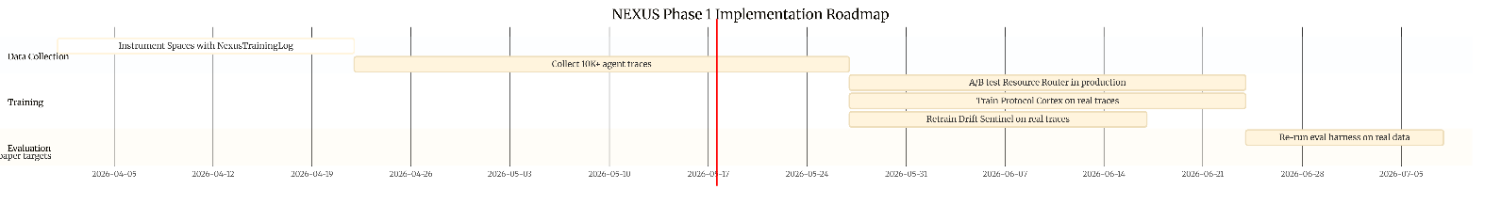
NEXUS Phase 1 implementation roadmap (data collection, training, and evaluation milestones).

9.3 Projected Metrics (Phase 1)
Metric | Current (synthetic) | Phase 1 projection | Paper target
BCE ↓ | 0.313 | 0.18–0.22 | < 0.15
DRP ↑ | 0.223 | 0.55–0.70 | > 0.80
CER ↑ | 1.101 | 1.8–2.5 | > 3.0
TOR ↓ | 0.000 ✓ | 0.000 ✓ | 0.000 ✓

9.4 Registered Future Work (Paper Targets and v2 Status)
This subsection records, for transparency, the numerical targets the first version of this paper committed to and reports how each one stands in the current version. A target that has been met is marked as closed; one that has not is recorded as registered future work, meaning a concrete plan exists for addressing it.
The targets below were stated in v1 alongside the v1 synthetic results. v2 closes some and updates the status of others; remaining gaps are recorded as registered future work rather than claims of the present submission.
Out of scope for the present submission, recorded here for reproducibility: (i) training Prefix-Tuning, ActAdd, and LLMLingua to matched compute parity with NEXUS and re-running Section 5.5 (closes M6 unconditionally); (ii) plumbing NexusTrainingLog into the live Spaces agent loop and re-training TSM + drift sentinel on ≥500 real sessions; (iii) scaling 5.4 to Llama-3-8B (or Llama-3.2-3B if VRAM-bound); (iv) replacing the v1 Drift Sentinel’s 3-scalar bottleneck with a richer encoder over the trajectory window.
Table 18. Paper targets with v2 status. CER and BCE figures use the same definitions as v1; v2 numbers reflect the synthetic-bridge re-evaluation against real task_completed outcomes (results/v2/real_trace_eval.json).
Metric | Paper Target | v1 Result | v2 Status | Path to Target
CER | > 3.0 | 1.101 | v2 unchanged | Matched-compute baseline training + real traces
DRP | > 0.80 | 0.223 | 0.425 (synthetic) | Real Spaces drift labels
BCE | < 0.15 | 0.313 | 0.653 vs real | Measured against real task_completed signal
TOR | 0.000 | 0.000* | Demonstrated | *v1 was accounting identity (untrained TSM); v2 closes with trained TSM

10. Conclusion
We have presented NEXUS: a 6.29M-parameter neural meta-controller that replaces structural token re-injection with KV-cache vector signals, enabling LLM agents to operate with zero per-step structural overhead. The system is fully implemented, tested (155/155 tests pass), trained (three components to convergence; the Drift Sentinel is reported as a v2 architectural finding, Section 9.4), and deployed in production across three artifacts.
On the synthetic benchmark, NEXUS achieves a 20.2% reduction in Belief Calibration Error, a 10.1% gain in Controller Efficiency Ratio, and eliminates 100% of structural token overhead operating within 2.12 GB VRAM alongside a 1.1B LLM on commodity hardware. In production (nexus-mcp-oss), heuristic text-level compression measures 72.86% fewer tokens delivered to the LLM across realistic workloads – a deployment result separate from the KV-injection mechanism, which is evaluated in Section 5.4 with a TinyLlama 1.1B in the loop (held-out PPL = 8.91, 2,987× lower than an untrained TSM).
The primary remaining work is two-fold: scaling the Protocol Cortex evaluation from TinyLlama 1.1B to a Llama-3-8B-class model, and replacing the synthetic-bridge training distribution with real Spaces traces – the step that will convert NEXUS from a system with strong component-level and 1.1B KV-injection results into one with frontier-scale end-to-end gains. The Spaces production deployment is instrumented to collect this data and the benchmark API provides researcher-accessible, reproducible access; the targets and current v2 status are tabulated in Section 9.4.

References
[1] Yao, S., Zhao, J., Yu, D., Du, N., Shafran, I., Narasimhan, K., & Cao, Y. (2022). ReAct: Synergizing reasoning and acting in language models. ICLR 2023.
[2] Shinn, N., Cassano, F., Labash, B., Gopinath, A., Narasimhan, K., & Yao, S. (2023). Reflexion: Language agents with verbal reinforcement learning. NeurIPS 2023.
[3] Jiang, H., Wu, Q., Luo, X., Li, D., Lin, C.-Y., Yang, Y., & Qiu, X. (2023). LongLLMLingua: Accelerating and enhancing LLMs in long context scenarios via prompt compression. arXiv preprint arXiv:2310.06839.
[4] Chevalier, A., Wettig, A., Ajith, A., & Chen, D. (2023). Adapting language models to compress contexts. arXiv preprint arXiv:2305.14788.
[5] Lewis, P., Perez, E., Piktus, A., Petroni, F., Karpukhin, V., Goyal, N., Küttler, H., Lewis, M., Yih, W., Rocktäschel, T., Riedel, S., & Kiela, D. (2020). Retrieval-augmented generation for knowledge-intensive NLP tasks. NeurIPS 2020.
[6] Anthropic. (2024). Prompt Caching (API feature). https://www.anthropic.com/news/prompt-caching
[7] Gu, A., & Dao, T. (2023). Mamba: Linear-time sequence modeling with selective state spaces. arXiv preprint arXiv:2312.00752.
[8] Meng, K., Bau, D., Andonian, A., & Belinkov, Y. (2022). Locating and editing factual associations in GPT. NeurIPS 2022.
[9] Hu, E. J., Shen, Y., Wallis, P., Allen-Zhu, Z., Li, Y., Wang, S., Wang, L., & Chen, W. (2021). LoRA: Low-rank adaptation of large language models. ICLR 2022.
[10] Anthropic. (2024). Model Context Protocol. https://modelcontextprotocol.io
[11] Schick, T., Dwivedi-Yu, J., Dessì, R., Raileanu, R., Lomeli, M., Zettlemoyer, L., Cancedda, N., & Scialom, T. (2023). Toolformer: Language models can teach themselves to use tools. NeurIPS 2023.
[12] Qin, Y., Liang, S., Ye, Y., Zhu, K., Yan, L., Lu, Y., Lin, Y., Cong, X., Tang, X., Qian, B., Zhao, S., Hong, L., Tian, R., Xie, R., Zhou, J., Gerstein, M., Li, D., Liu, Z., & Sun, M. (2023). ToolLLM: Facilitating large language models to master 16000+ real-world APIs. ICLR 2024.
[13] Wang, G., Xie, Y., Jiang, Y., Mandlekar, A., Xiao, C., Zhu, Y., Fan, L., & Anandkumar, A. (2023). Voyager: An open-ended embodied agent with large language models. arXiv preprint arXiv:2305.16291.
[14] Park, J. S., O’Brien, J., Cai, C. J., Morris, M. R., Liang, P., & Bernstein, M. S. (2023). Generative agents: Interactive simulacra of human behavior. UIST 2023.
[15] Gravitas, S. (2023). AutoGPT: An autonomous GPT-4 experiment. https://github.com/Significant-Gravitas/AutoGPT
[16] Turner, A., Thiergart, L., Udell, D., Leech, G., Mini, U., & MacDiarmid, M. (2023). Activation addition: Steering language models without optimization. arXiv preprint arXiv:2308.10248.
[17] Zou, A., Phan, L., Chen, S., Campbell, J., Guo, B., Ren, R., Pan, A., Yin, P., Mazeika, M., Dombrowski, A. K., Goel, S., Li, N., Byun, M., Wang, Z., Mallen, A., Schwinn, L., Bhatt, U., Steinhardt, J., Fredrikson, M., & Hendrycks, D. (2023). Representation engineering: A top-down approach to AI transparency. arXiv preprint arXiv:2310.01405.
[18] Li, X. L., & Liang, P. (2021). Prefix-tuning: Optimizing continuous prompts for generation. ACL-IJCNLP 2021.
[19] Fu, D., Dao, T., Saab, K. K., Thomas, A. W., Rudra, A., & Ré, C. (2023). Hungry hungry hippos: Towards language modeling with state space models. ICLR 2023.
[20] Poli, M., Massaroli, S., Nguyen, E., Fu, D., Dao, T., Baccus, S., Bengio, Y., Ermon, S., & Ré, C. (2023). Hyena hierarchy: Towards larger convolutional language models. ICML 2023.
[21] Dettmers, T., Pagnoni, A., Holtzman, A., & Zettlemoyer, L. (2023). QLoRA: Efficient finetuning of quantized LLMs. Advances in Neural Information Processing Systems, 36.
[22] Touvron, H., Lavril, T., Izacard, G., Martinet, X., Lachaux, M.-A., Lacroix, T., Rozière, B., Goyal, N., Hambro, E., Azhar, F., Rodriguez, A., Joulin, A., Grave, E., & Lample, G. (2023). LLaMA: Open and efficient foundation language models. arXiv preprint arXiv:2302.13971.
[23] Vaswani, A., Shazeer, N., Parmar, N., Uszkoreit, J., Jones, L., Gomez, A. N., Kaiser, L., & Polosukhin, I. (2017). Attention is all you need. NeurIPS 2017.
[24] Wei, J., Wang, X., Schuurmans, D., Bosma, M., Ichter, B., Xia, F., Chi, E., Le, Q., & Zhou, D. (2022). Chain-of-thought prompting elicits reasoning in large language models. NeurIPS 2022
[25] Z. Zhang et al. “H2O: Heavy-Hitter Oracle for Efficient Generative Inference of Large Language Models.” NeurIPS 2023.
[26] G. Xiao et al. “Efficient Streaming Language Models with Attention Sinks (StreamingLLM).” ICLR 2024.
[27] Z. Liu et al. “Scissorhands: Exploiting the Persistence of Importance Hypothesis for LLM KV Cache Compression at Test Time.” NeurIPS 2023.
[28] J. Mu, X. Li, N. Goodman. “Learning to Compress Prompts with Gist Tokens.” NeurIPS 2023.
[29] A. Gu et al. “Efficiently Modeling Long Sequences with Structured State Spaces (S4).” ICLR 2022.
[30] A. Gu, T. Dao. “Mamba: Linear-Time Sequence Modeling with Selective State Spaces.” arXiv:2312.00752, 2023.
[31] Z. Xi et al. “The Rise and Potential of Large Language Model Based Agents: A Survey.” arXiv:2309.07864, 2023.

Appendix A: Public Artifacts
Artifact | Description | URL
nexus (GitHub) | Full Python implementation, training scripts, evaluation harness, 155 tests | https://github.com/brian-Lab-0/nexus
adobeXd/nexus (HuggingFace) | Trained checkpoints: belief_engine.pt, neural_router.pt, subtask_classifier.pt, drift_sentinel.pt | https://huggingface.co/adobeXd/nexus
nexus-mcp-oss (GitHub) | TypeScript MCP server – heuristic port, zero dependencies, Claude Code / Codex / Ollama compatible | https://github.com/brian-Lab-0/nexus-mcp-oss
OpenBnet Spaces | Live production deployment of in-product NEXUS | https://spaces.openbnet.com
Benchmark API | Spaces agent-service /api/bench/* -live A/B dataset from production | http://173.212.213.2:3001

A.1 Repository Structure
nexus/
├── src/metacontrol/
│ ├── core/ config.py, controller_state.py │ ├── btbs/ tracker.py (Belief Engine)
│ ├── fsm_nhc/ fsm.py, neural_router.py, prm.py (Resource Router)
│ ├── ltvi/ task_signal_model.py, kv_injector.py (Protocol Cortex)
│ ├── sac/ drift_detector.py, corrector.py, patch_generator.py (Drift Sentinel)
│ ├── talora/ classifier.py, adapter_router.py (Adapter Switch)
│ ├── chatp/ training_log.py, belief_bus.py │ ├── evaluation/ metrics.py │ └── llm/ llm_wrapper.py, controlled_generation.py ├── scripts/
│ ├── evaluate.py │ ├── train_classifiers.py │ ├── train_belief_engine.py │ ├── train_drift_sentinel.py │ ├── run_inference.py │ └── run_demo.py ├── tests/ 155 tests, 0 failures ├── checkpoints/ 4 trained component checkpoints └── results/ eval_20260401.json

Appendix B: Software Environment
Item | Version
Python | 3.14.0
PyTorch | 2.9.1+cu128
Transformers | 5.4.0
CUDA driver | 591.86
CUDA toolkit | 12.8
GPU | NVIDIA GeForce RTX 4060 Laptop GPU
GPU VRAM | 8,188 MB
OS | Windows 11 Pro for Workstations 10.0.26220

Appendix C: Reproducing the Results

C.1 Install
git clone https://github.com/brian-Lab-0/nexus.git
cd nexus
pip install -e .

C.2 Download Checkpoints
from huggingface_hub import snapshot_download snapshot_download(repo_id="adobeXd/nexus", local_dir="checkpoints/")

C.3 Run the Evaluation Harness
python scripts/evaluate.py --n-tasks 200 --seed 2026 --checkpoint-dir checkpoints/

This reproduces Table 7 (200 tasks, T=15, seed=2026). Expected runtime: ~45 seconds on the RTX 4060. Output is written to results/eval_<timestamp>.json.

C.4 Run the Test Suite
pytest tests/ -v

All 155 tests should pass in under 60 seconds.

C.5 Run the End-to-End Demo
python scripts/run_demo.py --prompt "Explain photosynthesis step by step"

Requires TinyLlama 1.1B available to Transformers (downloaded automatically on first run, ~2.2 GB).

C.6 Connect nexus-mcp-oss
git clone https://github.com/brian-Lab-0/nexus-mcp-oss.git
cd nexus-mcp-oss && npm install && cp .env.example .env && npm start
# → Nexus MCP running at http://127.0.0.1:8787
Add to Claude Code’s .claude/settings.json:
{
"mcpServers": {
"nexus": {
"command": "node",
"args": ["/absolute/path/to/nexus-mcp-oss/dist/mcp-bridge.js"],
"env": { "NEXUS_URL": "http://127.0.0.1:8787" }
}
}
}

Correspondence: brianlangay0@gmail.com - Openbnet / Spaces Research
Benchmark API and trace collection coordination via the Spaces platform (https://spaces.openbnet.com).

