FLOODSENSE NORTH CALOOCAN: AN IoT-BASED COMMUNITY FLOOD MONITORING AND REPORTING SYSTEM

ABSTRACT

Flooding remains one of the most recurring natural disasters in the Philippines, causing significant disruptions to communities, infrastructure, and public safety. North Caloocan is among the areas frequently affected by flooding, particularly during periods of heavy rainfall and typhoons. Traditional flood monitoring methods often rely on manual observation and delayed reporting, resulting in slow dissemination of information and reduced effectiveness of emergency response efforts. This study developed FloodSense North Caloocan, an Internet of Things (IoT)-based community flood monitoring and reporting system designed to provide real-time flood information and improve disaster preparedness within the community.

The system integrates an ESP32 microcontroller and waterproof ultrasonic sensor to continuously monitor water levels and transmit data to a cloud-based database. A web application was developed using the MERN stack (MongoDB, Express.js, React, and Node.js) to provide real-time flood monitoring, community-based reporting, flood mapping, and notification services. The study employed a quantitative research methodology using survey questionnaires administered to residents of North Caloocan to identify flooding challenges and evaluate system acceptance.

Results indicate that residents strongly support the implementation of a real-time flood monitoring system and recognize its potential to improve awareness, preparedness, and response during flood events. The developed system successfully provided accurate water-level monitoring, timely notifications, and accessible flood information. The findings demonstrate that FloodSense North Caloocan can serve as an effective tool for enhancing community resilience and supporting local disaster risk reduction and management initiatives.

Keywords: Flood Monitoring, Internet of Things, FloodSense, North Caloocan, Disaster Management, Real-Time Monitoring, Community Reporting
INTRODUCTION & LITERATURE REVIEW

Introduction

Flooding is among the most frequent natural disasters affecting communities throughout the Philippines. Due to the country's geographical location within the Pacific typhoon belt, heavy rainfall, tropical storms, and typhoons regularly cause flooding in both urban and rural areas. These flood events result in significant damage to infrastructure, disruption of transportation systems, loss of property, and threats to human lives. As climate change continues to intensify weather patterns, the frequency and severity of flooding have increased, making disaster preparedness and flood management more important than ever.

Urban areas are particularly vulnerable to flooding because of rapid population growth, inadequate drainage systems, improper waste disposal, and unplanned urban development. In many communities, floodwaters can accumulate quickly during periods of intense rainfall, making it difficult for residents and authorities to respond effectively. Delays in obtaining accurate flood information often result in late evacuations, increased property damage, and greater risks to public safety.

North Caloocan is one of the areas in Metro Manila that regularly experiences flooding during the rainy season. Several barangays are vulnerable to rising water levels due to heavy rainfall, drainage issues, and the increasing effects of urbanization. Residents often depend on social media updates, word-of-mouth communication, and manual observation to determine flood conditions in their area. While these methods provide some information, they are often unreliable, inconsistent, and delayed. Consequently, residents may not receive timely warnings necessary for making informed decisions during emergencies.

The advancement of Information and Communication Technology (ICT) has created opportunities for improving flood monitoring and disaster response. The Internet of Things (IoT), in particular, has emerged as a powerful technology for real-time environmental monitoring. IoT devices can collect data from sensors, transmit information through wireless networks, and provide users with immediate access to critical information. In flood management, IoT-based systems can continuously monitor water levels and generate timely alerts that help communities prepare for potential flooding events.

In addition to sensor-based monitoring, community participation plays a crucial role in disaster management. Residents often possess valuable local knowledge regarding flood conditions, road accessibility, and affected areas. By integrating community reporting features into flood monitoring systems, authorities can obtain more comprehensive and accurate information regarding ongoing flood situations. This combination of automated monitoring and community participation can significantly enhance situational awareness and decision-making processes.

To address these challenges, this study developed FloodSense North Caloocan, an IoT-based community flood monitoring and reporting system. The system combines real-time water-level monitoring using ultrasonic sensors with community-generated reports and administrative validation mechanisms. Through a web-based platform, users can access flood information, receive notifications, view flood maps, and submit reports regarding flood conditions in their area. The system aims to improve disaster preparedness, support timely decision-making, and strengthen community resilience against flooding.

This study contributes to the growing body of research on disaster management technologies by providing a localized flood monitoring solution specifically designed for the needs of North Caloocan. Through the integration of IoT technologies, cloud-based data management, and community participation, FloodSense seeks to bridge existing gaps in flood monitoring and information dissemination.

Literature Review

Recent advancements in flood monitoring technologies have significantly improved the ability of communities and authorities to detect, monitor, and respond to flooding events. Researchers worldwide have explored various approaches involving IoT devices, wireless sensor networks, cloud computing, and web-based monitoring systems to enhance disaster preparedness and reduce flood-related risks.

According to Zakaria et al. (2023), a remote water-level monitoring system was successfully implemented at Poyanghu Lake using field sensors, a base station, a data center, and a web-based monitoring platform. The system continuously monitored water levels and generated early warnings whenever unusual changes were detected. Their findings demonstrated that real-time monitoring technologies can significantly improve emergency response capabilities and reduce the impact of flood disasters.

Similarly, Ahmed et al. (2023) developed a wireless sensor network and web-based decision support system for flood monitoring. Their system utilized rainfall, pressure, and temperature sensors strategically deployed near riverbanks to collect environmental data. The study emphasized the importance of continuous and reliable data collection in improving flood analysis and supporting informed decision-making during emergency situations.

Marzukh et al. (2018) introduced the Flood Detection and Warning System (FloWs), which utilized Arduino-based technology and GSM communication modules to disseminate flood alerts through SMS and MMS. The system also featured an Android application for real-time monitoring. Their research highlighted the effectiveness of combining mobile technologies with flood monitoring systems to improve communication and community awareness.

Within the Philippine context, researchers have also explored innovative approaches to flood monitoring and disaster management. Bentoso et al. (2021) developed a web-based flood warning decision support system for the province of Leyte. Their platform enabled local authorities to access real-time flood information and make informed decisions during emergencies. The study demonstrated how web technologies can improve coordination among disaster response agencies and reduce delays in information dissemination.

Arante et al. (2025) developed a secured IoT-based flood monitoring and forecasting system utilizing a genetic algorithm-based neuro-fuzzy network. Their approach improved prediction accuracy by analyzing environmental data and generating forecasts regarding possible flood events. The integration of IoT devices and intelligent algorithms demonstrated the potential of advanced technologies in strengthening disaster preparedness efforts.

Montesa et al. (2023) designed a coastal flood monitoring device that combined ultrasonic sensors and LoRa communication technology. The system accurately measured water levels and transmitted data over long distances while maintaining low power consumption. Their findings showed that sensor-based technologies can provide reliable and cost-effective flood monitoring solutions, particularly in geographically dispersed communities.

Further studies have emphasized the importance of integrating modern technologies into flood risk management systems. Fernández-Nóvoa et al. (2024) conducted a comprehensive review of flood early warning systems and highlighted the role of numerical modeling in enhancing flood risk management. Their findings indicated that technology-driven monitoring systems can improve disaster preparedness and support proactive risk reduction strategies.

Byaruhanga et al. (2024) reported a global transition from traditional flood prediction methods toward hybrid approaches incorporating machine learning, satellite imagery, and automated monitoring systems. Their review emphasized the growing importance of data-driven technologies in improving prediction accuracy and supporting real-time decision-making.

Meanwhile, Sanz et al. (2024) developed a cloud-based flood monitoring system using dense sensor networks and Narrowband Internet of Things (NB-IoT) connectivity. Their system successfully integrated real-time sensor data with cloud computing infrastructure to provide timely alerts and information to authorities and residents. The study demonstrated how cloud technologies enhance data accessibility, scalability, and reliability in disaster management applications.

The reviewed literature consistently highlights the value of real-time monitoring, sensor integration, web-based platforms, and community engagement in flood management. However, many existing systems focus primarily on monitoring and forecasting while providing limited opportunities for community participation and localized implementation. FloodSense North Caloocan addresses these gaps by combining IoT-based water-level monitoring with community reporting, administrative validation, flood mapping, and notification services specifically tailored to the needs of North Caloocan residents.

By integrating these features into a single platform, the proposed system aims to improve the accuracy, accessibility, and reliability of flood information while promoting greater community involvement in disaster preparedness and response.

METHODOLOGY

This study employed a quantitative research methodology to develop and evaluate FloodSense North Caloocan: An IoT-Based Community Flood Monitoring and Reporting System. Quantitative research was selected because it allows the collection and analysis of numerical data regarding residents’ experiences with flooding and their acceptance of the proposed system. The methodology focused on identifying flood-related challenges, assessing community needs, and evaluating the effectiveness of the developed platform through structured surveys and system testing.

To evaluate the effectiveness of the proposed system, the study employed a descriptive quantitative research design. This design was appropriate because it focused on describing the experiences, perceptions, and evaluations of respondents without manipulating any variables. The study sought to identify the common challenges residents encounter during flood events, determine their coping mechanisms, and assess their acceptance of the proposed system features.

The respondents of the study consisted of one hundred (100) residents from selected barangays in North Caloocan that are frequently affected by flooding. These respondents were selected using purposive sampling, a non-probability sampling technique that allowed the researchers to identify individuals who met specific criteria relevant to the objectives of the study. To qualify as respondents, participants were required to be residents of North Caloocan, have previous experience with flooding in the area, be at least fifteen years old, and voluntarily agree to participate in the study.

The primary research instrument used for data collection was a researcher-made survey questionnaire. The questionnaire was designed to gather information regarding the demographic profile of respondents, challenges encountered during flood events, coping mechanisms employed during emergencies, and perceptions regarding the proposed features of FloodSense North Caloocan. To ensure the validity and reliability of the instrument, the questionnaire underwent expert validation involving specialists in research methodology, computer science, and disaster management. Revisions were made based on the recommendations provided by the validators before the instrument was administered to respondents.

Data gathering was conducted through both printed questionnaires and online survey forms. Prior to data collection, the researchers secured the necessary permissions and informed respondents about the purpose of the study, the voluntary nature of participation, and the confidentiality of their responses. Completed questionnaires were collected, reviewed, and encoded for analysis. The data were then cleaned to remove incomplete or invalid responses before proceeding to statistical treatment.

The collected data were analyzed using descriptive statistical tools, specifically frequency, percentage, and weighted mean. Frequency and percentage were used to summarize respondent profiles and response distributions, while weighted mean was utilized to determine the overall evaluation of the system. These statistical methods enabled the researchers to objectively interpret respondents' perceptions regarding the usability, effectiveness, reliability, and overall acceptability of FloodSense North Caloocan.

The output of the study was the successful development and evaluation of FloodSense North Caloocan, a web-based and IoT-enabled flood monitoring and reporting system designed to provide real-time flood information, facilitate community participation, and support disaster preparedness efforts within flood-prone communities in North Caloocan. This methodology provided a structured approach for both the development and assessment of the proposed system while ensuring the reliability and validity of the findings.

Conceptual Framework
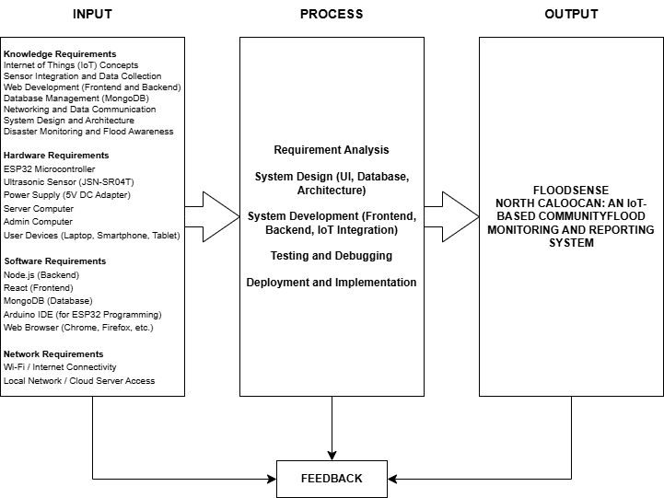

Figure 1: IPO Conceptual Framework

The Input-Process-Output (IPO) framework illustrates the development of FloodSense North Caloocan as an IoT-based flood monitoring and reporting system. The Input phase includes the knowledge, hardware, software, and network requirements necessary for system development, such as IoT concepts, ESP32 and ultrasonic sensors, web development tools, databases, and internet connectivity. The Process phase involves requirement analysis, system design, development, testing, and deployment to ensure the system functions accurately and efficiently. The Output is a fully operational flood monitoring platform that provides real-time flood data and community-based reporting to support informed decision-making during flood events. A Feedback mechanism is incorporated to gather user suggestions and reports, enabling continuous improvement of the system’s performance, usability, and reliability.

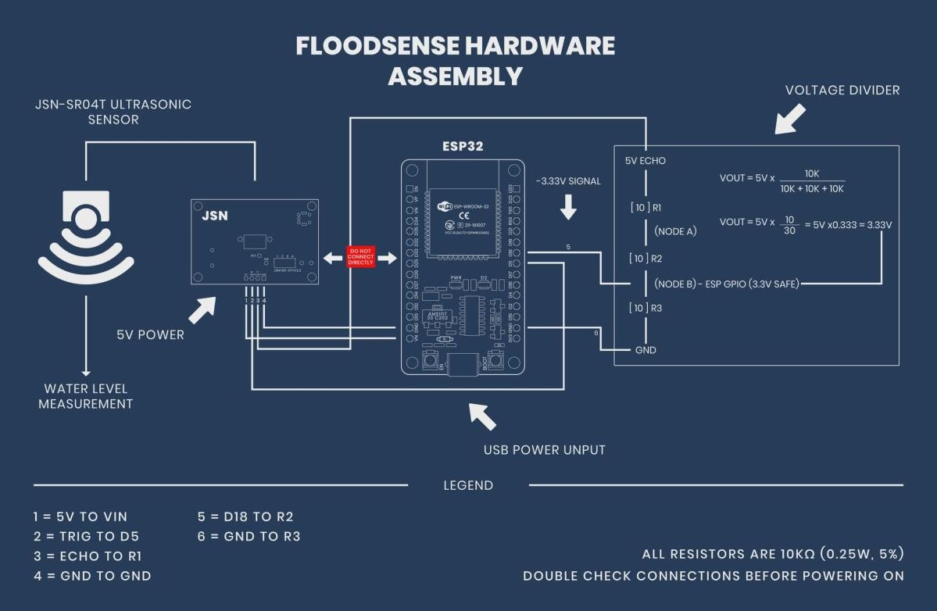
Hardware Blueprint

Figure 2: Hardware Blueprint

The FloodSense hardware setup uses an ESP32 connected to a JSN-SR04T ultrasonic sensor to measure water levels. The sensor runs on 5V and works by sending sound waves and receiving their echo to calculate distance. Its TRIG pin connects directly to the ESP32, while the ECHO pin outputs 5V, which must be reduced before entering the ESP32’s 3.3V input. A voltage divider is used to safely step down the ECHO signal to about 3.3V, protecting the microcontroller. The ESP32, powered via USB, processes the readings and sends the data to the system. This setup enables accurate and safe real-time flood monitoring.

System Architecture
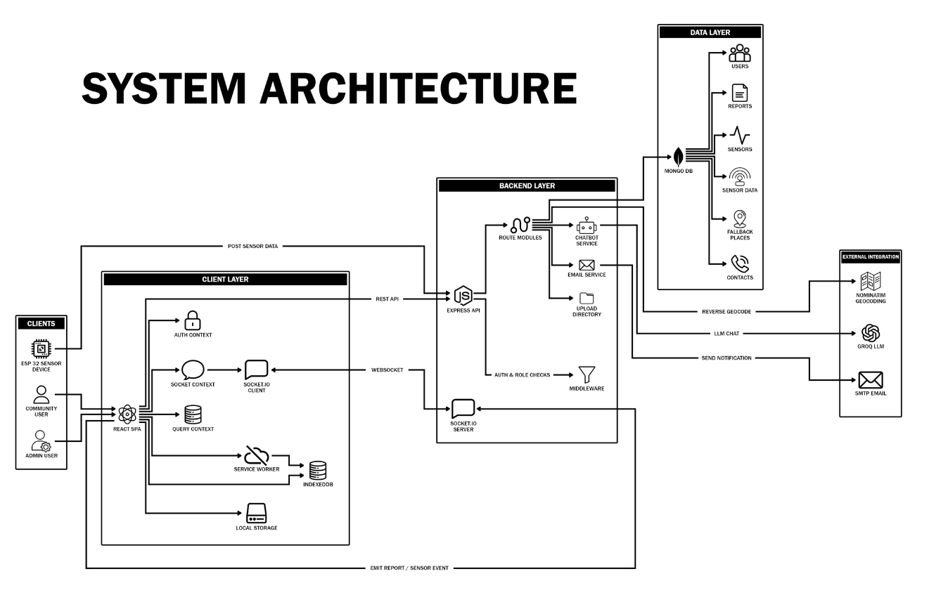
Figure 3: System Architecture

The System Architecture of FloodSense North Caloocan follows a layered design that supports real-time flood monitoring and reporting. The client layer consists of a React-based web application and ESP32 sensor devices for user interaction and data collection. The backend layer uses Express.js to process requests, manage system functions, and enable real-time communication. The data layer utilizes MongoDB to store users, reports, sensor readings, and other system data. External services such as geocoding, chatbot integration, and email notifications further enhance system functionality, ensuring efficient and reliable flood monitoring.

Use Case Diagram

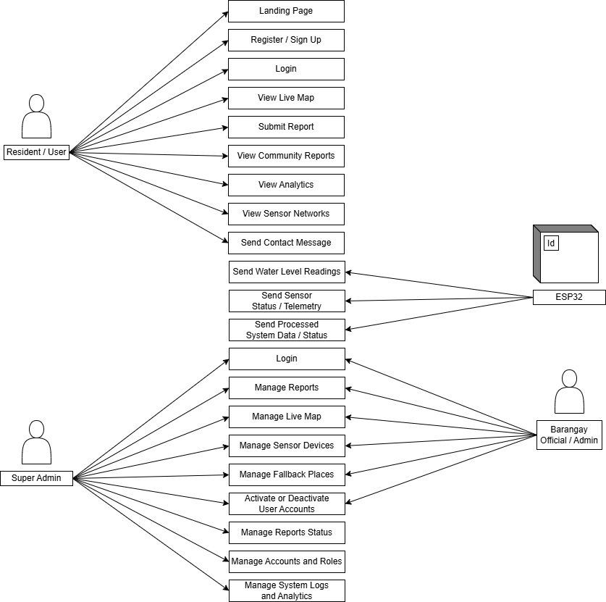
Figure 4: Use Case Diagram of the Proposed System

The Use Case Diagram illustrates the interactions between the Resident/User, Barangay Official/Admin, Super Admin, and ESP32 Sensor within the FloodSense North Caloocan system. Residents can register, log in, view flood information, submit reports, and access community data. The ESP32 sensor provides real-time water level readings to the system. Barangay Officials manage reports, maps, sensors, and user accounts, while the Super Admin oversees system-wide operations, user roles, analytics, and monitoring. These interactions support effective flood monitoring, reporting, and disaster response.
Context Diagram of the Proposed System

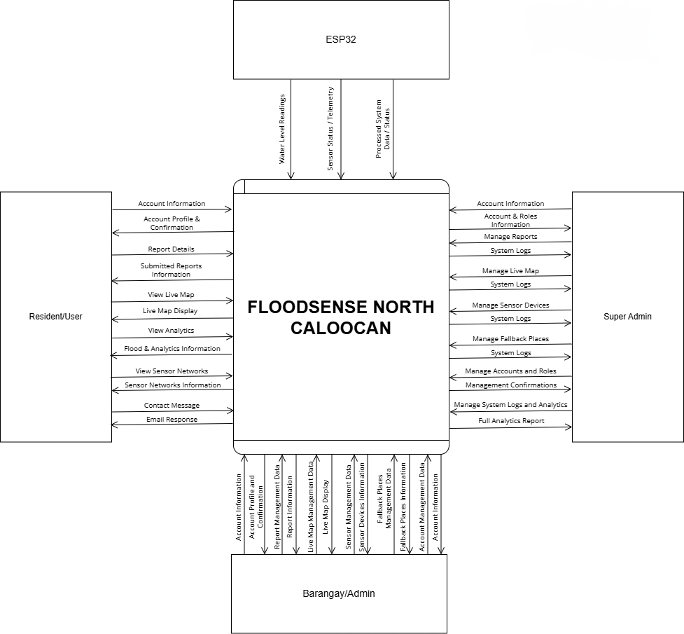
Figure 5: Context Diagram of the Proposed System

The Context Diagram provides a high-level overview of the interactions between the Users (Residents), Admin/Barangay, ESP32 Sensor, and the Flood Monitoring & Reporting System. Users submit flood reports, access flood information, and receive safety updates. Admins manage reports, users, and system data, while the ESP32 sensor supplies real-time water level readings. Together, these interactions enable accurate flood monitoring, efficient information sharing, and effective emergency response.
Data Flow Diagram Level 1

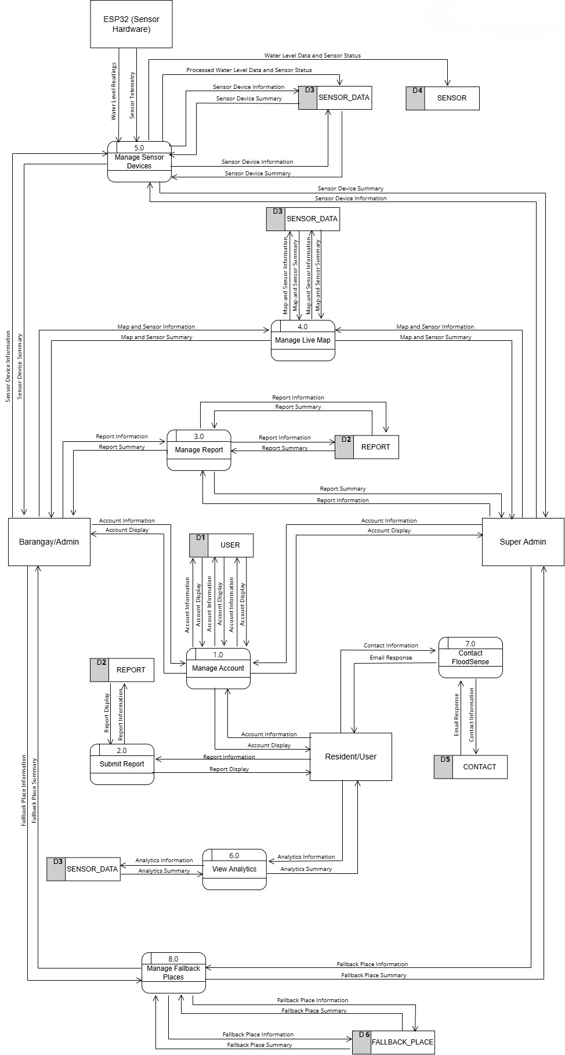
Figure 6: Data Flow Diagram Level 1

The System Flowchart illustrates how Users, Admins, and ESP32 Sensors interact with the FloodSense North Caloocan system. Users and administrators access the platform through authentication, allowing them to manage accounts, submit or validate reports, and access flood-related information. The ESP32 sensor continuously transmits real-time water level data, which is processed and stored in the database. The system then integrates sensor readings and user reports to generate alerts, maps, analytics, and safety information, supporting effective flood monitoring and response.

Entity Relationship Diagram
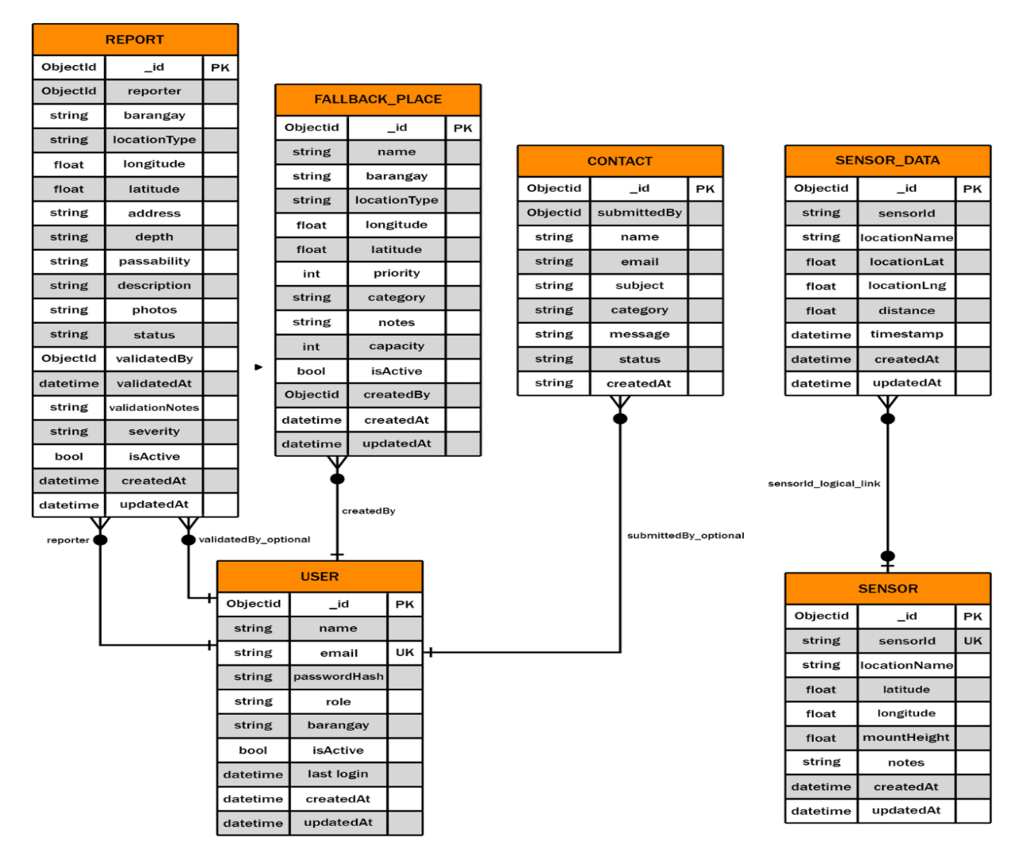
Figure 7: Entity Relationship Diagram

The ERD of FloodSense North Caloocan shows how the system manages flood monitoring and reporting through interconnected entities. The User entity handles system users, while the Report entity stores flood reports submitted and validated by users. The Fallback Place entity contains evacuation centers and safe locations. Real-time flood monitoring is supported by the Sensor and Sensor Data entities, which collect and store water-level readings. The Contact entity manages user inquiries and feedback. Together, these entities enable efficient flood monitoring, reporting, and emergency response management.

Proposed Flow Chart

Menu
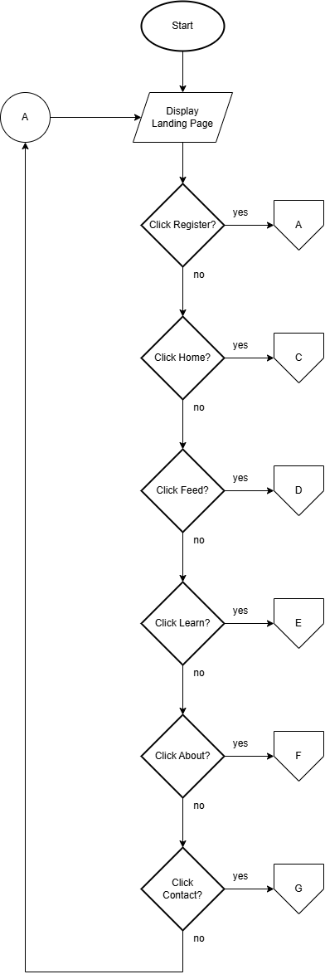

A – Register

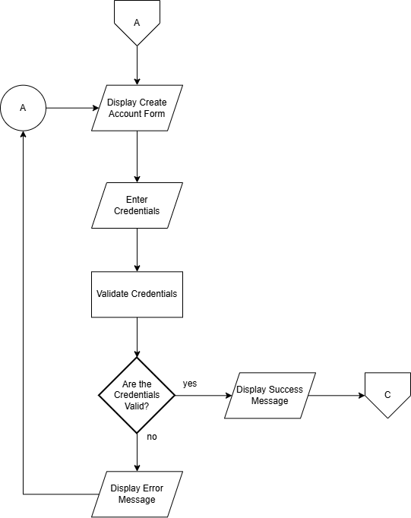

B – Login

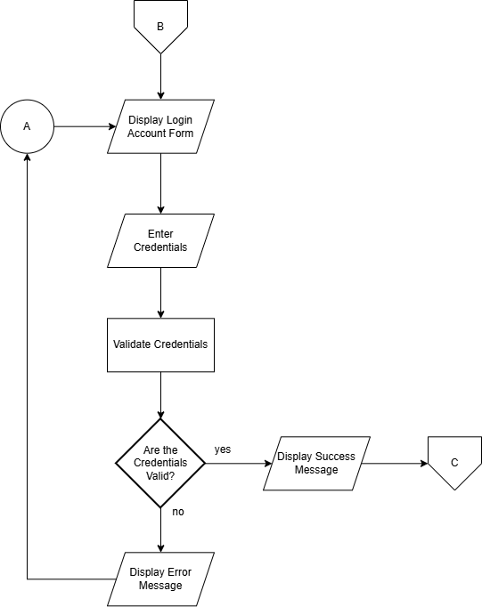
C – Home

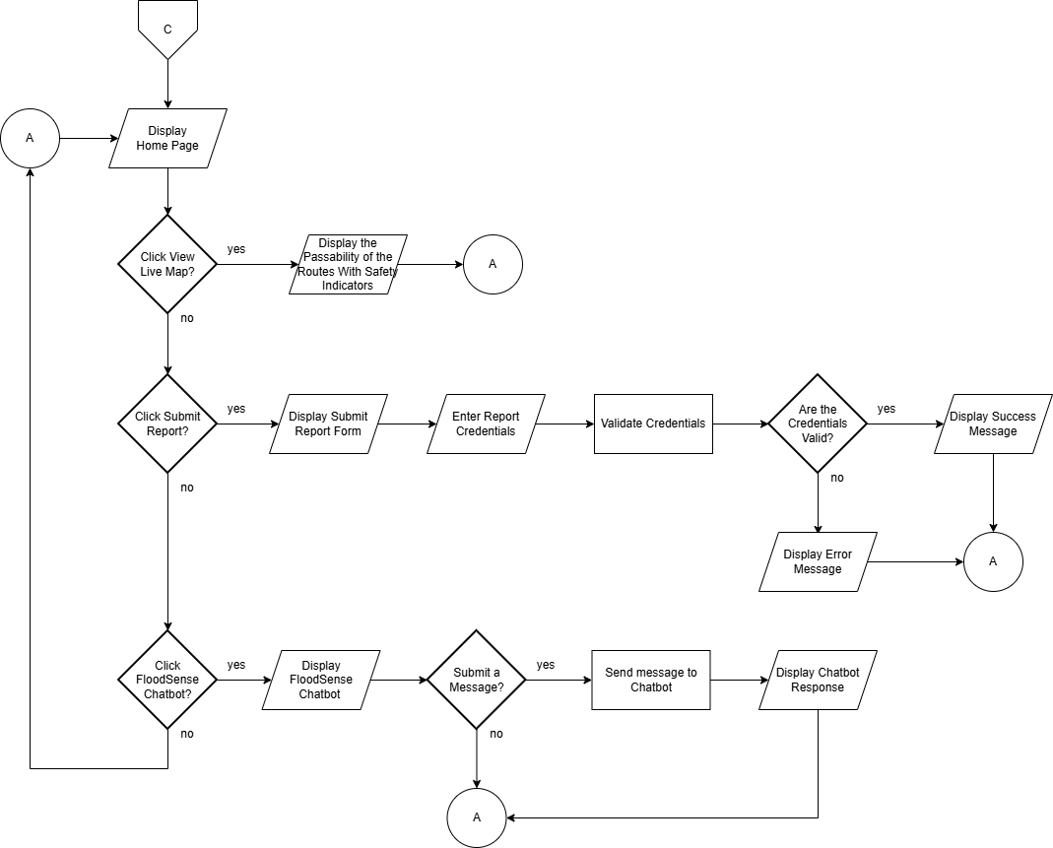

D – Feed
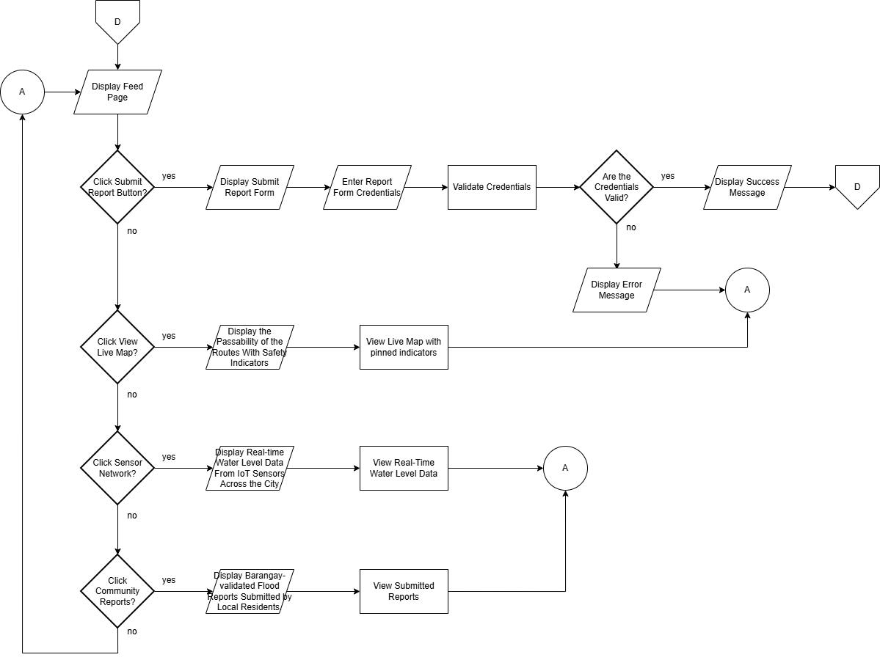
E – Learn
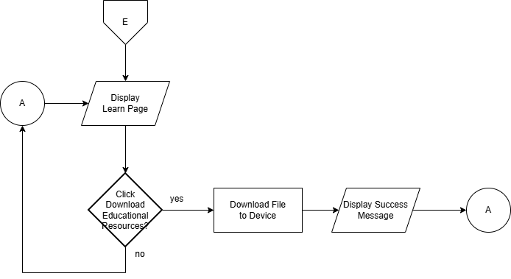
F – About
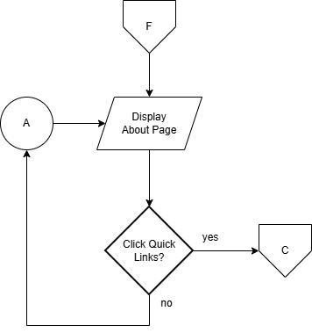

G – Contact
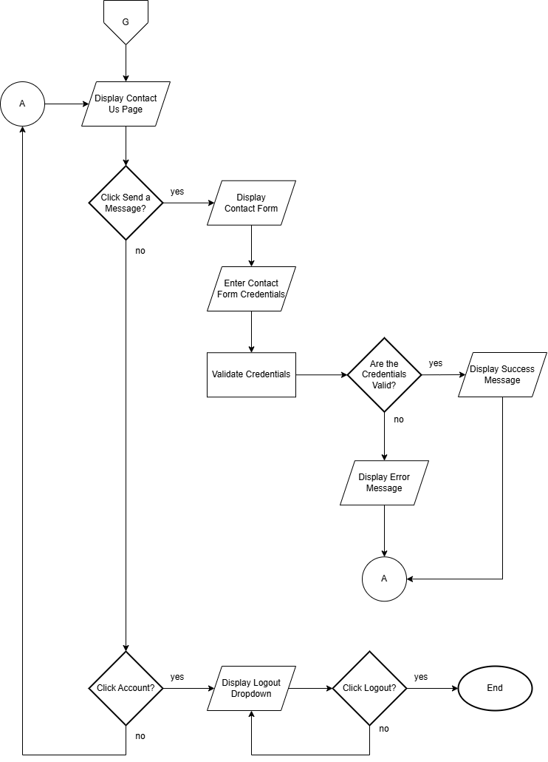
System Features

User

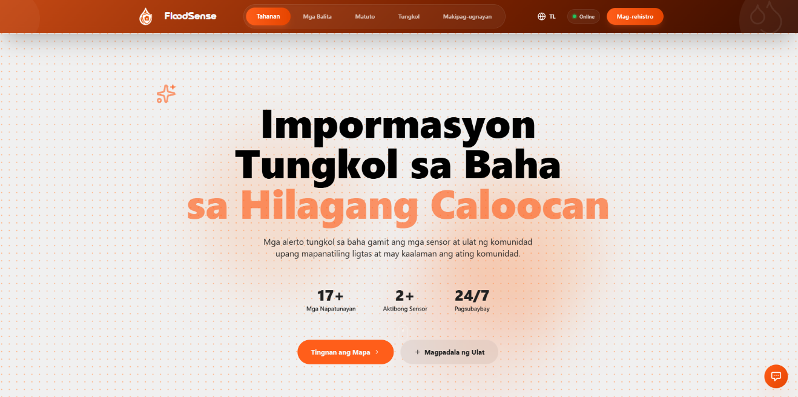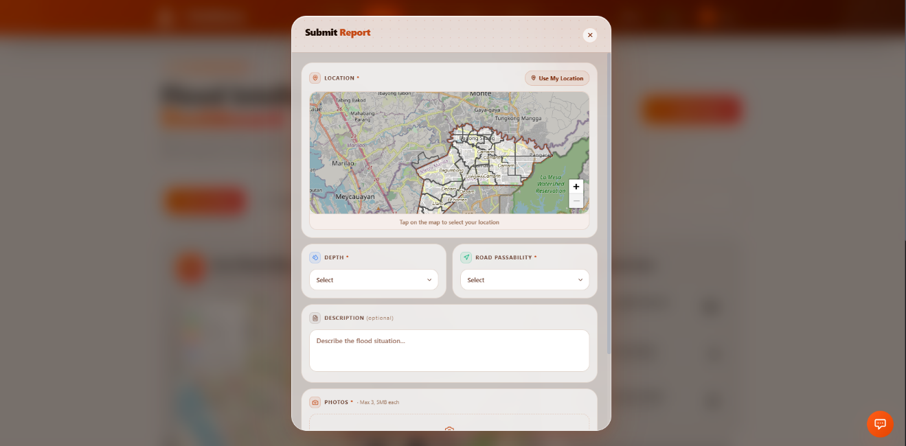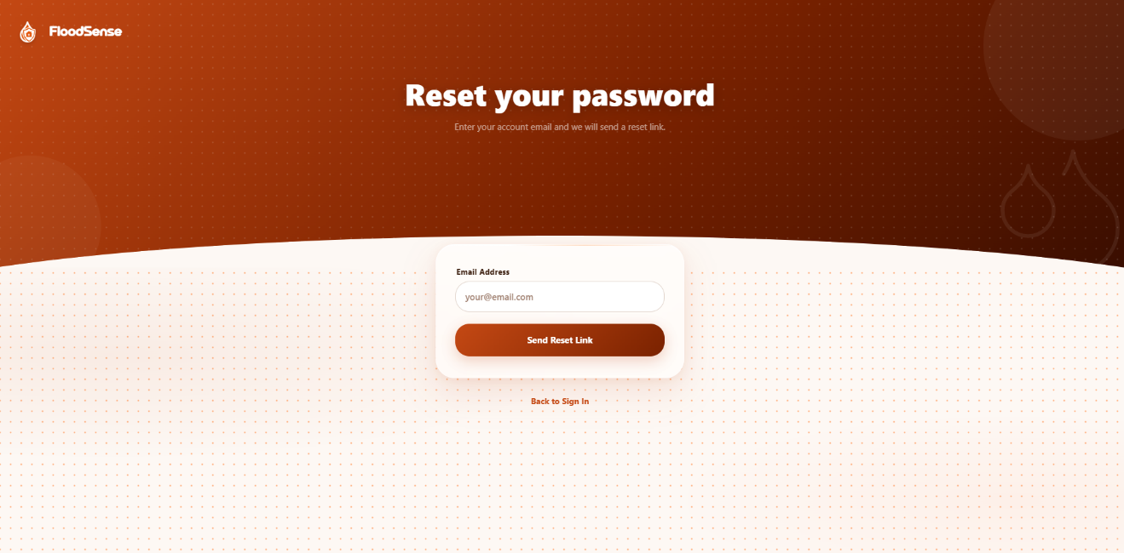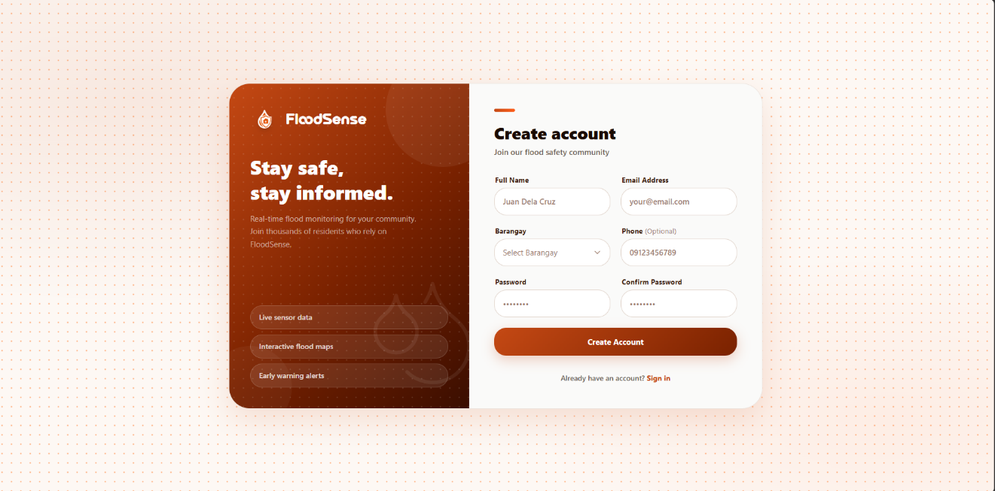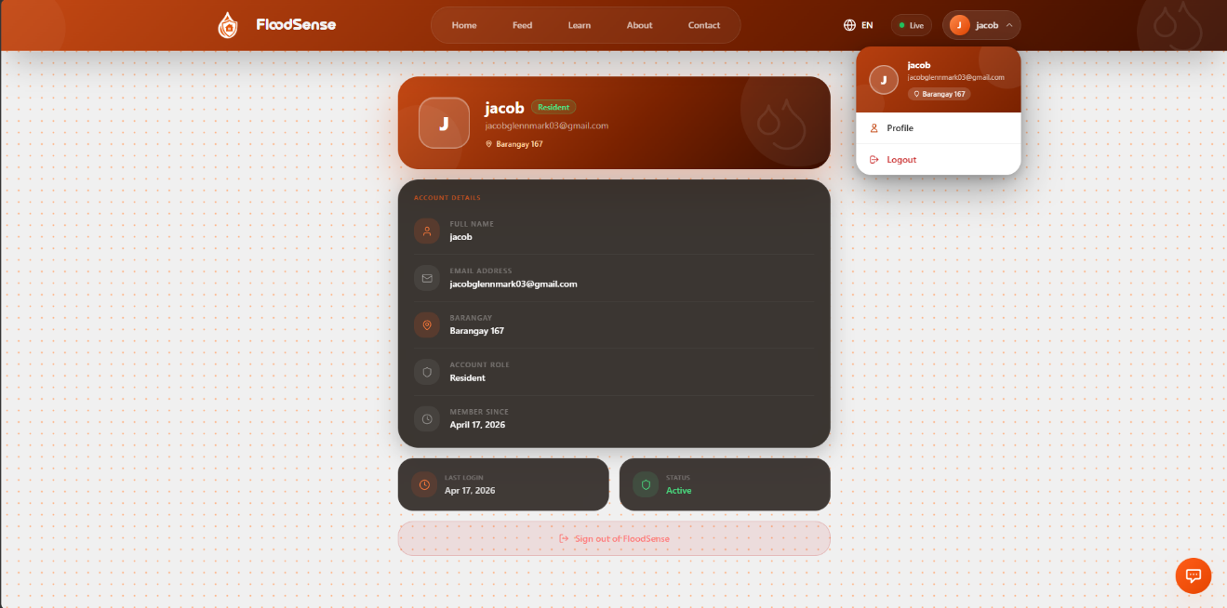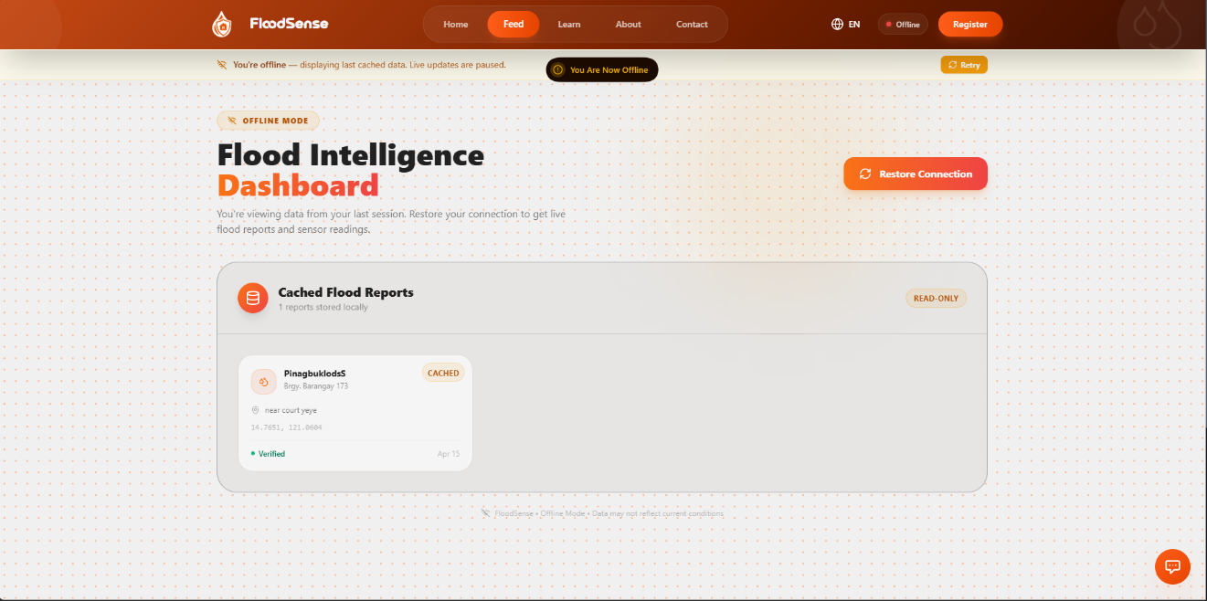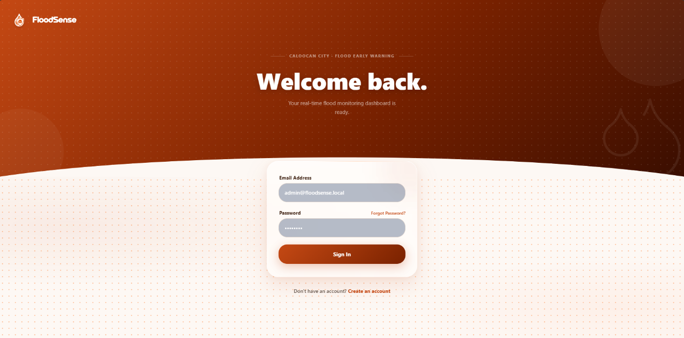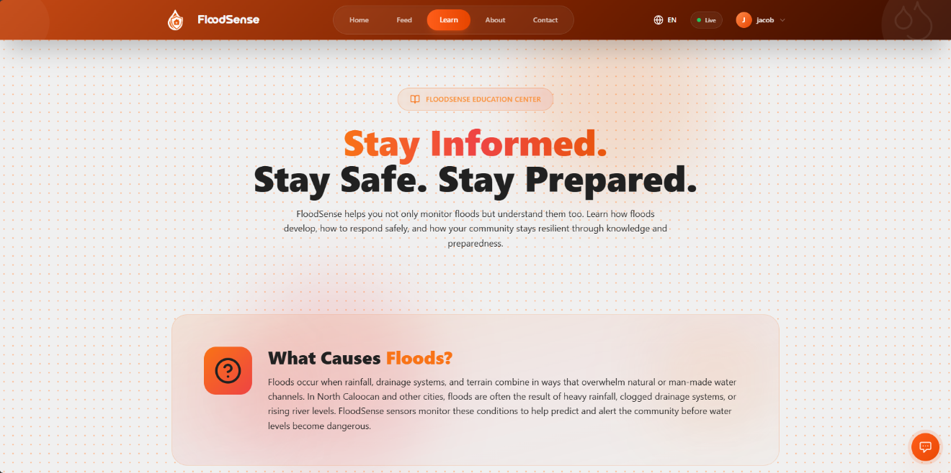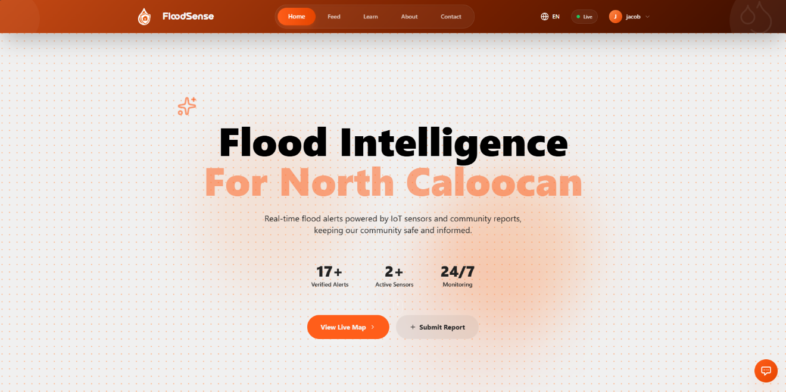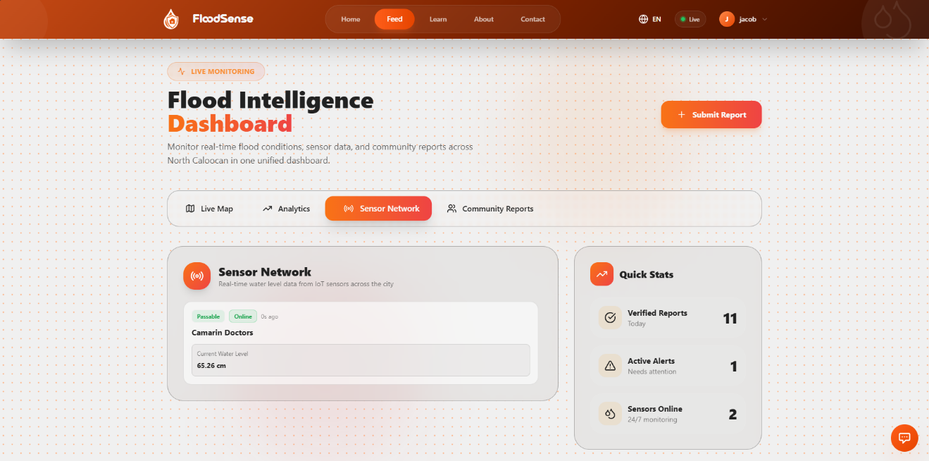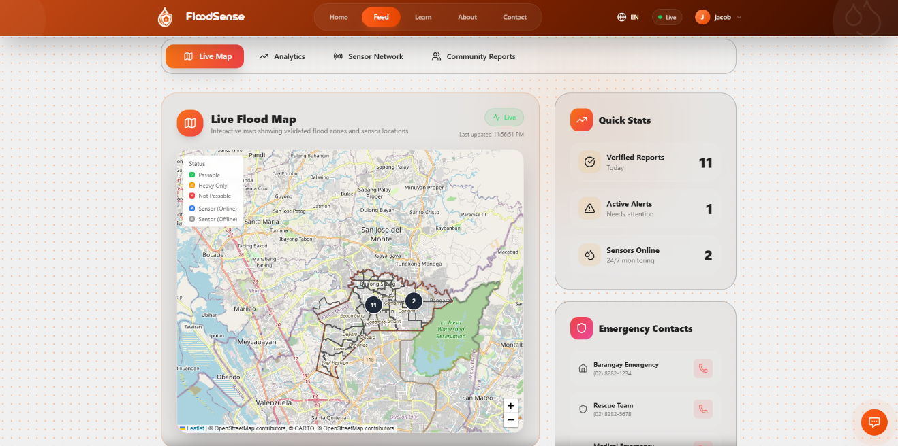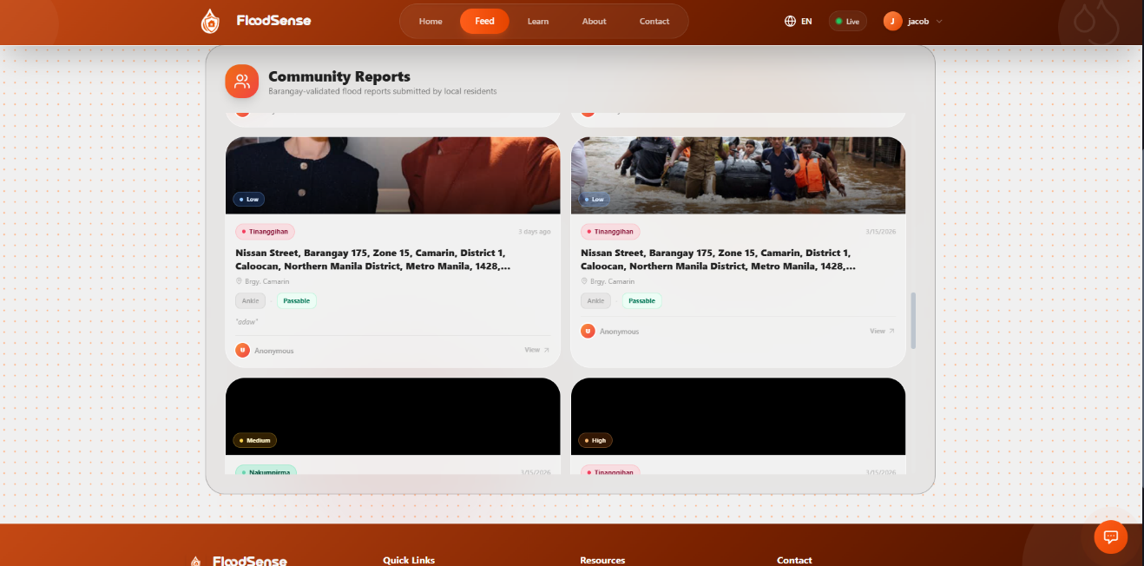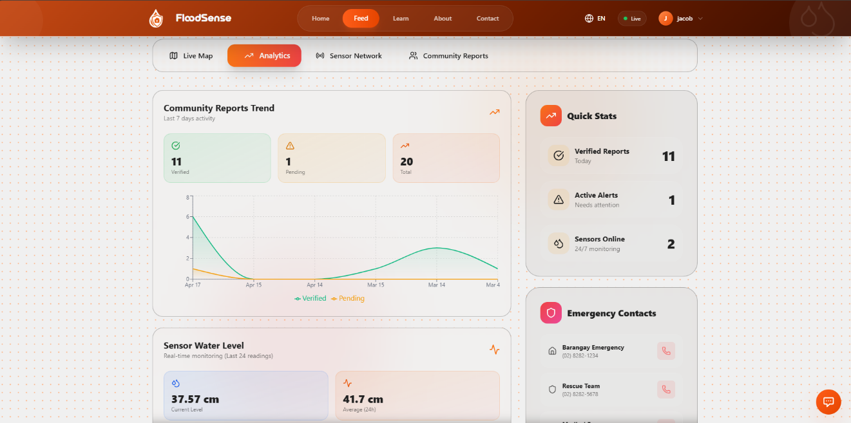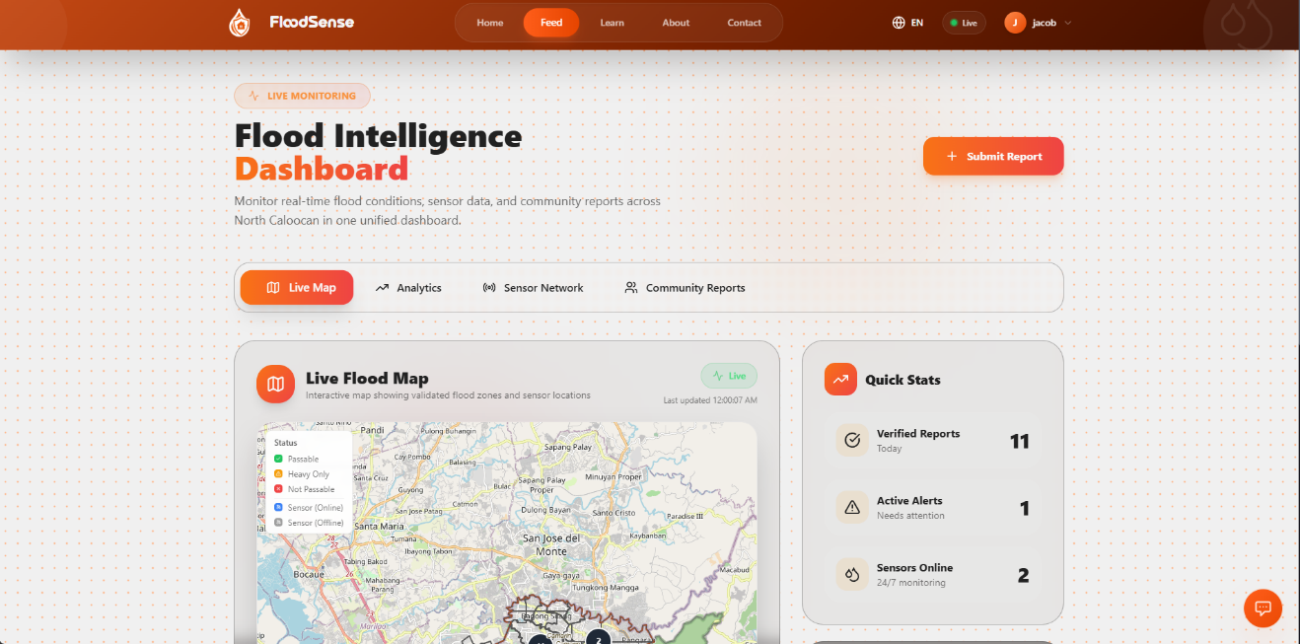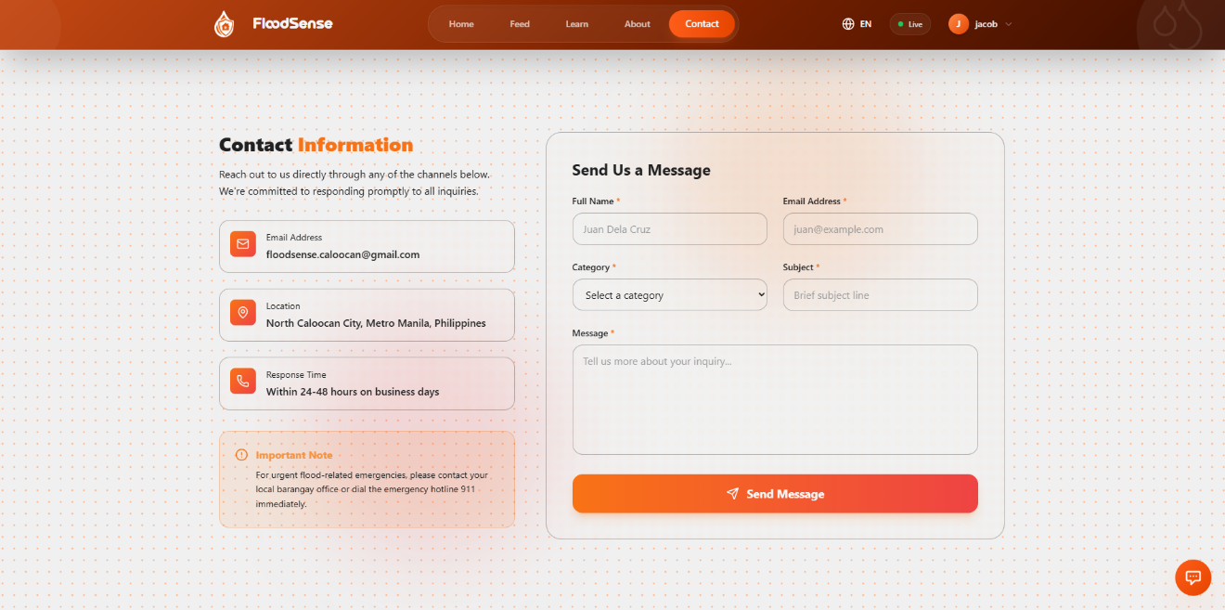

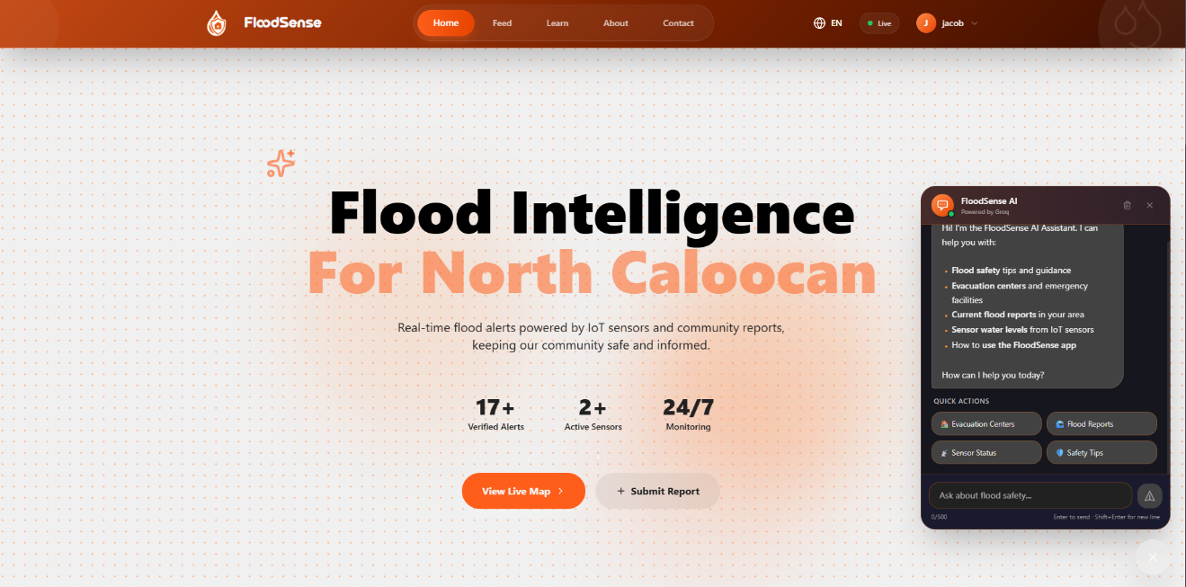

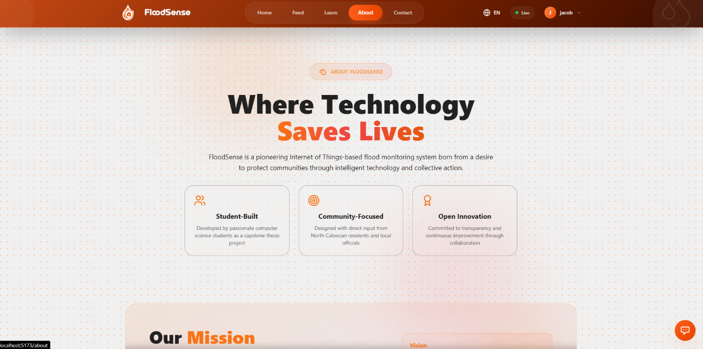

Admin

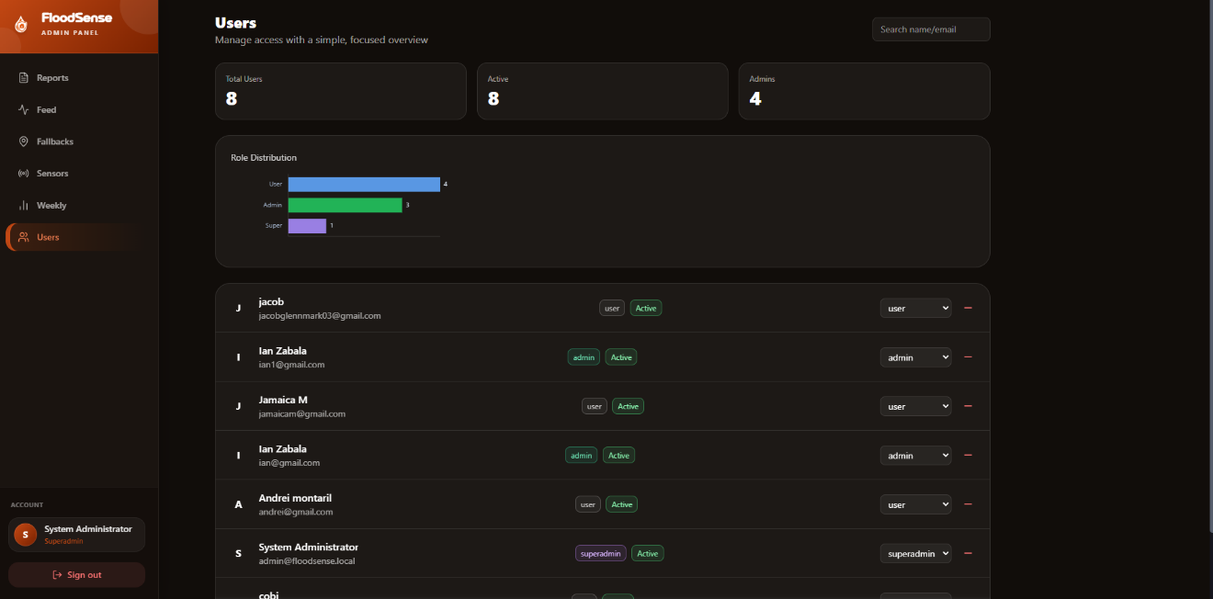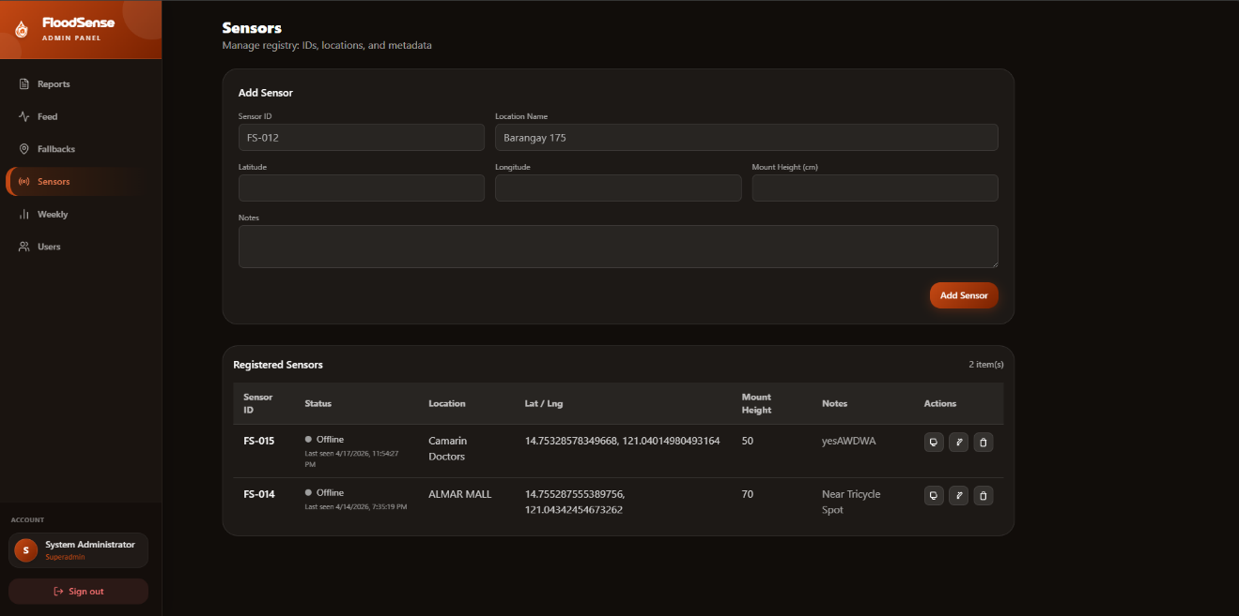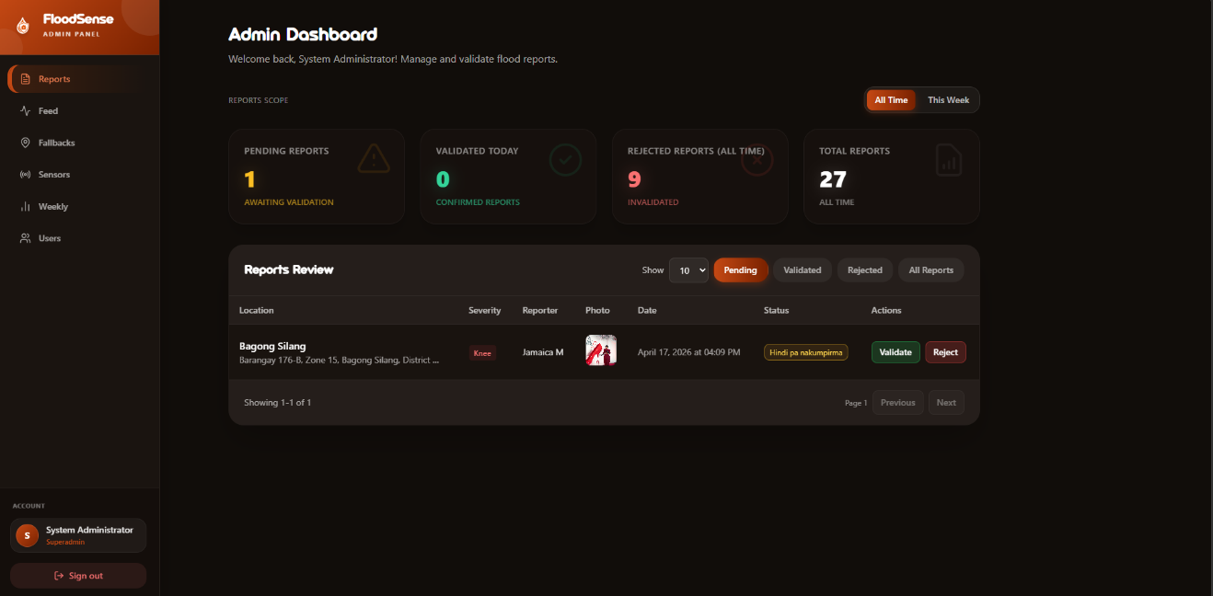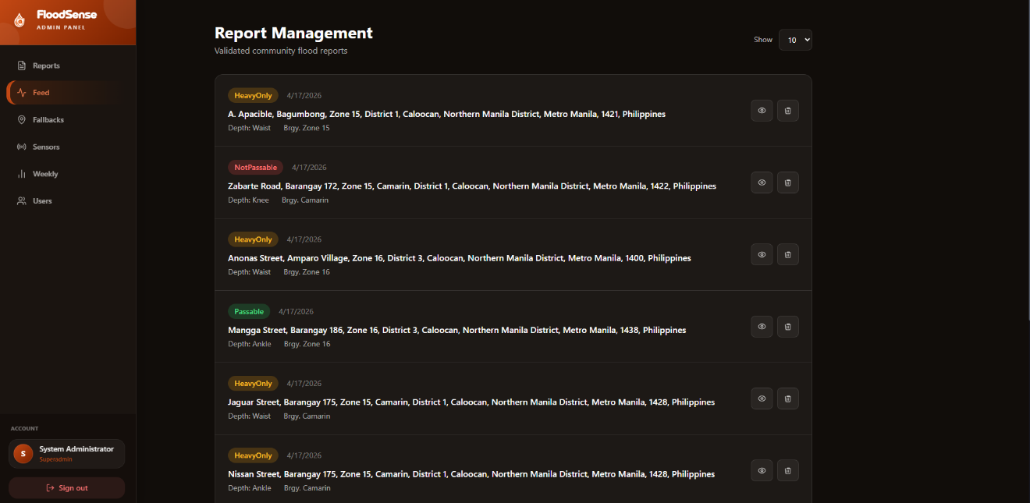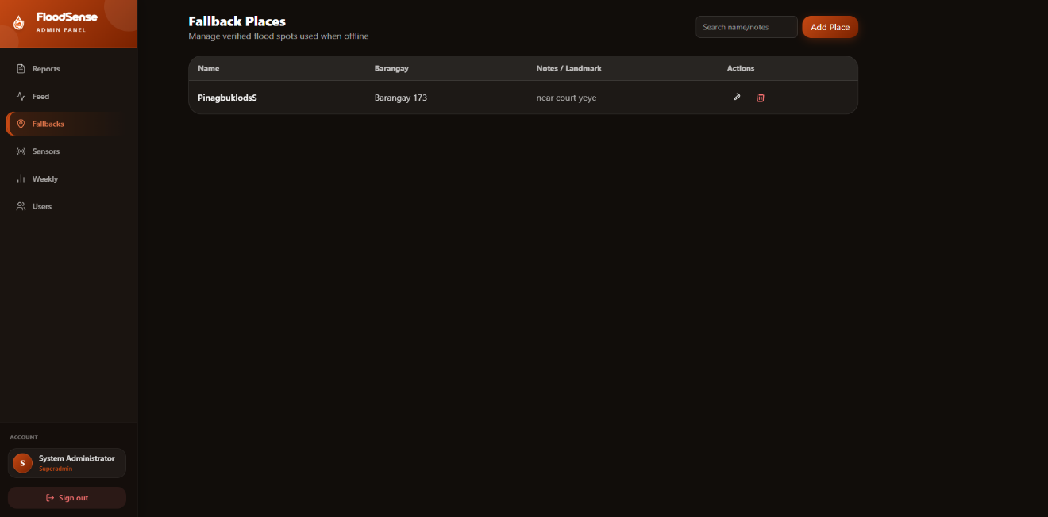

System Development Process

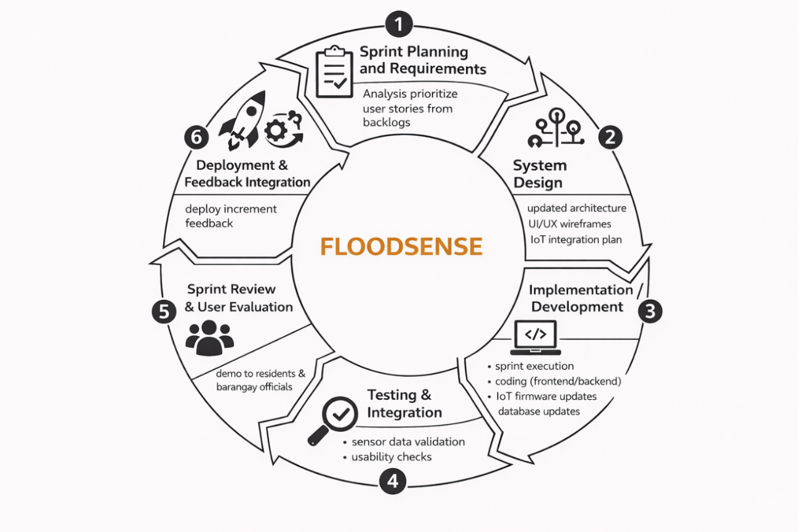
Figure 8: The Agile Development Process for FloodSense North Caloocan

The study utilized the Agile Software Development Life Cycle (SDLC) in developing FloodSense North Caloocan. Agile is an iterative and incremental approach that supports continuous development, testing, and improvement through short development cycles called sprints. It was chosen due to the system’s dynamic requirements, including real-time data processing, IoT integration, and community-based reporting. Agile promotes flexibility, stakeholder collaboration, and regular user feedback, ensuring that the system remains aligned with the needs of residents and barangay officials while enabling the timely delivery of functional features and continuous enhancements.

RESULTS AND DISCUSSION

The results of the study revealed significant findings regarding the flooding experiences of residents in North Caloocan and the effectiveness of the FloodSense system in addressing identified challenges. Data gathered from the respondents provided valuable insights into existing problems associated with flood monitoring, communication, and disaster preparedness within the community.

The pre-implementation survey indicated that flooding remains a recurring concern among residents of North Caloocan. Many respondents reported experiencing difficulties in obtaining timely and accurate flood-related information during periods of heavy rainfall and severe weather conditions. Delayed updates regarding flood levels often resulted in uncertainty, making it difficult for residents to make informed decisions regarding evacuation, travel routes, and personal safety. Respondents also reported challenges associated with weak communication channels, limited access to verified information, and difficulties identifying safe areas during flood events.

Another major concern identified was the reliance on social media posts, neighbors, and informal communication networks for flood updates. While these sources provide information, respondents noted that reports are often inconsistent, delayed, or unverified. This creates confusion and increases the possibility of misinformation during emergency situations. The findings demonstrate the need for a centralized platform capable of delivering reliable and real-time flood information to affected communities.

To address these concerns, FloodSense North Caloocan was developed as an integrated monitoring and reporting platform. The system combines IoT-based water level monitoring using ultrasonic sensors with a community-based reporting mechanism. Real-time data collected from sensors are transmitted through the ESP32 microcontroller to a centralized database and displayed on a web application accessible to residents and local authorities. The platform also allows users to submit flood reports accompanied by photographs and location details, which are subsequently validated by barangay officials before publication.

The post-implementation evaluation showed a high level of acceptance among respondents. In terms of accessibility and system performance, users reported that the platform was easy to navigate and provided a clear and user-friendly interface. The responsive design enabled residents to access information through both desktop and mobile devices, increasing usability across different user groups. Respondents also expressed satisfaction with the loading speed and reliability of the platform, particularly during testing scenarios involving simulated flood conditions.

Regarding information accuracy and reliability, respondents indicated strong confidence in the flood data provided by the system. The integration of sensor-generated information with barangay-validated community reports contributed significantly to user trust. Unlike traditional reporting methods that often rely solely on manual observations, FloodSense provides objective and continuously updated data regarding water levels and flood conditions. This feature enhances situational awareness and allows residents to monitor changing environmental conditions in real time.

The communication and monitoring features of the system also received positive evaluations. Respondents appreciated the real-time alerts and notifications that informed them of significant changes in water levels. The interactive flood map allowed users to visualize affected areas and identify locations experiencing potential flood risks. Additionally, emergency contact information and reporting features improved communication between residents and local authorities. These capabilities contribute to more effective disaster response and coordination during emergency situations.

User satisfaction results further demonstrated the effectiveness of the proposed platform. Most respondents agreed that FloodSense improves their ability to prepare for potential flooding events and enhances their awareness of local flood conditions. The system was perceived as a useful tool for identifying safer routes, monitoring flood-prone locations, and receiving verified updates from trusted sources. Furthermore, respondents expressed willingness to continue using the platform and recommended its implementation within their communities.

FURPS Model Mapping for FloodSense System
FURPS Quality Attribute | System Evaluation Area | Description (Based on Findings) | Weighted Mean | Interpretation
Functionality | Information Accuracy and Reliability | The system provides accurate, timely, and reliable flood-related information, meeting user needs effectively. | 4.52 | Excellent
Usability | Accessibility and System Performance | The interface is user-friendly, easy to navigate, and understandable for users of varying technical skills. | 4.65 | Excellent
Reliability | Communication, Alerts, and Monitoring | The system consistently delivers timely alerts, accurate mapping, and dependable monitoring features. | 4.66 | Excellent
Performance | Accessibility and System Performance | The system performs efficiently with fast response time, smooth operation, and functionality even under weak signal conditions. | 4.65 | Excellent
Supportability | Usefulness and Overall Satisfaction | The system is highly useful, flexible, and capable of supporting continuous improvements, contributing to high user satisfaction. | 4.72 | Excellent
The FURPS Model mapping confirms that the FloodSense system achieved excellent performance across all evaluated attributes. In terms of functionality (WM = 4.52), the system effectively delivers accurate and reliable flood-related information that meets user needs. Usability and performance both obtained a weighted mean of 4.65, indicating that the system is easy to use, responsive, and operates efficiently even under weak signal conditions. Reliability yielded a weighted mean of 4.66, demonstrating the system’s consistency in providing timely alerts and dependable monitoring features. Meanwhile, supportability achieved the highest weighted mean of 4.72, reflecting the system’s overall usefulness, adaptability, and strong user satisfaction. Overall, these findings indicate that the FloodSense system is a highly functional, reliable, user-friendly, and efficient solution, with strong potential for continuous improvement and long-term usability in flood monitoring and emergency response.

The findings support previous studies emphasizing the importance of IoT technology in disaster management. Similar to the works of Zakaria et al. (2023), Ahmed et al. (2023), and Sanz et al. (2024), the results demonstrate that real-time sensor monitoring can significantly improve the availability and reliability of environmental information. Likewise, the incorporation of community participation aligns with the findings of Seva et al. (2025), who highlighted the value of user engagement in enhancing the effectiveness of disaster monitoring systems.

Overall, the results indicate that FloodSense North Caloocan successfully addresses key challenges associated with traditional flood monitoring methods. By integrating IoT technology, community reporting, and barangay validation mechanisms, the system provides a comprehensive and reliable platform for flood monitoring and disaster preparedness. The positive evaluations received from respondents suggest that the system has the potential to support local government units and residents in reducing flood-related risks and strengthening community resilience.

CONCLUSION

Flooding continues to be one of the most significant environmental challenges affecting communities in North Caloocan. The recurring occurrence of flood events creates difficulties for residents, including delayed access to information, limited situational awareness, transportation disruptions, and increased risks to life and property. Traditional flood monitoring methods, which often rely on manual observation and fragmented communication channels, are no longer sufficient to meet the growing demand for timely and accurate flood-related information. These challenges highlight the importance of adopting innovative technologies that can improve disaster preparedness and response within local communities.

The development of FloodSense North Caloocan: An IoT-Based Community Flood Monitoring and Reporting System was undertaken to address these concerns through the integration of modern information technologies and community participation. The system combines IoT-based water level monitoring using ultrasonic sensors with a web-based platform that enables real-time data visualization, community reporting, and barangay validation. Through this approach, residents are provided with immediate access to reliable flood information, while local authorities are equipped with tools that support faster and more informed decision-making during emergency situations.

The findings of the study revealed that residents experience several challenges related to flooding, particularly in obtaining timely updates and identifying safe routes during emergencies. The results further demonstrated a strong acceptance of the proposed system among users. Respondents positively evaluated the platform in terms of accessibility, performance, information accuracy, communication features, and overall usefulness. The integration of real-time monitoring and community-generated reports contributed significantly to user confidence and satisfaction.

The study confirms that IoT technology can serve as an effective solution for enhancing flood monitoring and disaster risk reduction efforts. By providing continuous environmental monitoring and verified information dissemination, FloodSense improves community awareness and preparedness. The inclusion of barangay validation mechanisms further strengthens the reliability and credibility of the information presented to users.

In conclusion, FloodSense North Caloocan successfully achieved its objective of developing a responsive, reliable, and user-centered flood monitoring and reporting system. The system demonstrates the potential of combining IoT technologies with community engagement to improve disaster management practices. Its implementation can contribute to safer communities, more efficient emergency response, and enhanced resilience against future flooding events. Future enhancements may include the integration of predictive analytics, mobile application support, additional sensor deployment, and expanded coverage across other flood-prone areas within Caloocan City and neighboring communities.

REFERENCES

Ahmed, T., Rahman, M., & Islam, S. (2023). Wireless sensor and web-based decision support system for flood monitoring and environmental analysis. International Journal of Environmental Monitoring, 15(2), 101–115.

Arante, J. P., Santos, M. L., & Reyes, R. T. (2025). Secured IoT-based flood monitoring and forecasting system using a genetic-algorithm neuro-fuzzy network. Philippine Journal of Computing and Information Systems, 12(1), 45–60.

Bentoso, J. R., Mendoza, L. P., & Torres, C. D. (2021). Web-based flood warning decision support system for disaster management in Leyte. Journal of Philippine Information Technology Research, 8(3), 33–48.

Byaruhanga, J., Nsubuga, F., & Mugume, I. (2024). Evolution of flood prediction and forecasting models for flood early warning systems: A scoping review. Environmental Monitoring and Assessment, 196(4), 1–21.

Fernández-Nóvoa, D., García-Feal, O., & Gómez-Gesteira, M. (2024). Enhancing flood risk management: A comprehensive review on flood early warning systems with emphasis on numerical modeling. Water, 16(2), 1–25.

Gersaniva, P. R., & Damasco, A. J. (2025). Innovative flood monitoring system for community disaster preparedness and response. Asian Journal of Disaster Management, 14(1), 70–85.

Marzukh, S., Abdullah, N., & Hassan, M. (2018). Flood detection and warning system (FloWs) using Arduino Uno and GSM technology. International Journal of Advanced Engineering Research, 9(4), 55–67.

Montesa, K. A., Villanueva, R. M., & Cruz, J. L. (2023). Development of a coastal flood monitoring device using ultrasonic sensors and LoRa technology. Philippine Engineering and Technology Journal, 18(2), 91–108.

Sanz, A., Rodriguez, P., & Moreno, J. (2024). Cloud-based monitoring of hydrological processes using dense sensor networks and NB-IoT connectivity. Sensors, 24(5), 1–19.

Seva, R. R., Bautista, A. P., & Ramos, D. C. (2025). FloodCast: A user-centered flood monitoring system for improving community engagement and preparedness. Journal of Community Informatics and Disaster Resilience, 11(2), 50–68.

Tolentino, M. A., Cruz, E. P., & Rivera, D. S. (2022). Real-time flood detection using image processing and predictive analytics. International Journal of Computer Applications and Disaster Management, 13(1), 23–38.

Zakaria, H., Liu, Y., & Chen, X. (2023). Remote water-level monitoring system for flood management using sensor networks and web technologies. Journal of Hydrological Engineering, 28(6), 1–14.

