Smart Canteen Management System for Khaugallis and Messes

Prof. Renuka Vaidya
dept. of Information Technology
Vishwakarma Institute of Technology
Pune, India
renuka.vaidya@vit.edu
Vedant Girgaonkar
dept. of Information Technology
Vishwakarma Institute of Technology
Pune, India
vedant.girgaonkar24@vit.edu
Aricia Dubey
dept. of Information Technology
Vishwakarma Institute of Technology
Pune, India
aricia.dubey24@vit.edu
Sonali Ghule
dept. of Information Technology
Vishwakarma Institute of Technology
Pune, India
sonali.ghule24@vit.edu
Atreya Gosavi
dept. of Information Technology
Vishwakarma Institute of Technology
Pune, India
atreya.gosavi24@vit.edu
Vijay Gopale
dept. of Information Technology
Vishwakarma Institute of Technology
Pune, India
vijay.gopale24@vit.edu

Abstract — This paper presents a fully functional web-based Smart Canteen Management System (SCMS) that is aimed at improving the operational processes of Khaugallis, canteens in colleges, and small-scale messes. The system is designed and developed with React, Node.js, Express, Firebase, and WebSockets technologies and provides a real-time food ordering system, delivery scheduling, and vendor management services. The SCMS provides three different Vendor, Customer, and Admin Portals that offer structured functionality to the users based on their roles. Each vendor has the ability to run his/her own canteen through which the vendor can upload the menu items and fulfill the orders accordingly. The vendor can also keep a track of the inventory and the sales through a real-time dashboard provided by the system. The customers can receive the menu items and can order the items at any time (or) schedule the future pickup time. The customers can make the payments upon the delivery of the items (cash) or can make the payments online at the time of ordering the items. The model reduces the waiting times for the customers, thereby reducing the number of times the customers need to wait in the queues, which in turn increases the operational efficiency of the system. The system not only fully digitizes the operational processes of the traditional canteens but also the provision of services such as handwritten forms for ordering, communication with the vendors, coupon schemes for the customers, and payments from the customers.
Keywords— Smart canteen system, Firebase, React, Node.js, Express, WebSockets, food ordering system, real-time notifications, vendor dashboard.

Introduction
Management in the area of food service management can significantly increase convenience and operational effectiveness within the educational institutions. At the same time, there are quite many cafes as well as small stalls that still operate using a manual system, which includes verbal menus, handwritten orders, as well as manual handing of the coupons. Such practices only contribute to the development of inefficiency because they result in long waiting periods, misunderstanding, order errors, improper inventory control, as well as overloading of the space during the busiest hours.

It has been proven from the findings of previous research works that digital systems for ordering foods help in enhancing the efficiency and avoiding errors in the process due to replacing manual interaction with processes (Nair et al. [1]). But the major disadvantage of most of the existing systems is their incapability to provide real-time synchronization of orders (Kumar and Singh [3]).

In order to overcome the constraints mentioned above, we have come up with a Smart Canteen Management System (SCMS). SCMS is an internet-based solution where individuals can view the menu items, place their orders, book their pick-up timings, and pay for their orders using digital means like UPI.

The SCMS system will provide a central point of operations that will deal with order taking, menu modification, inventory management, and performance review through sales analysis. Transitioning from manual systems to more computerized systems is more precise and efficient due to effective resource utilization.

Time slot allocation is another critical component in the model. It aids in balancing the load, thus minimizing congestion. According to research, scheduling plays an essential role in enhancing service delivery operations (Saxena and Mehta [13]).

Furthermore, live monitoring and analysis of orders will enable vendors to get insights on customer demands, top-selling products, and high-traffic hours. Data-driven techniques have proven to be efficient when making plans in service-oriented systems (Hoffman and Novak [7]).

Overall, the Smart Canteen Management System uses digital ordering, automatic scheduling, real-time communications and analysis of data to completely change Food Service across the University. By doing this it reduces students' waiting time for food, maximizes vendors' workflow, and gives vendors vital information to enable them to make better decisions, showing directly how effective technology that has been designed correctly can resolve an operational issue within the area of education.

Literature Review
In recent years, extensive research has been conducted on the transformation process from traditional manual ordering to online ordering of meals. As stated by Nair et al. [1], ordering online ensures that order management becomes more efficient and eliminates any possibilities of error arising from the traditional method and eliminates communication barriers. However, this technique, which relies heavily on static order management, is not very efficient in dynamic environments.

Automated ordering systems using web technology and based on conventional client-server architecture have been further analyzed by Kumar & Singh [3]. Despite its efficiency in reducing dependence on manual labor, the system lacks analytical tools for the supplier side as well as real-time monitoring features. Due to such limitations, it may not be suitable for environments where demands fluctuate significantly, such as khaugallis and institutional kitchens.

Prakash & Sundaram [11] examined the challenges involved when such small-scale businesses attempted to adopt technology-driven solutions for their services. Some of the limitations highlighted through their research include implementation costs, training requirements, and overhead. This evidence suggests that there is a need for scalable, cheap and lightweight solutions. Cloud computing technologies such as Firebase fit into this description.

With the rapid increase in cloud computing technology, the majority of contemporary software applications utilize cloud computing facilities to ensure scalability and reliability. According to Rahman et al., [2], cloud-based applications have the ability to support many users at once without suffering from performance degradation, making them ideal for real-time applications. According to Prajapati et al., [6], the Firebase application offers the advantage of enabling real-time synchronization between many users without worrying about the complex back-end operations required to maintain such consistency. This is particularly beneficial when dealing with environments such as canteen and mess applications.

Firestore is evaluated as a NoSQL database for various applications by Chauhan and Sharma [12], who conclude that its event-driven model, offline support, and low operation costs make it ideal for real-time environments.

Where there is an abundance of individuals awaiting services, efficient queuing systems are imperative. According to Zhang et al., [4] event-driven communication systems such as WebSockets can be instrumental in enhancing queuing systems. The results from their study indicate that by notifying individuals instantly, they have a chance to alter their time of arrival and minimize their perception of queuing time.

System Architecture
The system is based on a three-tier architecture that includes:
- Presentation Layer (Frontend):
Developed using React.js, providing role-based interfaces for customers, vendors, and administrators.
- Application Layer (Backend):
Built using Node.js and Express.js to handle authentication, order processing, scheduling logic, and API communication.
- Data Layer (Database):
Firebase Firestore is used as a NoSQL cloud database to enable real-time data synchronization and horizontal scalability.
Additionally, WebSocket-based communication layer is integrated to facilitate event-driven updates such as order status changes and slot notifications.

Methodology

Requirement Engineering
A structured analysis of the requirements was performed based on dividing the system needs into three groups of stakeholders:
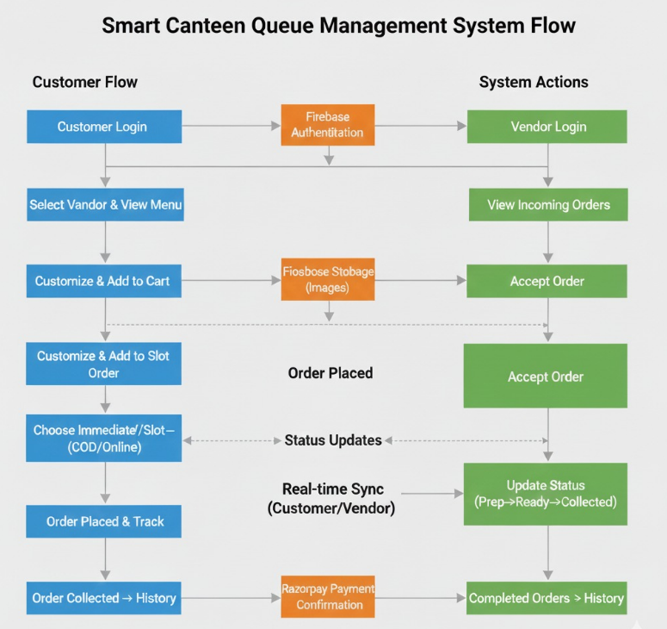
Fig. 1. System Flow
- Customers: real-time menu access, pre-ordering, slot-based scheduling, multiple payment options, and live order tracking
- Vendors: dynamic menu control, order queue visibility, inventory tracking, and sales analytics
- Administrators: vendor verification, system monitoring, and platform-level analytics

System Workflow Design
The workflow of the proposed system is as follows:
- Customer selects items and selects immediately or at a future time slot
- Order verified and saved to Firestore
- Real-time updates to vendor dashboard through WebSockets
- Order handled by vendor and status changed
- Customer receives real-time updates for preparation and pickup
This pipeline eliminates manual intervention and reduces dependency on verbal communication.
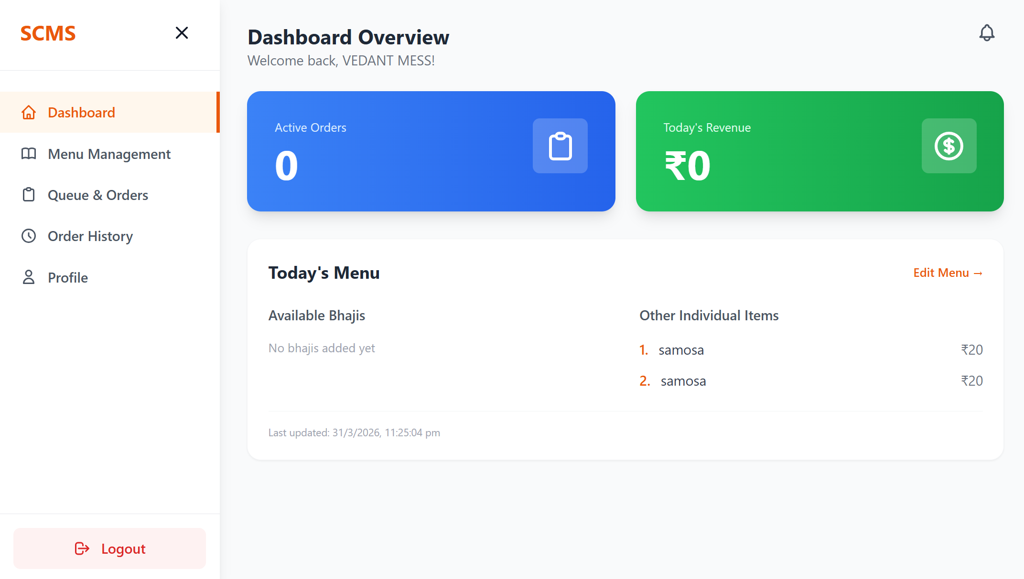
Fig. 2. Vendor Dashboard

Queue Optimization via Time-Slot Scheduling
A time-slot allocation mechanism is implemented to distribute demand across predefined intervals.
- Orders are mapped to slots based on availability and vendor capacity
- Vendors receive a structured view of upcoming workloads
- Customers are notified when their order is ready
This approach transforms the traditional FIFO queue into a controlled scheduling system, improving throughput and reducing congestion.

Implementation Modules
The system is modularized into three independent components:
- Customer Module: ordering, scheduling, payment, tracking
- Vendor Module: order management, menu updates, analytics dashboard
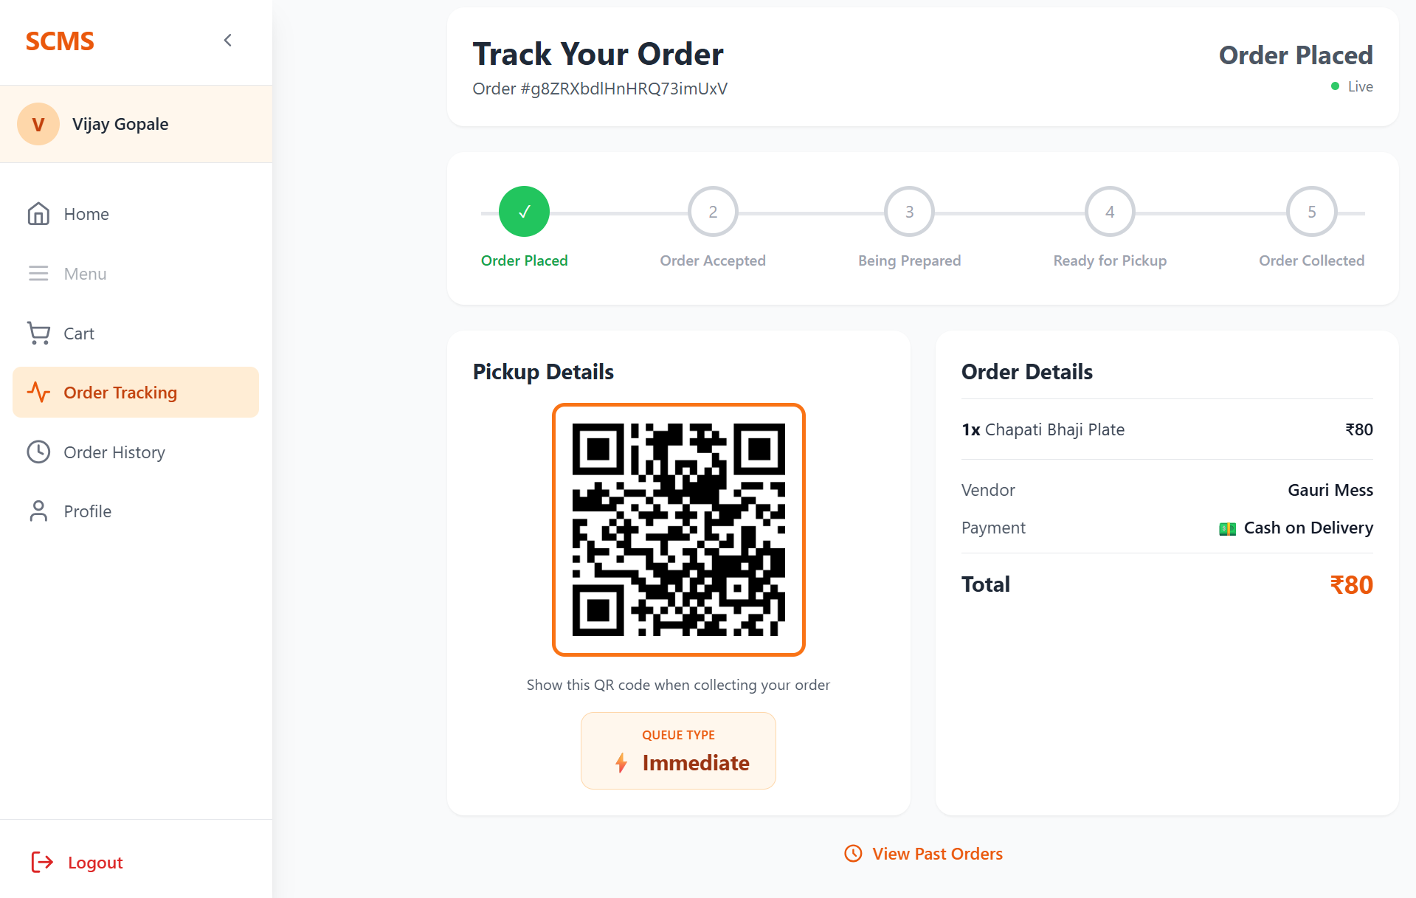
Fig. 3. Customer Order Tracking
- Admin Module: vendor control, monitoring, system-level insights
This modular design ensures scalability and ease of future enhancements.

Evaluation Strategy
The system was evaluated using functional and qualitative testing approaches, focusing on real-time synchronization accuracy, usability across different user roles & effectiveness of scheduling in reducing order overlap. Observations were recorded through controlled usage scenarios simulating peak-hour conditions.

Results and Discussion
Functional testing and controlled use scenarios confirmed that the Smart Canteen Management System (SCMS) reliably demonstrated real-time order synchronization and customer-vendor communication. The time-slot scheduling feature evenly distributed orders, diminished peak time clustering, and assisted workflow management. The SCMS system reduced manual errors and improved operational transparency.

Conclusion and Future Work
This paper describes a Smart Canteen Management System (SCMS) created to digitize more traditional canteen and mess systems using structured scheduling and real-time web technologies. The innovative use of React, Node.js, Express, Firebase, and WebSockets, allows for complete digital ordering and live tracking, As well as vendor-side management. The platform minimizes the system reliance on manual operations, improves overall coordination between the users and the vendors and increases operational transparency and workflow efficiency. The system analyzes and transcribes data to inform the vendor of the ordering habits and demands, which can streamline the planning of the vendor’s inventory and minimize waste of resources. The system’s architecture can be modified for additional features, and designed to be scalable for future use with educational institutions, or places with similar needs.
In the future SCMS, can be designed with more features such as demand forecasting, predictions of missing ingredients and smart time slot optimizers based on algorithms. Integrating real-time operational control (OTC) technologies such as QR-based pickup systems, smart kitchen notifications, and digital signs will further automate on-site operational processes. Furthermore, adapting the SCMS to a multi-vendor paradigm, adding enhanced user authentication, security controls, and offline capabilities, payment integrations, and integrations with 3rd party vendors will extend the SCMS functionality to support the streamlined operations of larger foodservice ecosystems. This includes food courts, corporate cafeterias, and similar venues.
SCMS represents the beginning of a new era for small food service systems to be digitized and transformed into efficient digital ecosystems.

References
- S. Nair, P. Surya, and R. Kumar, “Online Food Ordering System,” International Journal of Computer Applications, vol. 182, no. 9, pp. 23–28, 2020.
- M. Rahman and T. Hossain, “Cloud-Based Restaurant Management System Using Real-Time Synchronization,” in Proc. IEEE ICCIT, Dhaka, Bangladesh, pp. 234–239, 2019.
- R. Kumar and G. Singh, “Automation in Food Ordering System Using Web Technologies,” International Journal of Engineering Research & Technology (IJERT), vol. 8, no. 6, pp. 112–118, 2019.
- Y. Zhang and X. Liu, “Queue Optimization Techniques Using Real-Time Notification Systems in High-Density Environments,” IEEE Access, vol. 7, pp. 117920–117930, 2019.
- S. Thirumalai and R. Latha, “RFID and IoT-Based Smart Canteen Management System for Educational Institutions,” International Journal of Computer Science and Information Technologies (IJCSIT), vol. 10, no. 4, pp. 22–29, 2018.
- A. Prajapati and R. Patel, “Firebase-Based Real-Time Application Development: A Study on Performance and Scalability,” International Journal of Innovative Research in Computer and Communication Engineering (IJIRCCE), vol. 7, no. 5, pp. 5012–5020, 2019.
- D. Hoffman and T. Novak, “Role of Data Analytics in Improving Vendor Decision-Making,” Journal of Retail Analytics, vol. 12, no. 2, pp. 45–57, 2020.
- A. Khan and S. Begum, “Mobile-Based Real-Time Food Ordering and Notification System,” in Proc. IEEE International Conference on Advanced Computing and Communication Systems (ICACCS), Coimbatore, India, pp. 455–460, 2021.
- Google LLC, “Firebase Realtime Database and Firestore Documentation,” 2024.
- Mozilla Foundation, “WebSocket API Documentation,” Mozilla Developer Network, 2024.
- M. Prakash and R. Sundaram, “Challenges in Implementing Technology Solutions in Local Cafeterias,” International Journal of Management and Applied Science, vol. 6, no. 3, pp. 89–95, 2020.
- R. Chauhan and A. Sharma, “Evaluating Google Firestore for Real-Time Large-Scale Applications,” International Journal of Cloud Computing, vol. 9, no. 4, pp. 301–315, 2021.
- N. Saxena and R. Mehta, “Time-Slot Scheduling Models for Reducing Customer Wait Times in Service Systems,” Journal of Service Engineering, vol. 14, no. 1, pp. 56–67, 2021.
- M. Moretti, S. Russo, and F. Bianchi, “Predictive Analytics in Food Service Operations: Techniques and Applications,” IEEE Transactions on Industrial Informatics, vol. 17, no. 3, pp. 1994–2005, 2021.
- R. Sultana, F. Akter, and M. Hasan, “An IoT-Enabled Food Management System for Smart Campuses,” International Journal of Advanced Computer Science and Applications (IJACSA), vol. 11, no. 10, pp. 238–246, 2020.
- R. B. Vaidya, A. S. Jaiswal, C. R. Kulkarni, Y. Patil, and S. Ponde, “Smart Food Ordering System for Restaurants – Order Up,” International Journal of Advanced Research in Science, Communication and Technology (IJARSCT), vol. 2, no. 2, 2023.
- V. Liyanage, A. Ekanayake, H. Premasiri, P. Munasinghe, and S. Thelijjagoda, “Foody—Smart restaurant management and ordering system,” in Proc. 2018 IEEE Region 10 Humanitarian Technology Conf. (R10-HTC), Dec. 2018, pp. 1–6.
- C. Snae and M. Bruckner, “FOODS: a food-oriented ontology-driven system,” in Proc. 2008 2nd IEEE Int. Conf. on Digital Ecosystems and Technologies, Feb. 2008, pp. 168–176.
- R. P. Bhokarkar, S. V. Gaikwad, and K. V. Kale,
“Development of ATIS – web based system for Aurangabad city,” Journal of Emerging Technologies and Innovative Research (JETIR), vol. 5, no. 8, Aug. 2018.
- V. Chavan, P. Jadhav, S. Korade, and P. Teli,
“Implementing customizable online food ordering system using web based application,” International Journal of Innovative Science, Engineering & Technology (IJISET), vol. 2, no. 4, Apr. 2015.
- M. B. Subiramani, S. Gunasekaran, P. Dinesh, D. Dhayanandh, M. Dhaganithi, and K. Dhinesh Kumar,
“Platform for customers to connect with restaurants for food ordering, reservations, and take-out,” International Journal of Scientific and Applied Technology (IJSAT), vol. 17, no. 1, Jan.–Mar. 2026, doi: 10.71097/IJSAT.v17.i1.10325.

