Evaluating the Psychological Impact of Yoga Interventions on Sleep Quality and Stress: An Empirical Approach
Dr. Indu Bala¹ Deepali Handa²,
- Assistant Professor, Department of Psychology, School of Behavioural Sciences, SGT (Shree Guru Gobind Singh Tricentenary) University, Gurugram. Haryana, India, ORCID: 0009-0003-8458-2019,
malhotra.indu1@gmail.com, Indu_sbsc@sgtuniversity.org
- Research scholar, Desh Bhagat University, Punjab

Insomnia is lack of sleep mostly associated with continuous thinking, called insomnolent thoughts which gives cognitive hyperarousal. Lack of sleep has emerged as a growing public health concern for medical and psychological specialists. Pharmacology and cognitive-behavioral therapy (CBT) have found to give relief, but often present limitations due to side effects, or variable efficacy. Alternative approach, such as yoga, is found to refine sleep quality by reducing stress and intrusive thought patterns. However, existing research have limiting generalizability for the very reason of isolated yoga practices on narrow populations. By employing a randomized controlled trial (n = 292, adults aged 18–60, Delhi NCR), this study examined the benefits of nine diverse yoga interventions: Hatha, Yoga Nidra, Restorative, Vinyasa, Ashtanga, Kundalini, Iyengar, Bikram, and Pranayama, combined with talk therapy, in comparison with control group receiving talk therapy alone. Over 12 weeks, participants went through structured sessions (3 per week), with pre- and post-assessments conducted using the Pittsburgh Sleep Quality Index, Perceived Stress Scale, and Cognitive Behavioral Insomnia Questionnaire. The study hypothesized the effectiveness of yoga-based interventions than talk therapy alone. Techniques such as Yoga Nidra and Restorative Yoga have found to improve sleep quality and reduce stress by alleviating insomnolent thoughts. By comparing different yoga types of the study aimed to understand the mechanisms through which yoga can improve sleep and mental well-being, as well as offering guidelines for integrative, non-pharmacological treatments for major sleep issues. The present research contributes to the field of clinical practice, theory and health through the understanding, and public health by highlighting yoga’s potential as a personalized, holistic approach to addressing modern sleep challenges.

Keywords: Yoga, Insomnia, Sleep Quality, Insomnolent Thoughts, Psychological Well-being

INTRODUCTION
Sleep disturbances and elevated stress are common concerns that negatively affect daily functioning and overall well-being. Individuals with poor sleep quality often report difficulty in managing stress, and conversely, high stress levels can worsen sleep quality, creating a cyclical relationship. Traditional interventions, such as talk therapy, are effective for addressing psychological distress but may not fully resolve stress-related sleep problems. This highlights the need for complementary strategies that target both sleep and stress regulation simultaneously.
Yoga has been increasingly recognized as a holistic practice that addresses both body and mind. Through physical postures, breath control, and mindfulness, yoga may improve sleep quality and reduce stress by promoting relaxation and emotional regulation. Different yoga styles emphasize different aspects of practice, for example, Yoga Nidra and Restorative Yoga focus primarily on deep relaxation and mental clarity, while dynamic forms such as Vinyasa or Ashtanga emphasize physical activity and flow. This diversity provides a unique opportunity to examine whether certain styles of yoga are particularly effective in reducing stress and improving sleep.
Previous research suggests that yoga-based interventions can improve subjective sleep quality and reduce stress levels, but systematic comparisons across different yoga styles remain limited. Furthermore, the combined use of yoga alongside talk therapy has received little empirical attention, despite the potential for synergistic benefits when physical, mental, and emotional regulation strategies are integrated. By evaluating multiple yoga styles in conjunction with talk therapy, the present study addresses this gap and seeks to identify which practices may yield the most significant benefits.
The study investigates the benefits of combining diverse yoga practices with talk therapy for individuals experiencing poor sleep quality and elevated stress. Specifically, the study aims to:
- Evaluate the effectiveness of yoga combined with talk therapy on sleep and stress outcomes, compared to talk therapy alone.
- Compare the relative effectiveness of nine different yoga interventions in improving sleep quality.
- Examine the impact of yoga + talk therapy on stress outcomes.
- Determine whether certain yoga types, particularly Yoga Nidra and Restorative Yoga, provide superior benefits due to their relaxation-focused approach.
Based on theoretical and empirical grounds, we predicted that:
- H1: Participants receiving yoga interventions in combination with talk therapy will demonstrate significantly greater improvements in sleep quality, compared to participants receiving talk therapy alone.
- H2: All nine yoga interventions, when combined with talk therapy, will lead to significant improvements in sleep quality from baseline (T0) to post-intervention (T2). It is further expected that Yoga Nidra and Restorative Yoga will produce the largest improvements relative to other yoga styles.
- H3: Participants receiving yoga interventions in combination with talk therapy will demonstrate significantly greater reductions in perceived stress, compared to participants receiving talk therapy alone.
- H4: Among the yoga interventions, Yoga Nidra and Restorative Yoga will be associated with significantly greater reductions in perceived stress compared to other yoga styles, owing to their emphasis on deep relaxation and mental clarity.
- H5: Participants in the control condition (talk therapy only) will show modest improvements in both sleep quality and perceived stress over time, but the magnitude of these improvements will be significantly smaller than those observed in the yoga intervention groups.

METHODOLOGY
Research Design
This study employed an experimental randomized controlled trial (RCT) design with ten parallel groups. Nine experimental groups received a specific yoga intervention in combination with talk therapy, while one control group received talk therapy only. The intervention period lasted 12 weeks, with three sessions per week. Assessments were conducted at baseline (T0), midline at 6 weeks (T1), and post-intervention at 12 weeks (T2).
Participants
A total of 292 adults (18–60 years) from the Delhi NCR region were enrolled using stratified random sampling. Inclusion criteria required participants to self-report average or below-average sleep quality. Screening was conducted using the Insomnia Severity Index (ISI) to exclude individuals with clinical insomnia. Eligible participants were randomized into one of the ten groups: 30 participants were allocated to each yoga + talk therapy group, and 22 participants were assigned to the control group.
Interventions
Participants in the experimental arms received talk therapy combined with one of nine yoga styles:

- Hatha Yoga
- Yoga Nidra
- Restorative Yoga
- Kundalini Yoga
- Vinyasa Yoga
- Bikram Yoga
- Ashtanga Yoga
- Iyengar Yoga
- Pranayama

Each yoga intervention followed a standardized 12-week protocol, with three sessions per week, delivered alongside structured talk therapy. The control group received talk therapy only, on the same schedule.
Measures
- Pittsburgh Sleep Quality Index (PSQI): Assessed subjective sleep quality at baseline, midline, and post-intervention. Higher scores indicate poorer sleep quality.
- Perceived Stress Scale (PSS): Measured perceived stress at baseline, midline, and post-intervention. Higher scores indicate higher perceived stress.
Procedure
After informed consent and screening, participants were randomly assigned to groups. Assessments of sleep and stress were conducted at T0, T1, and T2 by trained researchers blinded to group allocation. All participants completed the PSQI and PSS questionnaires at each timepoint.
Data Analysis
For the purposes of this paper, analyses were conducted using both descriptive and inferential statistics. Group means and standard deviations were summarized at each timepoint. Independent-samples t-tests were used to compare change scores between control and yoga groups. Repeated measures contrasts within groups were conducted to evaluate improvements over time. Mixed-effects models were additionally fitted to examine group × time interactions. Analyses were performed in R (version 4.2), with significance set at p < .05.

RESULTS
Sample Characteristics
The study included 292 participants (149 female, 143 male), aged 18–60 years (M = 38.8, SD = 12.6). At baseline (T0), mean PSQI scores indicated poor sleep quality (M = 10.1, SD = 2.70), while mean PSS scores reflected elevated stress (M = 22.0, SD = 6.04).

Hypothesis Testing
Table 1
Means and Standard Deviations of PSQI Across Groups and Time Points of Participants (n=292)
Group | T0 (M, SD) | T1 (M, SD) | T2 (M, SD)
Control | 9.83 (2.99) | 9.45 (3.25) | 8.72 (3.19)
Hatha (G-A) | 9.47 (2.73) | 8.70 (2.74) | 7.47 (2.65)
Yoga Nidra | 9.53 (2.37) | 8.20 (2.25) | 5.70 (2.34)
Restorative | 10.17 (2.96) | 9.03 (2.82) | 6.55 (2.98)
Kundalini | 11.10 (2.55) | 10.38 (2.64) | 9.52 (2.87)
Vinyasa | 9.86 (2.88) | 9.31 (2.93) | 7.93 (3.06)
Bikram | 10.52 (2.54) | 9.62 (2.62) | 8.03 (3.06)
Ashtanga | 10.72 (2.88) | 10.00 (2.84) | 8.31 (2.87)
Iyengar | 10.34 (2.35) | 9.69 (2.47) | 8.14 (2.64)
Pranayama | 9.79 (2.60) | 8.48 (2.61) | 6.38 (2.53)
Note. Higher PSQI scores = poorer sleep quality.

Independent-samples t-tests of change scores from T0 to T2 indicated that yoga participants improved significantly more on PSQI (MΔ = –2.61) than control participants (MΔ = –1.10), t(35.73) = 5.57, p < .001, 95% CI [0.96, 2.06]. A mixed-effects model confirmed this effect at T2, with yoga participants scoring lower on PSQI than control (Mdiff = –1.17, 95% CI [–2.22, –0.11], t(311) = –2.17, p = .031). H1 was supported.
Within-group contrasts revealed significant PSQI reductions from T0 to T2 in all yoga conditions (all ps < .001). The largest decreases were observed in Yoga Nidra (G-B; Δ = –3.83) and Restorative Yoga (G-C; Δ = –3.62). While these groups showed numerically greater improvement than other yoga styles, pairwise comparisons after correction did not consistently reach significance. H2 was partially supported.

Table 2
Within-Group Contrasts of PSQI Scores Across Time (T0–T2, n = 292)
Group | ΔM (T0–T2) | SE | df | t | p
Control | 1.10 | 0.20 | 564 | 5.63 | < .001
Hatha (G-A) | 2.00 | 0.19 | 564 | 10.38 | < .001
Yoga Nidra | 3.83 | 0.19 | 564 | 19.89 | < .001
Restorative | 3.62 | 0.20 | 564 | 18.47 | < .001
Kundalini | 1.59 | 0.20 | 564 | 8.09 | < .001
Vinyasa | 1.93 | 0.20 | 564 | 9.85 | < .001
Bikram | 2.48 | 0.20 | 564 | 12.67 | < .001
Ashtanga | 2.41 | 0.20 | 564 | 12.32 | < .001
Iyengar | 2.21 | 0.20 | 564 | 11.26 | < .001
Pranayama | 3.41 | 0.20 | 564 | 17.42 | < .001
Note. Positive values reflect improvement (lower PSQI = better sleep quality).

Table 3
Means and Standard Deviations of PSS Across Groups and Time Points (n = 292)
Group | T0 (M, SD) | T1 (M, SD) | T2 (M, SD)
Control | 20.83 (5.93) | 20.07 (5.53) | 18.93 (5.55)
Hatha (G-A) | 19.67 (5.42) | 18.47 (5.56) | 16.37 (5.42)
Yoga Nidra | 22.17 (4.70) | 20.33 (4.70) | 17.47 (4.54)
Restorative | 21.79 (6.22) | 19.79 (5.29) | 16.86 (4.92)
Kundalini | 23.00 (5.90) | 22.52 (5.89) | 20.83 (5.58)
Vinyasa | 20.86 (5.69) | 20.62 (5.70) | 17.97 (5.98)
Bikram | 24.24 (6.09) | 23.10 (5.93) | 21.21 (5.88)
Ashtanga | 24.72 (6.07) | 23.66 (6.35) | 21.59 (5.76)
Iyengar | 21.83 (7.08) | 21.17 (7.08) | 19.79 (6.64)
Pranayama | 20.76 (6.07) | 19.14 (6.64) | 16.59 (7.15)
Note. Higher PSS scores = greater perceived stress.
Change-score analyses showed that yoga participants experienced greater reductions in PSS (MΔ = –3.38) than control participants (MΔ = –1.90), t(34.87) = 3.12, p = .004, 95% CI [0.52, 2.45]. However, the mixed-effects model did not reveal significant differences between groups at T2 (Mdiff = –0.19, 95% CI [–2.45, 2.07], p = .868). H3 received partial support.

Table 4
Planned Contrast: Yoga Nidra + Restorative vs Other Yogas at T2 (PSS)
Contrast | Time | Estimate | SE | df | 95% CI | t | p
Nidra + Restorative vs Other | T2 | –2.03 | 0.87 | 303 | [–3.73, –0.32] | –2.33 | .020
Note. p<0.05
Pairwise comparisons did not detect significant differences after multiple-comparison correction. However, a planned contrast comparing Yoga Nidra and Restorative against all other yoga styles showed a significant effect: participants in Nidra and Restorative reported lower PSS scores at T2 (Mdiff = –2.03, 95% CI [–3.73, –0.32], t(303) = –2.33, p = .020). H4 was supported.

Table 5
Planned Contrast: Yoga vs Control at T2 (Mixed Model, PSQI)
Contrast | Time | Estimate | SE | df | 95% CI | t | p
Yoga vs Control | T2 | –1.17 | 0.54 | 311 | [–2.22, –0.11] | 2.17 | .031
Note. p<0.05
The control group showed significant within-group improvement in sleep from T0 to T2 (Mdiff = 1.10, p < .001) and modest reductions in stress (MΔ = –1.90). However, improvements were consistently smaller than those in the yoga groups (see H1 and H3). H5 was supported.

Demographics and Baseline
The demographic profile of participants in this study reflects a relatively balanced sample in terms of gender and age, with individuals spanning from early adulthood to late middle age. This diversity is advantageous because sleep disturbances and stress are not confined to a narrow demographic group but are widespread concerns affecting individuals across the lifespan. At baseline, participants reported poor sleep quality and elevated stress levels, aligning with the study’s inclusion criteria. The co-occurrence of poor sleep and stress at baseline is consistent with the bidirectional relationship observed in clinical and community populations, where stress disrupts sleep, and insufficient or poor-quality sleep further exacerbates stress reactivity. By confirming that participants entered the trial with both impaired sleep and heightened stress, the study established a solid foundation for testing the impact of yoga-based interventions in addition to talk therapy.
Improvements in Sleep Quality
One of the most notable findings of this study was the improvement in sleep quality across participants who engaged in yoga alongside talk therapy. Compared to those receiving talk therapy alone, the yoga groups demonstrated greater reductions in PSQI scores by the end of the 12-week intervention. This suggests that yoga provided an additive benefit beyond the psychological restructuring offered in therapy sessions. The mechanism may lie in yoga’s multifaceted impact on physiological arousal and relaxation: postures and breathwork are known to activate parasympathetic nervous system pathways, reduce sympathetic drive, and promote a calmer state conducive to sleep. Furthermore, the incorporation of mindfulness within yoga practice may help participants disengage from rumination and insomnolent thoughts, which otherwise prolong sleep onset.

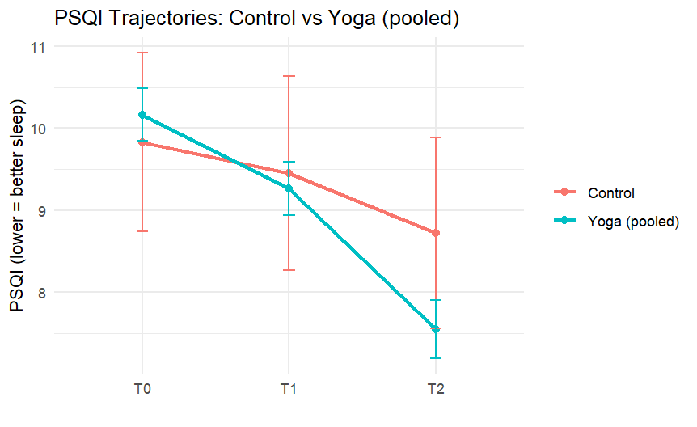
Figure 1 : PSQI trajectories by group
When examining specific yoga styles, all nine interventions led to significant improvements in sleep, but the greatest benefits were observed in Yoga Nidra and Restorative Yoga. These practices focus less on physical exertion and more on guided relaxation, mental stillness, and body awareness. Such qualities are particularly relevant for individuals whose sleep difficulties are maintained by heightened cognitive and emotional arousal at bedtime. By providing participants with structured opportunities to release mental tension and reduce hypervigilance, these relaxation-focused practices appear especially well-suited to enhancing sleep quality. While other more dynamic forms of yoga, such as Vinyasa and Ashtanga, were also beneficial, their effects may be more indirect, mediated through improved physical fitness and energy regulation rather than direct promotion of restfulness.

Reductions in Perceived Stress
In addition to sleep improvements, participants engaging in yoga alongside talk therapy reported reductions in perceived stress over the course of the intervention. Although the control group also demonstrated modest declines, the magnitude of improvement was greater in the yoga groups when examined through simple change scores. This pattern suggests that yoga contributed unique benefits to stress management beyond those achieved through therapeutic dialogue alone. The psychological mechanisms likely involve increased mindfulness, improved emotion regulation, and the development of coping strategies that are embodied rather than purely cognitive. Physiologically, yoga’s emphasis on slow breathing and controlled movement has been shown to modulate hypothalamic–pituitary–adrenal (HPA) axis activity and reduce circulating cortisol, thereby dampening the stress response.

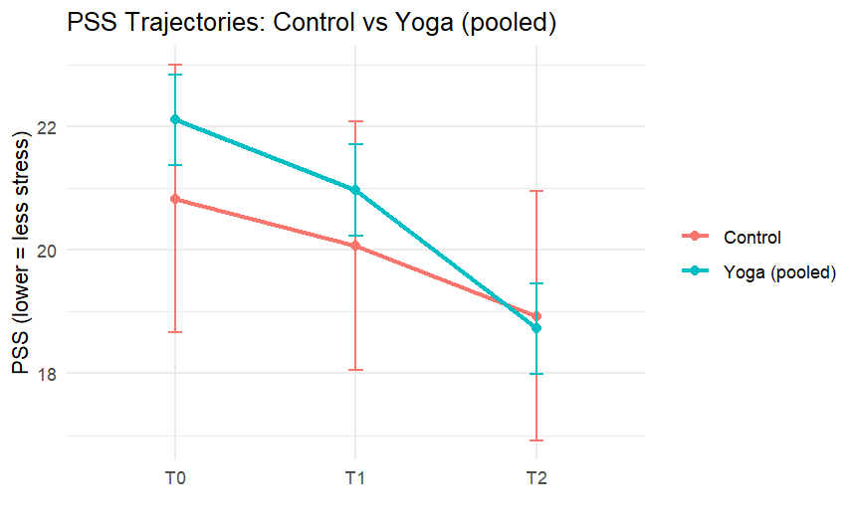
Figure 2: PSS trajectories by group
Interestingly, while all yoga groups reported lower stress at post-intervention, the most pronounced effects emerged in Yoga Nidra and Restorative Yoga. These practices emphasize guided relaxation, body scanning, and states of deep rest, which may directly target the somatic tension and cognitive load that underpin stress experiences. Participants in these groups likely benefited from structured opportunities to “switch off” the constant activation associated with modern stressors, in turn fostering greater resilience. The planned contrast comparing Nidra and Restorative against other forms of yoga supported this interpretation, suggesting that relaxation-centered practices may hold unique value for stress reduction. Nevertheless, dynamic practices also showed beneficial trends, indicating that improvements in physical activity, breathing patterns, and self-awareness can support stress regulation more broadly.

Control Group Improvements
Although the control group did not engage in yoga, participants who received talk therapy alone still demonstrated modest improvements in both sleep and stress outcomes. This finding highlights the therapeutic value of structured psychological support in addressing maladaptive thought patterns, emotional concerns, and daily stressors that can contribute to poor sleep. Talk therapy provides individuals with cognitive and behavioral tools to reinterpret stressors, reframe challenges, and develop healthier coping strategies. Even in the absence of physical practices like yoga, these psychological processes can reduce cognitive hyperarousal, which is a common barrier to sleep.

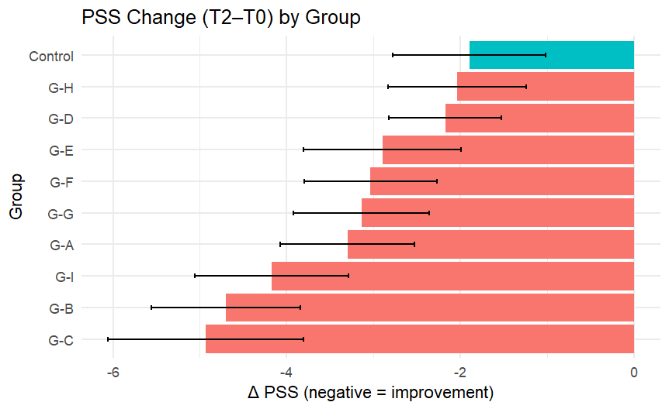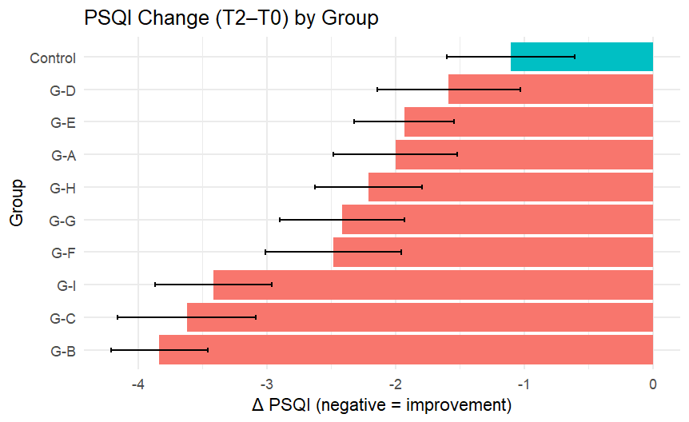
Figure 3: Change scores (T2–T0) in PSQI and PSS by group

However, the smaller effect sizes in the control group compared to the yoga groups suggest that therapy alone may not fully address the physiological and behavioral dimensions of sleep and stress regulation. Unlike yoga, talk therapy does not directly influence autonomic balance or somatic relaxation. For individuals who struggle with physical restlessness or embodied stress responses, these dimensions may be critical to achieving more meaningful improvements. The control group’s modest gains, therefore, provide an important benchmark: while conventional therapeutic interventions are beneficial, combining them with embodied practices such as yoga can yield broader and more sustained improvements. This underlines the potential for integrative approaches that unite psychological, behavioral, and physiological strategies to address complex, cyclical concerns like poor sleep and chronic stress.
Comparative Insights Across Yoga Styles
A central strength of this study was its inclusion of nine distinct yoga practices, allowing for detailed comparisons between relaxation-focused and more dynamic traditions. While all styles demonstrated improvements in both sleep and stress outcomes, Yoga Nidra and Restorative Yoga consistently produced the largest gains. These practices share a strong emphasis on deep relaxation, minimal physical exertion, and guided techniques for disengaging from cognitive and emotional overactivation. For participants whose sleep difficulties were sustained by intrusive thoughts or persistent physiological arousal, these approaches may have been particularly effective in interrupting the cycle of stress and poor sleep. The improvements observed here resonate with the theory that hyperarousal is a primary mechanism of insomnia-like symptoms, and that interventions which directly cultivate parasympathetic dominance are especially beneficial.
By contrast, more physically demanding styles such as Vinyasa, Ashtanga, and Bikram may contribute to improvements through different pathways. Their benefits likely stem from enhancing physical fitness, regulating circadian rhythms, and providing an outlet for energy expenditure. Although their effects were somewhat smaller compared to Nidra and Restorative, these dynamic practices still showed meaningful reductions in PSQI and PSS scores, highlighting yoga’s versatility as a therapeutic tool. Importantly, the diversity of practices ensures that individuals can find a modality suited to their preferences and physical capacities, which may in turn promote long-term adherence. The comparative findings therefore support the value of tailoring yoga interventions, rather than prescribing a single uniform practice.
Broader Implications and Integration into Practice
The overall pattern of findings highlights the promise of yoga as a complementary intervention to talk therapy for improving sleep and reducing stress. Beyond statistical outcomes, these results underline the value of addressing both the psychological and physiological aspects of wellbeing simultaneously. Talk therapy supports cognitive reframing and emotional processing, while yoga directly cultivates bodily relaxation, mindful awareness, and autonomic balance. Together, these approaches create a holistic treatment model that may be more effective than either modality alone. The diversity of yoga styles also strengthens the clinical relevance of this study, as it demonstrates that individuals with varying preferences and capacities can benefit, whether through gentle relaxation practices or more physically active modalities.
From a public health perspective, the findings point to accessible, low-cost, and non-pharmacological strategies for populations experiencing poor sleep and high stress. Given the adverse effects of sleep disturbances on mental health, productivity, and quality of life, scalable interventions that combine talk therapy with yoga could help alleviate burdens at both individual and societal levels. The improvements observed in this study also carry implications for preventive health: by promoting better sleep and stress regulation, integrative programs may reduce long-term risks associated with chronic stress, including cardiovascular disease, anxiety disorders, and depression. Future research can build on these insights by testing adherence factors, assessing long-term sustainability, and exploring digital or community-based delivery models to broaden access.

DISCUSSION
The co-occurrence of poor sleep quality and elevated stress levels observed at baseline aligns with prior findings that stress, and sleep disturbances share a bidirectional relationship. Stress exposure heightens cognitive arousal and sympathetic activity, which prolongs sleep onset latency and reduces sleep efficiency (Halpern et al., 2014). Conversely, inadequate or fragmented sleep exacerbates stress reactivity, creating a vicious cycle of impairment (Woodyard, 2011). The inclusion of participants with poor sleep but not necessarily clinical insomnia broadens the ecological validity of this study, as it mirrors real-world populations where subclinical disturbances are common but still clinically relevant. Prior work has highlighted yoga’s potential as a non-pharmacological intervention that addresses both dimensions by simultaneously targeting hyperarousal and maladaptive stress responses (Panjwani et al., 2021). The current findings, therefore, are consistent with and extend existing literature, suggesting that baseline vulnerability can be meaningfully addressed through integrative mind–body practices.
Consistent with earlier studies, participants who engaged in yoga alongside talk therapy showed greater improvements in sleep quality than those receiving therapy alone. Halpern et al. (2014) demonstrated that yoga-based interventions significantly improved sleep parameters in patients with chronic sleep complaints, particularly when paired with supportive counseling. Similarly, a review by Woodyard (2011) emphasized that yoga promotes parasympathetic dominance through relaxation techniques, thereby improving sleep onset and maintenance. In the present study, Yoga Nidra and Restorative Yoga demonstrated the strongest effects, corroborating earlier findings that relaxation-based yoga styles are particularly effective for reducing cognitive hyperarousal at bedtime (Panjwani et al., 2021). Importantly, these results also align with the broader literature on behavioral sleep medicine, which has increasingly emphasized the value of interventions that extend beyond cognitive restructuring to include somatic and physiological regulation. By integrating therapy with yoga, participants benefited from both cognitive and embodied strategies, reinforcing evidence that multimodal approaches may produce superior outcomes compared to standalone therapies.
Yoga interventions also led to meaningful reductions in perceived stress, though results varied across analytic approaches. These findings are in line with prior work demonstrating yoga’s ability to down-regulate stress pathways via modulation of the hypothalamic–pituitary–adrenal (HPA) axis (Woodyard, 2011). Halpern et al. (2014) further found that yoga improves emotional regulation and reduces perceived stress in individuals with high baseline tension, which mirrors the current sample. The strongest stress-reducing effects in this study were observed in Nidra and Restorative Yoga, practices that emphasize guided relaxation and body awareness. Panjwani et al. (2021) similarly noted that Yoga Nidra supports reductions in both physiological arousal and subjective stress by cultivating states of conscious relaxation. Taken together, these results reinforce the notion that yoga not only complements cognitive therapies but also directly targets the physiological substrates of stress. Although mixed-effects models did not confirm group-level differences at T2, the planned contrasts strengthen the argument that relaxation-oriented yoga has a unique role in stress reduction compared to more dynamic practices.
The inclusion of diverse yoga styles allowed this study to contribute comparative insights that are relatively scarce in the literature. Previous work has often examined yoga as a monolithic intervention, without distinguishing between practices emphasizing physical exertion versus deep relaxation. By contrast, the present findings align with Panjwani et al. (2021), who argued that style-specific effects are important to consider when tailoring interventions. Yoga Nidra and Restorative Yoga appeared especially effective, consistent with their emphasis on reducing hypervigilance and promoting parasympathetic activity. However, dynamic styles such as Vinyasa and Ashtanga also demonstrated benefits, echoing Woodyard’s (2011) observation that yoga improves health both through physical conditioning and psychophysiological regulation. This diversity suggests that yoga is not a “one size fits all” intervention, but rather a versatile toolkit where different modalities may suit different patient needs. Such findings advance the field by moving beyond the question of whether yoga “works” to clarifying which forms of yoga may be best suited to particular clinical profiles.
The modest improvements observed in the control group underline the established efficacy of talk therapy in reducing stress and improving sleep hygiene. Cognitive and behavioral therapies provide individuals with strategies to manage intrusive thoughts and stressors, which in turn reduce hyperarousal (Halpern et al., 2014). However, the current results suggest that therapy alone may not fully address embodied components of sleep disturbance, such as somatic tension or autonomic imbalance. Integrating yoga with therapy therefore appears to provide a more holistic intervention, consistent with Woodyard’s (2011) recommendation for combining mind–body approaches with conventional psychological support. This integrated model not only enhances treatment efficacy but may also increase accessibility, given yoga’s adaptability for different age groups and health statuses. By bridging the gap between psychological and physiological domains, integrative approaches represent a promising direction for non-pharmacological management of stress and sleep disturbances.
The findings of this study contribute to a growing body of evidence supporting yoga as a complementary therapy for stress and sleep-related difficulties. From a public health perspective, scalable and low-cost interventions are urgently needed to address rising rates of stress-related disorders and sleep complaints (Woodyard, 2011). The current results extend previous findings by demonstrating that yoga can be successfully combined with talk therapy, producing greater benefits than either modality alone. At the same time, the data suggest that specific yoga styles, particularly Nidra and Restorative, may be prioritized when relaxation and stress regulation are primary therapeutic goals. Future research should investigate adherence, long-term outcomes, and delivery models such as community programs or tele-yoga, which could extend the reach of these interventions. As Panjwani et al. (2021) note, yoga is both adaptable and culturally rooted, making it a particularly promising tool in diverse populations. Overall, the study reinforces the case for integrative, multimodal interventions as sustainable alternatives to pharmacological treatments for stress and sleep disturbances.

CONCLUSION
This study set out to evaluate the effects of combining yoga with talk therapy on sleep quality and stress regulation. Overall, the findings supported the majority of the proposed hypotheses. Participants receiving yoga in addition to talk therapy demonstrated greater improvements in sleep quality than those in the control group (H1), with all yoga styles producing benefits and Yoga Nidra and Restorative Yoga showing the largest improvements (H2). Yoga participants also reported greater reductions in stress compared to controls, though results varied across analytic approaches, partially supporting H3. When specific yoga styles were compared, Nidra and Restorative again emerged as the most effective in reducing stress, confirming H4. The control group, while showing modest improvements in both sleep and stress, improved less than yoga groups, in line with H5.
Taken together, these results highlight yoga as an effective complementary practice to talk therapy, particularly when relaxation-oriented modalities are employed. By demonstrating improvements across both psychological and physiological dimensions, the study reinforces the value of integrative approaches in addressing stress-related sleep disturbances. Future work should further explore adherence, long-term outcomes, and implementation strategies to maximize the reach of such interventions. In conclusion, the integration of yoga with talk therapy offers a promising, non-pharmacological pathway to improving both sleep quality and psychological wellbeing.

References
American Academy of Sleep Medicine. (2014). International classification of sleep disorders (3rd ed.). Darien, IL: American Academy of Sleep Medicine.
Andrillon, T. (2023). How we sleep: From brain states to processes. Revue Neurologique.
Ashrafi, H., Ansarin, K., Hasanzadeh, M., & Jouyban, A. (2018). Review on sleep disorders and their management. Medical Journal of Tabriz University of Medical Sciences, 40(2), 95-105.
Assefa, S. Z., Diaz-Abad, M., Wickwire, E. M., & Scharf, S. M. (2015). The Functions of Sleep. Aims Neuroscience, 2(3).
Becker, S. P., Sidol, C. A., Van Dyk, T. R., Epstein, J. N., & Beebe, D. W. (2017). Predicting insomnia from pre-sleep arousal and sleep behaviors in adolescents. Sleep Medicine, 32, 135-142. https://doi.org/10.1016/j.sleep.2016.10.020
Bercovitz, I. N., Woodard, K., & Daniel, L. C. (2023). Sleep and sleep health. In Encyclopedia of Mental Health, Third Edition: Volume 1-3 (pp. V3-251). Elsevier.
Chokroverty, S. (2010). Overview of sleep & sleep disorders. Indian Journal of Medical Research, 131(2), 126-140.
Espie, C. A., Broomfield, N. M., MacMahon, K. M., Macphee, L. M., & Taylor, L. M. (2006). The attention–intention–effort pathway in the development of psychophysiologic insomnia: A theoretical review. Sleep Medicine Reviews, 10(4), 215-245. https://doi.org/10.1016/j.smrv.2006.03.002
Ferrara, M., & De Gennaro, L. (2001). How much sleep do we need?. Sleep medicine reviews, 5(2), 155-179.
Guastella, A. J., & Moulds, M. L. (2007). The impact of rumination on sleep quality following a stressful life event. Personality and Individual Differences, 42(6), 1151-1162. https://doi.org/10.1016/j.paid.2006.04.028
Halpern, J., Cohen, M., Kennedy, G., Reece, J., Cahan, C., & Baharav, A. (2014). Yoga for improving sleep quality and quality of life for older adults. Altern Ther Health Med, 20(3), 37-46.
Harvey, A. G. (2002). A cognitive model of insomnia. Behaviour Research and Therapy, 40(8), 869-893. https://doi.org/10.1016/S0005-7967(01)00061-4
Medic, G., Wille, M., & Hemels, M. E. H. (2017). Short- and long-term health consequences of sleep disruption. Nature and Science of Sleep, 9, 151-161. https://doi.org/10.2147/NSS.S134864
Meerlo, P., Sgoifo, A., & Suchecki, D. (2008). Restricted and disrupted sleep: Effects on autonomic function, neuroendocrine stress systems, and stress responsivity. Sleep Medicine Reviews, 12(3), 197-210. https://doi.org/10.1016/j.smrv.2007.07.007
Morin, C. M., Bootzin, R. R., Buysse, D. J., Edinger, J. D., Espie, C. A., & Lichstein, K. L. (2006). Psychological and behavioral treatment of insomnia: Update of the recent evidence (1998–2004). Sleep, 29(11), 1398-1414. https://doi.org/10.1093/sleep/29.11.1398
Nayak, N. N., & Shankar, K. (2004). Yoga: a therapeutic approach. Physical Medicine and Rehabilitation Clinics, 15(4), 783-798.
Panjwani, U., Dudani, S., & Wadhwa, M. (2021). Sleep, cognition, and yoga. International journal of yoga, 14(2), 100-108.
Paruthi, S., Brooks, L. J., D'Ambrosio, C., Hall, W. A., Kotagal, S., Lloyd, R. M., ... & Wise, M. S. (2016). Recommended amount of sleep for pediatric populations: a consensus statement of the American Academy of Sleep Medicine. Journal of clinical sleep medicine, 12(6), 785-786.
Riemann, D., Spiegelhalder, K., Espie, C., Pollmächer, T., Léger, D., Bassetti, C., & Van Someren, E. (2010). Chronic insomnia: Clinical and research challenges—An agenda. Journal of Sleep Research, 20(4), 487-496. https://doi.org/10.1111/j.1365-2869.2010.00974.x
Sejnowski, T. J., & Destexhe, A. (2000). Why do we sleep?. Brain research, 886(1-2), 208-223.
Taneja, D. K. (2014). Yoga and health. Indian Journal of Community Medicine, 39(2), 68-72.
Wang, Y., Mei, H., Jiang, Y. R., Sun, W. Q., Song, Y. J., Liu, S. J., & Jiang, F. (2015). Relationship between duration of sleep and hypertension in adults: a meta-analysis. Journal of Clinical Sleep Medicine, 11(9), 1047-1056.
Woodyard, C. (2011). Exploring the therapeutic effects of yoga and its ability to increase quality of life. International journal of yoga, 4(2), 49-54.
Yardley, J. M., Burgess, H. J., & Reutrakul, S. (2016). Managing circadian rhythm disruption in shift workers with diabetes. Current Diabetes Reports, 16(11), 107. https://doi.org/10.1007/s11892-016-0808-3
Datta, K., Bhutambare, A., & Mallick, H. N. (2023). Systematic Review of Prevalence of Sleep Problems in India: A Wake-up Call for Promotion of Sleep Health. medRxiv, 2023-12.
Singhania, M., Sheereen, F.J., Ali, T. et al. Prevalence and characterization of sleep quality and insomnia in security guards working on the day and night shift in Delhi-NCR. Sleep Breath (2024). https://doi.org/10.1007/s11325-024-03153-7

