REIMAGINING MACRO SOCIAL WORK EDUCATION: THE COMMUNITY PRACTICE INNOVATION FRAMEWORK (CPIF) AS A PRACTICE-INFORMED CURRICULUM INNOVATION FRAMEWORK

Abstract
Higher education increasingly requires graduates to demonstrate innovation capability, interdisciplinary collaboration, and socially responsive practice alongside disciplinary competence. Within macro social work education, authentic community engagement has long been recognised as a cornerstone of professional learning through community profiling, mapping, needs assessment, programme planning, implementation, and evaluation. However, macro social work curricula continue to emphasise community assessment as the primary educational outcome, with limited attention devoted to transforming authentic community learning into innovation competency. This paper presents the Community Practice Innovation Framework (CPIF), a practice-informed curriculum innovation framework developed through reflective teaching practice and informed by authentic learning, experiential learning, innovation pedagogy, reflective practice, interdisciplinary learning, and competency-based education. Rather than introducing innovation as an isolated classroom activity, CPIF positions innovation as a curriculum outcome that emerges systematically from authentic community practice. CPIF consists of three interconnected curriculum domains: Authentic Community Inquiry, Innovation Co-creation, and Professional Transformation. The framework is illustrated through the development of Hands of Hope, a student-led educational board game created following authentic macro social work practice. CPIF contributes to contemporary social work education by extending the educational purpose of macro practice beyond community assessment towards innovation-oriented professional learning, aligning with the aspirations of the Malaysian Qualifications Framework (MQF 2.0).

Keywords: Macro social work education; curriculum innovation, authentic community practice, innovation pedagogy and competency-based education

INTRODUCTION

  - Reimagining Higher Education for Future-ready Graduates
Higher education is experiencing a significant paradigm shift as universities respond to increasingly complex social, economic, technological, and environmental challenges (Kolb, 2015; Malaysian Qualifications Agency, 2017). Contemporary graduates are expected to demonstrate not only disciplinary expertise but also critical thinking, collaboration, ethical reasoning, adaptability, digital literacy, and innovation (Council on Social Work Education, 2022; Kolb & Kolb, 2017). These expectations reflect a broader transition from knowledge transmission towards competency-based education, where learning is evaluated by graduates' ability to apply knowledge meaningfully within authentic professional contexts.

For social work education, these expectations are particularly significant. Contemporary social workers operate within dynamic environments characterised by demographic transitions, social inequalities, population ageing, mental health concerns, migration, environmental vulnerability, and rapid technological change. Addressing these complex issues requires professionals who can integrate evidence-informed practice with innovation, collaborative leadership, and community responsiveness (Herrington et al., 2014). Therefore, higher education institutions must reconsider how macro social work curricula prepare graduates for professional practice within this evolving landscape.
1.2 The Evolving Role of Macro Social Work Education

Macro social work education has traditionally played a central role in preparing future social workers to understand and respond to complex social problems at the community, organisational, and policy levels (Weil, 2013; Netting et al., 2017). Unlike micro practice, which focuses on individuals and families, macro practice emphasises community development, organisational change, policy advocacy, social planning, and collective action aimed at improving community wellbeing. Consequently, macro social work education has consistently incorporated authentic field-based learning experiences that enable students to apply theoretical knowledge within real community contexts (Herrington & Herrington, 2005; Herrington et al., 2014).
`Within many undergraduate programmes, macro practice includes community entry, profiling, mapping, stakeholder consultation, needs assessment, programme planning, implementation, and evaluation. These activities develop contextual understanding, ethical decision-making, communication skills, collaborative practice, and evidence-informed planning. However, the expectations placed upon contemporary social workers have expanded considerably. In addition to delivering interventions, social workers are increasingly expected to develop innovative community programmes, educational resources, psychosocial intervention tools, digital support systems, and technology-enabled services (Rietzschel & Reiter-Palmon, 2022). Despite these changing expectations, the educational structure of macro social work practice has remained relatively stable, with community profiling, mapping, and needs assessment often culminating in written reports or programme proposals, with limited emphasis on extending authentic learning towards innovation development.

1.3 The Pedagogical Challenge

Although authentic community practice remains one of the defining strengths of macro social work education, an important pedagogical challenge persists (Schön, 1983; Kolb, 2015). Existing curricula have been highly successful in preparing students to investigate community conditions, identify social issues, map community assets, and design intervention programmes. Nevertheless, these learning experiences frequently conclude once programme implementation and evaluation have been completed, creating an educational paradox where rich contextual understanding remains confined to assessment reports. Students generate extensive knowledge through profiling, mapping, stakeholder consultation, and needs assessment, yet much of this knowledge remains confined to academic assignments. The educational system therefore succeeds in developing competent practitioners while simultaneously underutilising the innovation potential embedded within authentic community experiences.From a curriculum perspective, the challenge is not the absence of authentic learning but the absence of a pedagogical mechanism that systematically connects authentic community practice with innovation development (Schön, 1987). Innovation is frequently introduced through independent classroom projects or isolated entrepreneurship activities disconnected from students' field experiences. As a result, innovation may be perceived as an additional academic requirement rather than a natural extension of professional social work practice.
Despite the growing emphasis on authentic learning, community engagement, and competency-based education within higher education (Herrington et al., 2014), an important gap remains in the pedagogical literature relating to macro social work education. Existing scholarship has demonstrated the educational value of community-based learning in strengthening competencies in community assessment, stakeholder engagement, programme planning, and reflective practice (Council on Social Work Education, 2022). Similarly, innovation pedagogy has received increasing attention across disciplines such as engineering, business, medicine, and teacher education (Rietzschel & Reiter-Palmon, 2022). However, these two streams of scholarship have largely developed in parallel. Consequently, limited attention has been devoted to explaining how community-generated knowledge can be systematically transformed into innovation through curriculum design.

The literature reveals three important gaps. First, existing macro social work education provides limited conceptual guidance regarding how authentic community practice can be extended beyond community assessment towards innovation-oriented learning. Second, current educational frameworks generally explain isolated aspects of professional learning rather than providing an integrated curriculum architecture. Authentic Learning emphasises meaningful engagement with real-world contexts, Experiential Learning explains learning through experience and reflection, Innovation Pedagogy focuses on innovation competency, and Competency-Based Education emphasises graduate outcomes. While each perspective offers valuable insights, none explicitly demonstrates how these educational principles may be systematically integrated within macro social work education to support innovation competency development. Third, increasing policy emphasis on graduate employability, innovation, and lifelong learning, as reflected in the Malaysian Qualifications Framework (MQF 2.0), requires curriculum models that operationalise these aspirations within authentic professional learning environments (Malaysian Qualifications Agency, 2017). Although MQF 2.0 identifies the competencies expected of graduates, it does not prescribe the pedagogical architecture through which these competencies should be developed within macro social work education.

1.4 Research Gap
In response to the identified pedagogical gap, this paper presents the Community Practice Innovation Framework (CPIF) as a practice-informed curriculum innovation framework for macro social work education. The framework was developed through reflective teaching practice and informed by a critical synthesis of contemporary educational scholarship, including authentic learning (Herrington & Herrington, 2005; Herrington et al., 2014), experiential learning (Kolb, 2015; Kolb & Kolb, 2017), innovation pedagogy (Rietzschel & Reiter-Palmon, 2022), reflective practice (Schön, 1983, 1987), interdisciplinary learning (World Health Organization, 2010), and competency-based education (Council on Social Work Education, 2022; Malaysian Qualifications Agency, 2017). Rather than replacing established approaches to macro social work practice, CPIF extends the educational value of authentic community engagement by positioning innovation as a curriculum outcome that emerges from systematic community inquiry. Specifically, the paper pursues four objectives: (1) to critically examine the pedagogical limitations of existing macro social work education in supporting innovation competency development; (2) to present CPIF as a practice-informed curriculum innovation framework; (3) to explain the theoretical foundations, curriculum architecture, and pedagogical principles underpinning CPIF; and (4) to illustrate the practical application of CPIF through an authentic macro social work learning experience involving student-led innovation.This paper contributes to the literature on social work education in several important ways. First, it presents CPIF as an integrated curriculum architecture that connects authentic community inquiry, innovation co-creation, and professional transformation. Second, it extends current understandings of authentic community practice by repositioning community engagement as the educational mechanism through which innovation is generated. Third, it demonstrates how curriculum innovation may be operationalised without fundamentally restructuring existing macro social work programmes. Finally, it contributes to competency-based higher education by illustrating how curriculum architecture may support the aspirations of MQF 2.0.

LITERATURE REVIEW

2.1 Macro Social Work Education and Authentic Community Practice
Macro social work pedagogy has long been acknowledged as an indispensable constituent of professional social work programmes, given its role in preparing students to comprehend and respond to complex social phenomena manifesting at the community, organisational, and policy tiers (Weil, 2013; Netting et al., 2017). Macro practice foregrounds collective action, community empowerment, organisational advancement, social strategising, policy advocacy, and sustainable community transformation. Consequently, macro social work education has consistently woven authentic community engagement into its fabric as a principal strategy for nurturing professional competence (Herrington et al., 2014). Authentic learning has emerged as one of the most influential pedagogical approaches within professional education, as it empowers students to construct knowledge through meaningful immersion in real-world situations rather than through decontextualised classroom exercises (Herrington & Herrington, 2005; Herrington et al., 2014). In social work pedagogy, authentic learning is most commonly actualised through community practice, wherein students collaborate directly with communities, organisations, and diverse stakeholders to comprehend and address genuine social problems (Weil, 2013). Unlike simulated learning environments, authentic community practice exposes students to the intricacy, indeterminacy, and heterogeneity that typify professional social work. Students confront competing community priorities, constrained resources, ethical quandaries, and manifold stakeholder perspectives that demand meticulous analysis and professional judgement.
Community profiling and community mapping rank among the most entrenched learning activities within macro social work pedagogy (Weil, 2013; Netting et al., 2017). They empower students to methodically investigate community attributes, demographic trajectories, social structures, institutional resources, cultural practices, environmental conditions, and community priorities. Through these endeavours, students acquire a holistic understanding of the contexts within which professional interventions are strategised and executed. Pedagogically, these activities fortify analytical reasoning, communication, cooperative inquiry, and evidence-informed decision-making (Gibbs & Gambrill, 2002; Lwin & Beltrano, 2022). However, within numerous macro social work curricula, the pedagogical function of community profiling and community mapping remains largely circumscribed to assessment. Students are typically expected to harness community findings for needs appraisal and programme design, following which the learning trajectory advances directly to intervention execution and evaluation. Whilst this sequence effectively nurtures professional assessment competencies, it affords comparatively meagre opportunities for students to reinterpret community knowledge as a wellspring of innovation. Consequently, authentic community inquiry harbours educational potential that remains substantially untapped.

2.2 Evidence-informed Learning and Innovation Pedagogy

Evidence-informed practice has become one of the defining hallmarks of contemporary professional education (Gibbs & Gambrill, 2002; Lwin & Beltrano, 2022). Across disciplines such as healthcare, education, psychology, and social work, graduates are expected to render professional decisions grounded in the synthesis of empirical evidence, professional expertise, contextual comprehension, and the perspectives of service users. Within social work pedagogy, evidence-informed learning transcends the mere application of research findings. Students are expected to cultivate the capacity to gather, interpret, and critically appraise multiple forms of evidence generated through genuine professional practice, encompassing community observations, stakeholder perspectives, demographic data, organisational intelligence, indigenous knowledge, and needs appraisals (Council on Social Work Education, 2022). However, within many prevailing curricula, evidence generated through authentic community practice primarily serves assessment and intervention strategising. Once these educational aims have been fulfilled, the learning process habitually concludes without probing how evidence may inform the development of inventive intervention resources. Consequently, evidence is customarily construed as a foundation for decision-making rather than as a catalyst for innovation. This constraint suggests that evidence-informed learning may be extended beyond professional judgement toward innovation-oriented curricular design.
Innovation has become an increasingly paramount educational objective within higher education, as universities strive to prepare graduates capable of addressing swiftly evolving professional and societal demands (Rietzschel & Reiter-Palmon, 2022; Seaborn & Fels, 2020). Within higher education, innovation pedagogy conceptualises inventiveness as a graduate competency that may be intentionally nurtured through curricular design rather than being treated as an innate personal attribute. Inventiveness develops through genuine problem-solving, cooperative inquiry, iterative design, critical reflection, and continuous refinement of ideas. Although innovation pedagogy has attracted considerable attention within engineering, commerce, medicine, and teacher preparation, its application within social work pedagogy remains comparatively circumscribed. This shifting professional landscape signals that innovation ought no longer to be regarded as an optional enrichment activity within social work education. Instead, it should become an intentional curricular outcome that complements, rather than supersedes, traditional professional competencies.

2.3 Interdisciplinary Learning and Competency-Based Education

Contemporary social problems are increasingly distinguished by complexity, necessitating cooperative responses that transcend the expertise of any solitary profession (World Health Organization, 2010; Adamson et al., 2020). Issues such as mental health, ageing, child safeguarding, disaster management, educational inequity, and community resilience demand cooperation among professionals hailing from diverse disciplinary backgrounds. Transdisciplinary learning diverges from multidisciplinary learning in that it underscores reciprocal knowledge exchange rather than parallel contributions from discrete disciplines. Students are encouraged to appreciate divergent modes of thinking, integrate complementary expertise, and formulate solutions that capitalise upon multiple professional perspectives whilst preserving the integrity of their own disciplinary knowledge. Within social work pedagogy, transdisciplinary learning has traditionally centred on collaboration with healthcare professionals, psychologists, educators, legal practitioners, and community organisations during field education. However, transdisciplinary learning may also unfold during curricular implementation through cooperative learning encounters involving students from disparate academic programmes. Such pedagogical partnerships create avenues for students to broaden their perspectives whilst acknowledging the complementary contributions of other disciplines. Rather than eroding disciplinary identity, transdisciplinary collaboration may bolster professional capability by exposing students to alternative approaches to communication, design, technology, and problem-solving.

Curricular innovation entails the systematic redesign of educational experiences to ensure that graduates develop competencies aligned with evolving professional expectations (Lodge & Ashford-Rowe, 2024). Unlike instructional innovation, which concentrates primarily on teaching methodologies, curricular innovation encompasses learning outcomes, learning encounters, assessment strategies, and graduate capability development. Recent developments in higher education have reinforced the significance of competence-driven education, wherein educational success is evaluated according to graduates' capacity to demonstrate integrated knowledge, practical skills, ethical reasoning, communication, leadership, cooperation, and lifelong learning (Council on Social Work Education, 2022; Malaysian Qualifications Agency, 2017). Within the Malaysian context, these aspirations are mirrored in the Malaysian Qualifications Framework (MQF 2.0), which advances learner-centred education, authentic assessment, flexibility, and holistic graduate development. The foregoing review demonstrates that contemporary scholarship has made substantial contributions to comprehending authentic learning, experiential learning, evidence-informed practice, innovation pedagogy, transdisciplinary education, and competence-driven curricular design. However, the literature also reveals that these educational perspectives have largely evolved independently. Although each perspective furnishes valuable insights, they rarely elucidate how authentic community practice may systematically become the pedagogical mechanism through which inventive competency is cultivated within macro social work education. This disconnection becomes progressively significant within contemporary higher education, where graduates are expected not merely to comprehend complex social issues but also to design inventive, evidence-informed, and socially responsive solutions. Accordingly, the literature suggests that macro social work education requires an integrated curricular framework capable of systematically connecting authentic community practice, transdisciplinary collaboration, reflective learning, and innovation development within a coherent educational architecture.

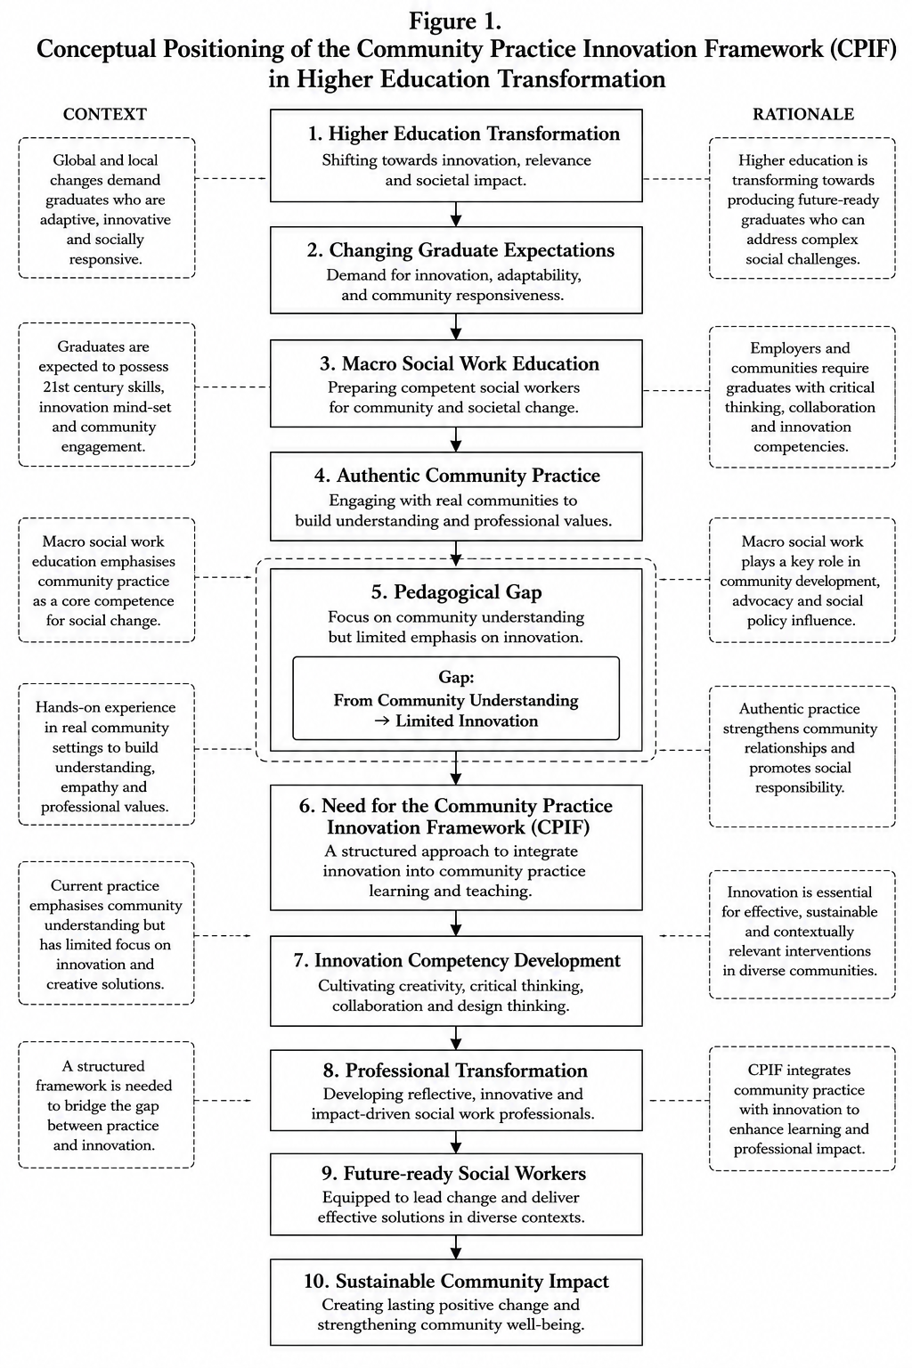
Figure 1. Conceptual Positioning of the Community Practice Innovation Framework
Higher Education Transformation

3. Development of the Community Practice Innovation Framework (CPIF)

3.1 Origins and Conceptual Foundations
The Community Practice Innovation Framework (CPIF) originated from sustained reflective teaching practice within undergraduate macro social work education rather than from the application of a single educational theory (Schön, 1983, 1987). The framework emerged through repeated observations of students' learning experiences during authentic macro social work practice and through critical reflection on how existing curriculum structures supported, and at times constrained, the development of innovation competency (Kolb, 2015; Schön, 1987).For several academic cycles, third-year undergraduate social work students participated in authentic macro social work practice involving collaboration with communities and community-based organisations. Students engaged in professional learning activities including community entry, profiling, mapping, stakeholder consultation, needs assessment, programme planning, intervention implementation, and programme evaluation. These activities consistently enabled students to demonstrate strong competencies in community assessment, collaborative practice, communication, and evidence-informed decision-making. However, reflective evaluation revealed a recurring educational pattern: while students demonstrated substantial capability in understanding community contexts and designing intervention programmes, learning frequently concluded once programme implementation and assessment had been completed. Opportunities for students to transform authentic community experiences into innovative professional resources remained comparatively limited.The development of CPIF was guided not by the assumption that macro social work education required fundamental curriculum reform but by the recognition that existing authentic learning experiences possessed unrealised educational potential (Herrington & Herrington, 2005). Traditional macro social work education successfully prepares students to investigate community issues, identify local strengths, analyse stakeholder relationships, and develop intervention plans (Kolb, 2015). Nevertheless, the curriculum sequence commonly concludes after programme implementation and evaluation, leaving limited opportunities for students to revisit authentic community findings as sources of innovation. From a curriculum perspective, the issue therefore lies not in what students learn, but in what happens after they learn it.
Following the identification of this pedagogical opportunity, the development of CPIF was informed by a critical synthesis of contemporary educational scholarship. Rather than adopting a single theoretical perspective, the framework integrates complementary educational concepts that collectively explain different dimensions of professional learning: authentic learning provides the pedagogical foundation by emphasising meaningful engagement with real-world contexts (Herrington & Herrington, 2005; Herrington et al., 2014); experiential learning explains how professional knowledge develops through experience, reflection, conceptualisation, and application (Kolb, 2015; Kolb & Kolb, 2017); reflective practice contributes an understanding of how learners construct professional judgement through critical reflection upon authentic experiences (Schön, 1983, 1987); innovation pedagogy provides principles for developing graduates capable of generating creative and socially responsive solutions (Rietzschel & Reiter-Palmon, 2022); interdisciplinary learning expands opportunities for collaborative knowledge construction by encouraging learners to engage with complementary disciplinary perspectives (World Health Organization, 2010; Adamson et al., 2020); and competency-based education ensures that curriculum design remains aligned with contemporary graduate expectations, including those articulated within MQF 2.0 (Malaysian Qualifications Agency, 2017; Council on Social Work Education, 2022).

3.2 Constructing the Curriculum Architecture
The development of CPIF did not involve replacing existing macro social work practice. Instead, the framework reorganises established learning experiences into a coherent pedagogical architecture comprising three interconnected layers. The first pedagogical layer, Authentic Community Practice, preserves the profession's established emphasis on community engagement, community inquiry, and evidence-informed understanding. The second pedagogical layer, Innovation Integration, extends authentic community learning through structured opportunities for interdisciplinary collaboration, reflective learning, innovation development, and authentic assessment. The final pedagogical layer, Professional Transformation, represents the educational outcomes of the curriculum through the development of innovation competency, professional identity, leadership, ethical reasoning, and graduate capabilities aligned with MQF 2.0. Collectively, these pedagogical layers explain how authentic community practice may progressively support innovation competency development without disrupting the existing structure of macro social work education.

To demonstrate the practical operation of CPIF, the framework was illustrated through an authentic learning experience involving undergraduate macro social work students. Following authentic community practice, students participated in an interdisciplinary educational workshop facilitated by undergraduate students from the Faculty of Education. The workshop introduced principles of educational game design and learner engagement, providing complementary expertise that expanded students' perspectives on educational innovation. Subsequently, one student group developed Hands of Hope, an educational board game informed by their community learning experiences. Within this paper, Hands of Hope serves exclusively as an illustrative pedagogical application of CPIF. It is presented to demonstrate how the proposed curriculum architecture may facilitate the transformation of authentic community practice into student-led innovation. The board game itself is not the primary contribution of the study; rather, it provides an example of how CPIF may be operationalised within macro social work education..

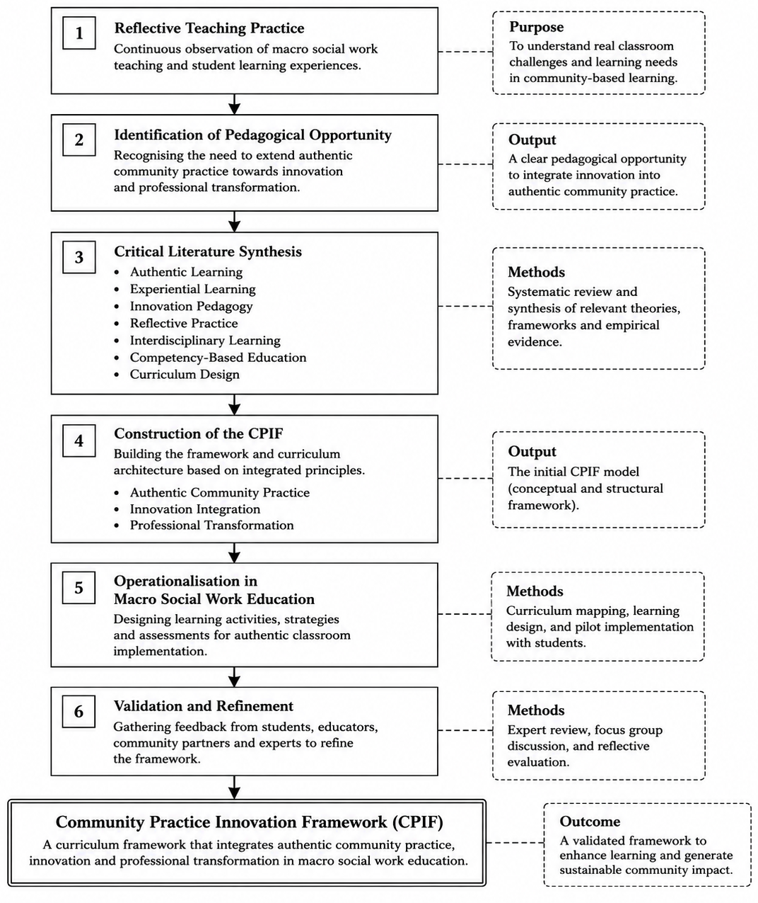
Figure 2. Development Process of CPIF

4. The Community Practice Innovation Framework (CPIF): A Curriculum Architecture for Macro Social Work Education

4.1 Conceptualising the Framework
The Community Practice Innovation Framework (CPIF) is presented as a curriculum architecture designed to explain how authentic community practice can systematically support innovation competency development within macro social work education. The framework emerged from reflective teaching practice and was informed by the synthesis of contemporary educational perspectives, including authentic learning, experiential learning, evidence-informed practice, innovation pedagogy, interdisciplinary learning, reflective practice, and competency-based education. Unlike educational approaches that introduce innovation as an additional classroom activity, CPIF conceptualises innovation as an educational consequence of authentic curriculum design. Innovation is therefore not treated as an isolated learning event, but as a capability that develops progressively through structured engagement with communities, critical interpretation of community knowledge, interdisciplinary collaboration, reflective learning, and authentic assessment.
The curriculum architecture of CPIF comprises three interconnected curriculum layers that collectively explain how authentic community learning progresses towards professional transformation. These curriculum layers are not intended to function as independent stages. Rather, they operate as an integrated educational system in which learning continuously evolves through authentic engagement, reflection, collaboration, and innovation. The first curriculum layer establishes the professional context of learning through authentic community practice. The second curriculum layer integrates innovation into the learning process by connecting community understanding with interdisciplinary collaboration, reflective learning, and creative problem-solving. The third curriculum layer represents the educational outcomes of the curriculum through the development of innovation competency, professional identity, leadership, and future-ready graduate attributes.

4.2 Curriculum Layer One: Authentic Community Practice
Authentic Community Practice forms the foundation of CPIF. Consistent with established macro social work education, students begin their learning journey through direct engagement with communities and community organisations (Weil, 2013; Netting et al., 2017). This curriculum layer includes activities such as community entry, community profiling, community mapping, stakeholder consultation, needs assessment, programme planning, intervention implementation, and programme evaluation. These activities enable students to develop contextual understanding while strengthening competencies in communication, ethical engagement, teamwork, critical inquiry, and evidence-informed decision-making.Importantly, CPIF reconceptualises these activities as more than professional assessment processes. Authentic community practice is positioned as the educational mechanism through which students generate the contextual understanding required for subsequent innovation. Community engagement therefore becomes the intellectual foundation of innovation rather than simply the setting in which learning occurs. By positioning authentic community practice as the first curriculum layer, CPIF preserves the professional identity of macro social work while simultaneously expanding its educational purpose.

4.3 Curriculum Layer Two: Innovation Integration
Innovation Integration represents the central contribution of CPIF (Rietzschel & Reiter-Palmon, 2022). This curriculum layer connects authentic community understanding with structured opportunities for innovation through reflective learning (Schön, 1987), interdisciplinary collaboration (World Health Organization, 2010), creative design, prototyping, and authentic assessment. Rather than introducing innovation independently of community practice, CPIF encourages students to revisit their community findings and critically interpret them as opportunities for innovation. Community needs, strengths, existing resources, and stakeholder perspectives become the basis upon which students design contextually relevant educational resources, intervention tools, digital applications, or community engagement strategies. Interdisciplinary collaboration further enriches this process by exposing students to complementary forms of expertise while preserving the integrity of disciplinary social work knowledge. Reflection supports students in evaluating the relevance, feasibility, ethical appropriateness, and sustainability of proposed innovations before implementation. Consequently, innovation becomes embedded within authentic curriculum processes rather than functioning as an isolated creative activity.

4.4 Curriculum Layer Three: Professional Transformation
Professional Transformation represents the educational outcome of CPIF (Malaysian Qualifications Agency, 2017; Council on Social Work Education, 2022). This curriculum layer extends beyond the production of innovative products by focusing on the formation of future-ready social workers capable of integrating knowledge, values, professional judgement, and innovation within authentic practice (Kolb & Kolb, 2017). Through repeated engagement with authentic community practice, innovation integration, and reflective learning, students gradually strengthen professional identity, innovation competency, collaborative leadership, ethical reasoning, adaptability, and lifelong learning. These capabilities align closely with the aspirations of competency-based higher education and the graduate attributes articulated within MQF 2.0. Importantly, professional transformation is conceptualised as an ongoing developmental process rather than a final stage of learning. Within CPIF, innovation therefore represents not the final destination of learning but one expression of broader professional growth.

4.5 Core Pedagogical Principles
The curriculum architecture is underpinned by five pedagogical principles that guide its implementation: (1) Authentic Community Engagement - learning begins through direct engagement with communities, recognising community members as partners in knowledge generation; (2) Evidence-informed Professional Learning - students integrate community knowledge, stakeholder perspectives, and professional judgement when designing interventions and innovations; (3) Innovation through Curriculum Integration - innovation develops through authentic curriculum experiences rather than isolated creativity exercises; (4) Interdisciplinary Collaboration - learning is strengthened through reciprocal engagement with students and professionals from complementary disciplines while maintaining disciplinary identity; and (5) Reflective Professional Growth - continuous reflection enables students to connect authentic experience, innovation, ethics, and professional identity throughout their learning journey. These principles collectively distinguish CPIF from approaches that separate community practice from innovation development.

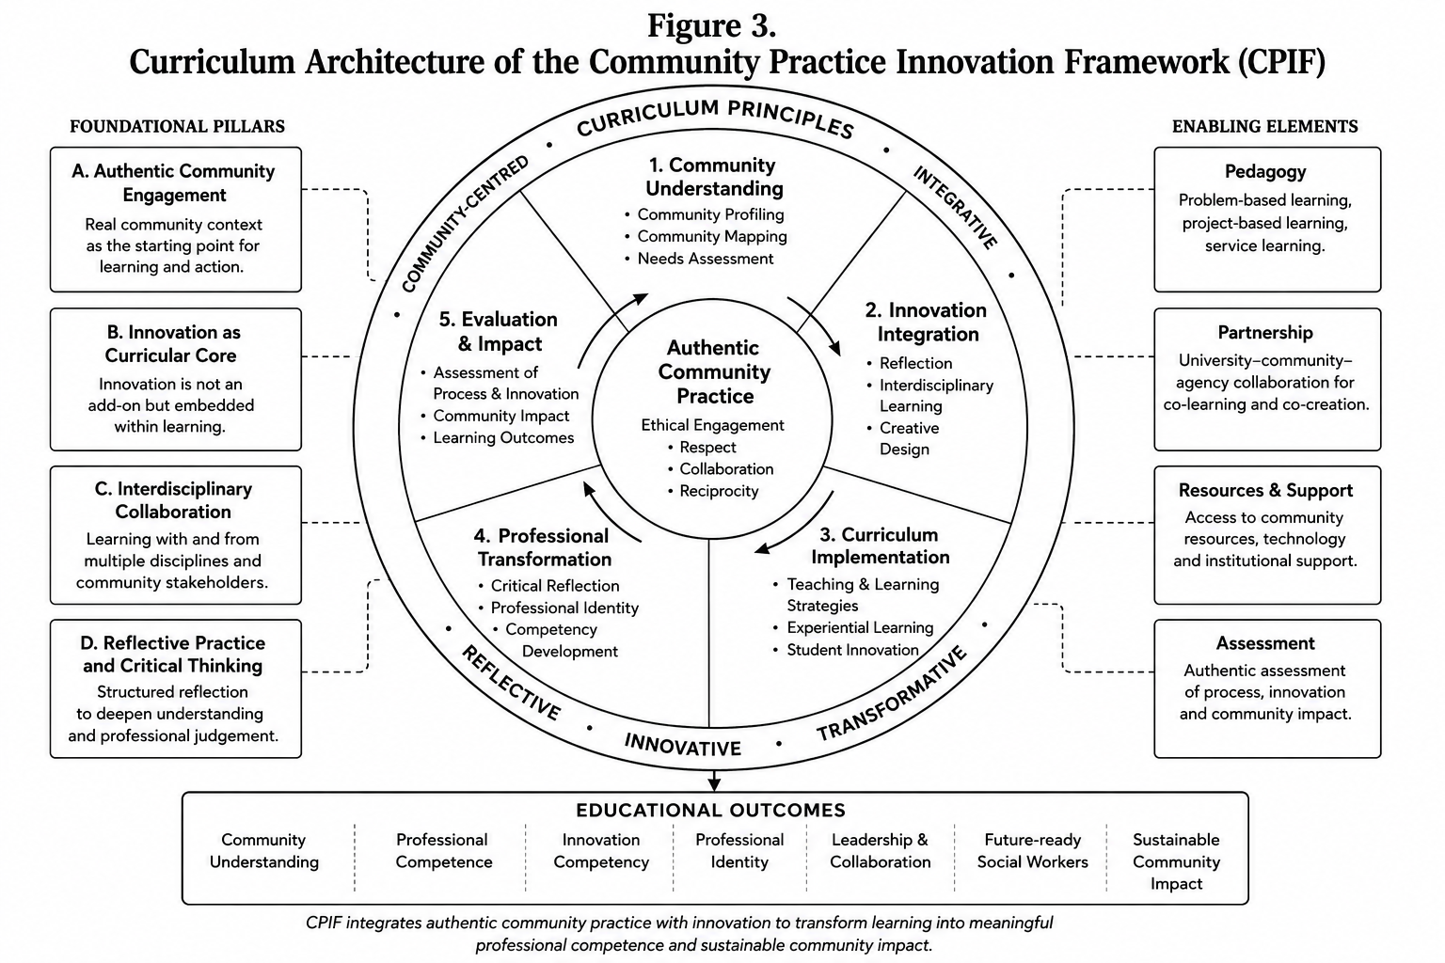
Figure 3. Curriculum Architecture of the Community Practice Innovation Framework (CPIF)

5. OPERATIONALISING THE COMMUNITY PRACTICE INNOVATION FRAMEWORK
5.1 Context and Implementation
To demonstrate how CPIF may be implemented within authentic macro social work education, this section presents its operationalisation in an undergraduate learning context (Weil, 2013; Netting et al., 2017). The implementation involved 69 third-year undergraduate social work students participating in authentic macro social work practice through collaboration with local communities and community organisations. Consistent with existing macro social work curricula, students undertook a sequence of professional learning activities, encompassing community entry, profiling, mapping, stakeholder consultation, needs appraisal, programme design, intervention execution, and programme evaluation. These activities constituted the bedrock of authentic community practice and remained unchanged throughout the implementation. Importantly, the purpose of this section is not to evaluate the efficacy of CPIF empirically. Rather, it demonstrates how the proposed curriculum architecture may be operationalised within authentic teaching practice.
The implementation of CPIF commenced with authentic community engagement, consistent with conventional macro social work education. Students worked cooperatively with community members and local organisations to develop a comprehensive understanding of community attributes, existing resources, local leadership, psychosocial issues, and community priorities. Community profiling enabled students to examine demographic attributes, socioeconomic conditions, available services, community strengths, and emerging social concerns. Community mapping complemented this process by identifying community assets, institutional networks, local organisations, and environmental resources. These learning activities generated rich contextual comprehension that informed subsequent programme design. More importantly, within CPIF, authentic community practice was intentionally positioned as the bedrock for innovation rather than solely as preparation for intervention strategising.
Following the completion of authentic community practice, students entered the second curriculum pillar of CPIF, wherein innovation became intentionally integrated into the learning process (Schön, 1987). Rather than concluding the curriculum with programme execution, students revisited their community findings through structured reflective discussion. To fortify inventive capability, students subsequently participated in a transdisciplinary workshop facilitated by undergraduate students from the Faculty of Education (World Health Organization, 2010). The workshop introduced principles of educational game design, learner engagement, instructional strategies, and creative resource development (Seaborn & Fels, 2020; Pérez Gallo, 2025). Importantly, the role of the Faculty of Education students was not to furnish professional social work knowledge. Instead, they contributed complementary expertise that expanded the innovation capability of social work students whilst preserving the disciplinary foundations of macro social work practice.
Following transdisciplinary collaboration, student groups independently transmuted authentic community findings into inventive professional resources (Rietzschel & Reiter-Palmon, 2022). One group developed Hands of Hope, an educational board game designed to facilitate psychosocial learning through cooperative gameplay and reflective discussion (Seaborn & Fels, 2020; Pérez Gallo, 2025). The board game incorporated community issues identified during authentic community practice and transmuted these findings into interactive learning activities that encouraged communication, teamwork, problem-solving, empathy, and psychosocial awareness. Within the context of CPIF, Hands of Hope represents an example of how authentic community practice may generate innovation when supported through structured curriculumintegration. Importantly, Hands of Hope should not be interpreted as the principal outcome of the framework. Distinct student cohorts working within different communities would be expected to produce different forms of innovation according to the unique needs, strengths, and priorities identified during authentic community engagement. Thus, the educational significance of CPIF lies in the curriculum process that facilitates innovation rather than in any individual innovation product.
The final curriculum pillar concentrated on professional metamorphosis through authentic assessment and critical reflection (Schön, 1987; Malaysian Qualifications Agency, 2017). Students presented their innovations to the course lecturer, who evaluated not merely the originality of the products but also the extent to which they were informed by authentic community practice (Council on Social Work Education, 2022). Assessment considered the relationship between community findings, innovation rationale, professional relevance, feasibility, ethical appropriateness, and anticipated community impact. Reflective activities further encouraged students to examine how their understanding of macro social work had evolved throughout the learning process. Rather than viewing innovation as an isolated academic exercise, students recognised innovation as an extension of professional responsibility grounded in authentic community engagement.
One of the defining characteristics of CPIF is its transferability across diverse educational contexts and community settings. The framework does not prescribe the type of innovation that students should develop. Instead, it provides a curriculum architecture through which authentic community practice informs innovation that is responsive to local contexts. Although Hands of Hope is presented as the illustrative innovation in this manuscript, other student cohorts may develop entirely different innovations depending on the communities with whom they engage. Communities experiencing mental health stigma may inspire psychoeducational board games or digital awareness campaigns. Rural communities may generate digital resource directories or community information systems. Work with older adults may lead to reminiscence toolkits or social participation programmes, whilst youth-focused projects may result in career readiness modules or peer-support initiatives. This flexibility demonstrates that CPIF is not a framework for producing a specific product; rather, it is a curriculum architecture that guides the educational process through which authentic community practice becomes the bedrock for innovation.

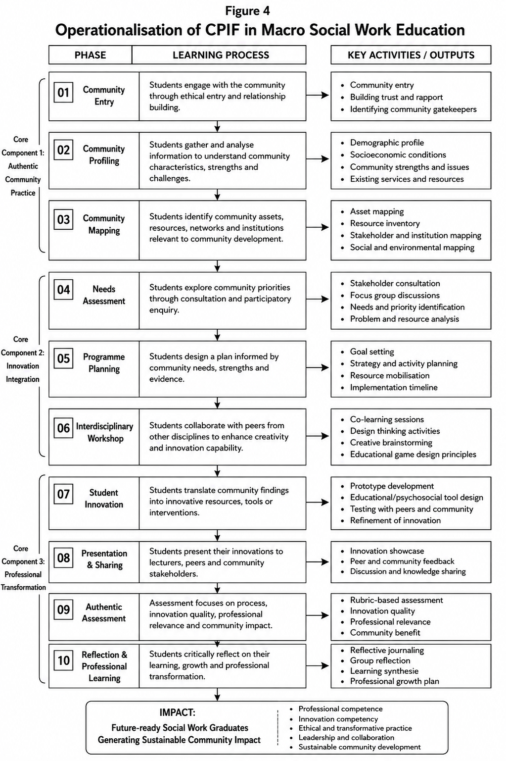
Figure 4 Operationalisation of CPIF in Macro Social Work Education

DISCUSSION
6.1 Reframing the Educational Purpose of Macro Social Work Practice
CPIF offers an alternative perspective on the educational purpose of macro social work practice (Weil, 2013; Herrington et al., 2014). Traditionally, authentic community engagement has been regarded as the context within which students develop competencies in community assessment, programme design, intervention execution, and evaluation (Netting et al., 2017). Whilst these competencies remain fundamental to professional education, CPIF argues that they represent merely a portion of the educational potential of macro social work practice (Rietzschel & Reiter-Palmon, 2022). The proposed curriculum architecture suggests that authentic community practice should additionally function as the educational bedrock for inventive competency development. Community profiling, community mapping, stakeholder consultation, and needs appraisal should thus not be viewed as the terminus of student learning but as the commencement of a broader curriculum process through which students develop the capability to generate contextually relevant and socially responsive innovations.
One of the principal contributions of CPIF is its reconceptualisation of authentic community practice as the bedrock of inventive competency (Herrington & Herrington, 2005; Kolb, 2015). Existing educational literature has consistently demonstrated that authentic learning enhances students' professional judgement, contextual comprehension, and reflective capability (Herrington et al., 2014). However, authentic lea curriculum process leading to innovation (Kolb, 2015). CPIF extends this perspective by suggesting that authentic community engagement possesses significant but underutilised educational potential (Schön, 1983). Community knowledge generated through profiling, mapping, stakeholder engagement, and needs appraisal furnishes students with rich contextual comprehension from which inventive solutions may emerge. Innovation thus becomes grounded in community realities rather than detached classroom creativity.
An important conceptual contribution of CPIF is the distinction between product-oriented innovation and curriculum-oriented innovation (Rietzschel & Reiter-Palmon, 2022; Lodge & Ashford-Rowe, 2024). Within higher education, innovation is frequently evaluated according to the products that students create. Whilst these products are valuable, they should not be regarded as the primary educational outcome. CPIF proposes that the principal educational outcome should be the development of students' capacity to generate innovation through authentic professional learning. Individual products, including educational board games such as Hands of Hope, represent merely one possible expression of this broader educational capability. This distinction explains why Hands of Hope is presented in this manuscript solely as an illustrative pedagogical application. The contribution of CPIF does not lie in producing a particular board game or intervention resource. Rather, it lies in providing a curriculum architecture capable of enabling future student cohorts to develop different innovations in response to different community contexts.
Another significant contribution of CPIF concerns the role of transdisciplinary learning within professional education (World Health Organization, 2010; Adamson et al., 2020). The illustrative implementation demonstrated that collaboration with undergraduate students from the Faculty of Education enriched the innovation capability of social work students without diminishing disciplinary identity. Importantly, transdisciplinary learning within CPIF is not intended to supplant disciplinary knowledge. Instead, it functions as curriculum enrichment that broadens students' professional thinking whilst maintaining the values, ethics, and practice principles of social work. This finding supports broader arguments that future-ready graduates require opportunities to learn across disciplinary boundaries whilst remaining grounded in their own professional identities.
CPIF also contributes to ongoing discussions concerning competence-driven curriculum design (Malaysian Qualifications Agency, 2017; Council on Social Work Education, 2022). Rather than treating graduate competencies as isolated learning outcomes, the framework demonstrates how competencies may emerge through the intentional integration of authentic learning experiences. Inventive competency, reflective practice, ethical reasoning, leadership, cooperation, and professional identity are developed not through discrete courses but through a coherent curriculum architecture embedded within authentic macro social work practice. This perspective aligns closely with the aspirations of MQF 2.0, which emphasises holistic graduate development, authentic assessment, learner-centred education, and lifelong learning. By integrating these principles into macro social work education, CPIF provides one possible curriculum pathway through which higher education institutions may operationalise competence-driven learning within authentic professional contexts. Furthermore, the framework may furnish useful insights for other professional disciplines that incorporate community engagement, including nursing, public health, teacher preparation, psychology, occupational therapy, and community development.
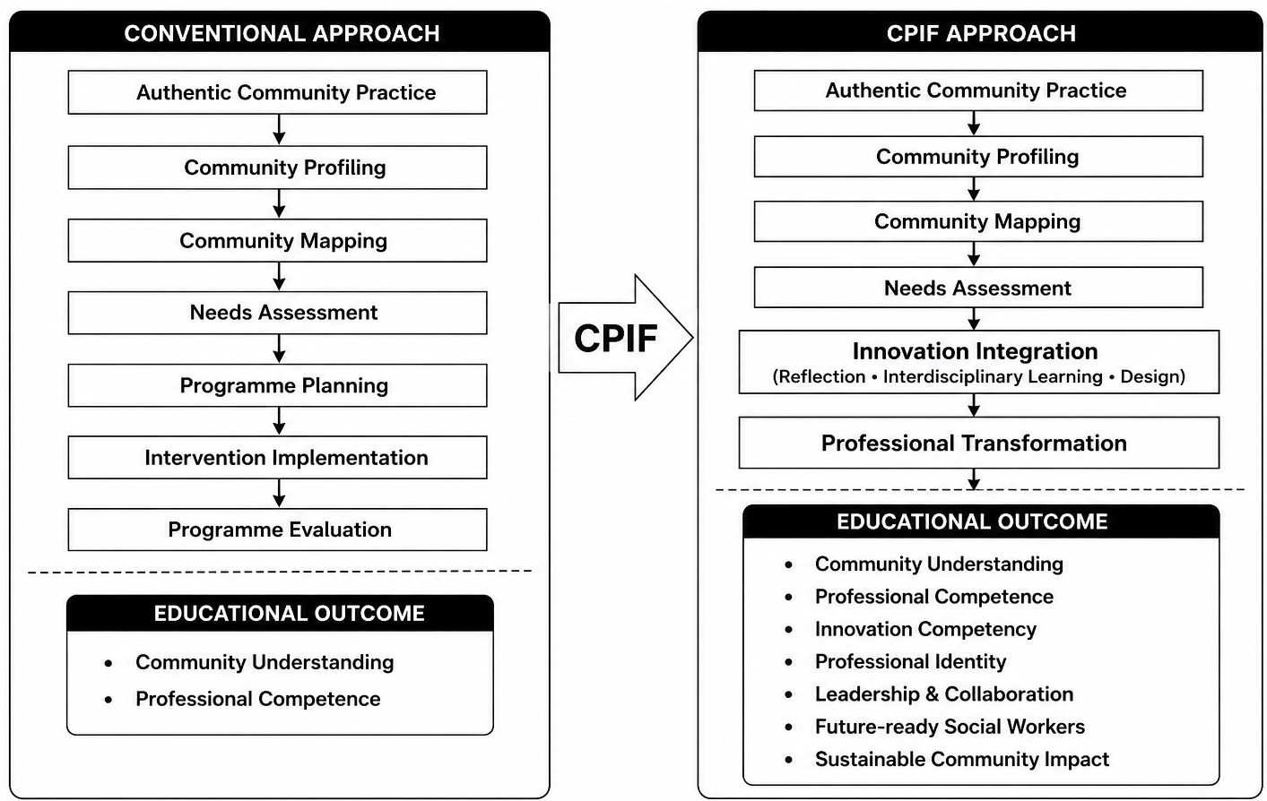
Figure 5 Theoretical Contribution of CPIF to Social Work Education

7. STRENGTHS, LIMITATIONS AND FUTURE DIRECTIONS
CPIF offers several important contributions to macro social work education. Primarily, the framework provides a coherent curriculum architecture that systematically integrates authentic community practice with inventive competency development (Herrington et al., 2014; Rietzschel & Reiter-Palmon, 2022). Rather than introducing innovation as an additional curriculum component, CPIF demonstrates how innovation may emerge organically through authentic community engagement, reflective learning, transdisciplinary collaboration, and competence-driven assessment. Secondarily, CPIF preserves the established strengths of macro social work education. Community profiling, community mapping, stakeholder consultation, needs appraisal, programme design, execution, and evaluation remain central learning experiences. The framework therefore does not require substantial curriculum restructuring. Instead, it extends the educational value of these existing activities by intentionally connecting them with innovation-oriented learning.
Tertiarily, the framework aligns closely with contemporary developments in competence-driven higher education. The curriculum architecture supports the development of graduate capabilities that extend beyond disciplinary knowledge, encompassing inventive competency, collaborative leadership, reflective practice, communication, ethical reasoning, and lifelong learning. These capabilities correspond closely with the graduate attributes articulated within MQF 2.0 (Malaysian Qualifications Agency, 2017). Finally, CPIF offers flexibility across diverse educational contexts. Because innovation is derived from authentic community comprehension rather than predetermined products, distinct student cohorts are expected to generate different forms of innovation according to local community priorities. This flexibility enhances the transferability of the framework whilst maintaining responsiveness to authentic community needs.
Several limitations should be acknowledged when interpreting the proposed framework. Primarily, CPIF is presented as a conceptual curriculum framework developed through reflective pedagogical praxis and theoretical synthesis (Schön, 1983). Although its development was informed by authentic curriculum implementation, the framework has not yet undergone comprehensive empirical validation (Kolb, 2015). Future research is therefore required to examine its efficacy across multiple educational settings. Secondarily, the illustrative pedagogical application presented in this manuscript was situated within a single undergraduate macro social work context involving one higher education institution. Consequently, the implementation described should be interpreted as an example of curriculum operationalisation rather than evidence of educational effectiveness. Broader implementation across different universities, cultural settings, and programme structures is required to establish the wider applicability of the framework. Tertiarily, transdisciplinary collaboration within the illustrative implementation involved undergraduate students from the Faculty of Education. Whilst this collaboration successfully enriched students' innovation capability, alternative transdisciplinary partnerships may produce different educational experiences depending on institutional contexts, available expertise, and curriculum arrangements. Finally, although Hands of Hope is presented as an example of student-led innovation, it should not be interpreted as evidence supporting the efficacy of CPIF. The board game serves solely to illustrate how authentic community practice may be translated into innovation through the proposed curriculum architecture.
The introduction of CPIF opens several opportunities for future scholarship within social work education and curriculum innovation. The priority is empirical evaluation (Council on Social Work Education, 2022). Future studies should investigate how the implementation of CPIF influences students' inventive competency, professional identity, reflective capability, and readiness for professional practice. Comparative studies involving multiple institutions would further fortify understanding of the framework's educational value across different contexts (Malaysian Qualifications Agency, 2017). Secondarily, future research should examine the transferability of CPIF beyond macro social work education. Professional programmes that incorporate authentic community engagement including nursing, public health, occupational therapy, teacher preparation, psychology, and community development may provide valuable contexts for exploring the adaptability of the curriculum architecture. Tertiarily, longitudinal studies are needed to determine whether graduates educated through CPIF demonstrate sustained inventive capability during professional practice. Such research would contribute to understanding the long-term influence of curriculum innovation on graduate employability, professional adaptability, and community impact. Finally, future scholarship may extend the conceptual framework by developing implementation guidelines, curriculum evaluation instruments, educator competency frameworks, and assessment rubrics that support wider adoption of CPIF across higher education institutions.

8. Conclusion
Higher education is increasingly expected to prepare graduates who can respond creatively and responsibly to complex societal challenges (Herrington et al., 2014; Kolb, 2015). Within macro social work education, authentic community practice has long served as the bedrock for developing professional competencies in community assessment, intervention strategizing, and cooperative practice (Schön, 1983, 1987). However, contemporary professional expectations require graduates who are also capable of transmuting authentic community comprehension into inventive and socially responsive solutions (Rietzschel & Reiter-Palmon, 2022).
This manuscript has presented the Community Practice Innovation Framework (CPIF) as a practice-informed curriculum architecture that elucidates how authentic community practice may systematically support inventive competency development within macro social work education (Malaysian Qualifications Agency, 2017; Council on Social Work Education, 2022). Drawing upon reflective pedagogical praxis and contemporary educational scholarship, the framework integrates authentic community engagement, transdisciplinary collaboration, reflective learning, innovation integration, and competence-driven education into a coherent curriculum structure.
The principal contribution of CPIF lies not in introducing innovation as an additional educational activity, but in repositioning authentic community practice as the bedrock from which inventive competency may be intentionally cultivated. Through this perspective, community profiling, community mapping, stakeholder consultation, and needs appraisal become more than assessment activities; they become pedagogical processes that enable students to generate contextually relevant innovations whilst fortifying professional identity and graduate capability. Although the framework is illustrated through the development of Hands of Hope, the significance of CPIF extends far beyond a single student innovation. The proposed curriculum architecture is transferable across different community contexts and possesses the potential to inform curriculum development within other professional disciplines that value authentic community engagement. Ultimately, CPIF advances a broader understanding of macro social work education by arguing that the success of authentic community practice should be measured not merely by students' ability to comprehend communities but also by their capacity to translate that comprehension into inventive professional responses capable of generating sustainable community impact.
REFERENCE
- Adamson, K., Ashcroft, T., Brough, M., Brown, L., Davies, C., Doel, M., Douglas, F., Eby, M., Gell, L., Grant, R., Hafford-Letchfield, T., Hek, R., Hubbard, A., Hughes, M., James, J., Phillips, J., Robinson, C., Ross, F., & Stanley, N. (2020). Integrating social work into interprofessional education: A case study. Journal of Interprofessional Care, 34(5), 1–12. https://doi.org/10.1080/13561820.2020.1762097

- Council on Social Work Education. (2022). 2022 educational policy and accreditation standards. CSWE.

- Gibbs, L., & Gambrill, E. (2002). Evidence-based practice: Counterarguments to objections. Research on Social Work Practice, 12(3), 452–476. https://doi.org/10.1177/1049731502012003007

- Herrington, J., & Herrington, A. (2005). Authentic learning environments in higher education. Information Science Publishing.

- Herrington, J., Reeves, T. C., & Oliver, R. (2014). Authentic learning environments. In J. M. Spector, M. D. Merrill, J. Elen, & M. J. Bishop (Eds.), Handbook of research on educational communications and technology (pp. 401–412). Springer.

- Kolb, A. Y., & Kolb, D. A. (2017). Experiential learning theory as a guide for experiential educators in higher education. ELTI: Experiential Learning & Teaching in Higher Education, 1(1), 7–44.

- Kolb, D. A. (2015). Experiential learning: Experience as the source of learning and development (2nd ed.). Pearson Education.

- Lodge, J. M., & Ashford-Rowe, K. (2024). Navigating pedagogical innovation in higher education: Education academics' experiences with active and inquiry-based learning in intensive teaching. Higher Education Research & Development, 43(3), 1–15. https://doi.org/10.1080/07294360.2024.2316436

- Lwin, K., & Beltrano, N. (2022). Rethinking evidence-based and evidence-informed practice: A call for evidence-informed decision making in social work education and child welfare practice. Social Work Education, 41(2), 166–174. https://doi.org/10.1080/02615479.2021.1908525

- Malaysian Qualifications Agency. (2017). Malaysian Qualifications Framework (2nd ed.). MQA.

- Netting, F. E., Kettner, P. M., McMurtry, S. L., & Thomas, M. L. (2017). Social work macro practice (6th ed.). Pearson.

- Pérez Gallo, V. H. (2025). Gamification as a teaching strategy to develop action-research competencies in social work students. Preprints, 202505.0226. https://doi.org/10.20944/preprints202505.0226.v1

- Rietzschel, E. F., & Reiter-Palmon, R. (2022). Innovation and creativity in organizations. In M. D. Mumford & S. Hemlin (Eds.), Oxford handbook of creativity and innovation (pp. 445–462). Oxford University Press.

- Schön, D. A. (1983). The reflective practitioner: How professionals think in action. Temple Smith.
- Schön, D. A. (1987). Educating the reflective practitioner: Toward a new design for teaching and learning in the professions. Jossey-Bass.

- Seaborn, K., & Fels, D. I. (2020). Gamification in theory and action: A survey. International Journal of Human-Computer Studies, 132, 101–120. https://doi.org/10.1016/j.ijhcs.2019.08.003

- Weil, M. (2013). Community practice: Theories and skills for social workers (3rd ed.). Oxford University Press.

- World Health Organization. (2010). Framework for action on interprofessional education and collaborative practice (WHO/HRH/HPN/10.3). WHO. https://iris.who.int/handle/10665/70185

