Echo - Verse AI: Multilingual Video Dubbing and Content Localization

Abstract — With the explosion of global video content, there’s a huge need for quick, genuine ways to dub videos into different languages—but old methods are slow, expensive, and stuck in one language at a time. They rely on hiring voice actors, manually tweaking timing, and endless editing, making it difficult for independent creators and teachers to reach worldwide audiences. This paper introduces Echo-verse AI, a smart, free open-source tool that handles the whole dubbing process automatically using AI, keeping the original voices’ tone, emotion, and even mouth movements in sync across over many languages. First, it pulls the audio from videos such as mp4, mvk files using FFmpeg.Then, Whisper transcribes the speech accurately, and pyannote . audio figures out who’s speaking in multi-person scenes. Smart trans- lation tools adapt the text naturally, Edge TTS creates realistic- sounding speech, and RVC clones the original voices to sound just like the speakers. Special algorithms line everything up perfectly—matching words to lip movements and adding timed subtitles. It can control through an easy Gradio web app that runs fast on everyday GPUs and Hugging Face for anyone to try.
Keywords—— Multilingual video dubbing, Speech recognition, Speaker diarization, Neural machine translation, Text-to-speech synthesis, voice cloning, Audio-visual alignment, automated local-ization, and open-source AI framework.

Introduction
The gradual increase in digital media and platforms like YouTube, online learning sites has made video the go-to way to share ideas, teach, entertain, and do business—reaching people everywhere, no matter their language. Stats show over 500 hours of content uploaded to YouTube every minute alone, fueling education, marketing, and storytelling on a massive scale. But here’s the reality check: most of these stays trapped in its birth language.
Language gaps still block most content from going truly global. Old-school dubbing means hiring pros, spending hours on scripts and recordings, and fine-tuning every lip movement by hand—it’s slow, pricey, and tough to scale for quick or massive projects. Picture this: for a 5-minute corporate video, need transcription experts, translators who get cultural nuances, voice actors matching the original tone, sound engineers for clean audio, and editors syncing it all frame-by- frame. Costs? Easily ₹1,50,000– ₹8,00,000 per minute for high- quality work through agencies, or locked of turnaround. Indie YouTubers or small edtech firms can’t touch that. Even big studios struggle with volume—dubbing one film into 10 languages is a multimillion-rupee ordeal. The result? Content stays local, creators dream small, and global audiences get repeats of the same Hollywood blockbusters.
AI is stepping up to change that. Tools like Whisper turn speech into accurate text fast—even handling accents and noise like a pro. Neural translation keeps the meaning alive across languages, not just word-for-word swaps. Edge TTS makes voices sound natural and expressive, with proper pauses and emphasis. RVC (Retrieval-based Voice Conversion) clones a speaker’s unique timbre without losing emotion, pulling from just seconds of audio. Together, they hint at full automation: transcribe, translate, synthesize, clone, sync—all in one flow. Early experiments prove it works; demos online show AI- dubbed clips fooling people into thinking they’re human- recorded.
Still, most setups fall short—they struggle with multiple voices overlapping (think podcasts or interviews), can’t cap- ture subtle feelings like sarcasm or excitement, or fail at syncing new audio so mouths move right. Many also lock users into complex installs or pricey cloud services, leaving everyday creators sidelined. Open-source starters like basic Whisper pipelines exist, but they’re clunky: no easy multi- speaker handling, weak emotion preservation, or one-click in- terfaces. Commercial options? Fast but expensive, proprietary, and often censored for ”quality.”
EchoVerse AL fills these gaps as a user-friendly, open- source framework for dubbing videos into 10+ languages at near-professional quality. It kicks off with FFmpeg pulling clean audio from files like MP4 or MKV, then Whisper transcribes it while pyannote sorts out who’s speaking in group talks. Translation happens context-smart, Edge TTS builds the new speech, RVC recreates the originals’ voices, and custom timing algorithms align everything—words to lips, plus timed subtitles—for seamless playback. A simple Gradio web app ties it together, running on standard GPUs, or Hugging Face.

Literature Survey

This Section determines the studies on the several research and recent progress in speech recognition, translation, text-to- speech, and voice cloning technologies.

The research of Gowda et al., [1] investigated real-time voice cloning by deep learning based models that could imitate voices of speakers without requiring a large amount training data. The proposed three-stage pipeline alleviated the dependence on large voice data, and eliminated the need for repetitive model retraining. Their system achieved natural- sounding voice.

The work of Gonza´lez-Docasal et al., [2] focused on improving the quality of voice cloning by selecting data and evaluation metrics based on alignment. Their work focused on the role of high-quality training data aside from the subjective Mean Opinion Score (MOS). While methodologically different from ours, they focused on enhancing voice naturalness and consistency in controlled experimental setups and did not address a practical video dubbing pipeline.

The study conducted by Zeng et al., [3] focused on ASR technical development with deep learning, pointing out the evolution from the HMM-based to end-to-end networks including CNNs, RNNs and Transformer based models. The paper showed how modern ASR systems are highly accurate, even in noisy Environments, something that is vital for video dubbing.

Voice Craft-Dub from Sung-Bin and team [4] at ICCV 2025. They built this cool neural codec setup that uses text and facial cues to generate dubbed audio with decent lip- sync—scoring around 4.0 on naturalness tests. It’s got a solid pipeline: pull audio, transcribe, synthesize, align. We leaned on their ideas for our timing tricks, but honestly, it shines mostly in English, chokes on group conversations .

Then there’s the IJFMR paper from 2024[5] on automating multilingual dubbing with deep learning. They sketched a full flow—FFmpeg for audio grabs, ASR, translation via something like NLLB, and XTTS for voices. Great starting point for short clips under a minute, and their PDF even has pseudocode we adapted. But single-speaker only, no real voice cloning (loses the original vibe), and it’s command- line hell. swapped in Edge TTS for smoother output, added RVC to clone timbres perfectly, and made it run on everyday laptops—90 cheaper than studios.

Methodology

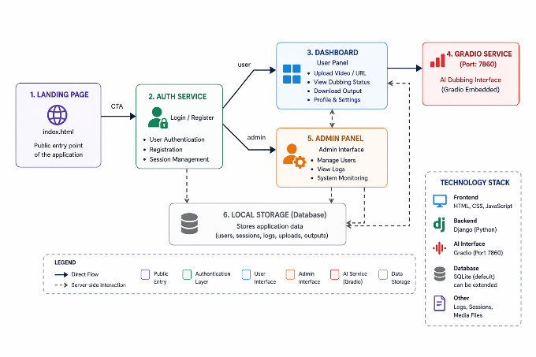
Fig 3.1: Block Diagram

The Fig 3.1 illustrates the EchoVerse AI system is made to be easy to use through an online interface. This system makes sure that people can talk to the AI video dubbing tool in an effective way. It starts with a landing page that tells people what the system can do. Then people go to the login part where they can safely log in or make an account to keep their information private.
After people log in they go to their dashboard where they can do all their work. They can put in video links from outside. Upload videos right to the dashboard. The dashboard also has an interface called Gradio that is fully connected to it.
The system also has a control panel for administrators. This panel helps administrators keep an eye on how the system’s working watch what is happening and manage user accounts to make sure everything is safe and working well. All the information from the application, like passwords, videos and processing results is stored in a central database.
This way the system can. Work quickly and efficiently. The system is also flexible. Can work with complex AI tools and the user interface at the same time without any problems. The EchoVerse AI system is made to be reliable and work smoothly.

System Architecture :
The proposed system, EchoVerse AI, implements a multi- stage pipeline for automated video translation and dubbing. The methodology integrates speech processing, natural lan- guage processing, and deep learning-based voice synthesis techniques to generate synchronized multilingual outputs. The complete workflow is illustrated in Figure 3.2.
  - Input Acquisition:
The system accepts input in the form of either:
    - Video file upload (MP4, MKV), or Video URL
    - This makes it flexible and usable for users.

Fig 3.2: System Architecture of Echoverse AI

2) Audio Extraction: The video that is input is processed with FFmpeg. This is to extract the audio signal. The audio that is extracted is converted into a.wav file. This is a format, for audio waveforms. It is then used for processing.
The audio signal can be represented as:
x(t) = A · sin(2πft + ϕ) (1)
where: A = amplitude , f = frequency ,ϕ = phase.
3) Speech Recognition (Whisper ASR): The extracted audio is transcribed into text using the Whisper Automatic Speech Recognition model.
The performance of speech recognition is evaluated using Word Error Rate (WER):

$WER=\frac{S+D+I}{N}$ x 100 (2)
where: S = substitutions, D = deletions ,I = insertions ,
N = total words

4) Speaker Diarization: To distinguish multiple speakers in the audio, speaker diarization is performed using pyannote.audio.This step breaks down the transcript into parts based on who’s speaking which helps to make a good copy of each persons voice.

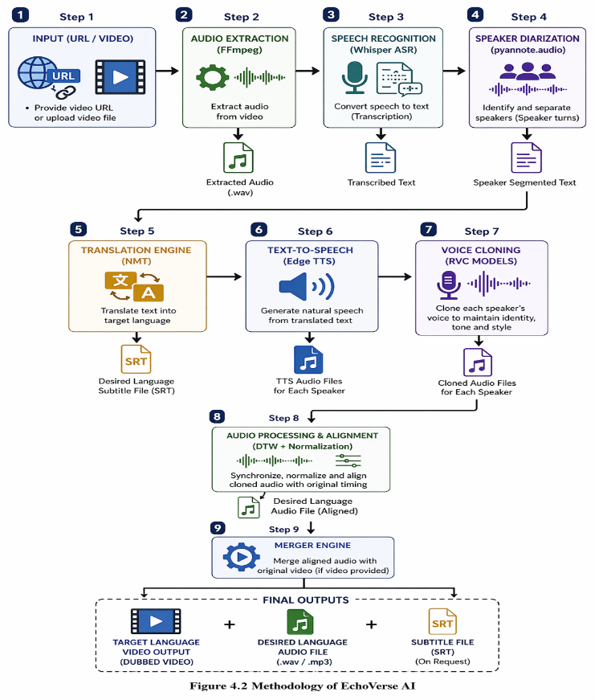
5) Neural Machine Translation : The generated speech is aligned with the original video timing using Dynamic Time Warping he text that has been written down is then changed into the language we want to use. This is done with a special kind of computer program called Neural Machine Translation

6) Text To Speech:The translated text is converted into speech using Edge Text- to-Speech (TTS). This module generates natural-sounding audio while preserving linguistic features such as intonation and rhythm.

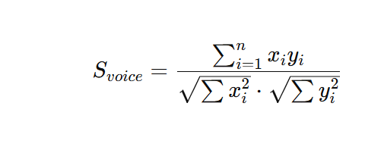
7) Voice Cloning (RVC Models): The similarity between original and generated voice is calculated using cosine similarity:
where $x_{i}$ = original voice embedding , $y_{i}$ = synthesized voice synthesized voice embedding
8) Merging and Output Generation : : The aligned audio is merged with the original video using FFmpeg.
The system pro- duces the following outputs:
- Dubbed video in target language .
- Translated audio file (.wav/.mp3) .
- Subtitle file (SRT).

Results

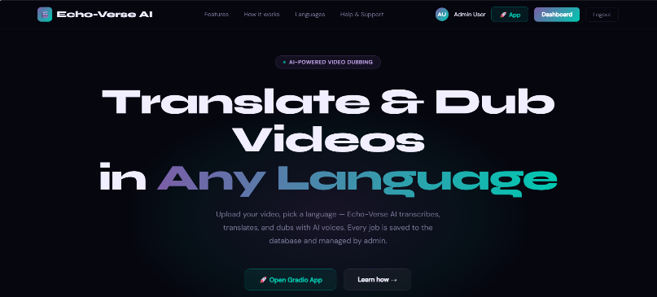
Landing Page of Echo-Verse AI

Fig 4.1: User interface landing page showing system overview and application access.

Fig 4.1: illustrates a landing page is defined as the key entry point of the system. It gives an overview of what multilingual video translation and dubbing basically does. Ease of access features like Features, Languages, Dashboard and Support while the non-toxic samples make up the rest of the data which shows a balanced distribution between the two classes.

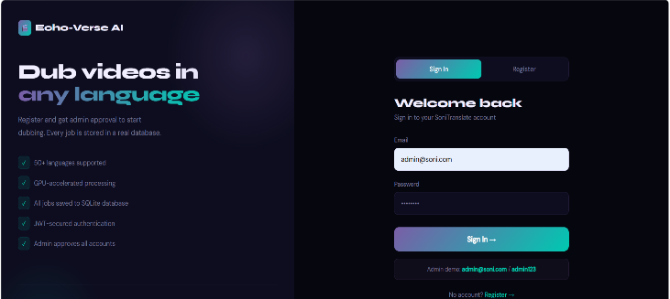
Secure Login Interface:

Fig 4.2: Secure login and registration module for authenticated user access.

Fig.4.2 screen is used for registering users and allowing them to log securely into the platform using their email credentials. It’s a way of ensuring that only valid users gain access to system resources.

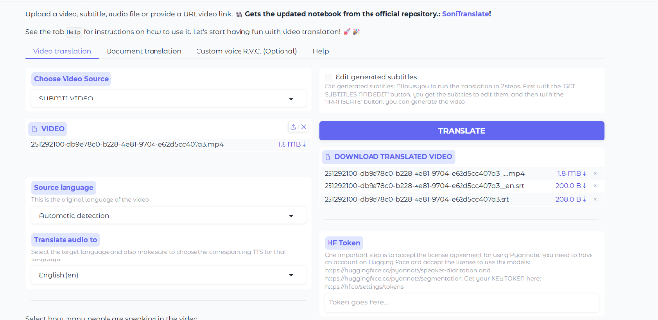
Video Upload and Translation InterfacePerformance Analysis:

Fig:4.3: Interface for uploading local videos and selecting target translation language
Fig. 4.3 represents that Users have the ability to directly upload local video files through the interface. The media formats are various and source language will be detected automatically.

URL-Based Video Translation:
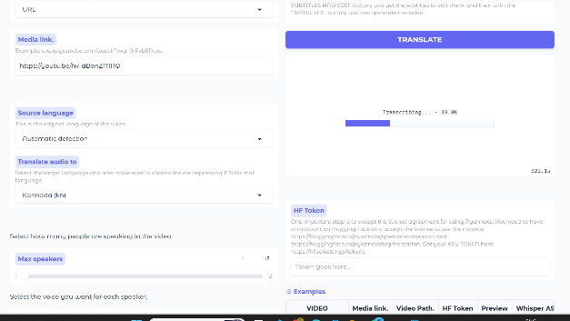

Fig 4.4: URL-based processing where the system fetches and translates online videos directly.

Fig 4.4 demonstrates ,Users can input Youtube or media URLs, so that thy can translate video directly online without the need to download the file manually.

Generated Output Files Panel:

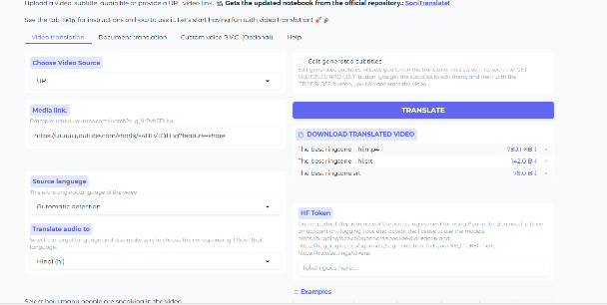

Fig 4.5: Generated translated video and subtitle outputs

Fig 4.5 represents ,Once the system finishes, you see the new files show up ready to grab. Usually there is an MP4 with translation, a matching SRT subtitle, along with the original subtitle text. Downloading them straight away lets you watch later or make changes if needed.


Original Youtube video :
Fig:4.6. the original you tube video interface
Fig:4.6 defines the that this video is located in you tube and this link has beebn taken to translate into many langiages .

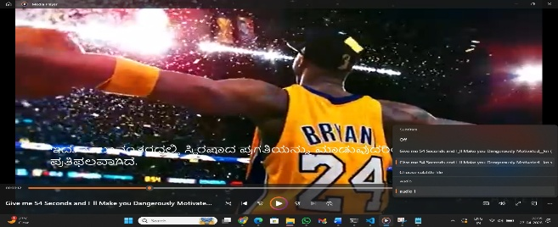
Subtitle Translation Result:

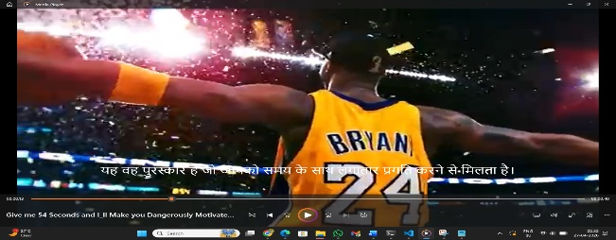
a) Kannada Subtitle Output Result
b) Hindi Subtitle Output Result

Fig 4.7 :Final translated video with synchronized multilingual subtitle rendering.

Fig 4.7 demonstrates the results of the video , a - Showing Kannada words below the video proves it handles different languages at once. Not just translation - it lines up timing too. Words appear right when spoken. This works across tongues without delay. b- showing speech to text happens smoothly here.A single video feed showed up in Hindi too, showing it works across languages.

Admin Dashboard:
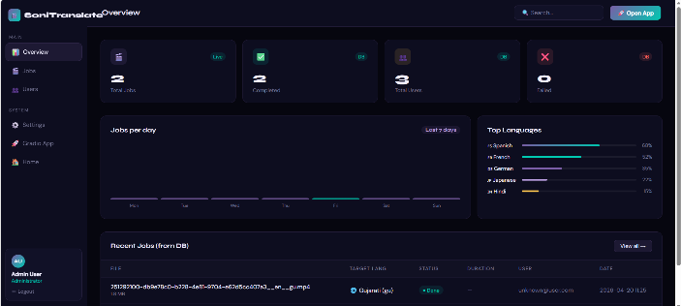
Fig 4.8 : Administrative dashboard for system monitoring.

Fig 4.8 pop up on the admin screen - jobs done, tasks that stalled, user count, how often each tongue gets picked.

Conclusion

The proposed Echo-Verse AI system showed that it is possible to have automatic, easy-to-use, effective and smart solution for multilingual video translation, subtitle generation and dubbing process using the integration of current AI technologies over a single platform. Video conversion from one language to another includes speech recognition, text translation, subtitle synchronization and voice synthesis can now be achieved with minimum human effort.

The system has been validated using uploaded videos as well as online video links. The results confirmed good performance in term of schedule subtitling with translations produce both fair and playable output. Additionally, we provide the user a friendly-interface on both user side and admin side .

Future Scope
Echo-Verse AI to support on-site live translation and dubbing for online meetings, webinars, and live streaming platforms. The system can be enhanced to provide a more realistic lip-sync feature for uploaded or live videos so that the translated voice aligns organically with the speaker’s face Furthermore, mobile applications and cloud solutions support this system more convenient, faster and accessible for everyday use.

References

- Sumaiya, M. N., B. V. Sreekanth, U. S. Akash, Aravind Sharma Kala, and G. M. Dharanendra Gowda. "Real-time human–machine interaction through voice augmentation using artificial intelligence." In Emerging IT/ICT and AI Technologies Affecting Society, pp. 147-160. Singapore: Springer Nature Singapore, 2022.
- González-Docasal, Ander, and Aitor Álvarez. "Enhancing voice cloning quality through data selection and alignment-based metrics." Applied Sciences 13, no. 14 (2023): 8049.
- Zeng, Taiyao. "Deep learning in automatic speech recognition (asr): A review." In Proc. 7th Int. Conf. Mod. Manag. Educ. Technol.(MMET), pp. 173-179. 2022.
- Sung-Bin, Kim, Jeongsoo Choi, Puyuan Peng, Joon Son Chung, Tae-Hyun Oh, and David Harwath. "Voicecraft-dub: Automated video dubbing with neural codec language models." In Proceedings of the IEEE/CVF International Conference on Computer Vision, pp. 14623-14632. 2025.
- Mahaganapathy, Ahrane, and Kengatharaiyer Sarveswaran. "Natural Language Processing Journal."
- Mohiuddin, Golam Md, Md Shohel Sayeed, and Ong Lee Yeng. "Deep learning models for culturally aware cyberbullying detection in Muslim societies: a systematic review." Discover Artificial Intelligence 5, no. 1 (2025): 322.
- Deng, Li. "Deep learning: from speech recognition to language and multimodal processing." APSIPA Transactions on Signal and Information Processing 5 (2016): e1.
- Zhang, Xueyao, Xiaohui Zhang, Kainan Peng, Zhenyu Tang, Vimal Manohar, Yingru Liu, Jeff Hwang et al. "Vevo: Controllable zero-shot voice imitation with self-supervised disentanglement." arXiv preprint arXiv:2502.07243 (2025).
- Guo, Yiwei, Zhihan Li, Hankun Wang, Bohan Li, Chongtian Shao, Hanglei Zhang, Chenpeng Du, Xie Chen, Shujie Liu, and Kai Yu. "Recent advances in discrete speech tokens: A review." IEEE Transactions on Pattern Analysis and Machine Intelligence (2025).
- Chaume, Frederic. Audiovisual translation: dubbing. Routledge, 2020.
- Danan, Martine. "Dubbing as an Expression of Nationalism." Meta 36, no. 4 (1991): 606-614.
- Brannon, William, Yogesh Virkar, and Brian Thompson. "Dubbing in practice: A large scale study of human localization with insights for automatic dubbing." Transactions of the Association for Computational Linguistics 11 (2023): 419-435.
- Zhang, Zhedong, Liang Li, Gaoxiang Cong, Haibing Yin, Yuhan Gao, Chenggang Yan, Anton van den Hengel, and Yuankai Qi. "From speaker to dubber: movie dubbing with prosody and duration consistency learning." In Proceedings of the 32nd ACM international conference on multimedia, pp. 7523-7532. 2024.
- Cong, Gaoxiang, Jiadong Pan, Liang Li, Yuankai Qi, Yuxin Peng, Anton Van Den Hengel, Jian Yang, and Qingming Huang. "Emodubber: Towards high quality and emotion controllable movie dubbing." In Proceedings of the Computer Vision and Pattern Recognition Conference, pp. 15863-15873. 2025.
- Chronopoulou, Alexandra, Brian Thompson, Prashant Mathur, Yogesh Virkar, Surafel M. Lakew, and Marcello Federico. "Jointly optimizing translations and speech timing to improve isochrony in automatic dubbing." arXiv preprint arXiv:2302.12979 (2023).

