Design and Analysis of a Power and Delay Optimized Radix -4 Approximate Subtractor.

ABSTRACT
Subtraction is a fundamental arithmetic operation of many systems. Conventional subtractor designs ensure exact computation but often incur significant hardware cost, power consumption, and propagation delay. Approximate computing has emerged as an effective approach to improve hardware efficiency by relaxing exact computation requirements in error-tolerant applications. In this work, approximate subtractor architectures are proposed by modifying borrow and difference logic expressions to reduce circuit complexity. Accurate subtractors in conventional subtractor structures are selectively replaced with approximate subtractor variants to achieve reductions in area, power, and delay while maintaining acceptable accuracy. The proposed approximate subtractor designs are implemented using Verilog HDL and synthesized using FPGA design tools. These approximate architecture is suitable for error-resilient applications .

Keywords:
Approximate Computing, Approximate Subtractor, Low Power VLSI, Error-Tolerant Systems, Digital Systems.

INTRODUCTION
Subtraction is a key arithmetic operation used extensively in arithmetic logic units (ALUs), digital filters, signal processing systems, and control systems. It plays an essential role in various applications such as image enhancement, digital communication, and numerical computation.

With the increasing demand for energy-efficient and high-performance systems, traditional accurate arithmetic circuits face challenges due to their higher power consumption, propagation delay, and hardware complexity. In many modern applications such as multimedia processing, artificial intelligence, and image processing, exact numerical precision is not always required. Small computational errors can be tolerated without significantly affecting system performance. Approximate computing provides a promising solution by allowing controlled inaccuracies in arithmetic operations to achieve significant improvements in hardware efficiency. By simplifying logic expressions and reducing gate count, approximate circuits can reduce power consumption, silicon area, and delay.

Subtractor circuits consist of difference and borrow generation logic, which contribute significantly to overall hardware complexity. By approximating borrow and difference logic in lower significance bits, hardware efficiency can be improved while limiting the impact on overall accuracy.

Approximate computing has emerged as a promising design paradigm for improving the energy efficiency of digital circuits by relaxing the requirement for exact computation in error-tolerant applications such as multimedia processing, machine learning, and signal processing. By allowing small computational inaccuracies, approximate arithmetic circuits can significantly reduce power consumption, delay, and hardware complexity while maintaining acceptable output quality. Several researchers have investigated approximate arithmetic units to optimize performance and energy efficiency in modern VLSI systems [1]-[3]. In particular, approximate adders and subtractors have been widely explored as fundamental building blocks for low-power arithmetic architectures [1]-[2], [4]. Architectural exploration of approximate arithmetic circuits has shown that simplified logic structures and logic approximation techniques can significantly reduce computational cost and hardware complexity while maintaining reasonable accuracy [2], [5]. Various studies have also proposed approximate subtractor architectures to simplify circuit design and improve the performance of digital systems [6]-[8]. Furthermore, approximate subtractors have been applied in arithmetic modules such as divider architectures and digital signal processing systems to reduce delay and energy consumption [9], [10]. Error-resilient applications such as image and signal processing have demonstrated the effectiveness of approximate arithmetic units in achieving significant hardware and power savings [11], [12]. The development of approximate ripple-borrow subtractor architectures and optimized arithmetic circuit libraries has further contributed to improving speed, area efficiency, and energy consumption in modern digital systems [13]-[17].

This work focuses on designing approximate subtractor architectures by modifying borrow propagation and difference logic expressions to achieve improved power, area, and delay characteristics.
BACKGROUND AND RELATED WORK
Accurate Radix-2 Full Subtractor
A conventional full subtractor generates difference and borrow outputs using XOR and combinational logic.
A conventional full subtractor performs subtraction of three input bits: minuend (A), subtrahend (B), and borrow input (Bin), producing difference (D) and borrow output (Bout).
This accurate implementation requires multiple logic gates and contributes to increased power consumption and propagation delay. Existing Radix-2 full subtractor is represented in Figure 1.The difference and borrow expressions are represented in equation (1) and (2) respectively.

The exact full subtractor logic is defined as:

Difference=A ⊕ B ⊕ Bin (1)
Borrow =A′B +A′ Bin +B Bin (2)
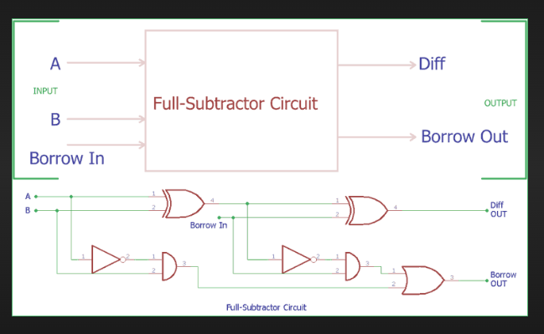

Figure 1: Radix-2 Accurate full subtractor.

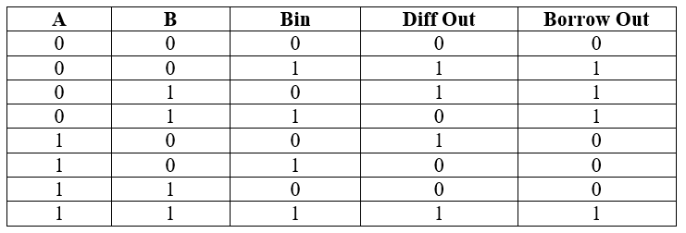

Table 1: Truth table of Radix-2 Accurate full subtractor.

Approximate subtractors simplify the logic expressions by modifying borrow and difference generation, thereby reducing hardware complexity. Previous research has demonstrated that approximate arithmetic circuits can achieve significant improvements in power efficiency, area reduction, and speed while maintaining acceptable error levels.
Approximate arithmetic circuits have been widely applied in adders and multipliers. However, approximate subtractors remain relatively less explored, despite their importance in arithmetic processing systems.
This work proposes approximate subtractor designs with simplified logic expressions to reduce gate count, power consumption, and delay. In the further section will be discussing on radix-4 accurate and approximate subtractor.

ACCURATE SUBTRACTOR ARCHITECTURE

Since Radix-2 subtractors are already available we have concentrated to design and test Radix- 4 subtractors where two bits can undergo subtraction simultaneously where critical path could be reduced. In this paper we have designed, tested accurate Radix- 4 subtractors and further approximated these Radix -4 subtractors and compared them with accurate Radix- 4 subtractors in next section . We have 2 cases in this design of accurate Radix-4 subtractors, in first case the design involves Radix- 4 accurate full subtractors with Bin which could be used in all bit positions other than LSB and the next case is Radix- 4 accurate half subtractors without Bin which could be used in LSB where there is no previous borrow in(Bin) .

Accurate Radix - 4 Full Subtractor.

Instead of using radix -2 accurate subtractors the Accurate Radix - 4 Subtractor can simultaneously subtract 2-bits which reduces critical path, delay and power. We have designed and tested accurate Radix-4 full and half subtractor and represented the results.
The Accurate Radix - 4 full subtractor is represented in Figure 2. This is with Bin circuit that can be used in all MSB positions other than LSB since all MSB bits has borrow in from previous bits. It can also be used on LSB bit position by making Bin as 0. The truth table Accurate Radix – 4 Full Subtractor is shown in Table I which involves two cases first case is when Bin is 0 and second case is when Bin is 1 since borrow can either be 0 or 1.Equation (3),(4),(5) represents the difference and borrow expressions for Accurate Radix – 4 Full Subtractor.

D0=A0​⊕B0​⊕Bin (3)
D1=A1​⊕B1​⊕(A0​​B0​+(A0​⊕B0​)​Bin) (4)
Bout=A1​​B1​+(A1​⊕B1​)​(A0​​B0​+(A0​⊕B0​)​Bin) (5)

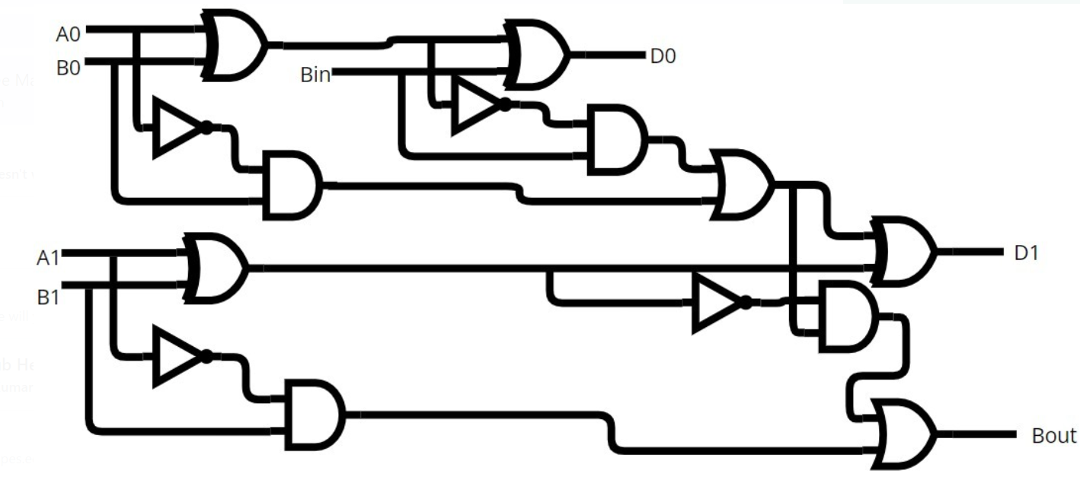
Figure 2: Accurate Radix – 4 Full Subtractor.

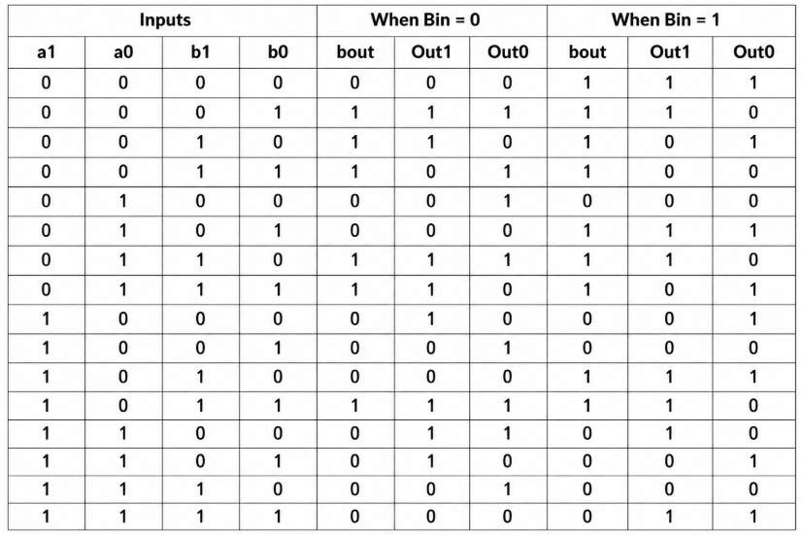

Table 2:Truth table of Accurate Radix - 4 Full Subtractor .

Accurate Radix - 4 Half Subtractor.

The Accurate Radix – 4 half subtractor is designed without Bin that can be used in LSB position where there is no requirement of Bin pin that is where there is no previous borrow. Using this without Bin circuit in turn reduces gate count from 14 (Radix -4 full subtractor) to 10 (Radix-4 half subtractor). Figure 3 represents Accurate Radix - 4 half subtractor and the truth table for Accurate Radix - 4 half subtractor is shown in Table 3. In accurate Radix - 4 half subtractor critical path to Bout path involves 4 gates represented in blue color. Equation (6),(7),(8) represents the difference and borrow expressions for Accurate Radix – 4 Half Subtractor.

D0​=A0​⊕B0 (6)
D1​=(A1​⊕B1​) + A0​​B0​ (7)
Bout=A1​​B1​+A0​​B0​(A1​⊕B1​)​ (8)

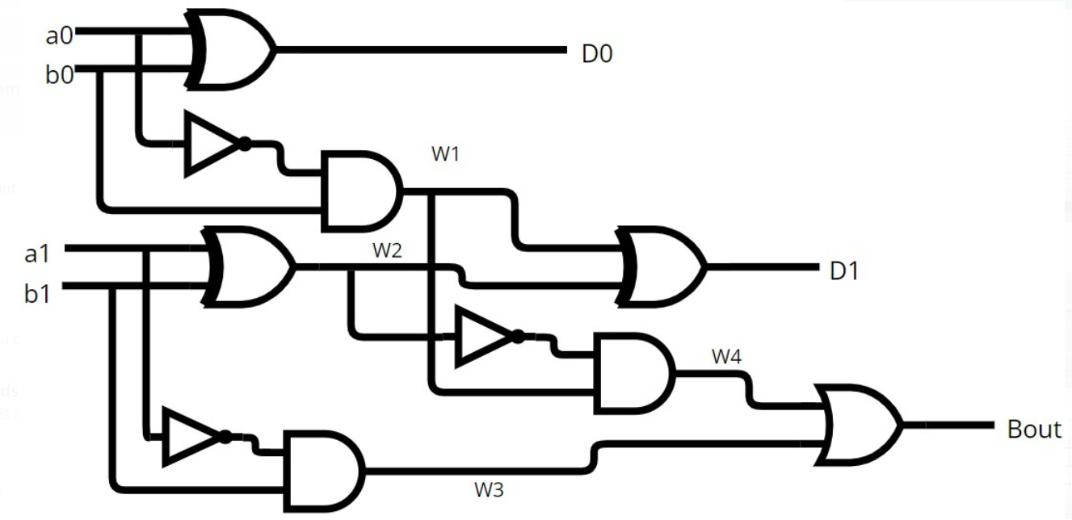
Figure 3: Accurate Radix - 4 half subtractor.

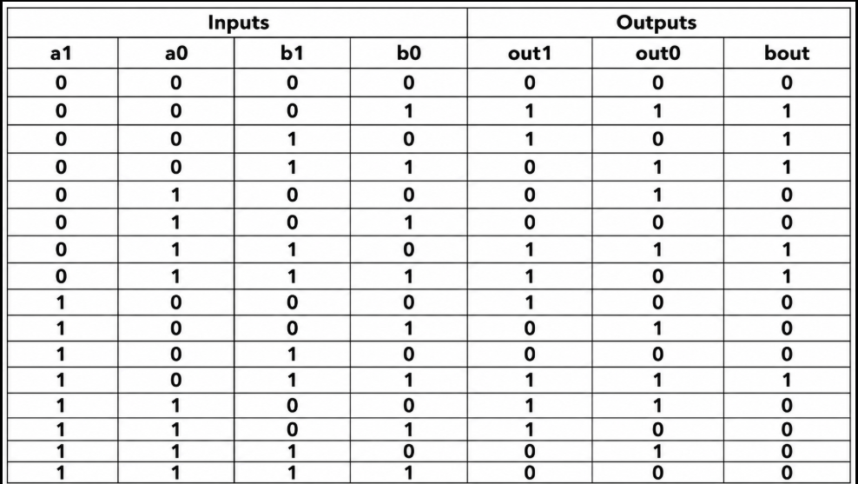

Table 3: Truth table of Accurate Radix - 4 half subtractor.

These accurate Radix - 4 full and half subtractors can be approximated to further reduce delay and power but it does give some error bits but these can be used in error tolerant applications. Also, further in higher order bit subtractors, the LSB bits could be replaced with approximate subtractors to reduce hardware cost, MSB bits may retain accurate subtractors to limit error propagation.

APPROXIMATE SUBTRACTOR ARCHITECTURE

Approximate Radix - 4 Full Subtractor.
Approximate subtractors are designed by simplifying difference and borrow logic. These designs reduce logic depth and gate count compared to accurate subtractors. Approximate subtractors simplify the expressions to reduce hardware complexity, delay, and power consumption. Here we are approximating Accurate Radix-4 Full subtractor represented in Figure 2 .The approximation is majorly done in borrow path since borrow path usually causes more delay .Therefore we have reduced one NOT and AND gate in borrow path using approximation .Due to this reduction in borrow path delay could be reduced and further gate count, power could be reduced. If we compare Accurate Radix-4 Full subtractor with Approximate Radix-4 Full subtractor the critical path of Bout is reduced from 4 gates to 3 gates represented with blue colored arrow. Equation (9),(10),(11) represents the difference and borrow expressions for Approximate Radix – 4 Full Subtractor. Truth table of Approximate Radix - 4 full subtractor is represented in Table 4 and error bits are highlighted in red color.

D0 = A0 ⊕ B0 ⊕ Bin (9)
D1=A1​⊕B1​⊕(A0​​B0​+(A0​⊕B0​)​Bin) (10)
Bout = A1​​(B1​+A0​​B0​+A0​​Bin+B0​Bin) (11)

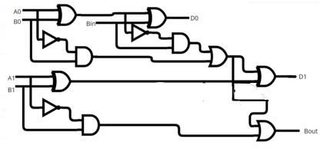

Figure 4: Approximate Radix - 4 full subtractor.

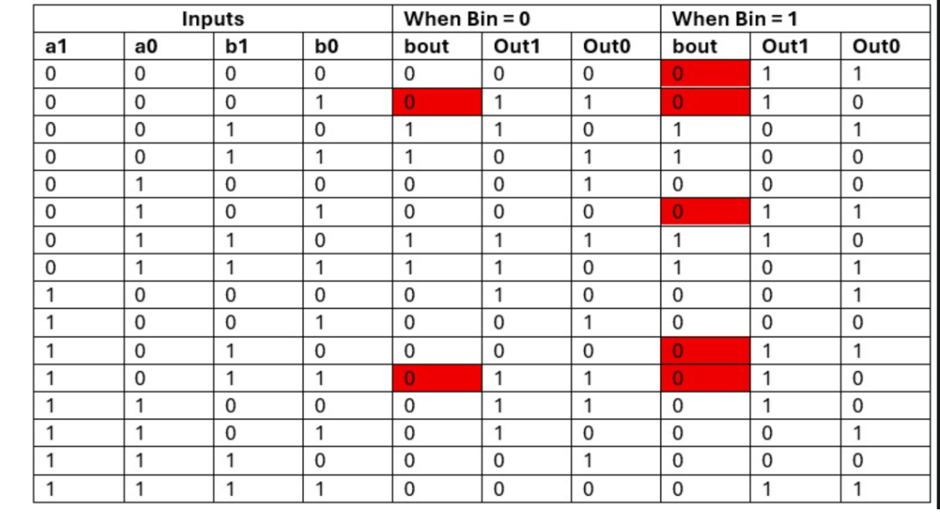

Table 4 : Truth table of Approximate Radix - 4 full subtractor.

Approximate Radix - 4 Half Subtractor.

Approximation of Radix -4 Half subtractor which is majorly involved in LSB position that is without Bin pin. This yield less error when approximated whereas the subtractors involved in higher order bits are approximated yields more error.
The Radix-4 approximate half subtractor is without Bin pin as represented in Figure 4 .It is the approximate version of accurate Radix-4 half subtractor. The subtractor is approximated in Bout path since this path is most responsible for delay in higher order subtractor circuits. Also, the proposed architecture offers advantages such as: Reduced logic gate count, Reduced power consumption, Reduced propagation delay, Improved area efficiency.
The proposed approximate subtractor architectures are implemented using Verilog HDL and verified using functional simulation. The truth table for Radix - 4 approximate half subtractor without is shown in Table 4. Bits highlighted in red color represents error bits. We observe that in this approximation version error is in only borrow out (bout) and both outputs (Out1 and Out0) gives out accurate output. In approximate Radix - 4 half subtractor critical path to Bout involves 3 gates represented in blue color. Overall Approximate Radix - 4 half uses 8 logic gates. Equation (12),(13),(14) represents the difference and borrow expressions for Approximate Radix – 4 Half Subtractor.

D0​=A0​⊕B0​ (12)
D1​=(A1​⊕B1​) +A0​​B0​ (13)
Bout=A0​​B0​+A1​​B1​ (14)

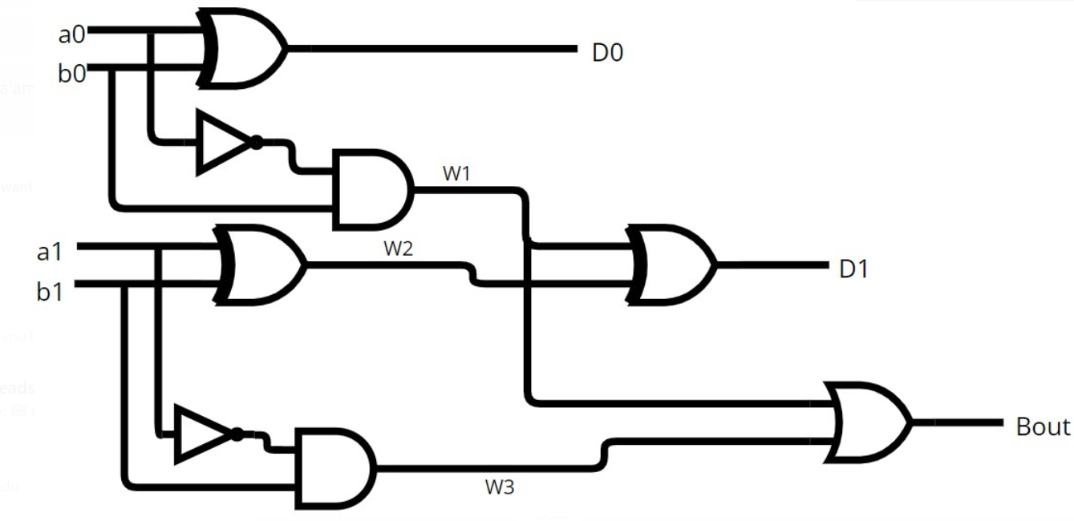
Figure 5: Approximate Radix-4 half subtractor .

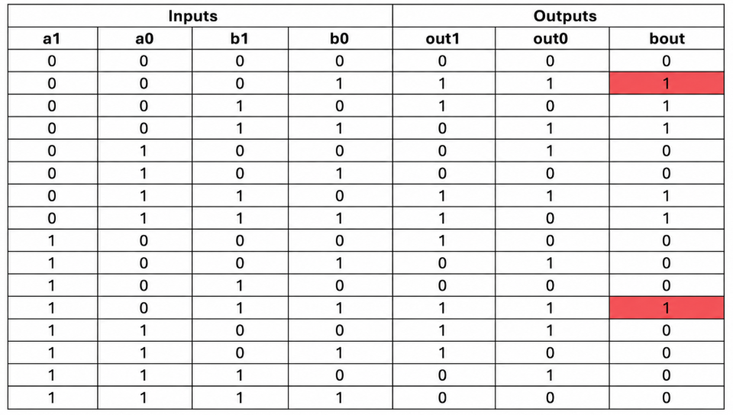

Table 5:Truth table of approximate Radix-4 half subtractor .
By comparing accurate with approximate circuit at gate level we can observe that , radix-4 accurate full subtractor observed in Figure 2 uses 14 gates whereas the radix-4 approximate full subtractor observed in Figure 4 uses 12 gates and also in radix-4 accurate half subtractor observed in Figure 3 uses 10 gates whereas the radix-4 approximate half subtractor observed in Figure 5 uses 8 gates and this gate reduction is in bout path which is usually responsible for delay in higher bit subtractors therefore the hardware complexity is reduction the bout path is more advantageous.

Synthesis is performed using FPGA design tools to evaluate performance metrics such as, Power consumption, Propagation delay, Error rate. Simulation results confirm the functional operation of the proposed subtractor designs. The architecture can be extended to multi-bit subtractor designs such as ripple borrow subtractors.

IMPLEMENTATION AND RESULTS

The proposed subtractor designs are implemented using Verilog HDL using Quartus Tool and synthesized using FPGA. Table 6 shows comparison of error results of accurate radix-4 half/full subtractor with approximate radix-4 half/full subtractor we observe that there approximate subtractor yields nominal error compared with accurate. Table 7 shows comparison of Power results of accurate with approximate subtractor we observe that power consumption is less in 4-bit radix subtractor when compared to using two radix-2 subtractor, also the approximate radix-4 subtractor consumes even less power. Table 8 shows delay results here also the approximate subtractor results proves that it produces less delay compared to other architectures.

Sl. No | Subtractor types | Error (%)
1. | Radix-2 accurate full subtractor | 0
2. | Radix-4 accurate full subtractor | 0
3. | Radix-4 approximate full subtractor | 7.29
4. | Radix-4 accurate half subtractor | 0
5. | Radix-4 approximate half subtractor | 4.16

Table 6: Comparison of error results of accurate and approximate subtractor.

Sl. No | Subtractor types | Power (µW)
1. | Radix-2 accurate full subtractor | 0.973 (each radix-2)  0.973x2=1.976 (2 radix-2 subtractors)
2. | Radix-4 accurate full subtractor | 1.672
3. | Radix-4 approximate full subtractor | 1.564
4. | Radix-4 accurate half subtractor | 1.404
5. | Radix-4 approximate half subtractor | 1.294

Table 7 : Comparison of power results of accurate and approximate subtractor.

Sl. No | Subtractor types | Delay (ns)
1. | Radix-2 accurate full subtractor | 6.798 (each radix-2)  6.798x2=13.596 (2 radix-2 subtractors)
2. | Radix-4 accurate full subtractor | 7.377
3. | Radix-4 approximate full subtractor | 7.176
4. | Radix-4 accurate half subtractor | 6.976
5. | Radix-4 approximate half subtractor | 6.776

Table 8 : Comparison of delay results of accurate and approximate subtractor.

CONCLUSION
The Radix-4 subtractor architectures has been presented in this work. Both accurate and approximate designs are tested and verified. By simplifying borrow and difference logic expressions, the proposed Radix-4 accurate and approximate subtractor achieves reductions in hardware complexity, power consumption, and propagation delay. Further these could be used in higher order subtractors. The approximate subtractor proposed is suitable for error-tolerant applications. Future work will focus on extending the design to multi-bit subtractors and optimizing approximation strategies for improved efficiency and accuracy trade-offs.

REFERENCES

- Ferreira, R., M. Leme, M. Corrêa, L. Agostini, C. Diniz and B. Zatt, "Approximate Subtractor Operator for Low-Power Video Coding Hardware Accelerators," 2019 26th IEEE International Conference on Electronics, Circuits and Systems (ICECS), Genoa, Italy, 2019, pp. 426-429, doi: 10.1109/ICECS46596.2019.8964783.
- Gupta, V., D. Mohapatra, A. Raghunathan, and K. Roy, “Low-power digital signal processing using approximate adders,” IEEE Transactions on Computer-Aided Design of Integrated Circuits and Systems, vol. 32, no. 1, pp. 124–137, Jan. 2013.
- Han, J. and M. Orshansky, “Approximate computing: An emerging paradigm for energy-efficient design,” in Proceedings of the IEEE European Test Symposium, 2013, pp. 1–6.
- Hashemi, S., R. Bahar, and S. Reda, “DRUM: A dynamic range unbiased multiplier for approximate applications,” in Proceedings of IEEE/ACM International Conference on Computer-Aided Design (ICCAD), 2015, pp. 418–425.
- Jiang, H., C. Liu, J. Han, and F. Lombardi, “Approximate arithmetic circuits: A survey, characterization, and recent applications,” IEEE Access, vol. 5, pp. 20297–20317, 2017.
- Kaushik, N. and B. Srinivasu, "High-Speed and Area-Efficient Serial IMPLY-Based Approximate Subtractor and Comparator for Image Processing and Neural Networks," IEEE Transactions on Nanotechnology, vol. 23, pp. 748-757, 2024, doi: 10.1109/TNANO.2024.3487223.
- Liu, C., J. Han, and F. Lombardi, “A low-power approximate adder with configurable error recovery,” in Proceedings of Design, Automation & Test in Europe (DATE), 2014, pp. 1–4.
- Nithyashree, R. V., et al., “Analysis of various approximate adders,” in Proceedings of IEEE International Conference on Electronics and Communication Systems, 2023, pp. 1–5.
- Palem, K. V., “Energy aware computing through probabilistic switching: A study of limits,” IEEE Transactions on Computers, vol. 54, no. 9, pp. 1123–1137, Sept. 2005.
- Raha, A., H. Jayakumar, and V. Raghunathan, “Input-based dynamic reconfiguration of approximate arithmetic units for video encoding,” IEEE Transactions on Very Large Scale Integration (VLSI) Systems, vol. 24, no. 3, pp. 846–857, Mar. 2016.
- Rehman, S., M. Shafique, A. Kumar, and J. Henkel, “Design and analysis of approximate ripple carry adders,” in Proceedings of IEEE International Conference on Computer Design (ICCD), 2014, pp. 1–6.
- Rehman, S., W. El-Harouni, M. Shafique, and J. Henkel, “Architectural-space exploration of approximate multipliers,” in Proceedings of the IEEE/ACM International Conference on Computer-Aided Design (ICCAD), 2016, pp. 1–8.
- Shafique, M., S. Rehman, R. Hafiz, and J. Henkel, “Approximate computing: From circuits to systems,” in Proceedings of the Design Automation Conference (DAC), 2015, pp. 1–6.
- Shafique, M., W. Ahmad, R. Hafiz, and J. Henkel, “Approximate computing: Techniques and applications,” IEEE Design & Test, vol. 33, no. 1, pp. 8–22, Feb. 2016.
- Venkataramani, S., A. Sabne, V. Kozhikkottu, K. Roy, and A. Raghunathan, “SALSA: Systematic logic synthesis of approximate circuits,” in Proceedings of the 49th Design Automation Conference (DAC), 2012, pp. 796–801.
- Verma, A. K., P. Brisk, and P. Ienne, “Variable latency speculative adders for approximate computing,” IEEE Transactions on Computer-Aided Design of Integrated Circuits and Systems, vol. 27, no. 11, pp. 1874–1885, Nov. 2008.
- Xu, Q., T. Mytkowicz, and N. S. Kim, “Approximate computing: A survey,” IEEE Design & Test, vol. 33, no. 1, pp. 8–22, Feb. 2016.

