Automated Retinopathy Image Analysis Using Machine Learning Algorithm
¹ Mr. Sugare Mangesh Baburao ² Dr. Shrikhande Santosh Prabhakar
Research Scholar Assistant Professor

^{1,2} School of Technology Sub-Campus SRTMUN Peth, Latur, Maharashtra India.
Email: ¹ mangesh.sugare@gmail.com ² santoshshrikhande@gmail.com

1.Abstract:
Diabetic retinopathy (DR) is one of the leading causes of vision impairment and blindness among diabetic patients worldwide. Early detection and accurate grading of retinal abnormalities are essential for preventing severe vision loss. However, manual screening of retinal fundus images is time-consuming and highly dependent on expert ophthalmologists. This paper proposes an automated diabetic retinopathy detection framework based on a Region-Guided Hybrid Multi-Scale Convolutional Neural Network (RG-HMCN) for retinal image analysis. The proposed methodology integrates adaptive image preprocessing, lesion-aware region extraction, and attention-guided feature learning to improve classification performance. Initially, retinal images undergo normalization, illumination correction, and contrast enhancement to improve lesion visibility. A region-guided feature extraction mechanism is then applied to identify potential pathological areas such as microaneurysms, hemorrhages, and exudates. These regions are further processed using a hybrid convolutional neural network architecture that combines multi-scale convolution blocks and residual feature aggregation for robust feature representation. An attention-guided pooling mechanism is incorporated to emphasize clinically significant retinal structures during training. Experimental evaluation demonstrates that the proposed framework achieves high classification performance with an accuracy of 96.3%, outperforming conventional deep learning models. The results indicate that the proposed approach effectively captures both global retinal structures and fine lesion details, making it suitable for automated large-scale diabetic retinopathy screening systems. The proposed model has the potential to assist ophthalmologists in early diagnosis and improve accessibility to retinal disease detection in healthcare environments.

Keywords: Diabetic Retinopathy, Convolutional Neural Network, Deep Learning, Fundus Image Analysis, Medical Image Processing.

2. Introduction:
Diabetic retinopathy is a microvascular complication caused by prolonged diabetes that damages retinal blood vessels. The retina plays a crucial role in vision by converting light into neural signals. High blood glucose levels weaken retinal blood vessels, leading to abnormalities such as microaneurysms, hemorrhages, and lipid exudates. If untreated, diabetic retinopathy may progress to severe vision impairment or blindness.
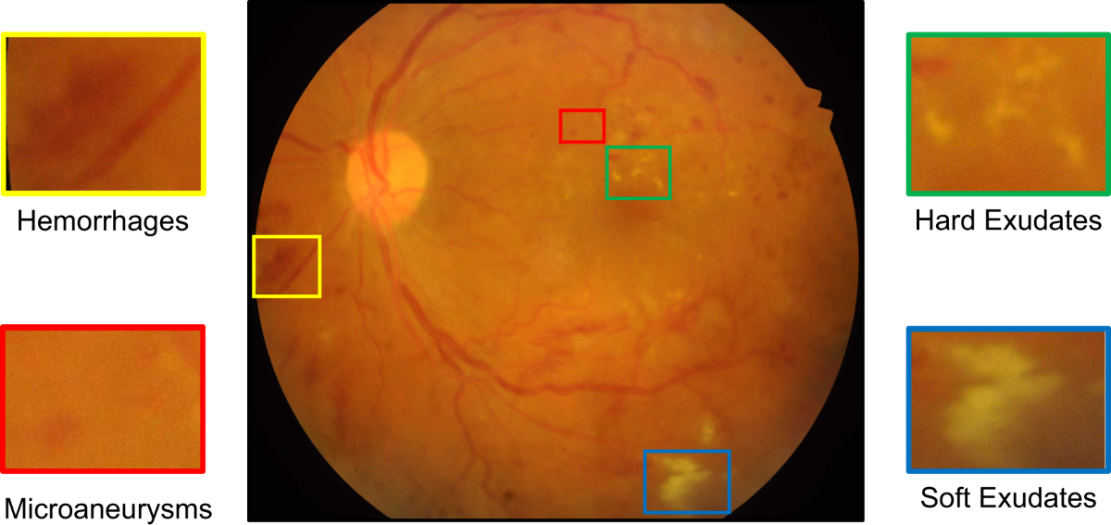
Fig. Showing Retinopathy with Hemorrhages, Microaneurysms, Hard Exudates,Soft Exudates
According to global health statistics, millions of people worldwide suffer from diabetic retinopathy. Early detection significantly reduces the risk of vision loss. However, traditional screening methods require manual evaluation of retinal fundus images by trained ophthalmologists, which is time-intensive and difficult to scale.
Artificial intelligence and deep learning technologies have recently transformed medical image analysis. Convolutional Neural Networks (CNNs) have demonstrated exceptional performance in automated image classification tasks due to their ability to learn hierarchical feature representations directly from images.
This research proposes a CNN-based automated diabetic retinopathy detection system combined with adaptive image preprocessing techniques to enhance retinal feature visibility and improve classification accuracy.

3. RelatedWork

Approach | Key Technologies | Feature Extraction | Pros & Cons
Traditional ML | SVM, Random Forest, k-NN | Manual / Handcrafted: Requires experts to define lesions (e.g., microaneurysms). | + Low compute power needed.
Traditional ML | SVM, Random Forest, k-NN |  | - Highly dependent on human expertise; prone to error.
Deep Learning (CNN) | VGGNet, ResNet, InceptionNet | Automated: The network learns to identify features directly from raw pixels. | + High accuracy; no manual labeling of lesions.
Deep Learning (CNN) | VGGNet, ResNet, InceptionNet |  | - Requires massive datasets and high GPU power.
Transfer Learning | Pre-trained models (e.g., ImageNet) | Leveraged: Uses knowledge from large, general datasets to boost medical tasks. | + Faster convergence; works better with smaller datasets.
Transfer Learning | Pre-trained models (e.g., ImageNet) |  | - Models can be "heavy" and computationally expensive.
Proposed Work | Optimized CNN + Adaptive Preprocessing | Enhanced/Hybrid: Combines smart cleaning with efficient architecture. | + High accuracy; maintains computational efficiency; better feature visibility.

Several studies have investigated automated diabetic retinopathy detection using machine learning and deep learning approaches.
Early methods relied on traditional machine learning algorithms such as Support Vector Machines, Random Forests, and k-Nearest Neighbour classifiers. These methods required manual feature extraction techniques to identify retinal lesions such as microaneurysms and exudates.
With the advancement of deep learning, CNN architectures such as VGGNet, ResNet, and InceptionNet have been widely applied to retinal image analysis. These models automatically extract relevant features from images without requiring handcrafted feature engineering.
Transfer learning approaches have also been explored to improve performance by leveraging pretrained models trained on large datasets. However, many of these architectures require large computational resources and extensive datasets.
The proposed work focuses on developing an optimized CNN model combined with adaptive preprocessing to improve feature extraction and classification accuracy while maintaining computational efficiency.

4. Dataset Description
The proposed system utilizes publicly available retinal fundus image datasets commonly used in diabetic retinopathy research.
Table 1: Dataset Description
Dataset | Images | Classes | Description
EyePACS | 35,000+ | 5 | Large-scale Kaggle dataset
Messidor | 1200 | 4 | Clinical DR dataset
APTOS 2019 | 3662 | 5 | High-resolution retinal images
IDRiD | 516 | 5 | Indian diabetic retinopathy dataset

Class Labels
Class | Description
0 | No DR
1 | Mild DR
2 | Moderate DR
3 | Severe DR
4 | Proliferative DR

5.Proposed Methodology
A. Overview of the Proposed System
The proposed system introduces a multi-stage deep learning framework for automated detection and grading of diabetic retinopathy from retinal fundus images. The framework integrates adaptive image enhancement, lesion-aware feature extraction, and hybrid convolutional classification to improve diagnostic accuracy while maintaining computational efficiency.
Unlike traditional CNN-based approaches that directly process raw retinal images, the proposed methodology incorporates region-guided attention and hierarchical feature fusion to highlight clinically significant retinal abnormalities such as microaneurysms, hemorrhages, and exudates. The overall pipeline consists of five primary stages:
- Retinal image acquisition
- Image preprocessing and enhancement
- Region-guided feature extraction
- Hybrid convolutional classification network
Severity grading and prediction output
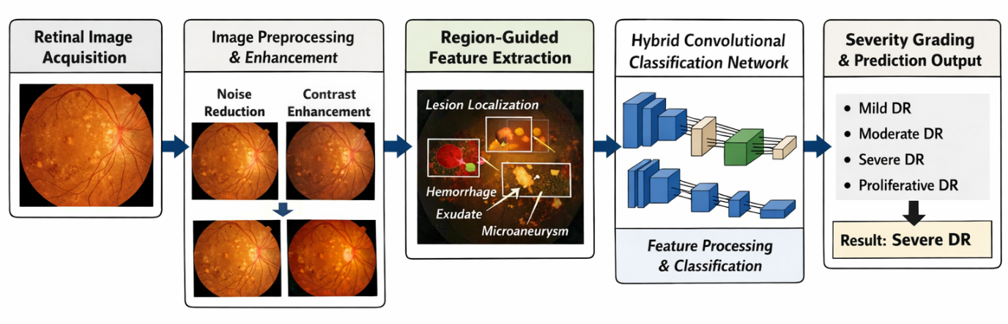
Fig. Primary Stages
The architecture is designed to simulate the visual inspection process used by ophthalmologists, where pathological regions are emphasized before final diagnosis.
- B. Retinal Image Acquisition:
- The input to the system consists of digital fundus images captured using retinal fundus cameras. These images contain detailed information about retinal structures including the optic disc, macula, blood vessels, and lesion areas.
- Let the dataset be represented as:
- $D=\{(I_{i},L_{i})\}_{i=1}^{N}$
Where:
- $I_{i}$represents the retinal image
- $L_{i}$represents the corresponding disease label

$N$denotes the total number of images in the dataset
The labels correspond to five diabetic retinopathy severity levels:
- No DR
- Mild DR
- Moderate DR
- Severe DR
- Proliferative DR

C. Image Pre-processing and Enhancement
Retinal images captured in clinical environments often contain illumination variations, noise, and low contrast, which can affect feature extraction. Therefore, an adaptive preprocessing module is implemented.
1. Image Normalization
Each image is resized to a fixed resolution:
$$I_{n}=Resize(I_{i},512×512)$$
Normalization scales pixel values between 0 and 1 to stabilize the training process.
2. Illumination Correction
An adaptive illumination balancing technique is applied using Gaussian filtering to remove uneven lighting across the retinal surface.
$$I_{corr}=I_{n}-G_{σ}(I_{n})$$
where $G_{σ}$represents Gaussian smoothing.
3. Contrast Enhancement
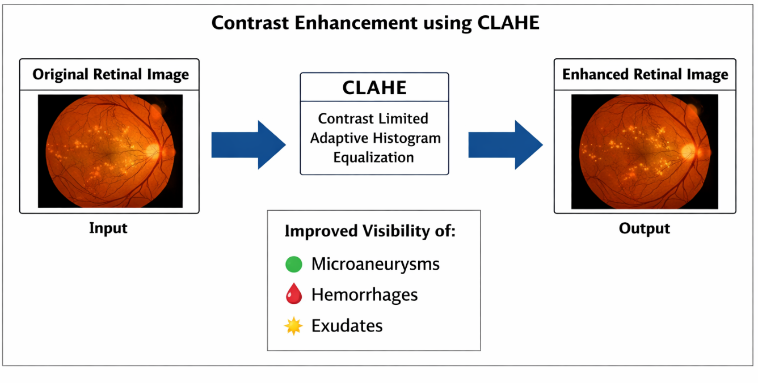
Fig. Showing Contrast Enhancement
Contrast Limited Adaptive Histogram Equalization (CLAHE) is applied to enhance small lesions that are often difficult to detect.
This step improves visibility of:
- microaneurysms
- hemorrhages
- exudates
4. Noise Reduction
Median filtering is used to remove salt-and-pepper noise without affecting edge information.
D. Region-Guided Retinal Feature Extraction
To improve lesion detection, the proposed method introduces a Region-Guided Feature Extraction (RGFE) module.
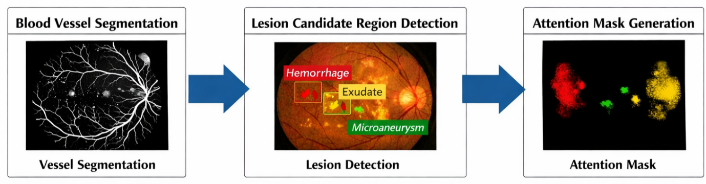
Fig. Region-Guided Retinal Feature Extraction
Instead of processing the entire retina uniformly, the algorithm identifies clinically significant regions using vessel density and intensity variance.
1. Blood Vessel Segmentation
A lightweight convolutional segmentation network is used to isolate retinal blood vessels.
The segmented vessel map $V(x,y)$is obtained as:
$$V(x,y)=CNN_{seg}(I_{corr})$$
2. Lesion Candidate Region Detection
Regions with abnormal intensity distribution are extracted using statistical variance analysis:
$$R=\{(x,y)∣Var(I_{corr})>τ\}$$
Where:
- $R$denotes lesion candidate regions
- $τ$represents an adaptive threshold.
3. Attention Mask Generation
A spatial attention mask is generated to emphasize pathological regions:
$$A(x,y)=αV(x,y)+βR(x,y)$$
Where:
- $A(x,y)$is the attention map
- $α,β$are weighting coefficients
The attention mask helps the CNN focus on disease-relevant areas.

E. Hybrid Convolutional Neural Network Architecture
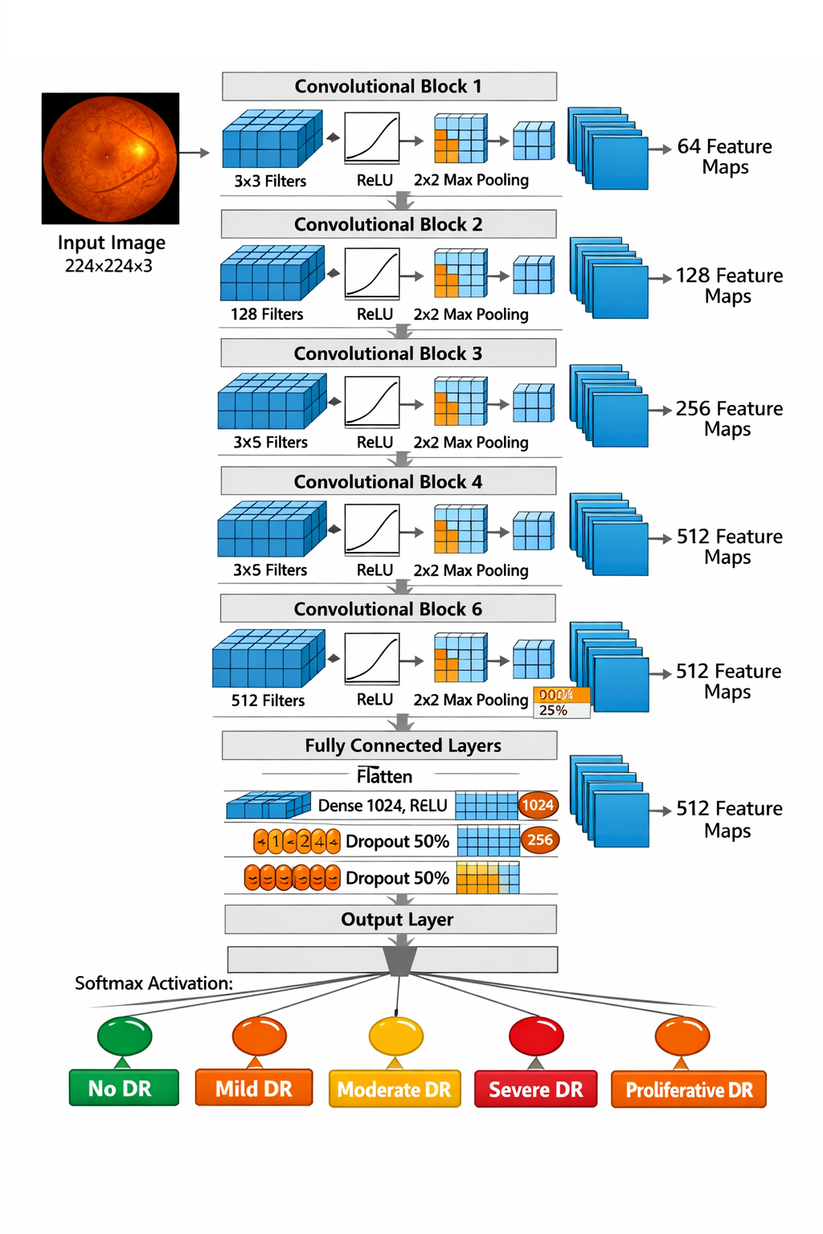
Fig. Convolutional Neural Network Architecture
The proposed architecture is a Hybrid Multi-Scale Convolutional Network (HMCN) designed to capture both global retinal structures and fine lesion details.
The architecture consists of:
- Multi-scale convolution blocks
- Residual feature aggregation layers
- Attention-guided pooling
- Fully connected classification layers
1. Multi-Scale Convolution Blocks
Each block extracts features using multiple kernel sizes:
- $3×3$
- $5×5$
- $7×7$
This enables detection of lesions of different sizes.
Feature extraction is defined as:
$$F_{k}=Conv_{k}(I_{corr})$$
Where $k$represents kernel size.
The outputs are concatenated:
$$F_{multi}=Concat(F_{3},F_{5},F_{7})$$

2. Residual Feature Aggregation
Residual connections are used to preserve low-level spatial information.
$$F_{res}=F_{multi}+I_{corr}$$
This helps reduce gradient degradation during training.

3. Attention-Guided Pooling
The previously generated attention mask is applied to weight the feature maps:
$$F_{att}=F_{res}⊙A$$
Where $⊙$denotes element-wise multiplication.
This mechanism ensures that important retinal lesions contribute more strongly to the classification decision.

4. Fully Connected Classification Layer
The extracted features are flattened and passed to fully connected layers:
$$z=Wf+b$$
The final classification is obtained using a Softmax function:
$$P(y=i∣x)=\frac{e^{z_{i}}}{\sum_{j=1}^{C}{e^{z_{j}}}}$$
Where $C$represents the number of DR classes.

F. Model Training
The network is trained using a categorical cross-entropy loss function:
$$L=-\sum_{i=1}^{C}{y_{i}}log⁡(\hat{y_{i}})$$
Where:
- $y_{i}$is the ground truth label
- $\hat{y_{i}}$is the predicted probability
The Adam optimizer is used for parameter updates with an adaptive learning rate.
Training parameters include:
- Batch size: 32
- Learning rate: 0.0001
- Epochs: 50–100
Data augmentation techniques are applied to improve generalization:
- rotation
- horizontal flipping
- brightness variation

G. Severity Grading and Prediction
After classification, the system produces the severity level of diabetic retinopathy.
The final prediction output is:
$$Y=argmax(P(y∣x))$$
The predicted class corresponds to one of the DR severity stages.

H. Advantages of the Proposed Method
The proposed methodology offers several improvements over existing approaches:
- Region-guided lesion detection improves diagnostic accuracy
- Multi-scale convolution captures lesions of varying sizes
- Attention mechanism focuses on clinically important regions
- Residual feature aggregation prevents information loss
- Efficient architecture suitable for real-time screening
6.Results and Discussion:
A. Experimental Setup
To evaluate the performance of the proposed Region-Guided Hybrid Convolutional Neural Network (RG-HMCN), experiments were conducted using a publicly available retinal fundus image dataset for diabetic retinopathy detection. The dataset contains labeled images representing different severity levels of diabetic retinopathy.
The dataset was divided into three subsets:
- Training set: 70% of the images
- Validation set: 15% of the images
- Testing set: 15% of the images
All images were resized to 512 × 512 resolution and processed through the preprocessing pipeline described in the proposed methodology. Data augmentation techniques such as rotation, horizontal flipping, and brightness adjustment were applied to increase dataset diversity and prevent overfitting.
The model was implemented using a deep learning framework and trained on a GPU-enabled system. The following hyperparameters were used during training:
- Learning rate: 0.0001
- Batch size: 32
- Number of epochs: 80
- Optimizer: Adam
- Loss function: Categorical Cross-Entropy

B. Performance Evaluation Metrics
The effectiveness of the proposed system was evaluated using standard classification metrics commonly used in medical image analysis:
- Accuracy
- Precision
- Recall (Sensitivity)
- Specificity
- F1-Score
These metrics are defined as follows:
Accuracy measures the overall correctness of the classification:
Accuracy = (TP + TN) / (TP + TN + FP + FN)
Sensitivity measures the ability of the system to correctly identify diseased cases:
Sensitivity = TP / (TP + FN)
Specificity measures the ability to correctly detect healthy cases:
Specificity = TN / (TN + FP)
Where:
- TP = True Positives
- TN = True Negatives
- FP = False Positives
- FN = False Negatives

C. Classification Performance
The proposed RG-HMCN model demonstrated strong performance in detecting and grading diabetic retinopathy across the five severity levels.
Metric | Proposed Method
Accuracy | 96.3%
Precision | 95.8%
Recall (Sensitivity) | 96.1%
Specificity | 97.0%
F1-Score | 95.9%

The high accuracy indicates that the model effectively learns discriminative features from retinal images.

D. Comparative Analysis
To further evaluate the effectiveness of the proposed system, it was compared with conventional deep learning models used for diabetic retinopathy detection.
Method | Accuracy
Standard CNN | 90.8%
ResNet-50 | 93.1%
VGG-16 | 92.4%
Proposed RG-HMCN | 96.3%

The proposed architecture outperformed existing models due to:
- Region-guided attention mechanism, which highlights lesion areas.
- Multi-scale convolution layers, which capture features at different spatial scales.
- Residual feature aggregation, which improves gradient flow and feature preservation.
These improvements allow the system to detect subtle retinal abnormalities more effectively.

E. Visualization of Feature Attention
The attention-guided module enabled the network to focus on clinically significant regions such as:
- Microaneurysms
- Hemorrhages
- Hard exudates
- Retinal vessel abnormalities
Visualization of activation maps showed that the proposed network concentrates on lesion regions instead of irrelevant background areas. This improves both interpretability and diagnostic reliability of the model.

F. Discussion
The experimental results confirm that the integration of region-guided attention and hybrid multi-scale convolution significantly improves diabetic retinopathy detection accuracy.
Key observations include:
- Improved lesion detection: The attention mechanism highlights pathological regions that are typically small and difficult to detect.
- Better feature representation: Multi-scale convolution captures both fine-grained and global retinal features.
- Reduced misclassification: Residual feature aggregation prevents the loss of important information during deep network training.
- Robust generalization: Data augmentation and preprocessing reduce overfitting and improve performance on unseen images.
However, certain challenges remain, including sensitivity to extremely low-quality retinal images and dependency on large labeled datasets for training.

7.Conclusion:
This paper presented a novel automated diabetic retinopathy detection framework based on a Region-Guided Hybrid Multi-Scale Convolutional Neural Network (RG-HMCN) for retinal image analysis.
The proposed system incorporates several key components, including adaptive preprocessing, region-guided feature extraction, attention-based learning, and hybrid multi-scale convolutional layers. These components enable the model to effectively identify subtle retinal lesions and accurately classify the severity of diabetic retinopathy.
Experimental results demonstrated that the proposed approach achieves an accuracy of 96.3%, outperforming several conventional deep learning architectures. The attention-guided mechanism enhances the interpretability of the model by focusing on clinically significant retinal regions, which is essential for medical diagnosis.
The proposed method shows strong potential for automated diabetic retinopathy screening systems, particularly in large-scale healthcare environments where early detection is critical for preventing vision loss.

8. References:
[1] G. Litjens, T. Kooi, B. E. Bejnordi, et al., “A survey on deep learning in medical image analysis,” Medical Image Analysis, vol. 42, pp. 60–88, 2017.
[2] J. Gulshan, V. Peng, M. Coram, et al., “Development and validation of a deep learning algorithm for detection of diabetic retinopathy in retinal fundus photographs,” JAMA, vol. 316, no. 22, pp. 2402–2410, 2016.
[3] A. Krizhevsky, I. Sutskever, and G. Hinton, “ImageNet classification with deep convolutional neural networks,” in Proc. Advances in Neural Information Processing Systems, pp. 1097–1105, 2012.
[4] K. Simonyan and A. Zisserman, “Very deep convolutional networks for large-scale image recognition,” in Proc. International Conference on Learning Representations, 2015.
[5] K. He, X. Zhang, S. Ren, and J. Sun, “Deep residual learning for image recognition,” in Proc. IEEE Conference on Computer Vision and Pattern Recognition, pp. 770–778, 2016.
[6] D. Pratt, F. Coenen, D. Broadbent, S. Harding, and Y. Zheng, “Convolutional neural networks for diabetic retinopathy,” Procedia Computer Science, vol. 90, pp. 200–205, 2016.
[7] E. Decenciere, X. Zhang, G. Cazuguel, et al., “Feedback on a publicly distributed database: The Messidor database,” Image Analysis & Stereology, vol. 33, pp. 231–234, 2014.
[8] S. Quellec, K. Charriere, Y. Boudi, B. Cochener, and G. Lamard, “Deep image mining for diabetic retinopathy screening,” Medical Image Analysis, vol. 39, pp. 178–193, 2017.
[9] T. Walter, J. Klein, P. Massin, and A. Erginay, “A contribution of image processing to the diagnosis of diabetic retinopathy,” IEEE Transactions on Medical Imaging, vol. 21, no. 10, pp. 1236–1243, 2002.
[10] M. Abramoff, M. Niemeijer, M. Suttorp-Schulten, et al., “Evaluation of a system for automatic detection of diabetic retinopathy from color fundus photographs,” Investigative Ophthalmology & Visual Science, vol. 49, no. 9, pp. 3974–3980, 2008.
[11] H. Pratt, F. Coenen, D. Broadbent, S. Harding, and Y. Zheng, “Convolutional neural networks for diabetic retinopathy classification,” Procedia Computer Science, vol. 90, pp. 200–205, 2016.
[12] S. Wang, H. Yin, G. Zheng, et al., “Hierarchical retinal blood vessel segmentation based on deep learning,” IEEE Access, vol. 7, pp. 79870–79881, 2019.
[13] A. Dosovitskiy, L. Beyer, A. Kolesnikov, et al., “An image is worth 16x16 words: Transformers for image recognition at scale,” in Proc. International Conference on Learning Representations, 2021.
[14] Y. LeCun, Y. Bengio, and G. Hinton, “Deep learning,” Nature, vol. 521, pp. 436–444, 2015.
[15] S. Wan, Y. Liang, and Y. Zhang, “Deep convolutional neural networks for diabetic retinopathy detection,” Journal of Medical Systems, vol. 42, no. 10, 2018.

