DEVELOPMENT AND ASSESSMENT OF A DIGITAL REGISTRAR RECORDS REQUEST SYSTEM WITH MOBILE PAYMENT AND SMS UPDATES

INTRODUCTION
Educational service units increasingly depend on digital platforms to deliver faster, more transparent, and more secure transactions. Among these units, the registrar’s office handles requests for transcripts, certifications, and other official records needed for enrollment, employment, graduation, licensure, and credential verification. When these services rely on manual procedures, requesters often experience repeated visits, longer waiting times, fragmented payment processes, and limited updates on request status (Ojo, 2020; Rashid & Rahman, 2021; Mukred et al., 2021).
Manual record handling has also been associated with document loss, delayed retrieval, weak traceability, and exposure to unauthorized access. In institutional settings where current students, alumni, and staff regularly interact with the same office, these weaknesses can reduce service efficiency and user satisfaction. Digital transformation in registrar operations is therefore a matter not only of convenience, but also of administrative control, accountability, data handling, and service responsiveness (Ojo, 2020; Rashid & Rahman, 2021; Mukred et al., 2021).
Existing studies support the use of registrar systems, online request platforms, e-payment mechanisms, and automated notifications in academic environments. Prior studies suggest that these features can improve transaction speed, accessibility, transparency, and user experience when they are properly integrated into a single service platform (Adeyemi & Akintoye, 2020; Alzahrani & Almuhanna, 2020; Anarado & Okafor, 2021; Azim & Mohamed, 2022; Wong et al., 2022). Studies on mobile payment adoption further show that perceived usefulness, transaction efficiency, trust, and convenience influence user acceptance of digitally enabled payment services (Alsulaiman, 2021; Gao et al., 2021; Lee et al., 2021; Zeng et al., 2021). However, many studies report evaluation results while providing only limited technical documentation of the developed artifact itself. As a result, readers may see favorable ratings yet remain unable to examine how the system was structured, how the modules interact, and how the assessment results relate to an actual implemented solution.
At the Bato Institute of Science and Technology, requesting school records was previously handled through a largely manual process. Requesters commonly needed to visit the campus, submit requirements, wait for status updates, and pay at the counter before the requested documents could be released. This situation also affected registrar accountability and transaction traceability because monitoring request progress and payment status required repeated manual checking. To address this service gap, a digital registrar records request system was developed with three core integrations: online records request processing, mobile payment handling, and SMS-based notification updates.
This study presents the contribution in a more defensible sequence: first, the development of a technology solution for registrar transactions; and second, the assessment of the implemented system. By documenting the system architecture, process flow, database design, interfaces, and observed evaluation results in one coherent paper, the study aligns with a technology development study followed by an assessment of the implemented artifact, consistent with prior work that treats the technical solution itself as a core scholarly contribution (Kim et al., 2020; Saha et al., 2022; Wong et al., 2022).

Study Objectives
The study aimed to develop and initially assess a digital registrar records request system with mobile payment and SMS updates. Specifically, the study sought to:
1. Develop a registrar service platform that supports account-based request filing, payment processing, and automated SMS notifications.
2. Describe the technical design of the developed system through its context diagram, process flow, architectural framework, database schema, and interface modules.
3. Assess the system in terms of ISO/IEC 25010 software quality characteristics, namely functionality, reliability, usability, efficiency, maintainability, portability, security, and compatibility.
4. Measure the performance of the developed system under test conditions using Apache JMeter.

METHODS

Research Design
The study employed a descriptive-evaluative quantitative design. The development phase focused on producing a working registrar records request system with integrated payment and SMS modules, while the assessment phase examined user ratings and observed system performance under controlled test conditions. This design was suitable because the study aimed to document the developed institutional artifact and then describe how it performed when used and tested in its implementation setting. Because the evaluation was limited to one institution and one implementation cycle, the study was designed to generate initial assessment evidence rather than final proof of generalized effectiveness.

Research Setting and Respondents
The study was conducted at the registrar’s office of the Bato Institute of Science and Technology, Brgy. Dolho, Bato, Leyte. A total of 100 respondents participated in the system evaluation, consisting of 59 students, 36 alumni, and 5 staff members. The number of respondents was based on the available user groups who participated during the initial institutional implementation period. For this initial institutional assessment, these groups were appropriate because they represented the primary requesters and the personnel directly involved in transaction monitoring and document processing.

System Development and Technical Design
The developed artifact was designed as a digital registrar records request system linking requesters, registrar personnel, payment services, SMS notification services, and a central database. The system was intended to support end-to-end transaction handling from request initiation to payment confirmation and release notification. Its major modules include user registration and login, records request filing, payment processing, SMS notification, request-status tracking, and administrative monitoring. In the present study, the system was evaluated as an implemented institutional prototype or pilot deployment within the registrar setting.
At the process level, the system begins when a student or alumnus logs in or registers, files a records request, and proceeds to payment when required. After payment, the system records the transaction, updates the request status, and sends SMS notifications to keep the requester informed. On the administrative side, registrar personnel review requests, monitor statuses, and mark documents as ready for release.
At the architectural level, the solution consists of front-end web and mobile interfaces, a backend application server, a central database, and integrations with external payment and SMS gateways. This structure supports transaction processing, notification delivery, account control, and data storage in one connected environment.
At the data level, the database schema organizes user accounts, document requests, payments, notifications, and related system logs. Foreign-key relationships and transaction records help maintain data consistency and traceability, while authentication and access restrictions support confidentiality and controlled access to registrar data.
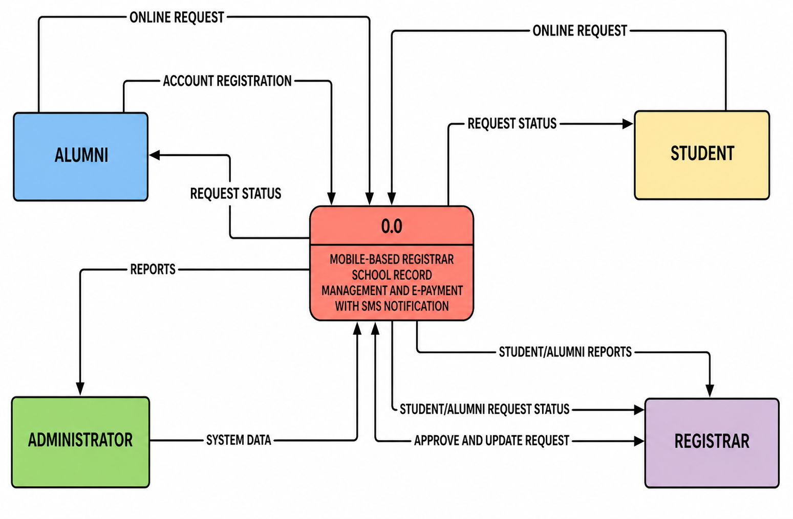
Figure 1. Context diagram of the developed system.
Figure 1 presents the external environment of the developed system. It shows the main actors that interact with the platform, including students or alumni as requesters and registrar personnel as administrative users, together with the linked payment and SMS services. The figure clarifies the system boundary and shows that the platform was designed to connect request processing, payment handling, and notification delivery in one transaction environment. It also highlights the user roles and the system’s dependence on external service connections for payment processing and message delivery.
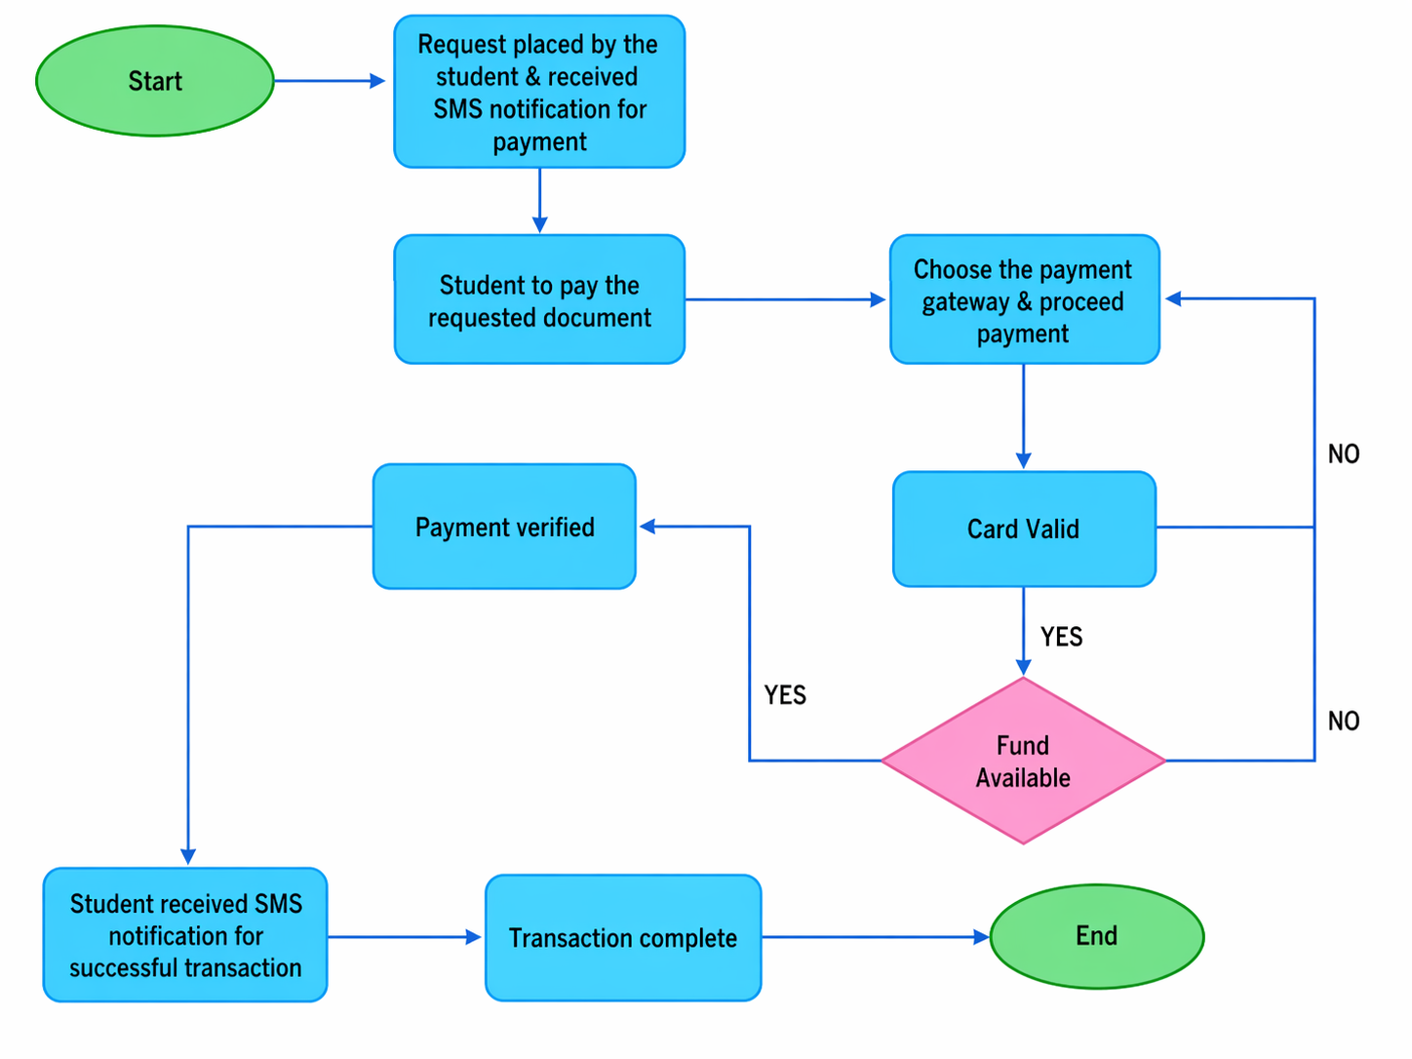
Figure 2. Payment flow chart of the developed system.
Figure 2 illustrates the sequence of payment-related activities after a records request is filed. It shows the decision flow from payment initiation to payment method selection, validation, authorization, and transaction completion. This figure supports the technical discussion by showing that payment handling was designed as a controlled process with verification steps before confirmation. As reflected in the flow, unsuccessful validation requires the user to retry with another valid payment method before the transaction can proceed.
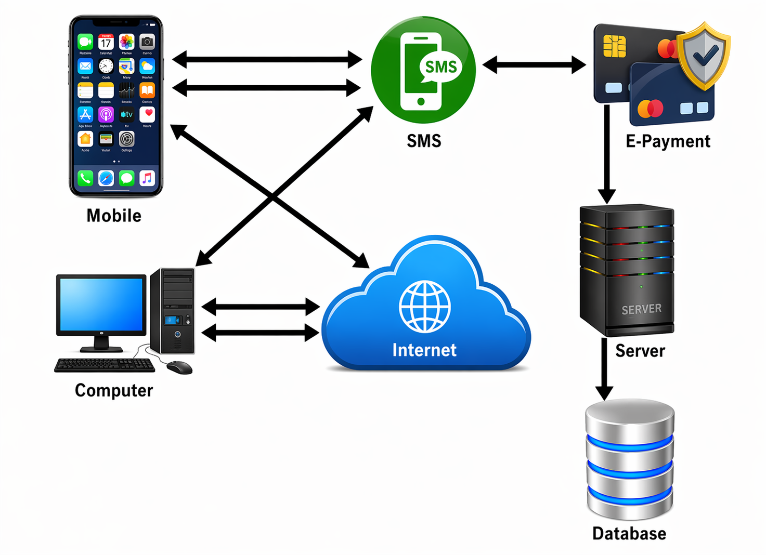
Figure 3. Architectural framework of the developed system.
Figure 3 shows the overall technical architecture of the platform. It identifies the front-end interfaces, backend application layer, database, and integrations with external payment and SMS gateways. The figure demonstrates how the major components were organized to support request filing, data storage, transaction processing, account management, and automated status updates. The modular arrangement also supports separation of functions, while the controlled backend and database layer support account security and data handling.
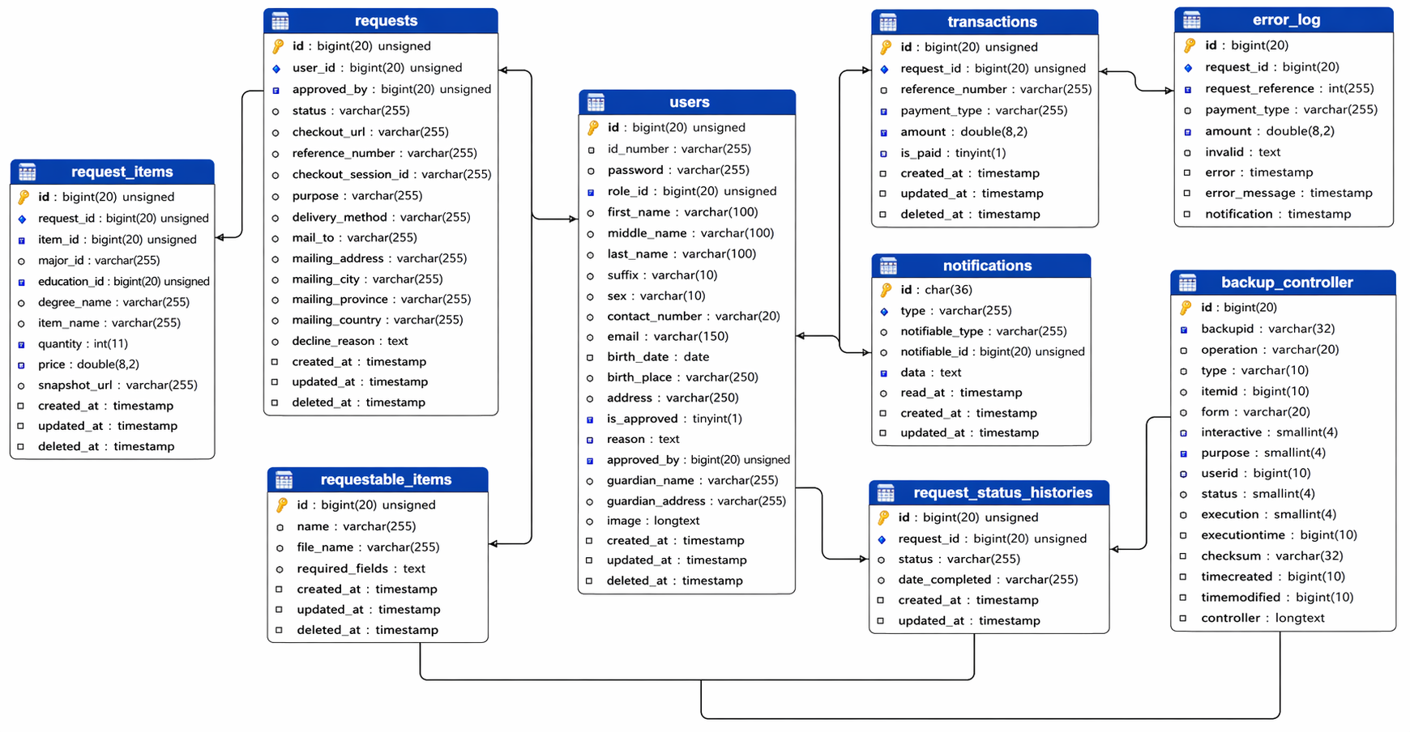
Figure 4. Database schema of the developed system.
Figure 4 presents the logical data structure of the system. It shows the key tables and relationships used to store user accounts, document requests, payments, notifications, and related records. This figure supports the technology-development contribution of the study by showing that the system was built on a structured and traceable data model rather than on isolated interface screens alone. In particular, the schema links user records with request and payment tables, allowing request status and transaction history to be tracked across the workflow.
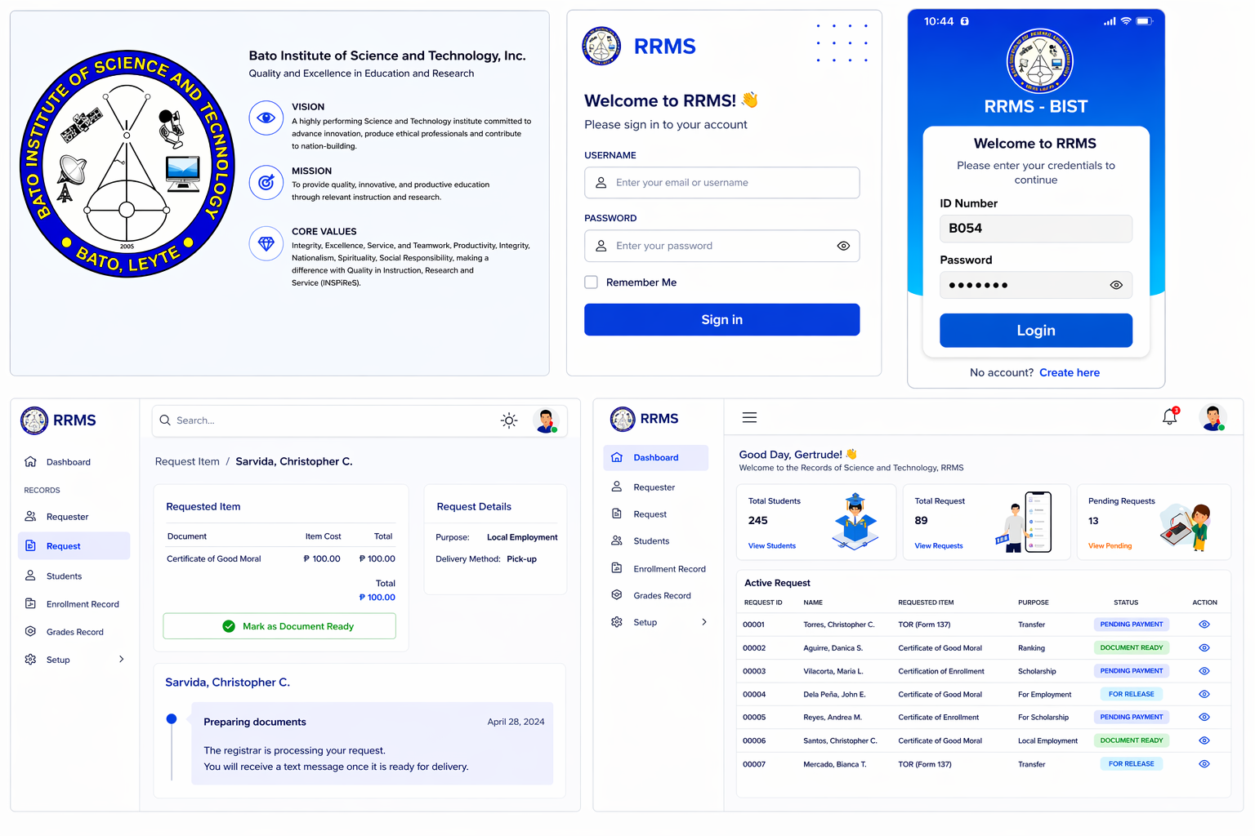
Figure 5. Sample interfaces: web login, mobile login, request status, and registrar dashboard.
Figure 5 displays selected interface outputs from the developed platform, including access screens and monitoring views for users and administrators. The web login, mobile login, and request-status screens represent user-facing interfaces, while the registrar dashboard represents the administrator-facing interface for monitoring and oversight. These interface samples provide visual evidence that the artifact progressed beyond conceptual design into an operationally usable implementation.
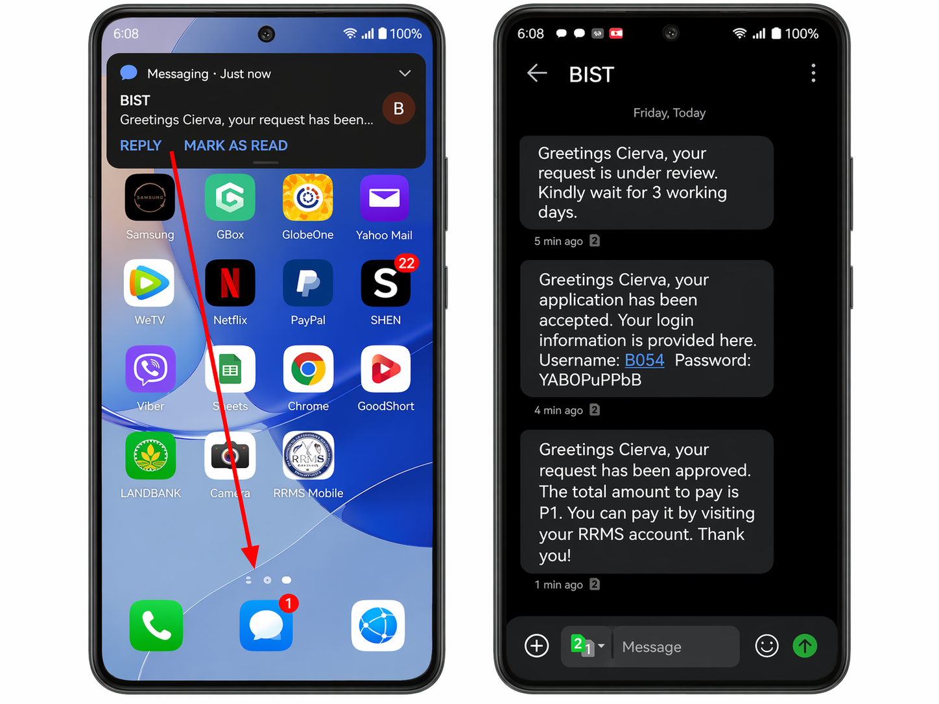
Figure 6. SMS notification update screen.
Figure 6 shows the SMS-based update feature of the system. It illustrates how requesters receive status-related messages after key transaction events, such as request confirmation, payment confirmation, or document availability. The figure supports the claim that the system includes an automated communication layer intended to improve transparency and reduce uncertainty during processing.
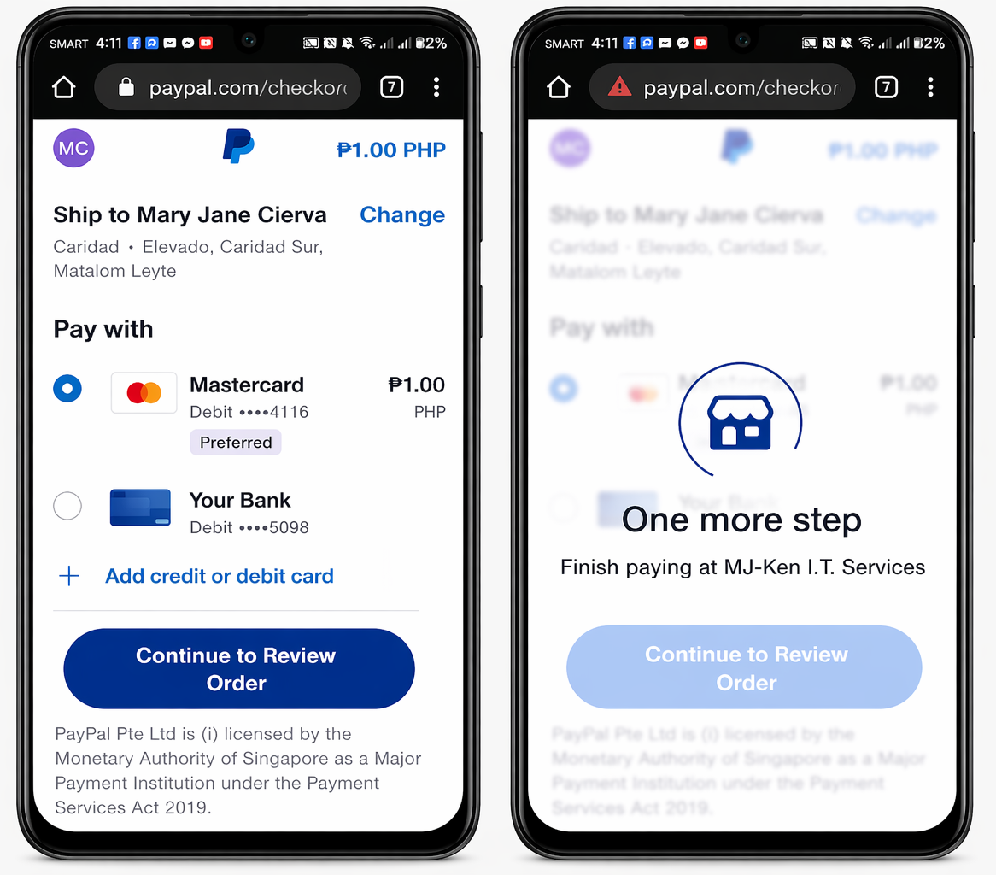
Figure 7. Payment interface through PayPal.
Figure 7 presents the payment interface used for digital transaction processing. It shows that the system was linked to an external payment service to support electronic settlement of records-related fees. In this study, the PayPal interface formed part of the implemented payment module demonstrated during the pilot institutional use of the system. This is important to the development section because it demonstrates actual payment integration as part of the implemented registrar solution.

Instrument
The primary evaluation instrument was a structured questionnaire based on ISO/IEC 25010 software quality dimensions. The questionnaire covered functionality, reliability, usability, efficiency, maintainability, portability, security, and compatibility. The indicators were adapted from ISO/IEC 25010-aligned software evaluation criteria used in related system-assessment studies and were checked for alignment with the objectives of the present study before administration. Each indicator was rated using a five-point scale: 5 - Excellent, 4 - Very Good, 3 - Good, 2 - Fair, and 1 - Poor.

Data Collection Procedure
Respondents were first allowed to access and use the developed system through its available interfaces. They performed actual system tasks such as logging in, filing requests, viewing request status, and navigating the user and administrative modules. Payment-related actions were either completed within the working payment interface or simulated when the transaction step was being demonstrated for evaluation purposes. After system use, they answered the evaluation questionnaire. In addition, Apache JMeter was used to examine response time, percentile response distribution, throughput, and error rate under concurrent request conditions.

Data Analysis
Frequency counts, percentages, and weighted mean were used to summarize the software quality evaluation results. Weighted mean values were interpreted using the study’s five-point scale, where values closest to 5 indicated Excellent performance. JMeter aggregate metrics were used to describe observed system performance, particularly average response time, median response time, percentile lines, throughput, and error percentage. Because the study was conducted in a single institutional setting, the findings were interpreted as context-bound assessment evidence rather than as a basis for broad generalization.

RESULTS AND DISCUSSION

Developed System Artifact
The study first presents evidence that a concrete technology artifact was produced. The context diagram indicates that the system mediates transactions among requesters, registrar personnel, payment services, and notification services. The payment flow and architectural framework likewise show that the system was designed as an integrated service platform rather than as a stand-alone request form or isolated prototype, which is consistent with prior records and academic request system studies that emphasize end-to-end integration of service modules (Kim et al., 2020; Saha et al., 2022; Wong et al., 2022).
The database schema and interface screenshots further support the technology-development contribution of the study. These technical outputs show that the system contains persistent data structures, role-based transactions, and user-facing modules for operational use and administrative monitoring. Presenting these elements before the assessment results strengthens the manuscript's alignment with technology development followed by assessment and helps prevent conclusions from resting on user ratings alone (Mukred et al., 2021; Saha et al., 2022).

Software Quality Assessment
Table 1. Summary of ISO/IEC 25010 evaluation results
Quality Characteristic | Weighted Mean | Interpretation
Functionality | 4.86 | Excellent
Reliability | 4.87 | Excellent
Usability | 4.86 | Excellent
Efficiency | 4.89 | Excellent
Maintainability | 4.87 | Excellent
Portability | 4.87 | Excellent
Security | 4.88 | Excellent
Compatibility | 4.89 | Excellent
Overall | 4.87 | Excellent
Table 1 shows that all eight ISO/IEC 25010 dimensions received excellent mean ratings. Efficiency and compatibility obtained the highest means at 4.89, followed by security at 4.88, while the remaining dimensions ranged from 4.86 to 4.87. These results indicate favorable user evaluation of the developed system within the implementation site, consistent with the caution commonly applied in single-site software evaluation studies (Azim & Mohamed, 2022; Bargas-Avila et al., 2020; Wong et al., 2022).
Functionality obtained a mean of 4.86, indicating that respondents generally perceived the system as capable of performing required tasks and producing expected outputs. Reliability and maintainability both received means of 4.87, suggesting that the system was viewed as dependable and manageable within the evaluated environment. These dimensions are important in registrar and records management settings because systems must support accurate transactions while remaining stable and maintainable over time (Adeyemi & Akintoye, 2020; Mukred et al., 2021; Saha et al., 2022).
Usability was also rated highly, indicating that respondents were generally able to learn and use the system with limited effort. Security and compatibility ratings remained strong, suggesting that authentication, access control, and information exchange functions were acceptable to users during implementation. This interpretation is consistent with usability and digital service research emphasizing learnability, interface clarity, trust, and integration as important elements of system acceptance (Azim & Mohamed, 2022; Bargas-Avila et al., 2020; Zeng et al., 2021).
Table 2. Performance of the system in terms of functionality
Items | E | V | G | F | P | Mean | Interpretation
The system performs the tasks required. | 90 | 6 | 4 | 0 | 0 | 4.86 | Excellent
The result is as expected. | 89 | 7 | 4 | 0 | 0 | 4.85 | Excellent
The system interacts with another system. | 88 | 8 | 4 | 0 | 0 | 4.84 | Excellent
The system prevents unauthorized access. | 90 | 7 | 3 | 0 | 0 | 4.87 | Excellent
Average |  |  |  |  |  | 4.86 | Excellent
Table 2 shows an overall mean of 4.86 (Excellent), indicating that respondents perceived the system as able to perform required tasks, generate expected results, interact with other systems, and prevent unauthorized access. Among the indicators, “The system prevents unauthorized access” obtained the highest mean (4.87), while “The system interacts with another system” received the lowest, though still excellent, mean (4.84). These results indicate confidence in the system’s core operations and control mechanisms. In a registrar context, this matters because the platform must process requests accurately while connecting with payment and notification services. This result agrees with studies on digital registrar and records platforms showing that integrated systems improve service delivery when functional requirements are clearly met and core services are linked in one workflow (Adeyemi & Akintoye, 2020; Alzahrani & Almuhanna, 2020; Anarado & Okafor, 2021).

Table 3. Performance of the system in terms of reliability
Items | E | V | G | F | P | Mean | Interpretation
The system shows minimal observable faults during current use. | 90 | 6 | 4 | 0 | 0 | 4.86 | Excellent
The system is capable of handling errors. | 90 | 8 | 2 | 0 | 0 | 4.88 | Excellent
The system needs to notify the user about the wrong data entry. | 90 | 8 | 2 | 0 | 0 | 4.88 | Excellent
The software resumes working and restores lost data after a failure. | 90 | 7 | 3 | 0 | 0 | 4.87 | Excellent
Average |  |  |  |  |  | 4.87 | Excellent
Table 3 yielded an average mean of 4.87 (Excellent), with the highest means found in “The system is capable of handling errors” and “The system needs to notify the user about the wrong data entry,” both at 4.88. The remaining indicators also stayed within the excellent range. These findings suggest that the respondents viewed the system as stable and dependable during use, particularly in terms of error handling and user feedback. Reliability is a critical quality dimension in record-management environments because document requests, payment status, and release updates require dependable processing and continuity. This interpretation is supported by research on electronic records management systems, which notes that system dependability, recoverability, and controlled data handling are central to institutional confidence in digital record platforms (Mukred et al., 2021; Saha et al., 2022).
Table 4. Performance of the system in terms of usability
Items | E | V | G | F | P | Mean | Interpretation
The user comprehends how to use the system quickly. | 92 | 6 | 2 | 0 | 0 | 4.90 | Excellent
The user learns to use the system quickly. | 91 | 7 | 2 | 0 | 0 | 4.89 | Excellent
The user utilizes the system without much effort. | 90 | 7 | 3 | 0 | 0 | 4.87 | Excellent
The system's interface looks good. | 82 | 14 | 4 | 0 | 0 | 4.78 | Excellent
Average |  |  |  |  |  | 4.86 | Excellent
Table 4 shows an average mean of 4.86 (Excellent). The highest-rated item was “The user comprehends how to use the system quickly” (4.90), followed by “The user learns to use the system quickly” (4.89). The lowest-rated item was “The system’s interface looks good” (4.78), although it still fell within the excellent range. This pattern suggests that the system was perceived as easy to understand and easy to learn, but that interface appearance may still offer room for refinement compared with the system’s operational ease of use. This is a useful finding because in technology-development studies, usability is not limited to visual appeal; it also includes how quickly users can understand tasks and complete them with minimal effort. Related usability studies emphasize that positive user experience is strongly tied to effectiveness, ease of learning, and low interaction effort, while visual design contributes to acceptance but does not alone determine usability quality (Azim & Mohamed, 2022; Bargas-Avila et al., 2020).
Table 5. Performance of the system in terms of efficiency
Items | E | V | G | F | P | Mean | Interpretation
The system responds quickly to the user. | 91 | 7 | 2 | 0 | 0 | 4.89 | Excellent
The system's execution time is appropriate. | 91 | 7 | 2 | 0 | 0 | 4.89 | Excellent
The software utilizes resources efficiently. | 91 | 6 | 3 | 0 | 0 | 4.88 | Excellent
Average |  |  |  |  |  | 4.89 | Excellent
Table 5 obtained the highest average mean among the dimensions, 4.89 (Excellent). “The system responds quickly to the user” and “The system’s execution time is appropriate” both recorded 4.89, while resource utilization received 4.88. These results indicate that respondents perceived the system as responsive and technically efficient during actual use. For a registrar records request system, efficiency is particularly important because users expect timely task completion during login, request filing, payment confirmation, and status checking. This user-rated efficiency is consistent with the JMeter results, which also showed acceptable response times and minimal overall error during testing. The result aligns with studies on online academic request systems and mobile payment use in higher education, which show that speed, performance expectancy, and low effort are important to positive system acceptance and continued use (Alsulaiman, 2021; Gao et al., 2021; Lee et al., 2021; Wong et al., 2022).
Table 6. Performance of the system in terms of maintainability
Items | E | V | G | F | P | Mean | Interpretation
The system faults can be easily diagnosed. | 90 | 8 | 2 | 0 | 0 | 4.88 | Excellent
The system continues functioning when changes are made. | 90 | 7 | 3 | 0 | 0 | 4.87 | Excellent
The software can be tested quickly. | 90 | 7 | 3 | 0 | 0 | 4.87 | Excellent
Average |  |  |  |  |  | 4.87 | Excellent
Table 6 shows an average mean of 4.87 (Excellent), with the highest score given to “The system faults can be easily diagnosed” (4.88). The indicators on continuous functioning during changes and quick testing both obtained 4.87. These results imply that the system was viewed not only as usable by end-users, but also as manageable from a technical perspective. In this study, maintainability should be understood as perceived maintainability based on the implemented system and its observable operation, rather than as long-term maintenance evidence gathered across multiple release cycles. This interpretation is consistent with prior records-management studies that emphasize the importance of sustainable system operation, coherent data structures, and ongoing administrative control in digital record environments (Mukred et al., 2021; Saha et al., 2022).
Table 7. Performance of the system in terms of portability
Items | E | V | G | F | P | Mean | Interpretation
The system can be moved to other environments. | 89 | 8 | 3 | 0 | 0 | 4.86 | Excellent
The software can be installed easily. | 90 | 7 | 3 | 0 | 0 | 4.87 | Excellent
Average |  |  |  |  |  | 4.87 | Excellent
Table 7 also produced an average mean of 4.87 (Excellent). Respondents rated “The software can be installed easily” slightly higher (4.87) than “The system can be moved to other environments” (4.86). This suggests that users viewed the current implementation as deployable and adaptable, although the evidence still comes from a single-site environment. The findings indicate that the developed system was perceived as transferable in principle, but broader portability claims would still require validation across actual multiple devices, platforms, and institutional settings. This cautious interpretation is appropriate for development-and-assessment studies, where early portability ratings indicate promise but do not replace cross-environment validation (Kim et al., 2020; Saha et al., 2022).
Table 8. Performance of the system in terms of security
Items | E | V | G | F | P | Mean | Interpretation
The software ensures the confidentiality of data. | 90 | 7 | 3 | 0 | 0 | 4.87 | Excellent
The software prevents unauthorized access and modification to programs and data. | 90 | 8 | 2 | 0 | 0 | 4.88 | Excellent
The software requires the authentication of users. | 90 | 8 | 2 | 0 | 0 | 4.88 | Excellent
A system log is maintained. | 90 | 7 | 3 | 0 | 0 | 4.87 | Excellent
Average |  |  |  |  |  | 4.88 | Excellent
Table 8 yielded an average mean of 4.88 (Excellent), making it one of the strongest-performing dimensions. The indicators on preventing unauthorized access and requiring authentication both obtained 4.88, while confidentiality and system logging each received 4.87. These results suggest that respondents recognized the importance of access control, user authentication, and data protection in the developed system. This is especially significant in registrar operations because academic records and payment-related transactions involve sensitive personal and institutional information. The result is consistent with studies on electronic records systems and payment-related technologies, which highlight security, trust, and controlled access as central conditions for acceptance and effective digital service delivery. In this study, the security result reflects perceived security and the presence of implemented controls rather than formal penetration testing (Mukred et al., 2021; Rashid & Rahman, 2021; Zeng et al., 2021).
Table 9. Performance of the system in terms of compatibility
Items | E | V | G | F | P | Mean | Interpretation
The software performs required functions while sharing the same environment and resources. | 91 | 5 | 4 | 0 | 0 | 4.87 | Excellent
The software allows two or more systems or components to exchange and use information. | 92 | 6 | 2 | 0 | 0 | 4.90 | Excellent
Average |  |  |  |  |  | 4.89 | Excellent
Table 9 obtained an average mean of 4.89 (Excellent), tied with efficiency as the highest-rated dimension. The item on allowing “two or more systems or components to exchange and use information” received the highest mean (4.90), while the item on performing required functions in a shared environment obtained 4.87. This suggests that respondents positively evaluated the system’s ability to work with related modules and exchange information across components. In the developed artifact, compatibility is central because the registrar request workflow depends on interaction among user accounts, payment services, SMS notification processes, and administrative monitoring tools. The result supports the technical framing of the study as an integrated platform rather than a stand-alone records tool. Prior studies on registrar and digital service systems similarly show that integration across modules improves workflow continuity, transaction monitoring, and service accessibility (Alshurideh et al., 2021; Anarado & Okafor, 2021; Wong et al., 2022).
The findings indicate that the developed digital registrar records request system was positively evaluated across functional, operational, and technical quality dimensions. The strongest dimensions, efficiency and compatibility, suggest that the artifact’s integrated design was one of its main strengths, while the usability results indicate that interface appearance may still be refined even though learnability and ease of use were already rated highly. These results support the argument that the study contributes first as a technology development paper, since it produced an integrated registrar artifact, and second as an assessment paper, since user ratings provide evidence that the developed system was acceptable within the implementation site. Still, the uniformly high scores should be interpreted with restraint as support for the system’s early technical promise rather than as final proof of generalized effectiveness (Bargas-Avila et al., 2020; Mukred et al., 2021; Wong et al., 2022).

Performance Test Results
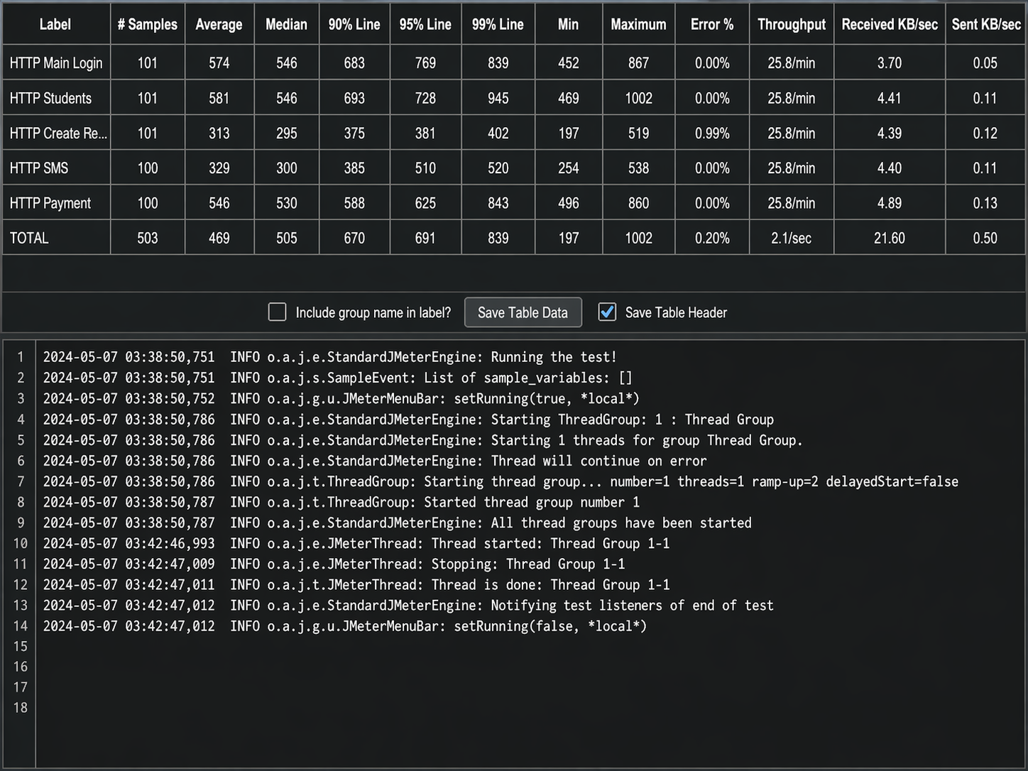
Figure 8. Apache JMeter aggregate report listener for the developed system.
Figure 8 presents the JMeter aggregate report generated during system testing. The figure summarizes module-level and overall performance metrics such as sample count, response time, throughput, and error percentage. It is included as assessment evidence to show the observed behavior of the developed system under the test conditions used in the study.
Performance testing through Apache JMeter showed that the developed system handled its core modules with acceptable speed and minimal observed errors during the test run. Average response times ranged from 313 ms to 581 ms across the major modules, with Create Request recording the lowest average response time and the Students module recording the highest. Based on the available aggregate report, the assessment covered 503 processed samples across the tested modules, although more detailed run descriptors such as virtual-user count and test duration were not reported in the manuscript source.
The aggregate test processed 503 samples, with an overall average response time of 469 ms, median of 505 ms, 90th percentile of 670 ms, 95th percentile of 691 ms, and 99th percentile of 839 ms. The observed throughput was 2.1 requests per second, and the overall error rate was 0.20%. Most modules recorded 0.00% error, while Create Request showed a minimal 0.99% error rate.
These results provide preliminary performance evidence that the system can support expected registrar transactions in the tested environment. However, the test results should not be treated as conclusive proof of scalability across other deployment settings without repeated stress, load, and field-based validation. This interpretation is consistent with the broader study on payment-enabled and service-oriented digital systems, where favorable initial test metrics are treated as early evidence of operational promise rather than final proof of deployment-wide robustness (Zeng et al., 2021; Wong et al., 2022).

Implications of the Findings
The findings suggest that the developed system has practical value as a digital alternative to manual registrar procedures within the study site. Its integrated request, payment, and notification features may help reduce procedural fragmentation, improve transaction monitoring, lessen the need for repeated manual follow-up in the registrar workflow, and reduce part of the clerical workload of registrar personnel. The technical documentation included in the study also strengthens the claim that the study contributes an implemented technology artifact, not merely a user survey of a proposed idea (Mukred et al., 2021; Wong et al., 2022).
At the same time, the present evidence should be interpreted cautiously. The results are better viewed as initial institutional evidence supporting the artifact’s usability and operational promise. Broader claims about effectiveness or transferability require further validation in other institutions and under wider deployment conditions, as also implied in earlier work on digital records and online request systems (Kim et al., 2020; Saha et al., 2022; Wong et al., 2022).

CONCLUSION
This study documented both the development and the assessment of a digital registrar records request system with mobile payment and SMS updates. By presenting the technical design alongside the software quality and performance results, the study more clearly aligns with a technology development followed by assessment framework.
The system received excellent user ratings across all assessed ISO/IEC 25010 dimensions and showed acceptable observed performance during JMeter testing. Within the implementation site, these results indicate that the artifact was operationally acceptable for registrar-related transactions at the time of evaluation. However, the present evidence is still best treated as support for institutional acceptability and initial technical viability rather than as final confirmation of effectiveness across wider deployment conditions.
The evidence remains bounded by one institution, one implementation context, and one cycle of evaluation. Accordingly, the study supports a claim of institutional acceptability and initial technical viability rather than a final claim of generalized effectiveness.

RECOMMENDATIONS
In view of the study findings, the following recommendations are offered to support the continued implementation of the developed system, improve its technical validation, and guide future development and wider assessment across other settings.
1. Sustain the system implementation at the institutional level while conducting routine post-deployment monitoring of response time, transaction errors, and message delivery status.
2. Strengthen the technical evaluation through repeated performance tests, stress testing, security testing, and compatibility checks across additional devices and deployment environments.
3. Expand future assessment to multiple institutions or campuses to determine whether the observed results remain consistent outside the original implementation site.
4. Enhance the platform through broader payment options, stronger reporting analytics, and cross-platform optimization, including additional testing for iOS and other environments.

Declaration of Generative AI and AI-assisted Technologies in the Manuscript Preparation Process
During the preparation of this work, the authors used ChatGPT to assist with academic checking, language refinement, and manuscript organization. After using this tool, the authors reviewed and edited the content as needed and take full responsibility for the final content of the manuscript.

REFERENCES
Adeyemi, B., & Akintoye, I. R. (2020). Development and usability evaluation of a school registrar system with e-payment and SMS notification. International Journal of Interactive Mobile Technologies, 14(13), 41-58. https://doi.org/10.3991/ijim.v14i13.12608
Alsulaiman, Z. (2021). Investigating the influence of mobile payment system characteristics on customer satisfaction and adoption. Computers in Human Behavior, 114, 106531. https://doi.org/10.1016/j.chb.2020.106531
Alshurideh, M., Alqudah, M., Alrawashedh, M., & Alhammad, F. (2021). Examining the role of mobile-based school records online request in improving the efficiency of school management. International Journal of Interactive Mobile Technologies, 15(1), 9-20. https://doi.org/10.3991/ijim.v15.i1.12191
Alzahrani, A., & Almuhanna, E. (2020). Development and evaluation of an online school registrar system with e-payment and SMS notification. International Journal of Emerging Technologies in Learning, 15(21), 177-189. https://doi.org/10.3991/ijet.v15i21.11956
Anarado, E. N., & Okafor, C. E. (2021). Development and evaluation of an integrated school registrar system with SMS notification and e-payment. International Journal of Advanced Computer Science and Applications, 12(4), 115-129. https://doi.org/10.14569/IJACSA.2021.0120415
Azim, A., & Mohamed, M. (2022). An online school registrar system with integrated e-payment and SMS notification: A usability study. Journal of Physics: Conference Series, 1930(1), 012035. https://doi.org/10.1088/1742-6596/1930/1/012035
Bargas-Avila, J. A., Alcaniz Raya, M., & Schwarz, M. (2020). User experience evaluation: Definitions, concepts and methods. In Design, User Experience, and Usability. Practice and Case Studies (pp. 3-16). Springer. https://doi.org/10.1007/978-3-030-49161-1_1
Gao, X., Ma, J., & Wu, Y. (2021). User adoption of mobile payment in higher education: An extension of the UTAUT model. Telematics and Informatics, 64, 101598. https://doi.org/10.1016/j.tele.2021.101598
Kim, J., Park, Y., Yeom, D., & Lee, J. (2020). A smartphone-based platform for online requests of academic records using blockchain technology. International Journal of Information Management, 52, 102067. https://doi.org/10.1016/j.ijinfomgt.2019.102067
Lee, J., Kim, H., Lee, D., & Lee, K. (2021). Mobile payment usage tendency by grade of education: middle, high, and university students. Informatics, 8(2), 31. https://doi.org/10.3390/informatics8020031
Mukred, M., Yusof, Z., Al-Moallemi, W., Mokhtar, U., & Hawash, B. (2021). Electronic records management systems and the competency of educational institutions. Journal of Information Science, 47(4), 565-584. https://doi.org/10.1177/0165551520927399
Ojo, T. (2020). Challenges of manual record keeping in Nigerian secondary schools: An empirical study of Lagos State. Library Philosophy and Practice, 1-16.
Rashid, M. A., & Rahman, M. S. (2021). Security challenges of manual record keeping in higher education institutions of Bangladesh. Journal of Information Security, 12(3), 173-187.
Saha, S., Pal, U., & Roy, S. (2022). A secure digital solution for schools: a case study on the development of a mobile-based student records management system. International Journal of Information Technology, 14, 2363-2372.
Wong, W. C., Lam, W. H., & Yuen, K. L. (2022). An online academic record request and e-payment system for higher education institutions. Journal of Computing in Higher Education, 34(1), 73-90. https://doi.org/10.1007/s12528-021-09293-3
Zeng, J., Yu, J., & Xiao, J. (2021). Design and Implementation of an Electronic Payment Gateway System. In 2021 5th International Conference on Advances in Computing and Communication Engineering (ICACCE) (pp. 54-58). IEEE. https://doi.org/10.1109/ICACCE52808.2021.9501384

