ENZYMATIC GENERATION OF FLAVOURS IN MEAT PRODUCTS
Shreya Sharma (PGD202451078) {Enzymes in Food Processing (CSU1624)}
Mail ID: Shreyabjt05@gmail.com

Abstract
According to the food laws in different countries it has been recognized that the natural flavors and flavor materials can be obtained through biotechnology. However, some of the conditions have to be guaranteed as in case of naturalness of the final product, which would only be possible by the food commodity if the raw materials used is obtained by natural and only physical processes permitted for the isolation and purification of the materials. Classic example of such physical processes are extraction, distillation and crystallization. According to the consumers, “label-friendly” products and the development of “bio-mediated” tools, like the use of living microorganisms like microbes, fungi and enzymes include new processes for the generation of flavors. Nowadays, many scientific studies demonstrate the do-ability of producing individual flavor compounds or the complex flavor preparations by fermentation or enzymatic reactions. Fermented sausages are traditional staples that have been crafted for hundreds of years, with recipes and methods passed down through families. In modern times, the shift from traditional "wild" fermentation to the use of microbial starter cultures has revolutionized the industry. These starters ensure that every batch of sausage is consistent in quality and, more importantly, safe to consume. Our understanding of the tiny organisms and enzymes behind this process has exploded over the last few decades. By studying how these biological catalysts work, scientists have been able to improve the overall taste, smell, and texture of the meat. Dry-cured meats usually require a lengthy aging process to develop their characteristic profile. During this time, proteins and fats break down into simpler components like amino acids and fatty acids. These components then undergo further changes to become aromatic volatiles, the molecules we perceive as flavor and scent.
Two main pathways create these flavors: Microbial Transformation, bacteria and fungi "eating" and converting meat components.
Chemical Reactions like the Maillard reaction, which is a complex interaction between sugars and amino acids.
A common misconception is that simply adding more protein-breaking enzymes (proteinases) or fat-breaking enzymes (lipases) will make the sausage age faster. However, this doesn't work because flavor isn't just about breaking things down, it’s about the secondary step where those broken-down pieces turn into volatile compounds like esters, alcohols, and ketones. To make the process faster, producers use some special starter culture or extracts from the mold like Mucor racemosus. These trigger the production of ammonia and some other aromatic compounds, giving sausage a great flavour in a spur of time.
Most of the flavour development in meat is due to the enzymes through meat itself like the muscle enzymes, peptidases and lipases and also through microorganisms like bacteria and mold introduced during processing. The effectiveness of meat enzymes is not always constant, it varies due to some of the reasons like the age and breed of the animal, environment given to the meat during its processing like temperature, osmotic levels, moisture which may increase the water activity and ultimately affects the overall quality of the meat etc. The flavour game in meat production requires a delicate balance. By controlling these enzymatic reactions, manufacturers can standardize their products and ensure that every product has a perfect, high-quality cured taste.

Introduction
Due to the climate change, soil erosion and human involvement there is a steady decrease in the agricultural areas. The growth of the human population drastically increases the agro-industrial productivity. The natural genetic diversity is intensively exploited and transgenic plants surviving on different soils and at warmer conditions will contribute remedies (Rhlid et al., 2018). This trend is clashing with consumers demand for more naturalness when it comes to food and food flavors. So, it has been studied that the naturalness has been classified in three categories. First, how the food has been grown, e.g. food origin (organic, local). Second, different steps involved in the production of food, e.g. what all technologies have been used and what ingredients have been used (free from undesirable compounds such as additives, artificial flavors, preservatives, etc.), presence of natural ingredients, slightly processed and the use of traditional methods. Third, what are the properties of the final product and its role, e.g. healthy, eco-friendly, sustainable, tasty and fresh (Roman et al., 2017). There are several options and opportunities in food industry to build insight towards naturalness and sustainability and to move towards the healthier options which would protect an individual’s body (Rhlid et al., 2018).
Flavour is an important taste component of beef to consumers and in the late 1800s, efforts were done to improve beef flavour in a controlled manner (Kerth and Miller, 2015). It basically comprises of taste and aroma and is involved in the consumer perception of buying it and their preferences regarding it (Jayasena et al., 2013). Meat in composed of proteins, lipids, water, carbohydrates, vitamins and minerals, out of which proteins, lipids and carbohydrates play major role which when upon heating produces distinct flavours(Mottram, 1998). Various compounds have different threshold for the generation of flavours as they have different tastes and odours. Sweet flavour in meat is derived from carbohydrates like glucose, sugars, amino acids and the presence of organic acids. The sour flavour arises when the amino acids reacts with organic acids. In addition, some flavour compounds are regarded as ‘acceptable flavour’, such as the fried meat flavour derived from the Maillard reaction between amino acids and carbohydrates and from the breakdown of lipids (Aaslyng and Meinert, 2017). Flavour generation is not just a two-step process and does not happen all at once. It follows some specific hierarchy given below (Fig. 1):
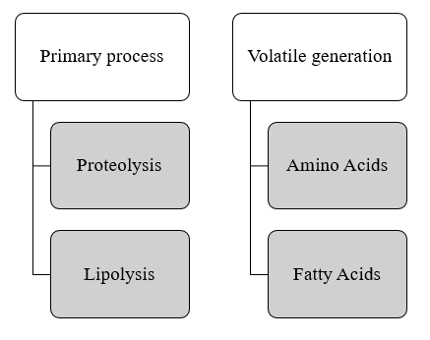
Fig. 1
- Primary proteolysis and lipolysis: Proteinases and lipases act like scissors. They cut long chains of proteins into amino acids and fats into free fatty acids. Adding these enzymes make the meat soft and flavorful.
- Volatile generation: The amino acids and the fatty acids must be converted into volatiles. Amino acids turn into esters and alcohols, whereas, fatty acids turn into aldehydes and
ketones. A chemical browning known as the Maillard reaction (reaction shown below), is a reaction between sugars and proteins that creates nutty and savory flavour notes.
Meat aging is a combination of modifications that start in the animal’s muscle immediately after slaughter, resulting in colour change, tenderness and a distinct aroma (Lonergan et al., 2018). The biochemical processes occurring during meat aging are mainly proceeded by endogenous enzymes, which leads to glycolysis, proteolysis and lipolysis. In the glycolysis reactions, glucose is used-up to produce lactic acid, which lowers muscle pH and decreases the energy reserves (ATP). The depletion in energy leads to the degradation or breakdown of myofibrillar proteins by the action of endopeptidases and by exopeptidases. Endogenous proteases (calpains, cathepsins and calpastatin) play a very important role in the proteolysis of meat, yet, exogenous proteases (peptidyl peptidases, aminopeptidases and carboxypeptidases) secreted from microorganisms involved in meat fermentation also helps in contributing the increase in concentration of peptides and amino acids (Wang et al., 2022). Lipolysis in the muscle and the adipose tissue is another reaction which takes place during the meat aging (Tatiyaborworntham et al., 2022). Flavour development in meat is a complex process. Normally, development of flavor compounds is a result from either enzymatic action or chemical reactions, for example lipid oxidation, Millard reactions (Fig. 2), Strecker degradations, (Fig. 3) etc. Organoleptic properties of the meat affected by the post mortem changes are mainly due to the enzymatic actions. These enzymatic reactions that occur at a low reaction rates takes place in the transformation of muscle to meat and affected by numerous internal factors like animal’s age, breed, sex and the feeding habits and extrinsic factors such as temperature, animal welfare, transport, stress, etc. (Abril et al., 2023). Myofibrillar protein (MP, 50%) and sarcoplasmic protein (SP, 30%), are the meat proteins which are rich in lysine and various essential amino acids that are easily and readily digestible and absorbed by the body, which is an important factor and criteria in contributing to the quality properties of fermented meat products (Bohrer, 2017).
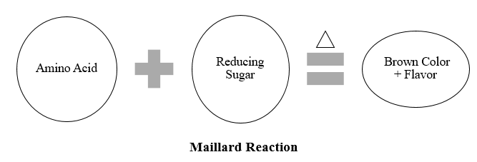
Fig. 2
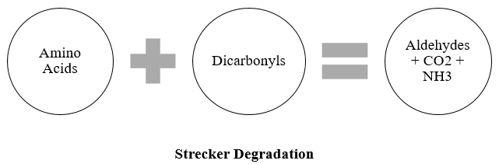
Fig. 3

Endogenous enzymes promotes the hydrolysis of protein (Berardo et al., 2017). It has been started by the build-up of peptides and amino acids during ripening of fermented meats, which influences the flavour development and texture softening of the final products (Akkerdaas et al., 2018).
In seafood industry, flavour stands as the strong benchmark for quality and consumer desirability (Peinado et al., 2015). While specific aromas are prioritizes, the development of an extra fishy profile often acts as a detrimental, reducing the marketability of fish-derived products (Ganeko et al., 2008).
The sensory experience of the fish products are dynamic results of its biological origin and its journey from water to plate. Each species possesses a distinct chemical signature. For example, salmon and trout may remain relatively mild in aroma when raw, but they undergo a transformation during heating to release a robust and pleasant flavour profile. The final quality is indistinguishably linked to handling protocols, storage temperatures and specific culinary methods applied during preparation (Peinadp et al., 2015).
The sensory profile of the meat products is a multi-dimensional experience where flavour acts as the primary driver of the consumer satisfaction. While volatiles aromatic compounds often receive the most attention for their immediate impact on the senses, a comprehensive understanding of the meat quality must also account for non-volatiles precursors and specific taste components (Shahidi, 1994).
In the unprocessed state, raw muscle tissue possesses a very neutral aroma and a basic, blood-like metallic taste. However, it functions as a dense "reservoir" of potential flavour. This reservoir contains (Crocker, 1948):
Non-volatile Precursors, which include nucleotides, vitamins, reducing sugars, free amino acids, and peptides.
Tactile Properties, the compounds provide the "mouthfeel" and taste enhancers that prepare the palate for more complex notes.
Thermal Transformation: During cooking or heat processing, these diverse intermediates interact with one another to develop the desirable, savoury aromas associated with high-quality muscle foods.
The transition from "bland" raw meat to a flavourful finished product occurs through two primary pathways: chemical reactions and enzymatic activity. During storage and high-heat processing, several critical reactions occur: The Maillard Reaction, which is the interaction between reducing sugars and amino acids. Degradation is the breakdown of sugars and the thermal degradation of lipids and pyrolysis is the high temperature chemical decomposition of peptides and amino acids.
While proteins provide the base, lipids/fats are responsible for the distinct, recognizable character of different meats. The fatty acid profiles in meat and seafood are species-dependent, meaning it is the lipid content that largely allows a consumer to distinguish between the flavour of beef, pork, or fish (Mottram et al., 1982).
Enzymes are the biological catalysts that produce flavour of meat over times. The two most influential processes are proteolysis (protein breakdown) and lipolysis (fat breakdown). This transformation is driven by proteinases such as cathepsins B, D, H, and L (Table 1) and various exopeptidases, including aminopeptidases. The specific sensory profile of products like dry-cured ham is heavily dictated by these enzymatic actions.

Table 1: Enzymes Involved in Meat and Seafood Flavour Generation.
Enzymes | Source | Substrate | Resulting compounds
Cathepsins B, D, H, L | Muscle | Myofibrillar proteins | Peptides, free amino acids contributing to flavour
Calpains | Muscle | Myofibrillar proteins | Early-stage proteolysis, tenderness development.
Aminopeptides | Muscle | Peptides | Free amino acids (flavour precursors).
Di and Tri peptidases | Muscle | Small peptides | Taste-active amino acids
Lipases | Adipose | Triglycerides | Free fatty acids (FFA)
Lipoxygenase | Fish | PUFAs | Fatty acid hydro peroxides gives fresh plant like aroma.
Urease | Fish | Urea | Ammonia gives off odour.

To produce a consistent, high-quality product, food processors must manage the "muscle enzyme systems." The efficiency of these enzymes is not fixed; it is influenced by both the biological history of the animal and the environment of the processing facility. Biological factors like Animal age at slaughter, genetic crossbreeding and their processing constraints like temperature, time duration, slat concentration and proper check of the water activity should be kept a keen check during processing (Fidel et al., 1998). By strictly controlling these variables, manufacturers can stabilize the activity of proteases and lipases, allowing for the standardization and enhancement of the final flavour profile (Fidel et al., 1998).

Proteolysis and lipolysis in meat flavour development (Robert J. Whitehurst and Maarten van Oort, 2010):
The complex sensory profile of dry-cured meats is a result of a sophisticated biochemical transformation that occurs during the aging process. Rather than a single event, the characteristic taste and aroma are synthesized through a multi-faceted interplay of ingredient addition and biological breakdown. The texture and fundamental "umami" profile of cured meats are largely dictated by proteolysis. During the ripening phase, meat proteins undergo a systematic breakdown. Large protein structures are first cleaved into polypeptides and smaller peptides, eventually resulting in a high concentration of free amino acids. This degradation is primarily driven by the meat’s own internal machinery—specifically endogenous enzymes like cathepsins. However, the process is a collaborative effort, as enzymes secreted by microbial cultures (often lactic acid bacteria or staphylococci) further refine these molecules. These amino acids act as direct flavour precursors, contributing to both the immediate taste on the tongue and the aromatic complexity of the final product.
While proteins provide the base, fats (lipids) provide the "soul" of the aroma through a two-stage process: Lipolysis and Oxidation. Enzymes known as phospholipases and lipases break down complex fats (phospholipids and triacylglycerol) into free fatty acids. These fatty acids are highly reactive. As they oxidize, they transform into a variety of volatile organic compounds that define the "cured" scent. This includes aliphatic hydrocarbons and alcohols which provides clean, sharp, or woody notes and are often responsible for the characteristic pungent or floral nuances. In a final touch of complexity, the alcohols produced during oxidation can react with free fatty acids to create esters, which are often associated with fruity and sweet aromatic undertones.
Beyond the internal breakdown of the meat itself, the total flavour profile is rounded out by carbohydrate metabolism and the exogenous additives like direct infusion of spices and seasonings.

Proteolysis (Fig. 4)
During the early stages of the aging process, there is a measurable surge in non-protein nitrogen (NPN) levels. This phenomenon serves as a primary indicator that proteolysis, the breakdown of complex proteins (Bellatti et al., 1985). This increase in NPN represents the accumulation of smaller nitrogen-containing molecules, such as peptides and free amino acids, which are the fundamental building blocks of the ham's eventually deep, savoury flavour. A critical distinction in the study of ham maturation is the source of this protein degradation. This initial transformation is likely to be endogenous in origin, meaning it is powered by the meat's own naturally occurring enzymes rather than environmental bacteria. This conclusion is supported by the fact that the internal tissues of the ham typically maintain a low microbial count during this period, leaving the meat's internal enzymatic machinery as the primary driver of change (Toldrá and Etherington, 1988). While proteolysis is active, it does not affect all protein structures equally at the start. Despite the overall increase in nitrogenous products, specific studies have shown a lack of proteolytic activity directed toward myofibrillar and sarcoplasmic proteins in certain conditions. This suggests that the early stages of maturation may involve a highly selective breakdown of specific protein fractions rather than a universal degradation of all muscle fibres. This selective breakdown is what prevents the ham from becoming overly soft while still developing its signature complexity (Molina and Toldrá, 1992).
Lysosomal proteinases (Spanier and Miller, 1993)
The intricate process of meat maturation relies heavily on the biochemical toolkit found within lysosomes specialized cellular organelles that house a diverse array of proteolytic enzymes and their regulatory counterparts, such as cystatins. These inhibitors play a crucial role in balancing enzymatic activity, ensuring that protein degradation occurs at a controlled rate. The most significant and thoroughly researched enzymes within these lysosomes are the cathepsins, specifically types B, D, H, and L. These enzymes share several defining characteristics like molecular profile which are relatively small proteins, typically falling within a molecular weight range of 20 to 40 kDa. Optimal environment are highly specialized for acidic conditions, which naturally occur in meat as the pH drops after slaughter.
Chemical classification enzymes are categorized based on their active sites. Cathepsins B, H, and L are classified as cysteine proteinases, whereas cathepsins D functions as an aspartic proteinase. In laboratory settings (in vitro), these cathepsins have demonstrated a robust capacity to break down various myofibrillar proteins, which are the structural components of muscle. As these endogenous enzymes dismantle the protein matrix, they release specific peptides that have been isolated and identified as direct contributors to the unique flavour profile of matured meat. Rather than being generic by-products, these peptides are responsible for specific taste sensations that define high-quality dry-cured products. This cellular "digestion" is essentially what turns tough muscle fibre into a tender, flavour-dense delicacy.
Neural proteinases: Calpains (Rosell and Toldra, 1996)
In addition to the acidic-environment enzymes like cathepsins, the early stages of meat maturation are influenced by a specific group of cysteine endopeptidases known as calpains. These enzymes are frequently referred to in scientific literature by several synonymous terms, including calcium-activated neutral proteinases (CANP), calcium-dependent proteases, or simply calcium-activated factor (CAF). The functionality of calpains is strictly regulated by the presence of calcium ions, which act as a necessary trigger for their activation. Unlike lysosomal enzymes that thrive in acidic environments, calpains exhibit their highest level of performance under neutral pH conditions, typically around 7.5. Structurally, they are primarily situated within the cytosol of the muscle cells and are notably concentrated in the Z-disc region, a critical structural component of the muscle fibre. The activity of calpains is highly sensitive to environmental changes. Once the salting stage of production begins, the increasing salt concentration typically inactivates these enzymes, bringing their contribution to a stop. Despite their short lifespan in the curing process, they play a vital role during the salting and early post-salting phases. During this window, they work in tandem with cathepsins to initiate the primary degradation of myofibrillar proteins.
Muscle exopeptidases
The scientific community has focused less on exopeptidases compared to other enzymes, despite their fundamental role in the final phases of protein breakdown within meat products (Toldrl and Verplaetse, 1998). These enzymes are the "finishers" of the proteolytic chain, opening peptides into the basic building blocks that define flavour. Significant efforts are underway to isolate and define the characteristics of dipeptidyl and tripeptidyl peptidases, which will soon provide a clearer picture of how proteins are transformed during the dry-curing cycle (Fidel et al., 1996). A critical driver of this transformation is aminopeptidase activity particularly alanyl aminopeptidase. This enzyme is directly linked to the liberation of free amino acids (FAAs). Studies have confirmed a sharp rise in FAA concentrations throughout the maturation of dry-cured ham, marking a transition from raw muscle to a complex, savoury food product (Aristoy and Toldri, 1991).
The breakdown of proteins is a delicate balance; it is essential for flavour but detrimental if it becomes excessive. If the proteolysis index climbs beyond 29–30%, the sensory quality of the ham begins to decline. This over-degradation can lead to an off-flavour profile dominated by unpleasant bitter and metallic notes (Virgili et al., 1995). Specific amino acids serve as the chemical fingerprints for various taste sensations (Careri et al., 1993). Glutamic Acid enhances the perception of saltiness. Tyrosine and lysine contribute to the deep, "aged" character of the meat. Leucine imparts a distinct acidic note. Table 2, given below, shows different proteolysis enzymes and their functions.

Table 2: Proteolytic enzymes in Meat Processing.
Enzyme Group | Optimal Conditions | Function | Impact on Flavour
Cathepsins B, D, H, L | Acidic pH | Breakdown of muscle proteins | Peptides with specific taste; amino acid release
Calpains | Neutral pH, Ca²⁺ dependent | Early proteolysis | Texture improvement, limited flavour role (inactivated by salting)
Exopeptidases (aminopeptidases) | Neutral to slightly alkaline | Release free amino acids | Flavour precursors (sweet, bitter, salty)
Dipeptidyl/Tripeptidyl Peptidases | Variable | Break down peptides | Taste-active molecules
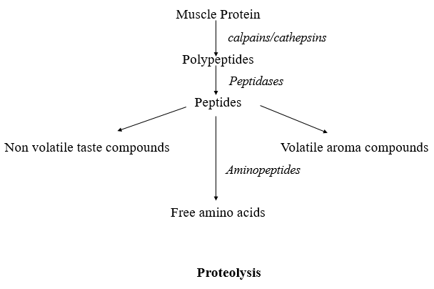
Fig. 4
Lipolysis (Fig. 5)
The maturation of dry-cured meat products is defined not only by protein breakdown but also by a profound transformation of fats. This process, known as lipolysis, involves the enzymatic decomposition of lipids into their constituent parts (Fig. 6), a phenomenon that is particularly aggressive in the subcutaneous adipose tissue (the fat layer beneath the skin). The chemical evolution of these fats begins almost immediately upon the start of production. Significant alterations are observed during the early stages of salting and post-salting, where researchers have documented a dramatic surge in the levels of free fatty acids (Motilva et al., 1993). Similar to the proteolytic pathways that break down proteins, the generation of free fatty acids is not a random occurrence. It is driven primarily by internal muscle enzyme systems. These natural biocatalysts are responsible for liberating fatty acids, which eventually serve as the foundation for the complex, savoury aroma and mouthfeel associated with high-quality cured ham (Motilva et al., 1993).
Adipose tissue lipases
Within the subcutaneous fat layers, or adipose tissue, three primary lipolytic enzymes facilitate the decomposition of lipids: lipoprotein lipase, hormone-sensitive lipase, and monoacylglycerol lipase (Belfrage et al., 1984). These catalysts function most effectively when the environment is within a neutral to basic pH range (Motilva et al., 1992). During the initial phases of meat processing, these enzymes trigger a rigorous period of triglyceride hydrolysis. This activity results in a significant accumulation of free fatty acids, as the complex fat molecules are dismantled. Specifically, the fatty acids produced in the highest concentrations during this time include myristic acid, heptadecanoic acid, linolenic acid and arachidonic acid (Fidel et al., 1996). The enzymatic profile of the muscle itself differs significantly from that of the surrounding fat. In the muscle, lysosomal acid lipase (Table 3) serves as the primary driver of lipolysis. As its name suggests, this enzyme is housed within the lysosomes and operates under markedly different conditions than its adipose counterparts. Unlike the neutral/basic enzymes in fat tissue, lysosomal acid lipase is optimized for an acidic environment, specifically between a pH of 4.5 and 5.5 (Imanaka et al., 1984). While it is capable of breaking down various glycerol (tri, di, and monoacylglycerols), it shows a distinct biochemical preference for the primary ester bonds found in triacylglycerol (Imanaka et al., 1984).
Muscle lipases
Lysosomal acid lipase (Table 3) is the major lipolytic enzyme in muscle. It is located in the lysosomes and hydrolyses tri, di and monoacylglycerols at acid pH (4.5-5.5) (Imanaka et al., 1984). Acid phospholipase A2 catalyses the hydrolysis of the 2-acyl ester of sn-3-phosphoglycerides at the lipid/water interface (Yuan et al., 1990). This enzyme plays an important role in the biochemical pathways involving phospholipids degradation. This is also the case in dry-cured ham since most of the generated free fatty acids proceed from phospholipid degradation (Flores et al., 1985). These free fatty acids accumulate as it progresses up to 10 months where they reach a maximum or even decrease. It should be taken into account that muscle lipases are still active after 15 months of processing. On the other hand, the generation of short chain free fatty acids is very low suggesting a minor role of muscle esterases even though they are quite stable and active (Motilva et al., 1993).

Table 3: Lipolytic enzymes in Meat.
Enzyme | Source | Optimal pH | Function
Lipoprotein Lipase | Adipose | Neutral/basic | Hydrolyses triglycerides
Hormone-sensitive Lipase | Adipose | Neutral/basic | Breaks down stored fat
Monoacylglycerol Lipase | Adipose | Neutral/basic | Converts MAG to glycerol + FA
Lysosomal Acid Lipase | Muscle | Acidic (4.5–5.5) | Hydrolyses tri-/di-/mono-acylglycerols
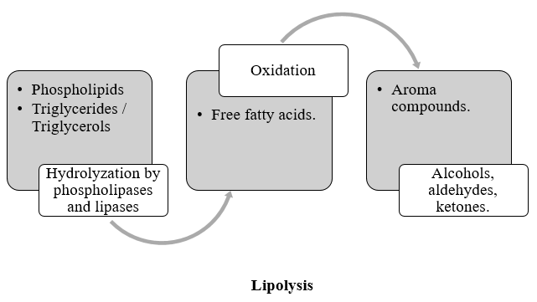
Fig. 5
Generation of volatiles
The distinctive and complex aromatic profile of dry-cured ham is fundamentally linked to the progression of lipid oxidation. This chemical transformation leads to the emergence of numerous volatile compounds, a process that becomes particularly pronounced during the final phases of maturation. These volatiles are the primary drivers of the "cured" sensory experience (Buscailhon et al., 1993). Research into the aromatic makeup of premium products, such as Iberian and French dry-cured hams, has led to the identification of dozens of specific chemical constituents. These compounds form the "volatile fraction" that gives each variety its unique identity (Garcia et al., 1991; Berdague et al., 1991). While the core components of these aromas are well-documented, the precise catalog of identified compounds can vary slightly between studies. These minor differences are often attributed to the specific extraction methodologies and analytical techniques employed by different laboratories (Garcia et al., 1991). Despite these technical variations, the fundamental link between lipid degradation and aroma remains a base of meat science.

Control of Enzymatic Activity (Flores and Told, 1993)
The precision with which proteolysis and lipolysis are managed directly indicates the success of the curing process. Achievement of the desired balance of texture and flavour requires a various approaches to controlling these biochemical reactions. The most direct method for regulating enzyme behaviour is through the management of the curing environment. By adjusting the relative humidity and ambient temperature within maturation rooms, producers can either accelerate or reduce the enzymatic activity to ensure the specific needs of the product. Beyond climate control, the application of salt serves as a powerful chemical inhibitor. High concentrations of salt have a proven suppressive effect on several key enzyme groups, including cathepsins which is the primary enzyme responsible for initial protein breakdown., aminopeptidases release free amino acids and neutral lipases is responsible for the degradation of fats in neutral pH environments. The foundation of high-quality meat starts long before the curing room. The age and genetic lineage of the livestock play a decisive role in the baseline activity of muscle enzyme systems. These biological variables determine the "proteolytic potential" of the raw material, ultimately influencing the consistency and sensory characteristics of the final ham.
Currently, the global market features a vast spectrum of meat products, each with unique colour and flavour profiles. These variations are a reflection of cultural traditions, long-standing regional customs and processing habits.

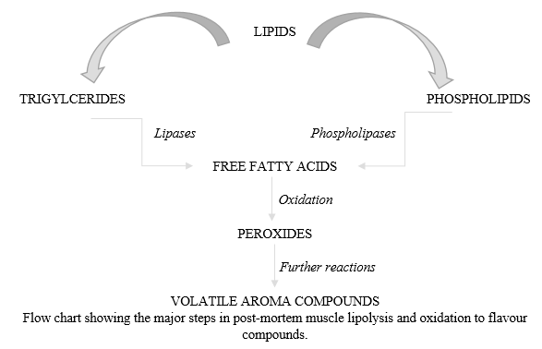
Fig. 6

Process Influence
Sensory profile of dried cured ham is strongly affected by hydrolysis and oxidation patterns which can significantly differ depending on the raw ham properties and the manufacturing technique.
Effect of raw meat
The inherent quality of dry-cured ham is deeply rooted in the biological makeup of the livestock. Recent scientific studies have identified significant variations in proteolytic activity specifically concerning cathepsin L, cathepsin H and various aminopeptidases across different porcine breeds. Current laboratory research continues to investigate how specific pork genotypes dictate these enzymatic behaviour, which are fundamental to the aging process (Flores et al., 1996). While enzymes are the drivers of flavour and texture, there is no direct link between the activity of muscle lipases or aminopeptidases and the general metabolic rate of the muscle tissue itself. However, researchers have noted a positive correlation between the concentration of natural pigments in the meat and its overall sensory appeal to consumers (Buscailhon et al., 1993).
The concentration of specific enzymes in the raw material can serve as a predictor for the final product's structural integrity. Elevated levels of cathepsin B in fresh hams have been statistically associated with higher moisture content and reduced protein density (Schivazzappa et al., 1992). When cathepsin B activity is extremely high, it can lead to excessive protein breakdown. This often results in a textural defect known as excessive softness, which is a primary characteristic of lower-quality or defective hams (Parolari et al., 1994).

Enzymes and Seafood Flavours (Bremner, 2002):
The olfactory profile of raw fish serves as a primary benchmark for assessing its freshness and overall quality. The initial aroma of freshly caught fish are the direct result of endogenous enzymes those naturally occurring within the fish own tissues (Table 4). These enzymes facilitate the first wave of aromatic development, producing the clean, sea-like notes that consumers associate with premium quality. As time passes, the aromatic profile shifts from delicate to pungent. This fishy or stale odour is the product of a collaborative effort between endogenous enzymes and spoilage bacteria. In tandem, they break down nitrogenous compounds and lipids, leading to the rancid notes characteristic of deteriorating seafood. When fish is heated, the resulting flavour is a complex mixture of taste-active compounds. Interestingly, these flavours are not solely the result of the cooking process itself; they are partially built upon the foundational work performed by endogenous enzymes prior to the application of heat. A critical player in the aromatic development of seafood is the enzyme lipoxygenase. Lipoxygenase triggers the formation of fatty acid hydroperoxides. These hydroperoxides are unstable and eventually break down through either enzymatic pathways or non-enzymatic chemical reactions.The result of this breakdown is a series of low molecular weight volatile compounds. Because these molecules are light enough to become airborne, they are directly responsible for the distinct odours both pleasant and unpleasant associated with different stages of fish freshness. Some of the seafood enzymes are listed below.

Table 4: Enzymes in seafood.
Enzymes | Components | Result
AMP deaminase | AMP | IMP formation contributes to delicious taste
Bromoperoxidase | Haloforms | Characteristic aroma of some seaweeds
Lipoxygenase | PUFA | Plant-like fresh aroma
Urease | Urea | Ammonia off-odour

Amino Acid | Taste Associated
Glutamic acid | Umami
Tyrosine | Aged flavour
Lysine | Aged flavour
Leucine | Acidic/bitter
Glycine | Sweet
Alanine | Sweet
Table 5: Key amino acids and their pronounced tastes.

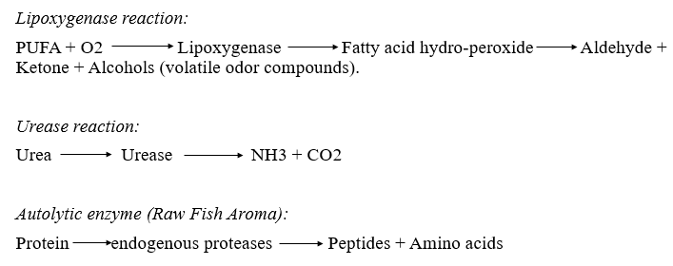
Fig. 7
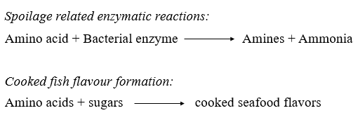
Fig. 8
Fig. 7, 8: Different reactions occurring when enzymes react with the components to induce flavour.

Conclusion
The development of the signature sensory profile in dry-cured ham is fundamentally dependent on the activity of muscle proteases and lipases. These enzymes act as the primary biochemical engines that transform raw muscle into a gourmet product. Because altering processing parameters or curing agents can lead to inconsistent quality, strict regulation of these muscle enzyme systems is vital for standardizing production and maximizing flavor intensity (Fidel et al., 1998).
Enzymatic flavour generation is a cornerstone of modern food science. A diverse array of biocatalysts including proteases, lipases, and amylases facilitate the complex biochemical shifts that occur during curing, fermentation, and aging. These processes serve a triple purpose like flavour Complexity by creating deep, savoury profiles, textural improvement by enhancing the tenderness of the meat and product safety by carefully regulating the enzymatic processes which helps in preventing spoilage and ensures the final product meets safety standards.
As global consumer demand shifts toward "natural" and traditionally processed foods, mastering the mechanisms behind these enzymatic reactions has become a priority for the meat industry. The efficacy of the muscle enzyme system is shown by a combination of biological raw material and technical process technology. The initial enzymatic potential is determined by the animal's genotype, age, and sex, as well as the specific treatments applied both ante-mortem (before death) and post-mortem (after death). Natural endogenous inhibitors, as well as those added during processing, play a role in modulating enzyme activity. However, much remains to be discovered regarding their stability during the ripening phase and their specific modes of interaction. In products like dry fermented sausages, exogenous enzymes those originating from starter cultures or natural microflora interact with the meat to further refine and modify the final flavour profile.
Production parameters are known to have a profound impact on how stable and active these enzymes remain throughout the long curing cycle. Ongoing research is essential to fully learn about these biochemical pathways. A deeper technical understanding of these mechanisms will empower producers to ensure consistent flavour development and maintain a high, standardized level of quality that satisfies the consumer expectations.

References
- Gatfield, I. L. (1995). Enzymatic and microbial generation of flavours. Perfumer & Flavorist, 20(5), 5-15.
- Robert J. Whitehurst and Maarten van Oort (2010). Enzymes in Food Technology, Second edition, Blackwell Publishing Ltd. ISBN: 978-1-405-18366-6.
- Bel-Rhlid, R., Berger, R. G., & Blank, I. (2018). Bio-mediated generation of food flavours–Towards sustainable flavour production inspired by nature. Trends in Food Science & Technology, 78, 134-143.
- Lonergan, S.M., Topel, D.G., Marple, D.N. The Science of Animal Growth and Meat Technology; Academic Press: Cambridge, MA, USA, 2018.
- Wang, D.; Cheng, F.; Wang, Y.; Han, J.; Gao, F.; Tian, J.; Zhang, K.; Jin, Y. The Changes Occurring in Proteins during Processing and Storage of Fermented Meat Products and Their Regulation by Lactic Acid Bacteria. Foods 2022, 11, 2427.
- Tatiyaborworntham, N.; Oz, F.; Richards, M.P.; Wu, H. Paradoxical effects of lipolysis on the lipid oxidation in meat and meat products. Food Chem. 2022, 14, 100317.
- Abril, B., Bou, R., García-Pérez, J. V., & Benedito, J. (2023). Role of enzymatic reactions in meat processing and use of emerging technologies for process intensification. Foods, 12(10), 1940.
- Flores, M., & Toldra, F. (2011). Microbial enzymatic activities for improved fermented meats. Trends in Food Science & Technology, 22(2-3), 81-90.
- Roman, S., Sánchez-Siles, L. M., & Siegrist, M. (2017). The importance of food naturalness for consumers: Results of a systematic review. Trends in food science & technology, 67, 44-57.
- Toldrá, F. (2008). Biotechnology of flavour generation in fermented meats. In Meat biotechnology (pp. 199-215). New York, NY: Springer New York.
- Shahidi, F. (Ed.). (2012). Flavour of meat and meat products. Springer Science & Business Media.
- Crocker, E. C. (1948). Flavour of meat. Journal of Food Science, 13(3), 179-183.
- Mottram, D. S., Edwards, R. A., & Macfie, J. H. (1982). A comparison of the flavour volatiles from cooked beef and pork meat systems. Journal of the Science of Food and Agriculture, 33(9), 934-944.
- Toldrá, F., Flores, M., & Sanz, Y. (1997). Dry-cured ham flavour: enzymatic generation and process influence. Food chemistry, 59(4), 523-530.
- Chizzolini, R., Dazzi, G., Madarena, G., Parolari, G., & Bellatti, M. (1985). [Biochemical and chemical-physical characteristics of connective and muscular tissues].[Italian]. Rivista di Suinicoltura.
- Toldrá, F., & Etherington, D. J. (1988). Examination of cathepsins B, D, H and L activities in dry-cured hams. Meat Science, 23(1), 1-7.
- Spanier, A. M., & Miller, J. A. (1993). Role of proteins and peptides in meat flavour.
- Rosell, C. M., & Toldrá, F. (1998). Comparison of muscle proteolytic and lipolytic enzyme levels in raw hams from Iberian and White pigs. Journal of the Science of Food and Agriculture, 76(1), 117-122.
- Toldra, F. (1998). Proteolysis and lipolysis in flavour development of dry-cured meat products. Meat science, 49, S101-S110.
- IMANAKA, T., AMANUMA-MUTO, K., OHKUMA, S., & TAKANO, T. (1984). Characterization of lysosomal acid lipase purified from rabbit liver. The Journal of Biochemistry, 96(4), 1089-1101.
- Flores, R., Duran-Vila, N., Pallas, V., & Semancik, J. S. (1985). Detection of viroid and viroid-like RNAs from grapevine. Journal of General Virology, 66(10), 2095-2102.
- Buscailhon, S., Berdagué, J. L., & Monin, G. (1993). Time‐related changes in volatile compounds of lean tissue during processing of French dry‐cured ham. Journal of the Science of Food and Agriculture, 63(1), 69-75.
- Akkerdaas, J., Totis, M., Barnett, B., Bell, E., Davis, T., Edrington, T., ... & van Ree, R. (2018). Protease resistance of food proteins: a mixed picture for predicting allergenicity but a useful tool for assessing exposure. Clinical and Translational Allergy, 8, 1-12.
- Berardo, A., Devreese, B., De Maere, H., Stavropoulou, D. A., Van Royen, G., Leroy, F., & De Smet, S. (2017). Actin proteolysis during ripening of dry fermented sausages at different pH values. Food chemistry, 221, 1322-1332.
- Toldrá, F., Flores, M., & Sanz, Y. (1997). Dry-cured ham flavour: enzymatic generation and process influence. Food chemistry, 59(4), 523-530.
- Parolari, G., Virgili, R., & Schivazappa, C. (1994). Relationship between cathepsin B activity and compositional parameters in dry-cured hams of normal and defective texture. Meat Science, 38(1), 117-122.
- Toldrá, F., & Flores, M. (1998). The role of muscle proteases and lipases in flavor development during the processing of dry-cured ham. Critical Reviews in Food Science, 38(4), 331-352.
- Bohrer, B. M. (2017). Nutrient density and nutritional value of meat products and non-meat foods high in protein. Trends in Food Science & Technology, 65, 103-112.
- Kerth, C. R., & Miller, R. K. (2015). Beef flavor: A review from chemistry to consumer. Journal of the Science of Food and Agriculture, 95(14), 2783-2798.
- Jayasena, D. D., Ahn, D. U., Nam, K. C., & Jo, C. (2013). Flavour chemistry of chicken meat: A review. Asian-Australasian journal of animal sciences, 26(5), 732.
- Mottram, D. S. (1998). Flavour formation in meat and meat products: a review. Food chemistry, 62(4), 415-424.
- Aaslyng, M. D., & Meinert, L. (2017). Meat flavour in pork and beef–From animal to meal. Meat science, 132, 112-117.
- Ganeko, N., Shoda, M., Hirohara, I., Bhadra, A., Ishida, T., Matsuda, H., & Matoba, T. (2008). Analysis of volatile flavor compounds of sardine (Sardinops melanostica) by solid phase microextraction. Journal of Food Science, 73(1), S83-S88.
- Peinado, I., Koutsidis, G., & Ames, J. (2016). Production of seafood flavour formulations from enzymatic hydrolysates of fish by-products. LWT-Food Science and Technology, 66, 444-452.
- Toldra, F. (1998). Proteolysis and lipolysis in flavour development of dry-cured meat products. Meat science, 49, S101-S110.
- Bremner, H. A. (Ed.). (2002). Safety and quality issues in fish processing. Elsevier.

