TRANSFORMING CANCER TREATMENT THOUGH GENE THERAPY
Aliza Nachan*
Guide: Ms. Tahoora Ansari Ayesha Momin
Nadeem Ahmed

M.S College Of Pharmacy
Gmail:- alizanachan62@gmail.com

Abstract
In the fight against cancer, gene therapy has emerged as a viable and cutting-edge tactic that offers fresh ideas to support established therapies like immunotherapy and chemotherapy. Ex vivo and in vivo techniques are currently used in clinical applications, such as introducing genes that transform inactive prodrugs into toxic compounds within cancer cells, delivering cytokine genes to enhance immune responses, and employing drug-resistance genes to shield healthy cells during high-dose chemotherapy. Other strategies silence oncogenes or restore tumour suppressor genes to attack cancer at its genetic origins.

Early findings indicate that gene therapy can cause tumour regression with tolerable levels of toxicity, despite the fact that the majority of human trials have involved patients with advanced, treatment-resistant malignancies. Vector delivery methods continue to be a significant obstacle, nevertheless. Research is still being done to improve viral vectors to reduce immunological reactions and side effects, improve the specificity and effectiveness of non-viral systems, more accurately control gene expression, and combine gene therapy with other cancer treatments for better results.

The development of gene therapy in oncology is described in this review, which also summarises important tactics, technological advancements, present difficulties, and future research priorities. It illustrates the increasing promise of gene-based therapies to cure cancer by analysing current clinical data and experimental research.

Keywords
Cancer treatment; Oncology; Ex vivo gene therapy; In vivo gene therapy; Viral vectors; Non- viral delivery systems; Prodrug activation; Cytokine gene delivery; Immunotherapy; Chemotherapy; Oncogene silencing; Tumour suppressor genes; Vector optimization; Targeted gene expression.

Introduction
Cancer is still one of the leading causes of illness and mortality globally, characterised by uncontrolled cell growth, invasion, and metastasis. Despite tremendous advancements in traditional treatments such as surgery, chemotherapy, and radiotherapy, these procedures sometimes lack specificity and can result in severe side effects and medication resistance. By focusing on the genetic foundation of the disease, gene therapy has become a novel and promising approach to treating a variety of malignancies [1]. Delivering genetic material into a patient's cells in order to replace, mute, or repair damaged genes that cause malignant transformation is known as gene therapy. More effective and focused gene delivery methods, including as viral and non-viral vectors, have been made possible by recent developments in molecular biology and vector design [2].

This therapeutic strategy offers a more individualised and successful cancer treatment by enhancing immune system activity against tumour cells, restoring tumour suppressor genes, and modulating oncogenes [3].
With the introduction of genome editing tools like CRISPR-Cas9 and RNA interference, which offer precise gene regulation capabilities, the field of gene therapy in oncology has grown. Furthermore, gene therapy, nanotechnology, and immunotherapy have demonstrated synergistic benefits that enhance therapeutic outcomes and reduce off-target consequences [4].As research continues to progress, gene therapy holds great potential to revolutionize cancer management and pave the way toward more targeted and less toxic treatment modalities [5].

History Of Gene Therapy In Cancer

When researchers originally proposed that inserting genetic information into human cells would be able to treat hereditary disorders in the early 1970s, the idea of gene therapy was born [6].Although early studies focused on single-gene conditions such severe combined immunodeficiency (SCID), it quickly became apparent that genetic techniques may also be used to treat cancer, which is caused by alterations in oncogenes, tumour suppressors, and DNA repair mechanisms [7]. In 1990, the United States hosted the first human clinical trial of gene therapy for cancer. Tumor-infiltrating lymphocytes that had been altered to carry a neomycin resistance gene were used in this investigation, which involved patients with advanced melanoma [8].

The change established the foundation for future cancer applications by demonstrating that gene transfer could be carried out safely in humans, even though it did not directly treat the illness.
Research on gene therapy has greatly expanded by the mid-1990s. Researchers started looking into suicide genes, reactivating tumour suppressor genes, particularly p53, and utilising cytokine genes to boost immune responses [9]. Remarkably, early therapeutic trials that delivered normal copies of p53 to patients with head and neck cancer via adenoviral vectors revealed positive indications of tumour decrease [10].
With the advent of oncolytic virotherapy in the early 2000s, a new approach was taken: genetically modified viruses are engineered to replicate exclusively in cancer cells, destroying them in the process. Oncorine (H101), an adenoviral medication that targets tumours with p53 gene abnormalities, became the first gene therapy product for cancer to get regulatory approval

in China in 2005, marking a significant milestone [11].This signified a shift from lab research to real-world clinical use.

Immune-based genetic therapy became popular in the 2010s. By modifying a patient's own T cells to identify and eliminate cancerous cells, chimeric antigen receptor T-cell (CAR-T) technology transformed the treatment of cancer. In 2017, Tisagenlecleucel (Kymriah) was approved by the U.S. FDA for the treatment of B-cell acute lymphoblastic leukaemia, marking a significant advancement in customised, gene-modified immunotherapy [12]. Genome-editing technologies like CRISPR/Cas9 have had a significant impact on cancer gene therapy in recent years. Reactivation of inactive tumour suppressor genes, modification of tumour immune microenvironments, and accurate targeting and correction of oncogenic mutations are all made possible by these technologies [13].

Recent advances in genome-editing technologies, such CRISPR/Cas9, have transformed the field by enabling very specific modifications to genes linked to immunological resistance and cancer formation [14]. Additionally, messenger RNA (mRNA) systems are currently being modified for cancer vaccines, providing a versatile and non-integrating delivery route, thanks to their success in producing the COVID-19 vaccine [14]. To sum up, gene therapy has advanced from early experimental attempts in the 1990s [17] to authorised medical therapies in the 2000s [15] and then into increasingly complex immunological and genome-modifying technologies in the ensuing decades [16].Gene therapy is still developing as a potent tool in contemporary oncology despite persistent difficulties, especially with regard to delivery effectiveness and safety [18,19]
.

Mechanisms of Gene Therapy in Cancer

In order to prevent cancer-promoting pathways, restore normal activities, or increase anti-tumor immunity, gene therapy for cancer modifies the genetic material of tumour or immune cells. Nowadays, a variety of mechanisms are investigated and used in both clinical and research contexts.

Gene Editing Approaches:

One innovative component of gene therapy is gene editing. Gene editing technologies directly cut, repair, or replace DNA sequences inside cells, in contrast to previous methods that simply introduced or silenced genes. This makes it possible to precisely target the mutations that cause cancer.[20,21] i.CRISPR/cas9 system: The most widely utilised gene editing technique available today is the CRISPR/Cas9 system. Like molecular scissors, it finds the precise DNA section to cut with the help of a little RNA molecule. The cell's repair system either shuts the faulty gene or replaces it with a repaired sequence once the DNA is cleaved [20]. CRISPR has been used in cancer to restore tumour suppressor genes like p53 and deactivate oncogenes like KRAS, which is frequently found in pancreatic tumours.In order to improve T cells' capacity to attack tumours, CRISPR is also utilised to alter immune cells, such as by eliminating the PD-1 gene [16,23].

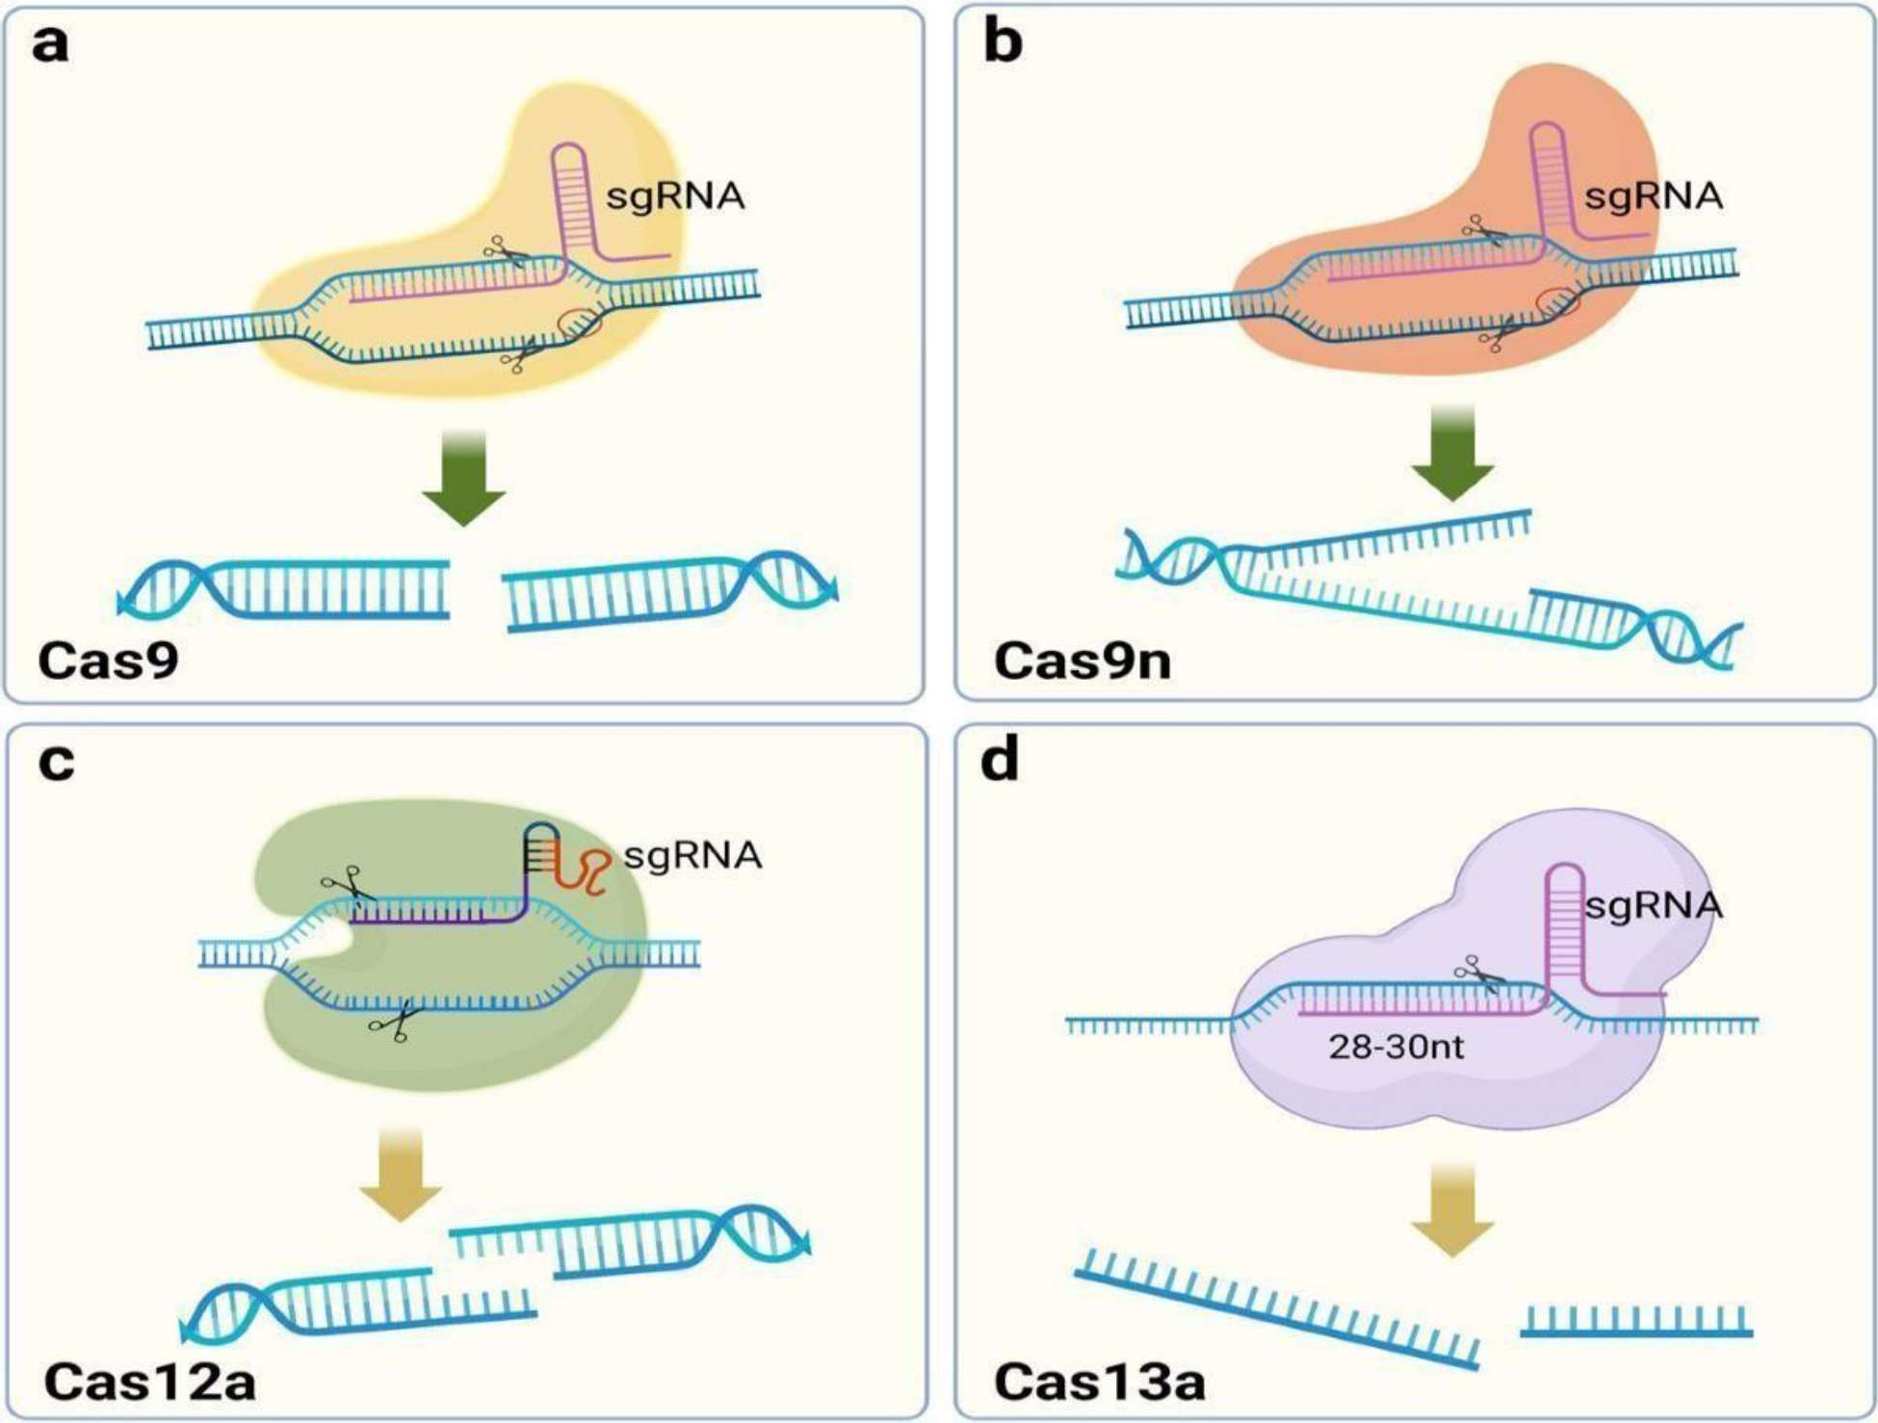

Figure 1.CRISPR/Cas9system

CRISPR-edited immune cells are being used in clinical trials to treat diseases such as multiple myeloma and leukaemia.[22]

Transcription Activator-Like Effector Nucleases, or TALENS, were the most advanced gene editing tool prior to CRISPR. Specialised proteins that attach to DNA sequences and accurately cut them are used by TALENs.

By eliminating genes that result in immunological rejection, TALENs have been used to produce universal CAR-T cells that are compatible with a variety of patients [23].
Compared to CRISPR, TALENs are more complicated and expensive to design, despite their excellent specificity.

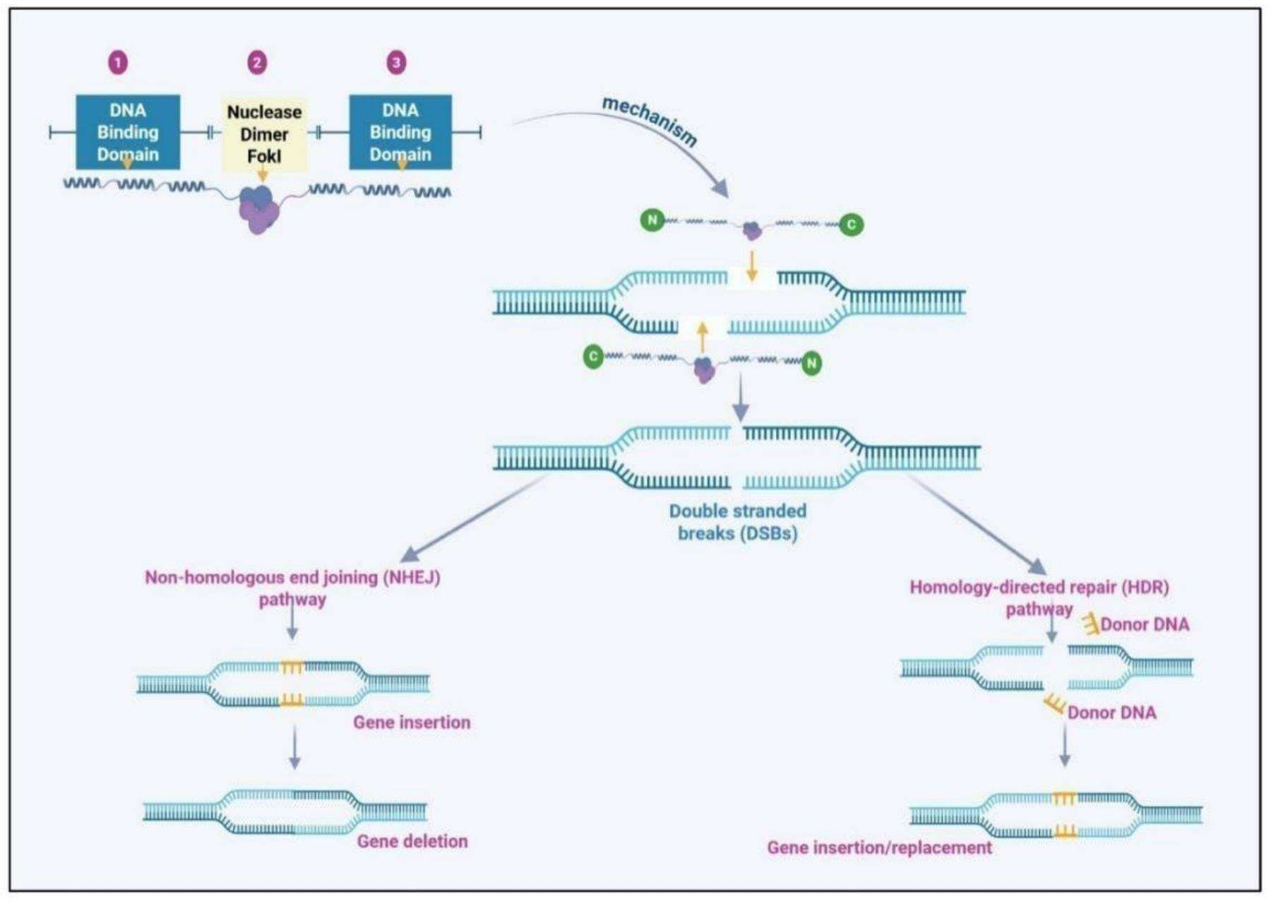

Figure 2.TALEN

ZFNs (Finger Nucleases):
ZFNs were the first programmable nucleases used for gene editing. They consist of engineered zinc Zinc finger proteins attached to a DNA-cutting enzyme.
In cancer therapy, ZFNs have been explored for disrupting oncogenes and enhancing T- cell immunotherapy [24]
While less common now, ZFNs laid the groundwork for current gene editing methods.

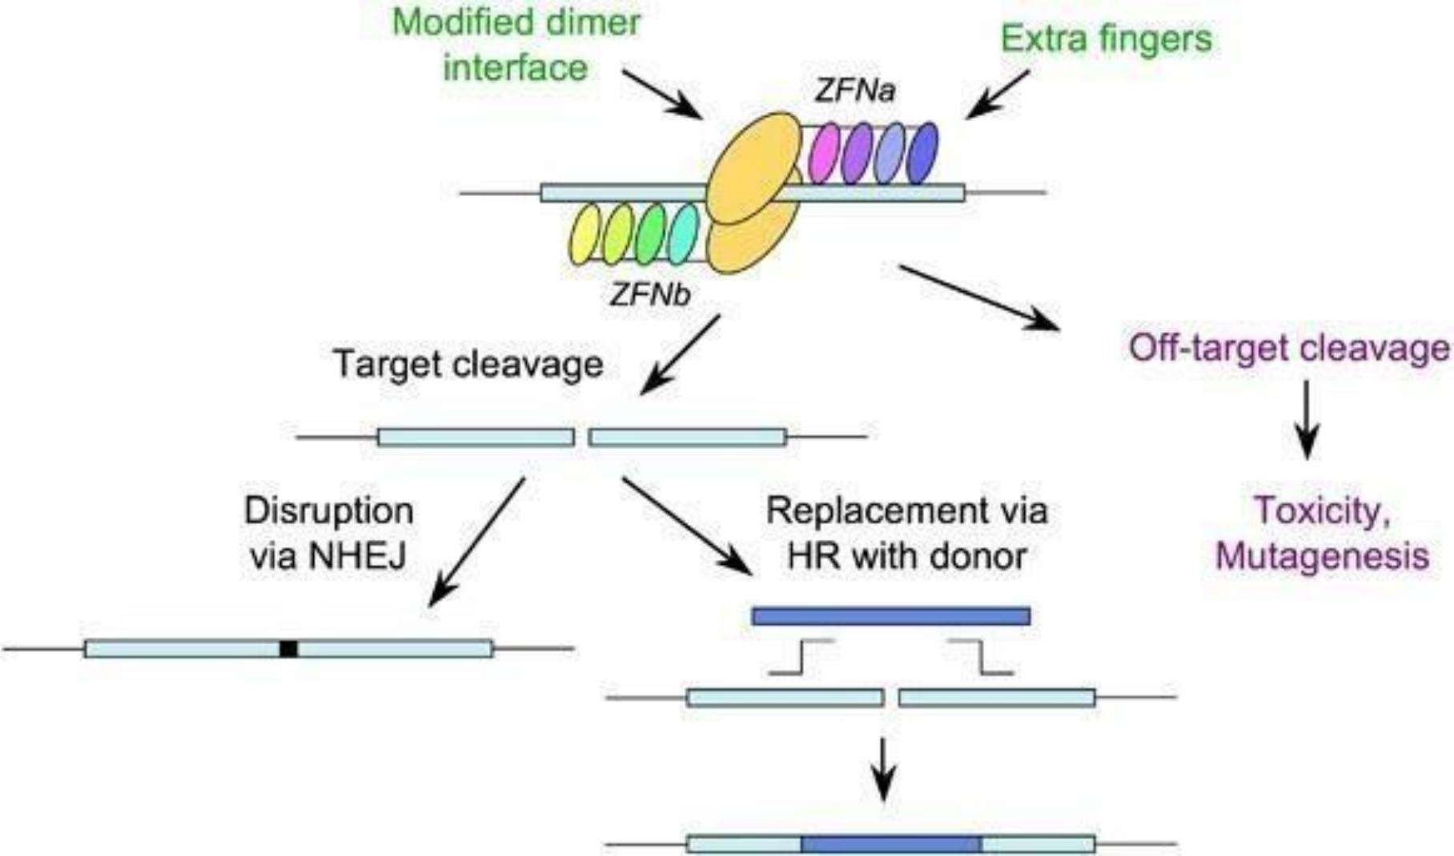

Figure 3.ZFNs(Finger Nucleases)

Next Generation Base Editing and Prime Editing:

Prime editing and base editing are more recent CRISPR variants.One DNA base (A, T, C, or G) can be changed without cutting the DNA thanks to base editing, which is helpful for fixing point mutations that cause cancer.

Because prime editing is more flexible, it can make precise fixes or insertions with fewer mistakes [25]. These methods hold promise for safer gene therapies, notwithstanding their early phases.

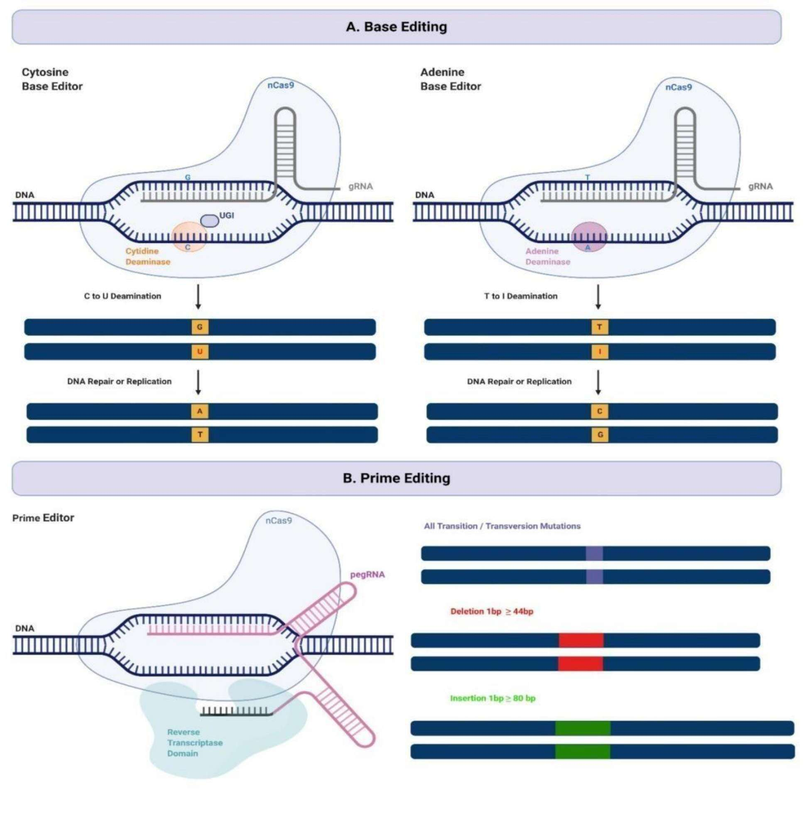

Figure 4.Base Editing ,Prime Editing

Gene Transfer Mechanisms:

Cancer gene therapy frequently entails the insertion of therapeutic genes into tumor or immune cells.

Viral Vectors: Adenoviruses, retroviruses, and lentiviruses serve as popular delivery systems. Adenoviral vectors, for instance, have introduced tumor suppressor genes such as p53 in cancers of the head and neck, whereas retroviruses have played a crucial role in the engineering of CAR- T cells [26,7].

Non-Viral Vectors: Nanoparticles, liposomes, and polymer-based carriers are gaining popularity because of their safety and reduced risks of immune response. Lipid nanoparticles are crucial in RNA-based treatments and vaccines[11]

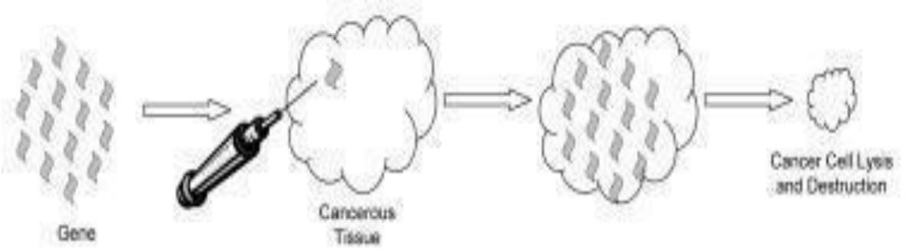

Figure 5.Gene transfer therapy

RNA-Based Therapeutic Mechanisms

RNA-based treatments have surfaced as a groundbreaking approach in contemporary medicine, allowing for the accurate control of gene expression in the prevention and management of different illnesses. These treatments mainly consist of RNA Interference (RNAi) and mRNA vaccines, both of which utilize inherent cellular processes to produce therapeutic results[27].

Interference by RNA (RNAi):

RNAi is a natural mechanism that inhibits gene expression at the post-transcriptional stage through small interfering RNA (siRNA) or microRNA (miRNA)[28]. After entering the cell, siRNA is integrated into the RNA-induced silencing complex (RISC), directing the complex to matching messenger RNA (mRNA) sequences, resulting in their cleavage and destruction[29].

This degradation hinders the translation of the target mRNA into protein, thereby decreasing or abolishing the expression of genes associated with the disease. RNAi-based therapies have shown potential in addressing genetic diseases, viral infections, and cancer, providing high specificity and efficacy[30].

mRNA Vaccines:

mRNA vaccines, a significant type of RNA therapeutics, introduce synthetic mRNA that encodes an antigenic protein into host cells, where ribosomes translate it into the respective protein [31]. This antigen subsequently initiates an immune response, resulting in the establishment of protective immunity. In contrast to traditional vaccines, mRNA vaccines are not infectious, do not integrate, and can be produced quickly. Their achievements were especially evident during the COVID-19 pandemic, underscoring their capacity for managing infectious diseases and tailored cancer immunotherapy [32].

Oncolytic virotherapy is a cutting-edge treatment method that employs viruses modified in the lab to specifically target and destroy cancer cells without harming healthy tissue. Oncolytic viruses are engineered to specifically attack tumor cells that have weakened antiviral defenses, unlike traditional viruses that can damage both healthy and cancerous cells [33]. Once these viruses enter the tumor cells, they multiply until the host cells burst, releasing viral offspring and tumor antigens that contribute to the activation of anti-tumor immune responses [34].

How Oncolytic Virotherapy Works:

- Selective Infection of Tumor Cells
Cancer cells frequently show reduced antiviral defenses as a result of genetic changes. Oncolytic viruses take advantage of this vulnerability by replicating specifically within tumor cells, without affecting healthy ones [35].

Paraphrased text:Direct Killing of Cancer Cells
After replicating, the oncolytic virus causes cell death, releasing new virus particles that go on to infect nearby tumor cells. This chain reaction increases the destruction of the local tumor [36].

ii. Immune System Activation
The breakdown of tumor cells releases antigens linked to the tumor, which stimulate dendritic cells and killer T cells, resulting in a widespread immune reaction targeting remaining cancer cells [37].

iv. Paraphrased text:Combination with Gene Therapy
Oncolytic viruses can be modified to deliver therapeutic genes that produce immune-boosting cytokines or tumor-inhibiting proteins. This combined treatment improves virus-induced cancer cell death and increases the immune system's ability to recognize tumors [38].
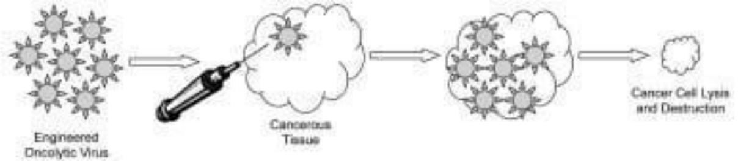

Figure 6.Oncolytic Virotherapy.
In general, oncolytic virotherapy functions as a two-pronged approach it directly destroys tumors while also stimulating the immune system, positioning it as a promising method in contemporary cancer gene therapy research [39].

Talimogene laherparepvec (T-VEC):
A modified herpes simplex virus (HSV-1) that received FDA approval in 2015 for the treatment of melanoma. T-VEC contains a gene that codes for GM-CSF, an immune-boosting protein which strengthens the body's anti-tumor immune response and encourages the destruction of tumor cells [40,41,44]. Oncorine (H101): a genetically modified adenovirus approved in China in 2005 for the treatment of head and neck cancers.Oncorine features a deletion in the E1B-55kDa gene, enabling it to replicate specifically in tumor cells that have p53 mutations, resulting in focused tumor elimination [42].

The effectiveness of these viral agents highlights the increasing significance of oncolytic virotherapy in contemporary cancer treatment, merging viral cell destruction with immune system stimulation to achieve better treatment results [43,45,46].

Advantages of Oncolytic Virotherapy:
Oncolytic virotherapy is a novel method for treating cancer that utilizes viruses modified in the lab to specifically target, multiply inside, and eliminate cancer cells without harming healthy tissue [47].
These viruses not only cause direct destruction of tumor cells but also boost systemic anti-tumor immunity by releasing tumor-related antigens that trigger immune cells [48].
In addition, oncolytic viruses can be engineered to deliver therapeutic genes, cytokines, or immune checkpoint inhibitors, which can improve their effectiveness against cancer [49]. The combination of direct cancer cell destruction and immune system stimulation makes this treatment especially effective in addressing tumor resistance and relapse [50].

Compared to conventional treatments such as chemotherapy and radiotherapy, oncolytic virotherapy exhibits reduced systemic toxicities and a greater level of tumor specificity [51]. The immune-boosting effects may result in sustained tumor control, even in distant metastatic areas, presenting a promising approach for combined treatments with immunotherapy or targeted medications [52].

Gene Delivery Systems:

Gene delivery systems form a fundamental part of gene therapy, ensuring the secure and effective transfer of therapeutic genes into target cells to produce the intended biological outcomes. The success of any gene therapy method is primarily determined by how effectively these systems safeguard genetic material against enzymatic breakdown, aid in entering cells, and allow for regulated expression of the introduced gene [53,54]. In cancer treatment, gene delivery systems play a crucial role in delivering tumor-suppressor genes, suicide genes, or immune-modulating genes into cancerous tissues to inhibit tumor growth and boost anti-tumor immunity [57].

These systems are generally categorized into viral and non-viral delivery methods, each with its own unique benefits and drawbacks. Viral vectors, including adenoviruses, adeno-associated viruses (AAVs), lentiviruses, and retroviruses, take advantage of the inherent ability of viruses to infect cells, allowing for the effective delivery of genetic material into host cells [53,55]. They offer high transduction efficiency and long-lasting gene expression, yet they pose safety issues concerning immune reactions, insertional mutagenesis, and complex production [57].

Alternatively, non-viral systemssuch as liposomes, cationic polymers, dendrimers, nanoparticles, and physical techniques like electroporation or gene gun technologyprovide safer and more versatile options [54,56,58]. These methods are less likely to trigger an immune response and are simpler to scale for production, although their ability to deliver genetic material is generally lower than that of viral systems [59,60].

Progress in nanotechnology and biomaterials science has notably improved non-viral gene delivery methods. For example, nanoparticle and liposome formulations can be surface-modified with targeting ligands or antibodies to allow for delivery specifically to tumors, thus reducing off- target effects [58,60]. Hybrid systems that combine the effectiveness of viral vectors with the safety of nonviral carriers are also being developed to strike a balance between efficiency, specificity, and safety [61,62].
An ideal gene delivery system should therefore guarantee biocompatibility, stability, efficient gene transfer, tissue specificity, and prolonged expression, which continue to be the primary objectives in advancing gene therapy for cancer and other genetic disorders [57,61].

Viral Vectors

Viral vectors are widely acknowledged as one of the most effective methods for delivering genes, thanks to their natural capability to enter host cells and promote significant levels of transgene expression. These vectors come from viruses that have been genetically altered to eliminate their ability to cause disease, while still keeping their ability to infect and efficiently transfer genetic material. Common viral vectors used in therapy include adenoviruses, adeno-associated viruses (AAV), lentiviruses, and retroviruses, each possessing unique characteristics that influence their effectiveness in treatment. Adenoviral vectors offer high transduction efficiency and can infect both dividing and non-dividing cells, although they frequently provoke robust immune responses [63].

In contrast, AAV vectors show minimal immune response and can maintain long-term gene expression, which makes them appropriate for treating chronic conditions [64]. Lentiviral and retroviral vectors incorporate into the host's genome, enabling long-term and consistent gene expression, although they carry a possible risk of causing insertional mutagenesis [65]. The choice of a suitable viral vector is influenced by factors including the type of target cells, the length of time expression is needed, and safety concerns. Progress in vector engineering, such as capsid modification, the use of tissue-specific promoters, and hybrid vector systems, keeps improving the adaptability and effectiveness of viral vectors in gene therapy [66,67].

Viral vectors utilize viruses that have been genetically modified to deliver therapeutic genes into cells. Since viruses naturally invade host cells, scientists utilize this characteristic by eliminating their harmful parts and substituting them with healing genetic material.

Non-Viral Delivery Systems

Non-viral gene delivery systems have become safe and effective alternatives to viral vectors in cancer gene therapy. These systems make use of nanocarriers like lipids, polymers, dendrimers, and inorganic nanoparticles to deliver therapeutic genes efficiently into target cells without causing significant immune reactions [68]. Lipid-based carriers, such as liposomes and lipid nanoparticles, can enclose DNA or RNA molecules, offering good biocompatibility and improved cellular absorption [69,70].

Polymeric nanocarriers, including polyethyleneimine (PEI), chitosan, and poly(lactic-co-glycolic acid) (PLGA), provide adjustable surface characteristics and controlled release properties, making them appropriate for targeted delivery to tumors [71,72]. Dendrimers and inorganic nanoparticles,

such as gold or silica nanoparticles, offer structural stability and a high capacity for carrying genes, thereby enhancing transfection efficiency [73].

These nanocarriers can be modified with targeting molecules and materials that respond to specific stimuli, ensuring targeted gene expression in tumor tissues while minimizing unintended effects [74]. Overall, non-viral systems present a promising approach for achieving safe and effective gene therapy in cancer treatment. Nanoparticles, lipid-based systems, and synthetic polymers are major categories of non-viral delivery methods[75,77].

These systems are less likely to cause immune responses and are frequently used in mRNA therapies and cancer vaccines [75,76]. Although they are generally safer, they may exhibit reduced efficiency in delivering genes, particularly to hard-to-reach tissues [76,77].

Targeted Delivery Strategies:
Targeted delivery systems have become a fundamental component of contemporary cancer therapy, allowing for accurate delivery of drugs to tumor sites while reducing unintended effects and enhancing treatment results. These strategies are generally categorized into passive targeting, active (ligand-directed) targeting, tumor-specific targeting, environment-responsive systems, and integrated multifunctional nanoplatforms.

Passive Targeting

Passive targeting takes advantage of the Enhanced Permeability and Retention (EPR) effect, which enables nanoparticles to build up in tumor areas because of porous blood vessels and impaired lymphatic system function [78,79,80,81]. This process helps achieve higher drug levels in the local area while reducing overall toxicity in the body. Liposomes, polymeric micelles, and polymer-drug conjugates are frequently employed for this purpose[82,83]. Nevertheless, tumor heterogeneity, fluctuating vascular permeability, and elevated interstitial pressure may influence the even distribution of nanomedicines[84,85]. Active (Ligand-Directed) Targeting

Active (Ligand-Directed) Targeting
Active targeting relies on interactions between ligands and their corresponding receptors, with examples including folate, transferrin, antibodies, and hyaluronic acid binding specifically to receptors that are highly expressed on tumor cells [86,87,88]. This method improves the uptake of therapeutic agents through receptor-mediated endocytosis, promoting the targeted delivery of treatments [89,90].

Nanocarriers based on dendrimers, such as PAMAM and PPI dendrimers, offer significant surface functionality for attaching ligands and a high capacity for drug loading, which makes them suitable for targeted therapy[91]. Dendrimers with surface modifications enhance cellular uptake and enable more controlled drug delivery[92].

Tumor-Selective Targeting
Tumor-specific targeting systems utilize the distinct characteristics of the tumor microenvironment, such as low pH, lack of oxygen, and higher enzyme levels, to activate drug delivery exclusively at cancerous areas [79,80,83]. This mechanism helps maintain the drug in the body for a longer period and minimizes its presence in the bloodstream.

Environment-Responsive (Stimuli-Sensitive) Systems

Environmentally responsive carriers dynamically change their characteristics in reaction to internal factors (such as pH, enzyme concentrations, and redox potential) or external factors (like light, temperature, and magnetic fields) [87,88,90].

For instance, pH-sensitive liposomes break down in the acidic environment of tumors, and redox- sensitive micelles break down in the presence of intracellular glutathione [91,92]. These systems allow for controlled, on-demand treatment with greater accuracy and reduced toxicity.

Integrated Multifunctional Platforms

Recent developments have resulted in multifunctional nanoplatforms that combine passive, active, and stimulus-responsive mechanisms within a single delivery system[84,85,89]. These theranostic nanoparticles combine therapeutic and imaging functions to enable diagnosis and treatment at the same time. Although preclinical results have been encouraging, clinical application is still hindered by immune system elimination, difficulties in large-scale manufacturing, and concerns regarding long-term safety [86,91]. Future designs seek to enhance biodegradability, avoid immune detection, and enable adaptive targeting for the next generation of cancer therapy.

Several clinical studies have investigated gene-based approaches in various types of cancer. CRISPR-Cas9-based gene editing has been tested in patients with advanced cancers, demonstrating acceptable safety and practical viability [93,94]. CAR-T cell treatments have been approved for various blood cancers and are currently being studied for solid tumors, with encouraging results observed in preclinical and early-stage clinical trials [95,96]. In addition, treatments involving altered oncolytic viruses, like Talimogene laherparepvec, have shown better long-lasting response rates in patients with advanced melanoma [97].

Challenges and Limitations:
While gene therapy has achieved significant advancements in cancer treatment, various ongoing challenges still limit its widespread use in clinical settings. The main challenges involve low gene delivery efficiency in specific tissues, the risk of unintended genetic changes, immune reactions against treatment vectors, and the overall high cost of production and therapy [98,99,100].

Additional challenges come from complicated manufacturing needs, regulatory restrictions, and problems related to targeted delivery, especially in solid tumor settings [101]. To overcome these issues, current research is concentrating on enhancing vector engineering, strengthening safety control mechanisms, and creating scalable, affordable production methods that may improve the long-term viability of gene therapy in cancer treatment [102].

Future Directions:
The future of gene therapy in cancer treatment holds great potential, with multiple groundbreaking developments expected to emerge soon. Newer CRISPR technologies, like base editors and prime editors, now allow for very accurate changes to the genome while reducing the risk of unintended mutations [103,104].

RNA-based treatments, such as mRNA vaccines and siRNA methods, are becoming versatile options for managing cancer, providing temporary but customizable control over tumor gene expression [105,106]. Advances in personalized medicine, fueled by patient-specific genomic profiling, enable treatments to be customized according to individual tumor mutations, enhancing effectiveness while reducing adverse effects[107,108].

The integration of artificial intelligence (AI) and machine learning (ML) into the design of gene therapy is improving the prediction of immune responses, the optimization of delivery methods, and the discovery of new tumor-specific targets [109,110].
Moreover, combination therapies that integrate gene therapy with immunotherapy, chemotherapy, or radiotherapy are leading to enhanced treatment outcomes and better patient responses [111,112]. In total, these advancements suggest a future in which gene therapy becomes more personalized, accurate, and secureable to tackle tumor diversity and overcome existing clinical challenges [113].

Discussion
A thorough review of the existing research on gene therapy in cancer highlights a notable progression from initial theoretical possibilities to real treatment opportunities, although ongoing challenges related to translation and biology still exist. Gene therapy offers a logical approach to tackling cancer at its molecular origin by introducing, fixing, or deactivating genes involved in the development of cancer [114].

Preclinical research using various models has shown that gene transfer can successfully inhibit tumor growth, reinstate tumor suppressor gene function, or make cancer cells more responsive to chemotherapy drugs. Nevertheless, despite significant advancements over the years, the application of clinical findings remains unreliable. Early trials confirmed the safety of the treatment but showed limited effectiveness, mainly because of inefficient delivery, differences within the tumor, and the immune system's removal of the vectors [115].

Furthermore, the complexity of the tumor microenvironment (TME)characterized by low oxygen levels, inadequate blood supply, and immune system evasiongreatly limits the effectiveness of therapeutic gene expression and the spread of vectors [116].

The advantages of current research are the significant technological progress that has transformed delivery methods and improved editing accuracy. Viral vectors, such as adenoviral, lentiviral, and adeno-associated systems, have been enhanced through modifications to their capsids, the use of tissue-specific promoters, and the selection of optimized serotypes to improve their targeting ability and safety [117].

At the same time, nonviral vectorssuch as lipid nanoparticles, polymeric carriers, dendrimers, and exosome-based systemsprovide scalable and less immunogenic alternatives [118]. These innovations have broadened the therapeutic applications of gene delivery across various types of cancer. In addition, the development of gene-editing technologies such as CRISPR/Cas9, TALENs, and base editors has transformed the ability to target the genome at a large scale, enabling accurate correction or elimination of cancer-causing mutations and the adjustment of tumor-related immunity.

The clinical effectiveness of CAR-T cell treatments demonstrates the practicality of gene editing in achieving long-term cancer management [119]. Although there have been these improvements, significant shortcomings still exist. Viral vectors encounter difficulties including restricted packaging capacity, possible insertional mutagenesis, and immune reactions when administered multiple times. Non-viral systems frequently experience low transfection efficiency and a lack of tumor specificity, particularly in solid tumors [118].

Moreover, tumor diversity and individual genetic variations still hinder the ability to predict how patients will respond to treatments. Another limitation is the lack of standardized preclinical protocols and the limited availability of long-term follow-up data in clinical studies, which makes safety evaluation and regulatory approval more challenging [116,120].

Recent studies point out new trends designed to address these challenges. Artificial intelligence (AI) and machine learning are being used to enhance vector design, forecast gene-host interactions, and tailor treatments according to tumor genomics [114,119].
Environmentally responsive delivery systemstriggered by pH levels, enzyme activity, or oxidative stresshave demonstrated potential in enabling targeted release and improved selectivity [118]. In addition, combination approaches that integrate gene therapy with immunotherapy, radiotherapy, or small-molecule inhibitors are showing enhanced clinical results and synergistic effects [119,121]. These multidisciplinary methods are slowly closing the gap between research and clinical practice.
Nevertheless, disputes and unresolved issues continue to be at the heart of the discussion.
Ethical issues surrounding germline editing, genetic privacy, and fair access to expensive treatments continue to be significant global challenges [115,120]. The long-term genetic stability of CRISPR/Cas-based treatments and the potential for unintended mutations remain unresolved. Moreover, strategies for safely and effectively administering repeated doses, especially when neutralizing antibodies are present, need further research. Scientifically, important questions involve finding biomarkers that can forecast long-lasting treatment responses, creating delivery methods that can address tumor diversity, and ensuring large-scale production under GMP conditions.

In conclusion, the area of gene therapy for cancer is at a pivotal momentprogressing quickly toward real-world application but still limited by biological and socioeconomic challenges. The coming together of nanotechnology, bioinformatics, and precision medicine is driving the field toward interventions that are safer, more efficient, and customized to individual patients. Future research should focus on standardizing preclinical models, conducting long-term safety assessments, and developing cost-effective manufacturing processes to ensure that the next generation of cancer gene therapies is not only scientifically sound but also available worldwide.

Conclusion
Gene therapy represents a promising and evolving approach in cancer treatment, providing the potential for more precise and effective patient care. Despite remaining challenges, ongoing research and technological advancements are gradually advancing the field. With continued support and international collaboration, gene therapy has the potential to significantly transform cancer treatment, bringing new hope to patients worldwide.

References
- M. El-Sayed, M. Ginski, C. Rhodes, J. Control. Release, 2002; 81: 355–365.
- Li L, Li W. Gene therapy for cancer: recent advances and future directions. Front. Oncol., 2020; 10: 605380.
- Ginn SL, Amaya AK, Alexander IE, Edelstein ML, Abedi MR, Wixon J. Gene therapy clinical trials worldwide to 2017: An update. J. Gene Med., 2018; 20(5): e3015.
- Naldini L. Gene therapy returns to centre stage. Nature, 2015; 526: 351–360.
- Fukumura D, Jain RK. Tumor microenvironment abnormalities: causes, consequences, and strategies to normalize. J. Cell Biochem., 2007; 101(4): 937–949.
- T. Friedman, R. Roblin; Gene therapy for human genetic disease? Science; 1972; 175(4025): 949–955.
- T. Wirth, N. Parker, B. Ylä-Herttuala; History of gene therapy. Gene; 2013; 525(2): 162–169.
- Rosenberg, S. A., et al. (1990). Gene transfer into humans—immunotherapy of patients with advanced melanoma using tumor-infiltrating lymphocytes modified by retroviral gene transduction. New England Journal of Medicine, 323(9), 570–578.
- Verma, I. M., & Somia, N. (1997). Gene therapy—promises, problems and prospects. Nature, 389(6648), 239–242.
- Clayman, G. L., et al. (1998). Adenovirus-mediated p53 gene transfer in patients with advanced head and neck cancer. Journal of Clinical Oncology, 16(6), 2221–2232.
- Garber, K. (2006). China approves world’s first oncolytic virus therapy for cancer treatment. Journal of the National Cancer Institute, 98(5), 298–300.
- Maude S.L., Frey N., Shaw P.A., et al.; Chimeric antigen receptor T cells for sustained remissiZons in leukemia; N. Engl. J. Med.; 2018; 371(16): 1507–1517.
- Li L., et al.; CRISPR/Cas9-mediated genome editing in cancer therapy: current status and future prospects; Cancer Gene Ther .; 2023; 30(2): 123–136.
- Nabulsi N., et al.; Messenger RNA-based cancer vaccines: development and delivery strategies; Front. Immunol.; 2025; 12: 100234.
- Verma, I. M., & Weitzman, M. D. (2005). Gene therapy: Twenty-first century medicine. Annual Review of Biochemistry, 74, 711–738.
- Li, L., Hu, S., & Chen, X. (2020). Overview of gene therapy and genome editing for inherited and acquired diseases. Biotechnology Advances, 40, 107502.
- Mulligan R.C.; The basic science of gene therapy; Science; 1993; 260(5110): 926–932.

- Rosenblum, D., Joshi, N., Tao, W., Karp, J. M., & Peer, D. (2018). Progress and challenges towards targeted delivery of cancer therapeutics. Nature Communications, 9, 1410.
- High K.A., Roncarolo M.G.; Gene therapy; New England Journal of Medicine; 2019; 381(5): 455–464.
- Doudna JA, Charpentier E. The new frontier of genome engineering with CRISPR-Cas9. Science; 2014; 346(6213): 1258096.
- Sander JD, Joung JK. CRISPR-Cas systems for editing, regulating and targeting genomes. Nature Biotechnology; 2014; 32(4): 347–355.
- Li et al. CRISPR/Cas9 in cancer therapy: applications, challenges, and future directions. Molecular Cancer; 2023; 22(1): 65.
- Qasim, W., et al. (2017). Molecular remission of infant B-ALL after infusion of universal TALEN gene-edited CAR-T cells. Science Translational Medicine, 9(374), eaaj2013
- Urnov, F. D., et al. (2010). Genome editing with engineered zinc finger nucleases. Nature Reviews Genetics, 11(9), 636–646
- Anzalone, A. V., et al. (2019). Search-and-replace genome editing without double-strand breaks or donor DNA. Nature, 576(7785), 149–157.
- Kim, H.,&Kim, J. S. (2014). A guide to genome engineering with programmable nuces durable response rate in patients with advanced melanoma. Journal of Clinical Oncology, 33(25), 2780– 2788.
- . A. Wittrup, J. Lieberman; Knocking down disease: a progress report on siRNA therapeutics (Nat. Rev. Genet.); (2015); Vol (16): Page (543–552).
- D.R. Corey; RNA interference: the nuts and bolts ofthe RISC machine (Cell Res.); (2007); Vol (17): Page (366–371).
- Castanotto, J.J. Rossi; The promises and pitfalls of RNA-interference-based therapeutics (Nature); (2009); Vol (457): Page (426–433).
- S. Setten, J.J. Rossi, P. Han; The current state and future directions of RNAi-based therapeutics (Nat. Rev. Drug Discov.); (2019); Vol (18): Page (421–446).
- K. Sahin, U. Karikó, Ö. Türeci; mRNA-based therapeutics — developing a new class of drugs (Nat. Rev. Drug Discov.); (2014); Vol (13): Page (759–780).
- T. Pardi, M.J. Hogan, F.W. Porter, D. Weissman; mRNA vaccines — a new era in vaccinology (Nat. Rev. Drug Discov.); (2018); Vol (17): Page (261–279
- J.C. Bell, B. Lichty, D.F. Stojdl; Getting oncolytic virus therapies off the ground; (Cancer Cell); (2003); Vol (4): Page (7–11).

- S.L. Gujar, D. Pol, J.C. Kim; Oncolytic virus therapy: current strategies and clinical trials; (Front. Oncol.); (2018); Vol (8): Page (178–189).
- J. Kaufman, F. Kohlhapp, H. Zloza; Oncolytic viruses: a new class of immunotherapy drugs; (Nat. Rev. Drug Discov.); (2015); Vol (14): Page (642–662).
- A. Lichty, R. Breitbach, J. Stojdl, J. Bell; Going viral with cancer immunotherapy; (Nat. Rev. Cancer); (2014); Vol (14): Page (559–578).
- D. Kirn, R. Martuza, J. Zwiebel; Replication-selective virotherapy for cancer: biological principles, risk management and future directions; (Nat. Med.); (2001); Vol (7): Page (781– 787).
- K. Liu, Y. Nace, S. Russell; Oncolytic virotherapy: combining immunotherapy and viral therapy for cancer treatment; (J. Clin. Invest.); (2020); Vol (130): Page (1405–1411).
- K. Harrington, H. Freeman, M. Pandha; Oncolytic viruses for cancer therapy: translating basic research into clinical success; (Nat. Rev. Cancer); (2019); Vol (19): Page (689–706).
- Andtbacka R.H.I., Kaufman H.L., Collichio F., et al.; Talimogene laherparepvec improves durable response rate in patients with advanced melanoma: results from a phase III trial (OPTiM); (J. Clin. Oncol.); (2015); Vol (33): Page (2780–2788).
- Liu B.L., Robinson M., Han Z.Q., et al.; ICP34.5 deleted herpes simplex virus with enhanced oncolytic, immune stimulating, and anti-tumour properties; (Gene Ther.); (2003); Vol (10): Page (292–303).
- Xia Z.J., Chang J.H., Zhang L., et al.; Phase III randomized clinical trial of intratumoral injection of E1B gene-deleted adenovirus (H101) combined with chemotherapy in late-stage cancer; (Mol. Ther.); (2004); Vol (10): Page (87–97).
- Hemminki O., Dos Santos J.M., Hemminki A.; Oncolytic viruses for cancer immunotherapy; (J. Hematol. Oncol.); (2020); Vol (13): Page (84–93).
- Pol J.G., Kroemer G., Galluzzi L.; First oncolytic virus approved for melanoma immunotherapy; (Oncoimmunology); (2016); Vol (5): Page (e1115641).
- Engeland C.E., Bell J.C., Kottke T.J.; Tumor-targeted oncolytic virotherapy and immune checkpoint inhibition: synergy and potential; (Cancer Cell); (2021); Vol (39): Page (1559– 1573).
- Hu B., Yang X., Zhang X., Zhang L.; Harnessing the potential of CAR-T cell therapy: progress, challenges, and future directions in hematological and solid tumor treatments; (J. Transl. Med.); (2023); Vol (21): Page (449).
- H. Fukuhara, Y. Ino, T. Todo; Oncolytic virus therapy: A new era of cancer treatment at dawn; Cancer Sci.; Year of Publication (2016); Vol (107): Page (1373–1379).
- S.J. Russell, K.W. Peng, J.C. Bell; Oncolytic virotherapy; Nat. Biotechnol.; Year of Publication (2012); Vol (30): Page (658–670).

- B.D. Lichty, A.T. Power, D.F. Stojdl, J.C. Bell; Viral immunotherapy of cancer: Bridging the gap from concept to clinical trial; Immunity; Year of Publication (2004); Vol (21): Page (679– 686).
- M. Guo, D. Guo, X. Zhang; Oncolytic virotherapy: Molecular mechanisms and clinical applications; Virol. Sin.; Year of Publication (2021); Vol (36): Page (897–907).
- R. Alemany; Virotherapy for cancer: Recent developments and future prospects; Clin. Transl. Oncol.; Year of Publication (2013); Vol (15): Page (182–188).
- D. Bartlett, S. Liu, P. Galanis; Oncolytic viruses as therapeutic cancer vaccines; Mol. Ther.; Year of Publication (2013); Vol (21): Page (251–259).
- M.A. Kotterman, T.W. Chalberg, D.V. Schaffer; Viral vectors for gene therapy: translational and clinical outlook (Annu. Rev. Biomed. Eng.); 2015; Vol (17): Page (63–89).
- Y. Wang, S. Gao; Nonviral gene delivery systems (Curr. Gene Ther.); 2014; Vol (14): Page (147–161).
- T.B. Lentz, S.J. Gray, R.J. Samulski; Viral vectors for gene delivery (Gene Ther.); 2012; Vol
(19): Page (589–598).
- M. Ramamoorth, A. Narvekar; Non viral vectors in gene therapy—an overview (J. Clin. Diagn. Res.); 2015; Vol (9): Page (GE01–GE06).
- Al-Dosari, M. S., & Gao, X. (2009). Nonviral gene delivery: Principle, limitations, and recent progress. AAPS Journal, 11(4), 671–681.
- M.A. Mintzer,E.E. Simanek; Nonviral vectors for gene delivery (Chem. Rev.); 2009; Vol (109): Page (259–302).
- T. Niidome, L. Huang; Gene therapy progress and prospects: nonviral vectors (Gene Ther.); 2002; Vol (9): Page (1647–1652).
- H. Yin, R.L. Kanasty, A.A. Eltoukhy, A.J. Vegas, J.R. Dorkin, D.G. Anderson; Non-viral vectors for gene-based therapy (Nat. Rev. Genet.); 2014; Vol (15): Page (541–555).
61 M.A. Kay; State-of-the-art gene-based therapies: the road ahead (Nat. Rev. Genet.); 2011; Vol
(12): Page (316–328).

- C.L. Hardee, L.M. Arévalo-Soliz, B.D. Hornstein, L. Zechiedrich; Advances in non-viral DNA vectors for gene therapy (Genes Basel); 2017; Vol (8): Page (65).
- Lundstrom K.; Viral Vectors in Gene Therapy; Diseases; 2018; Vol (6): Page (42).

- Ghosh S., Brown A.M., Jenkins C., Campbell K.; Viral Vector Systems for Gene Therapy: A Comprehensive Literature Review of Progress and Biosafety Challenges; [Journal]; 2022.
- Viral Vector–Based Gene Therapy; International Journal of Molecular Sciences; 2023; Vol
(24): Page (7736).
- Clinical and Translational Landscape of Viral Gene Therapies; Cells; 2022; Vol (13): Page (1916).
- Viral Vectors in Gene Therapy: Where Do We Stand in 2023?; Viruses; 2023; Vol (15): Page (698).
- Khan, M., Majad, A.; Polymers as Efficient Non-Viral Gene Delivery Vectors: The Role of the Chemical and Physical Architecture of Macromolecules; (Polymers); 2024; Vol (16(18)): Page 2629.
- Liu, X., et al.; Advances in Nanoparticles as Non-Viral Vectors for Efficient Genome Editing and Gene Therapy; (Pharmaceutics); 2024; Vol (16(9)): Page 1197.
- Zhang, L., et al.; Lipid-Based Non-Viral Vectors: A Promising Approach for Gene Delivery; (Mol. Pharm.); 2024; Vol (21): Page 312–322.
- Yagublu, O., et al.; Nanotechnology-Based Non-Viral Vectors for Gene Delivery in Cancer Therapy; (Front. Bioeng. Biotechnol.); 2024; Vol (12): Page 1349077.
- Patel, S., Kim, J., Herrera, M., Mukherjee, A., Kabanov, A. V.; Polymeric Nanocarriers as NonViral Vectors for Gene Delivery in Cancer; (Biomaterials); 2019; Vol (219): Page 119–138.
- Singh, R., Lillard, J. W.; Nanoparticle-Based Non-Viral Gene Delivery Agents for Cancer Therapy; (Cancer Lett.); 2014; Vol (345): Page 124–132.
- Wang, Y., Zhang, R., Tang, L., Yang, L.; Non-Viral Delivery Systems of mRNA Vaccines for Cancer Gene Therapy; (Int. J. Mol. Sci.); 2022; Vol (23): Page 8948.
- Li, Y., et al.; Emerging Non-Viral Vectors for Gene Delivery; (J. Nanobiotechnol.); 2023; Vol
(21): Page 0044-5.
- Wang, X., et al.; Advances in Nanoparticles as Non-Viral Vectors for Efficient Genome Editing and Gene Therapy; (Pharmaceutics); 2024; Vol (16 (9)): Page 1197.
- Mitchell, M. J., Billingsley, M. M., Haley, R. M., Wechsler, M. E., Peppas, N. A., Langer, R.; Engineering Precision Nanoparticles for Drug Delivery; (Nat. Rev. Drug Discov.); 2021; Vol (20): Page 101–124.
- Maeda, H.; The EPR effect and its importance in drug targeting; Adv. Enzyme Regul.; Year (2001); Vol (41): Page (189–207).

TRANSFORIMG CANCER TREATMENT THROUGH GENE THERAPY

- Matsumura, Y., Maeda, H.; A new concept for macromolecular therapeutics in cancer chemotherapy; Cancer Res.; Year (1986); Vol (46): Page (6387–6392). Maeda, H.; The EPR effect and its importance in drug targeting; Adv. Enzyme Regul.; Year (2001); Vol (41): Page (189–207).
- Fang, J., Nakamura, H., Maeda, H.; The EPR effect: Unique features and limitations; Adv. Drug Deliv. Rev.; Year (2011); Vol (63): Page (136–151).
- Greish, K.; Enhanced permeability and retention (EPR) effect for anticancer nanomedicine; Methods Mol. Biol.; Year (2010); Vol (624): Page (25–37).
- Allen, T.M., Cullis, P.R.; Liposomal drug delivery systems: From concept to clinical applications; Adv. Drug Deliv. Rev.; Year (2013); Vol (65): Page (36–48).
- Shi, J., Kantoff, P.W., Wooster, R.; Cancer nanomedicine: Progress, challenges and opportunities; Nat. Rev. Cancer; Year (2017); Vol (17): Page (20–37).
- Bertrand, N., Wu, J., Xu, X.; Cancer nanotechnology: Passive and active targeting in modern oncology; Adv. Drug Deliv. Rev.; Year (2014); Vol (66): Page (2–25).
- Danhier, F., Feron, O., Préat, V.; Passive and active tumor targeting of nanocarriers for anticancer drug delivery; J. Control. Release; Year (2010); Vol (148): Page (135–146).
- Byrne, J.D., Betancourt, T., Brannon-Peppas, L.; Active targeting mechanisms for nanoparticle systems in cancer therapy; Adv. Drug Deliv. Rev.; Year (2008); Vol (60): Page (1615–1626).
- Peer, D., Karp, J.M., Hong, S.; Nanocarriers as an emerging platform for cancer therapy; Nat. Nanotechnol.; Year (2007); Vol (2): Page (751–760).
- Wang, A.Z., Langer, R., Farokhzad, O.C.; Nanoparticle delivery of cancer drugs; Annu. Rev. Med.; Year (2012); Vol (63): Page (185–198).
- Davis, M.E., Chen, Z., Shin, D.M.; Nanoparticle therapeutics: An emerging treatment modality for cancer; Nat. Rev. Drug Discov.; Year (2008); Vol (7): Page (771–782).
- Bertrand, N., Leroux, J.C.; The journey of a drug-carrier in the body: An anatomophysiological perspective; J. Control. Release; Year (2012); Vol (161): Page (152– 163).
- Chauhan, A.S.; Dendrimers for drug delivery; Molecules; Year (2018); Vol (23): Page (938– 955).
- Torchilin, V.P.; Multifunctional nanocarriers; Adv. Drug Deliv. Rev.; Year (2012); Vol (64): Page (302–315).
- Sena M.A., Santos A.F.; Current applications and future perspective of CRISPR/Cas9 gene editing in cancer; (Mol. Cancer); (2022); Vol (21): Page (204).

- D’Aloia M.M., Barbieri V., Biamonte F.; GMP-manufactured CRISPR/Cas9 technology as an advantageous tool to support cancer immunotherapy; (J. Exp. Clin. Cancer Res.);
(2024); Vol
(43): Page (43).
- Hu B., Yang X., Zhang X., Zhang L.; Harnessing the potential of CAR-T cell therapy: progress, challenges, and future directions in hematological and solid tumor treatments; (J.
Transl. Med.); (2023); Vol (21): Page (449).
- Luo S., Shen Z.; Advancements and challenges in CAR-T cell therapy for solid tumors: a comprehensive review of antigen targets, strategies, and future directions; (Cancer Cell Int.); (2025); Vol (25): Page (313).
- Hu X., Zhang J., Zhang Y., Liu Y., Chen J., Wang H., Li R., Li H., Wu J.; Intratumoral oncolytic virus OH2 extends survival in patients with PD-1 pretreated melanoma: Phase Ia/Ib trial results and biomarker insights; (Cancer Sci.); (2025); Vol (116): Page (e16309).
- Seyhan A.A.; Gene therapy in oncology: current challenges and future directions; (Front. Oncol.); (2024); Vol (14): Page (1325).
- Katrekar D., Mali P.; Precision and safety in genome editing: addressing off-target effects and immune responses; (Nat. Rev. Genet.); (2023); Vol (24): Page (245–262).
- High K.A., Roncarolo M.G.; Gene therapy; (N. Engl. J. Med.); (2019); Vol (381): Page (455– 464).
- Walsh R.C., et al.; Manufacturing and regulatory challenges of cell and gene therapies: opportunities for improvement; (Mol. Ther. Methods Clin. Dev.); (2023); Vol (28): Page (34– 45).
102 Marquez Loza L., et al.; Innovations in vector design and delivery systems for cancer gene therapy; (Biomedicines); (2025); Vol (13): Page (758).
- Xu W., Zhang L., et al.; Cutting-edge applications ofbase editing and prime editing in gene therapy; (Front. Genome Ed.); (2024); Vol (1): Page (–).
- Kantor A.; CRISPR-Cas9 DNA base-editing and prime-editing: therapeutic advances and mechanistic insights; (Int. J. Mol. Sci.); (2020); Vol (21): Page (6240).
- Yan Y.; Advances in RNA-based cancer therapeutics: pre-clinical and clinical implications; (Biomolecules); (2025); Vol (15): Page (–).
- Shahid U.; Advances in RNA therapeutics: classes, innovations and oncology applications; (Pharmaceutics); (2025); Vol (17): Page (1305).

- Hussen B.M.; Integrating AI and RNA biomarkers in cancer: advances in precision oncology; (Biol. Signaling); (2025); Vol (8): Page (34).
- Youssef E., Fletcher B., Palmer D.; Enhancing precision in cancer treatment: the role of gene therapy and immune modulation in oncology; (Front. Med.); (2025); Vol (11): Page (1527600).
- Hasanzadeh A.; Could artificial intelligence revolutionise gene delivery vehicle design?; (Drug Dev. Res.); (2022); Vol (83): Page (895–905).
110 Mhatre S.; AI and ML for development of cell and gene therapy: fundamentals and applications; (Cell & Gene Therapy Insights); (2023); Vol (9): Page (45–60).
- Priceman S.J.; Combination gene and cellular immunotherapies: a review; (Mol. Ther.
Oncol.); (2022); Vol (26): Page (367–379).
- Lin J.; Combinational gene therapy toward cancer with nanoplatform: a review; (ACS Materials Au); (2023); Vol (3): Page (22–40).
- Abas M.D.M.; Review: Advancements of gene therapy in cancer treatment; (Biochim.
Biophys. Acta Rev. Cancer); (2024); Vol (1877): Page (188741).
- Y. Nayerossadat, T. Maedeh, P. A. Ali; Adv. Biomed. Res.; 2012; Vol. 1: 27–34.
- P. D. Wadhwa, S. P. Zielske, J. C. Roth, S. L. Gerson; Ann. Rev. Med.; 2002; Vol. 53: 437452.
- R. K. Jain, L. T. Fukumura; Cancer Res.; 2007; Vol. 67: 272–280.
- S. Kamaly, B. Yameen, J. Wu, O. C. Farokhzad; Chem. Rev.; 2016; Vol. 116: 2602–2663.
- A. Akinc, W. M. Allen, D. M. Haghgooie; Nat. Nanotechnol.; 2019; Vol. 14: 1084–1097.
- M. H. Amer; Mol. Clin. Oncol.; 2014; Vol. 2: 27–36.[120.J. B. Charlesworth, S.
M. Somia; Gene Ther.; 2020; Vol. 27: 243–255.
- J. B. Charlesworth, S. M. Somia; Gene Ther.; 2020; Vol. 27: 243–255.
- K. Takahashi, N. Sato, A. Nakamura; Nat. Rev. Drug Discov.; 2024; Vol. 23: 845– 867.

