Seasonal Variations in Sewage-Contaminated Water Quality of the Musi River: Implications for Peri-Urban, Urban & Rural Agriculture in Hyderabad, Telangana, India
Afroze Asfia*, SrinivasaraoTumati¹, Khaja Moinuddin²
*Research Scholar, Department of Chemistry B.E.S.T Innovative University.
¹Research Supervisor, B.E.S.T innovative university Associate Professor Department of Chemistry Vignan institute of technology science, Hyderabad.
²Khaja Moinuddin Department of Civil Engineering Osmania University.
Email ID: 2023wpche001@bestiu.edu.in*, prof.tumati@gmail.com¹, imoinuddink@gmail.com²

Abstract
This study investigates seasonal variations in sewage-contaminated water quality of the Musi River and its implications for peri-urban agriculture in Hyderabad, Telangana, India. Water samples were collected from multiple sites along the Musi River belt prior to crop sowing during the Kharif (2024) and Rabi (2014–25) seasons. Samples were analyzed for physicochemical parameters, including pH, electrical conductivity (EC), biochemical oxygen demand (BOD), chemical oxygen demand (COD), alkalinity, total solids (TS), total dissolved solids (TDS), total suspended solids (TSS), carbonate (CO₃²⁻), and bicarbonate (HCO₃⁻).
Results revealed elevated levels of pH, EC, BOD, alkalinity, TS, TDS, TSS, CO₃²⁻, and HCO₃⁻ in sewage-affected river water compared to non-polluted standards. These parameters were consistently higher during the Rabi season than Kharif, likely due to reduced dilution from lower rainfall and increased anthropogenic inputs. While pH, EC, and BOD remained within permissible limits for irrigation (as per BIS/FAO standards), TDS, TSS, and COD exceeded recommended thresholds, posing risks to soil health, crop productivity, and food safety in peri-urban farming systems.
Findings underscore the need for seasonal monitoring and wastewater treatment to mitigate pollution impacts on agricultural sustainability in rapidly urbanizing regions like Hyderabad.
Keywords: Musi River; sewage pollution; water quality; seasonal variation; peri-urban agriculture; physicochemical parameters; irrigation water; Hyderabad.
Introduction
Hyderabad, one of the world's most crowded urban hubs and India's bustling fourth-largest city, churns out massive amounts of waste every day—from household trash and factory runoff to farm chemicals and car fumes. This mess is loaded with nasty stuff like detergents, pesticides, nitrates, fluorides, and heavy metals (CPCB, 2000) . Rain or not, it all funnels through countless drains straight into the Musi River, turning its waters foul. Things get worse nearby: over-pumping groundwater around the Musi basin pulls in those river pollutants, tainting aquifers too. And here's the kicker—peri-urban farmers grab this murky water for irrigation, dumping contaminants right onto their fields. On top of that, they're pushing hard with fertilizers and pesticides, often way out of balance, which just piles on the soil pollution. The fallout? Risky soils, weaker crops, unsafe food, and health headaches for folks downstream. While we know urban rivers like the Musi are in trouble, few studies zoom in on how sewage pollution shifts with seasons and hits peri-urban farming head-on.
That's why we dove into this: tracking seasonal changes in the Musi River's water quality—physicochemical parameters against irrigation limits—and spotlighting risks for agriculture around Hyderabad, Telangana, India.
Materials and Method
The study area encompassed peri-urban, urban, and rural zones along the Musi River from Himayathsagar to Nalgonda in Hyderabad, Telangana, India. Water samples were collected to assess irrigation suitability amid pollution gradients, analyzed per standard protocols for key physicochemical parameters.
Study Area and Sampling: The research focused on the Musi River corridor (~150 km), spanning peri-urban (e.g., Himayathsagar, Ghatkesar), urban (e.g., Amberpet, Nagole), and rural (e.g., Chityala, Nalgonda) areas critical for agriculture. Ten surface water samples for irrigation were collected in triplicate from these locations during Kharif (2025) and Rabi (2024-25) seasons.
Analytical Methods: Samples were analyzed following APHA (1985) standard procedures. Electrical conductivity (EC) was measured using a conductivity bridge meter (Elico), while pH was determined via glass electrode pH meter (Elico). Parameters including total solids (TS), total dissolved solids (TDS), total suspended solids (TSS), biochemical oxygen demand (BOD), chemical oxygen demand (COD), HCO₃⁻, CO₃²⁻, acidity, and alkalinity were quantified per established protocols.
Data Presentation: Results for pH, salinity, TS, TDS, TSS, BOD, COD, carbonate, bicarbonate, acidity, and alkalinity from Kharif 2025 and Rabi 2024-25 are detailed in Tables 1 and 2. Complementary groundwater samples were collected from villages in the study area to evaluate subsurface impacts.

Results and Discussion
pH: The pH of surface water samples from the Musi River corridor ranged from 7.23 to 7.86 during the Kharif 2024 season and 7.50 to 8.00 during the Rabi 2024-25 season, reflecting neutral to slightly alkaline conditions (Table 1).
Rabi season samples exhibited marginally higher pH values compared to those from Kharif, likely attributable to reduced dilution from precipitation and elevated photosynthetic activity in cooler months.
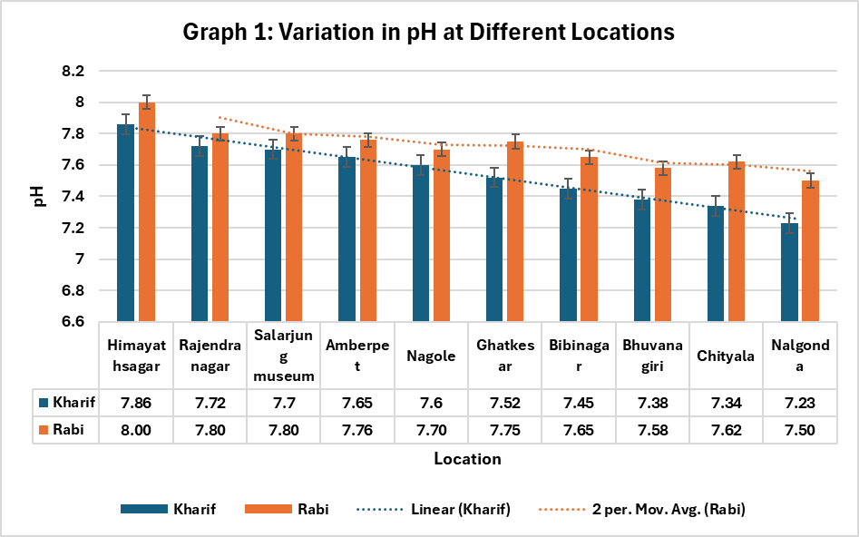
Electrical Conductivity (EC)
Electrical conductivity (EC) of sewage-irrigated surface water samples from the Musi River corridor varied between 1.65–2.60 dS m⁻¹ during Kharif 2024 (mean: 1.92 dS m⁻¹) and 2.20–2.90 dS m⁻¹ during Rabi 2024-25 (mean: 2.33 dS m⁻¹) (Table 1).
Mean EC levels were 21% higher in the Rabi season, likely due to elevated sulphate, chloride, and total solute concentrations from reduced monsoon dilution and persistent pollutant inputs. Compared to the permissible limit of 2.25 dS m⁻¹ for irrigation waters (ISI, 1982), one sample (Amberpet) exceeded this threshold during Kharif 2024, while seven of ten samples surpassed it in Rabi 2024-25, signalling heightened salinity risks for crops.
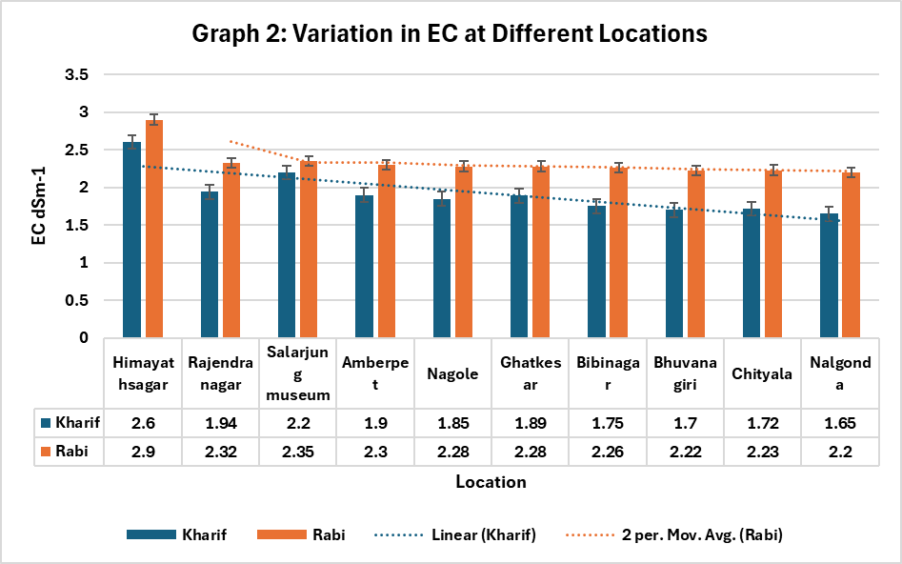
Total Solids (TS)
Total solids (TS) concentrations in sewage water samples from the Musi River corridor ranged from 2034–2400 mg L⁻¹ (mean: 2200 mg L⁻¹) during Kharif 2024 and 2102–2587 mg L⁻¹ (mean: 2310 mg L⁻¹) during Rabi 2024-25 (Table 1).
All samples exceeded the permissible limit of 1000 mg L⁻¹ for irrigation waters (ICMR, 1975), confirming widespread pollution across the urban-peri urban-rural gradient and underscoring potential risks to soil and crop health.

Total Dissolved Solid (TDS)
Total dissolved solids (TDS) in sewage water samples from the Musi River corridor ranged from 1652–1950 mg L⁻¹ (mean: 1782 mg L⁻¹) during Kharif 2024 and 1710–2103 mg L⁻¹ (mean: 1855 mg L⁻¹) during Rabi 2024-25 (Table 1).
These concentrations substantially exceeded the permissible limit of 500 mg L⁻¹ for irrigation waters (ISI, 1982), rendering the water unsuitable for crop irrigation across both seasons due to salinity buildup risks.
Total Suspended solids (TSS)
Total suspended solids (TSS) concentrations in sewage water samples from the Musi River corridor ranged from 382–450 mg L⁻¹ (mean: 418 mg L⁻¹) during Kharif 2024 and 392–484 mg L⁻¹ (mean: 455 mg L⁻¹) during Rabi 2024-25 (Table 1).
These levels exceeded the permissible limit of 100 mg L⁻¹ for irrigation waters (EPR, 1993) in both seasons, potentially causing aesthetic issues, clogging in irrigation systems, and reduced suitability for bathing or crop application.
Biological Oxygen Demand (BOD)
Biological oxygen demand (BOD) in sewage water samples from the Musi River catchment ranged from 152–225 mg L⁻¹ (mean: 184 mg L⁻¹) during Kharif 2024 and 224–303 mg L⁻¹ (mean: 254 mg L⁻¹) during Rabi 2024-25 (Table 2), reflecting substantial organic loading.
These values fell within safe irrigation limits of 100 mg L⁻¹ (ISI, 1983) and the broader acceptable range of 200–500 mg L⁻¹ (NEERI, 1985), indicating suitability for agricultural use despite elevated organic content. However, all samples greatly exceeded the drinking water threshold of 2 mg L⁻¹ (ISI, 1983), confirming unsuitability for potable purposes.
Chemical Oxygen Demand (COD)
Chemical oxygen demand (COD) in sewage water samples from the Musi River corridor ranged from 518–650 mg L⁻¹ (mean: 577 mg L⁻¹) during Kharif 2024 and 622–746 mg L⁻¹ (mean: 674 mg L⁻¹) during Rabi 2024-25 (Table 2).
These COD levels exceeded the critical discharge limit of 500 mg L⁻¹ for effluents onto cultivable land (ISI, 1982) across both seasons. Elevated values likely stem from industrial effluent inputs contaminating the river system.
Carbonates (CO₃⁻²) and Bicarbonates (HCO₃⁻)
Carbonate concentrations were below detectable limits in all sewage water samples collected from the Musi River corridor during both Kharif 2024 and Rabi 2024-25 seasons (Table 2).
Bicarbonate levels ranged from 64–128 mg L⁻¹ (mean: 89 mg L⁻¹) during Kharif 2024 and 76–158 mg L⁻¹ (mean: 110 mg L⁻¹) during Rabi 2024-25, with consistently higher values in the Rabi season (Table 2). Peak bicarbonate concentrations occurred at Amberpet, while the lowest were observed at Himayathsagar across both seasons.

Acidity
Acidity levels in sewage water samples from the Musi River corridor ranged from 2.8–4.7 mg L⁻¹ (mean: 3.71 mg L⁻¹) during Kharif 2024 and 2.8–5.8 mg L⁻¹ (mean: 4.12 mg L⁻¹) during Rabi 2024-25 (Table 2).
The highest acidity values (4.7 mg L⁻¹ in Kharif 2024 and 5.5 mg L⁻¹ in Rabi 2024-25) were recorded at Salarjung Museum, while the lowest (2.8 mg L⁻¹) occurred at Himayathsagar across both seasons. Overall, acidity was relatively elevated during the Rabi season compared to Kharif, consistent with reduced dilution and higher solute accumulation in the catchment.
Alkalinity
Alkalinity levels in sewage water samples from the Musi River corridor ranged from 480–654 mg L⁻¹ (mean: 574 mg L⁻¹) during Kharif 2024 and 520–720 mg L⁻¹ (mean: 624 mg L⁻¹) during Rabi 2024-25 (Table 2).
Peak alkalinity values (654 mg L⁻¹ in Kharif 2024 and 720 mg L⁻¹ in Rabi 2024-25 were recorded at Amberpet, while the lowest levels (480 mg L⁻¹ and 520 mg L⁻¹) occurred at Himayathsagar across both seasons. Rabi season samples consistently showed elevated alkalinity compared to Kharif, likely attributable to the accumulation of weak and strong bases—including carbonates, bicarbonates, and hydroxides from industrial effluents and reduced monsoon dilution.
Table 1: Physico-Chemical, Chemical and Biological characteristics of water samples collected at different locations along the Musi River belt area during Kharif 2024 and Rabi 2024-25

Table 2: Physico-Chemical, Chemical and Biological characteristics of Water samples collected at different locations along the Musi River belt area during Kharif 2024 and Rabi 2024-25

References
1. CPCB. Assessment and Development of River Basin. Series: ADSORBS/ 32/1999-2000. Central Pollution Control Board, Delhi, 2000.
2. APHA, Standard methods for the examination of water and waste water, American Public Health Association,Washington D C, United States of America, 1985.
3. Jackson ML. Soil chemical analysis. Prentice Hall of Indian Private Limited, New Delhi, 1973.
4. Indian Standards Institute (lSI). Indian standards for industrial and sewage effluent discharge. IS: 2490, 1982.
5. ICMR Manual of standards of quality for drinking water supplies. Special Report Serial Number 44, Indian Council of Medical Research, New Delhi, 1975.
6. Neeri. Waste water treatment annual report. National Environmental Engineering Research Institute, Nagpur,

