Foundational Numeracy Inequality and Adaptive Teaching in Ghana:
Evidence from the 2017/18 Multiple Indicator Cluster Survey and Insights from TALIS

Abstract
This study examined foundational numeracy inequality among children in Ghana and considered how adaptive teaching and differentiated instruction may respond to observed learning gaps. The main analysis used the Ghana Multiple Indicator Cluster Survey 2017/18 child questionnaire file and focused on children aged 7-14 with valid numeracy assessment responses (n = 5,139). Foundational numeracy was defined as successful completion of number reading, number discrimination, addition, and pattern recognition tasks. Weighted results showed that 15.5% of children demonstrated full foundational numeracy. Numeracy completion varied by household wealth, residence, mother's education, current school attendance, and region. Children from the richest households were more than three times as likely as those from the poorest households to demonstrate foundational numeracy in the adjusted model (OR = 3.54). To strengthen the adaptive-teaching discussion, the study also analysed the TALIS 2018 South African mathematics teacher sample as contextual evidence. Results showed that 79.1% of mathematics teachers reported being able to vary instructional strategies quite a bit or a lot, while 55.5% reported moderate or high professional-development need in individualised learning. The findings suggest that improving numeracy in unequal learning contexts requires not only access to schooling, but also classroom strategies that respond to learners' different readiness levels and support needs.
Keywords: foundational numeracy; adaptive teaching; differentiated instruction; mathematics education; Ghana; MICS; TALIS
Introduction
Foundational numeracy is an essential component of early learning and later educational success. Children who cannot recognise numbers, compare numerical quantities, perform basic addition, or identify simple patterns may struggle to progress in mathematics and in wider school learning. In countries where school access has expanded, the central policy question is no longer only whether children are in school, but whether they are acquiring the basic skills that schooling is expected to produce.
This study focuses on foundational numeracy inequality in Ghana. Ghana has made sustained efforts to expand access to basic education, but access alone may not be sufficient when children enter classrooms with unequal readiness levels. Socioeconomic background, residence, region, parental education, and school attendance can shape children's opportunities to acquire basic mathematical skills. When these inequalities are visible in nationally representative data, they provide a strong rationale for differentiated instruction and adaptive teaching.
Differentiated instruction refers to deliberate adaptation of content, process, learning activities, and assessment to meet learners' varied readiness levels and learning needs. Adaptive teaching is closely related: it emphasises teachers' ability to vary explanations, assessment methods, tasks, and instructional strategies when learners experience difficulty. In mathematics classrooms, these strategies are particularly important because children may be physically present in the same class while operating at very different numeracy levels.
The main empirical evidence in this study comes from the Ghana Multiple Indicator Cluster Survey (MICS) 2017/18. The study also uses TALIS 2018 as a complementary source of teacher-practice evidence. Because MICS and TALIS are different surveys with different samples, the two datasets are not merged. Instead, MICS is used to quantify child-level numeracy inequality in Ghana, while TALIS is used to provide contextual evidence about adaptive teaching and professional-development needs among mathematics teachers in an African setting.
Research Questions
- What proportion of children aged 7-14 in Ghana demonstrate foundational numeracy skills?
- How do foundational numeracy skills differ by sex, residence, household wealth, mother's education, school attendance, and region?
- Which child-level and household-level factors predict foundational numeracy achievement among Ghanaian children?
- What do TALIS 2018 data reveal about adaptive teaching readiness and professional-development needs among South African mathematics teachers?
- How can evidence on numeracy inequality and adaptive teaching inform the need for differentiated instruction in mathematics education?
Literature Review
The study is informed by human capital theory, social reproduction perspectives, and differentiated instruction theory. Human capital theory views education as an investment in skills and productivity, making numeracy a foundational competence for later learning and economic participation. However, social and cultural capital perspectives suggest that children's learning opportunities are shaped by family background, parental education, home resources, and community conditions.
Differentiated instruction provides a classroom response to these inequalities. Tomlinson (2014) argues that teachers should respond to learners' readiness, interests, and learning profiles through variation in content, process, product, and learning environment. In mathematics education, differentiated instruction may involve flexible grouping, varied tasks, alternative explanations, ongoing formative assessment, and targeted support for learners who have not mastered prerequisite skills.
Adaptive teaching is a related concept that emphasises teacher responsiveness during instruction. A teacher who can provide alternative explanations, use multiple assessment strategies, and vary instructional strategies is better positioned to support learners who are behind in foundational numeracy. The TALIS 2018 teacher questionnaire includes items on preparation for teaching in mixed-ability settings, professional development on individualised learning, and teacher self-efficacy in varying instructional strategies, using a variety of assessments, and providing alternative explanations when students are confused (OECD, 2018).
Previous learning-crisis literature shows that schooling does not automatically translate into learning. The World Development Report 2018 described learning poverty as a major education challenge and emphasised that many children attend school without acquiring basic skills. This study contributes to that discussion by showing, with Ghanaian MICS data, the extent to which foundational numeracy varies across social groups and by using TALIS to frame adaptive teaching as a practical response.
Methodology
This study used a quantitative secondary-data design. The primary dataset was the Ghana MICS 2017/18 child questionnaire file. The analytic sample included children aged 7-14 years with valid responses to the numeracy assessment items. This produced a final MICS analytic sample of 5,139 children.
The dependent variable was foundational numeracy. Following the MICS foundational learning structure, four numeracy task domains were constructed: number reading, number discrimination, addition, and pattern recognition. A child was coded as having foundational numeracy if all four task domains were completed successfully. Independent variables included child age, sex, residence, household wealth quintile, mother's education, current school attendance, and region.
The TALIS component used the 2018 international teacher file and focused on South African mathematics teachers because Ghana does not have a comparable TALIS teacher sample in the uploaded international file. South Africa was used only as African contextual evidence on teacher practices. The TALIS analysis examined teacher training in mixed-ability teaching, preparedness for mixed-ability settings, professional development in individualised learning, professional-development need in individualised learning, and self-efficacy in assessment and adaptive instructional strategies.
Weighted descriptive statistics were used for both datasets. For the Ghana MICS analysis, cross-tabulations and a weighted binary logistic regression model were used to identify predictors of foundational numeracy. For the TALIS analysis, weighted percentages were produced for South African mathematics teachers. Statistical results should be interpreted as associational because the data are cross-sectional.
Results
The Ghana MICS analytic sample consisted of 5,139 children aged 7-14 years with valid numeracy assessment responses. Weighted results showed that only 15.5% of children demonstrated full foundational numeracy. Among the numeracy domains, number discrimination had the highest completion rate (60.1%), while pattern recognition had the lowest completion rate (22.4%).
Table 1
Background Characteristics of the Ghana MICS Analytic Sample
Variable | Category | Unweighted n | Weighted %
Sex | Male | 2,565 | 51.3
 | Female | 2,574 | 48.7
Residence | Urban | 2,376 | 44.1
 | Rural | 2,763 | 55.9
Household wealth | Poorest | 1,305 | 20.1
 | Second | 894 | 22.4
 | Middle | 926 | 19.6
 | Fourth | 949 | 20.1
 | Richest | 1,065 | 17.9
Mother's education | Pre-Primary Or None | 1,934 | 33.7
 | Primary | 929 | 22.1
 | Jss/Jhs/Middle | 1,598 | 33.3
 | Sss/Shs/ Secondary | 426 | 7.6
 | Higher | 248 | 3.2
Current school attendance | Yes | 4,963 | 96.5
 | No | 118 | 2.6
Note. Percentages are weighted using the MICS children 5-17 sample weight. Mother's education excludes DK/missing in the displayed categories.
Table 2
Completion of Foundational Numeracy Task Domains
Numeracy domain | Unweighted n | Weighted completion %
Number reading | 5,139 | 54.9
Number discrimination | 5,139 | 60.1
Addition | 5,139 | 46.3
Pattern recognition | 5,139 | 22.4
Full foundational numeracy | 5,139 | 15.5
Note. Full foundational numeracy means successful completion of number reading, number discrimination, addition, and pattern recognition tasks.
Figure 1
Numeracy Task Completion among Children Aged 7-14 in Ghana
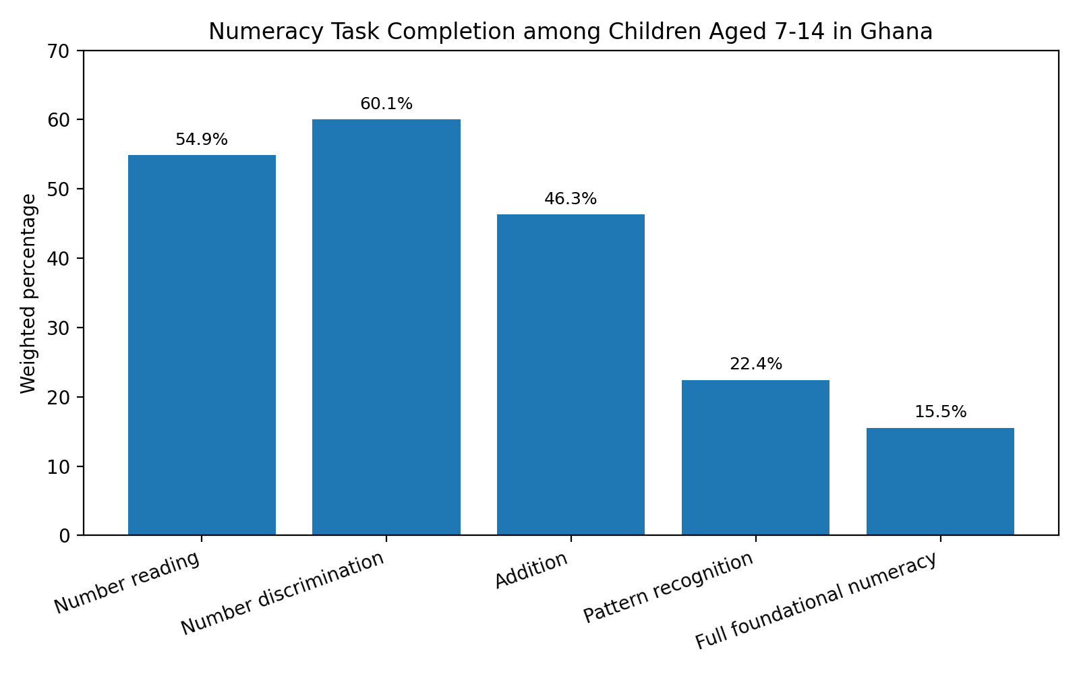
Note. Values are weighted percentages from the Ghana MICS 2017/18 child questionnaire file.
Foundational numeracy varied substantially across socioeconomic groups. Children from the richest households had the highest weighted numeracy rate, while children from the poorest households had the lowest. Children whose mothers had higher education also showed stronger numeracy outcomes than those whose mothers had no or pre-primary education. School attendance was strongly associated with foundational numeracy, although the overall level of numeracy remained low even among children who were attending school.
Table 3
Foundational Numeracy by Selected Characteristics
Variable | Category | Unweighted n | Foundational numeracy %
Sex | Male | 2,565 | 17.2
 | Female | 2,574 | 13.7
Residence | Urban | 2,376 | 20.7
 | Rural | 2,763 | 11.5
Household wealth | Poorest | 1,305 | 6.1
 | Second | 894 | 12.1
 | Middle | 926 | 13.2
 | Fourth | 949 | 19.8
 | Richest | 1,065 | 28.2
Mother's education | Pre-Primary Or None | 1,934 | 9.9
 | Primary | 929 | 14.0
 | Jss/Jhs/Middle | 1,598 | 19.4
 | Sss/Shs/ Secondary | 426 | 20.4
 | Higher | 248 | 30.7
Current school attendance | Yes | 4,963 | 16.1
 | No | 118 | 0.2
Note. Percentages are weighted within each category.
Figure 2
Foundational Numeracy by Household Wealth and Mother's Education
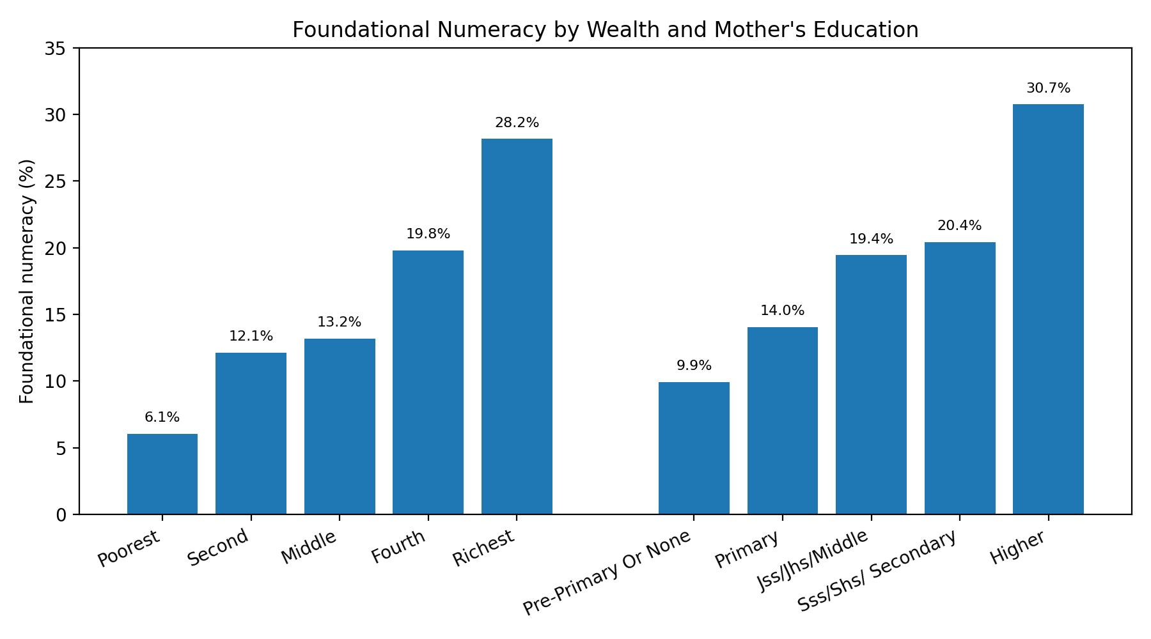
Note. Values are weighted percentages. The figure highlights inequality by household wealth and mother's education.

Table 4
Weighted Binary Logistic Regression Predicting Foundational Numeracy
Predictor | OR | 95% CI | p
Age (years) | 1.31 | 1.28-1.34 | < .001
Female (ref: male) | 0.70 | 0.63-0.77 | < .001
Rural (ref: urban) | 0.76 | 0.67-0.85 | < .001
Wealth: second (ref: poorest) | 1.94 | 1.56-2.40 | < .001
Wealth: middle (ref: poorest) | 1.77 | 1.41-2.21 | < .001
Wealth: fourth (ref: poorest) | 2.51 | 2.01-3.13 | < .001
Wealth: richest (ref: poorest) | 3.54 | 2.80-4.48 | < .001
Mother's education: primary (ref: none) | 1.22 | 1.04-1.43 | 0.015
Mother's education: JHS/middle (ref: none) | 1.40 | 1.21-1.61 | < .001
Mother's education: SHS/secondary (ref: none) | 1.29 | 1.04-1.59 | 0.019
Mother's education: higher (ref: none) | 2.04 | 1.56-2.67 | < .001
Attending school (ref: not attending) | 137.60 | 11.66-1623.22 | < .001
Note. OR = odds ratio. Reference groups are male, urban, poorest household, mother with no/pre-primary education, and not attending school. Region controls are included in the model but not displayed. The model uses the MICS sample weight but does not fully adjust standard errors for the complex sample design.
The regression results confirmed that numeracy inequality remained after controlling for other factors. Older children had higher odds of demonstrating foundational numeracy. Females and rural children had lower adjusted odds than males and urban children. Wealth was a strong predictor: children in the richest households had substantially higher odds of demonstrating foundational numeracy than children in the poorest households. Mother's education also showed a positive association, especially at the higher education level.
TALIS Insights on Adaptive Teaching
The TALIS teacher file contained 2,046 South African teacher records, including 402 mathematics teachers. The TALIS results are not merged with Ghana MICS; they are used to strengthen the discussion of adaptive teaching in unequal learning contexts. Among South African mathematics teachers, 73.2% reported that their formal education included teaching in mixed-ability settings, while 72.2% felt well or very well prepared for mixed-ability teaching. However, 55.5% reported moderate or high professional-development need in approaches to individualised learning.

Table 5
Adaptive Teaching Indicators among South African Mathematics Teachers in TALIS 2018
Indicator | Valid  unweighted n | Weighted %
Mixed-ability teaching included in formal education | 358 | 73.2
Well/very well prepared for mixed-ability teaching | 358 | 72.2
PD included individualised learning | 368 | 59.4
Moderate/high need for PD in individualised learning | 390 | 55.5
Can use varied assessment strategies | 399 | 89.8
Can provide alternative explanations | 400 | 94.8
Can vary instructional strategies | 399 | 79.1
High on all three adaptive-teaching items | 398 | 70.2
Note. Percentages use the TALIS teacher final weight. The sample is restricted to South African teachers who reported teaching mathematics in the current school year.
Figure 3
Adaptive Teaching Indicators among South African Mathematics Teachers
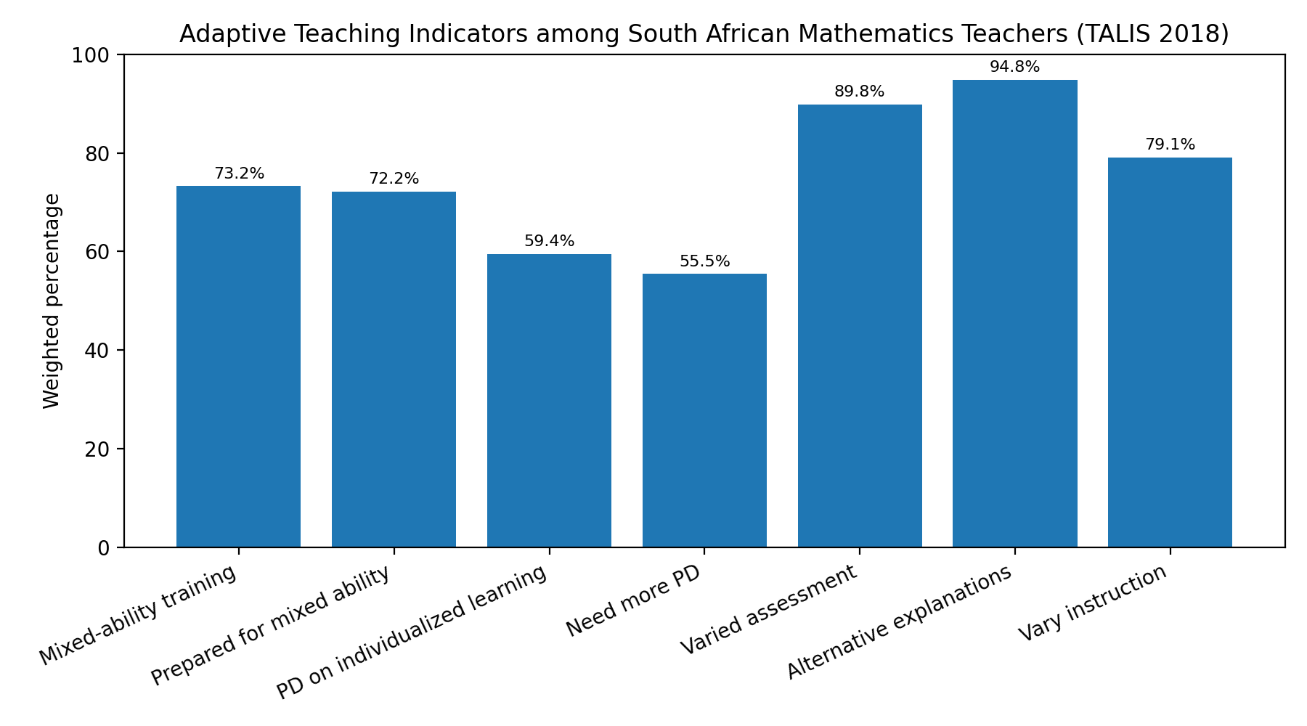
Note. Values are weighted percentages from TALIS 2018. These results are used as contextual evidence for adaptive teaching and differentiated instruction.
Discussion
The results show that foundational numeracy among Ghanaian children aged 7-14 is low and unequally distributed. Although more than half of children completed number reading and number discrimination tasks, far fewer completed pattern recognition, and only a small proportion demonstrated full foundational numeracy. This suggests that many children may be acquiring some early number skills without mastering the broader set of numeracy competencies required for mathematical progression.
The inequality pattern is important for differentiated instruction. Children from poorer households, rural areas, and less educated households were less likely to demonstrate foundational numeracy. In a classroom where learners differ widely in readiness, a single pace of instruction may leave behind those who have not mastered prerequisite number concepts. This makes differentiated instruction and adaptive teaching practical necessities rather than optional pedagogical preferences.
The TALIS evidence strengthens this argument by showing that adaptive teaching is measurable through teacher preparation, professional development, and self-efficacy. South African mathematics teachers generally reported high self-efficacy in providing alternative explanations and using varied assessment strategies. However, the reported need for additional professional development in individualised learning suggests that teachers may still require support to translate adaptive intentions into consistent classroom practice.
For Ghana, the implication is that foundational numeracy interventions should combine assessment, targeted support, and teacher capacity building. National and school-level data can identify children who are struggling, but teachers need practical strategies for grouping learners, diagnosing misconceptions, varying explanations, and monitoring progress. Differentiated instruction can therefore serve as a bridge between learning-assessment evidence and classroom response.
Conclusion and Recommendations
This study found substantial foundational numeracy inequality among children in Ghana using the 2017/18 MICS. Only 15.5% of children in the analytic sample demonstrated full foundational numeracy. Numeracy outcomes varied by wealth, residence, mother's education, school attendance, and region. The TALIS analysis, based on South African mathematics teachers, showed that adaptive teaching indicators are relevant for understanding how teachers can respond to diverse learner needs.
The study recommends that Ghana's mathematics education interventions should prioritise early diagnostic numeracy assessment, targeted support for children from poorer households and rural areas, and teacher professional development focused on differentiated instruction. Teacher training should strengthen skills in teaching mixed-ability classes, using varied assessment strategies, providing alternative explanations, and adapting instruction to learners' readiness levels.
Future research should collect Ghana-specific teacher and classroom data on differentiated instruction and link those data to student numeracy outcomes. Such research would allow stronger causal and classroom-level conclusions than are possible from the separate secondary datasets used in the present study.
Limitations
The study has limitations. First, the MICS analysis is cross-sectional and cannot establish causality. Second, the TALIS and MICS datasets are not linked; TALIS is used only as contextual teacher-practice evidence. Third, the TALIS component uses South African mathematics teachers because Ghana was not available as a comparable TALIS teacher sample in the uploaded file. Fourth, the Ghana MICS analysis uses weights but does not fully account for the complex sampling design in the regression standard errors.
References
Ghana Statistical Service, & UNICEF. (2020). Ghana Multiple Indicator Cluster Survey 2017/18: Survey findings report. Ghana Statistical Service and UNICEF.
Organisation for Economic Co-operation and Development. (2018). TALIS 2018 teacher questionnaire. OECD.
Organisation for Economic Co-operation and Development. (2019). TALIS 2018 results (Volume I): Teachers and school leaders as lifelong learners. OECD Publishing.
Tomlinson, C. A. (2014). The differentiated classroom: Responding to the needs of all learners (2nd ed.). ASCD.
UNICEF. (2019). MICS6 tools: Foundational learning module. UNICEF.
Vygotsky, L. S. (1978). Mind in society: The development of higher psychological processes. Harvard University Press.
World Bank. (2018). World development report 2018: Learning to realize education's promise. World Bank.
Appendix A
Variable Mapping for the Main Analyses
Dataset | Construct | Variable(s)
Ghana MICS | Foundational numeracy | Derived from FL23A-F, FL24A-E, FL25A-E, and FL27A-E
Ghana MICS | Child age | CB3
Ghana MICS | Sex | HL4
Ghana MICS | Residence | HH6
Ghana MICS | Region | HH7
Ghana MICS | Household wealth | windex5
Ghana MICS | Mother's education | melevel
Ghana MICS | Current school attendance | CB7
Ghana MICS | Sample weight | fsweight
TALIS 2018 | Mathematics teacher | TT3G15B2
TALIS 2018 | Mixed-ability training | TT3G06E1
TALIS 2018 | Mixed-ability preparedness | TT3G06E2
TALIS 2018 | Professional development in individualised learning | TT3G23H
TALIS 2018 | Need for professional development in individualised learning | TT3G27H
TALIS 2018 | Adaptive teaching self-efficacy | TT3G34J, TT3G34K, TT3G34L
TALIS 2018 | Teacher final weight | TCHWGT

