Integrating GIS-Based DRASTICA Model and Aquifer Protective Capacity for Hydrogeospatial Evaluation of Groundwater Vulnerability to contaminants in Owerri, Southeastern Nigeria.

*Bright O. Nwosu¹, Godwin J. Udom¹, Ferdinand D. Giadom¹ and Leonard I. Nwosu²
- Department of Geology, University of Port Harcourt, Nigeria.
- Department of Physics, University of Port Harcourt, Nigeria.

*Corresponding Author’s email: nwosubright97@gmail.com / +2348131204986

Abstract
Owerri, the capital of Imo State, depends almost exclusively on groundwater abstracted from shallow to intermediate-depth aquifers developed within the Benin Formation, a lithologic unit dominated by unconsolidated sands and sandstone with limited natural protection in most areas. This study integrates a GIS-based DRASTICA model with aquifer protective capacity evaluation derived from VES (longitudinal conductance values) to provide a comprehensive hydrogeospatial assessment of groundwater contamination risk in Owerri and its environs. 70 VES stations were interpreted to characterize subsurface lithology, determine vadose zone media, and aquifer protective potential, while digital elevation models, soil maps and LULC data were synthesized into a spatial database using ArcGIS 10.5 software. DRASTICA vulnerability indices range from 108 to 330 and delineate three dominant vulnerability classes: moderate (87.04%), high (14.42%), and very high (0.35%). Zones of elevated vulnerability are concentrated in densely urbanized areas and along the Imo River/Otamiri River zones, where shallow water tables, sandy vadose zones, minimal slopes collide with intense human activities to promote rapid contaminant infiltration. Longitudinal conductance values range from 0.004 to 31.003 Ω⁻¹, indicating predominantly poor to moderate aquifer protective capacity across greater parts of the Owerri, and consistent with areas of dominated by mostly sandy overburden. Areas of high longitudinal conductance correspond spatially with zones of low DRASTICA vulnerability, while areas of low conductance coincide with moderate to high vulnerability. The findings reveal the sensitivity of Owerri’s aquifer system to contamination from poorly managed waste disposal. The integrated DRASTICA–Aquifer Protective Capacity framework provides a replicable tool for groundwater protection planning, environmental monitoring, and sustainable urban development in rapidly urbanizing sedimentary environments.
Keywords: Groundwater, Anthropogenic activities, DRASTICA Vulnerability Model, Aquifer protective capacity, GIS.

INTRODUCTION
Groundwater provides the most reliable and commonly acceptable potable water source in many developing areas, particularly in sub-Saharan Africa, where surface water resources are often seasonal, polluted, or inadequately distributed [1], [6]. In Southeastern Nigeria, groundwater supplies support domestic consumption, small-scale industries, commercial activities, and institutional infrastructure. Owerri, the capital city of Imo State, exemplifies this dependence, as the majority of households and establishments rely on privately drilled boreholes and hand-dug wells for water supply. However, increasing pressure from rapid urbanization, population growth, industrial expansion, and unregulated land-use practices intensify the likelihood of groundwater contamination in the region [8], [19], [5]. The hydrogeologic framework of Owerri is dominated by the Benin Formation, otherwise known as the Coastal Plain Sands, a highly permeable sedimentary unit composed mainly of unconsolidated sands, gravelly sands, and minor clay intercalations. While this formation provides prolific aquifers with high yields, its intrinsic permeability and limited clay content in most arears significantly reduce its natural capacity to attenuate contaminants migrating from the surface [4], [16]. Consequently, pollutants introduced through anthropogenic activities can rapidly infiltrate the subsurface and degrade groundwater quality [17].
Industrialization, urbanization, and technological development have been widely recognized as major drivers of environmental degradation, particularly in rapidly growing cities in developing countries [26]. In Owerri and its environs, anthropogenic activities such as indiscriminate waste dumping, fuel storage and dispensing, poorly designed septic systems, agricultural chemical application, and urban runoff have increasingly compromised groundwater quality [19]. Previous studies have indicated high levels of nitrates, hydrocarbons, heavy metals, and microbial contaminants in groundwater within parts of Imo State, rendering some water sources unsafe for consumption [13], [20], [14]. Historically, remediation has been adopted as a reactive approach to groundwater contamination in the region. However, remediation efforts are often constrained by high costs, technical complexity, and inadequate funding. As a result, many contaminated boreholes in Owerri have been abandoned, placing an additional threat on surrounding aquifers and gradually facilitating water scarcity [7], [12]. This reveals the pressing requirement for proactive groundwater protection strategies that emphasize prevention rather than remediation. Groundwater vulnerability assessment provides a scientific basis for proactive protection by identifying areas that are more susceptible to contamination under prevailing hydrogeologic and land-use conditions [25]. Of the different methods created for this goal, index-based methods integrated within a GIS framework have been widely accepted because it is more flexible, having spatial explicitness and ability to synthesis diverse datasets. The DRASTIC model, remains one of the most commonly employed groundwater vulnerability assessment tools globally [3]. It evaluates intrinsic vulnerability using seven hydrogeologic parameters: depth to water, net recharge, aquifer media, soil media, topography, impact of the vadose zone, and hydraulic conductivity.
Research Gap
Despite the extensive application of the conventional DRASTIC model, it has been criticized for insufficiently accounting for anthropogenic influences, particularly in rapidly urbanizing environments [22]. To address this limitation, a modified version such as the DRASTICA model incorporate an additional parameter representing anthropogenic activity, mostly by evaluating the Landuse/Land cover pattern, thereby enhancing sensitivity to human-induced contamination pressures [23]. The applicability of this modification is particularly relevant in urban settings like Owerri, where land-use intensity and pollution sources also play a decisive role in groundwater quality degradation [25].
In parallel, geophysical methods provide valuable subsurface information that complements DRASTICA-based vulnerability indices. Vertical electrical sounding (VES), interpreted in terms of longitudinal conductance, offers an independent measure of aquifer protective capacity by quantifying the ability of overburden materials to retard contaminant migration. Clay-rich, low-resistivity layers exhibit high conductance and provide effective natural protection, whereas sandy, high-resistivity materials offer minimal attenuation [21]. The integration of GIS-based vulnerability models with geophysical aquifer protective capacity assessment has been shown to improve confidence in groundwater vulnerability mapping by linking surface susceptibility indicators with subsurface protective characteristics [2]. However, such integrated approaches remain underutilized in southeastern Nigeria, creating a significant knowledge gap in regional groundwater protection planning.
This research aims to fill the gaps by integrating a GIS-based modified DRASTICA model with aquifer protective capacity analysis to assess groundwater vulnerability to contaminants in Owerri and its environs by; delineating the spatial distribution of groundwater vulnerability using the DRASTICA model, assessing aquifer protective capacity based on longitudinal conductance derived from VES data, examine the spatial relationship between vulnerability and protective capacity, and provide evidence-based recommendations for groundwater protection and sustainable urban development in the study area.

METHODOLOGY

Research Design
This research adopts a descriptive research design with a quantitative GIS-based modeling approach. Geological and environmental parameters were collected through field surveys and secondary data sources, presented in the form of tables, maps and reports, which were further processed using the weighted overlay tool in the ArcGIS software, to design the DRASTICA model for groundwater vulnerability assessment as shown in Figure 1. This approach therefore integrates elements of applied research, targeting practical solutions in environmental protection and sustainable management.

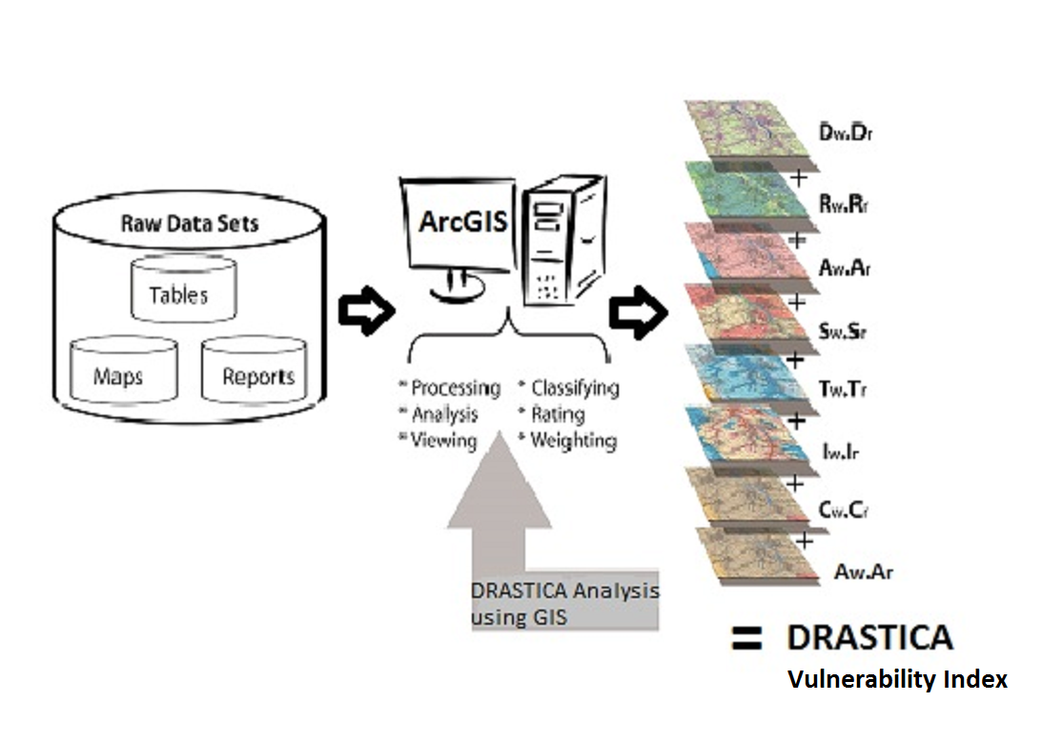
Figure 1: Methodological design of the GIS- based DRASTICA model.

Location and Description of the Study Area
Owerri is located in Southeastern Nigeria between latitudes 5.40° and 5.65° N and longitudes 6.95° and 7.29° E, covering an approximate area of 1,800 km². The region lies within the humid tropical rainforest belt and is characterized by a warm climate with mean annual temperatures ranging between 26 and 28 °C. Annual rainfall averages about 2,400 mm, with a bimodal distribution and a pronounced wet season extending from April to October [7]. High rainfall intensity, combined with relatively flat topography in some areas, promotes infiltration and groundwater recharge. Topographically, the area consists of gently undulating terrain with elevations ranging from about 50 to 150 m above sea level. Drainage is dominated by the Imo River and its tributaries, including the Nworie River, which traverse the western and central parts of the study area (Figure 2). These river valleys are associated with alluvial deposits and shallow water tables that enhance groundwater–surface water interaction.
Geologically, Owerri is underlain predominantly by the Benin Formation of Miocene to Recent age [26]. This formation comprises unconsolidated to poorly consolidated sands, gravelly sands, sandy clay, and occasional clay lenses (Figure 3). The high permeability of these materials results in productive aquifers but also increases susceptibility to contamination. Groundwater occurs under unconfined to semi-confined conditions, with water table depths varying spatially depending on topography, lithology, and proximity to surface water bodies [11]. Land use within Owerri has undergone rapid transformation over the last 20 years, driven by urban expansion, infrastructure development, and population growth. Residential, commercial, institutional, and industrial land uses now dominate areas that were previously agricultural or forested, significantly altering recharge patterns and increasing pollution loads [18].
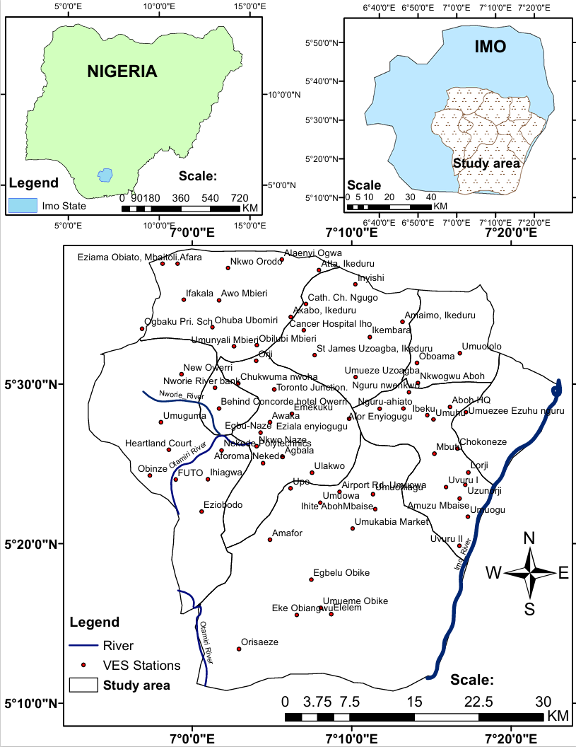
Figure 2: Location map of the study area showing VES sample stations.
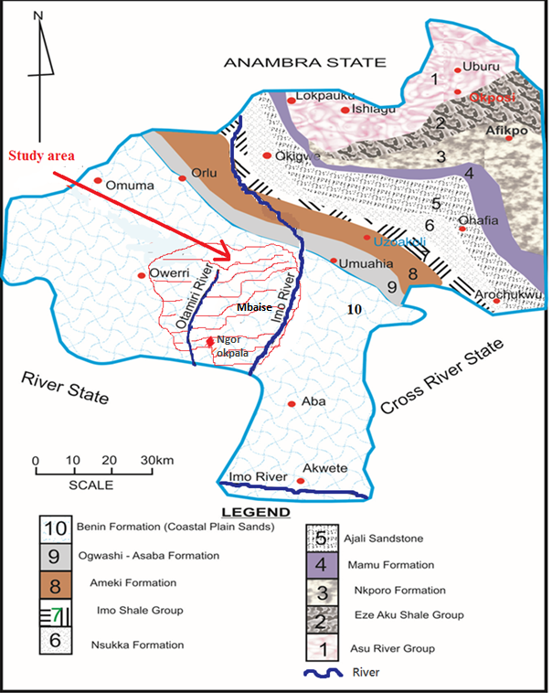
Figure 3: Geological Map of Imo River basin showing the study area (modified after [10]).

Data Acquisition and Processing
A combination of geophysical, hydrogeologic, and environmental datasets was adopted in this study. Seventy (70) vertical electrical soundings (VES) were carried out across the entire study area using the Schlumberger electrode configuration. The VES data (Figure 4 and Table 1) were interpreted to determine subsurface layer resistivities and thicknesses, which were subsequently used to infer aquifer media, vadose zone characteristics, and longitudinal conductance for determining the aquifer protective capacity. Water table depths were measured directly from eight boreholes within the study area, using water level dip meter and complimented with available borehole data in other locations. Secondary datasets included satellite-derived rainfall data, a 30 m resolution Shuttle Radar Topography Mission (SRTM) digital elevation model of Nigeria, soil maps obtained from national soil database, and land-use/land-cover data derived from ArcGIS ESRI Sentinel 2 Land cover website and served as the base spatial dataset, which represented the Anthropogenic factor indices. All datasets were processed and analyzed within a GIS environment. Point data were spatially interpolated using inverse distance weighting (IDW) to generate continuous raster surfaces, while categorical data were reclassified according to standardized rating schemes [2]. Spatial harmonization ensured consistent resolution, projection, and extent across all thematic layers.

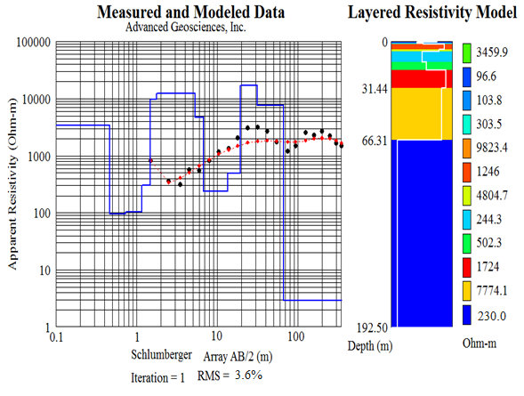
Figure 4: VES model result of Atta

Table 1: Atta VES analytical result
LAYER | DEPTH  (m) | RESISTIVITY  (ohm-m) | COLOUR CODE | LITHOLOGY
1 | 1.77 | 982.0 | Off-Red | Topsoil/lateritic sand
2 | 5.30 | 246.0 | Red | Sand
3 | 13.40 | 244.3 | Light Blue | Clayey Sand
4 | 19.20 | 502.3 | Green | Sand
5 | 31.40 | 1724 | Red | Medium/coarse sand
6 | 66.30 | 7774.1 | Yellow | Sandstone
7 |  | 230 | Blue | Medium/coarse sand

DRASTICA Vulnerability Assessment
The DRASTICA model employed in this study integrates eight parameters: depth to water (D), net recharge (R), aquifer media (A), soil media (S), topography (T), impact of the vadose zone (I), hydraulic conductivity (C), and anthropogenic activity (A). Each parameter was assigned a rating reflecting its relative influence on groundwater contamination potential, and a weight indicating its importance within the model framework.
The composite DRASTICA index was calculated using a linear weighted summation equation (Equation 1):
DRASTICA Index = Dr.Dw+ Rr.Rw+Ar.Aw+ Sr.Sw+ Tr.Tw + Ir.Iw+ Cr.Cw+Ar.Aw Equation 1
where:
where r​ and w​ represent the rating and weight of the respective parameters. The resulting index values were classified into vulnerability categories using standard thresholds, producing a geospatial map of groundwater vulnerability index across the study area [24].

Aquifer Protective Capacity Assessment
Aquifer protective capacity was evaluated using longitudinal conductance (S), derived from interpreted VES parameters according to:
S = ∑ $\frac{hi}{ρi}$
where h_{i}​ is the thickness (m) and ρ_{i}​ is the apparent resistivity (Ω) of the i^{th} subsurface layer(s) above the aquifer. High longitudinal conductance values indicate thick, low-resistivity (clayey) layers capable of attenuating contaminants, whereas low longitudinal conductance values reflect thin or sandy layers with limited aquifer protective capacity (APC). The computed conductance values were classified into aquifer protective capacity categories as stated by [21]: poor, weak, moderate, good and very good. Spatial interpolation produced a regional APC map, which was subsequently compared with the DRASTICA vulnerability map to evaluate concordance.

RESULTS
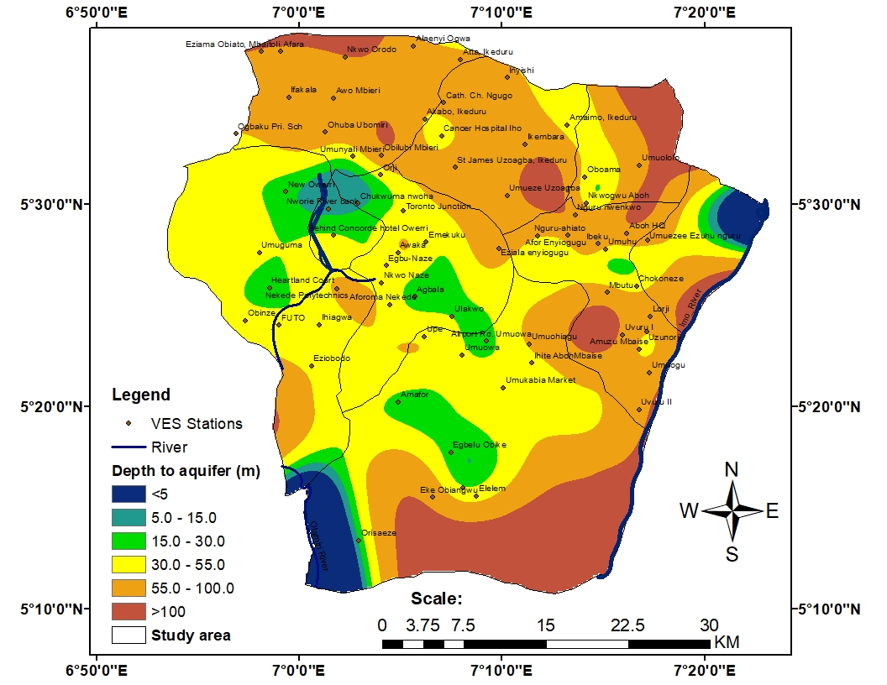
A
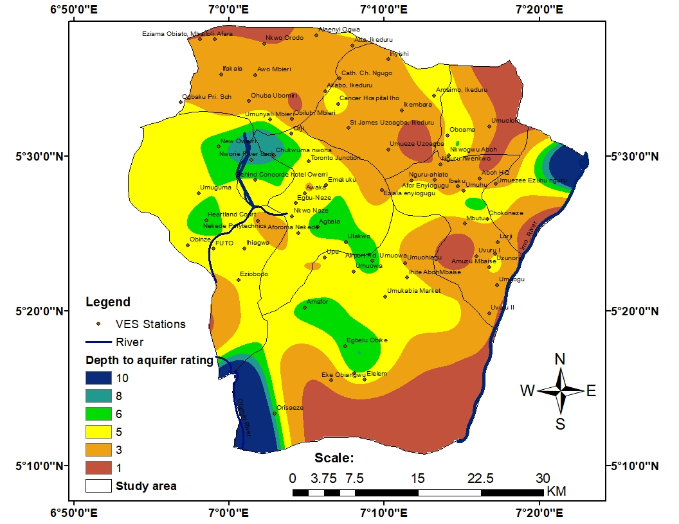
B
Figure 5 Depth to aquifer map showing (a) Aquifer Depth range (b) Aquifer Depth reclassified rating.

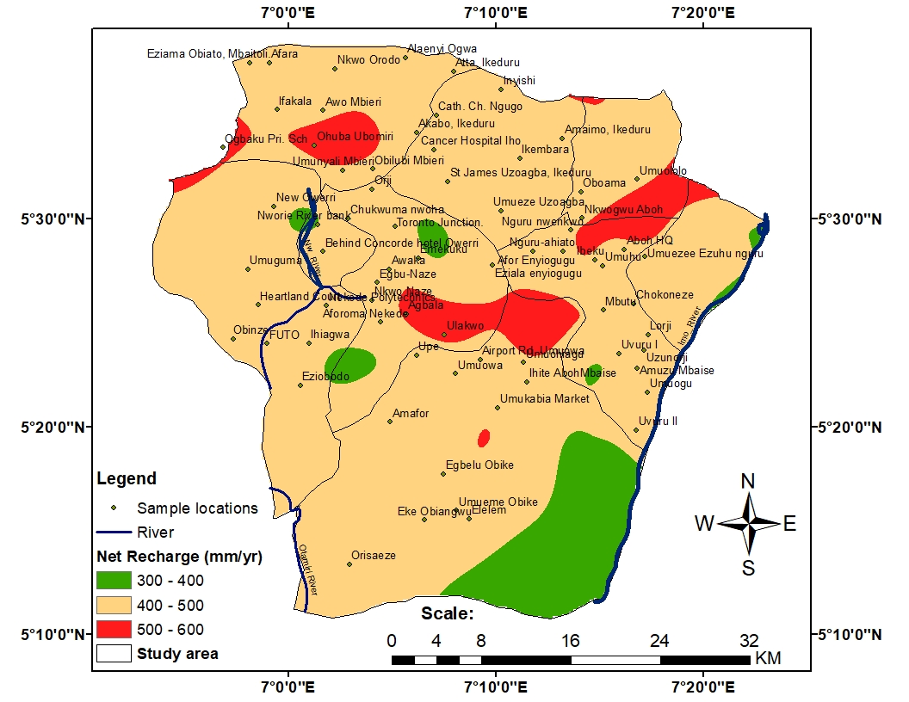
A
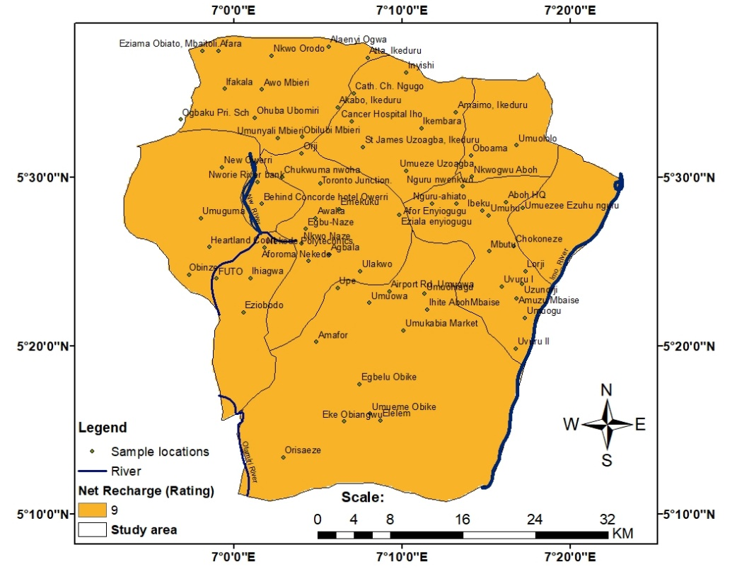
B
Figure 6 Net Recharge map showing (a) Aquifer Net recharge ranges (b) Aquifer Net recharge reclassified rating.

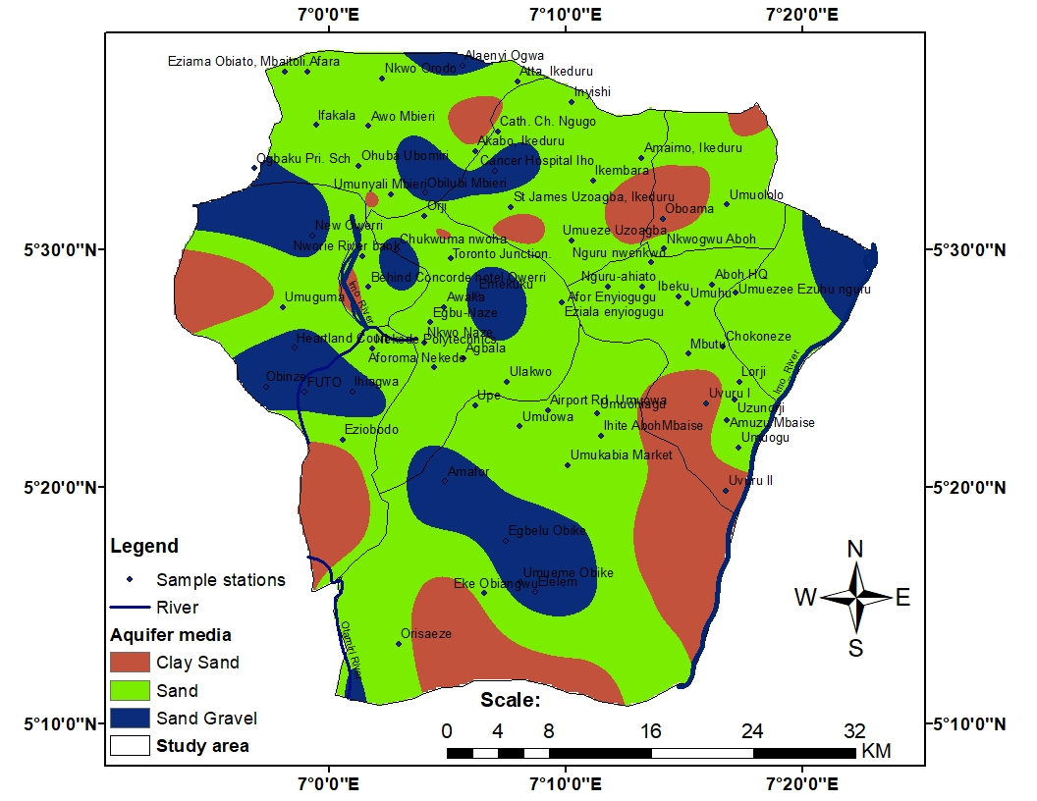
A
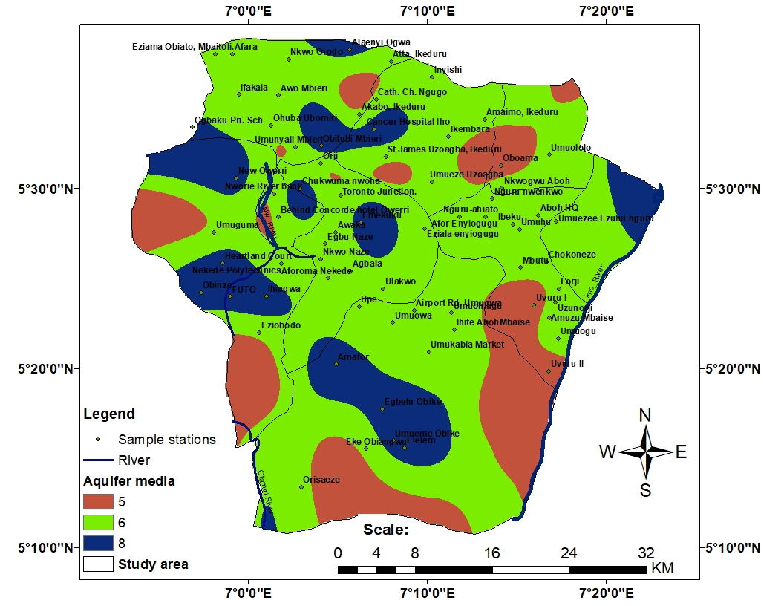
B
Figure 7 Aquifer media map showing (a) Aquifer media types (b) Aquifer media reclassified rating.
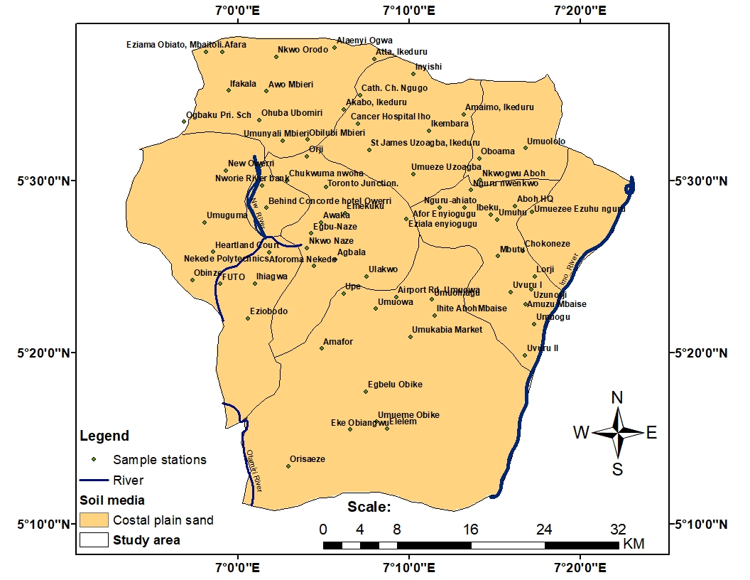
A
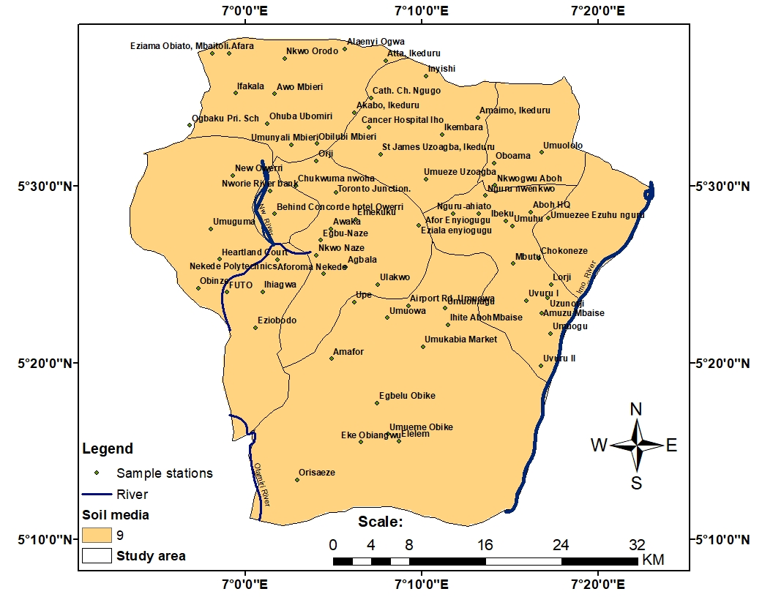
B
Figure 8 Soil media showing (a) Soil media types (b) Soil media reclassified rating.

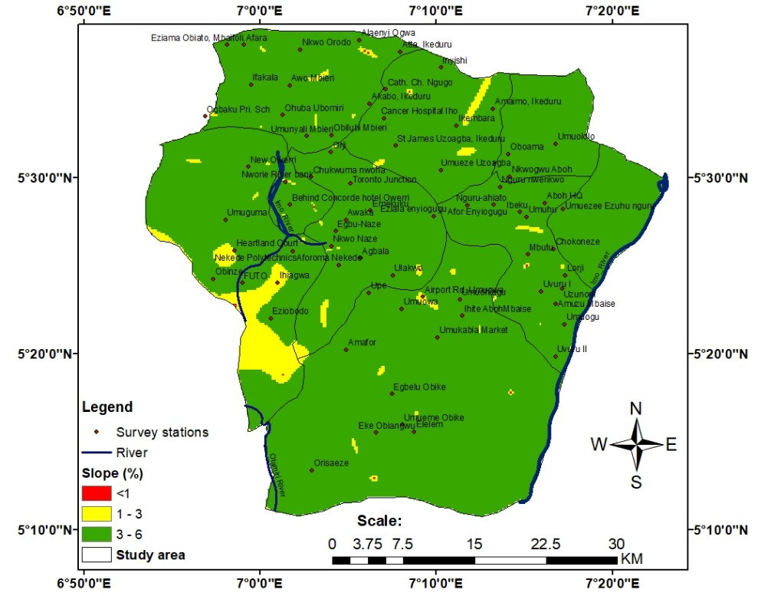
A
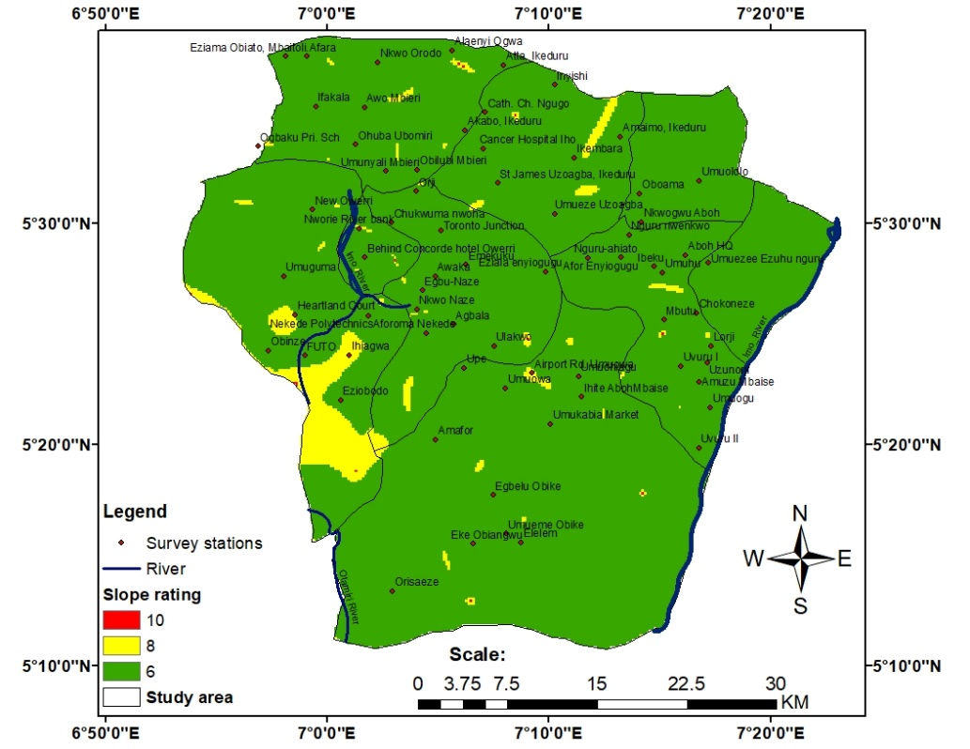
B
Figure 9 Topography parameter showing (a) Topography in slope percentage (b) Slope reclassified rating.
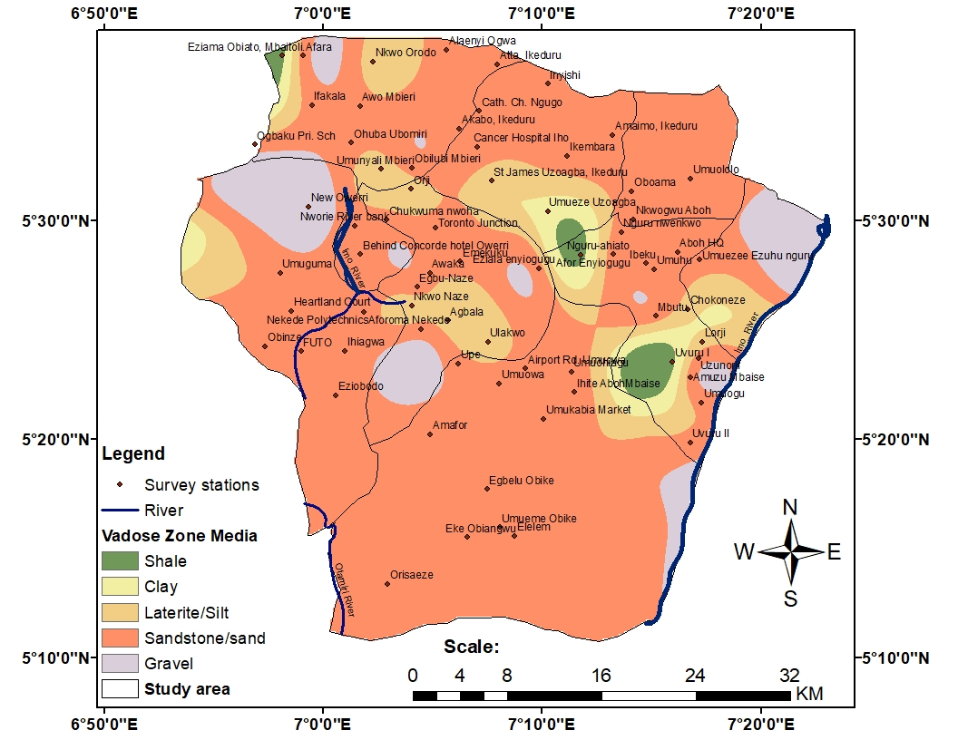
A
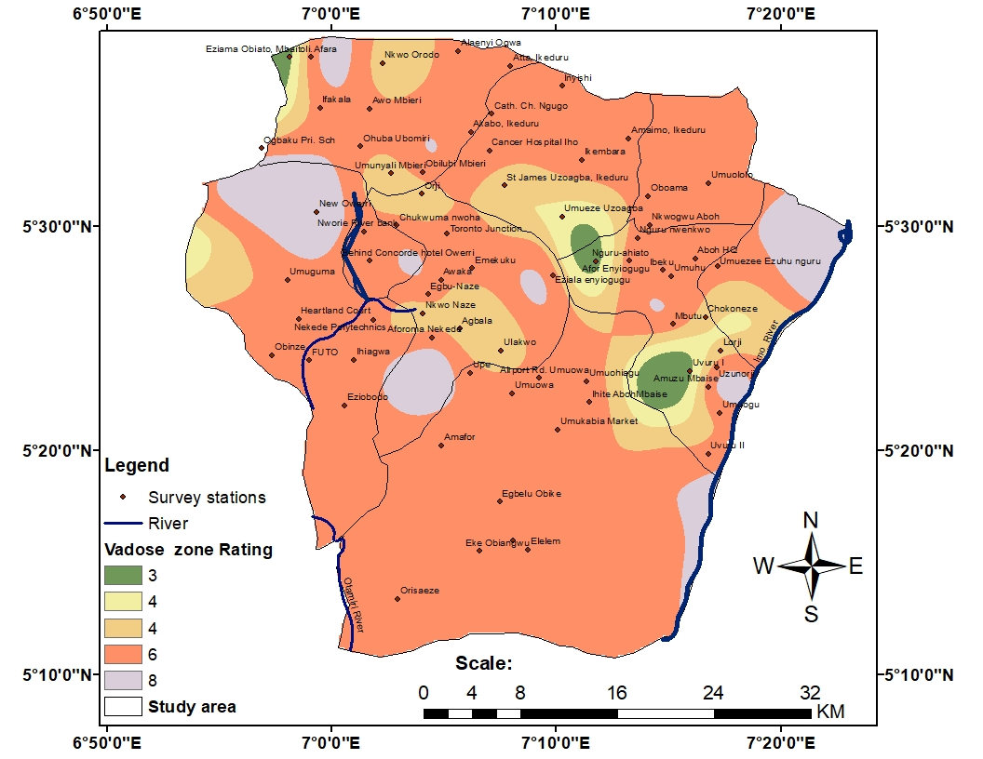
B
Figure 10 Vadose Zone media showing (a) Vadose zone media types (b) Vadose zone media reclassified rating.
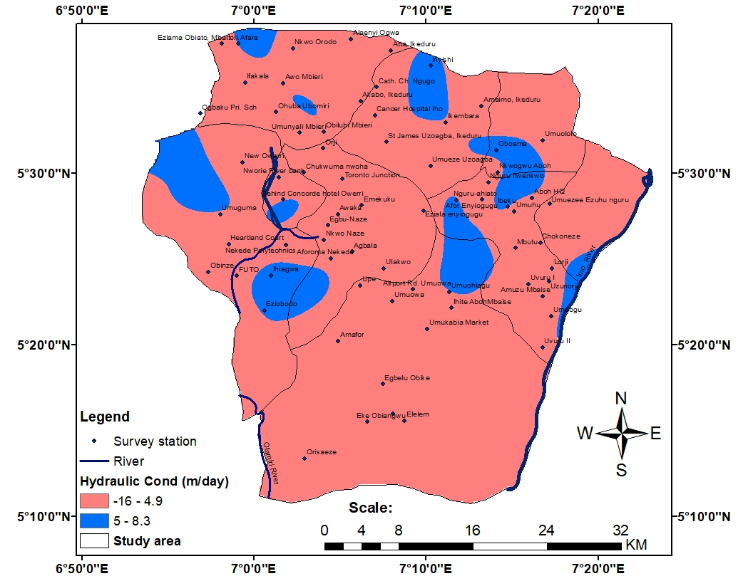
A
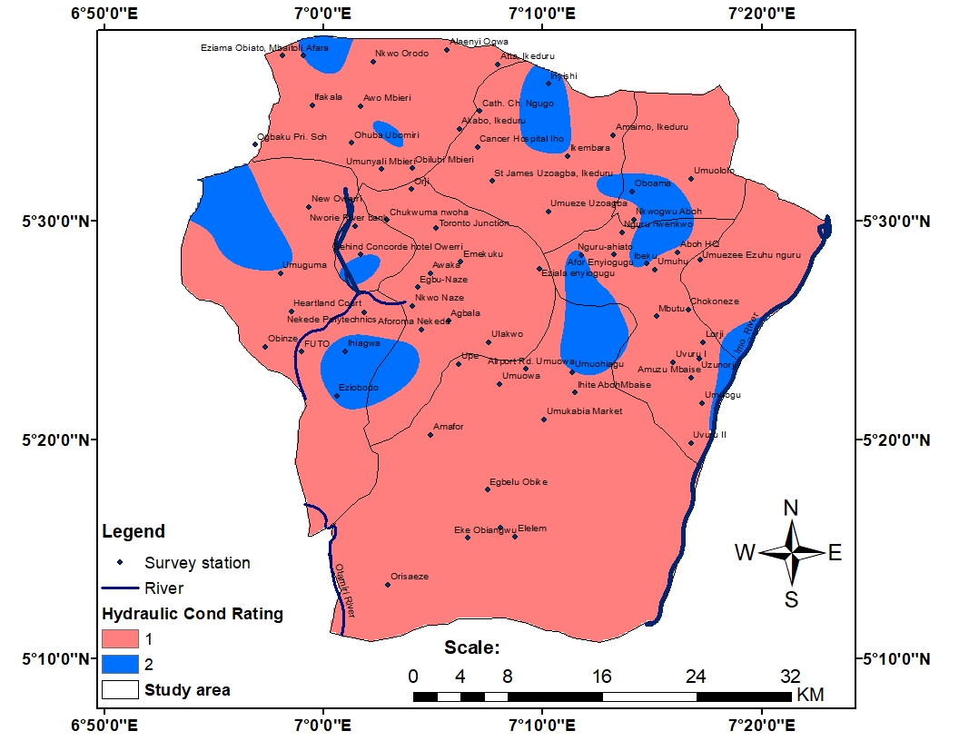
B
Figure 11 Hydraulic Conductivity map showing (a) Hydraulic Conductivity range (b) Hydraulic conductivity reclassified rating.
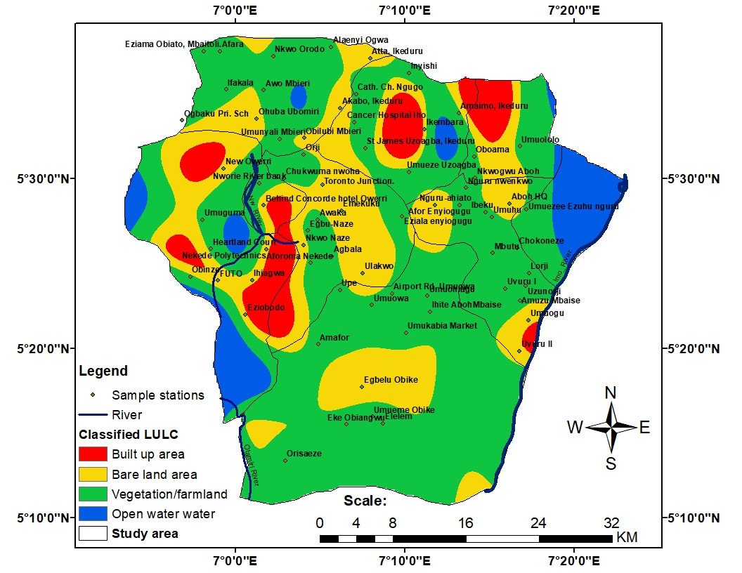
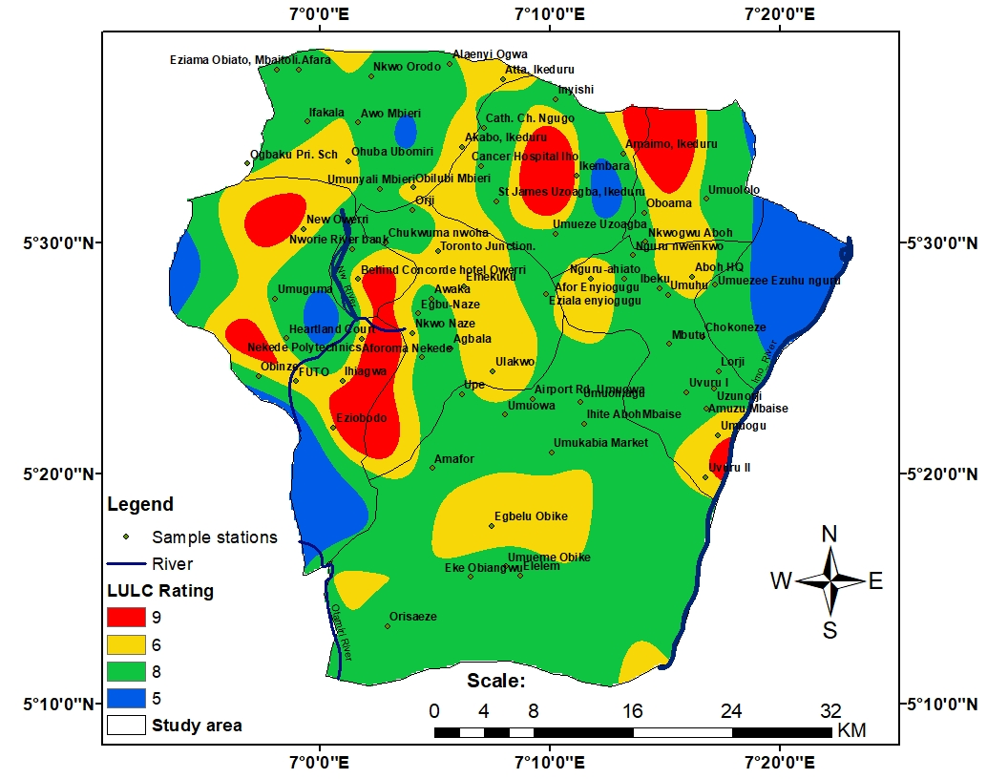
B
A
Figure 12 Impact of Anthropogenic Factor Parameter showing (a) Land Use Land Cover classes (b) Land Use Land Cover reclassified rating.

DRASTICA Vulnerability Distribution
Figure 5(a and b) to Figure 12(a and b) show the output results of each DRASTICA parameter and their corresponding ratings, delineating the entire study area. The rating maps were overlayed with the help of weighted overlay and raster calculator in the ArcGIS 10.5 software to produce a DRASTICA index model that showed a range of index values from 108 to 330 (Figure 13), reflecting considerable spatial variability in groundwater vulnerability across the study area. Three major vulnerability classes were identified: moderate, high, and very high.
Moderate vulnerability dominates the region, accounting for approximately 87.04% of the total area. These zones are prevalent in the northern and Northeastern parts of Owerri, including Atta, Amaimo, Ngugo, and Awaka. They are characterized by moderately deep-water tables, mixed sandy clayey vadose materials, and relatively lower anthropogenic pressure compared to the urban centers. High vulnerability zones cover about 12.42% of the area and are concentrated in densely populated and rapidly urbanizing locations such as New Owerri, Nekede, Umuguma, Ihiagwa, and Obinze. These high vulnerability areas exhibit shallow groundwater levels, highly permeable sandy soils, minimal slope, and intense human activities, all of which enhance contaminant transport to the aquifer. Very high vulnerability zones constitute approximately 0.54% of the study area and are primarily associated with the western Imo River floodplain. Here, sandy alluvial deposits, extremely shallow water tables, and flat terrain facilitate rapid infiltration and direct hydraulic connection between surface contaminants and groundwater.
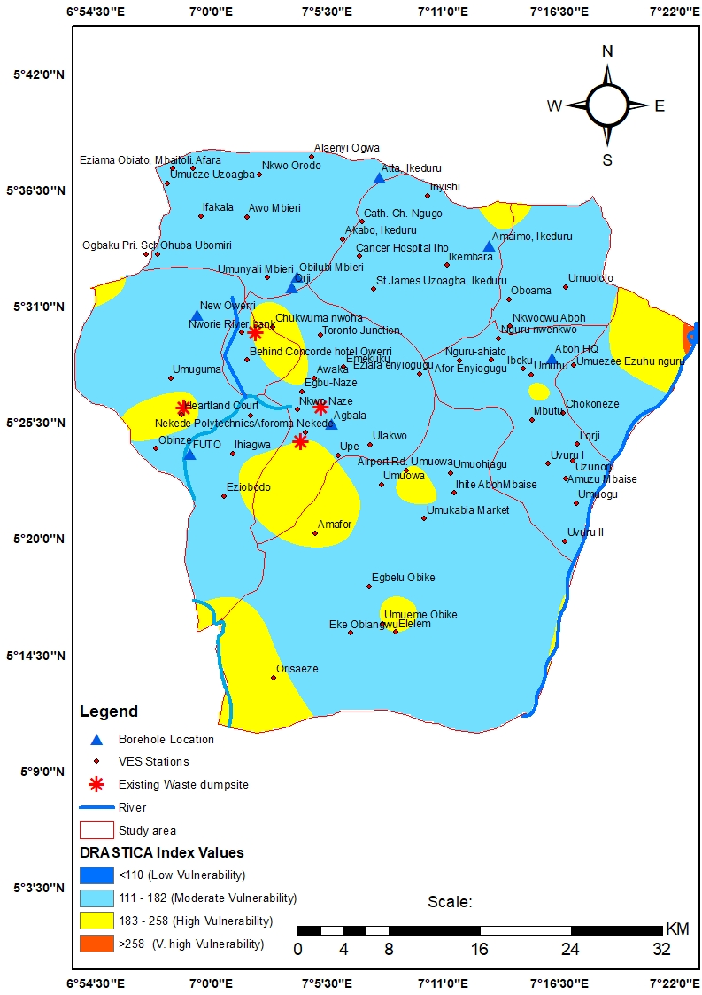
Figure 13 Final DRASTICA Vulnerability Index model

Aquifer Protective Capacity
Longitudinal conductance values range from 0.004 to 31.003 Ω⁻¹, representing variability in the ability of the subsurface to protect groundwater from surface-derived contamination (Figure 14). Extensive zones of poor to weak aquifer protective capacity dominate the central and north-western parts of Owerri, including the highly urbanized areas of New Owerri, Nekede, and Naze, reflecting the predominance of sandy overburden with limited clay.
Moderate to good protective capacity area characterizes transition zone occurring locally where thicker lateritic or clay-rich overburden are present, particularly near Amafor and along parts of the Nworie River bank. Very good to excellent protective capacity (>10 Ω⁻¹) is restricted to isolated pockets characterized by thick, low-resistivity clay deposits capable of significantly attenuating contaminant migration. Generally, Figure 14 highlights areas requiring stricter groundwater protection and careful land-use planning (within the moderate to poor protective capacity), mostly in the south-western parts of the study, indicated with yellow to red colour in Figure 14.
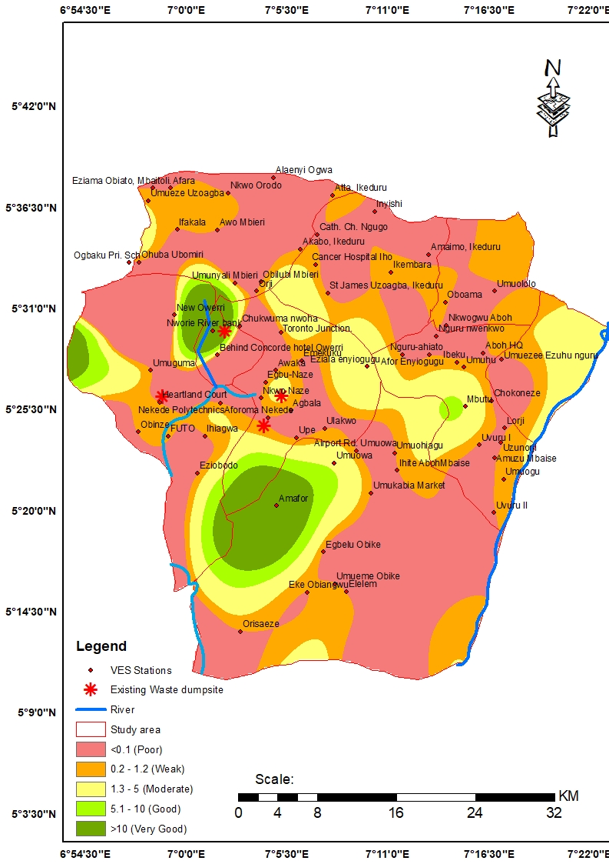
Figure 14 GIS map of aquifer protective capacity, showing longitudinal conductance values

Spatial Relationship Between DRASTICA model and Aquifer Protective Capacity
A strong spatial correspondence is observed between DRASTICA vulnerability and aquifer protective capacity. Areas identified as highly vulnerable by the DRASTICA model generally coincide with zones of poor or weak aquifer protective capacity, particularly within the central urban corridor and western parts. Conversely, regions exhibiting moderate vulnerability often align with moderate to very good protective capacity, revealing the influence of subsurface lithology on groundwater protection.

DISCUSSION
The results of this study confirm that the intrinsic hydrogeologic characteristics of the Benin Formation play a dominant role in controlling groundwater vulnerability in Owerri. The formation’s high permeability, combined with mostly shallow water tables and intense groundwater recharge, predisposes the mostly unconfined aquifer system to rapid contaminant infiltration, especial in the central and southwestern parts of Owerri. These natural factors are further intensified by anthropogenic pressures associated with urbanization. The spatial distribution of high vulnerability zones corresponds closely with areas of concentrated human activity, including residential estates, commercial centres, fuel stations, and waste disposal sites. Septic system leakage and poorly managed solid waste dumps are particularly significant sources of diffuse contamination, as indicated in Figure 12, within the highly vulnerable locations, further contributing to elevated nitrate and microbial levels reported in previous studies [15]. The Nworie River and Imo River floodplain represents a critical vulnerability hotspot due to its shallow groundwater and frequent flooding, which can mobilize and redistribute contaminants over wide areas from the relatively exposed surface water interaction. Comparable trends of groundwater exposure due to presence of anthropogenic activities have been observed in other areas of South-eastern Nigeria [13], reinforcing the need for targeted protection measures in the sand-rich sedimentary and riverine environments.
The strong agreement between DRASTICA vulnerability and aquifer protective capacity underscores the value of integrating GIS-based modeling with geophysical analysis. While DRASTICA effectively captures surface and near-surface susceptibility, longitudinal conductance provides essential insight into subsurface attenuation potential, together offering a holistic understanding of groundwater contamination risk.
CONCLUSION
This study conclusively demonstrates that the integration of GIS-based DRASTICA modeling with Vertical Electrical Sounding (VES) through aquifer protective capacity assessment provides a preferrable and scientifically reliable framework for evaluating groundwater vulnerability in Owerri, Southeastern Nigeria. The results reveal that groundwater across the study area is largely characterized by moderate to high vulnerability, with only limited zones benefiting from strong natural protection. This pattern is fundamentally controlled by the hydrogeological nature of the Benin Formation, whose dominance of unconsolidated, coarse-grained, and highly permeable sandy units promotes rapid infiltration and contaminant transport. Consequently, the aquifer protective capacity is generally weak, rendering groundwater resources, especially in the central and south-western parts of Owerri, particularly susceptible to surface-derived pollutants. The vulnerability is further aggravated by intense anthropogenic pressures; especially urban expansion, inadequate municipal waste management, and dense sanitation infrastructure, common within Owerri metropolis and other urban centres in Imo State. The strong spatial concordance observed between the DRASTICA vulnerability index and aquifer protective capacity classification underscores the internal consistency and reliability of the integrated approach, validating its effectiveness for groundwater risk assessment. Significantly, the study's methodological framework is flexible and can be applied elsewhere, making it suitable for application in other rapidly urbanizing sedimentary basins facing similar hydrogeological and land-use challenges. Based on the findings, this study emphasizes the urgent need for proactive groundwater protection and sustainable management strategies in the Owerri area. Land-use planning and zoning rules should be strictly enforced to limit activities that pose environmental hazards and high pollution risks activities within zones identified as highly and very highly vulnerable, such as New Owerri, Nekede and Eziobodo areas. Significant investment in sanitation infrastructure is essential to curb septic system leakage, indiscriminate municipal waste disposal, and associated contaminant loading into the subsurface environment. Furthermore, the establishment of routine and systematic groundwater quality monitoring programs, particularly in urbanized and floodplain areas, will enable early detection of contamination trends and support evidence-based decision-making. Finally, it is also imperative to establish the importance of developing a standard central urban water supply scheme, as this will aid effective monitoring and prevention of the spread of water borne diseases within the study area.
Conflict of interest
The authors declare that there is no conflict of interest whatsoever.
Ethical approval
The present research work does not contain any studies performed on animals/humans’ subjects by any of the authors.

REFERENCES
- Abadi, H.T., Asresie, T., Mihretu, A. and Gabrehewot W (2025). Assessment of groundwater quality for drinking purposes using water quality index in volcanic rock areas of Axum, Northern Ethiopia. Appl Water Sci 15, 227: 1-16
- Ahsen, M., Bilal, A., Umer, K., Omid, G., Hassan, A., Rana, F.T., Danish, F. and Thomas, B. (2020). A GIS-based DRASTIC Model and an Adjusted DRASTIC Model (DRASTICA) for Groundwater Susceptibility Assessment along the China-Pakistan Economic Corridor (CPEC) Route. International Journal of Geo-Information, 9(322), 1- 23
- Aller, L., Bennet T., Lehr, J.H., Petty, R.J., and Hackett, G. (1987). DRASTIC: A standardised system for evaluating groundwater pollution potential using hydrogeologic settings. US Environment Protection Agency Report (EPA/600/2-87/035), Ada, Oklahoma, USA.
- Anumaka, C.C., Anozie, H.C., Ahaneku, C.V., Okpara, A.O., Odinye, A.C., Onuchukwu, E.E. and Oshim, F.O., C.C. et al. (2024). Sedimentological Analysis and Depositional Environmental Interpretation of Benin Formation: A Case Study of Umuaka and its Environs in Njaba Local Government Area, Imo State, Nigeria. International Journal of Research and Innovation in Applied Science (IJRIAS), 7:492-509
- Boateng T.K, Opoku F, and Akoto O. (2019) Heavy metal contamination assessment of groundwater quality: a case study of Oti landfill site, Kumasi. Appl Water Sci 9(33):1–15
- Ghosh, A., Pant, D., Kajla, M. Mohokar H., Jarval A. and Keesari T. (2025) Isotope characterisation of groundwater resources in uranium impacted Fazilka, Punjab. J Radioanal Nucl Chem 334, 4243–4250
- Ibe, F. C., Opara, A. I., Amaobi C.E and Ibe B.O (2021). Environmental risk assessment of the intake of contaminants in aquifers in the vicinity of a reclaimed waste dumpsite in Owerri Municipal, Southeastern Nigeria. Applied Water Science, 11:24.
- Ibe F.C, Isiuku B.O, Enyoh C.E (2017) Trace metals analysis of soil and edible plant leaves from the abandoned municipal waste dumpsite in Owerri, Imo State, Nigeria. World News Nat Sci 13:27–42
- Iuliana G. B. and Madalina P. (2012). Application of DRASTIC Model and GIS for Evaluation of Aquifer Vulnerability; study case Barlad city Area. Water Resources and Wetlands Journal 5, 555-593
- IWACA (2006). Imo Water Corporation Agency Documentary on Groundwater Resources Potential of Imo State Nigeria (Unpublished). 20-39
- Nwachukwu, I. N., Dike, B. U., Nwoke, H. U., and Nwakwasi, L. N. (2023). Exploration of Ground Water Potential of Federal University of Technology, Owerri and Its Environs Using Resistivity Survey. Saudi Journal of Civil Engineering, 7(9):227–240.
- Nwachukwu, M.A., Huan, Feng and Duke Ophori (2010). Groundwater Flow Model and Particle Track Analysis for Selecting Water Quality Monitoring Well Sites and Soil Sample Profile. Journal of Spatial Hydrology 10(1): 1- 14
- Nwachukwu, M. A., Huan, F. and Alinnor, J. (2011). Trace Metal Dispersion in Soil from Auto-Mechanic Village to Urban Residential Areas in Owerri, Nigeria. Journal of Procedia Environmental Science 4(3): 310-322.
- Nwosu, B.O. and Nwosu, L.I. (2019). Assessment of Groundwater Vulnerability to Contaminants in Parts of Owerri West Area of Imo State Nigeria. IJRIAS 4(12): 82-94
- Nwosu, L.I. and Nwosu, B.O. (2016). Assessment of the Quality of Water Resources by Intergrating Physico-Chemical Analysis Result with Geoelectric survey Information in Owerri, Nigeria. Indian Journal of Applied Research 6(7): 113- 117
- Nwozor, R.N., Bassey, N.E., George, N.J. and Harry, T.A. (2025). Spatiotemporal and Hydrogeological Assessment of Groundwater Flow and Vulnerability in Parts of the Benin Formation, Akwa Ibom State, Southeastern Nigeria. Researchers Journal of Science and Technology, 5(2):1–15
- Obasi I.A, Nnachi E.E, Igwe O.E, Obasi N.P (2015) Evaluation of pollution status of heavy metals in the groundwater system around open dumpsites in Abakaliki urban, Southeastern Nigeria. Afr J Environ Sci Technol 9(7):600–609
- Obeta MC (2017). Patterns and problems of domestic water supply to rural communities in Enugu State, Nigeria. J Agric Ext Rural Dev 9(8):172–184
- Okere K.J, Abu G.O, Ndukwu B. (2018). Estimation and characterization of municipal solid waste in Nekede landfill, Owerri metropolis, Nigeria. Int J Eng Appl Sci 5(3):93–100
- Okoro, B. C., Uzoukwu, R.K. and Ademe, C.K. (2016). Quality Assessment of Groundwater Sources of Potable Water in Owerri, Imo State Nigeria. Open Access Library Journal, 3; e2445
- Oladapo, M.I. and Akintorinwa, O.J. (2007) Hydrogeophysical Study of Ogbese, Southwestern, Nigeria. Global Journal of Pure and Applied Sciences, 13, 55-61.
- Putranto, T. T., Winarno, T., and Susanta, A. P. A. (2020). Risk assessment of groundwater abstraction vulnerability using spatial analysis: case study at Salatiga groundwater basin, Indonesia. Indonesian Journal on Geoscience, 7(2), 215-224
- Rahman, A. (2008). A GIS-based DRASTIC model for assessing groundwater vulnerability in shallow aquifer in Aligarh, India. Applied Geography, 28, 32–53.
- Seraiche L., Dougha, M., Ghodbane, M., Selmane, T., Ferhati, A., Djemiat, D.E (2025). Groundwater vulnerability assessment in semi-arid regions using GIS-based DRASTIC models and FUZZY AHP: South Chott Hodna, Desalination and Water Treatment, 323(7): 1-17
- Simi, M.R., Bindhu, B.K., Varghese A. and Rani, M.R. (2022) Optimization of DRASTICA Vulnerability Assessment Model by Wilcoxon Rank Sum Non-Parametrical Statistical Test. Materials today: proceeding 58(1), 121-127
- Uzoije, P.A., Nwigwe, C and Nwosu, B. O. (2019). Vulnerability Assessment of a Sand-rich Alluvium: A DRASTIC Model Approach. IJSER 10(12), 1398- 1429

