Stimuli-Responsive Smart Polymer Microspheres: Synthesis Strategies and Biomedical Application

Abstract—Living systems modify their structure and operation in response to environmental changes to adapt to the changes in nature. Inspired by nature, scientists are working to develop materials that, like living things, can adapt their behaviour to different conditions to survive. Natural biological systems, which employ mechanisms of sensing, reacting, and learning, serve as inspiration for intelligent materials. Smart polymers, sometimes referred to as stimulus-responsive materials, are a class of materials that can reversibly change their characteristics in response to particular stimuli. The flexibility and reactivity of smart polymers confer upon them remarkable properties. They can adapt their molecular composition and function in response to environmental changes or external stimuli. These substances are similar to living systems in that they adjust to their environment. The distinctive and highly desirable features of smart polymers make them appealing for a variety of medical applications. This article provides a comprehensive review of recent developments in smart functional polymers, with a focus on their responses to physical, chemical, and biological stimuli. Additionally, it highlights some of the most advanced medical applications of these Review Article polymers, demonstrating their potential as materials that adapt to their surroundings.
Key Word- Smart Polymers (or Stimuli-responsive polymers), Microspheres, Functional Polymers, Polymeric Drug Delivery Systems, Controlled Release, Tissue Engineering
Introduction-
Large molecules called macromolecules or polymers consist of multiple repeating subunits that, depending on their connections and structure, can exhibit a wide array of properties. (1) (2) (3). Smart polymers, also known as stimuli-responsive or intelligent polymers, are a class of polymers that have recently attracted significant interest and research [6–10]. When exposed to external stimuli such as pH (4), temperature (5), force (6), molecules, and magnetic or electric fields (7) These polymers can change their physical or chemical behaviour. Certain polymer designs enable the reversal and control of these changes. Smart polymers can sense and adapt to their environment. (8) (9).
These intelligent polymers can also perform tasks such as drug delivery, cell delivery, and environmental sensing in response to biological stimuli. (10) In biology and medicine, they have been employed for several applications, including environmental cleanup, chemo-mechanical actuators, sensors and biosensors, and regulated and triggered drug administration. (11) (12) (13). Since this topic is still in its infancy, we can anticipate the emergence of novel smart polymers and their potential applications across various fields.
Smart microscopes integrate smart materials with micro- and nanotechnology, enabling them to generate feedback in response to changes in the external environment while retaining the unique properties of nanomaterials. Their stimuli-responsive properties are usefully achieved in two ways: by directly using stimuli-responsive materials to prepare microspheres. (14) (15) or by embedding or grafting functional components into polymer chains, including transformation in physical and chemical properties under external stimuli to meet the application requirements of a specific environment. By combining the advantages of smart, micromaterials, and nanomaterials, stimulus-responsive microspheres hold promise for applications in life sciences, environmental protection, and information technology.
Building on the above background, this study reviews recent advances in stimulus-responsive microspheres, examining their preparation, structure, excitation modes, and applications, while offering insights into future development.

2 Synthesis of Microspheres and Their Structure-
Both physical and chemical techniques can be used to create polymer microspheres. Emulsification-solvent evaporation, spray drying, microfluidics, electro-spraying, and membrane emulsification are examples of physical techniques that mostly use synthetic or natural polymers. Despite being simple and practical, these techniques frequently yield microspheres with irregular size distributions, which limits their use. Chemical approaches, on the other hand, employ processes such as emulsion polymerisation, soapless emulsion polymerisation, microemulsion polymerisation, fine emulsion polymerisation, and seed-swelling polymerisation to polymerise small-molecule monomers. Chemical methods are beneficial for applications requiring high accuracy because they provide greater control over the structure and properties of microspheres.
2.1 Physical Synthesis of Microspheres-
2.1.1 One popular method for creating polymeric microspheres, especially for regulated medication delivery, is the emulsification-solvent evaporation technique. To harden the polymer and encapsulate the active ingredient, this process involves first forming an emulsion and then removing the volatile organic solvent.
Depending on the drug's solubility, this method can be divided into two main categories:
1. O/W (oil-in-water) Emulsion—This is the ideal method for hydrophobic polymers (such as PLA and PLGA) and lipophilic (oil-soluble) drugs. (16)
Actions to take:
  - Preparation: Use a volatile organic solvent (the oil phase, O) to dissolve both the polymer and the lipophilic drug.
  - Emulsification is the process of dispersing the oil phase (O) into an aqueous phase (W) that contains an emulsifier or stabiliser (like PVA) while forcefully swirling or homogenising to produce an O/W emulsion (oil droplets stabilised in water).
  - Solvent Evaporation/Extraction: Evaporation (typically with stirring or low pressure) or diffusion into the huge volume of the external aqueous phase eliminates the organic solvent from the O droplets.
  - Solidification: The polymer precipitates and solidifies as the solvent evaporates, encasing the medication and creating microspheres.
  - Harvesting: After that, the solid microspheres are separated, cleaned, and allowed to dry.
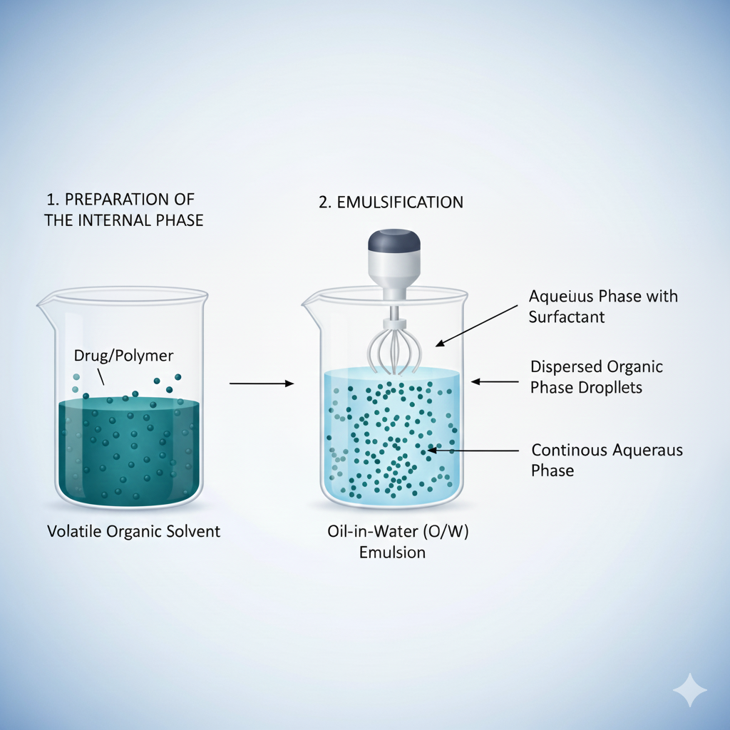
Using this technique, Wu et al. (17)also produced PCL microspheres, demonstrating that variables including the type and concentration of pyrogenic alkane agents, polymer concentration, and reaction temperature affect microsphere morphology. Furthermore, the effective encapsulation of lipophilic substances or medications is made possible by their incorporation into the oil phase during O/W emulsion-solvent evaporation. To produce a narrow particle size distribution and high drug-loading efficiency, Li et al (18)created ropivacaine-loaded microspheres using O/W emulsion-solvent evaporation, including oil-soluble ropivacaine. Using O/W emulsion-solvent evaporation, Xu et al. (19) created polylactide (PLA) porous microspheres, attaining bupivacaine encapsulation efficiency of more than 70%. However, during solvent evaporation, hydrophilic compounds have a tendency to migrate into the aqueous phase, which limits embedding efficiency and reduces the retention of active ingredients.
Thus, O/O emulsion-solvent evaporation is an efficient method for creating microspheres coated with water-soluble substances. This technique was used by Mei et al.¹³ to encapsulate a water-soluble medication, like rifampicin, in PCL microspheres. The compound emulsion method, an advancement over the single-emulsion approach, has two subcategories: O/W/O and W/O/W.
By using the O/W/O system to synthesise porous polyimide hollow microspheres, Ji et al.¹¹ showed how the emulsifier content affects the size and shape of the microspheres. This technique, frequently used in medication administration, enables encapsulation of proteins, enzymes, and peptides within microspheres. For example, Lin et al. (20) achieved prolonged drug release by encapsulating TGF-β3 and growth factor-releasing peptides in polyethene glycol (PEG)/PLA microspheres using W/O/W solvent evaporation. Park et al. (20) used the W/O/W emulsion-solvent evaporation process to create poly(lactic-co-glycolic acid) (PLGA) microspheres loaded with exenatide. Although the complex-emulsion approach is effective for encapsulating active macromolecules, it exposes proteins and pharmaceuticals to organic solvents during production, which may compromise their biological activity. Moreover, hydrophilic medications frequently diffuse into the external aqueous phase and bind poorly to the microsphere surface with this technique, resulting in an initial burst release that increases risks and reduces therapeutic and financial value. The solid-in-oil-in-water (S/O/W) emulsification method was created by Marquette et al. (21)to overcome these difficulties by substituting immunoglobulin powder for the aqueous drug phase. This method encapsulates solid particles by dispersing them in a polymer solution to make an S/O emulsion, which is subsequently emulsified in an aqueous surfactant solution to create an O/W system. Evaporation of organic solvents produces microspheres. This approach preserves the biological activity of the encapsulated proteins and reduces the initial burst release of the medication by keeping the drug solid throughout the manufacturing process, thereby minimising protein structural changes caused by solvent exposure.
Spray-Drying Method –
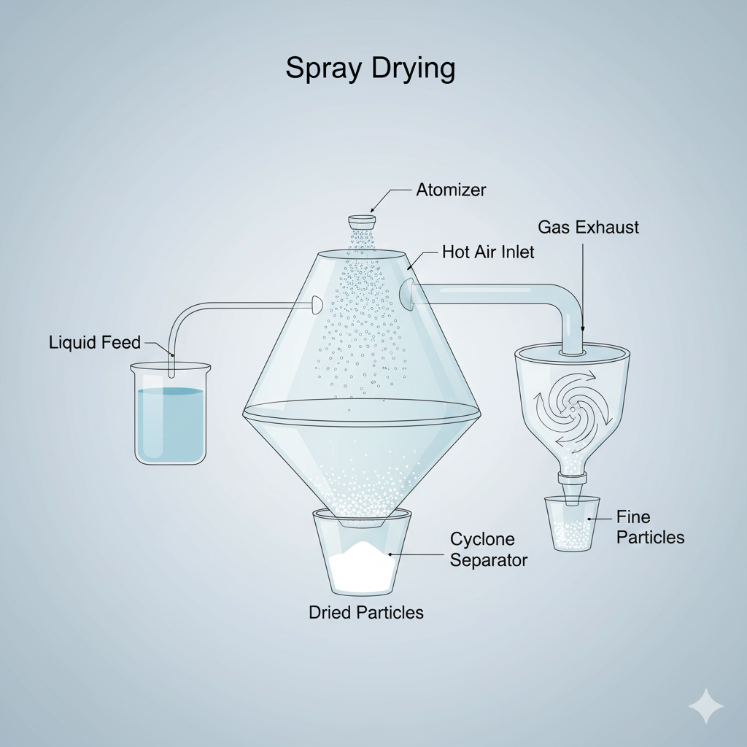
One of the earliest and most straightforward methods for producing industrial microspheres is spray-drying, which entails atomising a raw material solution or emulsion into fine droplets using a high-pressure nozzle. The solvent is quickly evaporated by hot air, drying the droplets into ultrafine particle-sized microspheres. Material composition, carrier concentration, feed rate, and inlet/outlet temperatures are some of the variables that affect microsphere properties. (22). Zhang et al. (23) prepared drug-loaded microspheres with chitosan as a carrier by spray-drying, methodically examining the effects of injection rate, inlet air temperature, drug-to-chitosan ratio, and chitosan concentration. The optimised technique produced sustained-release microspheres with smooth surfaces and a high drug-loading efficiency.
Operational simplicity, one-step particle creation, accurate particle size control, high active ingredient utilisation, and scalability for industrial production are just a few benefits of the spray-drying method. Effective medication distribution and controlled release are enabled by appropriate encapsulating materials. (24). Wei et al. created anticancer drug-loaded microspheres by spray-drying starch modified with succinic acid amide and N-maleoylalanine to achieve sustained-release characteristics. However, the high drying temperatures required are a significant drawback that may jeopardise the stability of temperature-sensitive chemicals.
Microfluidic Method-
In brief, the microfluidic approach to microsphere production creates highly uniform (monodisperse) droplets, which are then consolidated into microspheres using microscale channels and precise fluid-flow control.

How It Works (In Brief)
- Droplet generation involves pumping two immiscible fluids into a microchannel junction (such as a T-junction or flow-focusing device): the dispersed phase (microsphere material) and the continuous phase (carrier fluid like oil).
- Breakup: The scattered phase is compelled to split into distinct, homogeneous droplets as a result of regulated shear forces and interfacial tension. The channel shape and flow-rate ratios accurately determine the size of these droplets.
- Solidification: To create stable microspheres, the liquid droplets are subsequently solidified or cross-linked using techniques including UV radiation (photopolymerization), temperature changes, or chemical cross-linking.
This method enables precise control of fluid volumes at the microscale by integrating physics, materials science, and micro-machining. This technique employs volumetric or pressure-driven forces to generate droplets within microfluidic channels, thereby controlling continuous and dispersed-phase flows. The dispersed phase is compressed by the continuous phase, which destabilises the interface and creates spherical droplets that solidify into microspheres through solvent evaporation. Su et al. (25) created smooth, sustained-release bicalutamide-loaded microspheres using a microfluidic approach. Fluid dynamics, chip design, and material selection all affect the characteristics of these microspheres. Different microsphere structures, such as core-shell, multilayered (26), multi-nucleated, and multicomponent configurations (27) can be produced by adjusting these variables.
Key benefits of microfluidic technologies for microsphere fabrication include customizable size and morphology, high reproducibility, scalability, reduced risk of air-induced drug degradation, and ease of aseptic manufacturing.
Electrostatic Spraying Method-
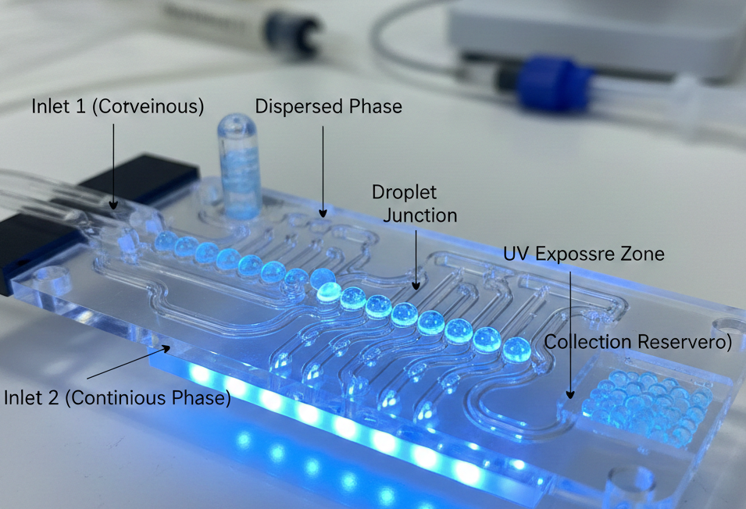
A technique called electrostatic spraying imparts an electrical charge to liquid droplets as they exit a spray nozzle. Similar to "magnetic spray paint," it makes sure the liquid adheres to the target surface uniformly and firmly.
How It Operates (The Three-Step Method)
- Charging: A high-voltage positive electrical charge is applied to the liquid (paint, sanitiser, or insecticide) as it travels through the nozzle.
- Atomization: A fine mist of charged droplets is created as the liquid is broken down. The droplets repel one another because they all carry the same positive charge, which prevents clumping and produces an extremely fine, uniform mist.
- Attraction: The sprayed object is typically grounded, meaning it is either negatively or neutrally charged. The positively charged droplets are strongly drawn in the direction of the item because opposing charges attract.
They consolidate into microspheres, according to Lu et al. (28)., biodegradable chitosan microspheres by a sequential method that combines electrostatic jetting and freeze-drying. By carefully controlling the voltage and flow rate, the main electrostatic jetting process first produced monodisperse microspheres with customised surface morphology. Hierarchical pore engineering is employed throughout the main and secondary drying stages following a predetermined freeze-drying process that controls ice crystal formation via the freezing temperature. This two-step process produces chitosan microspheres with consistent particle size and tunable porosity by precisely controlling their structure. Several variables, including voltage intensity, electrode gap, needle size, flow velocity, and polymer, affect the performance of microspheres produced by this technique.
This method was used by Liang et al. (29) to create gelatine methacryloyl-alginate core-shell microspheres that included human umbilical vein endothelial cells and human dental pulp stem cells. By restricting the drug-solvent interactions, this technique successfully decreases early drug release during manufacture and lowers drug degradation.
Membrane Emulsification: This precise method involves forcing one liquid through a porous membrane into another to produce homogeneous droplets (emulsions).
How It Operates (The Three-Step Method)
- Pressurisation: A membrane with millions of tiny, homogeneous pores is driven through the liquid to be disseminated, such as oil.
- Droplet Formation: The liquid creates tiny droplets when it leaves the pores on the other side. The size of the membrane pores, which are typically two to ten times the pore diameter, directly controls the size of these droplets.
- Detachment: The continuous phase, or second liquid, passes through the membrane's surface. Before the droplets can group, this flow gently rips them off the pore openings and carries them away.
Mi et al. (30) created agarose and calcium alginate microspheres with consistent size distributions using both direct and premixed membrane emulsification. Pore size, porosity, temperature, emulsifier type, and transmembrane pressure are some of the variables that affect the characteristics of microspheres made by membrane emulsification. To (31) (32)create methyl methacrylate microspheres, Nauman et al. (33) coupled membrane emulsification and emulsion polymerisation. By adjusting the membrane pore size, they achieved precise control over particle size.
Membrane emulsification is notable for producing microspheres with uniform, predictable particle sizes, ensuring batch-to-batch consistency. Its mild conditions are ideal for sensitive protein and peptide drugs, while the high emulsion stability reduces the risks of agglomeration and droplet rupture. Additionally, the simplicity of the method supports industrial scalability. However, limitations include potential effects on in vivo drug-release profiles and the risk of sudden drug release.

Chemical Synthesis of Microsphere-
The chemical preparation of polymer microspheres involves the polymerisation of small-molecule monomers and is primarily classified into emulsion, seed-swelling, precipitation, dispersion, and suspension polymerisation.

Emulsion Polymerisation-
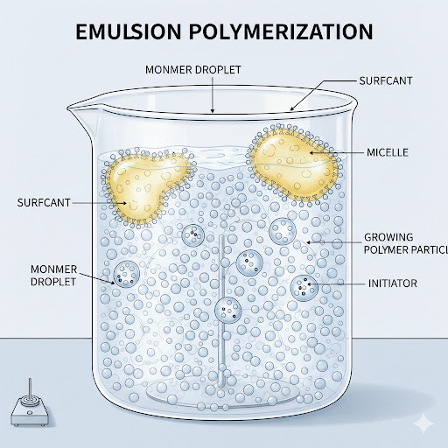
Emulsion polymerisation is a widely used method for producing monodisperse polymer microspheres, first introduced by Harkins in the 1950s. This approach is perfect for small-scale applications because it consistently produces microspheres with excellent monodispersity and particle sizes ranging from 50 to 800 nm by mixing a monomer, water, a water-soluble emulsifier, and an initiator. (34). Chen et al. (35) modified Fe₃O₄ with O-(propargyl)-N-(trimethylsilyl) carbamic acid methyl ester, adding polymerisable C=C triple bonds, and encased it with a helical polyacetylene (PA) shell via emulsion polymerisation to create core-shell Fe₃O₄/PA composite microspheres. Although emulsion polymerisation is effective and yields high-molecular-weight products, microsphere performance may be harmed by overuse of emulsifiers. Green techniques, including soapless and micro-emulsion polymerisation, have been developed for the synthesis of monodisperse microspheres. For customised functions, they can be readily altered with cationic or anionic groups. Abdollahi et al. developed functional polymer nanoparticles via soapless emulsion polymerisation of ethylene and poly(methyl methacrylate). Yang et al. (36) investigated the nucleation and growth mechanisms of monodisperse polystyrene (PS) microspheres containing carboxyl and sulfonic acid groups.
To produce stable submicron droplets, fine emulsion polymerisation employs emulsifiers and stabilisers under high shear. In contrast to traditional techniques, it employs micro-emulsification to reduce droplet size and requires emulsifiers. Microspheres that closely resemble the original droplet size are produced by polymerisation within these droplets. (37) Cordeiro et al (38). created monodisperse poly(methyl methacrylate) microspheres with magnetic nanoparticles and Cuban oil using fine emulsion polymerisations. In a similar vein,
Suspension Polymerisation—
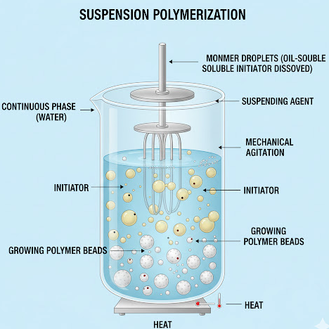
Immiscible liquids are suspended in a solution by emulsion polymerisation, where droplets combine to form larger particles by polymerisation or chemical processes. Suspension polymerisation is frequently employed to create liquid or colloidal particles. Abd El-Mageed et al. (39) used a-allyl alkylphenol to create homogenous, magnetically stable PS microspheres. Because monodisperse microspheres require precise control over stirring speed and dispersant use, sophisticated techniques such as micro-suspension polymerisation have been developed. Here is an image illustrating the key components and process of suspension polymerisation.
To disperse the monomer into micrometre- or sub-micrometre-sized droplets under shear forces, micro-suspension polymerisation uses ionic surfactants and emulsifiers to lower the surface tension between monomer droplets and the aqueous phase. Glasing et al. (40) polymerised styrene using cellulose nanocrystals as stabilisers to create homogeneous, monodisperse microspheres.
Micro-suspension polymerisation is easier to produce monodisperse microspheres than classical suspension polymerisation, but its usage in high-purity preparations is limited due to the high surfactant consumption.

Precipitation polymerisation-
This type of polymerisation yields a polymer that is insoluble in the reaction medium. The initiator and monomer are soluble, but as the polymer chains lengthen, they become insoluble and separate from the solution. This produces granules or powdered polymer particles. It is frequently employed in the production of spherical polymer beads.
Stöver et al. (41) used precipitation polymerisation to create poly(divinylbenzene) microspheres with customised architectures using acetonitrile. This method's low efficiency and dependence on hazardous solvents such as toluene and acetonitrile limit its environmental feasibility, despite its straightforwardness and lack of stabilisers. Advanced methods, including reflux precipitation polymerisation and distillation, have been developed to address these problems. Here's an image illustrating
Precipitation polymerisation is refined by solvent distillation, which regulates the process and requires careful solvent selection. Monomers create nuclei at the distillation temperature, which precipitate and expand by absorbing other monomers and oligomers to produce monodisperse microspheres. This technique was used by Zhang et al. (42) to create fluorinated hydrophobic PS microspheres with regulated particle sizes. Reflux precipitation polymerisation, on the other hand, uses magnetic stirring to reduce particle aggregation, improve reaction control, and simplify the setup by doing away with complicated equipment. This method was used by Wang et al. (43) to create spherical, monodisperse poly(ethylene glycol methacrylate phosphate) gel microspheres with plenty of phosphate groups.
Dispersion Polymerisation-
Dispersion polymerisation, a subset of precipitation polymerisation, employs dispersants or macromolecular monomers to stabilise insoluble polymers in the reaction medium. Initially, a homogeneous mixture of the monomer, dispersant, initiator, and solvent is formed. As polymerisation progresses, growing polymer chains precipitate when they reach a critical length and aggregate into particles. These particles are stabilised with dispersants and mechanical stirring, yielding a dynamically stable dispersion of microspheres.
Zhang et al. (23) utilised water-soluble potassium persulfate as an initiator to synthesise electromagnetic hydroxyl PS/Fe₃O₄ composite microspheres via dispersion polymerisation. Similarly, Fan et al. prepared magnetic core-shell microspheres with Fe₃O₄ as the core and poly(maleic anhydride-co-methyl methacrylate) as the shell (Figure 3d). Dispersion polymerisation, known for its simplicity, strong adsorption, and modifiable surfaces, has advanced with innovative initiation methods such as microwave and ultrasound. (44) These techniques, compared to traditional thermal initiation, considerably reduce reaction time, boost efficiency, and enhance process control. (45)

Seed Swelling Polymerisation-
To create the final particles, the method usually consists of two major steps:
- Seed preparation is the process of creating the first seed particles, which are frequently monodisperse and cross-linked, using techniques like emulsion or dispersion polymerisation.
- Growth and Swelling: Additional monomer (and frequently a swelling agent/pyrogen) is used to swell the pre-formed seed particles. The absorbed monomer is then polymerised inside the swelling seeds.
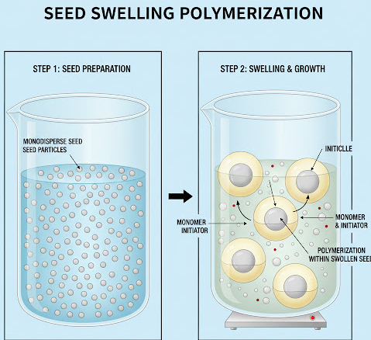
Monomers, initiators, reaction media, and swelling agents are all part of the two-step swelling process. Heat-induced polymerisation and monomer swelling occur after seed microspheres are first activated using a particular swelling agent. Kao et al. (46)created 0.55 µm poly(methyl methacrylate) seed microspheres via emulsion polymerisation. These were then activated, swelled, and polymerised to form monodisperse cross-linked microspheres with diameters of 1-4 µm. Although this method works well for size expansion, it depends on swelling agents, which can impair microsphere performance in two main ways: incomplete removal of swelling agents during post-treatment can change porosity and disrupt pore connectivity, and residual swelling agents trapped within the polymer matrix can reduce cross-linking uniformity, weakening the mechanical strength of the microsphere. (47) Furthermore, under physiological conditions, certain polar swelling agents may induce long-term chemical instability through gradual leaching. (48) The complex post can be prepared by directly employing stimuli-responsive materials to create microspheres or by grafting or embedding functional components into polymer chains, causing changes in physical and chemical properties in response to external stimuli to satisfy the demands of particular environment Stimulus-responsive microspheres, which combine the benefits of smart materials, micromaterials, and nanoparticles, have potential applications in information technology, environmental protection, and life sciences.
Smart Polymer Type-
In response to stimuli, polymers with responsive systems can undergo significant changes in their properties. The hydrophilicity, shape, solubility, degradation, and bond breaking of the polymer chains can all be altered by these stimuli. (49) (50). These modifications have an impact on the polymers' structural behaviour. Chemical, physical, or biological stimuli are all possible. While chemical stimuli (pH, ionic strength, and redox conditions) affect how polymers interact with the solvent or other polymers, physical stimuli (temperature, light, and electrical responsiveness) usually change how polymer chains move. Molecular processes, such as enzyme reactions and receptor recognition of ligands, are involved in biological responses, including glucose responsiveness. (51) (52) (53). Dual stimuli-responsive polymers are those that can react to many stimuli at once.
Physically Dependent Stimuli
3.1 Temperature-responsive Polymer-
Temperature-responsive polymers, sometimes referred to as thermoresponsive polymers, are "smart" materials that, when exposed to a change in temperature, experience a substantial, reversible physical change. At a certain temperature, this transformation often occurs as an abrupt transition from a water-soluble to a water-insoluble state. The lower critical solution temperature (LCST) and the upper critical solution temperature (UCST) are the critical temperature points for these polymers. (54) (55)A polymer that dissolves at low temperatures but becomes insoluble at higher temperatures is known as an LCST polymer. If a polymer behaves in the reverse way—that is, dissolving at higher temperatures while becoming insoluble at lower ones—it has a UCST. (56)
The LCST transition is reversible and depends on entropy. Examples of LCST polymers include poly (vinyl amide), poly (N-substituted acrylamide), poly (N-vinyl caprolactam), cellulose, chitosan, xyloglucan, and PLGA-PEG-PLGA triblock co-polymers (57) (58) (59). On the other hand, UCST polymers disintegrate as the temperature rises due to weaker connections between their chains, where the enthalpy of these interactions is more important than the entropy. The UCST transition is not abrupt and is dependent on enthalpy. UCST polymers are rarer than LCST polymers. Polybetaines, such as poly(2-dimethyl) methacryl oxoethyl-ammonium propane sulfonate, are examples of UCST polymers.
There are many benefits to thermosensitive polymeric systems, including the absence of dangerous organic solvents, the ability to deliver a variety of medications, fewer side effects, customised drug administration, and long-lasting release properties. Yet they also have several disadvantages, including rapid drug release, weak gelation (which could result in overdosing), concerns about the polymeric system's biocompatibility, and eventual acidification due to acidic degradation. (60)
⚡ Electro-Responsive Polymers (EAPs)
A subclass of smart polymers, known as electroresponsive or electroactive polymers (EAPs), can reversibly change their physicochemical properties in response to electrical stimuli. Depending on the strength, duration, and frequency of the electric current, they can change shape (swell, shrink, or bend) by transforming electric energy into mechanical energy. (61) (62). The pH level is changed, and the electric current breaks the hydrogen bonds between the polymer chains. Polypyrrole (PPY) and polythiophene (PT), both conductive polymers, are examples of electroresponsive polymers. (63) (64)
These materials are highly appealing because, unlike conventional ceramic actuators, they undergo significant deformation while maintaining high forces, thereby simulating the action of real muscles.
EEAPs, also known as electrically conductive polymers, are a class of electric-field-responsive polymers that have attracted significant scientific attention in recent years. EEAPs function without an electrolyte medium or ion migration, in contrast to ionic electroactive polymers (IEAPs). Either high electron mobility within their polymeric bonds or the presence of conductive particles affixed to their polymeric chains provides them the capacity to conduct electricity. They are characterised by their lightweight nature, biocompatibility, and ease of fabrication. They require a high electrical field strength (10-100 V µm) for operation, but researchers are striving to minimise it for safety concerns. These polymers exhibit excellent actuation performance owing to their high efficiency, durability, rapid response time, stability, and reliability. Piezoelectric polymers, dielectric elastomers, and electrostrictive polymers are some examples of EEAPs. Typically, EEAPs are conjugated polymers, which are organic polymers having a delocalized pi-electron system. (65) This provides them with unique electronic properties, including high electrical conductivity, strong optical absorption, and efficient charge transport. Polypyrene (PPY), polyaniline (PANI), and poly[3,4-(ethylenedioxy)thiophene] (PEDOT) are a few instances of conductive polymers.
Photo-Responsive Polymers—
Light-responsive polymers exhibit rapid and accurate responses under specific conditions, making them highly useful for a variety of applications. These polymers are light-sensitive because they experience a phase transition when exposed to light. One of the many benefits of using light as a stimulus is that it may be applied quickly and precisely (66) (67) (68). Furthermore, the light's wavelength can be adjusted, enabling long-distance applications to be controlled via fibre optic lines. When exposed to light, photo-responsive organisms behave differently. The polymers' conformation, polarity, amphiphilicity, charge, optical chirality, conjugation, and other molecular characteristics are all regulated by these stimuli (69). Macroscopic changes in material behaviours, including form (bending or contraction), solubility, wettability, conductivity, optical behaviour, adhesion, and more, can be used to monitor the molecular change brought on by exposure to light. Light control has a number of intrinsic benefits over electric, thermal, and magnetic stimuli. It allows for fine temporal and spatial precision of the reaction, perfect control of response strength by precise dosage, and remote and non-contact application.
A photo-responsive functional group, or chromophore, is essential for the development of photo-responsive polymers. Common examples of light-sensitive chromophores include spiropyran groups (70), azobenzene groups , (71) or nitrobenzyl groups (72) (73). Several photo-responsive polymers containing spiropyran or azobenzene have been reported, such as PHPMAm (74), PAA (75), and PNIPAM. (76)
Whether the polymer's reaction is reversible or irreversible depends on the chromophore selection. Reversible systems can switch between two photostationary states, which allows them to function as switches and change material properties. This reversibility is essential for many applications, such as actuators, artificial muscles, and information storage. Conversely, photodegradable materials and drug delivery systems are the main applications for irreversible chromophores. Irreversible chromophores can achieve 100% light conversion without creating an equilibrium between two states. This can lead to the efficient release of medications or a notable decrease in molecular weight for applications that need degradation. Many facets of photo-responsive polymers have been discussed in recent publications (77). Numerous studies on different kinds of photo-responsive polymers and their applications have been published. Schumers et al. examined photo-responsive block copolymers, (78) while Zhao investigated light-induced self-assembly (79). Zhao et al. reviewed photosensitive polymers with photoremovable groups (80), while Ikeda et al. presented photo-responsive liquid crystalline polymers and their uses as actuators (81).
Chemical Dependence Stimuli—
pH-Responsive Polymers—
When the pH of the surrounding environment varies, the structural and physical features of pH-responsive polymers, such as surface behaviour, solubility, and chain conformation and configuration, alter. These polymers have basic or acidic groups connected to them, and they are responsive to stimuli. They either absorb or release a proton in response to variations in the pH of their environment. Polymers with a large number of ionizable groups are called polyelectrolytes. Polymer chains in aqueous solutions may expand or contract as a result of ionic interactions brought on by a pH shift. The observed behaviour is caused by the produced charges' electrostatic repulsion. One of the most prevalent kinds of pH-responsive materials is polycarbon (66). Groups that can give or take protons in their molecules, such as –COOH, –SO3H, and N with three bonds, are found in polymers that react to pH variations. When the pH shifts, these groups may become ionised, changing the polymers' structural makeup. The apparent dissociation constant (Ka) of the pKa value differs from that of the monoacid or monobase with the same group, indicating the pH at which the ionisation degree changes considerably. The two primary categories of these polyelectrolytes are basic and acidic. They can be synthesised using a variety of techniques or obtained from natural sources. In recent years, there has been a lot of interest in natural pH-responsive polymers and multi-responsive polymers.
pH-responsive acidic polymer
A type of smart polymer called pH-responsive acidic polymers, or anionic pH-sensitive polymers, shows reversible changes in its physicochemical characteristics in response to pH variations in its surroundings. These polymers' pH-dependent behaviour is caused by acidic functional groups, primarily carboxylic acid (-COOH) or sulfonic acid (-SO₃H). These acidic groups remained mostly unionised at low pH (acidic environments), like in the stomach, which keeps the polymer chains tight and folded with little swelling. Because of this, there is very little drug release from the polymer matrix, which helps shield acid-labile medications from deterioration in the stomach environment.
The acidic groups undergo deprotonation and become ionised (-COO⁻) when the surrounding pH rises to neutral or alkaline circumstances, like in the colon or intestine. This ionisation causes electrostatic repulsion between polymer chains, which causes the polymer to significantly expand, become more porous, or dissolve. The entrapped medicine is released in a regulated and site-specific way as a result of this structural expansion. Acidic pH-responsive polymers are very helpful for enteric coating, controlled drug release, and colon-targeted drug delivery systems because of their pH-dependent swelling–deswelling mechanism.
Poly(acrylic acid), poly(methacrylic acid), Carbopol, and Eudragit® L and S grades—all of which are frequently utilised in pharmaceutical formulations—are typical instances of pH-responsive acidic polymers. These polymers have a number of benefits, including better drug stability, decreased stomach discomfort, site-specific drug delivery, and increased therapeutic efficacy. However, variables including ionic strength, polymer–drug interactions, and variations in stomach pH may affect how well they work. All things considered, pH-responsive acidic polymers are essential to contemporary pharmaceutical drug delivery systems because they allow for the targeted and intelligent release of medications in response to physiological pH changes. These polymers exhibit a smooth transition across a broad pH range due to their high degree of ionisation. Nevertheless, this feature also restricts their application as pH-responsive systems [86]. These polymers are a novel class of pH-responsive polymers that overcome the drawbacks of sulfonic acid polymers and are derived from p-aminobenzenesulfonamide. These polymers contain aniline with a sulfonamide functional group connected to them . The connected hydrogen atom ionises as a result of the amine nitrogen atom losing electrons to the sulfonyl group. As shown in the chemical structure, the R group determines the pKa value of these polymers, which show a narrow transition pH range of 0.2–0.3 units (83).
Ph – Responsive Basic Polymer-
A type of smart polymer known as pH-responsive basic polymers, or cationic pH-sensitive polymers, shows reversible changes in its structure and characteristics in response to changes in the pH of its surroundings. These polymers' pH sensitivity is caused by basic functional groups, mainly amine groups (-NH₂, -NR₂). These amine groups undergo protonation in an acidic environment, like the stomach or acidic tumour tissues, producing a positively charged polymer network. Electrostatic repulsion between polymer chains brought on by this protonation results in polymer swelling, higher hydration, and improved permeability, all of which aid in the drug's release.
At neutral or alkaline pH, the amine groups of basic polymers become deprotonated, reducing the overall positive charge on the polymer chains. As a result, electrostatic repulsion decreases, and the polymer structure becomes more compact or collapsed, leading to reduced swelling and slower drug release. This pH-dependent swelling and deswelling behaviour allows basic pH-responsive polymers to selectively release drugs in acidic environments, making them particularly useful for stomach-specific drug delivery, cancer therapy (acidic tumour microenvironment), and intracellular drug or gene delivery, where endosomal and lysosomal pH is low. (84)
Basic polymers that react to pH include chitosan, poly (ethylene imine), poly (N, N-dimethylaminoethyl methacrylate), and poly (vinyl pyridine). These polymers' capacity to increase drug solubility, improve bioavailability, and provide controlled and targeted release makes them popular in pharmaceutical and biomedical applications. However, issues including formulation complexity, biological pH fluctuation, and polymer toxicity at high charge density need to be properly addressed. All things considered, the intelligent release of therapeutic drugs in acidic physiological and pathological environments is made possible by pH-responsive basic polymers, which are crucial to improved drug delivery systems. (85) (86)
Redox-responsive polymers—
Redox-responsive polymers are part of a larger class of materials known as stimulus-responsive materials, which also comprises materials that respond to changes in temperature, light, pH, and other stimuli. Variations in the redox state of their environment can cause these materials to experience reversible changes in their chemical and physical behaviours. Many biological and chemical processes depend on redox reactions, which entail the transfer of electrons between distinct species. The insertion of redox-active groups capable of oxidation and reduction reactions is the foundation for the construction of redox-responsive polymers. By changing the chemical structure of the monomers, these groups—which are often incorporated into the polymer backbone or pendant groups—can have their redox potential changed Common redox-active functional groups that can experience reversible redox reactions in response to changes in the concentration of oxidising or reducing substances include quinones, ferrocenes, and viologens. (87) (88)
Biologically dependent stimuli—
Glucose-responsive polymer-
There are three ways that polymers can sense glucose and change their behaviour: by using an enzyme called glucose oxidase (GOx) that changes glucose into a different substance, by using proteins called lectins that stick to glucose molecules, and by using chemicals called boronic acid or phenylboronic acid that can form a bond with glucose. The choice of mechanisms allows the polymer to detect and respond to changes in glucose levels, making it useful for applications such as glucose sensing and insulin delivery. (89) (90)
In enzymatic sensing, glucose oxidase transforms glucose into gluconic acid and H₂O₂. The resulting change in pH level prompts alterations in polymer shape, such as shrinking, stretching, or expanding. Some polymers that have acids or bases in them can work with this enzyme to release insulin by themselves. Some examples are cellulose with PAA, PMAA with ethylene glycol, PVDF with PAA, poly(methacrylic acid-g-ethylene glycol), and PDEAEM. Additionally, chitosan and PEG grafts have been used as glucose-responsive polymers due to their non-toxic, non-immunogenic, and biocompatible behaviours. (91) (92)
Another approach involves proteins called lectins, with Concanavalin A (ConA) being a commonly used lectin. ConA can bind with glycoproteins when there is glucose around, and this makes the polymers stick together or form a network. Some polymers that can be attached to lectins are PLGA, PEG, chitosan-modified poly(acrylonitrile-co-acrylic acid), carboxymethyl dextran, and poly(ethylene glycol) dimethacrylate. Ongoing research in the field of glucose-responsive polymers aims to develop new materials with improved glucose responsiveness, stability, and biocompatibility (93)
Enzyme-responsive polymer-
Enzyme-responsive polymers, also called SP, are a type of polymer that can change their behaviour according to their surroundings, such as variations in pH, temperature, or the availability of specific enzymes. The development and design of enzyme-responsive polymers have recently become a new and promising field of research in stimuli-responsive materials. These polymers are designed to experience reversible alterations in their physical or chemical properties when they encounter a certain stimulus, leading to a variety of possible uses in drug delivery, biosensors, and tissue engineering. (94) (95) (96)

Application of smart polymer in biomedicine—
Application in Drug Delivery-
Smart polymers, also known as stimuli-responsive polymers, are polymeric materials that can sense changes in their environment and respond by altering their physical or chemical properties. In drug delivery systems, this unique behaviour is exploited to achieve controlled, targeted, and efficient release of drugs, thereby improving therapeutic outcomes and reducing side effects. The detailed applications of smart polymers in drug delivery are explained below. (97) (98) (99)
Smart polymers, also known as stimuli-responsive polymers, have extensive and advanced applications in biomedicine due to their ability to undergo reversible changes in their physical or chemical properties in response to biological stimuli such as pH, temperature, enzymes, light, or redox conditions. In drug delivery systems, smart polymers are used to achieve controlled, sustained, and targeted drug release at specific sites, such as tumours, inflamed tissues, or the gastrointestinal tract, thereby enhancing therapeutic efficacy and minimising systemic side effects. In cancer therapy, these polymers exploit the acidic and enzyme-rich tumour microenvironment to deliver anticancer agents while protecting healthy cells selectively. (100) (101)
Smart polymers serve as dynamic scaffolds in tissue engineering and regenerative medicine, promoting cell adhesion and proliferation while also allowing for non-invasive cell harvesting, notably through temperature-responsive behaviour. Injectable smart polymer hydrogels are frequently employed in minimally invasive therapies, where they form in situ depots for targeted drug administration and tissue regeneration. Smart polymers are also used as safe non-viral carriers for gene and nucleic acid delivery, protecting genetic material while allowing for intracellular release.
Their sensitive reaction to biomolecules makes them essential components of biosensors and imaging systems in diagnostics. Smart polymers are also utilised in wound dressings that detect infection or moisture changes, medical implant coatings to promote biocompatibility and minimise biofilm formation and smart sutures and artificial tissues. Overall, the intelligent and adaptable character of smart polymers has considerably revolutionised current biomedicine and shows enormous potential for individualised and precision care.
Advantages and Limitations of Smart Polymeric Drug Delivery System
Stimulus | Advantages | Limitation
Temperature | Simplicity in manufacturing, Ease of incorporation of active moieties, inject ability under application conditions | Thermolabile drugs are not noble nominees, with low mechanical strength, compatibility problems, and pH Suitable for thermolabile drugs mechanical strength is low,
Ph | Suitable for thermolabile Drugs | problems pH Suitable for thermolabile drugs mechanical strength is low
Electric Field | Pulsative release with changes in electric current | Lack of toxicity data Electric field Pulsative release with changes in electric current Need of on additional equipment for external applications of stimulus, difficult to improve the magnitude of electric current
Bio responsive | High Glucose Specificity | Slow Response rate

Biosensor-
Biosensors—devices that identify and transform environmental signals into comprehensible data—are critical in a variety of applications, including environmental monitoring and medical diagnostics (102) (103). Smart polymers may detect and react to specific biomolecules, such as medicines or illness signs. Researchers are interested in developing polymeric sensors because they can detect and respond to small changes in chemical, physical, and biological surroundings. These sensors can help to enhance the environment by addressing some of the difficulties that industries are now facing. Biosensors are extremely valuable in forensic analysis and clinical diagnostics because they can detect changes in physical factors like pH or temperature, or in the concentration of certain analytes that are associated with a range of disorders.
In addition, they may continuously monitor changes in specific biological parameters. Smart polymers can be designed to have high selectivity and sensitivity for specific molecules or analytes by adding specific chemical or biological groups to the polymer backbone that can interact with target molecules in a variety of ways, such as hydrogen bonding, electrostatic interactions, or covalent bonding. (104) (105)
Toma et al. generated PNIPA Am-co-methacrylic acid. They used a sensor surface with tiny indium tin oxide heaters that sense changes in light. The behaviour of light reflects this change. Hoogenboom and his colleagues developed a temperature and salt sensor by coating silver nanoparticles (AuNPs) with a temperature-sensitive polymer known as PNIPA Am [142]. When subjected to varied salt concentrations at high temperatures, the polymer sensor changes colour from red to purple or blue. In addition, Paek et al. developed a pH sensor employing PAA and Poly (2-vinyl pyridine), two pH-sensitive polymers. When the sensor is subjected to different pH levels or ionic concentrations, the colour changes. Smart polymers are excellent materials for a variety of biomedical applications because they can detect and respond to specific signals and substances in their environment.
Tissue Engineering-
Smart polymers, also known as "stimuli-responsive" or "intelligent" materials, have transformed tissue engineering by offering a dynamic platform that replicates the intricacy of the natural extracellular matrix (ECM). Unlike traditional static scaffolds, these polymers respond to minor external environmental signals by changing their physical or chemical properties—such as solubility, shape, or surface hydrophilicity—rapidly and reversibly. Physical triggers include temperature, light, and electric fields; chemical triggers include pH and ionic strength; and biological triggers include enzymes and glucose levels. In the context of tissue engineering, this responsiveness enables "active" training of cellular behaviour, allowing the material to adapt as new tissue grows and develops. (106) (107) (108)
The creation of injectable in-situ forming scaffolds, mainly utilising thermoresponsive polymers like poly(N-isopropylacrylamide) or PNiPAM, is one of the most significant uses of smart polymers. These substances can be combined with cells and therapeutic growth factors and then injected minimally invasively into a defect location because they are a free-flowing liquid at room temperature. The polymer goes through a phase shift when it reaches body temperature (37°C), forming a solid, porous hydrogel that precisely fits the injury's contour. This guarantees close contact between the scaffold and the host tissue, which is essential for efficient integration and nutrition exchange, and does away with the necessity for intricate pre-moulded operations.
In addition to providing structural support, smart polymers play a key role in cell sheet engineering, a method that circumvents the use of harsh proteolytic enzymes like trypsin, which frequently cause damage to cell-to-cell junctions. Researchers can cultivate confluent layers of cells at 37°C by applying a thin layer of thermoresponsive polymer to culture dishes. The entire cell sheet spontaneously separates as a single, complete unit when the temperature is dropped below the polymer's Lower Critical Solution Temperature (LCST), making the surface hydrophilic. The success rates of regeneration therapies can be greatly increased by stacking these sheets, which have their own endogenous extracellular matrix, to form thick, functional tissues like skin grafts, heart patches, or ocular membranes.
Smart polymers also function as complex controlled release mechanisms for bioactive compounds. The scaffold can initiate the localised release of anti-inflammatory medications or recruitment signals precisely when and where they are required by creating polymers that react to particular local cues, such as a pH drop close to an inflammatory site or the presence of particular matrix metalloproteinases (MMPs) secreted by migrating cells. This temporal management minimises systemic negative effects and guarantees that growth ingredients are not squandered. The development of genuinely biomimetic environments that can direct complicated tissue regeneration from the molecular level up to the organ scale is made possible by the integration of several "smart" capabilities onto a single scaffold. (109) (110) (111)
Future Prospects of Smart Polymer-
Due to rapid advances in polymer chemistry, materials science, nanotechnology, biotechnology, and artificial intelligence, smart polymers have a promising and revolutionary future. Because of their capacity to react dynamically to biological and environmental cues, smart polymers—also referred to as stimuli-responsive or intelligent polymers—are anticipated to be a key component of next-generation biomedical, pharmacological, and healthcare technology.
Smart polymers are anticipated to solve existing obstacles in drug delivery and cancer therapy, such as low bioavailability, multidrug resistance, and non-specific toxicity. Improved tumour targeting, regulated intracellular drug release, and combination therapy on a single platform will be made possible by advanced polymeric nanocarriers. The creation of self-regulated drug delivery systems, in which polymers independently modify drug release in response to real-time biological feedback, is a key future objective.
In tissue engineering and regenerative medicine, next-generation smart polymer scaffolds will closely mimic natural extracellular matrices, actively interact with cells, and adapt to biological cues. These materials will support faster tissue regeneration, controlled degradation, and integration with host tissues, thereby advancing artificial organs, 3D bioprinting, and biohybrid systems. Shape-memory and self-healing smart polymers will further enhance implant durability and functionality.
Additionally, smart polymers will be essential for wearable medical equipment, biosensing, and diagnostics. Real-time monitoring of physiological indicators and disease biomarkers will be enabled by integrating biosensors and electronic systems. The era of intelligent, self-governing healthcare will be ushered in by integrating smart polymers with AI and digital health platforms to enable responsive, feedback-controlled treatment solutions.
Acknowledgement
The authors would like to express their sincere gratitude to the scientists and researchers whose published work has been extremely helpful in preparing this review study. Their groundbreaking work in the fields of microsphere technology and smart polymers has given this study valuable insights and references. Additionally, the authors thank their individual schools for providing the resources, facilities, and academic environment that they needed. We would especially like to thank our mentors and colleagues for their support and helpful advice during the preparation of this manuscript. Ongoing advances have greatly aided the study and development of smart polymer microspheres and their biomedical applications in stimuli-responsive polymers.
Reference-
1. Corrosion behaviour amelioration of Ti-based alloys by the hybrid plasma electrolytic oxidation (PEO)/polymer coatings: A review. Arash Fattah-alhosseini, Razieh Chaharmahali,Mosab Kaseem. Iran : Elsevier, 2024, Hybrid Advances, Vol. 5.
2. Surface properties of plasma electrolytic oxidation coating modified by polymeric materials: A review. Tehseen Zehra, Arash Fattah-Alhosseini, Mosab Kaseem. Seoul : Elsevier, 2022, Progress in organic Coating, Vol. 171. 107053.
3. Innovative approach to boosting the chemical stability of AZ31 magnesium alloy using polymer-modified hybrid metal oxides. Mosab Kaseem, Ananda Repycha Safira,Mohammad Adil,Tehseen zehra,Muhammad Ali Khan, Arash Fattah- Alhosseini. 3, Seoul : Science Direct, March 2024, Journal of Magnesium and Alloys, Vol. 12.
4. Smart polymers and what they could do in biotechnology and medicine. Igor Y Galaev, Bo Mattiasson. 8, Sweden : Science Direct, 1999, Trends in Biotechnology, Vol. 17.
5. Solution Properties of Poly(N-isopropylacrylamide). M.Heskins, J.E.Guillet. 8, s.l. : Journal Of Macromolecular Science: Part A- Chemistry, 1968, Vol. 2.
6. Force-induced activation of covalent bonds in mechanoresponsive polymeric materials. Douglas A Davis Andrew Hamilton Jingeli Yaang, Lee D Cremar,Dara Van Gough, Stephanie L Potisek Mitchell T Ong, Paul v. Barun. s.l. : Nature, 2009.
7. Magnetic responsive polymer composite materials. Julie Thevenot, Hugo Oliveira, Olivier Sandre, Sebastien Lecommandoux. 17, s.l. : Royal Society Of Chemistry, 2013.
8. Intelligent thermoresponsive polymeric stationary phases for aqueous chromatography of biological compounds. Akihiko Kikuchi, Teruo Okano. 6, Japan : Elsevier, July 2002, Progress in Polymer Science, Vol. 27.
9. Thermoresponsive Polymers for Biomedical Applications. Mark A. Ward, Theoni K Georgiou. 3, s.l. : Polymer, 2011, Vol. 3.
10. Smart polymer based delivery systems for peptides and Protein. K. Al-Tahami, J. Singh,. s.l. : Bentham Sciences, 2007, Recent patents on drug delivery & formulation, Vol. 1.
11. Long period grating fibre sensor for detection of impurities infesting smart polymer composites. R. Savastru, S.Miclos,L.Baschir,D.Savastru,I.I Lancranjan. Romania : Elsevier, 2023, Composite Structure, Vol. 312.
12. P.Vyas, Udita Agrawal, Rajeev Sharma. Smart Polymeric Nano-Constructs in Drug Delivery. s.l. : Science Direct, 2013.
13. Deepti Bharti, Indranil Banerjee, Pretam Sarkar, Doman Kim, Kunal Pal. Smart polymers for biomedical applications. Advances in Biomedical Polymers and Composites. India : Elsevier, 2023, Chapter-9.
14. Reflections on the Evolution of Smart Polymers. Gillies, Elizabeth R. 1-2, s.l. : Wiley, 2019, Israel Journal Of Chemistry, Vol. 60.
15. SMART POLYMERS: INNOVATIONS IN NOVEL DRUG DELIVERY: INNOVATIONS IN NOVEL DRUG DELIVERY. Aggarwal, Apoorva Mahajan Geeta. 3, Punjab : International Journal of Drug Development & Research, September 2011, Vol. 3.
16. Solid-in-Oil-in-Water Emulsion: An Innovative Paradigm to Improve Drug Stability and Biological Activity. Anil Sawant, Seema Kamath, Hemanth kg, Girish Pai Kalyadi. 5, s.l. : AAPS Pharma Sci Tech, 2021, Vol. 22.
17. A facile strategy for controlling porous PLGA microspheres via o/w emulsion method. Xiao, Jinqiu Wu Jiaqiang Ding Bingyu. s.l. : Science Direct, 2022, Journal Of Polymer Research.
18. Preparation of ropivacaine loaded PLGA microspheres as controlled-release system with narrow size distribution and high loading efficiency. Xun Li, Yi Wei, Youbin Wu,Guanghui Ma, Kenji Ogino. s.l. : Colloids and Surface A Physicochemical and Engineering Aspects, 2018.
19. Porous Core/Dense Shell PLA Microspheres Embedded with High Drug Loading of Bupivacaine Crystals for Injectable Prolonged Release. Jinghua XU, Yanjie Bai,Zhening Wei, Lu Sun, Hui Xu. s.l. : AAPS Pharm Sci Tech.
20. Dual Delivery of TGF-β3 and Ghrelin in Microsphere/Hydrogel Systems for Cartilage Regeneration. Jianjing Lin, Li Wang , Jianhao Lin Qiang Liu. 19, 2021, Vol. 26.
21. Encapsulation of immunoglobulin G by solid-in-oil-in-water: Effect of process parameters on microsphere properties. Sarah Marquette, Claude Peerboom Andrew Yates, Laurence Denis Jonathan Goole. 3, s.l. : Science Direct, 2014, Vol. 86.
22. Ketoprofen Spray-dried Microspheres Based on Eudragit® RS and RL: Study of the Manufacturing Parameters. Glovanna Rassu Elisabetta Gavini, Gianpiera Spada ,. s.l. : Taylor & Francis, 2008, Drug Development and Industrial Pharmacy.
23. Preparation and properties of chitosan‐based microspheres by spray drying. Zeng-liang Zhang, Li-ji li, Dan sun ,Min Wang ,Ju- Ran shi, Di yang, Lu-hui wang , Sheng can zou. 4, s.l. : Food Science and Nutrition, 2020, Vol. 8.
24. Chitosan spray-dried microcapsule and microsphere as fertilizer host for swellable − controlled release materials. Debora Franca, Angela Franco Medina , Lucas Luiz Messa , Claudinei F Souza, Roselena Faez. s.l. : Science Direct, 2018, Carbohydrate Polymer, Vol. 196.
25. PLGA sustained-release microspheres loaded with an insoluble small-molecule drug: microfluidic-based preparation, optimization, characterization, and evaluation in vitro and in vivo. Yue Su, Jia Liu , Songwen Tan , Wenfang Liu ,Rongrong Wang, Chuanpin Chen. 1, China : Drug Delivery, 2022, Vol. 29.
26. High- Order Multiple Emulsions Formed In Poly (Dimethylsiloxane) Microfluidics. A.R. Abate, D.A. Weltz. 18, 2009, Vol. 5.
27. Single step emulsification for the generation of multi-component double emulsions. L.L.A. Adams Thomas E .Kodger, Shin-Hyun Kim, Ho Cheng Shum, Thomas Franke, David a Weitz. 41, s.l. : Royal Society of Chemistry, 2012, Soft Matter.
28. Smart Polymer Microspheres: Preparation,Microstructures, Stimuli-Respon Properties, and Applications. Tao Guo Lan Luo, Linlin Wang, Fenghua zhang , Yanju Liu. 2025.
29. Gelatin methacryloyl-alginate core-shell microcapsules as efficient delivery platforms for prevascularized microtissues in endodontic regeneration. Xi Liang, Li Xie , Qingyuan Zhang Ge Wang , Siyuan Zhang , Mingyan Jiang Ruitao Zhang , Ting Yang , Xingyu Hu , Ziyang Yang , Weidong Tian. s.l. : Science direct, Acta Biomater.
30. Preparation of water-in-oil emulsions using a hydrophobic polymer membrane with 3D bicontinuous skeleton structure. Yace Mi Weiqing Zhou, Qiang Li , Fangling Gong , Rongyue Zhang. s.l. : Elsevier, 2015, Journal of Membrane Science, Vol. 490.
31. Effect of process parameters on nanoemulsion droplet size and distribution in SPG membrane emulsification. Dong Hoon Oh, Prabagar Balakrishnan, Yu-Kyoung Oh ,Chul Soon Yong, Han-Gon Choi. 1-2, s.l. : Elsviewer, 2011, International Journal of Pharmaceutics, Vol. 404.
32. Preparation and analysis of uniform emulsion droplets using SPG membrane emulsification technique. al., Yuyama et. s.l. : Science Direct, Colloids and Surfaces A: Physicochemical and Engineering Aspects.
33. Particle size control in miniemulsion polymerization via membrane emulsification. Nida Nauman, Neomy Zaquen, Tanja Junkers, Cyrille Boyer, Per B. Zetterlund. 12, s.l. : Macromolecules, 2019, Vol. 52.
34. Structured, Composite Nanoparticles from Emulsion Polymerization – Morphological Possibilities. s.l. : Acs publication, 2020, Biomolecules.
35. Helical polymer/Fe3O4 NPs constructing optically active, magnetic core/shell microspheres: preparation by emulsion polymerization and recycling application in enantioselective crystallization. Huaiyu Chen, Jinyong Zhou and Jianping Deng. 2016, Polymer Chemistry.
36. Preparation of monodisperse polystyrene microspheres with different functional groups Preparation of monodisperse polystyrene microspheres with different functional groups using soap-free emulsion polymerization. Yang, B., et al. s.l. : Colloid and Polymer Science, 2019.
37. Emulsion and miniemulsion techniques in preparation of polymer nanoparticles with versatile characteristics. Ali Gharieh, Sepideh Khoee , Ali Reza Mahdavian. s.l. : Science Direct, 2019, Advances in Colloid and Interface Science.
38. Encaplulation of magnetic nanoparticles and copaiba Oil in Poly(Methyl Methacrylate) Nanoparticles via Miniemulsion Polymer-ization for Biomedical Application. cordeiro, A.p Feuser, P.E : Araujo, P.H. 2020, Macromolecular Symposia.
39. Suspension polymerization for fabrication of magnetic polystyrene microspheres stabilized with Hitenol BC-20. Ahmed I.A. Abd El-Mageed, Amro K.F. Dyab, Lamiaa A. Mohamed, Fouad Taha, Hisham A. Essawy. 2022, Polymer Bulletin.
40. Microsuspension Polymerization of Styrene Using Cellulose Nanocrystals as Pickering Emulsifiers: On the Evolution of Latex Particles. Joe Glasing, Philip G Jessop , Pascale Champagne, Wadood Y Hamad, Michael F Cunningham. 3, s.l. : Langmuir, 2020, Vol. 36.
41. Synthesis of monodisperse poly(divinylbenzene) microspheres. K, Li and HDH, Stöver. s.l. Journal of Polymer Science Part A: Polymer Chemistry, 1993.
42. Smart Polymer Microspheres: Preparation, Microstructures, Stimuli-Responsive Properties, and Applications. Leng*, Tao Guo Lan Luo Linlin Wang Fenghua Zhang Yanju Liu Jinsong. s.l. : ACS Publication.
43. Reflux Precipitation Polymerisation: A New Platform for the Preparation of Uniform Polymeric Nanogels for Biomedical Applications. Mingliang Fan, Fang Wang, Changchun Wang. s.l. : Wiley, 2018.
44. Study on Preparation of Silica Aerogels/Polystyrene Microspheres with Core-Shell Structure. Gang-qiang, Geng Xin-Jun Liu, Gong-Xun Bian.
45. Preparation and Performance Evaluation of a New Type of Polyethene-vinyl Acetate/Polystyrene Microsphere Composite Pour Point Depressant for Waxy Crude Oil. Yang*, Feng Yan Ziming Huang Qifu Li Shengbin Xu Chaofei Nie Xue Xia Fei. 28, s.l. : ACS Publication, 2024, Vol. 9.
46. Effect of crosslinking agents on the dispersive behaviour of polymer particles in seed swelling polymerisation. Yu-Chen Kao, Wha-Tzong Whang , Yi-Chun Chen. Taiwan : Elesview, 2017.
47. Porous microsphere and its applications. Yunpeng Cai, Yinghui Chen, Xiaoyun Hong, Zhenguo Liu, Weien Yuan. s.l. : International Journal of Nanomedicine, 2013.
48. Porous microspheres: Synthesis, characterisation and applications in pharmaceutical & medical fields. Debabrata Ghosh Dastidar, Sourabh Saha , Moumita Chowdhury. s.l. : International Journal of Nanomedicine, 2018.
49. Maria Rosa Aguilar, Julio San Román. Smart Polymers and Their Applications (2nd Edition). s.l. : Elsevier / Woodhead Publishing, 2019.
50. Temperature-triggered collection and release of water from fogs by a sponge-like cotton fabric. Helen Yang, Haijin Zhu, Marco M. R. M. Hendrix, Niek J. H. G. M. Lousberg.Gijsbertus de With, A. Catarina C. 8, s.l. : Advanced Materials, 2013, Vol. 25.
51. , Smart polymers for the controlled delivery of drugs – a concise overview,. H. Priya James, R. John, A. Alex & K. R. Anoop. 2, s.l. : Acta Pharmaceutica Sinica B, 2014, Vol. 4.
52. Smart functional polymers – a new route towards creating a sustainable environment. V. Anand Ganesh, Avinash Baji and Seeram Ramakrishna. s.l. : RSC Advances, 2014, Vol. 10.
53. Amino acid-derived stimuli-responsive polymers and their applications. Kamal Bauri, Mridula Nandib and Priyadarsi De. s.l. : Polymer Chemistry, 2018, Vol. 9.
54. Thermosensitive polymers: Synthesis, characterization, and delivery of proteins. Somnath Singh Dean C. Webster, Jagdish Singh. 1-2, s.l. : International Journal of Pharmaceutics, 2007, Vol. 341.
55. Smart” light-reflective windows based on temperature responsive twisted nematic liquid crystal polymers. A.J.J. Kragt, R.C.G.M. Loonen, D.J. Broer, M.G. Debije & A.P.H.J. Schenning. 12, s.l. : Journal of Polymer Science,, 2021, Vol. 59.
56. Thermoresponsive Polymers for Biomedical Applications. Mark A. Ward, Theoni K Georgui. 3, s.l. : Polymers, 2011, Vol. 3.
57. Environment-sensitive hydrogels for drug delivery. Yong Qiu, Kinam Park. 3, s.l. : Advanced Drug Delivery Reviews, 2001, Vol. 53.
58. Control of blood glucose by novel GLP-1 delivery using biodegradable triblock copolymer of PLGA-PEG-PLGA in type 2 diabetic rats. Suna Choi, Mirek Baudys Sung Wan Kim. 2004, Pharmaceutical Research (N. Y.), Vol. 21, pp. 827-831.
59. Biodegradable thermo-sensitive nanoparticles from poly(l-lactic acid)/poly(ethylene glycol) alternating multi-block copolymer for potential anti-cancer drug carrier. Kun Na, Kwang Hee Lee , Don Haeng Lee , You Han Bae. s.l. : European Journal of Pharmaceutical Sciences, 2006.
60. Temperature-Responsive Polymers: Synthesis, Properties, and Biomedical Applications. Wang, Shenglin Qiao and Hao. 10, s.l. : Nano Research, 2018, Vol. 11.
61. Stimuli-responsive surfaces for bio-applications. Mendesa, Paula M. s.l. : Royal Society of Chemistry, 2008, Chemical society review.
62. Electro-responsive polymer-based platforms for electrostimulation of cells. Piedade, Akel Ferreira Kanaan and Ana Paula. s.l. : Royal society Of Chemistry, 2022, Vol. 3.
63. Glutathione measurement in human plasma. Evaluation of sample collection, storage and derivatization conditions for analysis of dansyl derivatives by HPLC. D P Jones 1, J L Carlson, P S Samiec, P Sternberg Jr, V C Mody Jr, R L Reed, L A Brown. s.l. : Clinica Chimica Acta, 1998.
64. Disulfide-cross-linked PEG-poly(amino acid)s copolymer micelles for glutathione-mediated intracellular drug delivery. Ahn Na Koo 1, Hong Jae Lee, Sung Eun Kim, Jeong Ho Chang, Chiyoung Park, Chulhee Kim, Jae Hyung Park, Sang Cheon Lee. 48, s.l. : Chemical Communication, 2008, Vol. 28.
65. Micro and nanofilms of poly(vinylidene fluoride) with controlled thickness, morphology and electroactive crystalline phase for sensor and actuator applications. V. F. Cardoso, G. Minas, C. M. Costa, C. J. Tavares, S. Lanceros-Méndez. 8, s.l. : Bohrium, 2011, Smart Materials and Structures, Vol. 20.
66. X. Xiong.Aránzazu del Campo, J Cui. Chapter 4 - Photoresponsive Polymers. Smart Polymers and their Applications. s.l. : Science Direct, 2019.
67. Photoresponsive Polymers with Aggregation-Induced Emission. Tang*, Wutong DuXiaolin LiuLijie LiuJacky W. Y. Lam*Ben Zhong. 5, s.l. : ACS PUBLICATION, 2021, Vol. 3.
68. Photo-responsive polymers: synthesis and applications . Gohy, Olivier Bertranda Jean-François. 1, s.l. : Royal Society of Chemistry:, 2017.
69. Campo, Cui & Del. Smart Polymers and Their Applications. s.l. : ELSEVIER SCIENCE DIRECT, 2014.
70. Photoresponsive surfaces with controllable wettability. Shutao Wang, Yanlin Song, Lei Jiang. 1, 2007, Journal of Photochemistry and Photobiology , Vol. 8, pp. 18-29.
71. Light-Driven Motion of Liquids on a Photoresponsive Surface. Kunihiro Ichimura, Sang-Keun Oh Masaru Nakagawa. 5471, s.l. : Science, 2000, Vol. 288.
72. Multiple Micellization and Dissociation Transitions of Thermo- and Light-Sensitive Poly(ethylene oxide)-b-poly(ethoxytri(ethylene glycol) acrylate-co-o-nitrobenzyl acrylate) in Water. Zhao, Xueguang JiangChristopher A. LavenderJeremiah W. WoodcockBin. s.l. : ACS PUBLICATION, 2008, Vol. 41.
73. Photoresponsive nanocarriers based on PAMAM dendrimers with a o-nitrobenzyl shell. Yan Li, Xinru Jia, Min Gao, Hai He, Guichao Kuang, Yen Wei. s.l. : WILEY, 2009, Journal of Polymer Science Part A: Polymer Chemistry, Vol. 48.
74. Acoustic activation of drug delivery from polymeric micelles: effect of pulsed ultrasound. Rapoport, Alexander Marin Md Muniruzzaman Natalya. 3, s.l. : SCIENCE DIRECT , 2001, Journal of Controlled Release, Vol. 71.
75. A novel approach to magneto-responsive polymeric gels assisted by iron nanoparticles as nano cross-linkers. Miklós Czaun, László Hevesi, Makoto Takafujia and Hirotaka Ihara. 18, 2008, Chemical Communications.
76. Ultrasonically Controlled Release of Ciprofloxacin from Self-Assembled Coatings on Poly(2-Hydroxyethyl Methacrylate) Hydrogels for Pseudomonas aeruginosa Biofilm Prevention. P. Norris, M. Noble, I. Francolini, A. M. Vinogradov, P. S. Stewart, B. D. Ratner, J. W. Costerton, P. Stoodley. s.l. : ASM, 2005, Antimicrobial Agents and Chemotherapy.
77. Photodegradable Polymers for Biotechnological Applications. George Pasparakis, Theodore Manouras, Panagiotis Argitis, Maria Vamvakaki. 3, s.l. : WILEY, 2011, Macromolecular Rapid Communications, Vol. 33.
78. Light-Responsive Block Copolymers. Jean-Marc Schumers, Charles-André Fustin, Jean-François Gohy. 18, s.l. : Wiley, 2010, Macromolecular Rapid Communications, Vol. 31.
79. Light-Responsive Block Copolymer Micelles. Zhao, Yue. 2012, Macromolecules.
80. o-Nitrobenzyl Alcohol Derivatives: Opportunities in Polymer and Materials Science. Hui Zhao, Elizabeth S. Sterne E. Bryan Coughlin,Patrick Theato. s.l. : ACS Publications, Macromolecules.
81. Photomechanics of Liquid-Crystalline Elastomers and Other Polymers. Tomiki Ikeda Prof. Dr., Jun-ichi Mamiya Dr., Yanlei Yu Prof. Dr. 4, s.l. : Wiley, 2007, Angewandte Chemie International Edition, Vol. 46.
82. pH-Responsive Polymer. Miyata, Akifumi Kawamura & Takashi. 9, s.l. : Springer Nature, 2014, Encyclopedia of Polymeric Nanomaterials, Vol. 1.
83. PH-Induced solubility transition of sulfonamide-based polymers. Bae, Seong Il Kang You han. 3, s.l. : Elsevier, 2022, Journal of Controlled Release, Vol. 80.
84. 'Smart polymers in biotechnology and medicine. Galaev, I Yu. 5, 1995, Russian Chemical Reviews, Vol. 64.
85. PH values in chronic wounds. Evaluation during modern wound therapy. J Dissemond 1, M Witthoff, T C Brauns, D Haberer, M Goos. s.l. : Hautarzt, 2003, Vol. 54, pp. 959-965.
86. Acidic extracellular pH promotes experimental metastasis of human melanoma cells in athymic nude mice. Einar K Rofstad, Berit Mathiesen, Kristil Kindem, Kanthi Galappathi. s.l. : Cancer Research, 2006, National Library Of Medicine.
87. Redox Responsive Copolyoxalate Smart Polymers for Inflammation and Other Aging-Associated Diseases. Aileru, Berwin Singh Swami Vetha Angela Guma Adam Azeez. s.l. : International Journal of Molecular Sciences, 2021.
88. Redox-Responsive Hydrogels for Tunable and “On-Demand” Release of Biomacromolecules. Ruveyda Kilic Boz, Duygu Aydin ,Salli Kocak, Bianka Golba ,Rana Sanyal,Amitav Sanyal*. s.l. : ACS Publication, 2022, Bioconjugate Chemistry.
89. Smart Approaches to Glucose-Responsive Drug Delivery. Matthew J Webber, Daniel G Anderson. 7-8, s.l. : National Library Of Medicine, 2015, Journal of Drug Targeting, Vol. 23.
90. Glucose-responsive polymeric complex enables smart insulin delivery. Shou, Yufeng. s.l. : Springer Nature, MRS Bulletin, Vol. 46.
91. Recent progress in design and preparation of glucose-responsive insulin delivery systems. Teng, Di Shen Haojie Yu Li Wang Amin Khan Fazal Haq Xiang Chen Qiao Huang Lisong. s.l. : Pubmed, 2020, Journal of Controlled Release.
92. Glucose-responsive microgels integrated with enzyme nanocapsules for closed-loop insulin delivery. Zhen Gu 1, Tram T Dang, Minglin Ma, Benjamin C Tang, Hao Cheng, Shan Jiang, Yizhou Dong, Yunlong Zhang, Daniel G Anderson. 8, s.l. : ACS Nano, 2013, ACS Nano, Vol. 7.
93. Smart Polymeric Gels: Redefining the Limits of Biomedical Devices. Somali Chaterji, Il Keun Kwon, Kinam Park. 2007, Progress in Polymer Science, Vol. 32.
94. olon-specific drug delivery: influence of solution reticulation properties upon pectin beads performance. O. Chambin, G. Dupuis, D. Champion, A. Voilley, Y. Pourcelot. s.l. : Elesvier, 2006, International Journal of Pharmaceutics,, Vol. 321.
95. Polysaccharides in colon-specific drug delivery. Kumria, V.R. Sinha Rachna. 1-2, s.l. : Elsevier, 2001, International Journal of Pharmaceutics, Vol. 224.
96. Narain, Anika B. Asha S,hruti Srinivas ,Xiaojuan Hao, Ravin Narain. Chapter 5 - Enzyme-Responsive Polymers: Classifications, Properties, Synthesis Strategies, and Applications. Smart Polymers and their Applications (Second Edition). s.l. : Woodhead Publishing in Materials, 2019.
97. Inamuddin, Abdullah M. Asiri, Ali Mohammad. Applications of Nanocomposite Materials in Drug Delivery. s.l. : Woodhead Publishing, 2018.
98. X.J.Li, N. Gao. 5 - Controlled drug delivery using microfluidic devices. s.l. : Woodhead Publishing Series in Biomaterials, 2013.
99. Performance of PEO/Polymer Coatings on the Biodegradability, Antibacterial Effect and Biocompatibility of Mg-Based Materials. Arash Fattah-Alhosseini Razieh Chaharmahali, Armin Rajabi Kazem Babaei Mosab Kaseem. s.l. : National Library Of Medicine, 2022, Journal of Functional Biomaterials.
100. Stimuli-Responsive Polymers and Their Applications in Nanomedicine. Langowska, Etienne Cabane Xiaoyan Zhang Karolina. 2012, Biointerphases,, Vol. 7.
101. Intelligent Polymers, Fibers and Applications. Li Jingcheng, Rituparna Ghosh, Amutha Chinnappan Wanasinghe A. D. M. s.l. : MDPI.
102. A.A. Zuber, E. Klantsataya & A. Bachhuka. s.l. : Elsevier, 2019, Comprehensive Nanoscale Science and Technology.
103. Nanosensors for therapeutic drug monitoring: implications for transplantation. Ashkan Shafiee, Elham Ghadiri , Jareer Kassis , Anthony Atala. 20, s.l. : Nanomedicines, 2019, Vol. 14.
104. Emerging applications of stimuli-responsive polymer materials. Martien A. Cohen Stuart, Wilhelm T. S. Huck, Jan Genzer, Marcus Müller, Christopher Ober, Manfred Stamm, Gleb B. Sukhorukov, Igal Szleifer, Vladimir V. Tsukruk, Marek Urban,. 2010, Nature Materils, Vol. 9.
105. Active Control of SPR by Thermoresponsive Hydrogels for Biosensor Applications. Mana Toma, Ulrich Jonas, Anca Mateescu, Wolfgang Knoll, Jakub Dostalek. s.l. : Pubmed, 2013, The Journal of Physical Chemistry C.
106. Atala, Mark E. Furth Anthony. Chapter 6 - Tissue Engineering: Future Perspectives. Principles of Tissue Engineering (Fourth Edition). s.l. : Science Direct, 2014.
107. Tissue Engineering and Regenerative Medicine: History, Progress, and Challenges. Francois Berthiaume, Timothy J. Maguire Martin L Yarmush. s.l. : A-Z Publication, 2011, Annual Review of Chemical and Biomolecular Engineering.
108. Randall E. McClelland, Robert Dennis, Lola M. Reid, Jan P. Stegemann, Bernard Palsson, Jeffrey M. Macdonald. Introduction to Biomedical Engineering. [book auth.] Lola M. Reid, Jan P. Stegemann, Bernard Palsson, Jeffrey M. Macdonald Robert Dennis. Introduction to Biomedical Engineering. s.l. : Elseevier, 2012.
109. Thermoresponsive Surface-Grafted Poly(N-isopropylacrylamide) Copolymers. David Cunliffe, Carolina de las Heras Alarcón, Vanessa Peters, James R. Smith, Cameron Alexander. s.l. : Langmuir, 2003, Langmuir.
110. Cell Attachment–Detachment Control on Temperature-Responsive Surfaces (Ann. Biomed. Eng., 2010). Yoshikazu Kumashiro, Masayuki Yamato, Teruo Okano. 6, 2010, Annals of Biomedical Engineering, Vol. 38, pp. 1977-1988.
111. Thermoresponsive Terpolymers Based on Methacrylate Monomers. Georgiou, M.A. Ward & T.K. s.l. : Wiley online Library, 2010, Journal of Polymer Science Part A: Polymer Chemistry, Vol. 48, pp. 775-783.
112. Simultaneous Diels-Alder click reaction and starch hydrogel microsphere production via spray drying. Hongliang Wei, Weikun Li , HongLi Chen, Xujun Wen , Juan He , Jingjing Li. s.l. : Science Direct, 2020, Vol. 241.
113. The Origin and the Future of Microfluidics. Whitesides, George M. s.l. : Nature, 2006.

