Deep Learning-Based Rice Disease Classification Using EfficientNetB0 and Explainable AI
Kala K U¹ Deekshith C S² Alen Jose Giju³ Gopika M C⁴
^{1,2,3,4} Jain Deemed to be University, Bangalore, Karnataka, India
kala.ku@jainuniversity.ac.in

Abstract Rice is one of the most important food crops in the world, that plays a vital role in the maintenance of global food security, especially in countries like China and India. However, the crop is more prone to various diseases like Brown Spot, Bacterial Leaf Blight, Leaf Smut, and Rice Blast, which may affect the yield of the crop. Hence, it is important to diagnose the diseases at an early stage to avoid losses in the crop.
Traditional methods of plant disease detection involve the visual inspection of the crops by experts in the field. However, the traditional method of plant disease detection is more cumbersome, taking a long time to complete the detection process. With the recent advancements in artificial intelligence, it has become possible to automate the detection of plant diseases.
In the present work, a deep learning framework has been proposed to classify the diseases of the rice plant by employing the EfficientNetB0 model coupled with the Explainable Artificial Intelligence model. In the proposed work, a comparative deep learning model has been employed to classify the diseases of the rice plant leaves. Transfer learning has been employed to enhance the accuracy of the model, and the LIME explanation method has been employed to identify the regions of the rice plant leaves. From the experimental results, it has been evident that the proposed model has achieved a classification accuracy of more than 80 percent.
Keywords: EfficientNetB0, Explainable Artificial Intelligence, Precision Agriculture, Deep Learning, Rice Disease Detection, Transfer Learning.

.
1 Introduction
Rice is the major source of food for more than half of the population of the world. In many agricultural countries, the production of rice is a vital factor in maintaining food security. However, the rice plant is more prone to several diseases, which affect the productivity of the crop to a great extent. Among the various diseases affecting the rice plant, the most common are Brown Spot, Bacterial Leaf Blight, Leaf Smut, and Rice Blast. These diseases affect the leaves of the plant, which in turn affects the photosynthetic activity of the plant, leading to a reduction in the yield of the crop. Hence, the detection of the diseases is a vital factor in the practice of sustainable agriculture.
The traditional methods of detecting diseases in the rice plant are based on the inspection of the plant by experts in the field of agriculture. Though the traditional method is more commonly practiced, it has several disadvantages:
• Strong reliance on expert knowledge
• Diagnosis takes considerable time
• Risk of human error during inspection
• Difficult to manage and monitor large-scale agricultural fields
Recent progress in computer vision and artificial intelligence (AI) has made it possible to develop automated systems for detecting plant diseases. Deep learning approaches, especially Convolutional Neural Networks (CNNs), have proven to be highly effective for image classification tasks. Because of this, they are now widely used in precision agriculture to identify and classify plant diseases more efficiently.
This study aims to build a deep learning–based system capable of identifying different rice diseases from leaf images. The model is developed using EfficientNetB0, a modern convolutional neural network architecture known for delivering high accuracy while maintaining computational efficiency.
The rest of this paper is structured as follows: Section 2 reviews existing literature, Section 3 explains the proposed methodology and experiments, Section 4 presents the results and analysis, and Section 5 concludes the study along with suggestions for future work.

2 Literature Review: Deep Learning in Plant Disease Detection
Automated plant disease detection has become a major research area in precision agriculture because of its potential to reduce crop losses and improve agricultural productivity. Early studies on plant disease diagnosis focused on the use of Convolutional Neural Networks (CNNs) trained on large image datasets for accurate disease classification.
Study | Year | Crop Type | Model Used | Task
Mohanty et al. | 2016 | Multi-crop | AlexNet, GoogleNet | Disease classification
Sladojevic et al. | 2016 | Various plants | Custom CNN | Disease detection
Too et al. | 2019 | Multi-crop | VGG16, ResNet | Disease classification
Zhang et al. | 2020 | Rice | CNN | Rice disease detection
Wang et al. | 2021 | Plant leaves | CNN + Grad-CAM | Disease analysis
Liu et al. | 2023 | Peach | EfficientNetB0 | Plant disease detection
Kumar et al. | 2023 | Tomato | DenseNet | Disease classification
Proposed Work | 2026 | Rice | EfficientNetB0 + LIME | Rice disease classification
In addition, the earlier CNN-based research showed the superiority of deep learning methods over traditional machine learning approaches such as the Random Forest classifier and the Support Vector Machine.
Another important trend in the application of deep learning methods to plant diseases is the use of Transfer Learning. This trend has gained popularity because it improves the accuracy of the model on a given dataset, reducing the training time.
In addition, the recent research has proposed the application of Explainable Artificial Intelligence techniques such as Grad-CAM and LIME to improve the accuracy of the model. These techniques enable users to understand the areas of the plant image that affect the model's predictions.
Although there has been a growing trend in the application of deep learning methods to plant diseases, there has been a lack of research on the application of explainable artificial intelligence techniques to the classification of rice diseases. The proposed model addresses the research gap by integrating the EfficientNetB0 model with the LIME model.

3 Proposed Methodology
The methodology that is to be implemented is a structured multi-stage deep learning model for rice disease classification. First and foremost, the collection and preparation of the data are to be carried out, followed by the use of deep learning models to extract features from the images and then train them to classify the different rice leaf diseases.
Explainable Artificial Intelligence (XAI) is also to be implemented along with the classification models to provide a visual explanation of the classification results and to identify the specific regions of the rice leaf images that are contributing to the classification results.
3.1. Dataset
The dataset used in this study consists of approximately 16,000 images of both healthy and diseased rice leaves. These images were collected from publicly available plant disease datasets and various agricultural image repositories.
The dataset is categorized into five main classes representing different conditions of rice leaves.

Class | Description
Healthy | A normal rice leaf that is free from disease or insect damage.
Insect Damage | Rice leaves damaged due to insect feeding activity.
Rice Stripe | Leaves showing yellow or white stripe patterns caused by bacterial infection.
Leaf Scald | Disease characterized by irregular brown lesions on rice leaves.
Rice Blast | A highly destructive fungal disease that significantly reduces crop yield.
Rice Leaf Folder | Damage caused by leaf folder larvae that fold and feed on rice leaves.
Rice Tungro | A viral disease that causes stunted growth and reduced yield in rice plants.

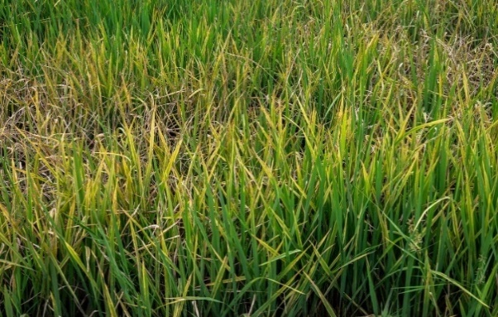
To facilitate supervised learning, each image is labeled based on the disease category.
.

Sample 1 Sample 2
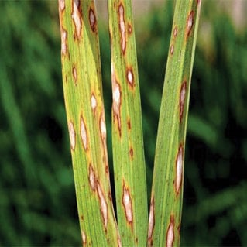
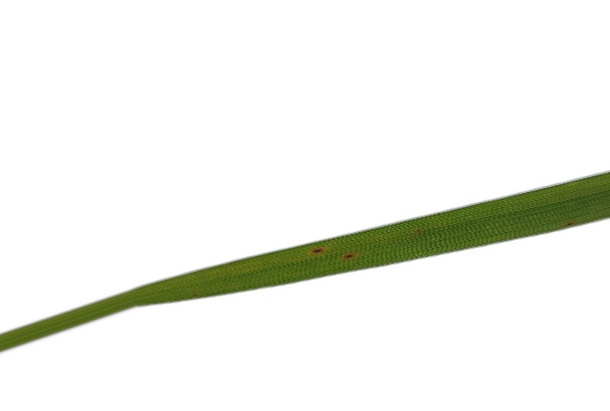
Sample 3 Sample 4

Because the photographs vary in terms of lighting, background environments, and leaf orientations, the model learns more robust traits.
3.2 Image Preprocessing
Image preprocessing has an important role in improving the performance of deep learning models by reducing noise and normalizing input data. Proper preprocessing ensures that the images are standardized before being fed into the model, that helps in improving training stability and accuracy.
The preprocessing methods used in this study include the following steps:
3.2.1 Image Resizing
All images are resized to 224 × 224 pixels to match the input size required by the EfficientNetB0 architecture. Image Resized ensures that all images have a consistent resolution, which is necessary for efficient model training.
3.2.2 Image Normalization
Pixel values are normalized to a range between 0 and 1 in order to improve training convergence and stabilize the learning process. Normalization helps the neural network learn patterns more effectively by ensuring that input values remain within a standardized scale.

3.3 Deep Learning Models
In this study, several deep learning architectures are evaluated for the classification of rice leaf diseases. These models are used to analyze rice leaf images and identify different disease categories.
The deep learning models evaluated in this research include:
• ResNet
• DenseNet
• MobileNetV3
• GhostNet
• EfficientNetB0
Among these architectures, EfficientNetB0 is selected as the primary model because it provides a good balance between classification accuracy and computational efficiency.

(a) ResNet
ResNet (Residual Network) is a deep convolutional neural network architecture that introduces residual connections to address the vanishing gradient problem. These residual connections allow the network to train deeper models more effectively by enabling gradients to flow through shortcut paths. ResNet is widely used in image classification and computer vision tasks due to its strong performance.
(b) DenseNet
DenseNet (Dense Convolutional Network) connects each layer in the network to every other layer in a feed-forward manner. This dense connectivity improves gradient flow and encourages feature reuse throughout the network. As a result, DenseNet is effective in extracting detailed and fine-grained image features.
(c) MobileNetV3
MobileNetV3 is a lightweight convolutional neural network architecture designed for mobile and embedded devices. It provides efficient performance with reduced computational cost while maintaining competitive accuracy in image classification tasks.
(d) GhostNet
GhostNet is an efficient neural network architecture that generates more feature maps using fewer parameters. This design reduces computational complexity while maintaining high classification accuracy, making it suitable for resource-constrained environments.
(e) EfficientNetB0
EfficientNetB0 is a convolutional neural network architecture that uses compound scaling to balance network depth, width, and resolution. This balanced scaling enables EfficientNetB0 to achieve high classification accuracy while maintaining strong computational efficiency.

4 Methodology and Experiments
This section covers the deep learning architecture, training setup, assessment measures, dataset, and preprocessing techniques.

4.1 Dataset
The dataset used in this study consists of more than 16,000 images of rice leaves representing different disease conditions. These images include both healthy leaves and leaves affected by various rice diseases. The dataset was collected from publicly available plant disease datasets and agricultural image sources.
All images are processed and standardized before being used for model training and evaluation.
Table 2. Dataset Statistics
Aspect | Details
Dataset | Rice Disease Dataset
Total Images | Approximately 16,000
Classes | Healthy, Insect Damage, Leaf Scald, Rice Blast, Rice Leaf Folder, Rice Stripe, Rice Tungro
Image Type | RGB
Image Size | Resized to 224 × 224 pixels

4.2 Preprocessing
Image preprocessing is performed to improve the quality of training data and enhance the performance of deep learning models. Proper preprocessing helps ensure that the input images are standardized and suitable for model training.
The preprocessing techniques used in this study include:
• Image resizing: All images are resized to 224 × 224 pixels to match the input requirements of the deep learning models.
• Pixel normalization: Pixel values are normalized to ensure consistent input scaling and improve training convergence.
• Data augmentation: Techniques such as rotation, flipping, and zooming are applied to increase dataset diversity and reduce overfitting.
• Noise reduction and background removal: Unnecessary noise and background elements are minimized to allow the model to focus on the important features of the leaf images.
As a result of these preprocessing steps, the model can more effectively focus on the regions of the leaf where disease symptoms appear, thereby improving classification performance.

4.3 Deep Learning Model
In this study, deep learning models are used to analyze rice leaf images and classify different disease categories. Among the evaluated architectures, EfficientNetB0 is selected as the primary model due to its high classification accuracy and computational efficiency.
EfficientNetB0 is a convolutional neural network architecture that uses compound scaling to balance network depth, width, and image resolution. This balanced scaling enables the model to achieve strong performance while maintaining efficient computational requirements.
The pretrained EfficientNetB0 model is fine-tuned using transfer learning to adapt it to the rice disease dataset. Additional layers such as Global Average Pooling, Dense layers, and Dropout layers are added to improve classification performance and reduce overfitting.
The model is trained to classify rice leaf images into multiple disease categories, including Healthy, Insect Damage, Leaf Scald, Rice Blast, Rice Leaf Folder, Rice Stripe, and Rice Tungro. By leveraging deep learning techniques, the system can automatically extract relevant features from leaf images and accurately identify disease patterns.

4.4 Hyperparameters
Table 3. Hyperparameters for Classification
Parameter | Value
Input size | 224 × 224
Batch size | 32
Loss Function | Categorical Crossentropy
Activation | ReLU
Optimizer | Adam
Learning rate | 0.0001
Epochs | 25–50
Train/Validation split | 80% / 20%
Evaluation metrics | Accuracy, Precision, Recall, F1-score

5 Result Analysis and Discussion
In tasks involving the categorization of rice diseases, the EfficientNetB0 model performed admirably.
Accuracy and F1 Score
The model showed effective feature extraction and classification skills, with an overall classification accuracy of over 80%.

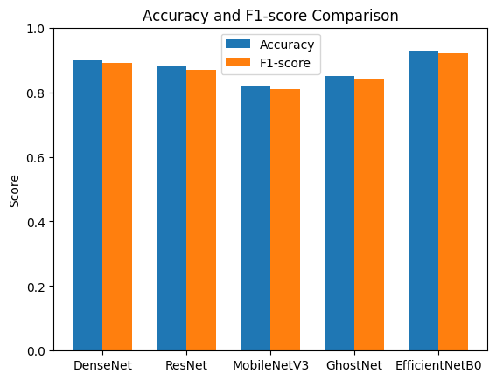
Fig. 1

Precision and Recall
The model demonstrated dependable classification performance by exhibiting balanced precision and recall across several illness categories.

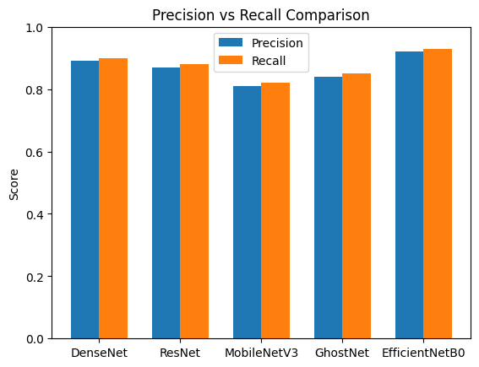
Fig. 2

Explainability of the Model
Using the LIME explanation technique, the model determines which important regions of rice leaf photographs are responsible for disease prediction. Increased transparency has led to greater confidence among farmers and agricultural experts.

Training Time Comparison
The comparative visualization of training time vs validation accuracy evaluation across architectures is depicted in fig.

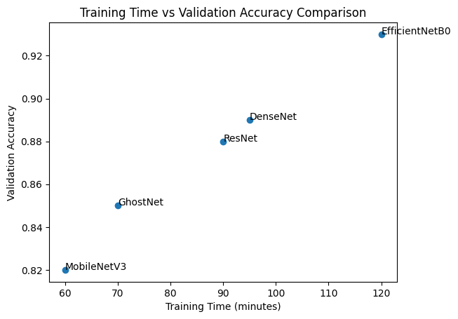
Fig. 3

Even while EfficientNetB4 performs exceptionally well in classification, the model's complexity and input resolution require a significantly longer computation time. Lightweight models, such as MobileNetV3 and GhostNet, are suitable for real-time or edge deployment scenarios due to their reduced computing costs and training periods.

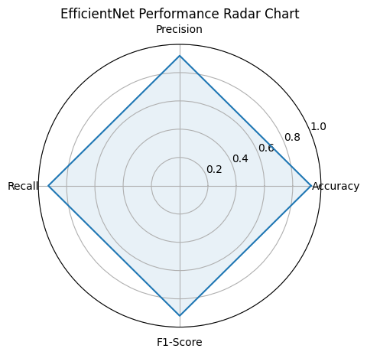
Fig. 4

Discussion
The results show that EfficientNetB0 provides good classification performance at a relatively low computational complexity. Explainable AI greatly enhances the system's suitability for real-world agricultural environments.
6. Conclusion and Future Work
This study proposed a deep learning–based rice disease classification system using the EfficientNetB0 architecture combined with Explainable Artificial Intelligence (XAI) techniques. The proposed model successfully classified multiple rice diseases with an accuracy of more than 80%, demonstrating the effectiveness of transfer learning in agricultural image analysis.
In addition to classification, the integration of the LIME explanation technique provides visual insights into the model’s decision-making process. This improves the transparency and interpretability of the system, making it more reliable for practical agricultural applications.
Future research can focus on the following areas:
• Expanding the dataset by including more real-world agricultural images
• Deploying the system on mobile devices to assist farmers in real-time disease detection
• Integrating Internet of Things (IoT)–based crop monitoring systems for continuous field analysis
• Exploring other explainability techniques such as SHAP and Grad-CAM to further improve model interpretability
Overall, the proposed approach demonstrates the potential of deep learning and explainable AI in improving automated plant disease detection and supporting smart agriculture systems.
7 References
1. "Using deep learning for image-based plant disease identification," Frontiers in Plant Science, vol. 7, 2016, Sharada P. Mohanty, David P. Hughes, and Marcel Salathé.
2. Konstantinos P. Ferentinos, "Deep learning models for plant disease diagnosis and detection," Computers and Electronics in Agriculture, vol. 145, pp. 311–318, 2018.
3. "EfficientNet: Rethinking model scaling for convolutional neural networks," by Marcus Tan and Quoc V. Le, Proceedings of the International Conference on Machine Learning, 2019.
4. Carlos Guestrin, Sameer Singh, and Marco Tulio Ribeiro, "Why should I believe you? "Explaining any classifier's predictions," in the 2016 ACM SIGKDD Conference on Knowledge Discovery and Data Mining Proceedings.

5. "Grad-CAM: Visual explanations from deep networks using gradient-based localization," Ramprasaath R. Selvaraju et al., IEEE International Conference on Computer Vision, 2017.
6. "Very deep convolutional networks for large-scale image recognition," Karen Simonyan and Andrew Zisserman, International Conference on Learning Representations, 2015.
7. "Deep residual learning for image recognition," Kaiming He et al., IEEE Conference on Computer Vision and Pattern Recognition, 2016.
8. "MobileNets: Efficient convolutional neural networks for mobile vision applications," Andrew G. Howard et al., 2017.
9. Too, E. C., Yujian, L., Njuki, S., and Yingchun, L., "A comparative study of fine-tuning deep learning models for plant disease identification," Computers and Electronics in Agriculture, 2019.

10. "Rice disease recognition using deep convolutional neural network," Computers and Electronics in Agriculture, 2018; Zhang, S., Huang, W., and Zhang, C.
11. "Automatic image-based plant disease severity prediction using deep learning," Wang, G., Sun, Y., and Wang, J. Computers and Electronics in Agriculture, 2017.
12. Barbedo, J. G. A., "Factors impacting the application of deep learning for plant disease identification," Biosystems Engineering, 2018.
13. Sladojevic, S. et al., "Deep neural networks based recognition of plant illnesses by leaf image classification," Computational Intelligence and Neuroscience, 2016.
14. Brahimi, M., Boukhalfa, K., and Moussaoui, A., "Deep learning for tomato illnesses classification and symptoms visualization," Applied Artificial Intelligence, 2017.

