How do indigenous traditions shape Himalayan hospitality and tourism in Sikkim?
Anurag Koirala*, Amit Kumar Singh**
*Research Scholar, Department of Tourism, School of Professional Studies, Sikkim University, Email: anuragkoirala.93@gmail.com
**Associate Professor & HOD, Department of Tourism, School of Professional Studies, Sikkim University, Email: aksingh01@cus.ac.in
Abstract
Himalayan hospitality in Sikkim draws on indigenous cultural traditions that interweave spiritual, environmental, and social principles. This study analyses hospitality practices among different ethnic groups—Bhutia, Lepcha, and others within Nepalis like Khas (Bahun, Chhetri), Rai, Limboo, Gurung, Magar, Sherpa, Tamang, Kami, Damai, Sarki, Bhujel, Giri, and Sanyasi. The rituals, foods, symbolic performances, and rituals that make up guest–host relationships and reinforce cultural bonds include presenting khadas, ritual cleansing for feet, fumigation with herbs native to the region, group dances for ceremonies, and group feasts. The study also notes the overlap between these traditions and community-based tourism (CBT), assessing its promise for preserving and revitalizing cultural traditions and its danger of commodification. The results are that tourist development that is sustainable, with a foundation in participatory governance and community ownership, is required for preserving the authenticity and dynamism of Himalayan hospitality. By placing hospitality as a living cultural heritage, this article sheds light on its roles in promoting cultural continuity and socio-economic adaptability in Sikkim.
Keywords: Himalayan hospitality, indigenous traditions, Sikkim, cultural rituals, intangible heritage, community-based tourism, sustainable development

1. Introduction
Hospitality in the Himalayan region goes beyond commerce, reflecting sacred traditions that are a testament to interconnections between people, nature, and spirituality. This reflects the broader Himalayan context, where culture, ecology, and economy are deeply interconnected, shaping indigenous practices and social systems (Sati, 2026). As guided by the ideology of Atithi Devo Bhava— "the guest is akin to a deity"—Sikkim hospitality is an interweaving cultivation between cultural rituals and communal ethos that go beyond service and exchange. The ethos is poignantly expressed in the various customs of each multi-ethnocultural group within Sikkim, namely the Bhutia, Lepcha, and hundreds of Nepali sub-groups including Khas (Bahun and Chhetri), Rai, Limboo, Gurung, Magar, Sherpa, Tamang, Kami, Damai, Sarki, Bhujel, Giri, and Sanyasi (Government of Sikkim, n.d.; Sati, 2026; Subba, 2008).
There are unique practices that are a collective embodiment of Himalayan hospitality within each society. The Bhutia custom of khada (ritual scarves) offerings, the Oral Lepcha tradition by the hearth, and Nepali ritual foot washing or Bahu Bhattyer are a testament to the spiritual and environmental worldview within the region. The practices are more than a reinforcement for social relationships; they are significant intergenerational conduits for knowledge and cultural preservation (Bista, 1991; Fürer-Haimendorf, 1981; Sati, 2026; Subba, 2008; UNESCO, n.d.; UN Tourism, n.d.).
Along with the growth of community-based tourism (CBT), such traditions are becoming a part and parcel of the tourism activities like homestays, festivals, and cultural programs (Lama, 2014). Community-based tourism (CBT) has proven to be a double-edged sword: while it generates economic opportunities, enhances local livelihoods, and fosters community pride, it also poses risks of cultural commodification, particularly when sacred rituals and traditions are staged or modified primarily for tourist consumption. Such processes may lead to the dilution of symbolic meanings and the transformation of lived cultural practices into performative spectacles (Cohen, 1988; Greenwood, 1989; Shepherd, 2002). Thus, culturally sensitive governance for tourism and involvement of the communities are essential for striking a balance between the preservation of heritages and sustainable development of tourism.
The present work endeavours to chart the breadth and range of hospitality traditions in Sikkim and understand their symbolic meaning and their transforming relationship with CBT. Situating these traditions within larger socio-economic and cultural contexts, the research endeavour is to draw attention to hospitality as a living and dynamic heritage that supports both identity and livelihood for the native people of Sikkim.
2. Literature Review
The literature on Himalayan hospitality in Sikkim shows that hospitality is not merely a commercial service practice but a culturally embedded system of ritual care, symbolism, and social obligation. Hospitality in the Himalayan context as a sacred act, where the guest is treated as a morally and spiritually significant presence rather than a simple consumer of services. The relationship between culture, environment, and economy in the Himalaya has been widely discussed, highlighting how traditional practices are increasingly influenced by tourism and development processes (Sati, 2026 In Sikkim, this broader cultural logic is reflected in the customs of the Bhutia, Lepcha, and Nepali communities, where welcoming guests involves practices such as khada offerings, ritual foot-washing, herbal fumigation, communal meals, storytelling, and participation in festivals. These practices are deeply embedded in indigenous belief systems that integrate spirituality, ecology, and social relations, and they serve as important expressions of cultural identity and continuity (Sati, 2026; Subba, 2008).
Several studies focus on the community-specific expressions of this tradition. Bhutia hospitality is often described through Buddhist ritual care, blessing practices, and sacred food-sharing. Bhutia cultural traditions are deeply embedded within a sacred spatial framework, where landscapes are not merely physical settings but are imbued with spiritual meanings and ancestral significance. The perception of space among the Bhutia community reflects a strong linkage between territory, identity, and ritual practice, where boundaries are culturally constructed through religious beliefs and social memory. These sacred landscapes influence everyday practices, including hospitality, as welcoming a guest is not only a social act but also a spiritually mediated interaction within a culturally defined space (S.D. Bhutia, 2025).
Lepcha hospitality is linked with animistic beliefs, hearth-centered storytelling, and ecological reverence. This ecological and spiritual orientation is rooted in broader indigenous knowledge systems that evolved historically, particularly during the Namgyal Dynasty, where Lepcha cultural practices adapted to changing socio-political contexts while maintaining their connection to nature and ancestral traditions (Lepcha M, 2024).
Among Nepali sub-groups, hospitality is expressed through rites such as Griha Pravesh, Bahu Bhattyer, raadi mat seating, and the serving of traditional drinks and foods that reinforce kinship and respect. These practices show that hospitality functions as a living cultural text through which identity, memory, and social continuity are reproduced across generations. This is particularly evident among Limboo communities, where changing religious landscapes have contributed to dynamic processes of identity construction, with rituals and social practices—including hospitality—serving as key mediums for negotiating continuity and change (Manger, 2022).
The literature also highlights the role of hospitality in preserving intangible cultural heritage. Rituals of welcome, clan-based feasts, and oral traditions help maintain communal identity and transmit knowledge to younger generations. Everyday hospitality practices are tied to spiritual worldview, local ecology, and social cohesion, making them important markers of indigenous knowledge systems. A major theme in the literature is the relationship between hospitality traditions and community-based tourism (CBT). Lama (2014), and Chaudhary and Lama (2014) show that homestays and village tourism in Sikkim create space for visitors to experience local rituals while generating income for communities. Cajee (2014) further argues that eco-cultural tourism can support environmental, cultural, and economic sustainability when it is rooted in local ownership and community participation. The literature therefore presents CBT as a powerful mechanism for cultural revitalization, livelihood generation, and heritage promotion.
At the same time, scholars warn about the risks of commodification and superficial representation in tourism contexts. When sacred rituals are shortened, staged, or repackaged primarily for tourist consumption, their original symbolic and spiritual meanings may be diluted or transformed, reducing them to performative spectacles rather than lived cultural practices (MacCannell, 1973). Scholars emphasize the importance of participatory governance, equitable benefit-sharing, and community control over cultural representation in tourism development. Such approaches ensure that local communities retain agency in how their traditions are preserved and presented, thereby safeguarding authenticity and cultural integrity. This body of literature suggests that the sustainability of Himalayan hospitality depends not only on tourism growth but also on ethical cultural management, community ownership, and the intergenerational transmission of cultural knowledge (Chaudhary & Lama, 2014; Scheyvens, 1999).
Overall, the literature establishes that Himalayan hospitality in Sikkim is deeply connected to indigenous worldview, family and clan rituals, and community-based tourism. However, it also indicates a need for more integrated research that links hospitality rituals, cultural preservation, and tourism governance in a single analytical framework. This study is therefore well positioned to bridge this gap by examining hospitality as both a cultural practice and a tourism resource.

3. Research Gap and Rationale
Although Sikkim is widely discussed through homestays and rural tourism, the literature still leans toward livelihood outcomes, destination planning, and participation, with less attention to hospitality as intangible cultural heritage and to the comparative meanings of ritual practice across communities. UNESCO’s framework highlights that living heritage can contribute to sustainable development, but tourism must respect the rights, aspirations, and wishes of the communities concerned. UN Tourism likewise positions rural tourism and indigenous tourism as pathways for community development and cultural preservation. In Sikkim, foundational CBT work by Chaudhary and Lama (2014) established the livelihood value of community-based tourism, yet a comparative study of Bhutia, Lepcha, and Nepali hospitality practices, lineage rites, and tourism governance remains limited (UNESCO, n.d.; UN Tourism, n.d.; Chaudhary & Lama, 2014). This study addresses that gap by examining hospitality as living heritage and by assessing how community-based tourism can safeguard authenticity while creating local benefits.
4. Research Questions
- What indigenous hospitality practices are observed among Bhutia, Lepcha, and selected Nepali sub-groups in Sikkim?
- How do these practices function as intangible cultural heritage in guest–host relationships and lineage induction?
- How does community-based tourism influence the preservation, adaptation, or commodification of these practices?
- What community-led governance measures can strengthen ethical and culturally respectful tourism in Sikkim?
5. Research Objectives
- To identify and compare key hospitality rituals across Bhutia, Lepcha, and selected Nepali sub-groups.
- To interpret the symbolic and cultural meanings embedded in these hospitality practices.
- To assess the opportunities and risks created by community-based tourism for cultural safeguarding.
- To propose culturally sensitive and community-led approaches for tourism development in Sikkim.
6. Methodology
The study follows a qualitative, exploratory, and interpretive design. It is based on documentary analysis of peer-reviewed journal articles, doctoral research, official UNESCO and UN Tourism resources, and relevant Sikkim tourism policy documents. This approach is appropriate because the subject concerns meanings, symbols, ritual practice, and community representation rather than measurable service outcomes alone.
The analysis uses thematic comparison across Bhutia, Lepcha, and selected Nepali hospitality traditions. The core themes examined are ritual form, symbolic meaning, guest–host interaction, lineage or household induction, and the effects of tourism on continuity, adaptation, or commodification.
Because the paper is conceptual and literature-based, it does not report primary survey data or interviews. Instead, it synthesizes secondary evidence to build an analytical framework for understanding how living heritage can be protected within community-based tourism.

7. Himalayan Hospitality as Intangible Cultural Heritage
Sikkim’s cultural philosophy views hospitality as something that extends beyond mere courtesy; it represents an expression of community spirituality and shared value systems rooted in indigenous worldviews. In the Himalayan context, hospitality is relationally embedded, where interactions between host and guest are mediated through symbolic practices, emotional exchange, and shared cultural narratives that reinforce social bonds and collective identity (Sati, 2026; Subba, 2008). Unlike standardized forms of commercial hospitality, these traditions emphasize reciprocity, respect, and moral obligation, reflecting the broader cultural ethos of interconnectedness between individuals, community, and the sacred (Bista, 1991; Fürer-Haimendorf, 1981). Rituals associated with welcoming guests—such as the offering of sacred scarves (khada), herbal fumigation, ritual food sharing, and sacred music or storytelling—serve as repositories of cultural memory and act as mechanisms through which communal identity and intangible heritage are preserved and transmitted across generations (Sati, 2026).
7.1 Traditional Hospitality Practices by Community
Bhutia
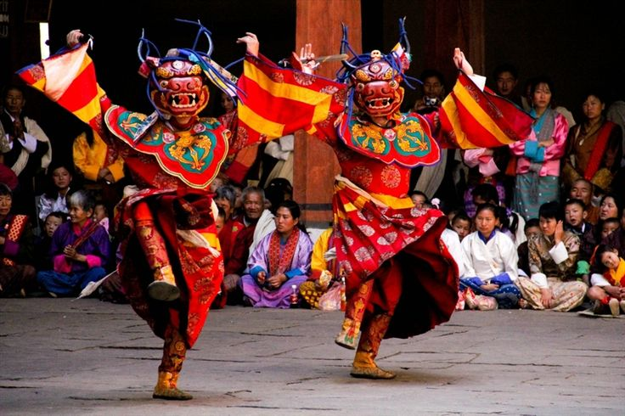
Bhutia hospitality is deeply embedded in Tibetan Buddhist ritual and cultural traditions, where welcoming a guest is considered both a social and spiritual act. Guests in Bhutia households are often received with the offering of a white khada (ceremonial scarf), symbolizing purity, and respect, reflecting the integration of Buddhist values into everyday social practices. Such ritual gestures are not merely formalities but are imbued with religious significance, reinforcing moral relationships, spiritual well-being, and communal harmony (Sati, 2026; Subba, 2008). Hosts in Bhutia households often perform ritual fumigation by burning juniper or incense at the entrance to purify the space and ward off negative energies, invoking auspicious spiritual forces in accordance with Tibetan Buddhist practices. Such acts of purification are integral to domestic ritual life and reflect the broader cosmological belief in maintaining harmony between the physical and spiritual realms (Samuel, 1993). Guests are typically served warm, nourishing foods such as herbal broths prepared with locally available and medicinally significant ingredients, which not only provide physical comfort in the cold Himalayan climate but also symbolize care, healing, and hospitality rooted in indigenous ecological knowledge systems (Bista, 1991; Sati, 2026; Subba, 2008). During major festivals such as Losoong, hospitality extends into the communal sphere, where guests are integrated into collective celebrations involving prayers, feasting, and ritual performances like cham dances, reinforcing both religious devotion and social cohesion within the community (Samuel, 1993; Subba, 2008). As illustrated in Figure 1.1 Cham dance being performed by the Bhutia community during Losoong festival.

Figure 1.1 Source: www.indianetzone.com/chaam_dance

Lepcha
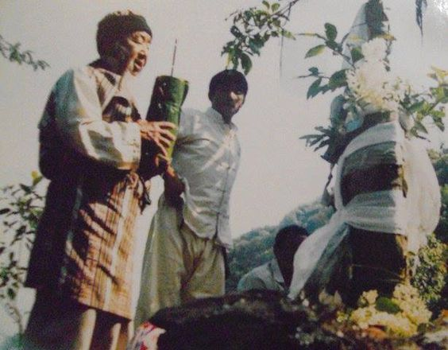
The Lepcha community expresses hospitality through intimate and ritualized practices grounded in their animistic worldview, where nature, ancestors, and spiritual forces are deeply interconnected. Guests are often offered traditional foods derived from local ecological knowledge, including preparations such as bamboo shoots cooked in bamboo tubes, reflecting both subsistence practices and cultural identity tied to the environment. These acts of offering are not merely culinary but signify a deeper relationship with nature and community life (Lepcha, 2024; Sati, 2026; Subba, 2008). Rituals of care may also include the symbolic cleansing or soothing of the guest through the use of locally available herbs and plant-based preparations, reinforcing notions of purity, healing, and belonging within the natural and spiritual order (Fürer-Haimendorf, 1981; Lepcha, 2024). Storytelling forms a central component of Lepcha hospitality, where guests are welcomed into the domestic space and invited to gather around the hearth, listening to narratives of mountain deities, forest spirits, and ancestral origins. These oral traditions function as important cultural mechanisms that integrate the guest into the community’s cosmology while facilitating intergenerational transmission of knowledge and identity (Lepcha, 2024; Subba, 2008).

Figure: 1.2 Source: spaindustrialdesign.wordpress.com/2020/12/16/lepcha-handloom-of-sikkim
Nepali Sub-Groups
Khas (Bahun and Chhetri)
Khas (Bahun–Chhetri) hospitality reflects strong notions of ritual purity, respect, and social hierarchy embedded within Hindu cultural traditions. Guests are typically offered a designated and respectful seating space—often on traditional mats or near the household hearth—symbolizing their honored status within the domestic sphere and reinforcing norms of Swagat (welcome) and reverence (Bista, 1991; Subba, 2008). Ritual acts of cleansing, including the washing of a guest’s feet or offering water for purification, are rooted in broader Hindu practices associated with auspiciousness and the removal of impurity, reflecting both spiritual and social dimensions of hospitality (Michaels, 2021). The application of locally prepared substances such as clarified butter or herbal oils may further signify care, comfort, and symbolic healing, reinforcing the host’s duty toward the well-being of the guest (Bista, 1991; Sati, 2026). Guests are commonly served traditional foods and beverages—such as buttermilk, sel roti, and other locally prepared items—while being invited to sit near the hearth, share stories, and participate in household interactions. These practices transform hospitality into a participatory and relational experience, integrating the guest into the familial and cultural environment while reinforcing community bonds and intergenerational knowledge exchange (Sati, 2026; Subba, 2008).

Rai and Limboo
Hospitality among Rai and Limboo communities is deeply embedded in Kirati cultural traditions, where welcoming a guest is closely associated with ritual exchange, communal bonding, and symbolic expressions of warmth. The offering of traditional fermented beverages such as tongba (millet beer) and jaand (fermented rice beer) is a central element of hospitality, signifying respect, conviviality, and the establishment of social connection between host and guest (Gaenszle, 2000; Subba, 2008). These practices are rooted in indigenous knowledge systems that emphasize sharing, reciprocity, and community cohesion. In addition to food and drink, forms of ritual care—such as the use of locally available herbs for warmth, healing, or symbolic cleansing—reflect a broader ecological understanding and the integration of nature within everyday cultural practices (Fürer-Haimendorf, 1981; Lepcha, 2024). Musical and performative traditions also play a significant role in hospitality, where dances such as the Chyabrung of the Limboo and various Rai song traditions serve as participatory forms of welcome, honouring the guest while reinforcing collective identity, oral heritage, and social solidarity (Gaenszle, 2000; Subba, 2008). These performative interactions transform hospitality into a shared cultural experience, strengthening both interpersonal relationships and intergenerational transmission of tradition. These hospitality practices are not merely social gestures but are embedded in broader processes of identity formation shaped by evolving religious beliefs and cultural adaptation (Manger, 2022). Figure 1.3 illustrates the Limboo community performing Chyabrung.
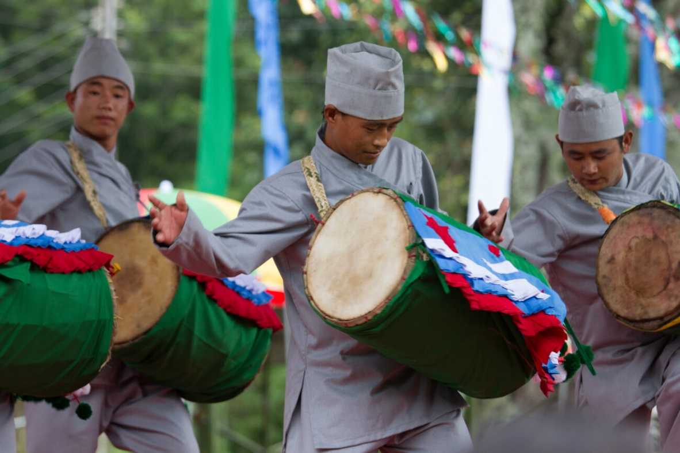

Figure: 1.3 Source: sikkimproject.org/reviving-limbu-language-and-culture
Gurung, Magar
Among the Magar and Gurung communities, hospitality practices are closely linked to subsistence traditions, ecological knowledge, and ritual life, where food plays a central role in expressing respect and inclusion. Guests are often served locally sourced foods, including meat that is dried or smoked—such as pork or other livestock—reflecting both environmental adaptation and cultural preferences rooted in highland livelihoods (Bista, 1991; Gurung, 1980). Fermented foods and broths, prepared using indigenous techniques, further illustrate the integration of local ecological knowledge and culinary traditions within hospitality practices (Fürer-Haimendorf, 1981; Sati, 2026). Beyond food, hospitality extends into participatory cultural expressions, where guests are invited to engage in communal singing and folk performances, such as Gurung songs and dances, symbolizing inclusion within the social and cultural fabric of the community (Gurung, 1980). Ritual elements, including the lighting of butter lamps and the sharing of traditional foods like dumplings, often accompany such gatherings, representing warmth, auspiciousness, and spiritual well-being, while reinforcing communal identity and continuity of cultural traditions (Subba, 2008).
Sherpa, Tamang
Hospitality among Sherpa and Tamang communities is deeply shaped by Tibetan Buddhist traditions, where welcoming a guest is both a social and spiritual act embedded in ritual practice. The presentation of khada (ceremonial scarves) and the lighting of butter lamps are common gestures used to convey respect, invoke blessings, and generate auspicious conditions, reflecting Buddhist cosmological principles of merit-making and purification. Contemporary research on Himalayan cultural systems further emphasizes that such ritualized hospitality practices remain central to identity formation and everyday religious life, even as tourism and modernization reshape local contexts (Li, 2024; Nyaupane & Timothy, 2022).
Guests are often offered warm, nourishing foods such as barley-based soups and locally prepared meals, which not only provide physical comfort in high-altitude environments but also symbolize care, reciprocity, and ecological adaptation within indigenous food systems (Jasrotia & Kour, 2022; Sati, 2026). Recent studies on Himalayan homestay and community-based tourism further highlight how such practices are increasingly incorporated into tourism experiences, where traditional food and ritual warmth become key elements of cultural exchange and visitor satisfaction (Thakur et al., 2024; Dam, 2025).
In many households, hospitality extends into explicitly ritual domains, where guests may be invited into domestic shrine spaces for brief puja (prayer) ceremonies dedicated to household deities or protective spirits. These practices merge spiritual and domestic hospitality, reinforcing shared belief systems while also serving as important mediums for the transmission of cultural knowledge and values across generations (Chettri & Sharma, 2024; Subba, 2008).
Kami, Damai, Sarki
Among Kami, Damai, and Sarki communities, hospitality practices are closely intertwined with traditional occupations, craftsmanship, and cultural expression, reflecting both social identity and symbolic honour. The Kami, historically associated with metalworking and blacksmithing, are known for producing utilitarian and ritual objects, and the presentation of crafted items can symbolize respect, skill, and cultural pride within social exchanges (Bista, 1991; Subba, 2008). Similarly, the Damai community—traditionally recognized as hereditary musicians—plays a central role in ritual and ceremonial life through musical performances, particularly using ensembles such as the Naumati Baja, which are performed during auspicious occasions including weddings and communal gatherings (Sherpa, 2024). These musical traditions are not merely performative but serve as important markers of ethnic identity and social cohesion, embedding guests within the ceremonial and emotional fabric of the community.
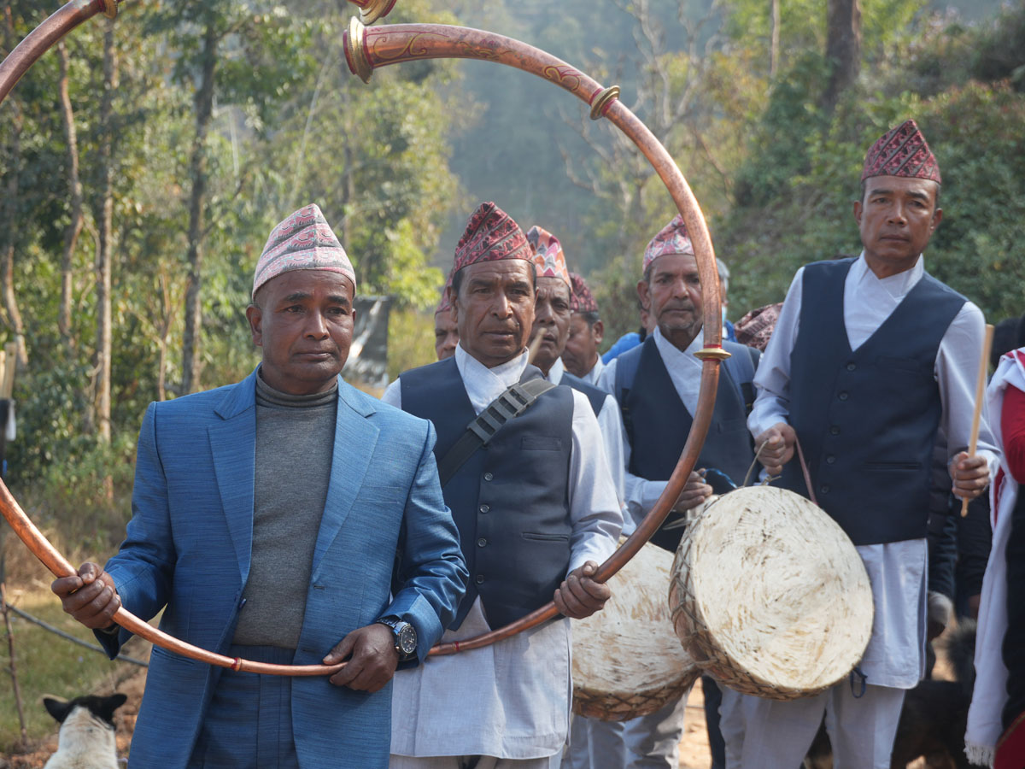
Hospitality within these communities often extends into performative and material expressions, where music, craft, and symbolic offerings function as mediums of inclusion and samman (respect). The Sarki community, traditionally associated with leatherwork and craft production, similarly reflects identity through material culture, where handcrafted items signify warmth, utility, and social belonging. The performance of Naumati Baja—a traditional ensemble of nine instruments played during life-cycle rituals—serves as a ceremonial welcome, integrating guests into communal celebrations and reinforcing collective identity and continuity (Sherpa, 2024). Such practices highlight how hospitality among these groups transcends verbal interaction, becoming a multisensory cultural experience rooted in sound, materiality, and shared ritual participation.

Figure: 1.4 Source: www.sambhavnepal.org/project/naumati-baja-preservation-project
Bhujel, Giri, Sanyasi
Among Bhujel and Giri communities, hospitality practices are often expressed through material offerings and ritual gestures that symbolize prosperity, care, and social harmony. The presentation of food items—such as seasonal fruits, grains, and locally produced staples—on traditional serving ware reflects agrarian values and the cultural importance of sharing abundance as a marker of respect and inclusion (Bista, 1991; Subba, 2008). These practices are embedded within broader Hindu and indigenous frameworks where hospitality is closely linked to notions of generosity, auspiciousness, and the moral duty of the host.
Within ascetic and religious traditions associated with Sanyasi practitioners, hospitality may also take explicitly ritual forms, including brief benedictions, the sprinkling of holy water, or the offering of grains such as rice to invoke blessings, protection, and spiritual well-being for guests. Such practices reflect long-standing Hindu ritual traditions centered on purification, sacred symbolism, and the transmission of divine grace within domestic and social spaces (Michaels, 2004; UNESCO, n.d.).
Recent scholarship on Himalayan cultural systems further highlights that these forms of ritualized hospitality continue to function as important mechanisms of cultural continuity and identity, even as communities engage with changing socio-economic contexts and tourism dynamics (Chettri & Sharma, 2024; Nyaupane & Timothy, 2022). Together, these practices illustrate how hospitality in such communities transcends material exchange, becoming a symbolic and spiritual act that reinforces social cohesion, ethical values, and intergenerational cultural transmission.

8. Community-Based Tourism and Tradition
Community-based tourism (CBT) in Sikkim actively involves local communities in tourism planning and management, enabling visitors to experience authentic cultural practices while simultaneously supporting the preservation of indigenous traditions and livelihoods. Such participatory models emphasize local ownership, cultural integrity, and sustainable development, ensuring that tourism benefits are equitably distributed among community members (Chaudhary & Lama, 2014; Nyaupane & Timothy, 2022; UN Tourism, n.d.). Recent studies highlight that increasing tourism and processes of globalization have significantly influenced local cultural systems, prompting communities to consciously safeguard rituals, customs, and heritage practices as valuable cultural assets within tourism frameworks (Chettri & Sharma, 2024; Thakur et al., 2024).
Ritual practices—such as initiation ceremonies, life-cycle rites, and domestic religious observances—serve as important mechanisms for reinforcing lineage, ancestral continuity, and social identity within Himalayan communities. When carefully integrated into CBT experiences, these rituals function not only as attractions for visitors but also as powerful tools for intergenerational knowledge transmission and cultural continuity (Lepcha, 2024; Sati, 2026; UNESCO, n.d.).
At the same time, the incorporation of ritual practices into tourism presents both opportunities and challenges. Many homestay-based tourism initiatives in the Himalayan region include curated experiences such as ritual cleansing, traditional food offerings, and cultural performances, which contribute to the conservation of intangible heritage and the strengthening of community identity (Jasrotia & Kour, 2022; Thakur et al., 2024). However, scholars caution that commodification poses a significant risk when sacred rituals are altered, shortened, or staged primarily to meet tourist expectations, potentially leading to a loss of symbolic meaning and cultural authenticity (Cohen, 1988; Shepherd, 2002).
Therefore, the sustainability of CBT in Sikkim depends on robust governance frameworks that prioritize participatory decision-making, equitable benefit-sharing, and community control over cultural representation. Empowerment-based approaches ensure that local communities retain agency in managing how their traditions are presented, thereby safeguarding both cultural integrity and long-term sustainability (Scheyvens, 1999; Timothy, 2007; UN Tourism, n.d.). These transformations reflect broader regional trends where tourism acts as both a driver of economic opportunity and a source of cultural change (Sati, 2026).
8.1. Tradition of Inducting Newlywed Couples
Bhutia Tradition (Tibetan-Buddhist)
The Bhutia community of Sikkim follows Tibetan Buddhism, interwoven with indigenous animistic beliefs that emphasize the presence of local deities, ancestral spirits, and protective forces within the landscape. Households commonly maintain shrine spaces dedicated to such deities, often conceptualized as Yul Lha (territorial or local gods), who are believed to safeguard the family and clan while ensuring harmony between the human and spiritual realms (Sati, 2026). These domestic ritual spaces play a significant role during key life-cycle events such as births, marriages, and other transitional rites, reinforcing both religious continuity and social identity (Subba, 2008; Chettri & Sharma, 2024).
Following marriage, the bride is ritually introduced into the groom’s ancestral household through practices that symbolically affirm her integration into the lineage and its spiritual obligations. This process often includes offerings made at the family shrine—such as the lighting of butter lamps and the burning of juniper incense—which are central elements of Tibetan Buddhist ritual practice aimed at invoking blessings, purifying space, and establishing auspicious beginnings. The presence of a Lama or monk to conduct prayers and rituals further underscores the religious significance of the event, as blessings are sought for fertility, prosperity, and familial harmony, reflecting broader Buddhist cosmological values (Sati, 2026).
Ritual performances and communal participation also form an integral part of such ceremonies. Collective dances and festive gatherings, often associated with blessings and social cohesion, serve to symbolically integrate the couple into the community while reinforcing shared cultural identity and continuity (Subba, 2008). While specific named rituals may vary across regions and lineages, these performative traditions function as embodied expressions of spiritual bonding and communal affirmation.
Beyond formal rituals, the gradual incorporation of the bride into household life is reflected through her participation in everyday religious and domestic practices, including involvement in food preparation, ritual offerings, and shared meals. These activities signify not only her social acceptance but also her active role in sustaining the spiritual and cultural continuity of the family across generations (Bista, 1991; Lepcha, 2024; Sati, 2026). Together, these practices highlight how Bhutia marital customs intertwine spirituality, kinship, and hospitality, creating a holistic system of cultural integration and identity formation.
Lepcha Tradition (Animist Indigenous)
The Lepchas, who refer to themselves as Rongkup Rumkup (often translated as “children of the snowy peaks”), possess a deeply rooted spiritual worldview centered on nature, ancestral spirits, and sacred landscapes. Their belief system reflects an animistic cosmology in which mountains, rivers, forests, and other elements of the natural environment are imbued with spiritual significance, and ancestral spirits are considered active guardians of lineage and community well-being (Lepcha, 2024; Subba, 2008). This worldview emphasizes harmony between humans and nature, where spiritual guidance is believed to be mediated through ancestral forces and ritual specialists.

During Lepcha marriage ceremonies, ritual specialists such as the Mun (female shaman) and Bongthing (male shaman) play a central role in officiating rites that invoke blessings from both ancestral spirits and nature deities. Marriage is understood not merely as a union between two individuals but as an alliance between lineages, requiring spiritual sanction and communal recognition (Fürer-Haimendorf, 1981; Lepcha, 2024). Post-wedding rituals often involve symbolic offerings—such as millet-based beverages, fruits, and sacred herbs—presented at or near the household altar to seek acceptance of the bride into the groom’s lineage and to ensure protection and prosperity for the new household (Lepcha, 2024; Sati, 2026).

Unlike more codified ritual systems, Lepcha domestic life reflects a relatively fluid and collective division of responsibilities, where there is no formally institutionalized “first kitchen” ritual. Instead, the bride’s integration into the household occurs gradually through participation in everyday domestic and ritual practices, including food preparation and communal activities. This process signifies not only social acceptance but also spiritual incorporation into the lineage, as the blessings of ancestral and territorial spirits are believed to extend to all members of the household (Subba, 2008).

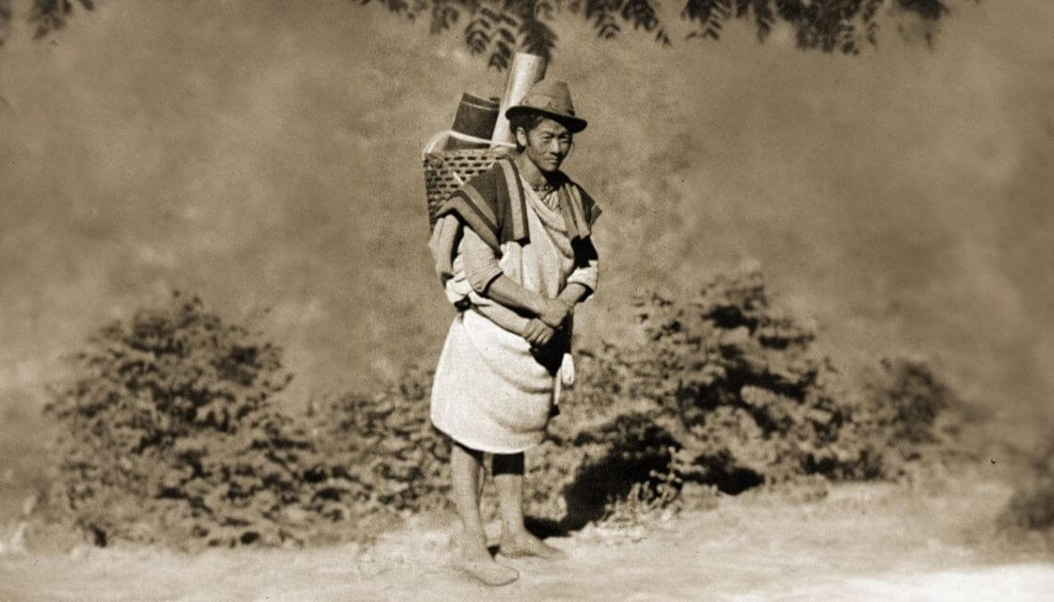
Overall, these practices illustrate the Lepcha emphasis on maintaining a delicate balance between the human community and the spiritual-natural world, where kinship, ecology, and belief systems are intricately interconnected. Such traditions continue to serve as vital mechanisms for cultural continuity and identity preservation, even in the face of social and economic transformations (Chettri & Sharma, 2024; Nyaupane & Timothy, 2022).
Figure: 1.5 Source: lepcha.info/traditions-and-faith-of-the-indigenous-tribe-of-lepcha

Nepali Tradition (Hindu)
Upon arrival at her husband’s household, the bride is ritually welcomed through Griha Pravesh, a significant rite in Hindu marriage traditions symbolizing her transition into a new domestic and spiritual space. This ceremony often involves the performance of aarti at the threshold by senior female members of the household, accompanied by the lighting of an oil lamp (diya), which represents purity, auspiciousness, and the invocation of divine blessings (Fuller, 2004; Michaels, 2004). The placement of the lamp alongside grains such as rice or paddy at the entrance symbolizes prosperity and abundance, and is commonly associated with the arrival of Goddess Lakshmi, the deity of wealth and well-being, into the household (Michaels, 2004).
Ritual actions involving grain—such as touching, transferring, or symbolically dispersing rice—are widely recognized in Hindu domestic rites as markers of fertility, continuity, and sustenance. The inclusion of sacred objects like threads, coins, or betel nuts within these rituals further reinforces symbolic meanings related to prosperity, lineage continuity, and ritual purity (Uberoi, 2006). Anthropologically, such practices are interpreted as part of broader rites of passage, wherein the bride’s movement into the marital household is marked by symbolic acts that transform her social identity and integrate her into the kinship and economic structure of the family.
These ritualized interactions, sometimes accompanied by playful or competitive elements among family members, serve not only as symbolic enactments of transition but also as social mechanisms for easing integration, reinforcing familial bonds, and publicly acknowledging the bride’s new role within the household (Uberoi, 2006). Through these performative acts, abstract cultural values—such as prosperity, fertility, and continuity—are materially and socially enacted within the domestic sphere.
The post-wedding phase often includes practices in which the bride participates in food preparation and service within the household, commonly conceptualized across South Asian traditions in forms such as pehli rasoi or similar customs. These acts are widely interpreted as the bride’s first formal contribution to the domestic economy and her symbolic acceptance of caregiving and nurturing roles within the family (Fuller, 2004; Uberoi, 2006). From an anthropological perspective, such practices represent the consolidation phase of the rite of passage, where the individual is fully incorporated into the new social structure and begins to perform expected roles within the household.
Overall, these rituals illustrate how domestic hospitality, gender roles, and spiritual symbolism converge within Hindu marriage traditions, transforming the bride into both a bearer of prosperity and an active participant in the cultural and religious continuity of the lineage.
Figure 1.6 illustrates the griha pravesh ceremony of newly wed of the Nepali community.
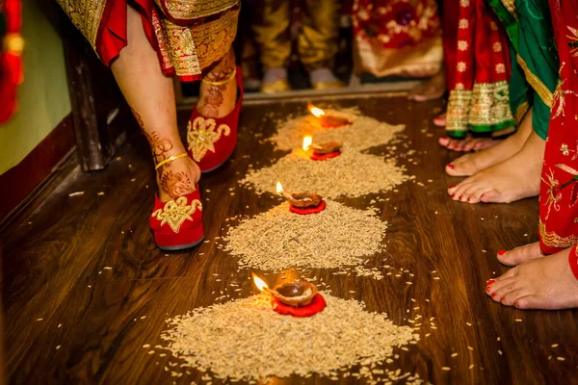
Figure: 1.6 Source: depositphotos.com/photos/indian-nepali-wedding.html?offset=400
8.2 Impact on Community-Based Tourism and Cultural Preservation
Induction rites, although primarily situated within the private domain of family life, hold significant potential within the context of cultural tourism and heritage preservation. Cajee (2014) argues that eco-cultural tourism can function as an important vehicle for sustaining traditions when they are incorporated responsibly and ethically into tourism practices. This aligns with broader scholarship on community-based tourism (CBT), which emphasizes that culturally embedded experiences can promote both heritage conservation and livelihood generation when communities retain control over representation (Nyaupane & Timothy, 2022; Scheyvens, 1999).
In practice, village-based tourism initiatives in Sikkim—such as those documented in Darap and similar rural settings—showcase traditional dances, culinary practices, and ritual performances for visitors. These include participatory elements such as communal meals, local performances, and demonstrations of domestic and ritual practices, allowing visitors to engage with living traditions while contributing to the local economy (Chaudhary & Lama, 2014; Thakur et al., 2024). Through such engagement, communities not only generate income but also facilitate the intergenerational transmission of cultural knowledge.
Rai and Kumar (2025) further highlight that CBT not only creates economic opportunities but also strengthens cultural pride and identity among local communities. When traditions are valued by both outsiders and insiders, communities are more likely to sustain them as living practices rather than allowing them to decline. This perspective is supported by recent research, which shows that recognition through tourism can reinforce intangible cultural heritage and motivate its continued practice across generations (Jasrotia & Kour, 2022; Nyaupane & Timothy, 2022).
Across Sikkim’s diverse communities, induction rituals associated with marriage—whether among Bhutia, Lepcha, or Nepali groups—serve as foundational practices that integrate individuals into familial, spiritual, and social systems. These rituals reflect distinct cultural frameworks, ranging from Tibetan Buddhist and animistic traditions among the Bhutias, to nature-centric and ancestral belief systems among the Lepchas, and Hindu rites such as Griha Pravesh and post-marital domestic practices among Nepali communities (Sati, 2026; Subba, 2008; Lepcha, 2024). Despite their diversity, these practices share a common function of reinforcing lineage continuity, social cohesion, and spiritual belonging.
When incorporated into community-based tourism, such rituals acquire broader socio-economic significance. Homestays, festivals, and cultural programs provide platforms through which these traditions are selectively presented to visitors, enabling communities to create sustainable economic models while safeguarding their intangible cultural assets (Jasrotia & Kour, 2022; Thakur et al., 2024). However, scholars caution that commodification poses a significant risk when sacred rituals are modified or staged primarily for tourist consumption, potentially eroding their symbolic meaning and cultural authenticity (Cohen, 1988; Shepherd, 2002).
Overall, as Cajee (2014) and Rai and Kumar (2025) suggest, tourism has the potential to bridge contemporary development and cultural traditions when implemented responsibly. With appropriate governance mechanisms—such as participatory decision-making, benefit-sharing, and community ownership—ritual practices like lineage induction and ancestral worship can continue to thrive within modern tourism contexts while retaining their cultural integrity (Scheyvens, 1999).
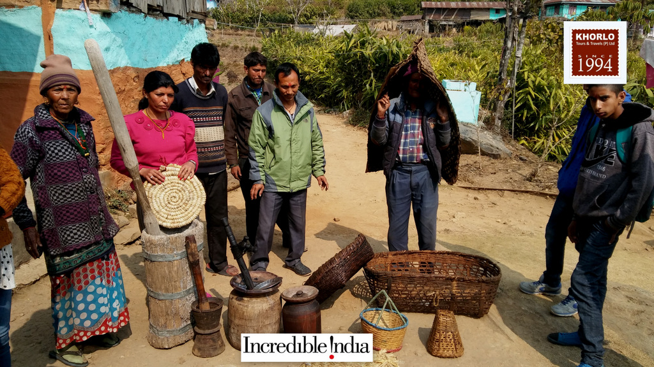
Figure: 1.7 Source: incredibleindiainfo.org
9. Suggestions
Based on the study, several suggestions emerge for preserving and strengthening Himalayan hospitality in Sikkim.
First, tourism development should remain community-led. Local people should decide how rituals, performances, and hospitality practices are presented to outsiders so that cultural meaning is protected and commercial pressure does not distort sacred traditions. Community ownership is essential for ensuring that tourism supports rather than replaces indigenous cultural values.
Second, homestay operators and local tourism stakeholders should receive training in cultural interpretation. Guests can appreciate hospitality traditions more meaningfully when hosts explain the spiritual, ecological, and social significance of practices such as khada offering, herbal fumigation, Griha Pravesh, or clan feasting. This can help transform tourism from passive consumption into cultural learning.
Third, local traditions should be documented systematically through ethnographic records, community archives, audio-visual documentation, and school-based cultural education. Since many hospitality rituals are transmitted orally, documentation can help preserve knowledge for younger generations while also creating resources for responsible cultural promotion.
Fourth, tourism policy should recognize hospitality rituals as part of intangible cultural heritage, not just as entertainment products. Government departments, tourism agencies, and cultural institutions should include heritage safeguards in CBT planning, homestay registration, and cultural programming.
Fifth, future tourism planning should balance economic gain with cultural dignity. Rituals should not be overperformed, shortened, or altered only to suit tourist schedules. A respectful pace, community consent, and appropriate timing should guide the presentation of any cultural practice to visitors.
9.1 Future Research
This study opens several avenues for future research on Himalayan hospitality and its relationship with community-based tourism in Sikkim. First, future studies may adopt a comparative approach by examining hospitality traditions across different Himalayan states or among other indigenous communities in Northeast India. Such comparison would help identify both shared cultural patterns and region-specific forms of hospitality practice.
Second, further research may explore the perspective of tourists. While this study emphasizes community traditions and cultural meaning, future work can examine how visitors interpret rituals such as khada offering, foot-washing, herbal fumigation, clan feasts, and ceremonial welcome practices. Understanding visitor perception can help assess whether these practices are being received as authentic cultural experiences or as staged performances.
Third, more detailed ethnographic and participatory research may be conducted at the household and village level to document how hospitality rituals are practiced in everyday life and how they are changing over time. Such studies may include interviews with elders, women, youth, homestay owners, and community leaders to understand intergenerational transmission, gender roles, and local decision-making in cultural preservation.
Fourth, future researchers may investigate the impact of tourism commercialization on the symbolic and spiritual meaning of hospitality rituals. This would be useful in identifying when and how cultural practices shift from sacred or social functions toward tourist-oriented performance, and what safeguards communities can adopt to maintain authenticity.
Fifth, longitudinal studies may be carried out to assess whether community-based tourism actually contributes to cultural continuity, livelihood improvement, and youth engagement in traditional practices over the long term. This would provide stronger evidence on the sustainability of hospitality-based tourism models in Sikkim.
Lastly, future research may also examine the role of digital media and virtual promotion in representing Himalayan hospitality. As tourism increasingly relies on online platforms, it would be valuable to study how indigenous hospitality is narrated, marketed, and visually presented to wider audiences, and whether such representation supports or simplifies cultural heritage.
10. Conclusion
This study set out to explore the deeper cultural logic of Himalayan hospitality in Sikkim, moving beyond transactional understandings of service to examine hospitality as a lived expression of spirituality, kinship, and indigenous knowledge systems. The findings reaffirm that across Bhutia, Lepcha, and Nepali communities, hospitality is not merely an act of welcoming but a culturally embedded practice that reflects relational ethics, ancestral continuity, and ecological consciousness (Sati, 2026; Subba, 2008; Lepcha, 2024). These traditions illustrate that hospitality in the Himalayan context is inseparable from ritual life, where everyday practices—ranging from domestic offerings to marriage induction rites—serve as mechanisms for sustaining both social cohesion and cultural identity.
Central to this study is the recognition that induction rituals, particularly those associated with marriage, function as critical rites of passage that integrate individuals into familial, spiritual, and socio-economic systems. Drawing on anthropological frameworks, these practices can be understood as transformative processes that mark transitions in identity while reinforcing lineage continuity and collective belonging. Whether expressed through Bhutia shrine-based rituals, Lepcha nature-oriented ceremonial practices, or Nepali domestic rites such as Griha Pravesh and post-marital food traditions, these customs collectively embody a holistic system of hospitality that binds individuals to both community and cosmology.
The study further demonstrates that such indigenous practices hold significant relevance in contemporary tourism contexts, particularly within community-based tourism (CBT) frameworks. As highlighted in the introduction, the growing emphasis on experiential and sustainable tourism has created opportunities for communities to present their cultural practices as living heritage. In line with this, CBT initiatives in Sikkim have enabled the integration of ritual practices, culinary traditions, and everyday cultural expressions into tourism experiences, thereby generating livelihood opportunities while supporting cultural preservation (Nyaupane & Timothy, 2022; Thakur et al., 2024).

At the same time, the study acknowledges the inherent tensions within this process. While tourism can revitalize cultural pride and incentivize the continuation of traditions, it also carries the risk of commodification when sacred rituals are modified or staged for external consumption. Scholars have long cautioned that such transformations may dilute symbolic meanings and reduce complex cultural practices into performative displays (Cohen, 1988; Shepherd, 2002). Therefore, the sustainability of Himalayan hospitality within tourism depends on ethical cultural management, where communities retain agency over how their traditions are represented and practiced.

In this context, the arguments presented in the introduction are reaffirmed: that the future of tourism in regions like Sikkim lies not merely in showcasing destinations, but in curating meaningful, culturally grounded experiences rooted in indigenous knowledge systems. When guided by participatory governance, equitable benefit-sharing, and respect for cultural integrity, tourism can act as a bridge between tradition and modernity, ensuring that practices such as lineage induction, ritual hospitality, and ancestral worship remain dynamic and relevant in changing socio-economic landscapes (Scheyvens, 1999; UNESCO, n.d.).

Ultimately, this study contributes to a growing body of scholarship that repositions hospitality as a cultural and philosophical construct rather than a purely service-oriented function. By situating Himalayan hospitality within the intersections of ritual, identity, and tourism, it highlights the need for a more nuanced and culturally sensitive approach to tourism development—one that values people over places and recognizes communities as custodians of living heritage.

11. References
- Bhutia Sangay Diki. (2025). Bhutia’s Sacred Landscape: Cultural Boundaries and Perceptions International Journal of Multidisciplinary Research & Reviews, 4(2), 144-155. https://doi.org/10.56815/ijmrr.v4i2.2025.144-155
- Bista, D. B. (1991). Fatalism and development: Nepal’s struggle for modernization. Orient Longman.
- Cajee, L. (2014). Eco-cultural tourism: A tool for environmental, cultural and economic sustainability (A case study of Darap Village, West Sikkim). SHS Web of Conferences, 12, 01029. https://doi.org/10.1051/shsconf/20141201029
- Chaudhary, M., & Lama, R. (2014). Community-based tourism development in Sikkim of India—A study of Darap and Pastanga villages. Transnational Corporations Review, 6(3), 228–237. https://doi.org/10.5148/tncr.2014.6302
- Chettri, U., & SHARMA, S. (2024). Integrating Folktales in Archaeological Investigations: A Study from Sikkim-Darjeeling Himalayas. SPACE AND CULTURE, 12(3), 83-106. https://doi.org/10.20896/saci.v12i03.1513
- Cohen, E. (1988). Authenticity and commoditization in tourism. Annals of Tourism Research, 15(3), 371–386. https://doi.org/10.1016/0160-7383(88)90028-X
- Dam, S. (2025). Leveraging upscale homestays for sustainable tourism and local community livings in Sikkim, India. Bali Journal of Hospitality, Tourism and Culture Research, 2(2).
- Fuller, C. J. (2004). The camphor flame: Popular Hinduism and society in India. Princeton University Press.
- Fürer-Haimendorf, C. von. (1981). Himalayan traders: Life in highland Nepal. John Murray.
- Gaenszle, M. (2000). Origins and migrations: Kinship, mythology and ethnic identity among the Mewahang Rai of east Nepal. Mandala Book Point.
- Ganga, K.C. (2020). Traditional marriage customs in Maharjan community of Lalitpur District... Journal of Population and Development, 1(1), 33–45. https://doi.org/10.3126/jpd.v1i1.33102
- Greenwood, D. J. (1989). Culture by the pound: An anthropological perspective on tourism as cultural commodification. In V. L. Smith (Ed.), Hosts and guests: The anthropology of tourism (2nd ed., pp. 171–185). University of Pennsylvania Press.
- Government of Sikkim. (n.d.). People and culture. https://sikkimtourism.gov.in
- Government of Sikkim. (2024, December 19). IHM promotes sustainable tourism with workshop on rural homestays under Sikkim INSPIRES. https://www.sikkim.gov.in/media/news-announcement/news-info
- Gurung, H. (1980). Vignettes of Nepal. Sajha Prakashan.
- Khattri, M.B. (2011). Rites of passage: Flow of gifts. Dhaulagiri Journal of Sociology & Anthropology, 4, 111–128. https://doi.org/10.3126/dsaj.v4i0.4516
- Kour, P., & Jasrotia, A. (2022). Eco-friendly hospitality in Himalayas: An investigation on homestay services in India. ASEAN Journal on Hospitality and Tourism, 20(2), 22-37. https://doi.org/10.5614/ajht.2022.20.2.02
- Lama, R. (2014). Community-based tourism and cultural resilience in Sikkim: A case study (Doctoral thesis, Kurukshetra University, Haryana).
- Lepcha, M. (2024). Indigenous Knowledge Systems and Change among the Lepchas of Sikkim during the Namgyal Dynasty (Doctoral dissertation, Sikkim University).
- Li, P. (2024). A Historical Review of the Study of Multi-Ethnic Cultural Exchanges in the Himalayan Region. African and Asian Studies, 24(3), 300-321. https://doi.org/10.1163/15692108-12341633
- MacCannell, D. (1973). Staged authenticity: Arrangements of social space in tourist settings. American Journal of Sociology, 79(3), 589–603. https://doi.org/10.1086/225585
- Manger, N. T. (2022). Changing Religious Scapes and Identity Construction among Limbus of Eastern Himalayas (Doctoral dissertation, Sikkim University).
- Michaels, A. (2004). Hinduism: Past and Present. Princeton University Press.
- Nyaupane, G., & Timothy, D. J. (2022). Tourism and Development in the Himalaya. Routledge. https://doi.org/10.4324/9781003030126
- Rai, R., & Kumar, P. (2025). The Role of Tourism in Preserving and Promoting Intangible Cultural Heritage of Sikkim: An In-Depth Analysis. In Sustainable Business Ecosystems and Social Perspectives (pp. 277-306). IGI Global Scientific Publishing. https://10.4018/979-8-3693-8437-4.ch013
- Sati, V. P. (2026). Exploring the mystical Himalaya: Cultures, economies and environment. Springer Nature.
- Scheyvens, R. (1999). Ecotourism and the empowerment of local communities. Tourism Management, 20(2), 245–249. https://doi.org/10.1016/S0261-5177(98)00069-7
- Shepherd, R. (2002). Commodification, culture and tourism. Tourist Studies, 2(2), 183–201. https://doi.org/10.1177/146879702761936653
- Sherpa, A. (2024). Naumati baja: The tradition of nine musical instruments in Nepali folk music. International Journal for Multidisciplinary Research, 6(3). https://doi.org/10.36948/ijfmr.2024.v06i03.23085
- Subba, J. R. (2008). History, culture and customs of Sikkim. Gyan Publishing House.
- Thakur, S., Sood, S., Singh, R. K., & Singh, R. (2024). Status of homestay tourism in Indian Himalayan region: Analysis of customer review and policy support for sustainable tourism. Tourism and Hospitality Research, 24(4), 588-601. https://doi.org/10.1177/14673584231170578
- Timothy, D. J. (2007). Empowerment and stakeholder participation in tourism destination communities. In A. Church & T. Coles (Eds.), Tourism, power and space (pp. 199–216). Routledge.
- Uberoi, P. (2006). Freedom and destiny: Gender, family, and popular culture in India. Oxford University Press.
- UN Tourism. (n.d.). Rural tourism. https://www.unwto.org/rural-tourism
- UNESCO. (n.d.). Sustainable development and living heritage. https://ich.unesco.org/en/sustainable-development-and-living-heritage
- UNESCO. (n.d.). Sustainable tourism. https://www.unesco.org/en/query-list/s/sustainable-tourism
- UNESCO. (n.d.). What is intangible cultural heritage? https://ich.unesco.org/en/what-is-intangible-heritage-00003

