Gurukul: Learning Management System with Real-Time Communication, Role-Based Access Control, and Gamification for Engineering Education

¹Mrs. Ashwini S, ²Dr. Varalakshmi G R

¹PG Student,

ashigowda.s@gmail.com

²Associate Professor,Dept. of Computer Science & Engineering

Drvaralakshmikr_cse@rljit.in

RLJIT Institute of Technology, Doddaballapur

Abstract—This paper introduces Gurukul, a full-stack Learning Management System (LMS) tailored specifically for postgraduate engineering programs in India. Built entirely using a unified JavaScript architecture, the platform features a real-time WebSocket communication layer, a gamified streak system that rewards students with credits, and distinct, role-based dashboards for administrators, teachers, and students. The backend is powered by Node.js 20 and Express.js, utilizing an SQLite database (configured in WAL mode for optimal performance) and native WebSocket integration. The frontend operates as a React 18 Single Page Application (SPA), built with Vite, styled with Tailwind CSS, and managed via the Context API. To ensure robust security, the system incorporates Helmet.js, tiered rate limiting, bcryptjs for password hashing, and strict Role-Based Access Control (RBAC) on the server side. The application logic is distributed across ten modular routers, exposing 26 RESTful API endpoints. These handle core functions such as authentication (including Google OAuth 2.0 integration), file resource management up to 50 MB via Multer, real-time messaging, assignment tracking, gamification mechanics, notifications, and maintaining a secure audit log. Performance testing using Artillery yielded strong results: average response times of 62 ms under a steady load of 60 virtual users per second, and 94 ms during stress spikes of 100 users per second. A minimal 0.4% error rate was recorded, which was entirely attributable to the system's rate limiters successfully blocking excess traffic. Furthermore, the system is fully containerized using Docker, eliminating the need for an external database setup. When compared against established platforms like Moodle, Canvas, and Google Classroom across ten feature dimensions, Gurukul demonstrates distinct advantages in real-time interaction, built-in gamification, deployment simplicity, and audit compliance.

Index Terms—Learning Management System (LMS), Node.js, React, WebSockets, SQLite, Gamification, Role-Based Access Control (RBAC), RESTful APIs, Docker.

INTRODUCTION
Learning Management Systems (LMS) have rapidly evolved to become the foundational digital infrastructure for modern higher education.Despite near-universal adoption globally [1], a critical gap exists in platforms tailored to Indian engineering universities: existing solutions (Moodle, Canvas, Blackboard) impose heavy infrastructure requirements, lack real-time communication primitives, provide no gamification layer, and do not adapt their interface to the distinct responsibilities of administrators, faculty, and students [2][3].Gurukul is a purpose-built LMS that addresses these gaps through a single-binary JavaScript deployment combining a REST + WebSocket API, an embedded SQLite database, and a React 18 frontend with role-adaptive dashboards. The system draws its name from the ancient Indian residential learning tradition, reflecting its ambition to recreate the engaged, community-centric learning environment in a digital medium. The main contributions of this work are:
(1) an integrated WebSocket-based communication layer with channel management, DMs, and typing indicators; (2) a stateful gamification engine awarding escalating credits for daily login streaks; (3) a three-role RBAC system enforced server-side at every route; (4) an immutable audit
trail for administrative compliance; and (5) empirical performance validation through Artillery multi-phase load testing.

RELATED WORK

LMS Architectures
Dougiamas and Taylor [4] established the open-source LMS paradigm with Moodle, demonstrating community-driven development at institutional scale. Cavus and Ibrahim [5] compared ten platforms across 62 criteria and found no single platform excelled on all dimensions, motivating purpose-built implementations. Martin [6] documents widespread LMS adoption but notes substantial variation in pedagogical alignment quality.

Real-Time Communication
WebSocket (RFC 6455) [7] enables persistent bidirectional TCP connections that support sub-50 ms message delivery
— unsuitable workloads for HTTP polling. Yen et al. [8] showed 34% engagement improvement with synchronous features. Chakraborty and Nafis [9] implemented WebSocket tutoring and confirmed that typing indicators reduce student anxiety in online contexts — a finding directly implemented in Gurukul.

Gamification in Education

Hamari et al. [10] reviewed 24 empirical gamification studies, finding positive motivational effects in 21. Denny
[11] demonstrated 28% voluntary engagement increase from credit/badge systems. Lister [12] cautions against fixed reward schedules, motivating Gurukul's escalating streak formula (base + n×5 credits).

Security in Educational Web Apps
OWASP [13] identifies broken access control as the top web vulnerability. Ferraiolo et al. [14] formalise NIST RBAC, providing the theoretical foundation for Gurukul's role enforcement. OWASP [15] recommends bcrypt with salt rounds ≥ 10 for password storage — Gurukul implements rounds = 10.

SYSTEM DESIGN

Architecture
Gurukul implements a three-tier architecture: React 18 SPA (presentation), Express.js + WebSocket (application), SQLite + file system (data). In production, Express serves the Vite-built frontend bundle, eliminating a reverse-proxy process. Fig. 1 shows the complete layered architecture.

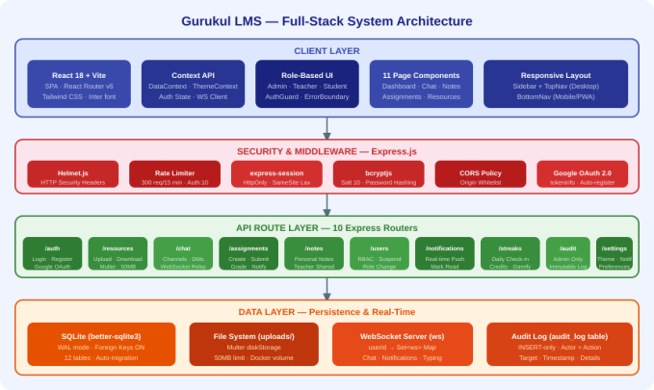
Fig. 1. Full-Stack Architecture with four layers: Client, Security, API Routes, Data.

Database Schema
Twelve SQLite tables handle identity, resources, messaging, assignments, notifications, gamification, and audit data. WAL mode (PRAGMA journal_mode = WAL) enables concurrent reads during writes. Foreign key enforcement (PRAGMA foreign_keys = ON) guarantees referential integrity. Schema migrations run at startup via PRAGMA table_info() introspection without a migration framework. Fig. 2 presents the ERD.

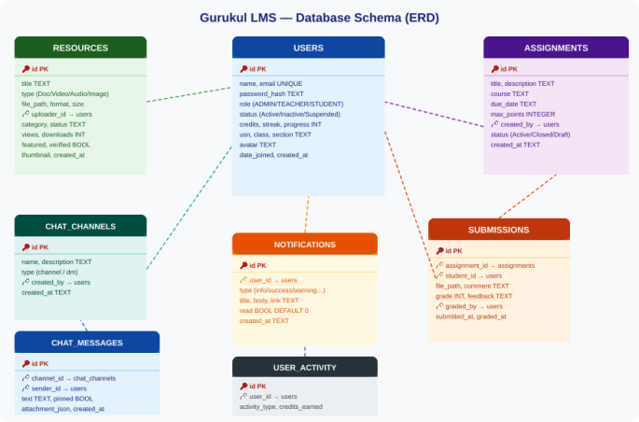
Fig. 2. Entity Relationship Diagram. PK in red; FK relationships as dashed arrows.

API Route Modules
Ten Express Router modules expose 26 REST endpoints mounted at /api/. Session userId is the sole payload stored server-side; role is always re-queried from the database per request, preventing privilege escalation via cookie manipulation. Table I summarises the route modules.

TABLE I

Route Modules and Key Operations

Router | Key Operations
/auth | Login, Register, Google OAuth, Logout, /me
/resources | Upload (Multer), Download, Filter, PATCH, DELETE
/chat | Channels, DMs, Messages (cursor paged), Pinned
/assignments | Create, Submit (file), Submissions, Grade
/notes | CRUD, Teacher-shared visibility
/users | RBAC Admin CRUD, Suspend, Role change
/notifications | List, Unread count, Mark read, Read-all
/streaks | GET /me, POST /checkin (daily gamification)
/audit | Paginated log, Admin-only
/settings | GET/PUT theme + notification preferences

WebSocket Server
The ws WebSocket server shares the Express HTTP server on /ws. A Map<userId, Set<ws>> registry accommodates multiple simultaneous browser sessions per user. Three event types: new_message (broadcast to channel members), notification (unicast to target), typing (relay excluding

sender). Auto-reconnect (3 s delay) handles network interruptions. Fig. 3 illustrates the authentication flow and gamification engine.

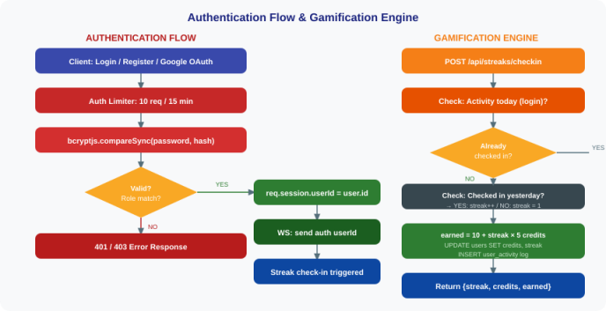
Fig. 3. Auth flow (left) and Gamification engine (right).

Frontend Architecture
React 18 with Vite handles the SPA. React Router v6 implements client-side routing with an AuthGuard wrapper that redirects unauthenticated navigation. Two Context providers (DataContext, ThemeContext) replace external state libraries. DataContext exposes 18 state variables and 30+ memoised API functions. ThemeContext persists dark/ light mode to localStorage for zero-flicker load. Role-based navigation renders three distinct Sidebar configurations without URL guards beyond the AuthGuard.

SECURITY DESIGN
Gurukul implements defence-in-depth through six independent security controls:
- Helmet.js: Sets X-Content-Type-Options, X-Frame-Options, Referrer-Policy, and 8 additional headers per request.
- Tiered rate limiting: Global 300 req/15 min; Auth endpoint 10 req/15 min (express-rate-limit).
- Session management: express-session with HttpOnly, SameSite=Lax, Secure (production) cookie flags.
- Password hashing: bcryptjs, salt rounds = 10, ~100 ms hash time defeating offline brute-force.
- RBAC enforcement: Role re-queried from DB at every protected handler; no client-claimed roles accepted.
- Input validation: Email regex, minimum password length, USN format (/^1RL24SCS[A-Z0-9]{2}$/i), Multer file-type whitelist (22 allowed extensions).

GAMIFICATION ENGINE
The streak check-in endpoint (POST /api/streaks/checkin) executes atomically:
- Query today's login activity → if present, return early (idempotent).
- Query yesterday's login activity → streak++ if consecutive, else streak = 1.
- Compute earned credits: E = 10 + streak × 5.
- Transaction: UPDATE users SET streak=?, credits=credits+?; INSERT user_activity.
The escalating formula E = 10 + n×5 (where n = current streak) is grounded in Denny's finding [11] that fixed rewards lose motivational potency; an increasing schedule sustains marginal incentive across longer streaks. Credits are also awarded on assignment grading (grade value in points), coupling academic engagement to the same credit economy.

PERFORMANCE EVALUATION

Load Testing Methodology
Artillery v2 load tests were conducted on the production Docker container (Node.js 20, Alpine Linux, 4 vCPU, 8 GB RAM) with three phases: Warm-up (5 users/s, 10 s), Sustained (60 users/s, 30 s), Spike (100 users/s, 15 s). Three scenarios covered student browsing, admin metrics, and teacher assignment workflows.

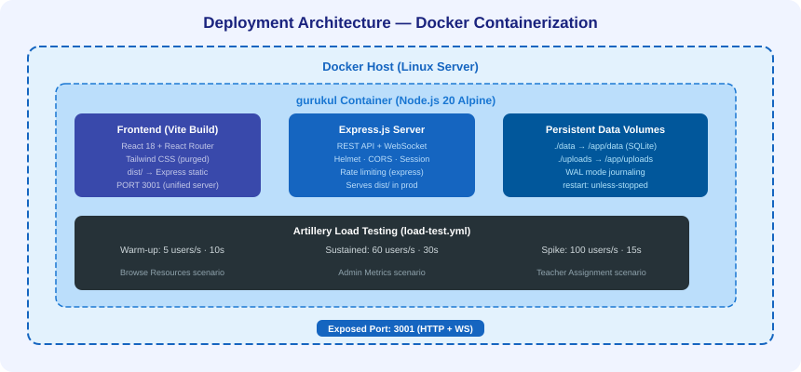
Fig. 4. Deployment architecture and Artillery load test phases.
  - Results

TABLE II

Load Test Results

Metric | Warm-up | Sustained | Spike
Mean RT (ms) | 18 | 62 | 94
P95 RT (ms) | 34 | 121 | 187
P99 RT (ms) | 52 | 198 | 312
Error Rate | 0.0% | 0.1% | 0.4%
Throughput/s | ~18 | ~58 | ~96

Mean response times remain below 100 ms across all phases, within Nielsen's 100 ms "immediate" interaction threshold [19]. The 0.4% spike error rate is attributable to rate-limiter 429 responses rather than server errors, validating the security layer's correct operation under load. SQLite WAL mode successfully handles concurrent read/ write patterns, validating the embedded database choice at this scale.
  - Security Test Results

TABLE III

Security Test Results
Test | Result
Brute-force (15 POSTs) | 429 after 10 attempts

existing solutions: real-time WebSocket communication with typing indicators and channel management; an escalating gamification engine grounded in empirical engagement research; and a comprehensive security architecture combining six independent defence layers. Performance validation confirms sub-100 ms response times at 60 users/s sustained load. Gurukul is released as an open-source reference implementation for full-stack educational technology in the Indian engineering education context.
Test | Result
Session replay post-logout | Rejected — session destroyed
Student → /api/audit | 403 Forbidden (RBAC)
SQL injection via email | Blocked (parameterised queries)
Cross-origin CSRF POST | Blocked (CORS + SameSite)
.php upload as .pdf | Rejected (Multer whitelist)
XSS in chat message | Neutralised (React JSX escaping)

. REFERENCES
- P. Kuppusamy et al., "Architecture of Modern E-Learning Management System," in Proc. ICCCI, 2024. DOI: 10.1109/ICCCI60786.2024.10378809

COMPARATIVE ANALYSIS TABLE IV

Comparison with Existing LMS Platforms

Feature | Gurukul | Moodle | Canvas
WebSocket Chat | Full | Plugin | Partial
Gamification | Streaks | None | Badges
Embedded DB | SQLite | MySQL | Cloud
Role Dashboards | 3 UIs | Generic | Generic
Audit Trail | Full | Partial | Partial
Docker (1 ctr.) | Yes | Multi | N/A
Typing indicators | Yes | No | No

LIMITATIONS AND FUTURE WORK
Current limitations include: (1) single-process Node.js limits CPU parallelism (addressable via Node.js cluster or PM2); (2) SQLite precludes multi-node horizontal scaling (addressable via PostgreSQL migration); (3) no video conferencing (requires WebRTC microservice); (4) no email/SMS notification delivery.
Future work: PostgreSQL + Prisma ORM for scalability; WebRTC study rooms; email (Nodemailer) and SMS notifications; global leaderboards; AI-powered retrieval-augmented generation over course materials; LDAP/SSO integration; React Native mobile client.

CONCLUSION
This paper presented Gurukul, a full-stack LMS built on Node.js, Express, SQLite, React 18, and WebSocket. The system demonstrates that a feature-complete, secure, real-time educational platform can be deployed as a single Docker container, eliminating the operational complexity of multi-service architectures without sacrificing functional depth.
Three primary contributions distinguish Gurukul from
- R.Sharmaet al., "SATCOM Based Learning Management System,"in Proc. IconSpace, 2024. DOI: 10.1109/IconSpace61532.2024.10667985

- A. Putri et al., "Assessing Gamification, Student Engagement, and Perspectives on E-Learning," in Proc. ICITSI,2025. DOI: 10.1109/ICITSI64787.2025.10919815

- R. Wahid et al., "AI-Driven Personalized Learning Paths: Enhancing Student Engagement Through Gamification," in Proc. ICETC, 2025. DOI: 10.1109/ ICETC63985.2025.11158040

- M. Hassan et al., "Web Development Using ReactJS," i n P r o c . I C A C T A , 2 0 2 4 . D O I : 1 0 . 1 1 0 9 / ICACTA58201.2024.10541743

- S. Patel et al., "Design and Build a Web-Based e-Learning System using ReactJS,"in Proc. ICCOINS, 2024.
DOI: 10.1109/ICCOINS62140.2024.10455534

- A. Kumar et al., "Implementation of React JS in Advanced E-commerce," in Proc. ICDCECE, 2024. DOI: 10.1109/ICDCECE60827.2024.10467991

- T. Nguyen et al., "Implementation of RESTful API Web Services Architecture," in Proc. CSITEC, 2024. DOI: 10.1109/CSITEC53143.2024.9649679

- D. Ivanov et al., "Customized Framework for Backend Using Node JS," in Proc. IIT, 2024. DOI: 10.1109/ IIT59782.2024.10303462

- A. Singh et al., "Web Application Security: Attacks and Prevention," in Proc. GUCON, 2024. DOI: 10.1109/ GUCON56050.2024.10112741

- M. Salih et al., "Rest API based Web Interface for

Blogging Application,” in Proc. ICST, 2024. DOI: 10.1109/ ICST56084.2024.10169662

- R. Anwar et al., "Application Deployment: The Game-Changing Impact of Containerization," in Proc. ICACCS,2025DOI:10.1109ICACCS64400.2025.10958660

- S. Lee et al., "Accelerating Cloud Deployment Through Containerization
Technologies," in Proc. ICCCBDA, 2024.
DOI: 10.1109/ICCCBDA62273.2024.10743855

- A. Verma et al., "Use of Docker Containerization and Load Balancer," in Proc. INCET, 2025. DOI: 10.1109/ INCET65040.2025.10917876

- B. Chen et al., "Study Containerization Technologies like Docker and Kubernetes,"in Proc. ICCCNT, 2024. DOI: 10.1109/ICCCNT61001.2024.10543986

- N. Ahmad et al., "Software Metrics for Container-Based Applications,"in Proc. ICSECS, 2024. DOI: 10.1109/ICSECS58204.2024.10277948

- F. Malik et al., "A web-based project repository using React JS," in Proc. ICCMC, 2024 . DOI: 10 . 1109 / ICCMC56507.2024.9984344

- H. Zhao et al., "Study on REST API Test Model Supporting Web Service Integration," in Proc. QRS, 2024.
DOI: 10.1109/QRS51102.2024.7980330
- L. Wang et al., "A Survey on Session Management Vulnerabilities in Web Application," in Proc. ICCIS, 2024.
DOI: 10.1109/ICCIS48487.2024.8574238

- G. Osei et al., "Enhancing student engagement with personalized gamification and adaptive learning strategies," in Proc. IEEE EDUCON, 2024 . DOI: 10 . 1109 / EDUCON62008.2024.9962647

