A Study on Accounting Insights into Consumer Spending Behaviour in Online Retailing Markets: Evidence from Sikkim

Abstract
The rapid growth of e-commerce has transformed the way consumers purchase goods and services. With the increasing use of smartphones, internet facilities, and digital payment systems, online shopping has become an important part of consumers' daily lives. In emerging markets such as Sikkim, e-commerce platforms like Amazon, Flipkart, Myntra, and Meesho have gained significant popularity among consumers, especially young people.
This study aims to analyze consumer spending behaviour on e-commerce platforms from an accounting perspective. The research focuses on understanding consumers' online purchasing habits, preferred platforms, shopping frequency, and factors influencing expenditure decisions. Primary data was collected from more than 70 respondents through a structured questionnaire. The collected data was analyzed using percentage analysis, frequency distribution, tables, and charts.
The findings reveal that consumers between the age group of 18–25 years are the most active online shoppers. Amazon and Flipkart are the most preferred platforms, while clothing products are the most frequently purchased items. Convenience, discounts, product variety, and digital payment options significantly influence consumer spending behaviour. The study concludes that e-commerce has become an important factor affecting expenditure patterns and financial decision-making among consumers in Sikkim.
Keywords: Consumer Spending Behaviour, E-Commerce, Online Shopping, Consumer Expenditure, Digital Payments, Accounting Perspective, Consumer Purchase Behaviour.

1: Introduction
1.1 Background of the Study
E-commerce refers to the buying and selling of goods and services through electronic platforms using the internet. Over the past decade, technological advancements have significantly increased the popularity of online shopping. Consumers can now purchase products from the comfort of their homes without visiting physical stores.
The growth of e-commerce has been supported by increasing internet penetration, smartphone usage, digital payment systems, and improved logistics services. Popular online marketplaces such as Amazon, Flipkart, Myntra, and Meesho provide consumers with a wide range of products at competitive prices.
In Sikkim, online shopping has become increasingly popular among young consumers. Consumers are attracted to e-commerce due to convenience, product variety, home delivery services, and promotional discounts.
From an accounting perspective, consumer spending behaviour is important because it reflects how consumers allocate their financial resources. Understanding expenditure patterns helps businesses in sales forecasting, budgeting, inventory management, and financial planning.
1.2 Significance of the Study
The study is important because:
- It helps understand changing consumer expenditure patterns.
- It provides insights into online purchasing behaviour.
- It assists businesses in planning marketing and sales strategies.
- It helps understand the role of digital payments in expenditure decisions.
- It contributes to accounting and financial decision-making.
2. Statement of the Problem
The growth of e-commerce has significantly influenced consumer buying behaviour across India, including smaller regions such as Sikkim. Online platforms provide convenience and accessibility, encouraging consumers to make frequent online purchases.
The survey data indicates that a large number of respondents actively participate in online shopping. Most respondents belong to the 18–25 age group and frequently use platforms such as Amazon and Flipkart. Clothing products are the most commonly purchased items.
However, consumer expenditure behaviour differs across individuals. Some consumers shop frequently while others make occasional purchases. Understanding these differences is important from an accounting perspective because expenditure decisions directly affect household budgeting and financial management.
Therefore, this study attempts to examine consumer spending behaviour and identify factors influencing expenditure decisions among online consumers in Sikkim.

3. Objectives of the Study
- To study consumer spending behaviour on e-commerce platforms in Sikkim.
- To identify the most preferred online shopping platforms.
- To examine the frequency of online purchases among consumers.
- To analyze the types of products commonly purchased online.
- To understand factors influencing consumer expenditure decisions.
- To study the role of digital payment systems in online purchasing behaviour.
- To examine the accounting implications of consumer expenditure patterns.
4. Literature Review
Pavlou (2003)
Pavlou examined consumer acceptance of electronic commerce and found that trust plays a significant role in online purchasing decisions. Consumers are more likely to spend money on platforms they perceive as secure and reliable.
Kim (2008)
Kim studied consumer decision-making in online shopping and found that financial risk, privacy concerns, and transaction security significantly influence expenditure decisions.
Jarvenpaa (2000)
Jarvenpaa found that consumer trust positively affects repeat purchasing behaviour. Satisfied consumers are more likely to continue spending on the same online platforms.
Chen and Barnes (2007)
The study highlighted the importance of website quality, customer service, and transaction security in influencing consumer spending behaviour.

5. Research Methodology
5.1 Research Design
The study follows a descriptive research design.
5.2 Sources of Data
Primary Data
Primary data was collected through a structured questionnaire distributed among respondents.
5.3 Data Collection Method
The survey method was adopted using Google Forms.
5.4 Sample Size
More than 70 respondents participated in the study.
5.5 Sampling Technique
Convenience sampling was used.
5.6 Area of Study
The study was conducted in Sikkim.
5.7 Tools of Analysis
- Percentage Analysis
- Frequency Distribution
- Tabulation
- Charts and Graphs

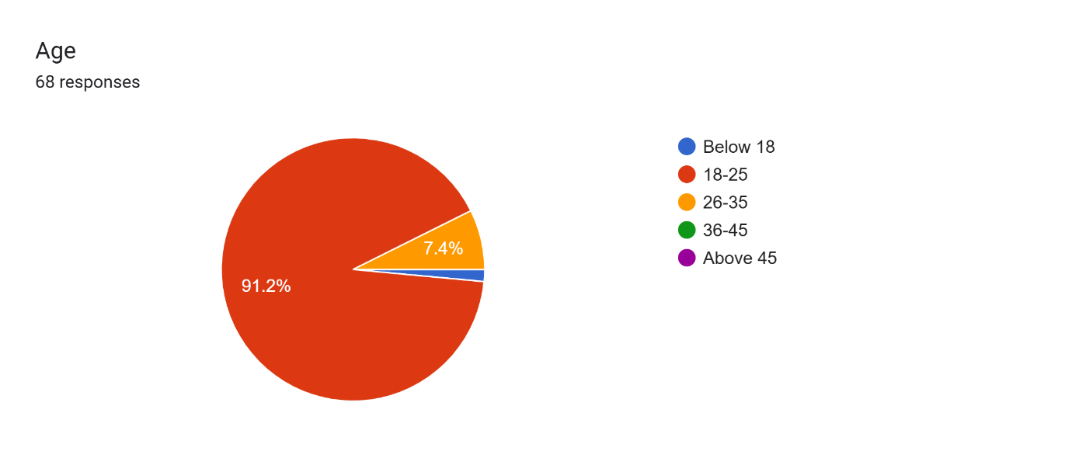

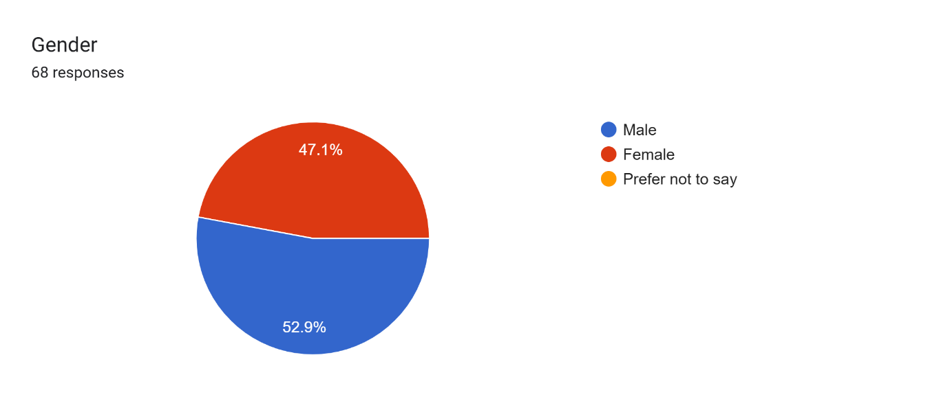

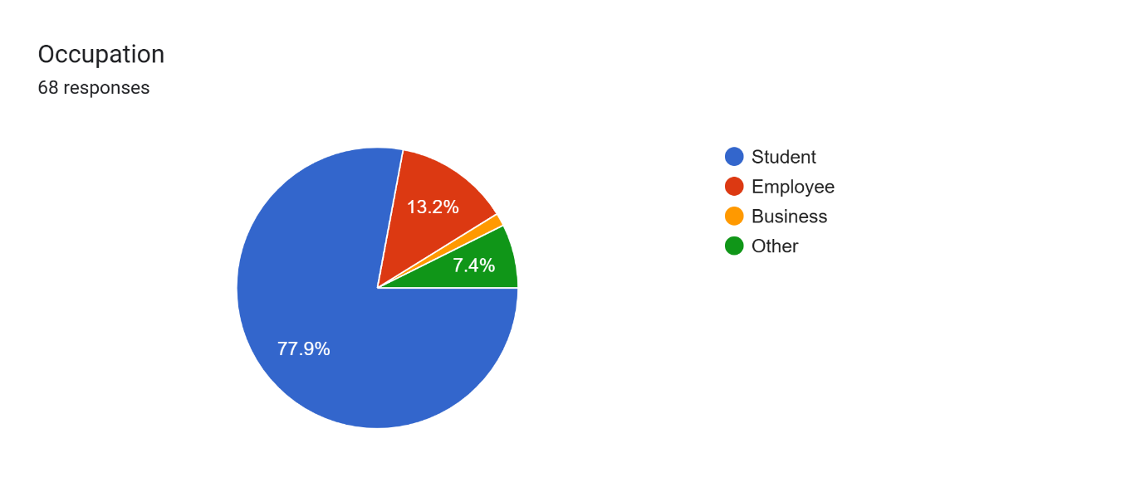
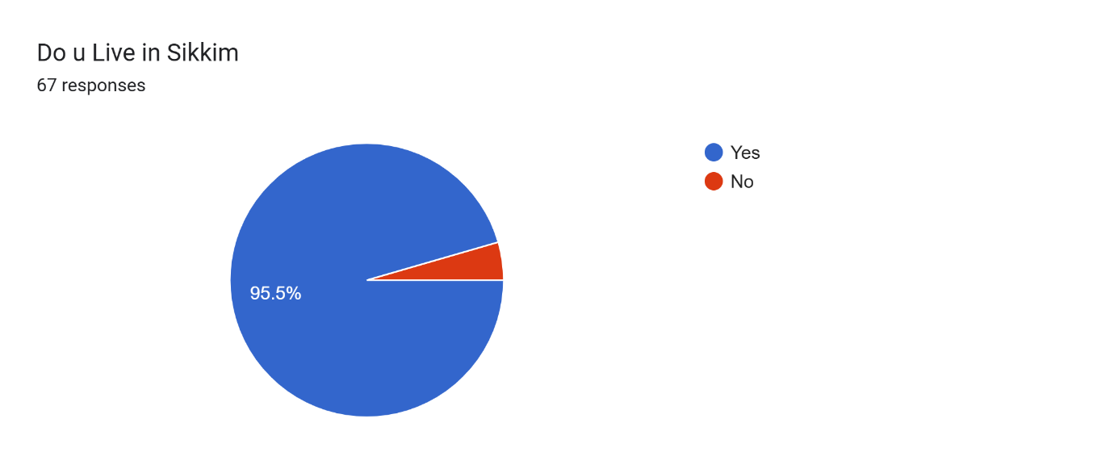
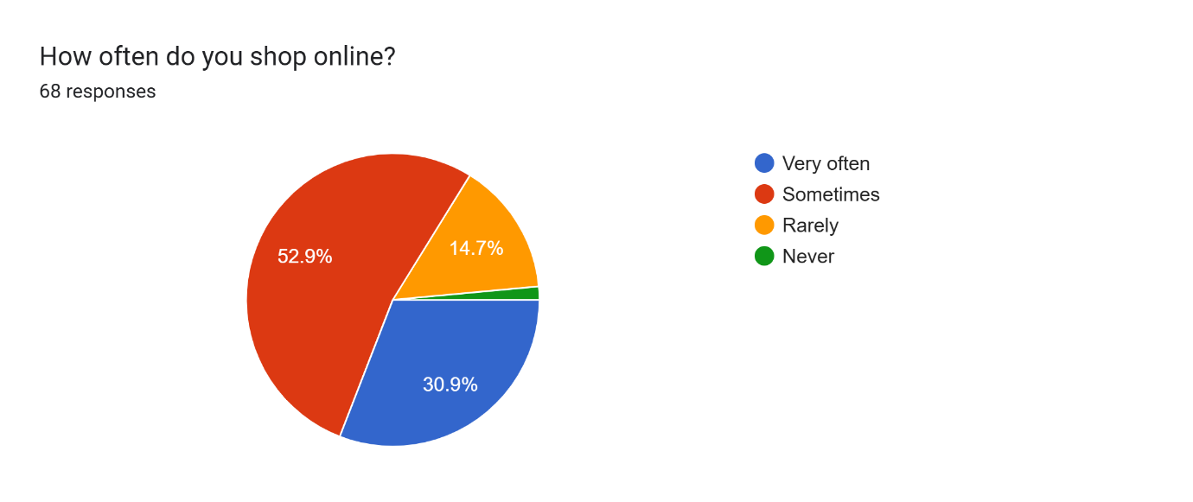

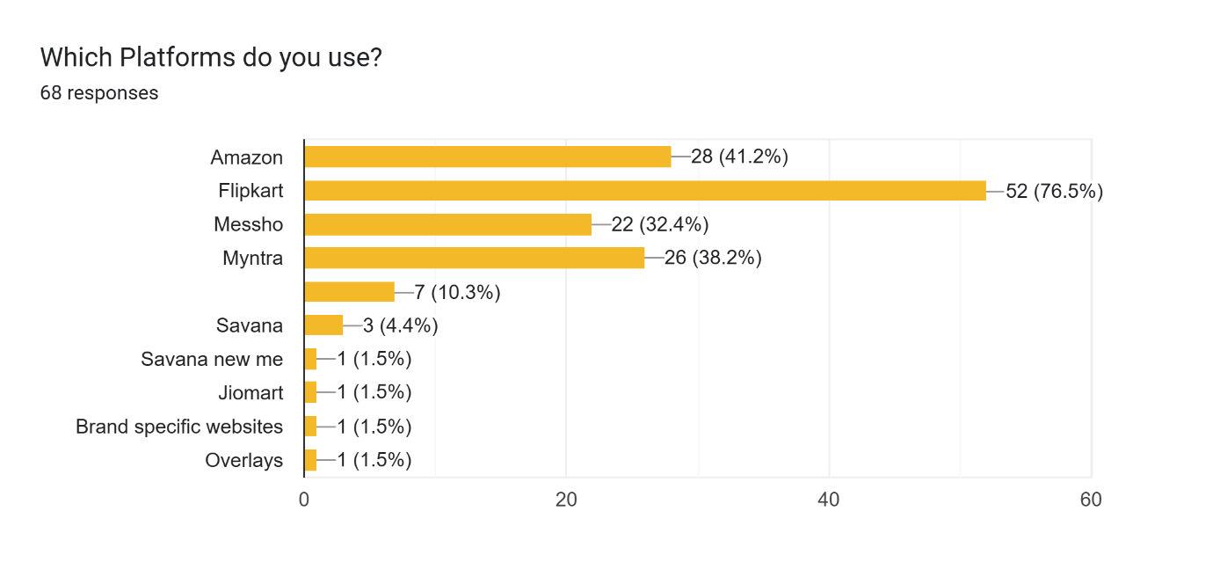
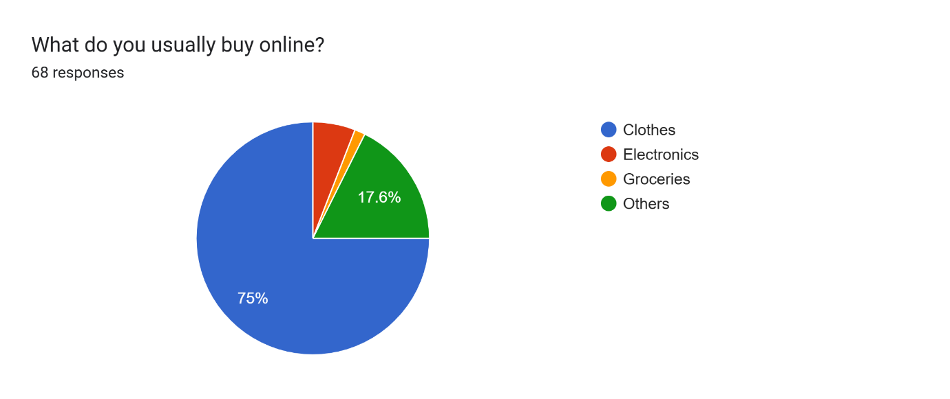

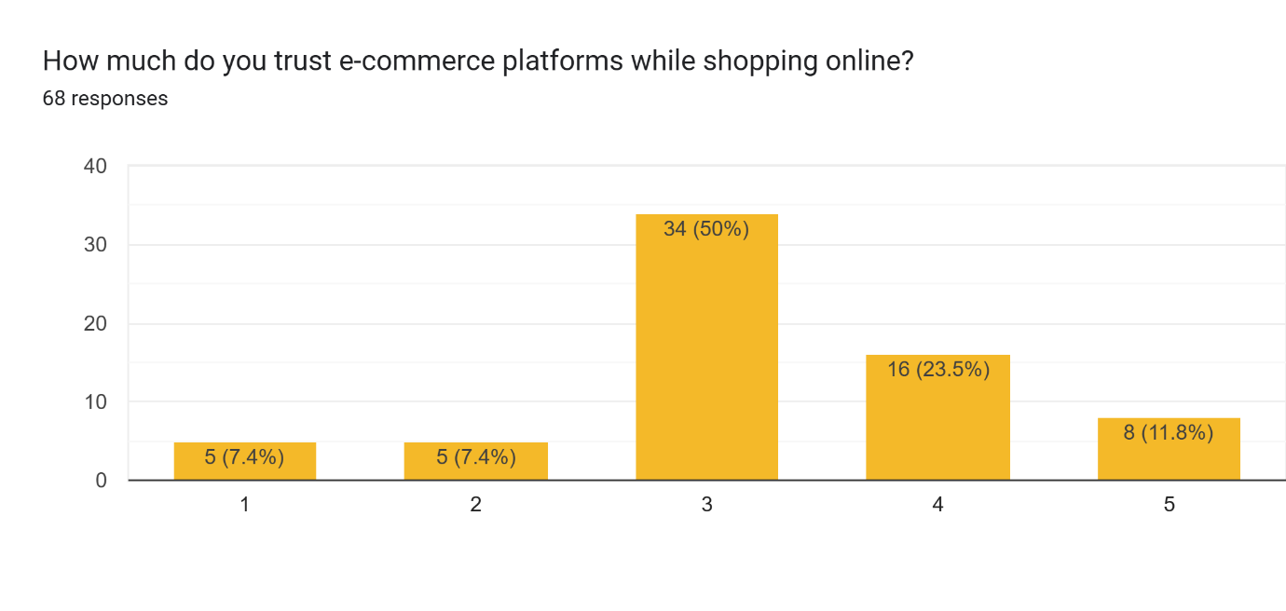
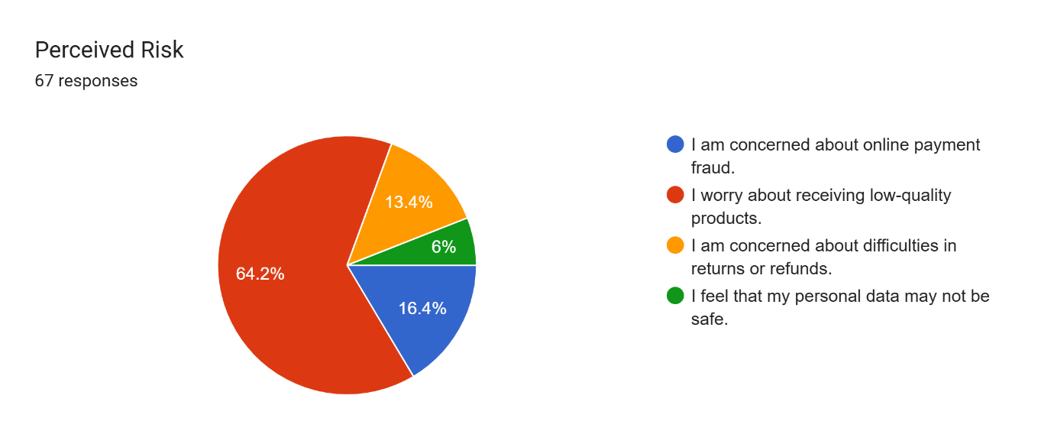

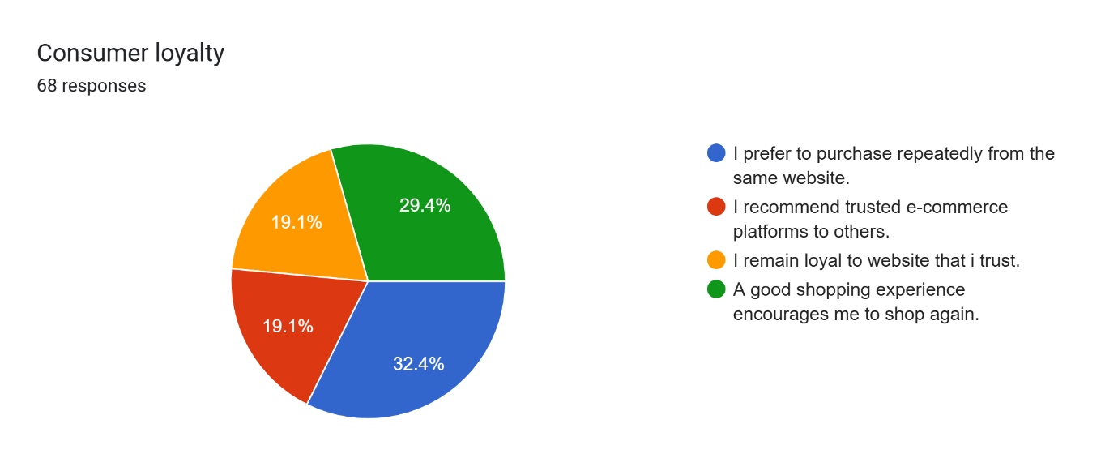

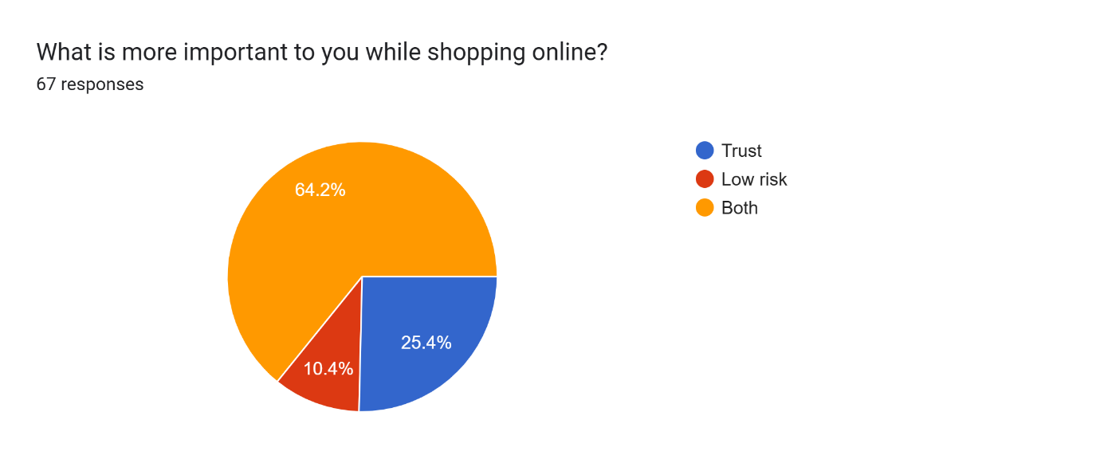

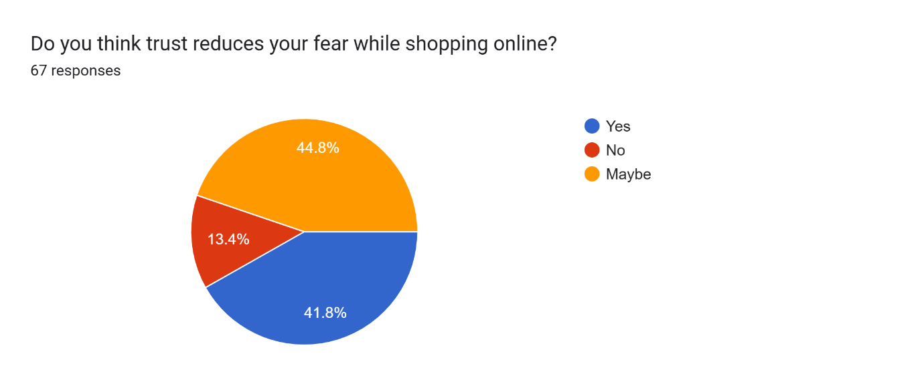
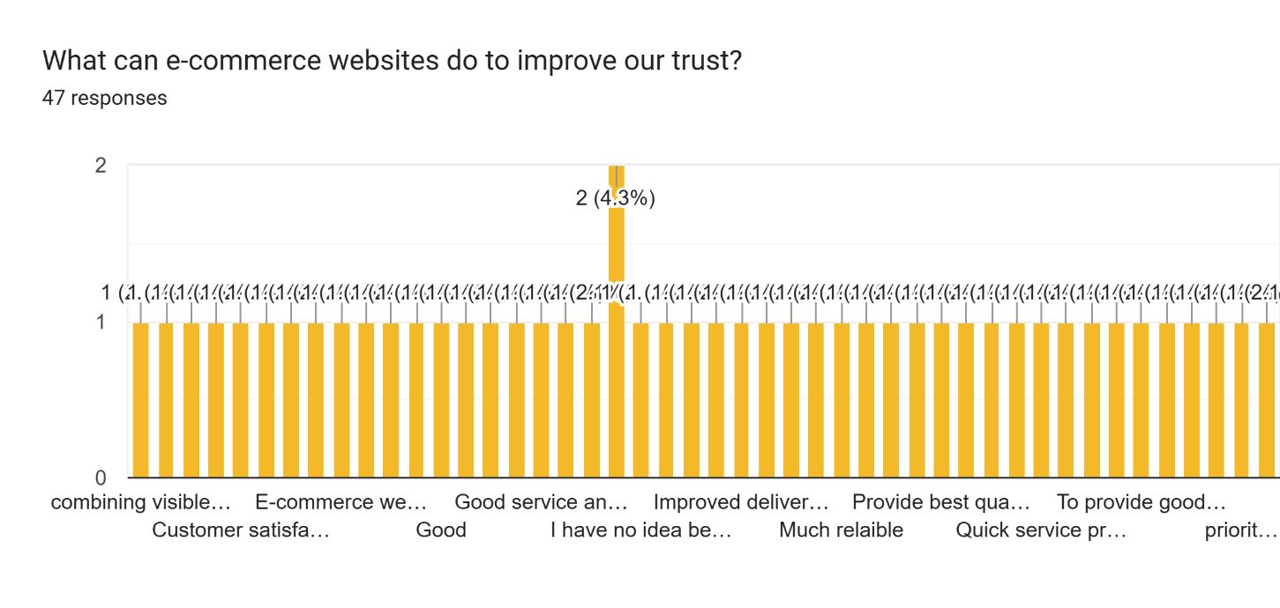
6. Data Analysis and Interpretation
Age-wise Distribution
The majority of respondents belong to the 18–25 age group, indicating that young consumers are the primary users of e-commerce platforms.
Occupation-wise Distribution
Students form the largest category of respondents, showing that online shopping is highly popular among younger individuals.
Preferred E-Commerce Platforms
Amazon and Flipkart are the most preferred online shopping platforms due to their reliability, product variety, and attractive offers.
Shopping Frequency
Most respondents reported shopping online either occasionally or frequently, indicating regular engagement with e-commerce platforms.
Product Categories Purchased
Clothing products are the most commonly purchased items, followed by other consumer goods.

7. Findings of the Study
- Most respondents belong to the age group of 18–25 years.
- Students are the most active online shoppers.
- Amazon and Flipkart are the leading e-commerce platforms.
- Clothing products are the most frequently purchased category.
- Online shopping has become a regular habit for many consumers.
- Discounts and promotional offers strongly influence purchasing decisions.
- Convenience and home delivery encourage online expenditure.
- Digital payment systems have simplified online transactions.
- Consumers increasingly rely on e-commerce platforms for their purchasing needs.
- Consumer expenditure behaviour is influenced by platform reliability and ease of use.

8. Conclusion
The study concludes that e-commerce platforms significantly influence consumer spending behaviour in Sikkim. The increasing use of digital technology and online payment systems has encouraged consumers to purchase products through online platforms. Young consumers, especially students, constitute the largest segment of online shoppers.
Amazon and Flipkart dominate the market due to their wide product range, competitive pricing, and customer-friendly services. Clothing products remain the most preferred category among consumers. The availability of discounts, easy payment options, and home delivery services contributes significantly to consumer expenditure decisions.
From an accounting perspective, understanding consumer spending patterns helps businesses improve budgeting, financial planning, sales forecasting, and inventory management. As e-commerce continues to expand, businesses must adapt to changing consumer expenditure trends to remain competitive.

9. Suggestions
- E-commerce companies should strengthen payment security measures.
- Businesses should maintain transparent pricing policies.
- Consumers should prepare budgets before making online purchases.
- Online platforms should improve delivery efficiency.
- Customer support services should be strengthened.
- Financial literacy programs should encourage responsible spending.
- Businesses should regularly analyze consumer expenditure patterns for better financial planning.
- More awareness should be created regarding safe digital payment practices.

References
- Pavlou, P. A. (2003). Consumer Acceptance of Electronic Commerce.
- Kim, D. J. (2008). A Trust-Based Consumer Decision-Making Model in Electronic Commerce.
- Jarvenpaa, S. L. (2000). Consumer Trust in an Internet Store.
- Chen, Y. H., & Barnes, S. (2007). Initial Trust and Online Buyer Behaviour.
- Primary data collected through a questionnaire survey conducted among consumers in Sikkim.

