Smart Crop Advisory System

Dr.B.Devender Associate Professor
Department Of CSE(AIML) Keshav Memorial Engineering College
Hyderabad,India
Ragu Dileep Department Of CSE(AIML)  Keshav Memorial Engineering College Hyderabad,India ragudileep123@gmail.com | Shivam Sharma Department Of CSE(AIML)  Keshav Memorial Engineering College Hyderabad,India shivam22112004@gmail.com | G.Kalyan Chakrawarthy Department Of CSE(AIML) Keshav Memorial Engineering  College Hyderabad, India  kalyanreddy216205@gmail.com

Abstract— Agriculture plays a crucial role in the economy, especially in developing countries where a large population depends on farming for their livelihood. However, farmers face challenges such as selecting suitable crops, applying appropriate fertilizers, detecting plant diseases, managing irrigation, and making profitable market decisions. These challenges often arise due to lack of timely information and expert guidance, leading to reduced productivity and financial loss.
The Smart Crop Advisory System addresses these issues using Machine Learning and Deep Learning techniques. The system provides crop recommendations based on soil and environmental parameters, suggests fertilizers, detects plant diseases using image processing, offers irrigation advice based on weather data, displays market prices, and estimates profit.
The system is implemented using Python and Flask, integrating multiple agricultural services into a single platform. This enables farmers to make informed decisions, optimize resource utilization, and improve crop productivity. The proposed solution supports sustainable agriculture and enhances farmers’ income through data- driven insights.

Keywords— Smart Agriculture, Crop Recommendation, Machine Learning, Deep Learning, Precision Farming, Fertilizer Recommendation, Disease Detection, Image Processing, Irrigation Scheduling, Market Price Prediction, Profit Estimation, Flask, Web Application.

INTRODUCTION

Agriculture plays a vital role in the economy, especially in developing countries where a large population depends on farming. However, traditional farming methods often rely on manual decision-making and experience, which may not always produce optimal results. Farmers face challenges such as selecting suitable crops, managing soil health, detecting plant diseases, planning irrigation, and determining market prices, all of which directly affect productivity and profitability.
With advancements in Artificial Intelligence (AI) and Machine Learning (ML), it is possible to improve agricultural practices through data-driven decision-making. These technologies analyze soil, weather, and crop data to provide accurate recommendations. However, most existing systems focus on individual tasks and do not provide a complete solution for farmers.
To address this limitation, the Smart Crop Advisory System is proposed as an integrated platform that offers crop recommendation, fertilizer suggestion, disease detection, irrigation advice, market price analysis, and profit estimation. The system combines multiple functionalities into a single interface, enabling farmers to make informed decisions efficiently.
The proposed system uses Machine Learning, Deep Learning, and real-time data to improve accuracy and usability. It reduces reliance on guesswork, optimizes resource utilization, and supports sustainable farming practices, ultimately helping farmers increase productivity and income.

LITERATURE REVIEW

The rapid advancement of Artificial Intelligence (AI) and Machine Learning (ML) has significantly transformed the agricultural sector by enabling intelligent decision-making systems that improve productivity and efficiency. One of the major applications of deep learning in agriculture is plant disease detection, where Convolutional Neural Networks (CNNs) are used to analyze crop leaf images and identify disease patterns with high precision. These models are capable of automatically extracting hierarchical features from raw image data, thereby eliminating the need for manual feature engineering. Research has demonstrated that deep learning-based systems achieve higher accuracy compared to traditional image processing techniques, making them highly effective for real-time disease detection and classification in agricultural fields [1]. In addition to disease detection, machine learning-based crop recommendation systems have gained considerable attention for their ability to provide data-driven suggestions for crop selection. These systems utilize various input parameters such as soil nutrients

(nitrogen, phosphorus, potassium), environmental conditions (temperature, humidity, rainfall), and soil pH levels to predict suitable crops for a given region. By applying classification algorithms, these systems help farmers make informed decisions, reduce risks associated with crop failure, and improve overall yield. Such approaches play a crucial role in modern precision agriculture by replacing traditional trial- and-error methods with scientifically supported recommendations [2].
Further research in plant disease detection highlights the importance of large datasets and advanced neural network architectures in improving model performance. Deep learning models trained on diverse datasets are capable of identifying multiple disease classes across different crop types, ensuring robustness and scalability. These systems not only detect diseases but also assist in recommending appropriate treatments, thereby minimizing crop damage and increasing agricultural productivity. The integration of deep learning into agriculture has thus proven to be a powerful approach for addressing plant health monitoring challenges [3]. Efficient water management is another critical factor in agriculture, and several studies have focused on irrigation management using weather forecasting and IoT-based systems. These systems collect real-time environmental data such as temperature, humidity, rainfall, and soil moisture, and use predictive models to recommend optimal irrigation schedules. By providing precise irrigation recommendations, these systems help conserve water resources, reduce wastage, and ensure that crops receive adequate water for growth. Such intelligent irrigation systems contribute significantly to sustainable agriculture and are particularly beneficial in regions with limited water availability [4].
Market price prediction is also an important aspect of agricultural decision-making, where machine learning techniques are used to analyze historical and current market data to forecast crop prices. These systems employ regression and time-series models to identify patterns and trends in market fluctuations, enabling farmers to decide the best time to sell their produce. By providing insights into expected market prices, these systems help farmers maximize profit and reduce economic uncertainty. However, many of these systems operate independently and lack integration with other agricultural advisory tools [5]. The development of these intelligent agricultural systems is supported by machine learning libraries such as Scikit-learn, which provide efficient tools for data preprocessing, feature selection, model training, and evaluation. These libraries simplify the implementation of machine learning algorithms and enable rapid prototyping of predictive models. Their flexibility and ease of use make them highly suitable for developing agricultural applications that require accurate and efficient data analysis [6]. Deep learning methodologies and frameworks further enhance the capabilities of agricultural systems by enabling the development of complex neural network models. These models can handle large volumes of data and capture intricate patterns that are difficult to identify using traditional methods. The availability of well-established deep learning resources and techniques has significantly contributed to the advancement of AI-based agricultural solutions, making them more reliable and scalable for real-world applications [7].
Frameworks such as TensorFlow provide a robust platform for building and deploying large-scale machine learning and deep learning models. These frameworks support high-performance computations and enable efficient handling of complex datasets, which is essential for applications such as crop prediction and disease detection. Their scalability and flexibility make them suitable for integrating multiple models within a single system [8]. Image preprocessing plays a crucial role in improving the performance of deep learning models used for disease detection. Libraries such as OpenCV are widely used to perform tasks such as image resizing, normalization, noise reduction, and enhancement before feeding the images into neural networks. Proper preprocessing ensures that the input data is consistent and improves the accuracy and reliability of model predictions [9]. Additionally, foundational research in deep learning provides theoretical insights into neural network architectures, optimization techniques, and learning algorithms, which are essential for building advanced AI- based systems in agriculture [10].
Despite significant advancements in individual areas such as crop recommendation, disease detection, irrigation management, and market prediction, most existing systems focus on single functionalities and lack integration. This limitation forces farmers to use multiple tools, increasing complexity and reducing usability. There is a strong need for a unified system that combines all these features into a single platform. The Smart Crop Advisory System addresses this gap by integrating machine learning models, deep learning techniques, and real-time data sources to provide comprehensive, accurate, and user-friendly agricultural recommendations. This integrated approach not only improves efficiency but also supports sustainable farming practices by enabling farmers to make informed decisions based on real-time insights.

- Research Gaps

Despite the advancements in smart agriculture systems, several research gaps still exist, which the Smart Crop Advisory System aims to address while also highlighting areas for future improvement. One major limitation of existing systems is the lack of integration between different agricultural functionalities. Most systems focus only on a single task such as crop recommendation, disease detection, or irrigation management, but do not provide a unified platform that covers all aspects of farming. The proposed system addresses this gap by integrating multiple modules into a single system, although further enhancements can improve seamless interaction between modules.
Another limitation in existing research is the dependency on static datasets, which restricts adaptability to changing environmental conditions. While the Smart Crop Advisory System incorporates real-time data through weather and market APIs, there is still scope for improving dynamic learning and model updates using continuously evolving datasets.
Accuracy and reliability of predictions remain a challenge in many systems, especially when dealing with diverse agricultural conditions. Although machine learning and deep learning models provide good results, their performance depends on the quality and diversity of training data. Further research is required to improve model generalization across different regions and crop types.
In addition, many existing systems lack explainability and user guidance. Farmers often receive predictions without understanding the reasoning behind them. The proposed system improves usability by providing structured outputs such as recommendations, confidence values, and suggestions, but more advanced explainable AI techniques can further enhance user trust and decision-making.
Finally, real-world implementation challenges such as integration with IoT devices, automated irrigation systems, and real-time sensor data are still underexplored. Addressing these gaps can significantly improve the practical applicability and scalability of smart agricultural advisory systems.

SYSTEM ARCHITECTURE

- User Interface (UI)
Frontend: A web-based interface developed using HTML, CSS, and JavaScript that allows users to input soil data, upload crop images, and view recommendations. Multi-platform Accessibility: Supports access from mobile, tablet, and desktop devices.
- Backend Server
Flask Server: Handles user requests, processes input data, and communicates with machine learning models. API Integration: Enables communication between frontend, models, and external services. The system also includes user management, market price dashboard, and irrigation scheduling features.
- Machine Learning Module
  - Crop Recommendation: Predicts suitable crops based on soil and environmental parameters.
  - Fertilizer Recommendation: Suggests fertilizers based on nutrient analysis.
  - Disease Detection: Uses CNN models to identify plant diseases from leaf images.
  - Irrigation Module: Provides irrigation advice using weather data.
- Data Storage
Database: Stores user data, input parameters, and historical records using MySQL or SQLite.
- External Services
  - Weather API: Provides real-time environmental data for irrigation planning.
  - Market API: Supplies crop price data for decision-making and profit estimation.
- Output Module
Displays results such as crop recommendations, fertilizer suggestions, disease detection, irrigation advice, market prices, and profit estimation through the user interface
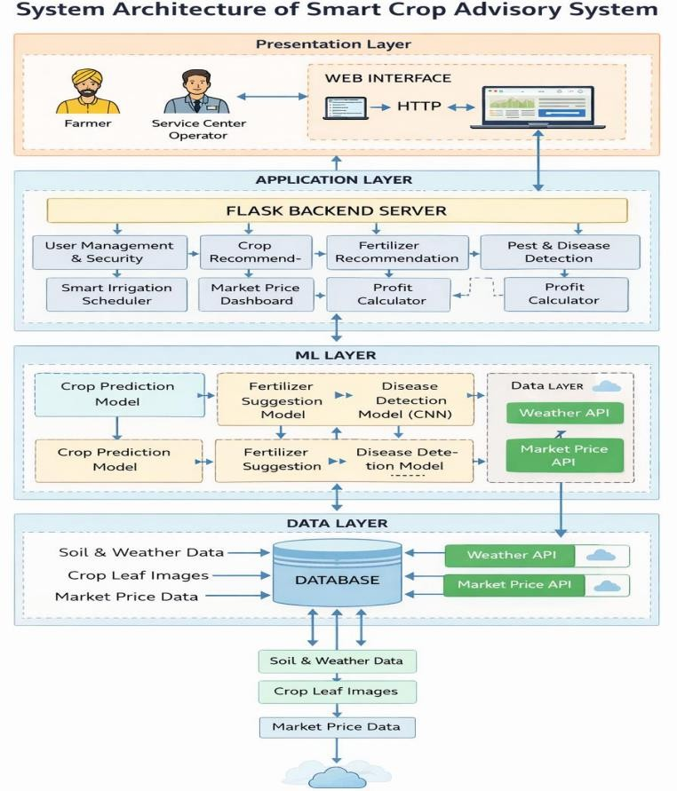
Fig.1.System Architecture

- SYSTEM WORKFLOW

User Interaction:
The user accesses the system through the web interface and selects a feature such as crop recommendation, fertilizer suggestion, disease detection, irrigation advice, or profit calculation.

Input Processing:
The user provides required input data such as soil nutrients (N, P, K), temperature, humidity, rainfall, crop details, or uploads crop leaf images. The system validates the input to ensure correctness and completeness.

Backend Communication:
The validated input is sent to the Flask backend server through HTTP requests. The backend processes the request and forwards it to the appropriate module based on the selected feature.

Model Execution:
The system executes the corresponding machine learning or deep learning model:
i)Crop Prediction Model for crop recommendation ii)Fertilizer Recommendation Model for nutrient analysis iii)Disease Detection Model (CNN) for image-based disease identification
iv)Irrigation module using weather data

External Data Integration:
The backend retrieves real-time data from external APIs such as weather services and market price databases to enhance irrigation advice and profit estimation.

Result Generation:
The system processes model outputs and compiles the final recommendations including crop suggestions, fertilizer guidance, disease detection results, irrigation advice, and profit estimation.

Output Display and Storage:
The results are displayed to the user through the frontend interface in a clear format. The system also stores inputs and outputs in the database for future reference and analysis.

v.RESULTS AND DISCUSSIONS

The Smart Crop Advisory System was evaluated based on its ability to process user inputs and generate accurate agricultural recommendations across multiple modules. Instead of focusing solely on model accuracy, the evaluation considered functional performance, response quality, and end-to-end execution of features such as crop recommendation, fertilizer suggestion, disease detection, irrigation advice, and profit calculation.

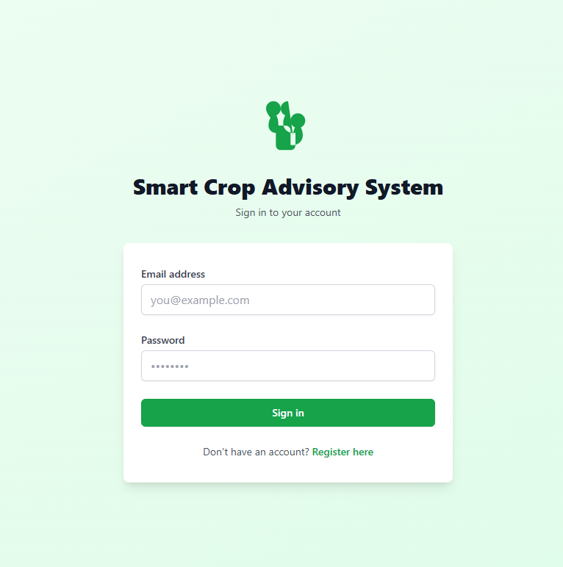

Fig 2: Smart Crop Advisory System – User Login Interface

The system successfully accepts user inputs through a user-friendly web interface, including login and dashboard functionalities. After authentication, users can access various modules such as Crop Recommendation, Fertilizer Advisor, Disease Detection, Irrigation Advisor, Market Price Analysis, and Profit Calculator.
The backend is implemented using Flask, which provides a lightweight and efficient REST API for handling user requests and integrating machine learning models. The system supports real-time processing and can be scaled for larger deployments. Pre-trained models are loaded to ensure fast and accurate predictions.

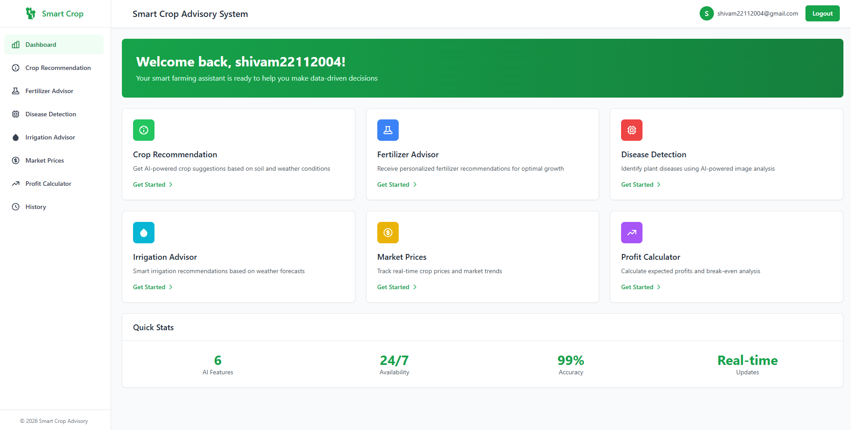

Fig 3: Smart Crop Advisory System – Main Dashboard with Feature Modules
For crop recommendation, the system processes soil and environmental parameters such as nitrogen, phosphorus, potassium, temperature, humidity, and rainfall. Based on these inputs, the machine learning model predicts the most suitable crop. The output includes the recommended crop along with confidence values, ensuring transparency and clarity for users.

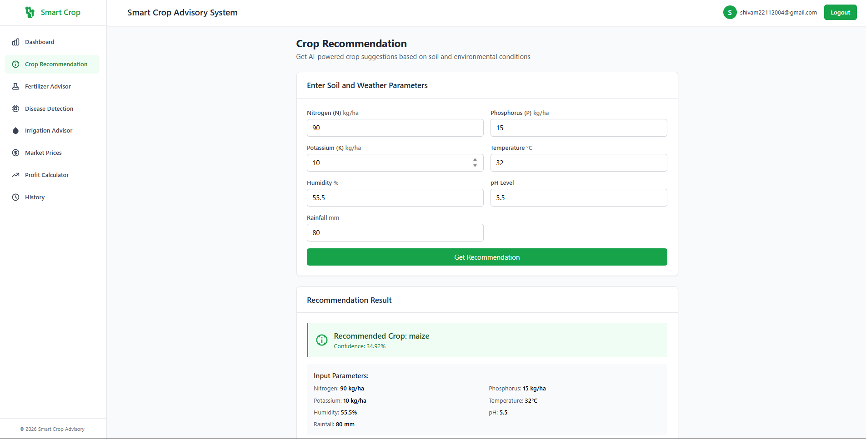
Fig 4: Crop Recommendation Module – Input and Output Results

The fertilizer advisor module analyzes soil nutrient levels and crop type to suggest appropriate fertilizers. The results include fertilizer type, application guidelines, timing, precautions, and benefits, making the recommendations practical and easy to follow.
The market price module provides current crop price information across different locations, assisting farmers in making informed selling decisions. Additionally, the profit calculator computes total cost, revenue, profit, and return on investment (ROI) based on user inputs, offering valuable financial insights.
For disease detection, the system uses a Convolutional Neural Network (CNN) that processes crop leaf images. By analyzing visual patterns, the model can accurately identify plant diseases and provide treatment suggestions. Image preprocessing techniques such as resizing and normalization are applied to ensure consistent input for the model.
The disease detection module is based on a Convolutional Neural Network (CNN) that identifies crop diseases from leaf images. Before prediction, the uploaded images are processed through resizing and normalization to improve accuracy. The system also includes an irrigation recommendation module that uses real-time weather data from external APIs to suggest proper watering schedules based on rainfall and climate conditions.

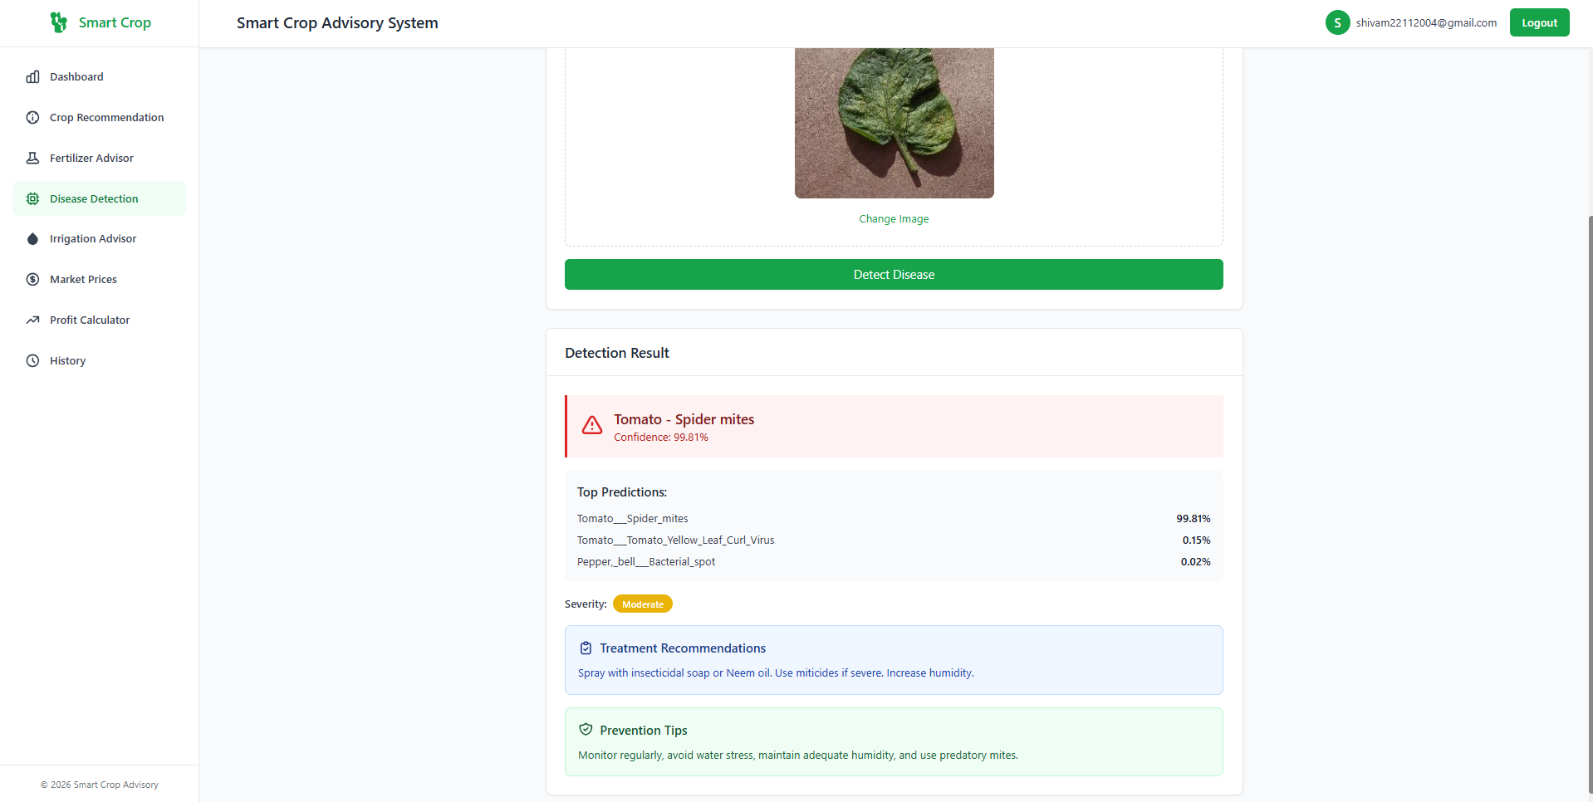
Fig 5: Disease Detection Module – Leaf Image Analysis and Prediction Results
The disease detection module utilizes a Convolutional Neural Network (CNN) to analyze uploaded leaf images. The system accurately identifies plant diseases and provides confidence scores, severity levels, treatment recommendations, and preventive measures. This enables farmers to take timely action and reduce crop loss. The system includes several intelligent modules to support farmers in decision-making. The crop recommendation module uses machine learning algorithms such as Random Forest or Decision Trees to analyze soil nutrients like nitrogen, phosphorus, and potassium along with environmental factors such as temperature, humidity, and rainfall to suggest suitable crops. The fertilizer recommendation module checks soil nutrient levels and recommends appropriate fertilizers to improve crop growth and maintain soil health.

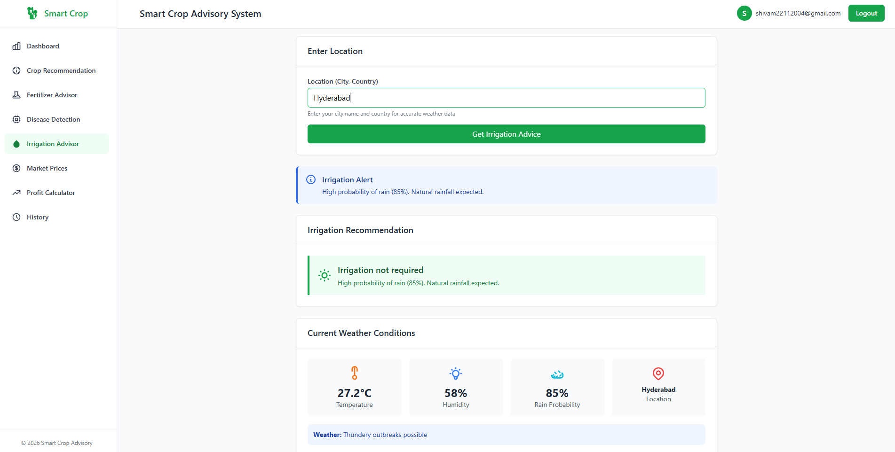
Fig 6: Irrigation Advisory Module – Weather-Based Recommendation Output

The irrigation advisor integrates real-time weather data to provide recommendations based on environmental conditions such as temperature, humidity, and rainfall probability. It suggests whether irrigation is required, thereby optimizing water usage and improving resource efficiency.
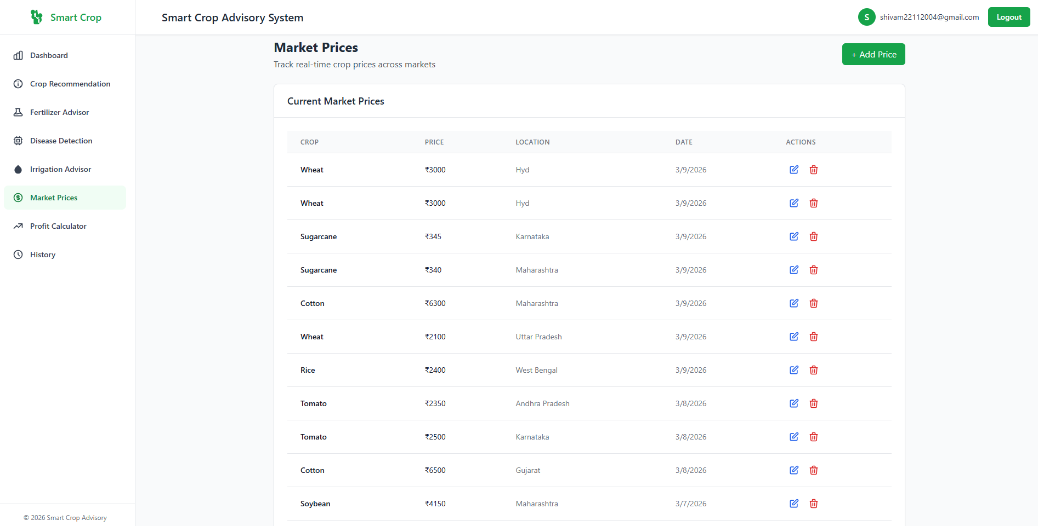
Fig 7: Market Price Module – Real-Time Crop Price Display

The market price module provides current crop price information across different locations, assisting farmers in making informed selling decisions. Additionally, the profit calculator computes total cost, revenue, profit, and return on investment (ROI) based on user inputs, offering valuable financial insights.
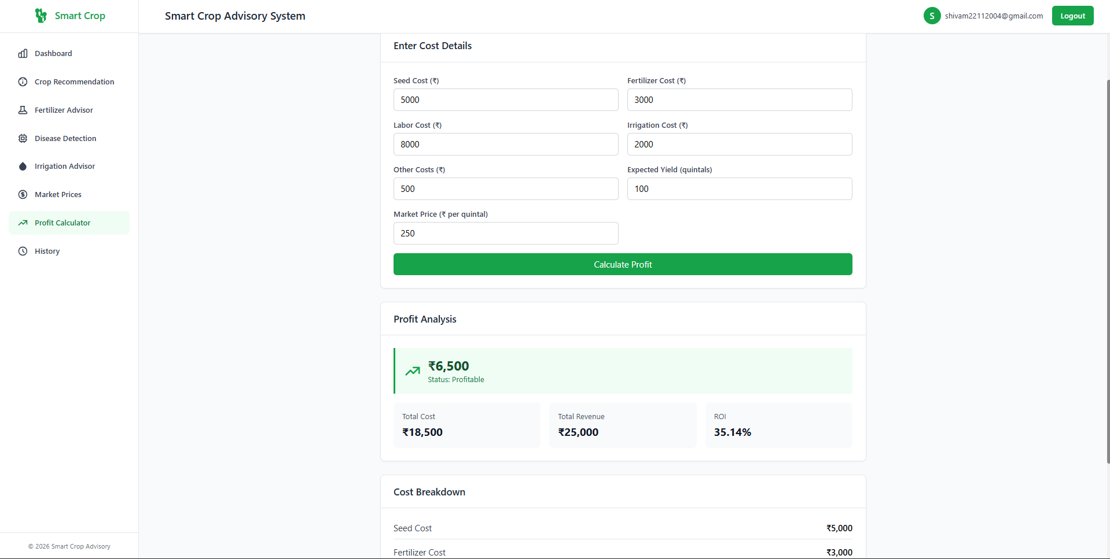
Fig 8: Profit Calculator Module – Cost Analysis and Profit Estimation

The system was tested using multiple input scenarios and datasets. In all cases, it produced consistent, structured, and meaningful outputs. The response time was efficient, and the system successfully handled multiple functionalities through its modular architecture. The backend of the Smart Crop Advisory System is developed using Flask along with Machine Learning and Deep Learning models to handle the main functionalities of the system. Flask is used to create REST APIs that allow communication between the frontend and backend. CORS is enabled so that the React frontend can interact smoothly with the backend even when both are hosted on different servers.
In addition, the backend contains a profit calculation module that estimates profit or loss using cultivation cost, expected yield, and market prices. User details, crop information, and prediction results are stored in databases such as MySQL or SQLite for efficient data management and retrieval.
Overall, the results demonstrate that the Smart Crop Advisory System effectively provides end-to-end agricultural support, from data input to actionable recommendations. The integration of machine learning models, real-time APIs, and an intuitive user interface makes the system scalable, reliable, and suitable for real-world farming applications.

VI. CONCLUSION

This project focuses on the design and implementation of an AI-based Smart Crop Advisory System that assists farmers in making accurate and data-driven agricultural decisions. The primary objective of the system is to provide intelligent recommendations related to crop selection, fertilizer usage, disease detection, irrigation planning, and market analysis using machine learning and deep learning techniques.
The system integrates multiple AI models to handle different agricultural tasks. The crop recommendation model analyzes soil nutrients such as nitrogen, phosphorus, potassium, along with environmental factors like temperature, humidity, and rainfall to suggest the most suitable crops. The fertilizer recommendation module identifies nutrient deficiencies and provides appropriate fertilizer guidance to improve soil health and crop productivity.
For disease detection, the system uses a Convolutional Neural Network (CNN) that processes crop leaf images. By analyzing visual patterns, the model can accurately identify plant diseases and provide treatment suggestions. Image preprocessing techniques such as resizing and normalization are applied to ensure consistent input for the model.
The system also incorporates a weather-based irrigation module, which utilizes external APIs to fetch real-time weather data and recommend optimal irrigation schedules. This helps in efficient water management and prevents both over-irrigation and under-irrigation.
The backend is implemented using Flask, which provides a lightweight and efficient REST API for handling user requests and integrating machine learning models. The system supports real-time processing and can be scaled for larger deployments. Pre-trained models are loaded to ensure fast and accurate predictions.
A modern React-based frontend is developed to provide a user-friendly interface. Users can input soil parameters, upload crop images, and view recommendations in an interactive manner. The frontend communicates with the backend using HTTP requests, ensuring seamless data exchange.
The system also includes a profit estimation module, which calculates expected profit or loss based on cultivation cost, yield, and market prices. Additionally, a market price dashboard helps farmers make better selling decisions by providing updated price information.

REFERENCES

- L. Li, S. Zhang, and B. Wang, “Plant Disease Detection and Classification by Deep Learning – A Review,” IEEE Access, 2021, https://ieeexplore.ieee.org/document/9399342
- P. Kaur and A. Kaur, “Machine Learning-Based Crop Recommendation System,” International Journal of Advanced Research in Computer Science and Software Engineering, 2021, https://www.ijarcsse.com/docs/papers/Volume_11/Issu e_6/V11I6-0010.pdf
- S. P. Mohanty, D. P. Hughes, and M. Salathé, “Using Deep Learning for Image-Based Plant Disease Detection,” Frontiers in Plant Science, 2016. https://doi.org/10.3389/fpls.2016.01419
- A. Ramesh and B. V. Vardhan, “Efficient Irrigation Management Using Weather Forecasting and IoT,” International Journal of Engineering Research & Technology, 2018. https://www.ijert.org/research/efficient-irrigation-
management-using-weather-forecasting-and-iot-
IJERTV7IS060124.pdf
- A. Sharma and R. Jain, “Agricultural Market Price Prediction Using Machine Learning Techniques,” International Journal of Computer Applications, 2020. https://www.ijcaonline.org/archives/volume176/numbe r36/31456-2020920331/
- F. Pedregosa et al., “Scikit-learn: Machine Learning in Python,” Journal of Machine Learning Research, 2011. https://jmlr.org/papers/v12/pedregosa11a.html
- F. Chollet, Deep Learning with Python. Manning Publications, 2017.
https://www.manning.com/books/deep-learning-with- python
- M. Abadi et al., “TensorFlow: Large-Scale Machine Learning on Heterogeneous Systems,” Google Research, 2016.
https://www.tensorflow.org
- G. Bradski, “The OpenCV Library,” Dr. Dobb’s Journal of Software Tools, 2000. https://opencv.org
- I. Goodfellow, Y. Bengio, and A. Courville, Deep Learning. MIT Press, 2016. https://www.deeplearningbook.org
- PlantVillage Dataset, “PlantVillage Dataset for Plant Disease Detection,” https://www.kaggle.com/datasets/emmarex/plantdiseas e
- Kaggle, “Crop Recommendation Dataset,” https://www.kaggle.com/datasets/atharvaingle/crop- recommendation-dataset
- OpenWeatherMap API, “Weather Data API,” https://openweathermap.org/api

