Temperature dependence of acoustic parameters in Some Liquid Mixtures

ABSTRACT
The variation of Ultrasonic Velocities and densities of certain ternary mixture of Ethanol+1-Propanol+Benzene of fixed equal volumes were measured at various temperatures namely 300K, 305K, 310K, 315K, 320K, and 325K . The measured data is used to evaluate the various acoustic parameters like adiabatic compressibility, free length, free volume, and internal pressure. It was observed that adiabatic compressibility (β), free length (Lf), and free volume (Vf), increased with increase in temperature, whereas internal pressure (Pi) decreased with increase in temperature. The results were discussed in the light of intermolecular interactions.
P
P
INTRODUCTTION
The Ultrasonic studies of Liquid mixtures are always of great research interest for both Physicists and chemists. Because they provide a great support in understanding the intermolecular interactions among the component molecules. Ultrasonic velocity and the derived acoustical parameters like adiabatic compressibility, free length, relaxation time, acoustic impedance etc.
In recent years ultrasonic investigations find large number of applications in characterizing of thermodynamic and physiochemical aspect of ternary liquid mixtures. The acoustical and thermodynamic parameter have been used to study different kinds of associations, molecular motion and various types of interaction and their strengths influenced by the size of pure component and the mixtures. [1,2]
P
P
P
P.
The accurate thermodynamic properties of alcohols, in particularly 1-propanol are of interest for different branches of science and engineering. Propan-1-ol is an important industrial chemical fluid. 0T 0PT ropan-1-ol is used as a solvent in the pharmaceutical industry. Hydrogen bonding is one of the most important types of intermolecular interactions play an important role in various physicochemical, biological and industrial processes_{. [3, 9, 5]} Some acoustic and thermodynamic parameters were calculated. [3,4,5. 6]
P
P
Adiabatic compressibility (β) is given by
P
(1)

where U is ultrasonic velocity, ρ is density of the mixture
This communication presents the variation of some acoustic parameters of ternary mixture containing, ethanol, 1-propanol and benzene with temperature for a fixed concentration of equal volumes of the individual liquids making up the mixture.

EXPERIMETAL
The solutions were prepared in volume fraction by taking liquids of ethanol, 1-propanol and benzene . The volume fractions of the component liquids making the mixture were kept constant in the ratio of 1:1:1 throughout the variation of temperature. The density, viscosity, and ultrasonic velocity were measured as a function of temperature of the ternary liquid mixture at 2 MHz and at temperatures of T =300K,305K, 310K, 315 K, 320 K and 325 K. The density of the various systems at different temperatures were measured using relative measurement method and the viscosity of the mixture was measured using an Ostwald`s viscometer. The flow time was determined using a digital stopwatch with an accuracy of ±0.01s. The ultrasonic velocity of the liquid mixture was measured using a single crystal variable path interferometer at 2 MHz. The selected temperature of the liquid mixture was maintained constant by circulating water from a thermostatically controlled water bath with an accuracy of ±0.1 K.
Intermolecular free length (Lf)
(2)

K_{T} is the temperature-dependent constant known as Jacobson's constant (K_{T} = 2.131 × 10⁻⁶ at 318K),

The Free volume (Vf) is given by
(3)

The internal Pressure P_{i} is given by

Pi =bRT(kη/U)^{1/2}(ρ^{2/3}/M_{eff} ^{7/6}) (4)

M_{eff} is the effective molecular weight of the mixture (M_{eff} = ΣmiXi), where mi and Xi are the molecular weight and mole fraction of individual constituents, respectively), k is a temperature-independent constant which is equal to 4.281 × 10⁹ for all liquids, η is the viscosity of the mixture, b stands for cubic packing, which is assumed to be 2 for all liquids, T is the absolute temperature in Kelvin. R is the universal gas constant, k is Boltzmann's constant, and h is Planck's constant, f is the frequency of ultrasonic wave.

RESULTS AND DISCUSSION
P P
The data obtained from experiment relating to density, viscosity, and ultrasonic velocity at indicated temperatures for frequency 2MHz, for the given mixture, and calculated values of adiabatic compressibility, free length, free volume, internal pressure are shown in Table1.
Table 1: Density (ρ), viscosity (µ) velocity (U), adiabatic compressibility (β), free length (Lf), free volume (Vf) and internal pressure (Pi)of ethanol+1-propanol+benzene mixture.

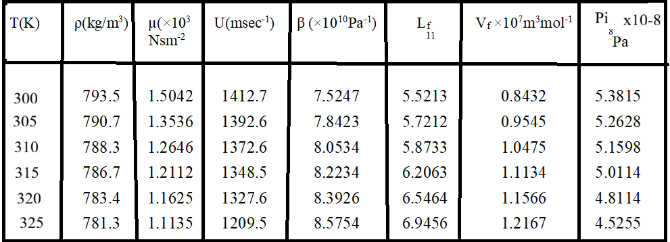

From Table 1 and Figures 1 & 2, it can be observed that the density, viscosity and ultrasonic velocity decrease with increase in temperature. The decrease of values with temperature shows a decrease in intermolecular forces due to the increase in the thermal energy of the system. The velocity decreases with the increase in temperature because the fact that free length increases with the increase of temperature. Since the association of the interacting molecules varies with the temperature of the ultrasonic wave, cohesive energy, cohesive
force as well as internal pressure increases with the increase of temperature. However, adiabatic compressibility (β), free length (Lf), free volume (Vf) and except internal pressure (Pi) increased with increase in temperature.
The free length dependence on the adiabatic compressibility and show a similar behavior to that of the compressibility and inverse to that of velocity. It increased with increase in temperature of mixture, indicating that there is a less interaction between solute molecules. Free volume of the mixture increased as the internal pressure decreased with increase in temperature of mixture. This is most likely because of the loose packing of the molecules inside the shield, which may be brought about by the decreasing magnitude of interactions. [3]. However, adiabatic compressibility (β), free length (Lf), free volume (Vf) and except internal pressure (Pi) increased with increase in temperature. It increased with increase in temperature of mixture, indicating that there is a less interaction between solute molecules. Free volume of the mixture increased as the internal pressure decreased with increase in temperature of mixture [7,8].

From Figures 1 & 2, it is evident that ultrasonic velocity (U), adiabatic compressibility (β), free length (Lf), and free volume (Vf), increased almost linearly with increase in temperature. While, internal pressure (Pi) decreased almost linearly with increase in temperature. As may be expected, the density and viscosity of the system decreased with increase in temperature. The molecules in a liquid are held together much more strongly than in a gas. A force is needed to overcome the mutual attraction of the molecules so that they can be displaced relative to each other. The more strongly the molecules are held together, the smaller the flow for a given shearing stress. With increasing temperature, the random kinetic energy of the molecules helps to overcome the molecular forces and reduces the viscosity. [9,10]

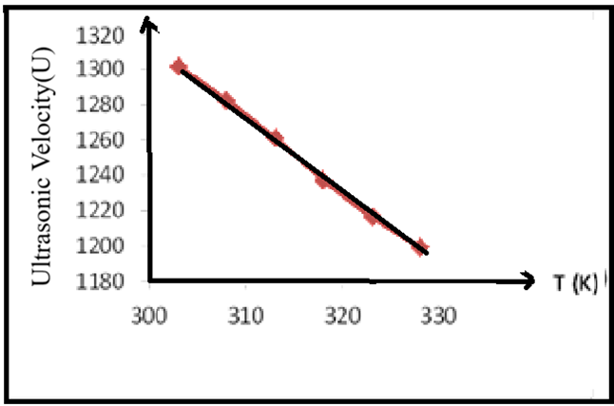
Figure1. Variation of ultrasonic velocity U(msec-1) of mixture with temperature T(K)

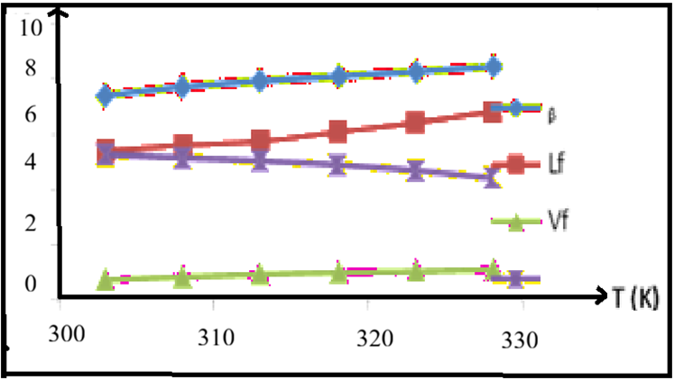

Figure 2.Variation of adiabatic compressibilityβ, free length Lf, free volume Vf and
Internal Pressure (Pi) of mixture with temperature

From the above discussion, one can conclude that the ultrasonic velocity and the thermodynamic parameters: adiabatic compressibility, free length, free volume, and internal pressure of ethanol+1-propanol+benzene mixture increase as the temperature rises. However, the internal pressure decreases with temperature increase. As usual, the density and viscosity of the ternary mixture decrease with increase in temperature. This could be due to the energy obtained to overcome the resistance to flow. The linear variation of acoustical parameters with temperature denote that there exist less intermolecular forces among the components of the liquid mixture used in the present study[11].

REFERENCES

[1].Kinocid, J. Am. Chem. Soc., S1, 2950, 2. 1929.

[2]. Mehta S K and Chauhan R K, J Solution Chem., , 26, 295. 1996.

[2]. Mehra and Sajnami, Ind. J. Pure and Appl. Phys., 38, 760 2000.

[3]. R.J. Fort, and Moore, W.R., Trans. Faraday Society, 61, 2102 1965.

[4]. Thirumaran S and Sathish K, Bull Pure Appl Sci., 27D(2), 239-248. 2008.

[5]. D. M. Bhattacharya, D.V. Kawadkar, C.V. Pandhumaker and A. V. Wankahade, J. Chem. Eng. Data, 62(12)
4083-4092,2017.
[6]. X. Jiang, C. Zhu and Y. Ma, J. Chem. Thermodyn. 71,50-63,2014.

[7]. Y. Akhtar, International J. Engg. Tech. Mang. Res 6 (11),11-17,2019.

[8]. Y. Akhtar, S. F. Ibrahim, Arabian J. Chem. 4 , 487-490,2011.

[9].V.Kannappam and S.Chidambara Vinayagam , Indian J. Pure & Applied Physics, 44,670-676, 2006.

[10]. Yasmin Akhtar, International Journal of Engineering Technologies and Management Research, 7(9),10-
13.2020.
[11]. G.R. Bedare , V.D Bhandakkar , B.M.Suryavanshi , International Journal of Applied Physics and
Mathematics, 2(3), 197-2,2012.

