Qualitative Phytochemical Screening and ANTIBACTERIAL ACTIVITY OF MORINGA OLEIFERA Linn. and Terminalia arjuna Linn.

1.INTRODUCTION
Medicinal plants have been utilised in conventional medicines for centuries and it has played a crucial role in preventing diseases. Phytochemicals chemical derived from plants and its synthetic constituents are liable for the shading and different properties of the plant. A few phytochemicals have a wide scope of exercises, which confers resistance against long term diseases. The phytochemicals like alkaloids, flavonoids, tannins, saponins, sugars, glycosides, Phyto-sterols, phenols, protein and amino corrosive, diterpenes and so forth are referred to show therapeutic actions along with their physiological activities (Nadkarni et.al. 2009).
Moringa oleifera has a place with the group of Moringaceae, local to India, Africa, Arabia, South Asia, and the pacific and Caribbean Islands. Moringa oleifera is a little, quickly developing evergreen or deciduous tree that normally grows up to 9-12 m tallness, open crown of hanging delicate branches, fluffy foliage of outing natural leaves and thick corky, whitish bark (NASIR, 1972; Parrotta, 2001; Ramachandran et.al.,1980). Moringa oleifera is normally known as "Drumstick". It is a little or medium estimated tree, found in the sub-Himalayan tract (Gupta RK ,2010). Moringa leaves contains phytochemical having strong anticancer, antimicrobial and are viewed as brimming with therapeutic properties (Tiloke et.al.,2013; Caceres, 1991)
Terminalia arjuna (T. arjuna) is a deciduous enormous measured fluted tree to 30 m tall and 2-2.5 m breadth at bosom tallness, with a frequently buttressed trunk. T. arjuna has a place with the group of Combretaceae, it is a huge tree, found all through the South Asian district. This tree is typically evergreen (Ali, M. 1994). The bark of T. arjuna is hostile to dysentery, antipyretic, astringent, cardiotonic, Lithotriptic, anticoagulant, hypolipidemia, antimicrobial specialist(Phani Kumar,2013; Ram et.al., 1997; Nema et.al. 2012). The powder of the bark goes about as a diuretic in cirrhosis of liver and gives alleviation in suggestive hypertension(Chatterjee, A. S.,1994). Antibacterial obstruction has become a worldwide issue. Techniques to improve the momentum circumstance remember inquire about for finding new and creative antibiotics. The chemotherapeutic operators have been of incentive in controlling numerous diseases however they rely upon sensible use to limit the occurrence of creating obstruction. Due to the cost effective antibacterial properties, a huge extent of the populace uses restorative plants for the treatment of irresistible illnesses. As per World Health Organization (WHO), over 80% of the total population depends on customary medicine (Chatterjee, A. S. 1994; World Health Organization. (2002).
The therapeutic estimation of plants lies in some synthetic substances that produce an unmistakable physiologic activity on human body. The most significant bioactive mixes of plants are alkaloids, flavonoids, tannins and phenolic compounds. The phytochemical investigate dependent on ethno pharmacological data is commonly viewed as a viable methodology in the disclosure of new enemy of infective operators from higher plants. As of late, the utilization of plants as a wellspring of crucial mixes to battle microbial diseases has picked up noticeable quality. The need to look for plant-based antimicrobials is expanding because of significant expense, decreased adequacy and expanded protection from traditional drugs. This examination broke down the phytochemical structure of Moringa olifera, and antimicrobial capability of its methanol and hexane extricates on Escherichia coli, Klebsiella pneumonia, Pseudomonas aeuriginosa and Candida albicans.( Duraipandiyan et.al. 2006; Mangale et.al. 2012)
The investigation assessed antibacterial action of Moringa oleifera leaf concentrates and Terminalia arjuna bark separates against four microorganisms, viz. Escherichia Coli, Pseudomonas aeroginosa, Staphylococcus aureus and Salmonella typhii. Phytochemical investigation of the leaf in solvents of differing extremity; viz., methanol and chloroform were additionally done.
Phytochemical analysis of Moringa oleifera Linn has revealed a wide range of bioactive substances that enhance its medicinal and therapeutic value. Plant extracts derived through various techniques have been thoroughly examined for their phytochemical makeup, revealing a rich assortment of compounds such as alkaloids, flavonoids, phenolic compounds, and glycosides (Danjuma et al., 2025 ; Tambe & Gadhave, 2024). These substances are recognized for their antioxidant, antimicrobial, and potential therapeutic effects, establishing Moringa oleifera as a significant plant in both traditional and contemporary medicine. The following sections elaborate on the primary discoveries regarding the phytochemical composition of M. oleifera. Moringa oleifera extracts consistently contain alkaloids and flavonoids, which are known for their antioxidant and anti-inflammatory effects (Mali et al., 2024) (Kandeepan et al., 2022). Phenolic Compounds and Tannins are abundant in Moringa oleifera and contribute to their potent antioxidant activity, as shown by various assays such as DPPH and ABTS (Ogundipe et al., 2022) (Al-Reza et al., 2022). The presence of glycosides and terpenoids has been verified and linked to numerous health benefits, including anti-cancer and anti-thyroid activities (Mali et al., 2024) (Tambe & Gadhave, 2024). Extraction methods and various solvents such as ethanol, methanol, and ethyl acetate have been utilized to extract phytochemicals, with ethanol and ethyl acetate yielding higher concentrations of bioactive compounds (Shaeroun et al., 2019).
Based on the extraction method, different solvent was used which include ethanol and distilled water as well; ethanol usually results in descent concentration of all active compounds(Malhotra & Mandal, 2018). Moringa oleifera displays significant antioxidant and antimicrobial activities, attributed to its rich phytochemical content. These properties are advantageous for developing natural therapeutic agents (Seck et al., 2024). The Plant extracts have demonstrated potential in inhibiting enzymes, such as α-amylase and α-lipase, indicating their use in managing diabetes and obesity (Ogundipe et al., 2022). Although the phytochemical analysis of Moringa oleifera underscores its potential as a source of natural therapeutic agents, it is crucial to consider the variability in compound concentration due to different extraction methods and environmental factors. Further research is necessary to standardize the extraction processes and to fully comprehend the pharmacological implications of these phytochemicals.
Moringa oleifera has high antibacterial activity against both Gram-positive (e.g. Staphylococcus aureus) and negative bacteria (e.g. Escherichia coli)(Danjuma et al., 2025) (Tambe & Gadhave, 2024)(Malhotra & Mandal, 2018). Zone of Inhibition: Substantial zones of inhibition mainly on ethanolic extracts with strong antibacterial effectiveness were reported (Souleymane et al., 2025).
The phytochemical attributes and antibacterial potential of Terminalia arjuna has been better documented, therefore, this herbal extract needs much more investigation for its full therapeutic benefit as only few resources are available regarding the use of Moringa oleifera.
On the other hand, there is a need for continuous examination of substitutes like Terminalia arjuna as the emergence of resistant strains means that Moringa oleifera cannot continue to be used successfully and replaces antibiotic which confirm their antibacterial activity.
The Moringa oleifera and Terminalia arjuna species show considerable potential for natural antimicrobials shown by qualitative phytochemical screening. Moringa oleifera leaves, in particular, have an impressive phytochemical profile and are effective against a variety of bacterial strains. The following sections provide significant insights on their phytochemical constituents and antibacterial potential. For phytochemical screening, some normal and accessible standard tests were finished. Antimicrobial bioassay was done through agar well dissemination technique.
MATERIALS AND METHODS
Collection of the plant samples and preparation of the plant extracts of Moringa oleifera leaves and bark of Terminalia Arjuna.
1. Collection of plant materials:
Leaves of Moringa and bark of Arjuna were secured from nearby markets from Pune. It was guaranteed that the plant was solid and uninfected. The leaves were washed under running faucet water to dispense with dust then the plant materials were kept in until all the water content dissipated and the plant turned out to be all around dried for pounding. Subsequent to drying the plant material were ground utilizing with mechanical blender to get fine powder and the powder was put away in impermeable plastic holder with appropriate marking for sometime later.
2. Identification
1.
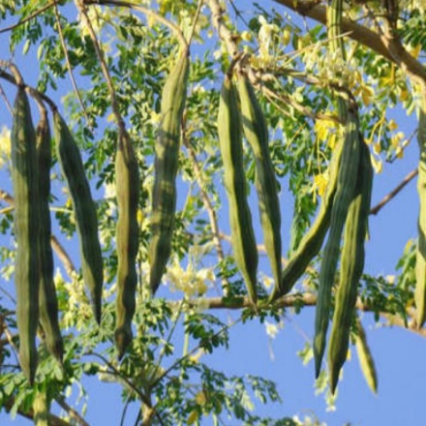  Moringa oleifera (whole plant) |  | 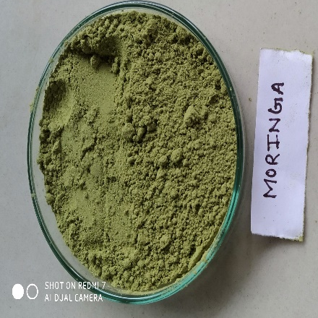  Moringa oleifera (Leaf Extract)
2.
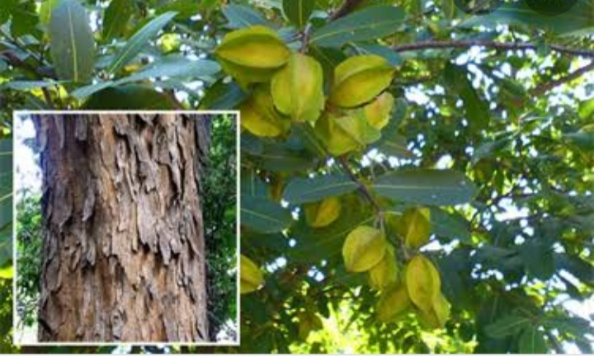  Terminalia arjuna (whole plant) |  | 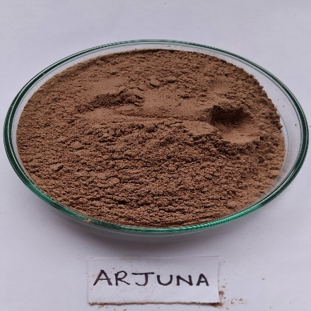Terminalia arjuna (Bark Extract)

3. Preparation of leaf and bark extracts:
The dry powder plant material of Moringa leaf and Arjuna's bark was extricated with water, methanol, ethanol, acetone, chloroform, ether utilizing a maceration procedure. 2 gm of powdered plant material said something a gauging bottle moved into a 250ml dry funnel shaped flask. Flagon was loaded up with various solvents (30ml) independently. flak were saved aside for 24 hrs at room temperature shaking much of the time. Blend was separated through whatman no. 1 paper. Filtrate moved into wet petri plate. Extraction were dried by evaporation of solvents and exposed to subjective phytochemical examination.

4. Determination of Extractive value of Moringa leaf and Arjuna’s bark (Khandelwal, 2002)
The extracts obtained were concentrated to dryness by maintaining a filtrate for complete solvent evaporation. The extractive value in percentage was calculated by using aqueous, methanolic, ethanolic, acetone, chloroform and petroleum ether extracts
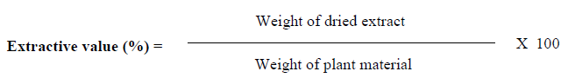

Table I: Extractive value of Moringa oleifera (leaves):

Solvents | Weight of Plant material (g) | Colors of extract | Extractive value (%)
Aqueous (Water) | 2 | Green | 5.00
Methanol | 2 | Green | 14.50
Ethanol | 2 | Green | 9.50
Acetone | 2 | Green | 5.35
Chloroform | 2 | Green | 6.30

Figure 1: : : Extractabilities (%) of active compounds by different solvents from Moringa oleifera (leaves)

Table II: Extractive value of Terminalia arjuna (Bark)

Solvents | Weight of Plant material (g) | Colors of extract | Extractive value (%)
Aqueous (Water) | 2 | Brown | 10.50
Methanol | 2 | Dark Brown | 13.00
Ethanol | 2 | Dark Brown | 4.90
Acetone | 2 | Yellowish | 2.45
Chloroform | 2 | Yellowish | 1.35

Figure 2: Extractabilities % of active compounds by different solvents from Terminalia arjuna (Bark)

5. Preliminary Phytochemical Analysis:
Phytochemical analysis (Rangari, V. D.,2002; Harborne, J. B.,1998) was done by the accompanying techniques to test for the nearness of the Phytosterol, Terpenoids, Total alkaloids, Carbohydrates, Flavonoids, Tannins, Proteins, Glycoside , Starch , Amino acids.
- Test for Phytosterol:
Leibermann- Burchard reaction – To 3 ml extract, 10 ml chloroform was added followed by 2 ml of acetic anhydride. Then 2 drops of conc. Sulphuric acid was added from the side of the test tube. The blue green colour indicated the presence of steroids
- Test for Terpenoids:
Salkowski test: The extract was mixed with 2 ml of chloroform and concentrated H2SO4 (3 ml) is carefully added to form a layer. A reddish brown colouration of the interface is formed to show positive result of the presence of terpenoids. Salkowski test gave a positive result hence confirms the presence of Terpenoids
- Test for Alkaloids:
Mayer’s reagent & Wagner’s reagent confirmed the presence of Alkaloids in the extract. The Methanolic plant extract was warmed with 2% H2SO4 for two minutes. It is filtered and few drops of reagents were added separately.
- Mayer’s reagent-A creamy- white colored precipitation appeared giving a positive
result.
- Wagner’s reagent-A reddish-brown precipitate appeared which also confirms the presence of alkaloids in the extract.

- Test for Carbohydrate:
Fehling’s and Anthron’s test confirmed the presence of carbohydrate. Fehling’s Test: Fehling A and Fehling B reagents were mixed and few drops of extract was added and boiled. A brick red coloured precipitate of cuprous oxide forms, confirming the presence of carbohydrates
- Test for Flavonoids:
Ammonium Test: Plant extract heated with ethyl acetate for 3 min + mixture was filtered + 1ml ammonia solution was added. Layer’s were allowed to separate. Yellow coloration at ammonia layer indicate the presence of flavonoid
- Test for Tannins:
To 1.2 ml of extract of drug, added few drops of 5% FeCl₃ solution. A greenish colour indicates the presence of Galacto-tennins, while brown colour indicates Tannins
- Test for Protein –
Millon’s test - Dissolved small quantity of aqueous extract of drug in 1 ml of distilled water and 5-6 drops of millon’s reagent. A white precipitate is formed which turns red on heating.
- Test for Glycosides:
Keller-Kiliani Test and Concentrate H2SO4 Test confirmed the presence of Glycosides in the methanolic plant extract. Keller-Kiliani Test: In 2 ml plant extract, glacial acetic acid, one drop of 5% FeCl3 and conc. H2SO4 were added. Reddish brown color appears at junction of the two liquid layers and upper layer appears bluish green, confirming the presence of glycosides. Concentrate H2SO4 Test: In 5 ml plant extract, 2 ml glacial acetic acid, one drop of 5% FeCl3 and conc. H2SO4 were added. Brown ring appears, indicating the presence of glycosides.
- Test for Starch:
Dissolved 0.015 g of Iodine and 0.075 g of KI in 5 ml of distilled water and added 2-3 ml of an aqueous extract of drug. A blue colony is produced.
- Test for amino acids :
Ninhydrin test - About 3ml of plant extract solution was heated followed by addition of 3 drps of 5% ninhydrin solution. The test tubes with this solution were kept in boiling water bath for 10 minutes. The purple color was observed. It indicated the presence of amino acids.

Table III: Phytochemical screening of different solvent extracts of Moringa oleifera.
Sr. no. | Phyto-constituent | Phytochemical test | Results
 |  |  | Water | MeOH | ETOH | Chloroform | Acetone
1 | Phytosterols | Liebermann-Burchard's test | - | - | - | - | -
2 | Terrpenoids | Salkowski reaction | + | - | + | + | +
3 | Alkaloids | Mayer’s test  Wagner test | -  + | -  + | -  + | -  + | -  +
4 | Carbohydrates | Fehling test | - | - | - | - | -
5 | Flavanoids | Lead Acetate test | - | + | - | - | -
6 | Tannins | 5% Fecl₃ Test | - | + | + | + | +
7 | Proteins | Ninhydrin test | _ | - | - | - | -
8 | Glycosides | Keller-Killiani test | - | - | - | + | -
9 | Starch | Iodine | - | - | - | - | -
10 | Amino acid | Ninhydrine | + | - | - | - | -

Table IV: Phytochemical screening of different solvent extracts of Terminalia arjuna
Sr. no. | Phyto-constituent | Phytochemical test | Results
 |  |  | Water | MeOH | ETOH | Chloroform | Acetone
1 | Phytosterols | Liebermann-Burchard's test | - | - | - | - | -
2 | Terrpenoids | Salkowski reaction | + | - | + | + | +
3 | Alkaloids | Mayer’s test  Wagner test | -  + | -  + | -  + | -  + | -  +
4 | Carbohydrates | Fehling test | - | - | - | - | -
5 | Flavanoids | Lead Acetate test | - | + | - | - | -
6 | Tannins | 5% Fecl₃ Test | - | - | - | +
7 | Proteins | Ninhydrin test | _ | - | - | - | -
8 | Glycosides | Keller-Killiani test | - | - | - | + | -
9 | Starch | Iodine | - | - | - | - | -
10 | Amino acid | Ninhydrine | + | + | - | - | -

6. Determination of the Antibacterial Activity: Selection of the Microorganisms:
The bacterial strains utilized for this investigation were Escherichia coli, Pseudomonas aeroginosa, Staphylococcus aureus and Salmonella typhii. All the bacterial strains were developed and kept up in supplement agar. These living beings utilized were acquired from the Microbiology Department of MUIS of Ganpat University.
Well Diffusion Method:
The antibacterial movement of the leaf removes was resolved utilizing agar well dispersion strategy. The antibacterial movement of methanolic and chloroform concentrate of Moringa oliefera and Terminilia arjuna was tried on microbes viz. Escherichia coli, Pseudomonas aeroginosa, Staphylococcus aureus ,Salmonella typhii by standard agar well dissemination technique. 1 ml organisms stock culture were vaccinated on supplement agar medium and filled sanitized Petri dishes. Wells of 5 mm distance across were made on the supplement agar utilizing a sterile plug borer. The cut agar plates were deliberately evacuated by the utilization of cleaned forceps. To each well, 20 μL of plant separates were stacked with the assistance of micropipette under aseptic conditions. The plates were containing development of the test living being and concentrates were hatched in well and plates were kept in hatchery at 37 °C for 24 h. The plates were analyzed for proof of zones of hindrance, which show up as a reasonable territory around the wells. The breadth of such zones of restraint was estimated. Control tests involving inoculums with gentamicin anti-toxin circles were arrangement and the plates were incubated at 37 °C for 24 h. The zones of restraint were then recorded and analyzed.

RESULT
The exxtractibilities of concentrates of Moringa oleifera and Terminalia arjuna was explored and described to in Table No. 1 and 2 From the current examination it was discovered that, the extractive estimation of methanolic remove was the highest with the values of 14.5% and 13 % when contrasted with other dissolvable concentrates. The aquous concentrates of Moringa and chloroform concentrate of Arjuna demonstrated lower extractive worth 5% and 1.35% than other dissolvable concentrates.
From the subjective examination of Moringa oleifera and Terminalia arjuna extracts the non-appearance of sterol, sugars, alkaloids, tannins, starch, amino corrosive were explored.
The different concentrates of Moringa oleifera in particular methanol and chloroform concentrates of its leaves and barks were tried against Staphylococcus aureus, Escherichia coli, and Pseudomonas vulgaris for their antibacterial action.

Table V: Antibacterial activity of Moringa oleifera
 | Staphylococcus aureus | Escherichia coli | Pseudomonas vulgaris
Chloroform | 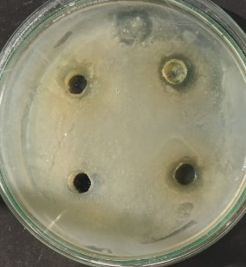 | 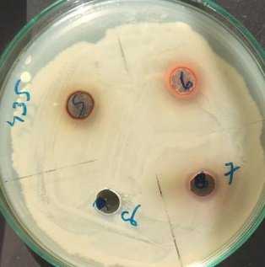 | 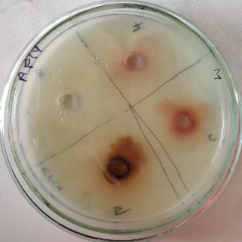
Methanol | 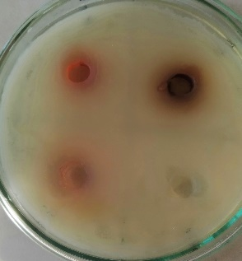 | 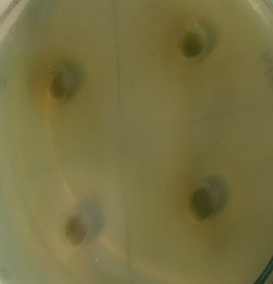 | 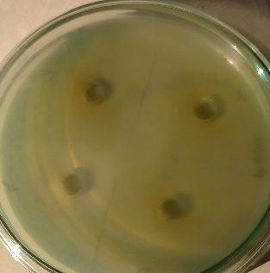

Table VI: Antimicrobial activity of Chloroform, Methanol extract of medicinal plants against pathogens
Name of extract | Solvent | Zone of Inhibition (mm)
Name of extract | Solvent | Escherichia Coli | Pseudomonas vulgaris | Staphylococcus aureus
Moringa oleifera | Methanol | - | - | -
Moringa oleifera | Chloroform | 5 | - | -

Table VII: Antibacterial activity of Terminalia arjuna.
 | Staphylococcus aureus | Escherichia coli | Pseudomonas vulgaris
Chloroform | 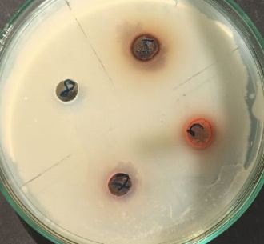 | 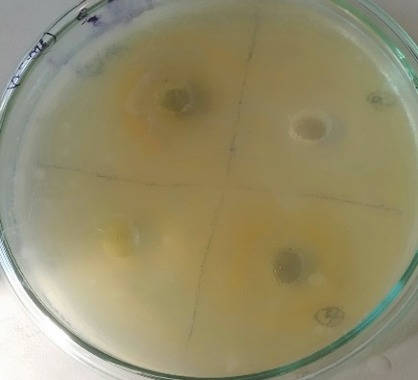 | 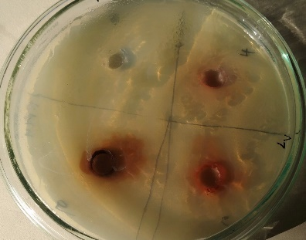
Methanol | 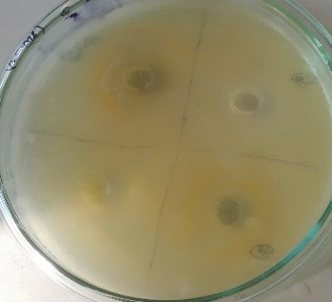 |  | 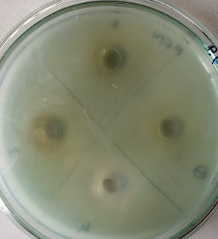

Table VIII: Antimicrobial activity of Chloroform, Methanol extract of medicinal plants against pathogens
Name of extract | Solvent | Zone of Inhibition (mm)
Name of extract | Solvent | Escherichia Coli | Pseudomonas vulgaris | Staphylococcus aureus
Terminalia arjuna | Methanol | 8 | 7 | -
Terminalia arjuna | Chloroform | 6 | - | 11

DISCUSSION
Restorative plants are vital to the wellbeing of individual and networks(Pascaline et.al. 2011). Phytochemical examination led on the plant extracts uncovered the phytochemical constituents which are referred to display therapeutic activities(Sofowora, A. ,1993). The phytochemical examination of Moringa oleifera plant removes utilizing water, methanol, chloroform, acetone, ethanol is appeared in Table no: 3 -From the phytochemical investigation it was discovered that sterol is missing in Moringa oleifera. Terpenoids were available in ethanol, fluid, chloroform, and acetone separate. Alkaloids were present Wagner test but remained undetected in Mayer's test (absolutely missing). Starch was also not detected. Flavonoids were available in methanol extract. Tannin was found in methanol, ethanol, chloroform, acetone separate however, protein was missing. Glycosides were found in chloroform separates but starch was thoroughly missing. Amino acids were found in the fluid concentrate. The phytochemical examination of Terminalia arjuna plant removes utilizing water, methanol, chloroform, acetone, ethanol is appeared in Table. From the phytochemical investigation it was discovered that sterol is missing. Terpenoids were available in ethanol, watery, chloroform, and acetone separate. Similar to the Moringa extracts, In T. arjuna extracts also showed Alkaloids were present in Wagner test but remained undetected in Mayer's test (absolutely missing). Starch was also not detected. Flavonoids were available in methanol concentrate of T. arjuna bark. Regular cancer prevention agents originate from plant as phenolic mixes, for example, flavonoids (Ali,2008; Napoleanet.al. 2009). Tannin was found in chloroform remove. Protein was not found. Glycosides just found in chloroform extricate. Starch was thoroughly missing. Amino acids were just found in fluid and methanol separates.
The antibacterial action of chloroform, and methanol extricates was explored utilizing agar well dispersion strategy, against the chose human pathogens, for example, Escherichia Coli, Pseudomonas aeruginosa, Staphylococcus aureus. All the inspected separate indicated fluctuating degrees of antibacterial exercises against the pathogens. Table-5 showes the antibacterial action of chloroform concentrate of Moringa oleifera indicated greatest zone of hindrance (5 mm) against Escherichia Coli. The antibacterial movement of chloroform concentrate of Moringa oleifera demonstrated no zone of restraint against Pseudomonas aeruginosa, Staphylococcus aureus. The antibacterial action of Methanol concentrate of Moringa oleifera indicated no zone of hindrance against the microbes on Pseudomonas aeruginosa(Karande et.al.2020; Deshpande et.al. 2022; Malhotra et.al. 2018). announced that E.coli, P.aeruginosa, S. aureus to be touchy to chloroform concentrate of Moringa oleifera leaf. Table-6 shows the antibacterial action of chloroform concentrate of Terminalia arjuna indicated most extreme zone of restraint (11 mm) against Staphylococcus aureus. The antibacterial action of chloroform concentrate of Terminalia arjuna demonstrated no zone of hindrance against Pseudomonas aeruginosa and, Staphylococcus aureus. The antibacterial action of methanol concentrate of Terminalia arjuna demonstrated greatest zone of restraint (8 mm) against E.coli and indicated the base inhibitory zone (6 mm) against Pseudomonas aeruginosa.

CONCLUSION
It can be concluded that the selected medicinal plants are the source of secondary metabolites like alkaloids, phytosterols, glycosides, phenols, flavonoids and terpenoids. Due to the presence of these secondary metabolites the selected medicinal plants have high healing potential.
Moringa oleifera and Terminalia arjuna show potential antimicrobial activity against tested bacteria viz, E.coli , Pseudomonas aeruginosa and Staphylococcus aereus. These two plants are considered in one of the new infection fighting strategies in controlling bacteria. These plants could be source of new antibiotic compound.

ACKNOWLEDGEMENT
The authors are grateful to Mehsana Urban Institute of Science, Ganpat University, Kherva, Gujarat for providing necessary facilities for my research work for encouragement and facilities given during present investigation.
References:
- Nadkarni, K. M. (2009). Indian materia medica (Vol. 1, pp. 811–816). Bombay Popular Prakashan.
- Roloff, A., Weisgerber, H., Lang, U., & Stimm, B. (2009). Moringa oleifera Lam., 1785. Wiley-VCH Verlag GmbH & Co. KGaA.
- Nasir, E., & Ali, S. I. (1972). Flora of West Pakistan: An annotated catalogue of the vascular plants of West Pakistan and Kashmir. Fakhri Printing Press.
- Parrotta, J. A. (2001). Healing plants of peninsular India. CABI Publishing.
- Ramachandran, C., Peter, K. V., & Gopalakrishnan, P. K. (1980). Drumstick (Moringa oleifera): A multipurpose Indian vegetable. Economic Botany, 34(3), 276–283.
- Gupta, R. K. (2010). Medicinal and aromatic plants (pp. 151–152). CBS Publishers & Distributors.
- Tiloke, C., Phulukdaree, A., & Chuturgoon, A. A. (2013). The antiproliferative effect of Moringa oleifera crude aqueous leaf extract on cancerous human alveolar epithelial cells. BMC Complementary and Alternative Medicine, 13, 226–233.
- Caceres, A., Cabrera, O., Morales, O., Mollinedo, P., & Mendia, P. (1991). Pharmacological properties of Moringa oleifera: Preliminary screening for antimicrobial activity. Journal of Ethnopharmacology, 33(3), 213–216.
- Ali, M. (1994). Textbook of pharmacognosy (1st ed.). CBS Publishers.
- Phani Kumar, G., Navya, K., Ramya, E. M., Venkataramana, M., Anand, T., & Anilakumar, K. R. (2013). DNA damage protecting and free radical scavenging properties of Terminalia arjuna bark in PC-12 cells and plasmid DNA. Free Radicals and Antioxidants, 3, 35–39.
- Ram, A., Lauria, P., Gupta, R., Kumar, P., & Sharma, V. N. (1997). Hypocholesterolaemic effects of Terminalia arjuna tree bark. Journal of Ethnopharmacology, 55(3), 165–169.
- Nema, R., Jain, P., Khare, S., Pradhan, A., Gupta, A., & Singh, D. (2012). Antibacterial and antifungal activity of Terminalia arjuna leaves extract with special reference to flavonoids. Basic Research Journal of Medical and Clinical Sciences, 1(5), 63–65.
- Chatterjee, A. S. (1994). The treatise on Indian medicinal plants. Publication and Information Directorate, Council of Scientific and Industrial Research.
- World Health Organization. (2002). Traditional medicine strategy 2002–2005 (WHO/EDM/TRM/2002.1). World Health Organization.
- Andy, I. E., Eja, M. E., & Mboto, C. I. (2008). Antimicrobial studies on medicinal plants. Malaysian Journal of Microbiology, 4(1), 25–29.
- Duraipandiyan, V., Ayyanar, M., & Ignacimuthu, S. (2006). Antimicrobial activity of some ethnomedicinal plants used by Paliyar tribe from Tamil Nadu, India. BMC Complementary and Alternative Medicine, 6, 35.
- Mangale, S. M., Chonde, S. G., Jadhav, A. S., & Raut, P. D. (2012). Study of Moringa oleifera (drumstick) seed as natural adsorbent and antimicrobial agent for river water treatment. Journal of Natural Products and Plant Resources, 2(1), 89–100.
- Khandelwal, K. R. (2002). Practical pharmacognosy: Techniques and experiments (9th ed.). Nirali Prakashan.
- Rangari, V. D. (2002). Pharmacognosy and phytochemistry (p. 132). Career Publications.
- Harborne, J. B. (1998). Phytochemical methods (pp. 117–119). Chapman & Hall.
- Pascaline, J., Charles, M., Lukhoba, C., & George, O. (2011). Phytochemical constituents of some medicinal plants used by the Nandis of South Nandi District, Kenya. Journal of Animal and Plant Sciences, 9, 1201–1210.
- Sofowora, A. (1993). Medicinal plants and traditional medicine in Africa (pp. 191–289). John Wiley & Sons.
- Ali, S. S., Kasoju, N., Luthra, A., Singh, A., Sharanabasava, H., Sahu, A., et al. (2008). Indian medicinal herbs as sources of antioxidants. Food Research International, 41(1), 1–15.
- Napolean, P., Anitha, J., & Emilin, R. R. (2009). Isolation, analysis and identification of phytochemicals with antimicrobial activity from Moringa oleifera Lam. Current Biotica, 3(1), 33–37.
- Karande Sucheta, Balak Palak, Saroha Pooja and Patel Saloni (2020) Phytochemical Analysis and Antimicrobial Activity of Ocimum sanctuma (Tulsi) and Hemidesmus indicu (Anantamul) Int. Res. J. of Science & Engineering, Special Issue A9, July, 2020 pp 147-156.
- Deshpande, A., Gaikwad, P., & Pareek, K. (2022). Antimicrobial and antioxidant activity of root extract of Cissus quadrangularis. World Journal of Pharmaceutical Research, 12(1), 1421–1425.
- Malhotra, S. P. K., & Mandal, T. K. (2018). Phytochemical screening and in vitro antibacterial activity of Moringa oleifera (Lam.) leaf extract. International Journal of Current Research in Biosciences and Plant Biology, 3(4), 367–372. https://doi.org/10.26832/24566632.2018.030406
- Danjuma, K., Lawan, I., Jaafar, S., & Abdulmajid, S. A. (2025). Preliminary qualitative phytochemical screenings and antimicrobial potentials of the leaf extracts of Moringa oleifera grown in Enugu State, southeastern Nigeria. Indonesian Journal of Health Sciences Research, 7(1), 1–9.
- Souleymane, K., Oumar, D. A., Hissein, A. H., Yaro, B., & Savadogo, A. (2025). Phytochemical profiling and anti-MRSA activity of extracts from Moringa oleifera Lam. and Senna occidentalis (L.) Link cultivated under organic conditions. Microbiology Research Journal International, 35(10), 32–44.

